* 1. PK parameters
* 2. Time profiles and residual plots
  + 2.1. Time profiles and residual plots for Larson 2013 8y-18y 400mg FCT meal
  + 2.2. Time profiles and residual plots for Filmcoated_tablet_400mg_sd
  + 2.3. Residuals across all simulations
* 3. Demography

# 1. PK parameters

Figure 1: C_max of Raltegravir shown as box-whisker plot, which indicates the 5th, 25th, 50th, 75th, and 95th percentiles in linear scale.

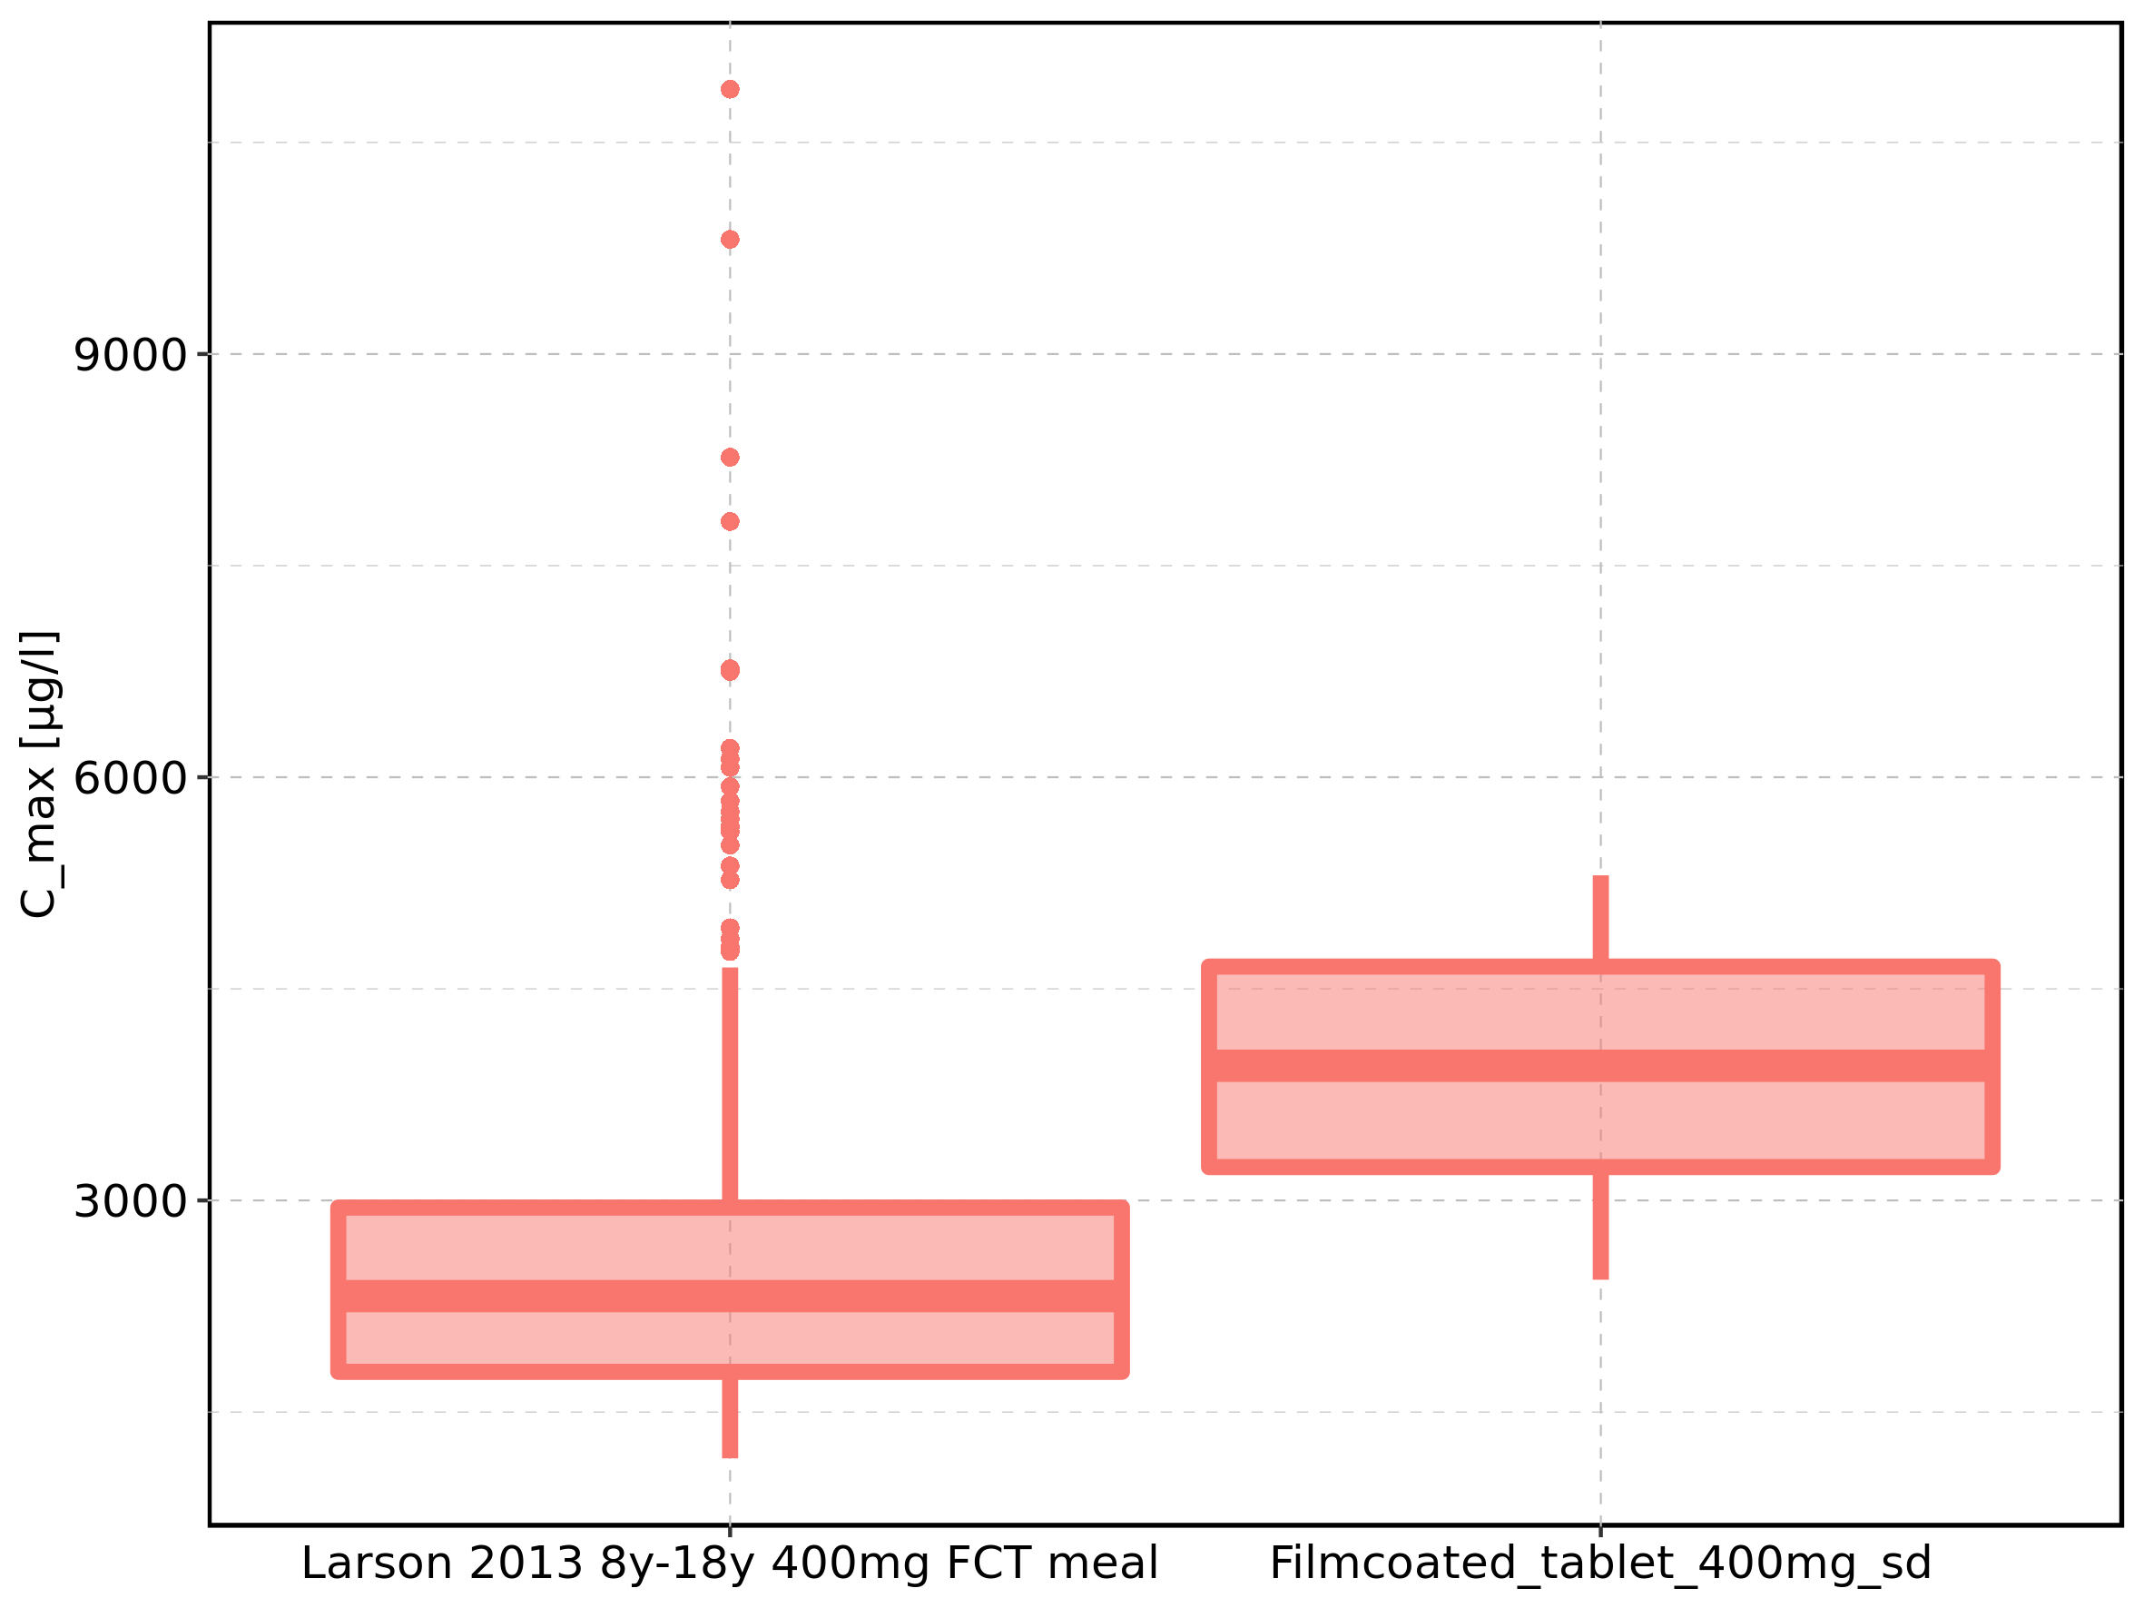

|  |  |  |  |  |  |  |  |  |  |  |
| --- | --- | --- | --- | --- | --- | --- | --- | --- | --- | --- |
| Population | N | 5th percentile | 25th percentile | 50th percentile | 75th percentile | 95th percentile | mean | standard deviation | geo mean | geo standard deviation |
| Larson 2013 8y-18y 400mg FCT meal | 500 | 1171.264 | 1784.944 | 2321.552 | 2949.242 | 4651.398 | 2549.832 | 1206.8866 | 2326.870 | 1.523041 |
| Filmcoated_tablet_400mg_sd | 100 | 2437.788 | 3236.536 | 3954.538 | 4657.555 | 5304.384 | 3940.920 | 908.8899 | 3833.698 | 1.270937 |

Figure 2: C_max of Raltegravir shown as box-whisker plot, which indicates the 5th, 25th, 50th, 75th, and 95th percentiles in logarithmic scale.

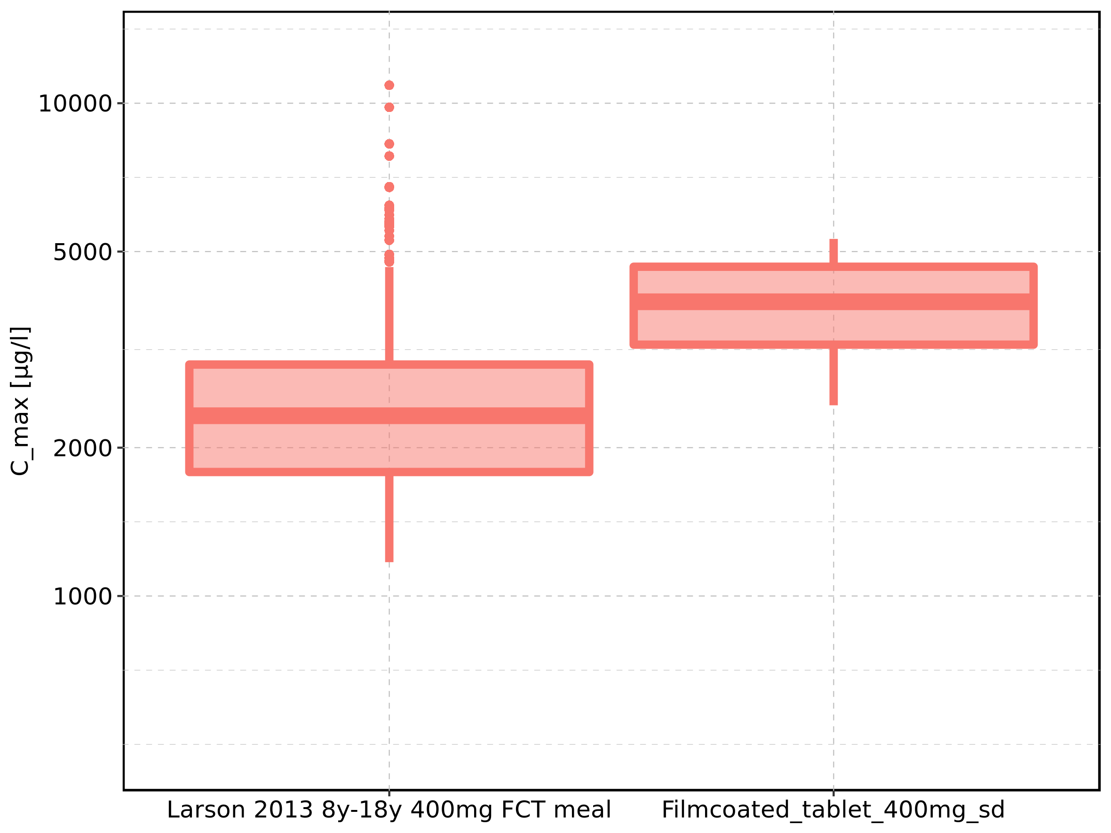

Figure 3: Age-dependence of C_max for Larson 2013 8y-18y 400mg FCT meal in comparison to Filmcoated_tablet_400mg_sd. Profiles are plotted in a linear scale.

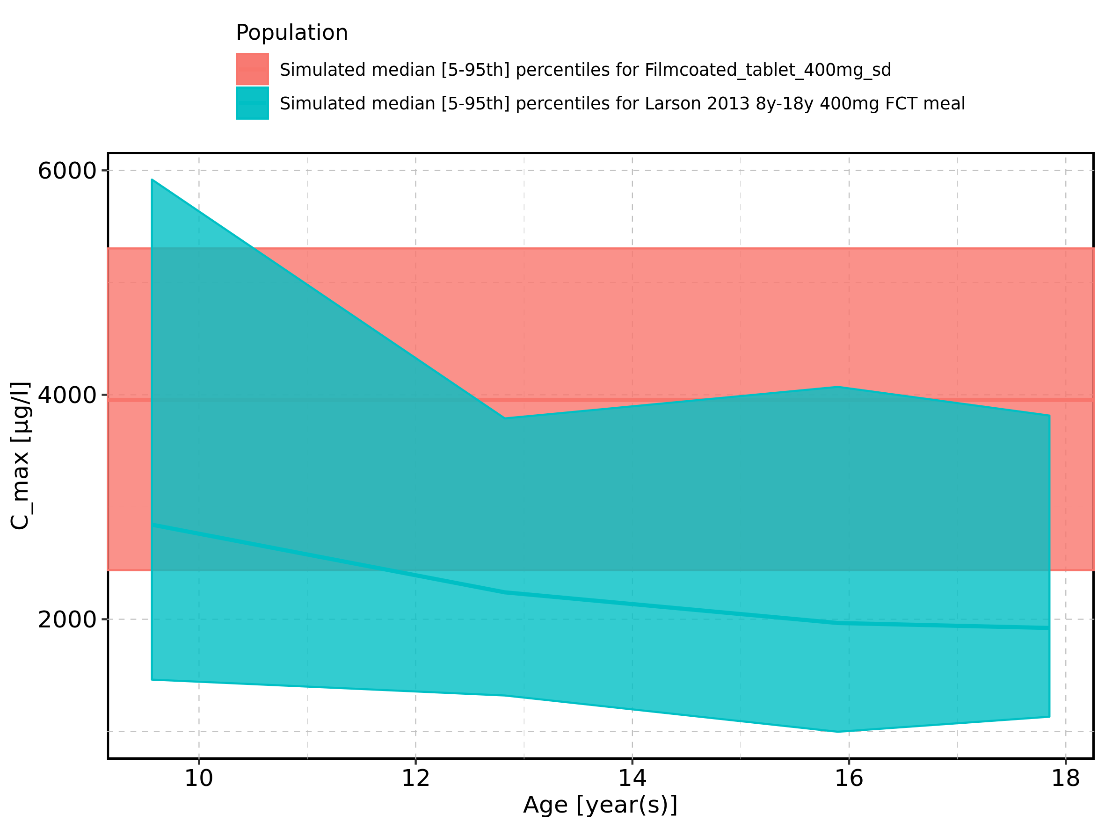

Figure 4: Age-dependence of C_max for Larson 2013 8y-18y 400mg FCT meal in comparison to Filmcoated_tablet_400mg_sd. Profiles are plotted in a logarithmic scale.

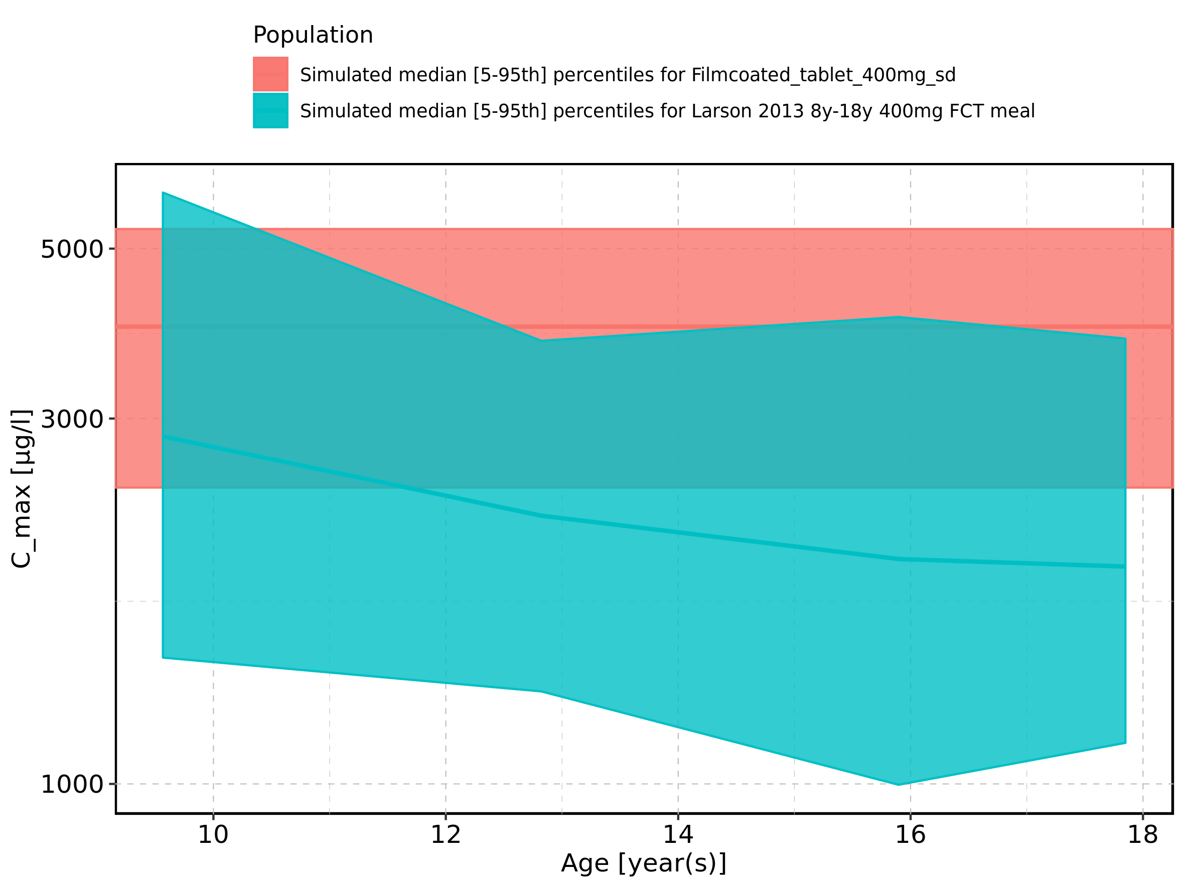

Figure 5: Age-dependence of C_max for Larson 2013 8y-18y 400mg FCT meal. Profiles are plotted in a linear scale.

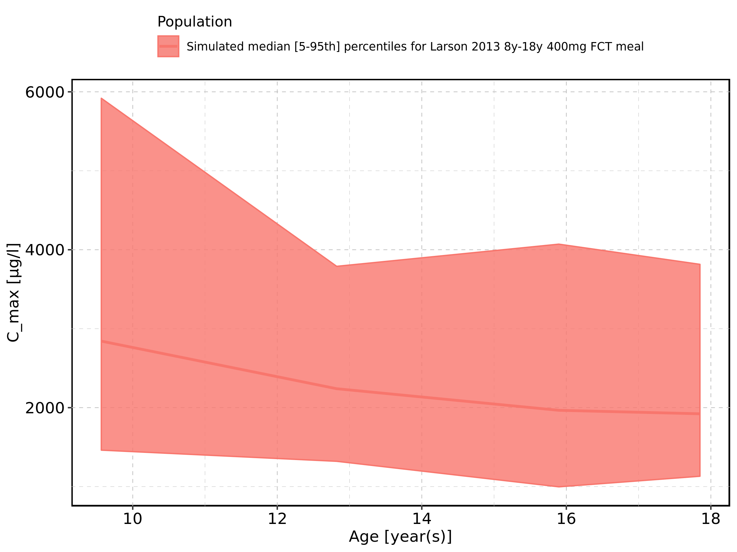

Figure 6: Age-dependence of C_max for Larson 2013 8y-18y 400mg FCT meal. Profiles are plotted in a logarithmic scale.

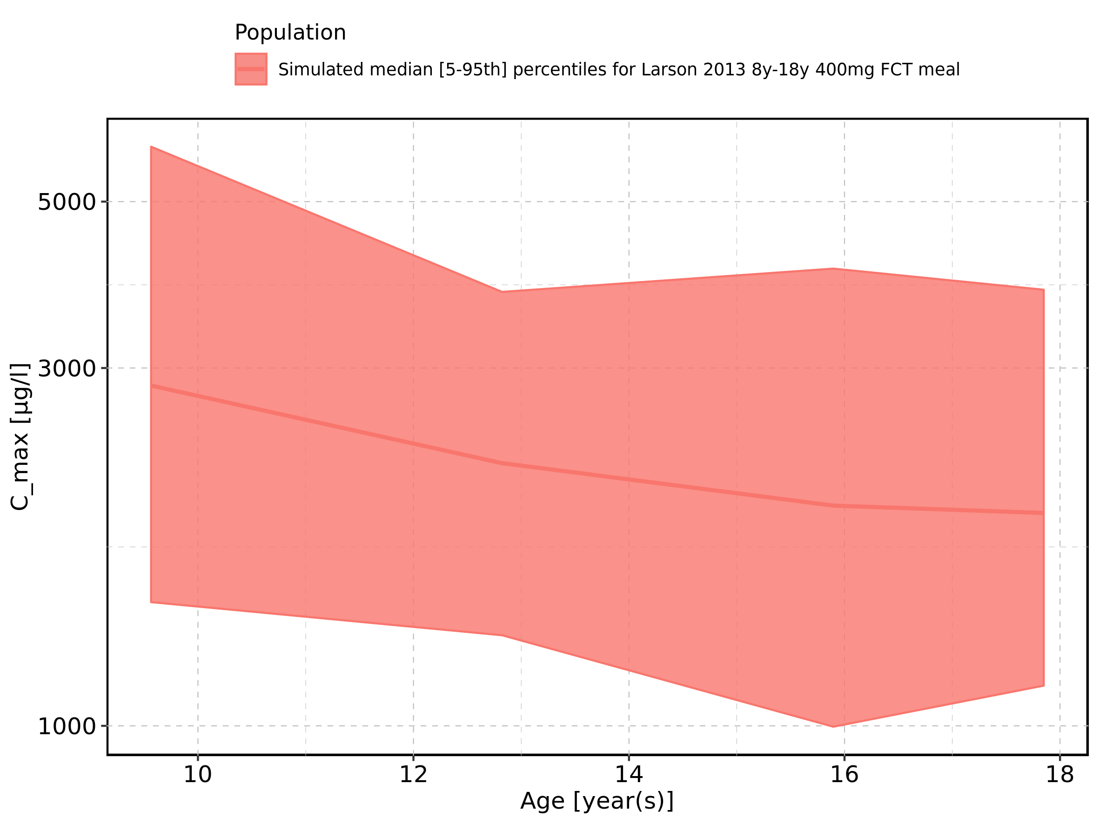

Figure 7: Age-dependence of C_max for Filmcoated_tablet_400mg_sd. Profiles are plotted in a linear scale.

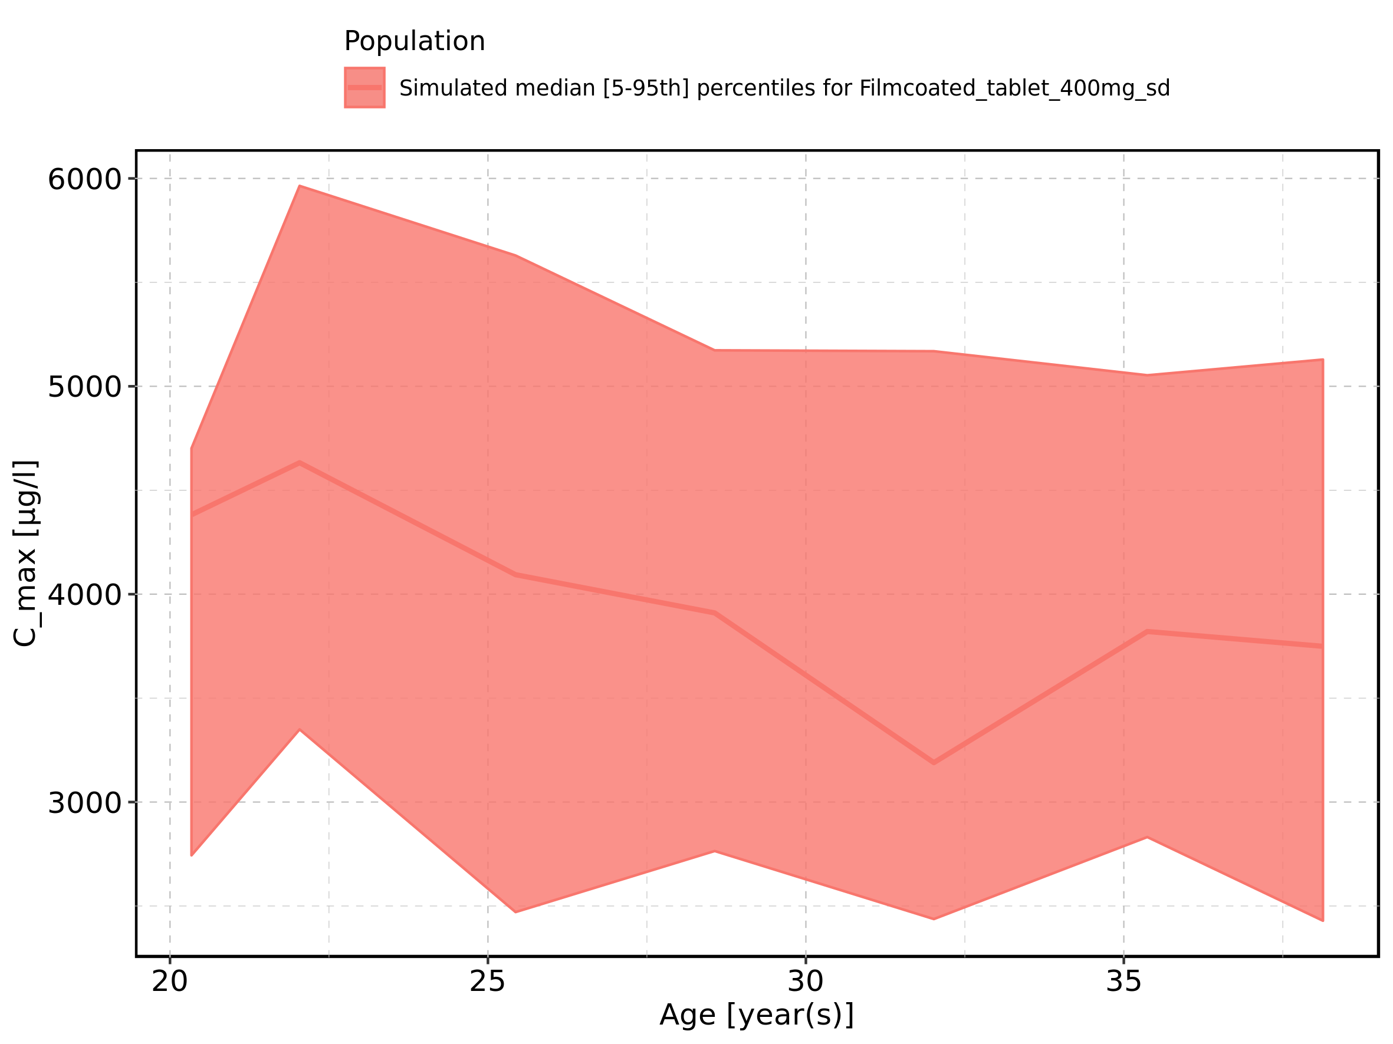

Figure 8: Age-dependence of C_max for Filmcoated_tablet_400mg_sd. Profiles are plotted in a logarithmic scale.

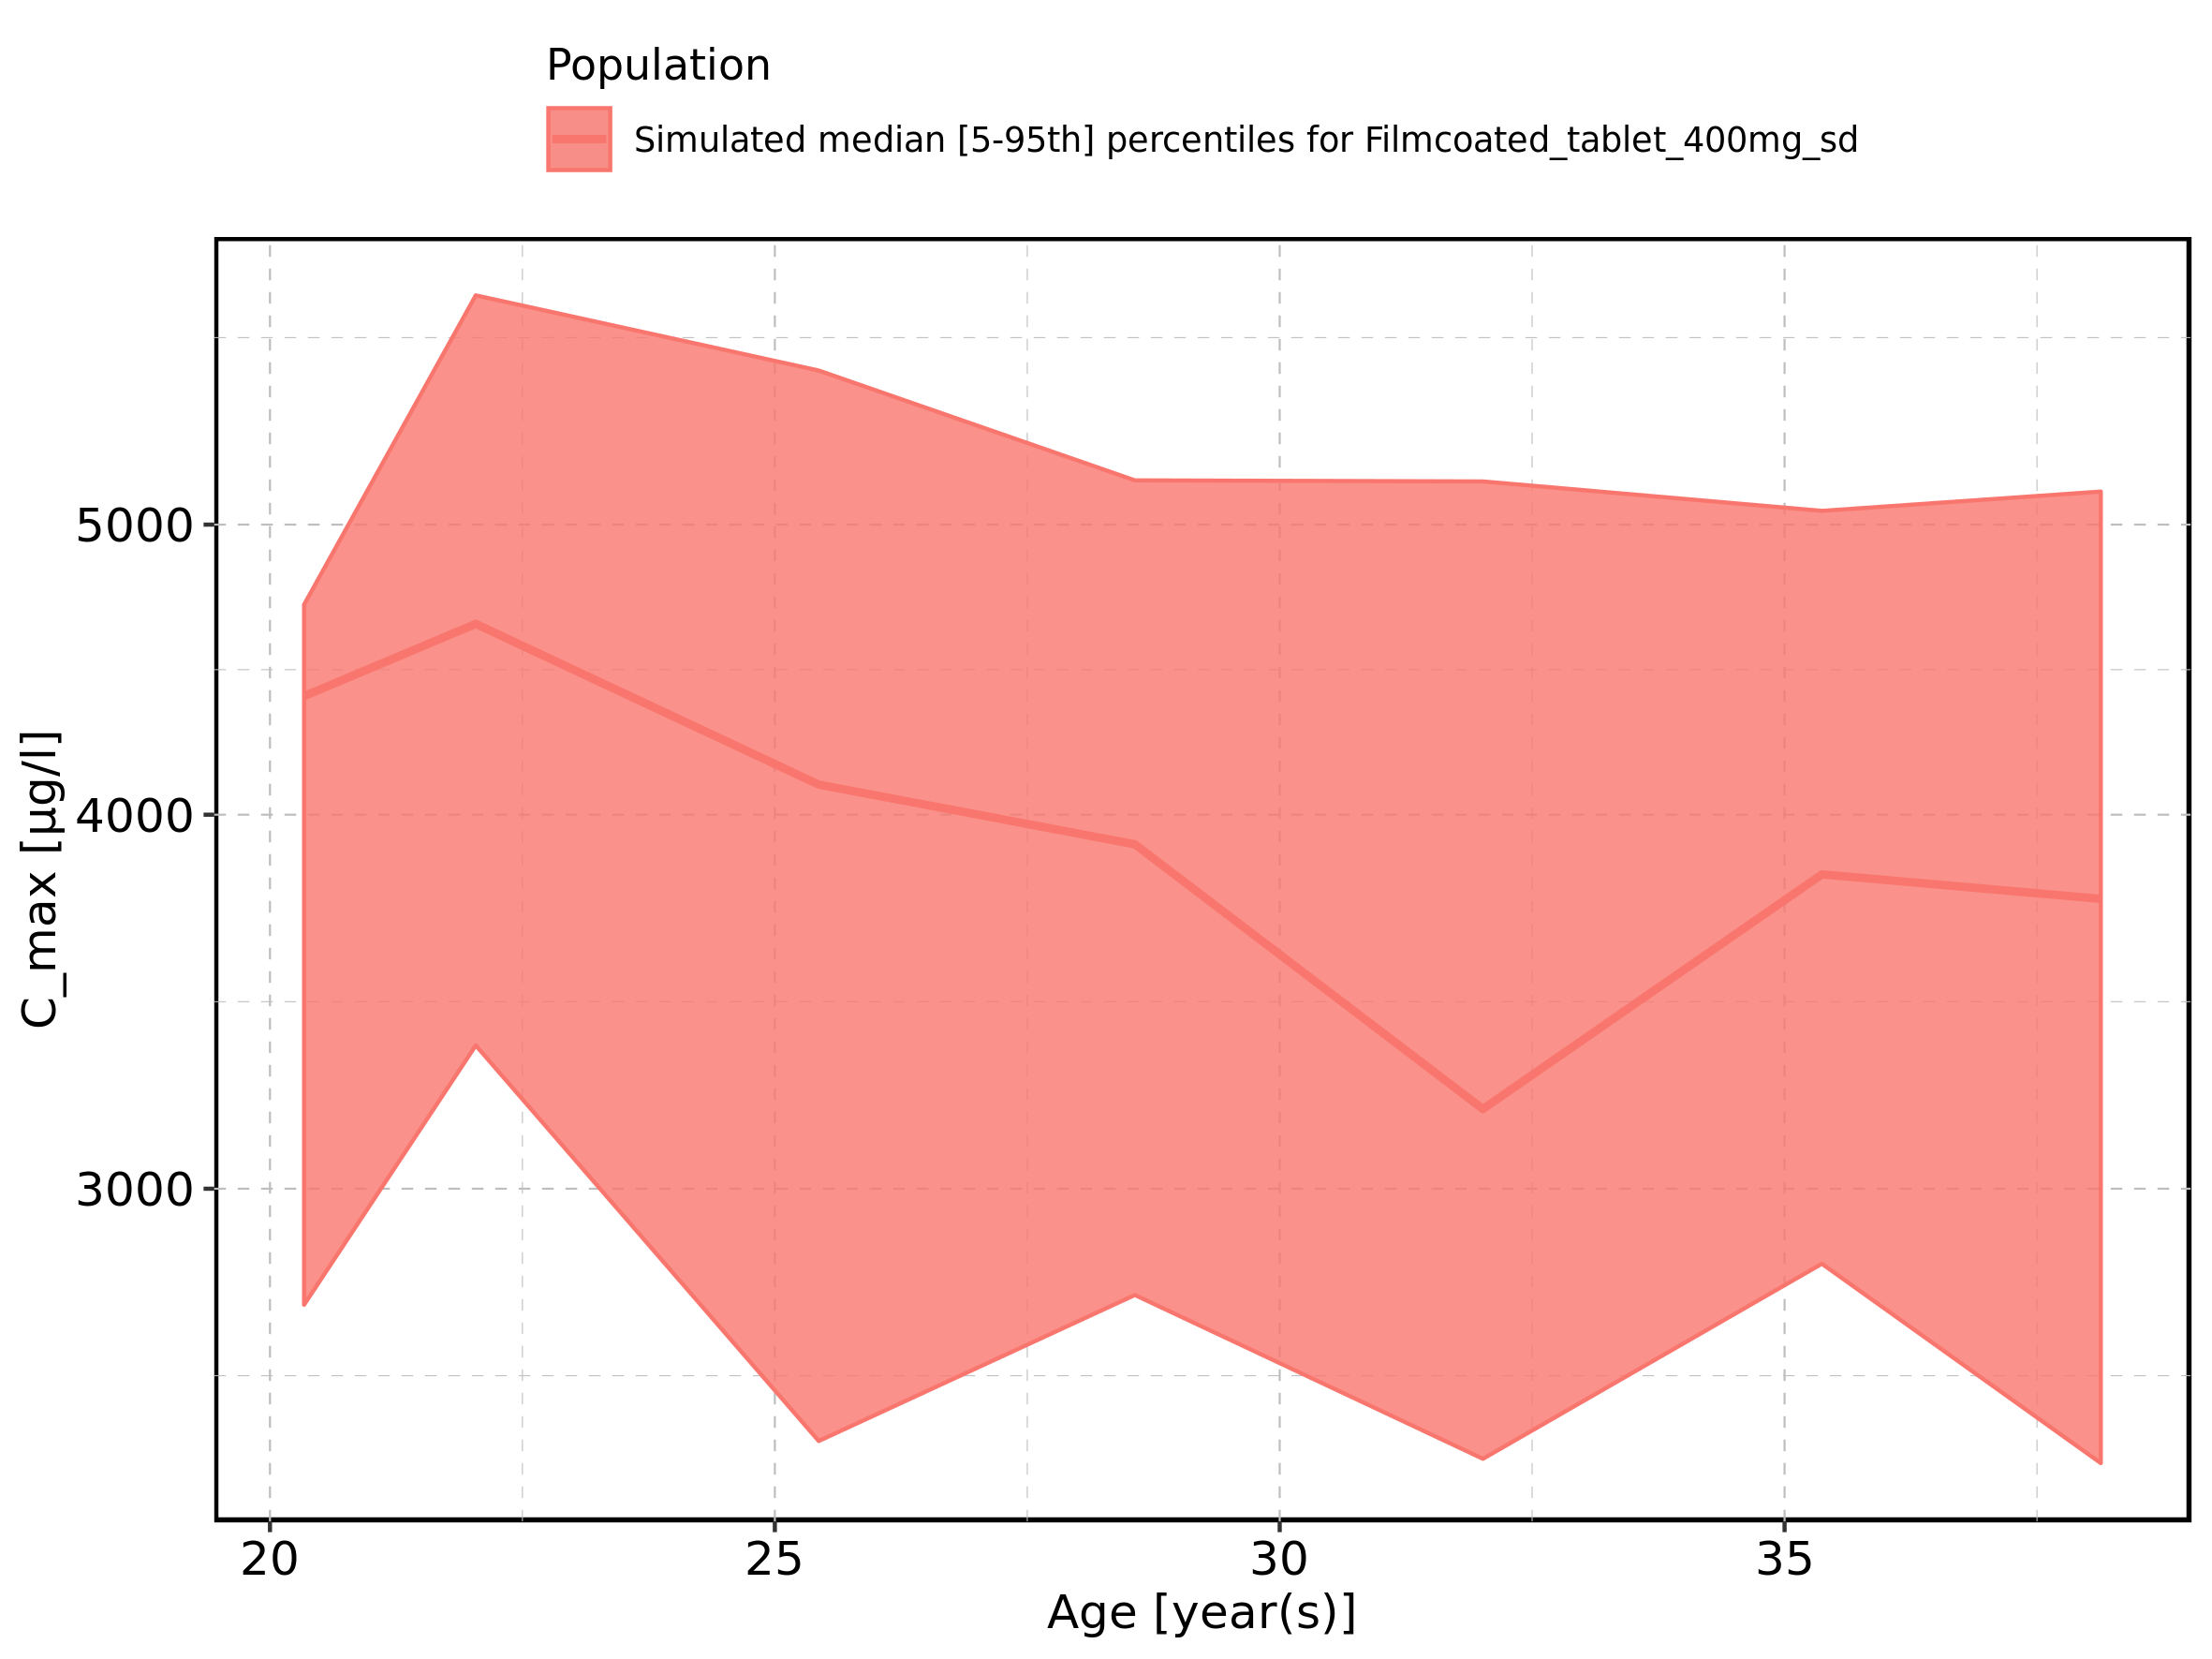

Figure 9: Height-dependence of C_max for Larson 2013 8y-18y 400mg FCT meal in comparison to Filmcoated_tablet_400mg_sd. Profiles are plotted in a linear scale.

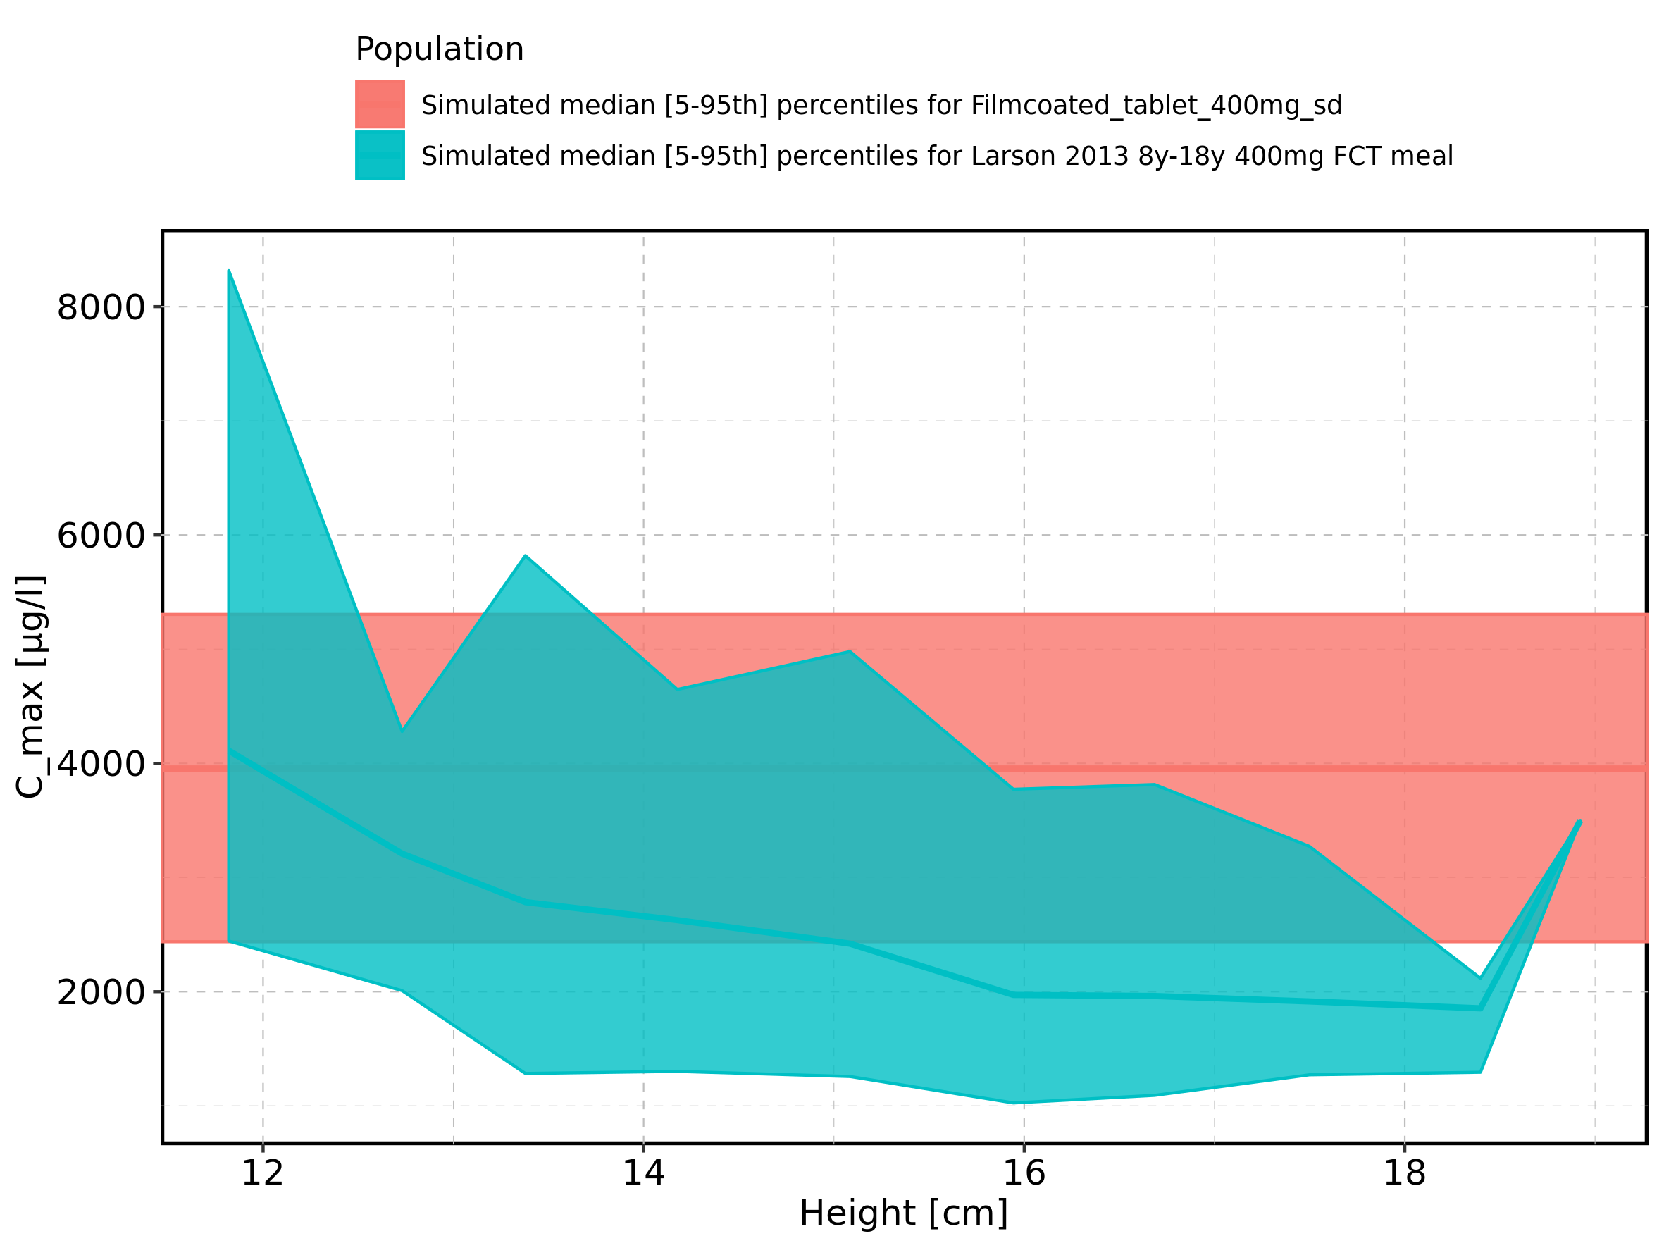

Figure 10: Height-dependence of C_max for Larson 2013 8y-18y 400mg FCT meal in comparison to Filmcoated_tablet_400mg_sd. Profiles are plotted in a logarithmic scale.

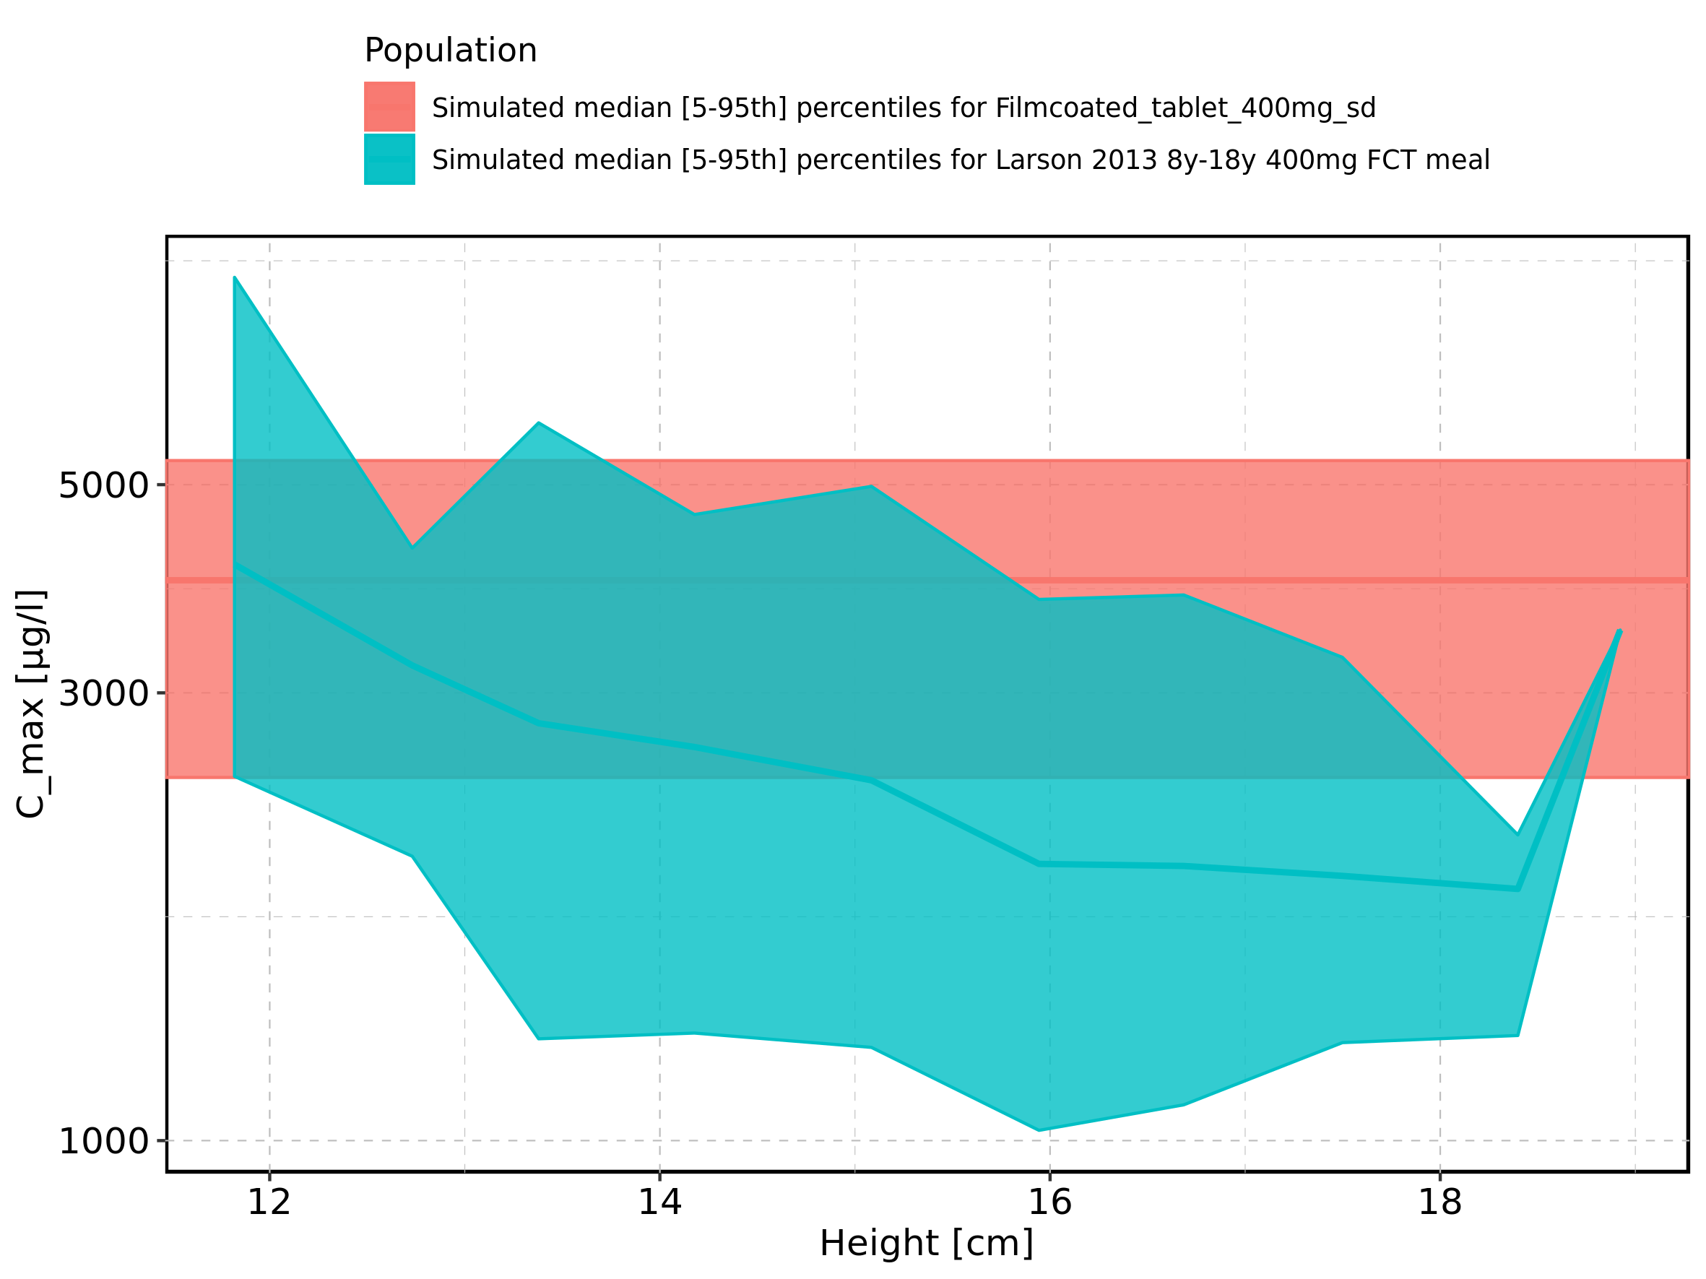

Figure 11: Height-dependence of C_max for Larson 2013 8y-18y 400mg FCT meal. Profiles are plotted in a linear scale.

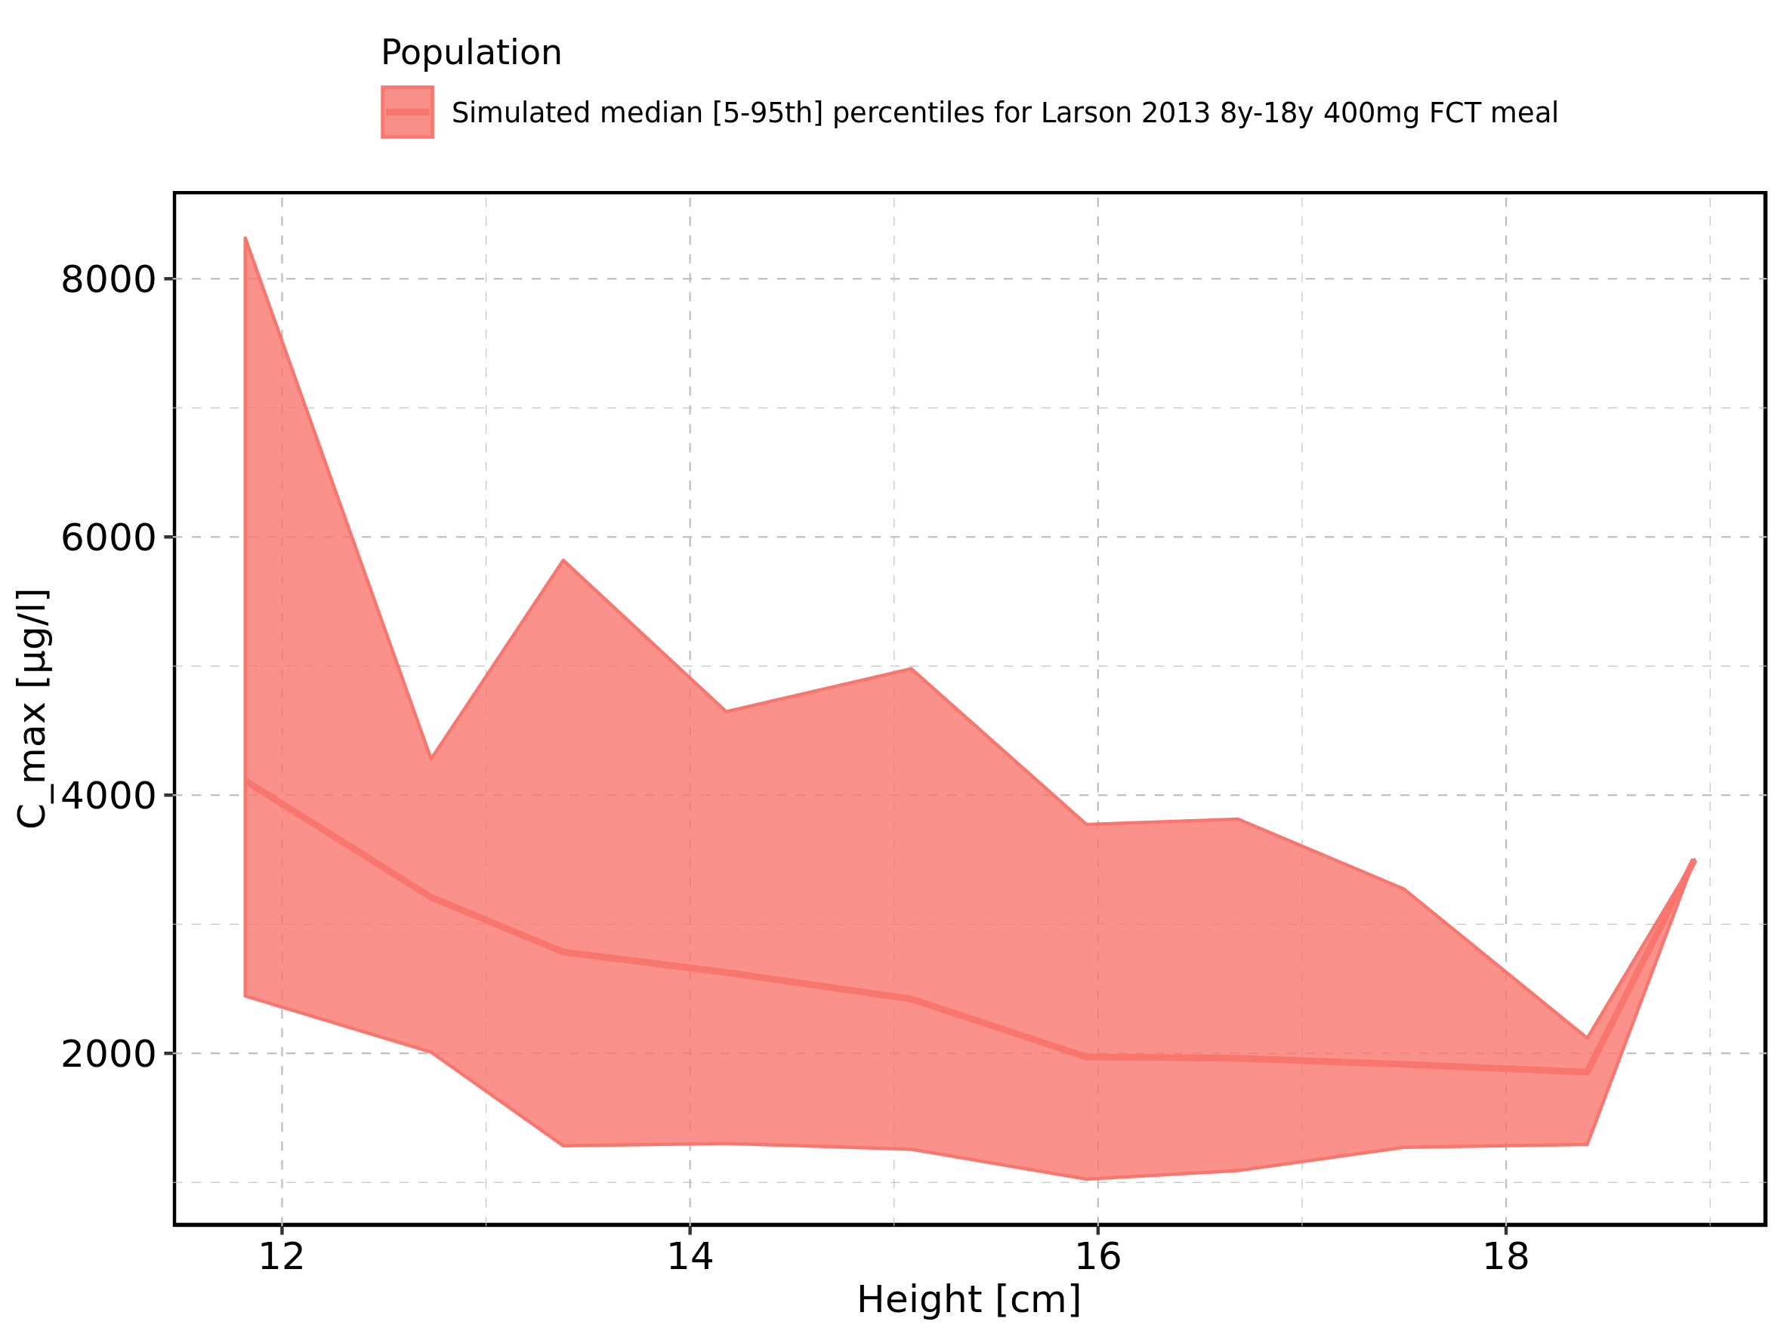

Figure 12: Height-dependence of C_max for Larson 2013 8y-18y 400mg FCT meal. Profiles are plotted in a logarithmic scale.

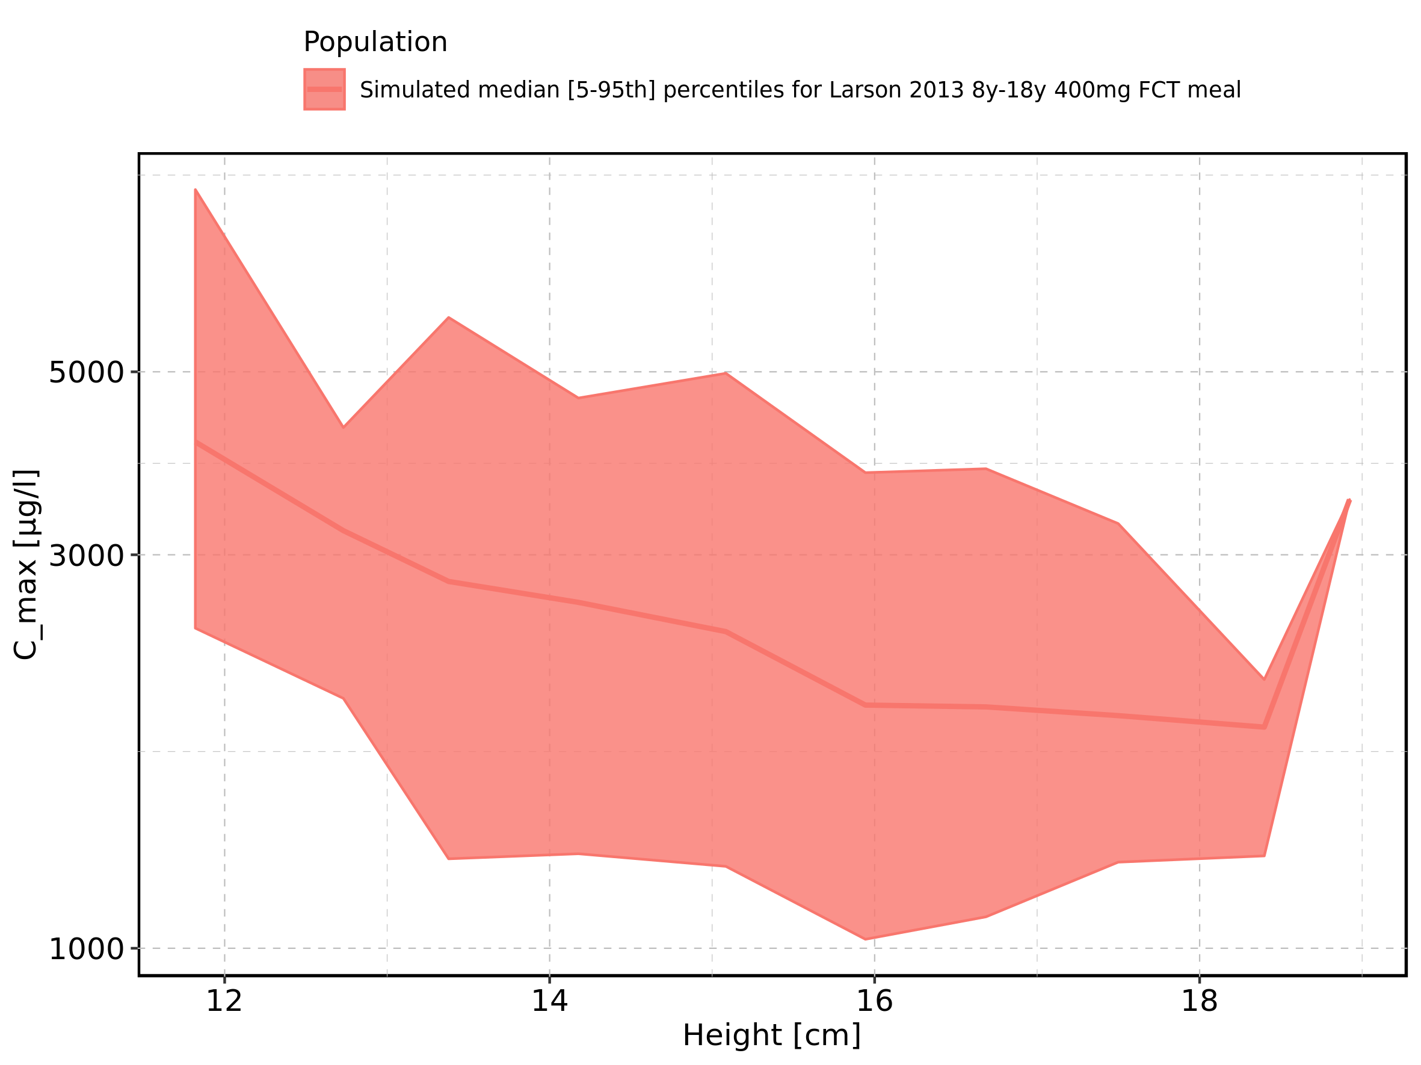

Figure 13: Height-dependence of C_max for Filmcoated_tablet_400mg_sd. Profiles are plotted in a linear scale.

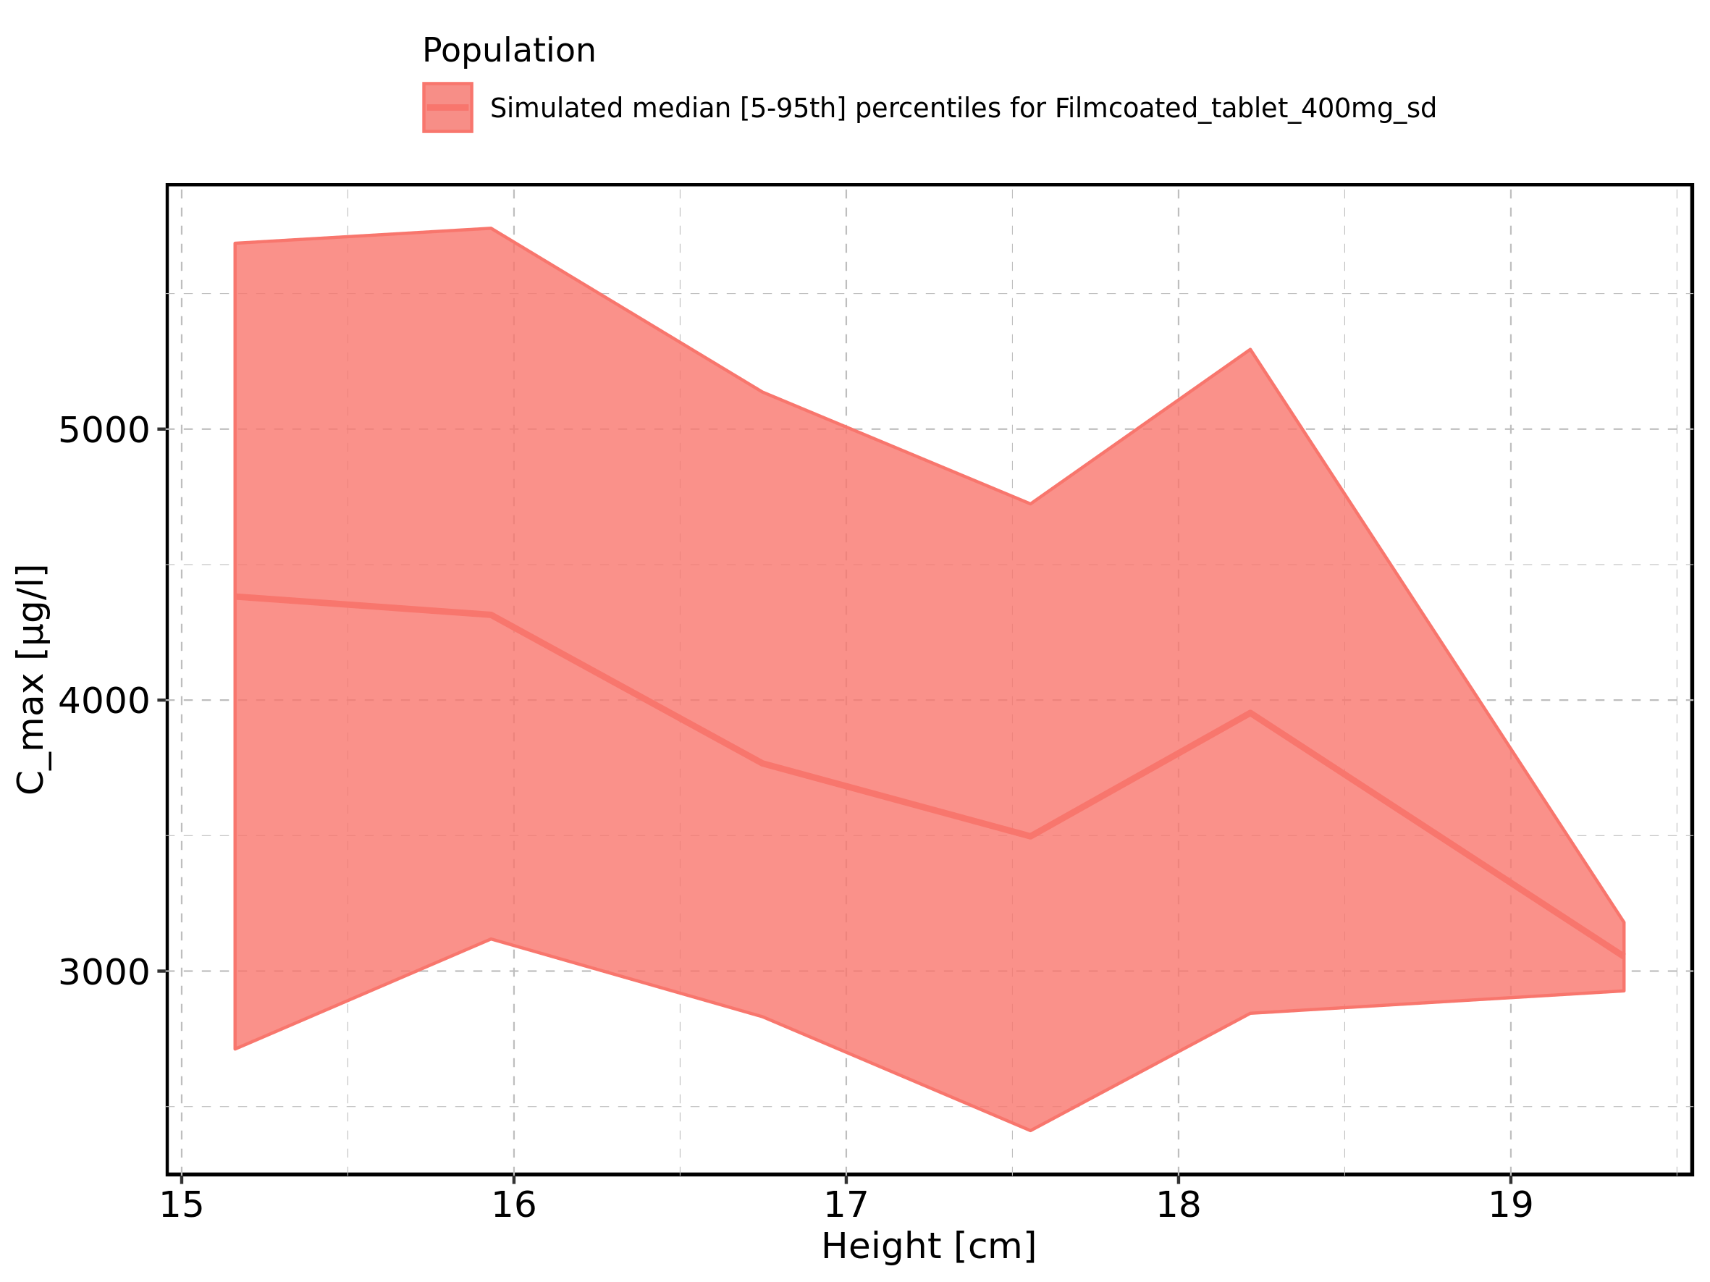

Figure 14: Height-dependence of C_max for Filmcoated_tablet_400mg_sd. Profiles are plotted in a logarithmic scale.

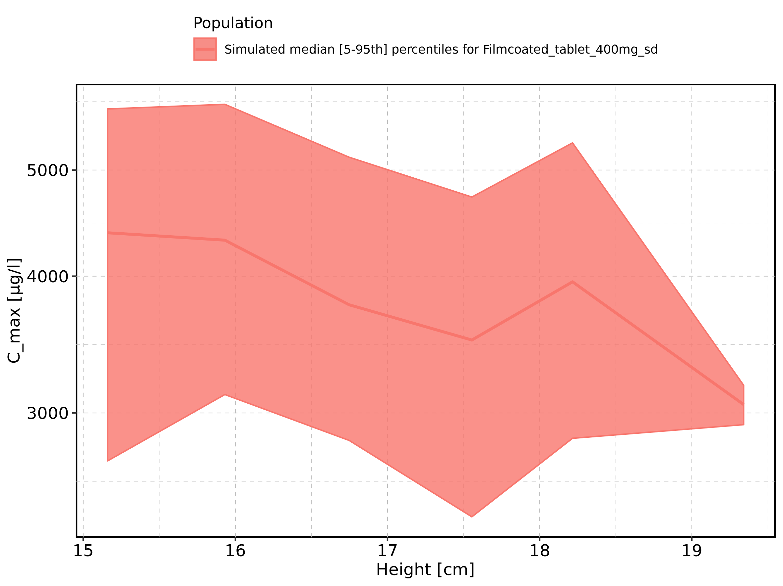

Figure 15: Weight-dependence of C_max for Larson 2013 8y-18y 400mg FCT meal in comparison to Filmcoated_tablet_400mg_sd. Profiles are plotted in a linear scale.

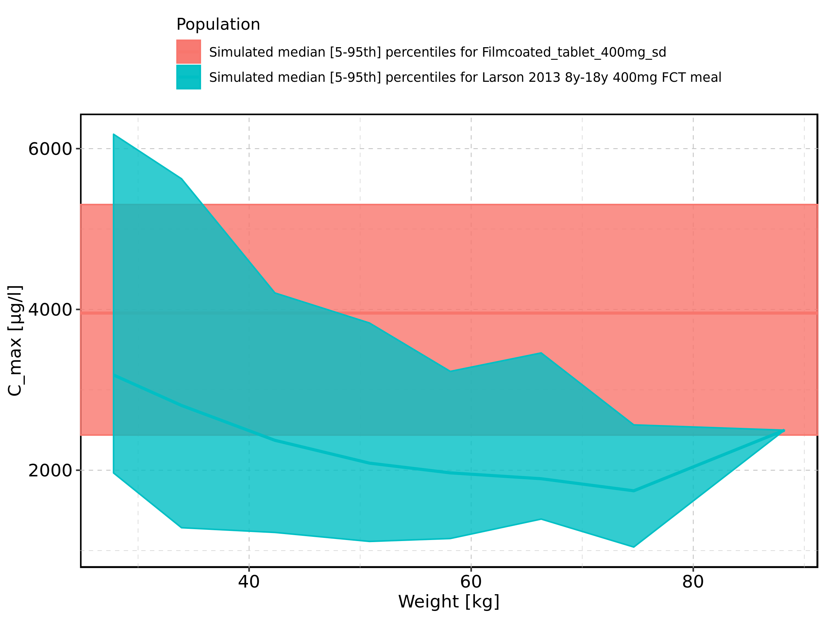

Figure 16: Weight-dependence of C_max for Larson 2013 8y-18y 400mg FCT meal in comparison to Filmcoated_tablet_400mg_sd. Profiles are plotted in a logarithmic scale.

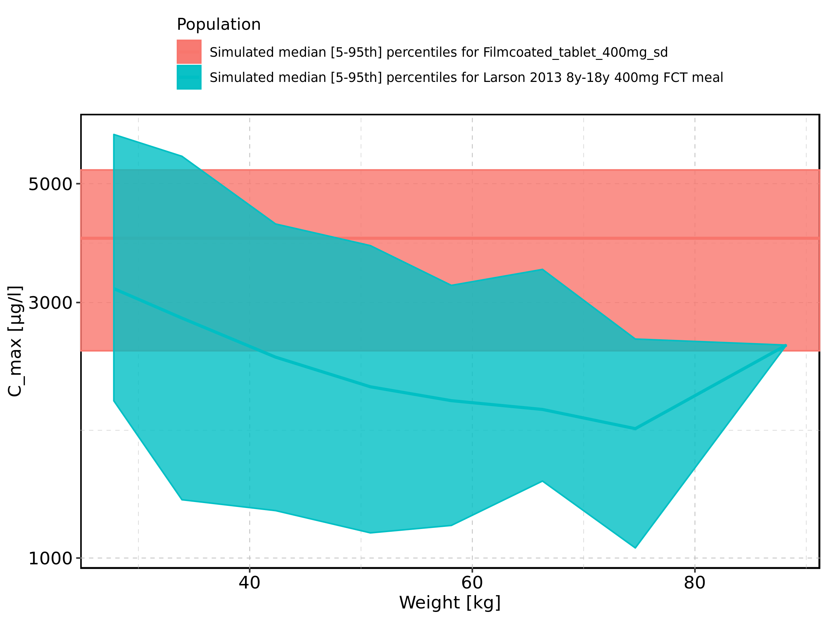

Figure 17: Weight-dependence of C_max for Larson 2013 8y-18y 400mg FCT meal. Profiles are plotted in a linear scale.

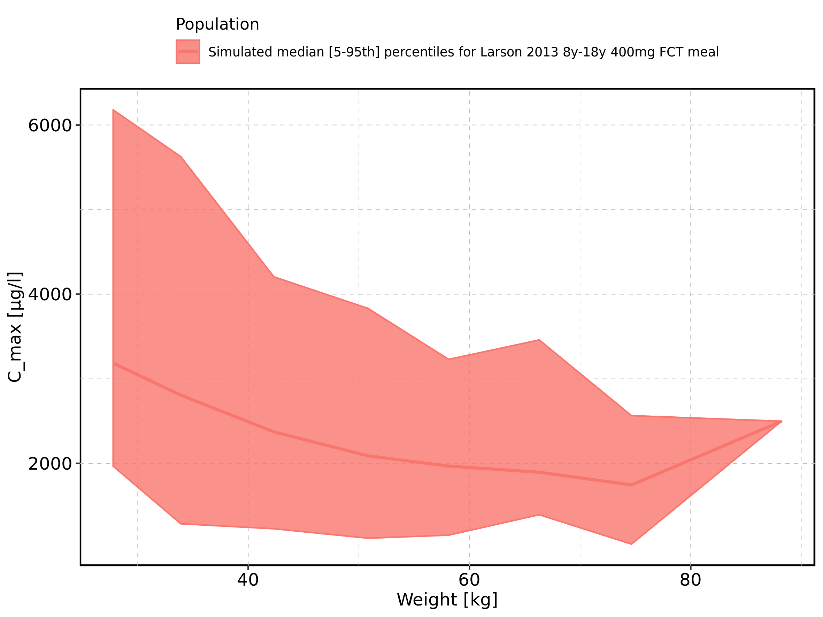

Figure 18: Weight-dependence of C_max for Larson 2013 8y-18y 400mg FCT meal. Profiles are plotted in a logarithmic scale.

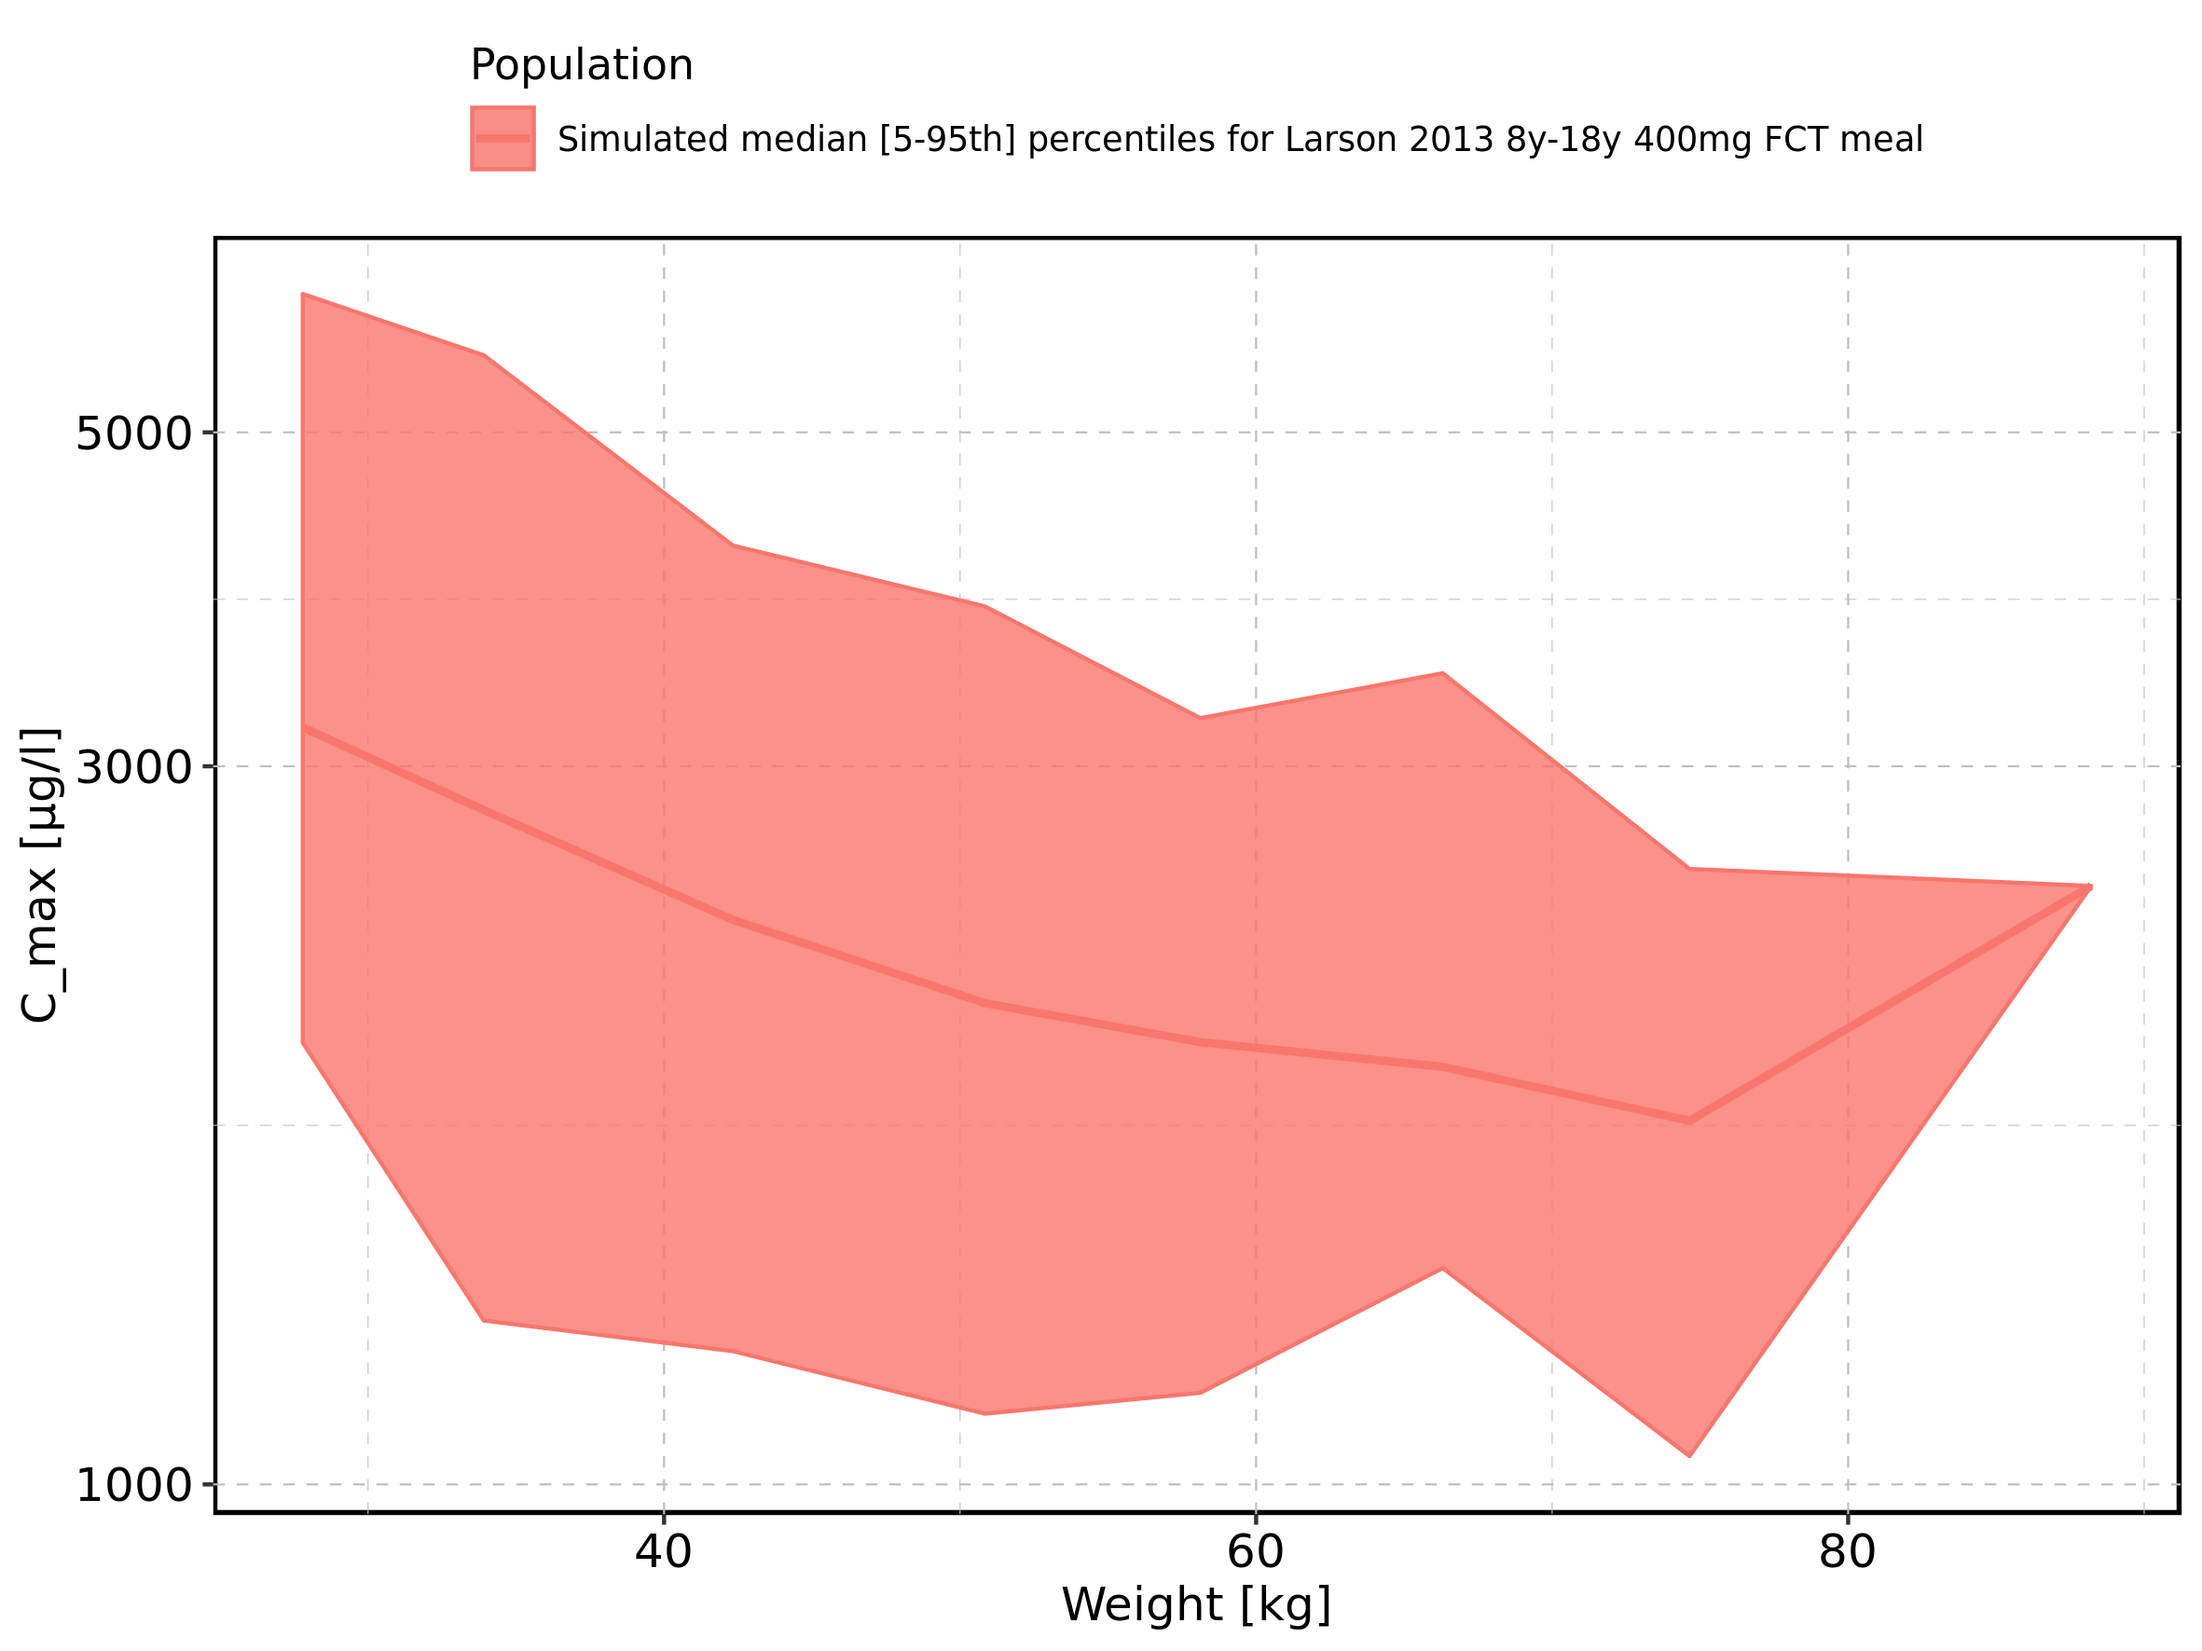

Figure 19: Weight-dependence of C_max for Filmcoated_tablet_400mg_sd. Profiles are plotted in a linear scale.

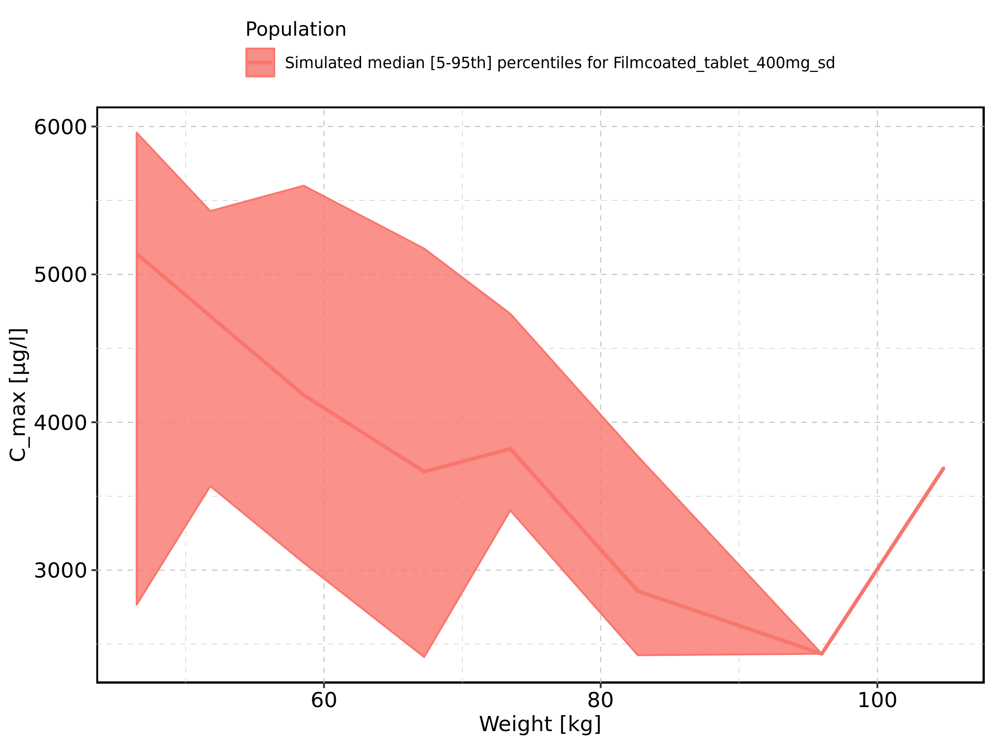

Figure 20: Weight-dependence of C_max for Filmcoated_tablet_400mg_sd. Profiles are plotted in a logarithmic scale.

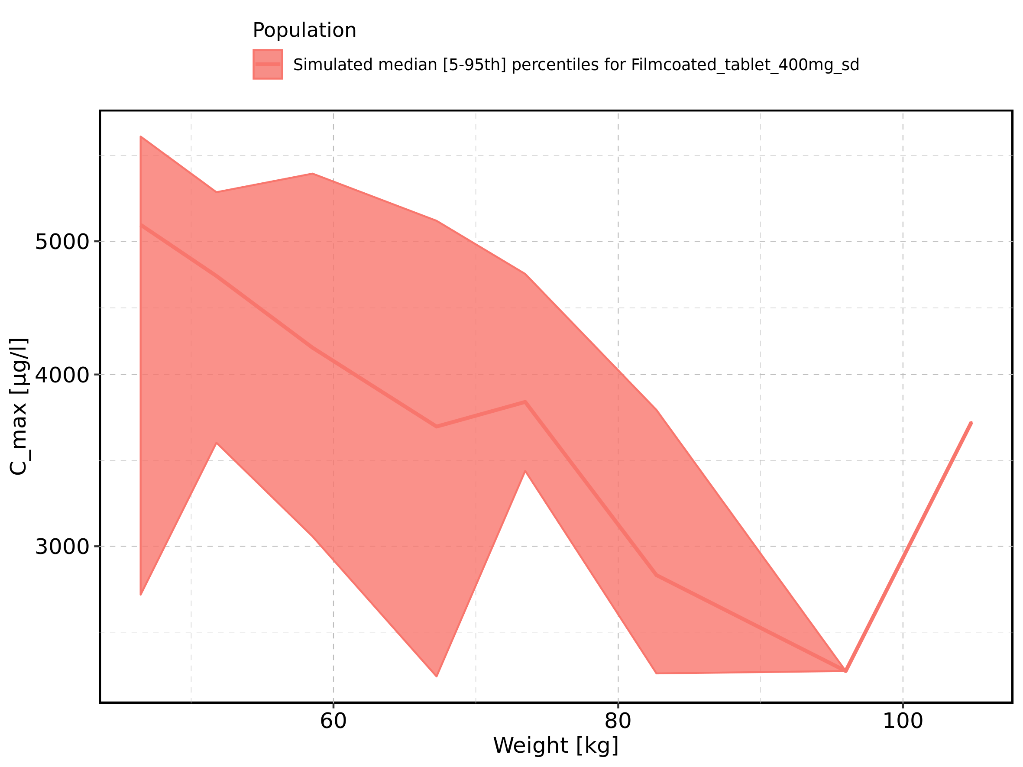

Figure 21: BMI-dependence of C_max for Larson 2013 8y-18y 400mg FCT meal in comparison to Filmcoated_tablet_400mg_sd. Profiles are plotted in a linear scale.

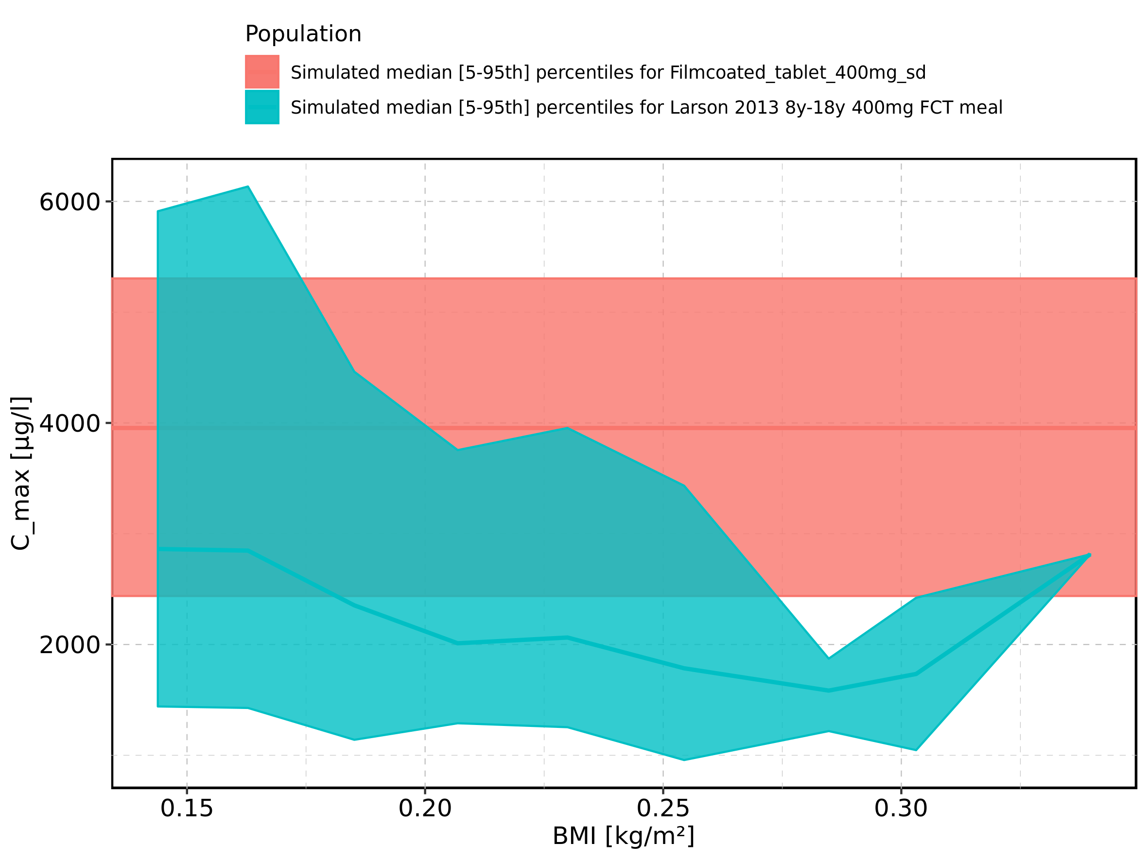

Figure 22: BMI-dependence of C_max for Larson 2013 8y-18y 400mg FCT meal in comparison to Filmcoated_tablet_400mg_sd. Profiles are plotted in a logarithmic scale.

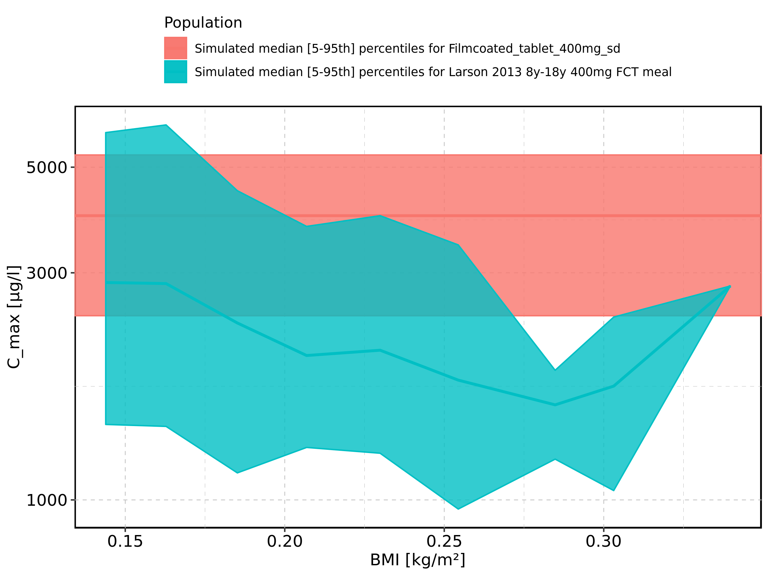

Figure 23: BMI-dependence of C_max for Larson 2013 8y-18y 400mg FCT meal. Profiles are plotted in a linear scale.

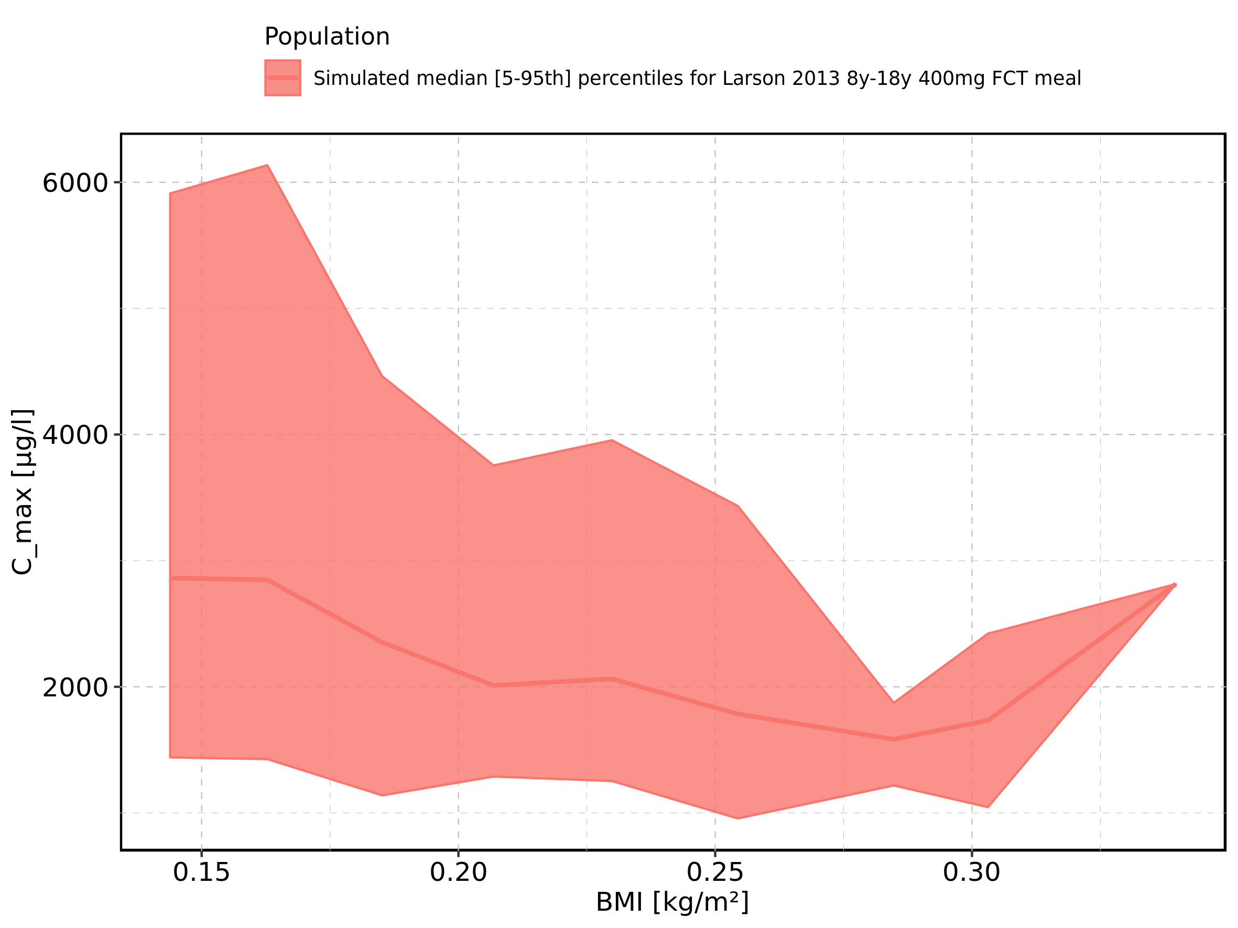

Figure 24: BMI-dependence of C_max for Larson 2013 8y-18y 400mg FCT meal. Profiles are plotted in a logarithmic scale.

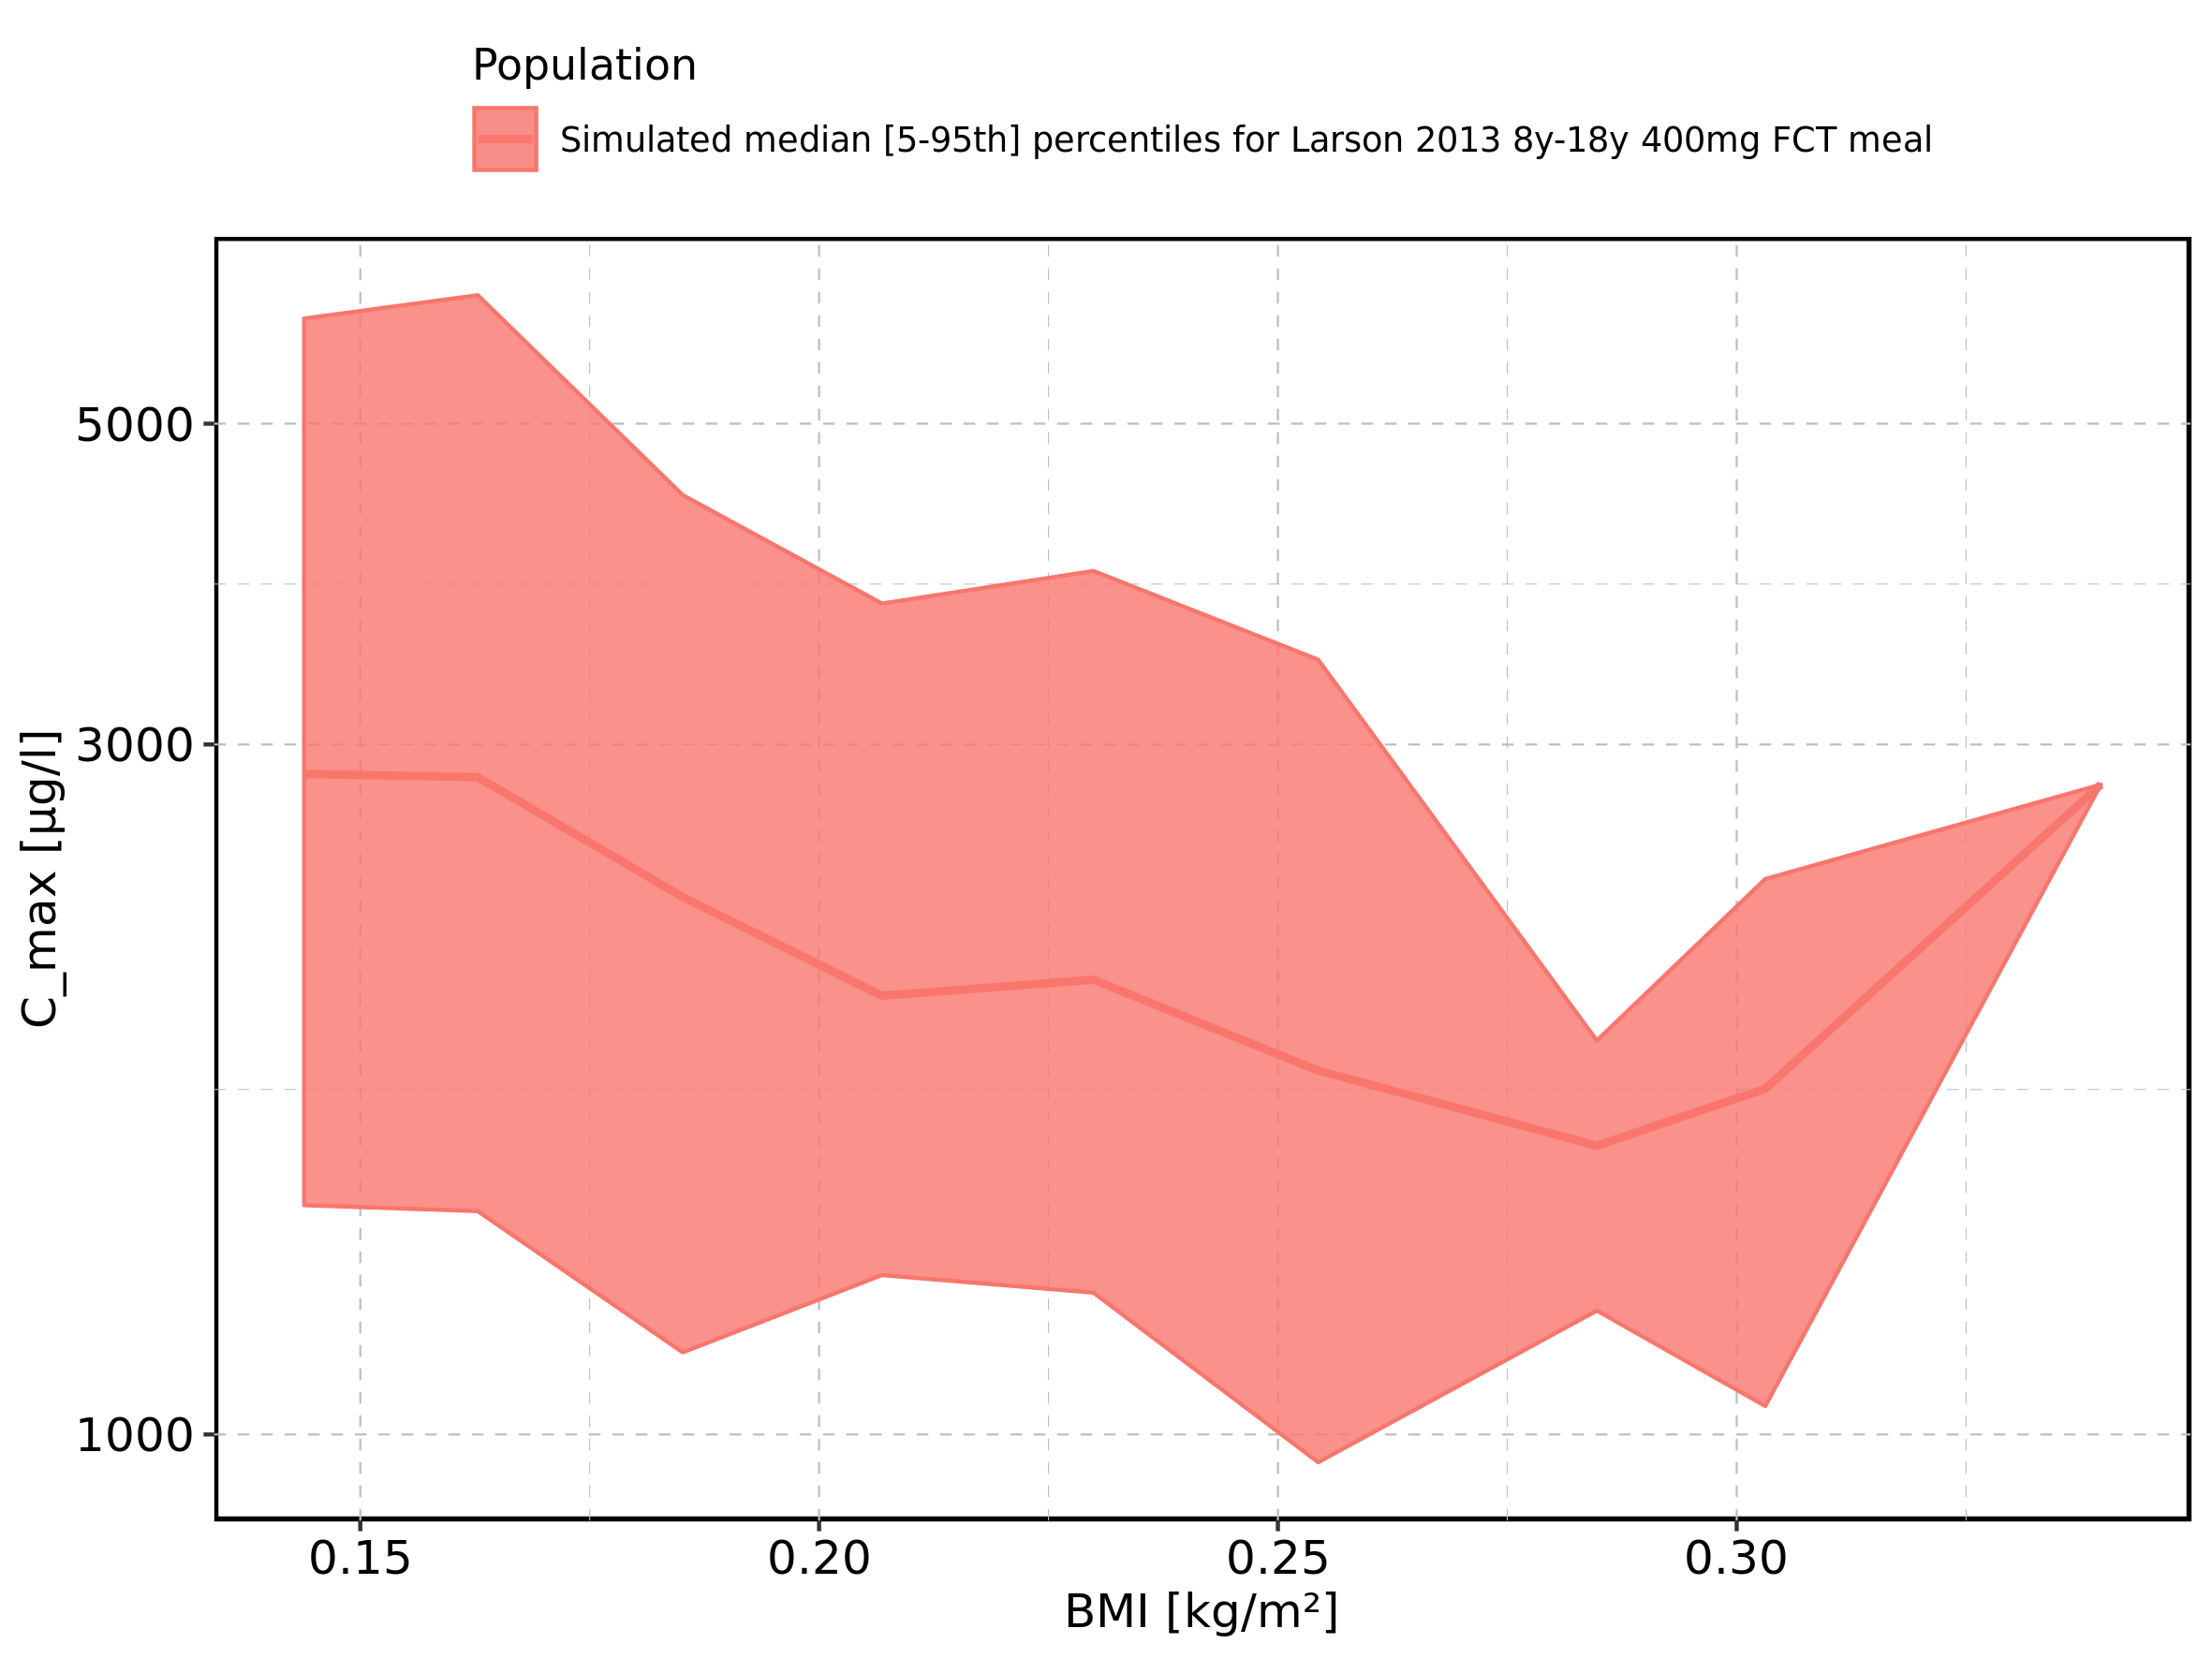

Figure 25: BMI-dependence of C_max for Filmcoated_tablet_400mg_sd. Profiles are plotted in a linear scale.

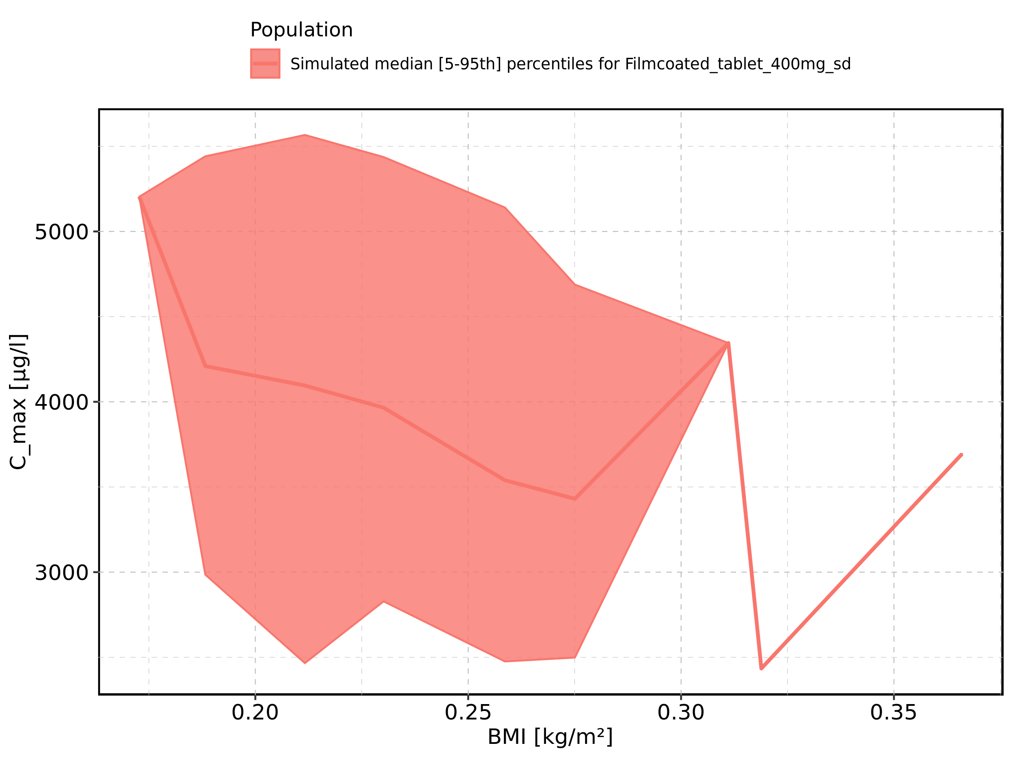

Figure 26: BMI-dependence of C_max for Filmcoated_tablet_400mg_sd. Profiles are plotted in a logarithmic scale.

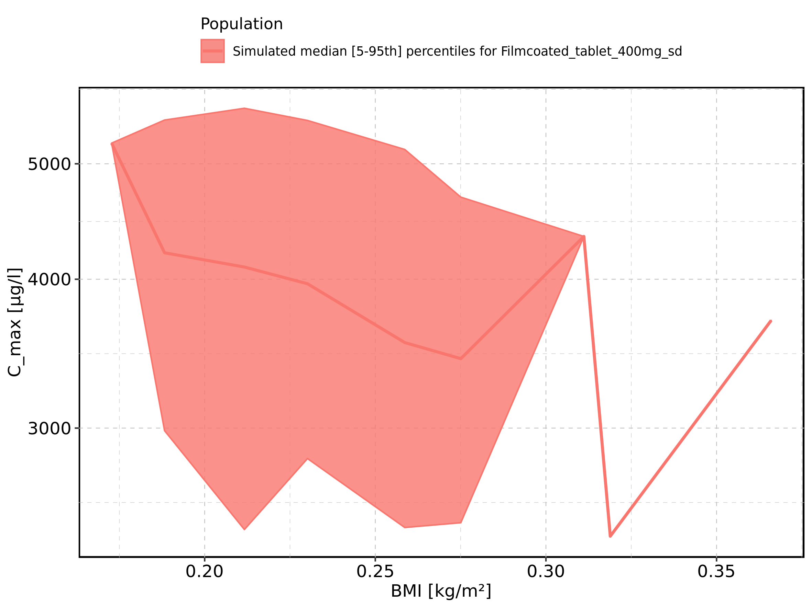

Figure 27: Gender-dependence of C_max for Larson 2013 8y-18y 400mg FCT meal in comparison to Filmcoated_tablet_400mg_sd. Profiles are plotted in a linear scale.

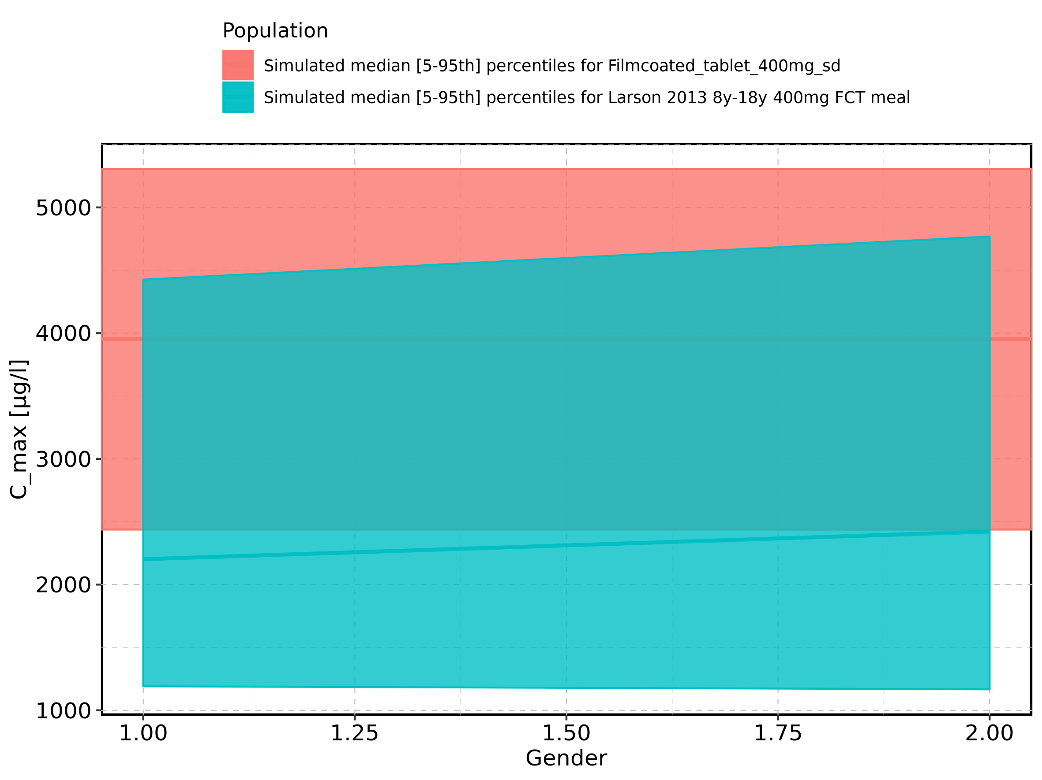

Figure 28: Gender-dependence of C_max for Larson 2013 8y-18y 400mg FCT meal in comparison to Filmcoated_tablet_400mg_sd. Profiles are plotted in a logarithmic scale.

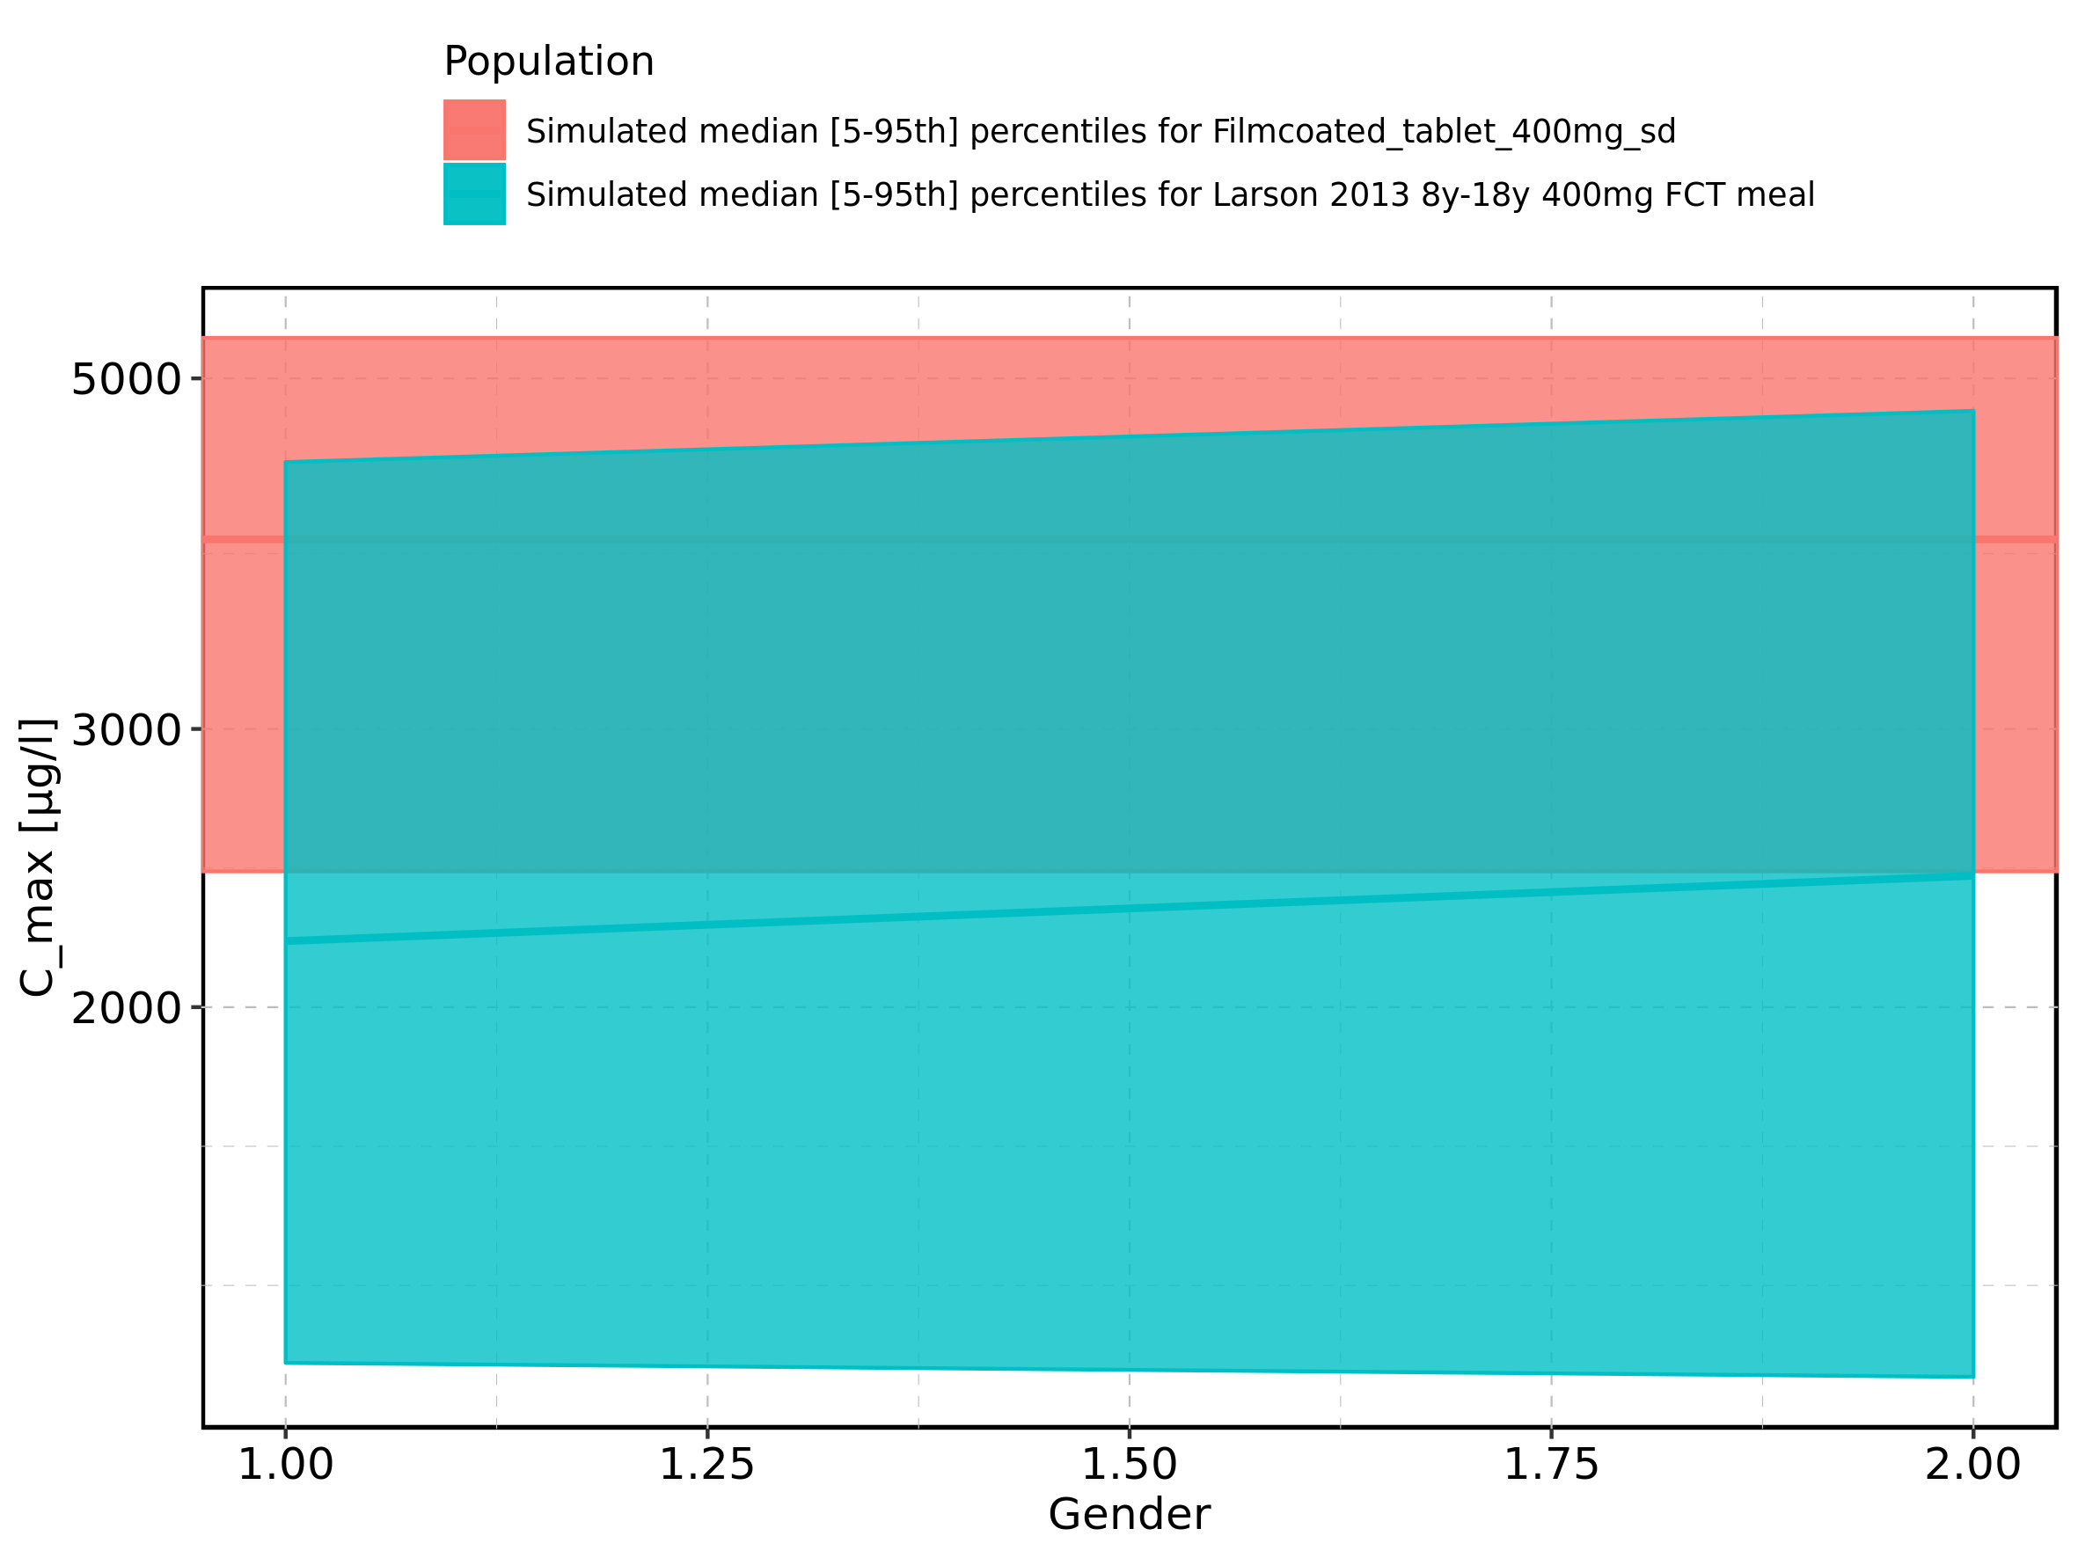

Figure 29: Gender-dependence of C_max for Larson 2013 8y-18y 400mg FCT meal. Profiles are plotted in a linear scale.

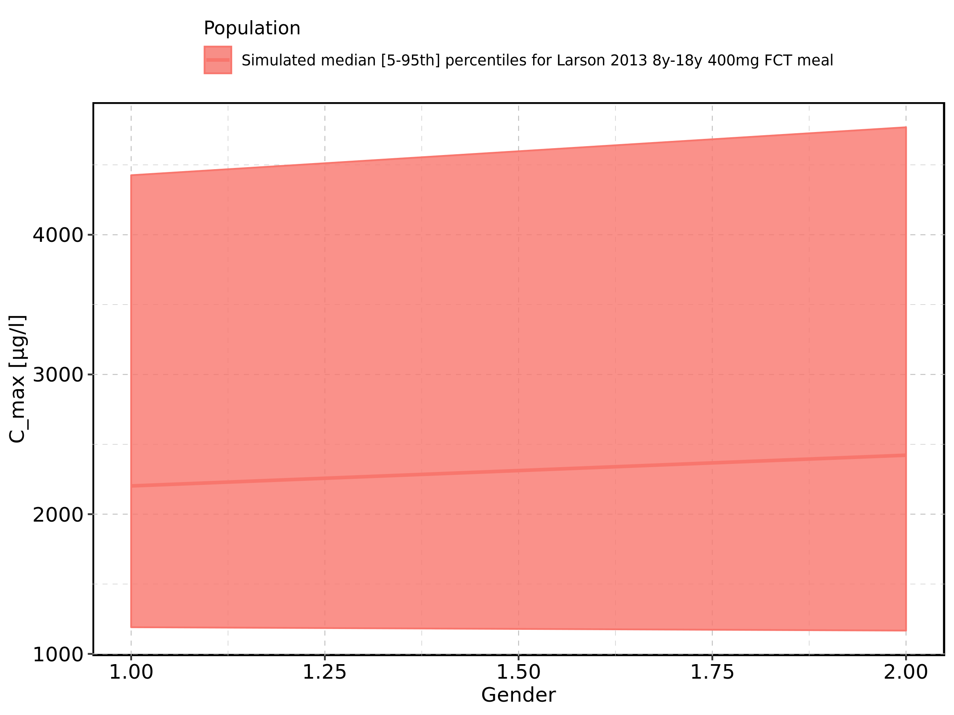

Figure 30: Gender-dependence of C_max for Larson 2013 8y-18y 400mg FCT meal. Profiles are plotted in a logarithmic scale.

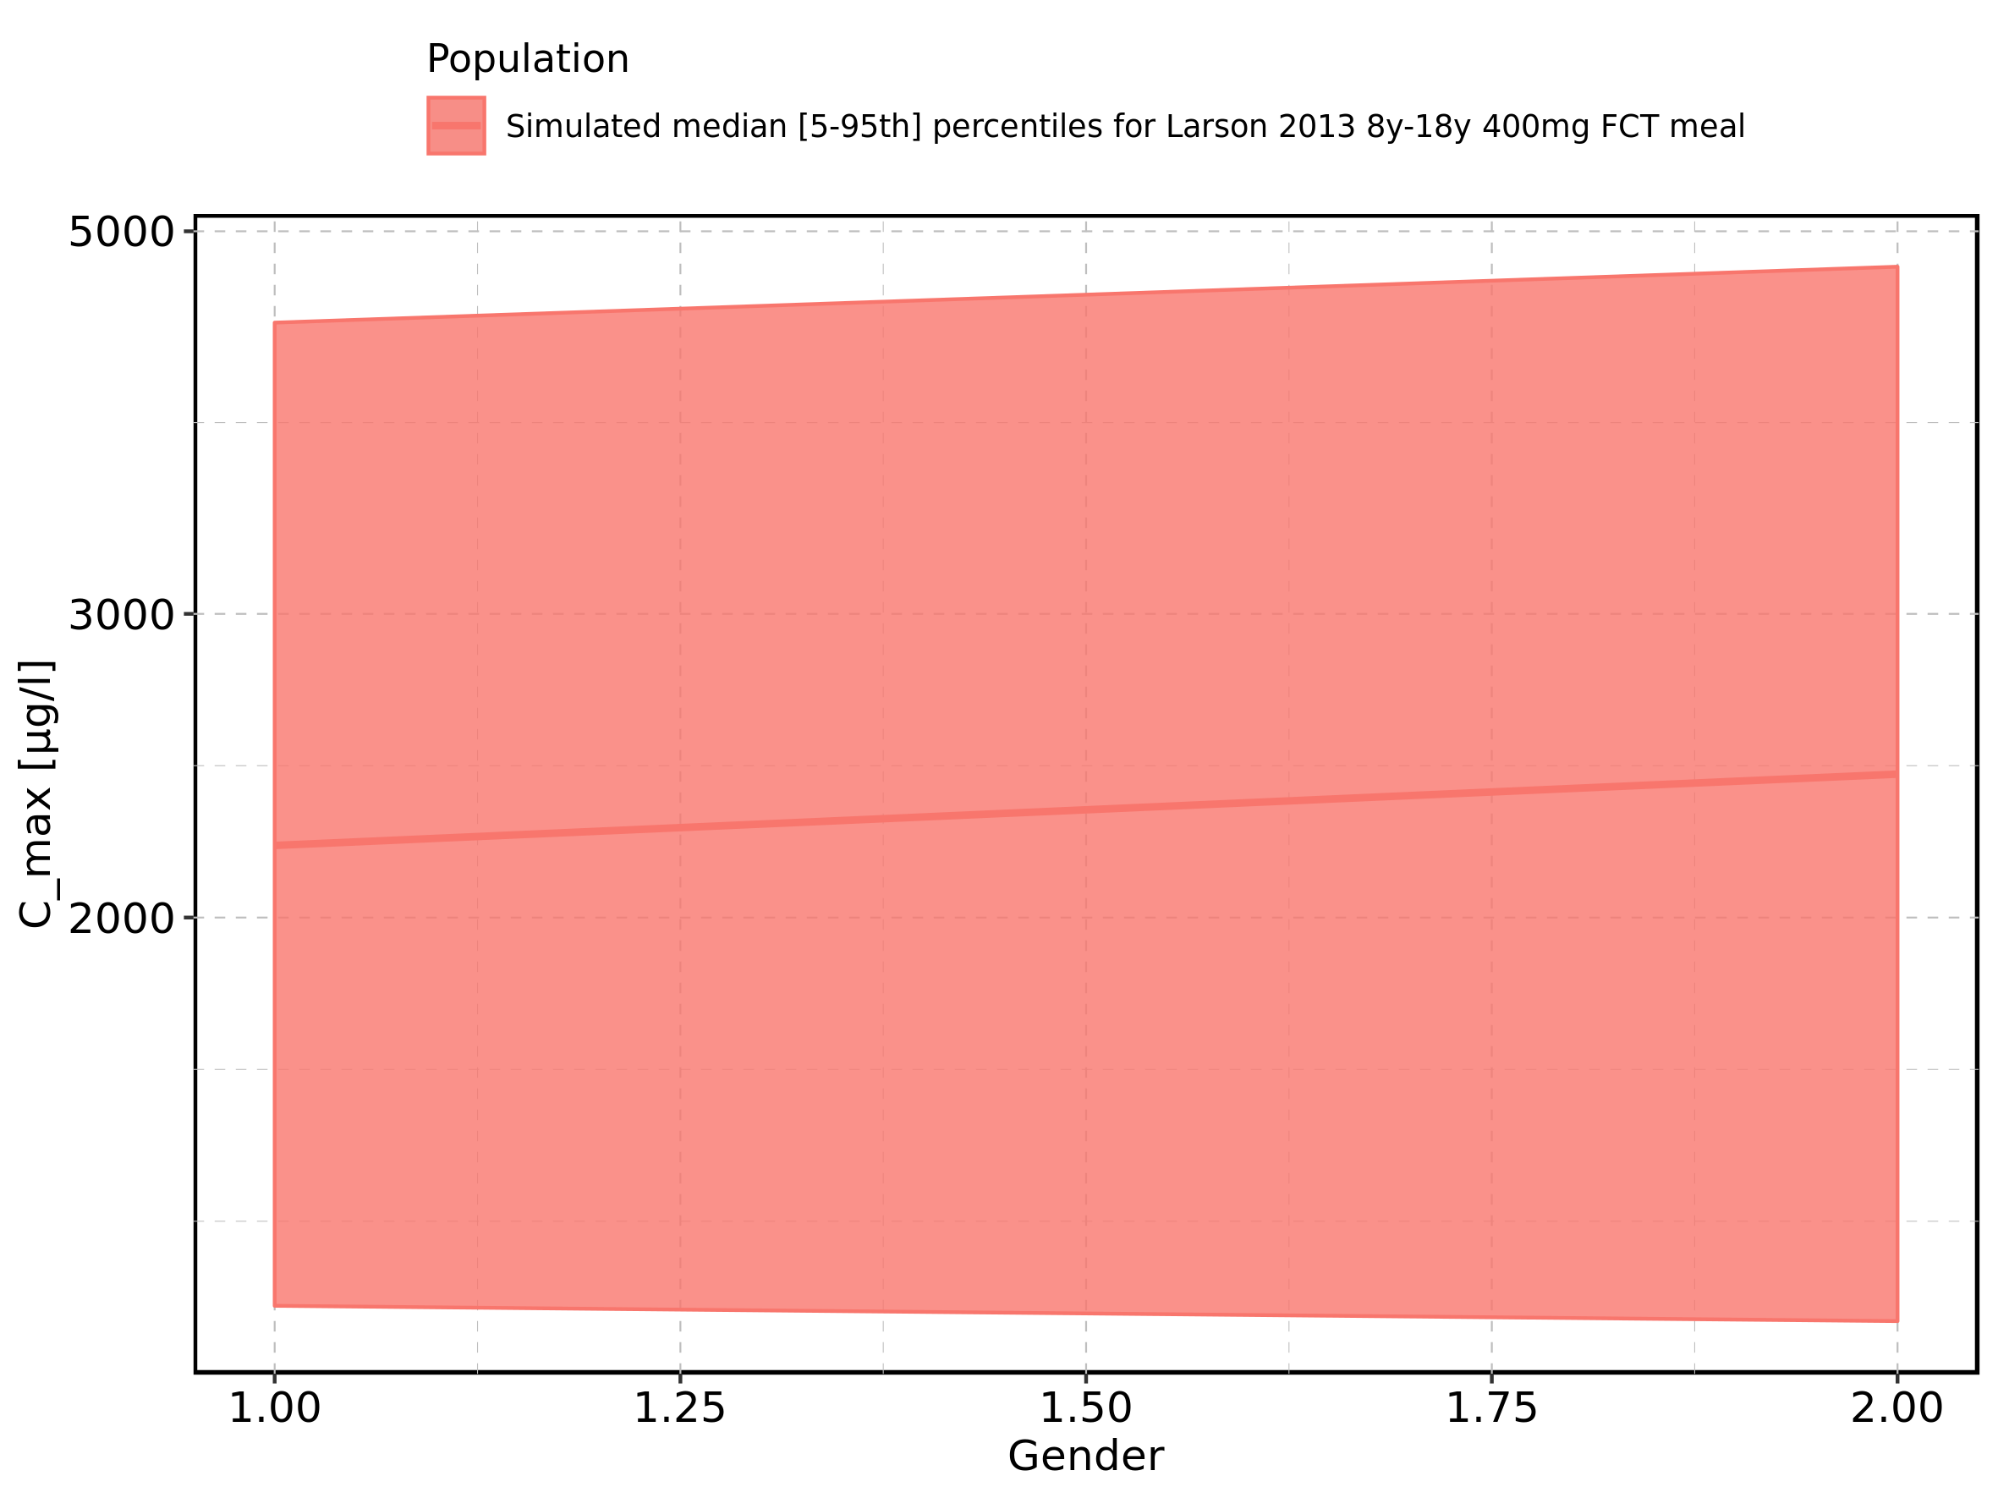

Figure 31: Gender-dependence of C_max for Filmcoated_tablet_400mg_sd. Profiles are plotted in a linear scale.

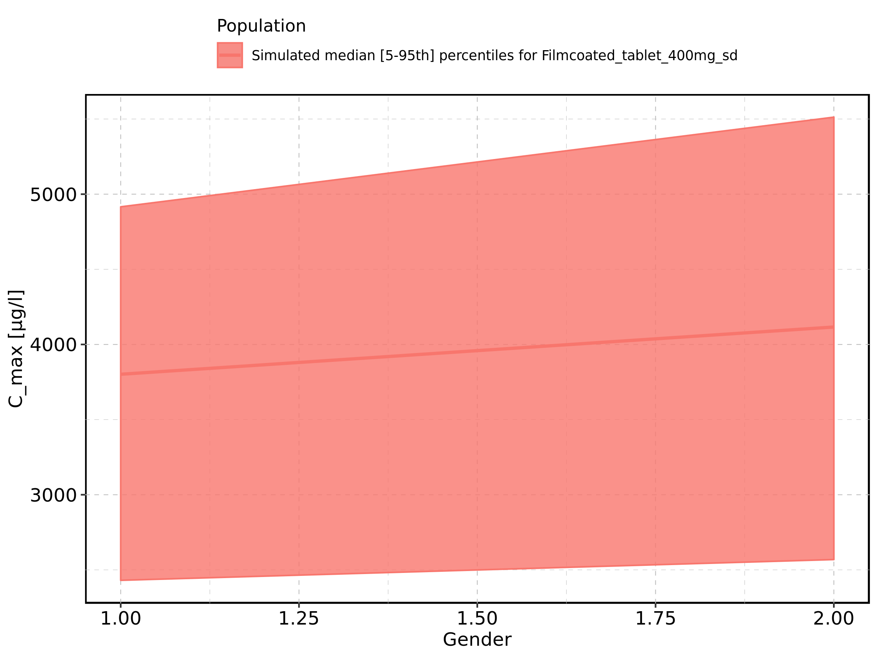

Figure 32: Gender-dependence of C_max for Filmcoated_tablet_400mg_sd. Profiles are plotted in a logarithmic scale.

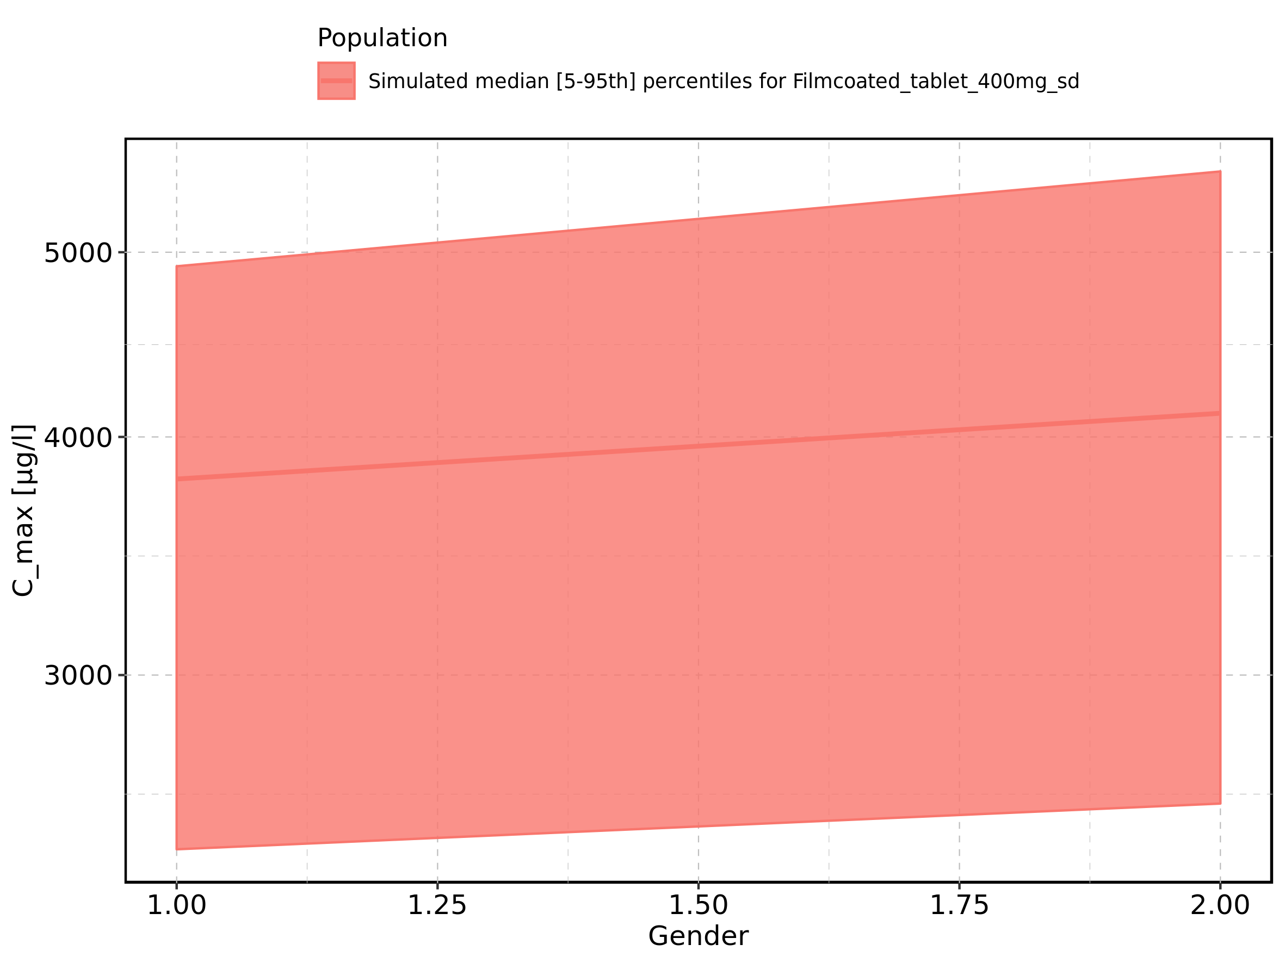

Figure 33: C_max_norm of Raltegravir shown as box-whisker plot, which indicates the 5th, 25th, 50th, 75th, and 95th percentiles in linear scale.

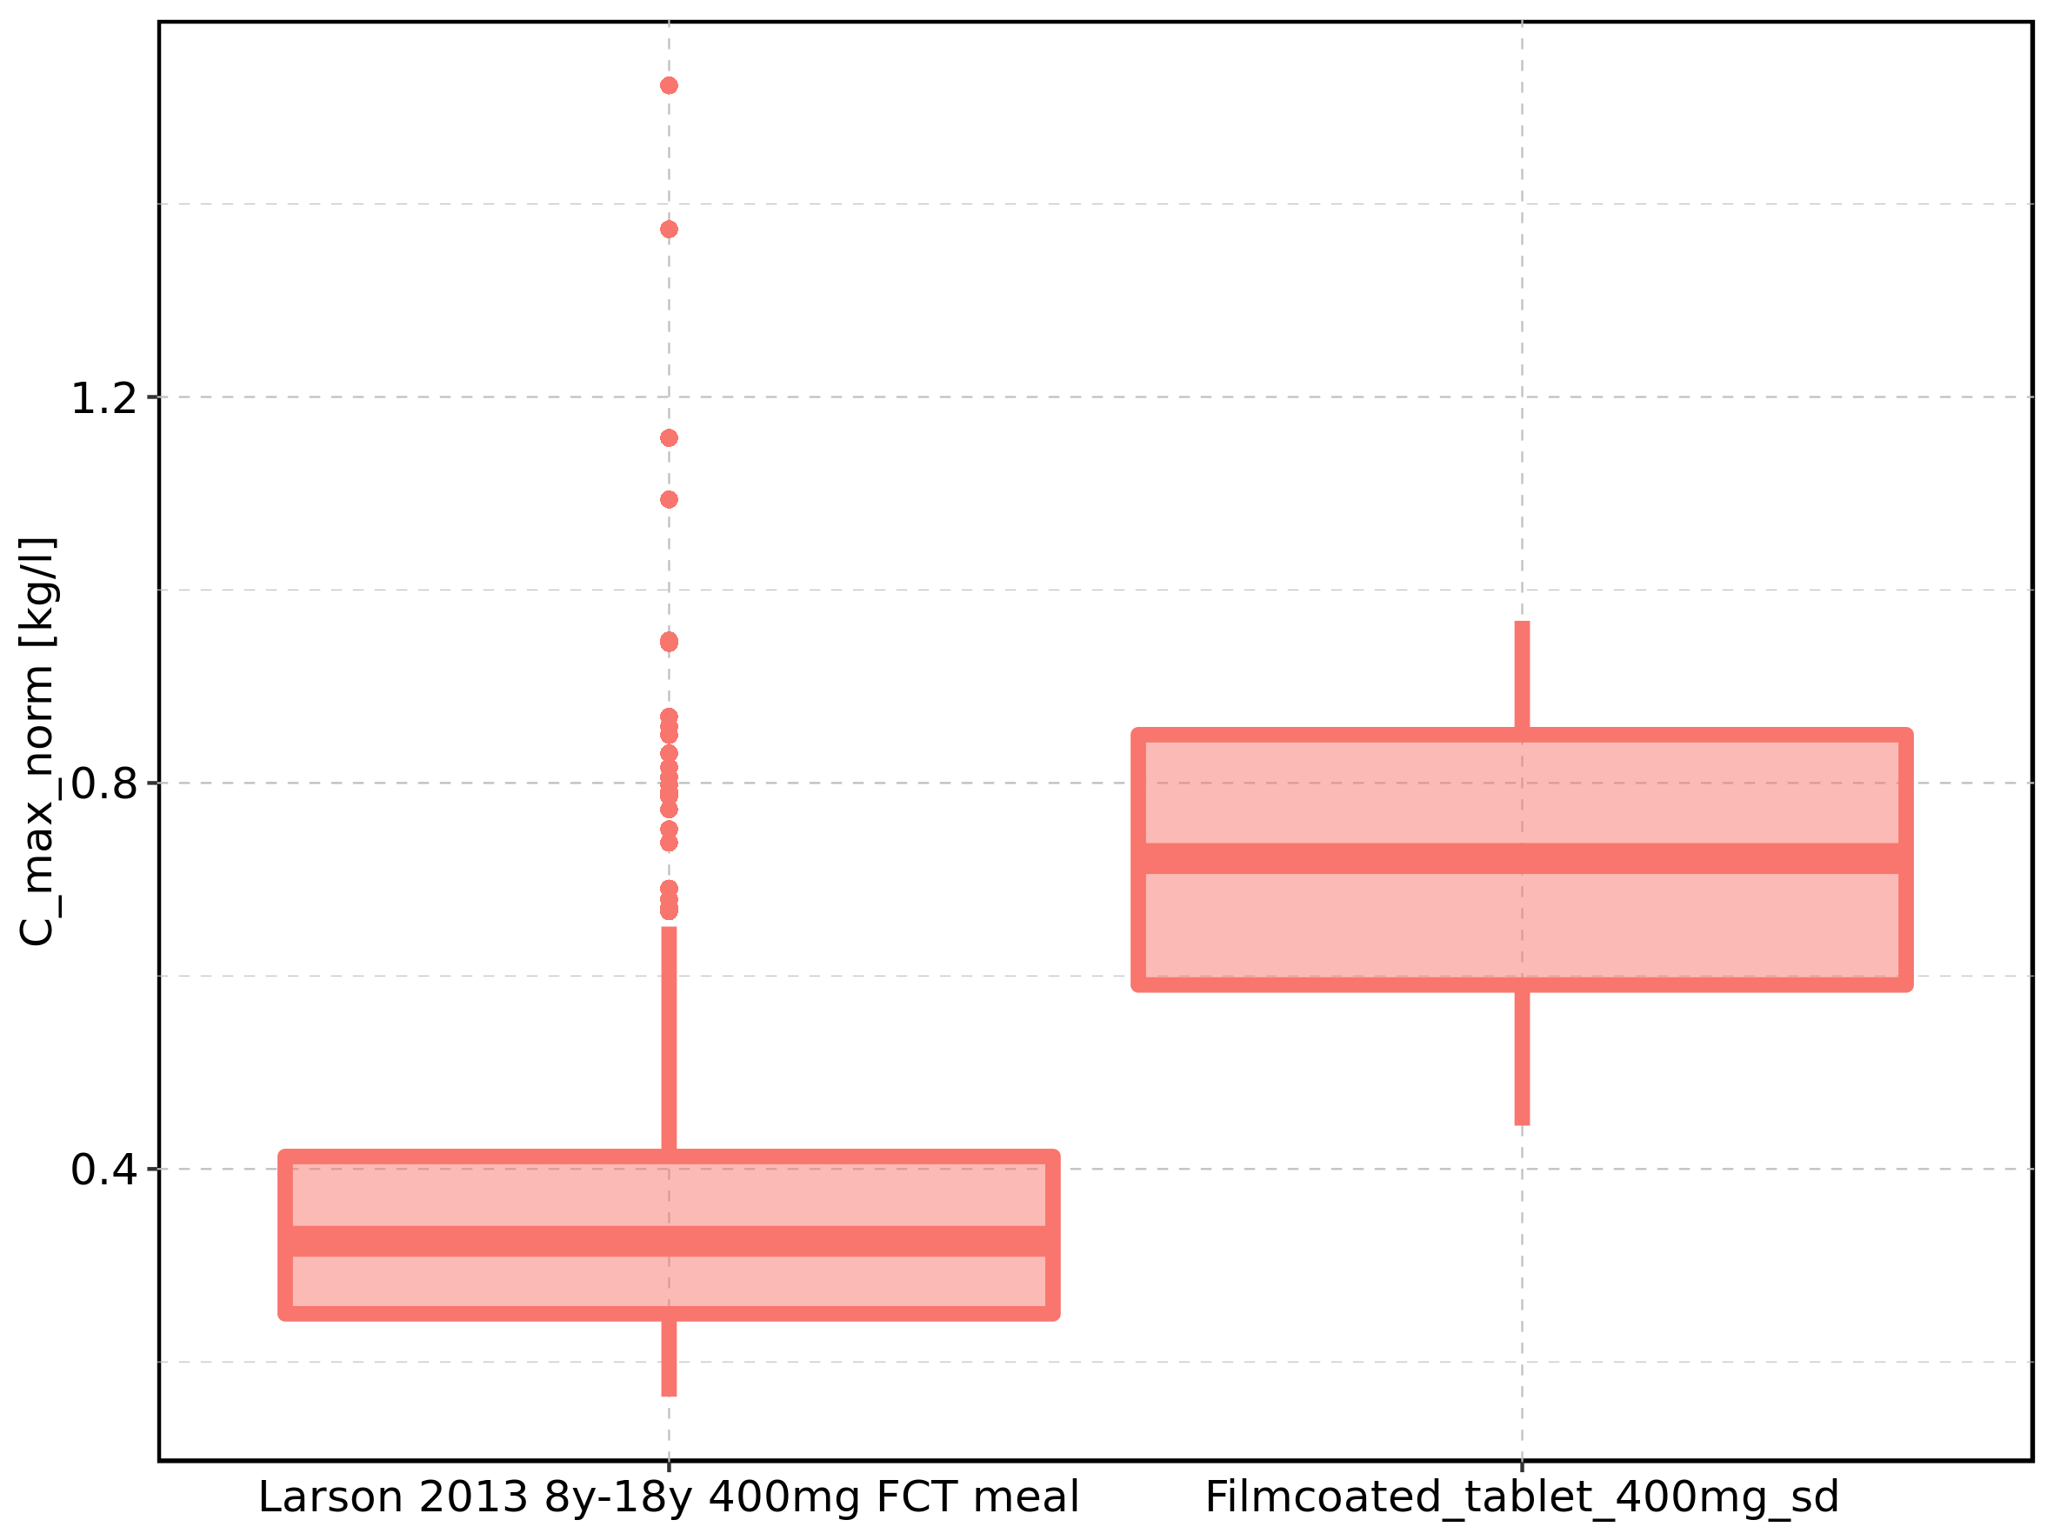

|  |  |  |  |  |  |  |  |  |  |  |
| --- | --- | --- | --- | --- | --- | --- | --- | --- | --- | --- |
| Population | N | 5th percentile | 25th percentile | 50th percentile | 75th percentile | 95th percentile | mean | standard deviation | geo mean | geo standard deviation |
| Larson 2013 8y-18y 400mg FCT meal | 500 | 0.1639770 | 0.2498922 | 0.3250172 | 0.4128938 | 0.6511956 | 0.3569764 | 0.1689641 | 0.3257618 | 1.523041 |
| Filmcoated_tablet_400mg_sd | 100 | 0.4448963 | 0.5906679 | 0.7217033 | 0.8500038 | 0.9680502 | 0.7192180 | 0.1658724 | 0.6996499 | 1.270937 |

Figure 34: C_max_norm of Raltegravir shown as box-whisker plot, which indicates the 5th, 25th, 50th, 75th, and 95th percentiles in logarithmic scale.

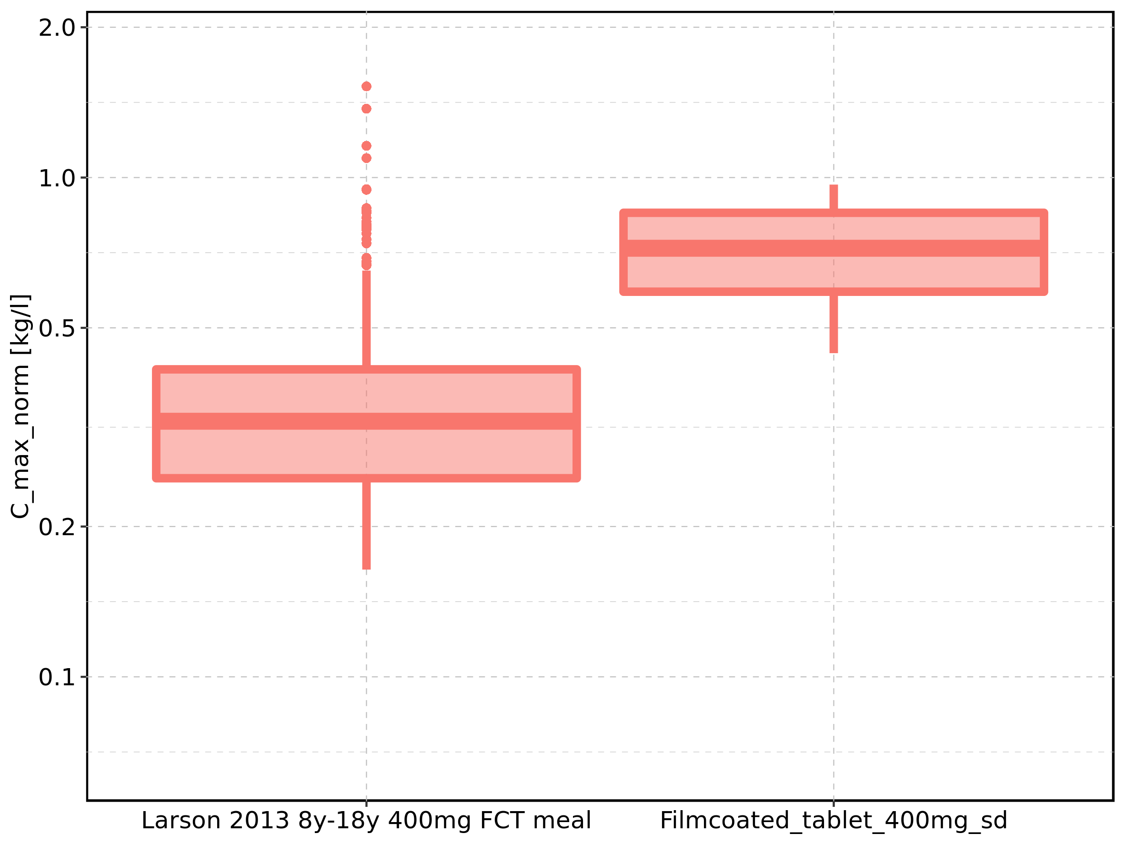

Figure 35: Age-dependence of C_max_norm for Larson 2013 8y-18y 400mg FCT meal in comparison to Filmcoated_tablet_400mg_sd. Profiles are plotted in a linear scale.

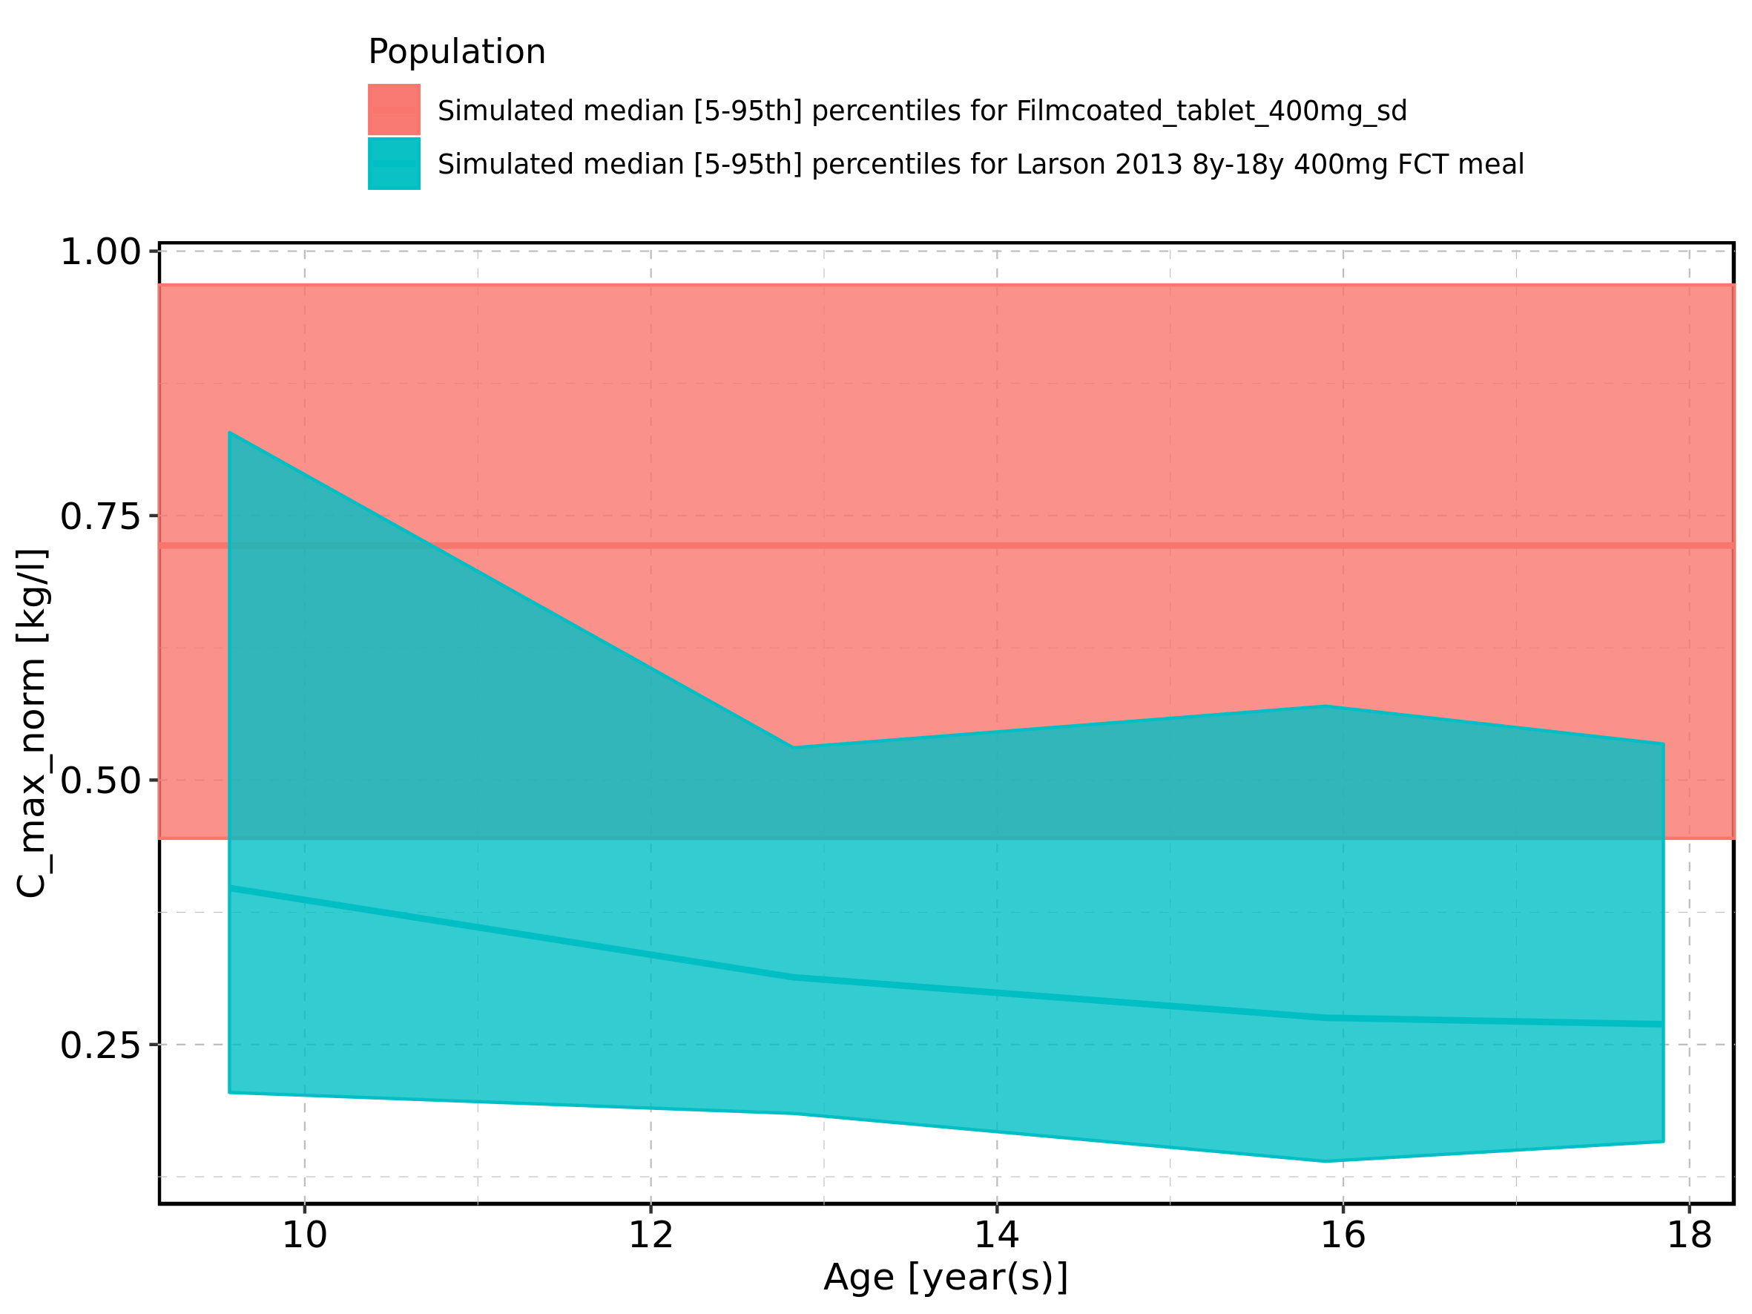

Figure 36: Age-dependence of C_max_norm for Larson 2013 8y-18y 400mg FCT meal in comparison to Filmcoated_tablet_400mg_sd. Profiles are plotted in a logarithmic scale.

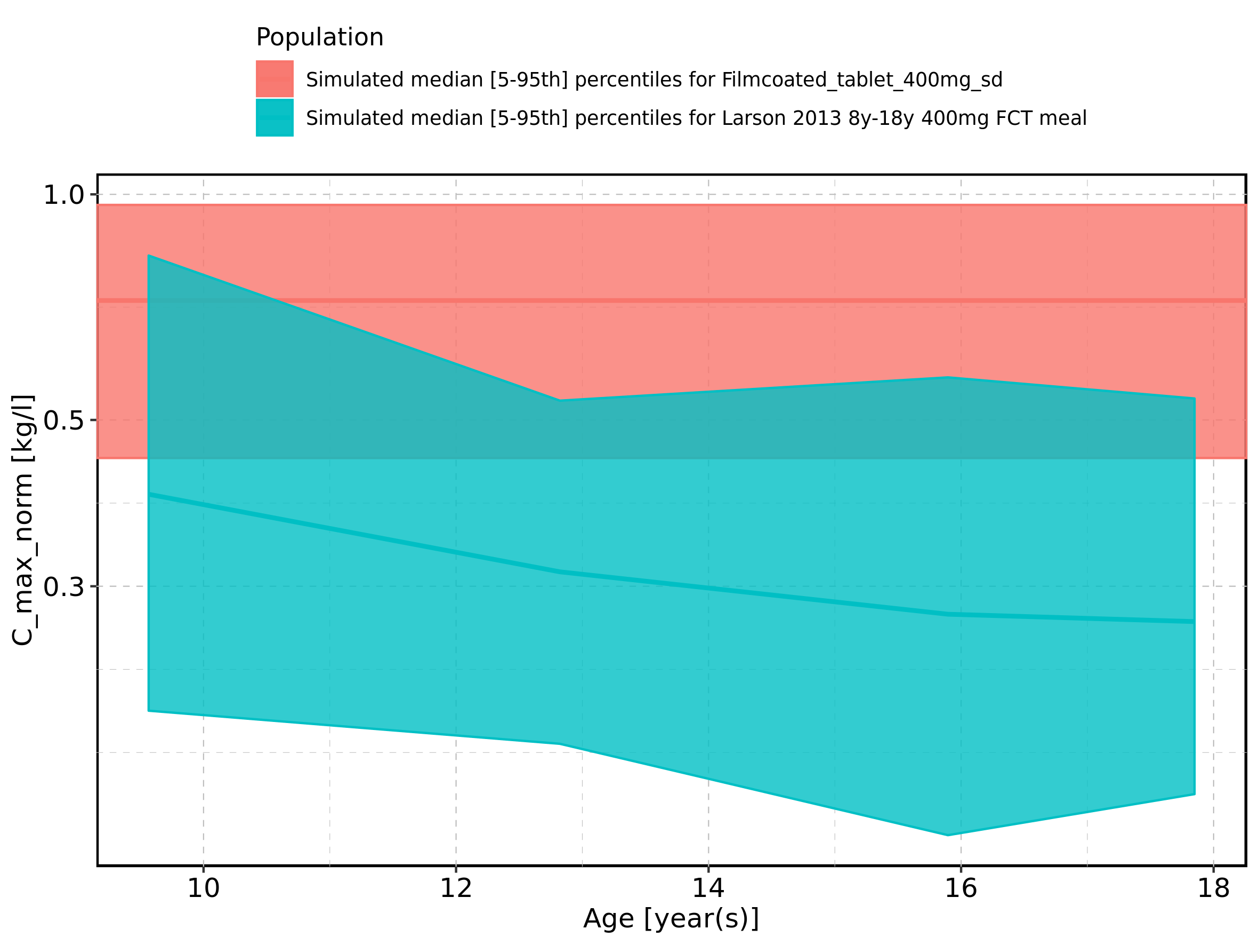

Figure 37: Age-dependence of C_max_norm for Larson 2013 8y-18y 400mg FCT meal. Profiles are plotted in a linear scale.

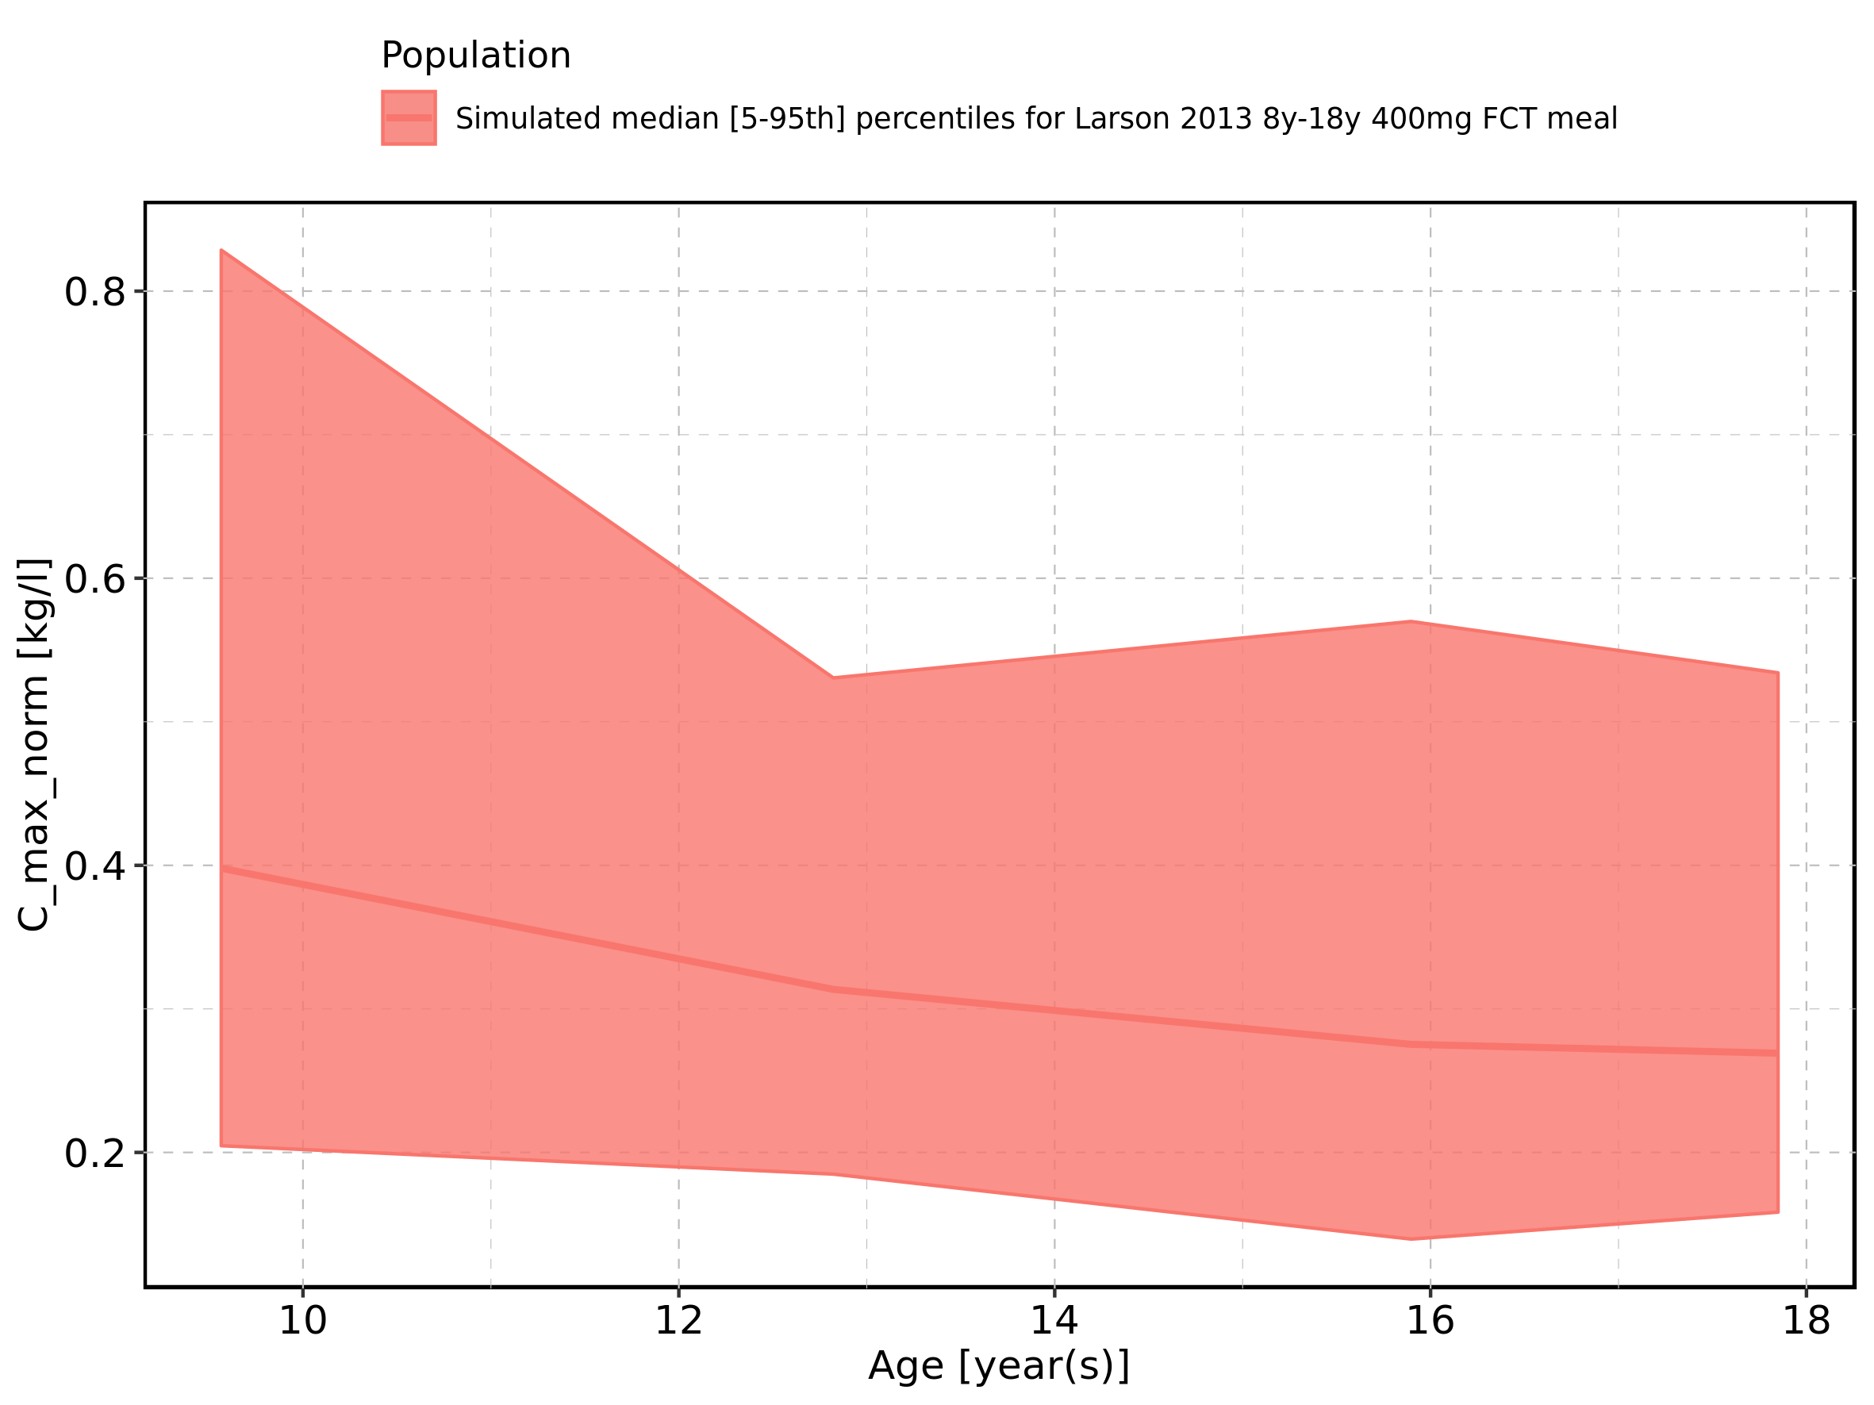

Figure 38: Age-dependence of C_max_norm for Larson 2013 8y-18y 400mg FCT meal. Profiles are plotted in a logarithmic scale.

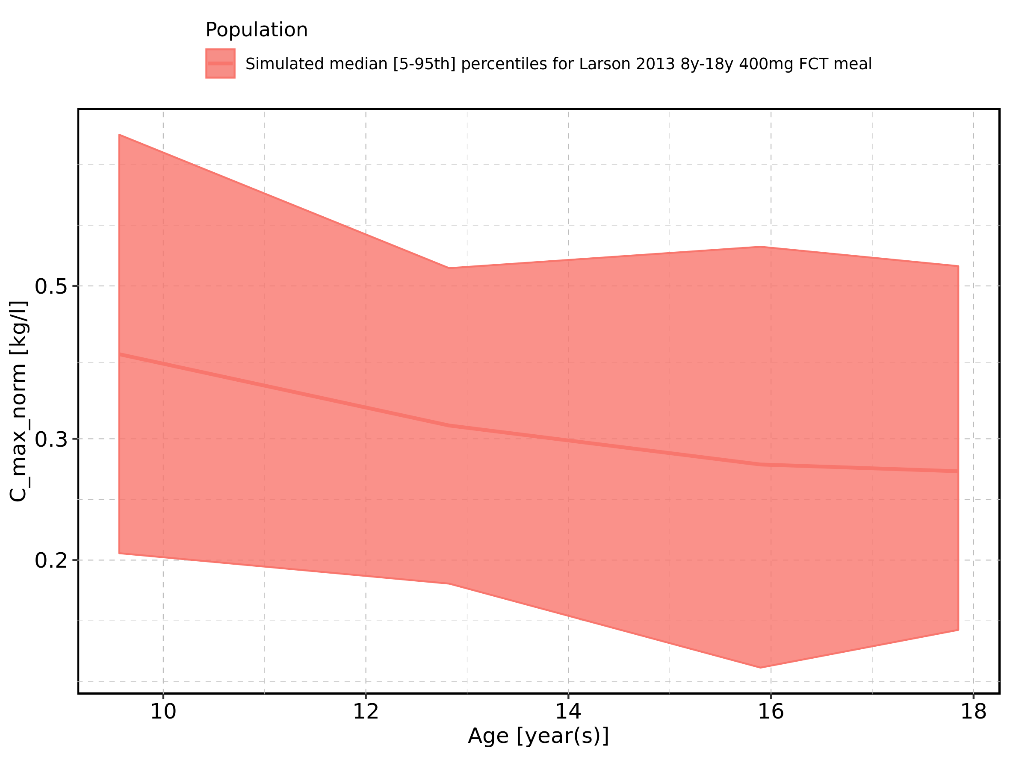

Figure 39: Age-dependence of C_max_norm for Filmcoated_tablet_400mg_sd. Profiles are plotted in a linear scale.

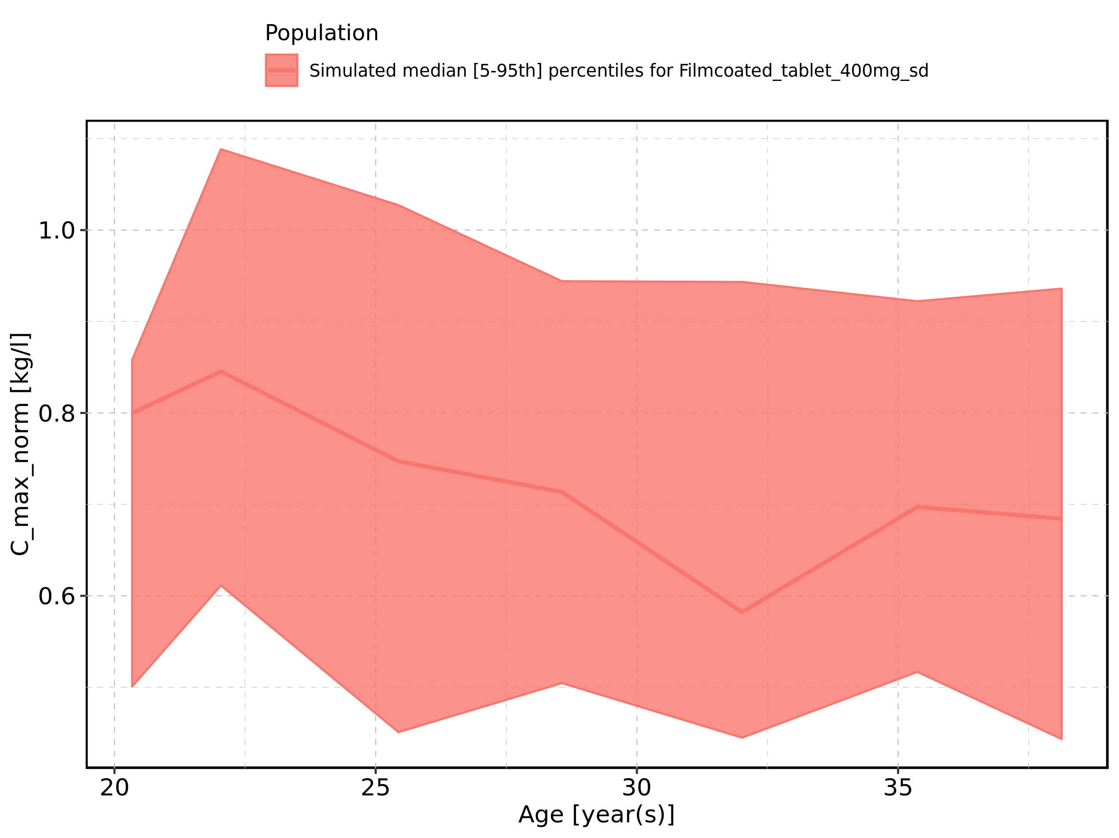

Figure 40: Age-dependence of C_max_norm for Filmcoated_tablet_400mg_sd. Profiles are plotted in a logarithmic scale.

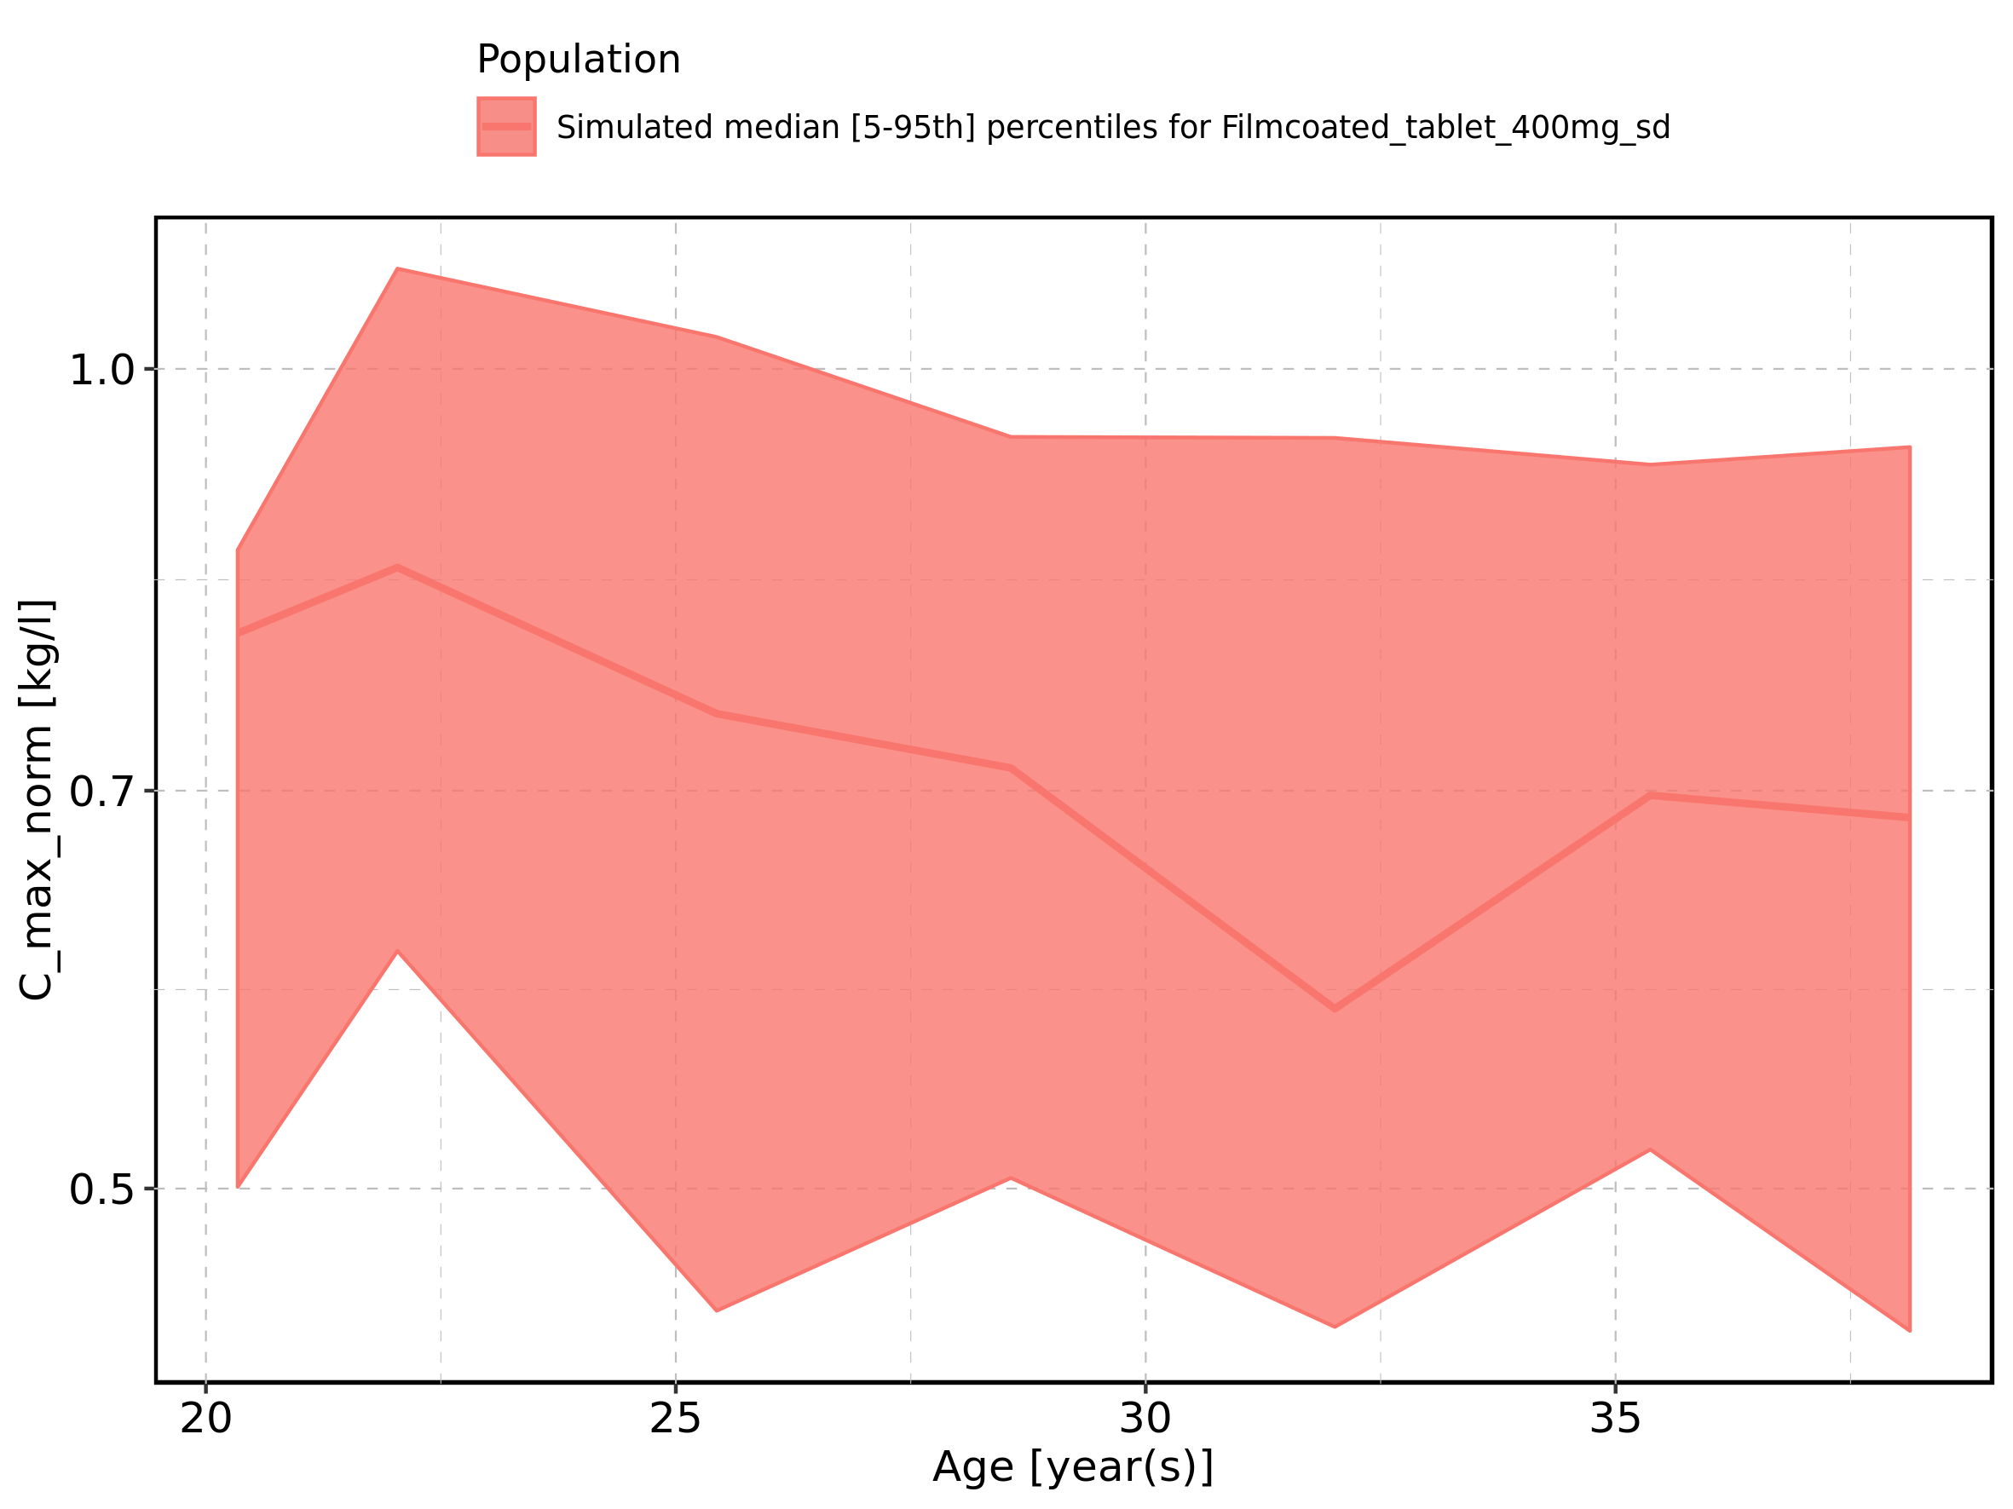

Figure 41: Height-dependence of C_max_norm for Larson 2013 8y-18y 400mg FCT meal in comparison to Filmcoated_tablet_400mg_sd. Profiles are plotted in a linear scale.

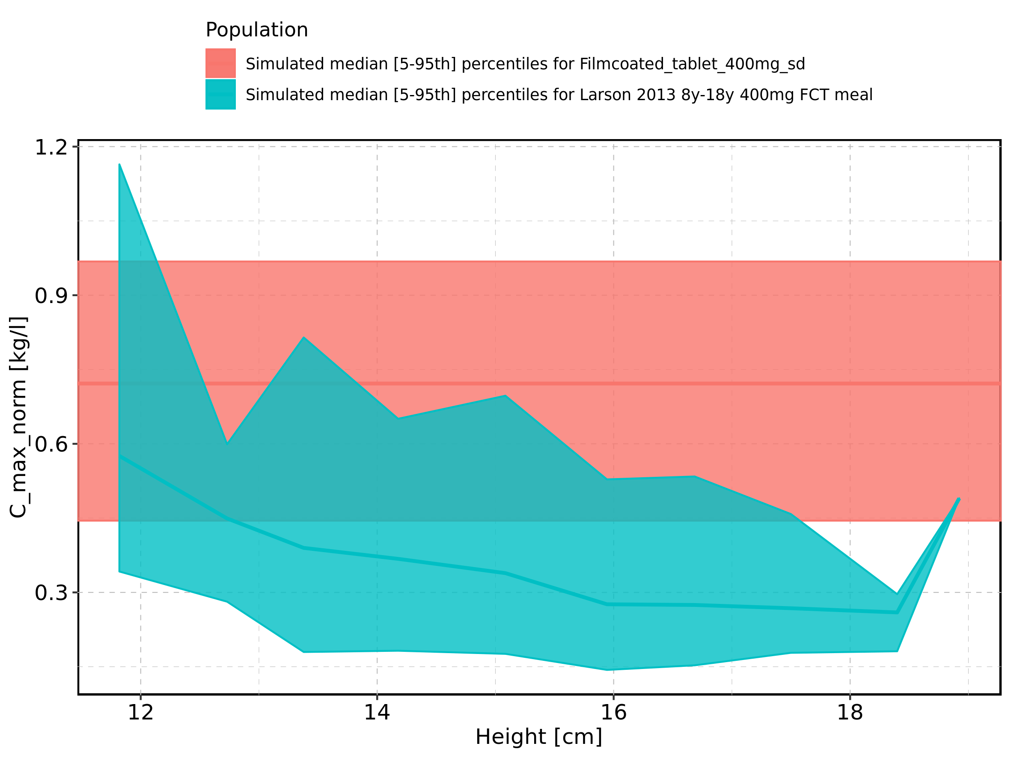

Figure 42: Height-dependence of C_max_norm for Larson 2013 8y-18y 400mg FCT meal in comparison to Filmcoated_tablet_400mg_sd. Profiles are plotted in a logarithmic scale.

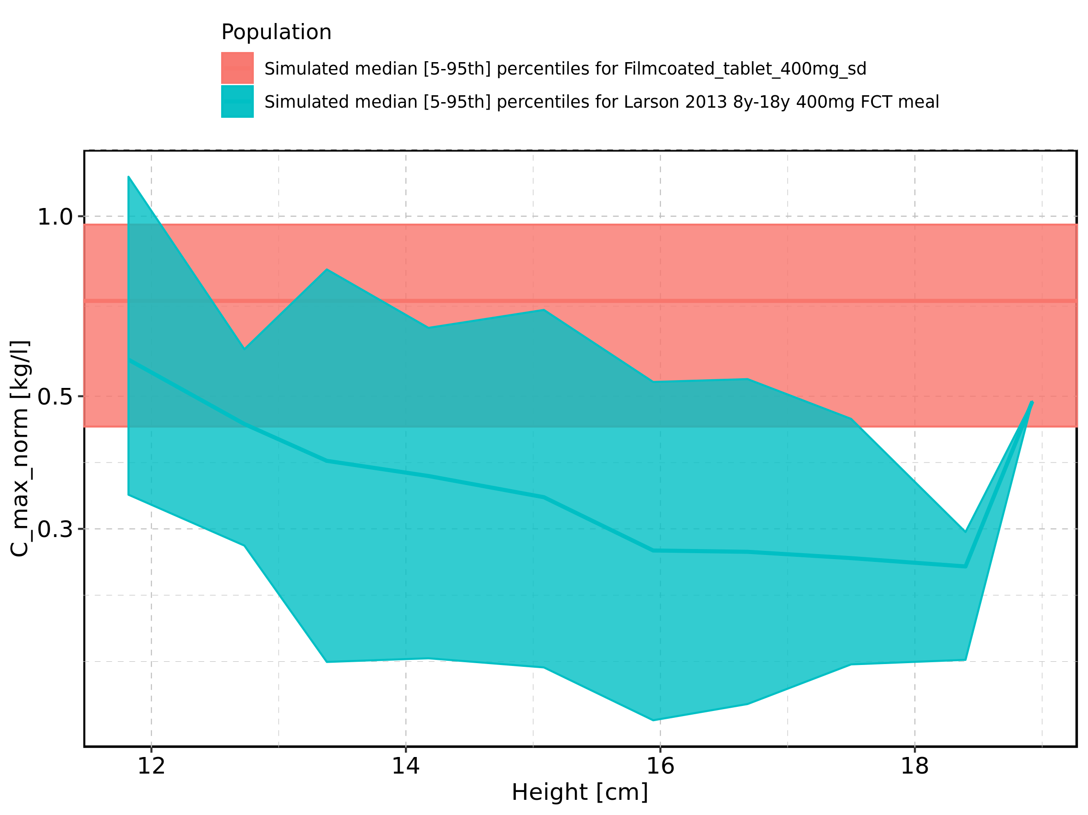

Figure 43: Height-dependence of C_max_norm for Larson 2013 8y-18y 400mg FCT meal. Profiles are plotted in a linear scale.

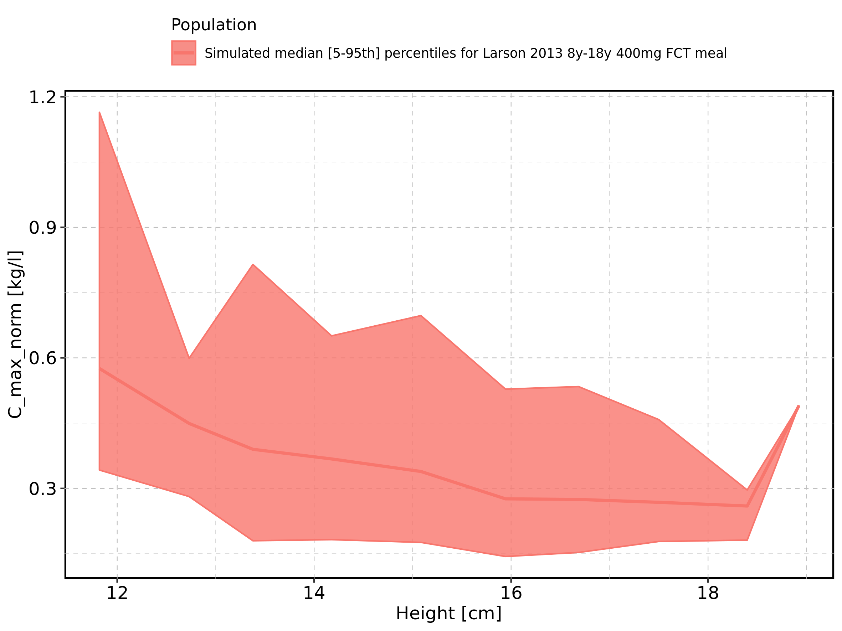

Figure 44: Height-dependence of C_max_norm for Larson 2013 8y-18y 400mg FCT meal. Profiles are plotted in a logarithmic scale.

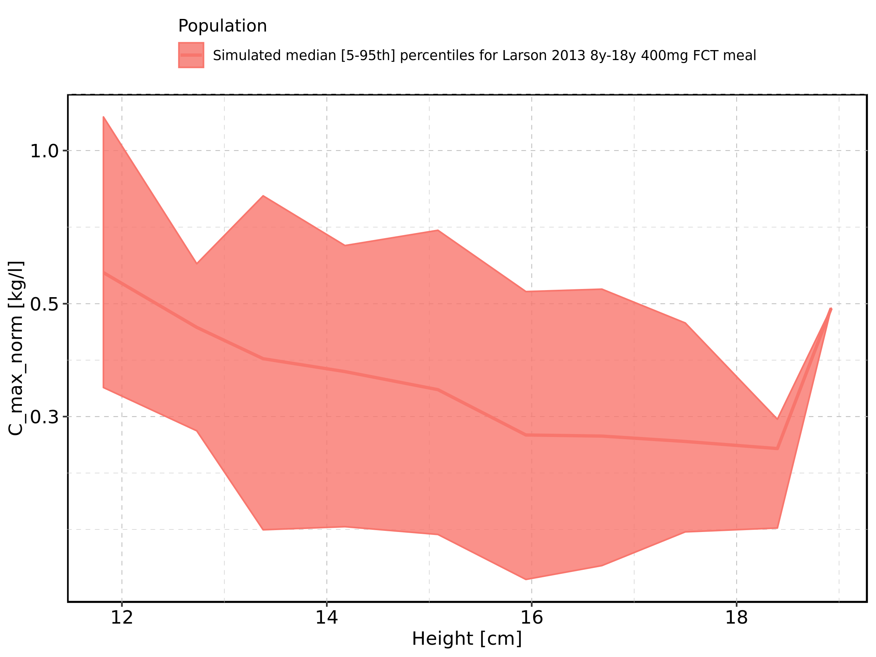

Figure 45: Height-dependence of C_max_norm for Filmcoated_tablet_400mg_sd. Profiles are plotted in a linear scale.

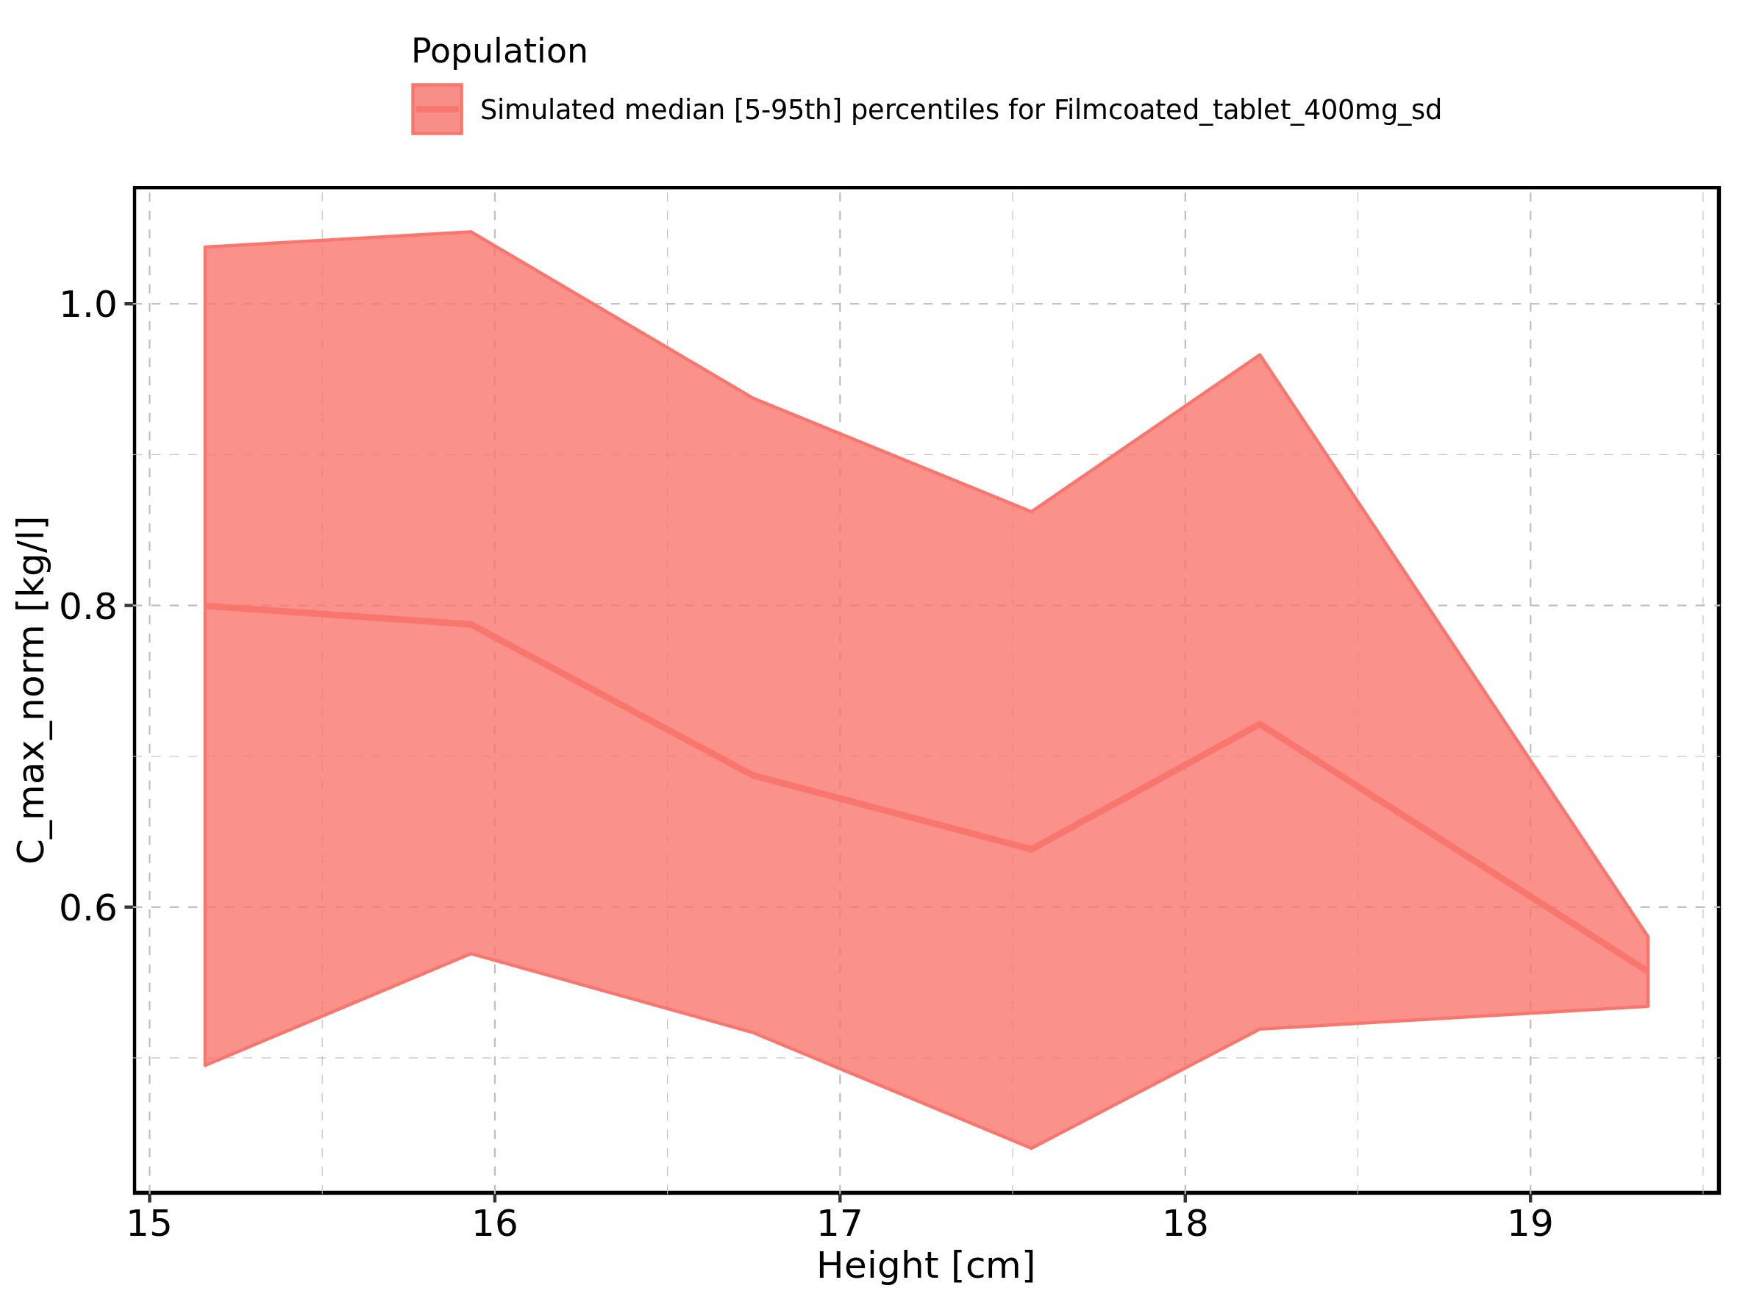

Figure 46: Height-dependence of C_max_norm for Filmcoated_tablet_400mg_sd. Profiles are plotted in a logarithmic scale.

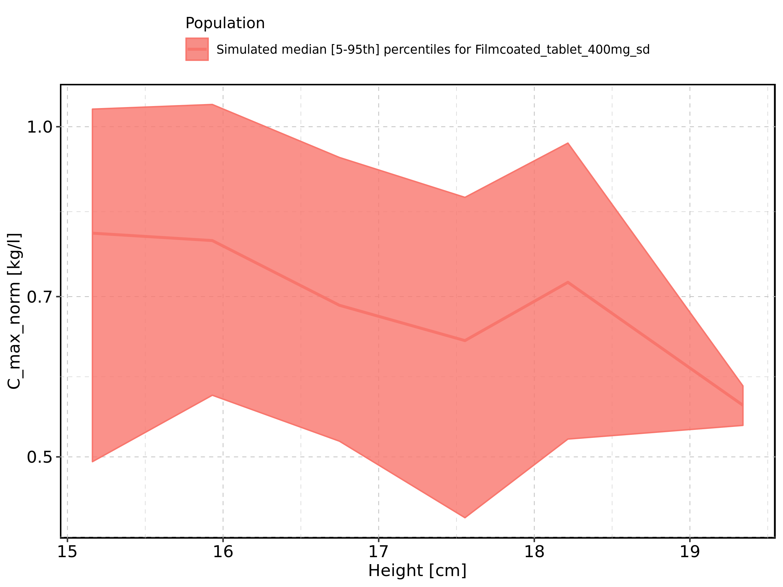

Figure 47: Weight-dependence of C_max_norm for Larson 2013 8y-18y 400mg FCT meal in comparison to Filmcoated_tablet_400mg_sd. Profiles are plotted in a linear scale.

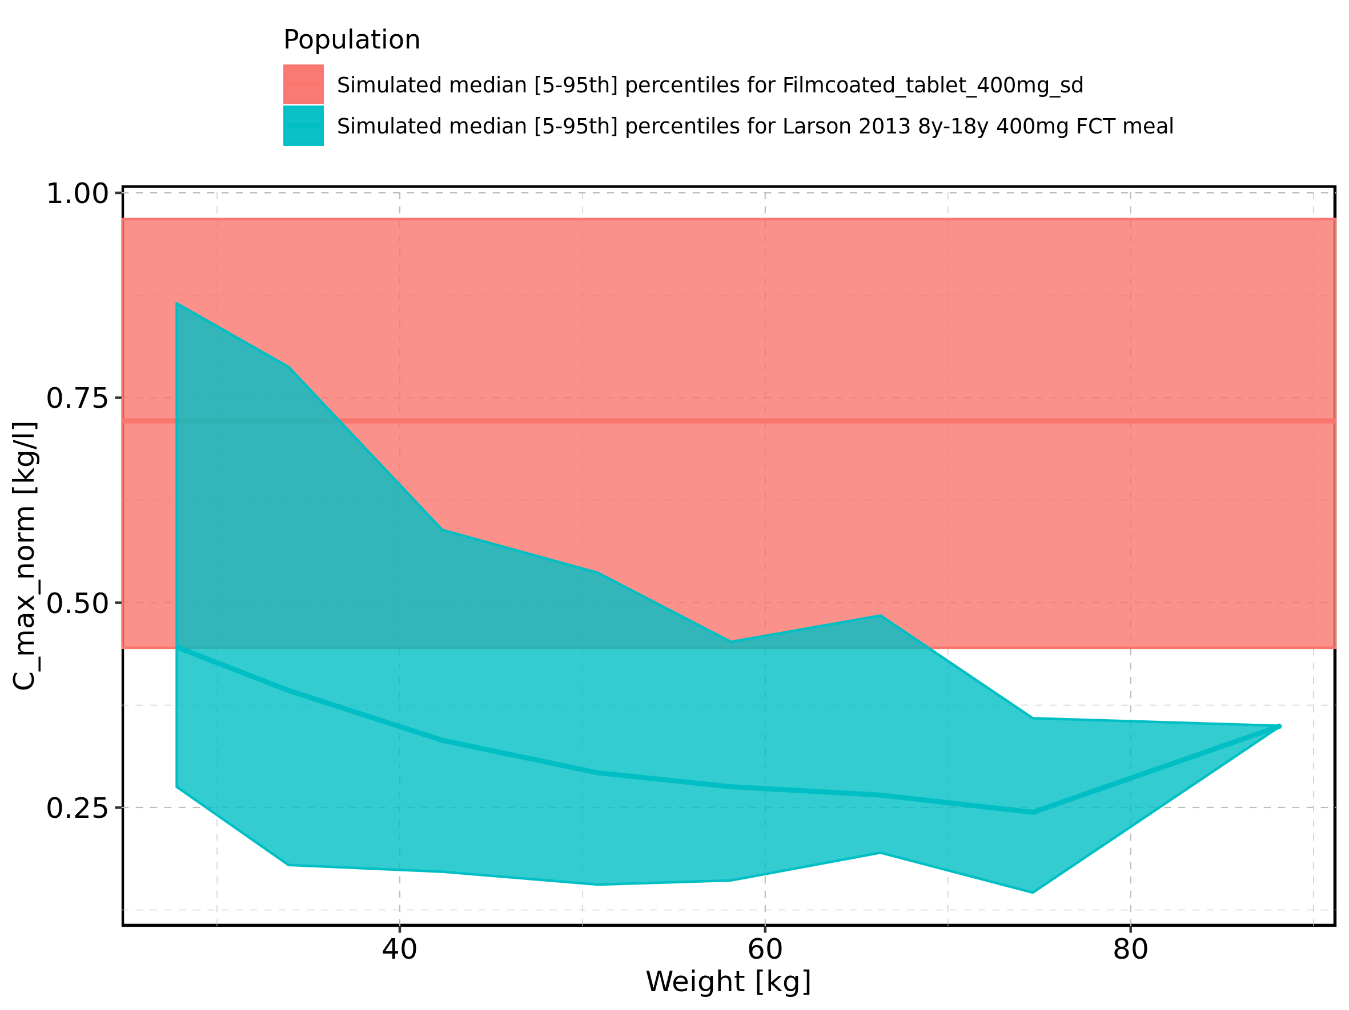

Figure 48: Weight-dependence of C_max_norm for Larson 2013 8y-18y 400mg FCT meal in comparison to Filmcoated_tablet_400mg_sd. Profiles are plotted in a logarithmic scale.

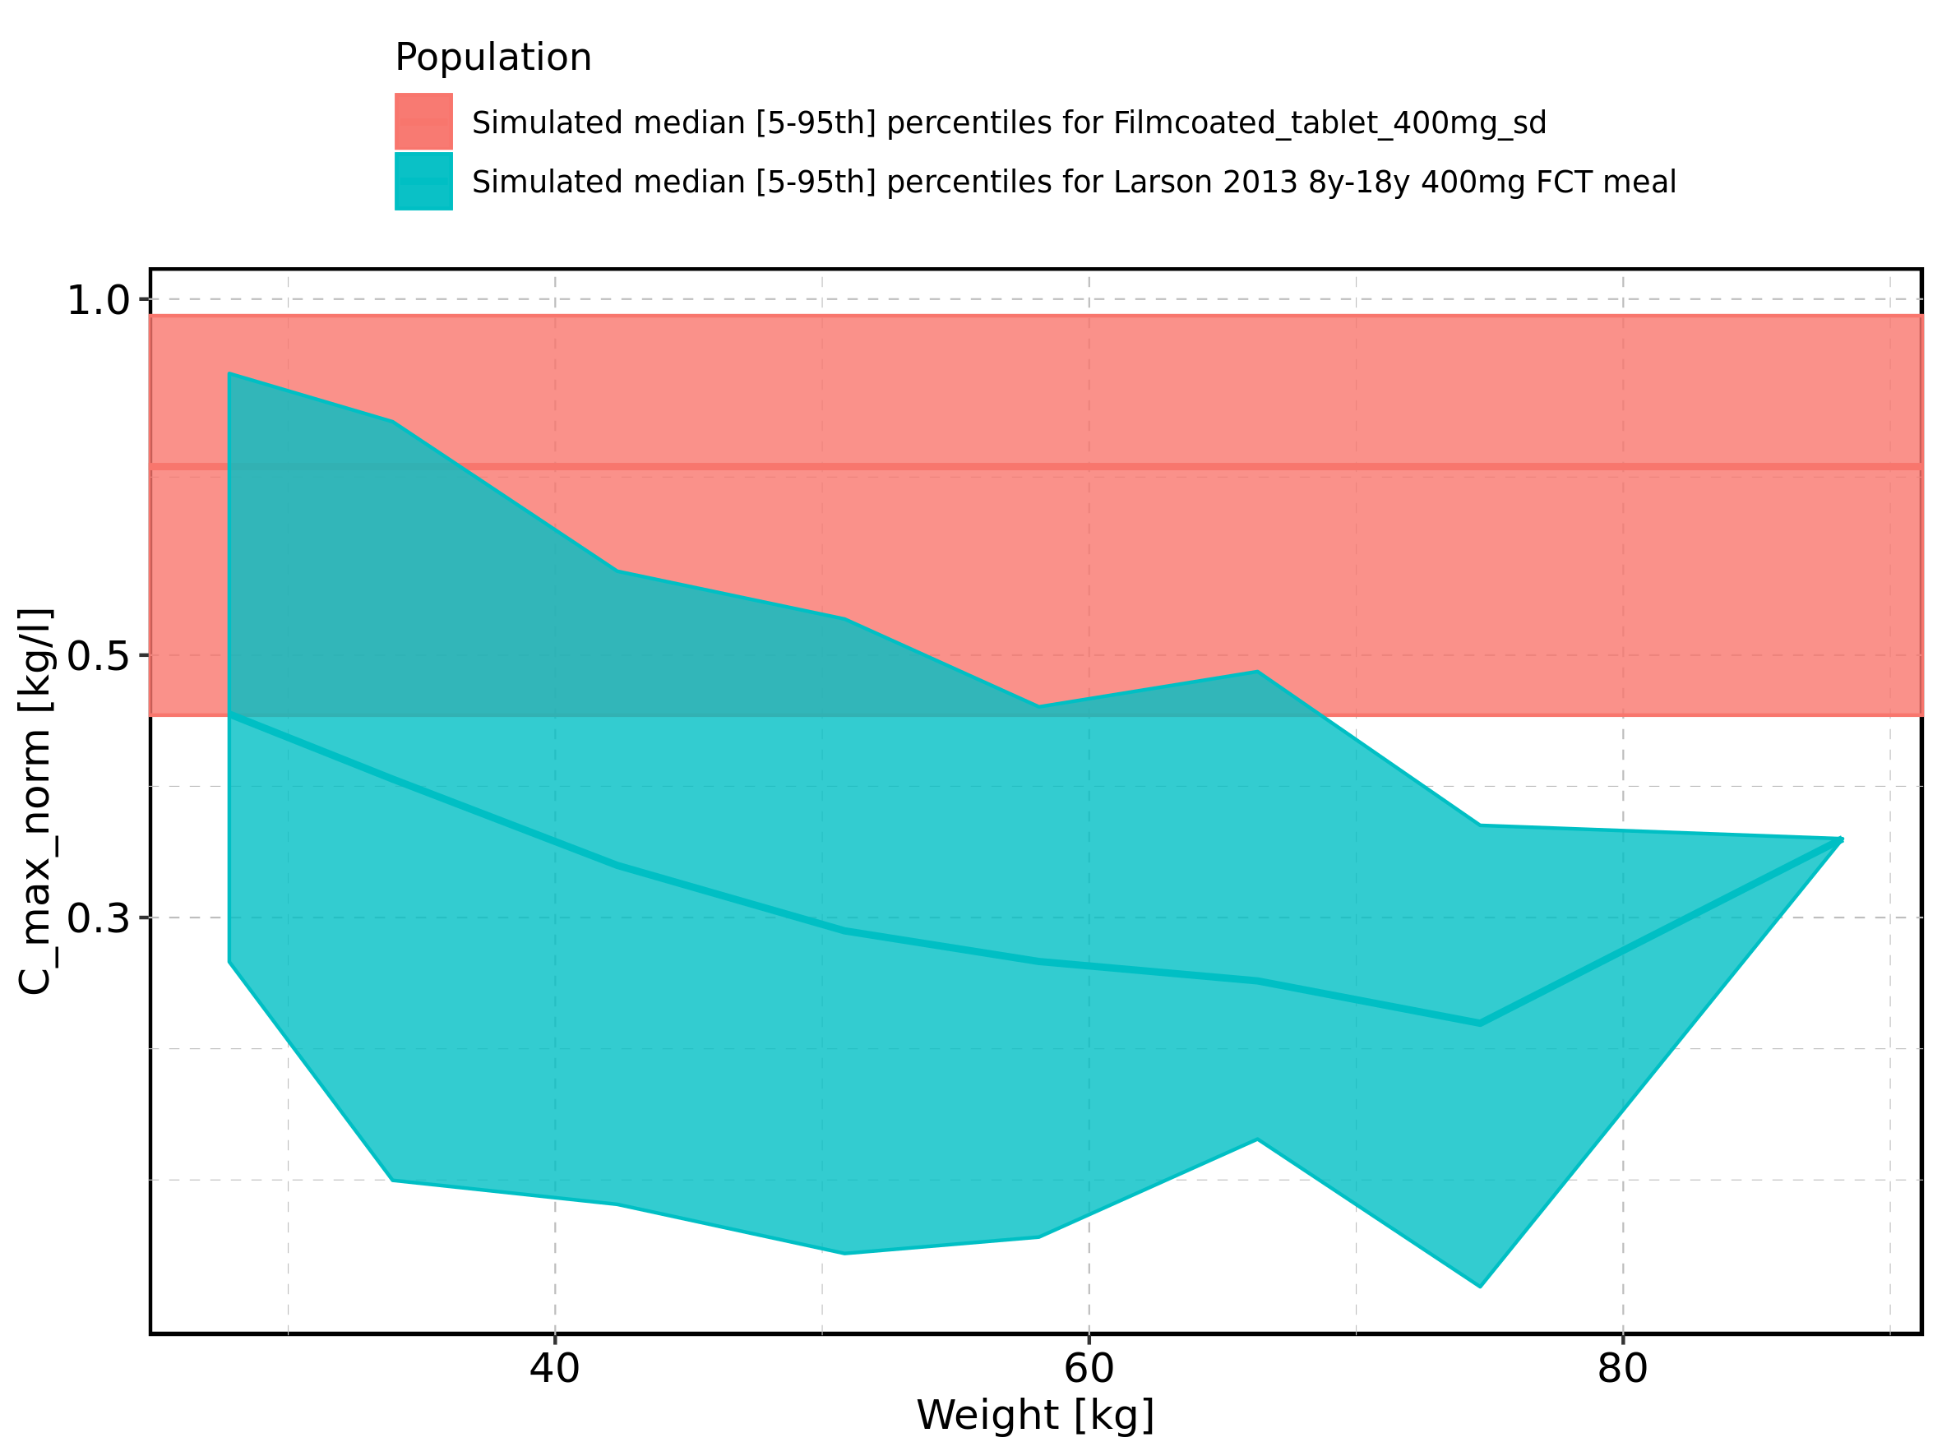

Figure 49: Weight-dependence of C_max_norm for Larson 2013 8y-18y 400mg FCT meal. Profiles are plotted in a linear scale.

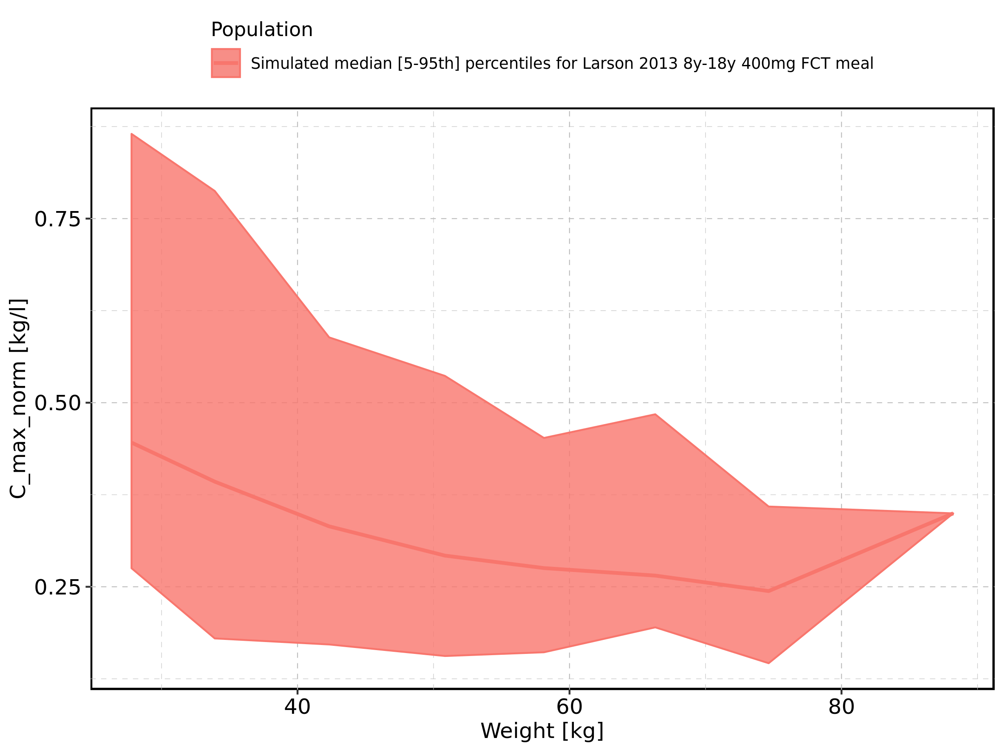

Figure 50: Weight-dependence of C_max_norm for Larson 2013 8y-18y 400mg FCT meal. Profiles are plotted in a logarithmic scale.

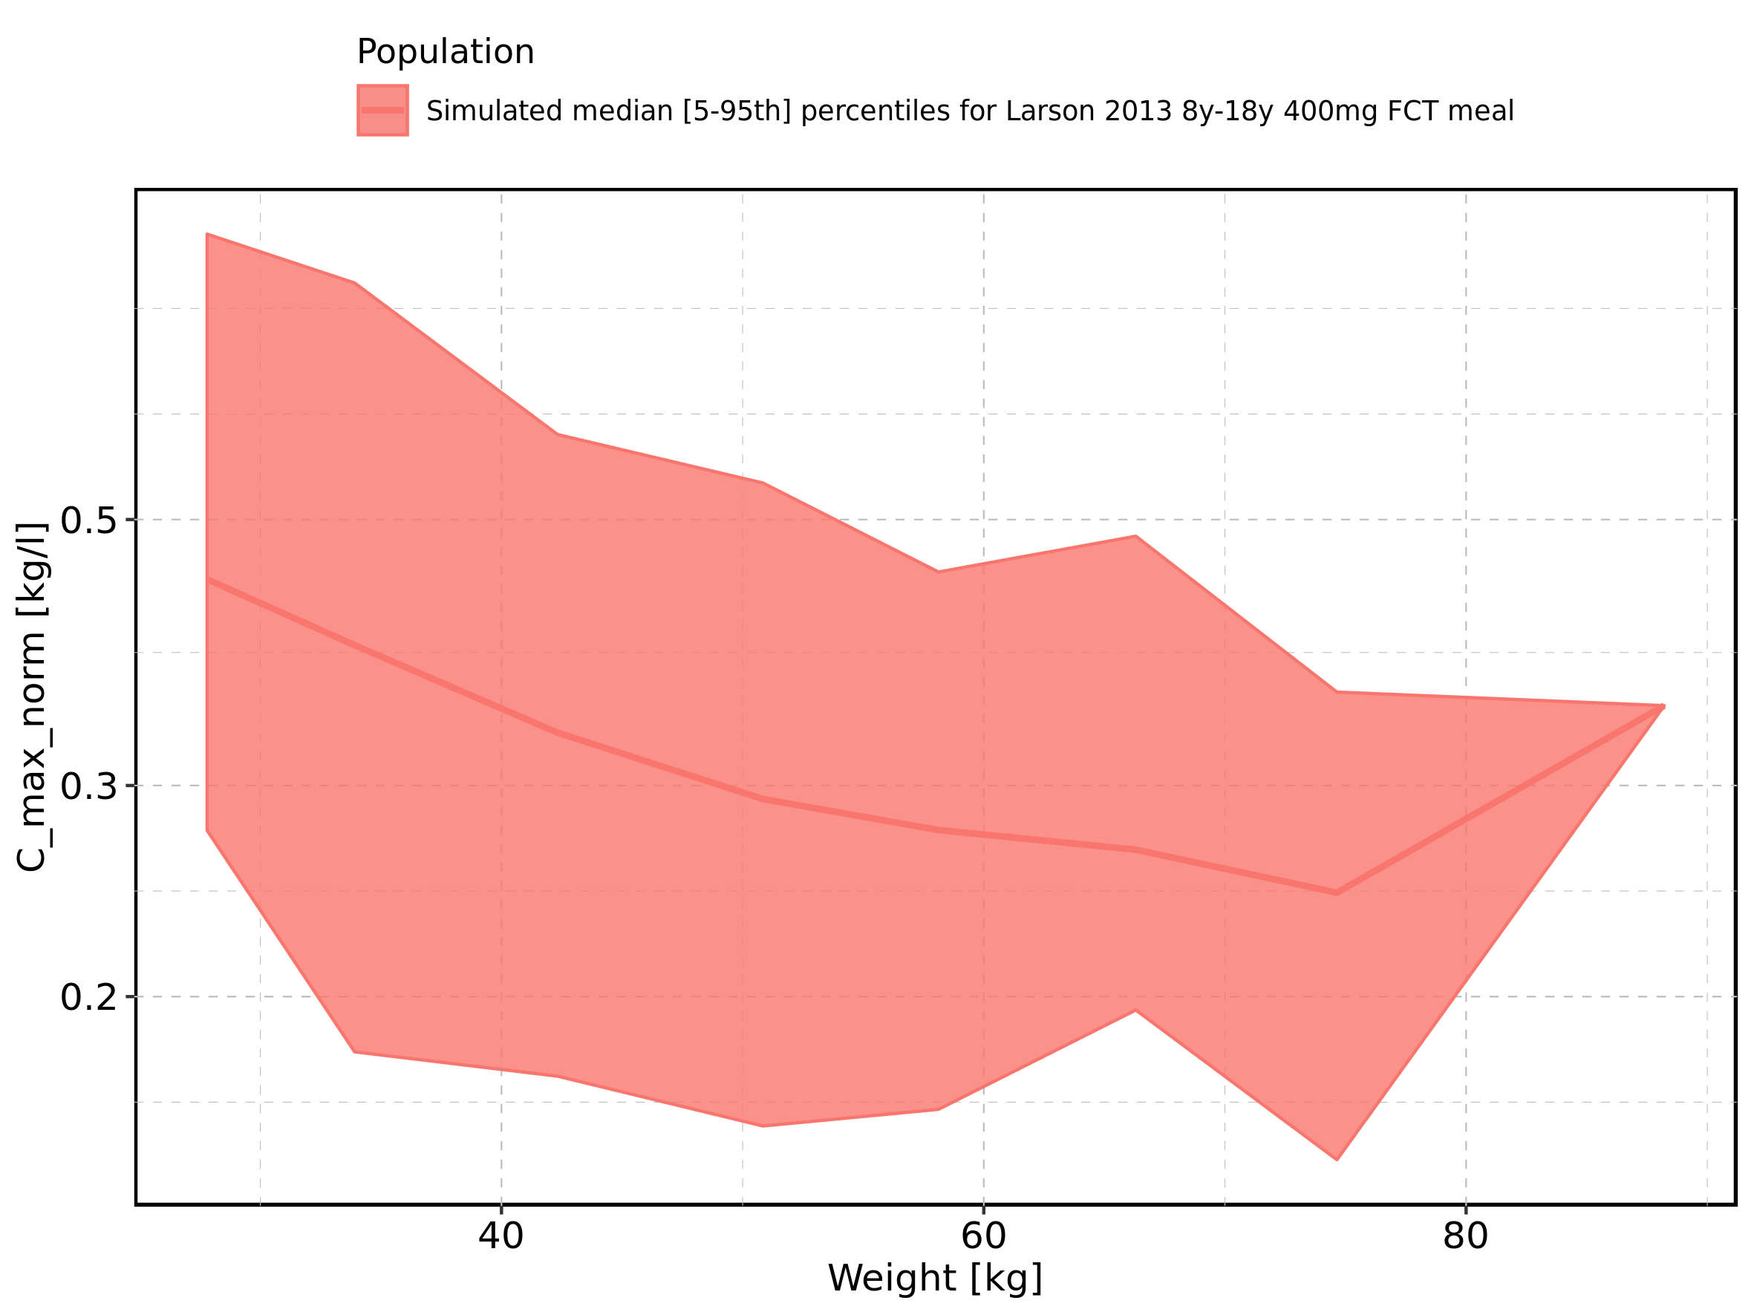

Figure 51: Weight-dependence of C_max_norm for Filmcoated_tablet_400mg_sd. Profiles are plotted in a linear scale.

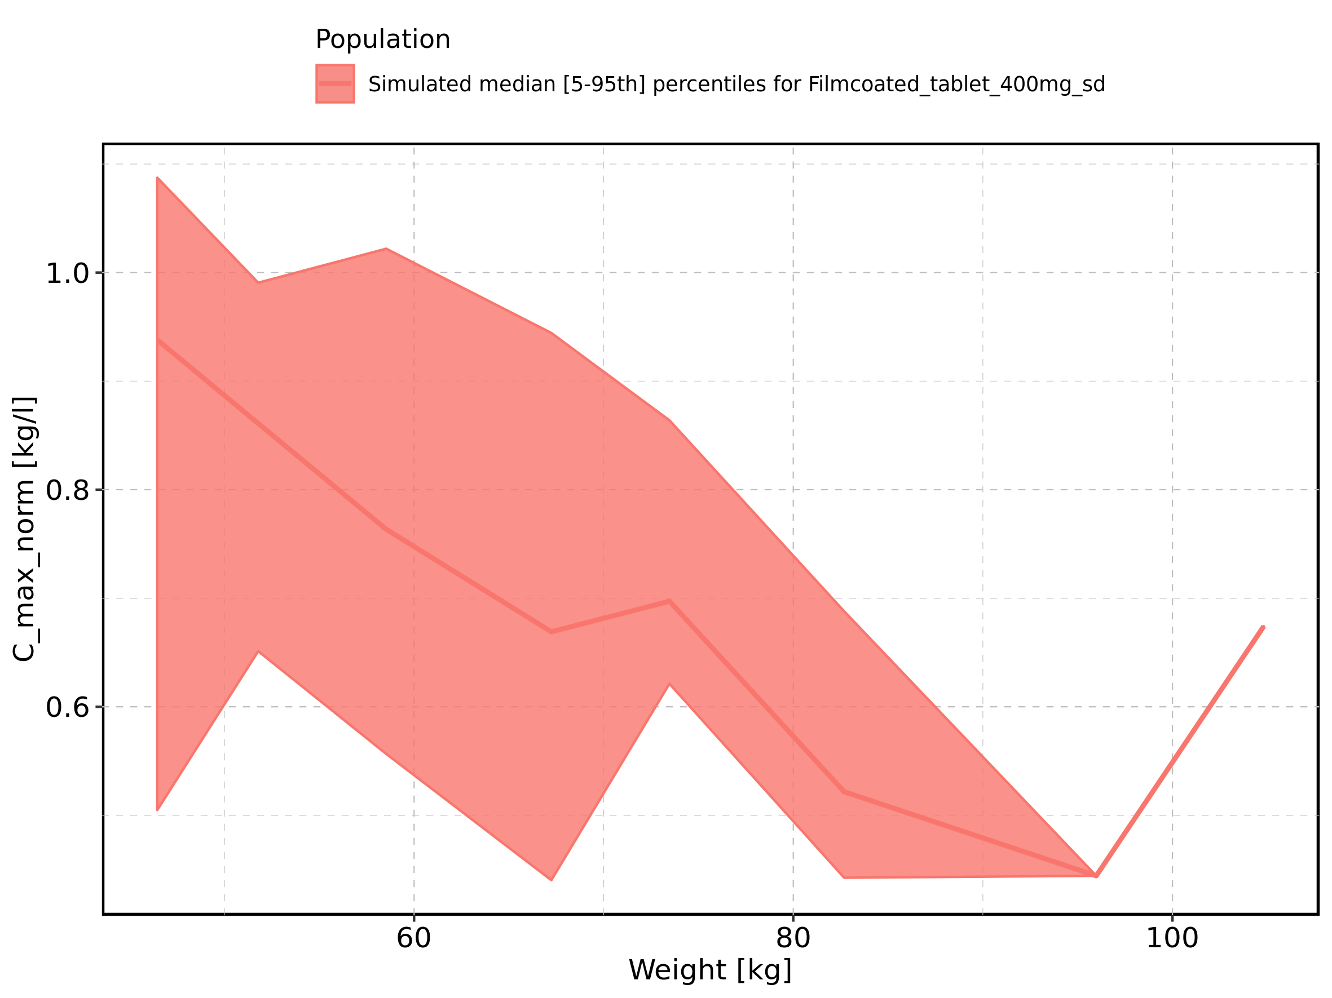

Figure 52: Weight-dependence of C_max_norm for Filmcoated_tablet_400mg_sd. Profiles are plotted in a logarithmic scale.

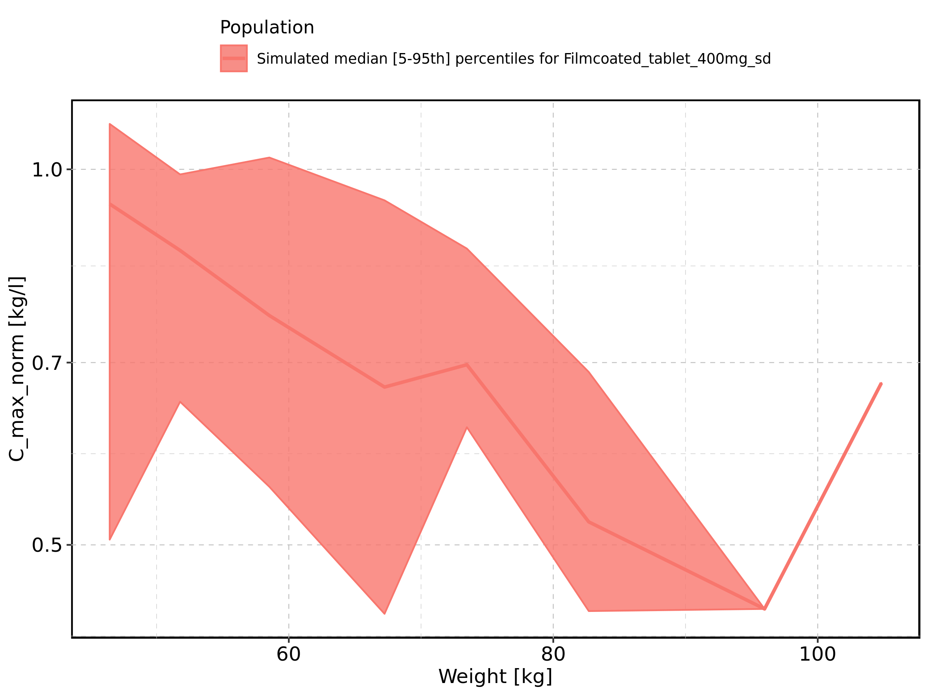

Figure 53: BMI-dependence of C_max_norm for Larson 2013 8y-18y 400mg FCT meal in comparison to Filmcoated_tablet_400mg_sd. Profiles are plotted in a linear scale.

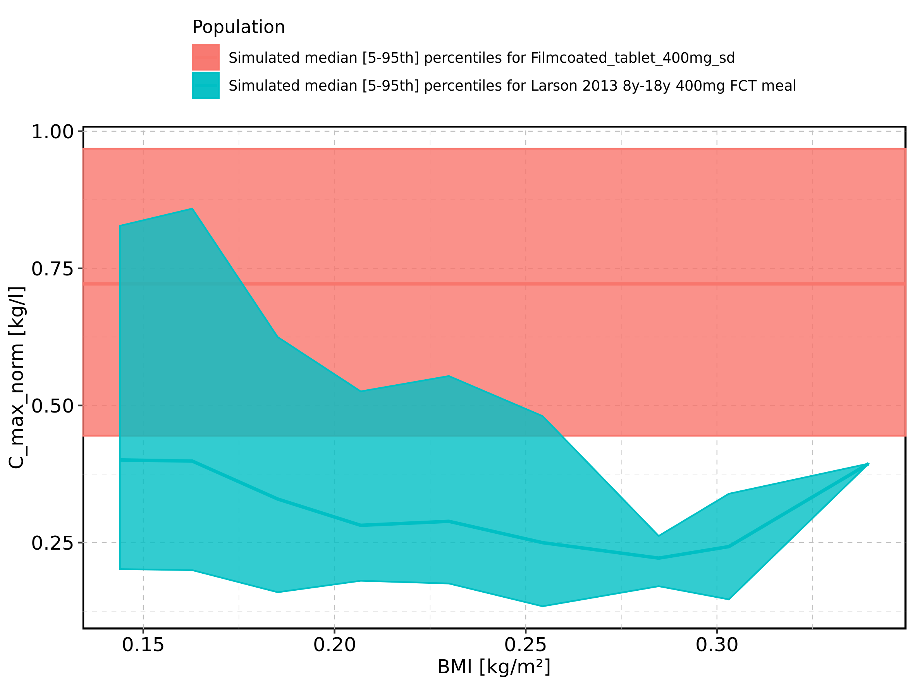

Figure 54: BMI-dependence of C_max_norm for Larson 2013 8y-18y 400mg FCT meal in comparison to Filmcoated_tablet_400mg_sd. Profiles are plotted in a logarithmic scale.

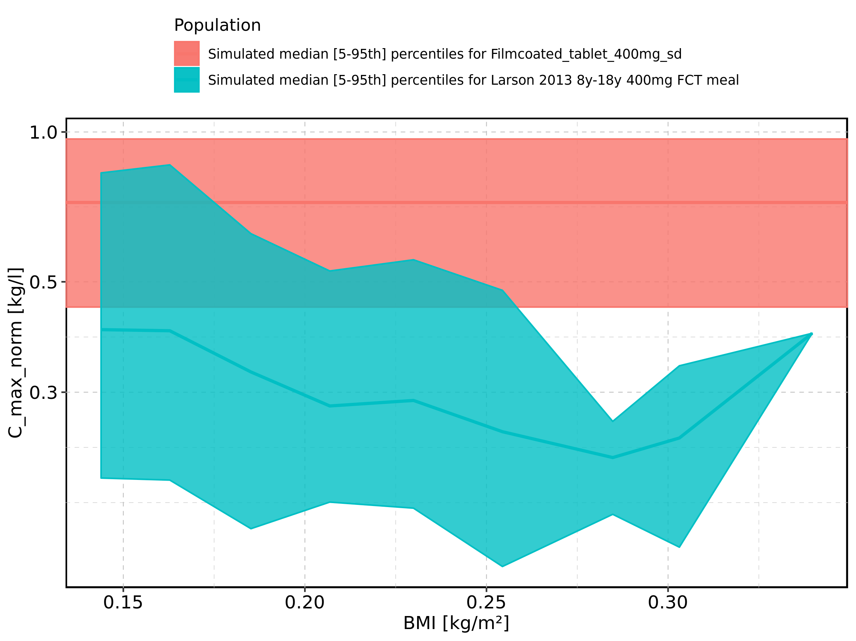

Figure 55: BMI-dependence of C_max_norm for Larson 2013 8y-18y 400mg FCT meal. Profiles are plotted in a linear scale.

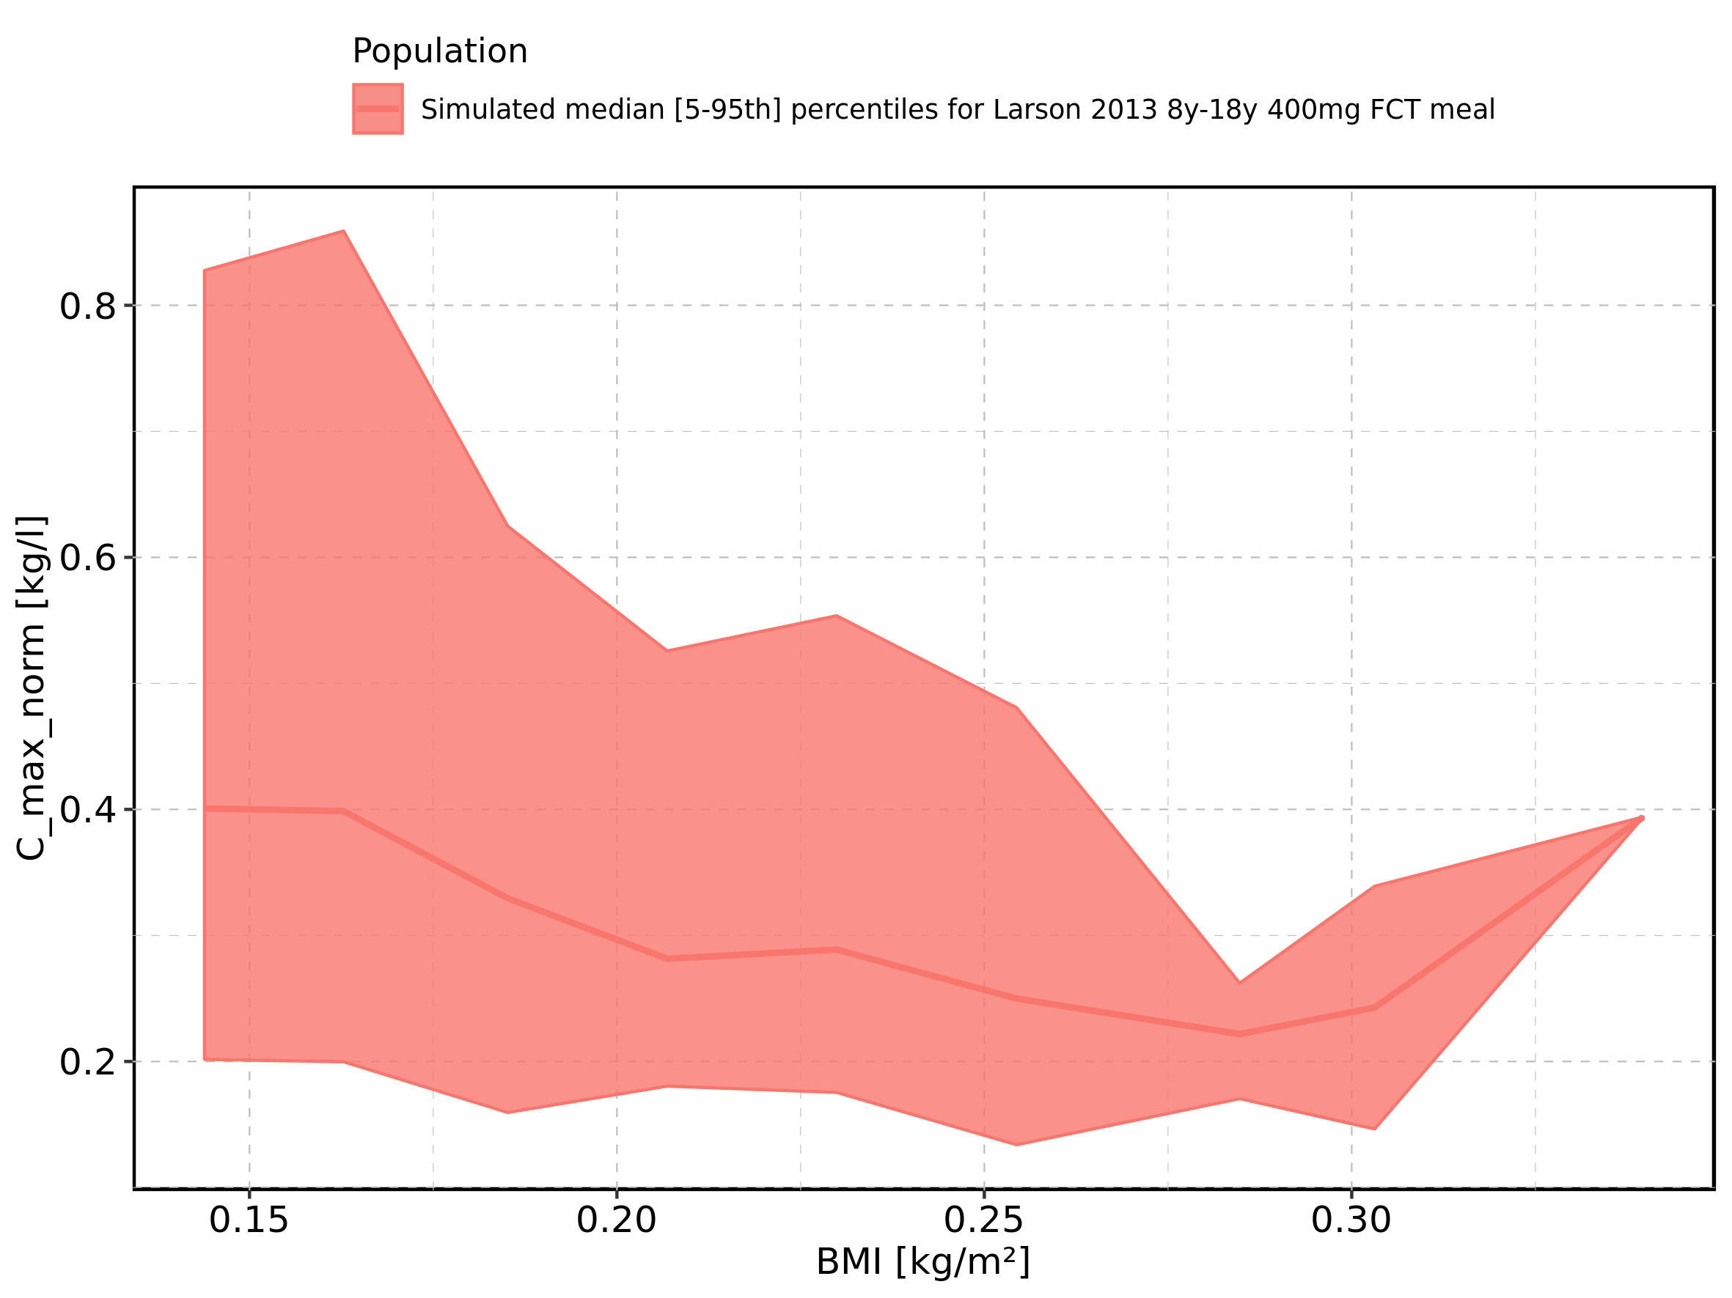

Figure 56: BMI-dependence of C_max_norm for Larson 2013 8y-18y 400mg FCT meal. Profiles are plotted in a logarithmic scale.

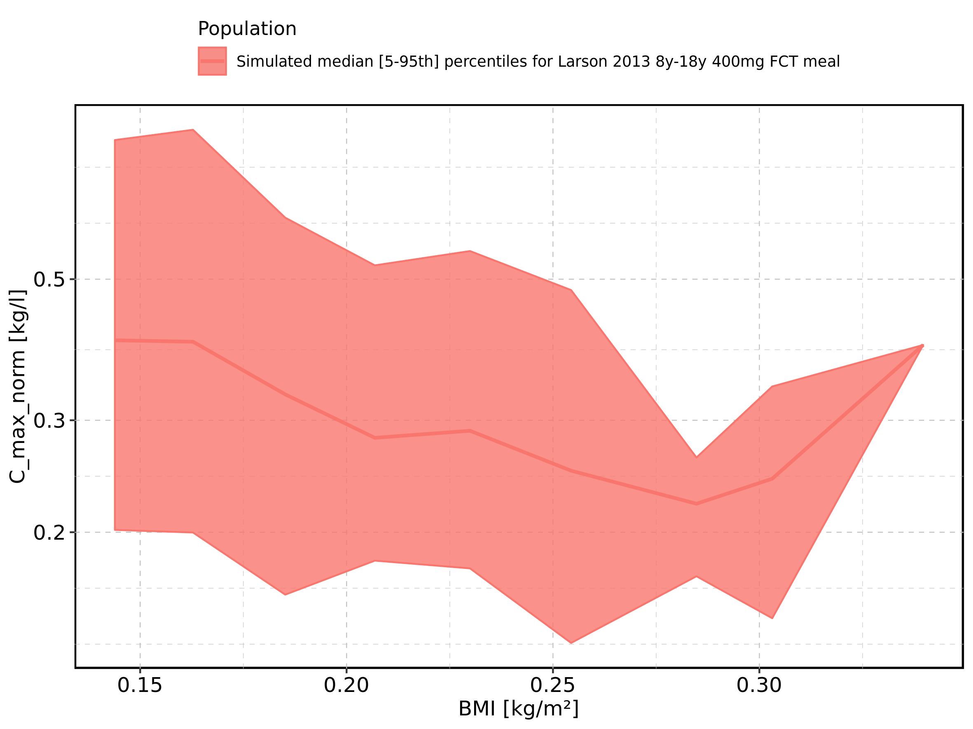

Figure 57: BMI-dependence of C_max_norm for Filmcoated_tablet_400mg_sd. Profiles are plotted in a linear scale.

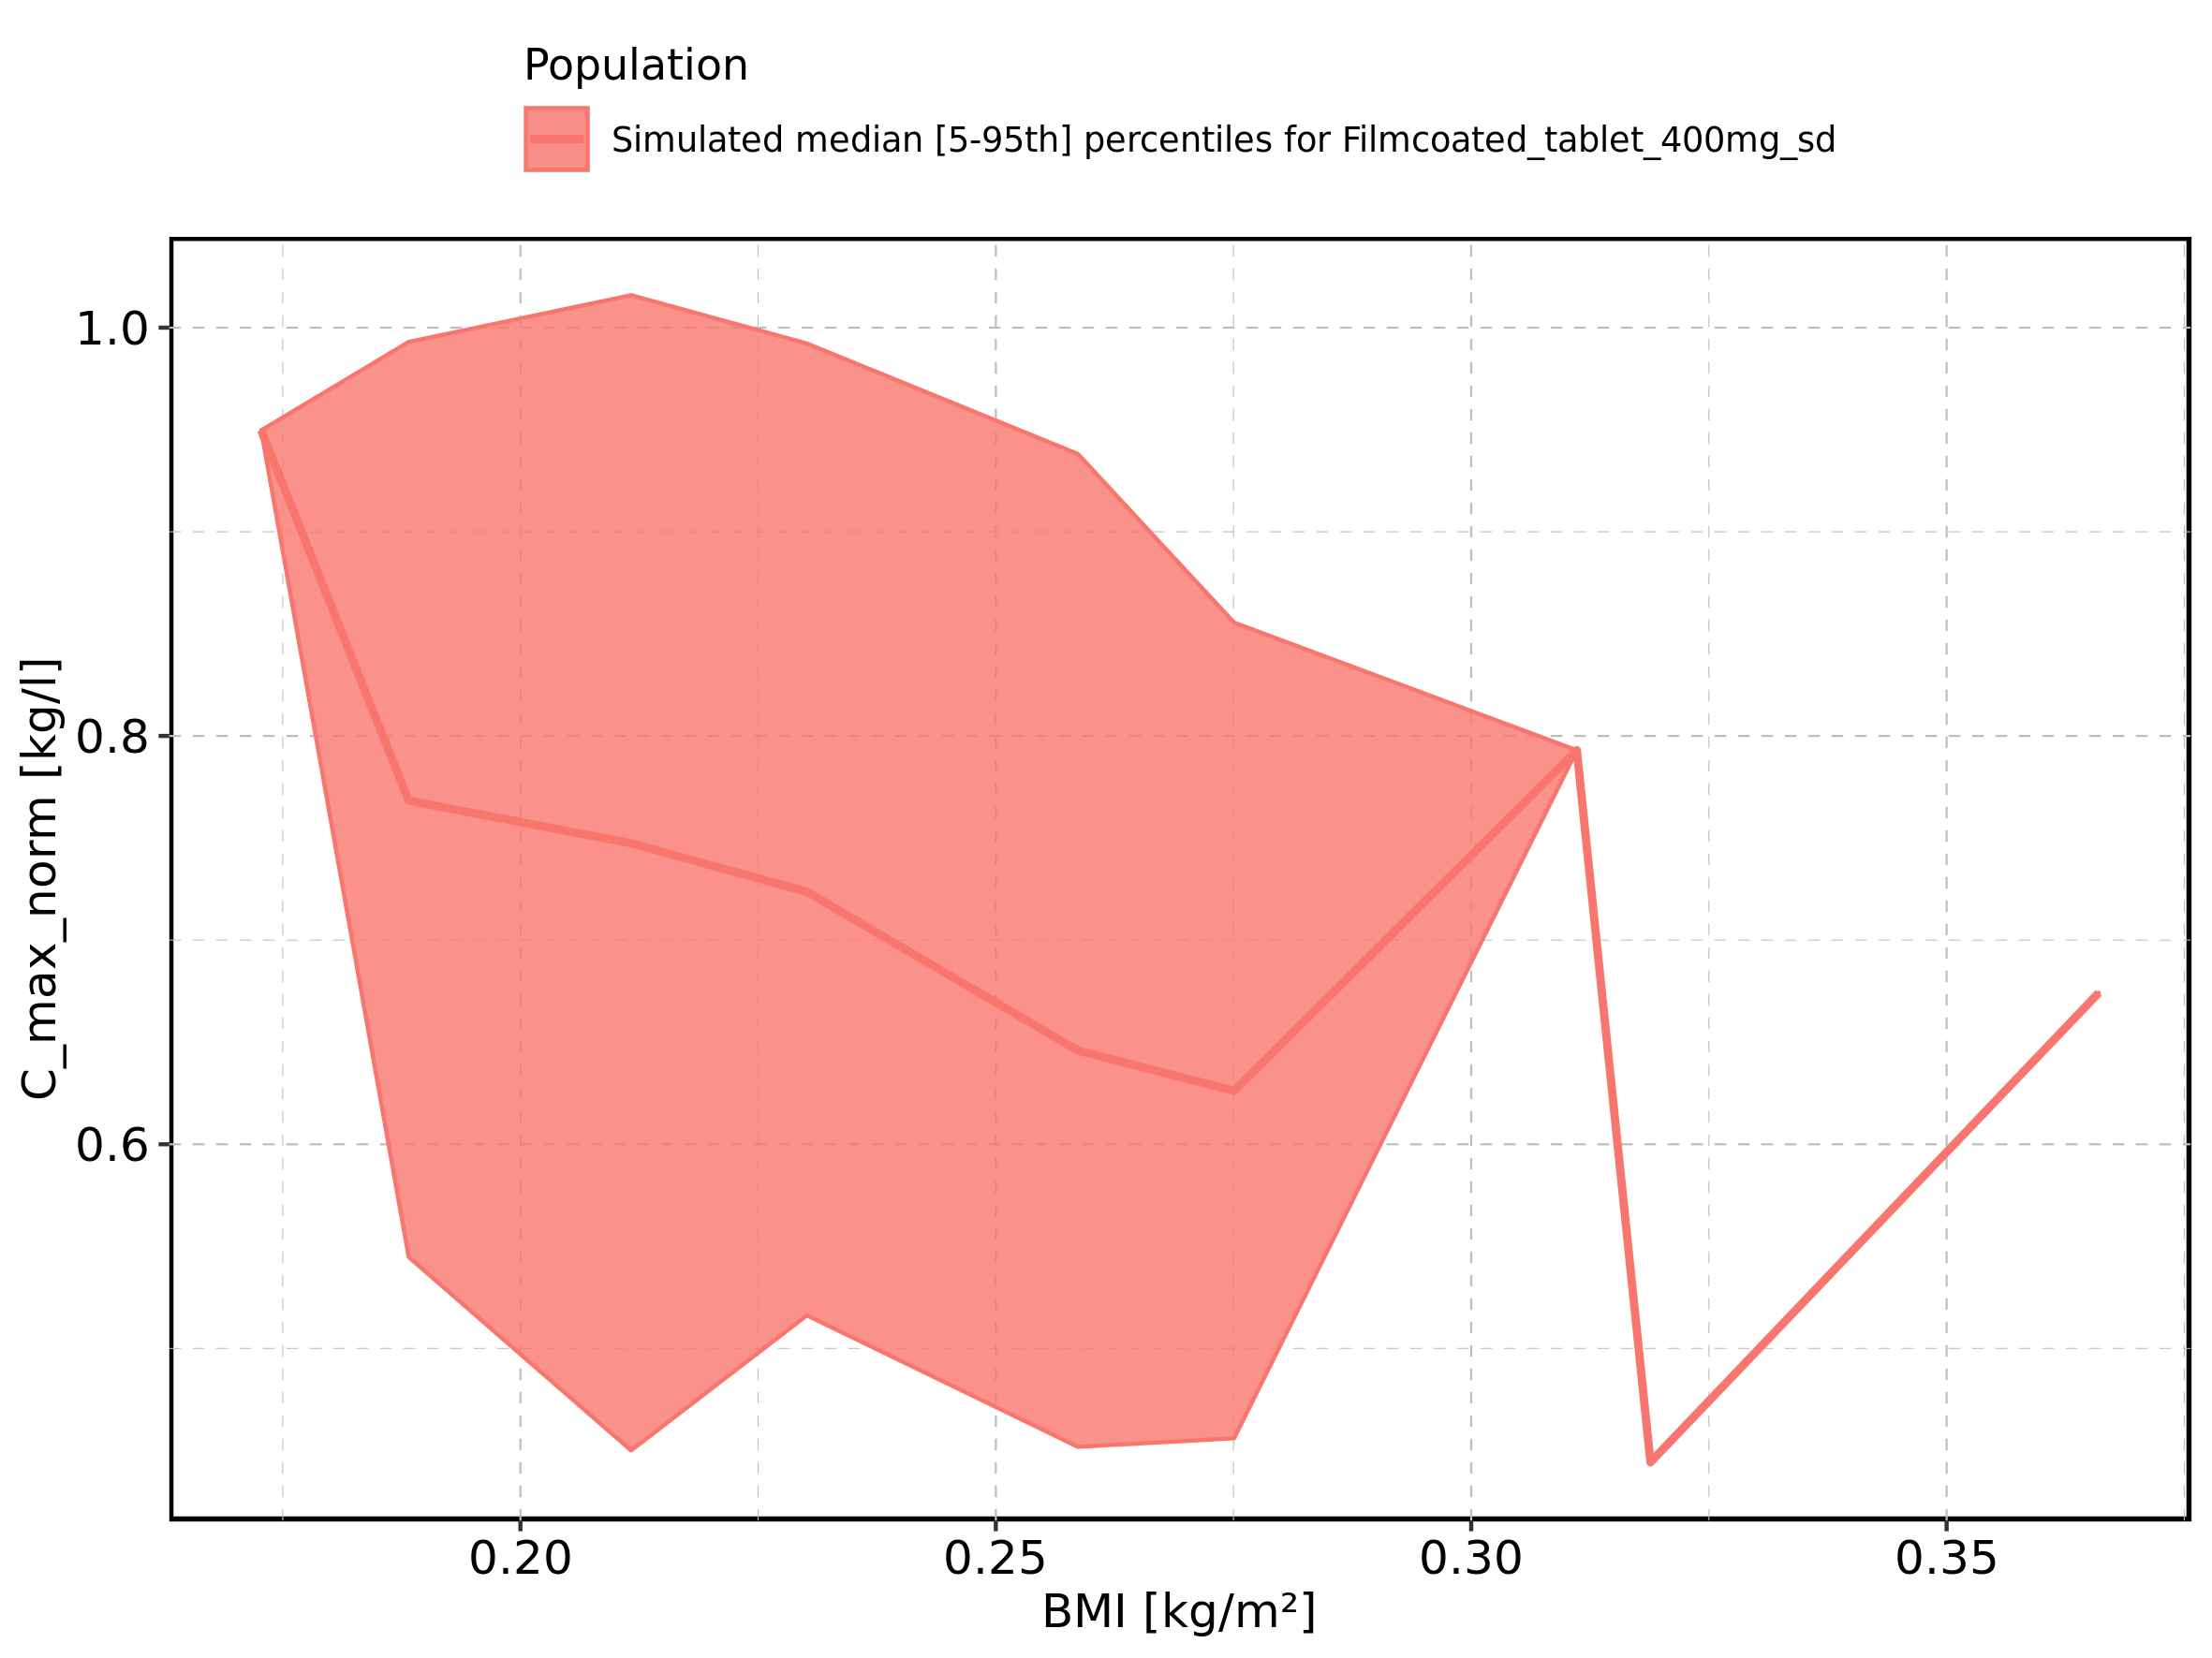

Figure 58: BMI-dependence of C_max_norm for Filmcoated_tablet_400mg_sd. Profiles are plotted in a logarithmic scale.

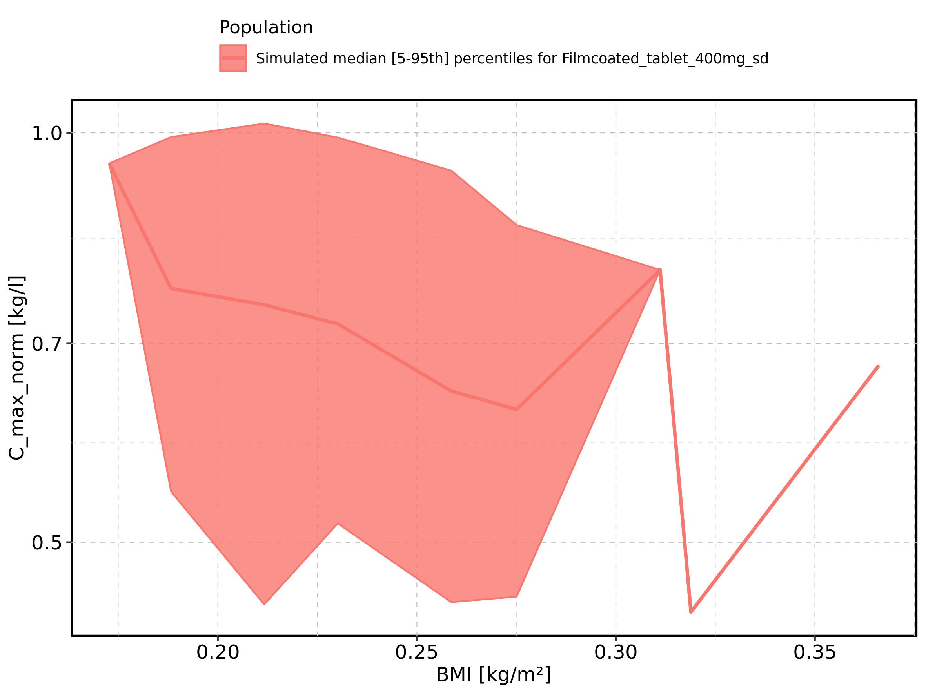

Figure 59: Gender-dependence of C_max_norm for Larson 2013 8y-18y 400mg FCT meal in comparison to Filmcoated_tablet_400mg_sd. Profiles are plotted in a linear scale.

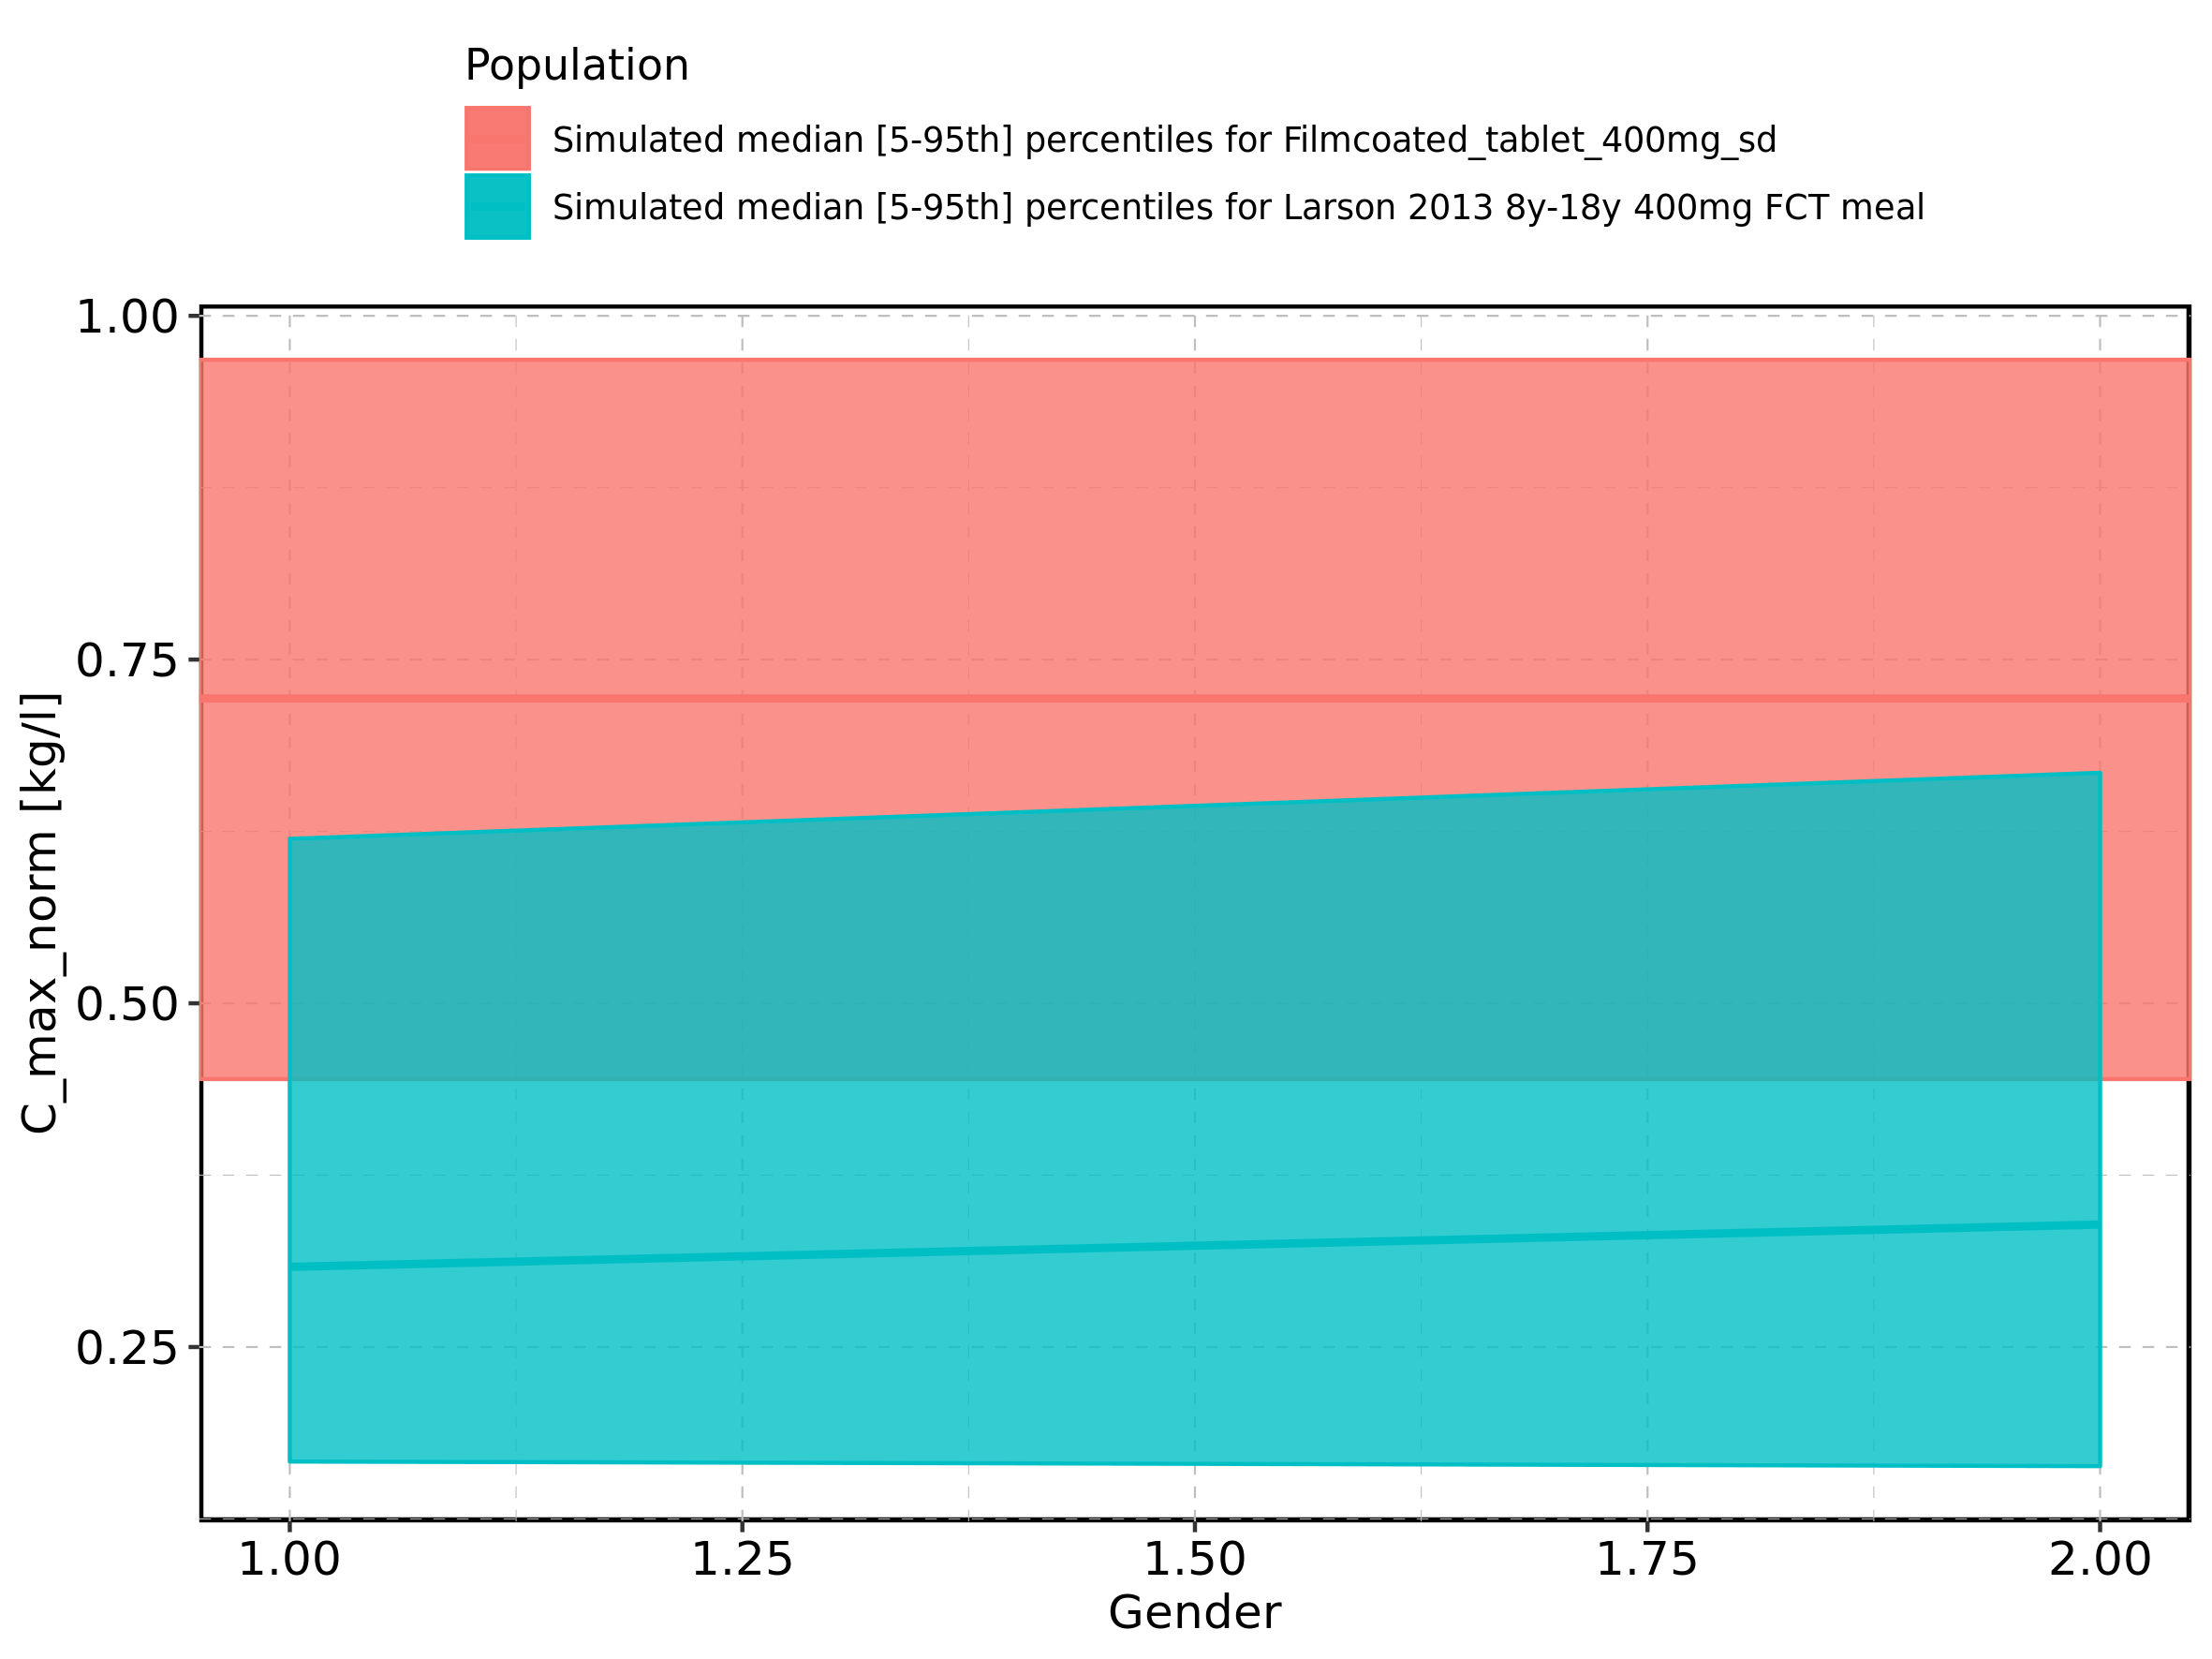

Figure 60: Gender-dependence of C_max_norm for Larson 2013 8y-18y 400mg FCT meal in comparison to Filmcoated_tablet_400mg_sd. Profiles are plotted in a logarithmic scale.

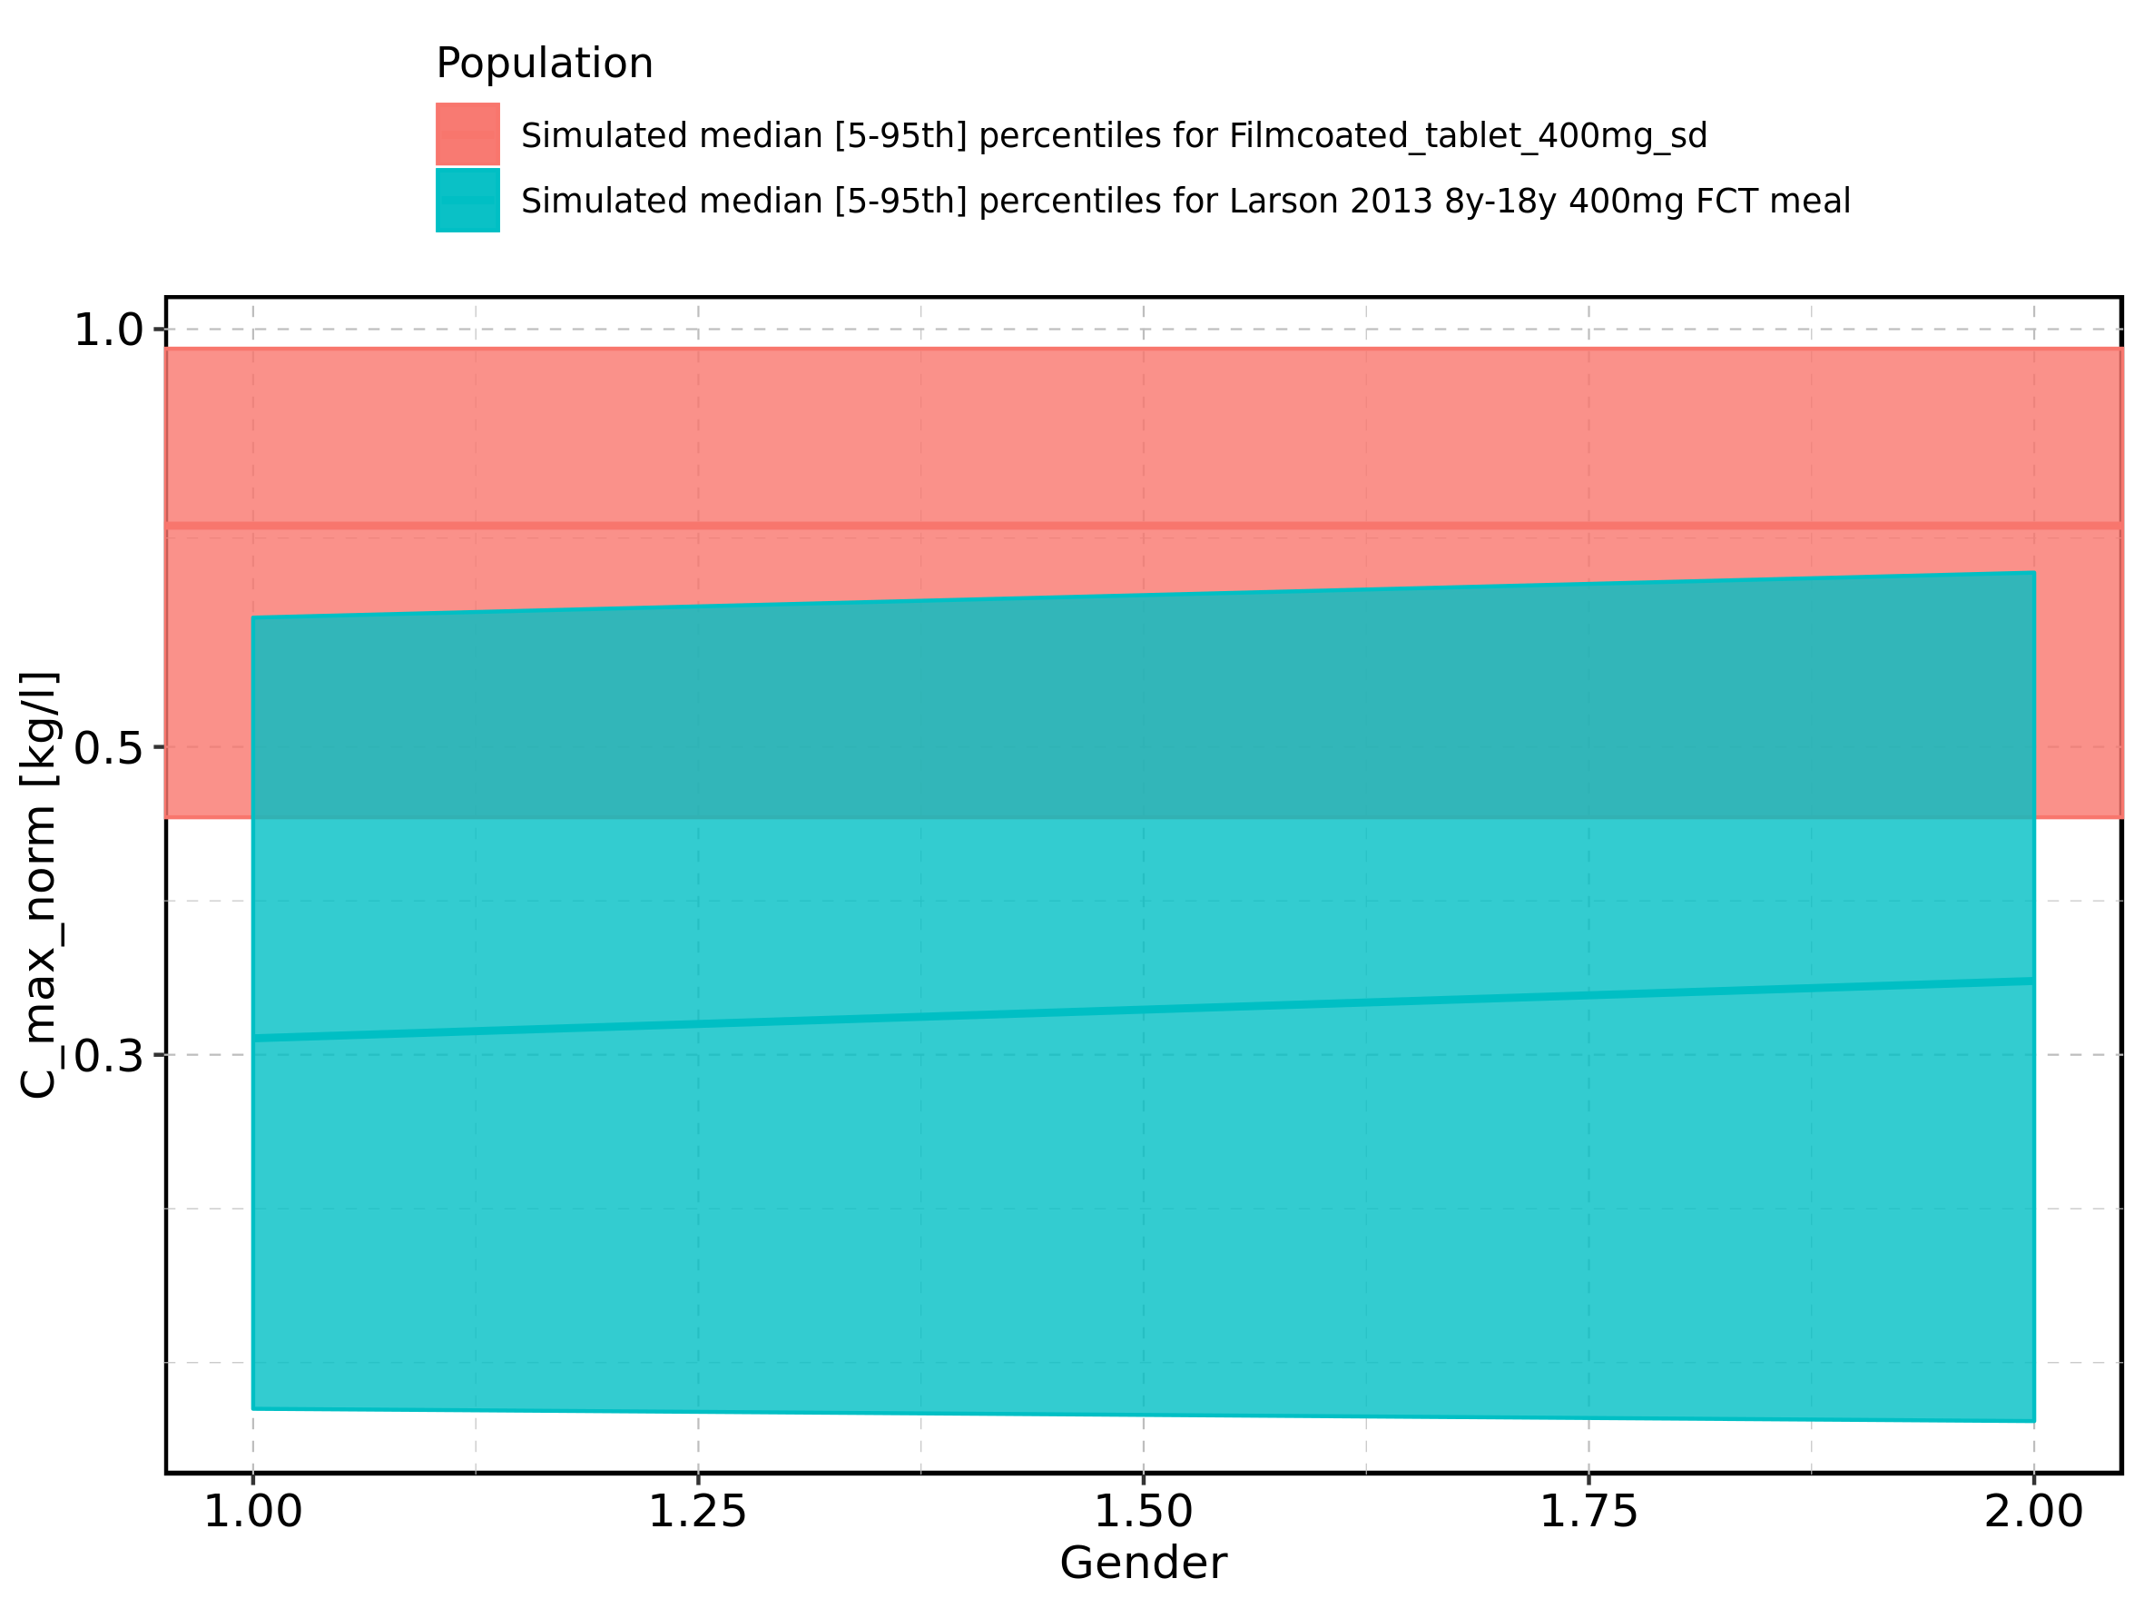

Figure 61: Gender-dependence of C_max_norm for Larson 2013 8y-18y 400mg FCT meal. Profiles are plotted in a linear scale.

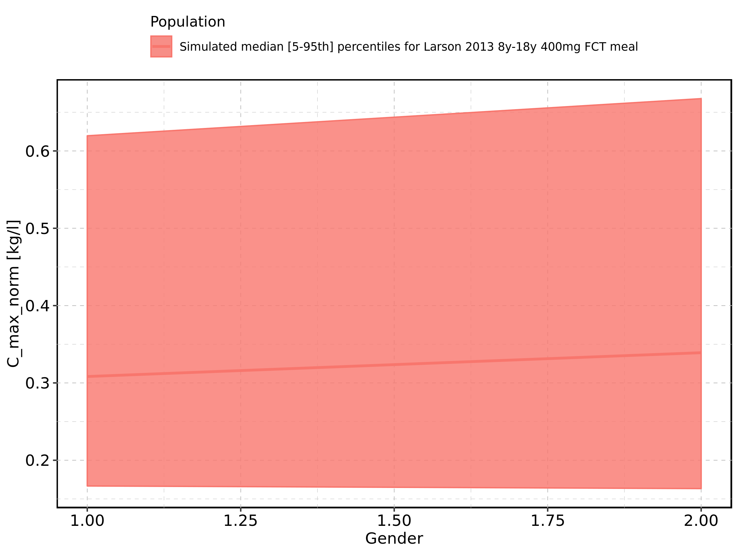

Figure 62: Gender-dependence of C_max_norm for Larson 2013 8y-18y 400mg FCT meal. Profiles are plotted in a logarithmic scale.

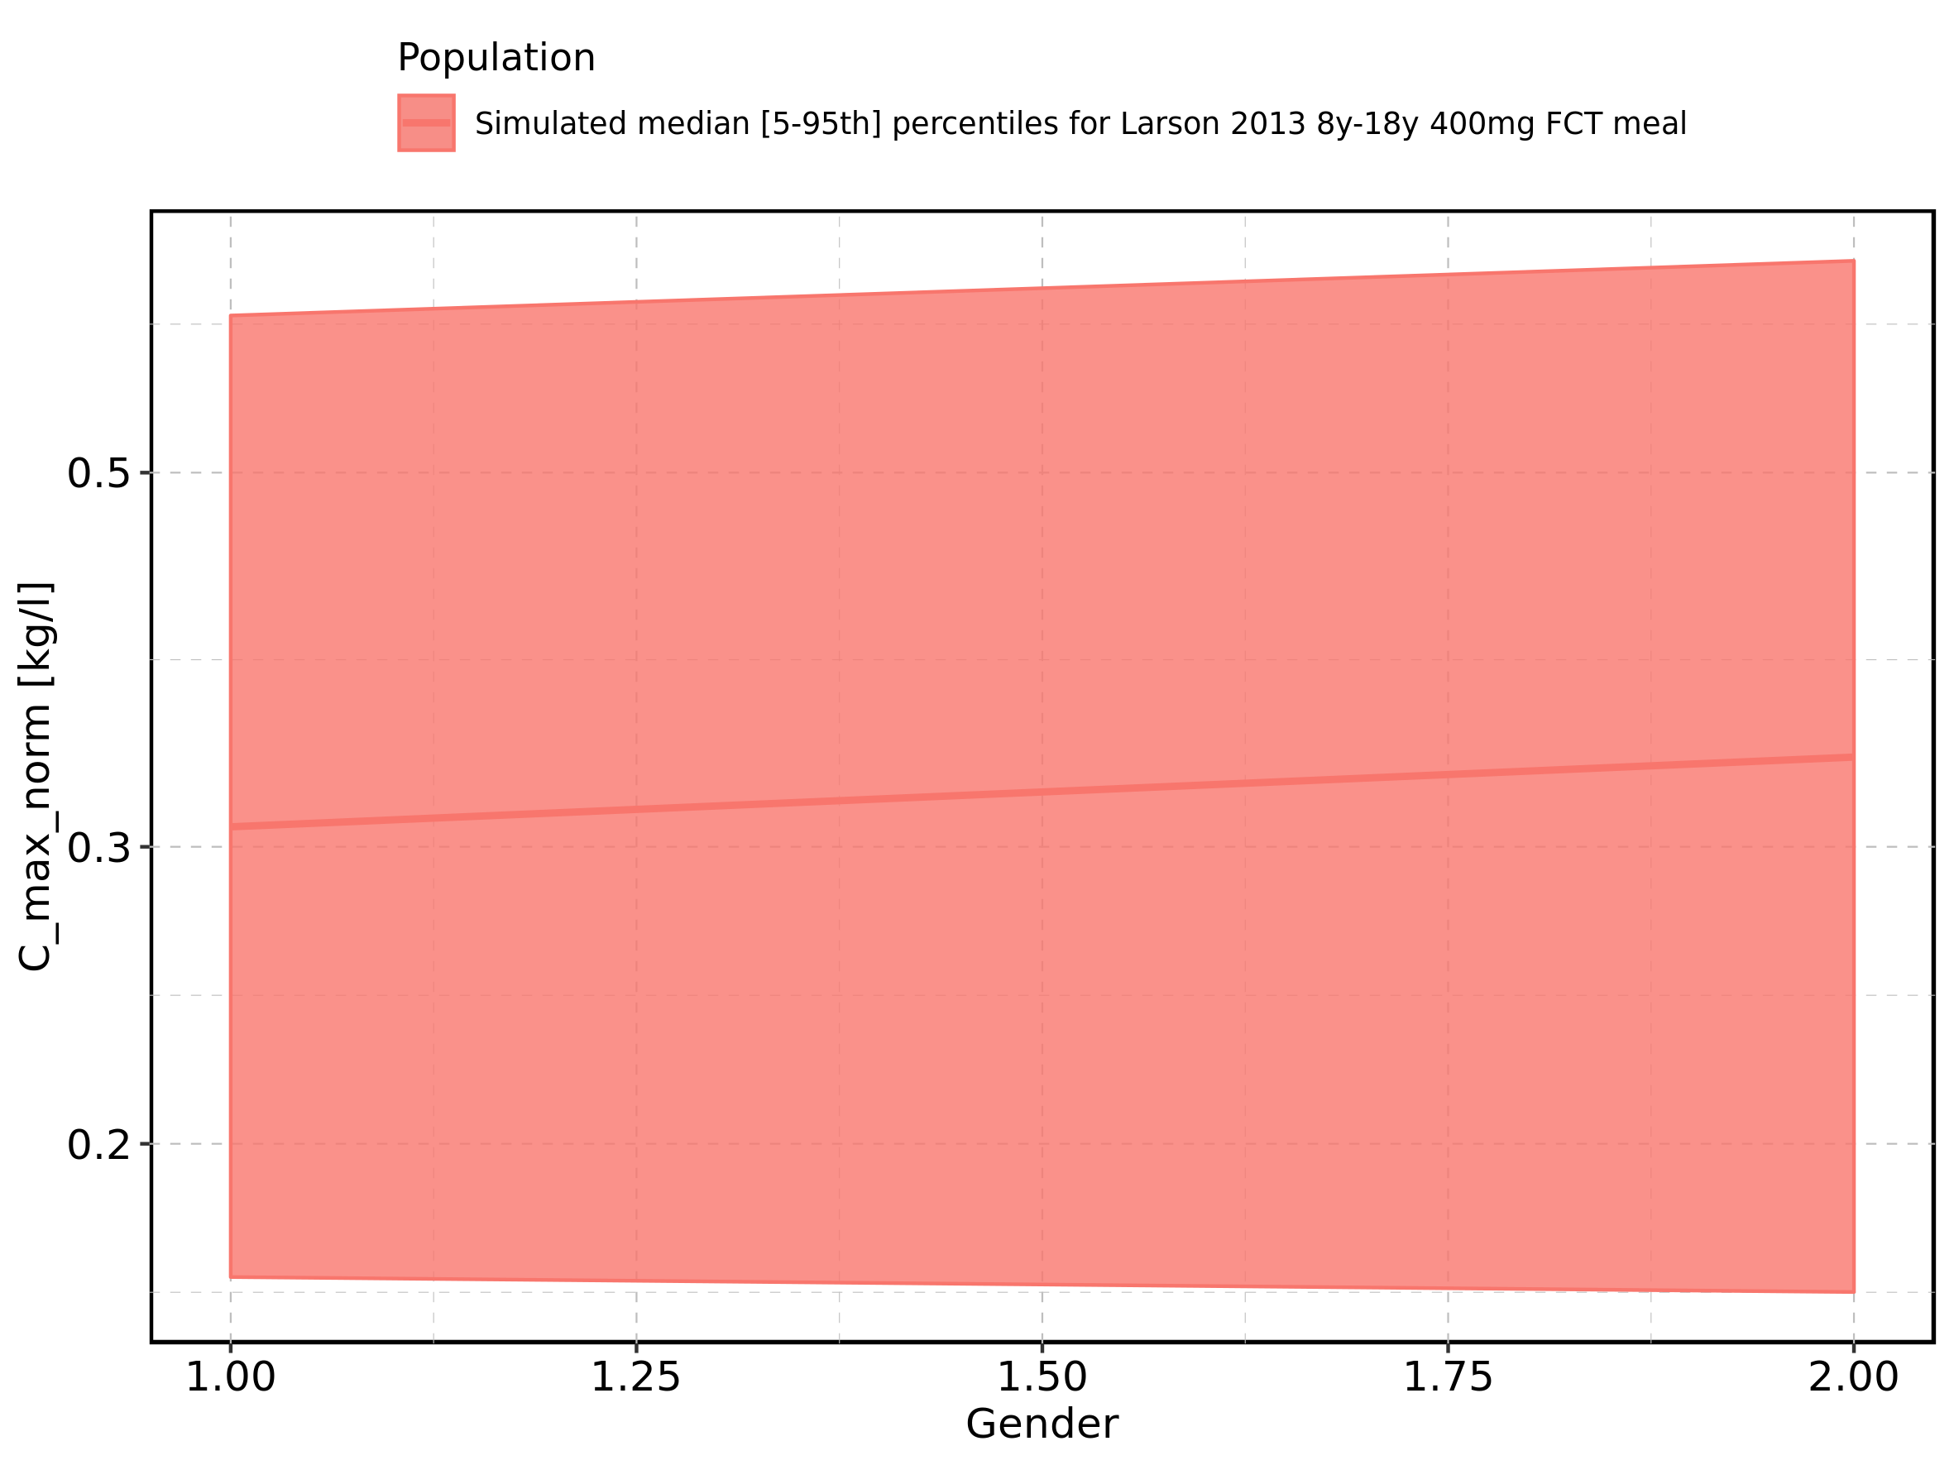

Figure 63: Gender-dependence of C_max_norm for Filmcoated_tablet_400mg_sd. Profiles are plotted in a linear scale.

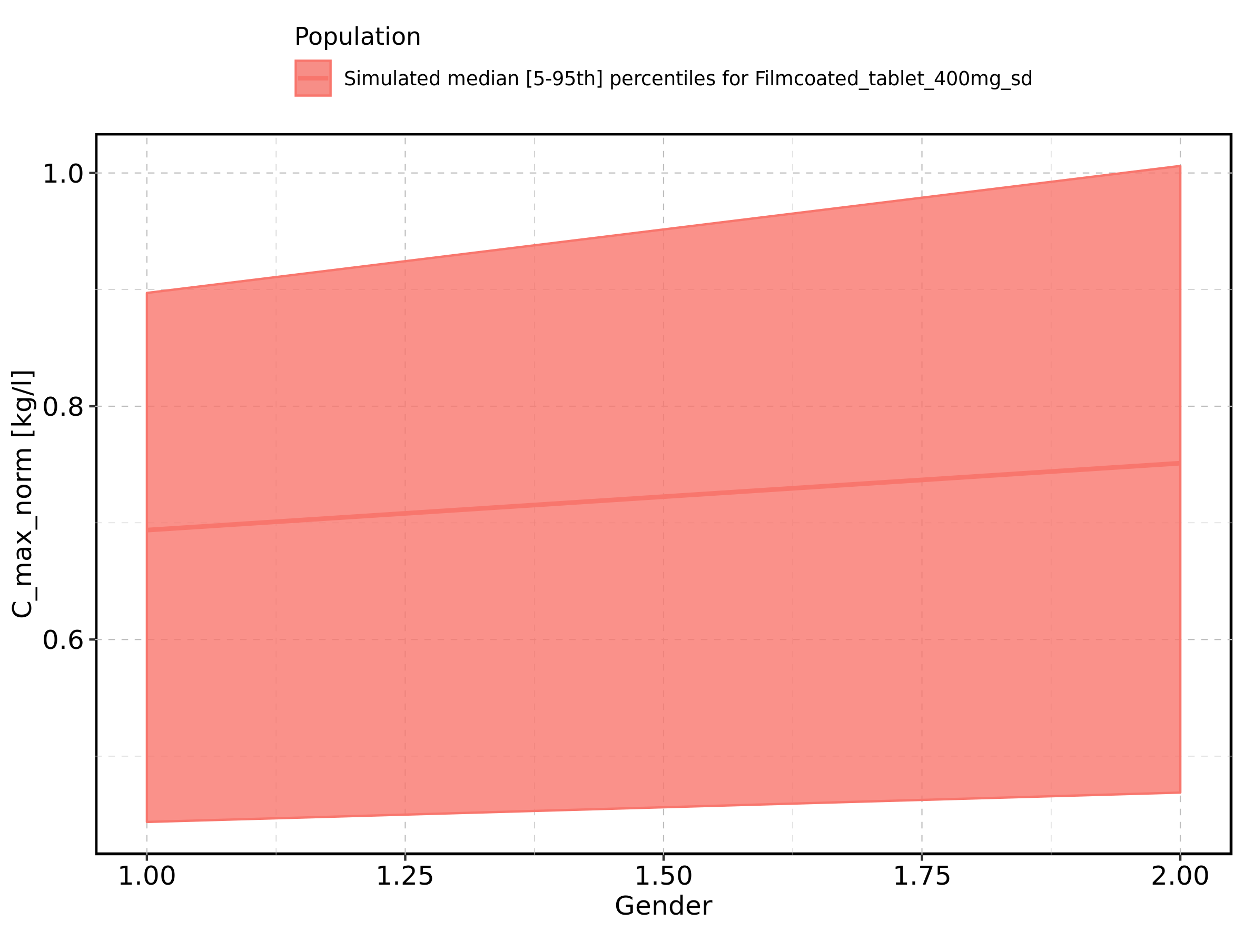

Figure 64: Gender-dependence of C_max_norm for Filmcoated_tablet_400mg_sd. Profiles are plotted in a logarithmic scale.

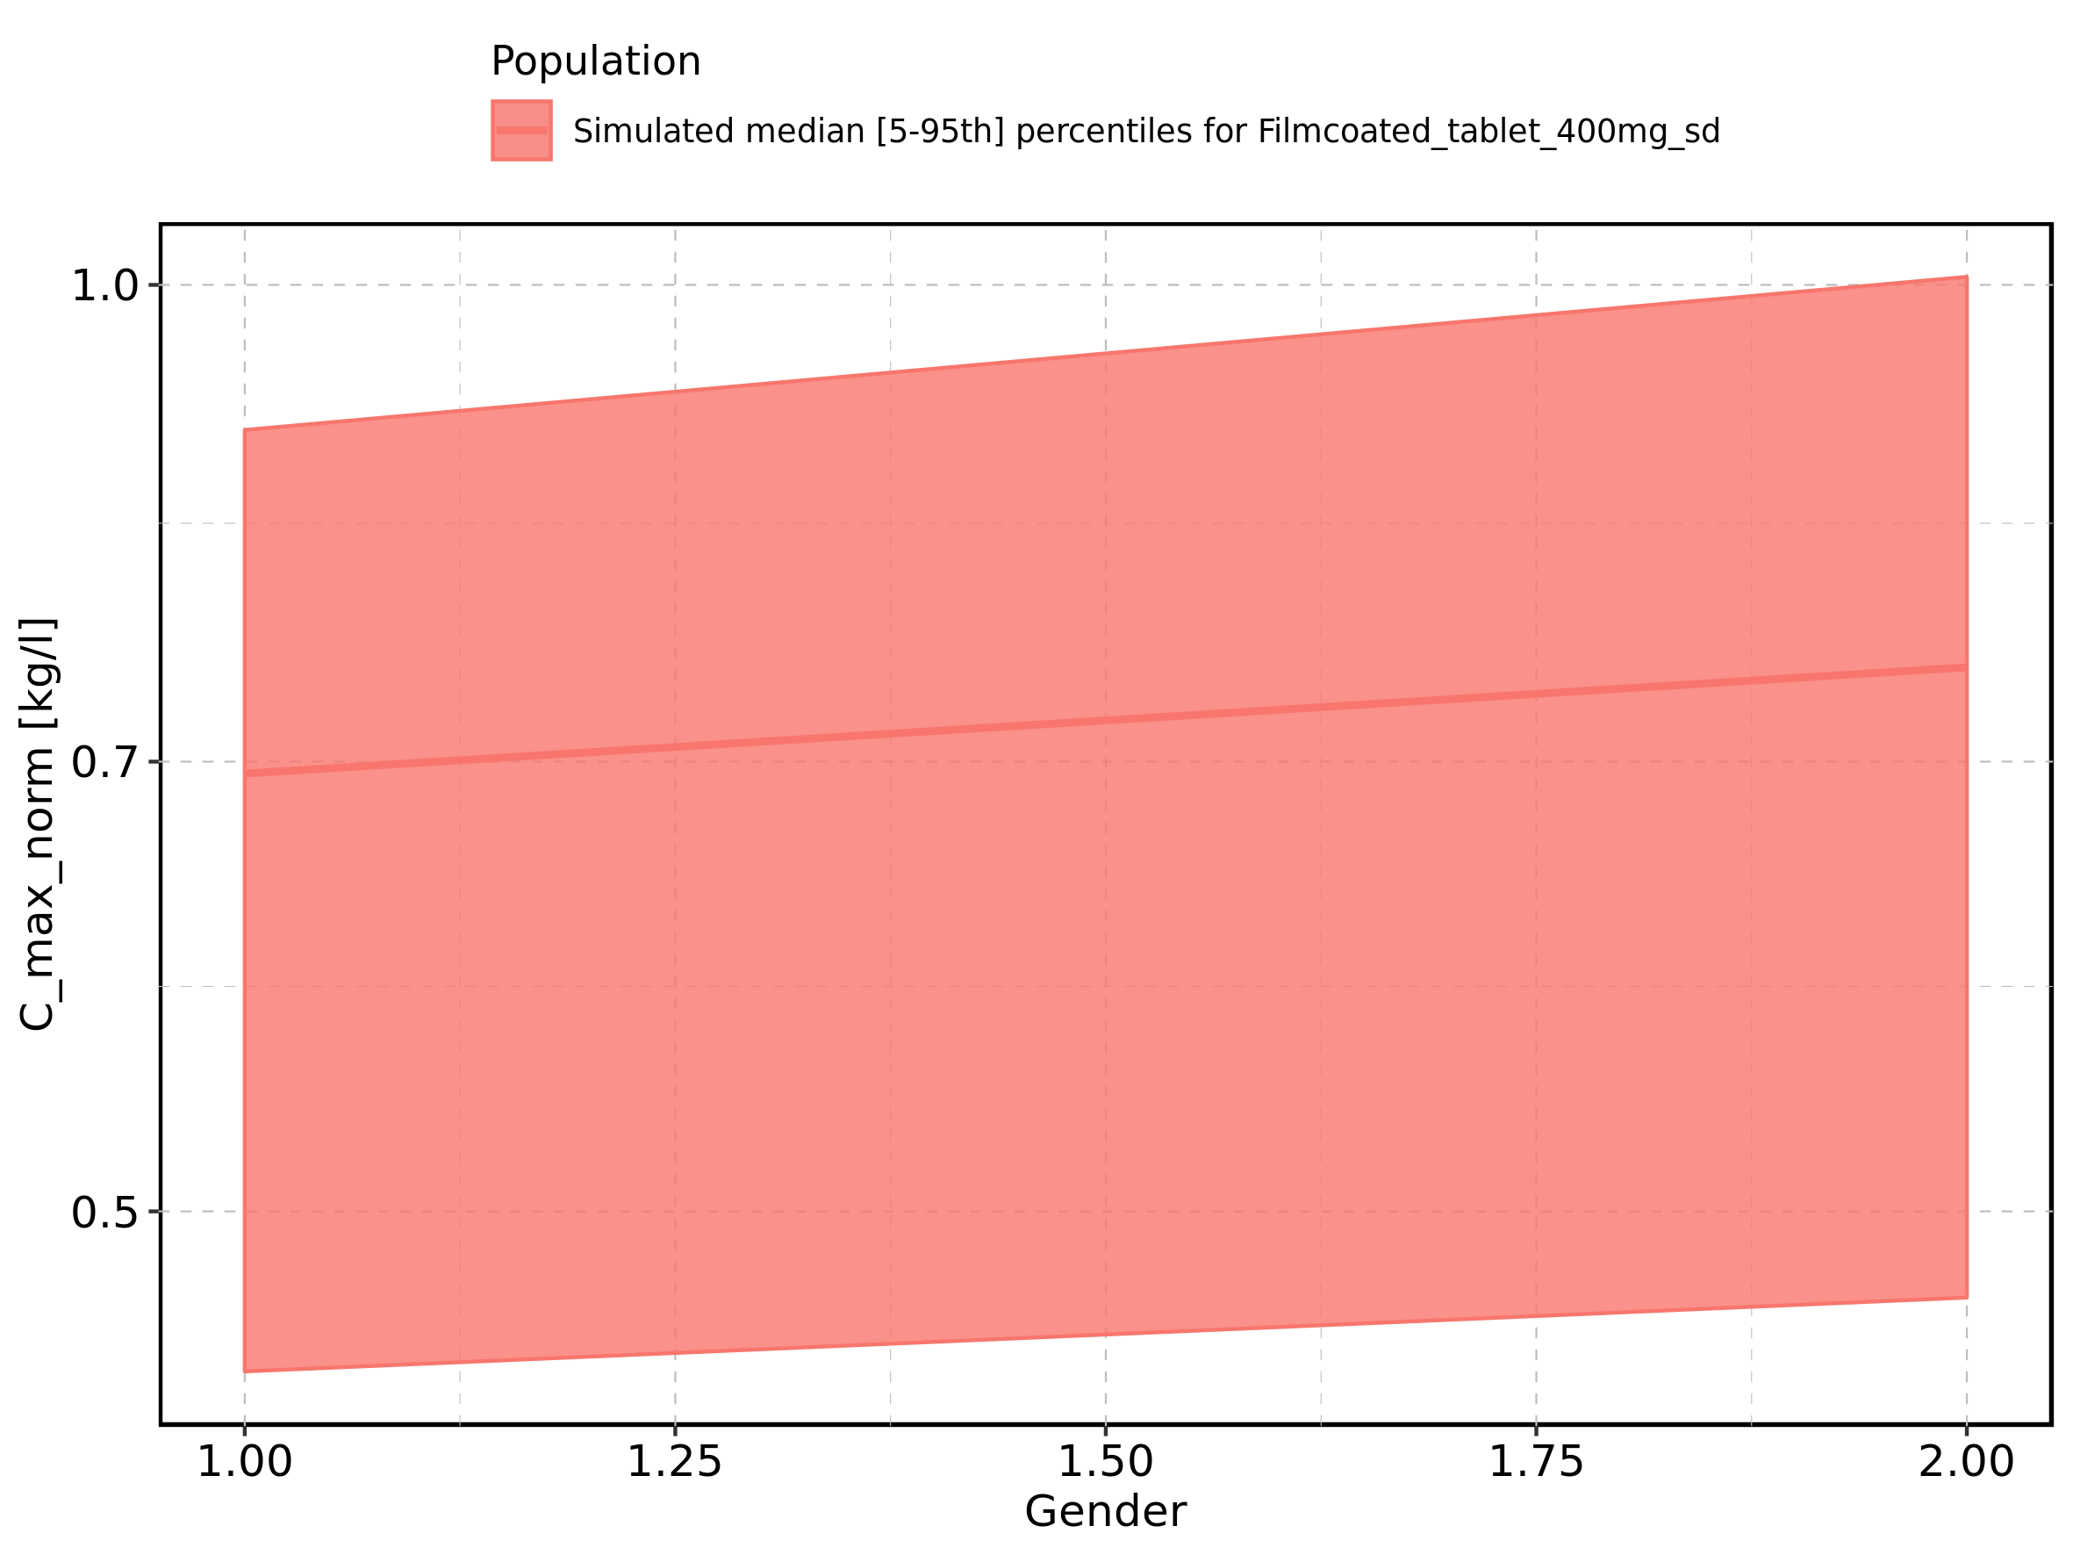

Figure 65: t_max of Raltegravir shown as box-whisker plot, which indicates the 5th, 25th, 50th, 75th, and 95th percentiles in linear scale.

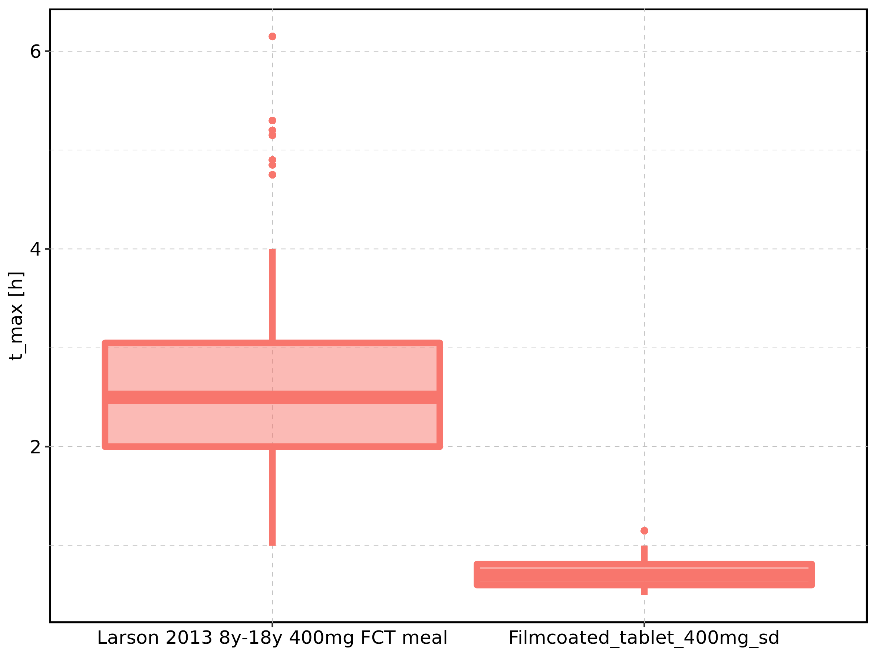

|  |  |  |  |  |  |  |  |  |  |  |
| --- | --- | --- | --- | --- | --- | --- | --- | --- | --- | --- |
| Population | N | 5th percentile | 25th percentile | 50th percentile | 75th percentile | 95th percentile | mean | standard deviation | geo mean | geo standard deviation |
| Larson 2013 8y-18y 400mg FCT meal | 500 | 0.9975 | 2.0 | 2.5 | 3.0500 | 4 | 2.5419 | 0.8782893 | 2.3720858 | 1.485027 |
| Filmcoated_tablet_400mg_sd | 100 | 0.5000 | 0.6 | 0.7 | 0.8125 | 1 | 0.7290 | 0.1516209 | 0.7135402 | 1.232465 |

Figure 66: t_max of Raltegravir shown as box-whisker plot, which indicates the 5th, 25th, 50th, 75th, and 95th percentiles in logarithmic scale.

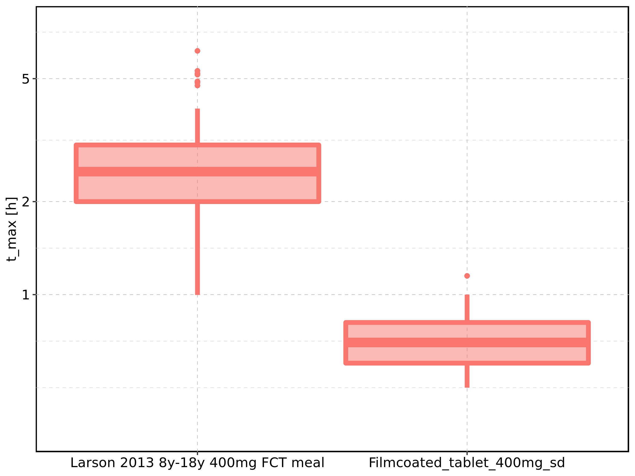

Figure 67: Age-dependence of t_max for Larson 2013 8y-18y 400mg FCT meal in comparison to Filmcoated_tablet_400mg_sd. Profiles are plotted in a linear scale.

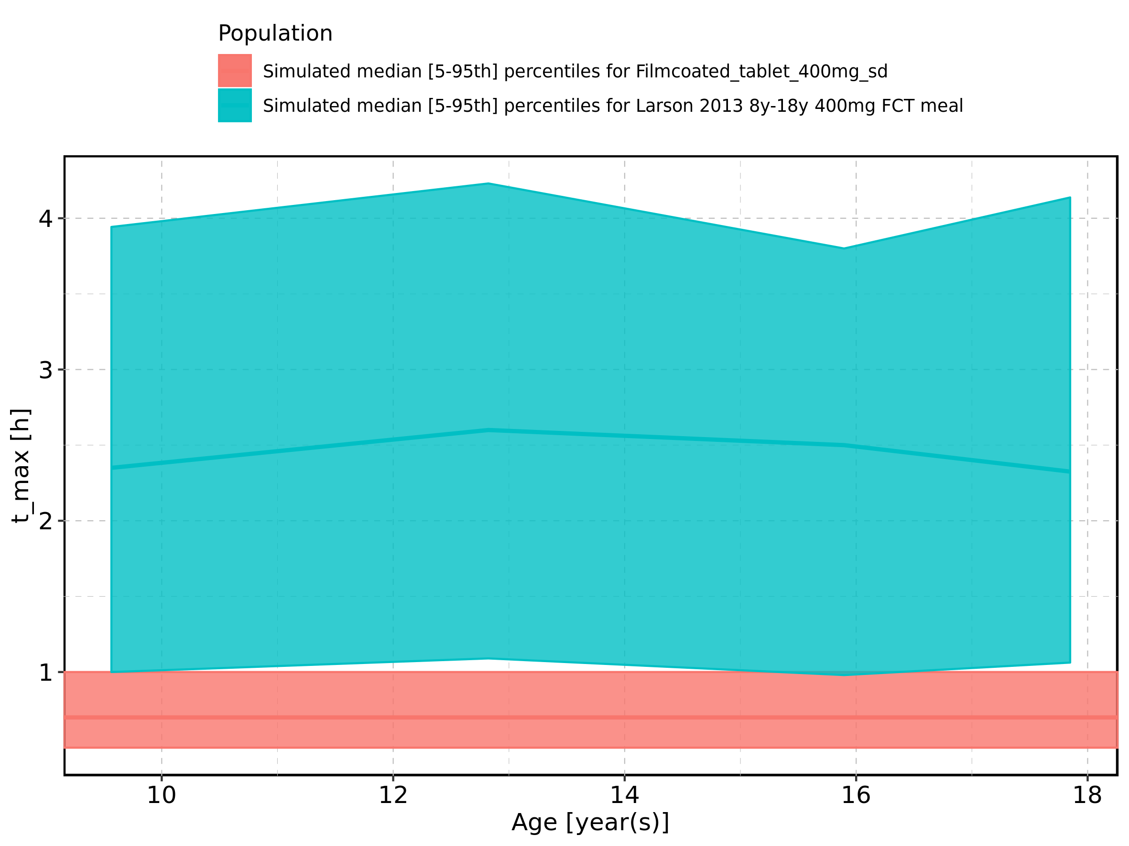

Figure 68: Age-dependence of t_max for Larson 2013 8y-18y 400mg FCT meal in comparison to Filmcoated_tablet_400mg_sd. Profiles are plotted in a logarithmic scale.

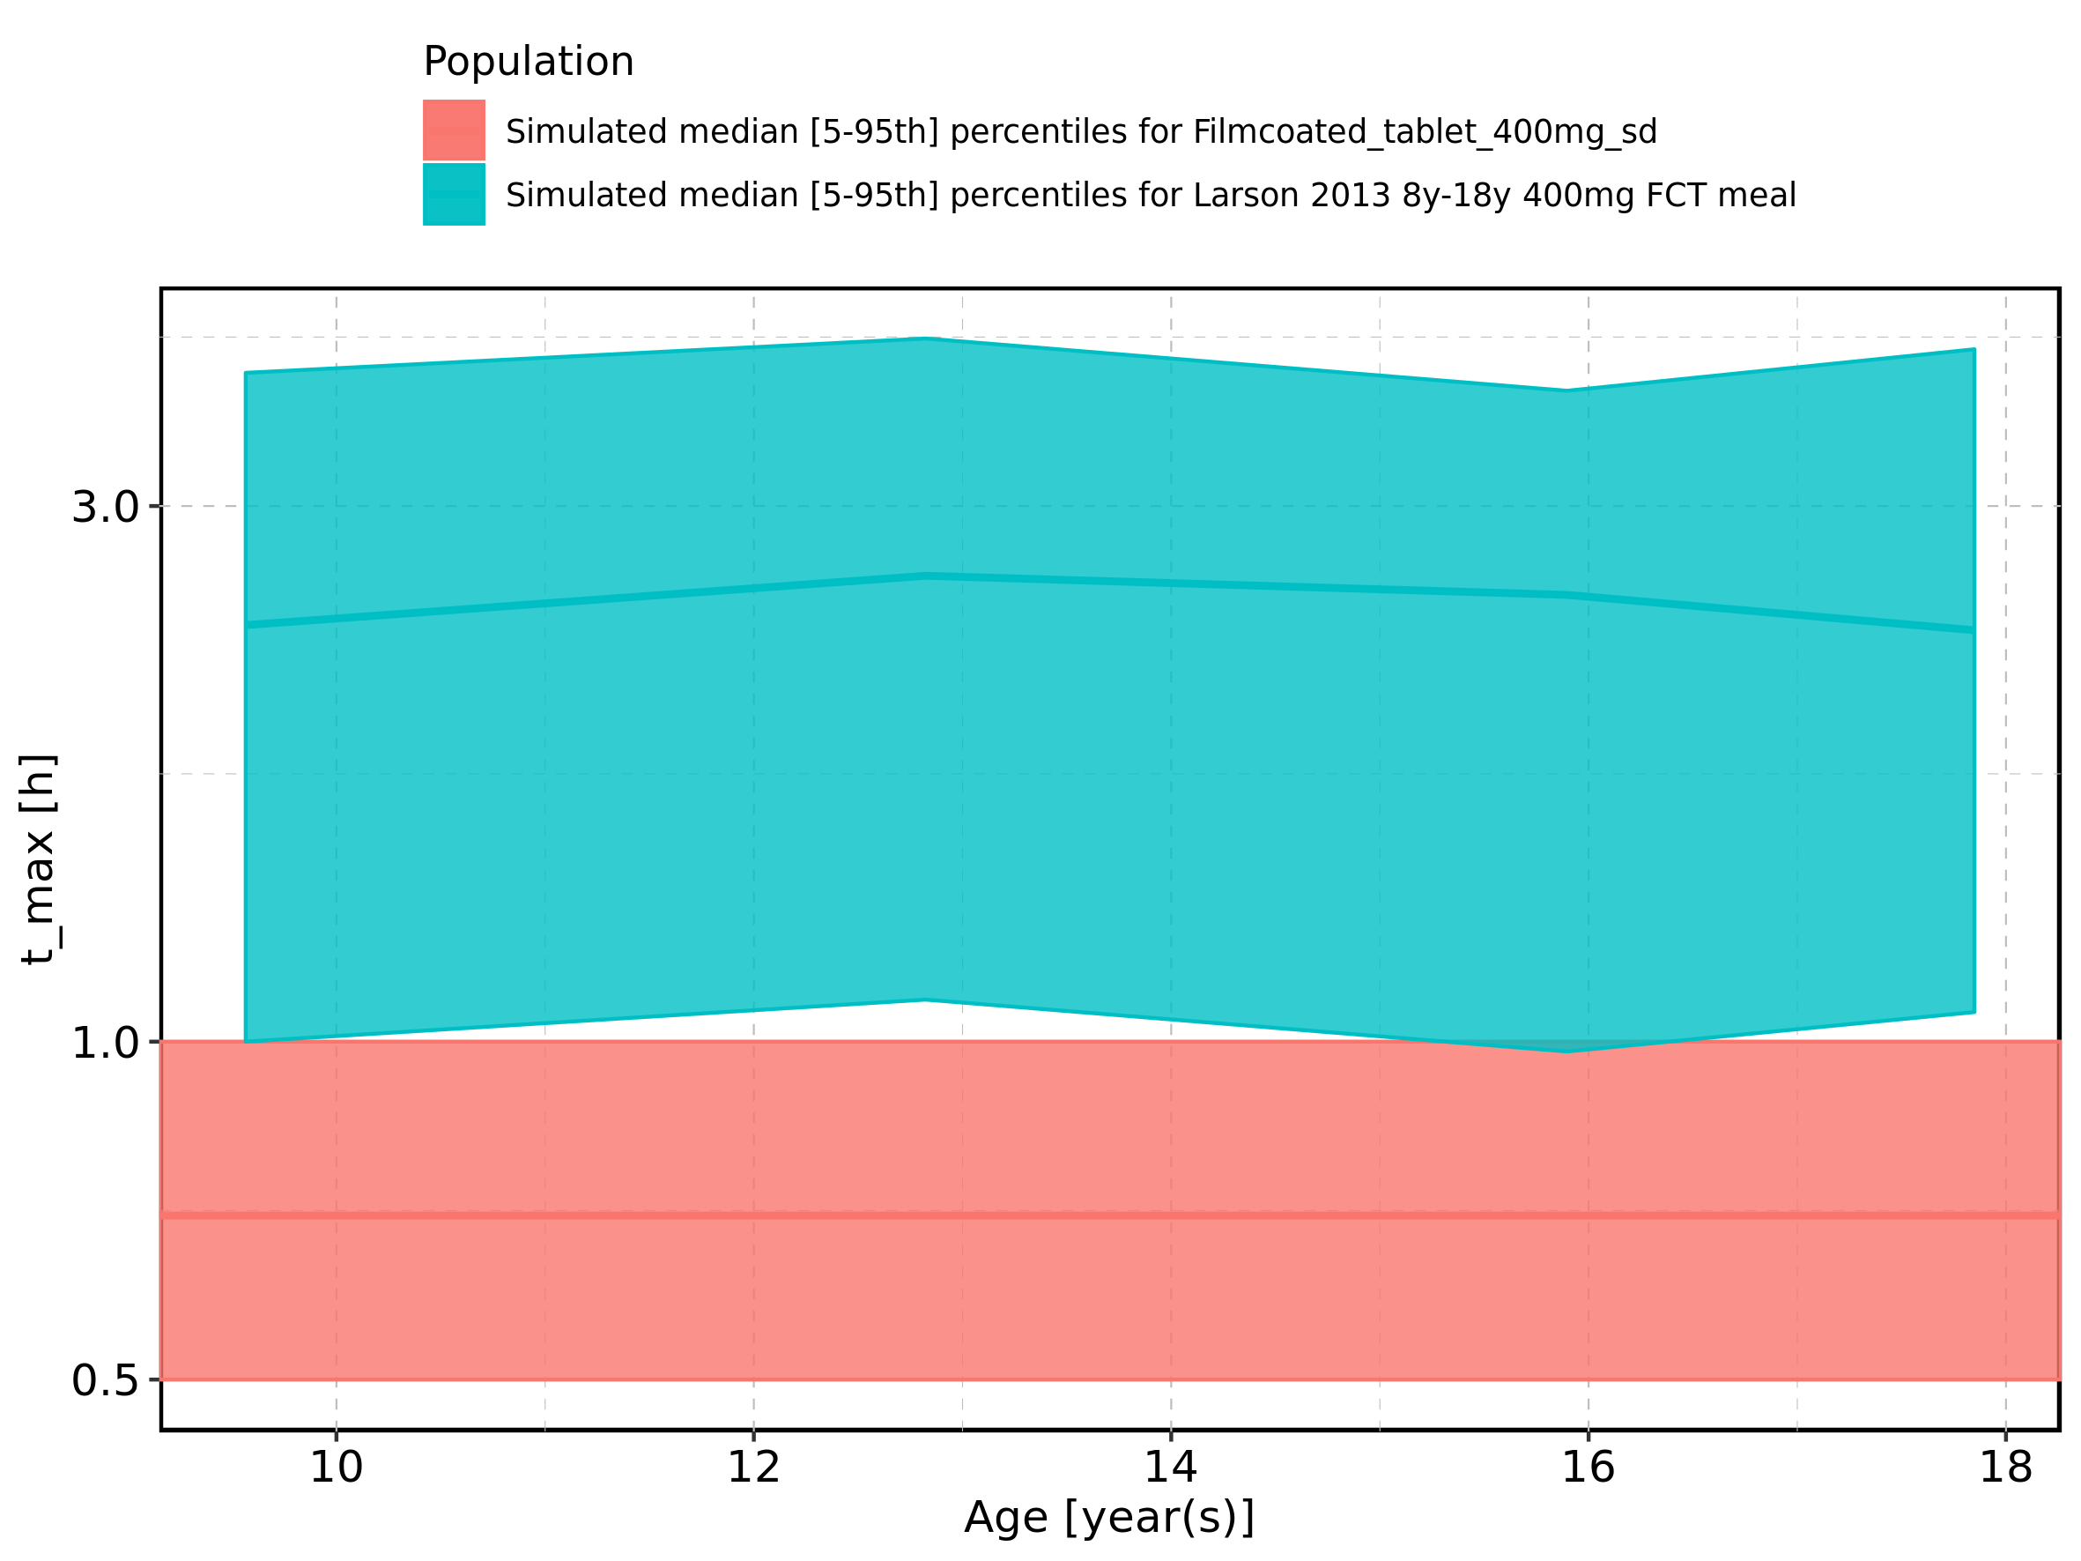

Figure 69: Age-dependence of t_max for Larson 2013 8y-18y 400mg FCT meal. Profiles are plotted in a linear scale.

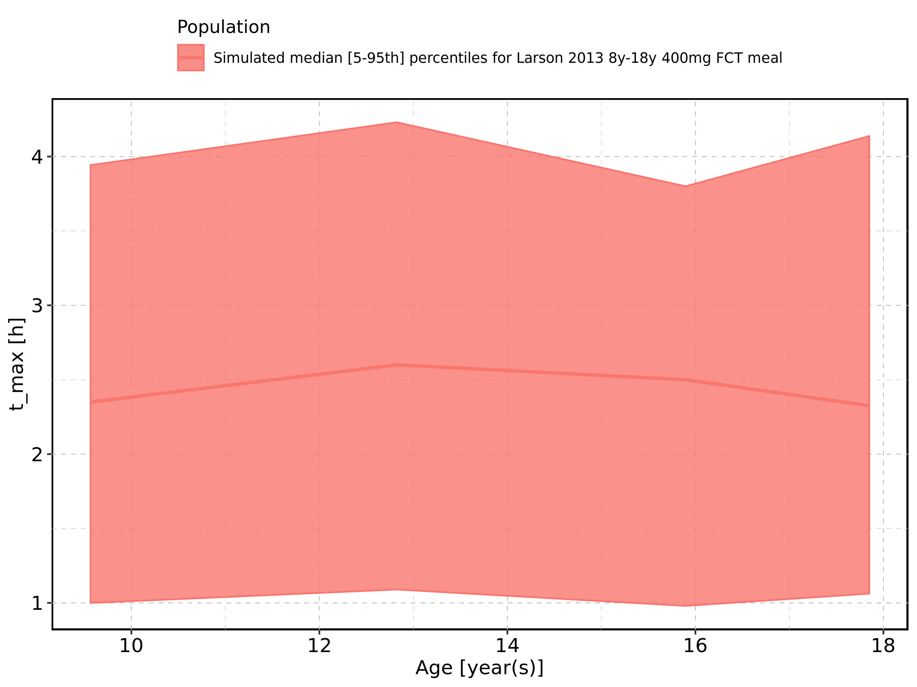

Figure 70: Age-dependence of t_max for Larson 2013 8y-18y 400mg FCT meal. Profiles are plotted in a logarithmic scale.

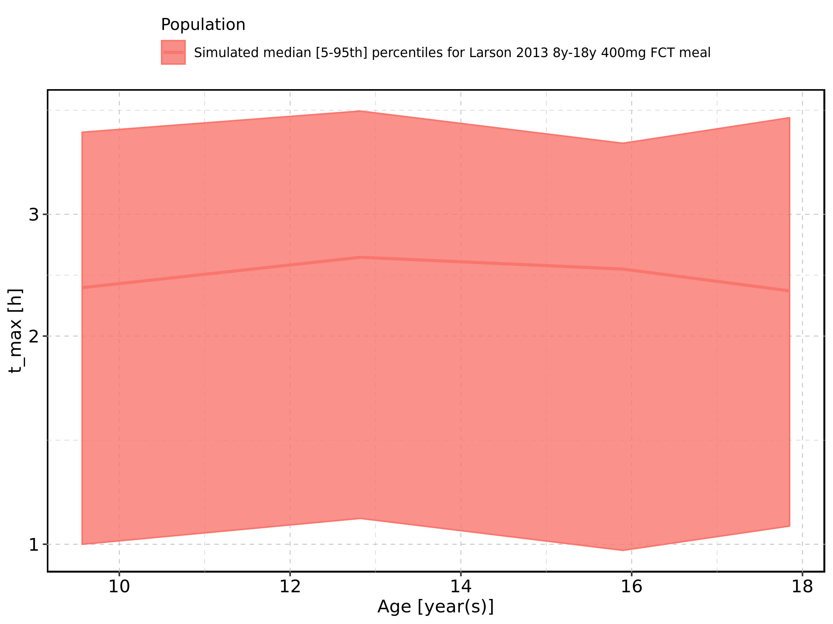

Figure 71: Age-dependence of t_max for Filmcoated_tablet_400mg_sd. Profiles are plotted in a linear scale.

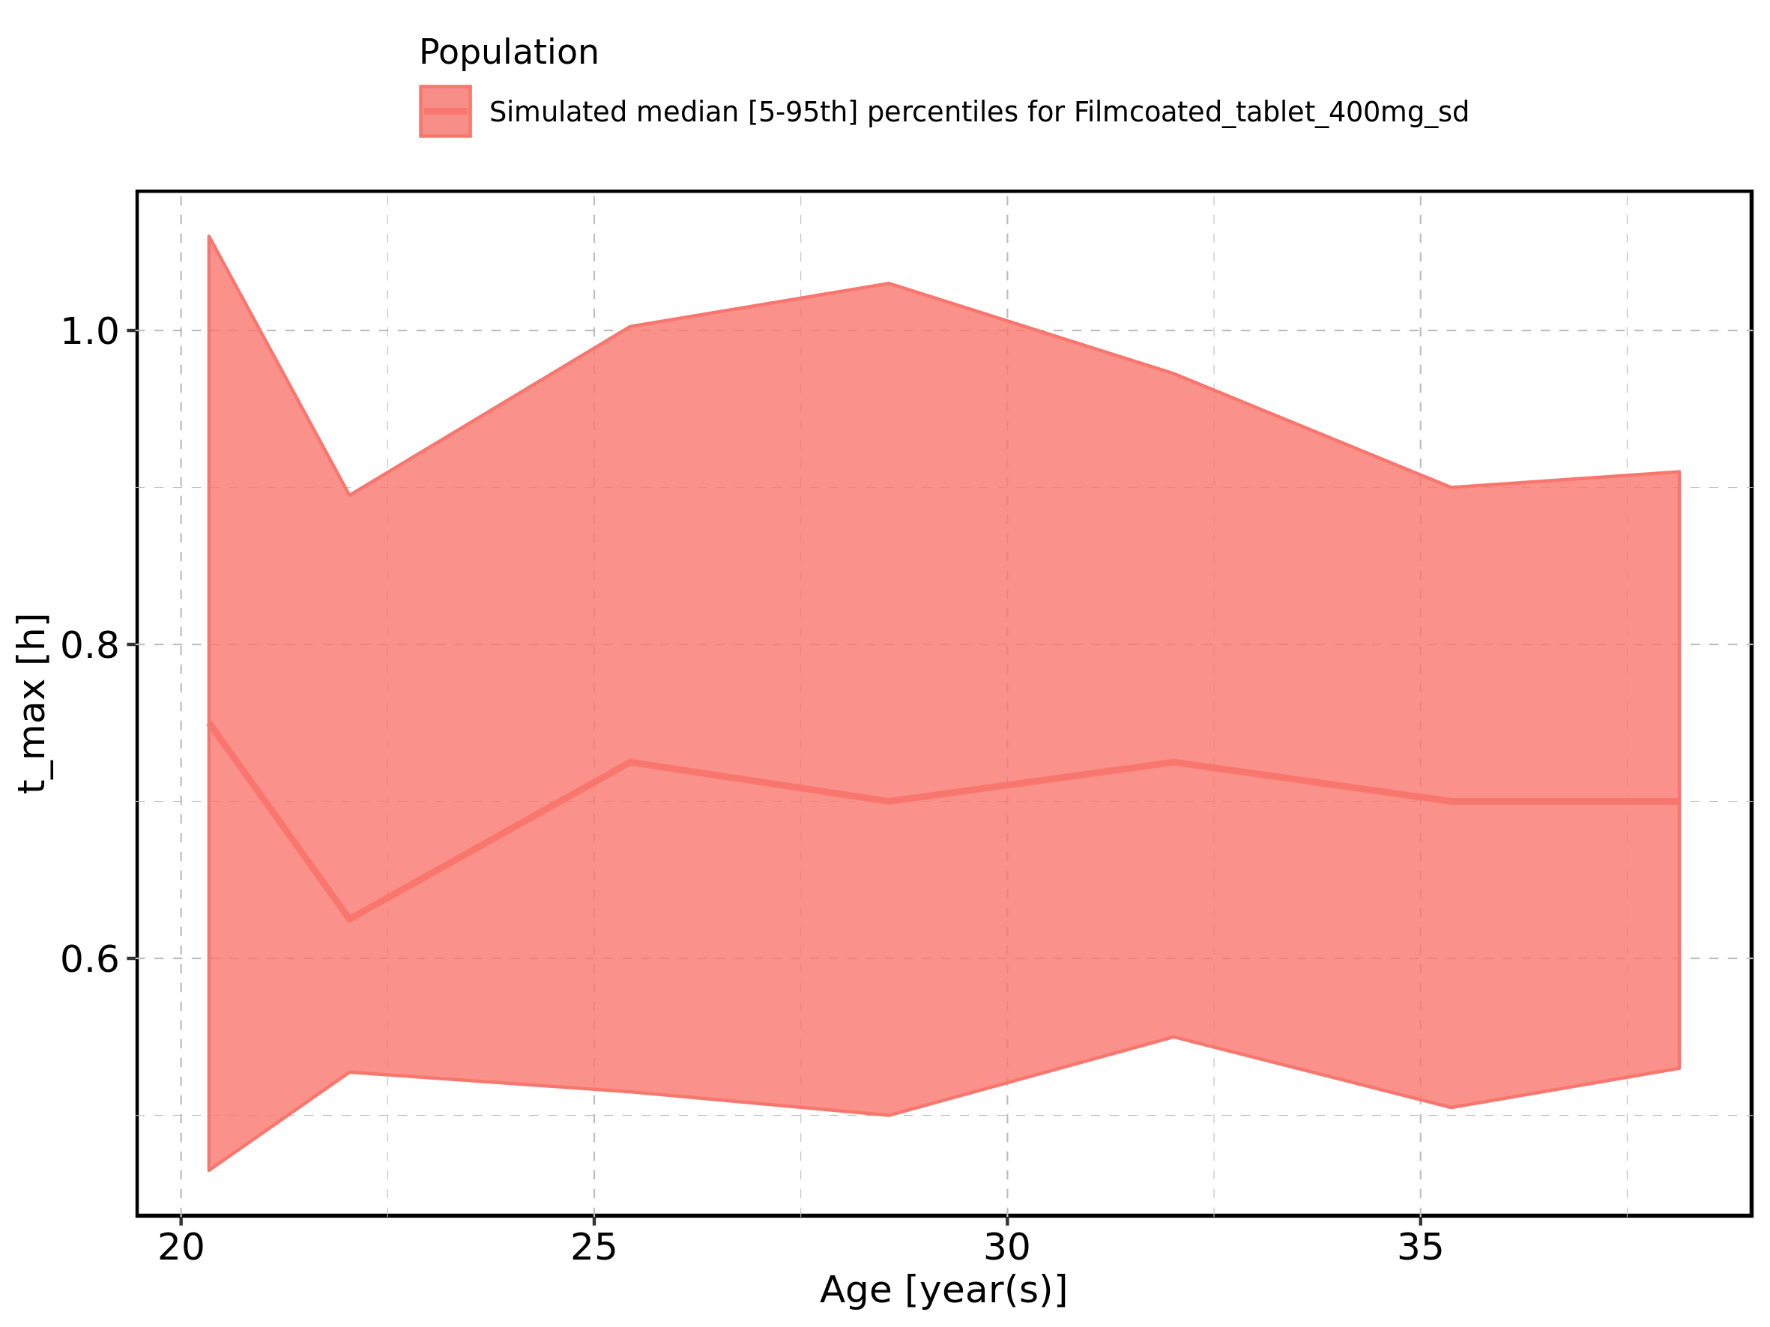

Figure 72: Age-dependence of t_max for Filmcoated_tablet_400mg_sd. Profiles are plotted in a logarithmic scale.

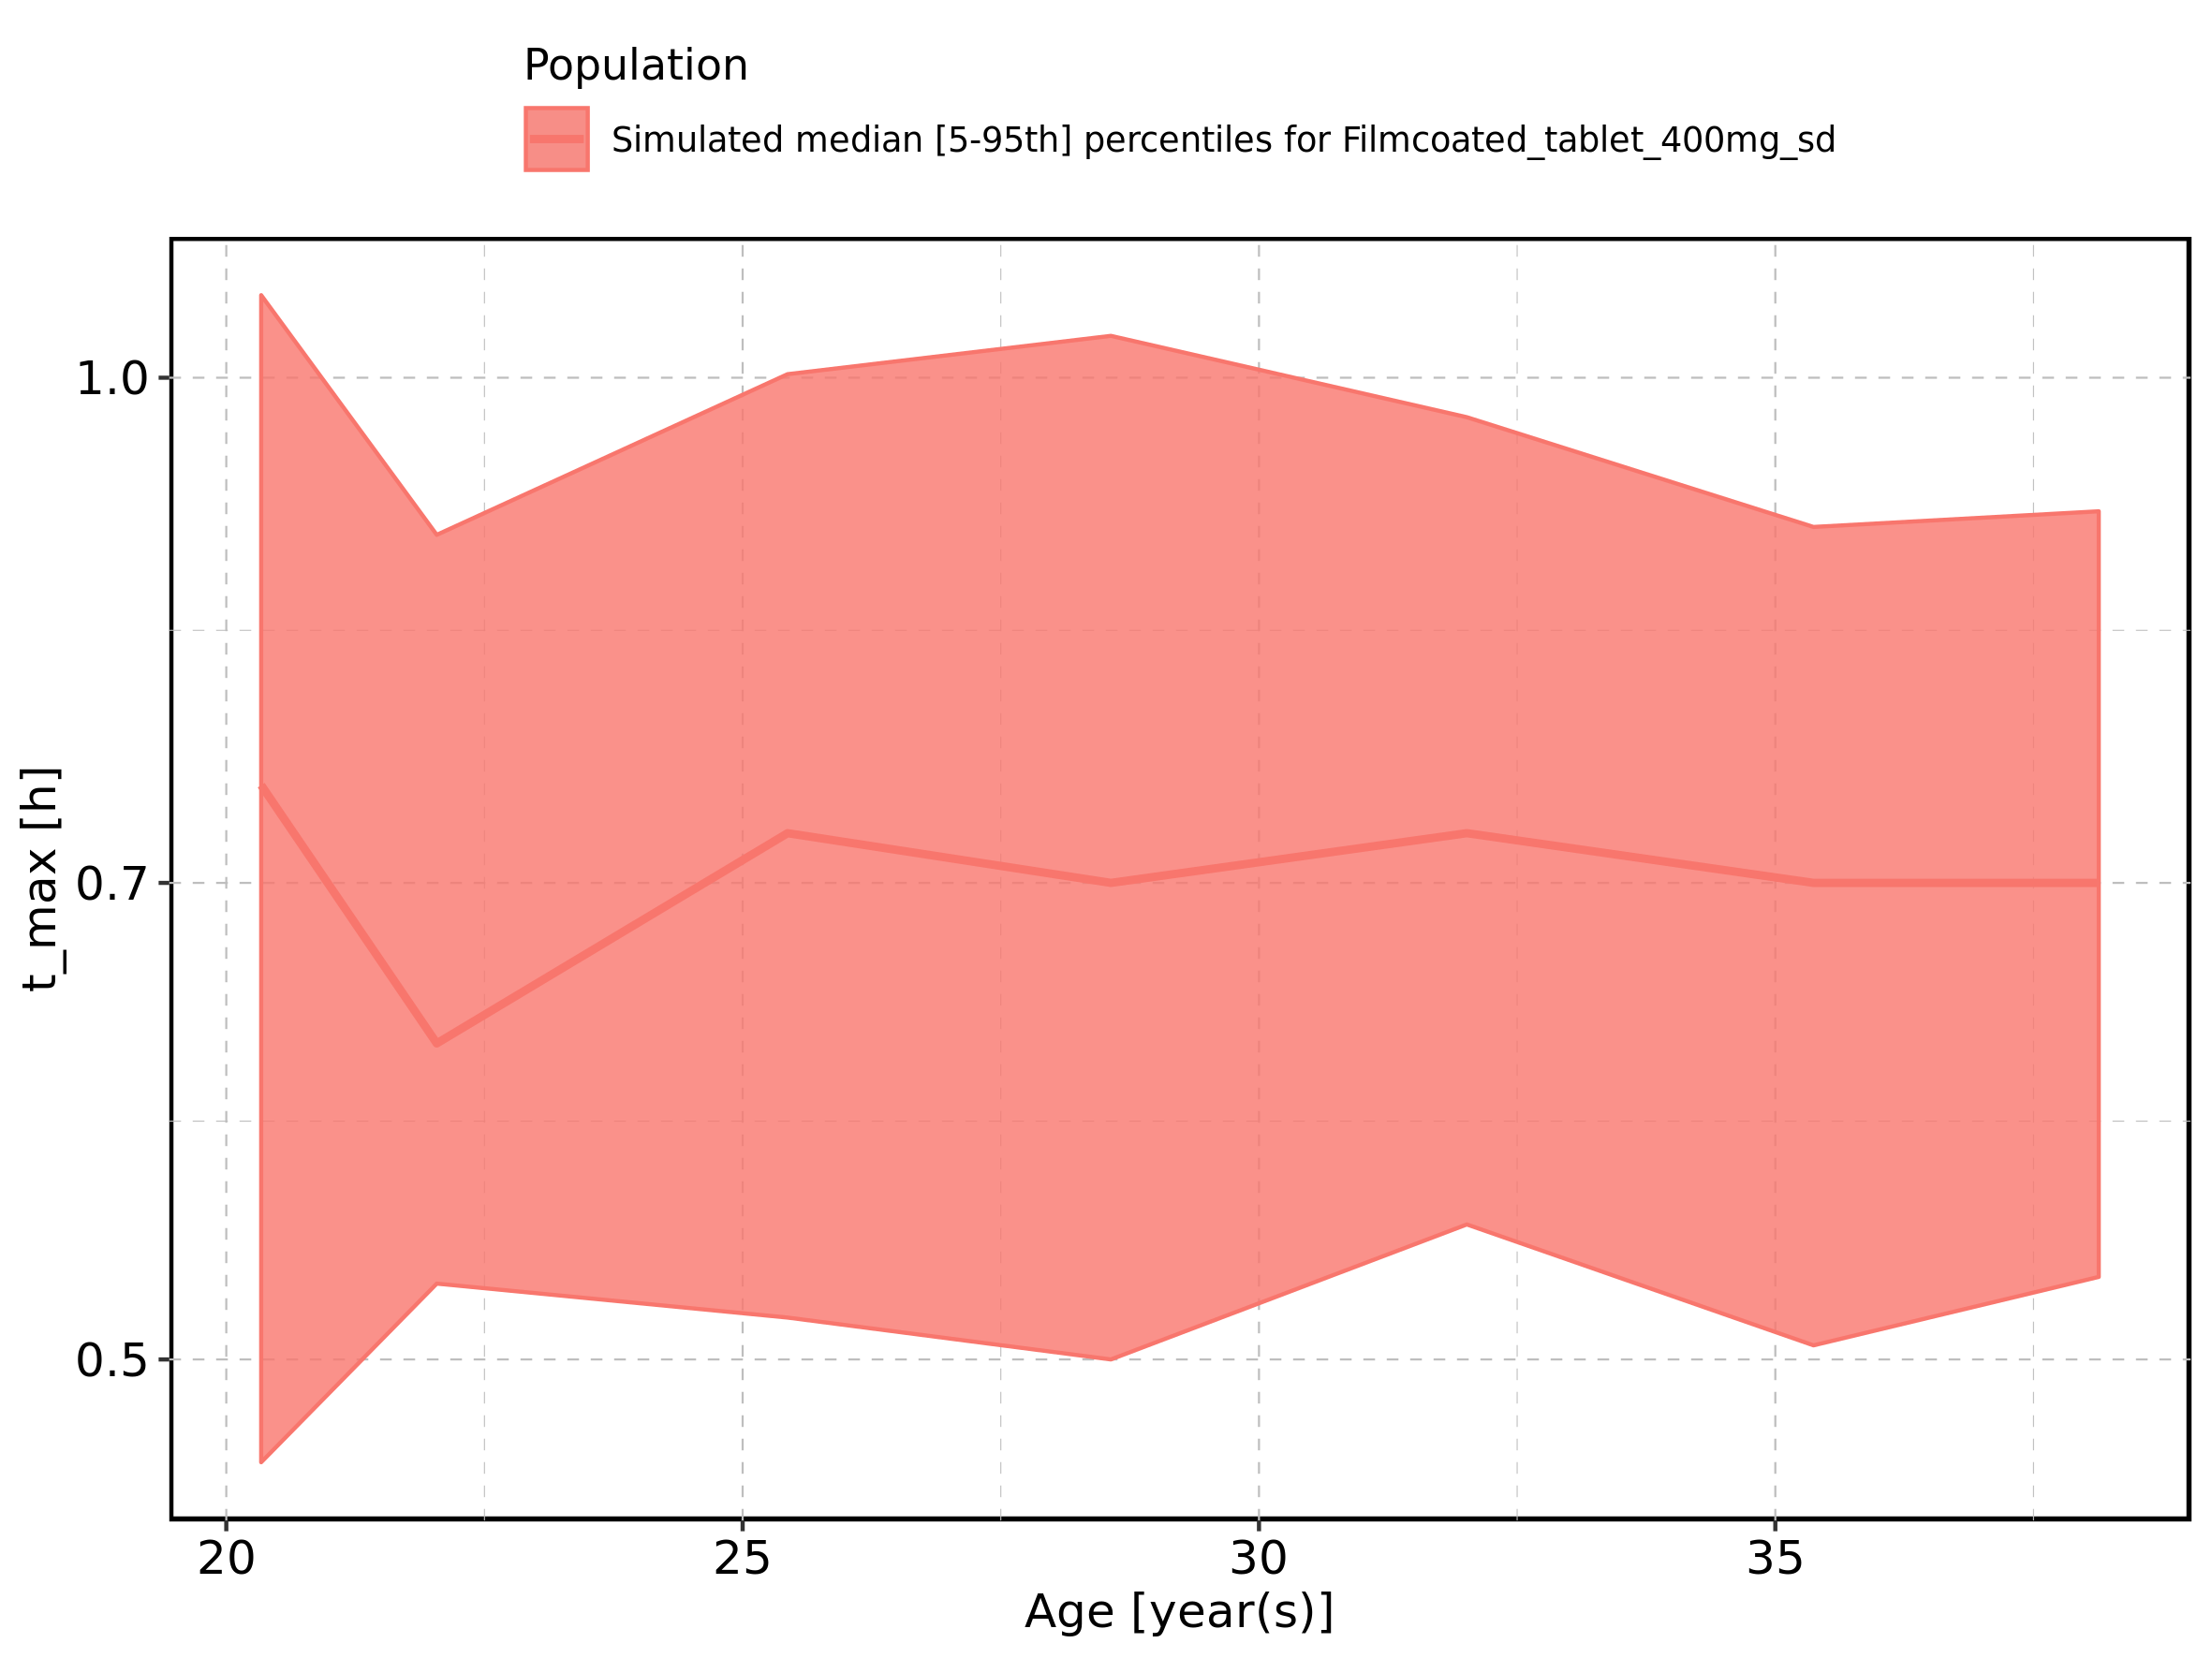

Figure 73: Height-dependence of t_max for Larson 2013 8y-18y 400mg FCT meal in comparison to Filmcoated_tablet_400mg_sd. Profiles are plotted in a linear scale.

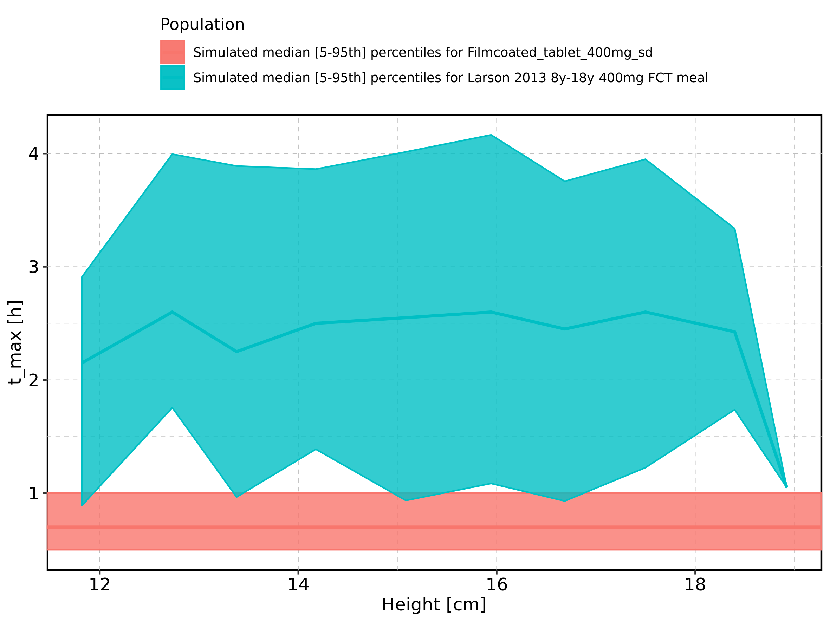

Figure 74: Height-dependence of t_max for Larson 2013 8y-18y 400mg FCT meal in comparison to Filmcoated_tablet_400mg_sd. Profiles are plotted in a logarithmic scale.

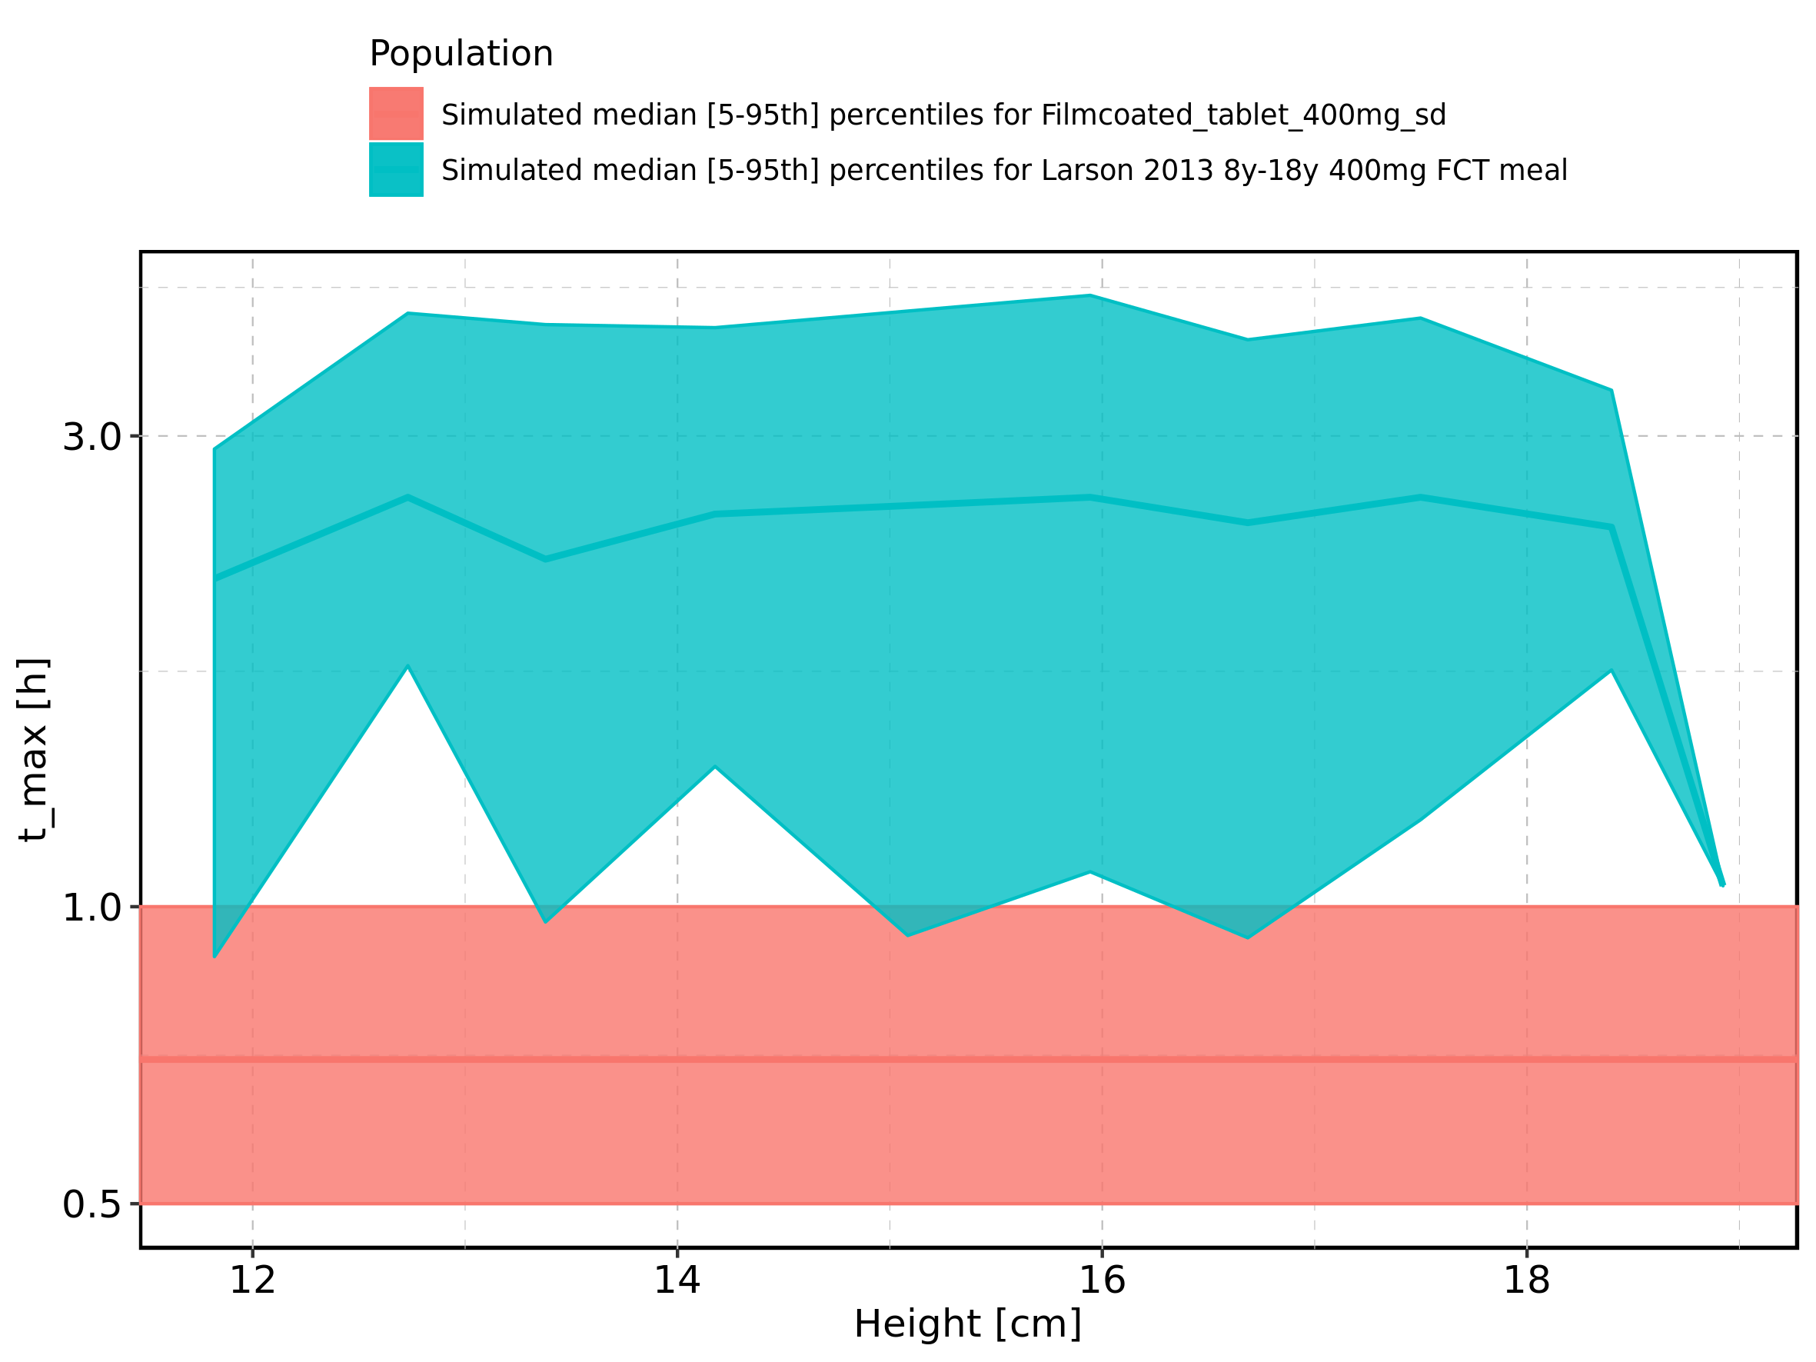

Figure 75: Height-dependence of t_max for Larson 2013 8y-18y 400mg FCT meal. Profiles are plotted in a linear scale.

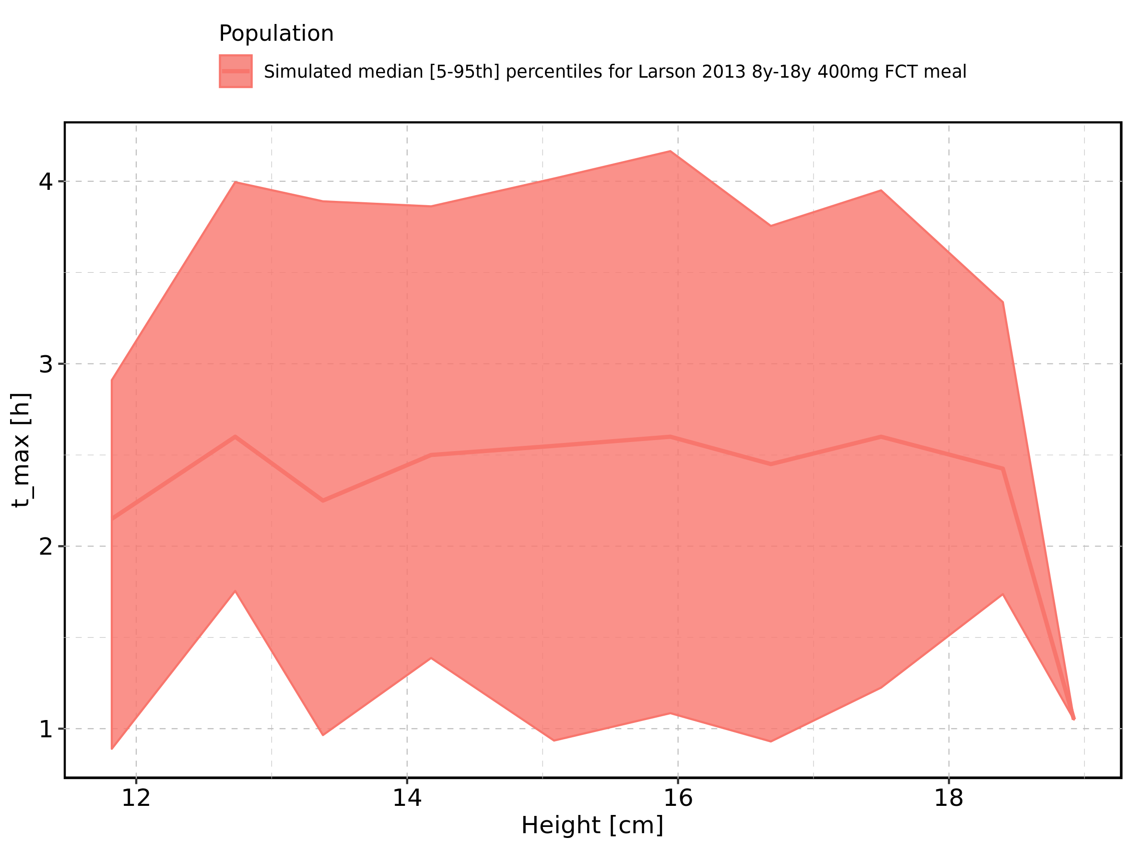

Figure 76: Height-dependence of t_max for Larson 2013 8y-18y 400mg FCT meal. Profiles are plotted in a logarithmic scale.

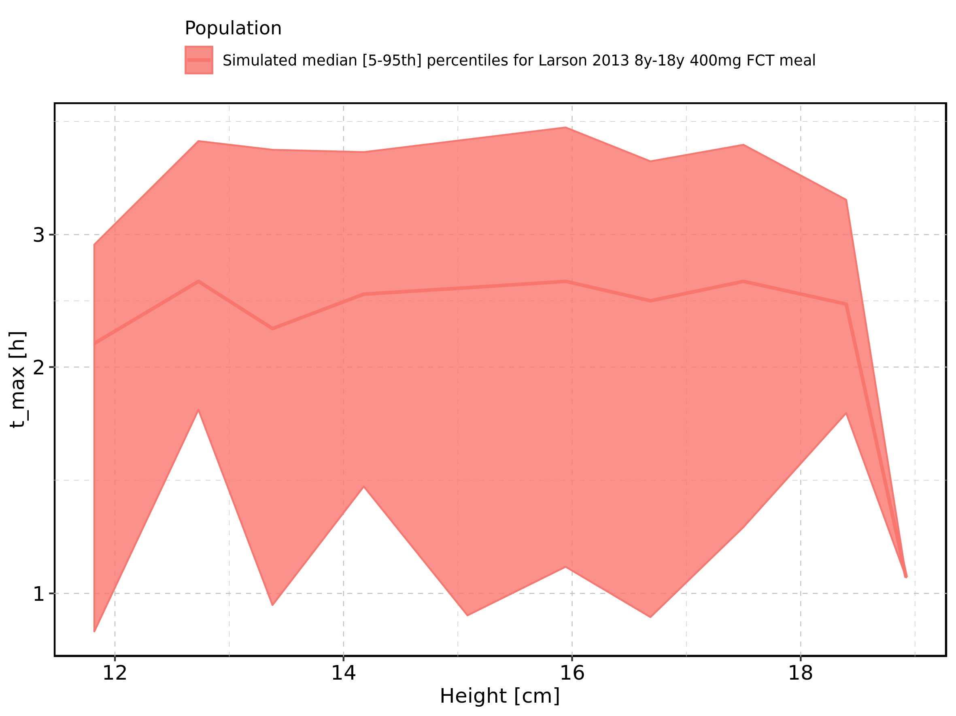

Figure 77: Height-dependence of t_max for Filmcoated_tablet_400mg_sd. Profiles are plotted in a linear scale.

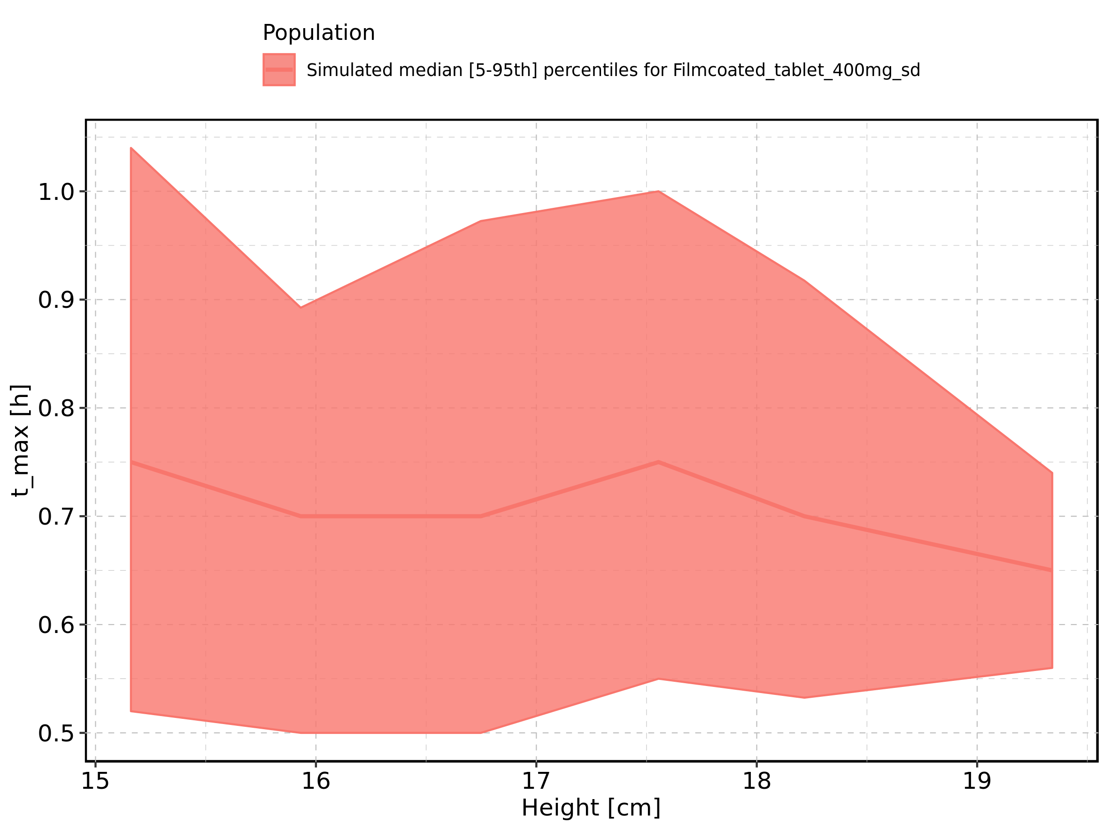

Figure 78: Height-dependence of t_max for Filmcoated_tablet_400mg_sd. Profiles are plotted in a logarithmic scale.

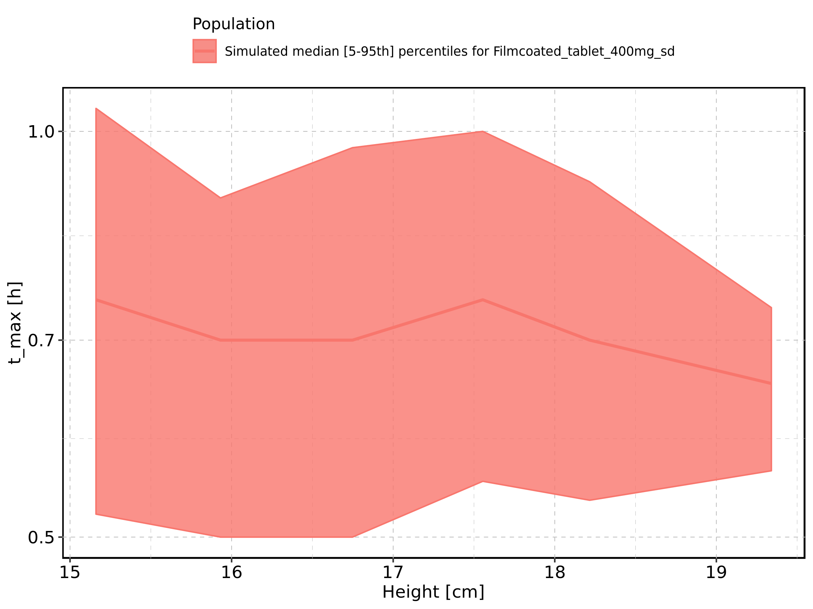

Figure 79: Weight-dependence of t_max for Larson 2013 8y-18y 400mg FCT meal in comparison to Filmcoated_tablet_400mg_sd. Profiles are plotted in a linear scale.

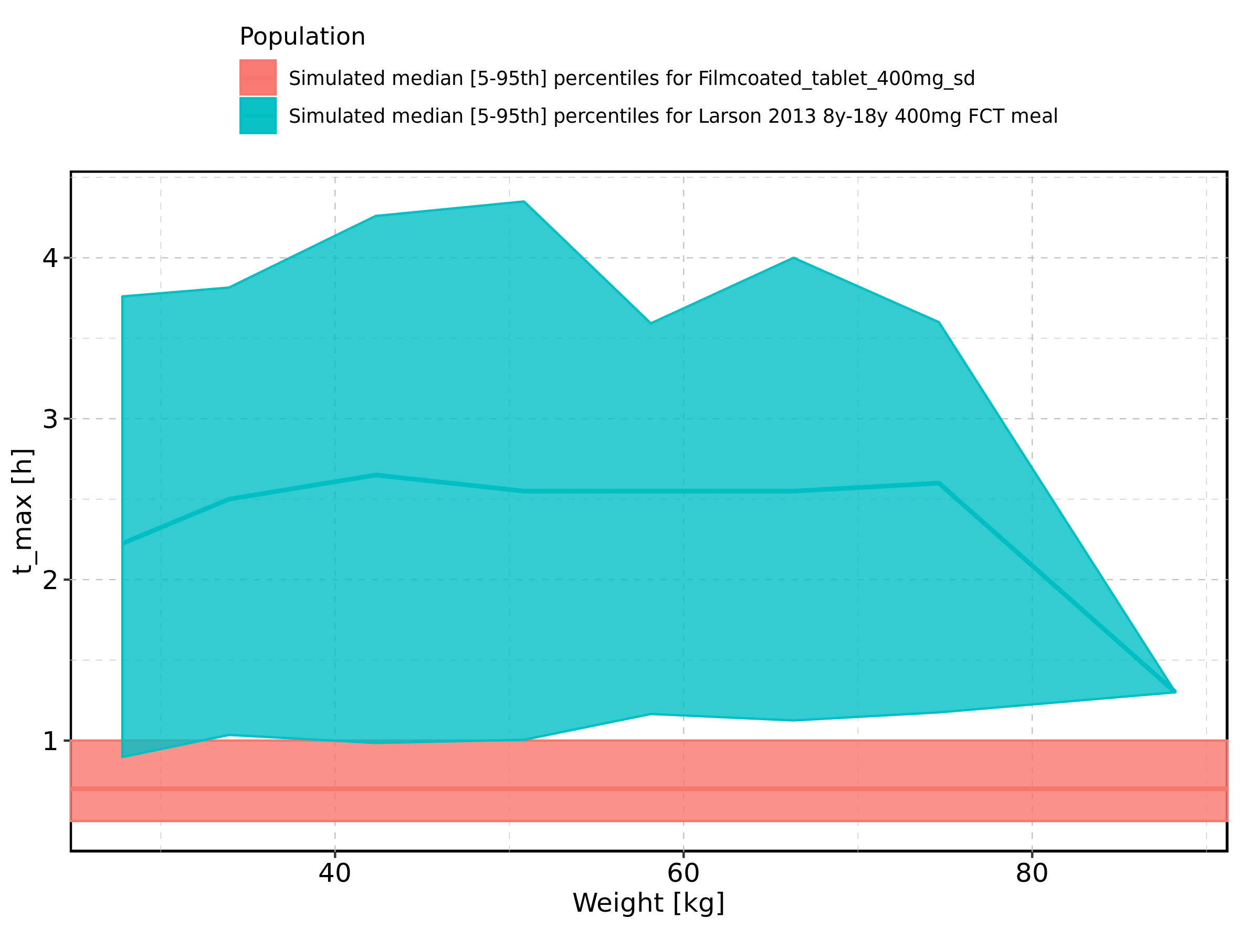

Figure 80: Weight-dependence of t_max for Larson 2013 8y-18y 400mg FCT meal in comparison to Filmcoated_tablet_400mg_sd. Profiles are plotted in a logarithmic scale.

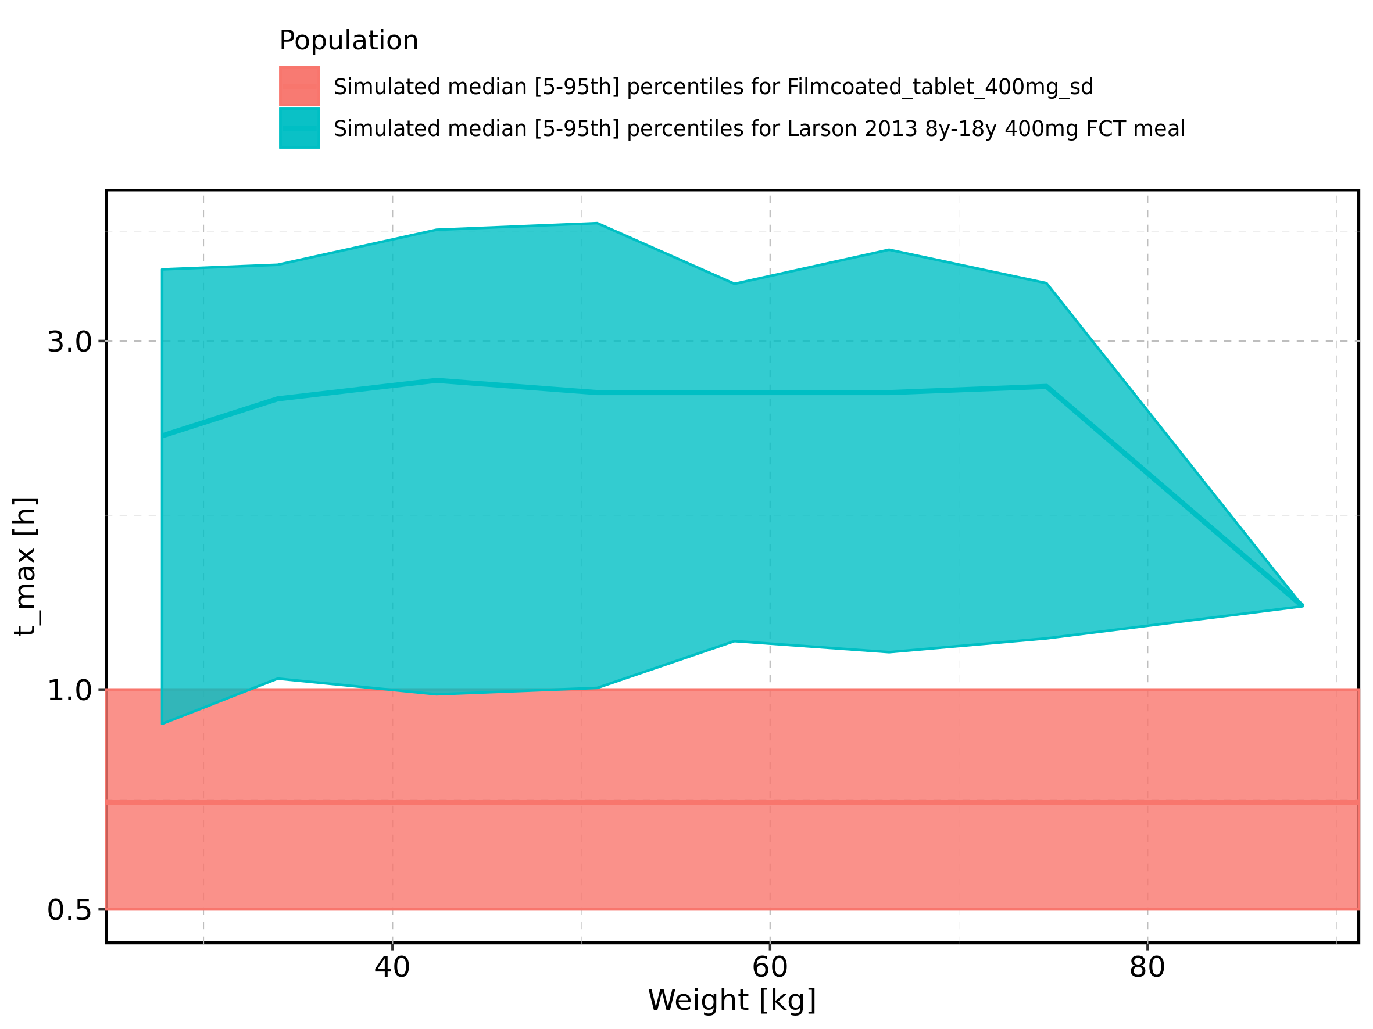

Figure 81: Weight-dependence of t_max for Larson 2013 8y-18y 400mg FCT meal. Profiles are plotted in a linear scale.

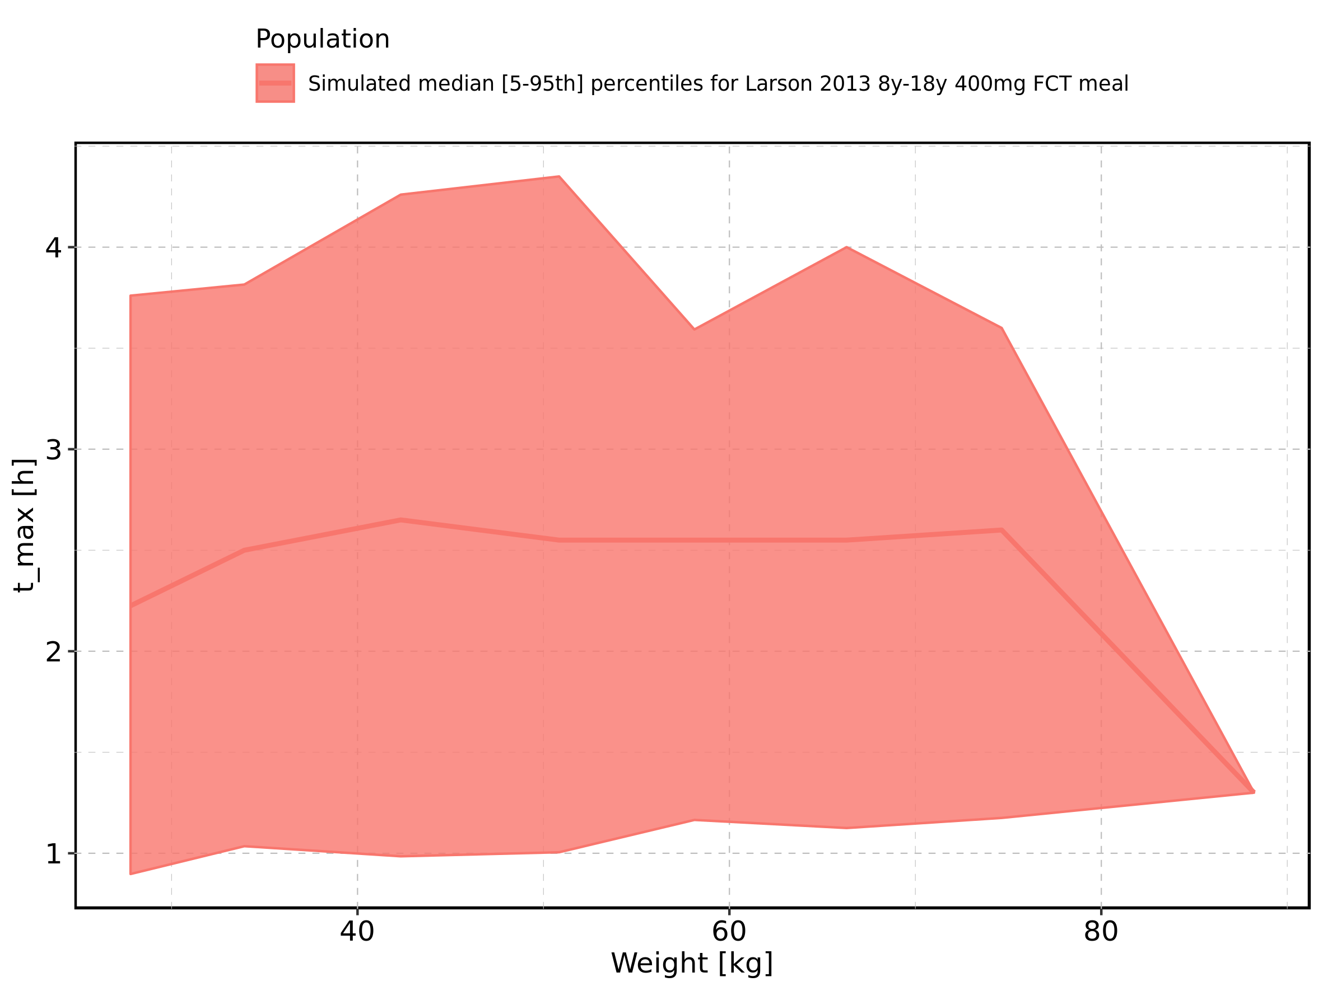

Figure 82: Weight-dependence of t_max for Larson 2013 8y-18y 400mg FCT meal. Profiles are plotted in a logarithmic scale.

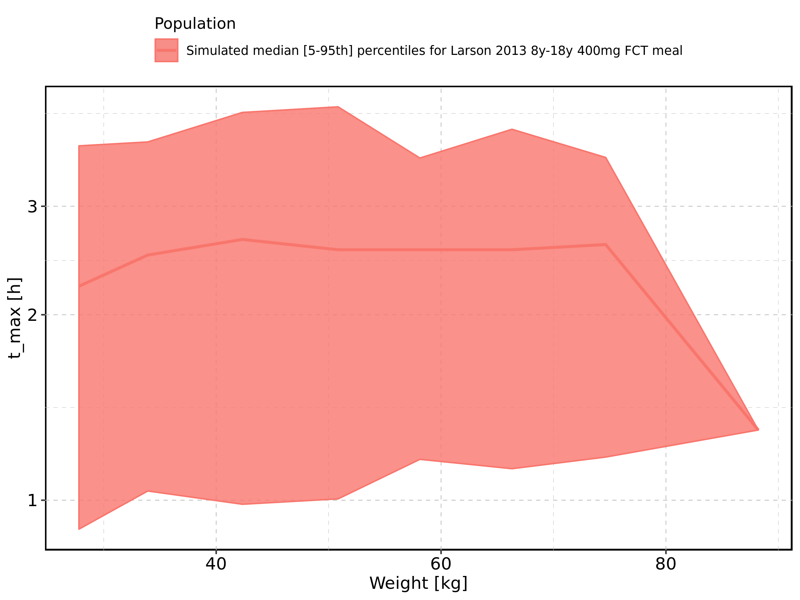

Figure 83: Weight-dependence of t_max for Filmcoated_tablet_400mg_sd. Profiles are plotted in a linear scale.

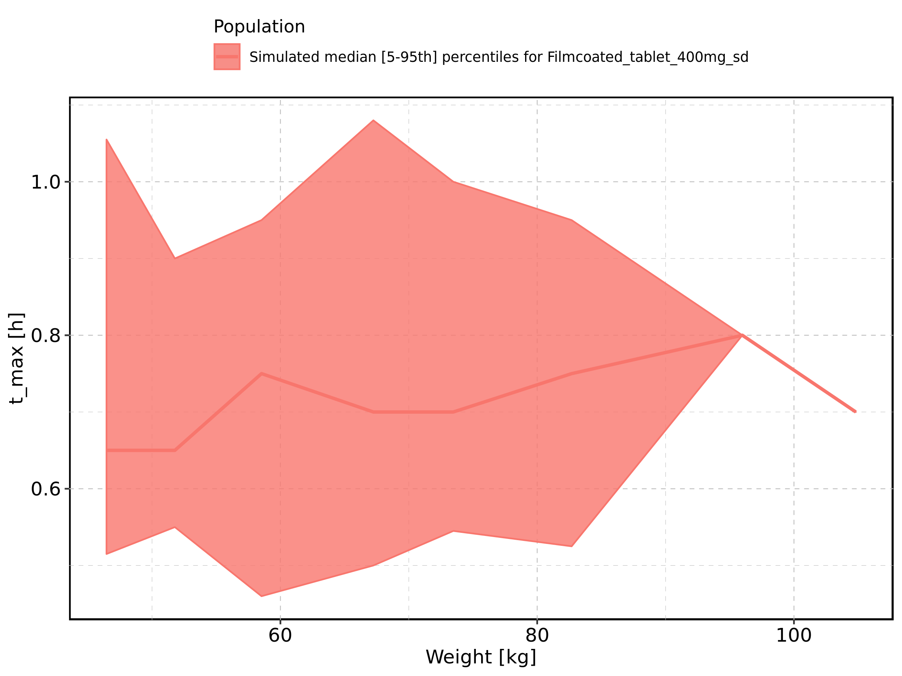

Figure 84: Weight-dependence of t_max for Filmcoated_tablet_400mg_sd. Profiles are plotted in a logarithmic scale.

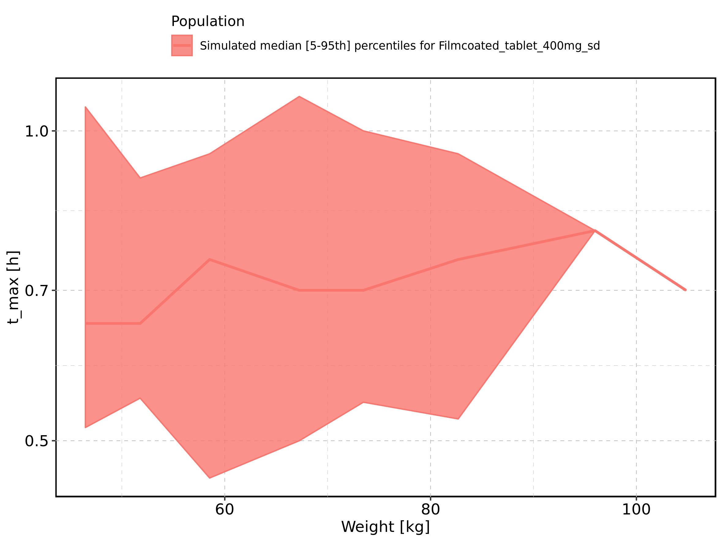

Figure 85: BMI-dependence of t_max for Larson 2013 8y-18y 400mg FCT meal in comparison to Filmcoated_tablet_400mg_sd. Profiles are plotted in a linear scale.

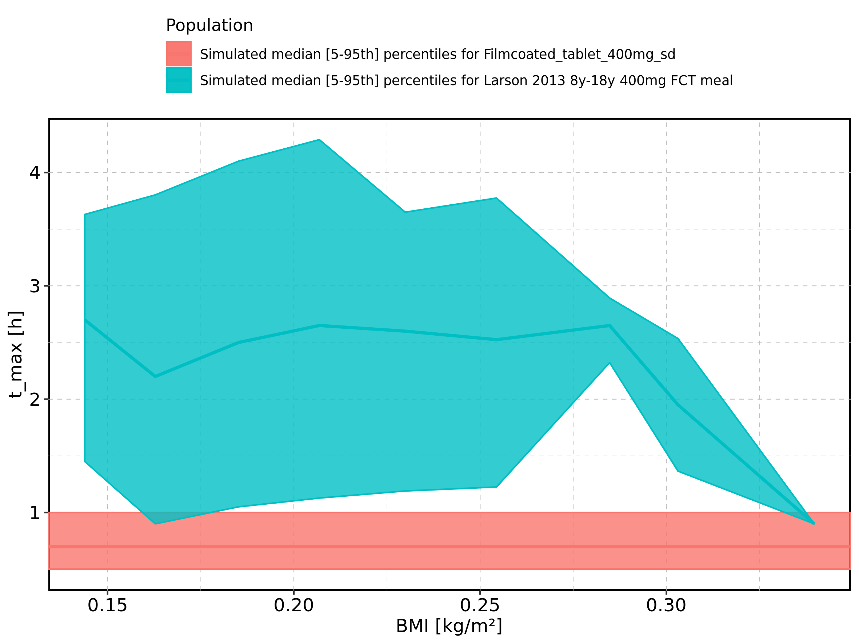

Figure 86: BMI-dependence of t_max for Larson 2013 8y-18y 400mg FCT meal in comparison to Filmcoated_tablet_400mg_sd. Profiles are plotted in a logarithmic scale.

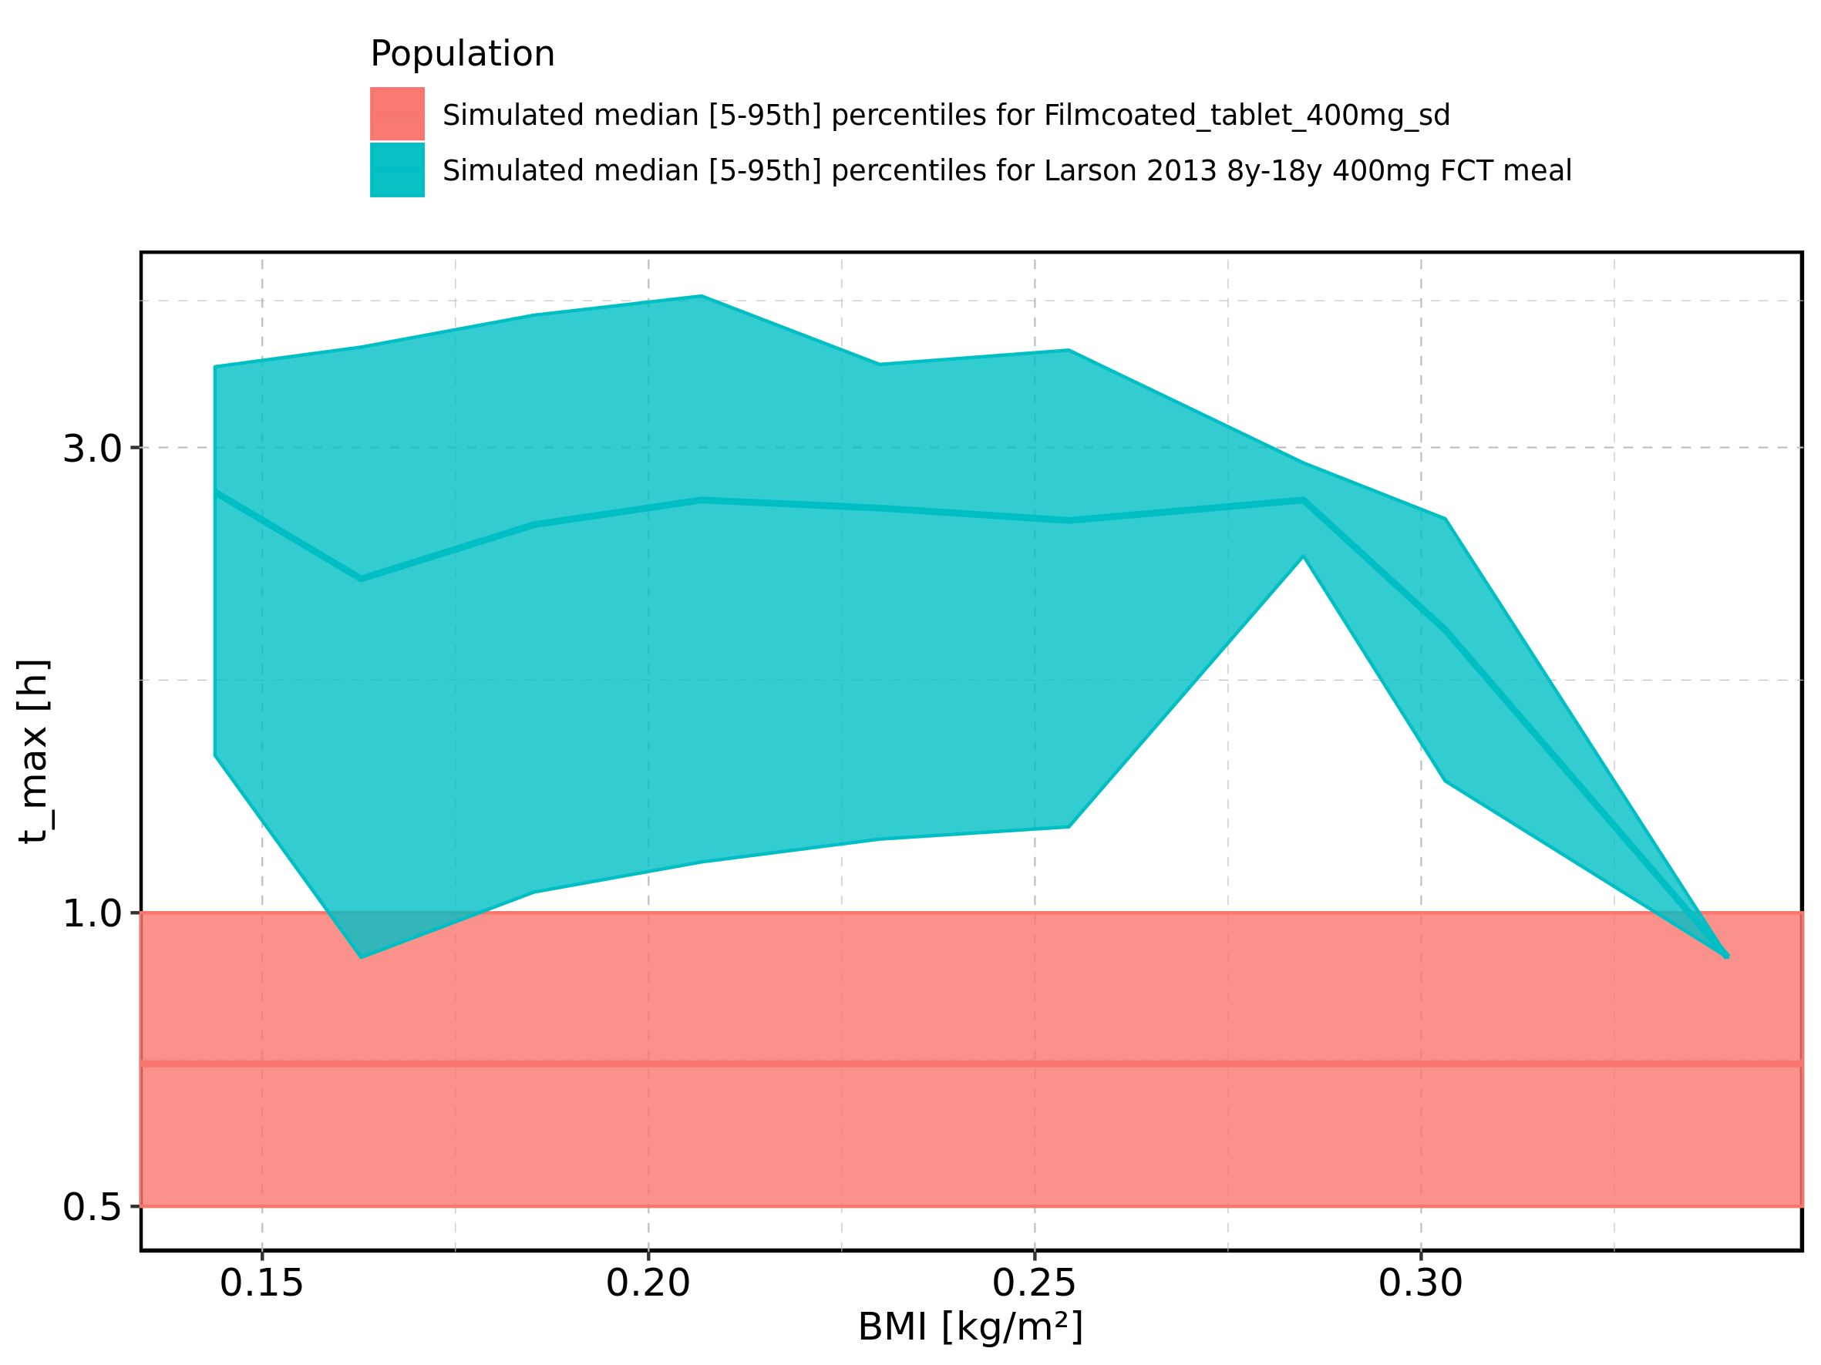

Figure 87: BMI-dependence of t_max for Larson 2013 8y-18y 400mg FCT meal. Profiles are plotted in a linear scale.

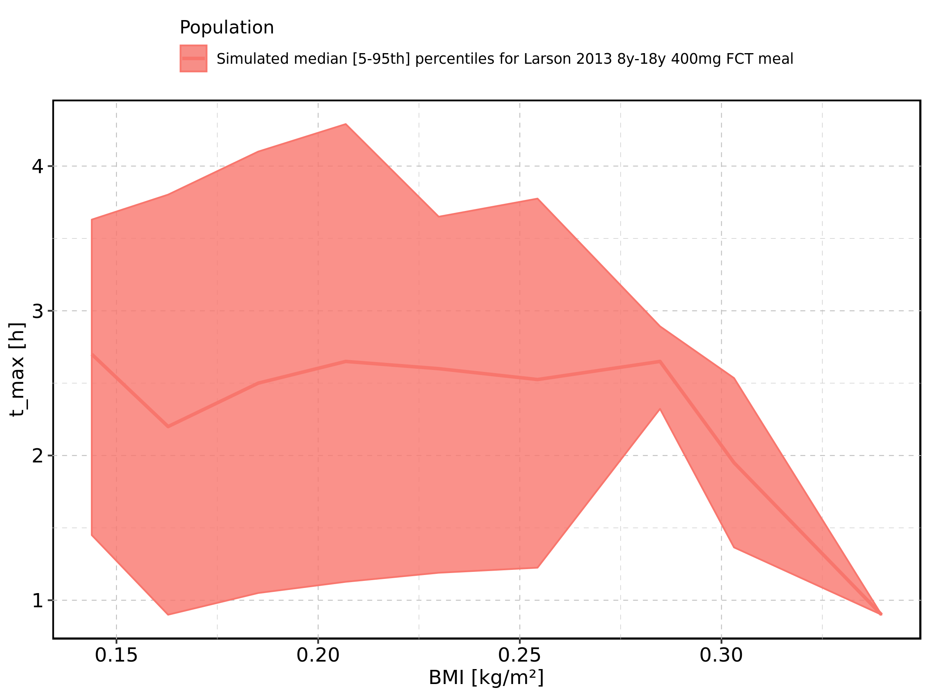

Figure 88: BMI-dependence of t_max for Larson 2013 8y-18y 400mg FCT meal. Profiles are plotted in a logarithmic scale.

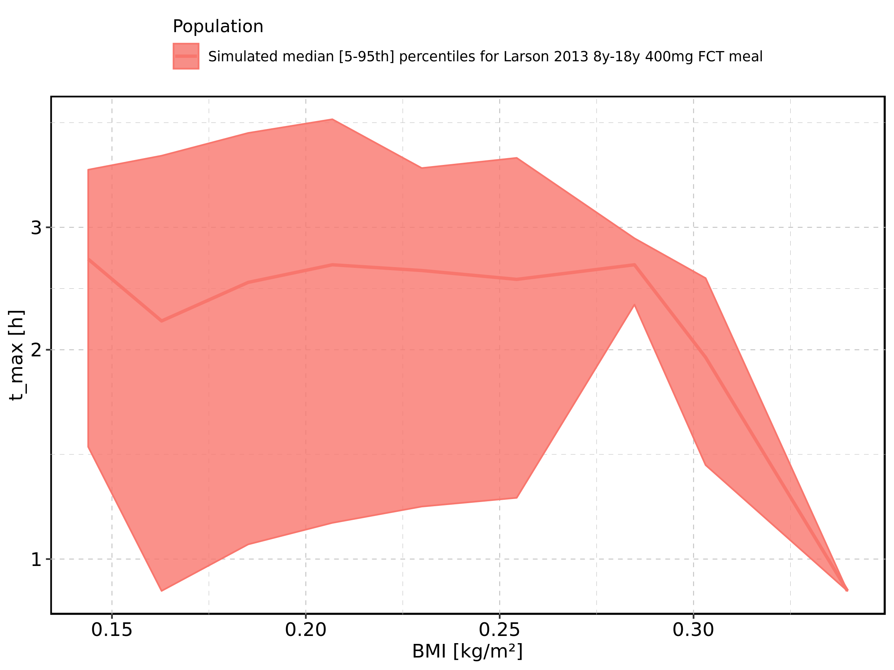

Figure 89: BMI-dependence of t_max for Filmcoated_tablet_400mg_sd. Profiles are plotted in a linear scale.

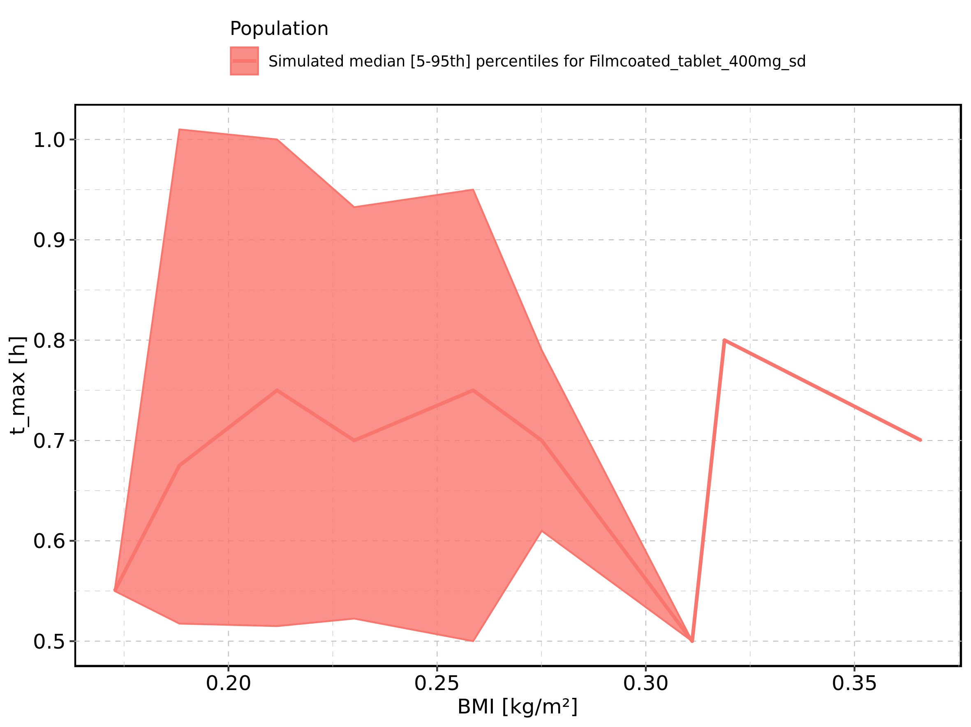

Figure 90: BMI-dependence of t_max for Filmcoated_tablet_400mg_sd. Profiles are plotted in a logarithmic scale.

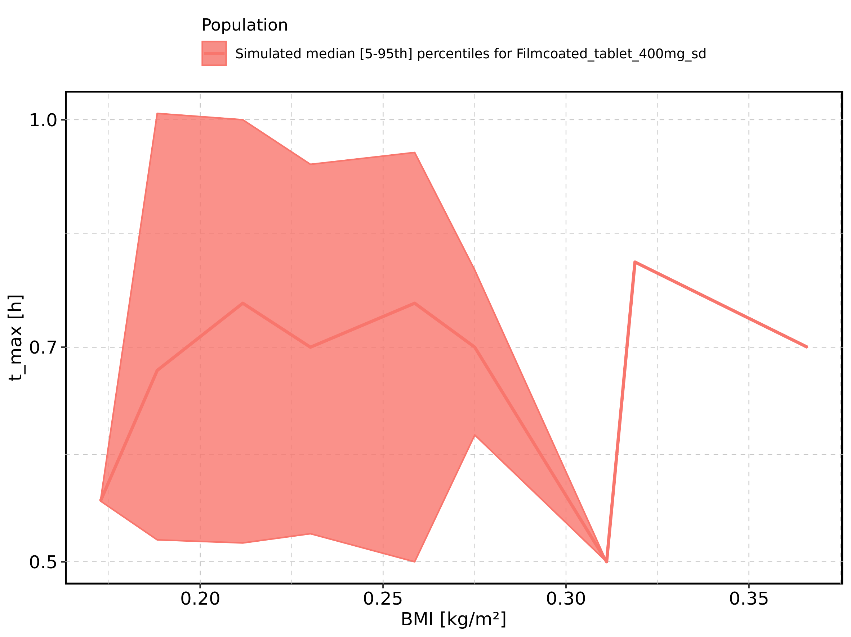

Figure 91: Gender-dependence of t_max for Larson 2013 8y-18y 400mg FCT meal in comparison to Filmcoated_tablet_400mg_sd. Profiles are plotted in a linear scale.

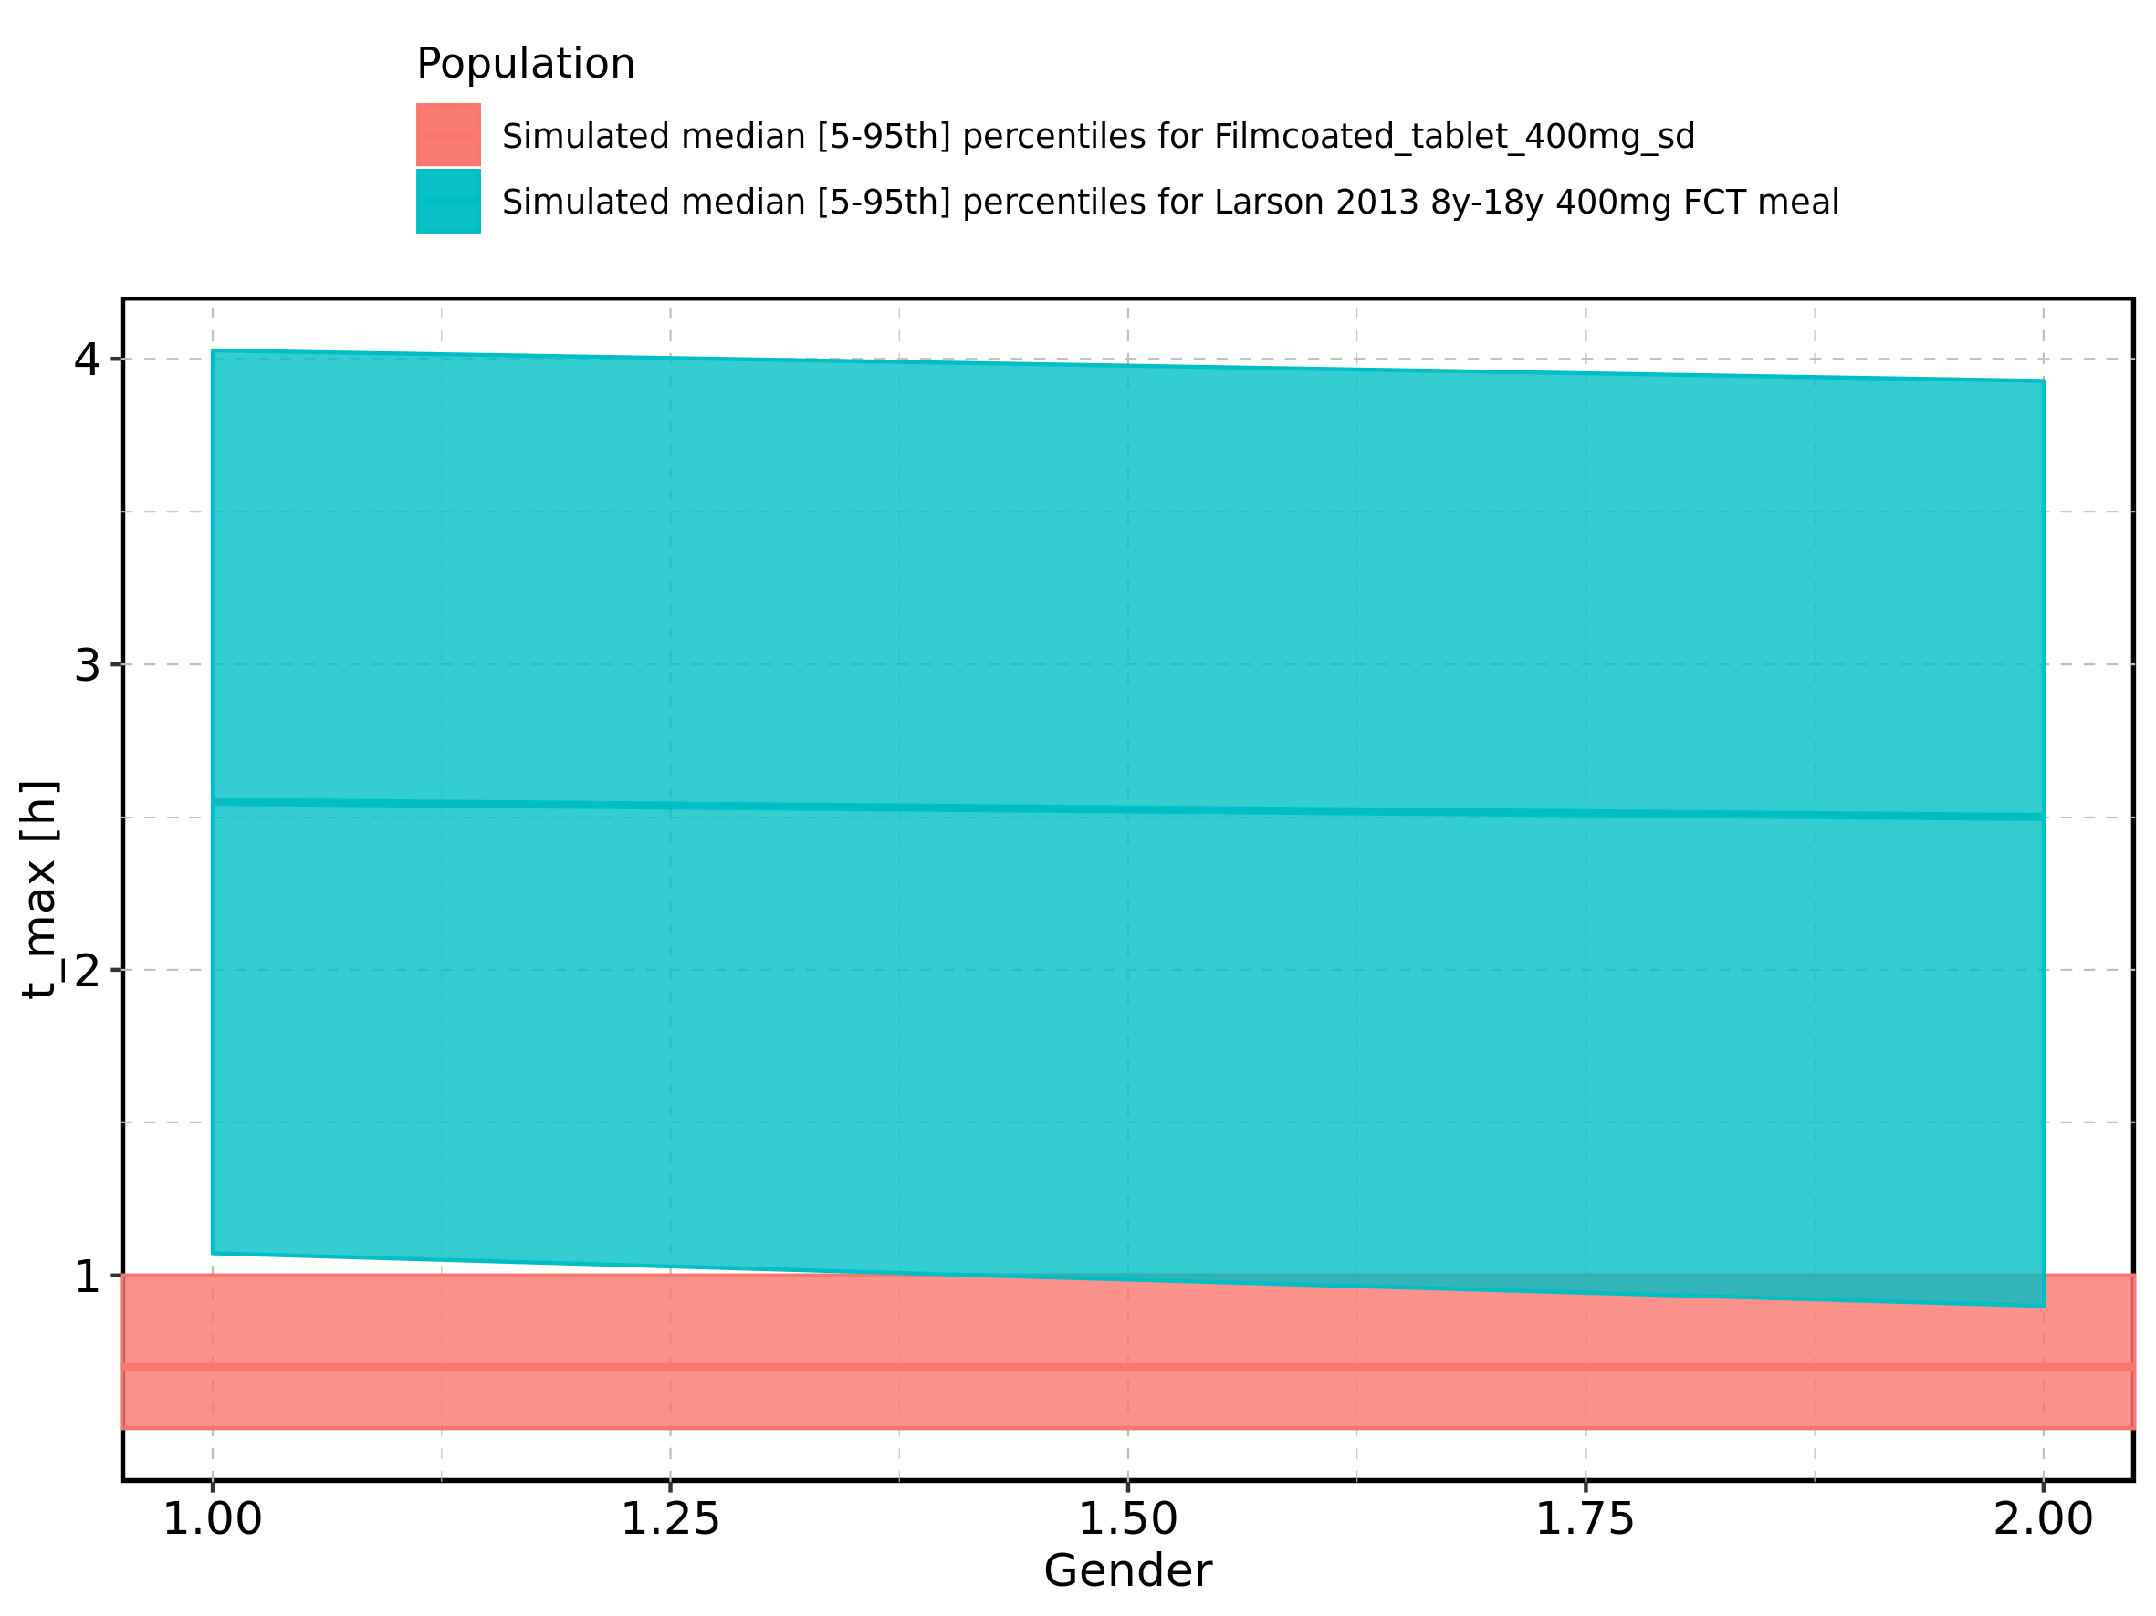

Figure 92: Gender-dependence of t_max for Larson 2013 8y-18y 400mg FCT meal in comparison to Filmcoated_tablet_400mg_sd. Profiles are plotted in a logarithmic scale.

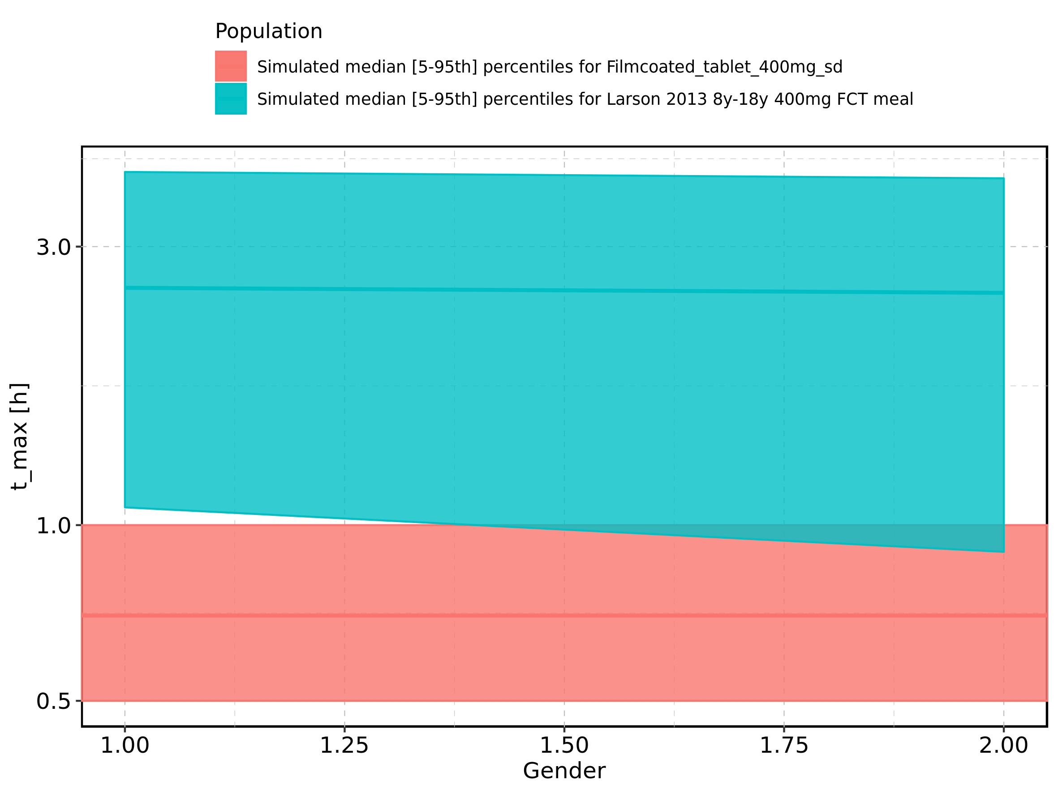

Figure 93: Gender-dependence of t_max for Larson 2013 8y-18y 400mg FCT meal. Profiles are plotted in a linear scale.

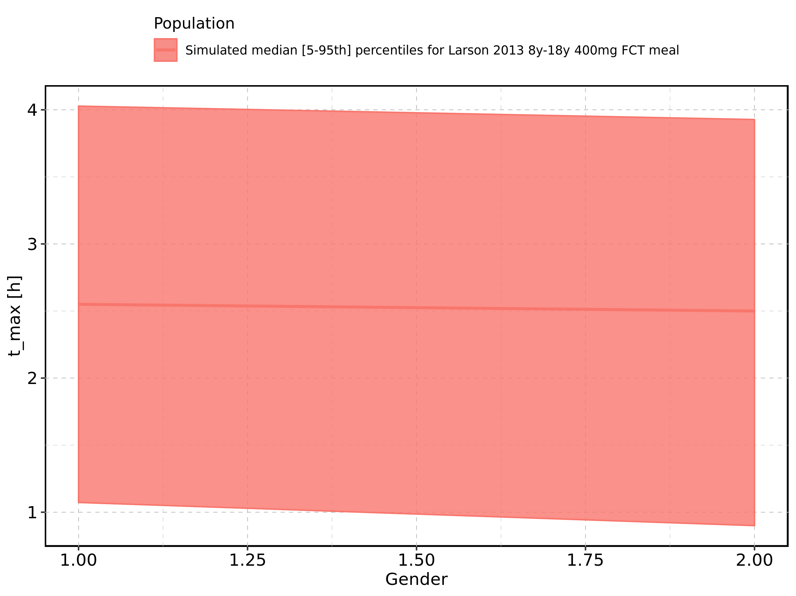

Figure 94: Gender-dependence of t_max for Larson 2013 8y-18y 400mg FCT meal. Profiles are plotted in a logarithmic scale.

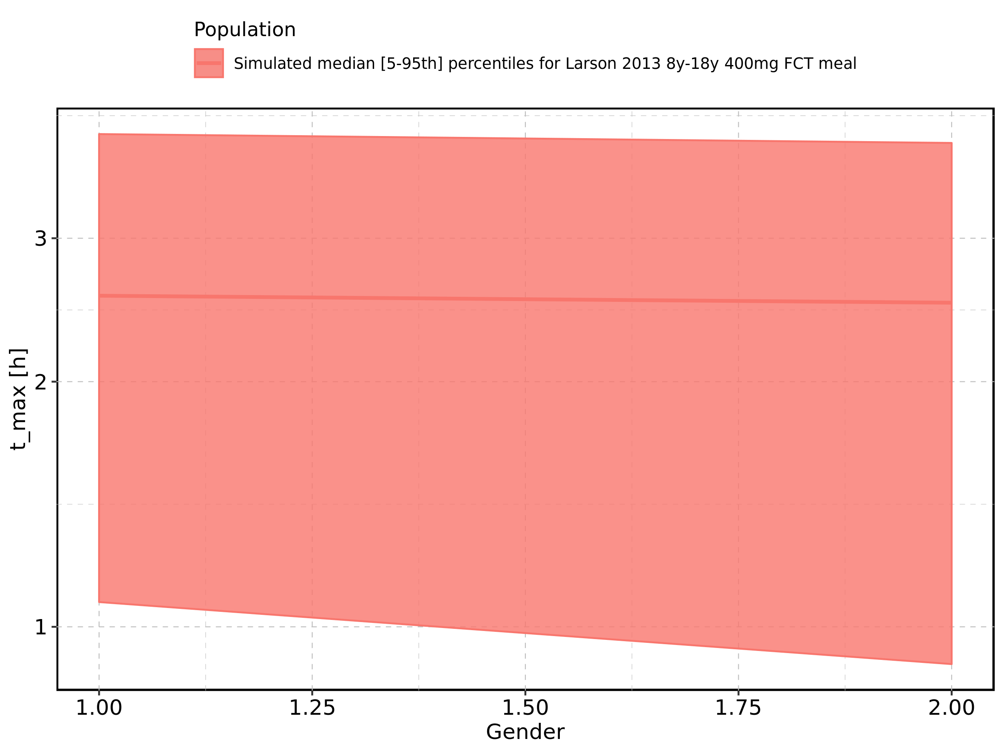

Figure 95: Gender-dependence of t_max for Filmcoated_tablet_400mg_sd. Profiles are plotted in a linear scale.

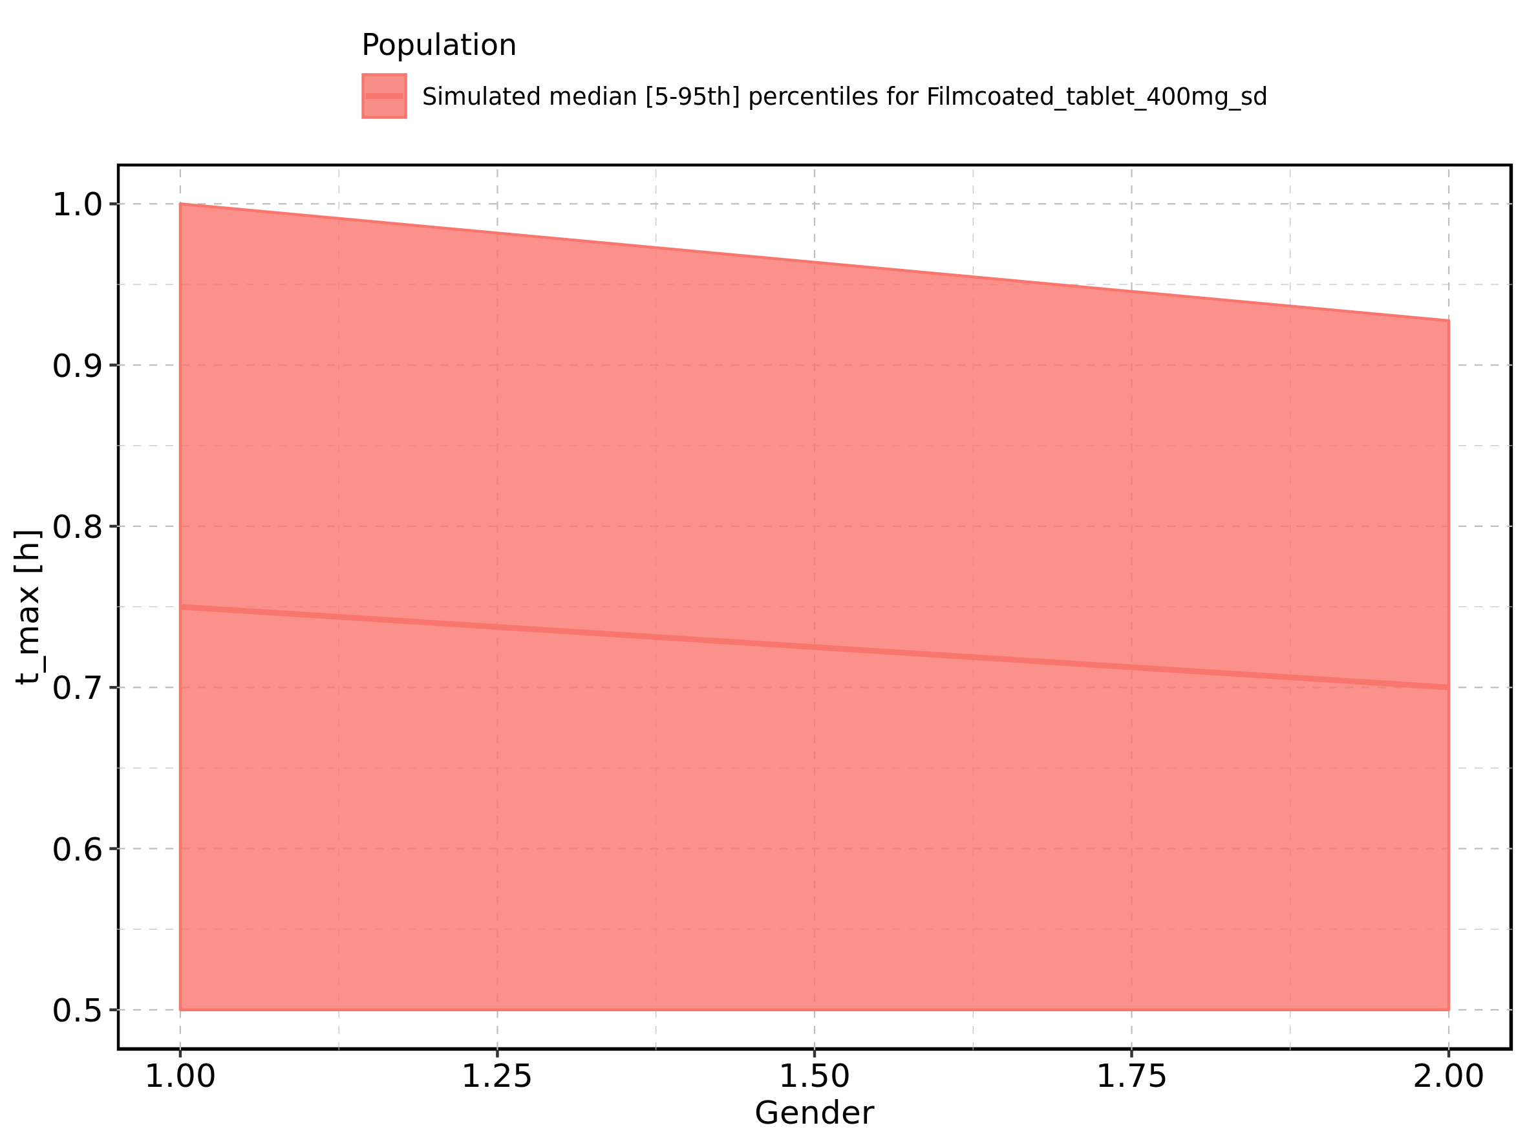

Figure 96: Gender-dependence of t_max for Filmcoated_tablet_400mg_sd. Profiles are plotted in a logarithmic scale.

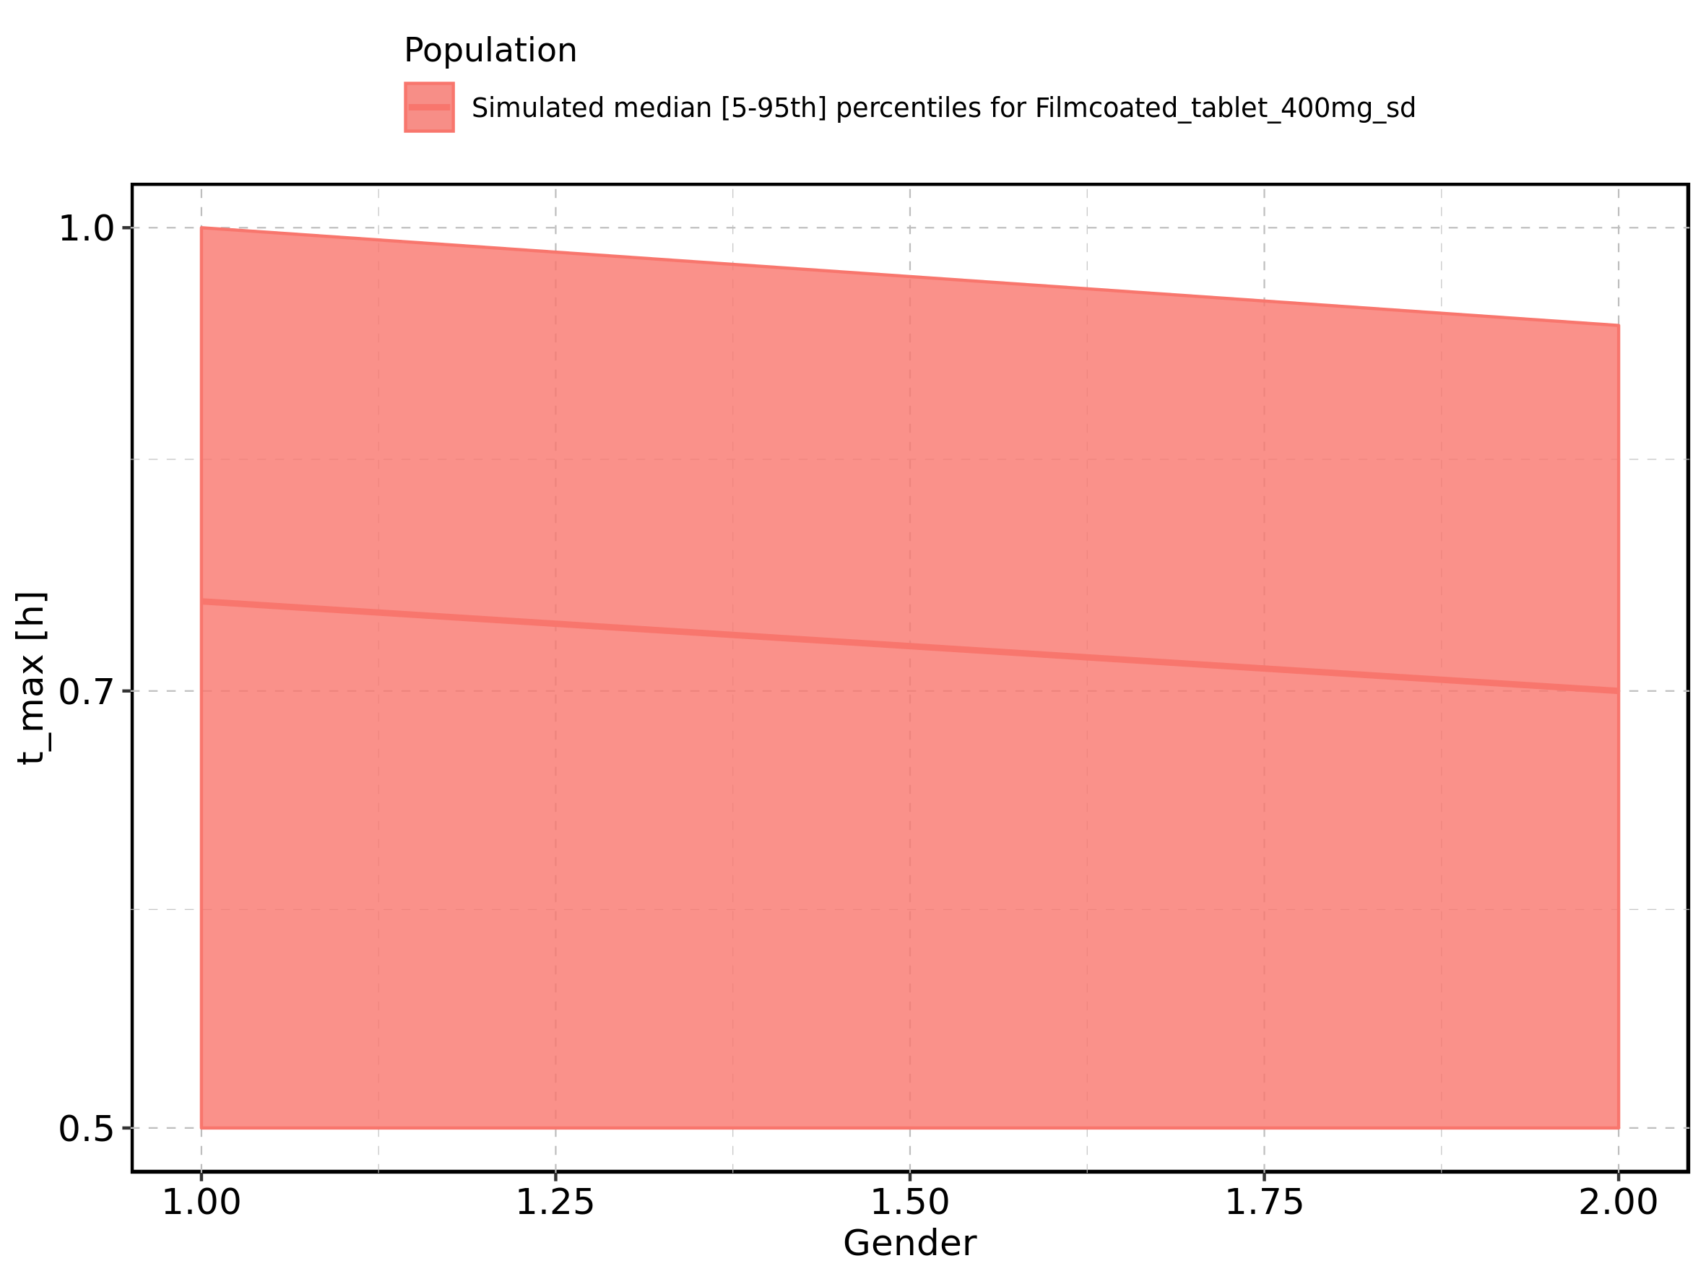

Figure 97: C_tEnd of Raltegravir shown as box-whisker plot, which indicates the 5th, 25th, 50th, 75th, and 95th percentiles in linear scale.

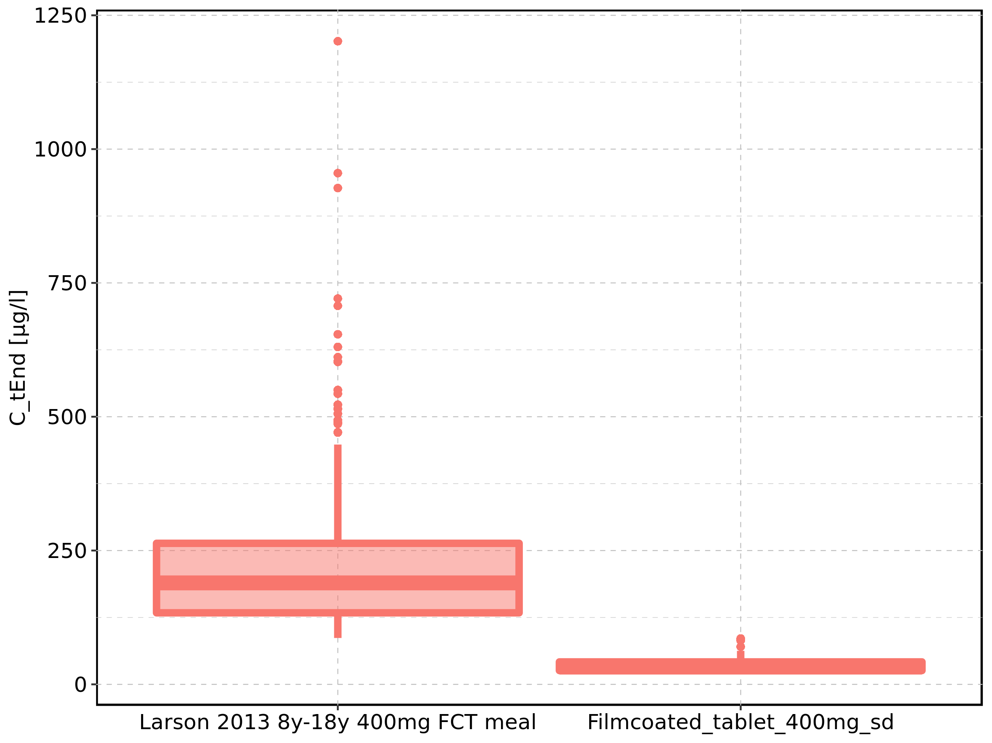

|  |  |  |  |  |  |  |  |  |  |  |
| --- | --- | --- | --- | --- | --- | --- | --- | --- | --- | --- |
| Population | N | 5th percentile | 25th percentile | 50th percentile | 75th percentile | 95th percentile | mean | standard deviation | geo mean | geo standard deviation |
| Larson 2013 8y-18y 400mg FCT meal | 500 | 86.63046 | 133.65437 | 189.56246 | 263.51473 | 448.02293 | 218.90325 | 129.11610 | 191.12204 | 1.666366 |
| Filmcoated_tablet_400mg_sd | 100 | 19.57484 | 25.79622 | 32.34815 | 41.91365 | 62.67601 | 35.38577 | 14.20645 | 33.01047 | 1.444113 |

Figure 98: C_tEnd of Raltegravir shown as box-whisker plot, which indicates the 5th, 25th, 50th, 75th, and 95th percentiles in logarithmic scale.

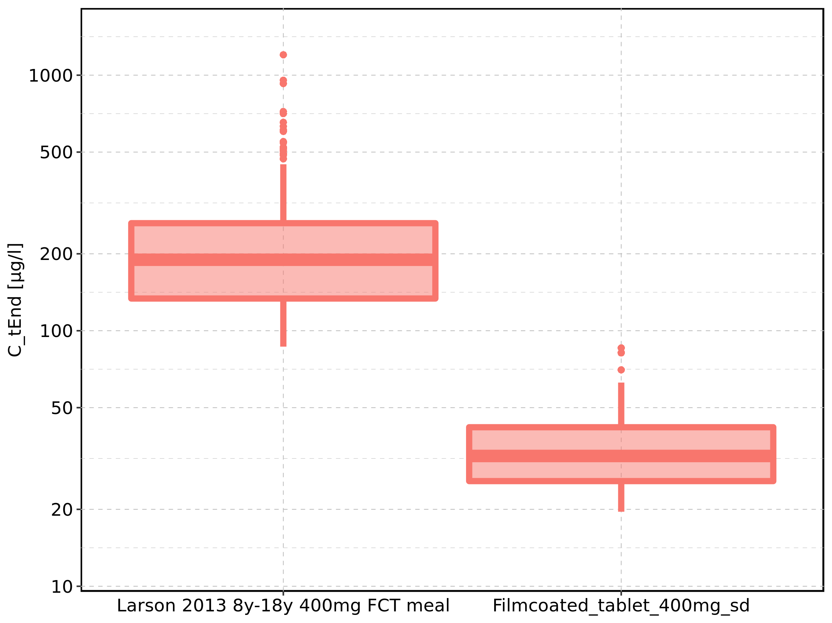

Figure 99: Age-dependence of C_tEnd for Larson 2013 8y-18y 400mg FCT meal in comparison to Filmcoated_tablet_400mg_sd. Profiles are plotted in a linear scale.

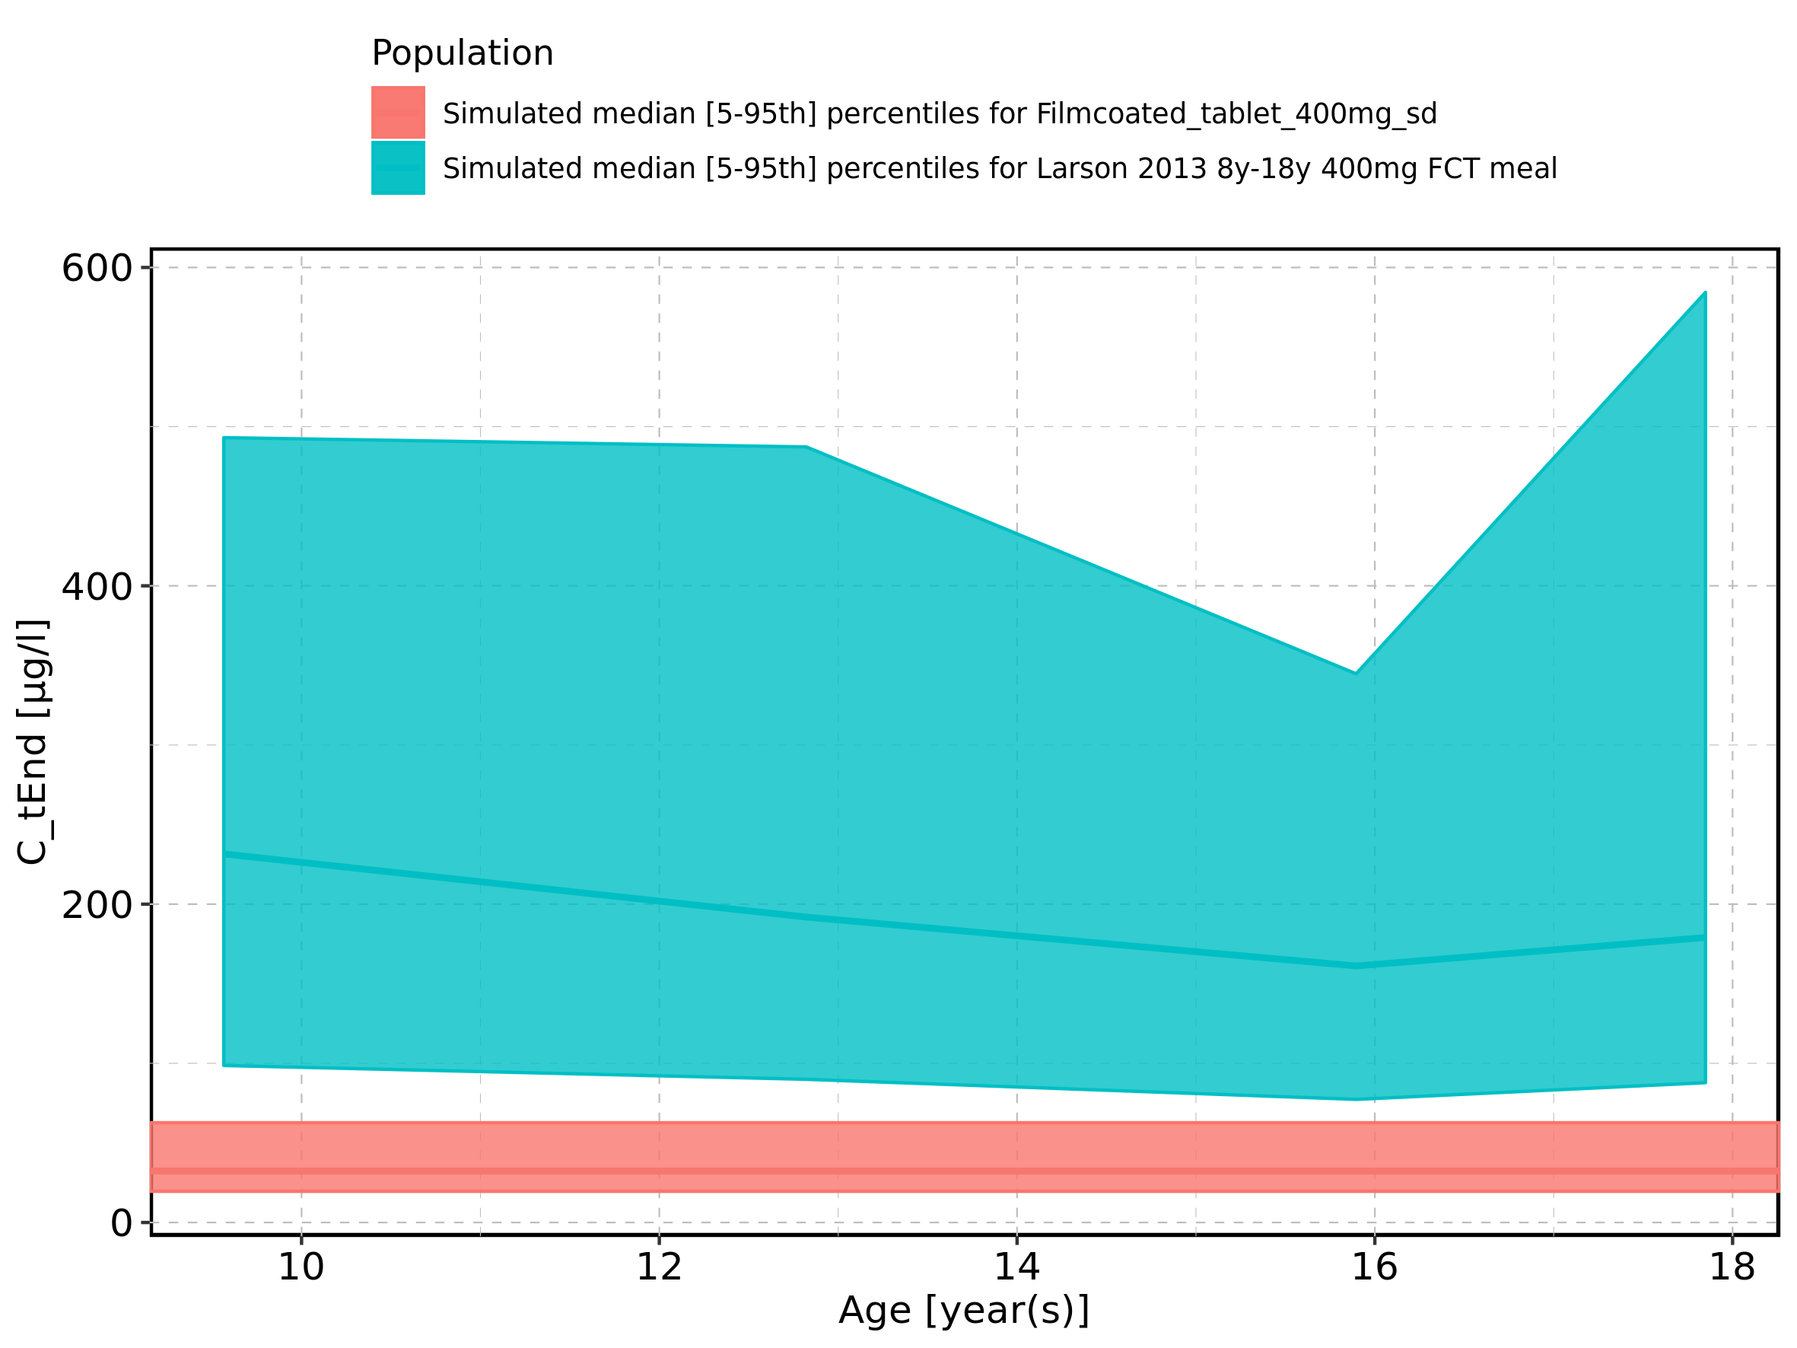

Figure 100: Age-dependence of C_tEnd for Larson 2013 8y-18y 400mg FCT meal in comparison to Filmcoated_tablet_400mg_sd. Profiles are plotted in a logarithmic scale.

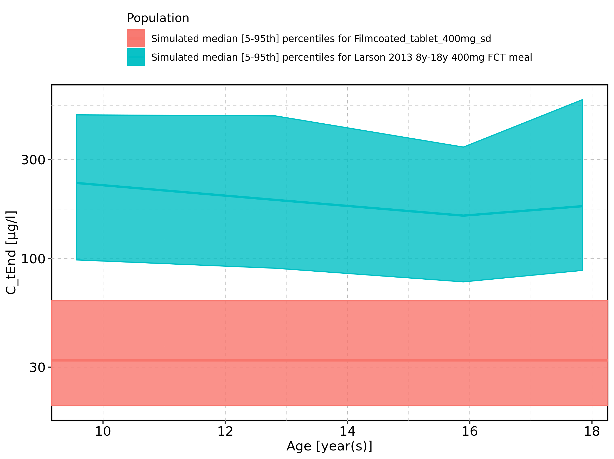

Figure 101: Age-dependence of C_tEnd for Larson 2013 8y-18y 400mg FCT meal. Profiles are plotted in a linear scale.

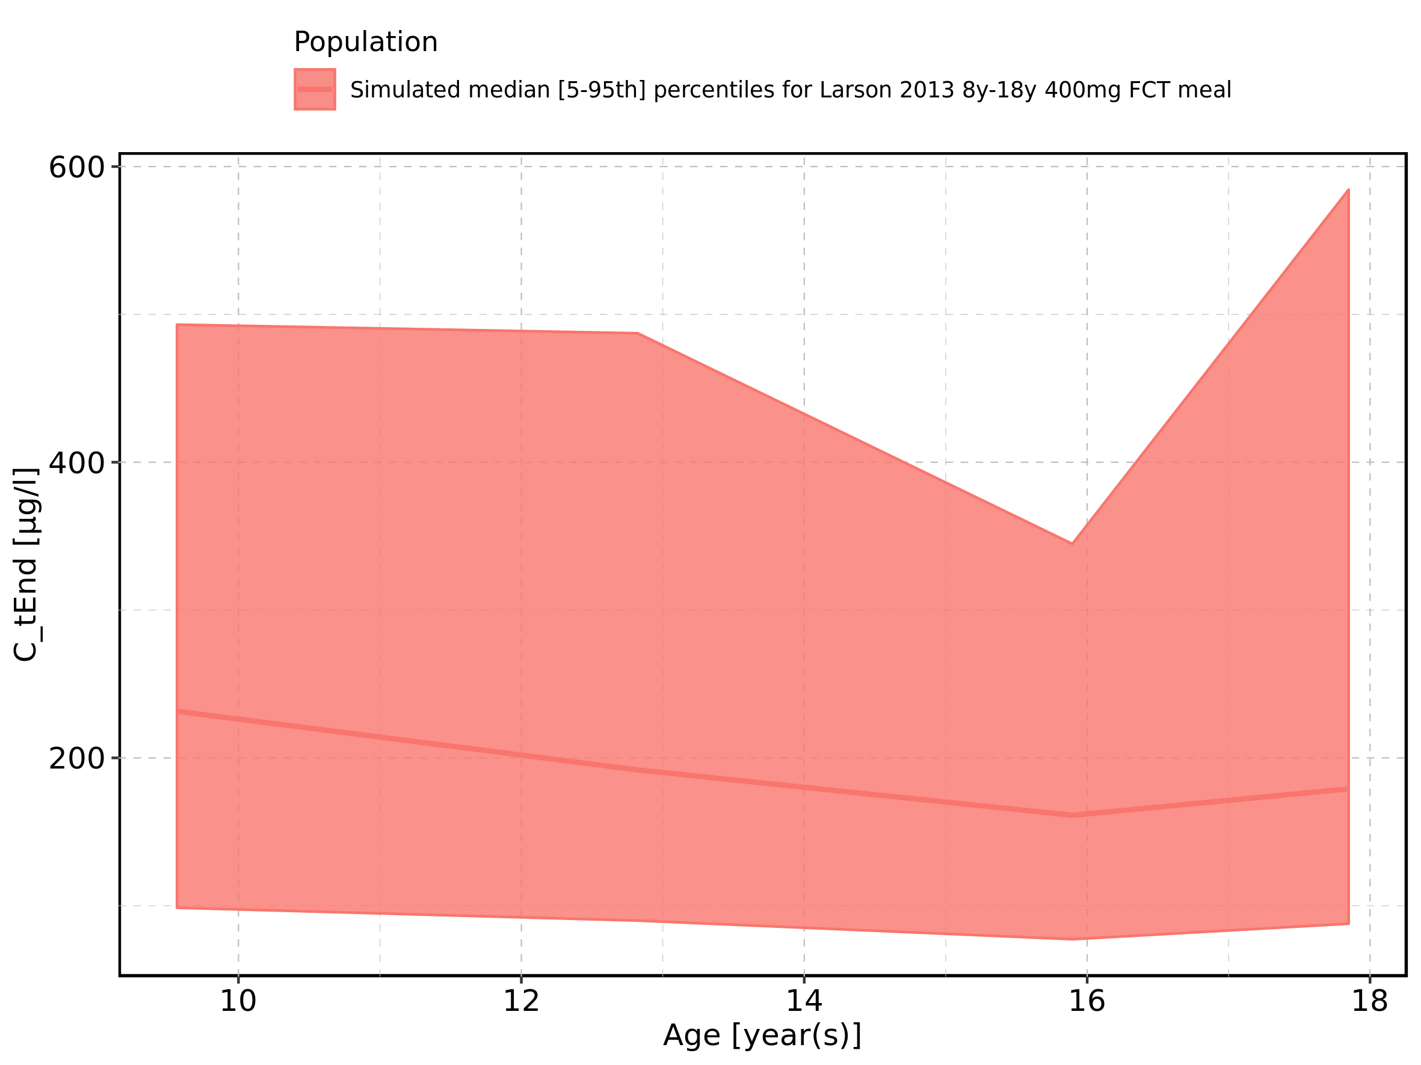

Figure 102: Age-dependence of C_tEnd for Larson 2013 8y-18y 400mg FCT meal. Profiles are plotted in a logarithmic scale.

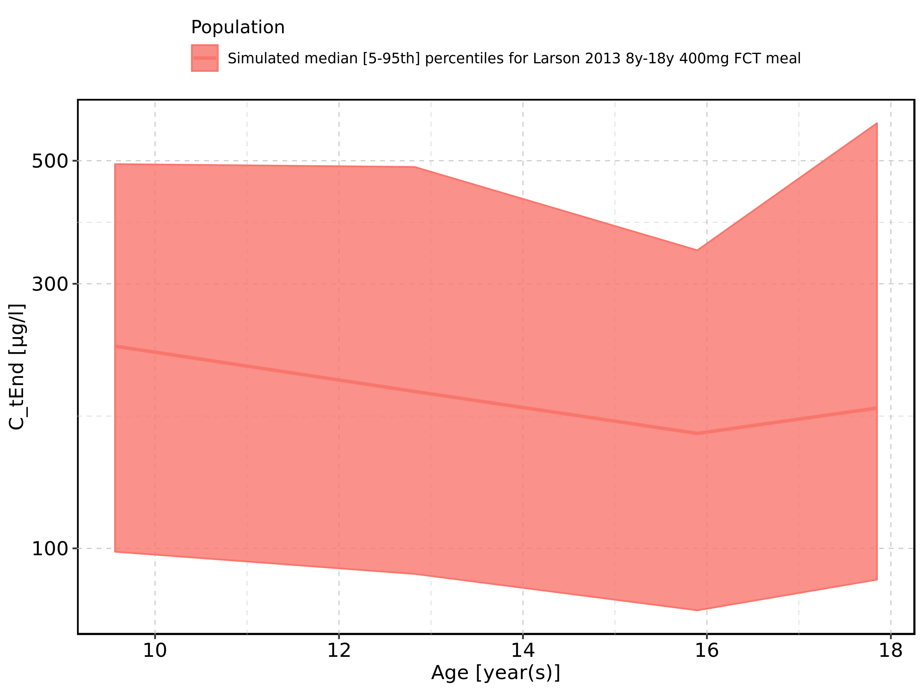

Figure 103: Age-dependence of C_tEnd for Filmcoated_tablet_400mg_sd. Profiles are plotted in a linear scale.

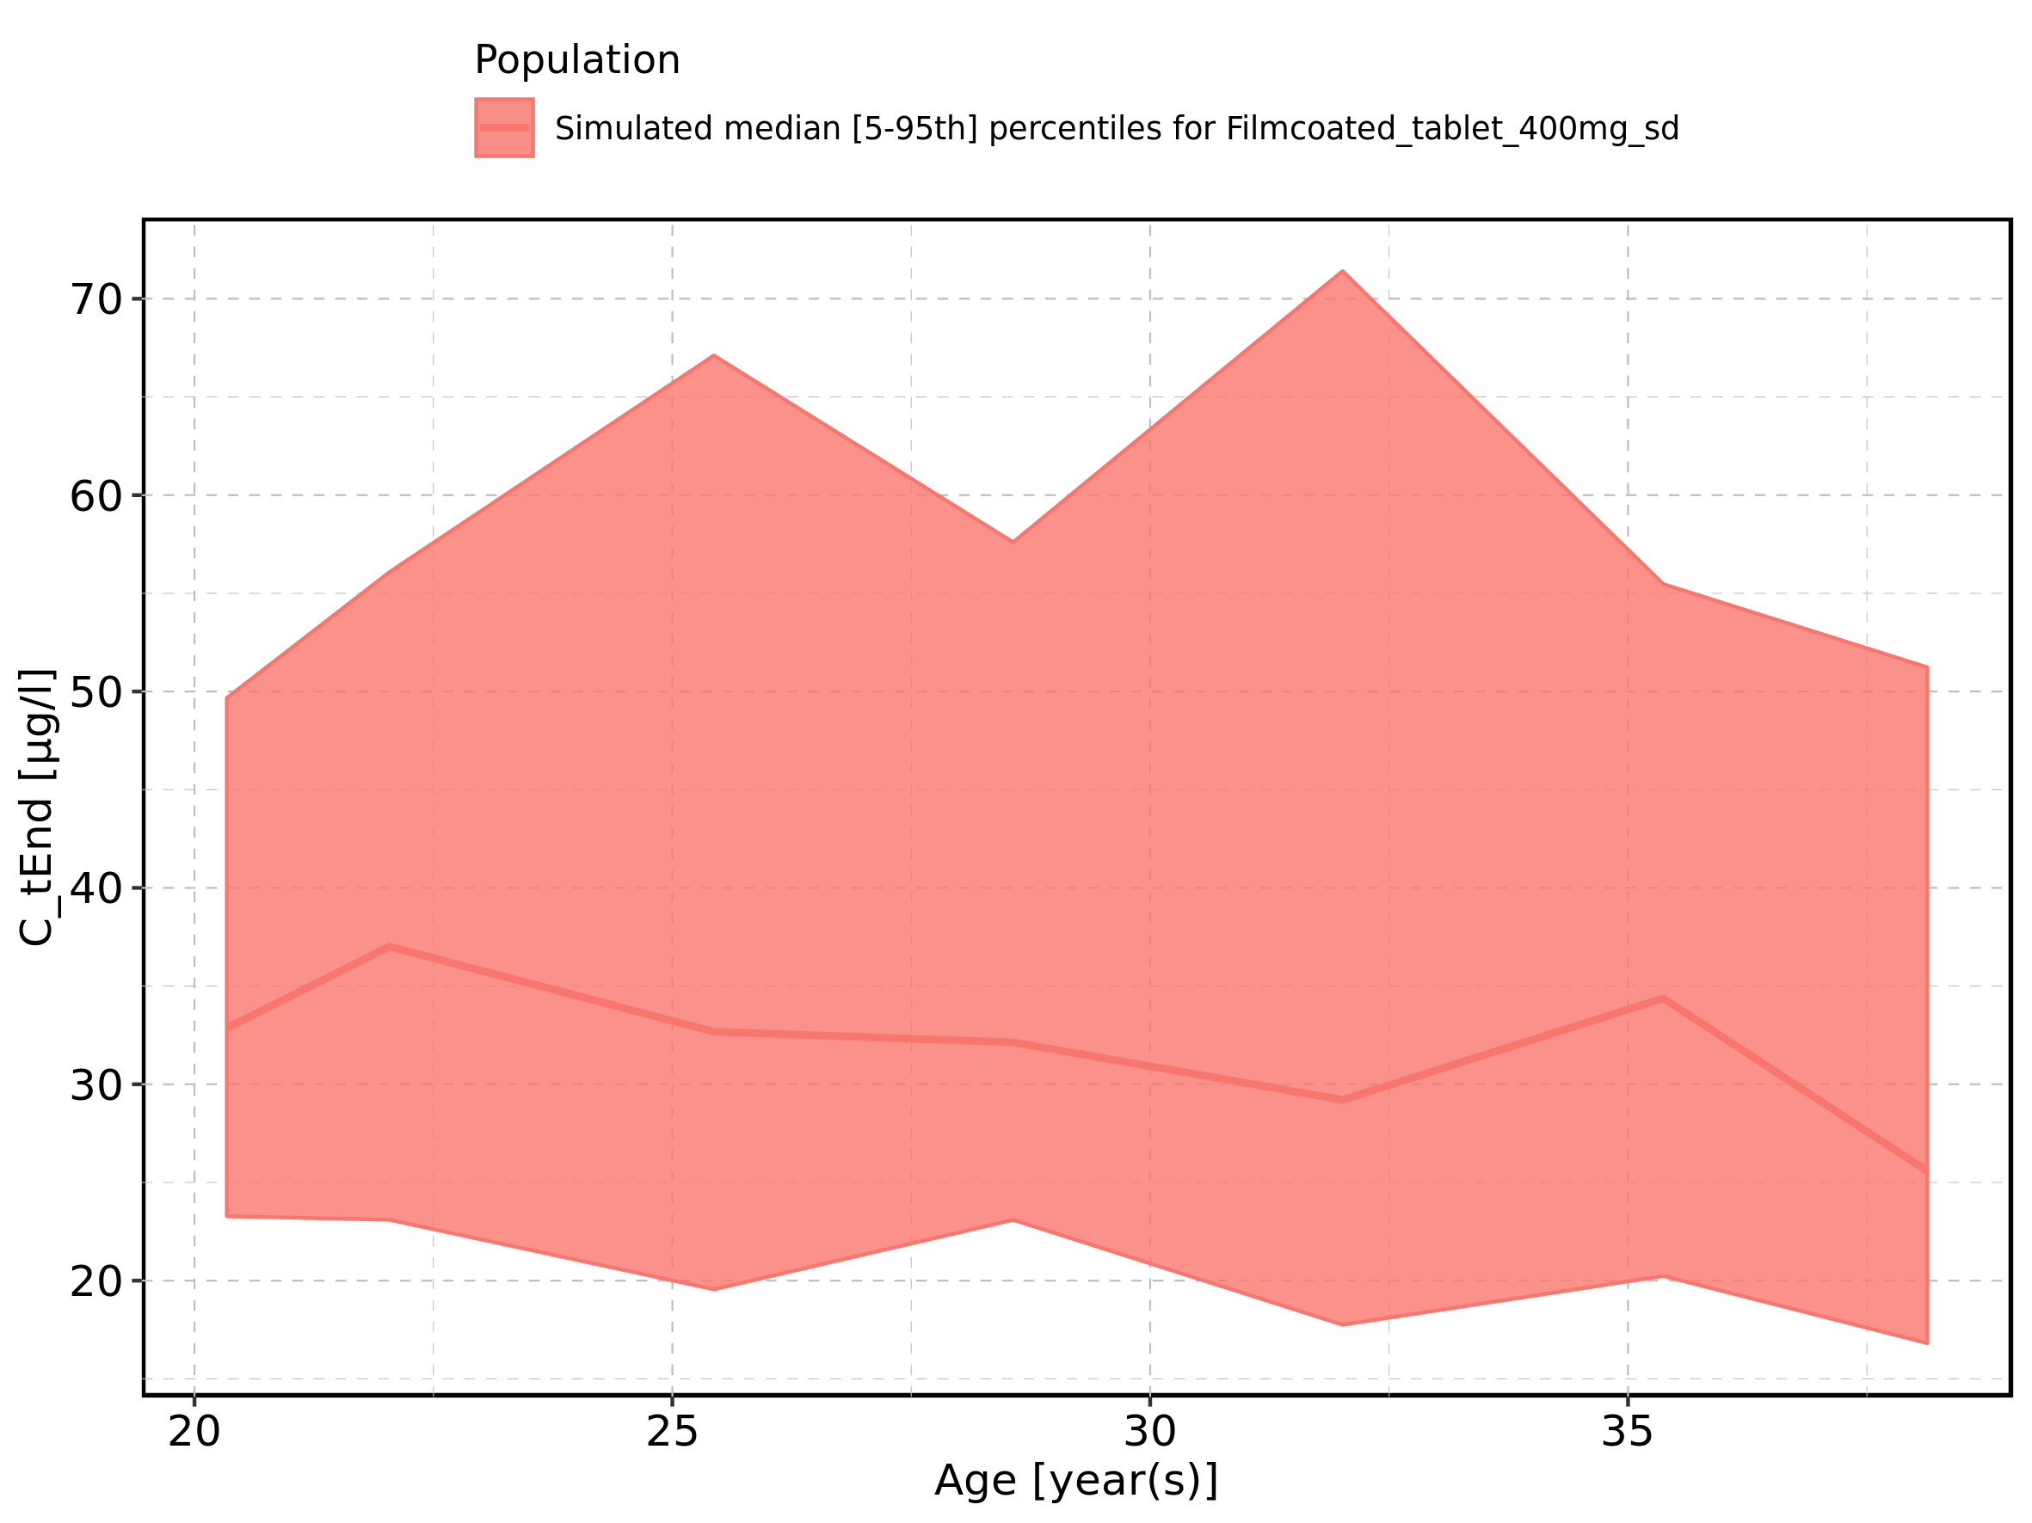

Figure 104: Age-dependence of C_tEnd for Filmcoated_tablet_400mg_sd. Profiles are plotted in a logarithmic scale.

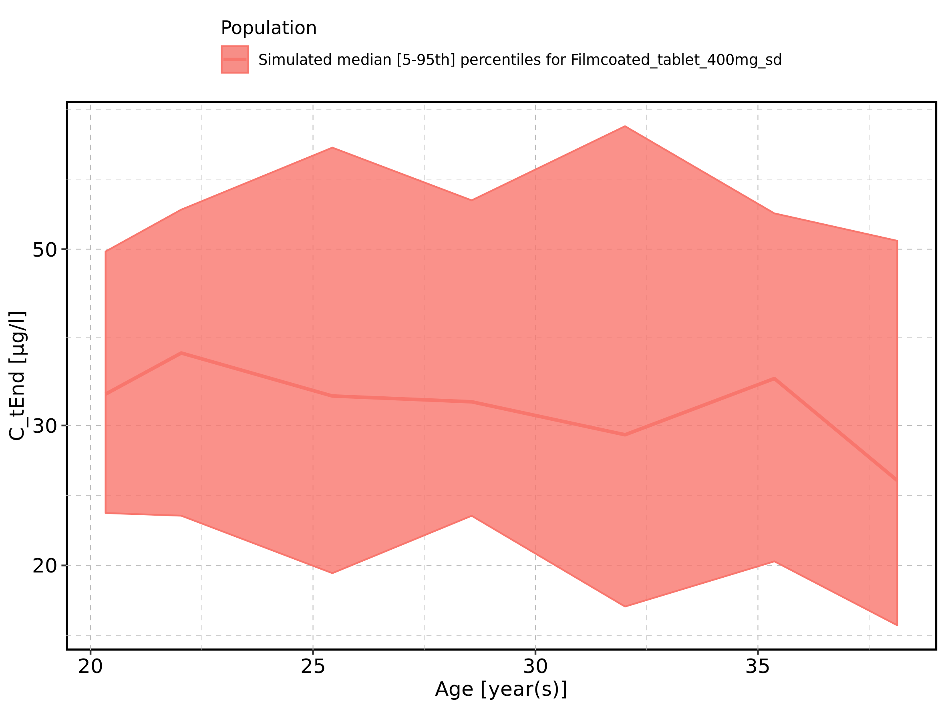

Figure 105: Height-dependence of C_tEnd for Larson 2013 8y-18y 400mg FCT meal in comparison to Filmcoated_tablet_400mg_sd. Profiles are plotted in a linear scale.

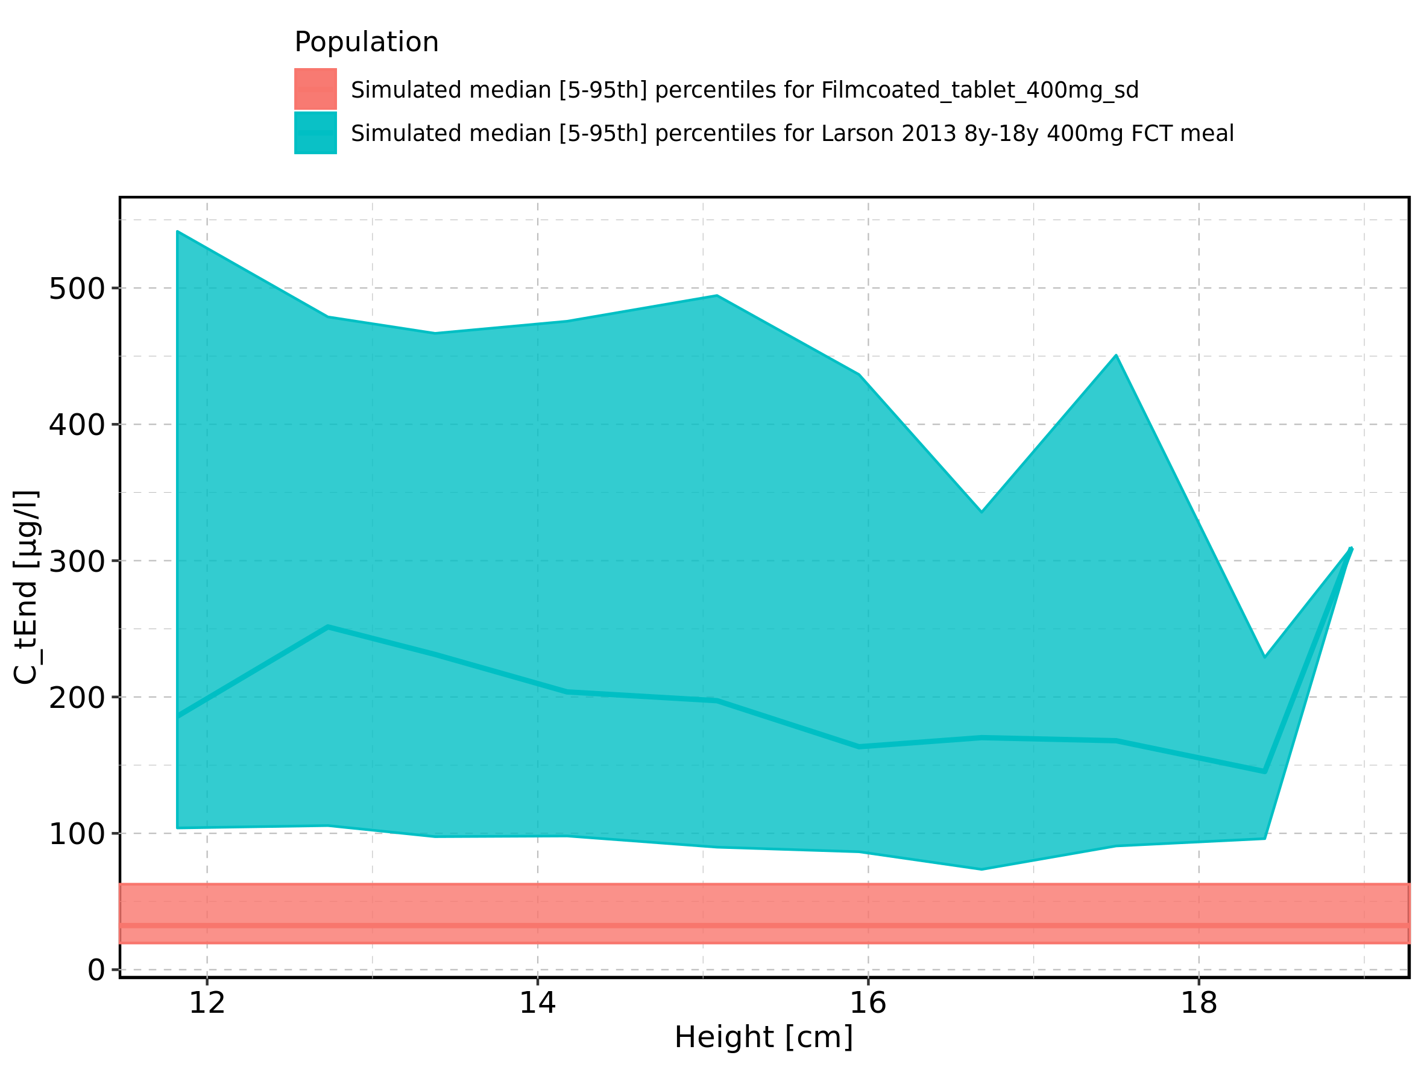

Figure 106: Height-dependence of C_tEnd for Larson 2013 8y-18y 400mg FCT meal in comparison to Filmcoated_tablet_400mg_sd. Profiles are plotted in a logarithmic scale.

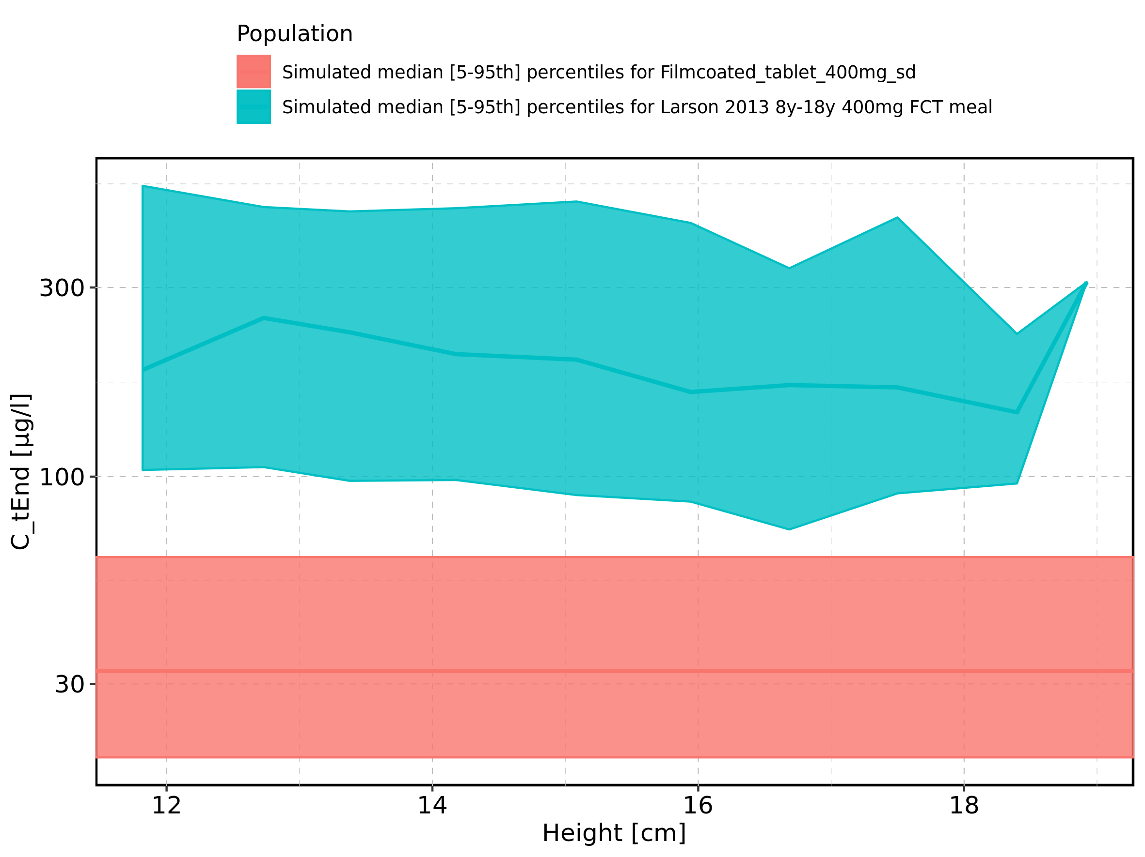

Figure 107: Height-dependence of C_tEnd for Larson 2013 8y-18y 400mg FCT meal. Profiles are plotted in a linear scale.

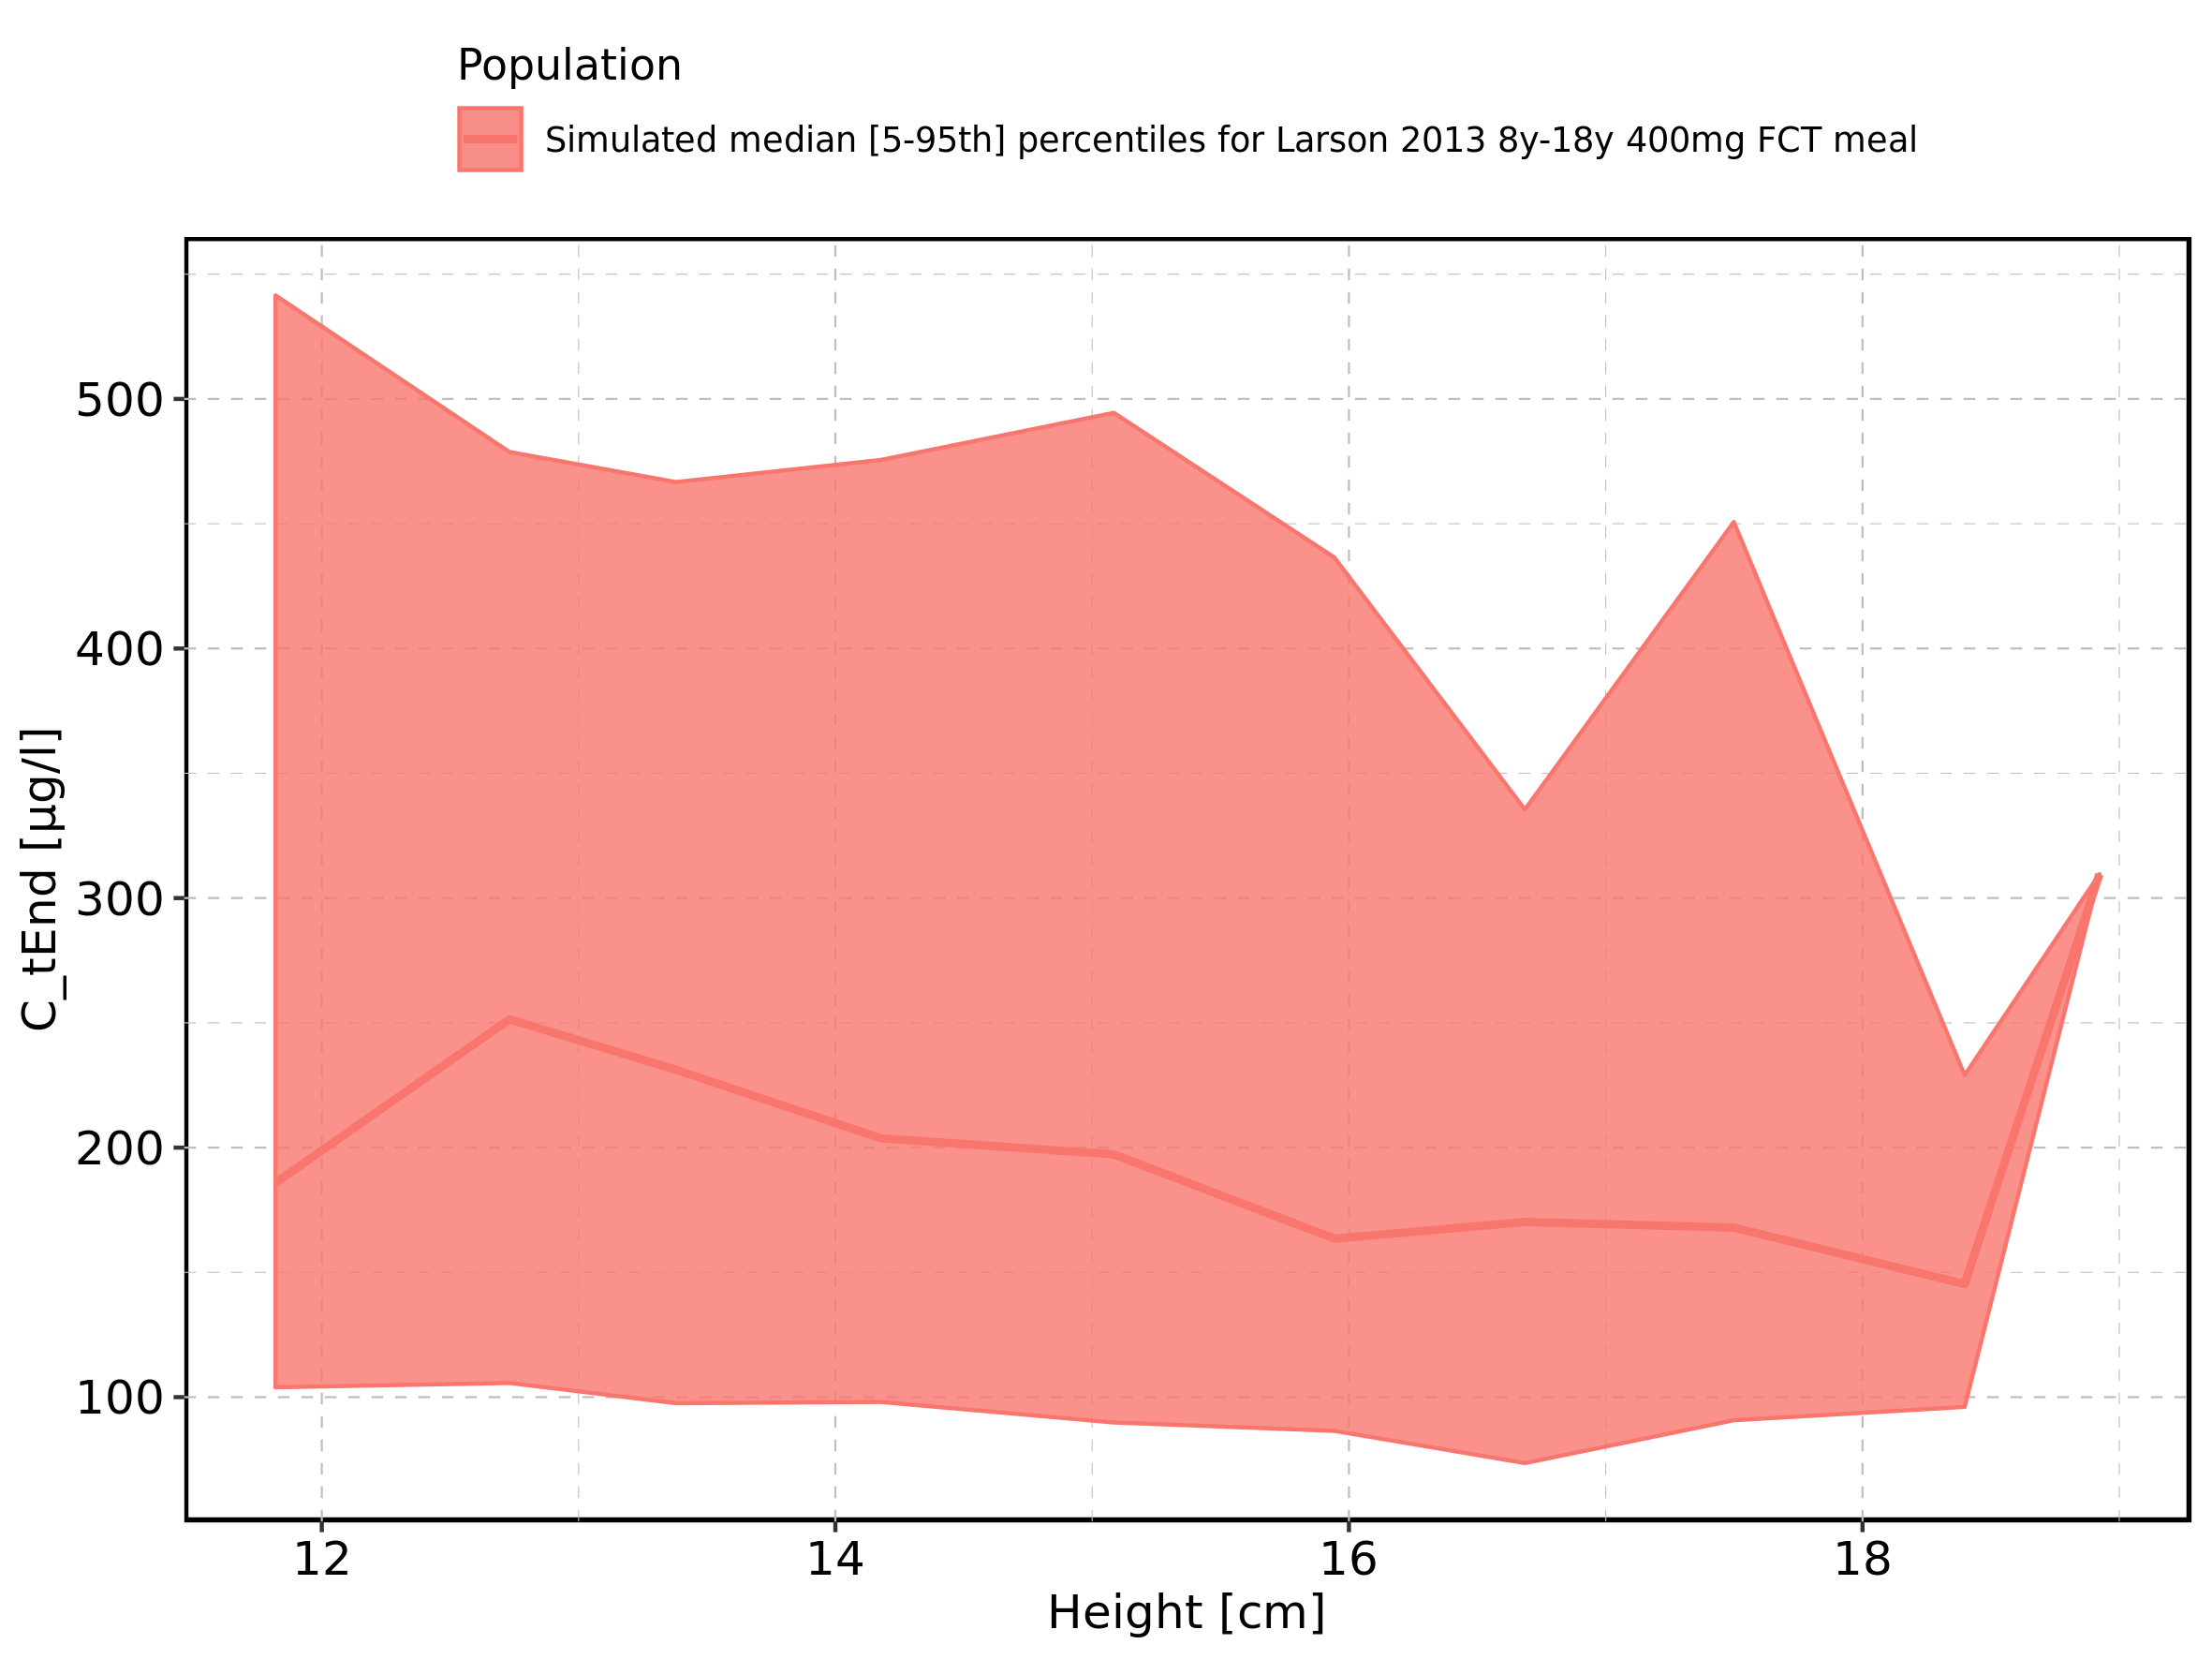

Figure 108: Height-dependence of C_tEnd for Larson 2013 8y-18y 400mg FCT meal. Profiles are plotted in a logarithmic scale.

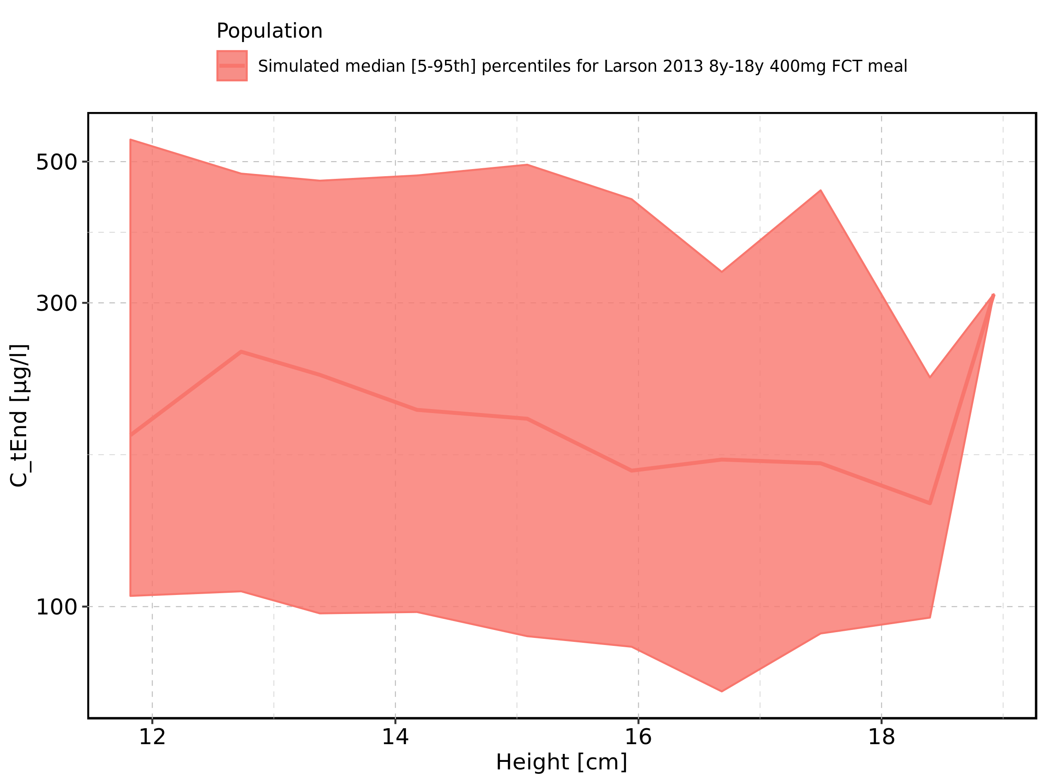

Figure 109: Height-dependence of C_tEnd for Filmcoated_tablet_400mg_sd. Profiles are plotted in a linear scale.

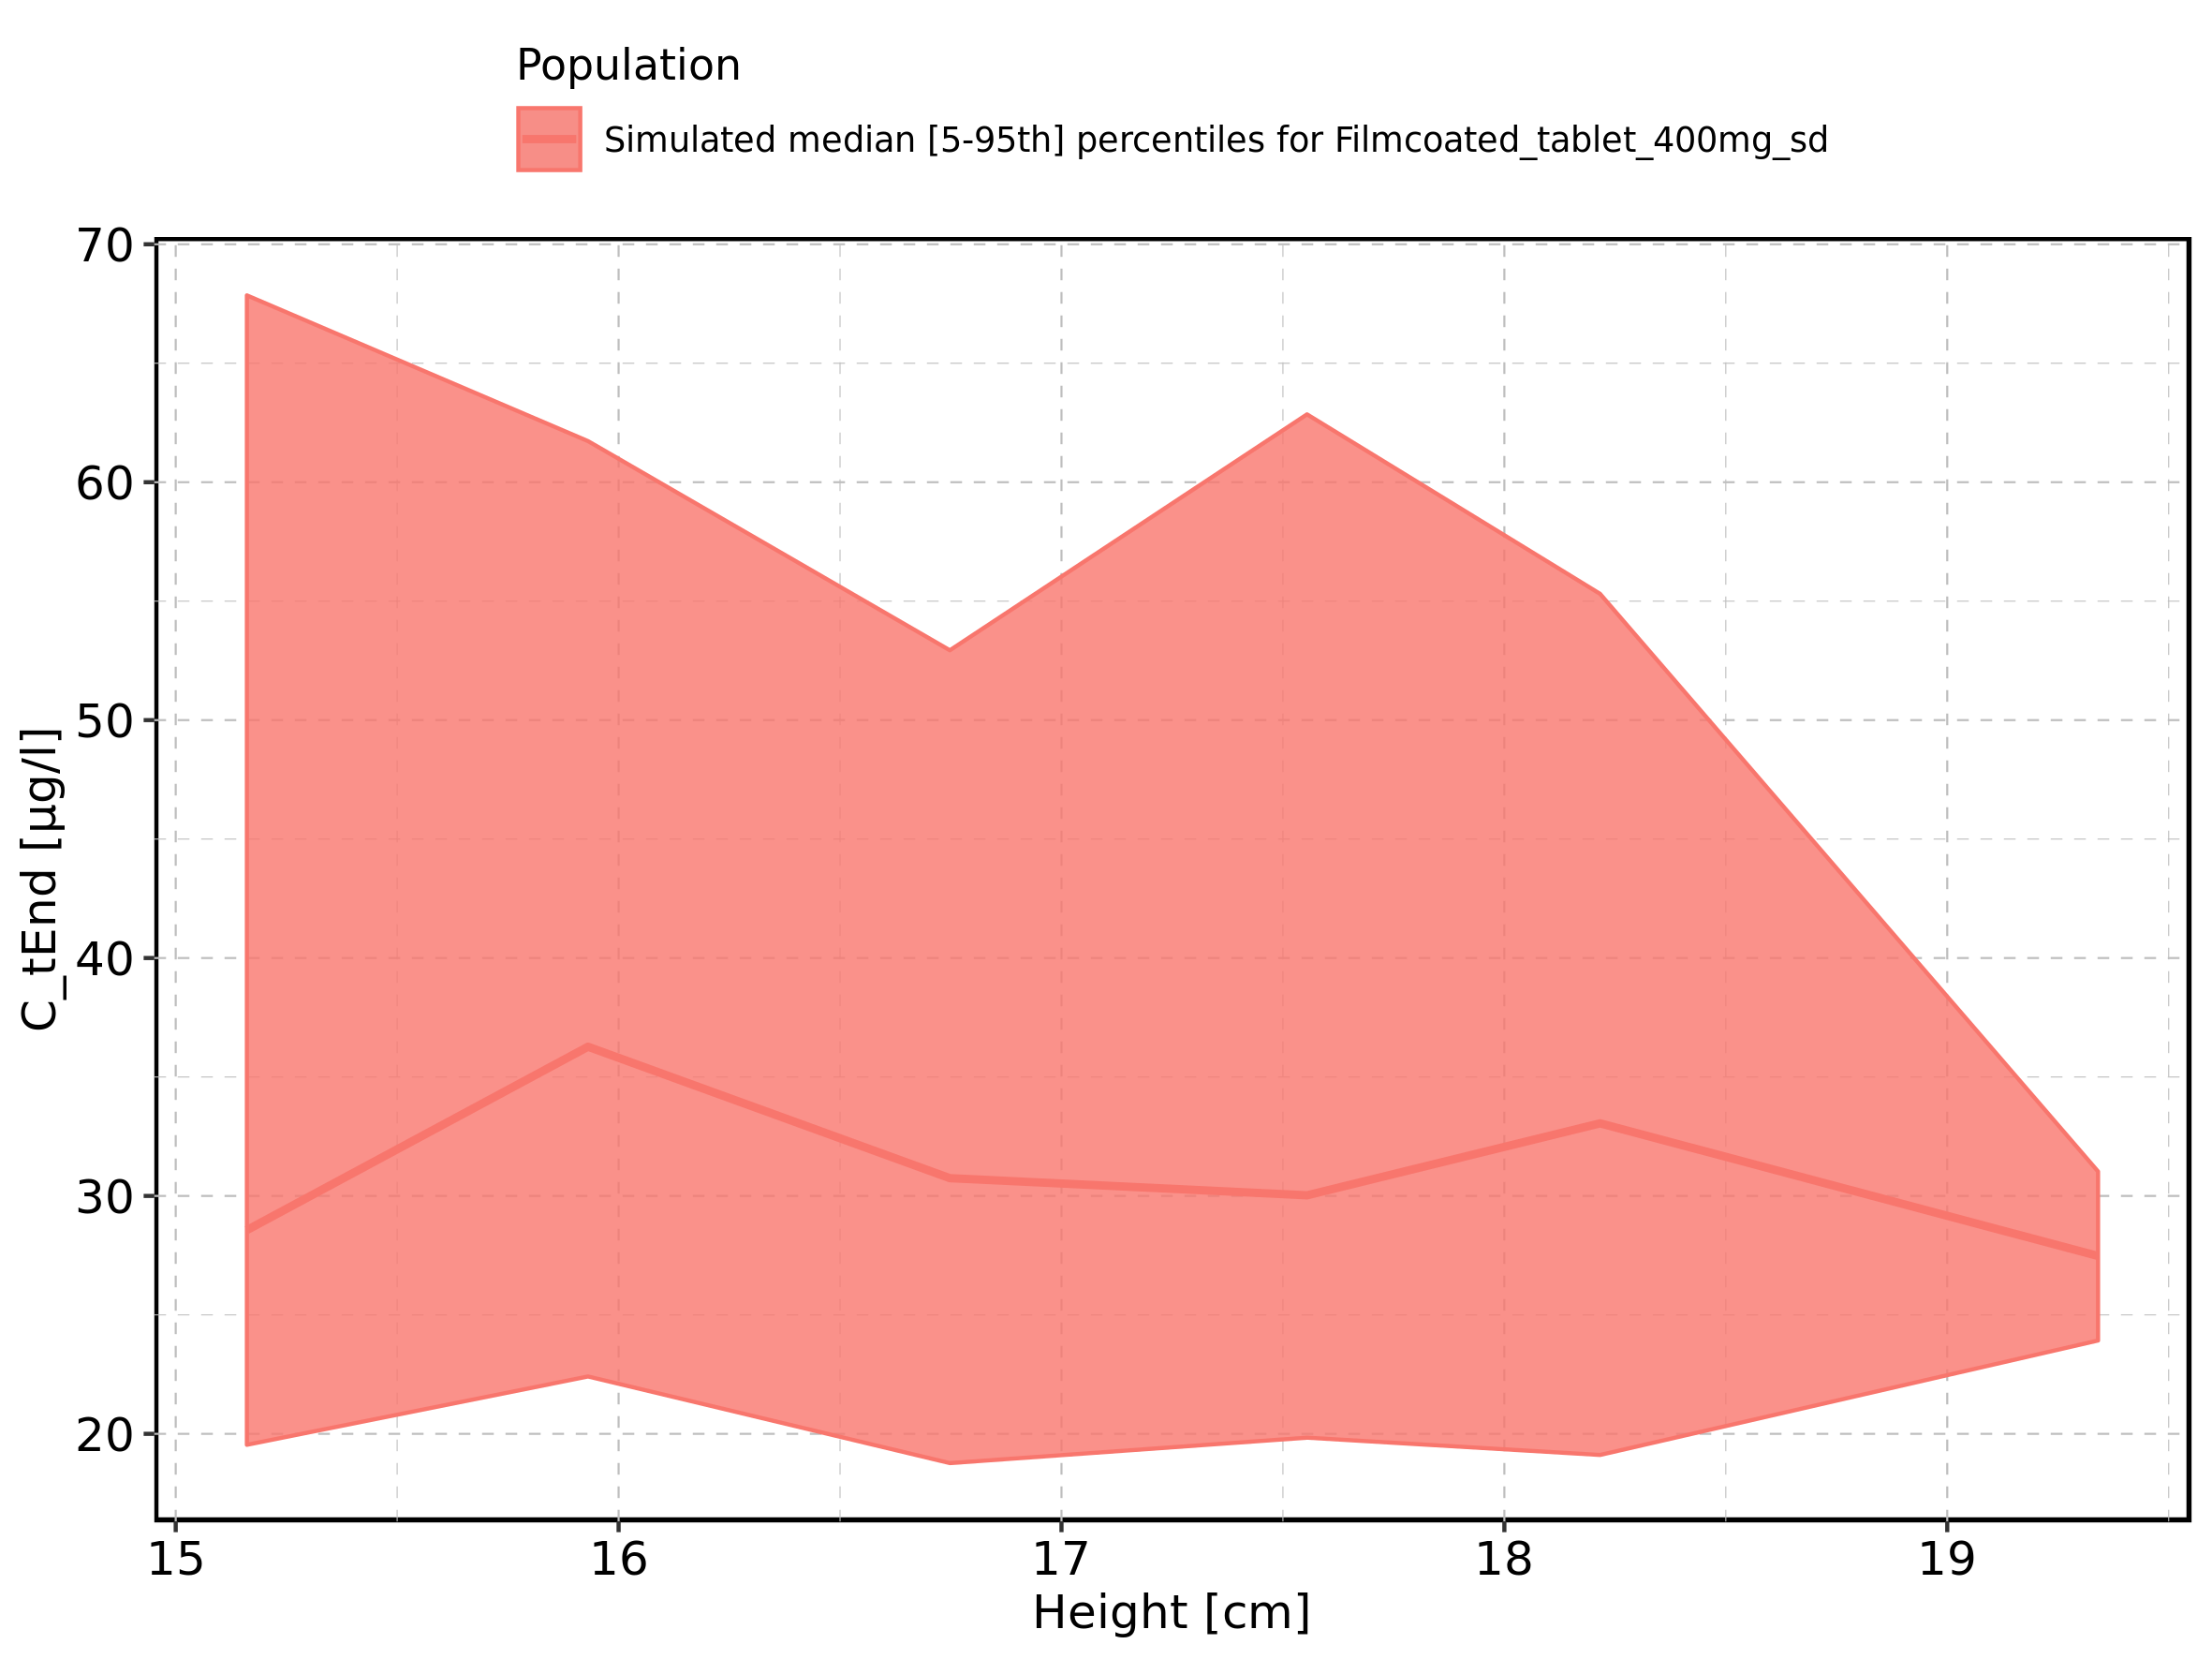

Figure 110: Height-dependence of C_tEnd for Filmcoated_tablet_400mg_sd. Profiles are plotted in a logarithmic scale.

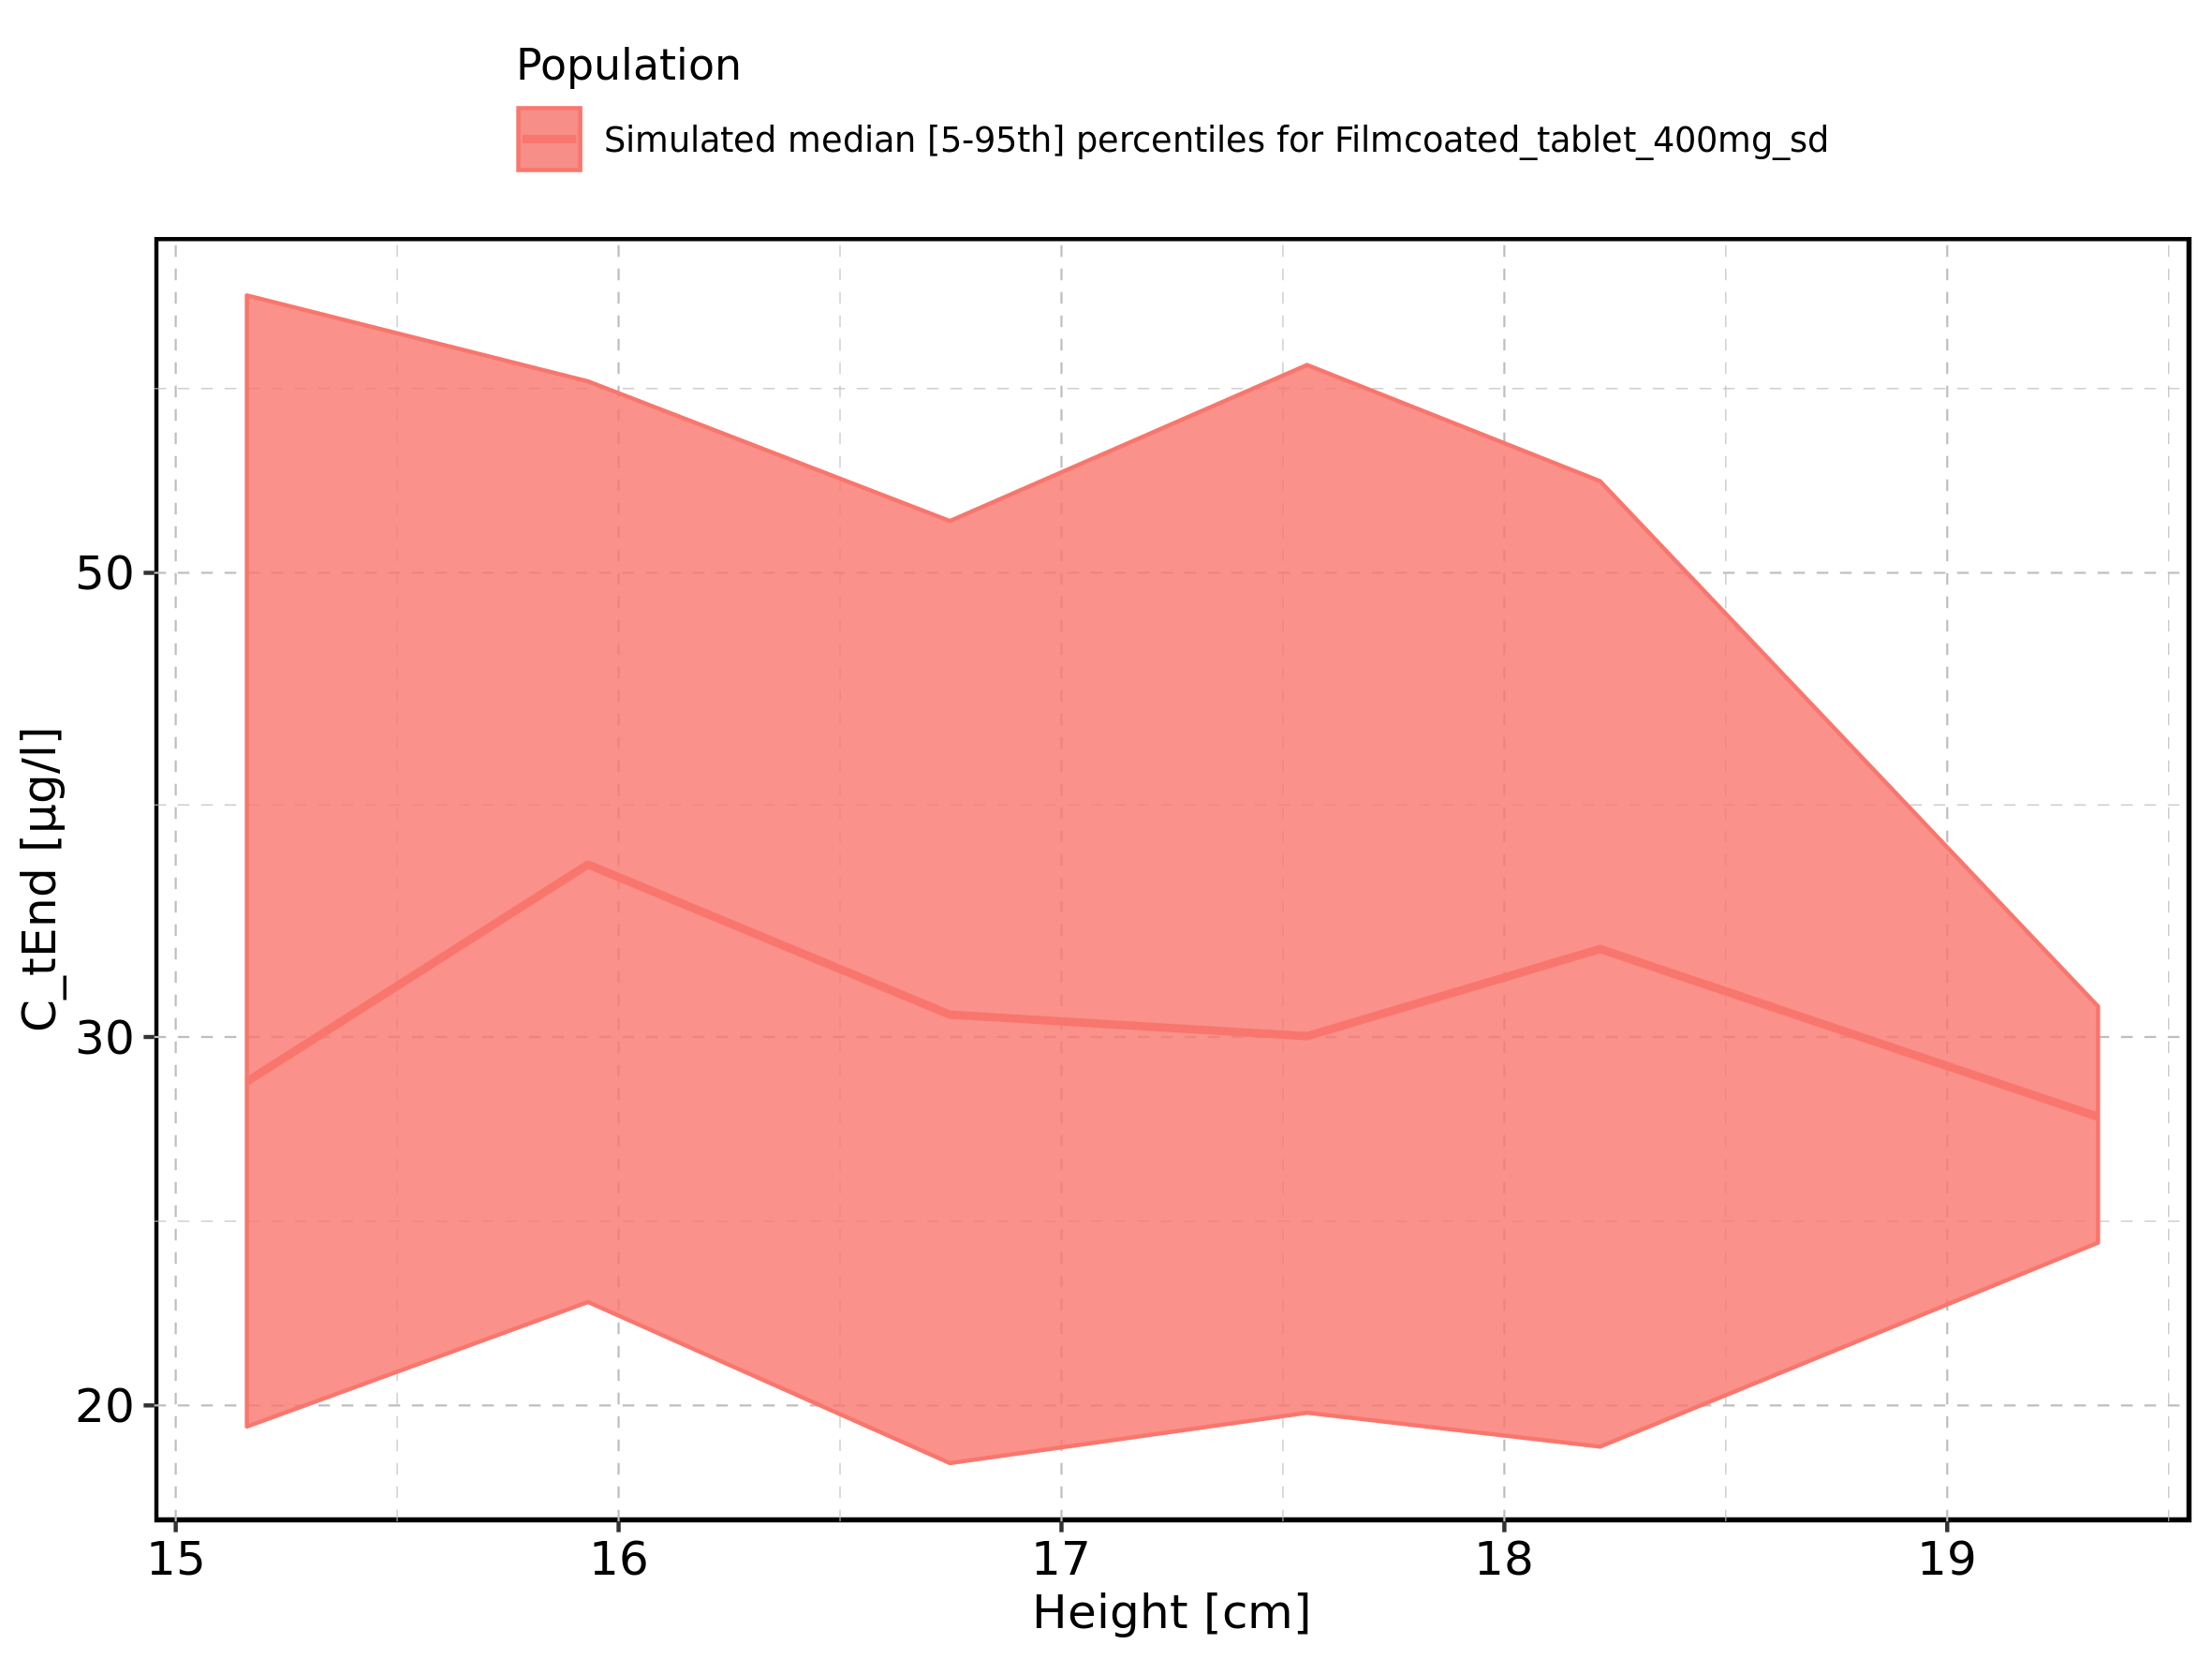

Figure 111: Weight-dependence of C_tEnd for Larson 2013 8y-18y 400mg FCT meal in comparison to Filmcoated_tablet_400mg_sd. Profiles are plotted in a linear scale.

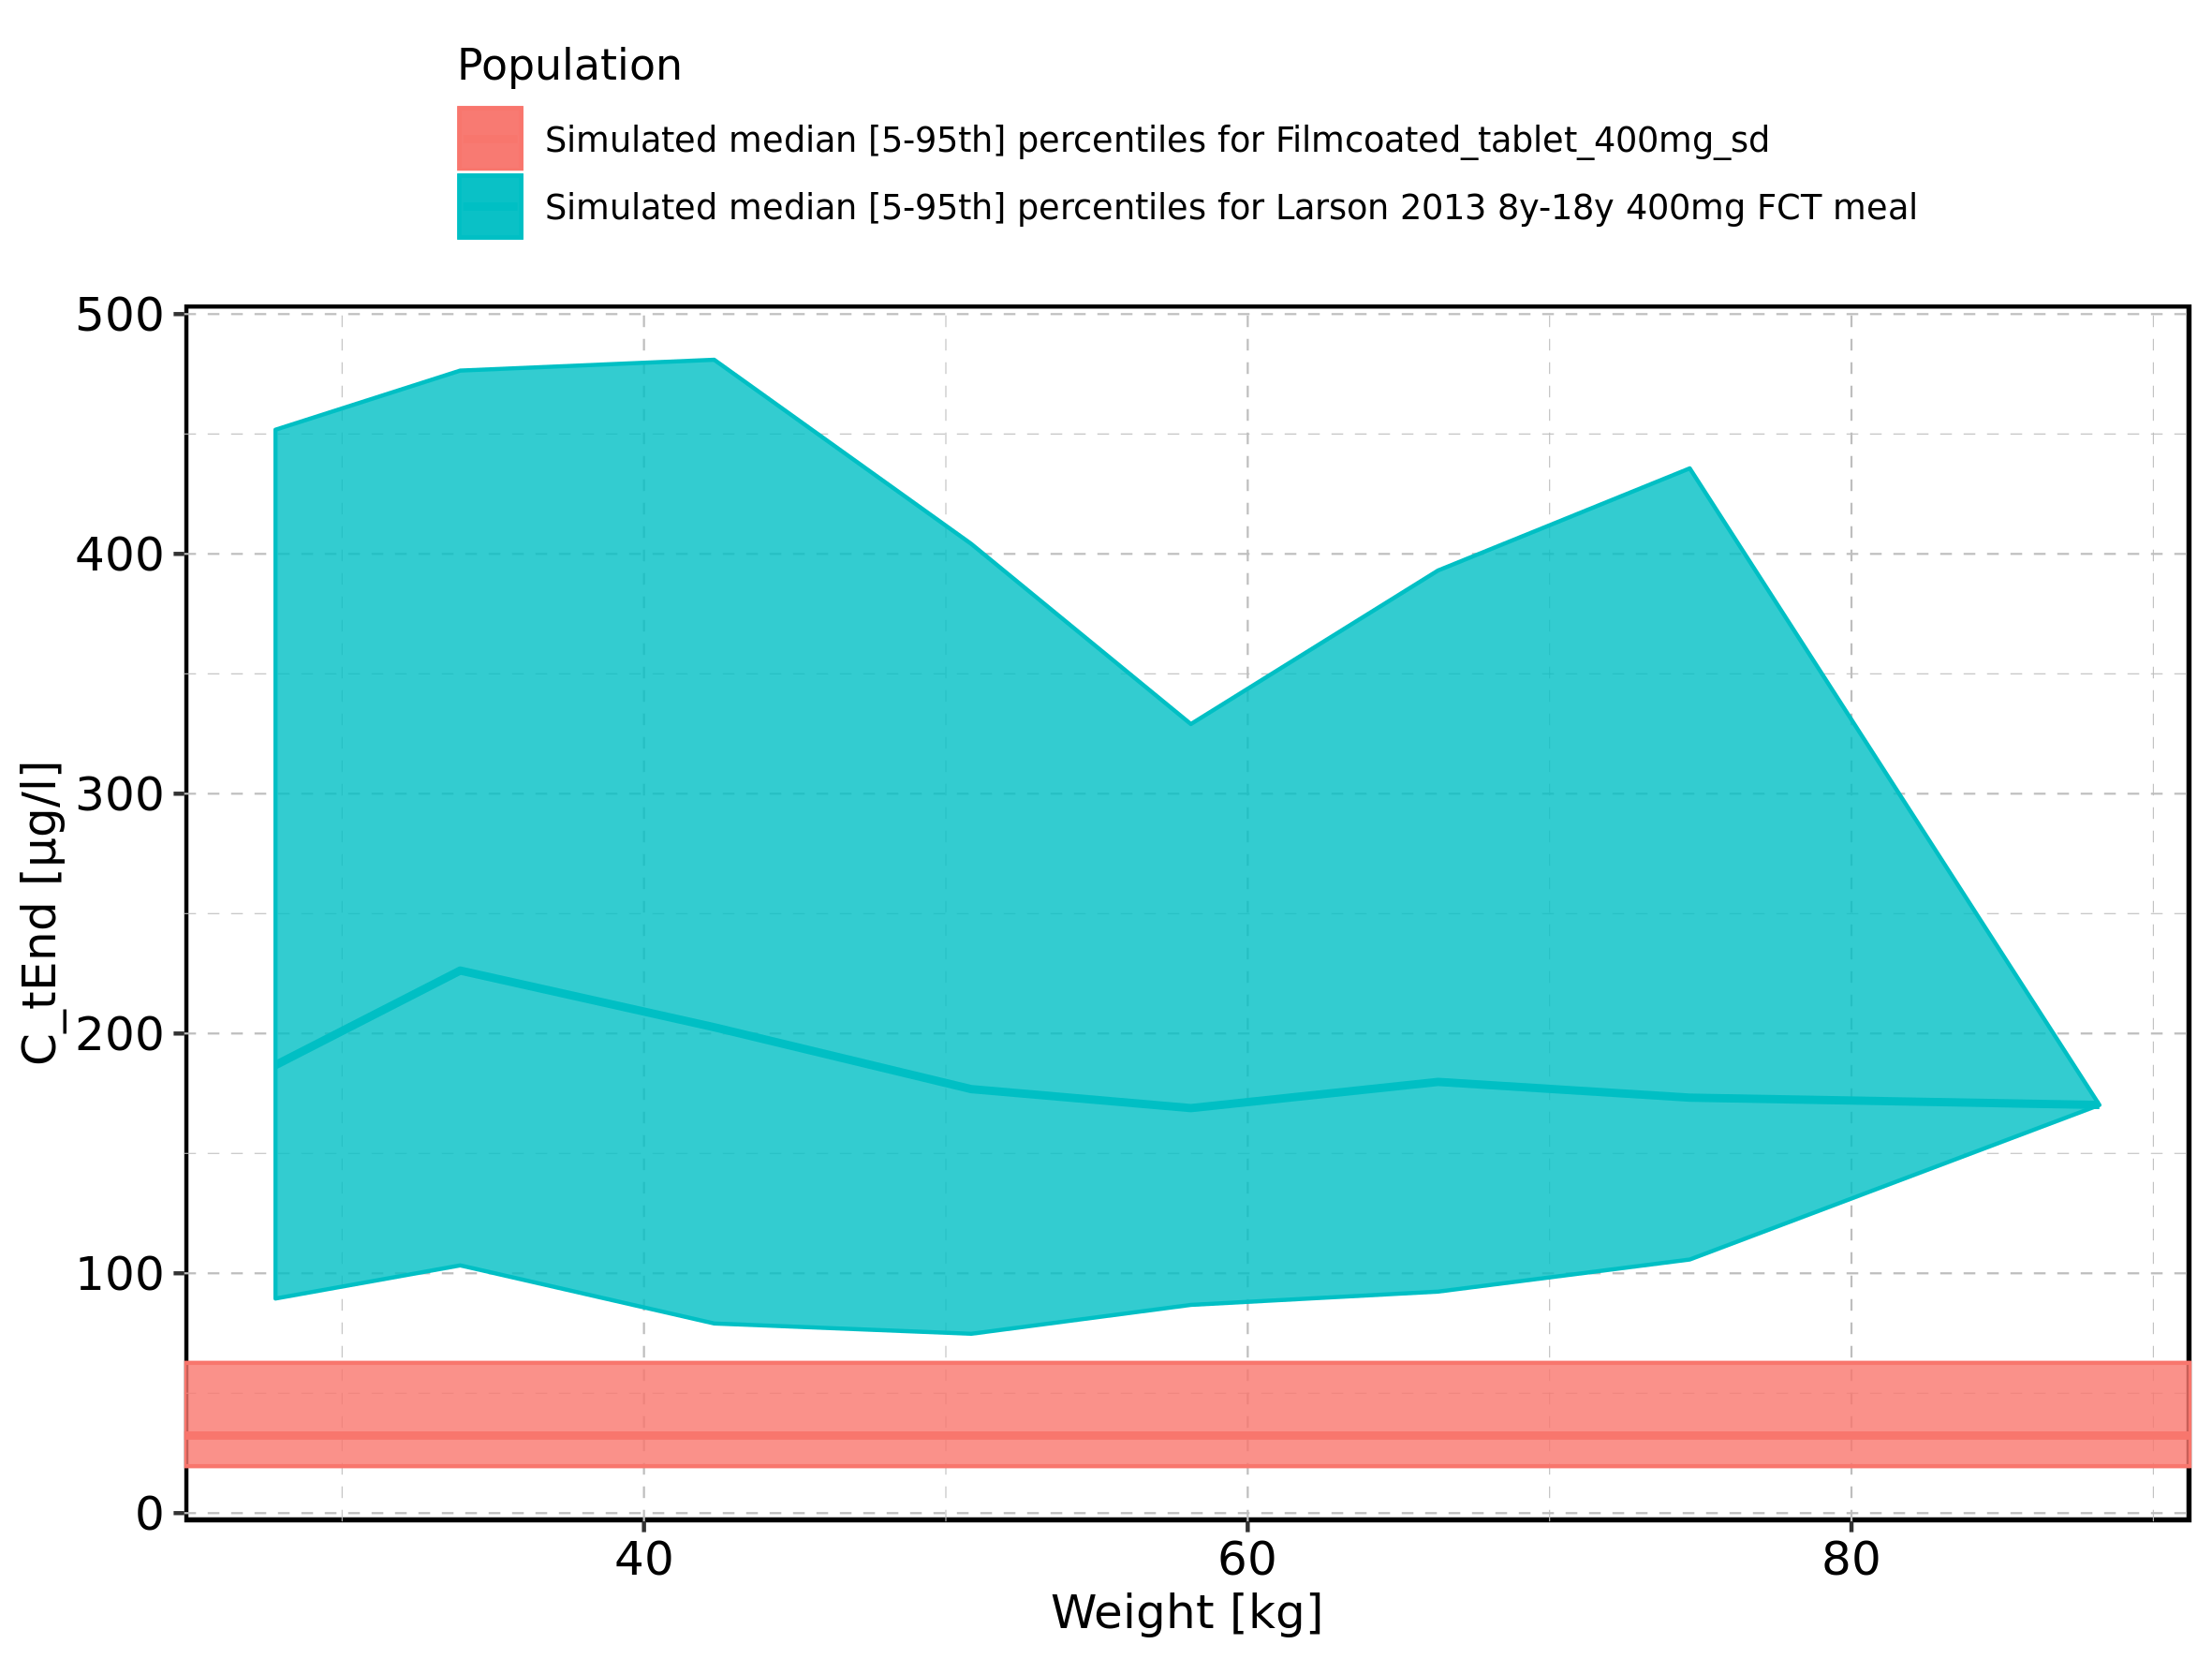

Figure 112: Weight-dependence of C_tEnd for Larson 2013 8y-18y 400mg FCT meal in comparison to Filmcoated_tablet_400mg_sd. Profiles are plotted in a logarithmic scale.

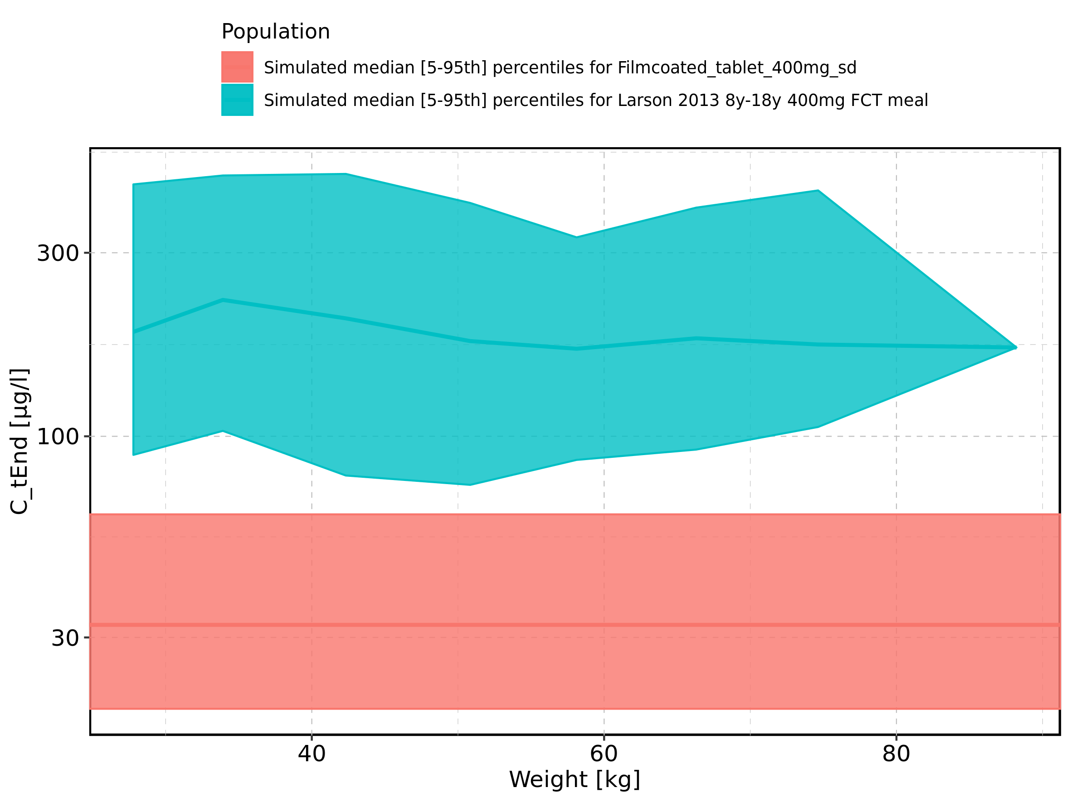

Figure 113: Weight-dependence of C_tEnd for Larson 2013 8y-18y 400mg FCT meal. Profiles are plotted in a linear scale.

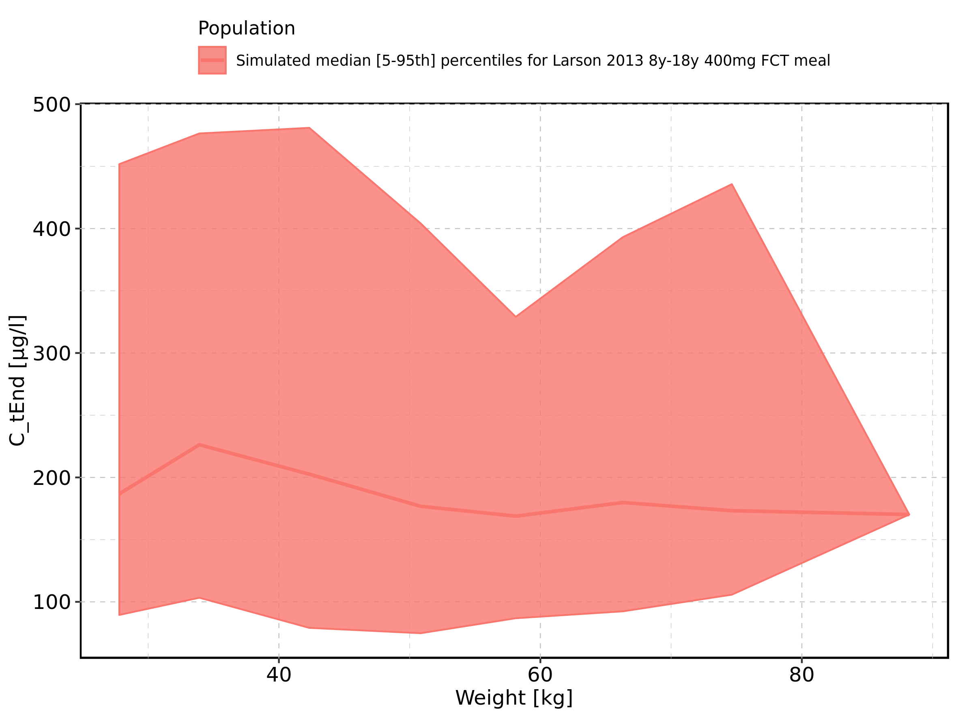

Figure 114: Weight-dependence of C_tEnd for Larson 2013 8y-18y 400mg FCT meal. Profiles are plotted in a logarithmic scale.

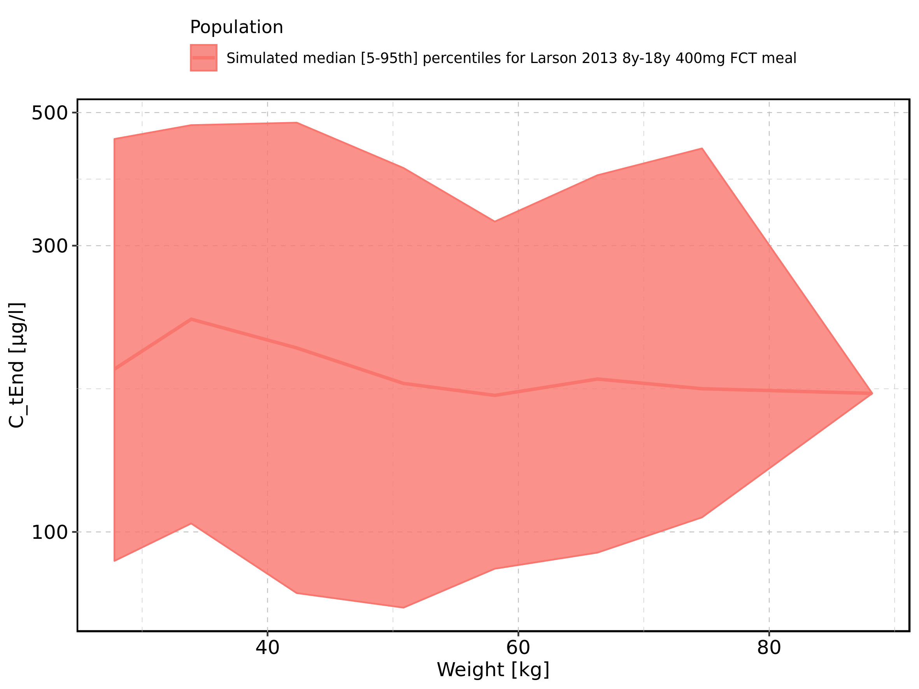

Figure 115: Weight-dependence of C_tEnd for Filmcoated_tablet_400mg_sd. Profiles are plotted in a linear scale.

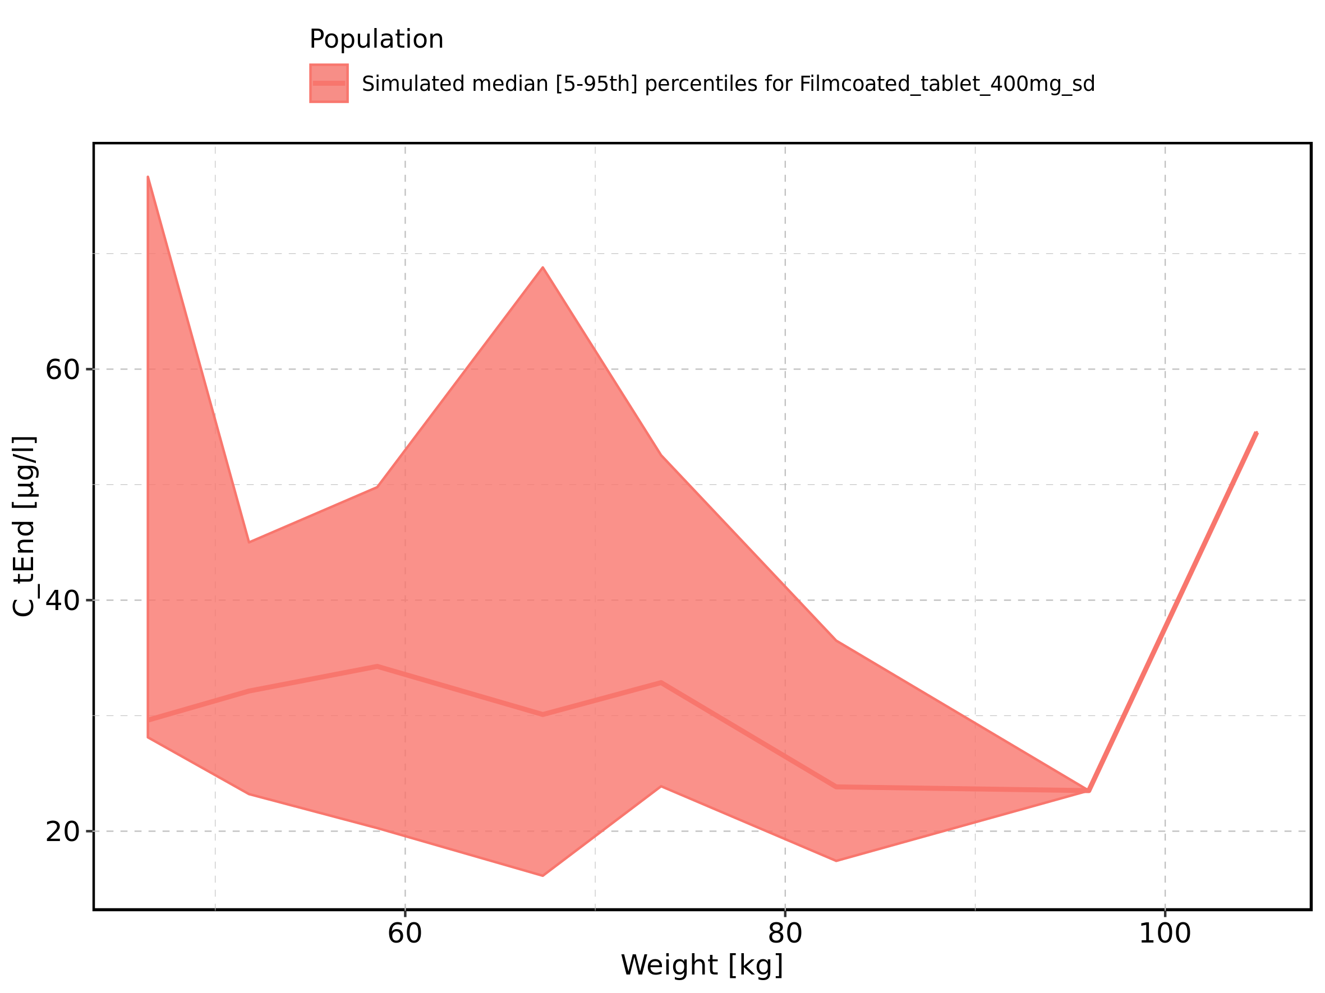

Figure 116: Weight-dependence of C_tEnd for Filmcoated_tablet_400mg_sd. Profiles are plotted in a logarithmic scale.

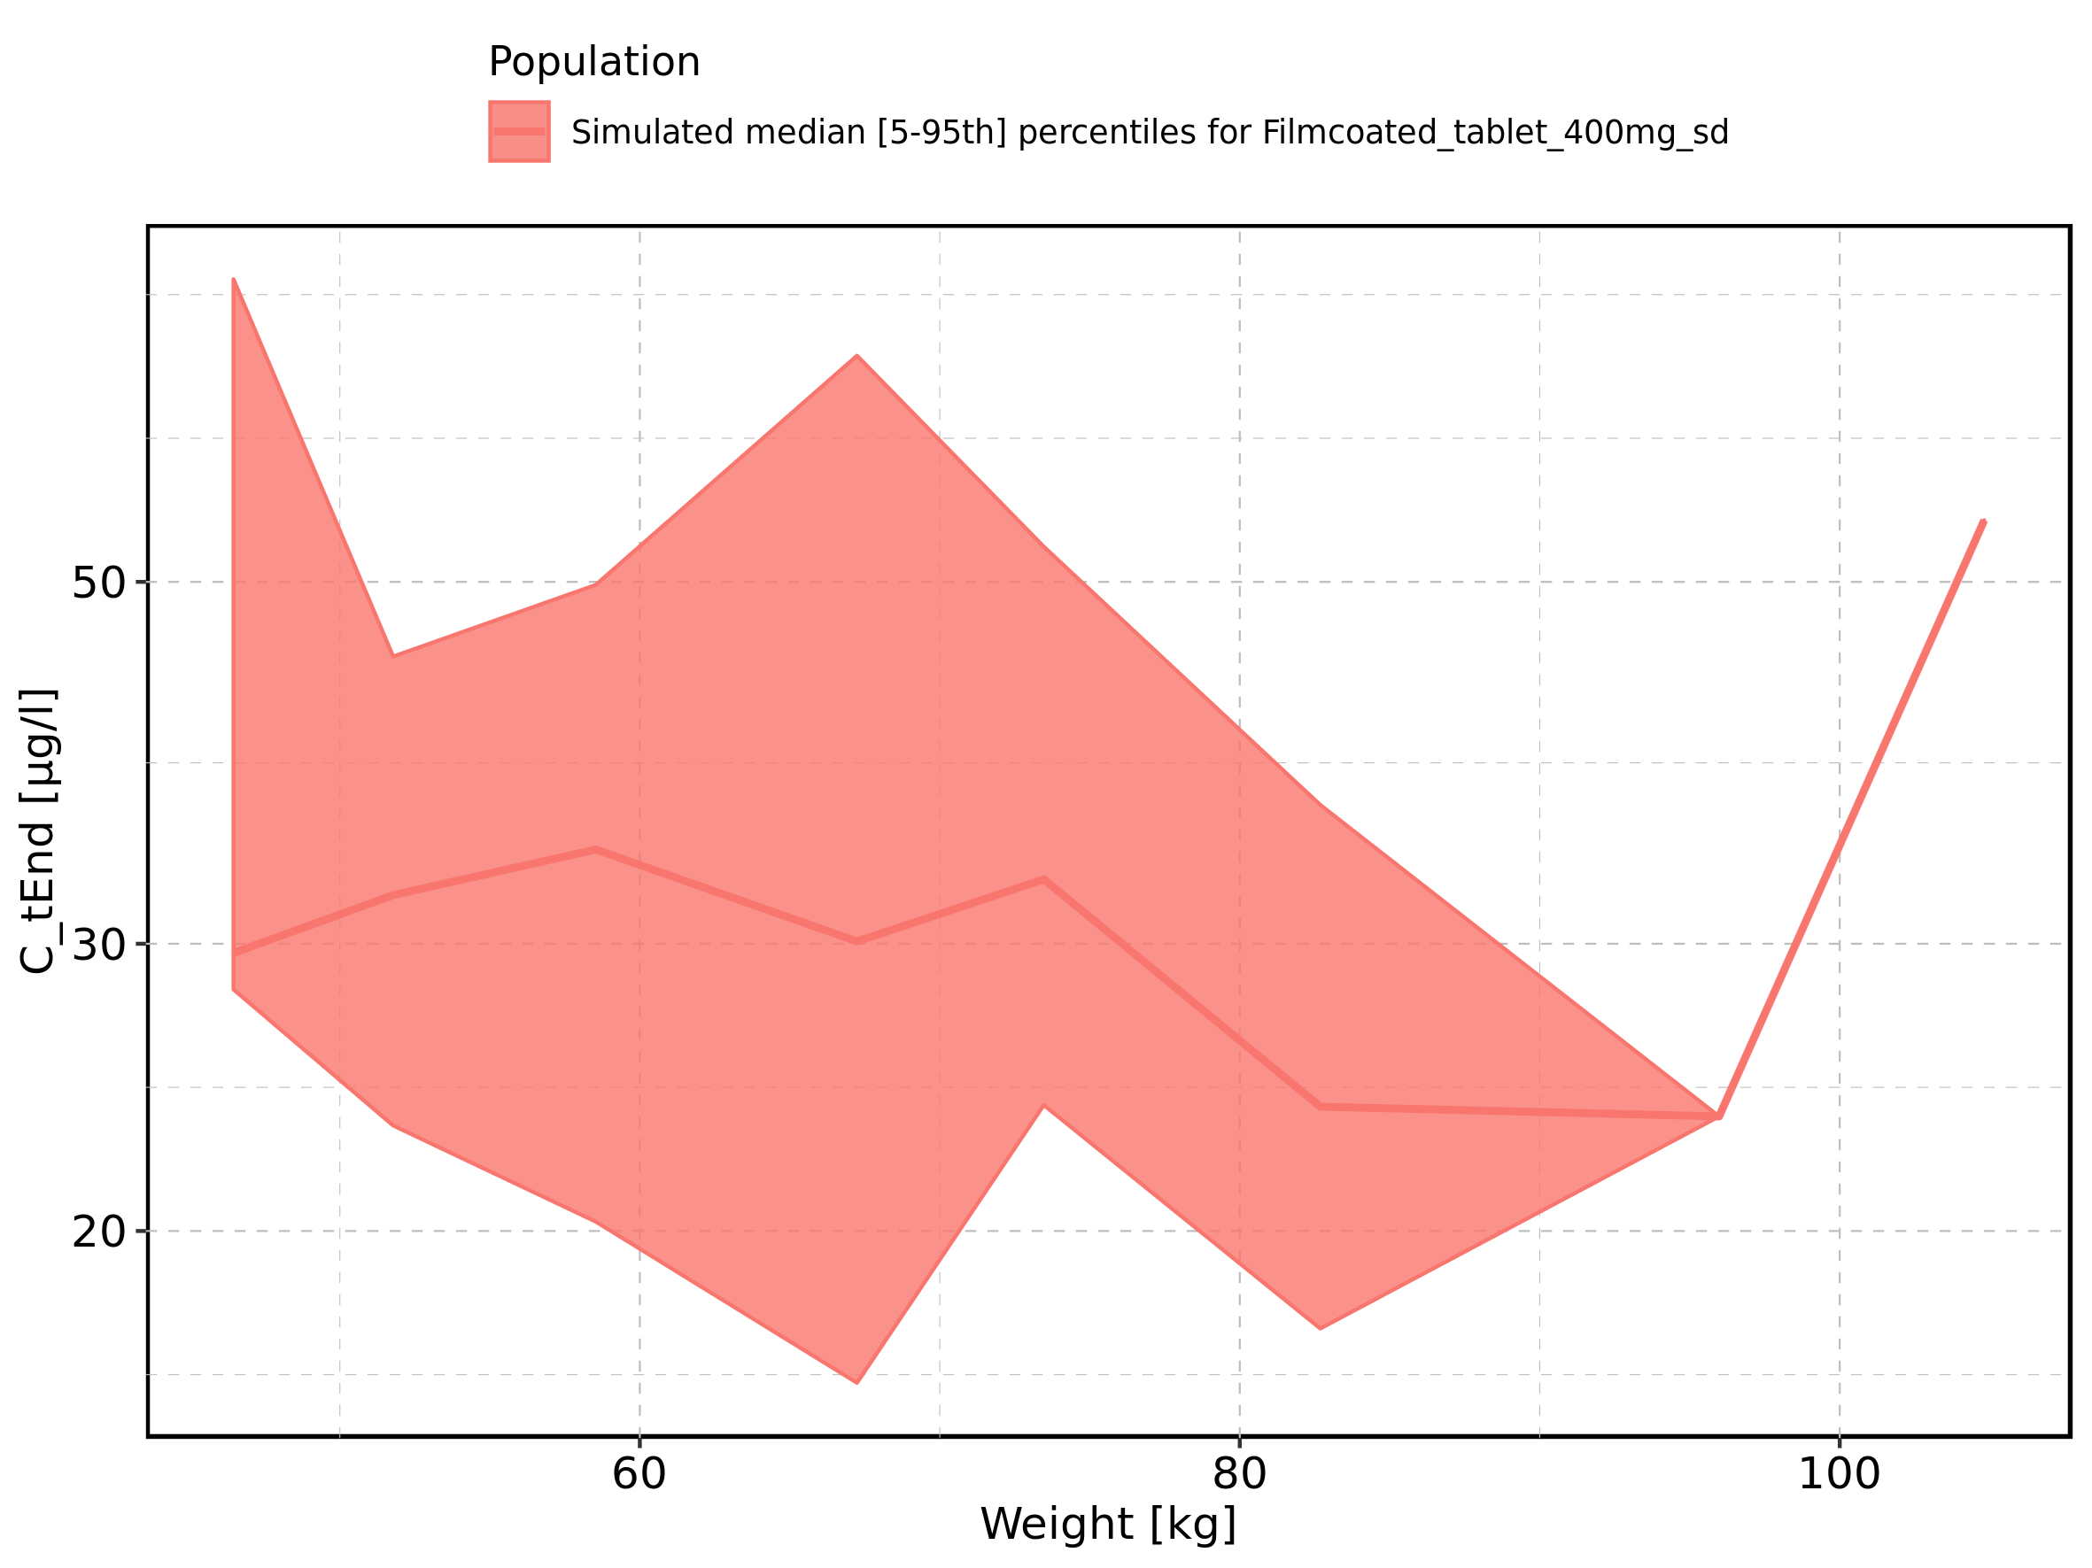

Figure 117: BMI-dependence of C_tEnd for Larson 2013 8y-18y 400mg FCT meal in comparison to Filmcoated_tablet_400mg_sd. Profiles are plotted in a linear scale.

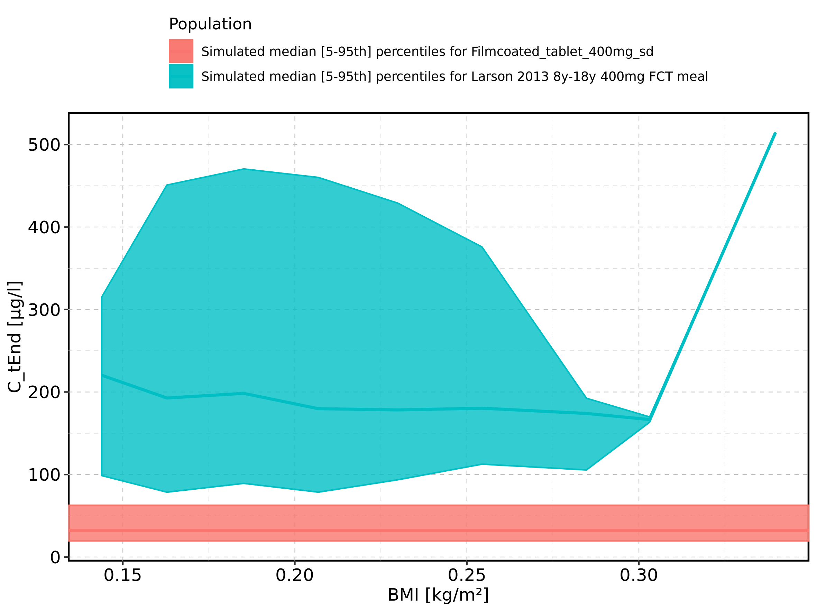

Figure 118: BMI-dependence of C_tEnd for Larson 2013 8y-18y 400mg FCT meal in comparison to Filmcoated_tablet_400mg_sd. Profiles are plotted in a logarithmic scale.

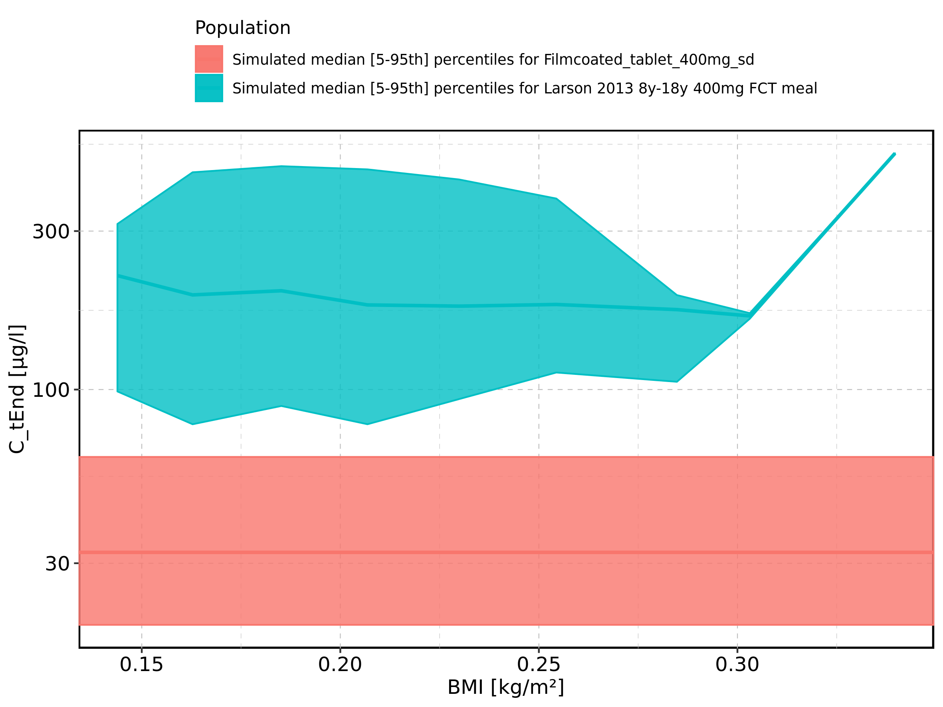

Figure 119: BMI-dependence of C_tEnd for Larson 2013 8y-18y 400mg FCT meal. Profiles are plotted in a linear scale.

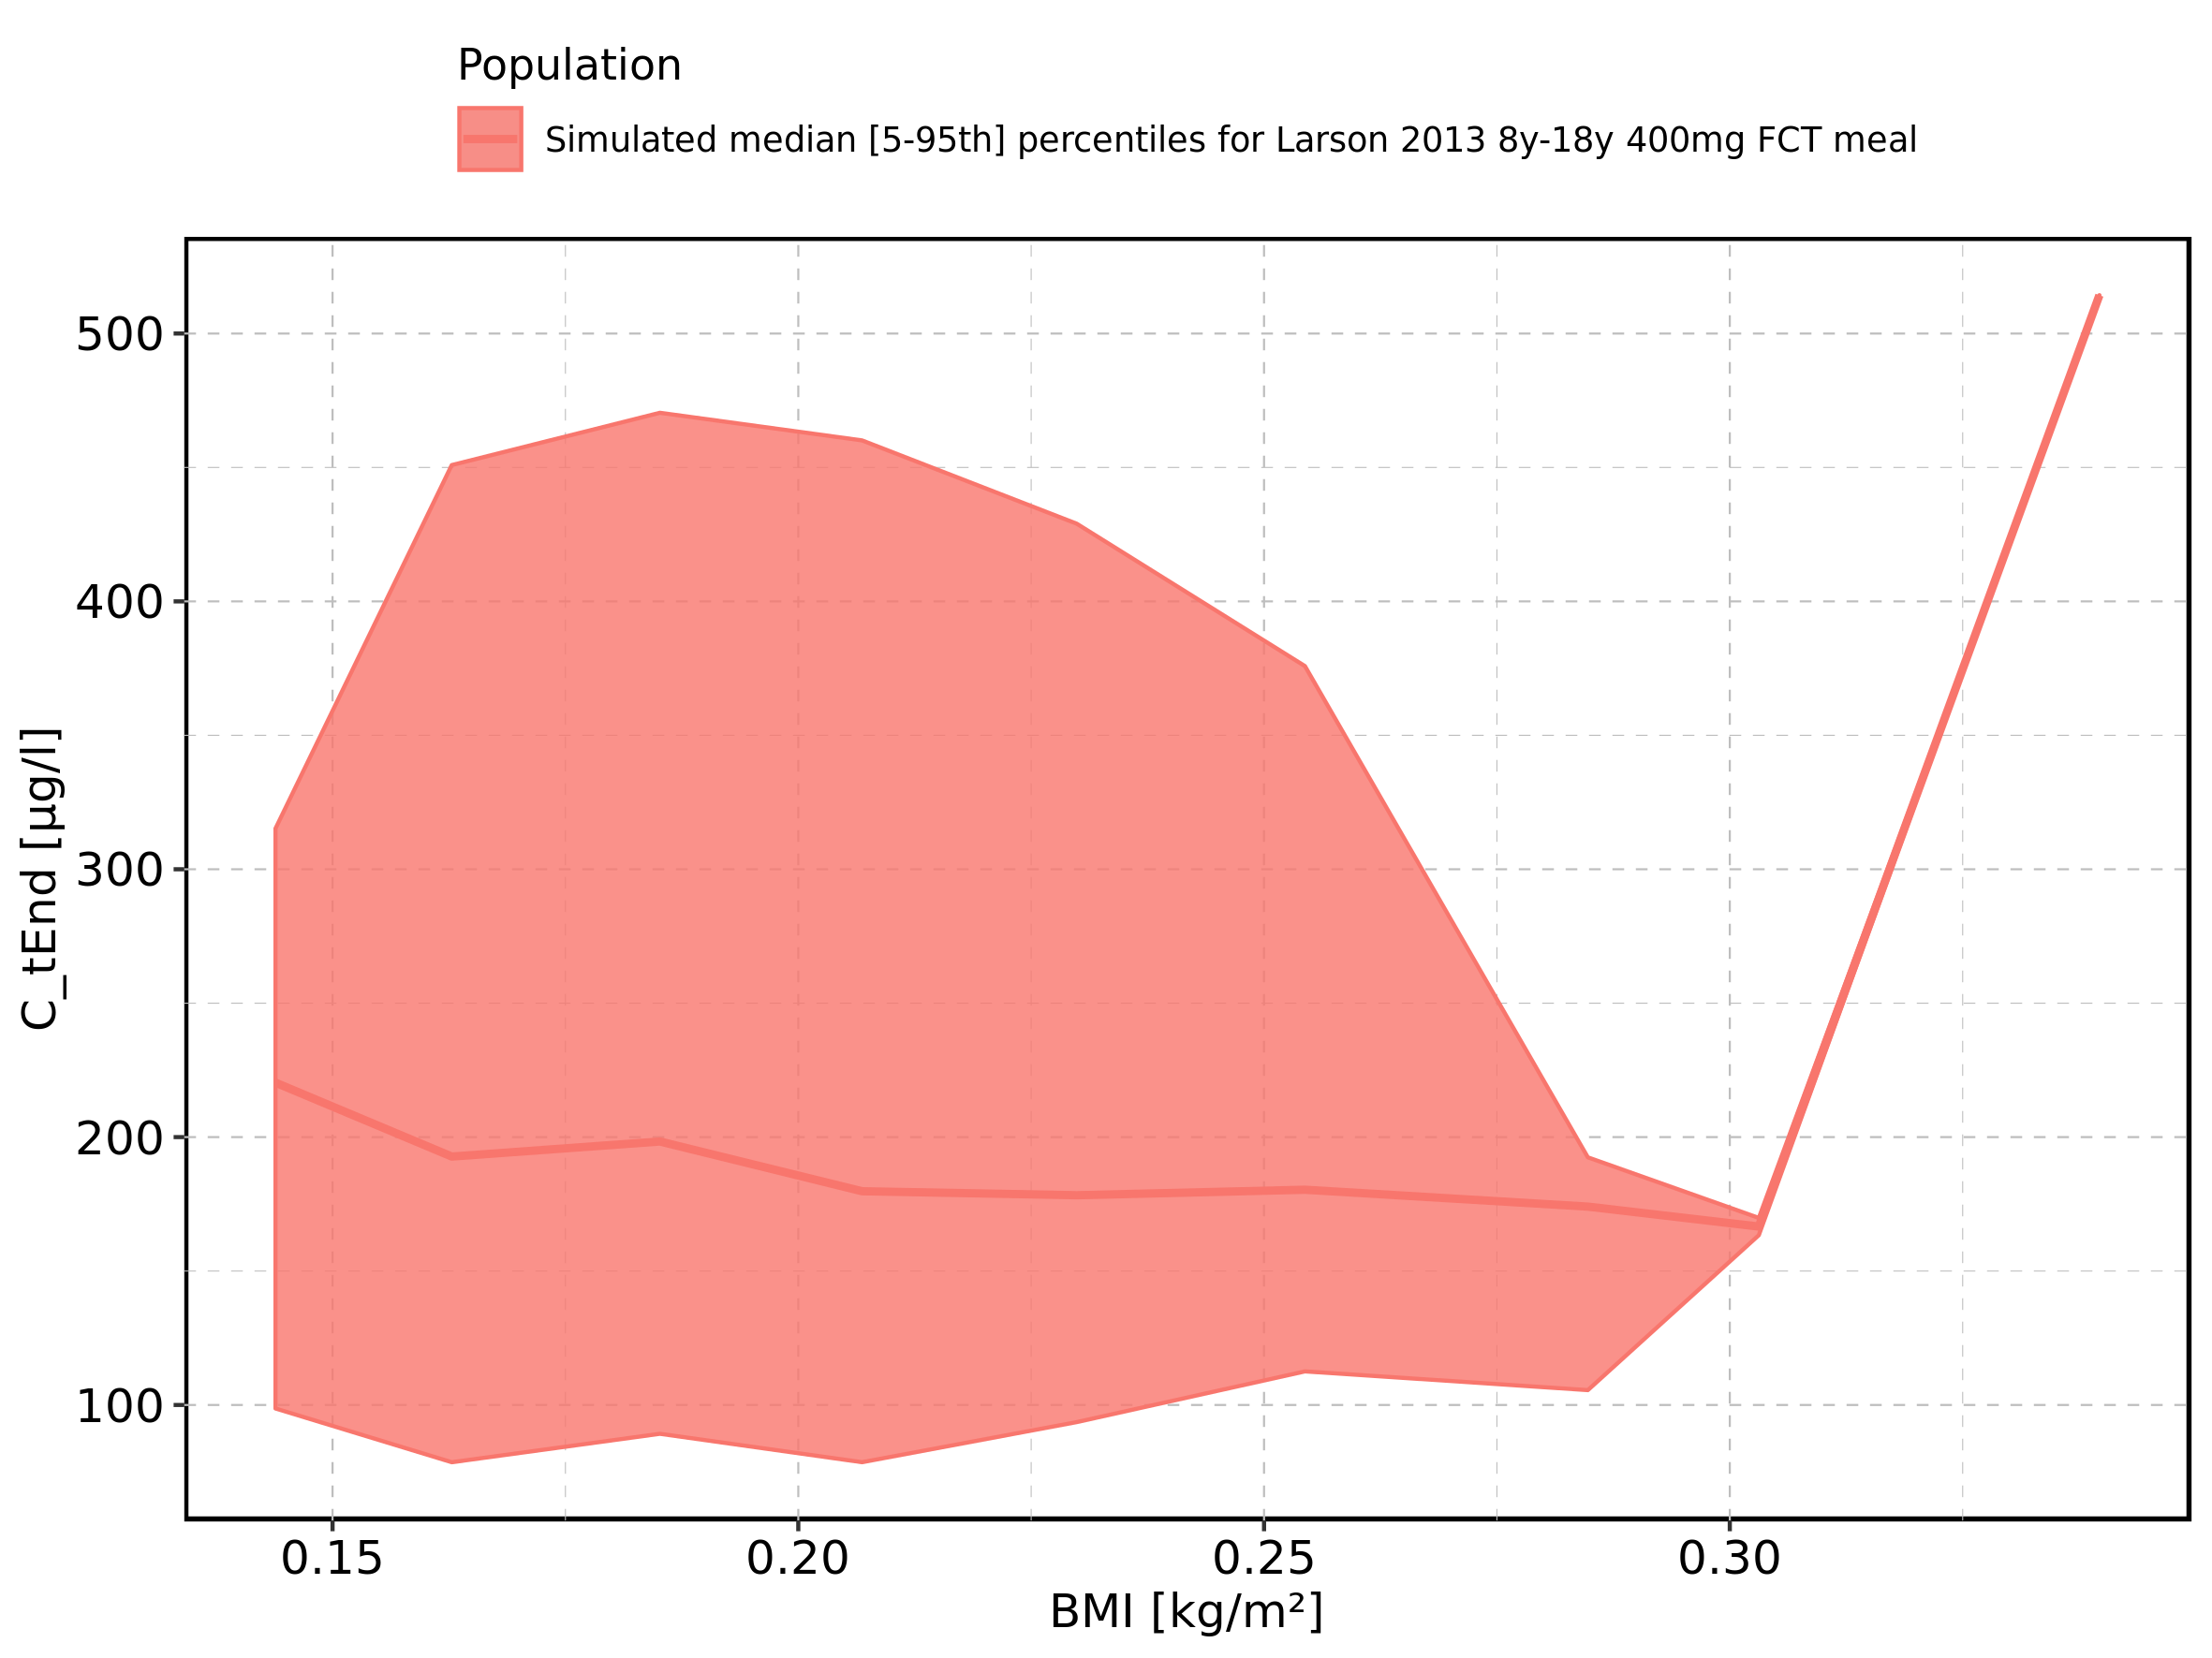

Figure 120: BMI-dependence of C_tEnd for Larson 2013 8y-18y 400mg FCT meal. Profiles are plotted in a logarithmic scale.

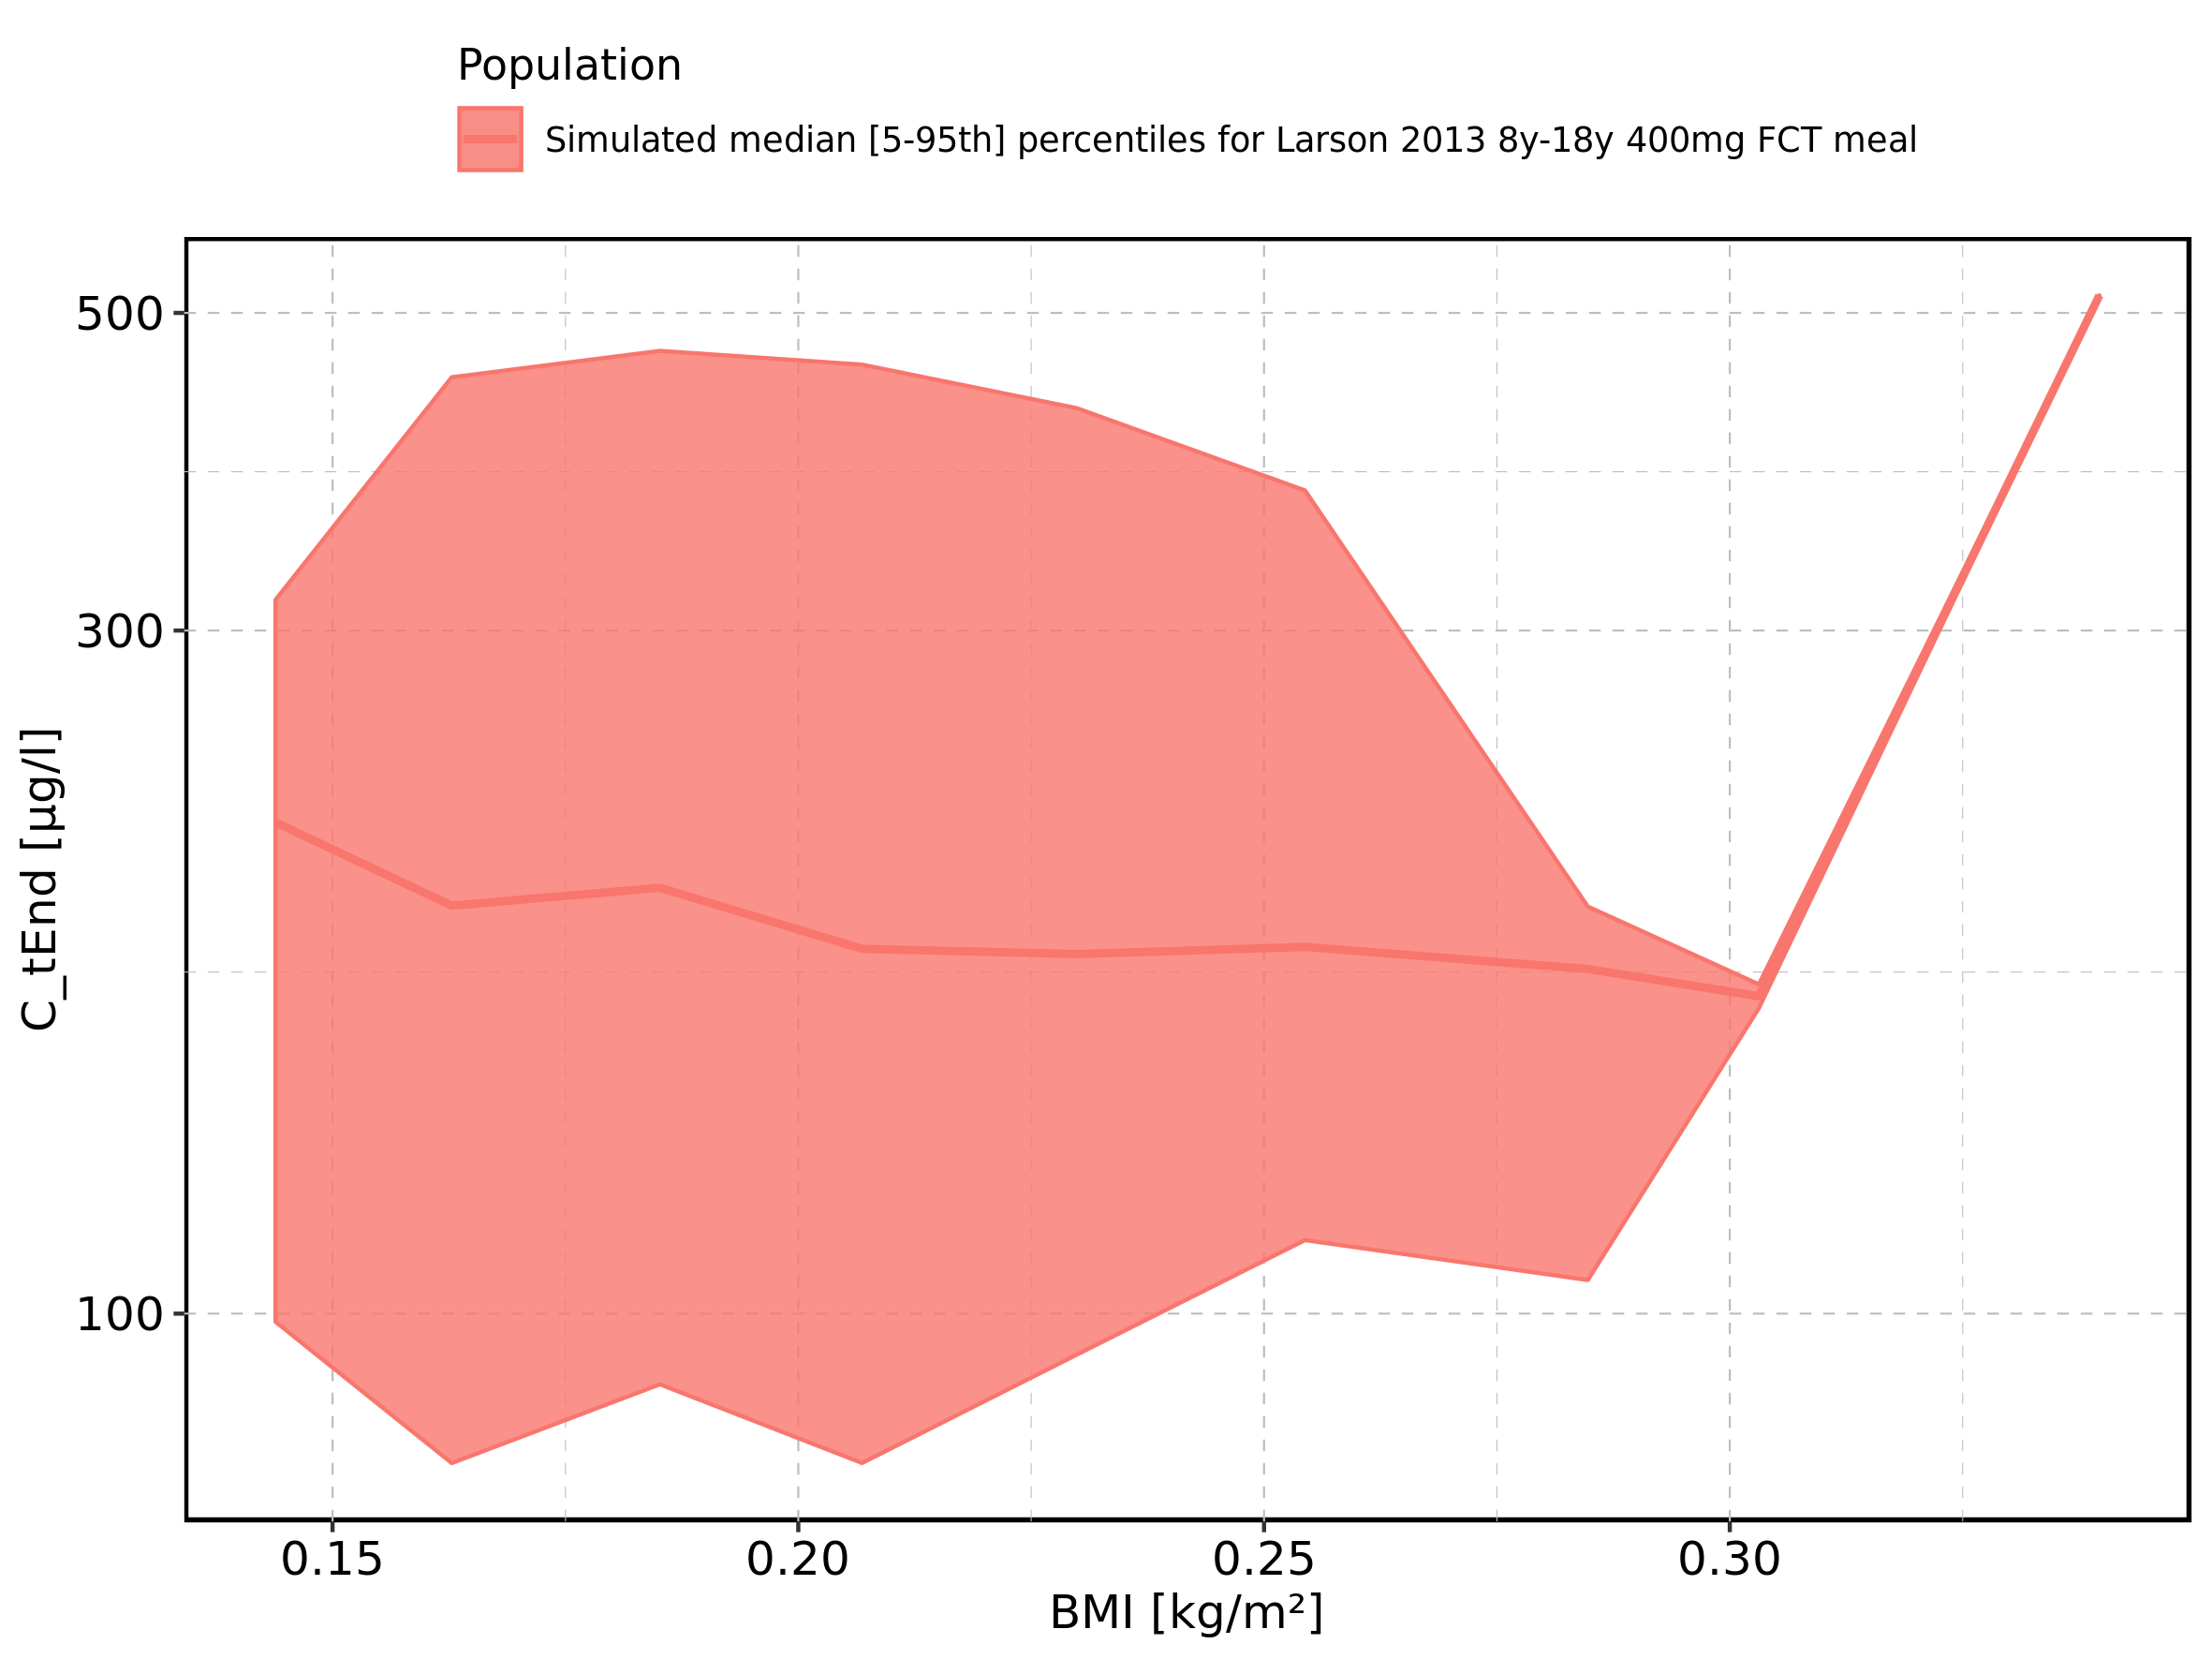

Figure 121: BMI-dependence of C_tEnd for Filmcoated_tablet_400mg_sd. Profiles are plotted in a linear scale.

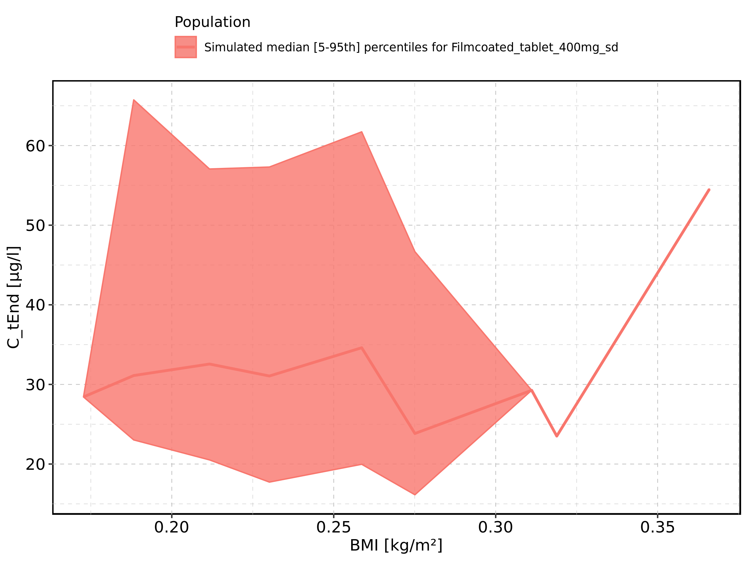

Figure 122: BMI-dependence of C_tEnd for Filmcoated_tablet_400mg_sd. Profiles are plotted in a logarithmic scale.

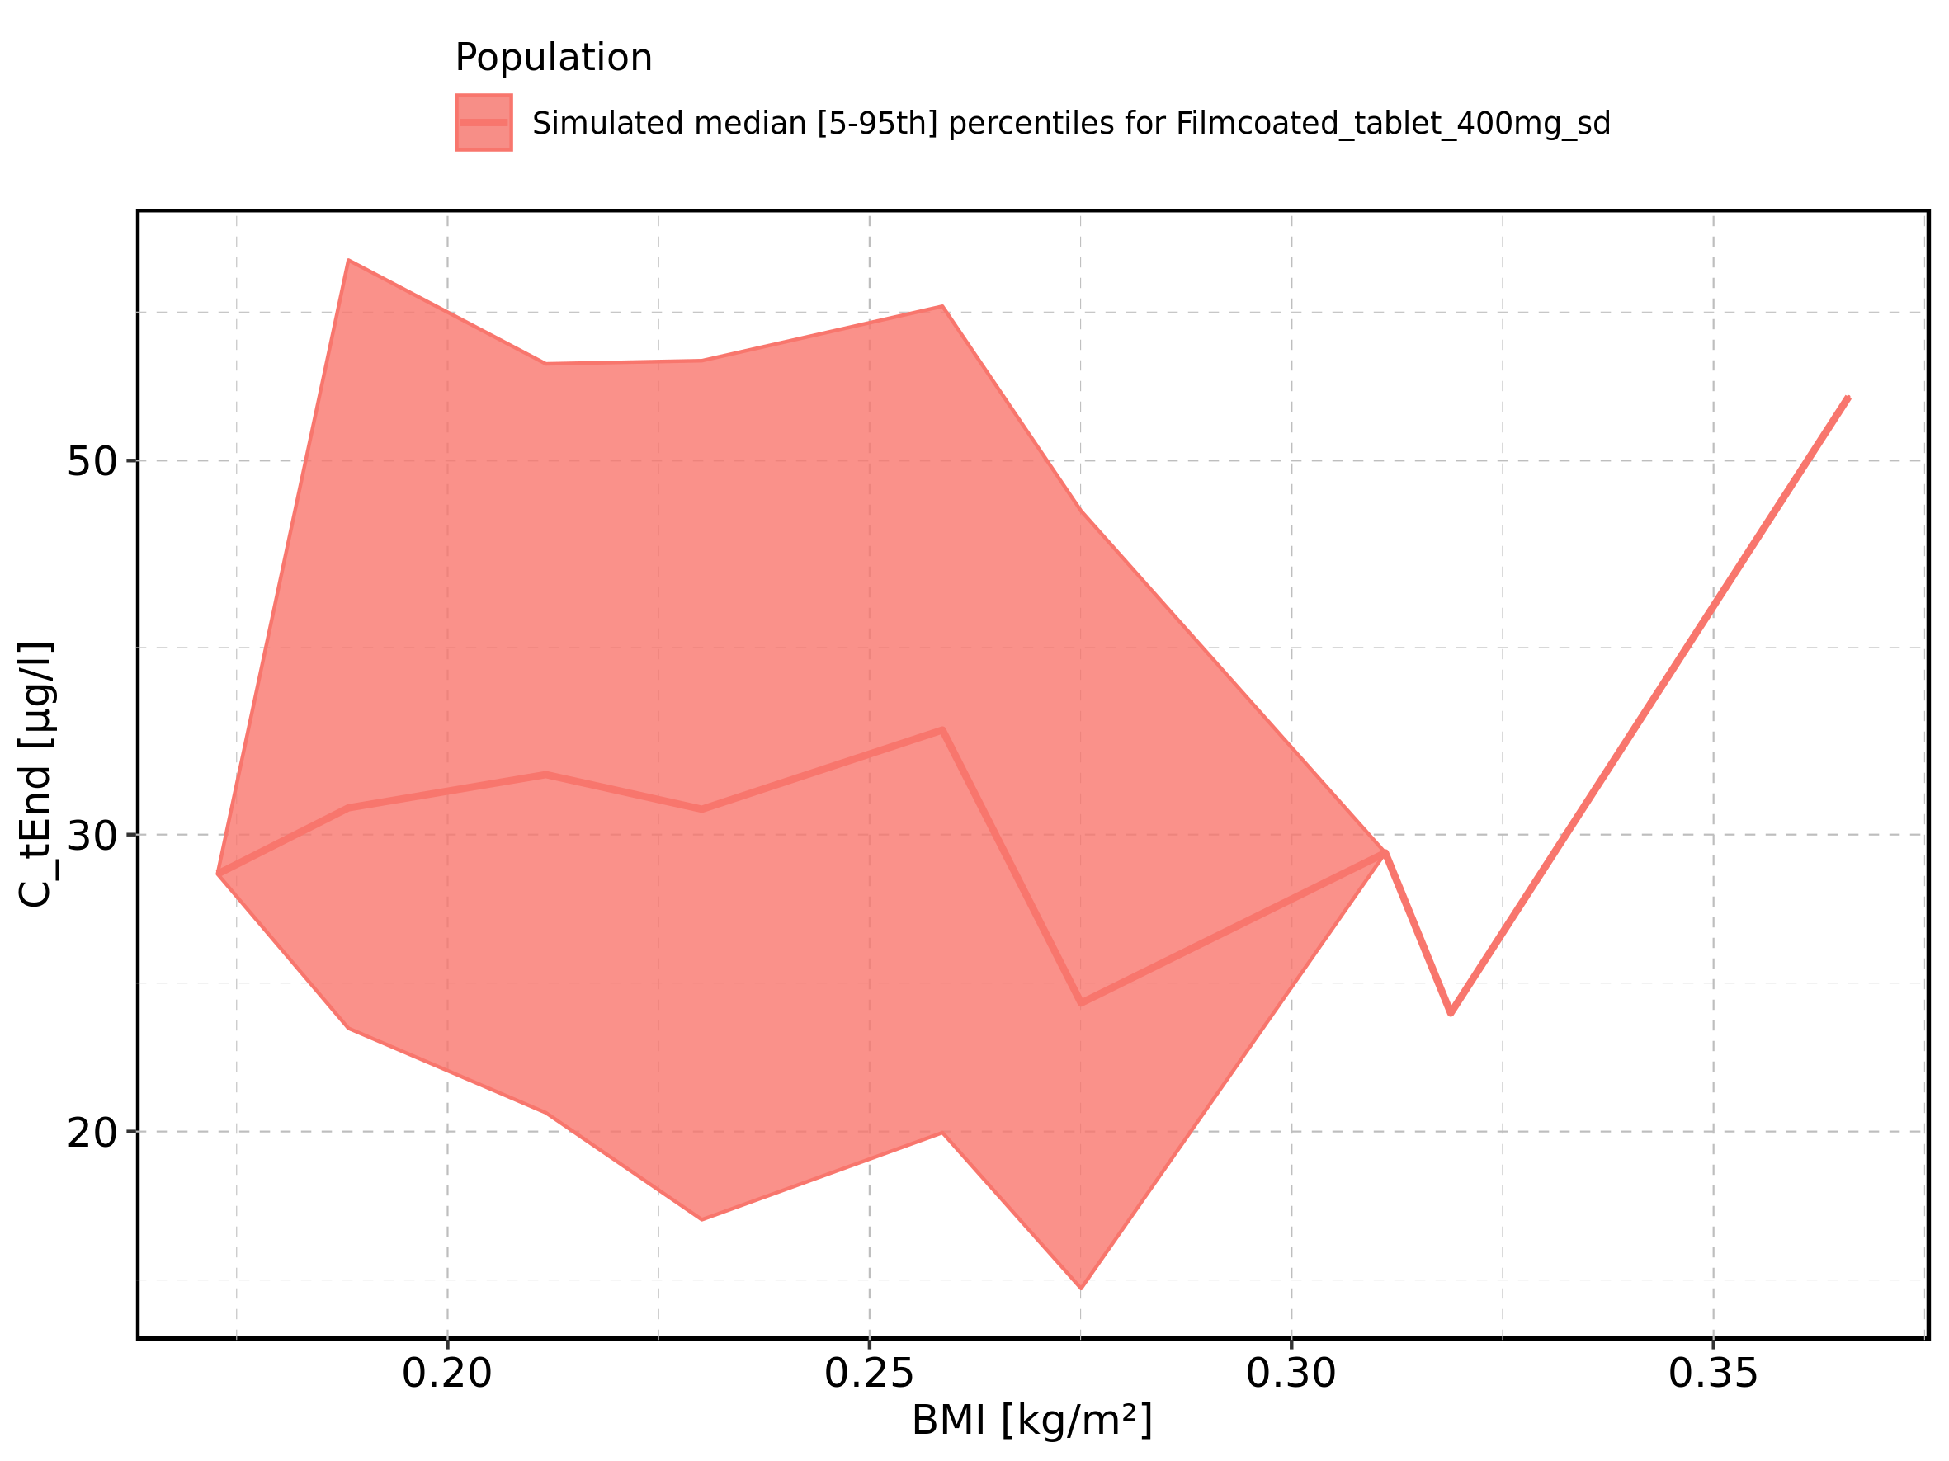

Figure 123: Gender-dependence of C_tEnd for Larson 2013 8y-18y 400mg FCT meal in comparison to Filmcoated_tablet_400mg_sd. Profiles are plotted in a linear scale.

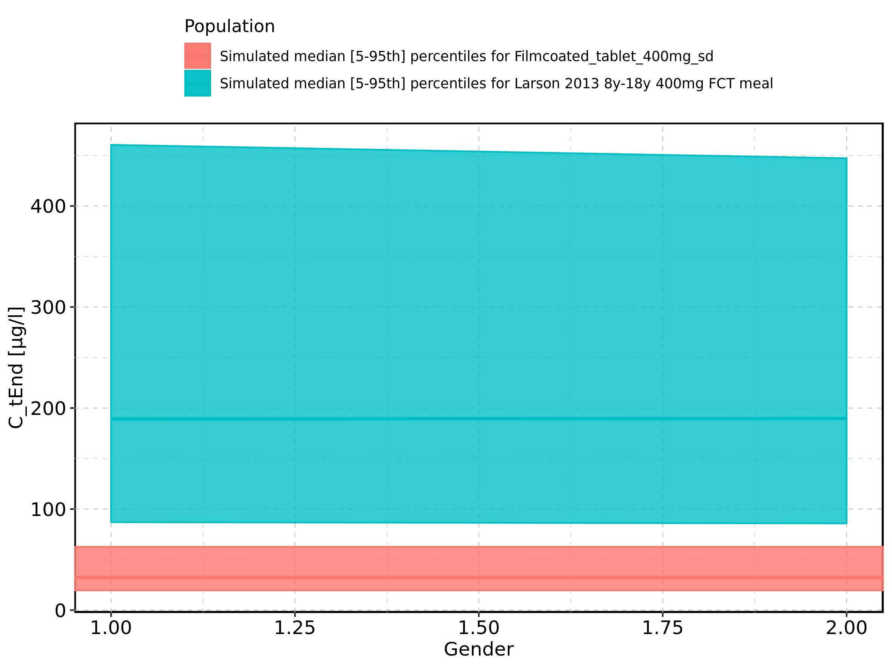

Figure 124: Gender-dependence of C_tEnd for Larson 2013 8y-18y 400mg FCT meal in comparison to Filmcoated_tablet_400mg_sd. Profiles are plotted in a logarithmic scale.

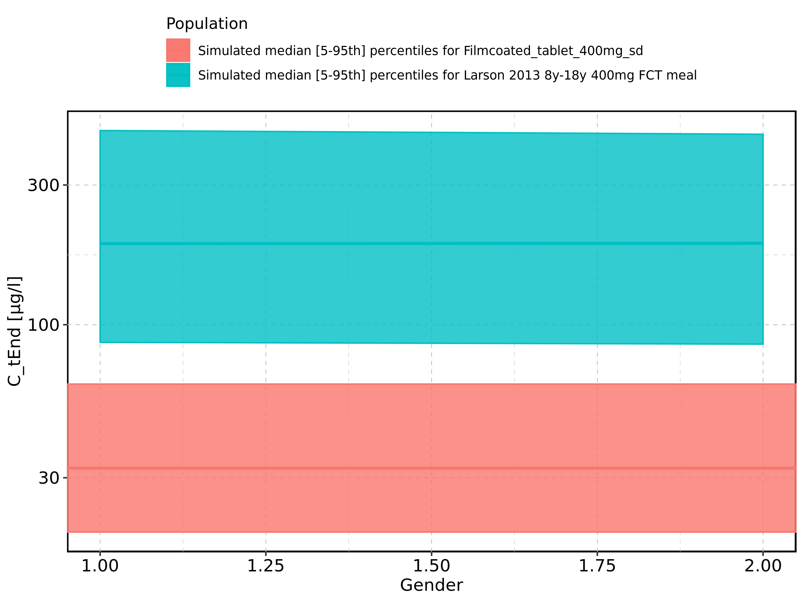

Figure 125: Gender-dependence of C_tEnd for Larson 2013 8y-18y 400mg FCT meal. Profiles are plotted in a linear scale.

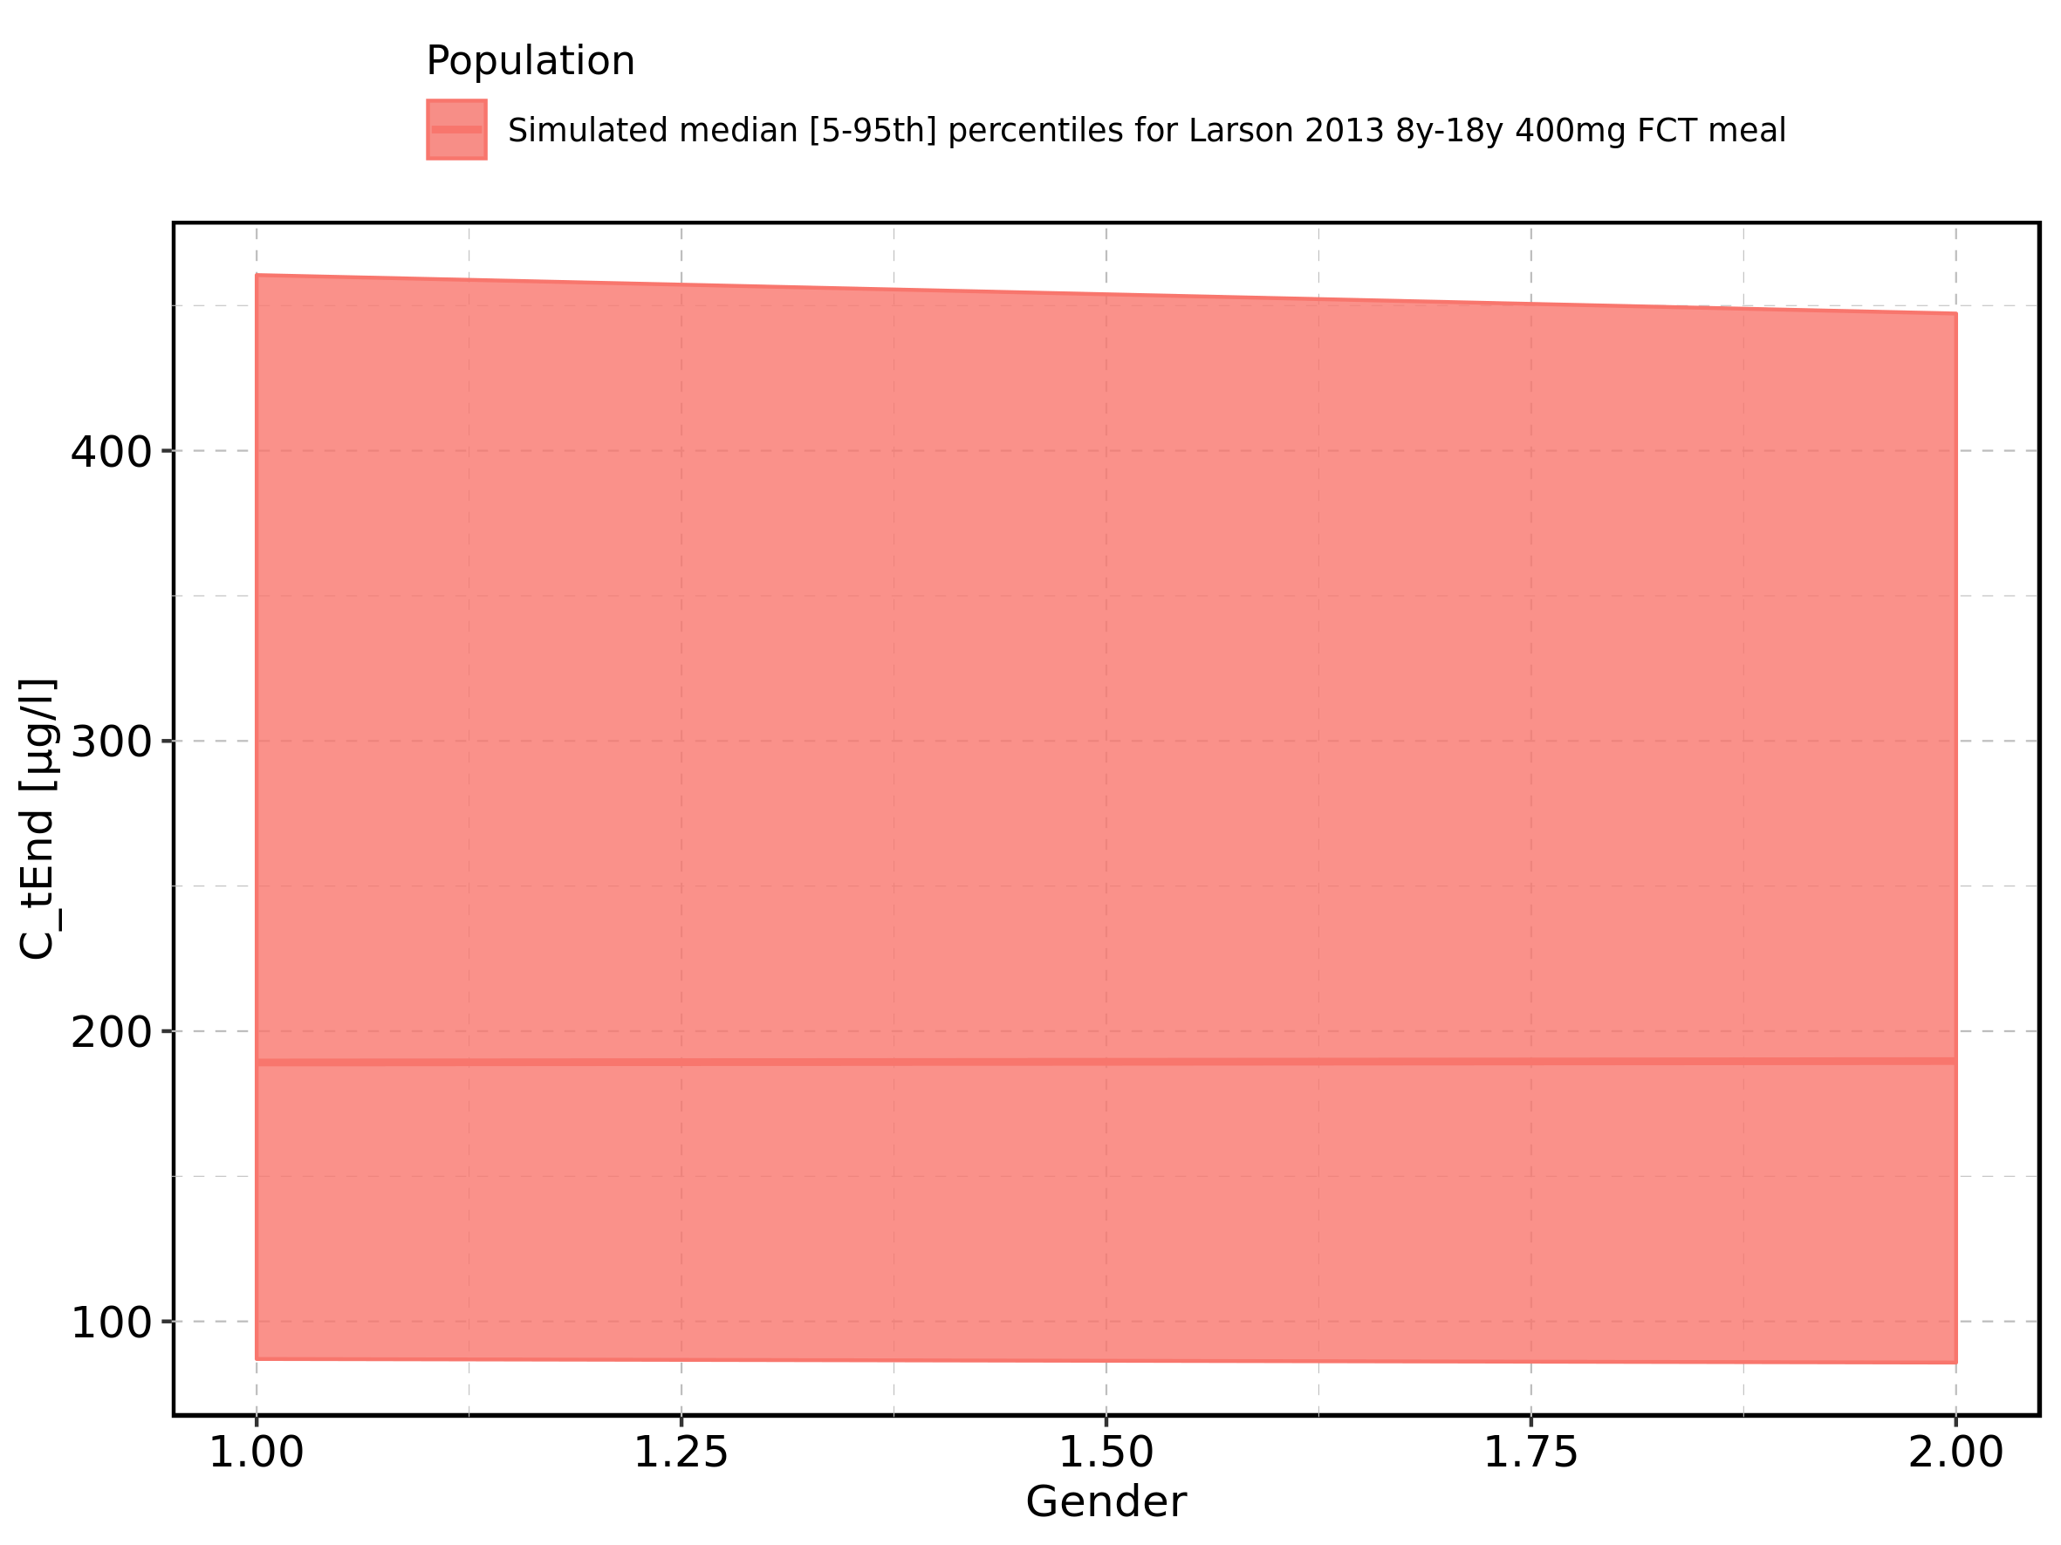

Figure 126: Gender-dependence of C_tEnd for Larson 2013 8y-18y 400mg FCT meal. Profiles are plotted in a logarithmic scale.

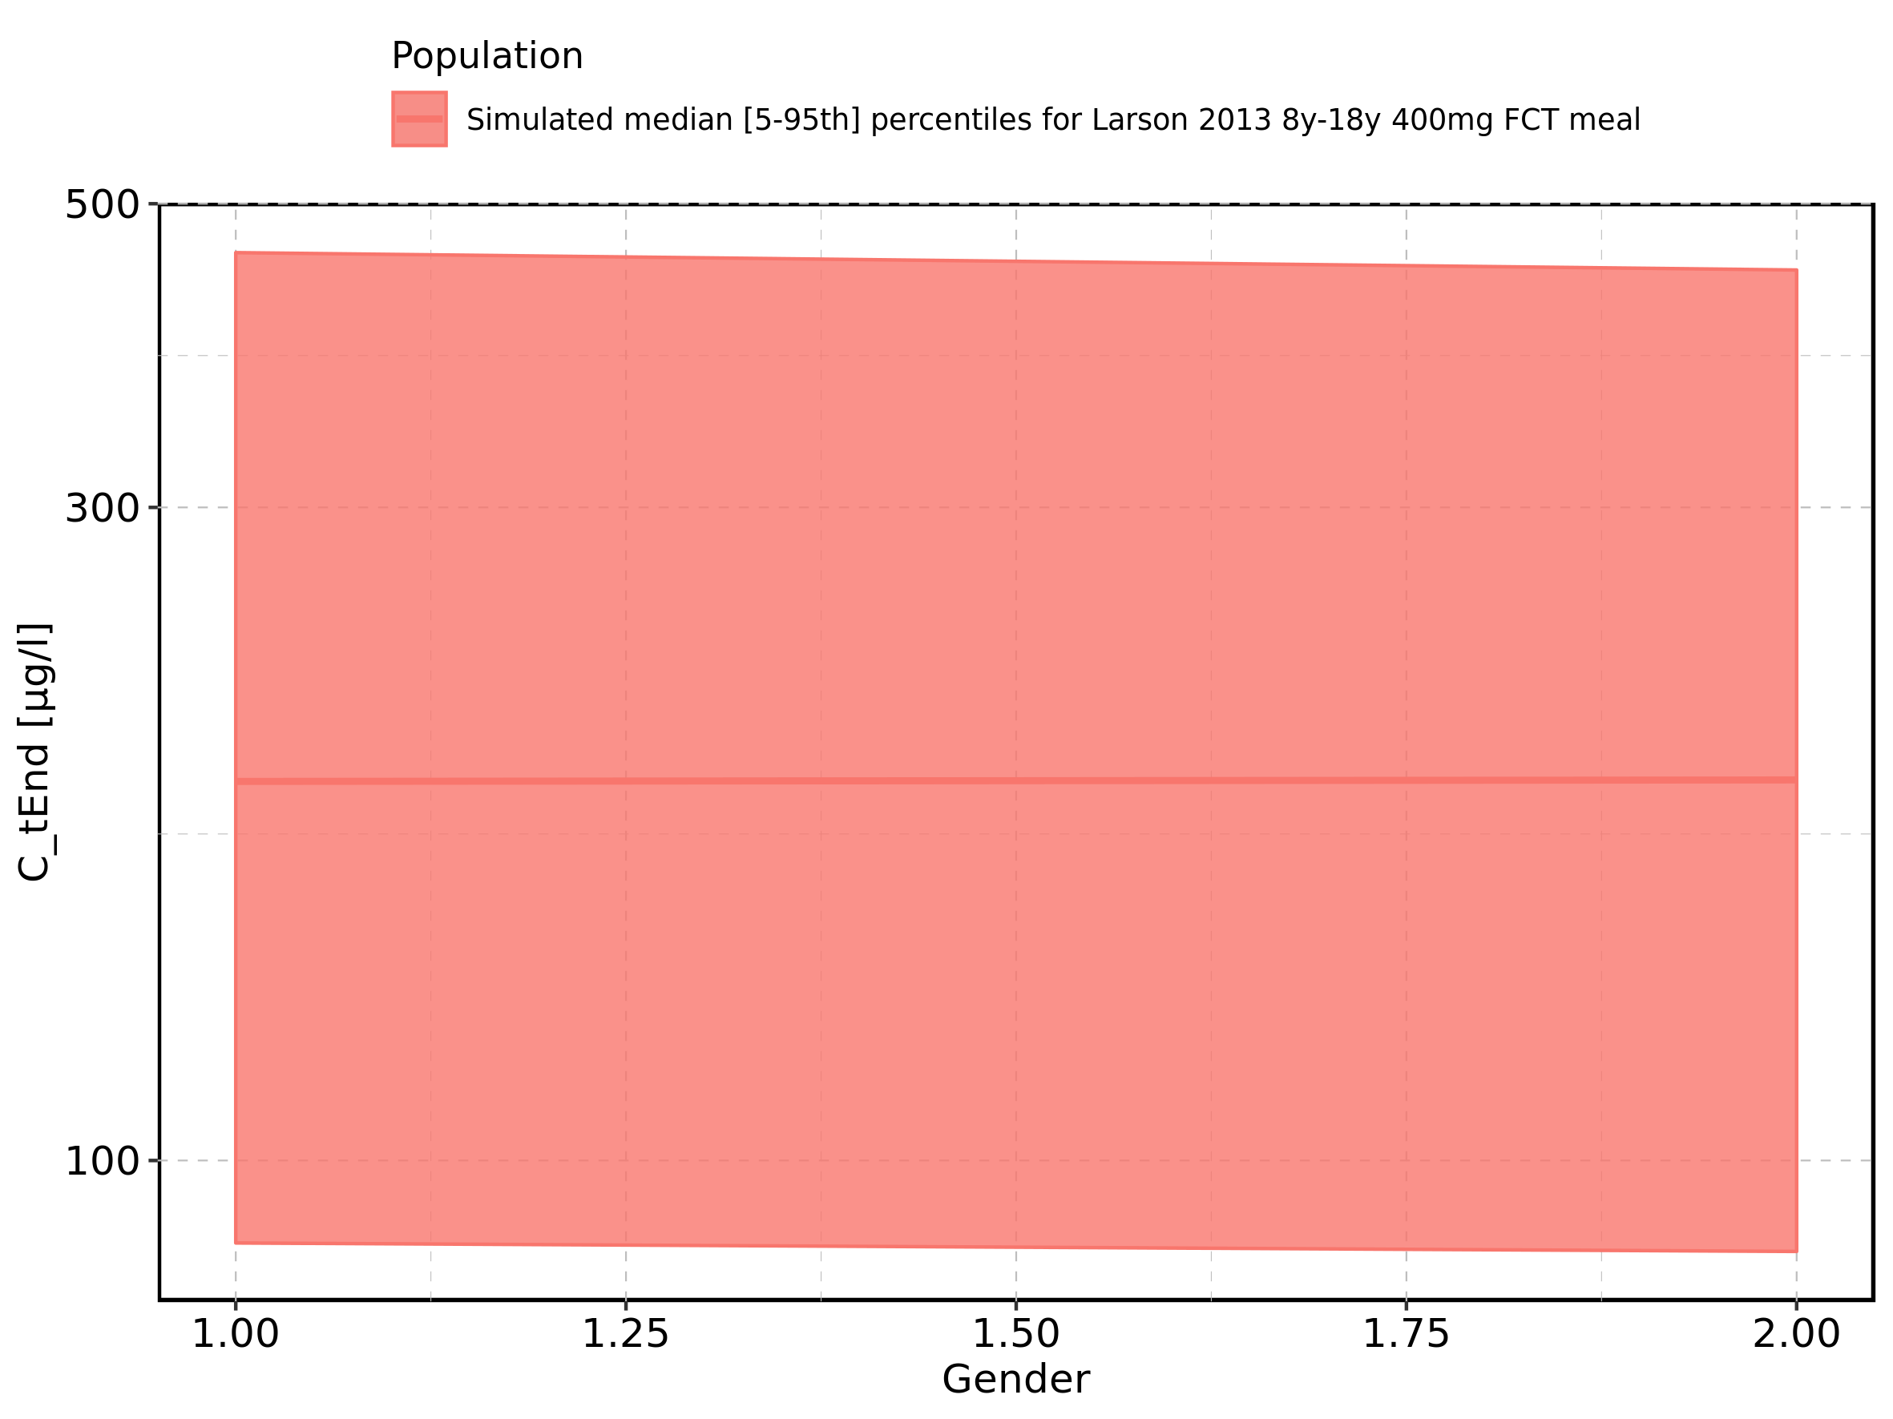

Figure 127: Gender-dependence of C_tEnd for Filmcoated_tablet_400mg_sd. Profiles are plotted in a linear scale.

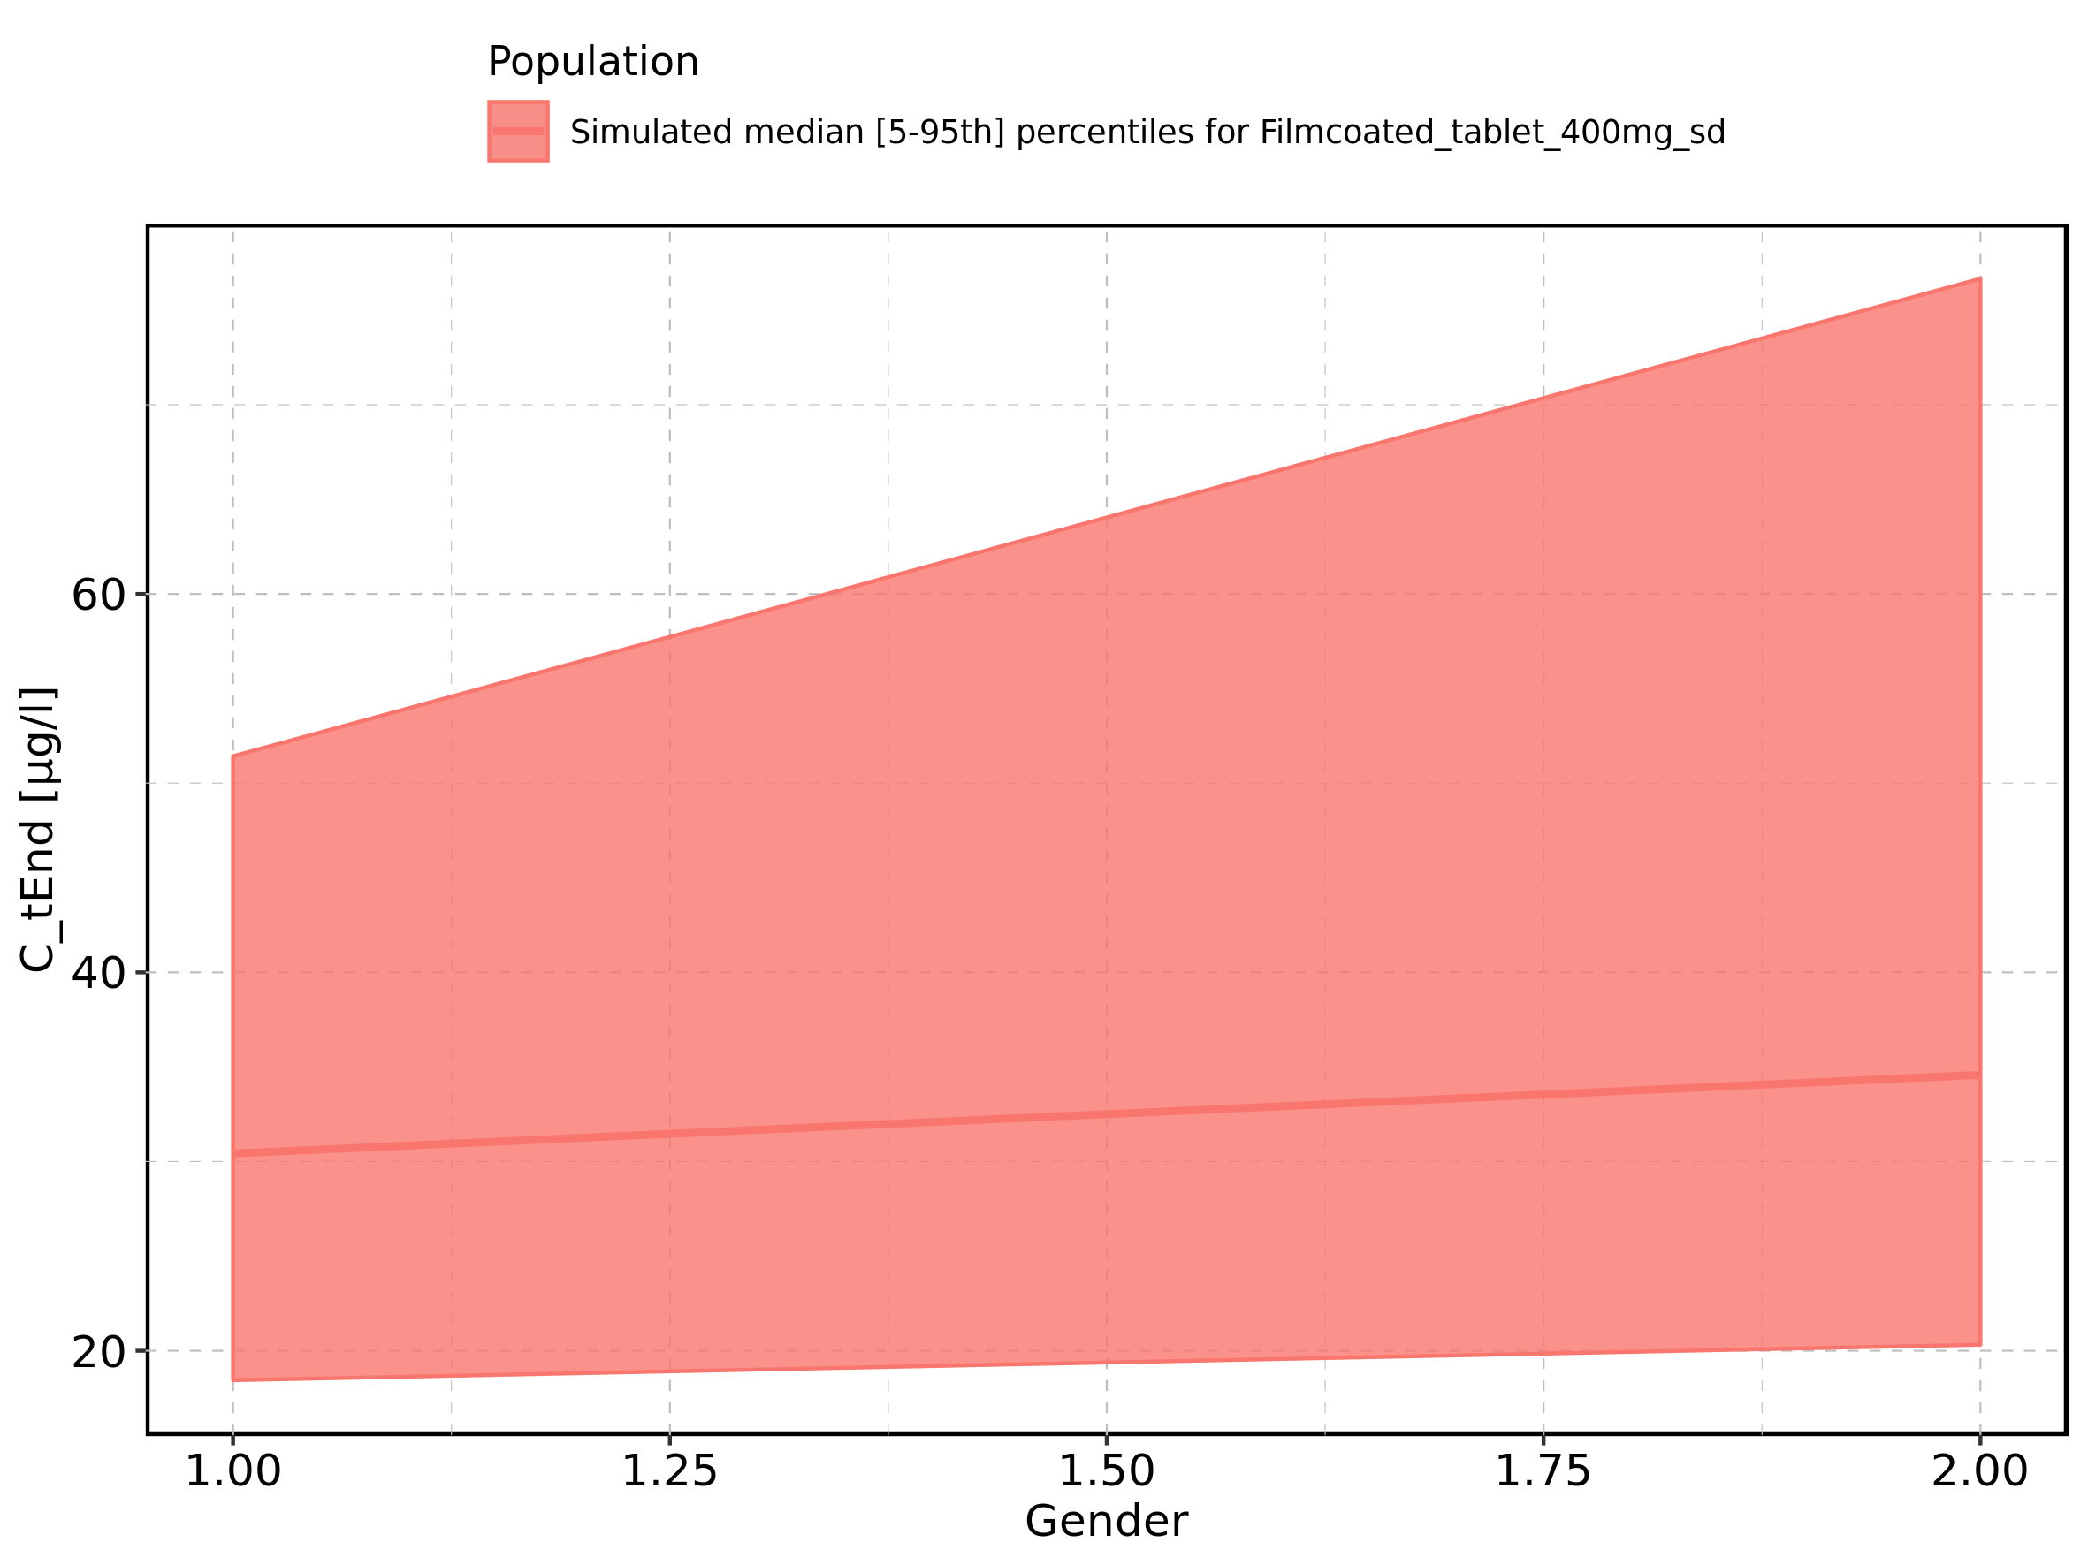

Figure 128: Gender-dependence of C_tEnd for Filmcoated_tablet_400mg_sd. Profiles are plotted in a logarithmic scale.

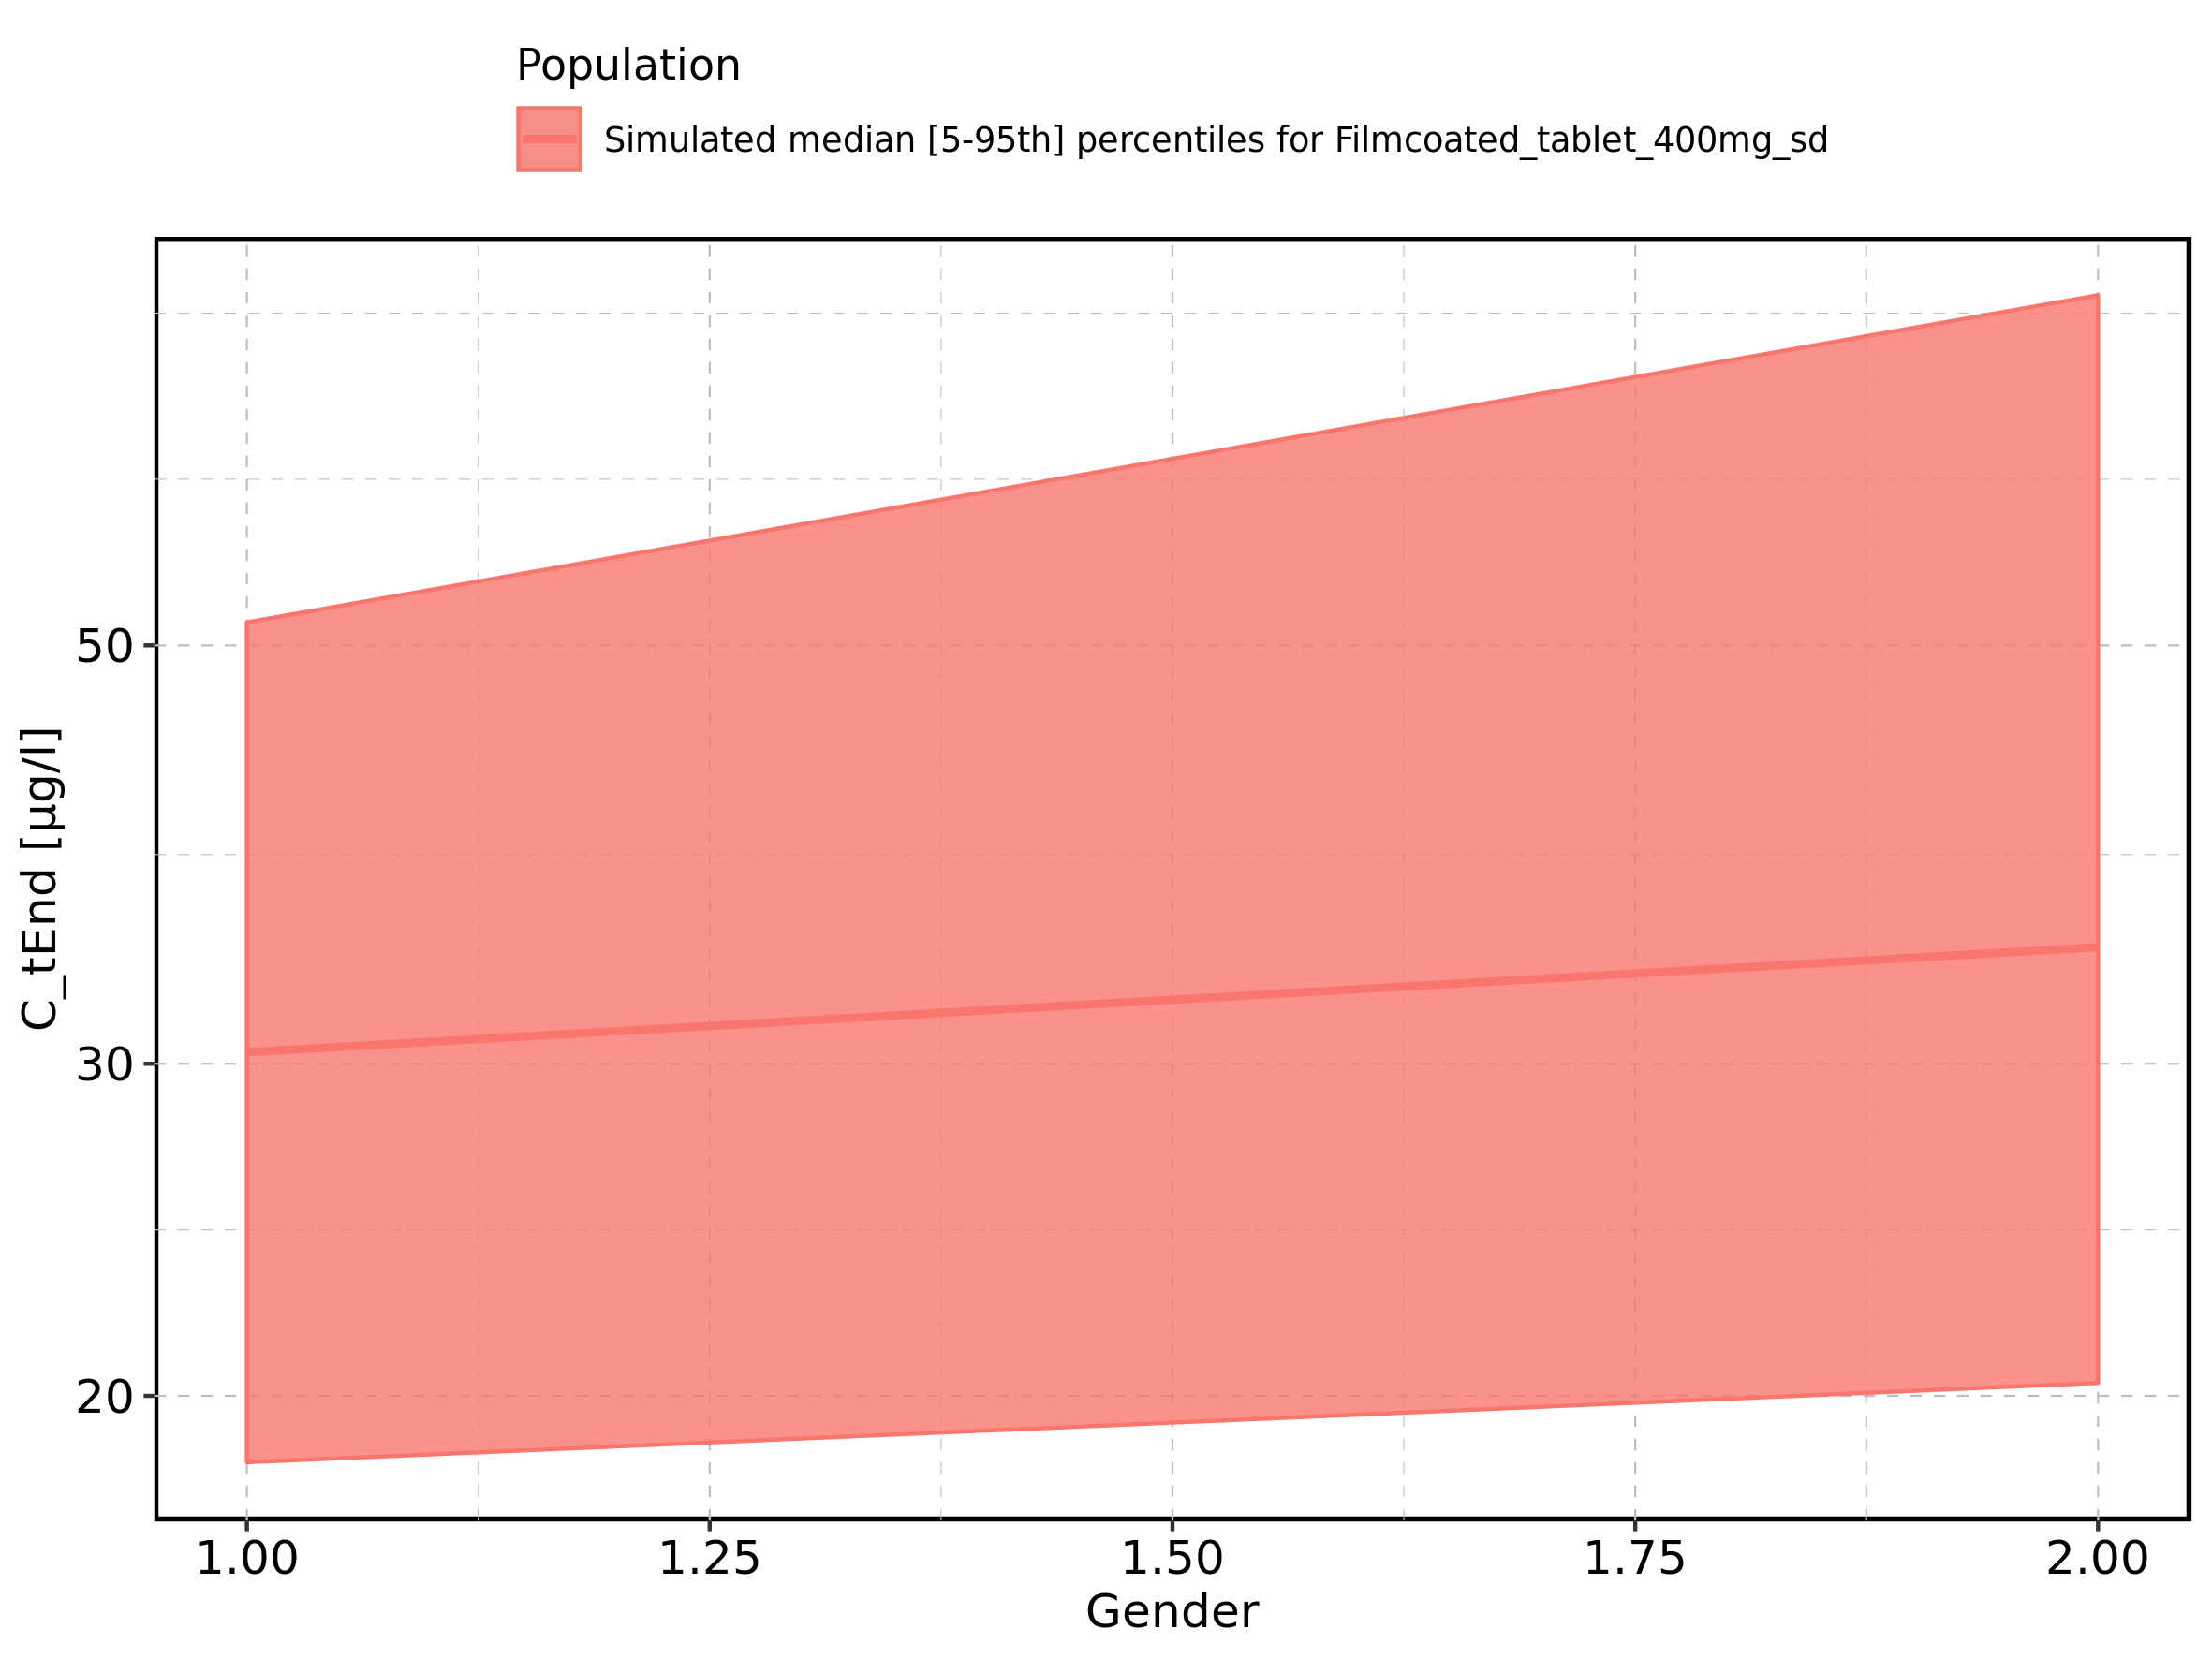

Figure 129: AUC of Raltegravir shown as box-whisker plot, which indicates the 5th, 25th, 50th, 75th, and 95th percentiles in linear scale.

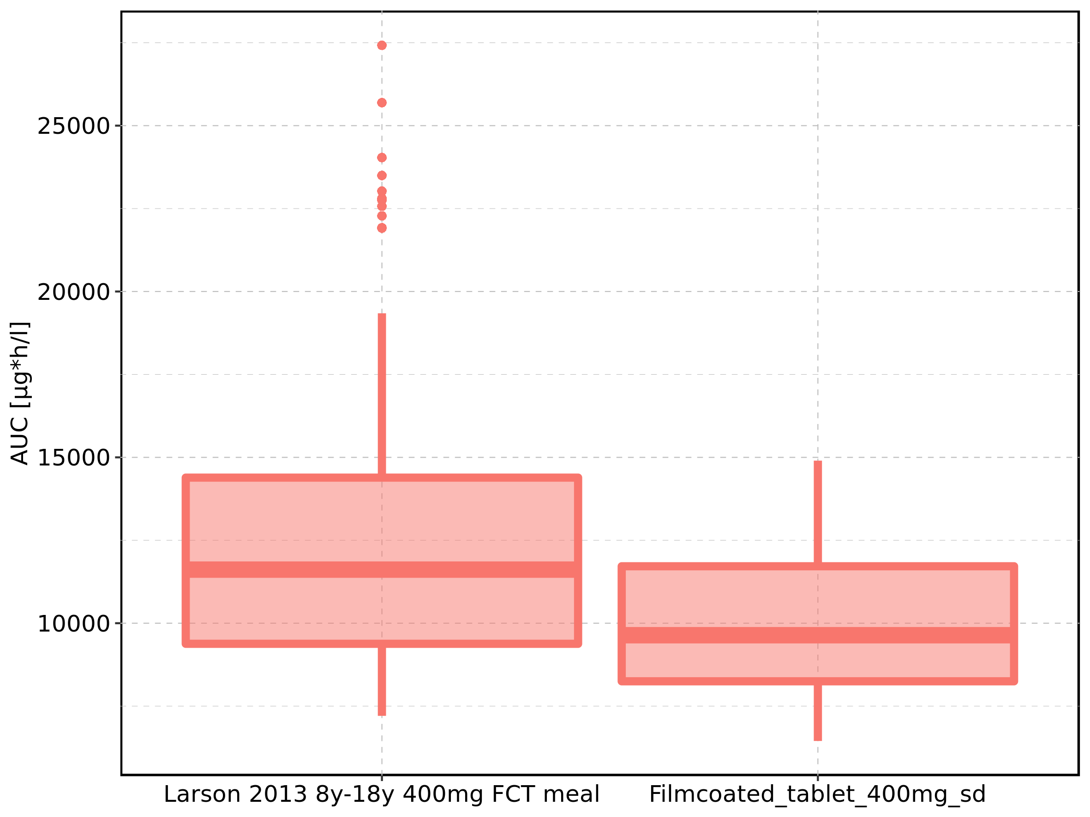

|  |  |  |  |  |  |  |  |  |  |  |
| --- | --- | --- | --- | --- | --- | --- | --- | --- | --- | --- |
| Population | N | 5th percentile | 25th percentile | 50th percentile | 75th percentile | 95th percentile | mean | standard deviation | geo mean | geo standard deviation |
| Larson 2013 8y-18y 400mg FCT meal | 500 | 7207.278 | 9378.917 | 11615.205 | 14388.95 | 19343.09 | 12199.87 | 3756.553 | 11656.084 | 1.353277 |
| Filmcoated_tablet_400mg_sd | 100 | 6449.274 | 8248.730 | 9637.507 | 11717.01 | 14901.11 | 10129.70 | 2672.292 | 9784.557 | 1.305605 |

Figure 130: AUC of Raltegravir shown as box-whisker plot, which indicates the 5th, 25th, 50th, 75th, and 95th percentiles in logarithmic scale.

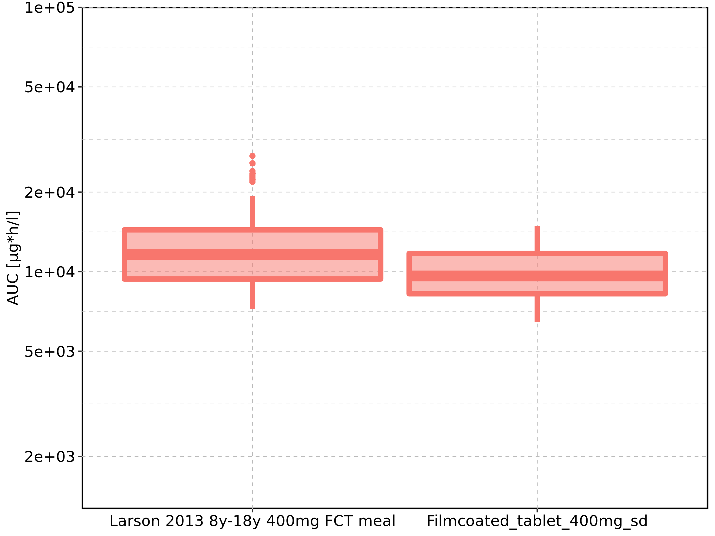

Figure 131: Age-dependence of AUC for Larson 2013 8y-18y 400mg FCT meal in comparison to Filmcoated_tablet_400mg_sd. Profiles are plotted in a linear scale.

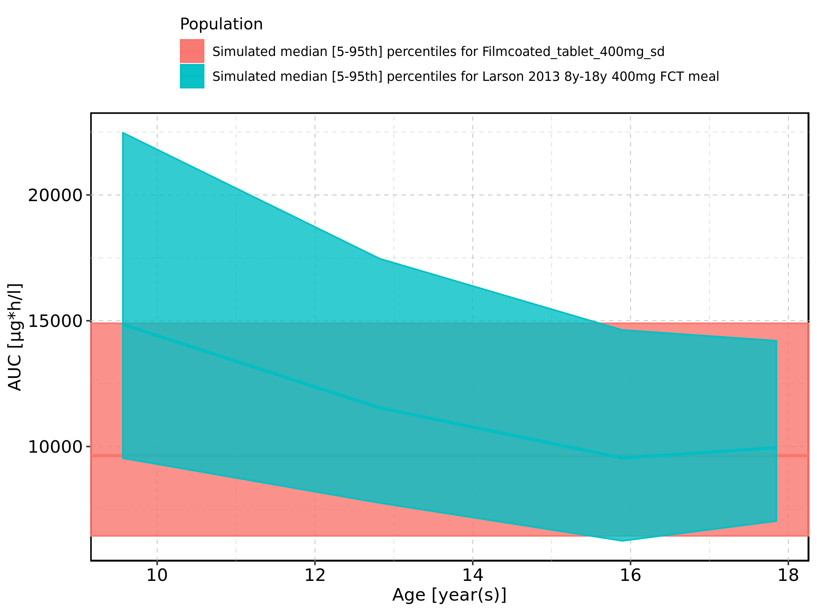

Figure 132: Age-dependence of AUC for Larson 2013 8y-18y 400mg FCT meal in comparison to Filmcoated_tablet_400mg_sd. Profiles are plotted in a logarithmic scale.

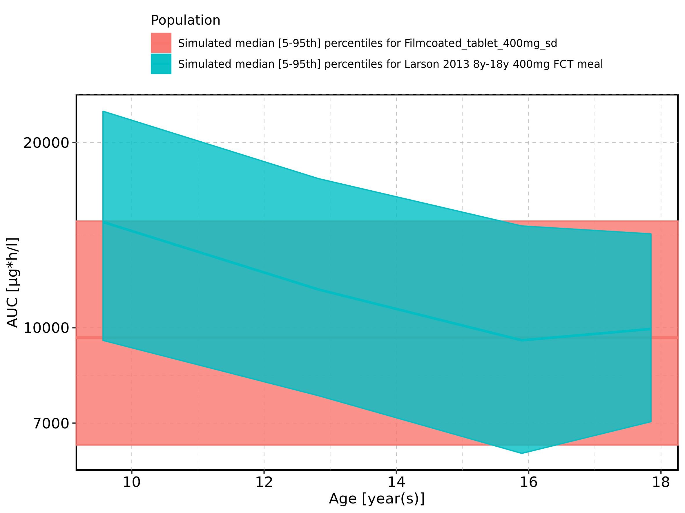

Figure 133: Age-dependence of AUC for Larson 2013 8y-18y 400mg FCT meal. Profiles are plotted in a linear scale.

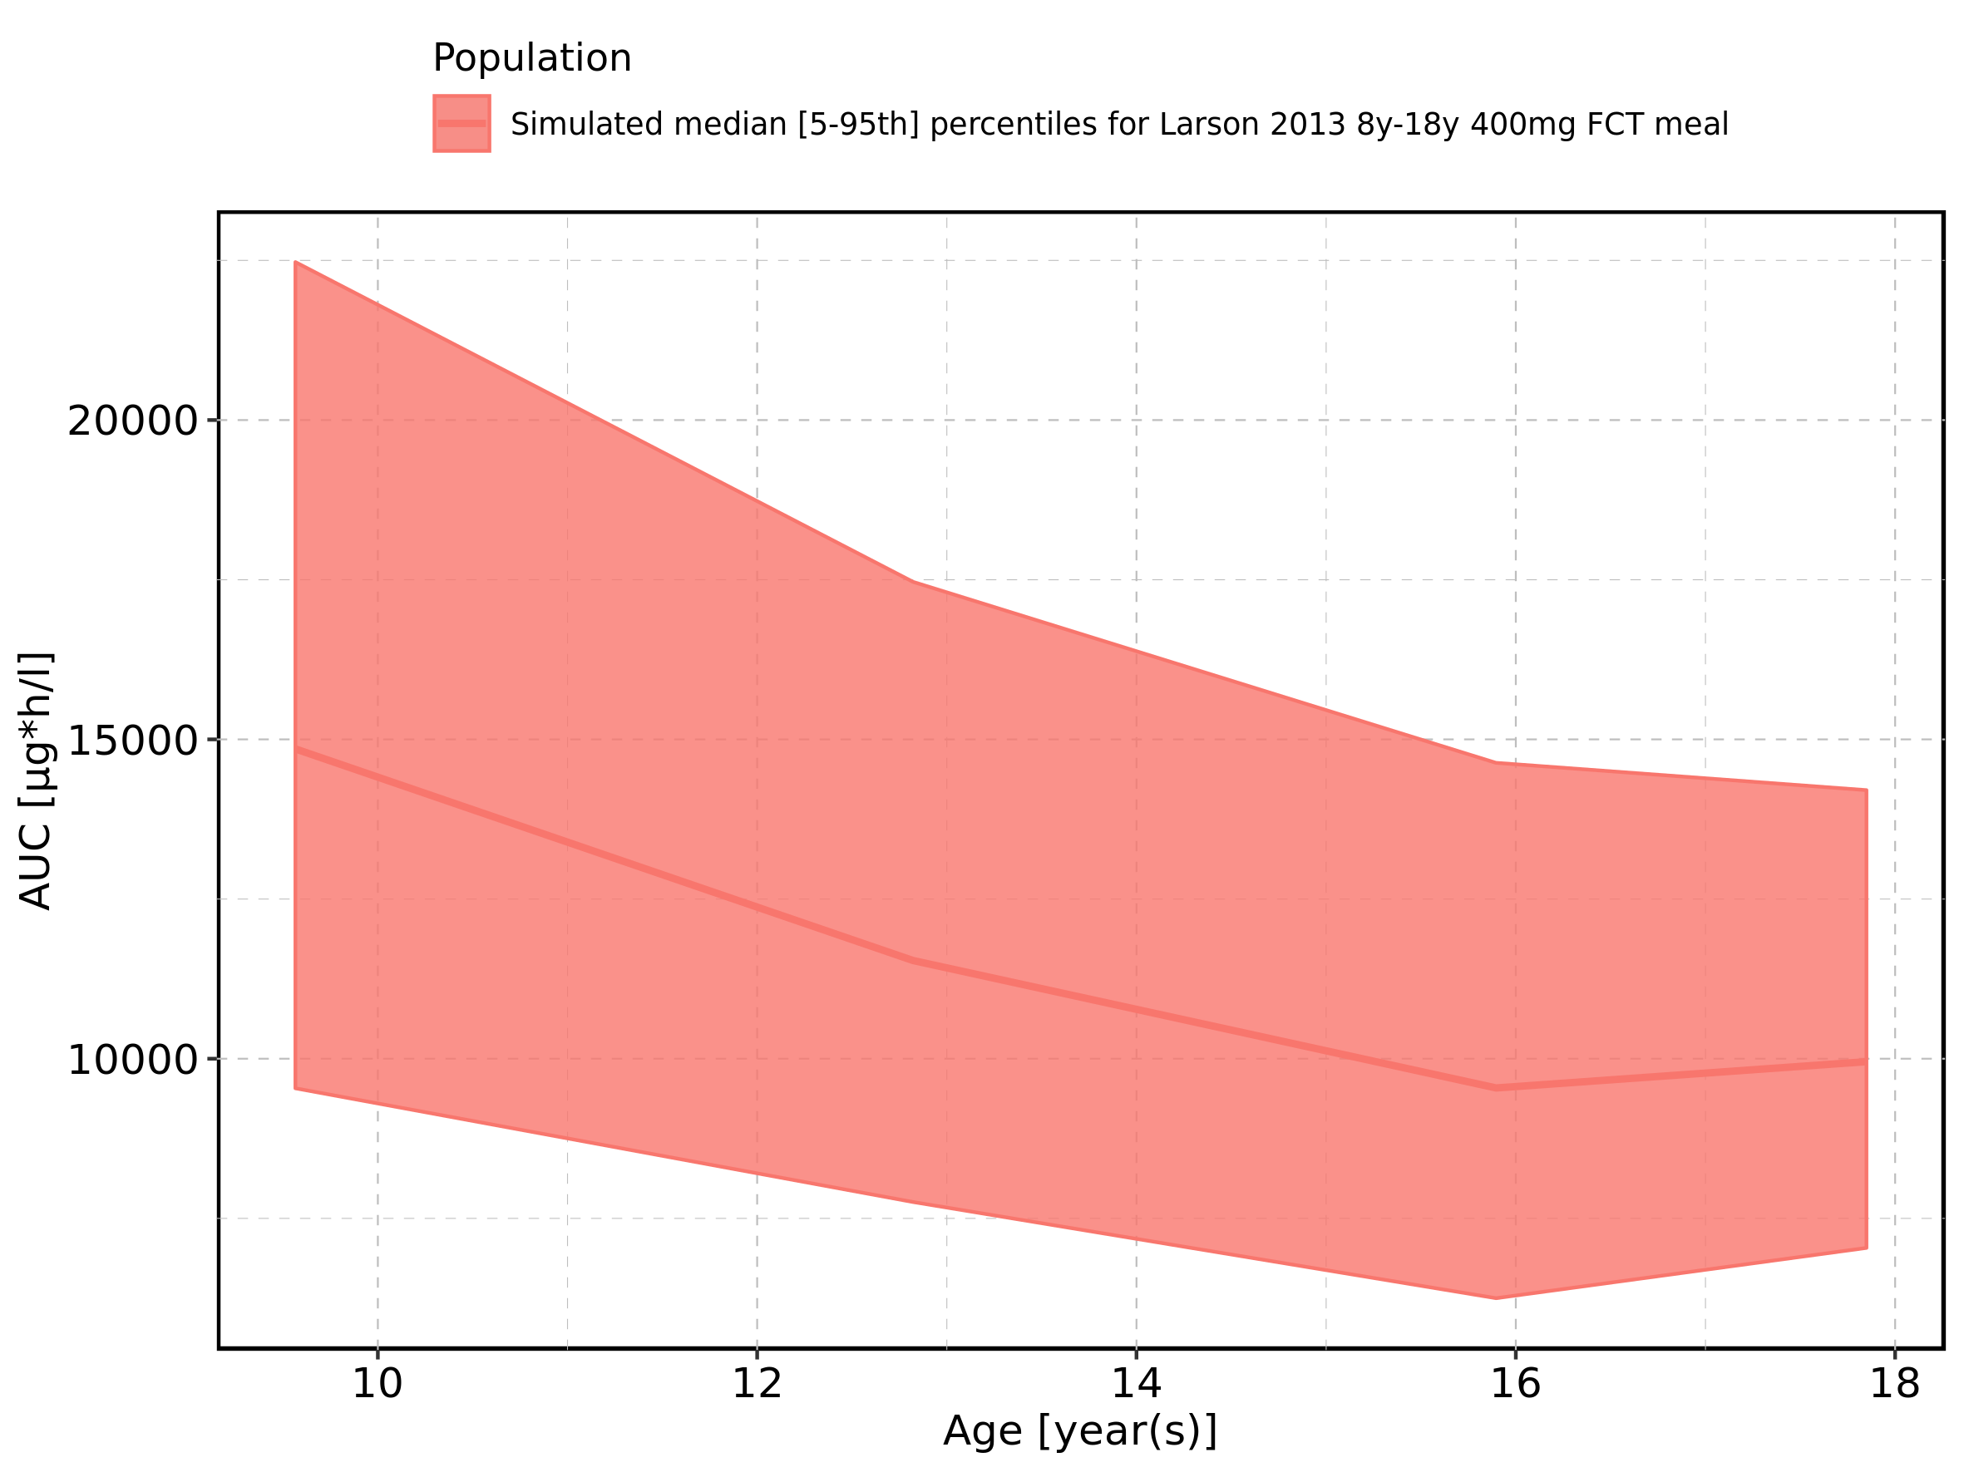

Figure 134: Age-dependence of AUC for Larson 2013 8y-18y 400mg FCT meal. Profiles are plotted in a logarithmic scale.

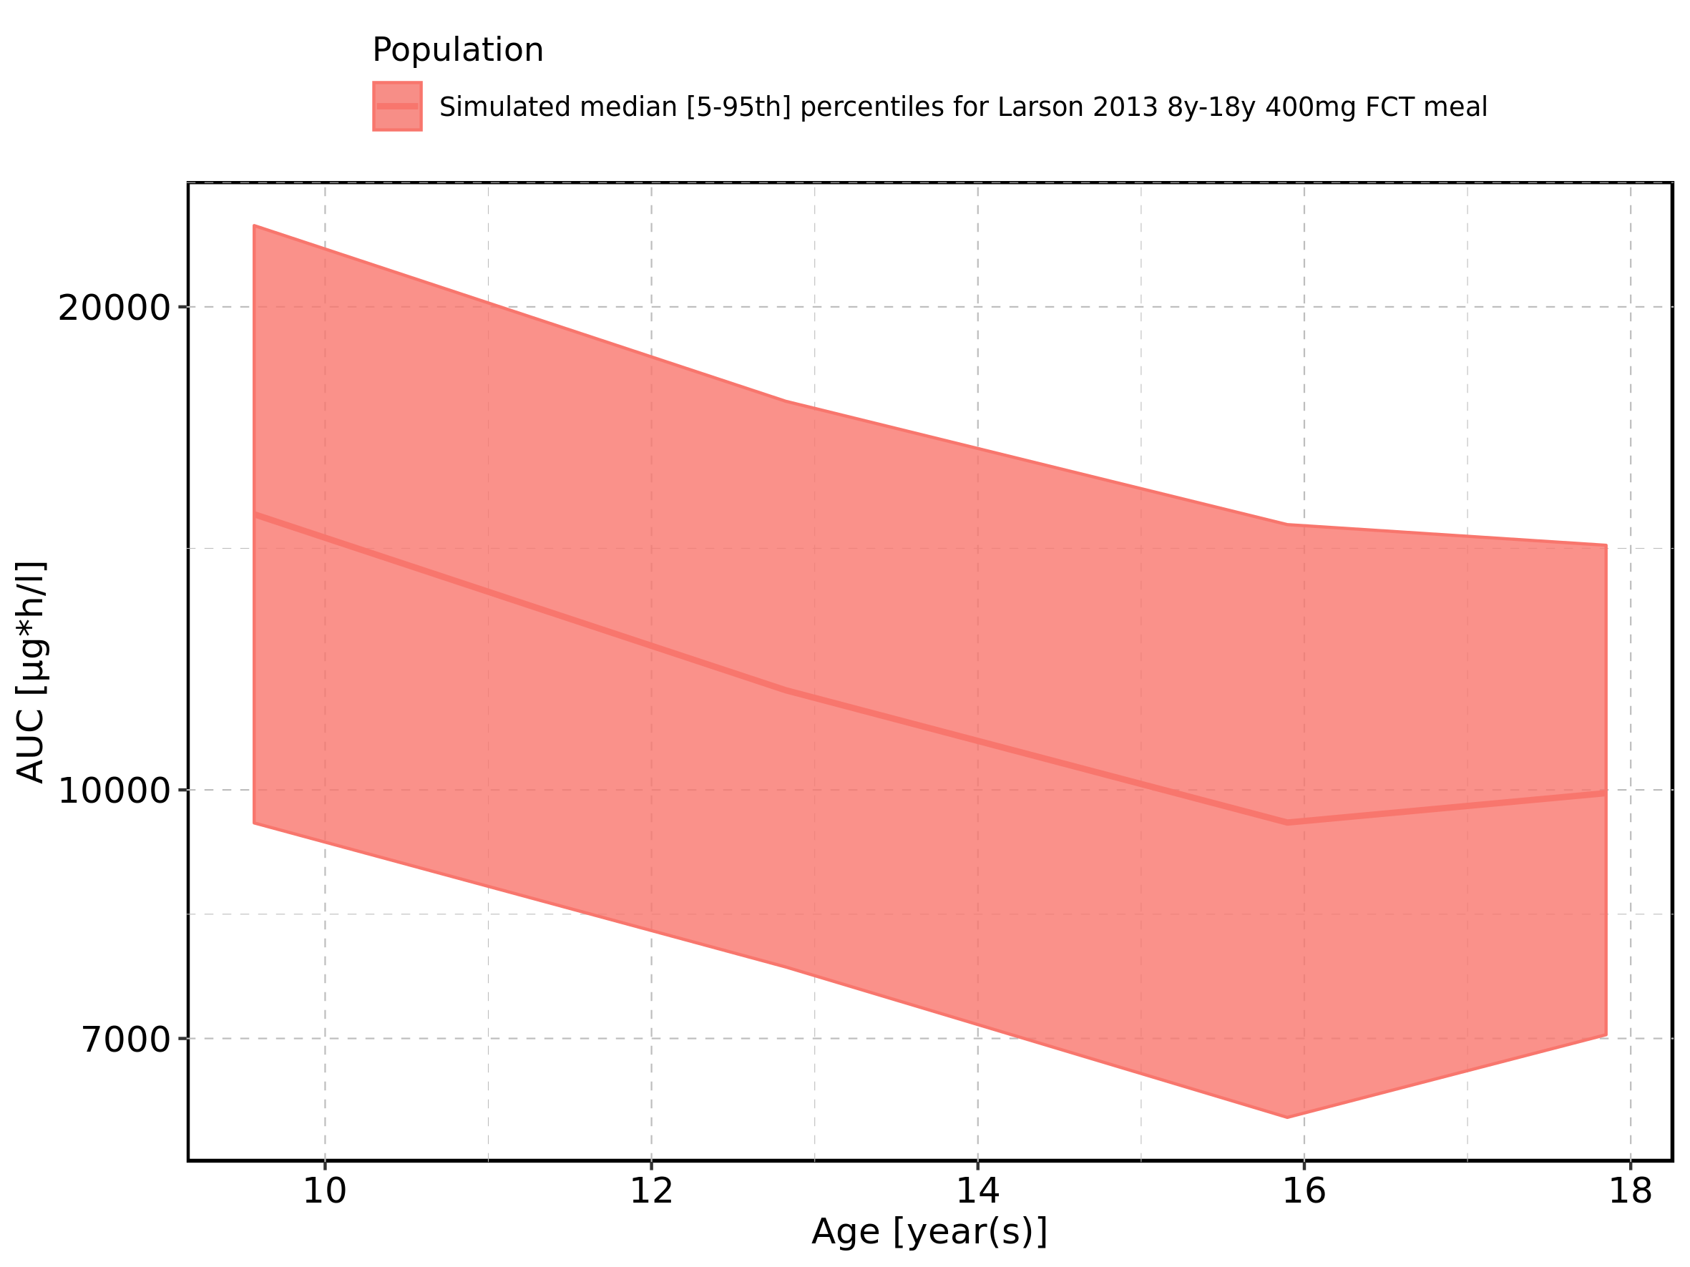

Figure 135: Age-dependence of AUC for Filmcoated_tablet_400mg_sd. Profiles are plotted in a linear scale.

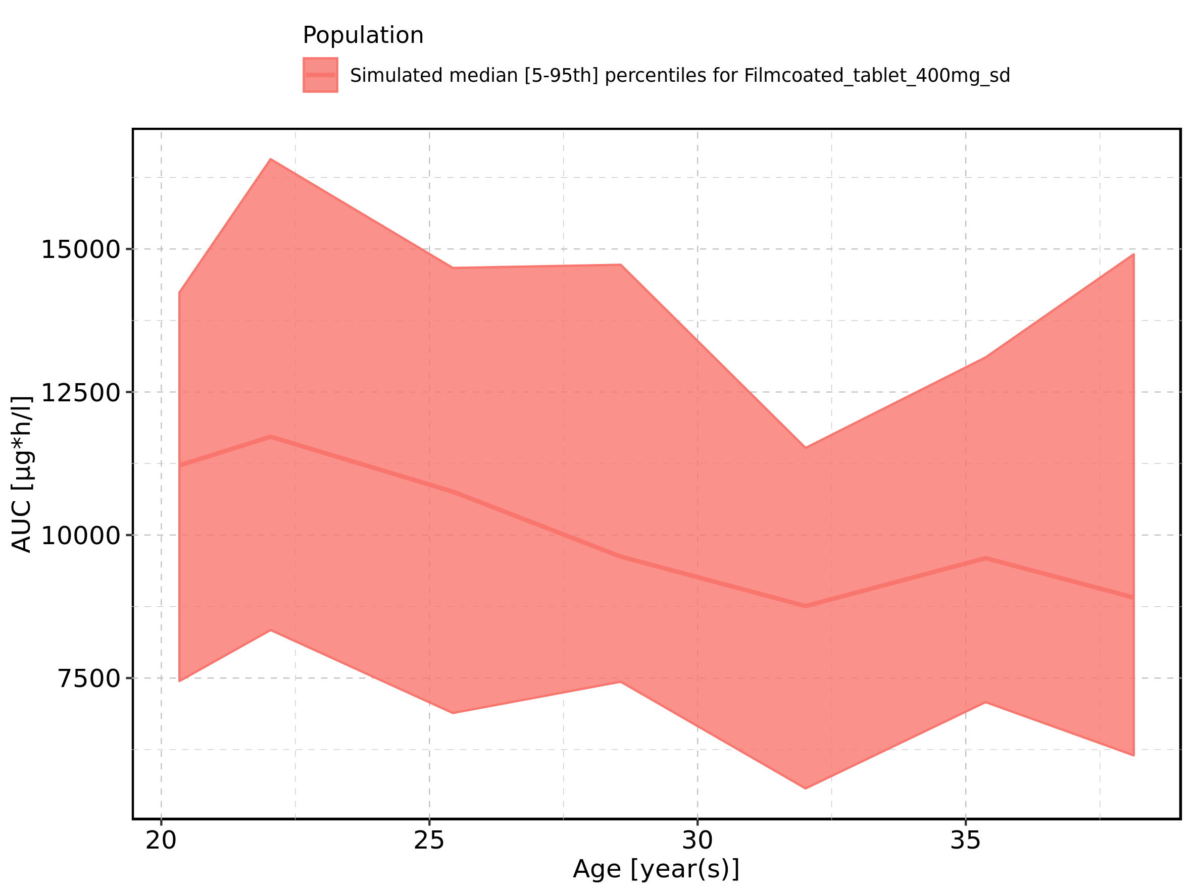

Figure 136: Age-dependence of AUC for Filmcoated_tablet_400mg_sd. Profiles are plotted in a logarithmic scale.

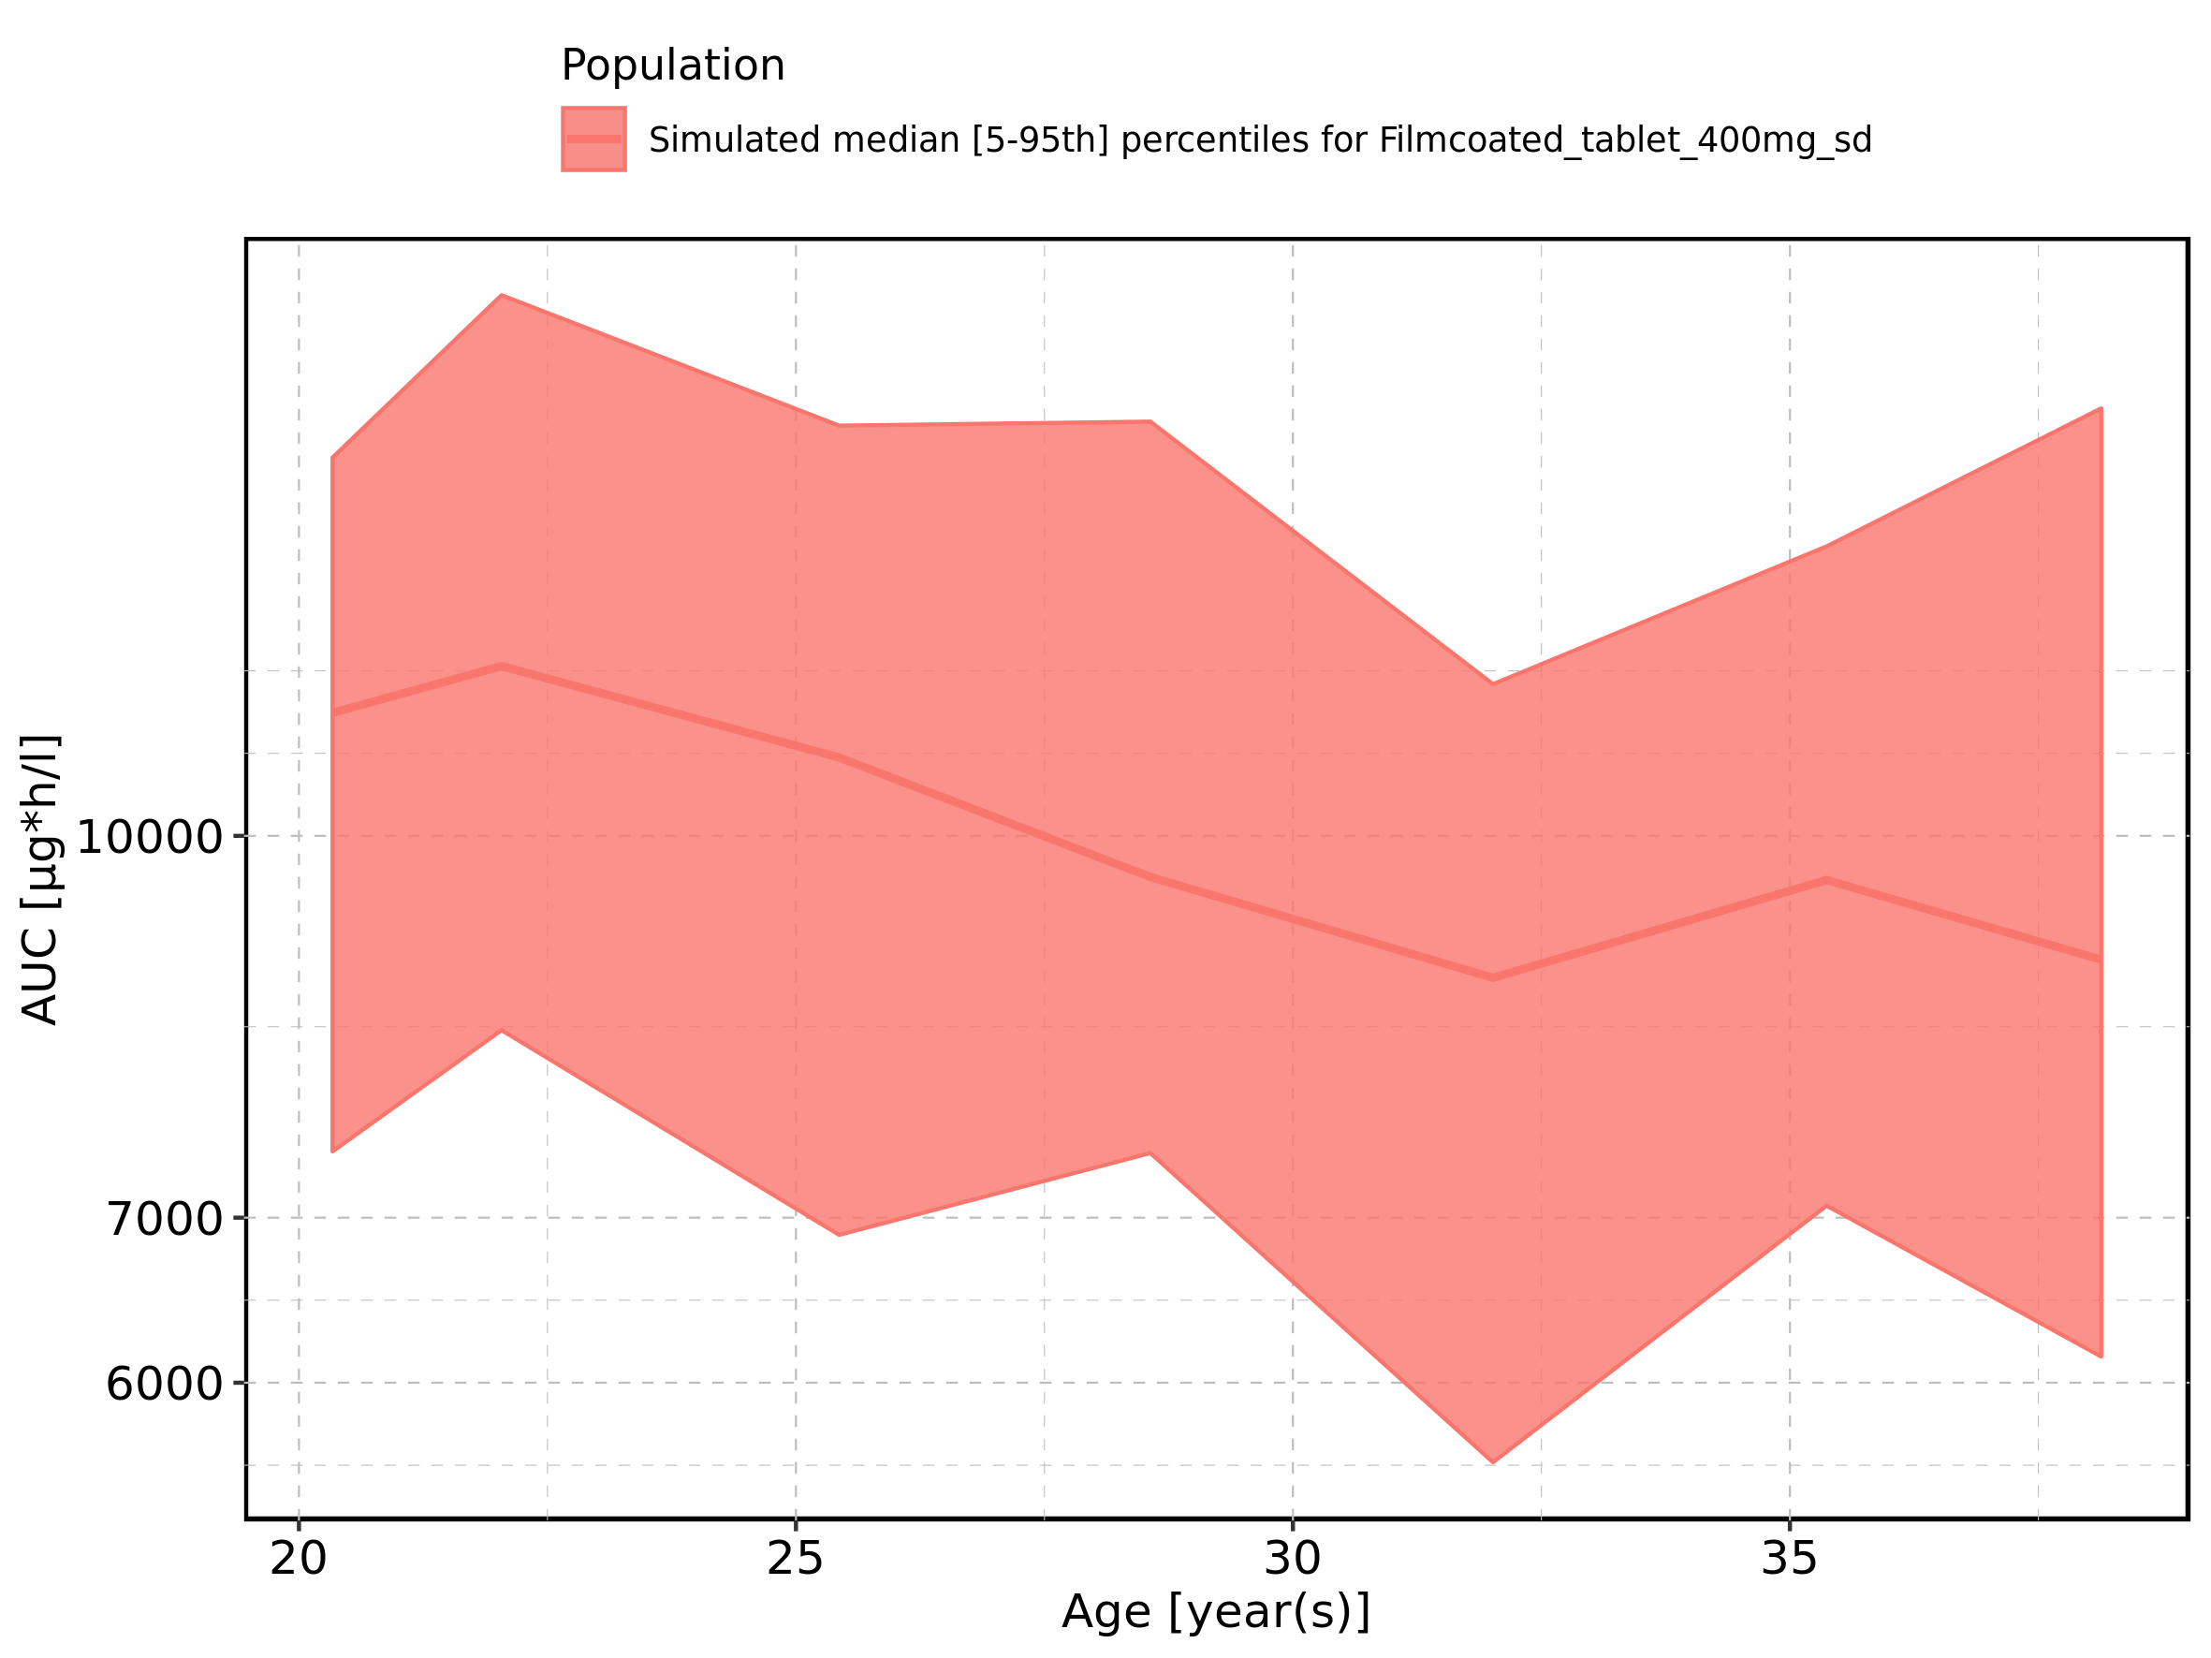

Figure 137: Height-dependence of AUC for Larson 2013 8y-18y 400mg FCT meal in comparison to Filmcoated_tablet_400mg_sd. Profiles are plotted in a linear scale.

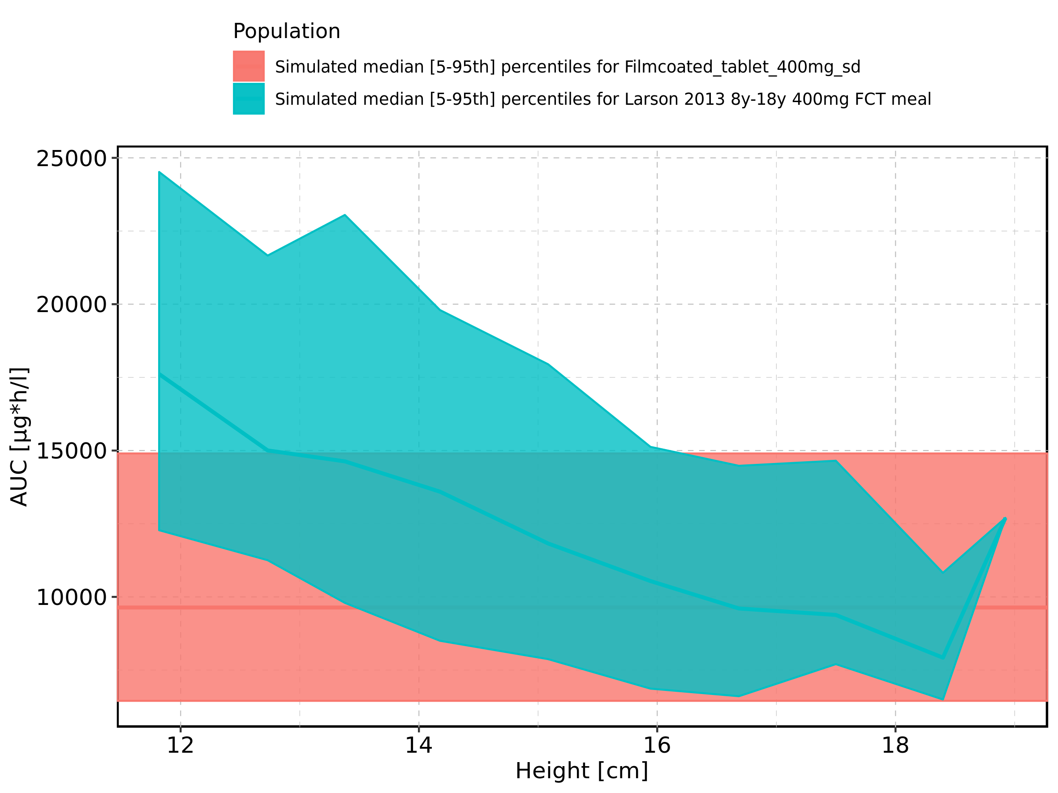

Figure 138: Height-dependence of AUC for Larson 2013 8y-18y 400mg FCT meal in comparison to Filmcoated_tablet_400mg_sd. Profiles are plotted in a logarithmic scale.

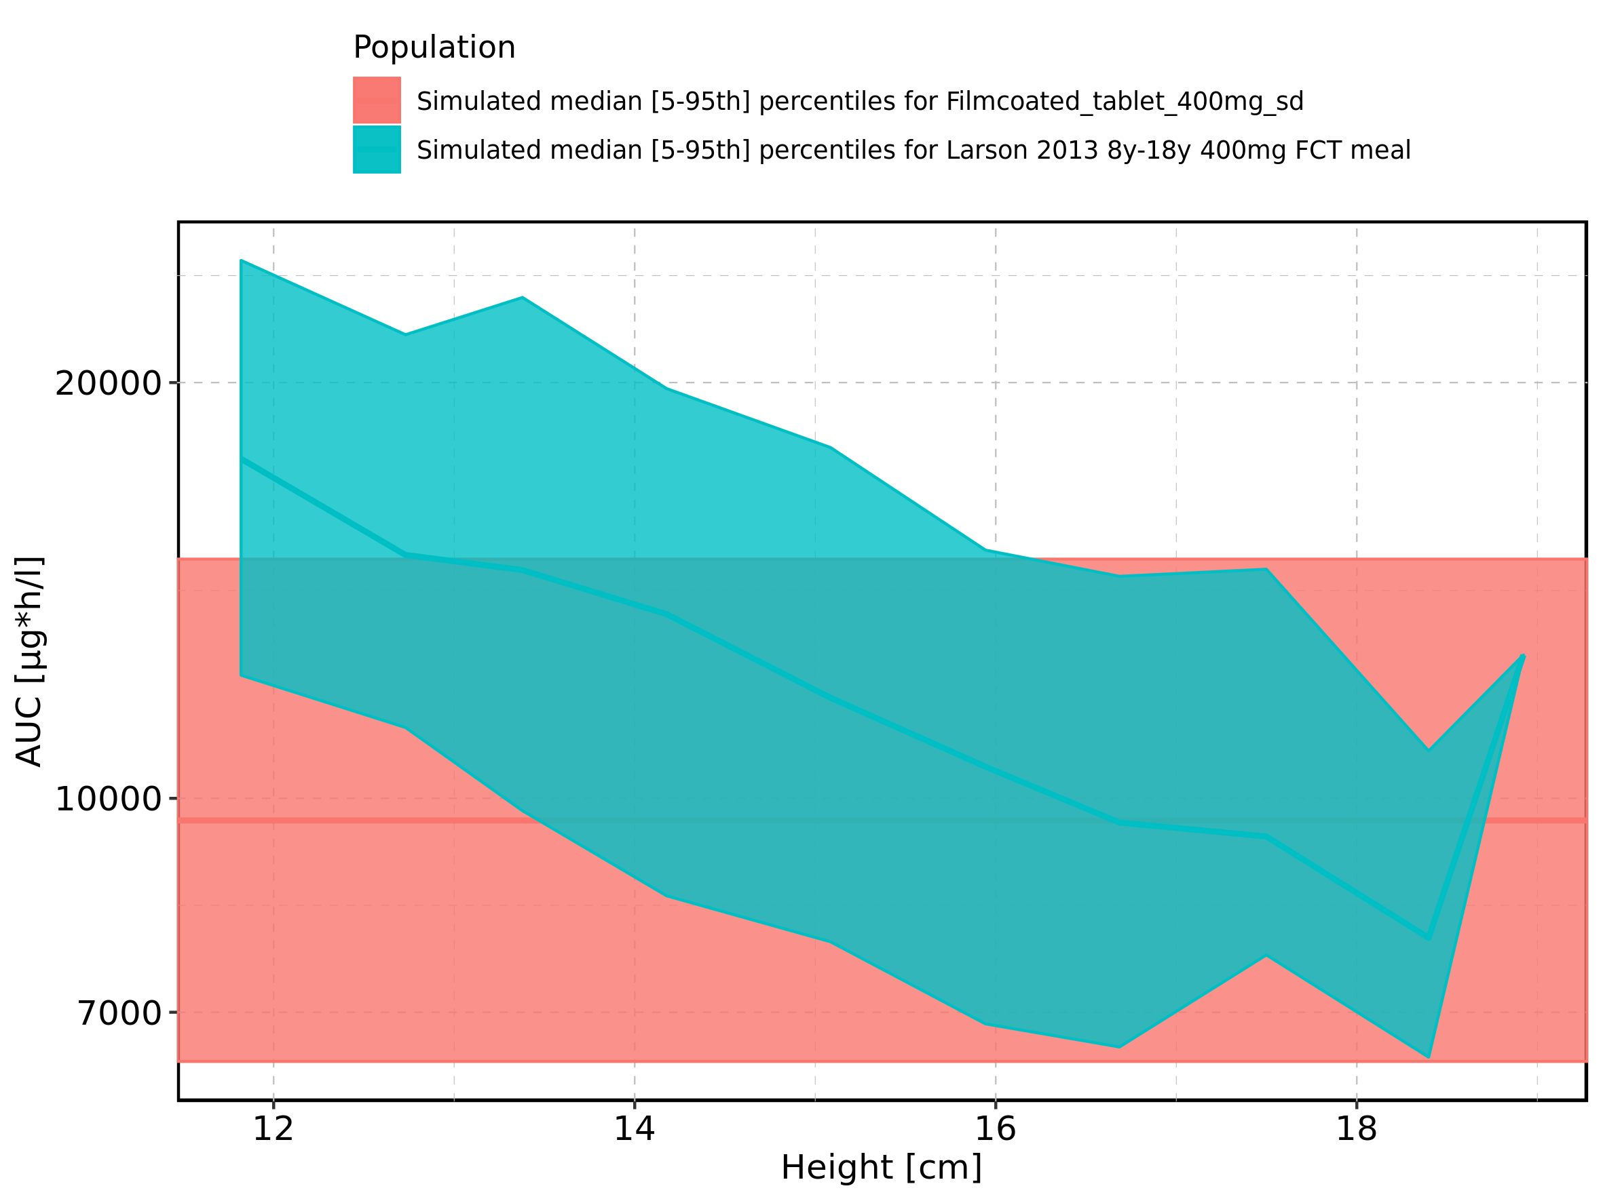

Figure 139: Height-dependence of AUC for Larson 2013 8y-18y 400mg FCT meal. Profiles are plotted in a linear scale.

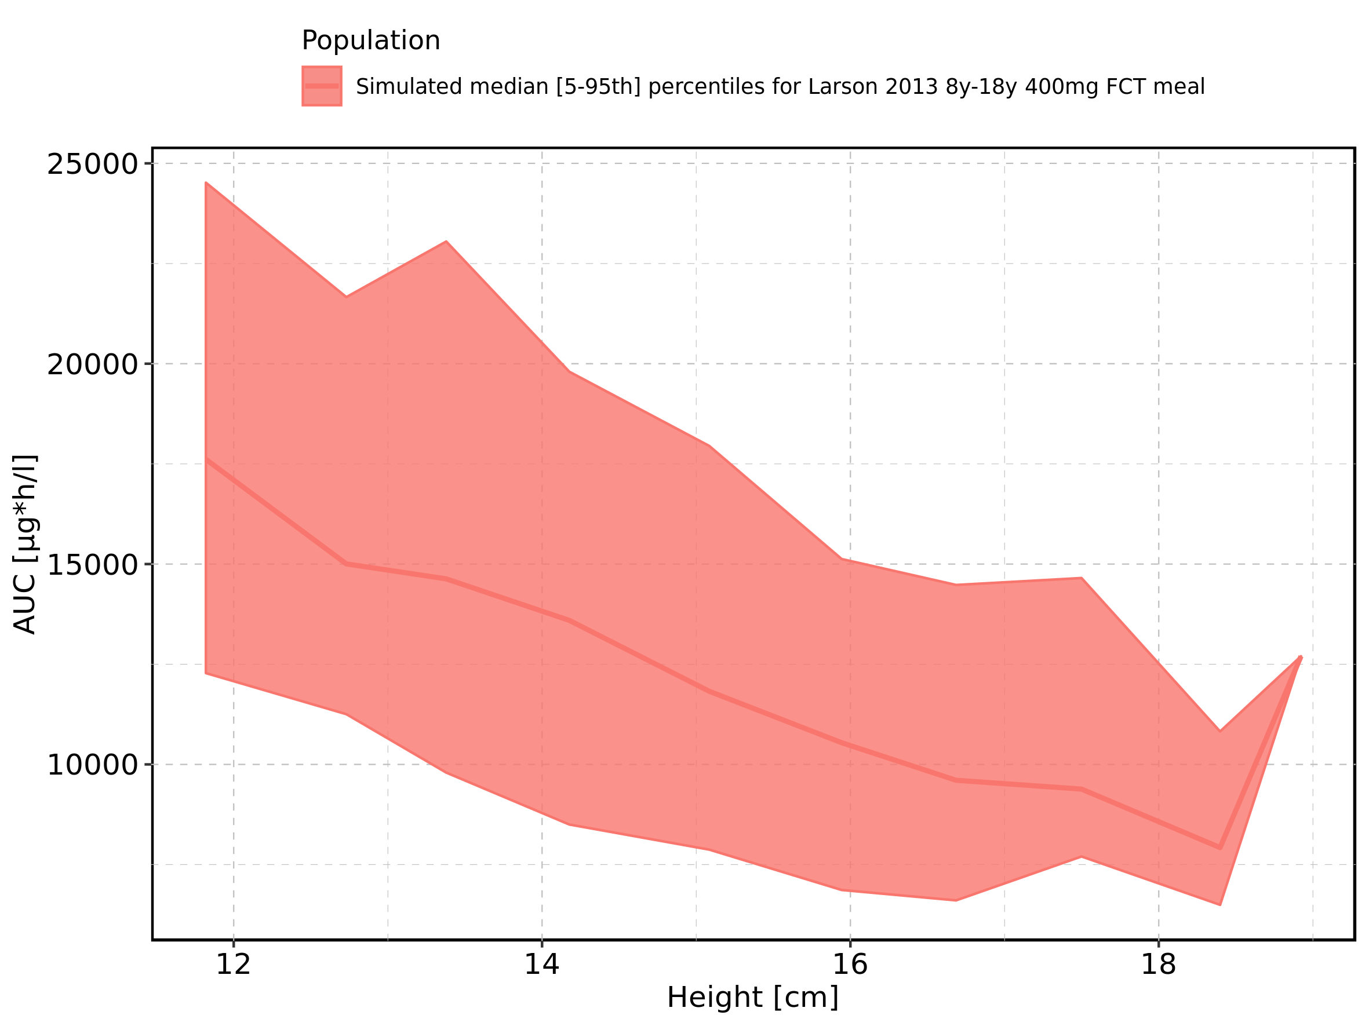

Figure 140: Height-dependence of AUC for Larson 2013 8y-18y 400mg FCT meal. Profiles are plotted in a logarithmic scale.

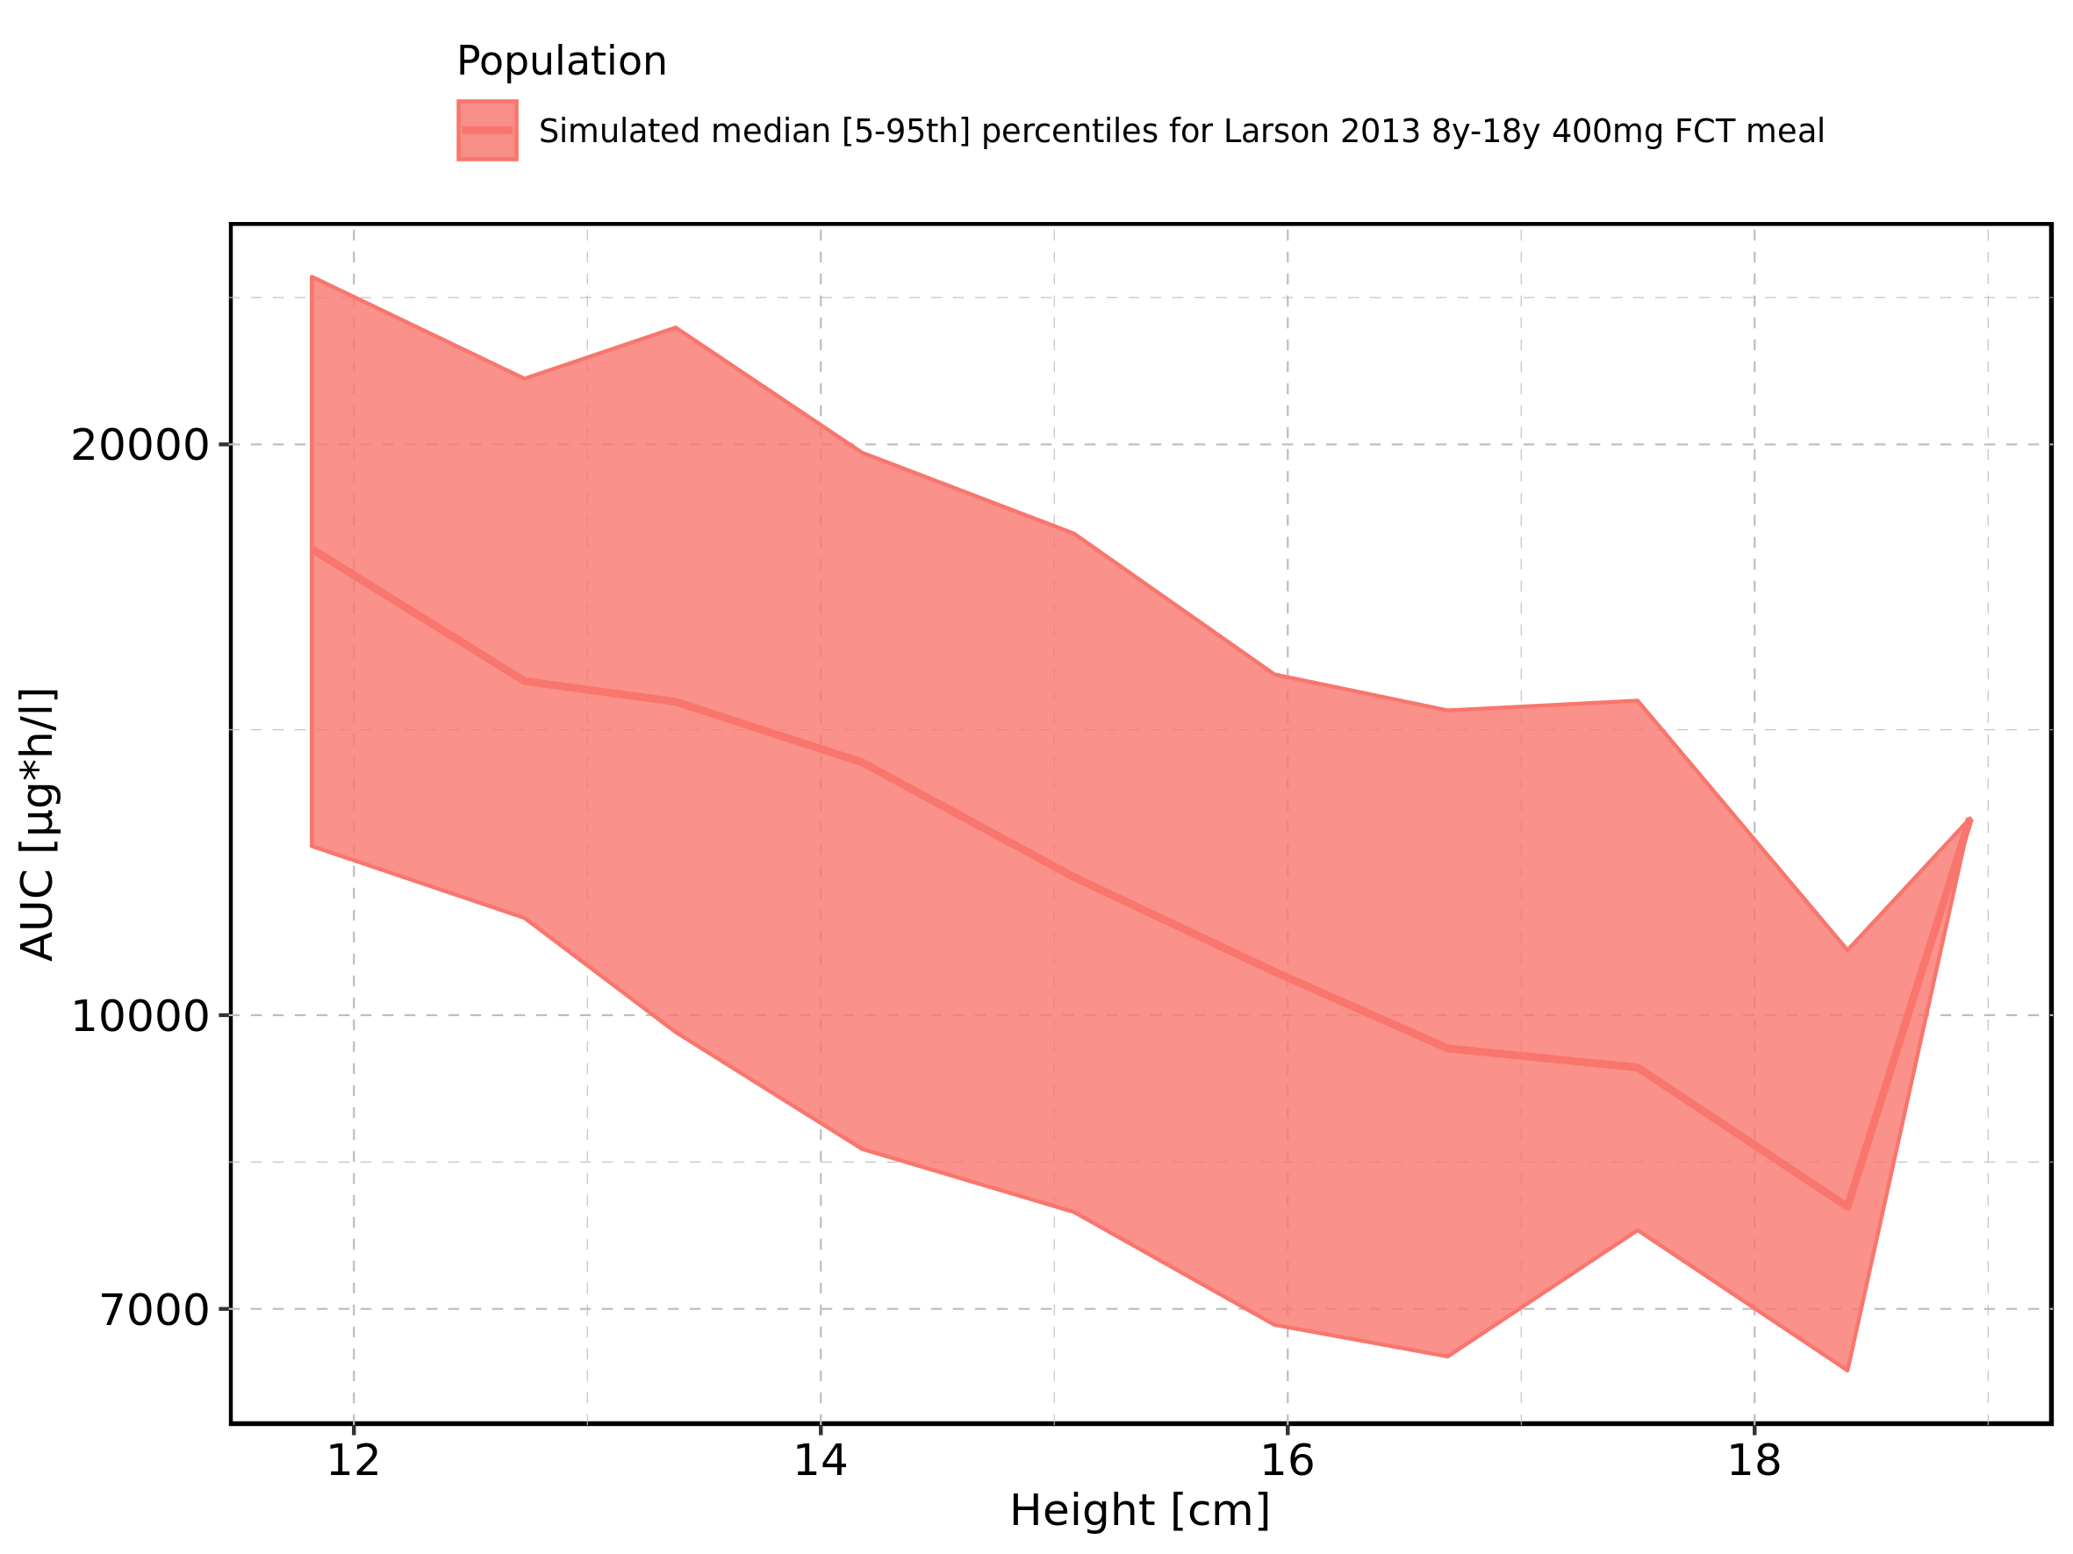

Figure 141: Height-dependence of AUC for Filmcoated_tablet_400mg_sd. Profiles are plotted in a linear scale.

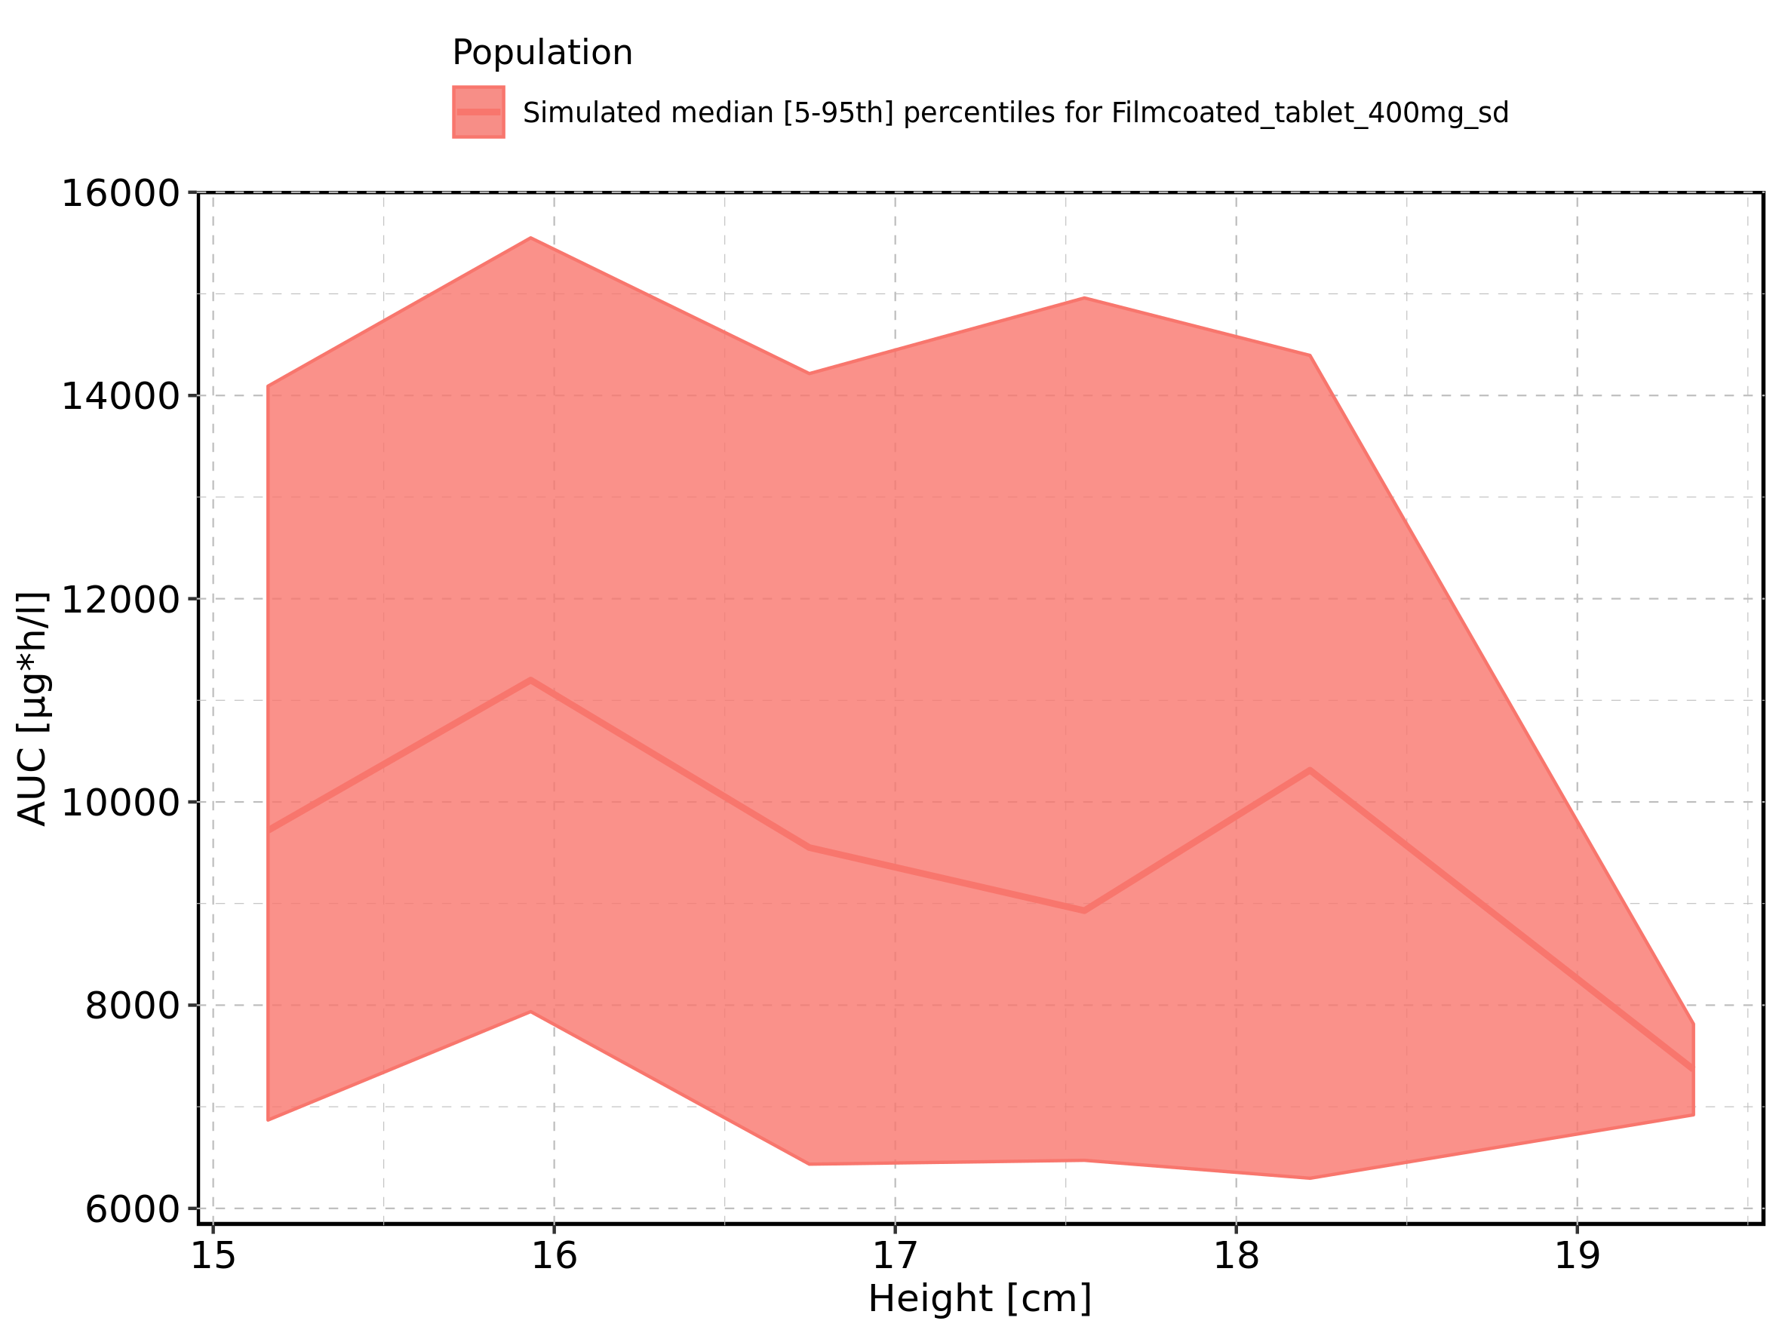

Figure 142: Height-dependence of AUC for Filmcoated_tablet_400mg_sd. Profiles are plotted in a logarithmic scale.

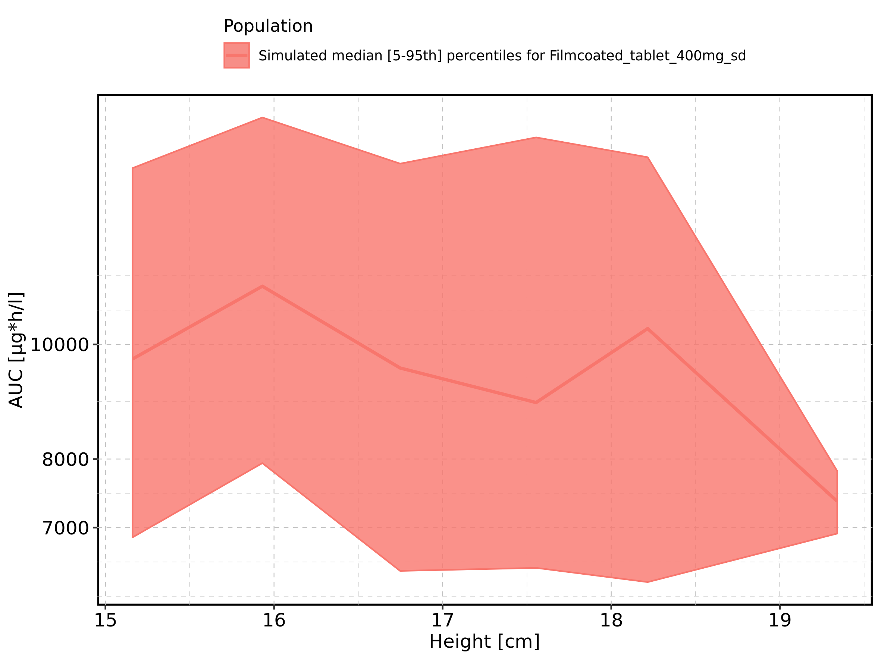

Figure 143: Weight-dependence of AUC for Larson 2013 8y-18y 400mg FCT meal in comparison to Filmcoated_tablet_400mg_sd. Profiles are plotted in a linear scale.

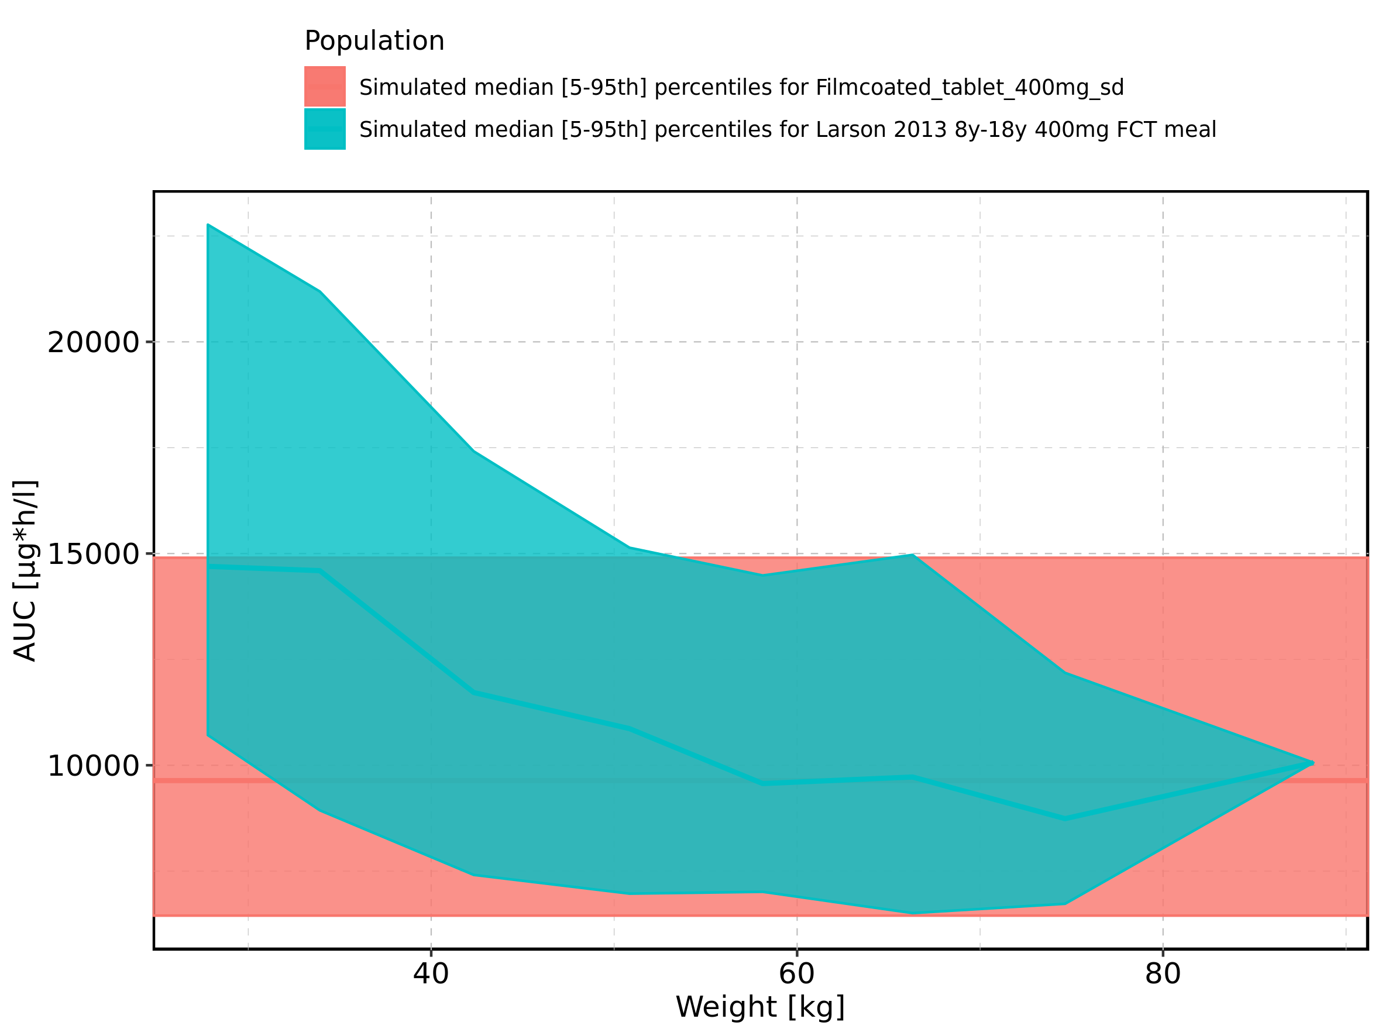

Figure 144: Weight-dependence of AUC for Larson 2013 8y-18y 400mg FCT meal in comparison to Filmcoated_tablet_400mg_sd. Profiles are plotted in a logarithmic scale.

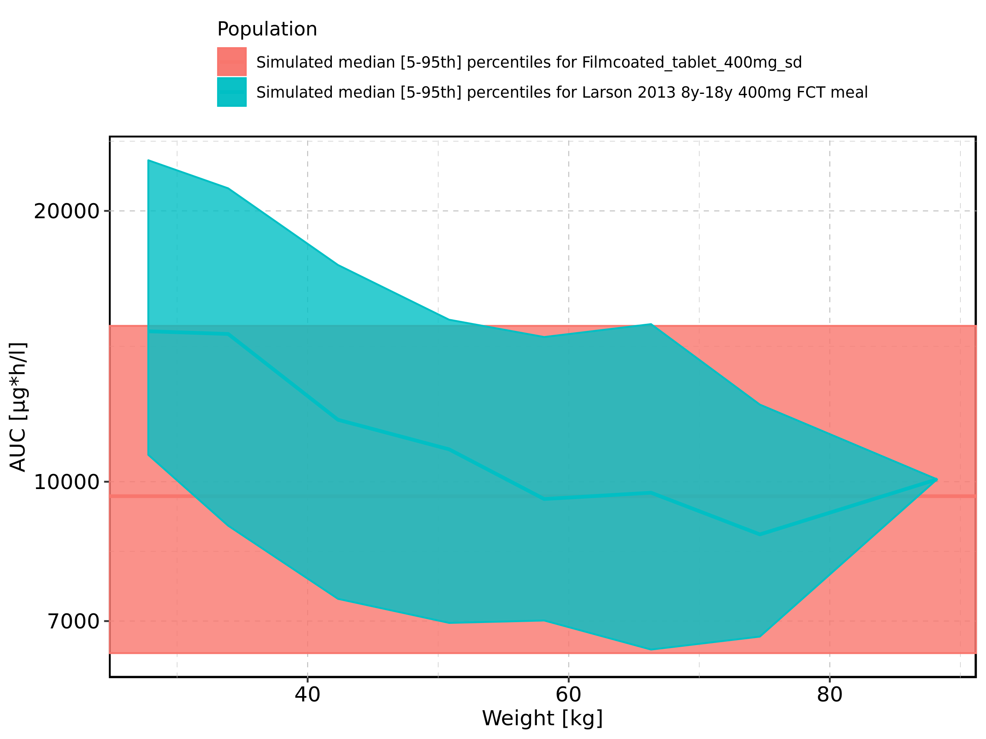

Figure 145: Weight-dependence of AUC for Larson 2013 8y-18y 400mg FCT meal. Profiles are plotted in a linear scale.

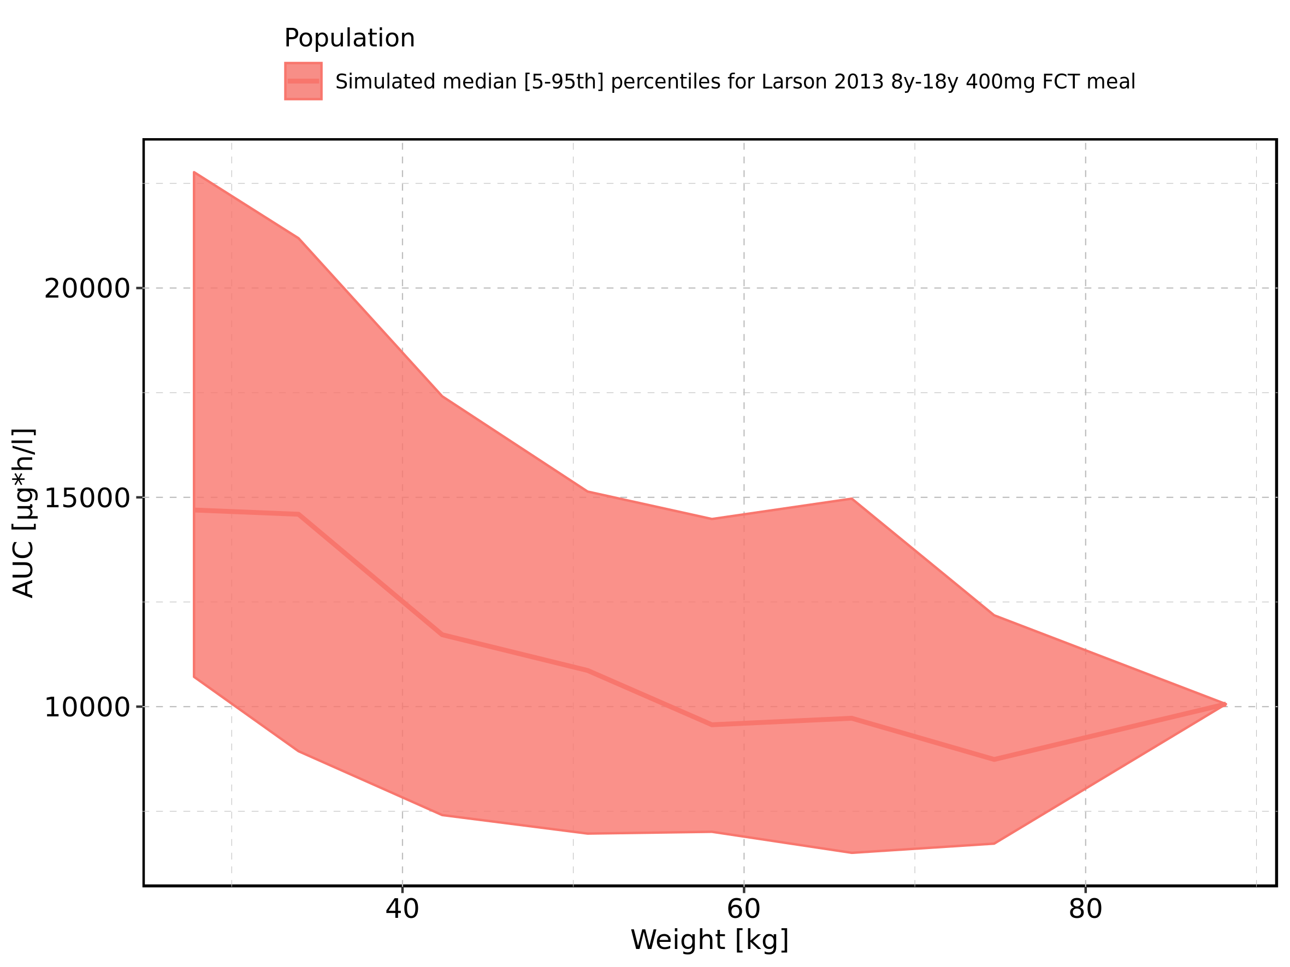

Figure 146: Weight-dependence of AUC for Larson 2013 8y-18y 400mg FCT meal. Profiles are plotted in a logarithmic scale.

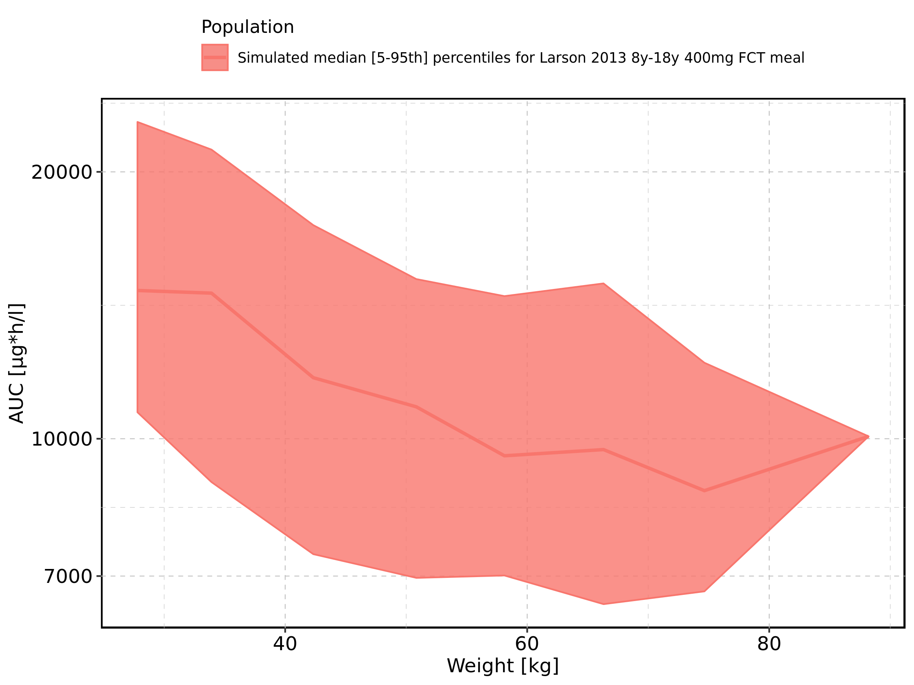

Figure 147: Weight-dependence of AUC for Filmcoated_tablet_400mg_sd. Profiles are plotted in a linear scale.

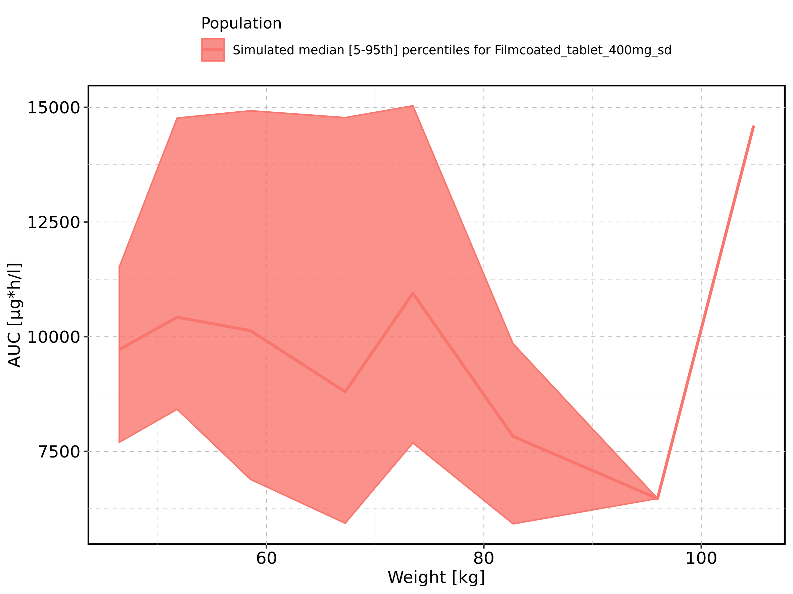

Figure 148: Weight-dependence of AUC for Filmcoated_tablet_400mg_sd. Profiles are plotted in a logarithmic scale.

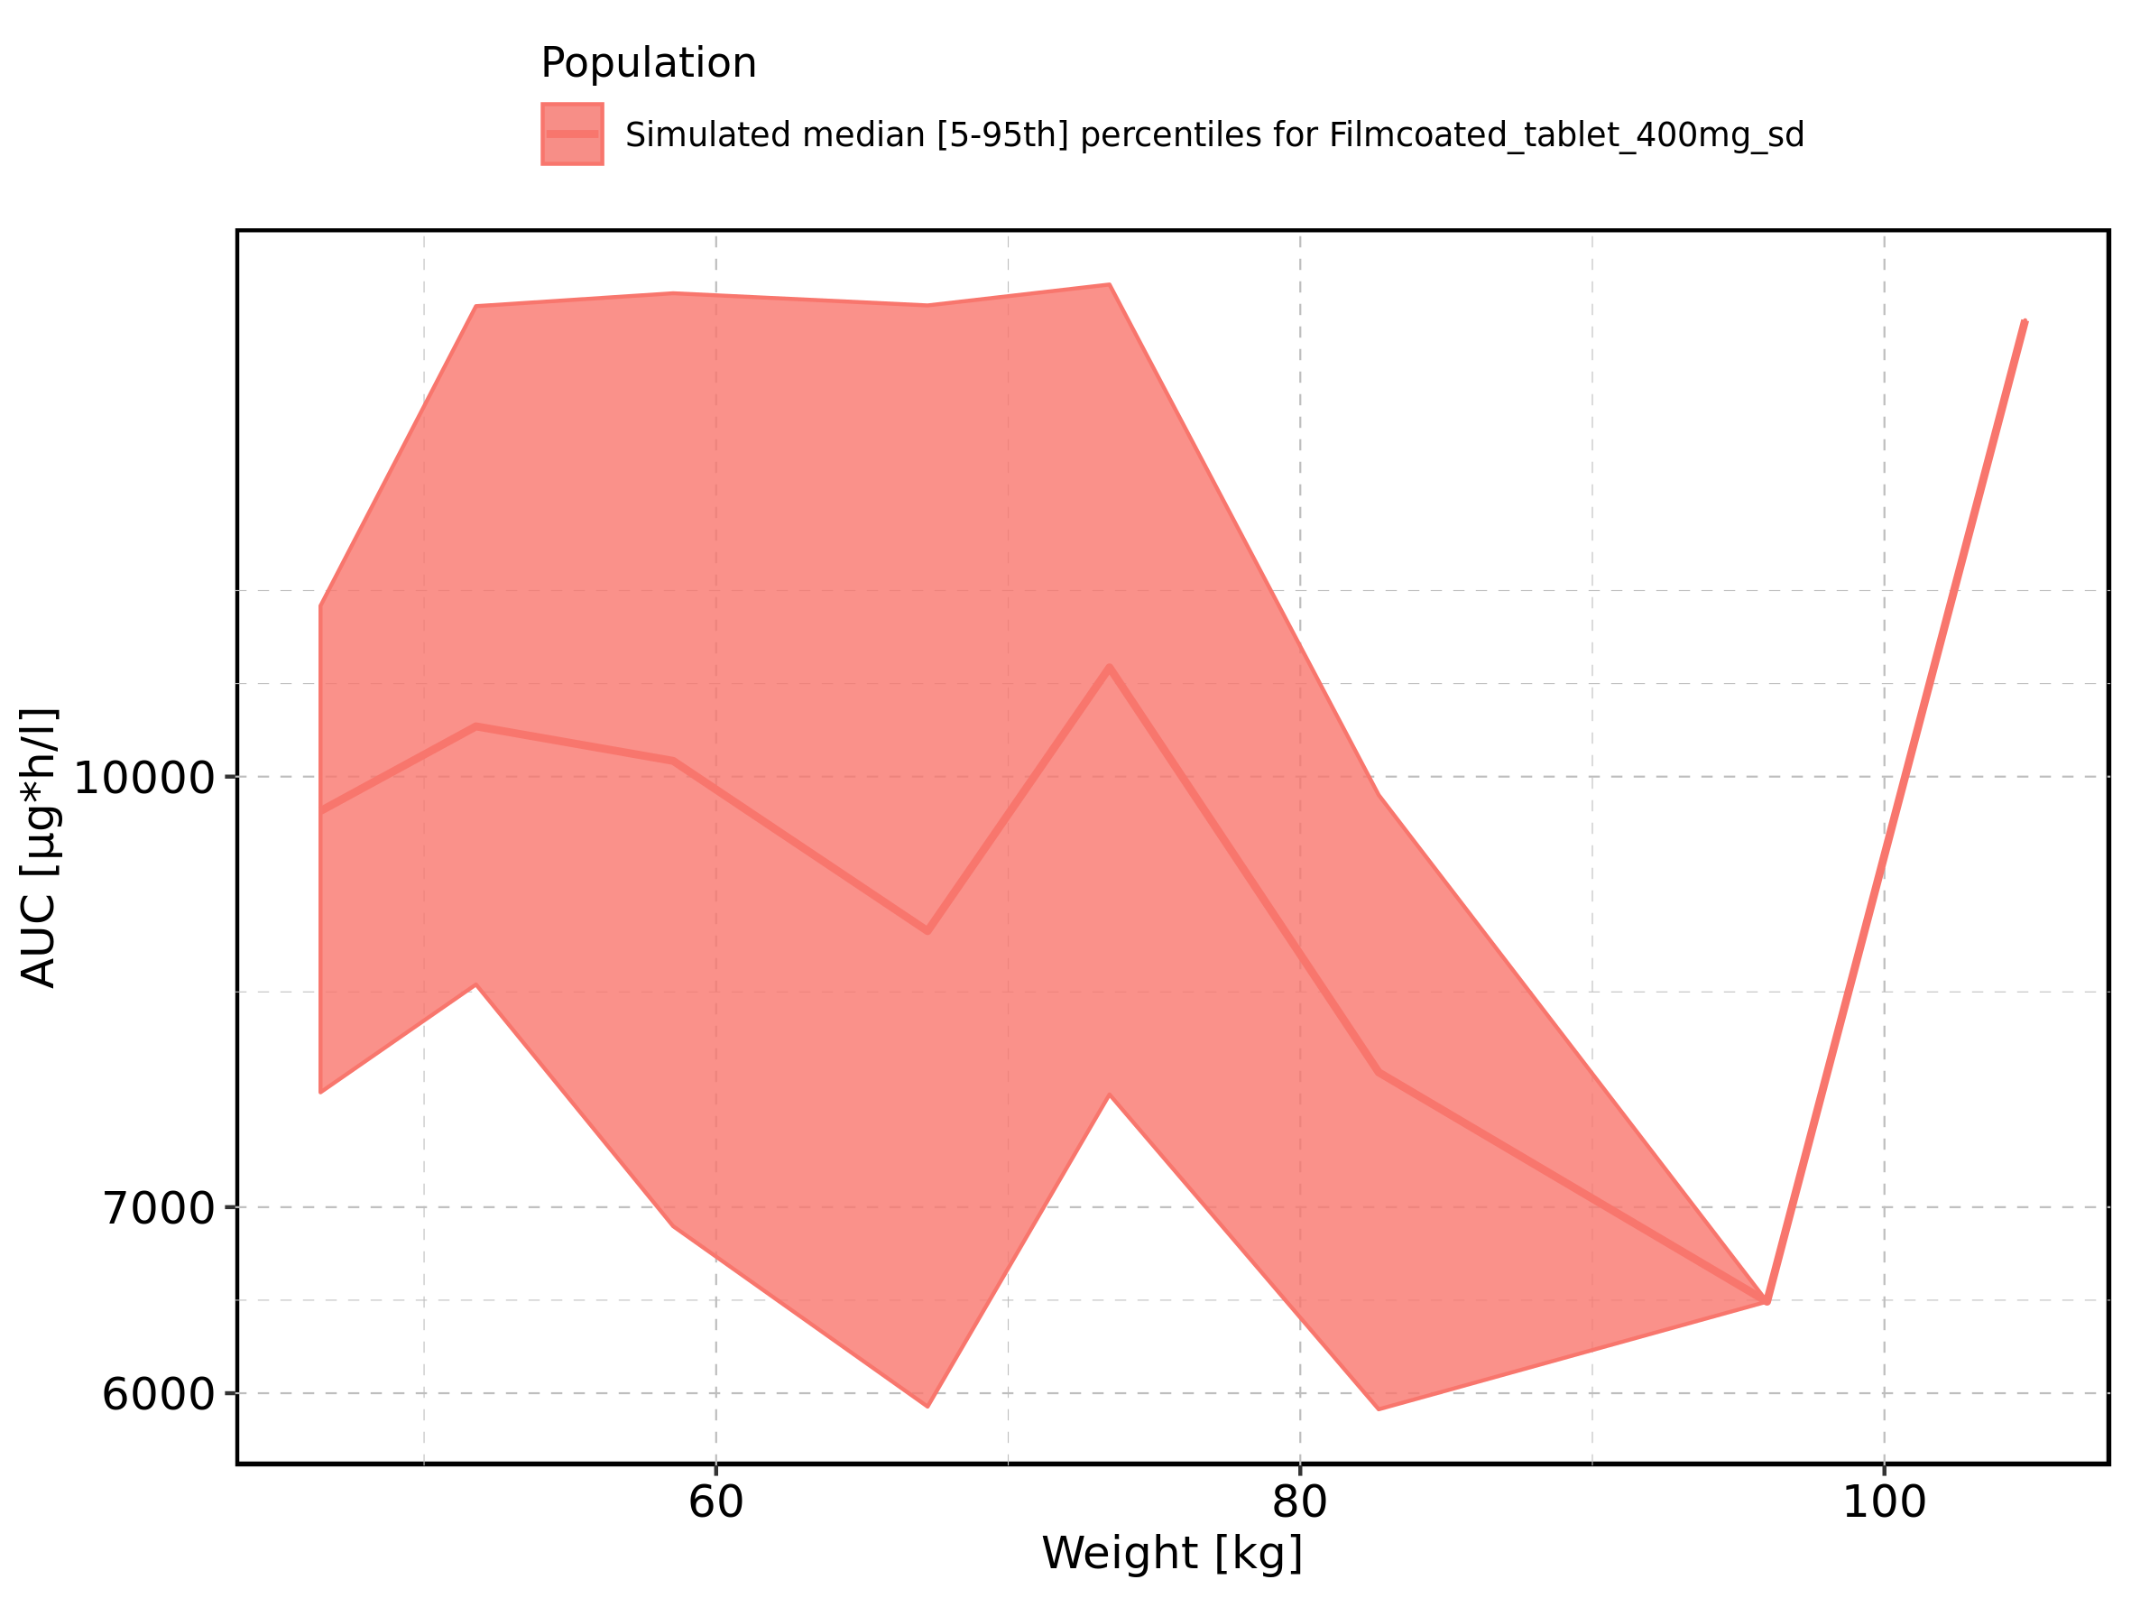

Figure 149: BMI-dependence of AUC for Larson 2013 8y-18y 400mg FCT meal in comparison to Filmcoated_tablet_400mg_sd. Profiles are plotted in a linear scale.

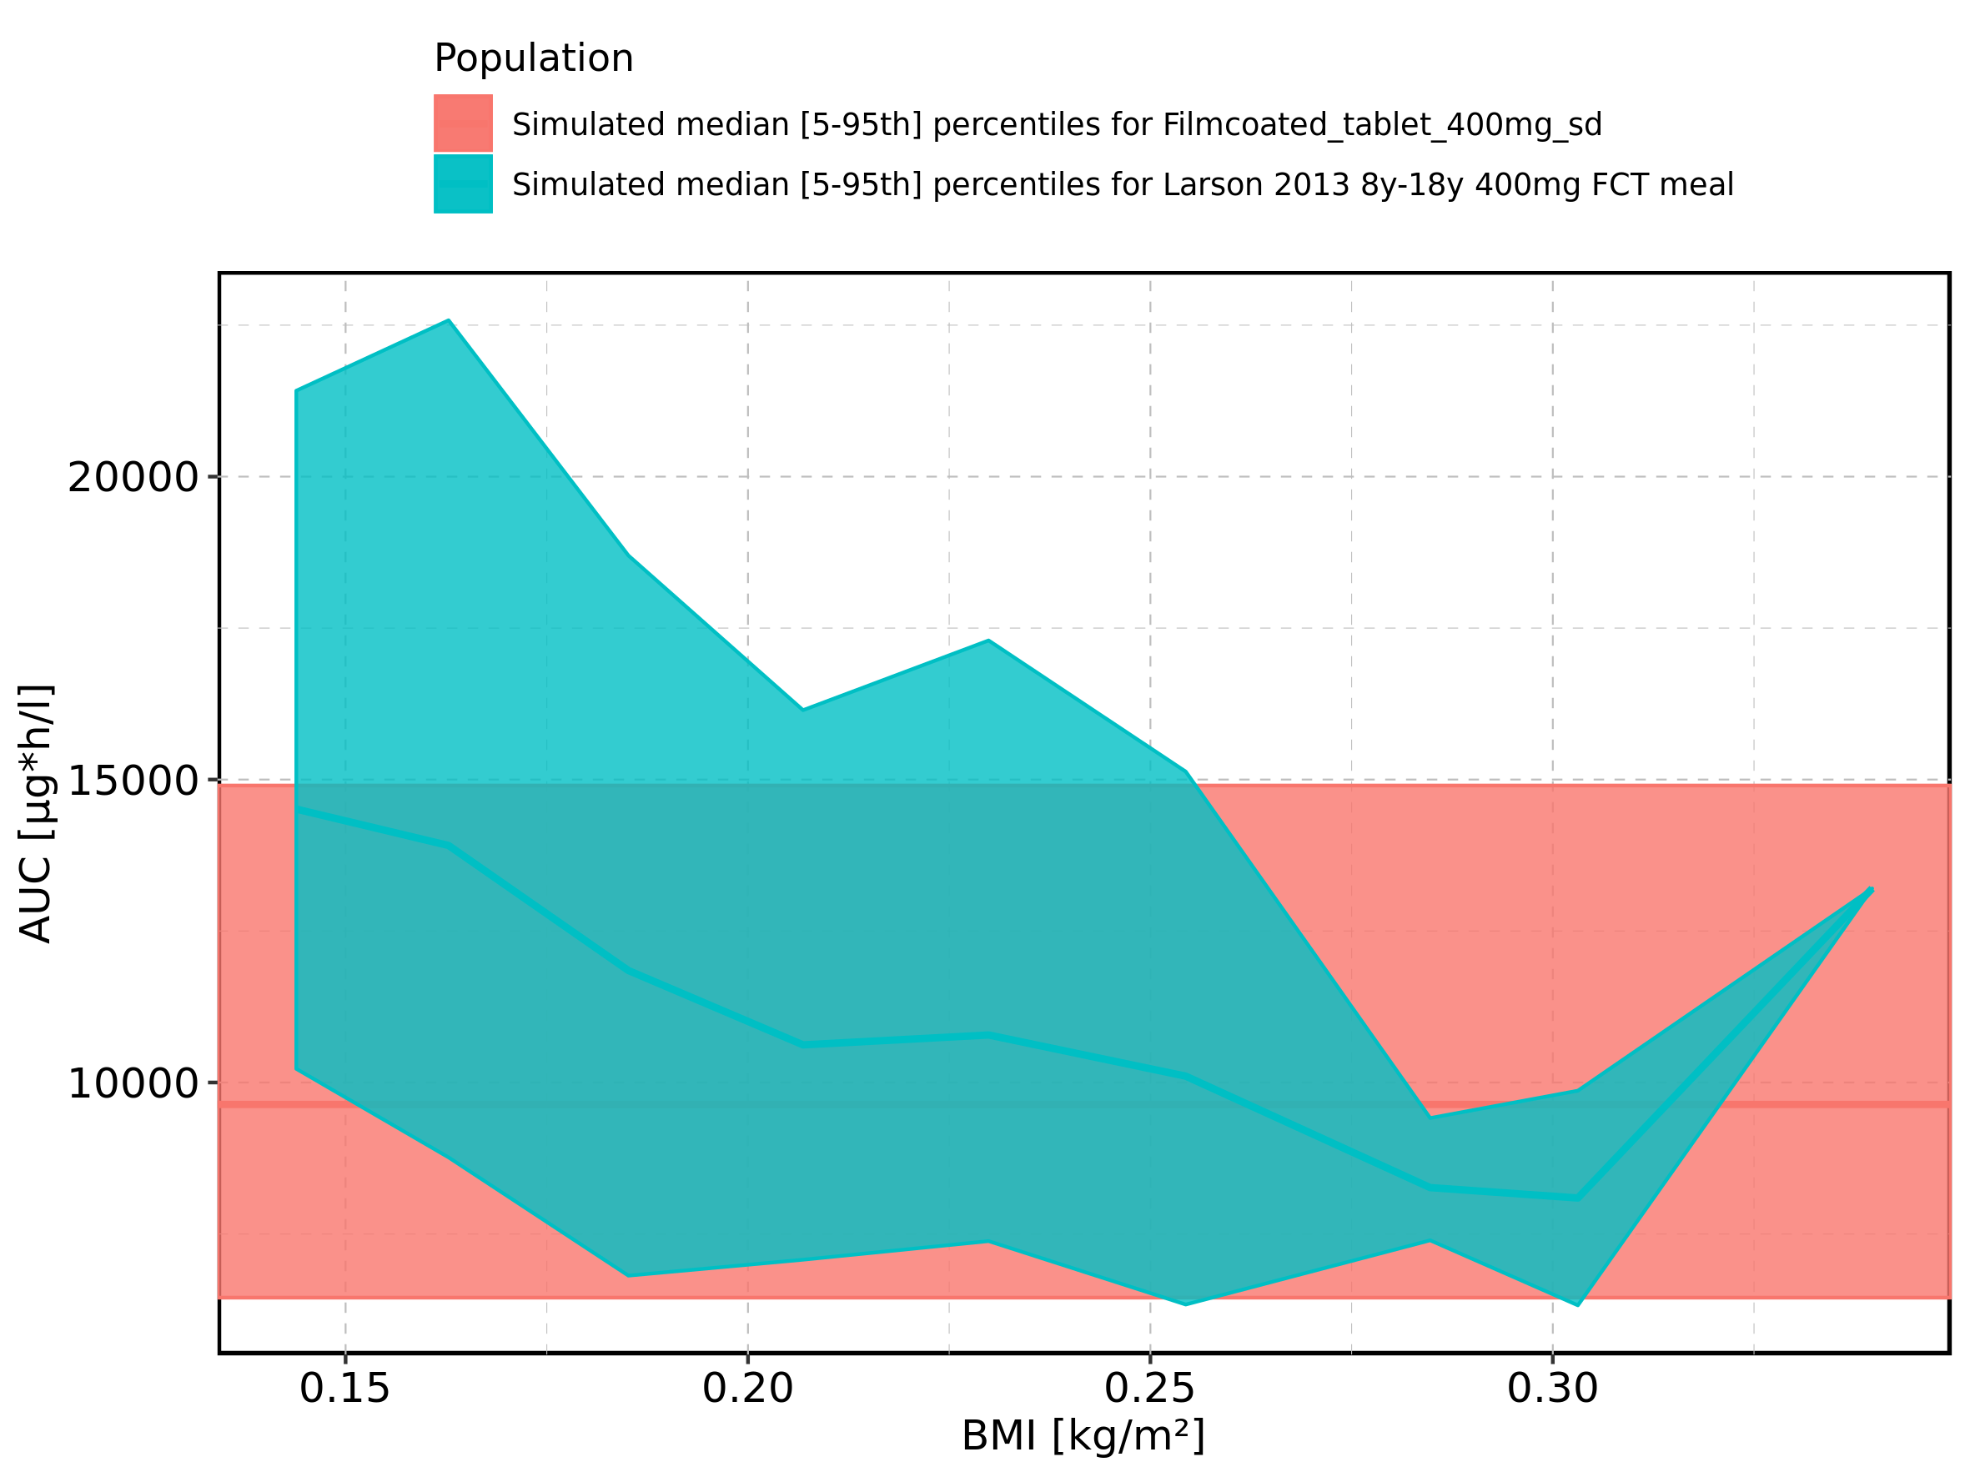

Figure 150: BMI-dependence of AUC for Larson 2013 8y-18y 400mg FCT meal in comparison to Filmcoated_tablet_400mg_sd. Profiles are plotted in a logarithmic scale.

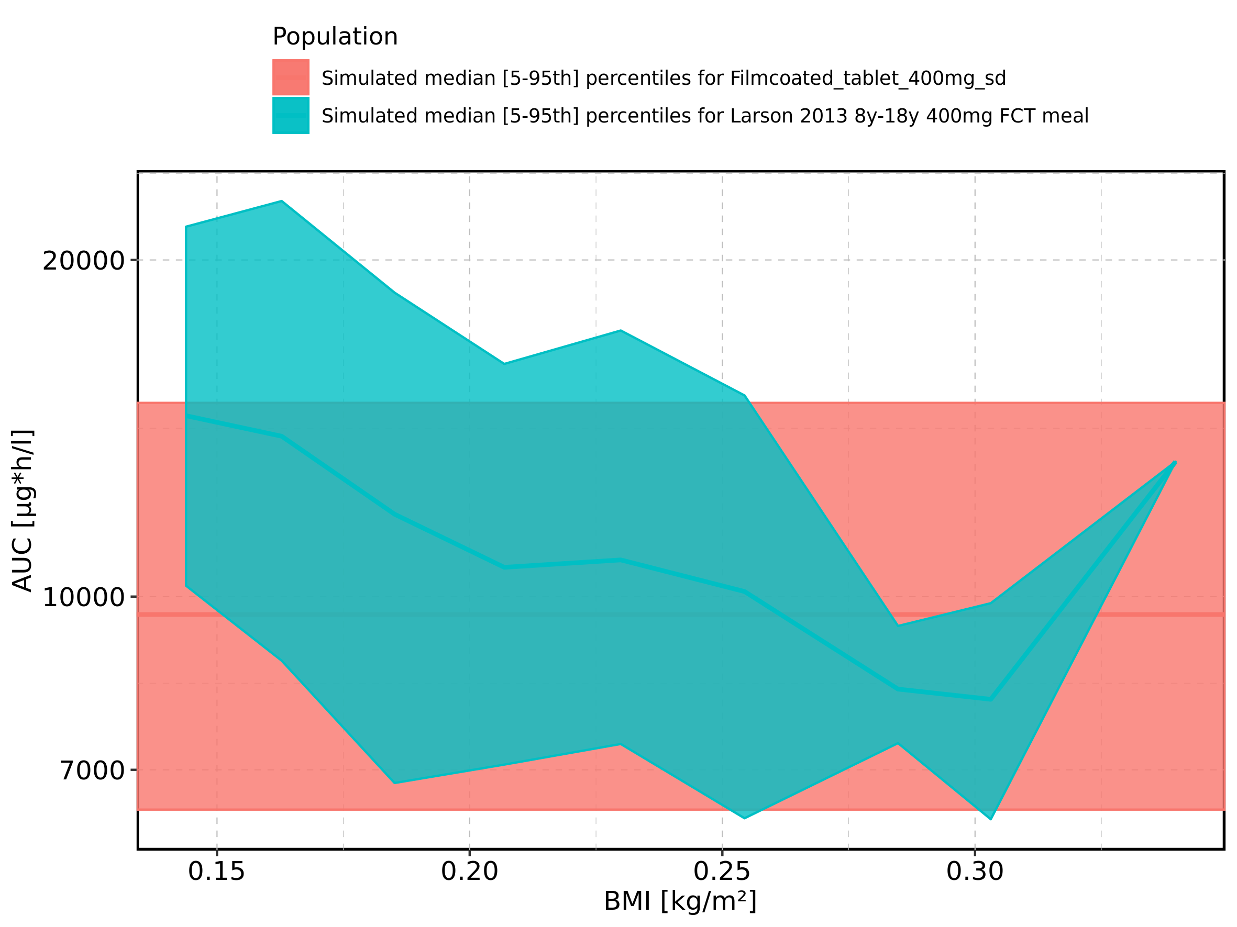

Figure 151: BMI-dependence of AUC for Larson 2013 8y-18y 400mg FCT meal. Profiles are plotted in a linear scale.

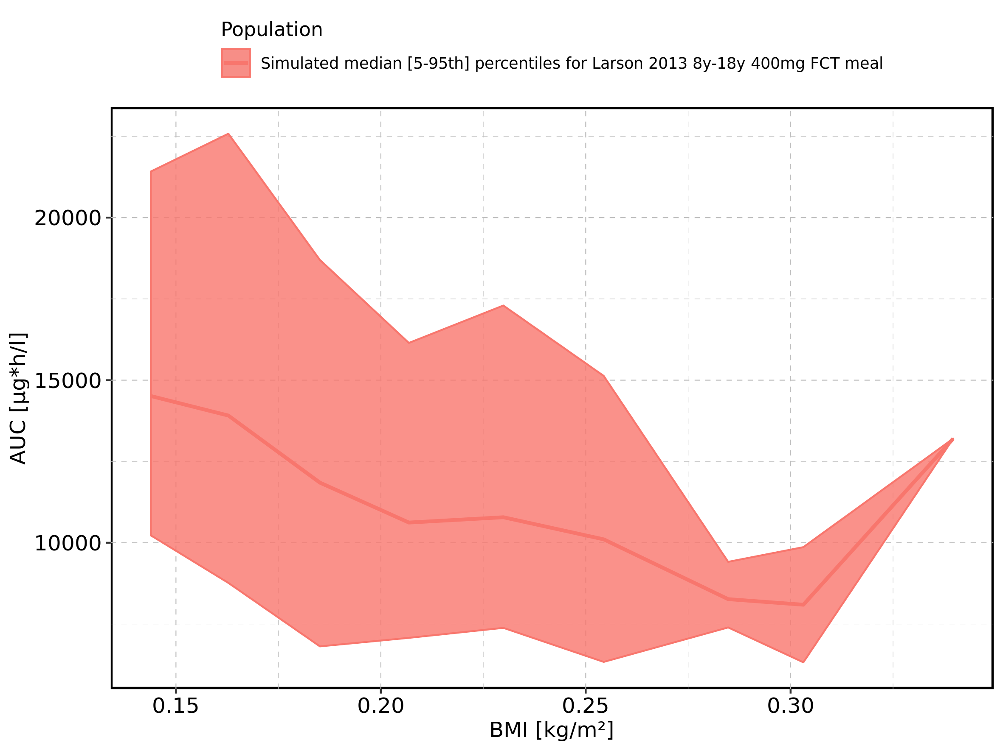

Figure 152: BMI-dependence of AUC for Larson 2013 8y-18y 400mg FCT meal. Profiles are plotted in a logarithmic scale.

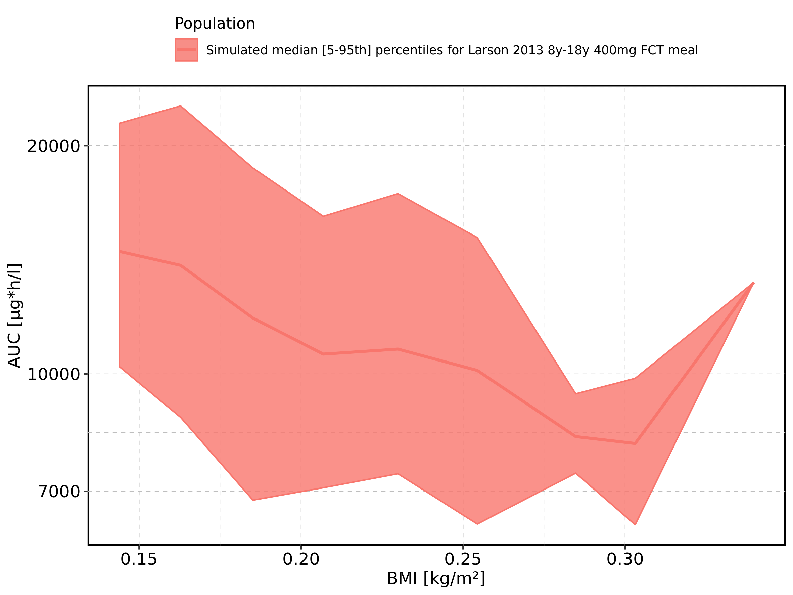

Figure 153: BMI-dependence of AUC for Filmcoated_tablet_400mg_sd. Profiles are plotted in a linear scale.

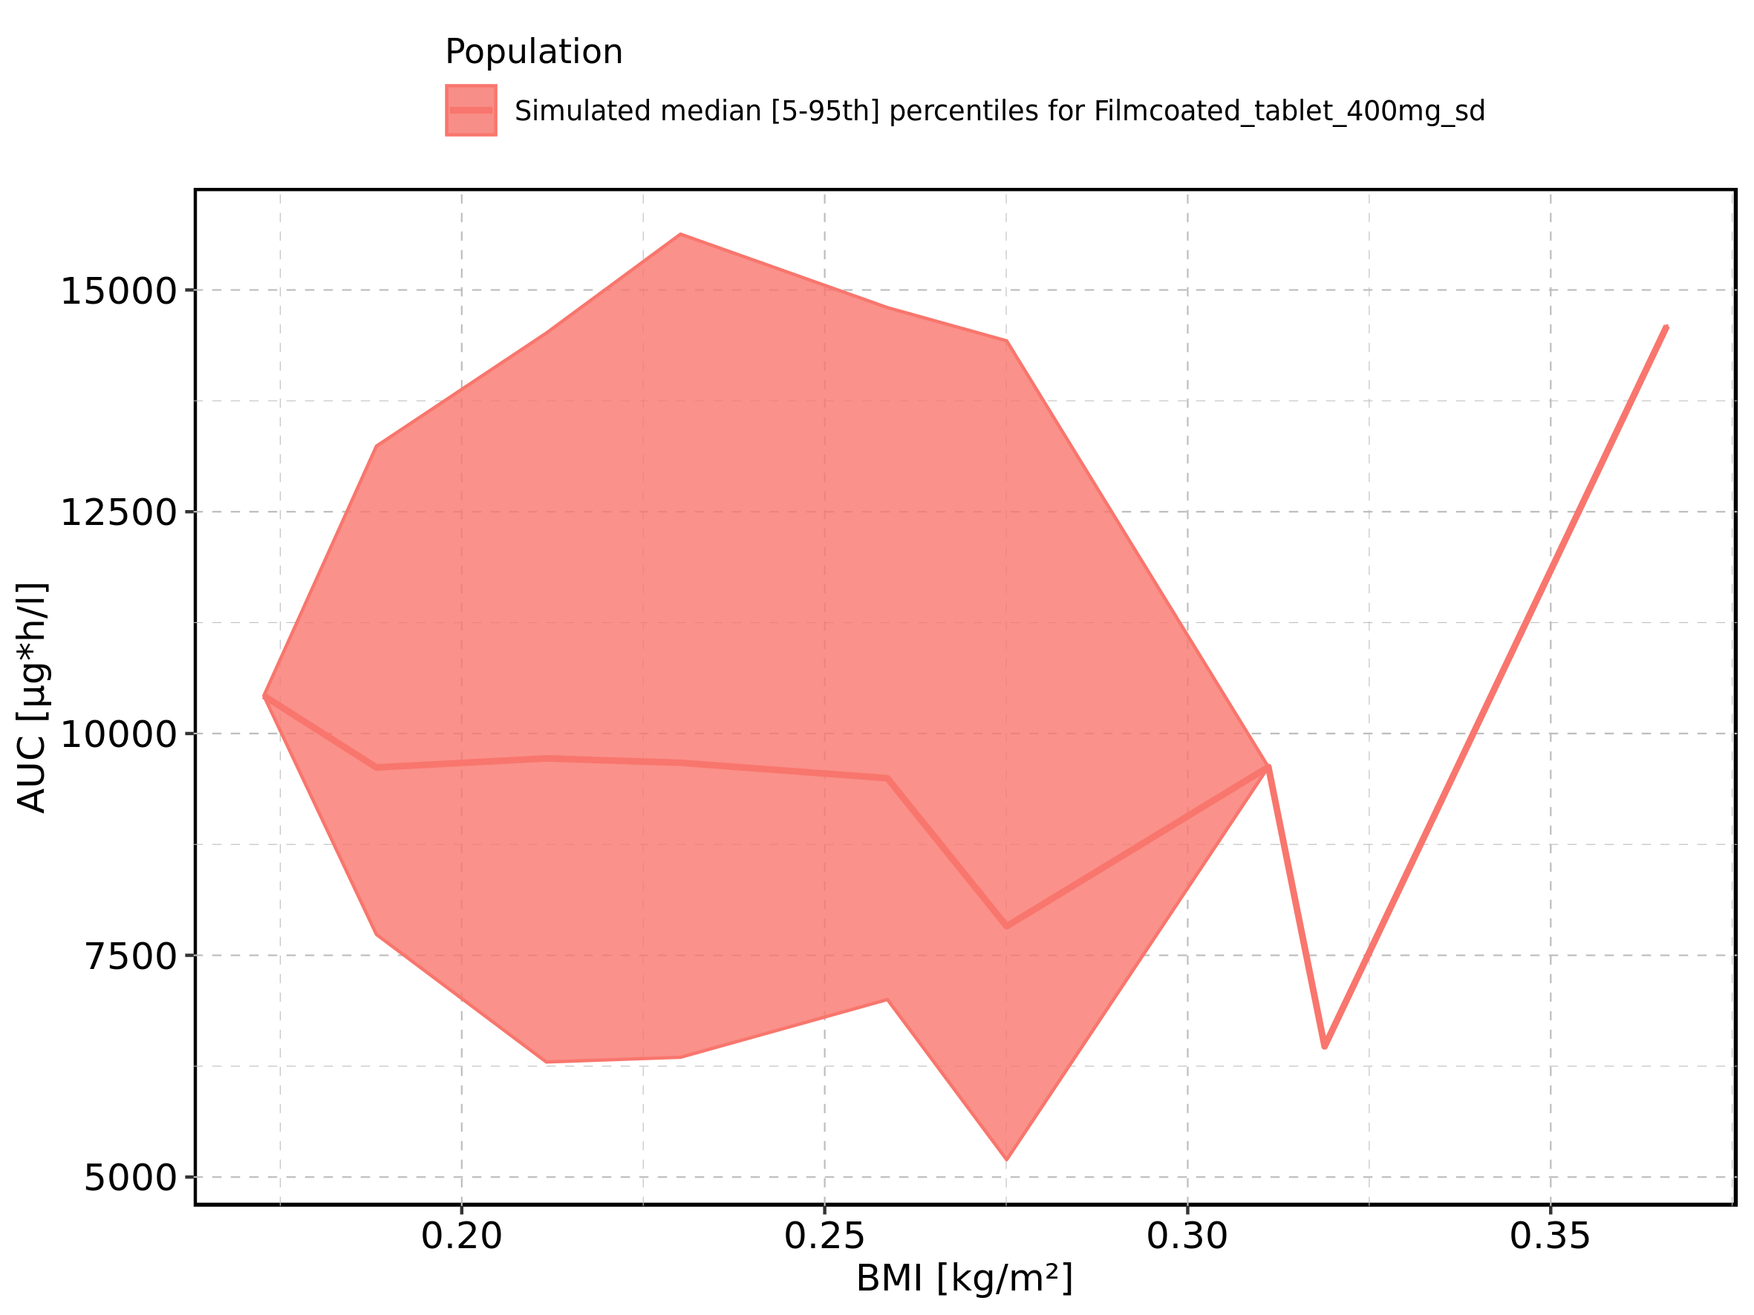

Figure 154: BMI-dependence of AUC for Filmcoated_tablet_400mg_sd. Profiles are plotted in a logarithmic scale.

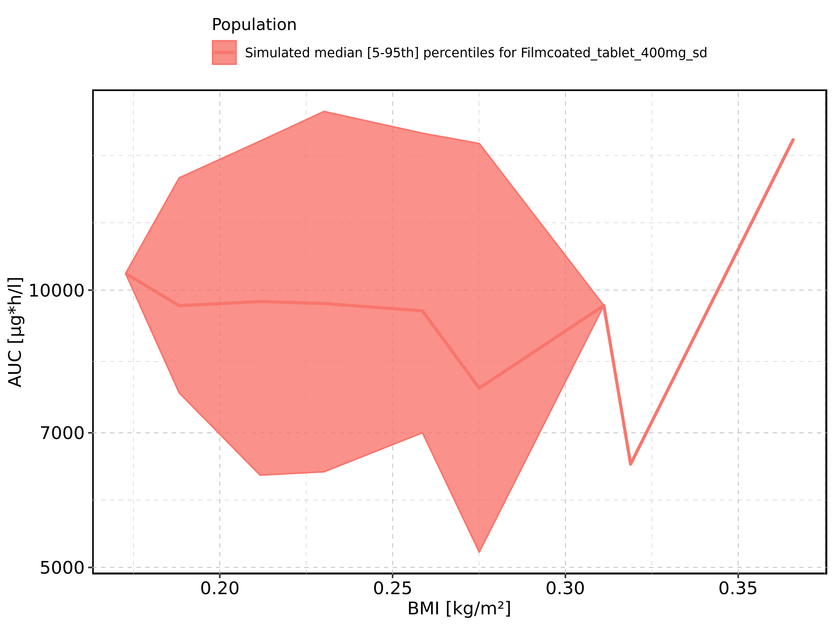

Figure 155: Gender-dependence of AUC for Larson 2013 8y-18y 400mg FCT meal in comparison to Filmcoated_tablet_400mg_sd. Profiles are plotted in a linear scale.

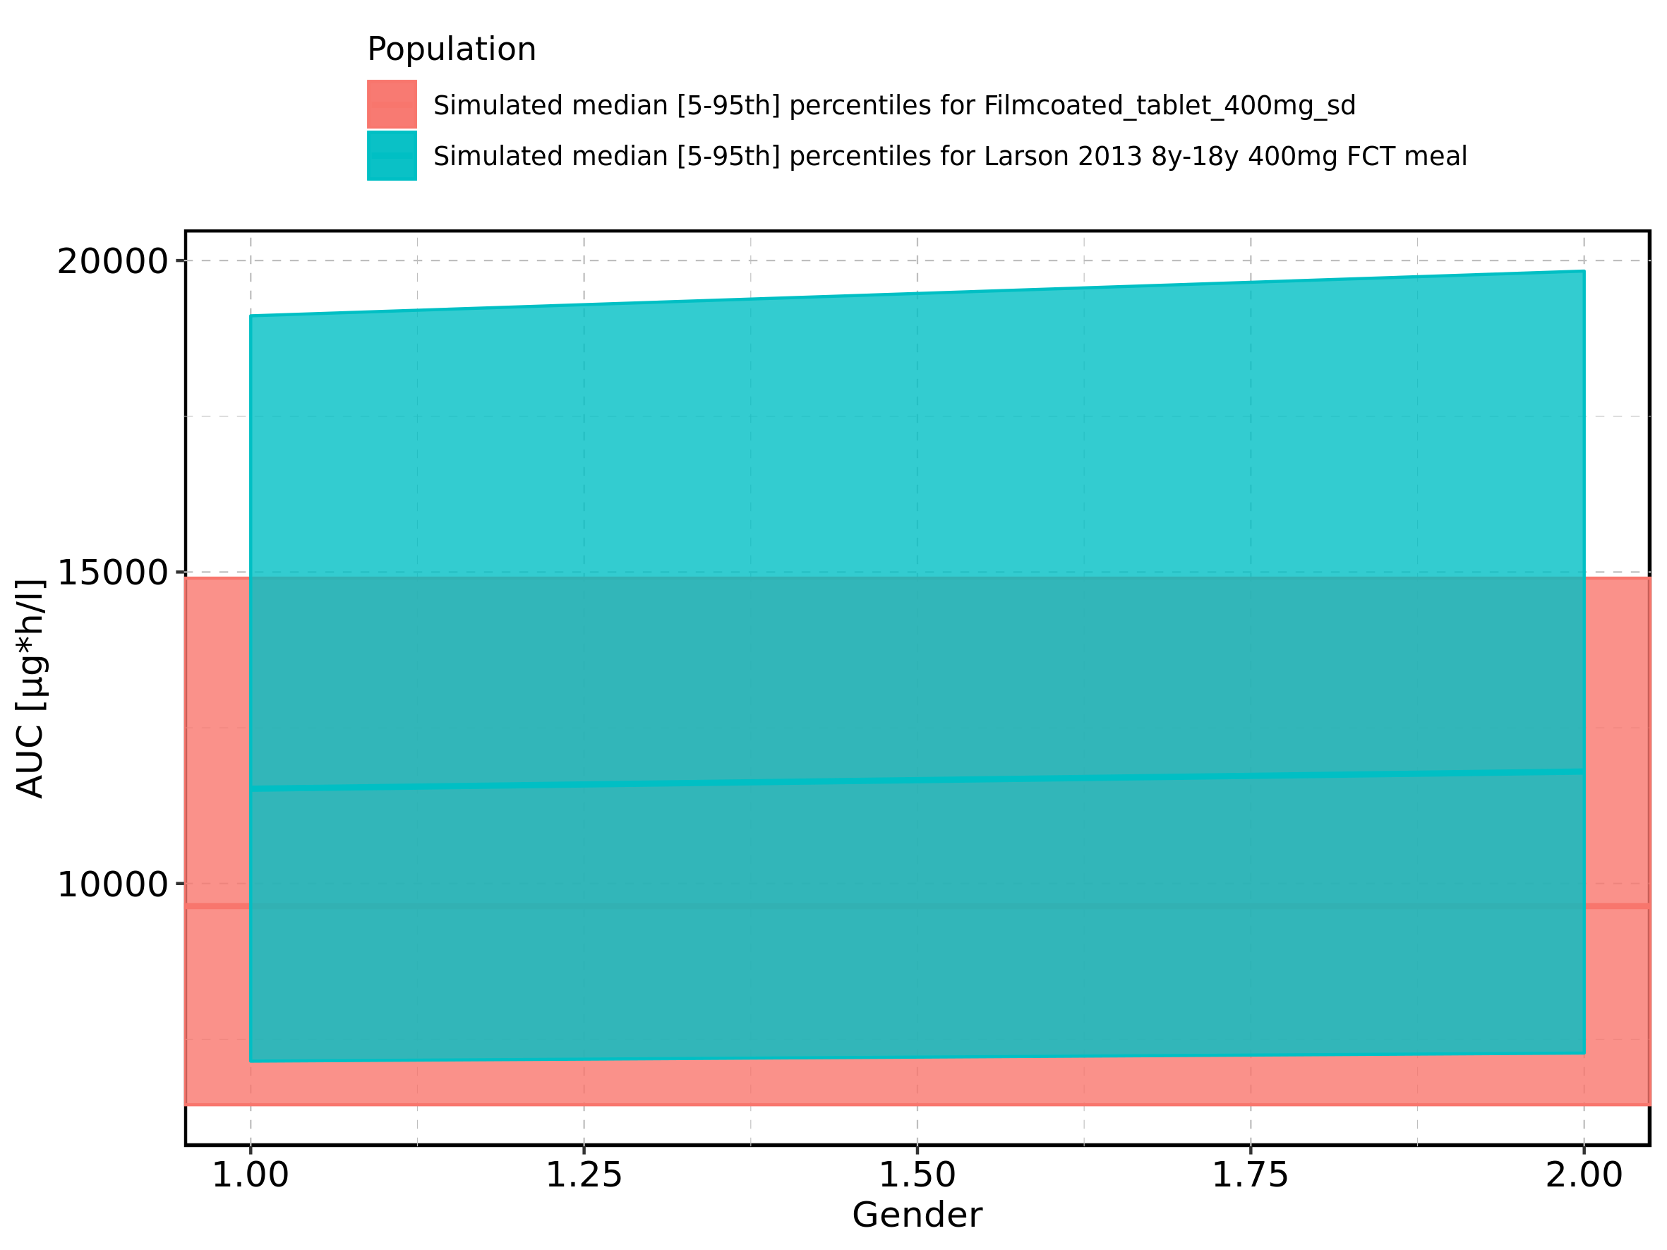

Figure 156: Gender-dependence of AUC for Larson 2013 8y-18y 400mg FCT meal in comparison to Filmcoated_tablet_400mg_sd. Profiles are plotted in a logarithmic scale.

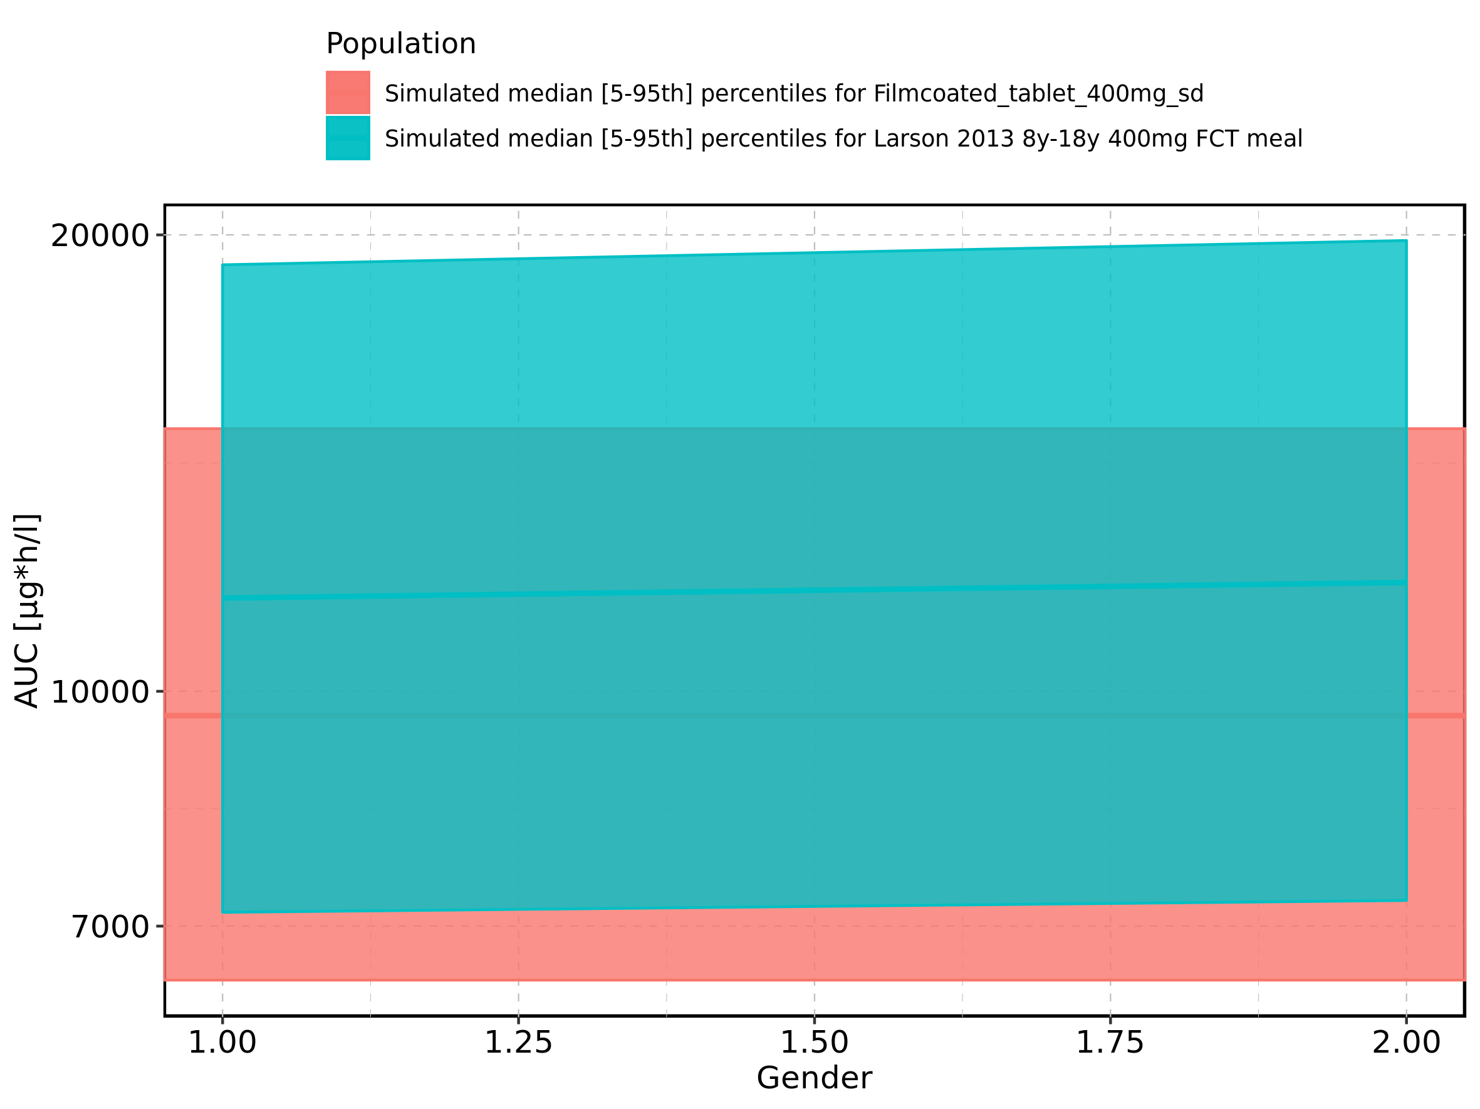

Figure 157: Gender-dependence of AUC for Larson 2013 8y-18y 400mg FCT meal. Profiles are plotted in a linear scale.

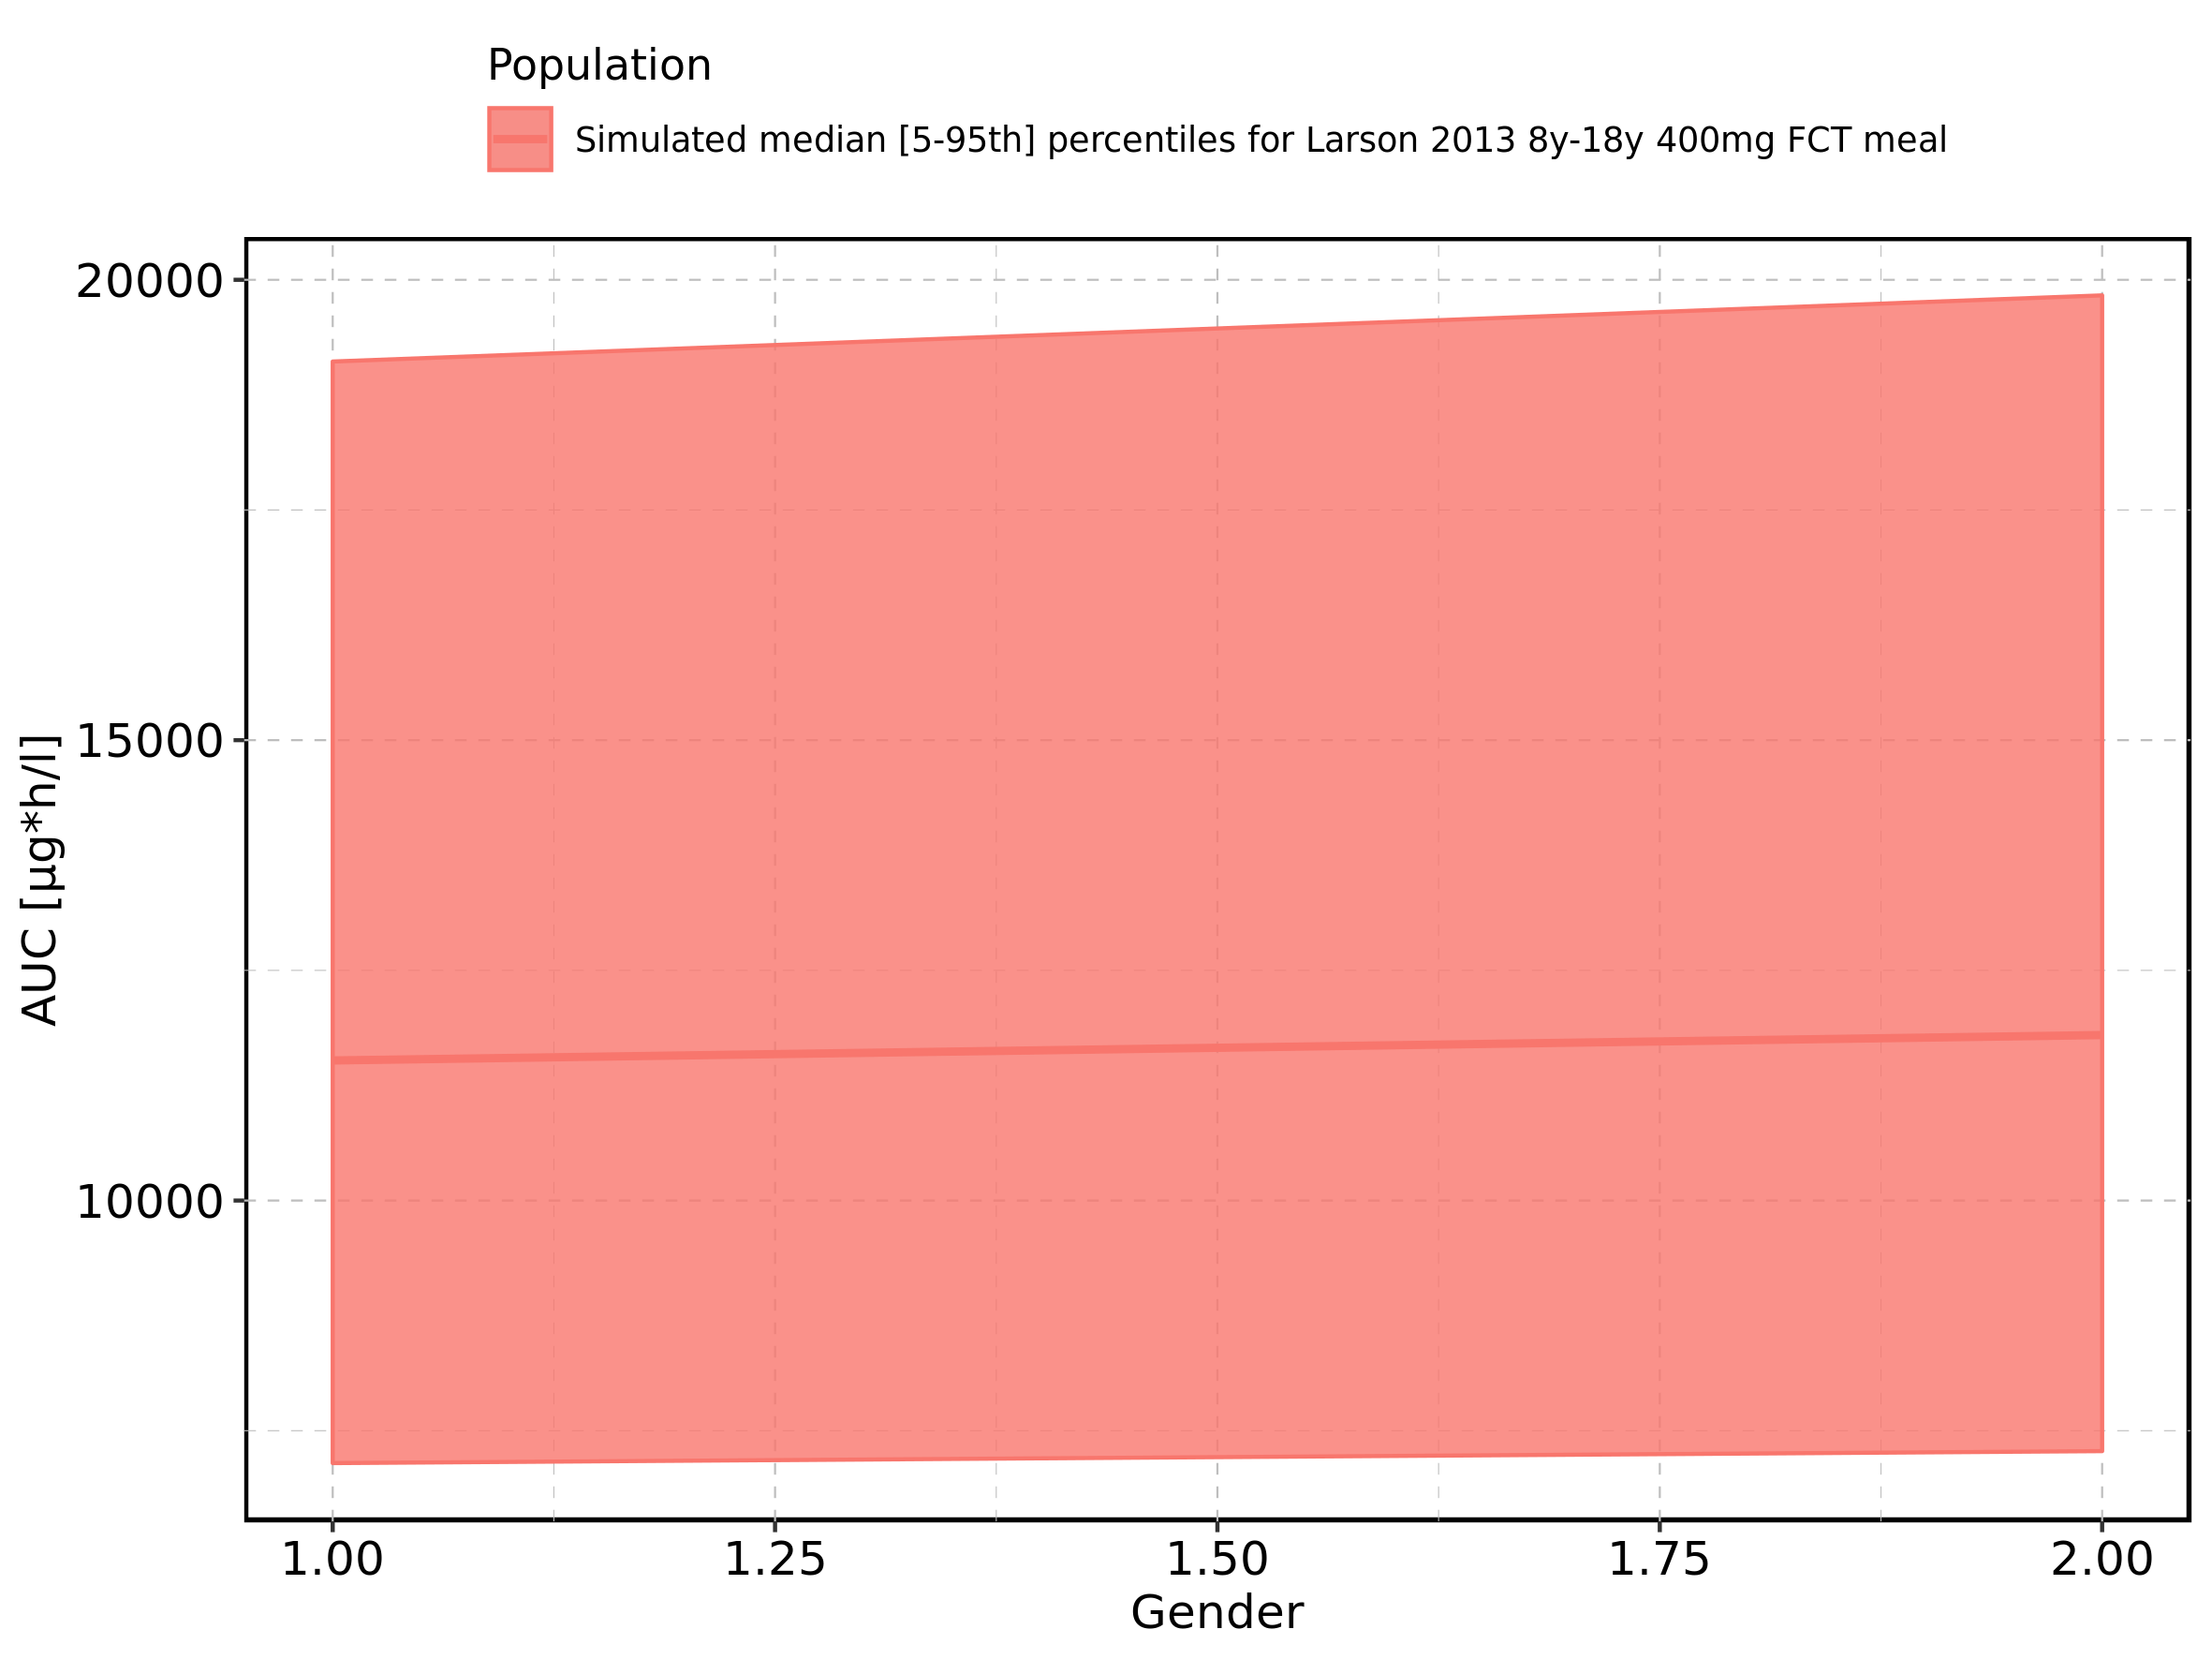

Figure 158: Gender-dependence of AUC for Larson 2013 8y-18y 400mg FCT meal. Profiles are plotted in a logarithmic scale.

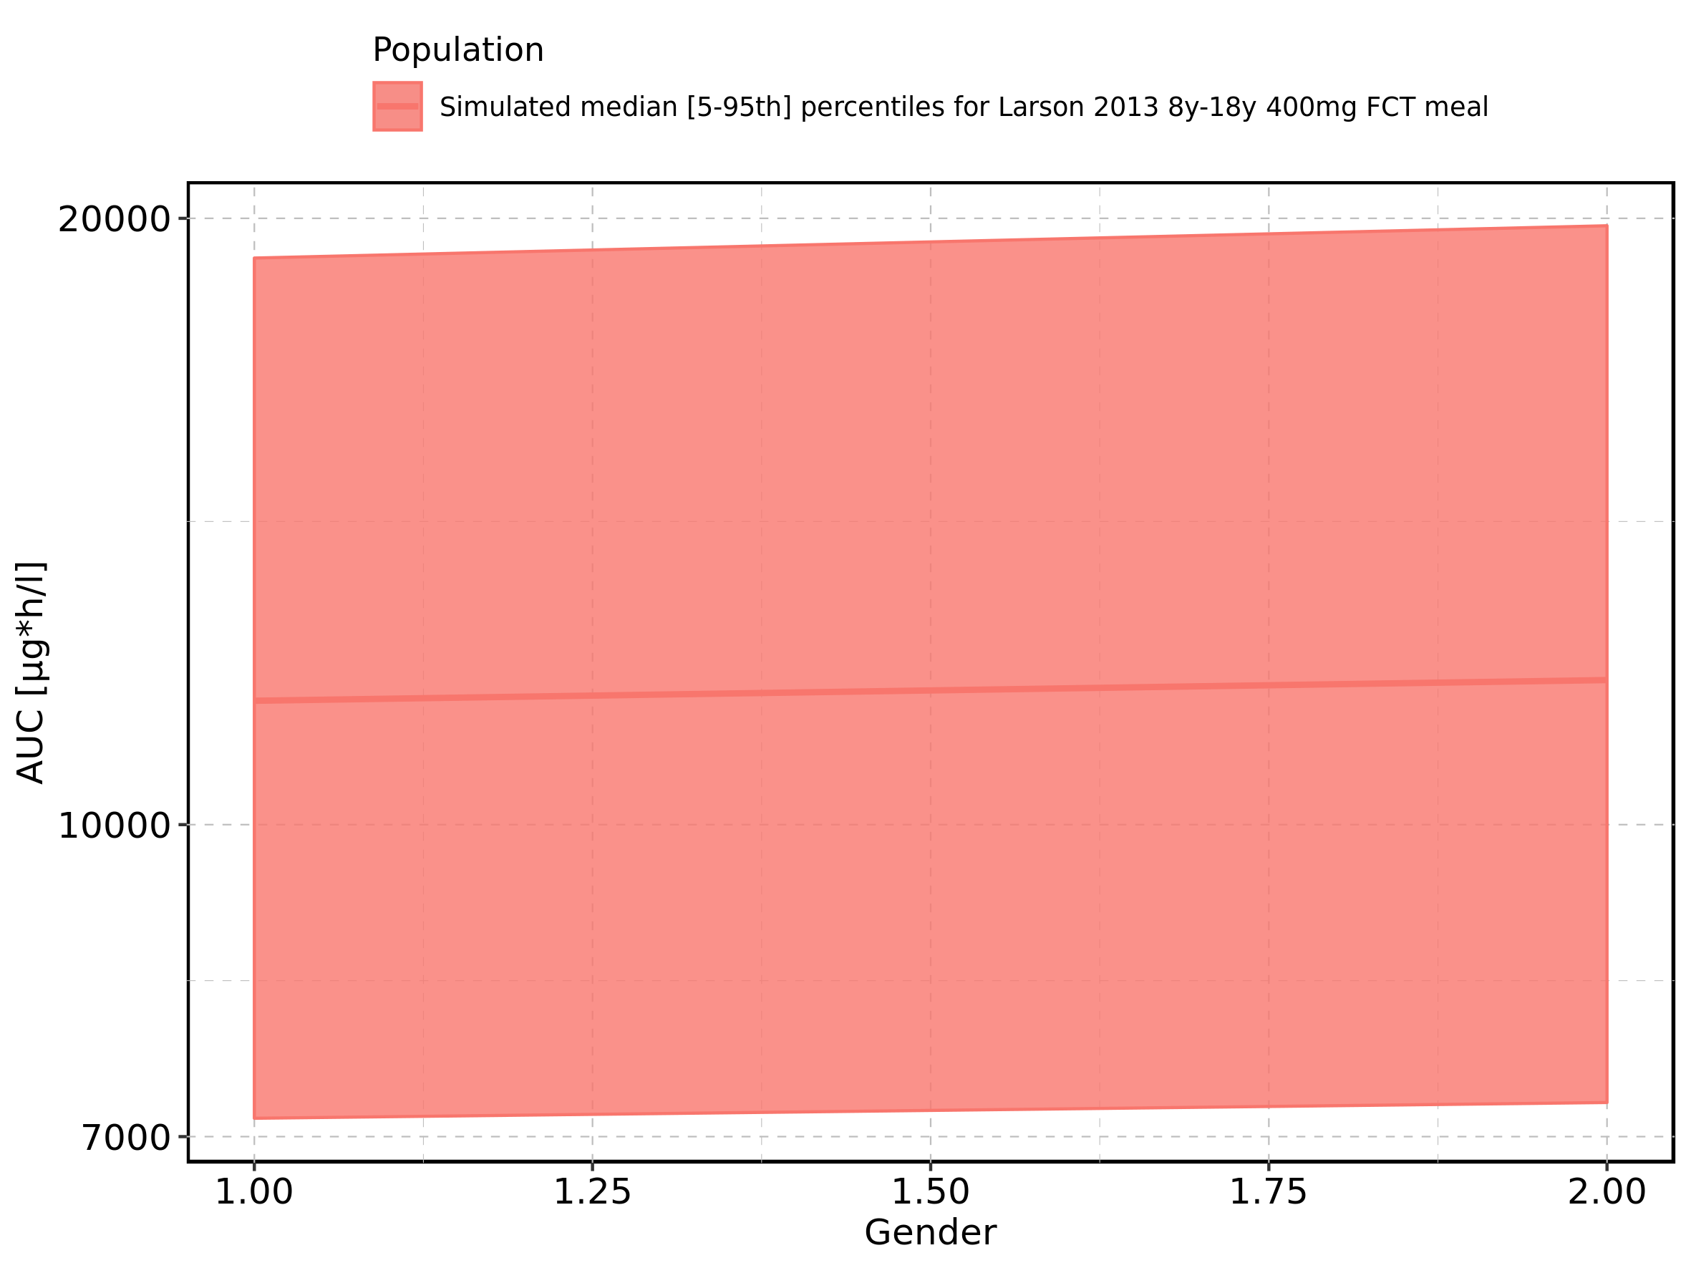

Figure 159: Gender-dependence of AUC for Filmcoated_tablet_400mg_sd. Profiles are plotted in a linear scale.

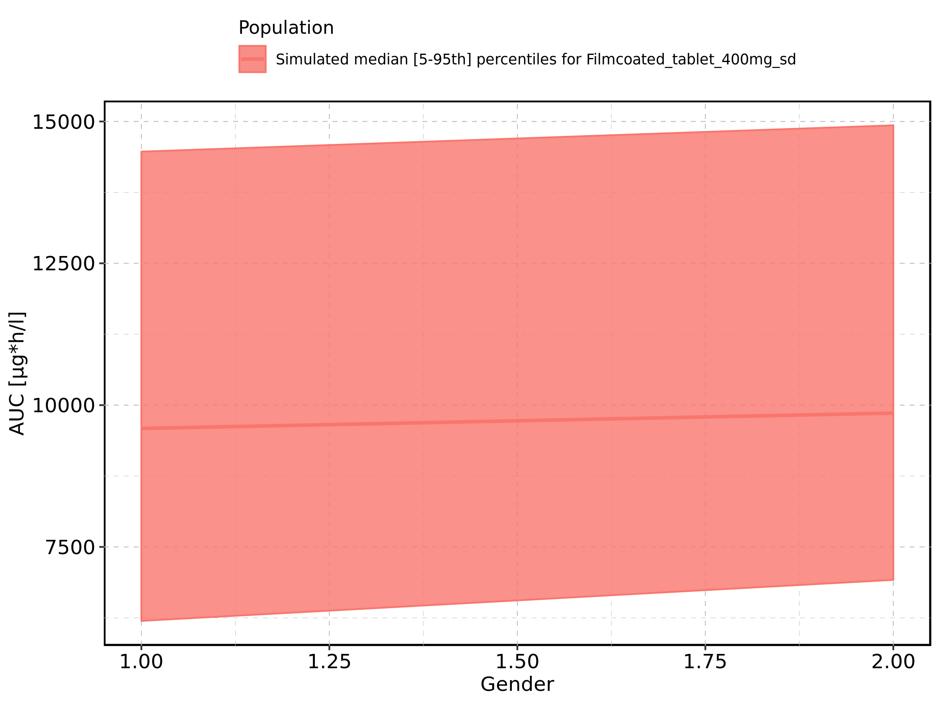

Figure 160: Gender-dependence of AUC for Filmcoated_tablet_400mg_sd. Profiles are plotted in a logarithmic scale.

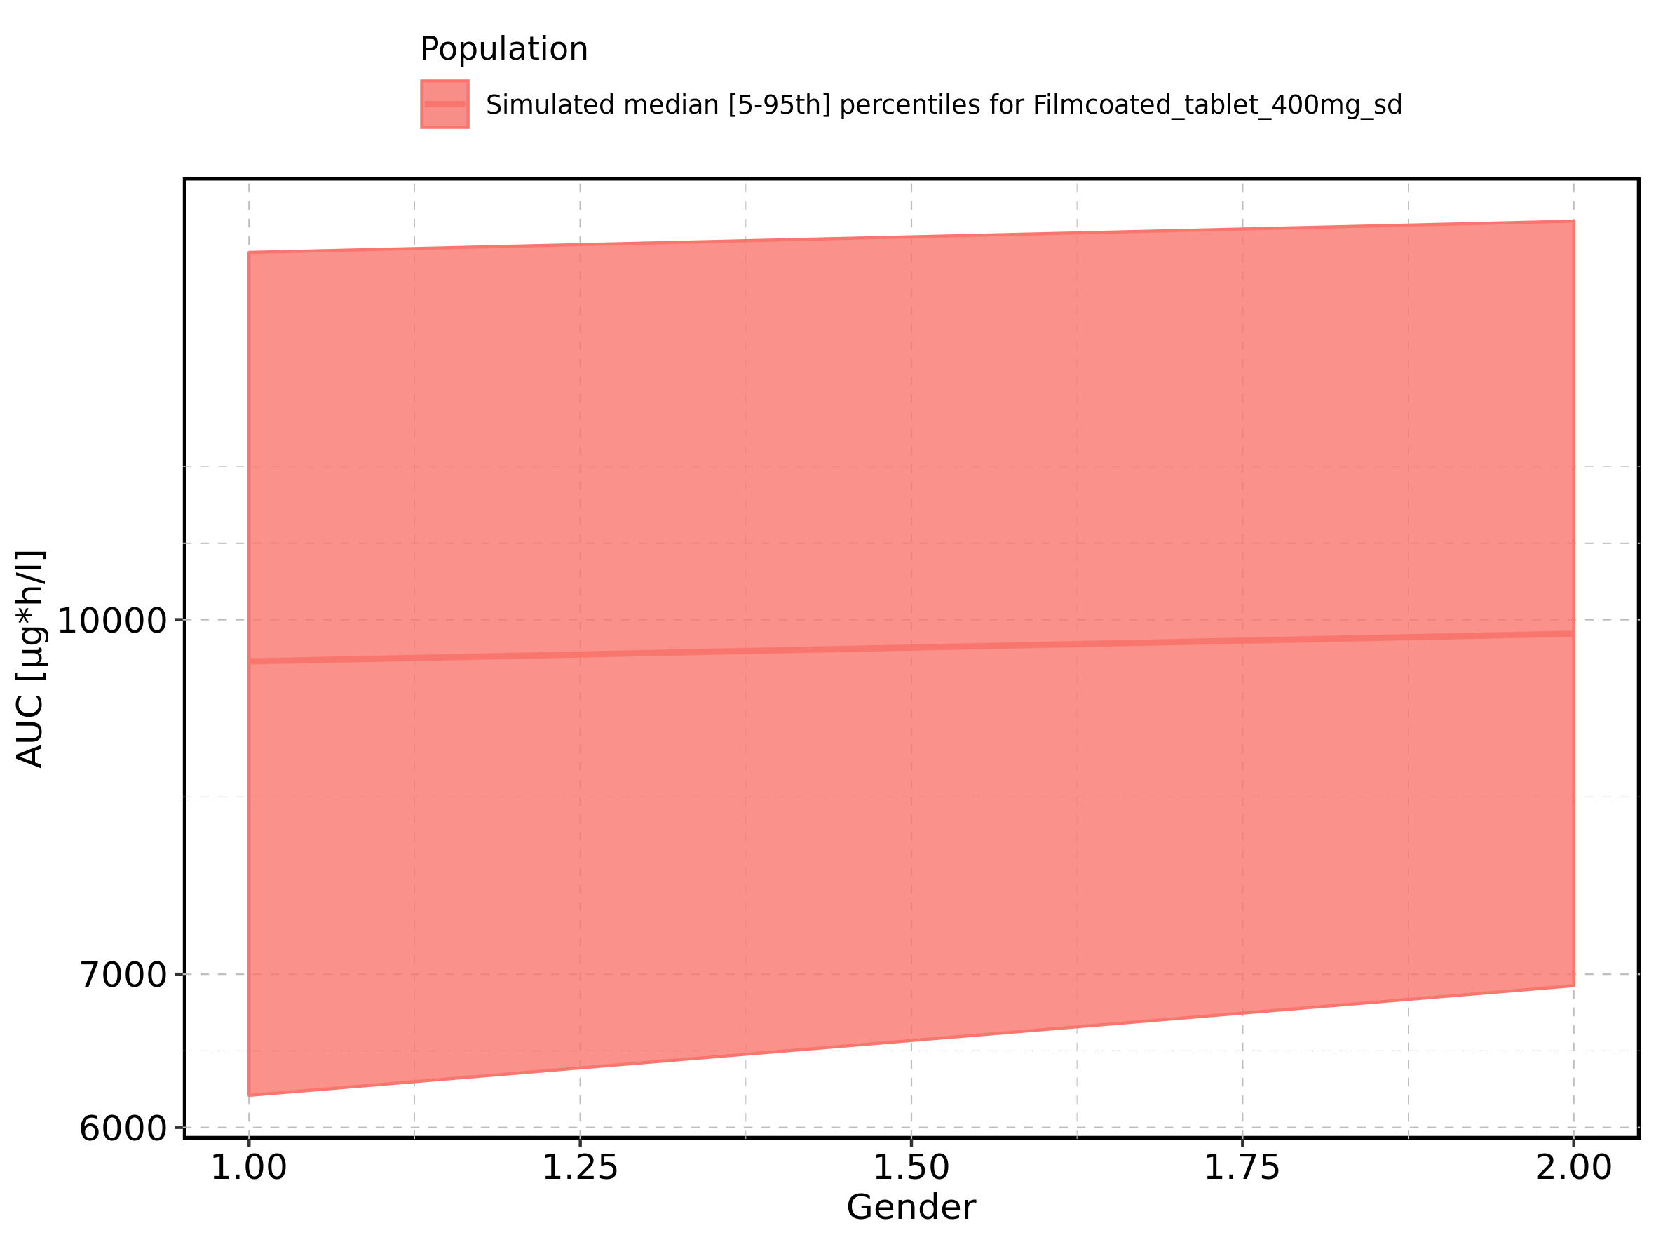

Figure 161: AUC_norm of Raltegravir shown as box-whisker plot, which indicates the 5th, 25th, 50th, 75th, and 95th percentiles in linear scale.

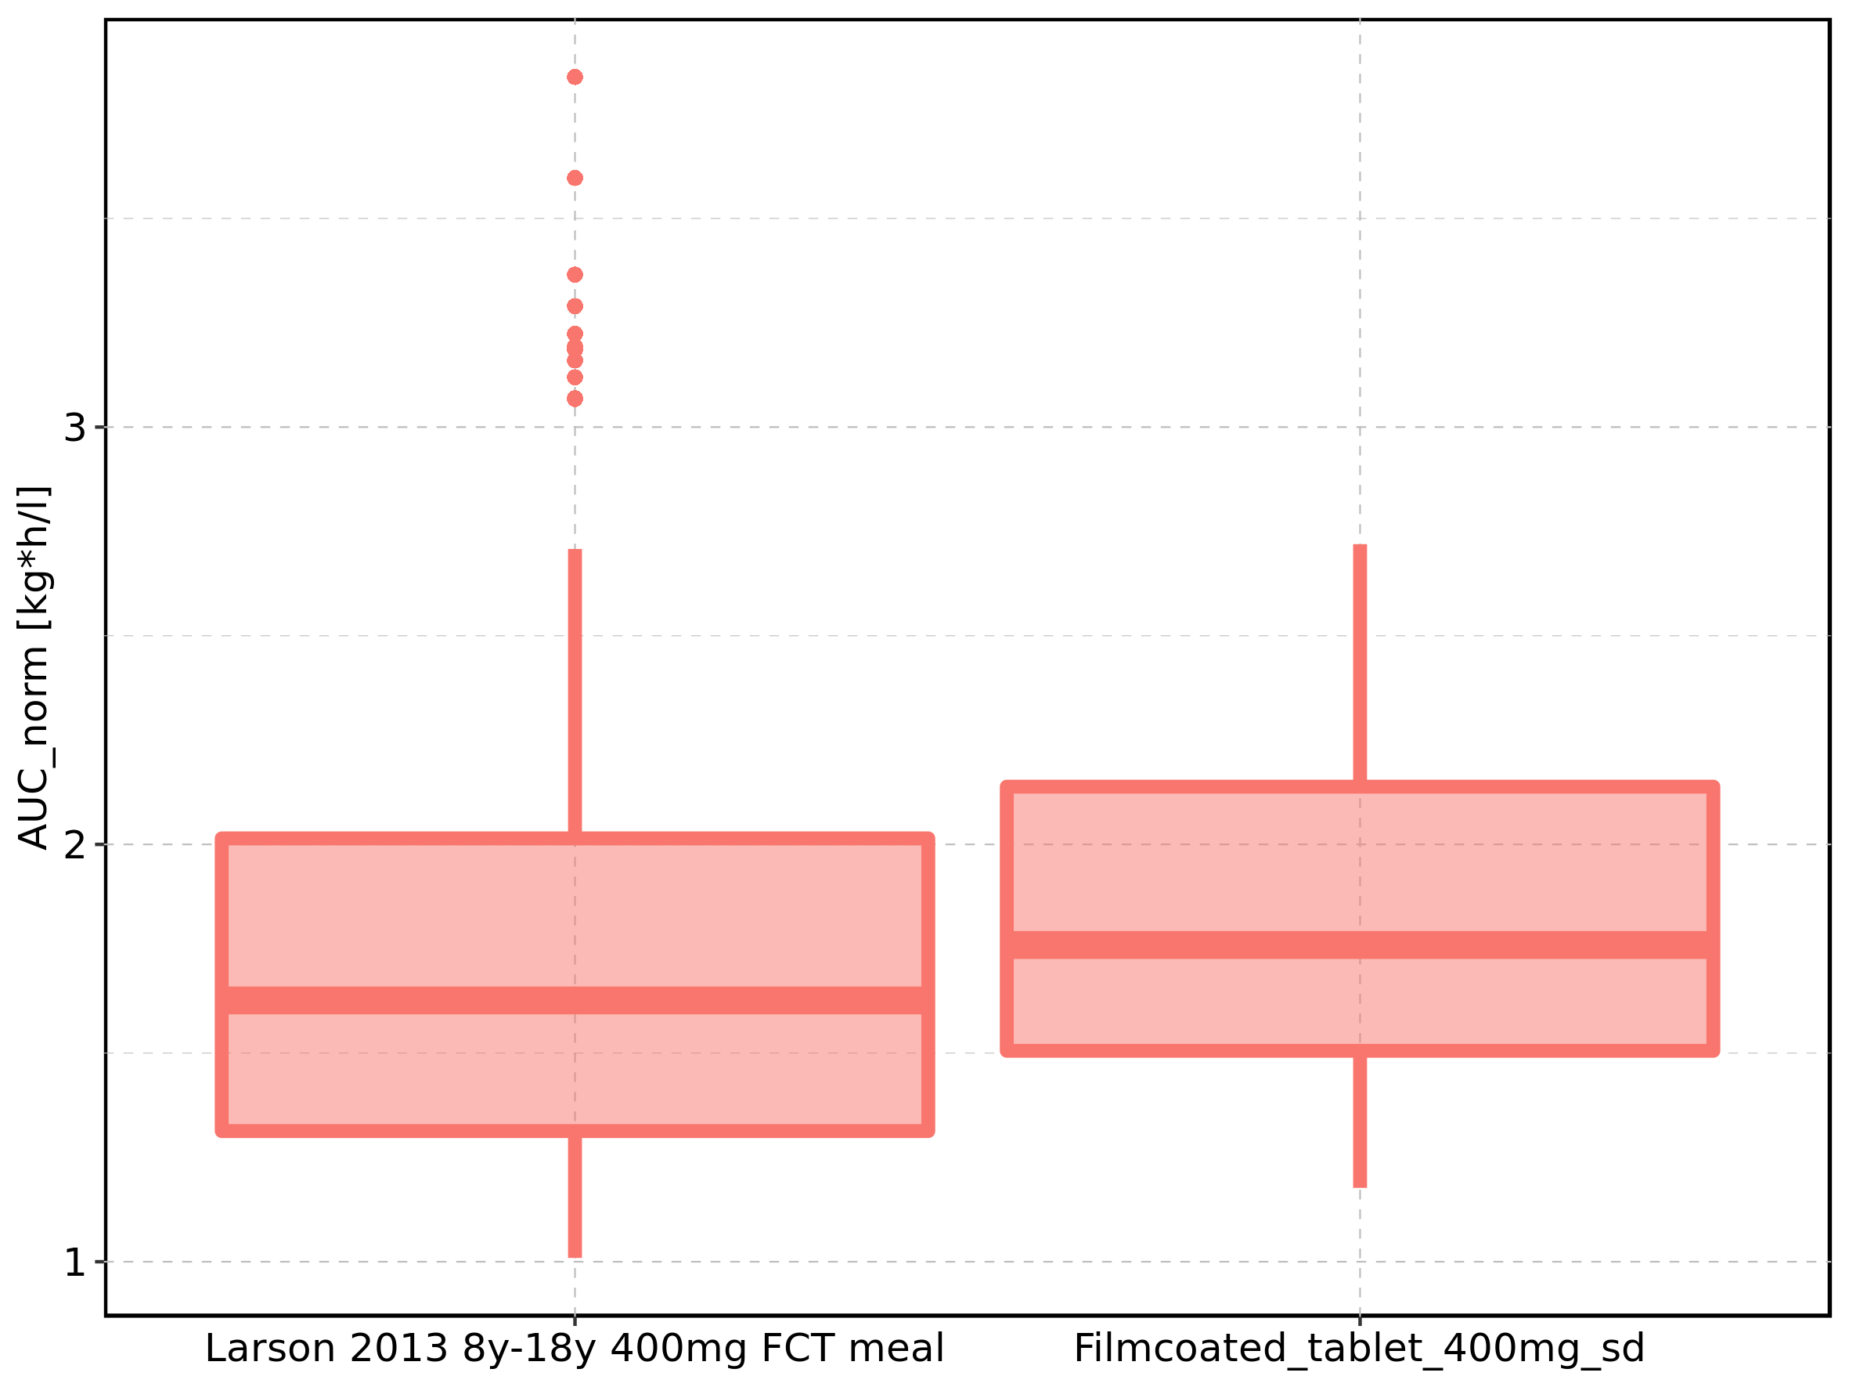

|  |  |  |  |  |  |  |  |  |  |  |
| --- | --- | --- | --- | --- | --- | --- | --- | --- | --- | --- |
| Population | N | 5th percentile | 25th percentile | 50th percentile | 75th percentile | 95th percentile | mean | standard deviation | geo mean | geo standard deviation |
| Larson 2013 8y-18y 400mg FCT meal | 500 | 1.009019 | 1.313048 | 1.626129 | 2.014454 | 2.708033 | 1.707981 | 0.5259173 | 1.631852 | 1.353277 |
| Filmcoated_tablet_400mg_sd | 100 | 1.176992 | 1.505393 | 1.758845 | 2.138354 | 2.719452 | 1.848670 | 0.4876934 | 1.785682 | 1.305605 |

Figure 162: AUC_norm of Raltegravir shown as box-whisker plot, which indicates the 5th, 25th, 50th, 75th, and 95th percentiles in logarithmic scale.

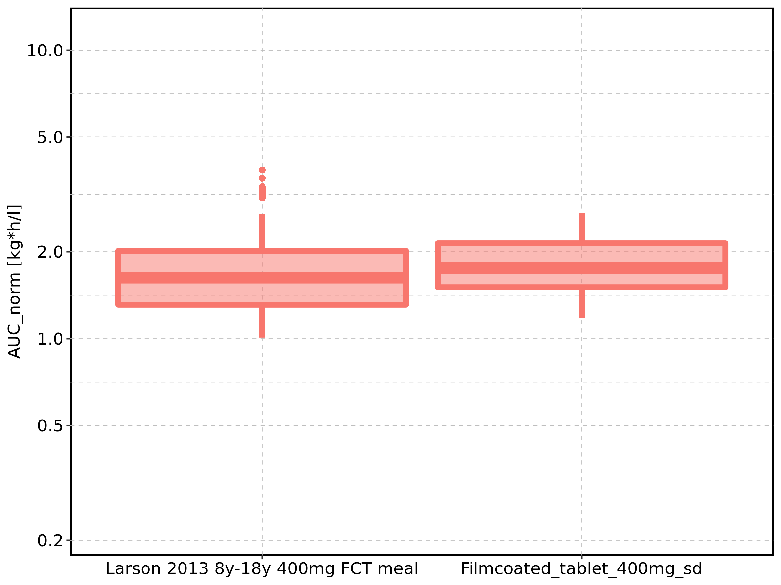

Figure 163: Age-dependence of AUC_norm for Larson 2013 8y-18y 400mg FCT meal in comparison to Filmcoated_tablet_400mg_sd. Profiles are plotted in a linear scale.

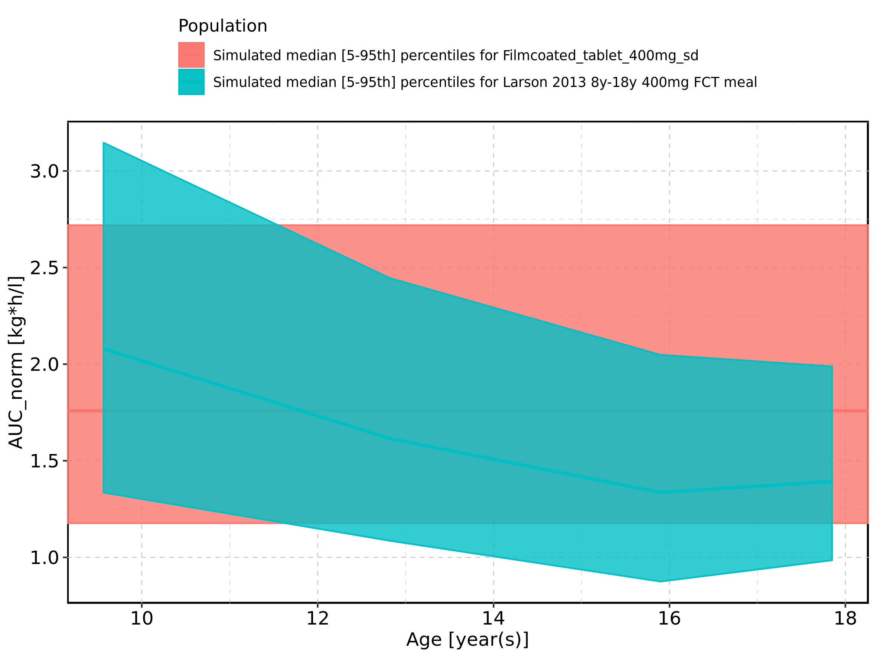

Figure 164: Age-dependence of AUC_norm for Larson 2013 8y-18y 400mg FCT meal in comparison to Filmcoated_tablet_400mg_sd. Profiles are plotted in a logarithmic scale.

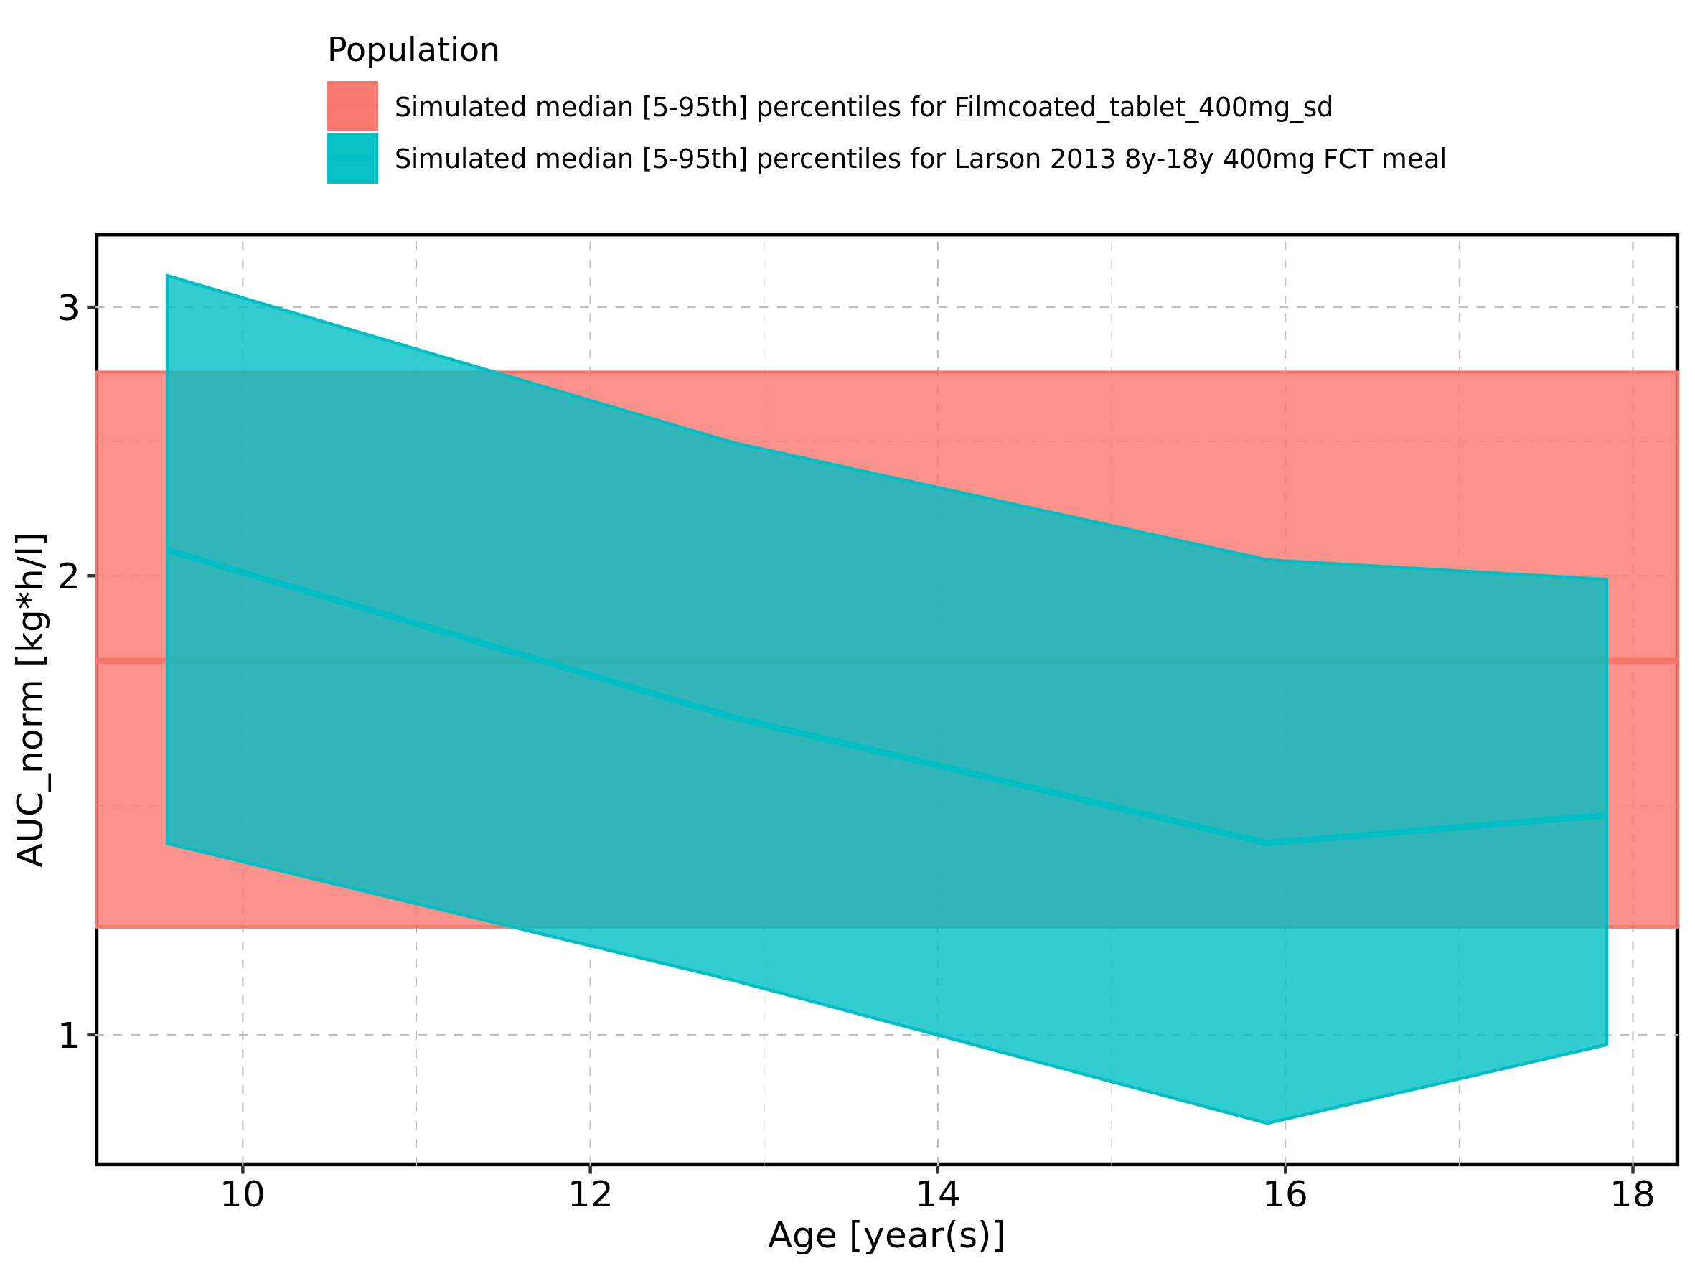

Figure 165: Age-dependence of AUC_norm for Larson 2013 8y-18y 400mg FCT meal. Profiles are plotted in a linear scale.

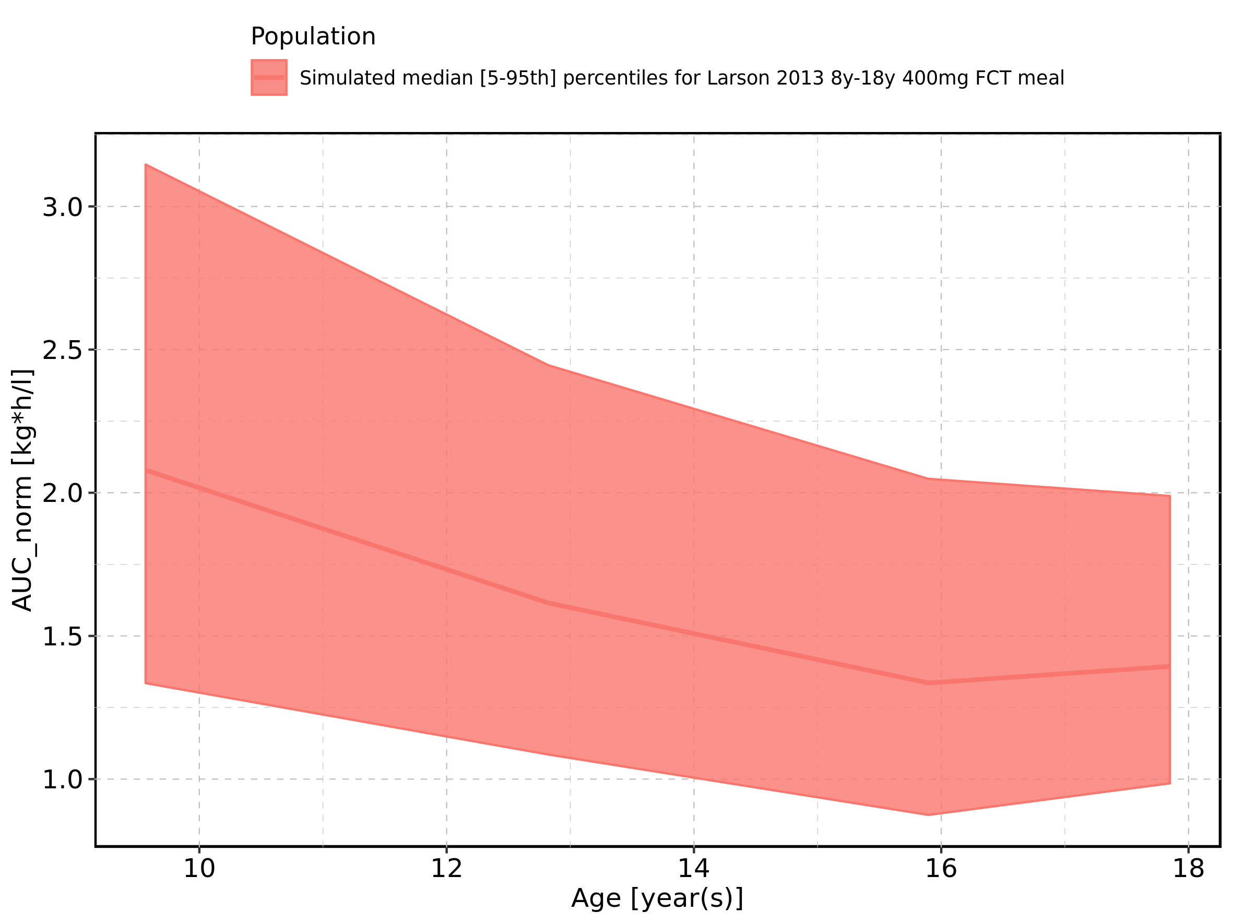

Figure 166: Age-dependence of AUC_norm for Larson 2013 8y-18y 400mg FCT meal. Profiles are plotted in a logarithmic scale.

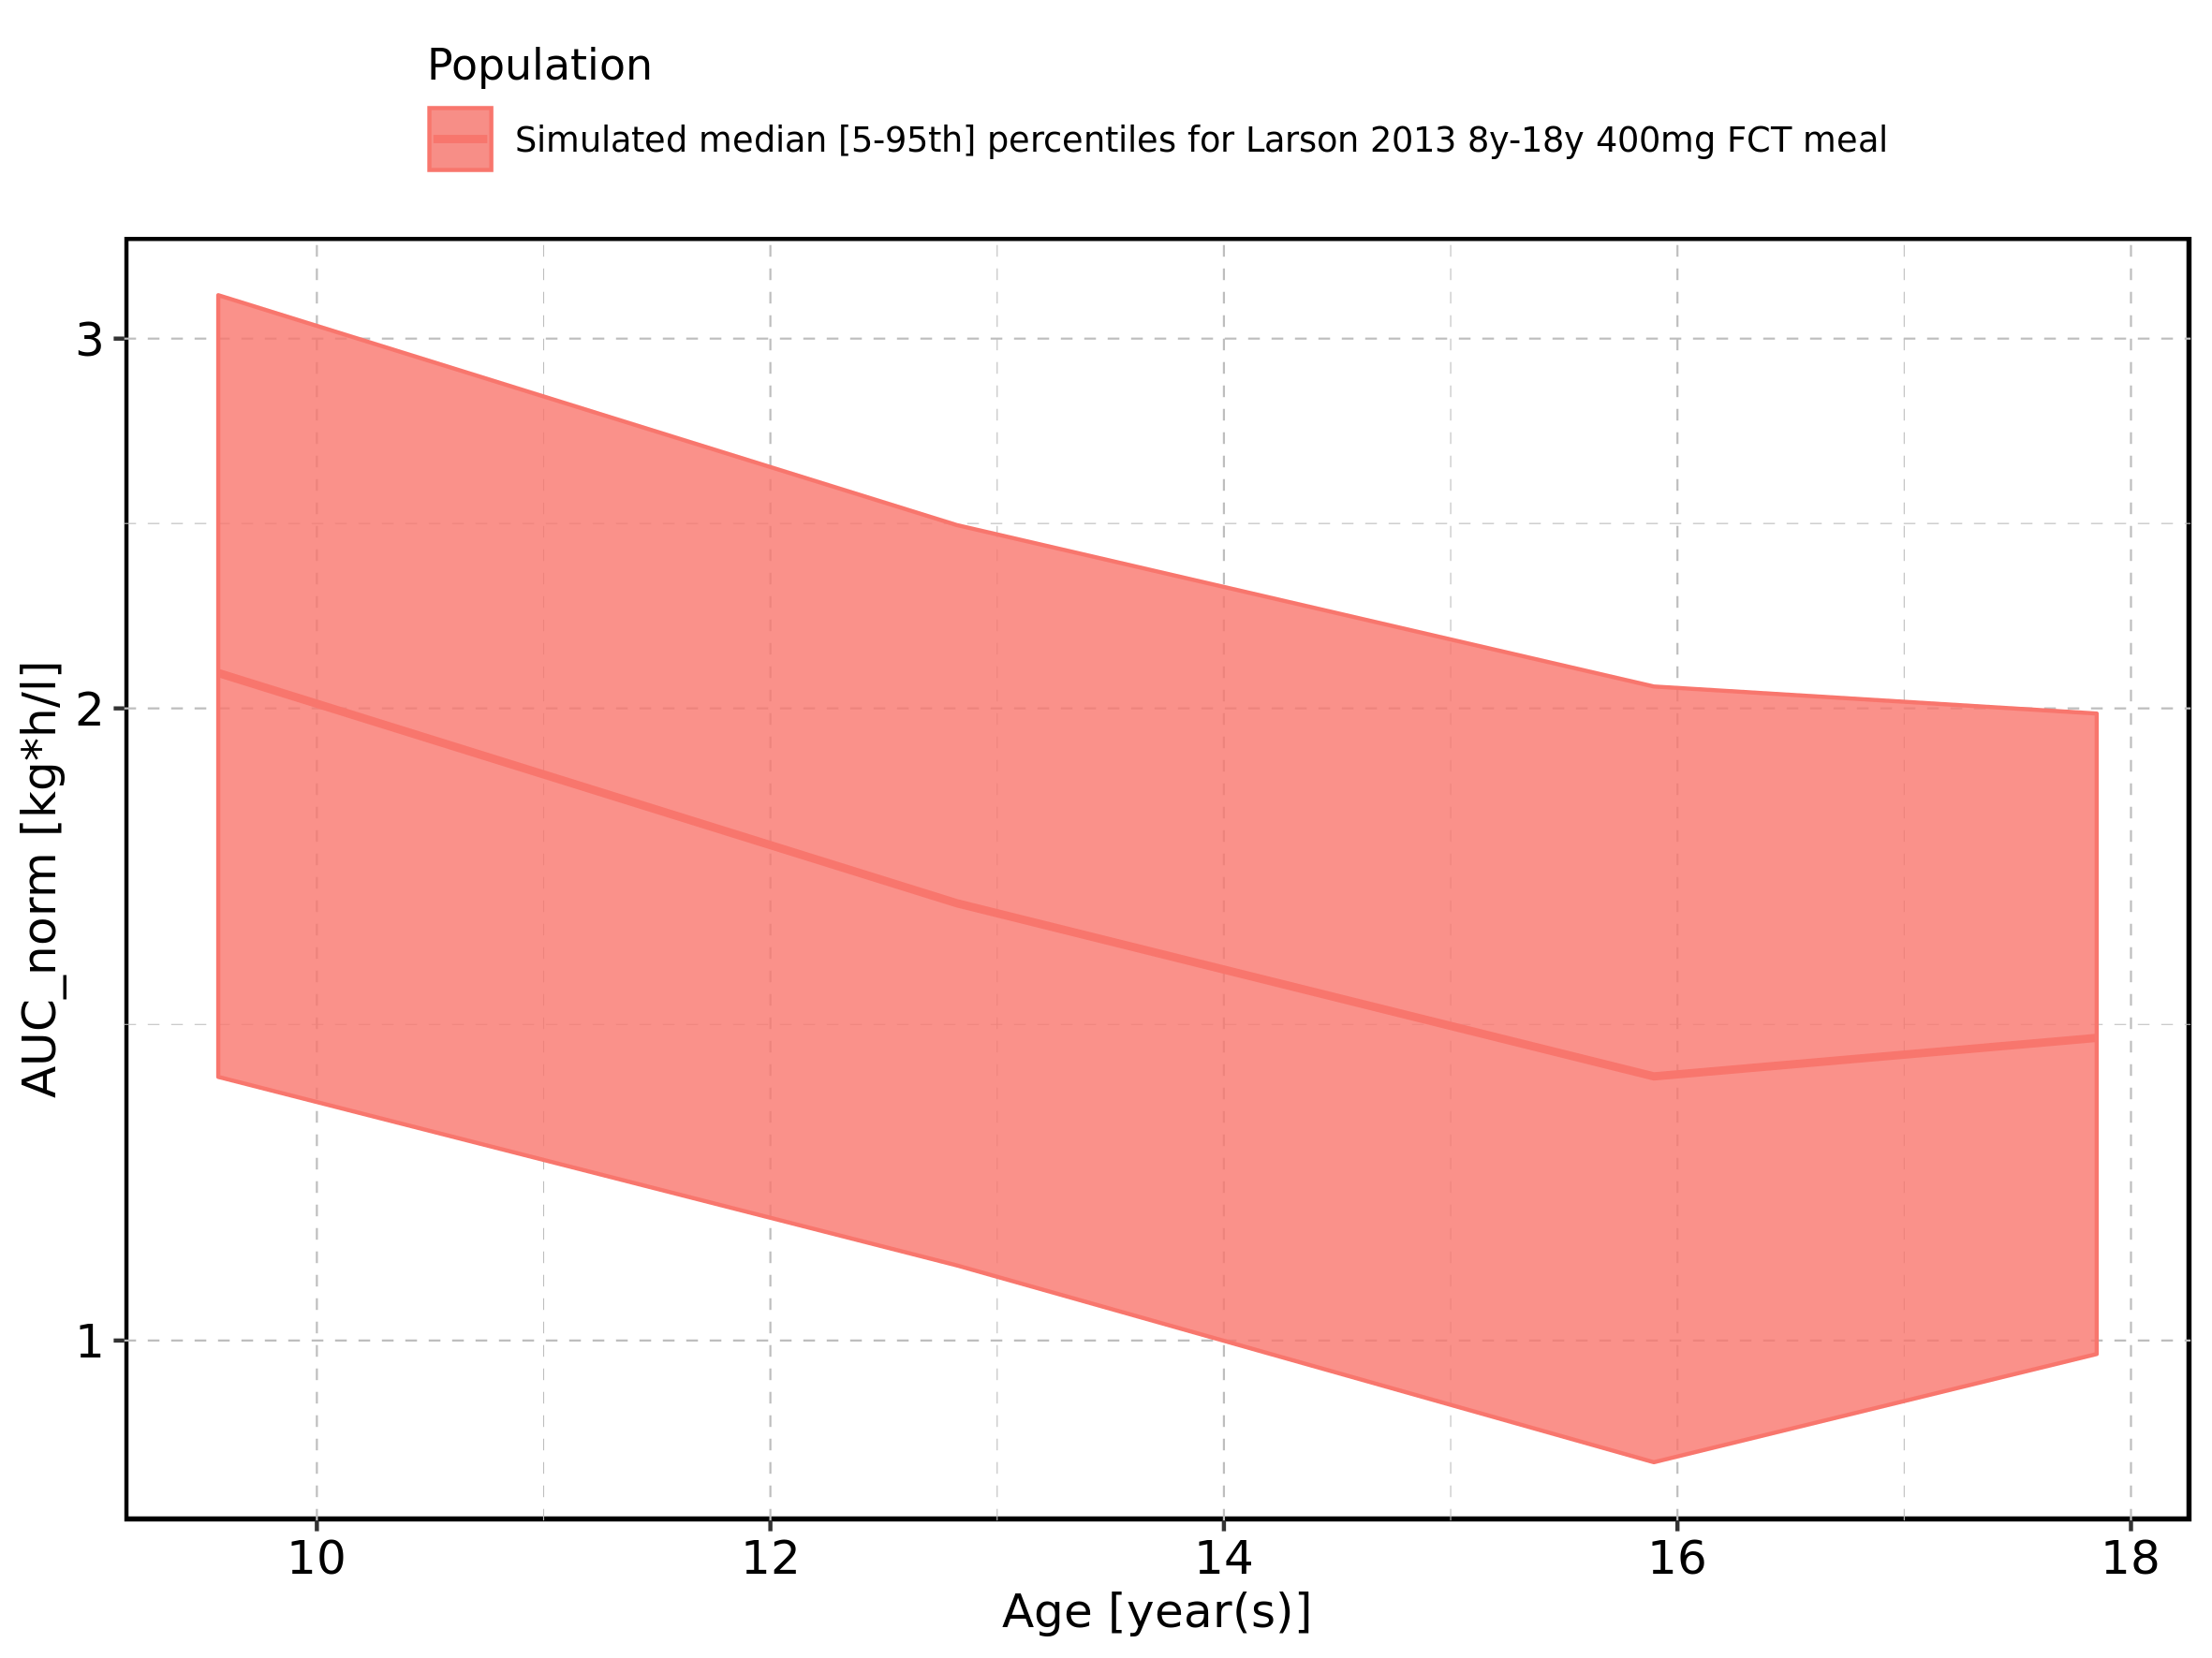

Figure 167: Age-dependence of AUC_norm for Filmcoated_tablet_400mg_sd. Profiles are plotted in a linear scale.

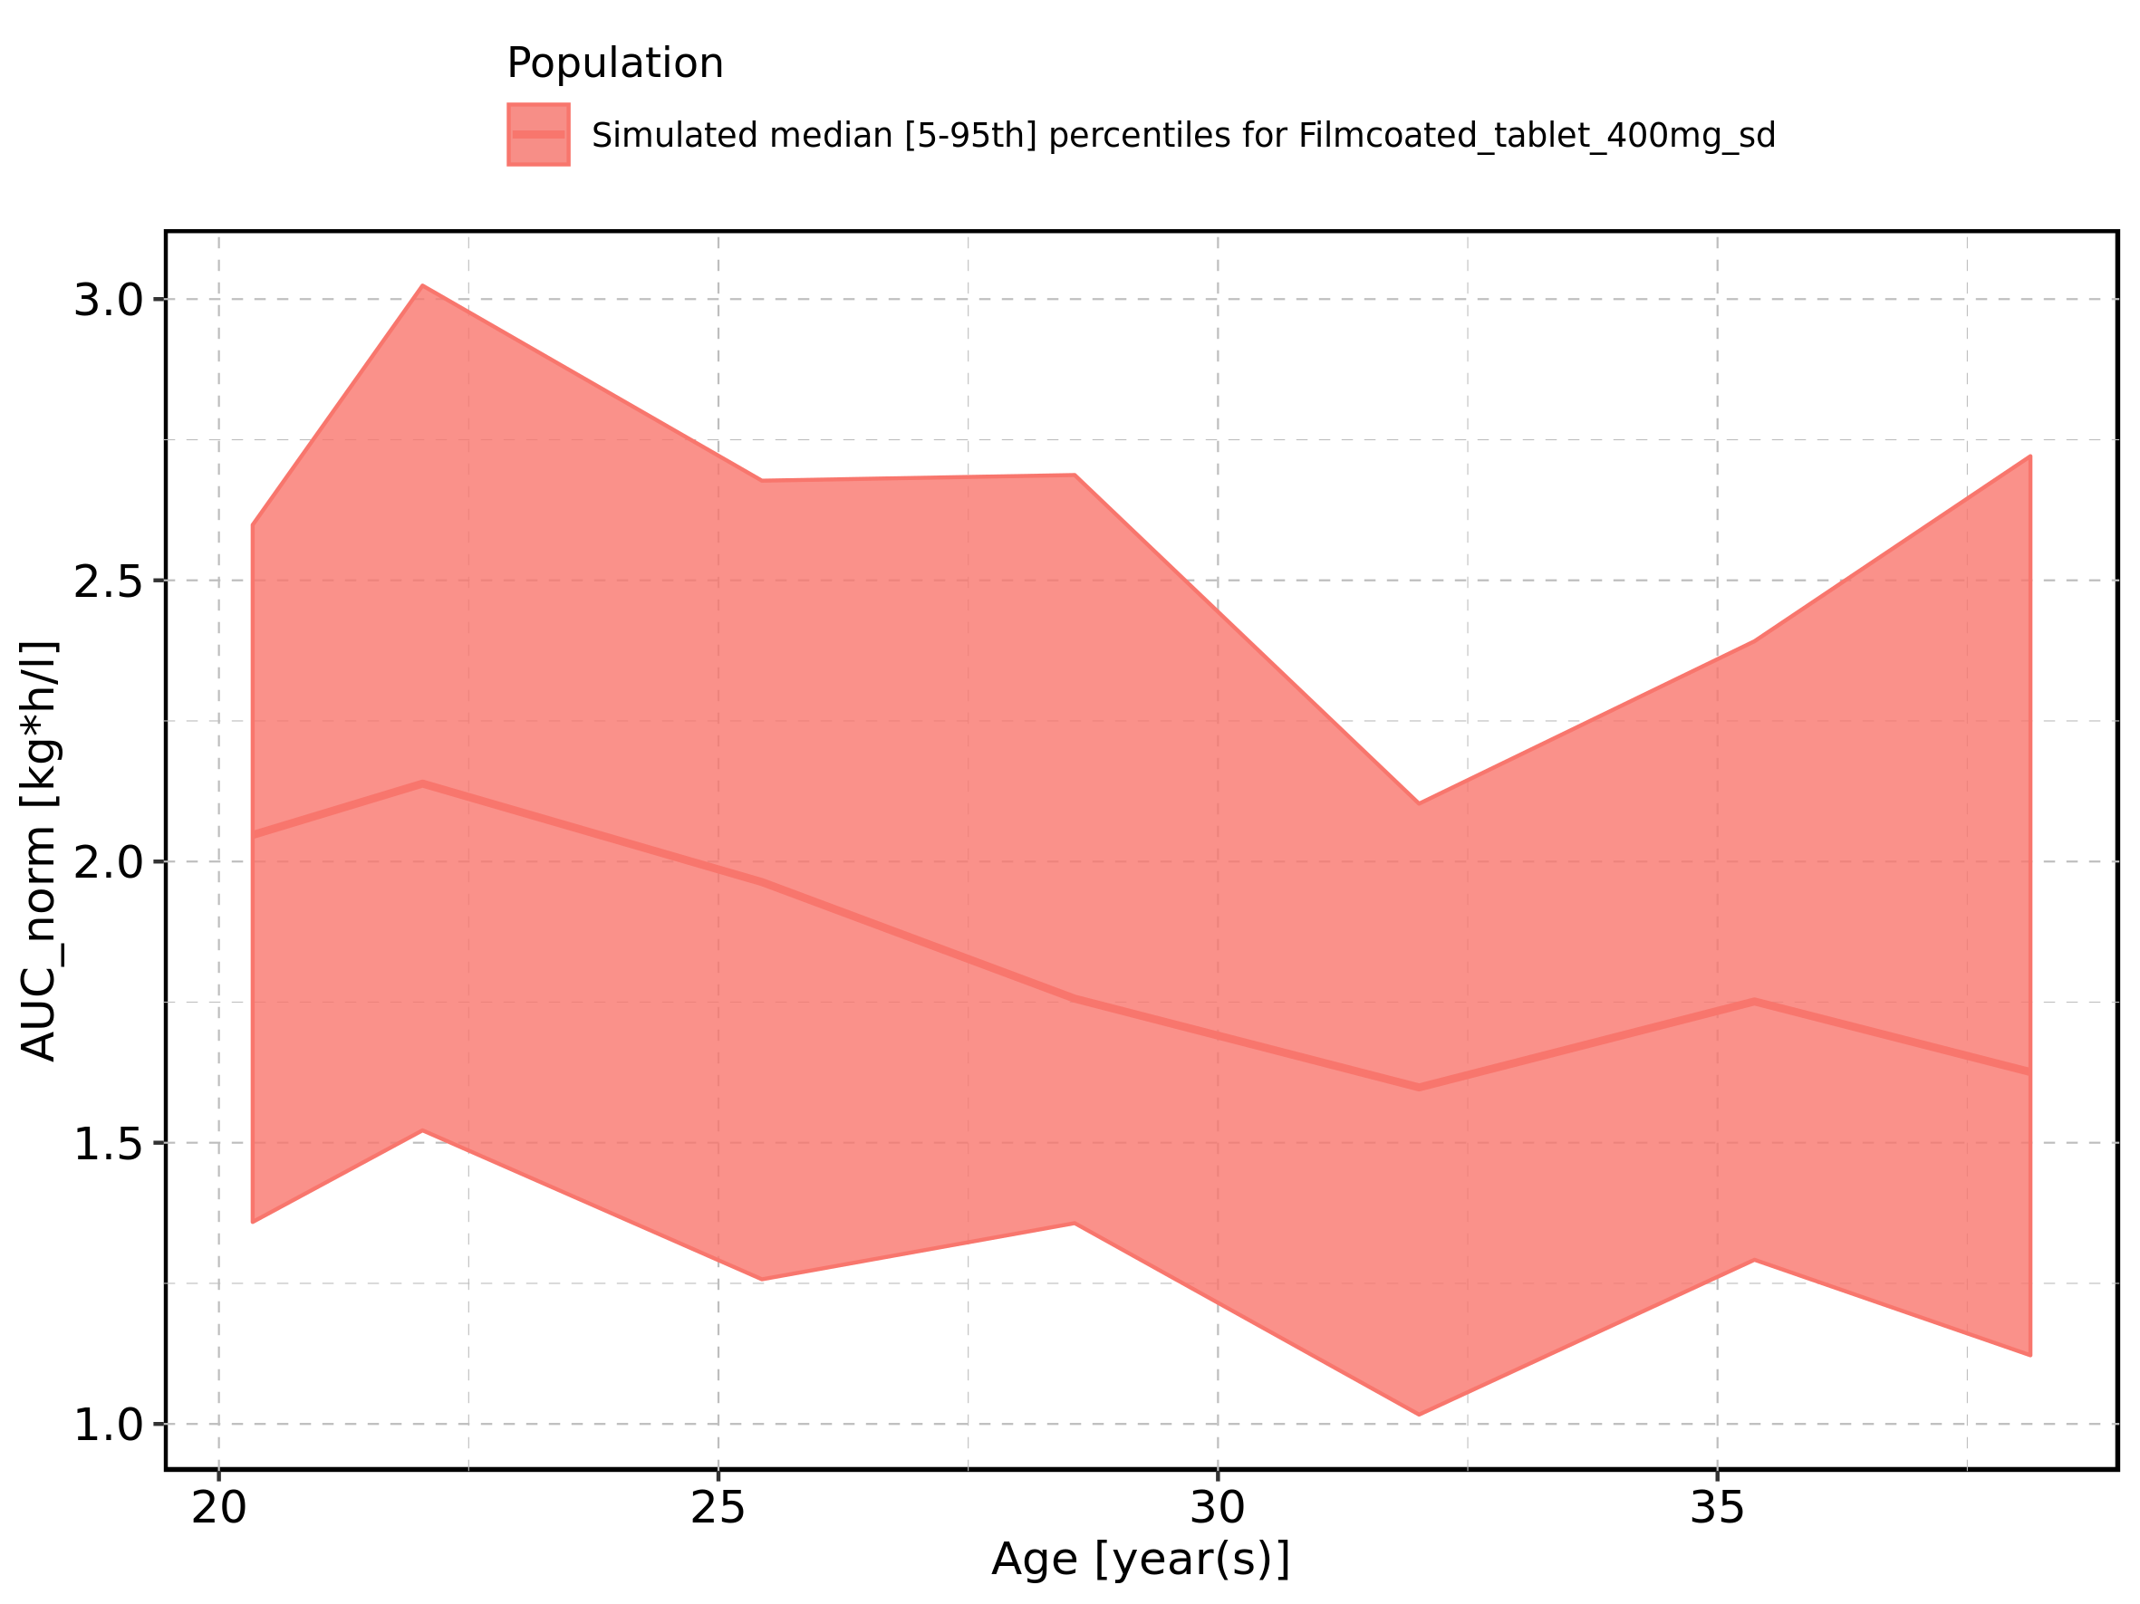

Figure 168: Age-dependence of AUC_norm for Filmcoated_tablet_400mg_sd. Profiles are plotted in a logarithmic scale.

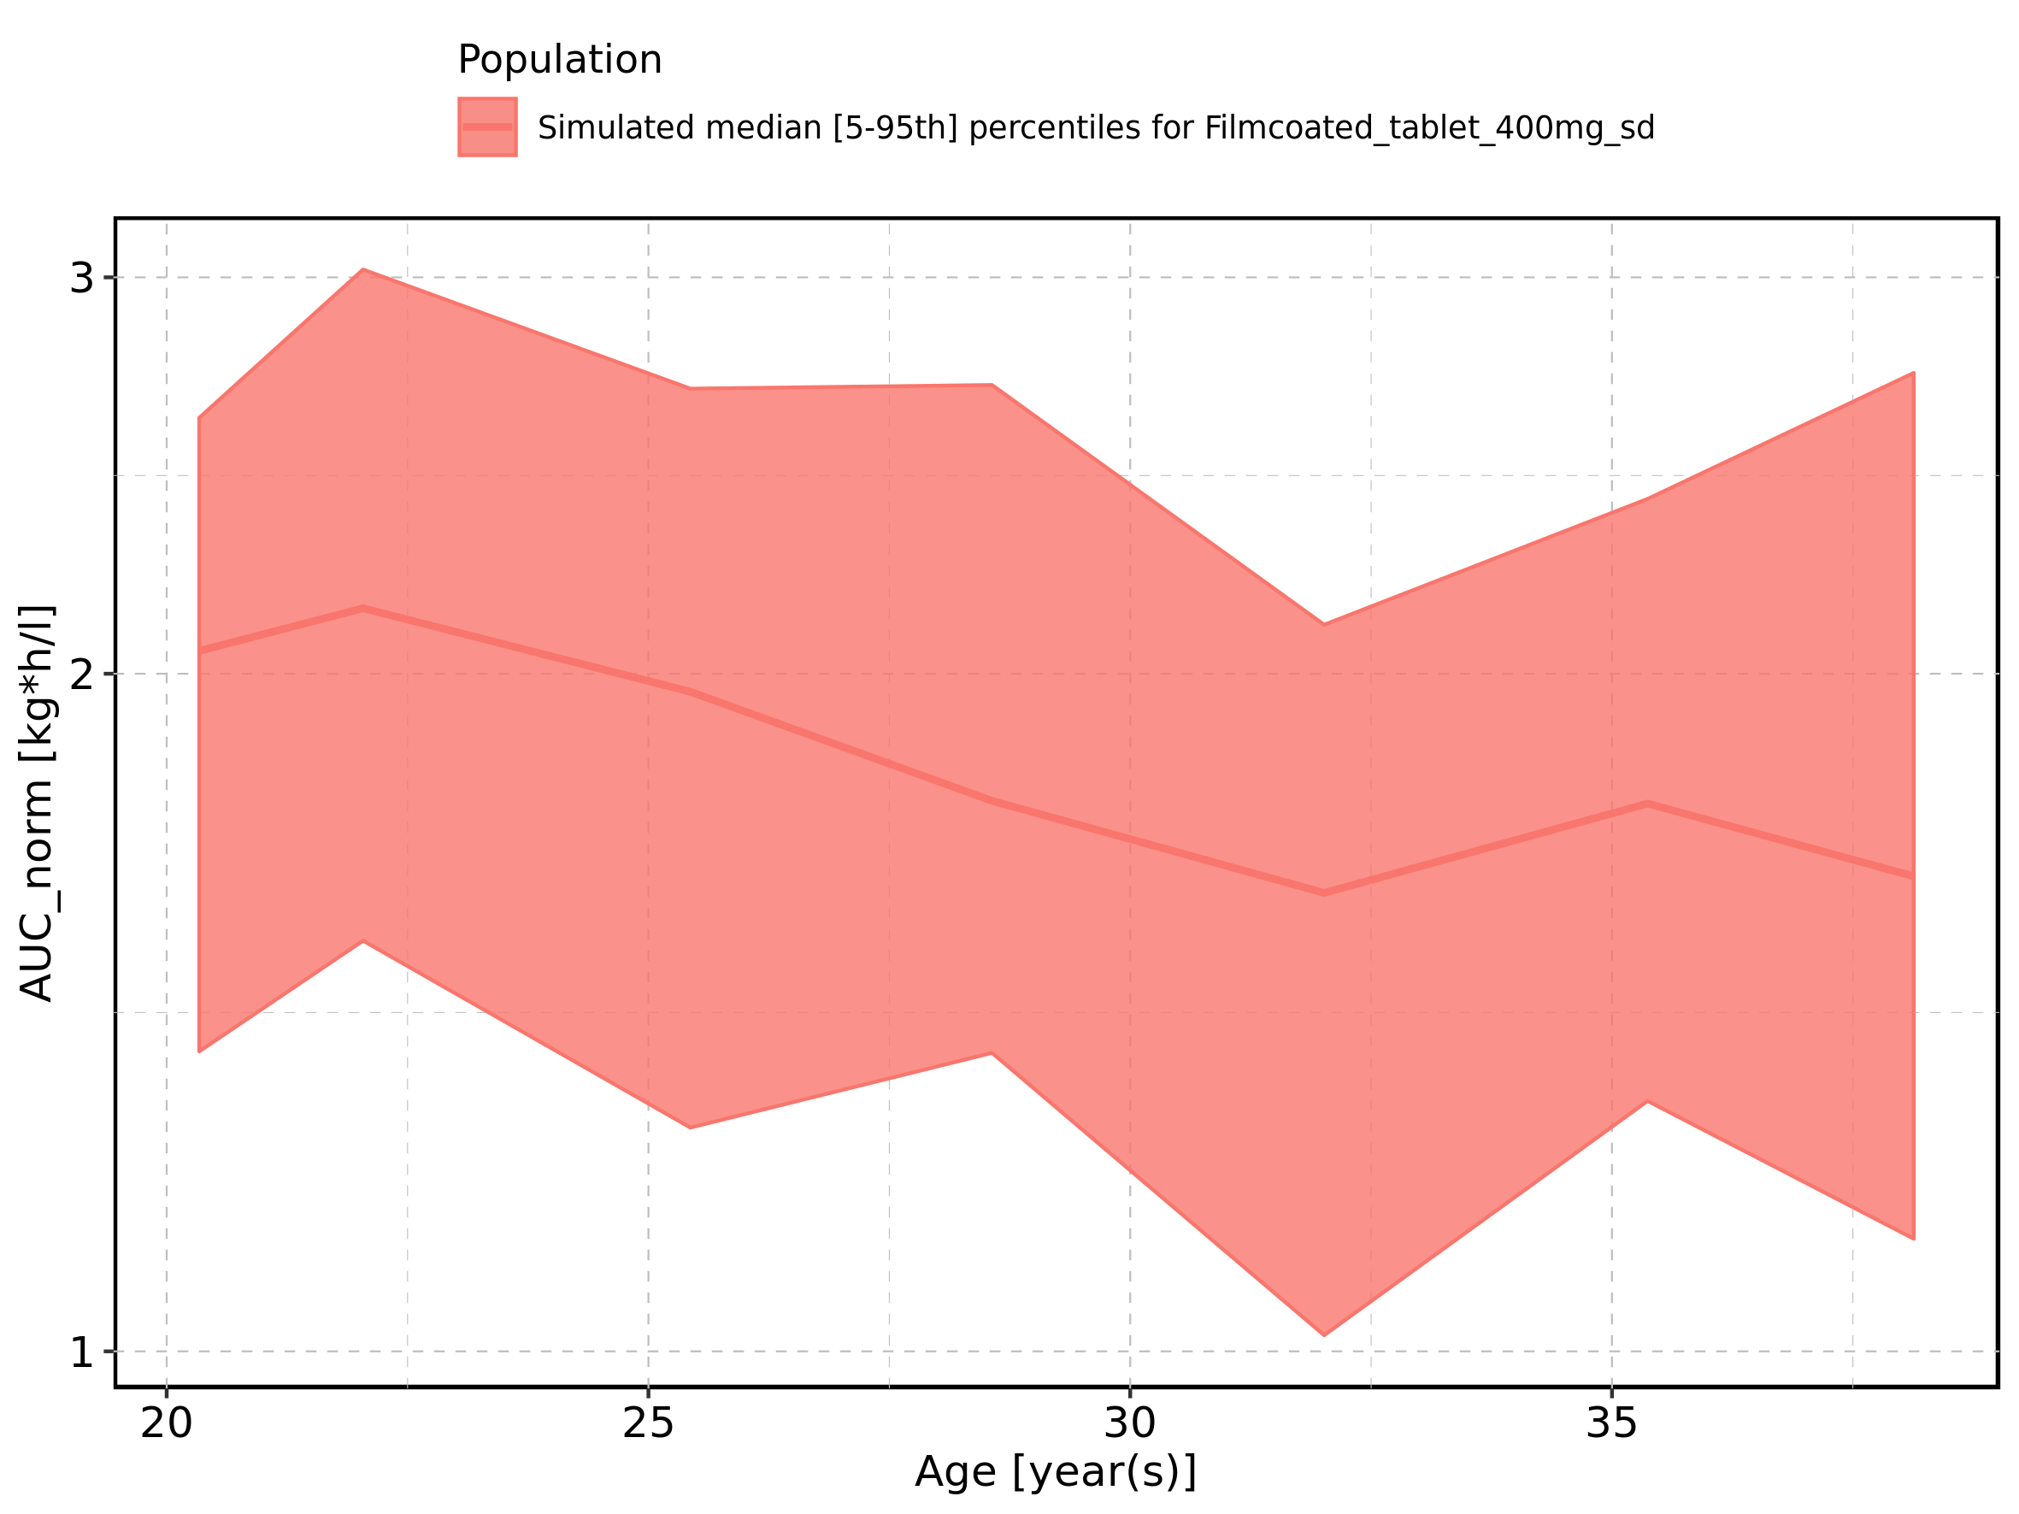

Figure 169: Height-dependence of AUC_norm for Larson 2013 8y-18y 400mg FCT meal in comparison to Filmcoated_tablet_400mg_sd. Profiles are plotted in a linear scale.

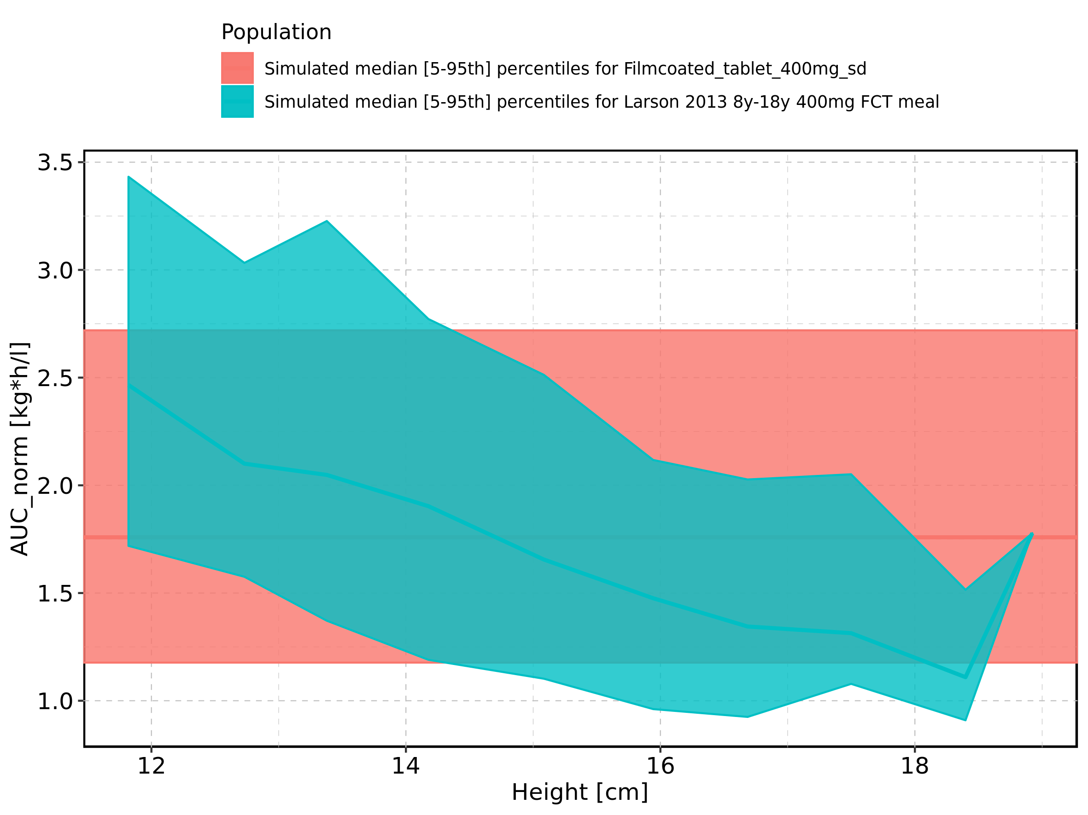

Figure 170: Height-dependence of AUC_norm for Larson 2013 8y-18y 400mg FCT meal in comparison to Filmcoated_tablet_400mg_sd. Profiles are plotted in a logarithmic scale.

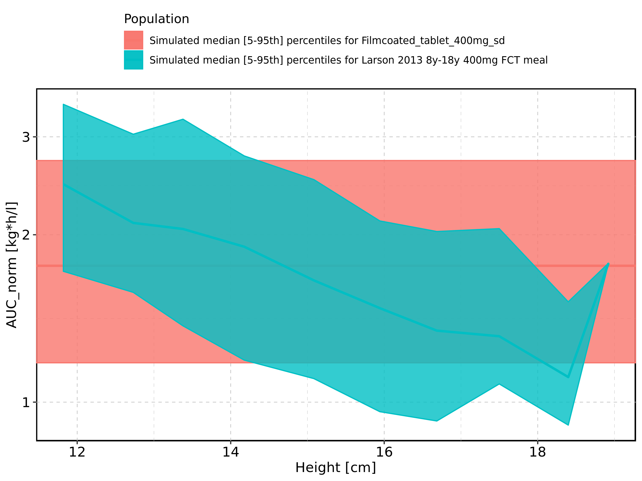

Figure 171: Height-dependence of AUC_norm for Larson 2013 8y-18y 400mg FCT meal. Profiles are plotted in a linear scale.

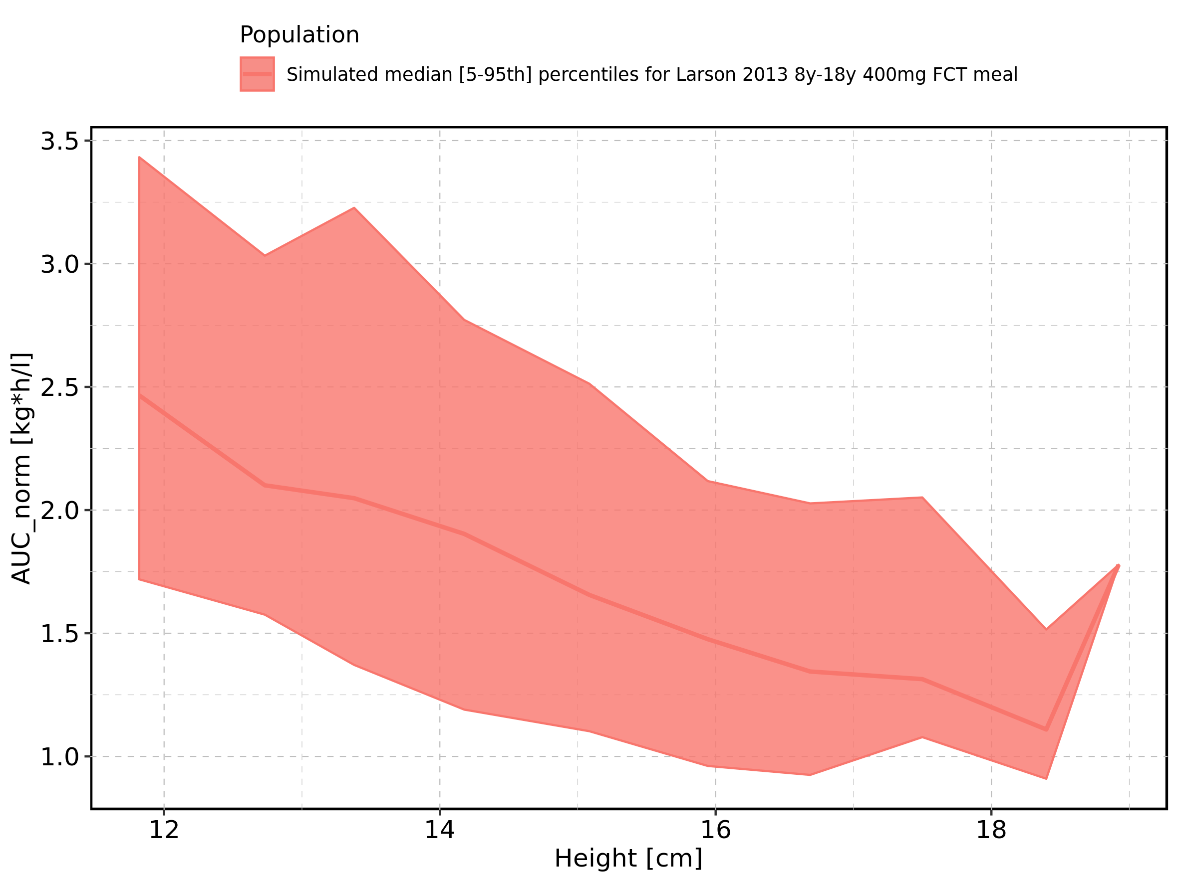

Figure 172: Height-dependence of AUC_norm for Larson 2013 8y-18y 400mg FCT meal. Profiles are plotted in a logarithmic scale.

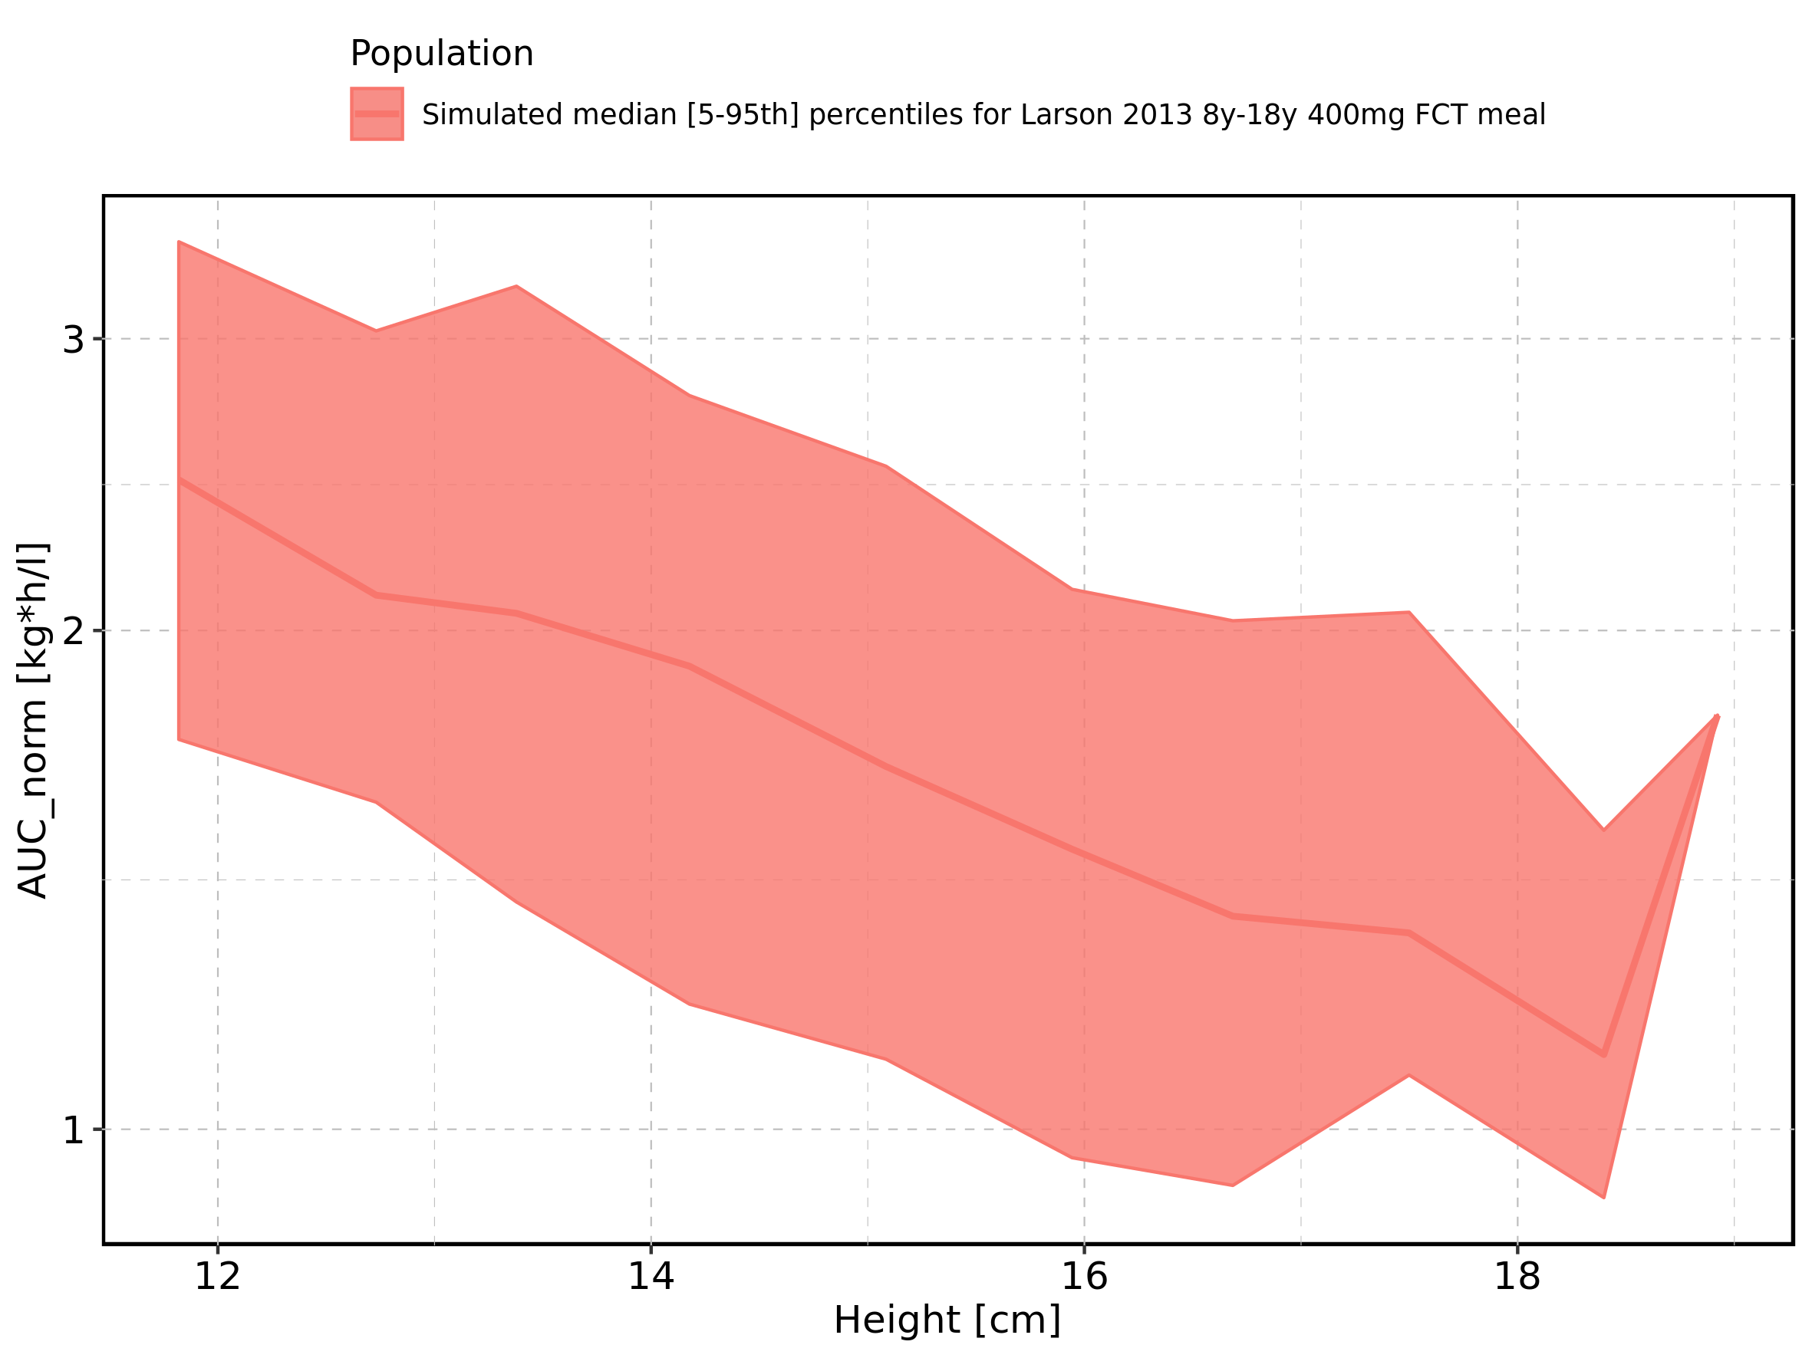

Figure 173: Height-dependence of AUC_norm for Filmcoated_tablet_400mg_sd. Profiles are plotted in a linear scale.

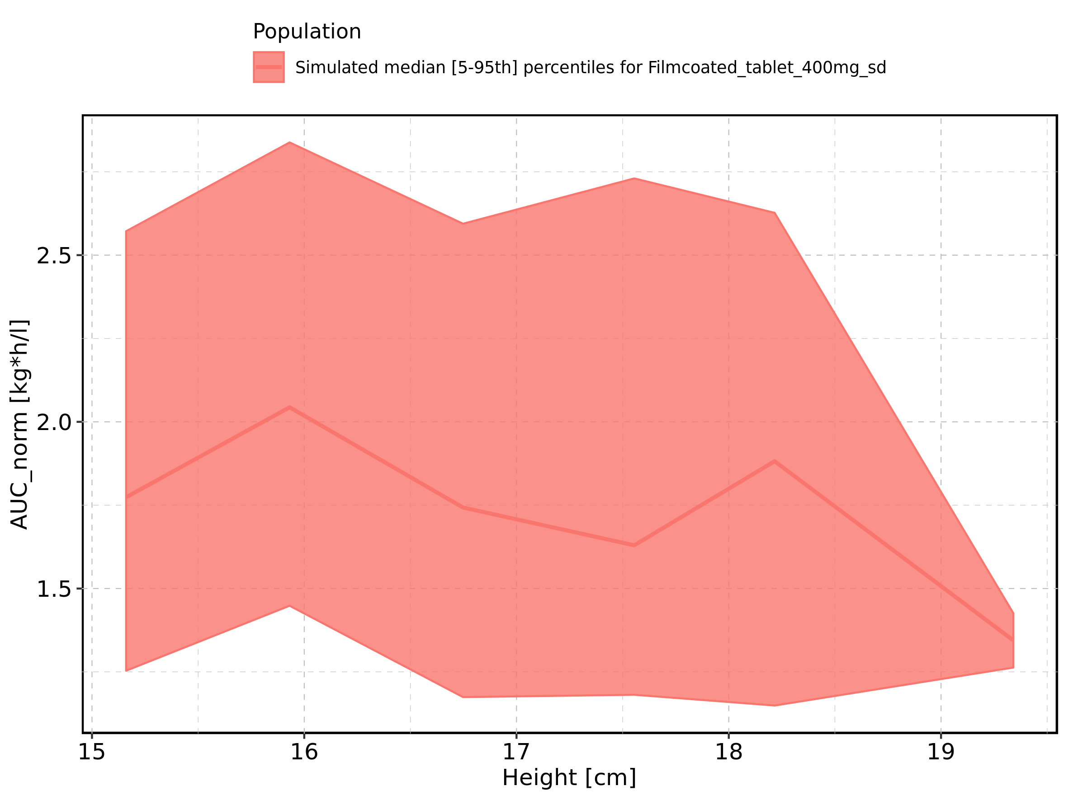

Figure 174: Height-dependence of AUC_norm for Filmcoated_tablet_400mg_sd. Profiles are plotted in a logarithmic scale.

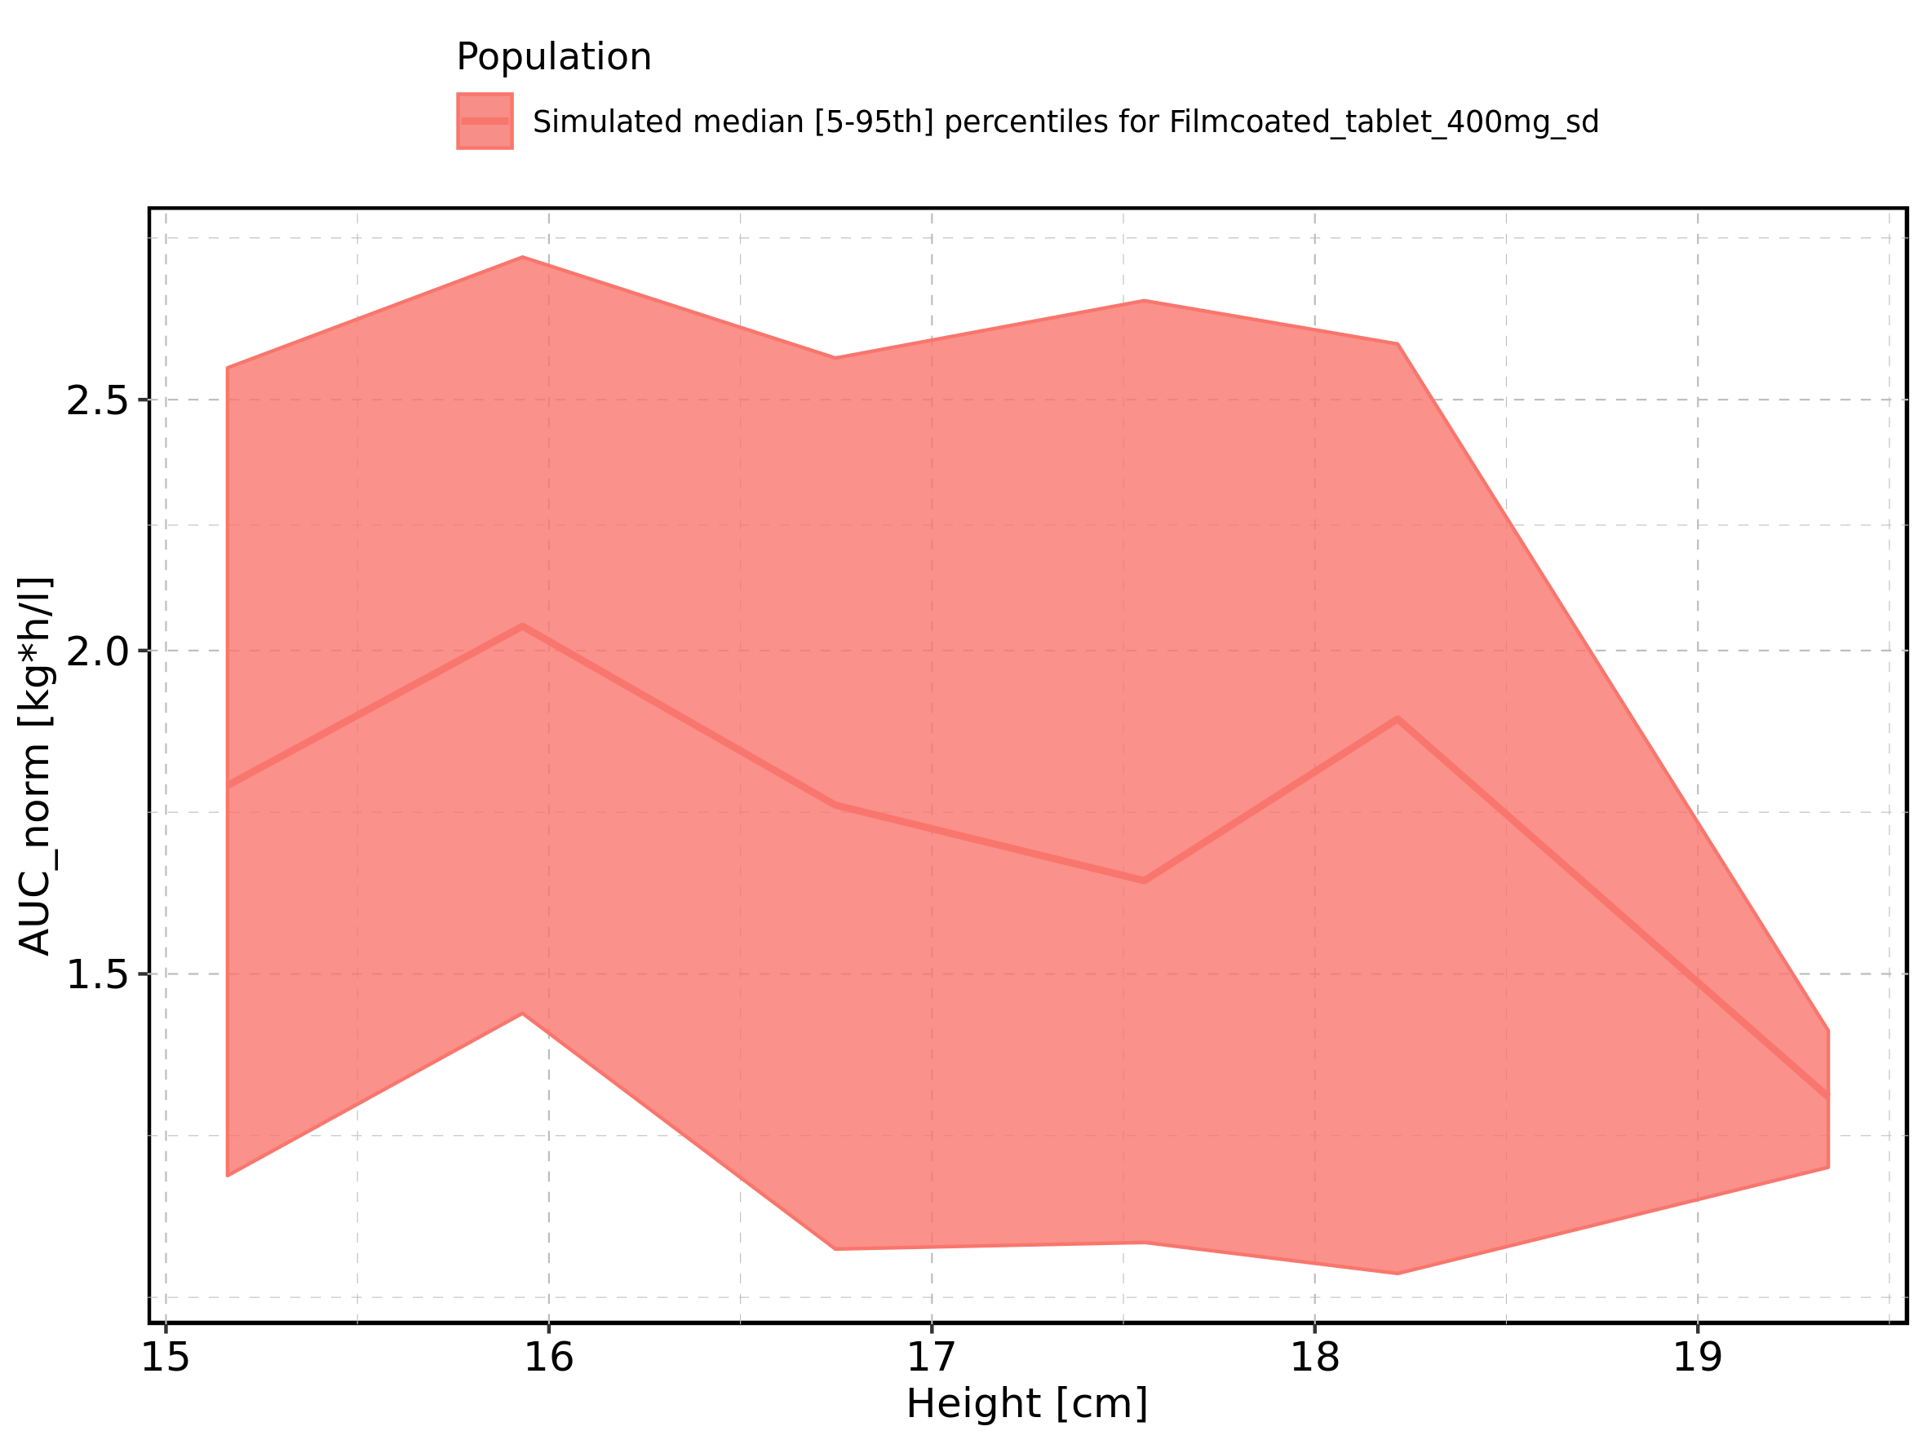

Figure 175: Weight-dependence of AUC_norm for Larson 2013 8y-18y 400mg FCT meal in comparison to Filmcoated_tablet_400mg_sd. Profiles are plotted in a linear scale.

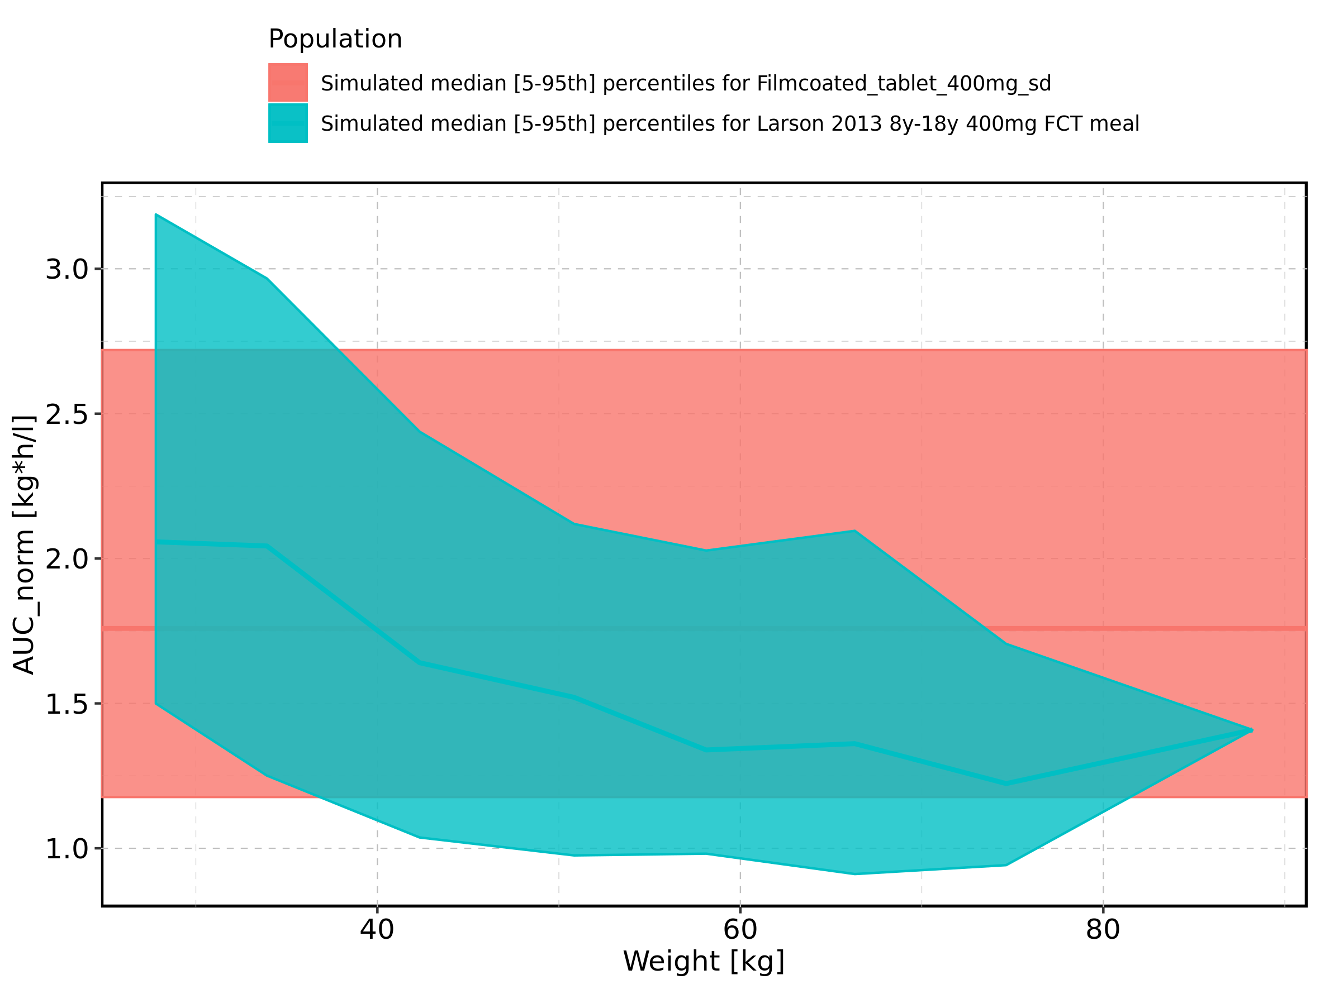

Figure 176: Weight-dependence of AUC_norm for Larson 2013 8y-18y 400mg FCT meal in comparison to Filmcoated_tablet_400mg_sd. Profiles are plotted in a logarithmic scale.

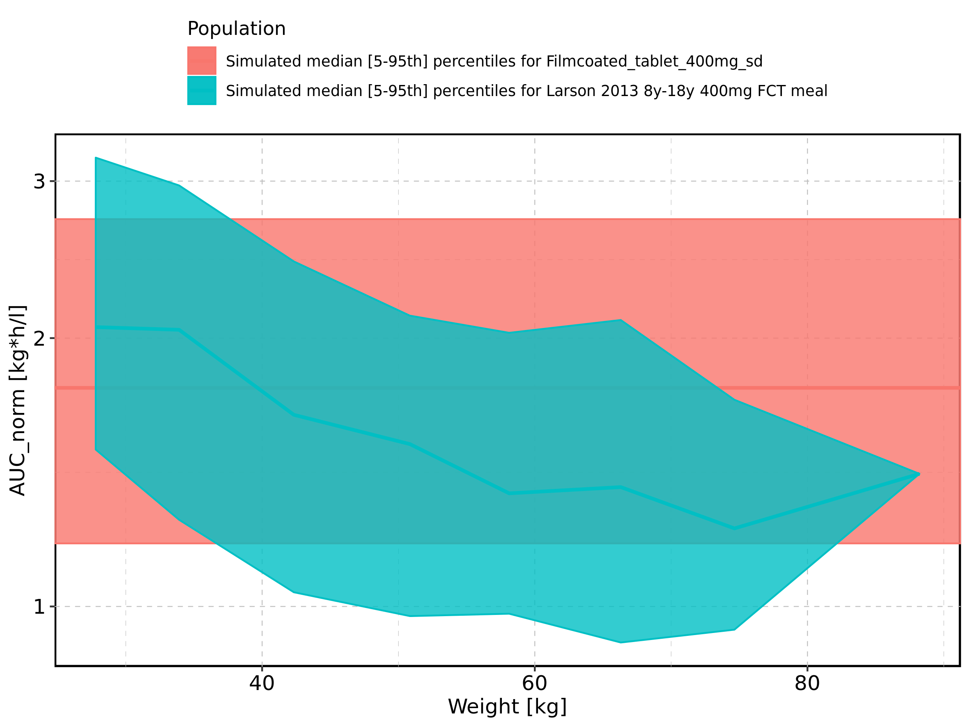

Figure 177: Weight-dependence of AUC_norm for Larson 2013 8y-18y 400mg FCT meal. Profiles are plotted in a linear scale.

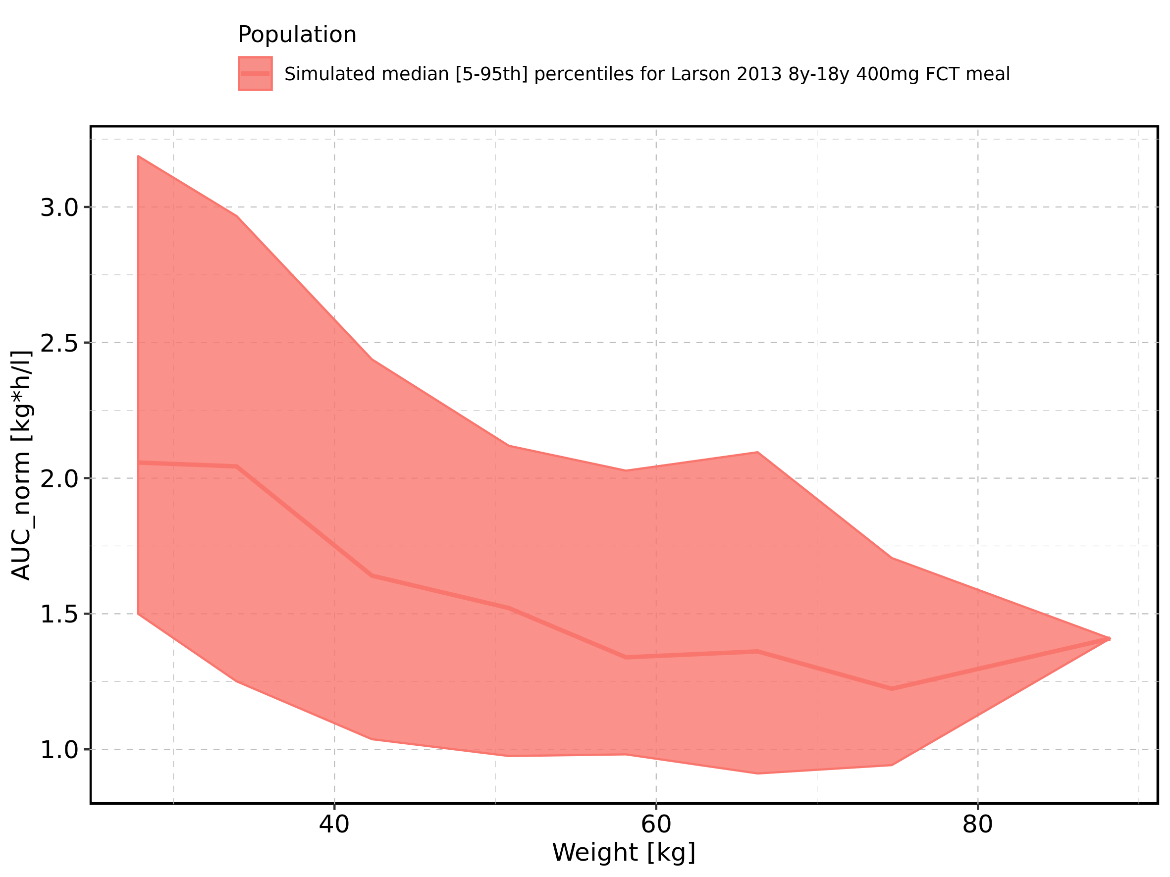

Figure 178: Weight-dependence of AUC_norm for Larson 2013 8y-18y 400mg FCT meal. Profiles are plotted in a logarithmic scale.

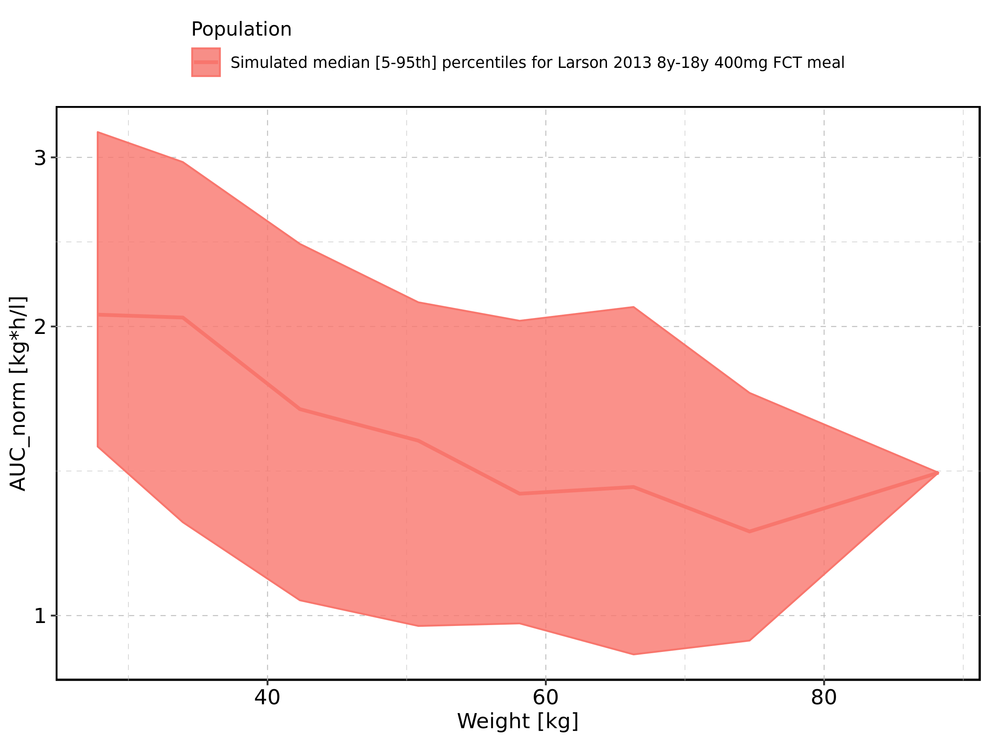

Figure 179: Weight-dependence of AUC_norm for Filmcoated_tablet_400mg_sd. Profiles are plotted in a linear scale.

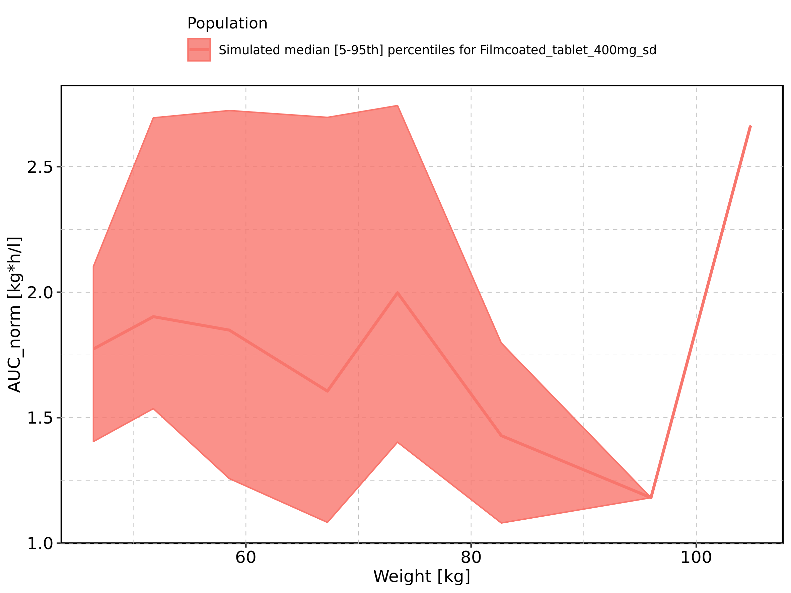

Figure 180: Weight-dependence of AUC_norm for Filmcoated_tablet_400mg_sd. Profiles are plotted in a logarithmic scale.

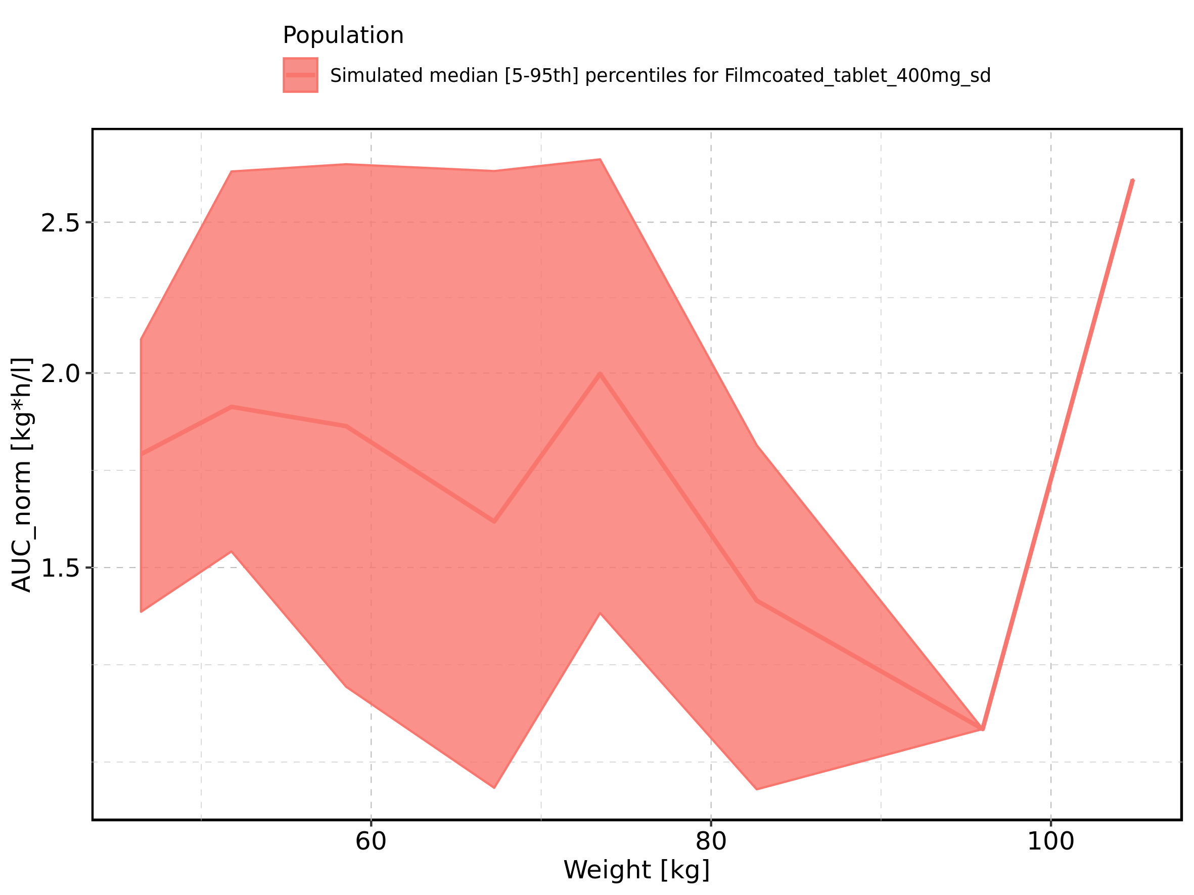

Figure 181: BMI-dependence of AUC_norm for Larson 2013 8y-18y 400mg FCT meal in comparison to Filmcoated_tablet_400mg_sd. Profiles are plotted in a linear scale.

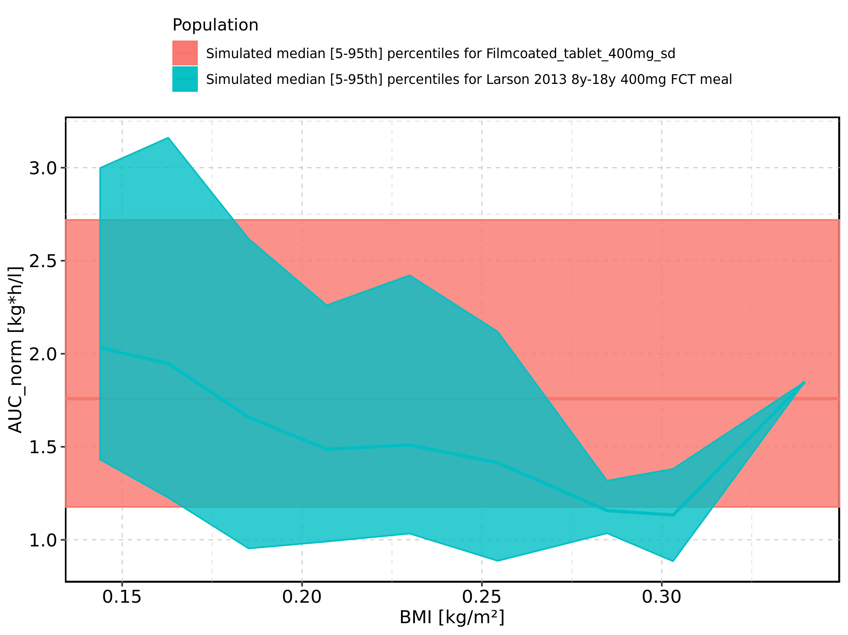

Figure 182: BMI-dependence of AUC_norm for Larson 2013 8y-18y 400mg FCT meal in comparison to Filmcoated_tablet_400mg_sd. Profiles are plotted in a logarithmic scale.

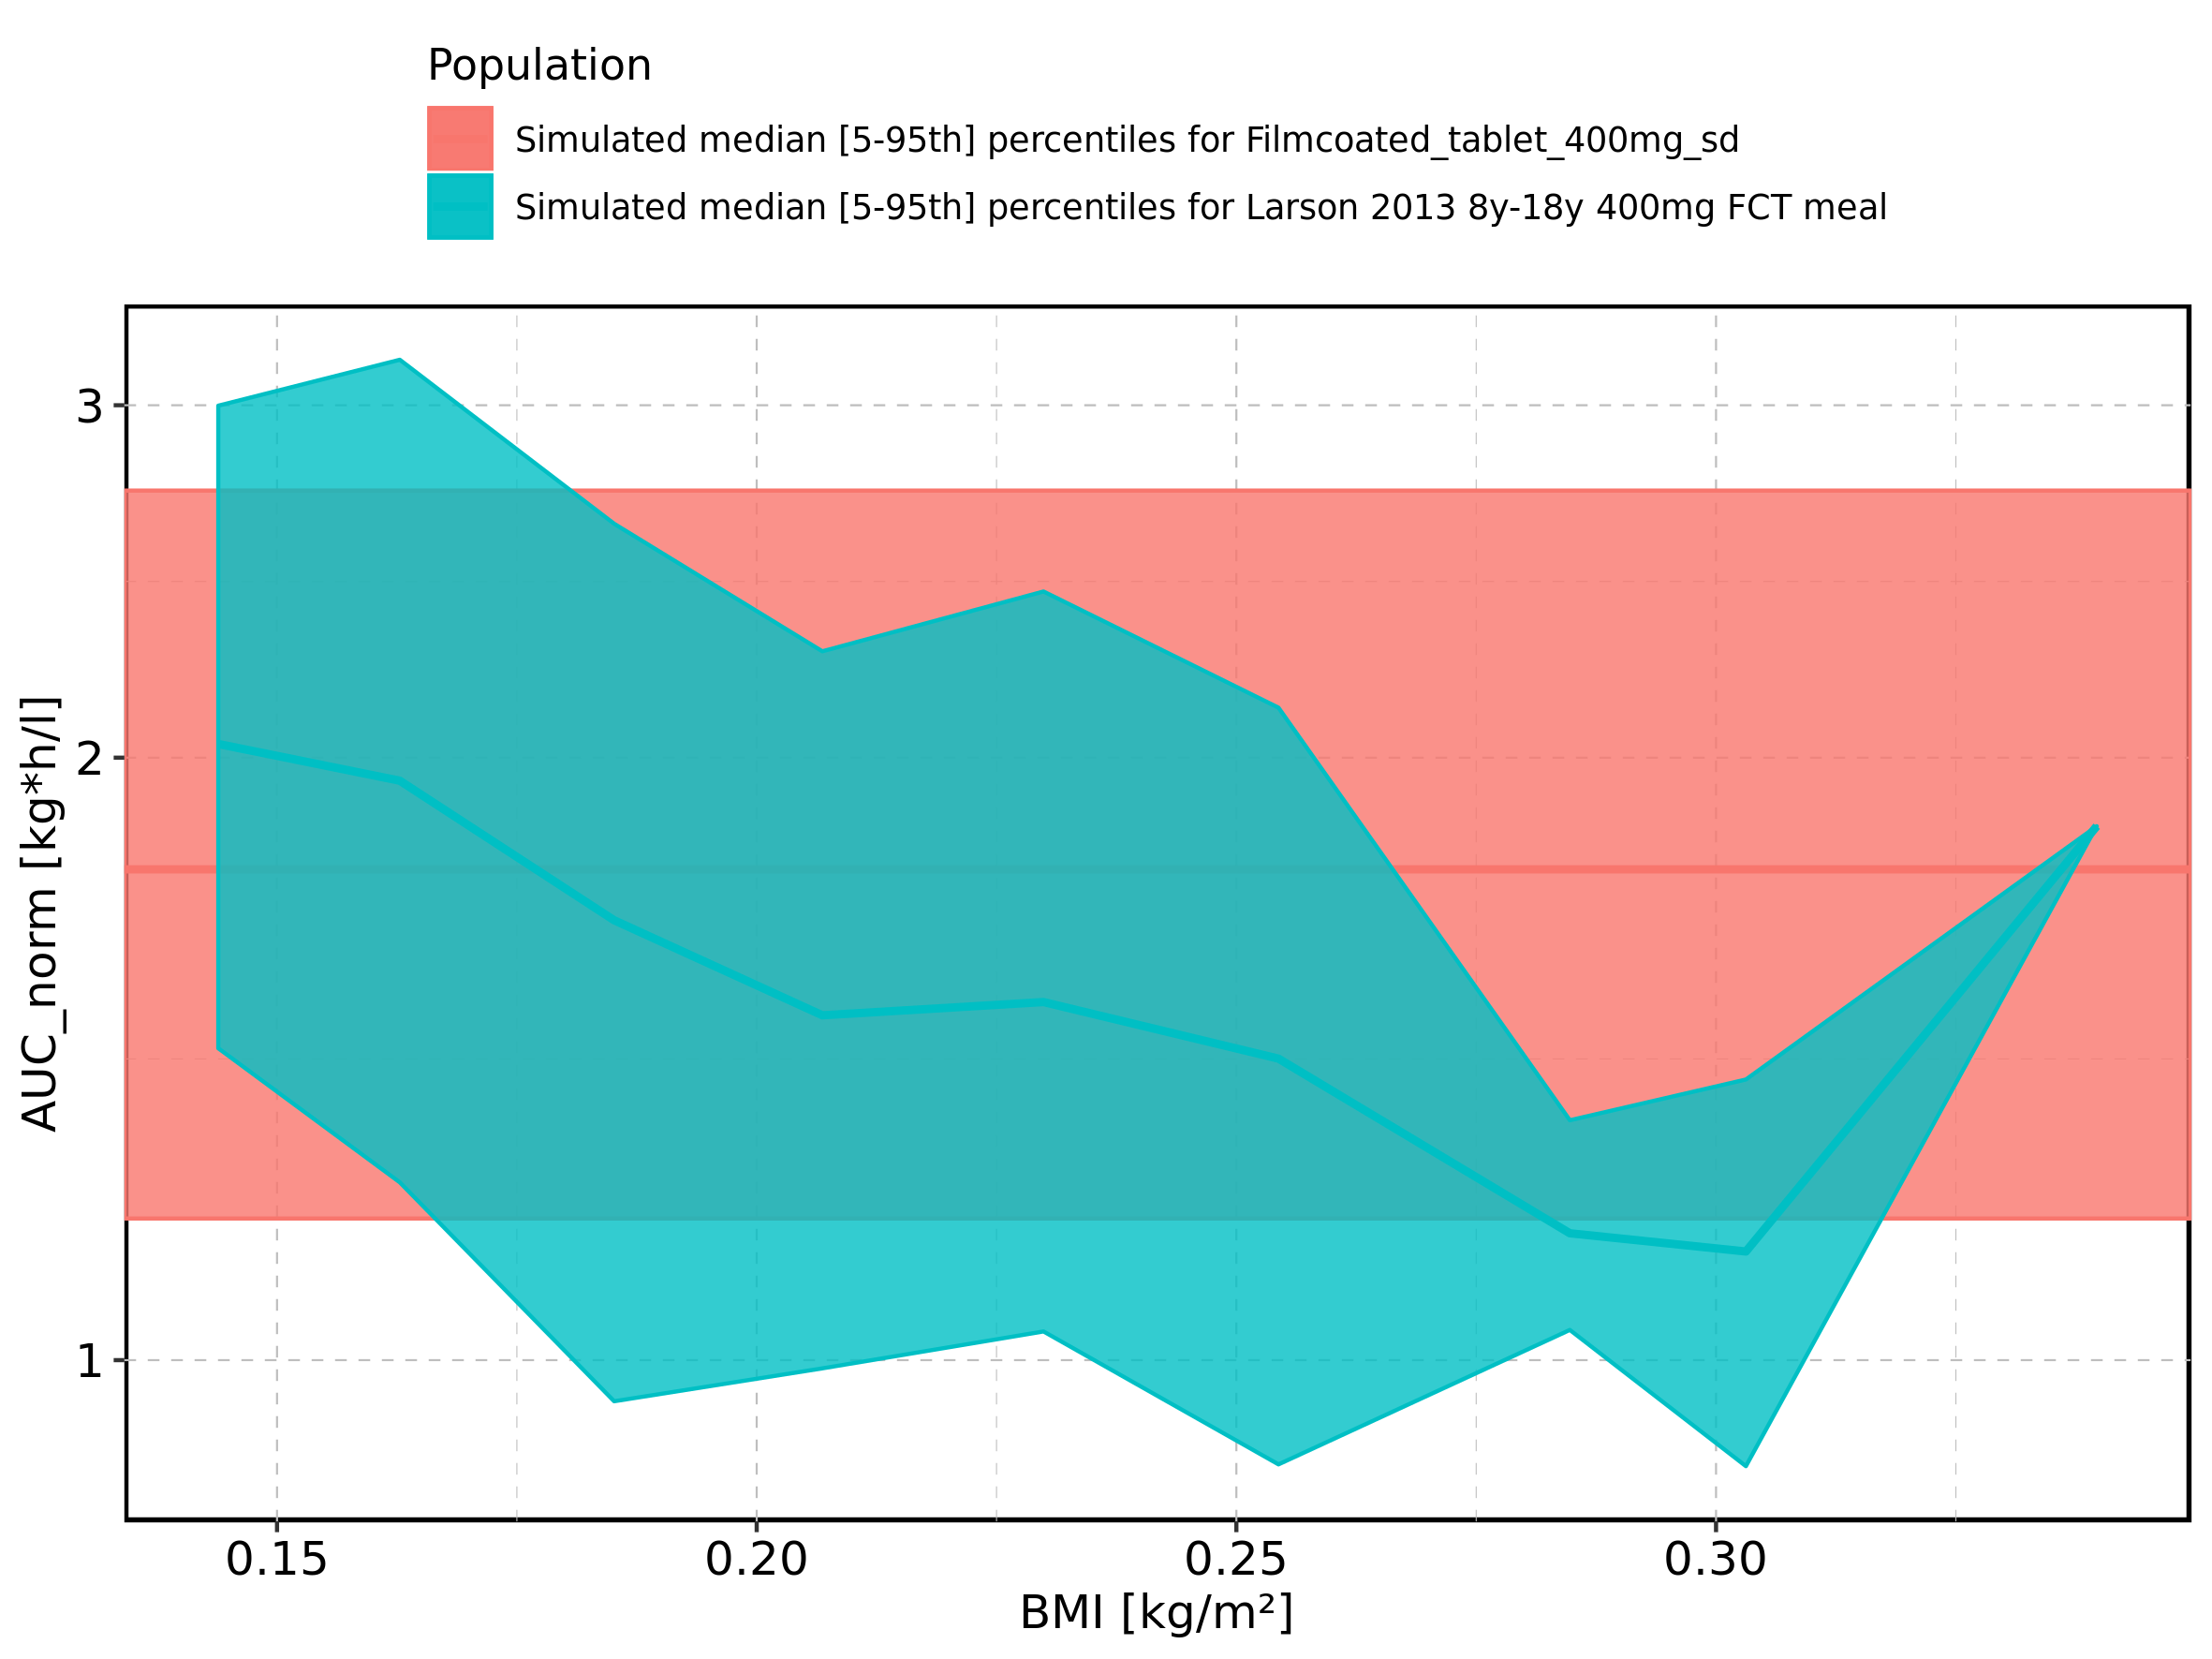

Figure 183: BMI-dependence of AUC_norm for Larson 2013 8y-18y 400mg FCT meal. Profiles are plotted in a linear scale.

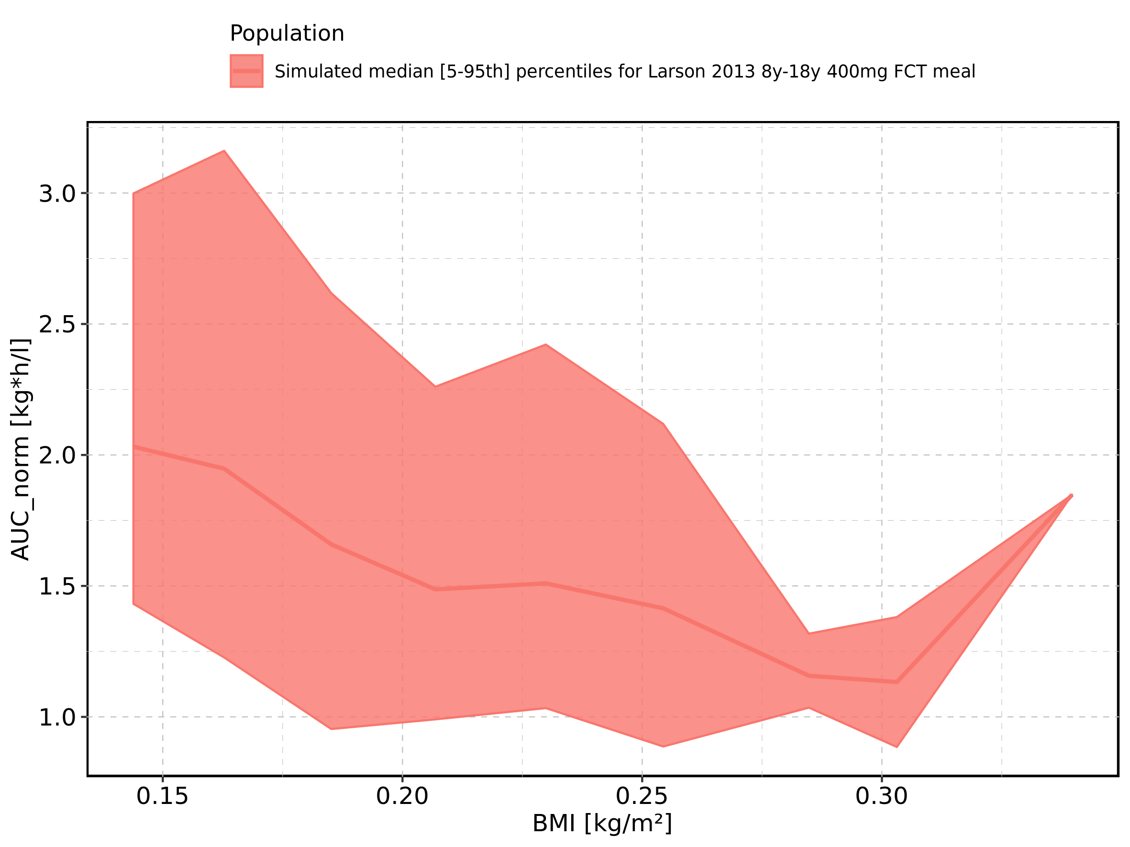

Figure 184: BMI-dependence of AUC_norm for Larson 2013 8y-18y 400mg FCT meal. Profiles are plotted in a logarithmic scale.

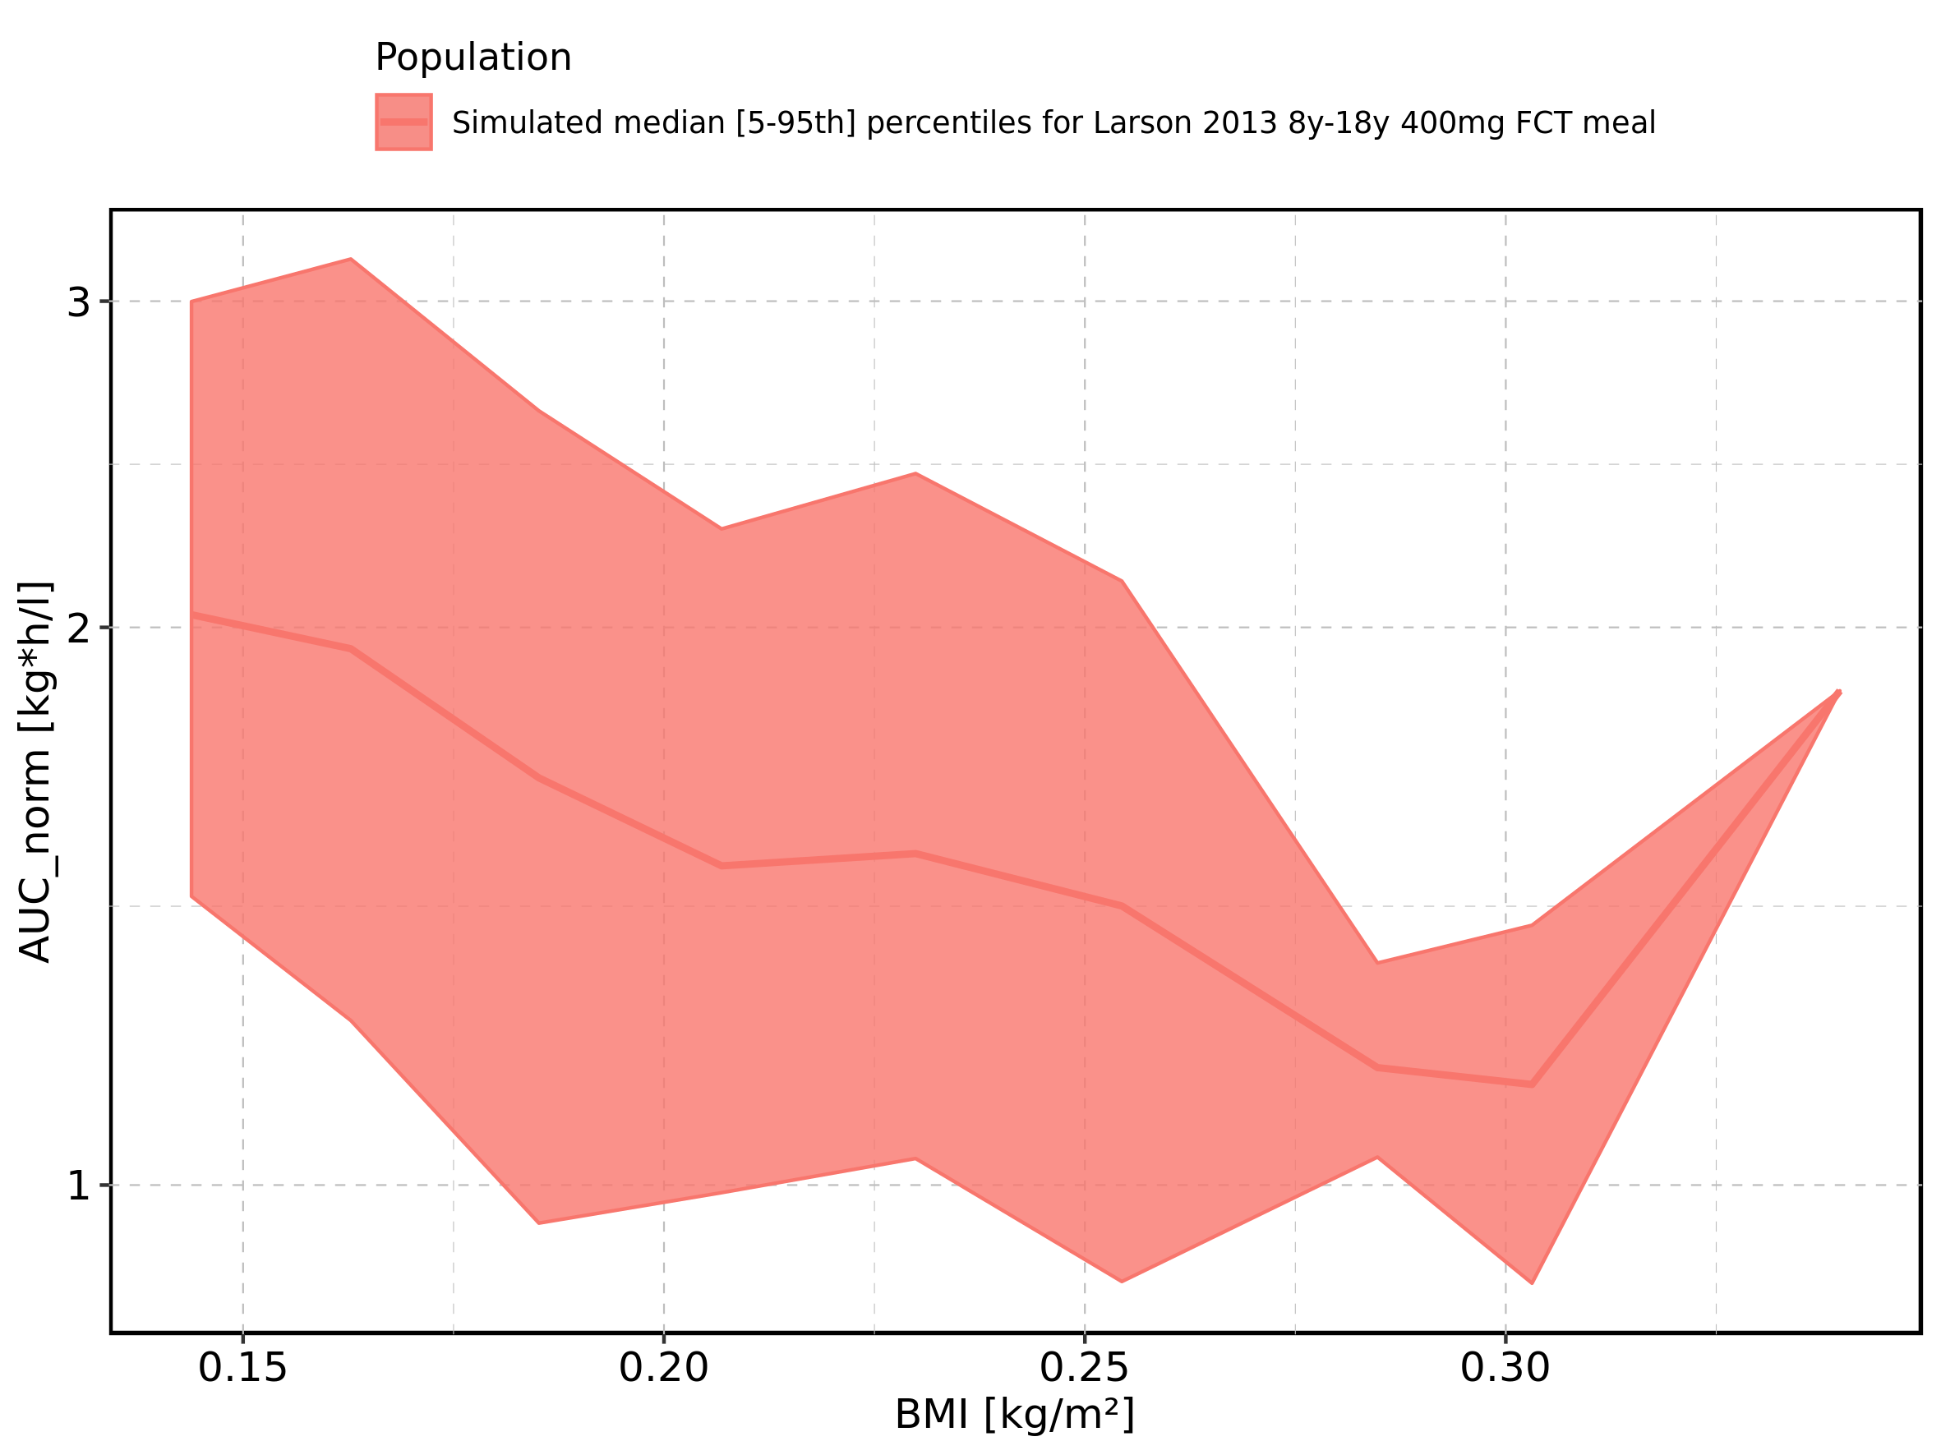

Figure 185: BMI-dependence of AUC_norm for Filmcoated_tablet_400mg_sd. Profiles are plotted in a linear scale.

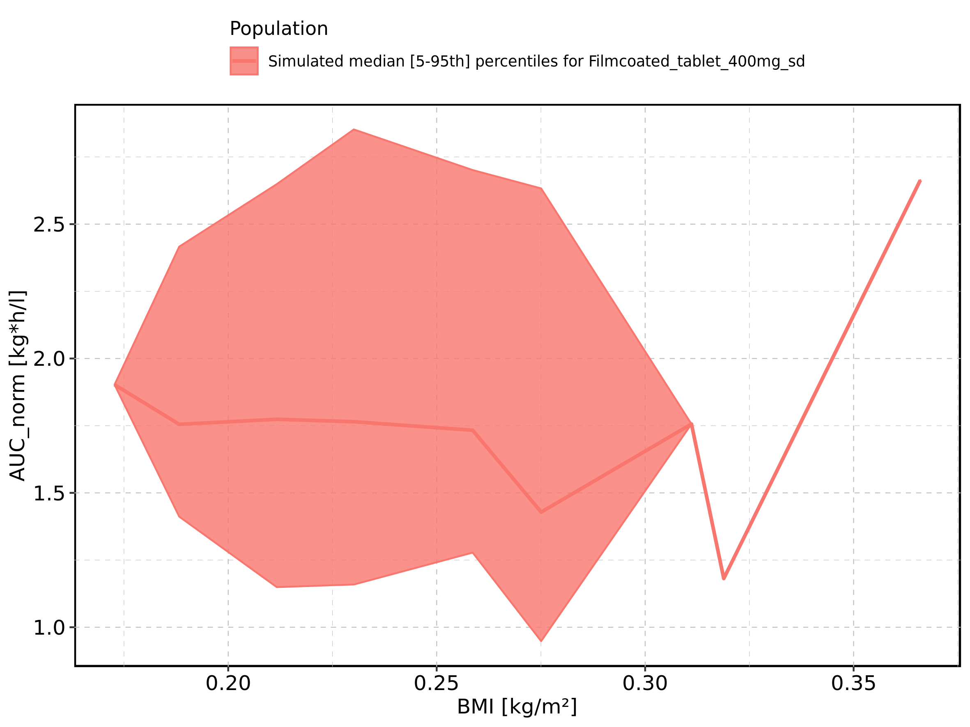

Figure 186: BMI-dependence of AUC_norm for Filmcoated_tablet_400mg_sd. Profiles are plotted in a logarithmic scale.

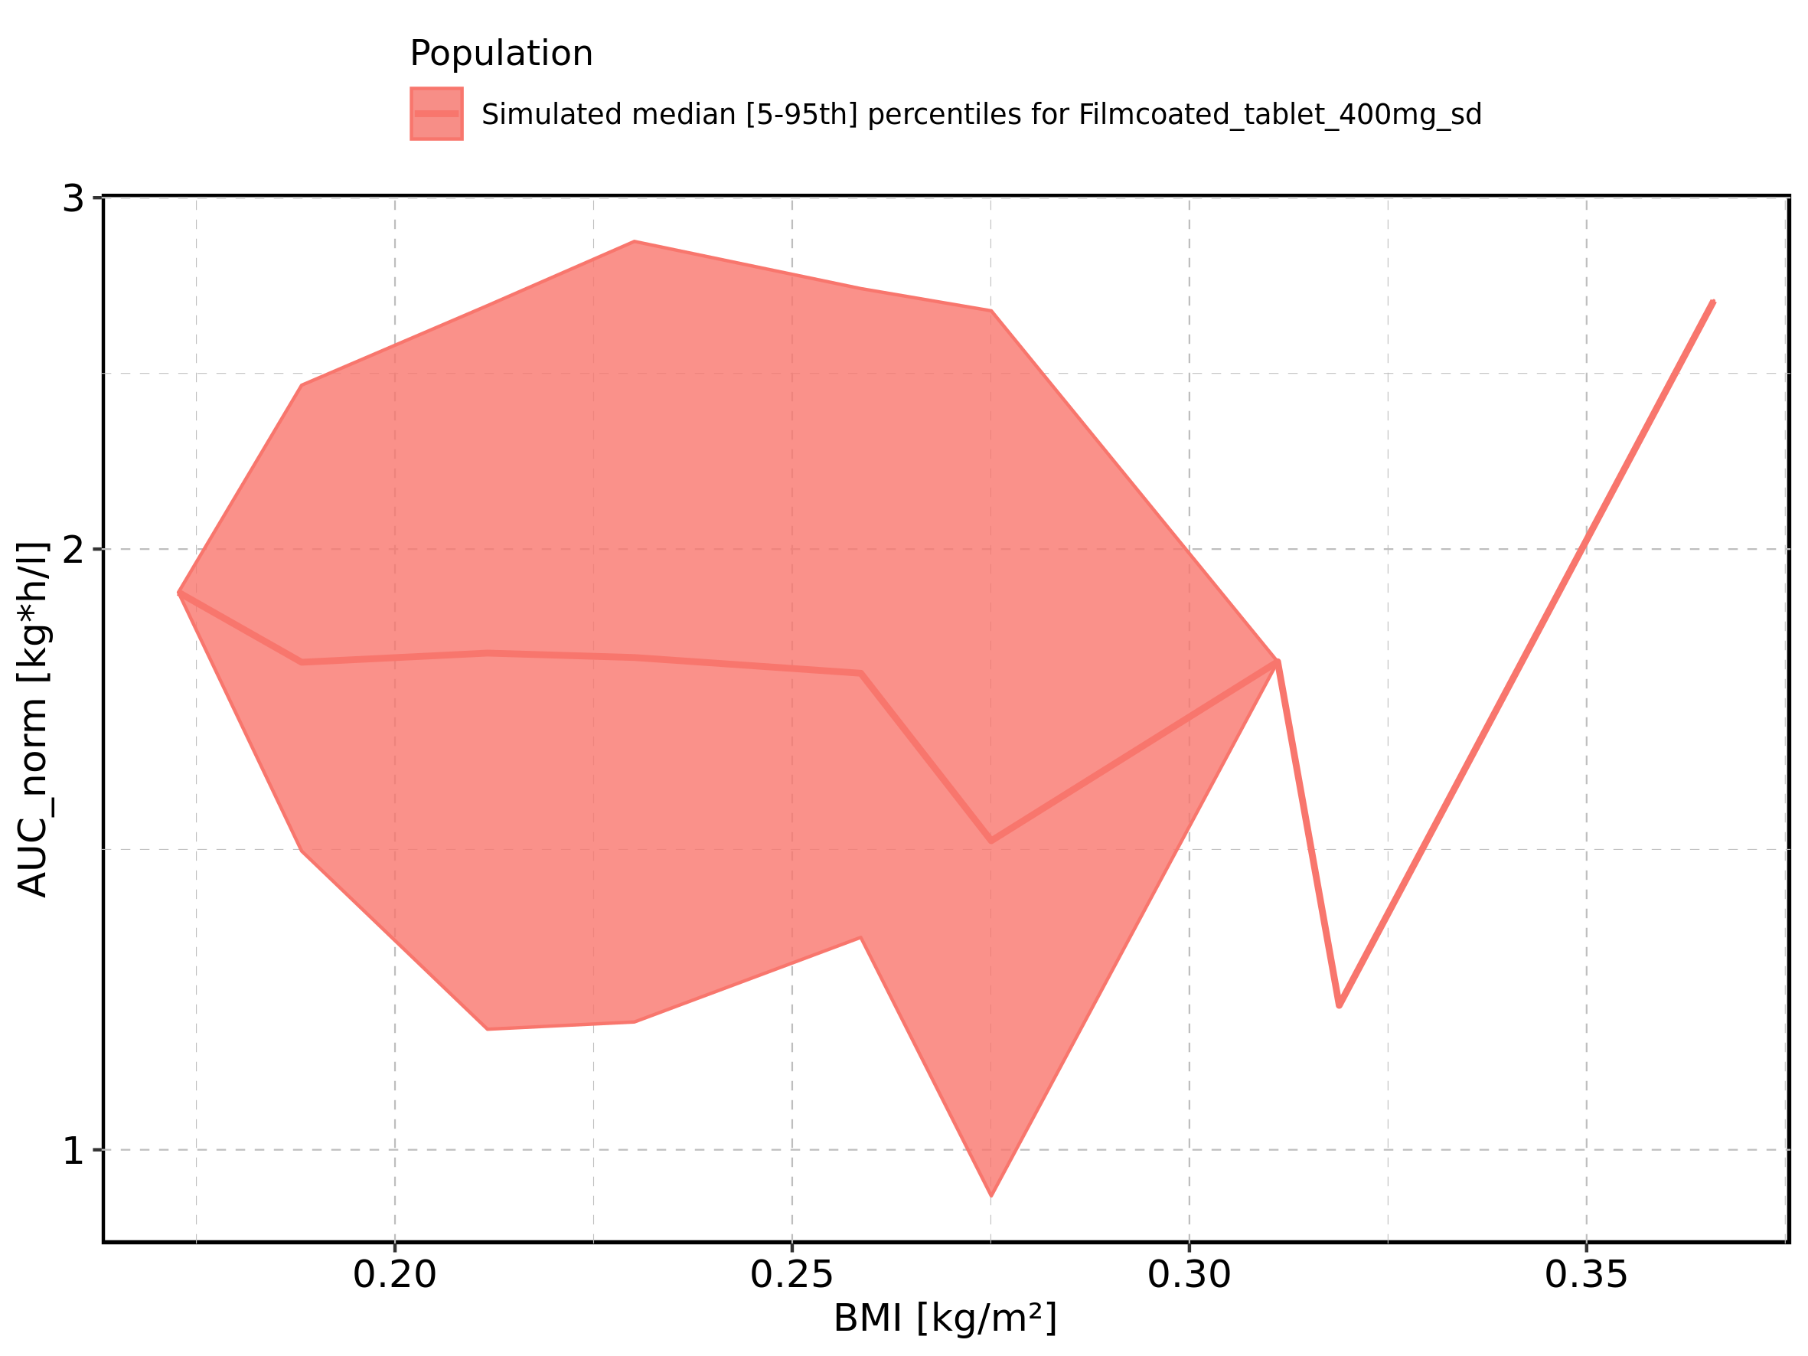

Figure 187: Gender-dependence of AUC_norm for Larson 2013 8y-18y 400mg FCT meal in comparison to Filmcoated_tablet_400mg_sd. Profiles are plotted in a linear scale.

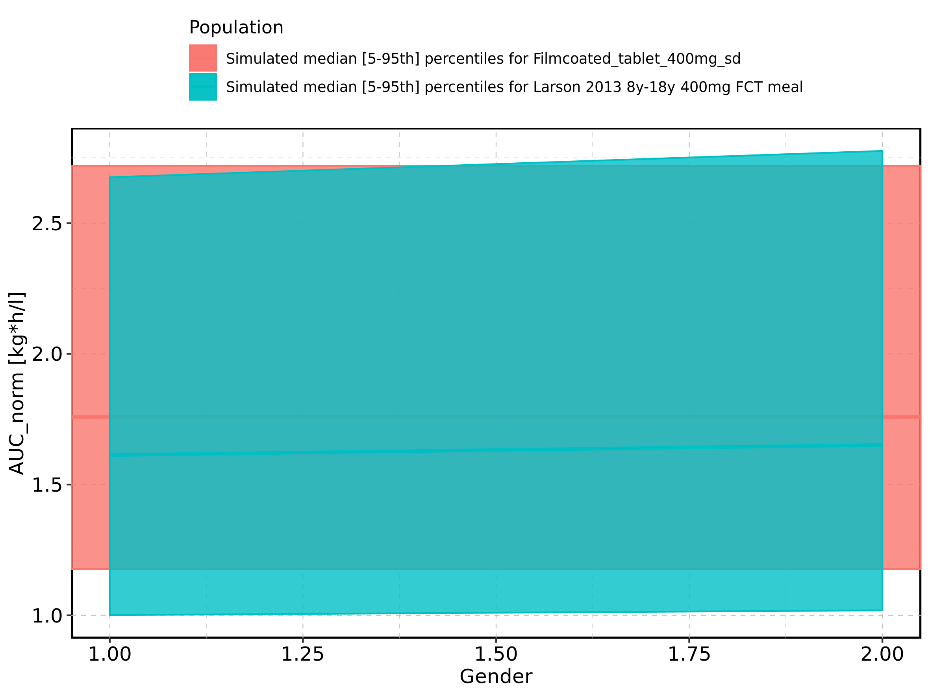

Figure 188: Gender-dependence of AUC_norm for Larson 2013 8y-18y 400mg FCT meal in comparison to Filmcoated_tablet_400mg_sd. Profiles are plotted in a logarithmic scale.

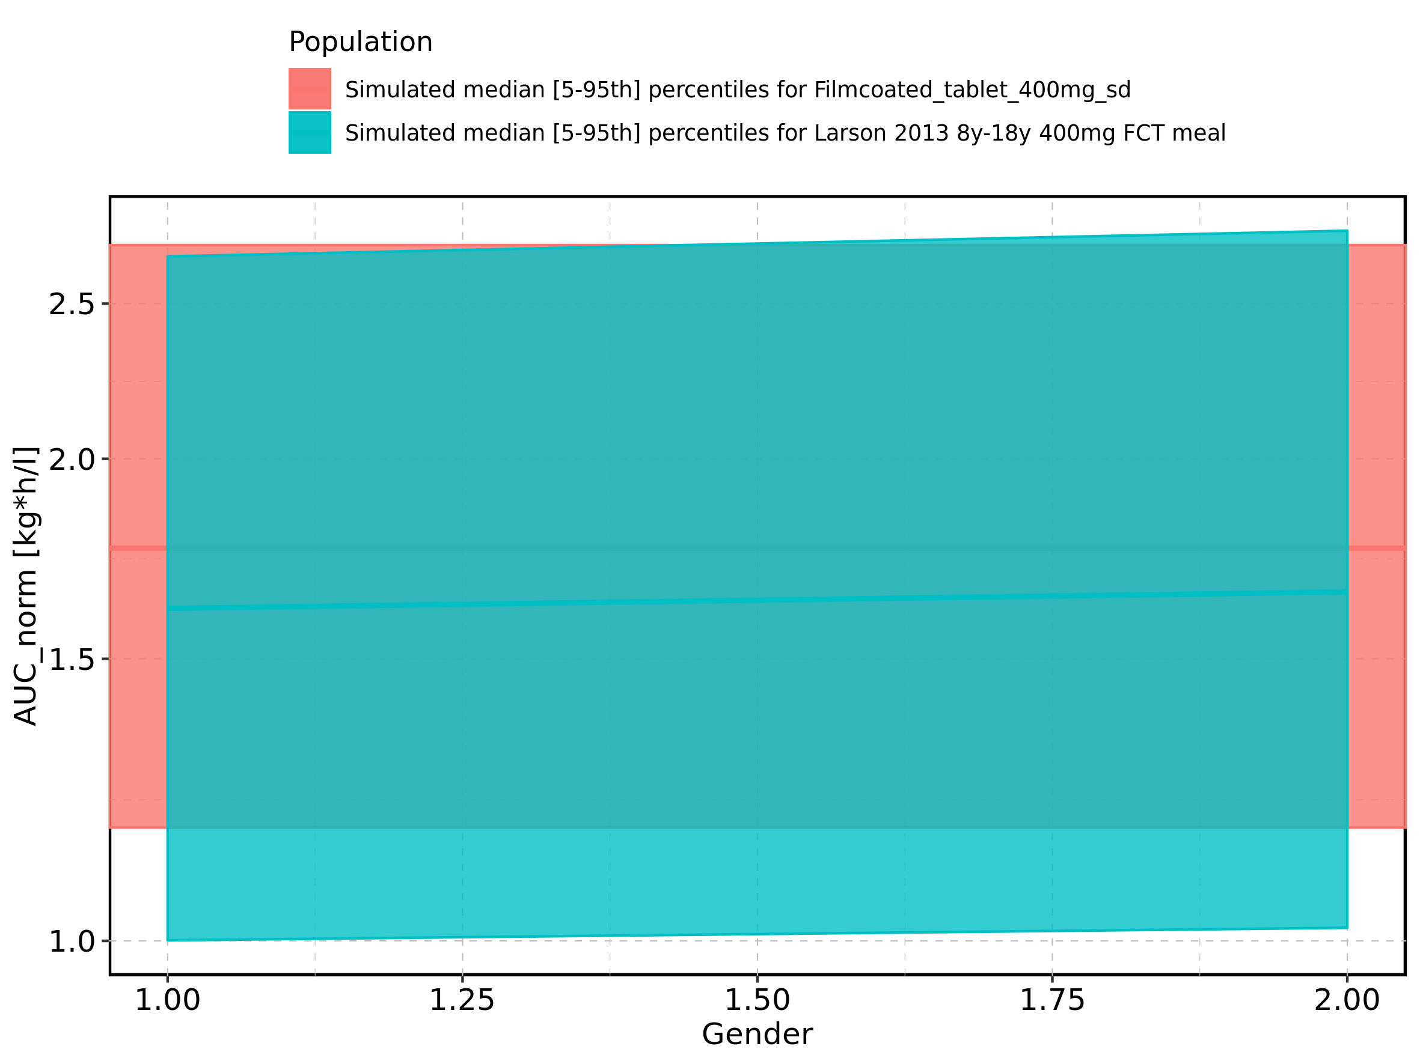

Figure 189: Gender-dependence of AUC_norm for Larson 2013 8y-18y 400mg FCT meal. Profiles are plotted in a linear scale.

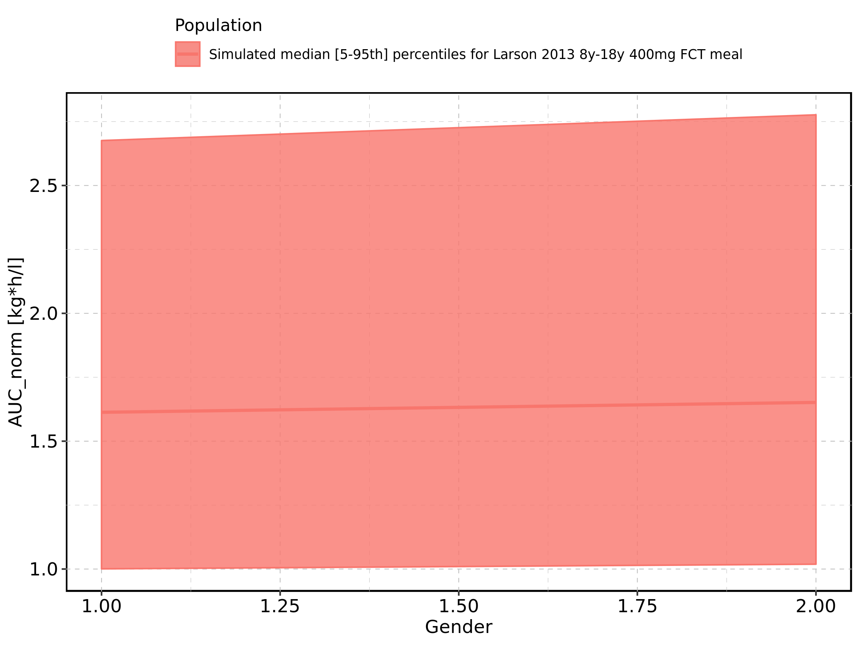

Figure 190: Gender-dependence of AUC_norm for Larson 2013 8y-18y 400mg FCT meal. Profiles are plotted in a logarithmic scale.

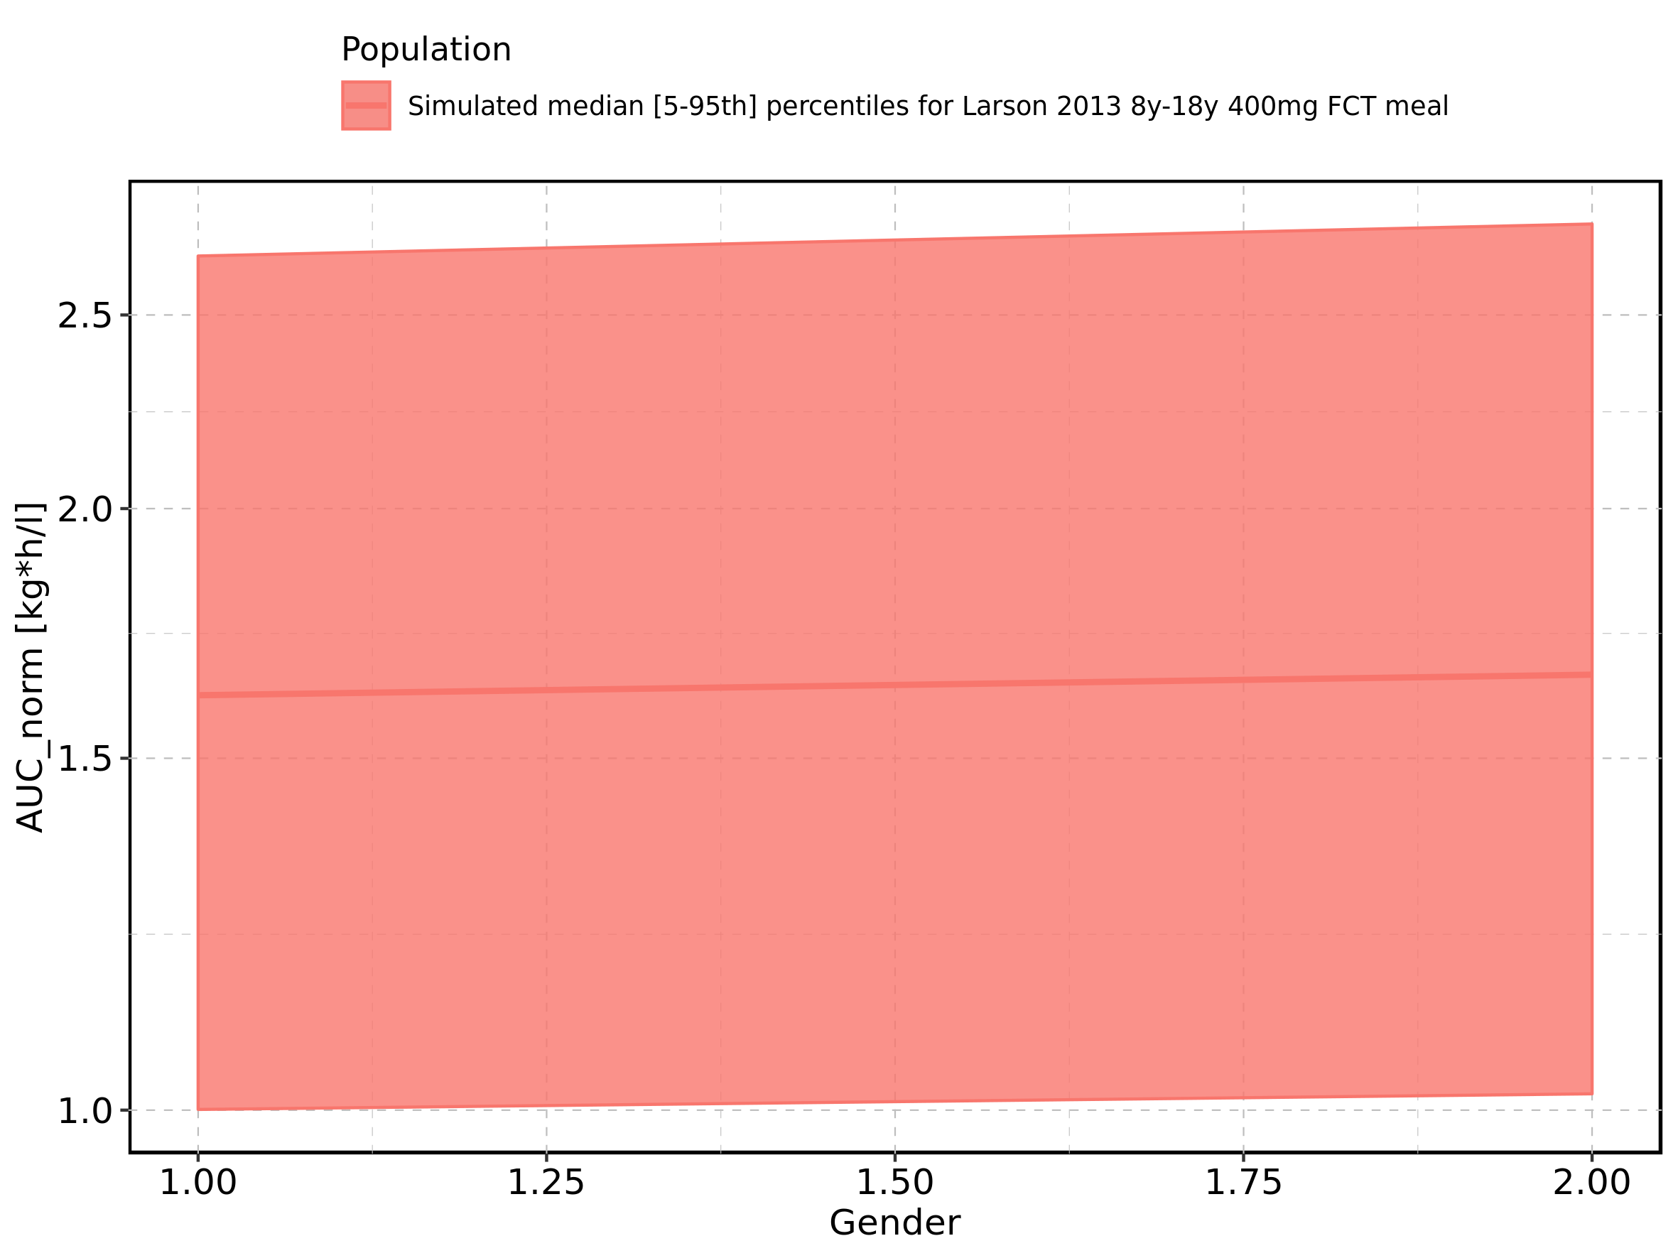

Figure 191: Gender-dependence of AUC_norm for Filmcoated_tablet_400mg_sd. Profiles are plotted in a linear scale.

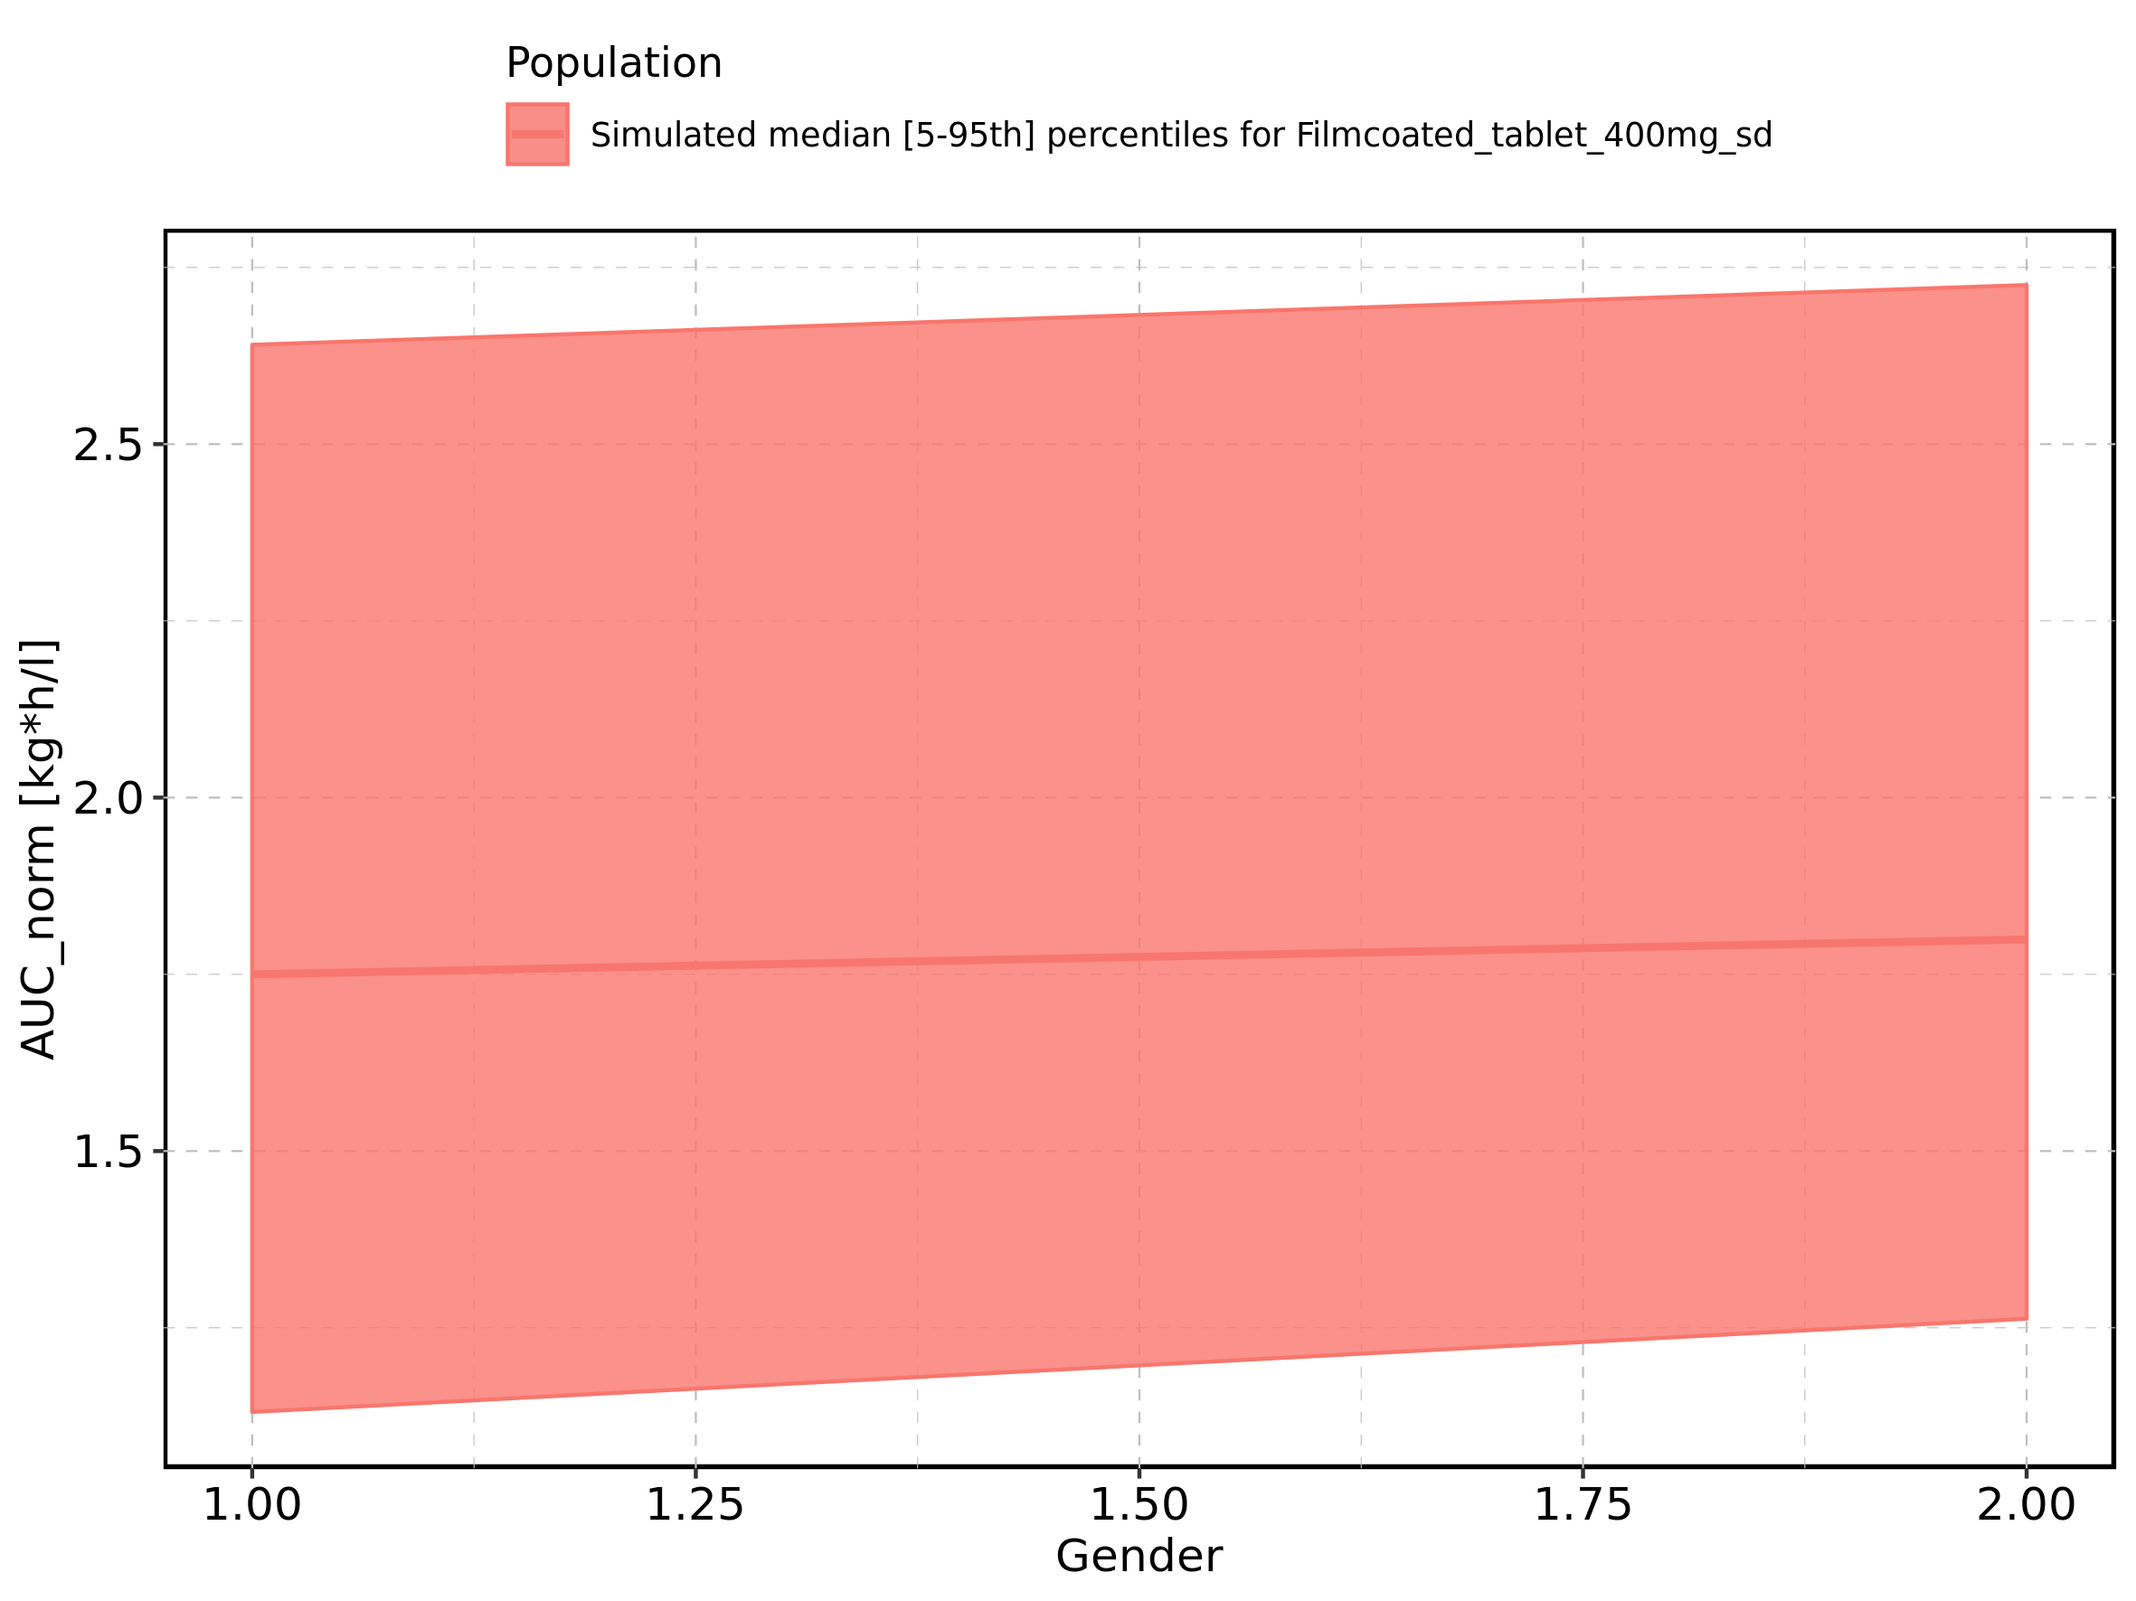

Figure 192: Gender-dependence of AUC_norm for Filmcoated_tablet_400mg_sd. Profiles are plotted in a logarithmic scale.

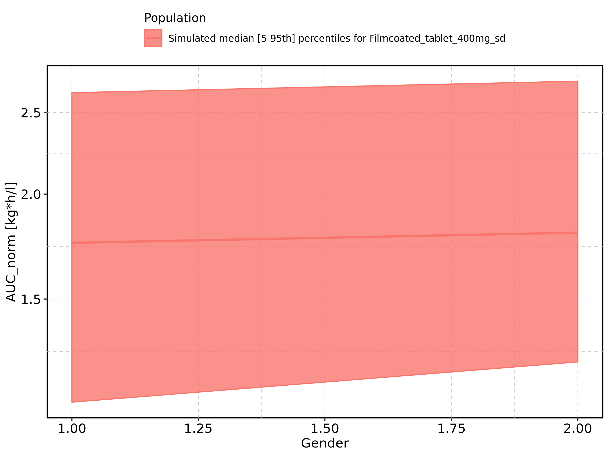

Figure 193: AUC_inf of Raltegravir shown as box-whisker plot, which indicates the 5th, 25th, 50th, 75th, and 95th percentiles in linear scale.

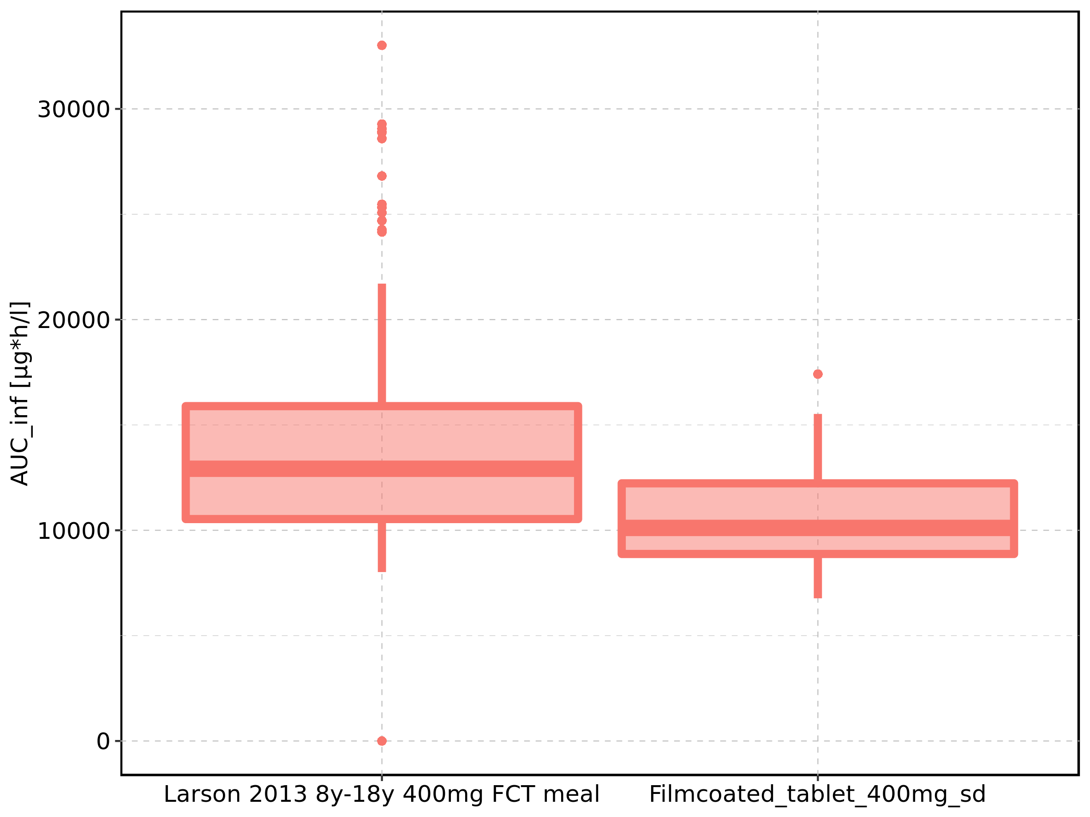

|  |  |  |  |  |  |  |  |  |  |  |
| --- | --- | --- | --- | --- | --- | --- | --- | --- | --- | --- |
| Population | N | 5th percentile | 25th percentile | 50th percentile | 75th percentile | 95th percentile | mean | standard deviation | geo mean | geo standard deviation |
| Larson 2013 8y-18y 400mg FCT meal | 500 | 8017.562 | 10533.549 | 12921.05 | 15892.62 | 21707.95 | 13652.18 | 4460.211 | 0.00 | NA |
| Filmcoated_tablet_400mg_sd | 100 | 6771.970 | 8875.698 | 10112.32 | 12229.14 | 15523.15 | 10626.71 | 2757.612 | 10275.45 | 1.300506 |

Figure 194: AUC_inf of Raltegravir shown as box-whisker plot, which indicates the 5th, 25th, 50th, 75th, and 95th percentiles in logarithmic scale.

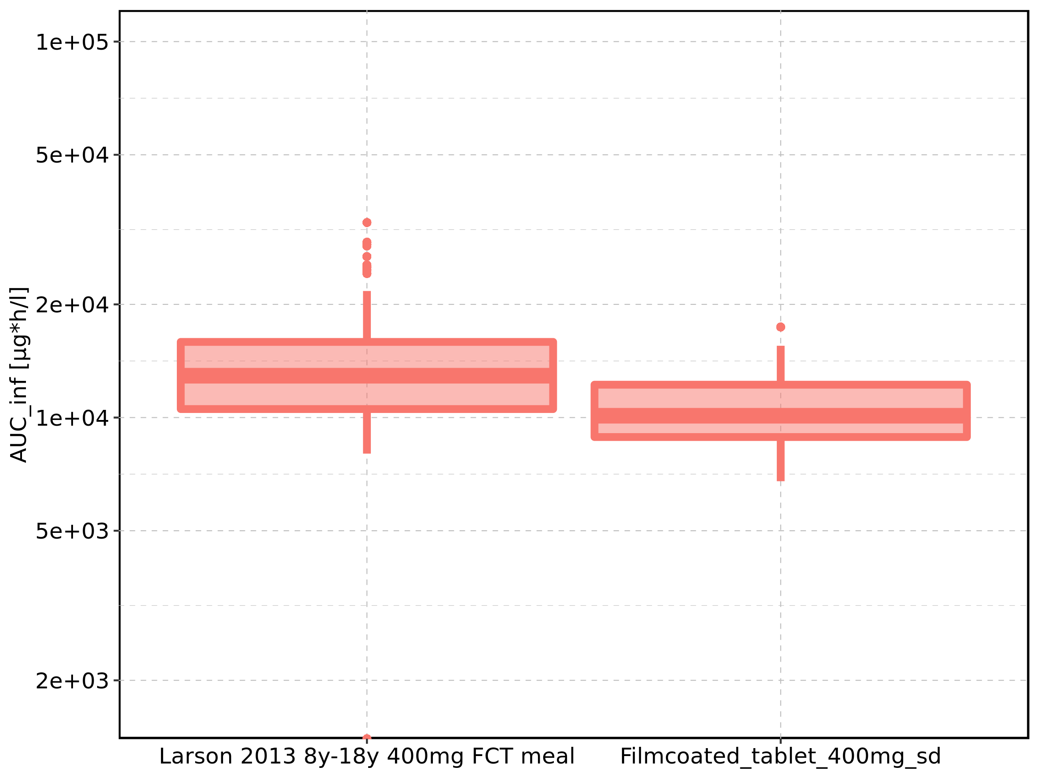

Figure 195: Age-dependence of AUC_inf for Larson 2013 8y-18y 400mg FCT meal in comparison to Filmcoated_tablet_400mg_sd. Profiles are plotted in a linear scale.

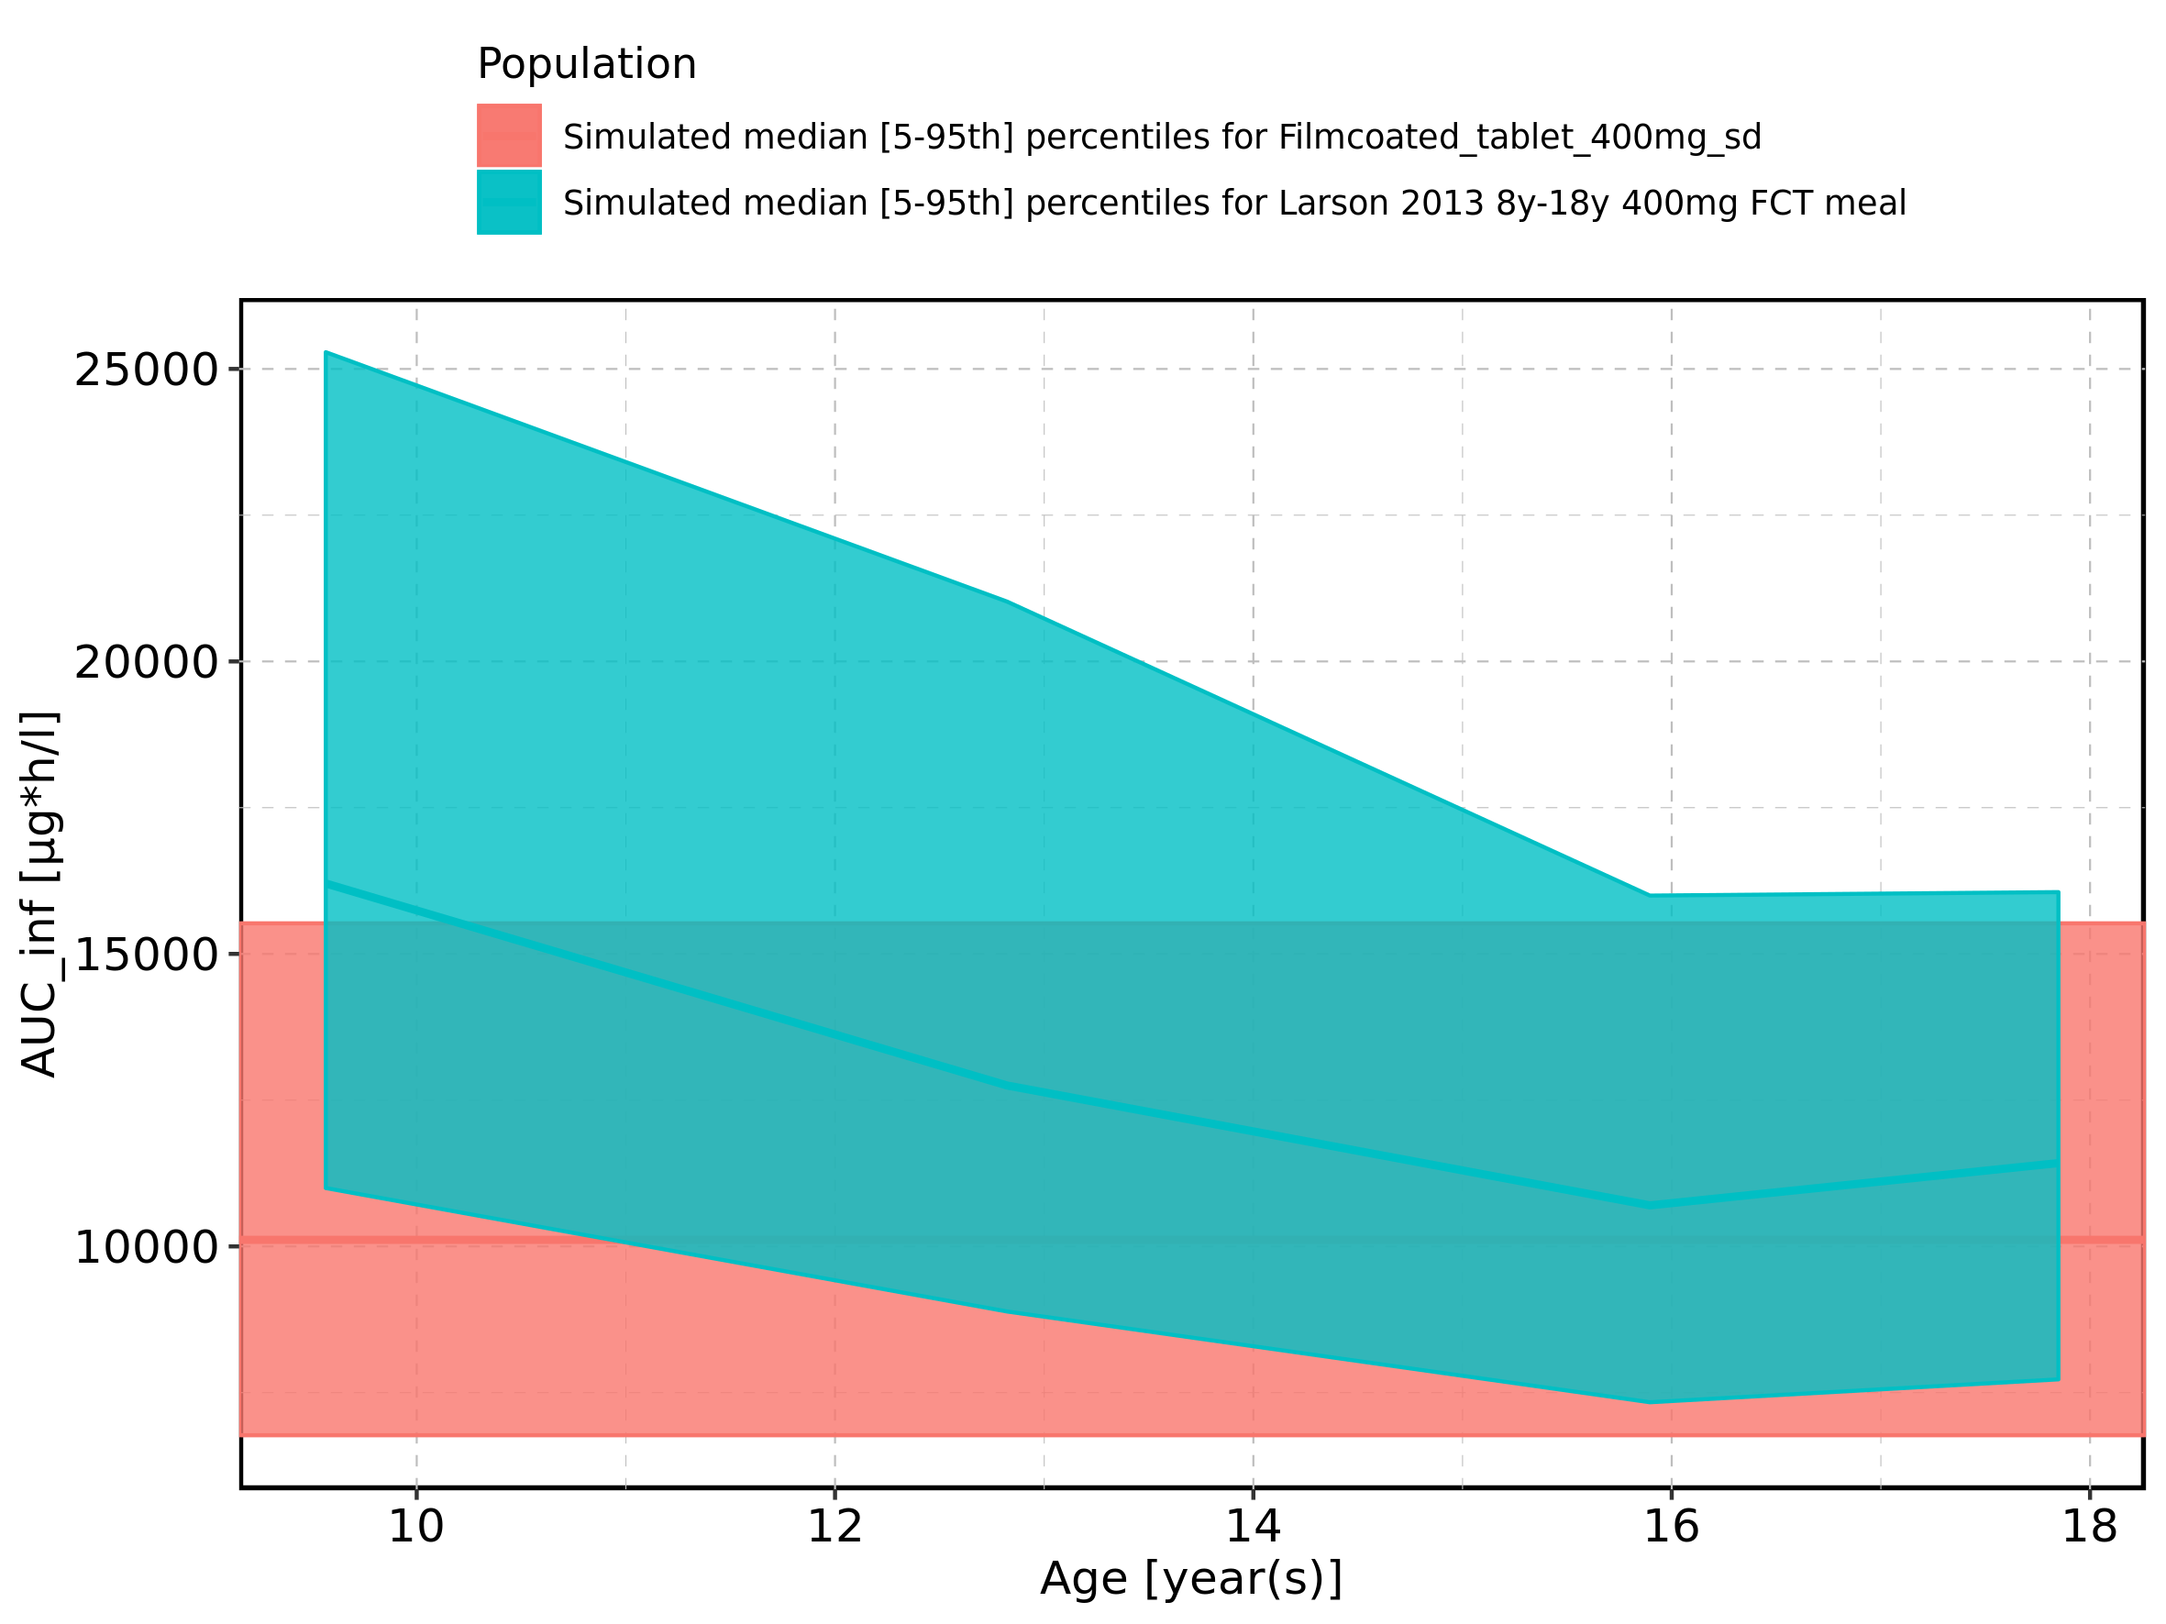

Figure 196: Age-dependence of AUC_inf for Larson 2013 8y-18y 400mg FCT meal in comparison to Filmcoated_tablet_400mg_sd. Profiles are plotted in a logarithmic scale.

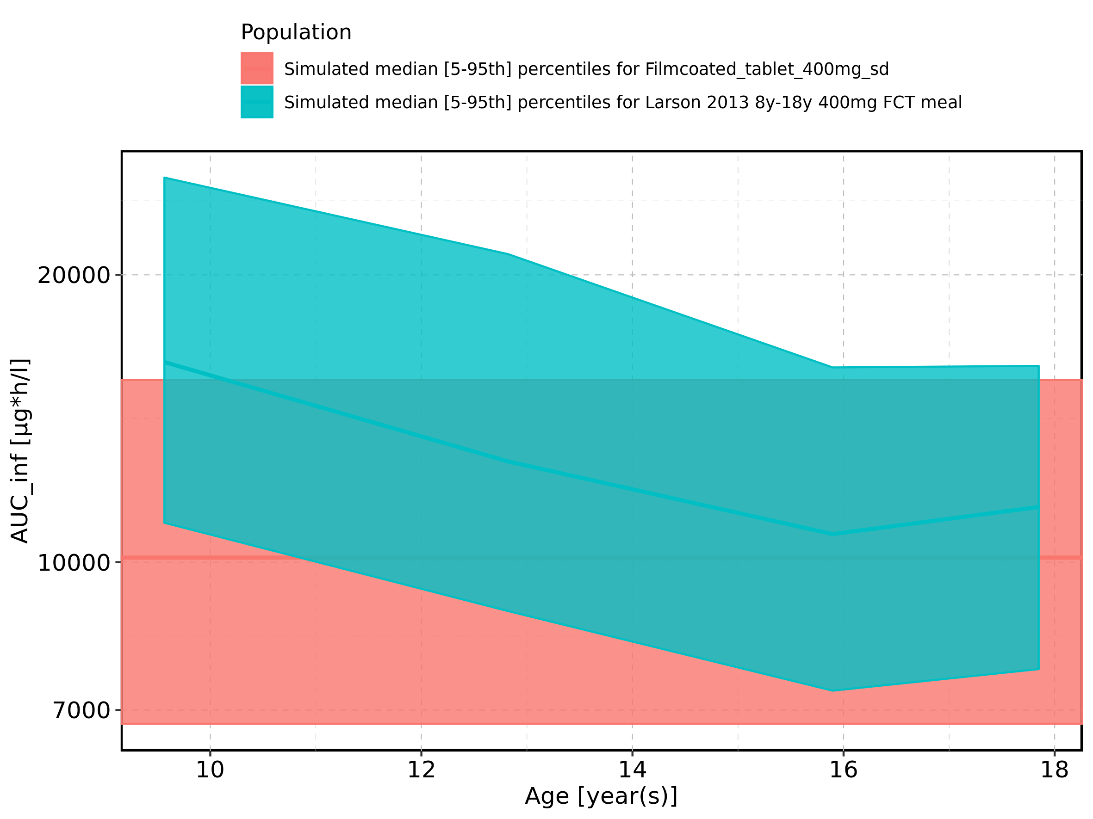

Figure 197: Age-dependence of AUC_inf for Larson 2013 8y-18y 400mg FCT meal. Profiles are plotted in a linear scale.

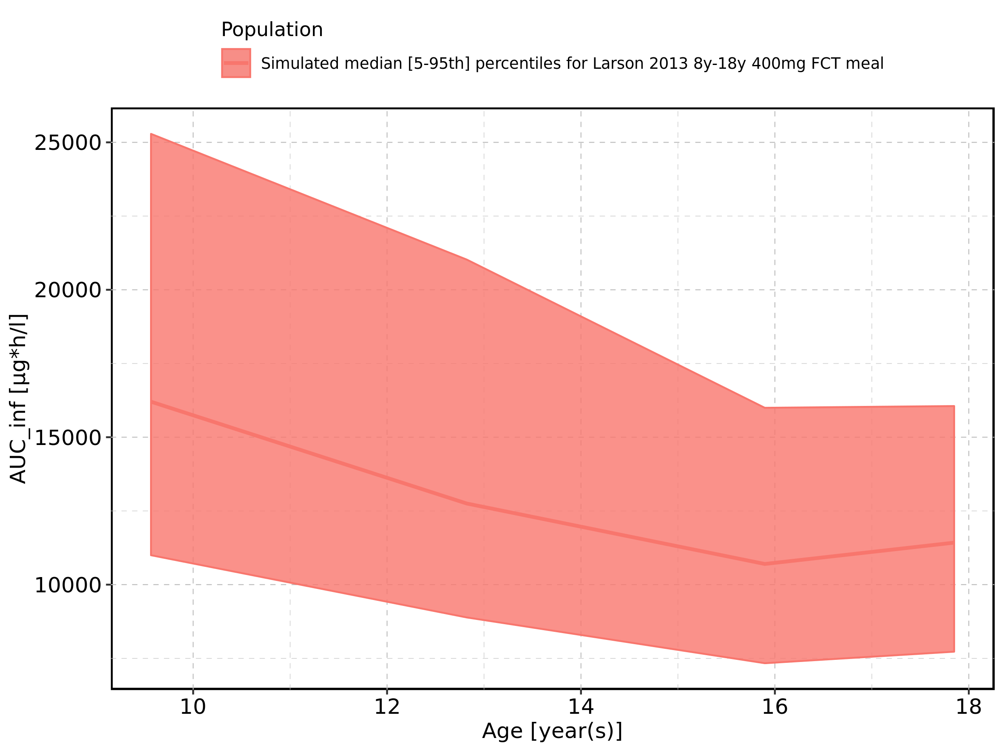

Figure 198: Age-dependence of AUC_inf for Larson 2013 8y-18y 400mg FCT meal. Profiles are plotted in a logarithmic scale.

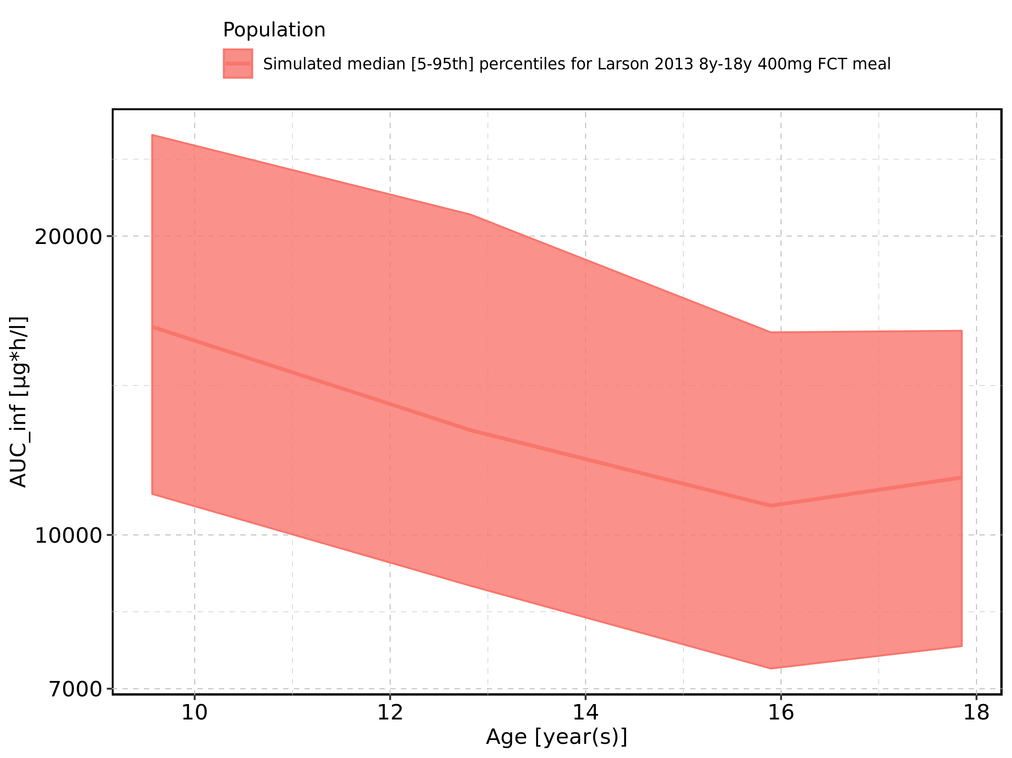

Figure 199: Age-dependence of AUC_inf for Filmcoated_tablet_400mg_sd. Profiles are plotted in a linear scale.

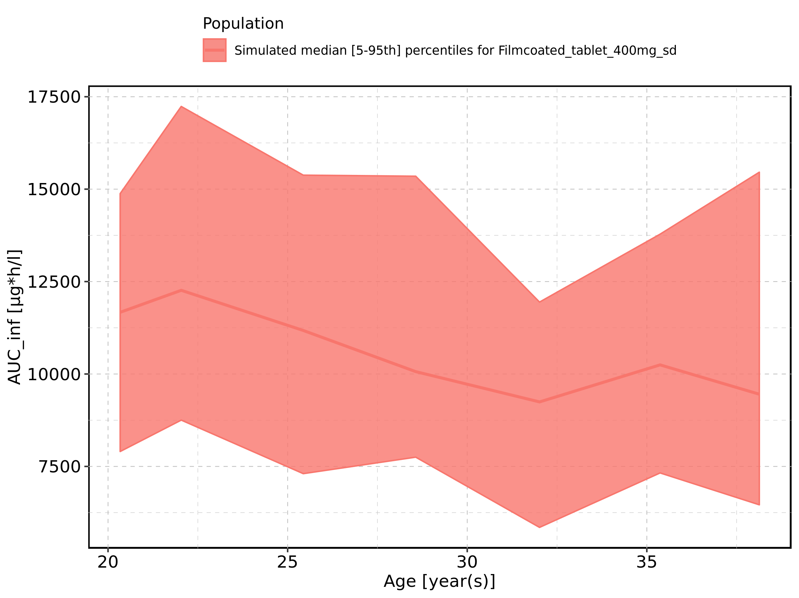

Figure 200: Age-dependence of AUC_inf for Filmcoated_tablet_400mg_sd. Profiles are plotted in a logarithmic scale.

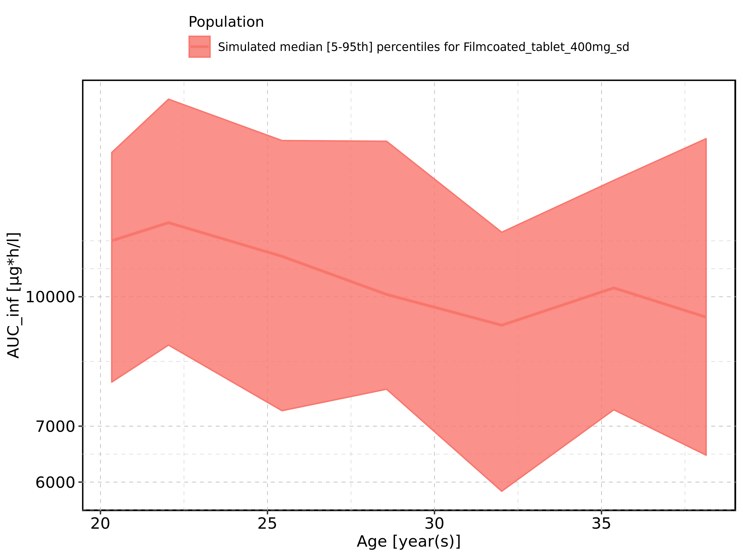

Figure 201: Height-dependence of AUC_inf for Larson 2013 8y-18y 400mg FCT meal in comparison to Filmcoated_tablet_400mg_sd. Profiles are plotted in a linear scale.

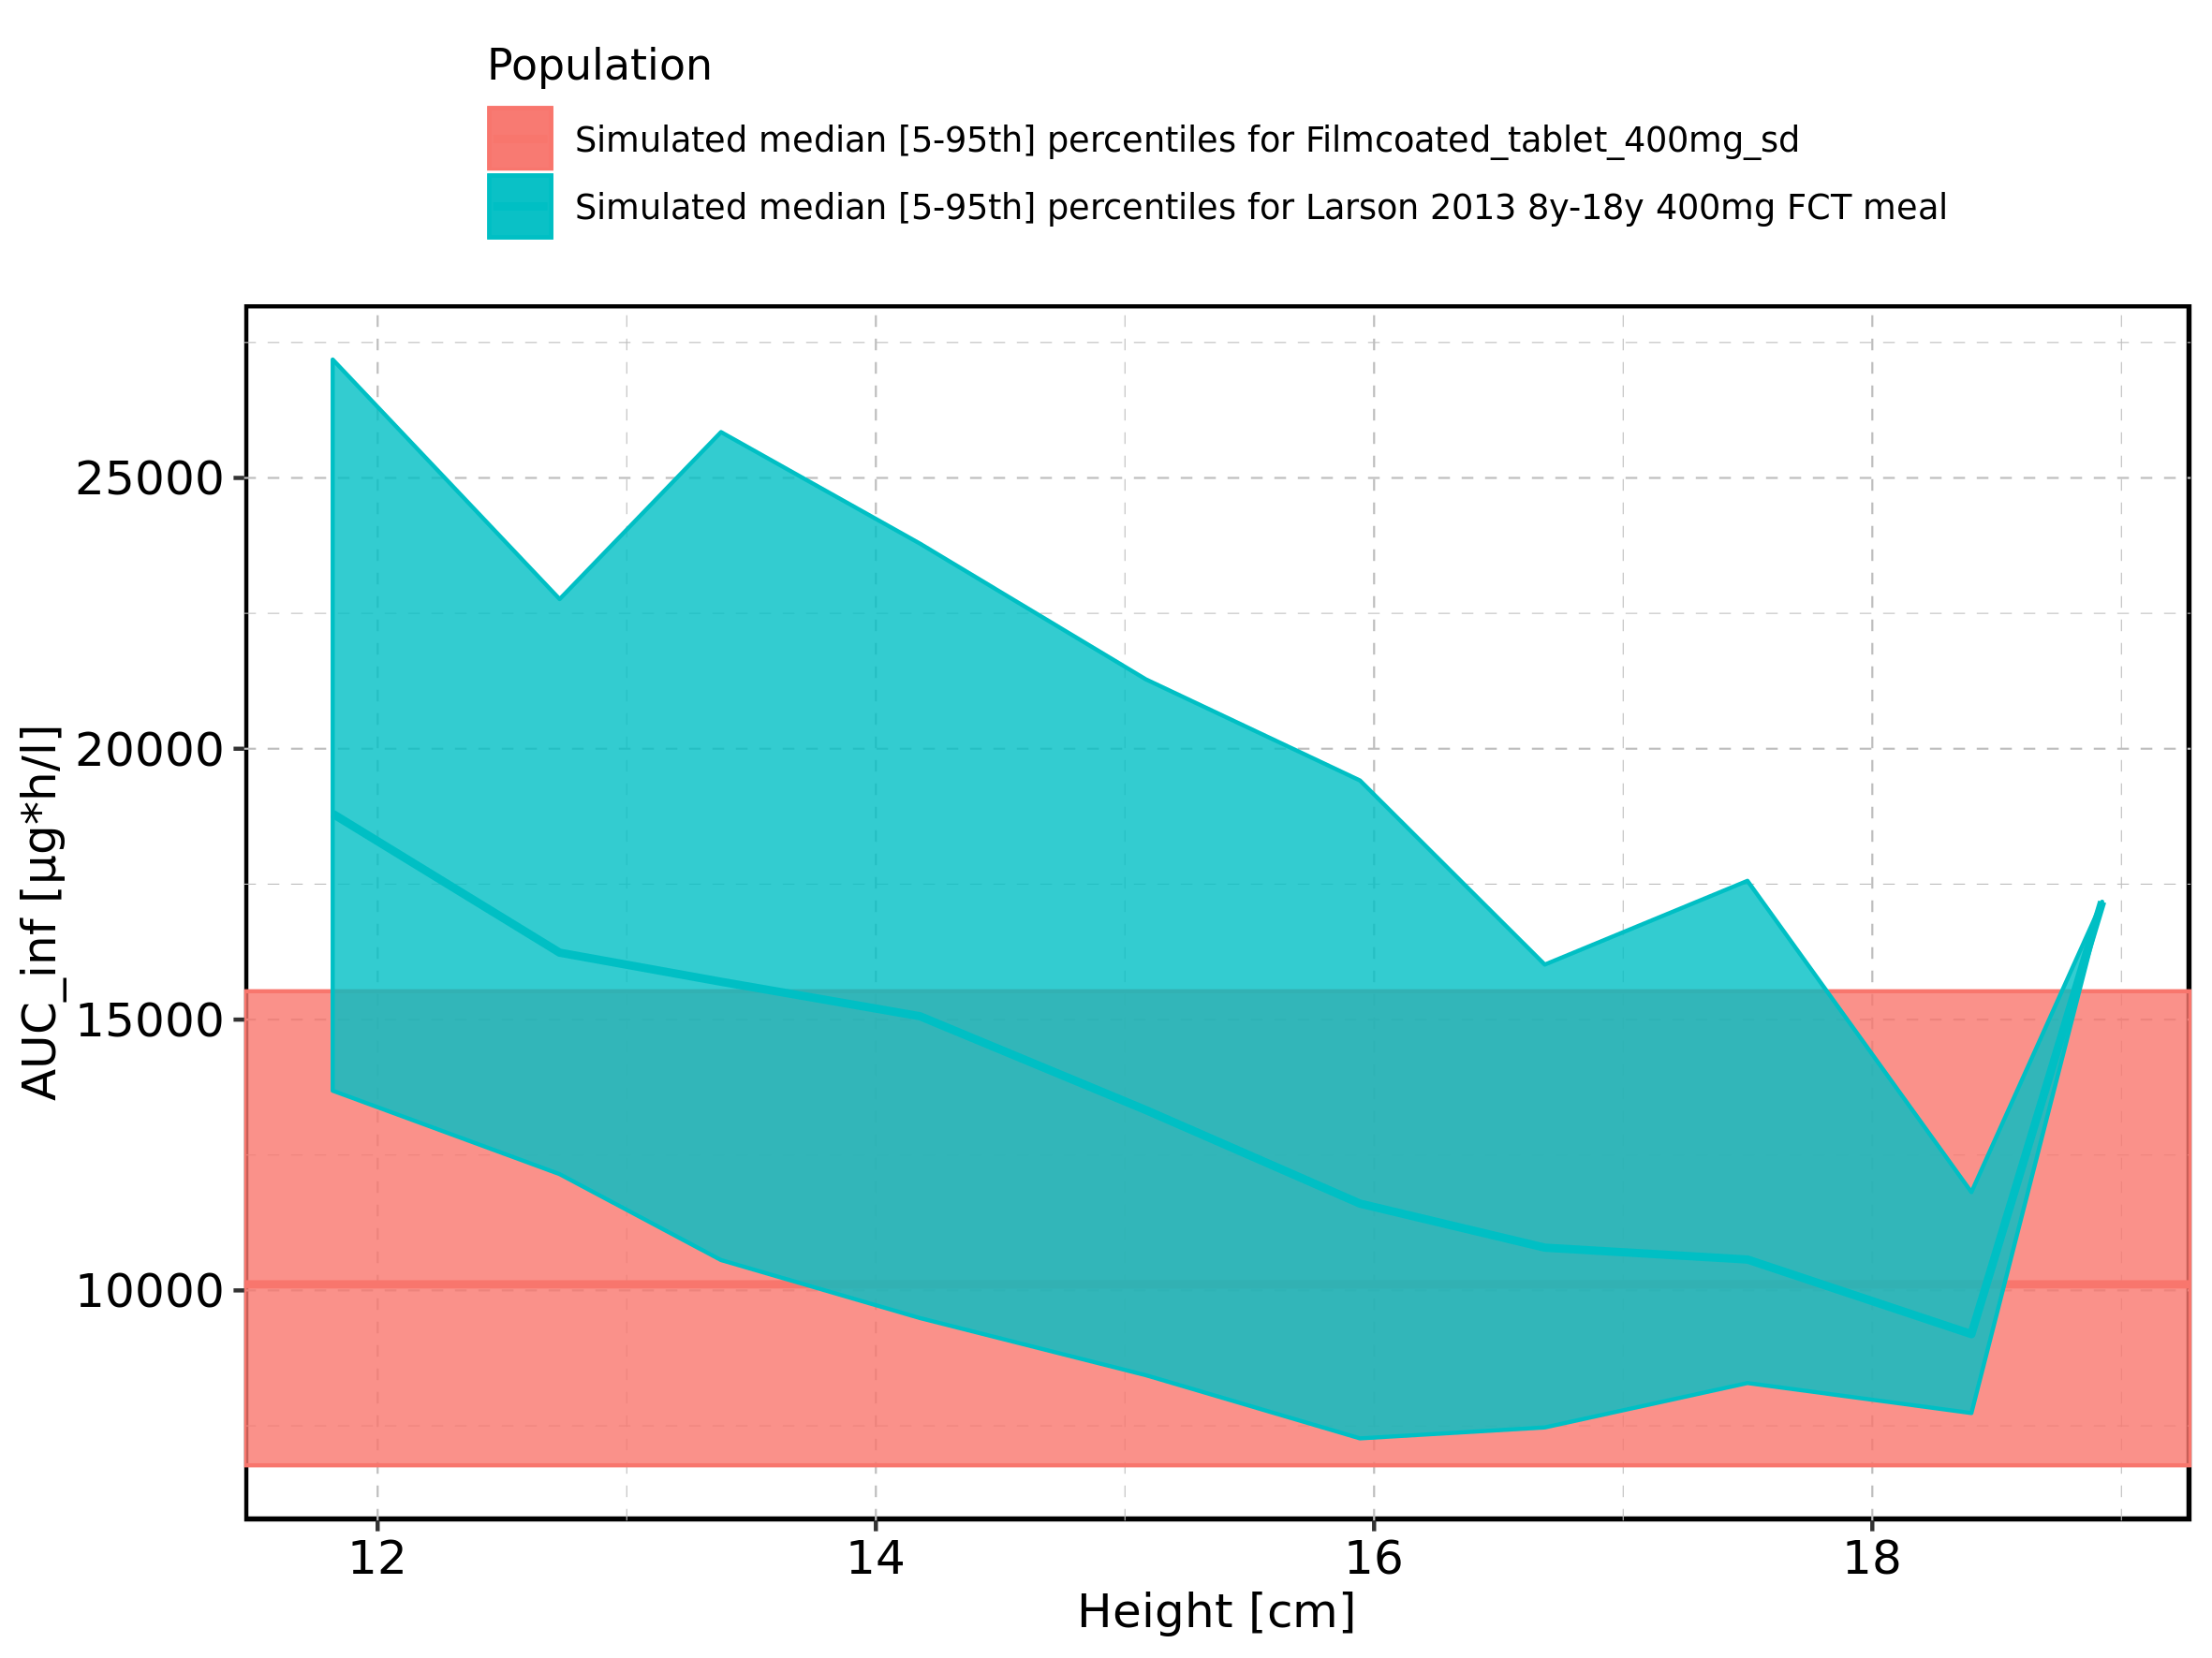

Figure 202: Height-dependence of AUC_inf for Larson 2013 8y-18y 400mg FCT meal in comparison to Filmcoated_tablet_400mg_sd. Profiles are plotted in a logarithmic scale.

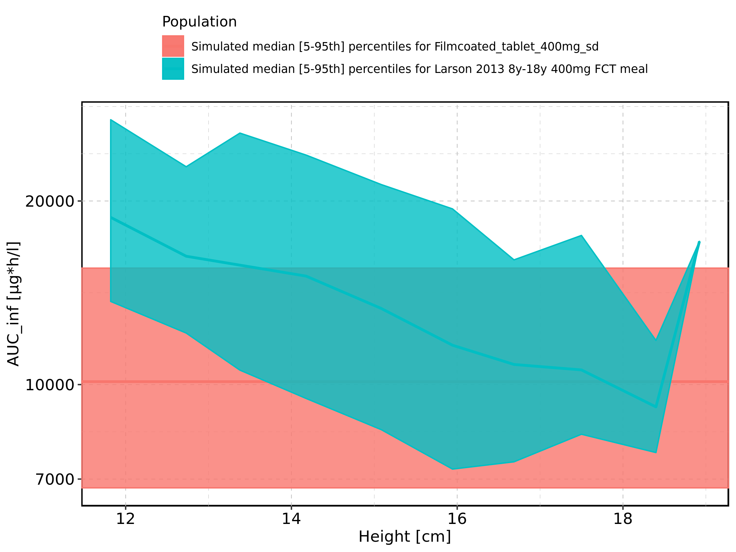

Figure 203: Height-dependence of AUC_inf for Larson 2013 8y-18y 400mg FCT meal. Profiles are plotted in a linear scale.

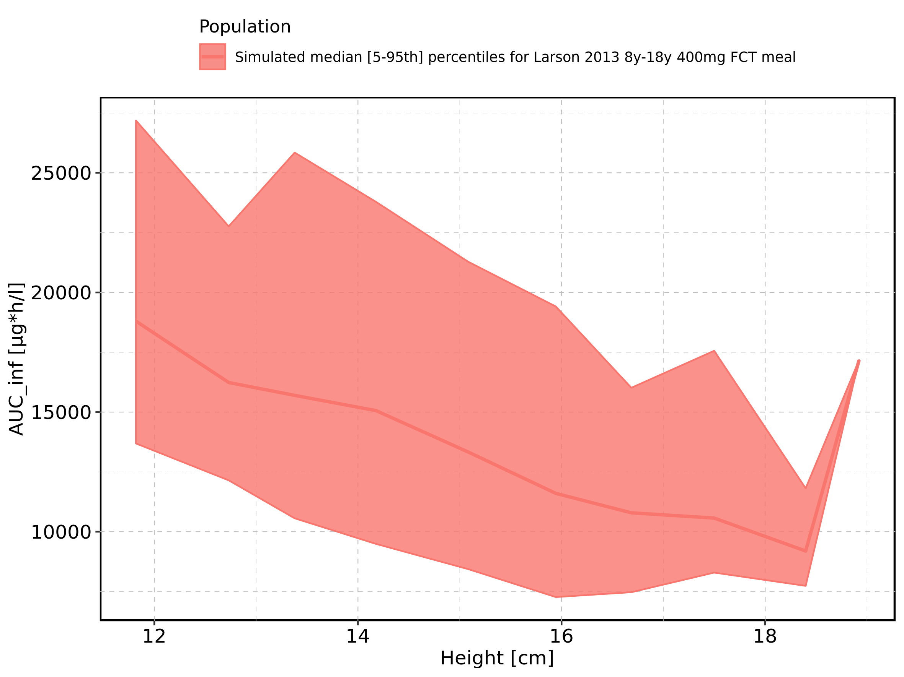

Figure 204: Height-dependence of AUC_inf for Larson 2013 8y-18y 400mg FCT meal. Profiles are plotted in a logarithmic scale.

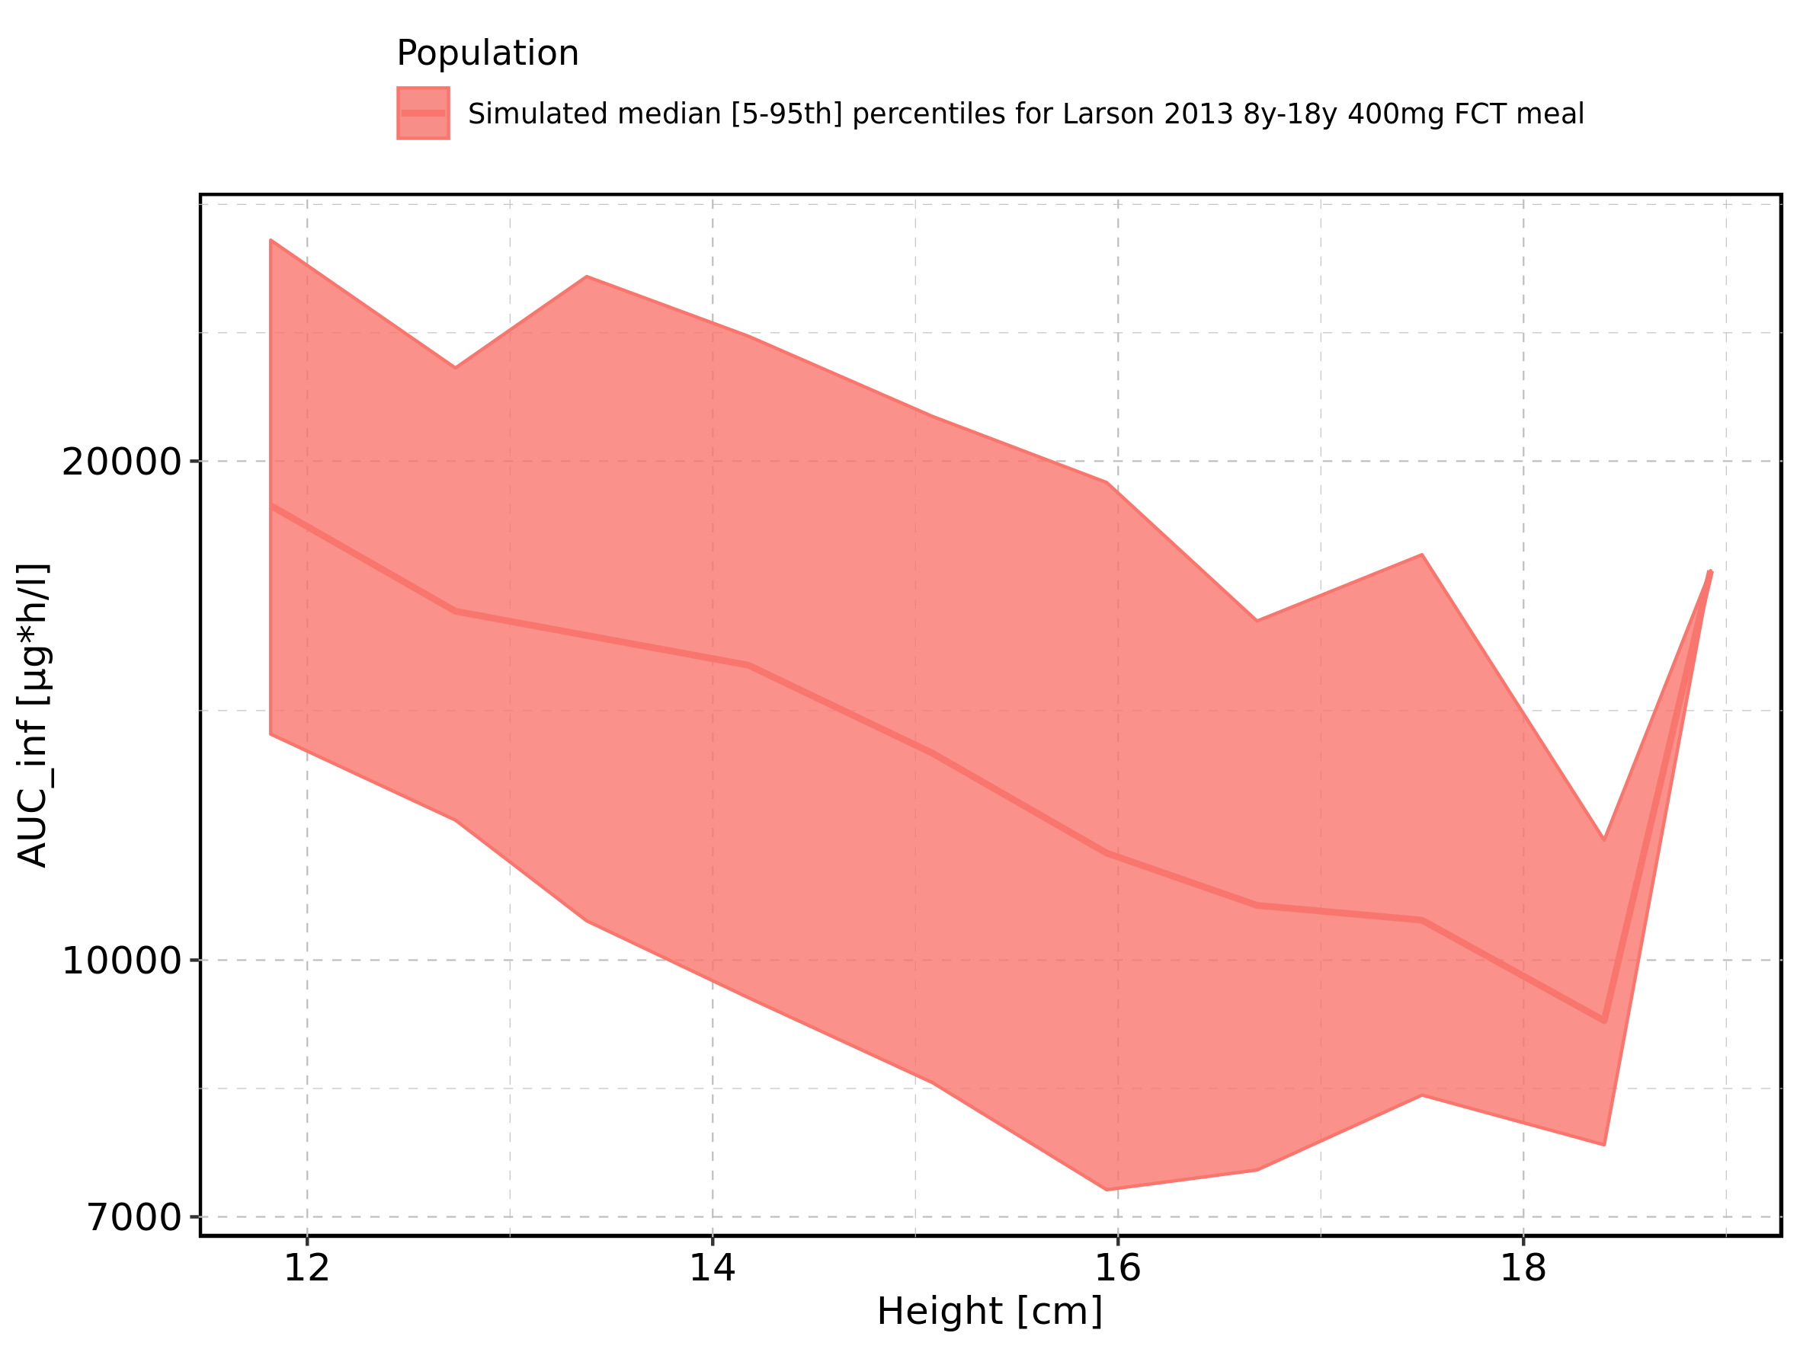

Figure 205: Height-dependence of AUC_inf for Filmcoated_tablet_400mg_sd. Profiles are plotted in a linear scale.

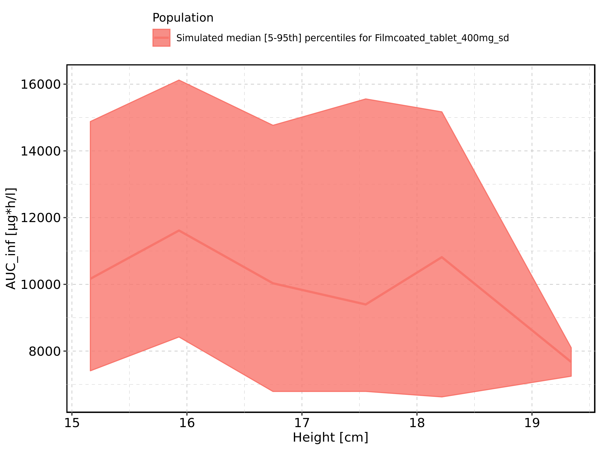

Figure 206: Height-dependence of AUC_inf for Filmcoated_tablet_400mg_sd. Profiles are plotted in a logarithmic scale.

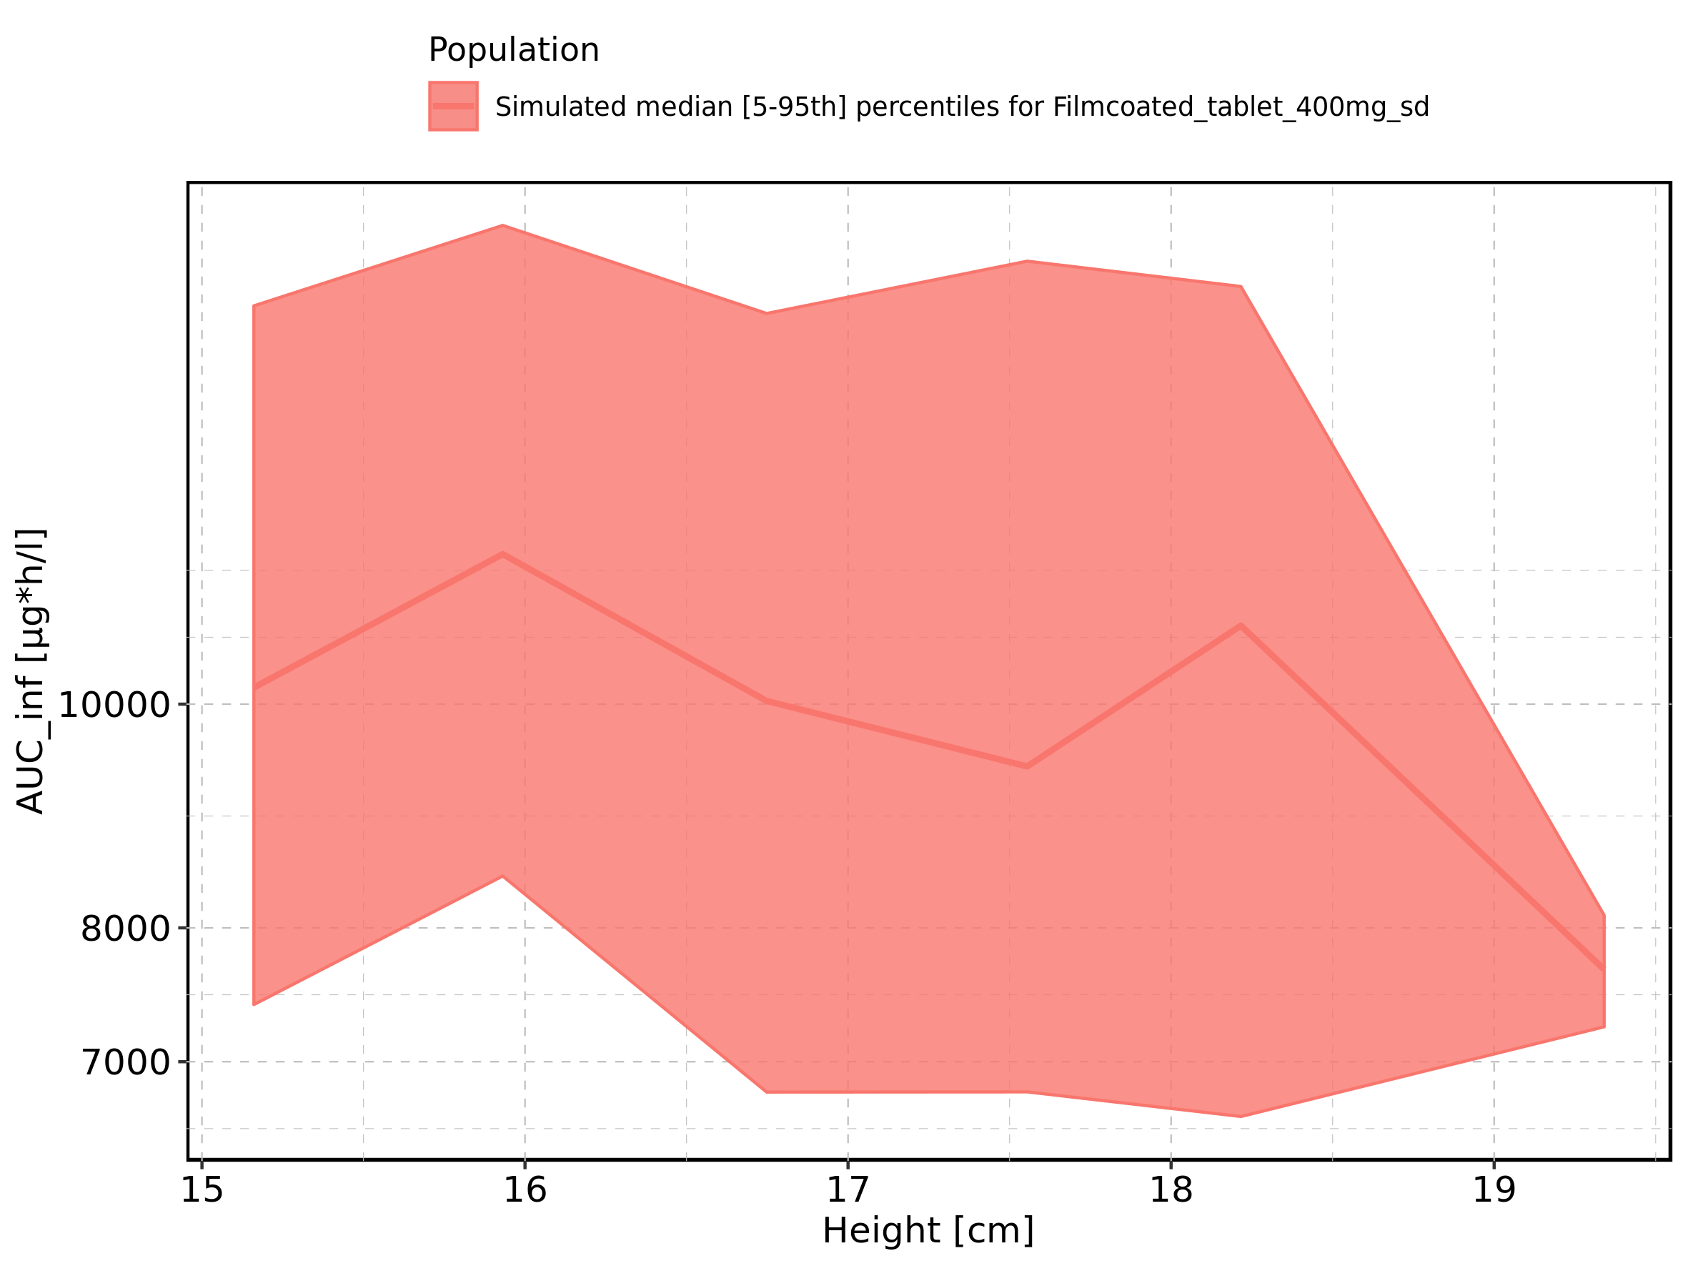

Figure 207: Weight-dependence of AUC_inf for Larson 2013 8y-18y 400mg FCT meal in comparison to Filmcoated_tablet_400mg_sd. Profiles are plotted in a linear scale.

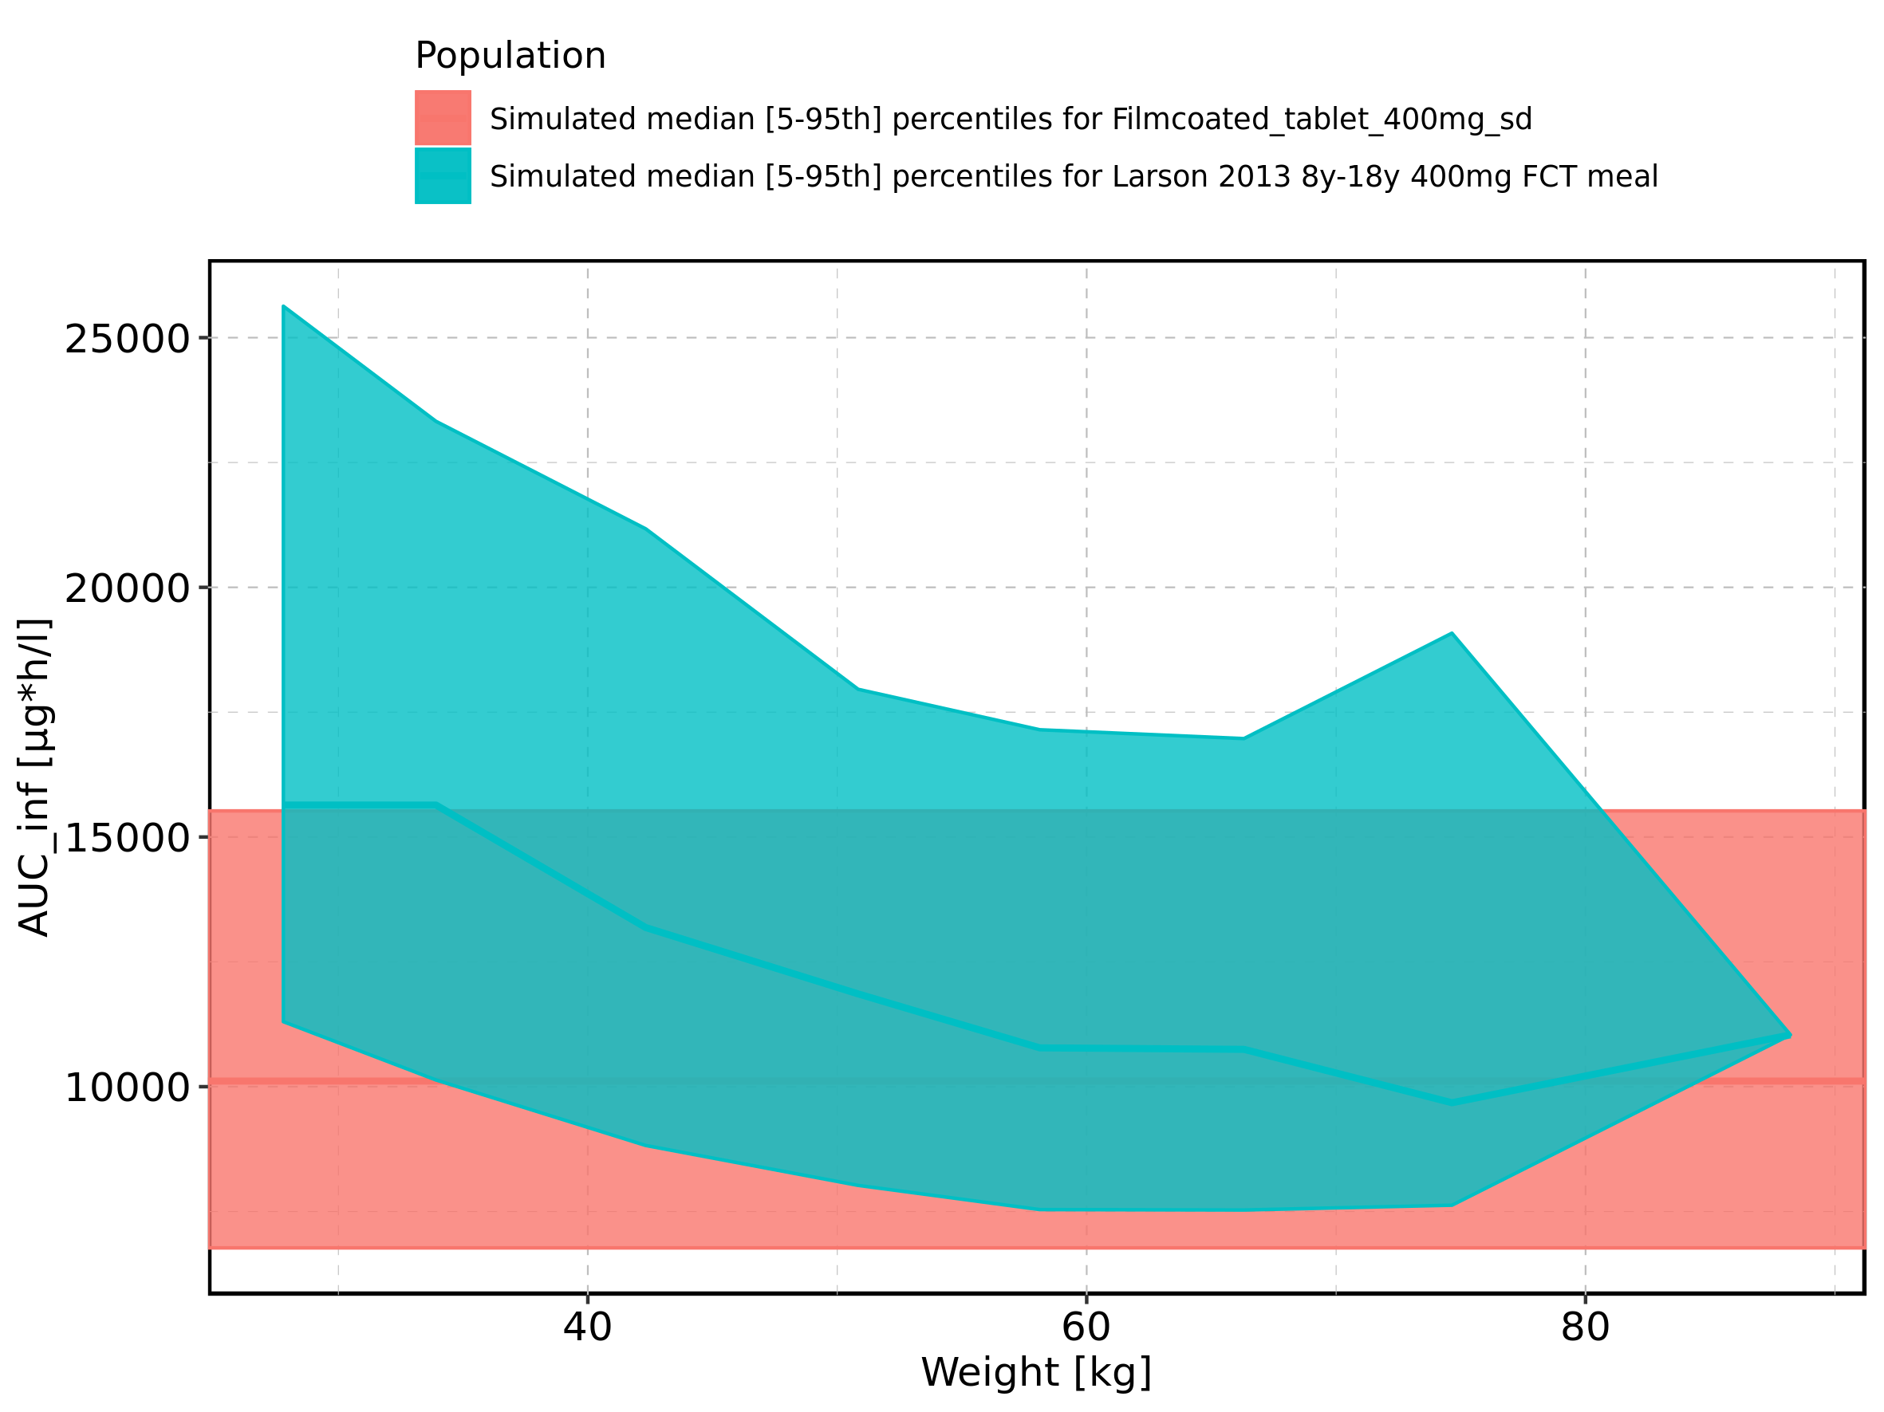

Figure 208: Weight-dependence of AUC_inf for Larson 2013 8y-18y 400mg FCT meal in comparison to Filmcoated_tablet_400mg_sd. Profiles are plotted in a logarithmic scale.

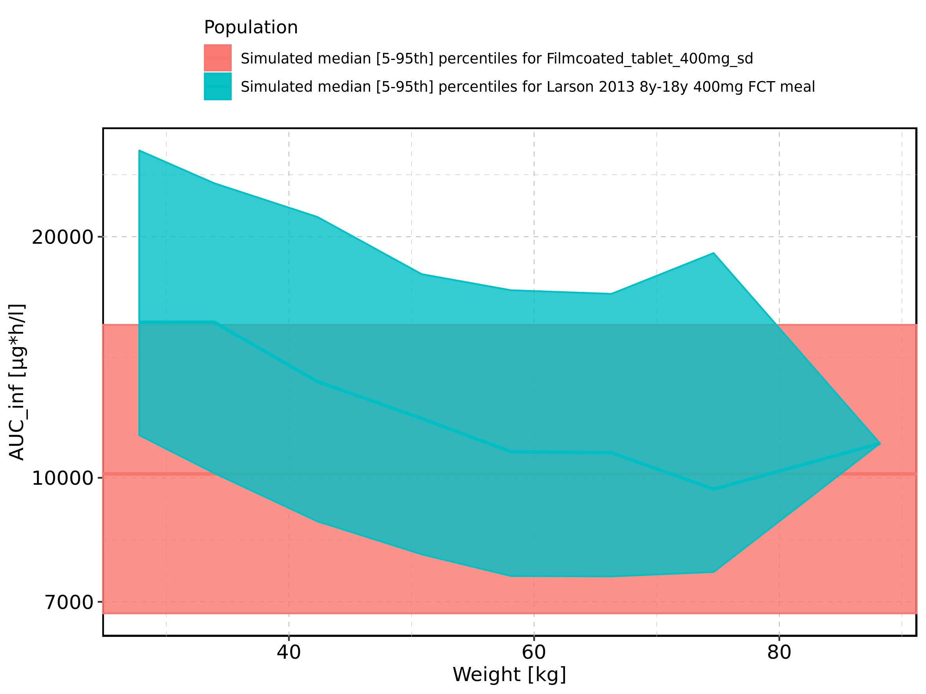

Figure 209: Weight-dependence of AUC_inf for Larson 2013 8y-18y 400mg FCT meal. Profiles are plotted in a linear scale.

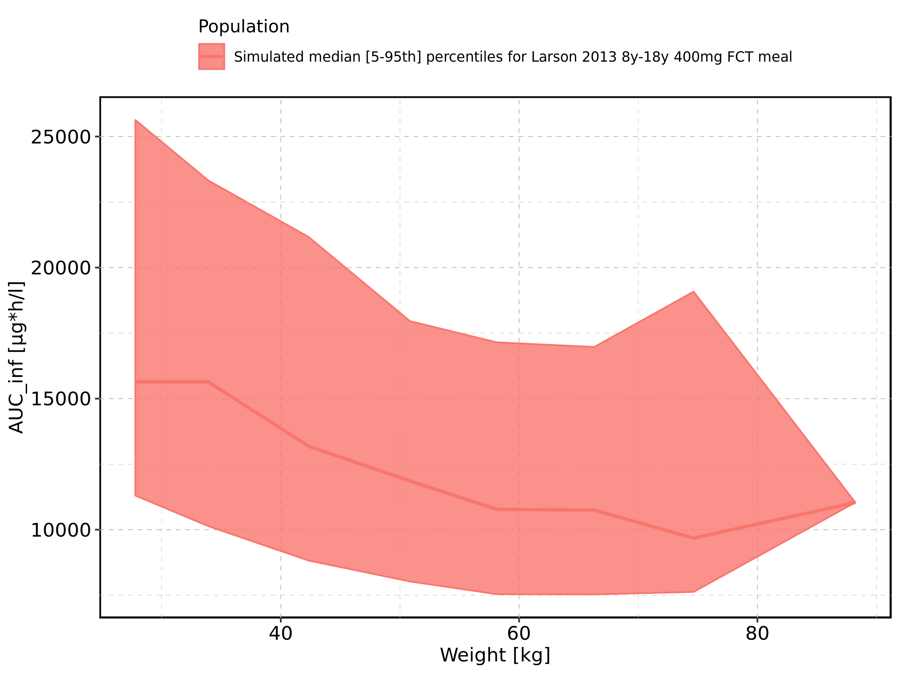

Figure 210: Weight-dependence of AUC_inf for Larson 2013 8y-18y 400mg FCT meal. Profiles are plotted in a logarithmic scale.

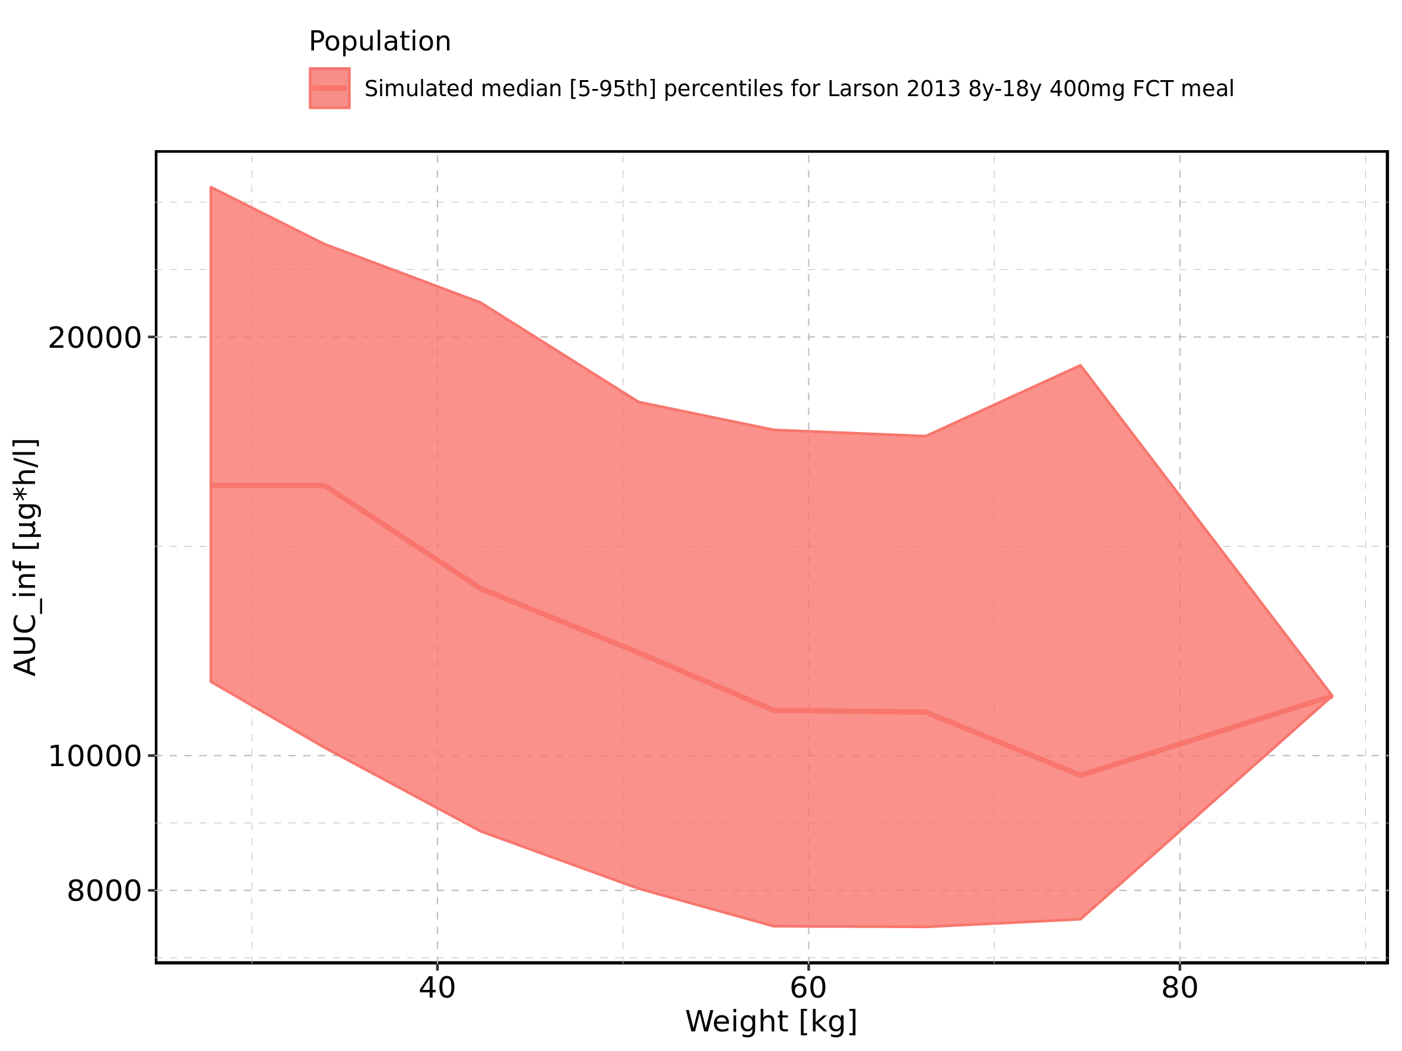

Figure 211: Weight-dependence of AUC_inf for Filmcoated_tablet_400mg_sd. Profiles are plotted in a linear scale.

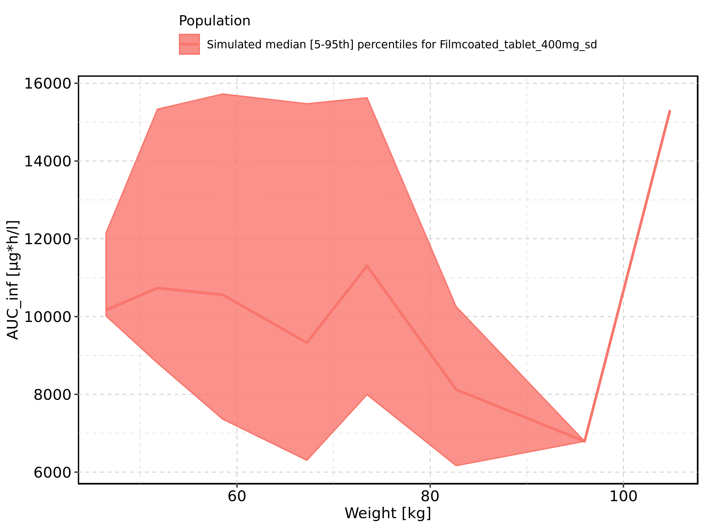

Figure 212: Weight-dependence of AUC_inf for Filmcoated_tablet_400mg_sd. Profiles are plotted in a logarithmic scale.

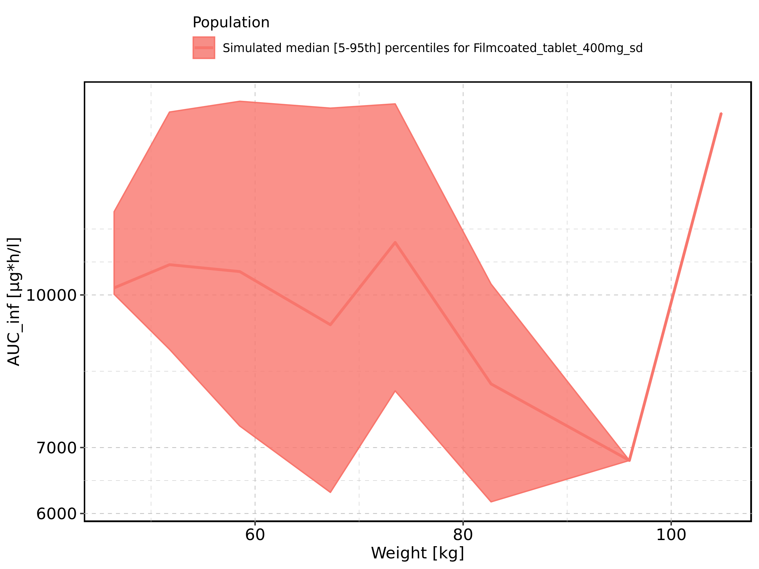

Figure 213: BMI-dependence of AUC_inf for Larson 2013 8y-18y 400mg FCT meal in comparison to Filmcoated_tablet_400mg_sd. Profiles are plotted in a linear scale.

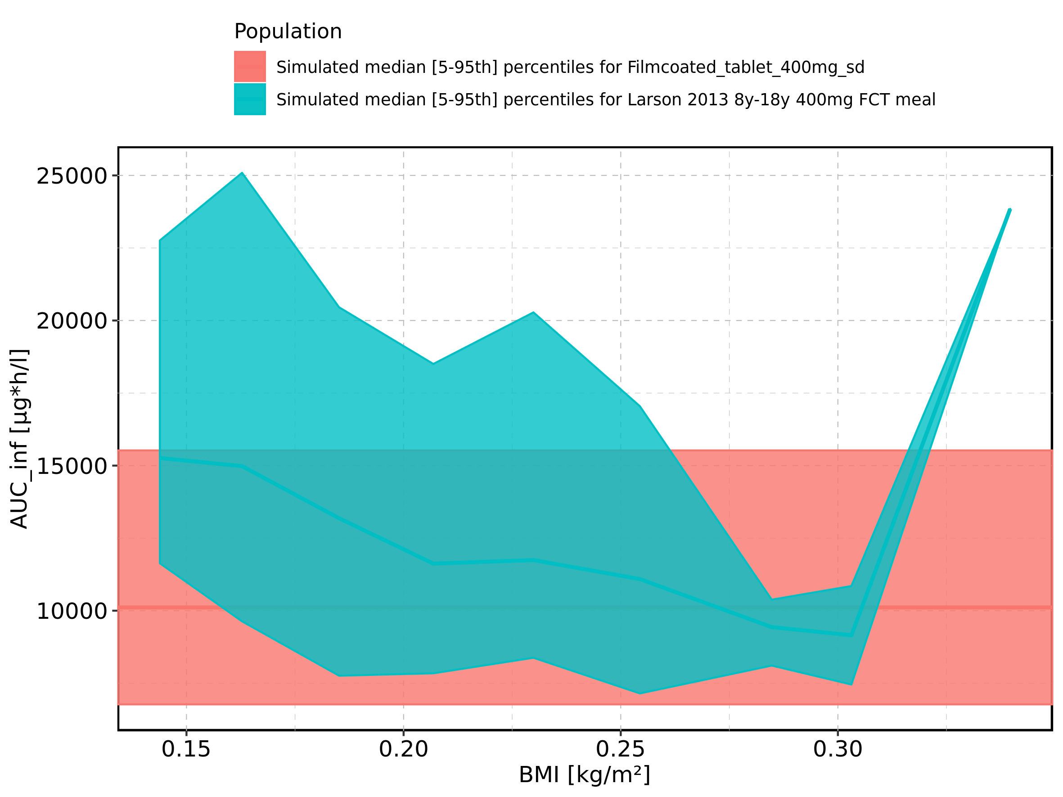

Figure 214: BMI-dependence of AUC_inf for Larson 2013 8y-18y 400mg FCT meal in comparison to Filmcoated_tablet_400mg_sd. Profiles are plotted in a logarithmic scale.

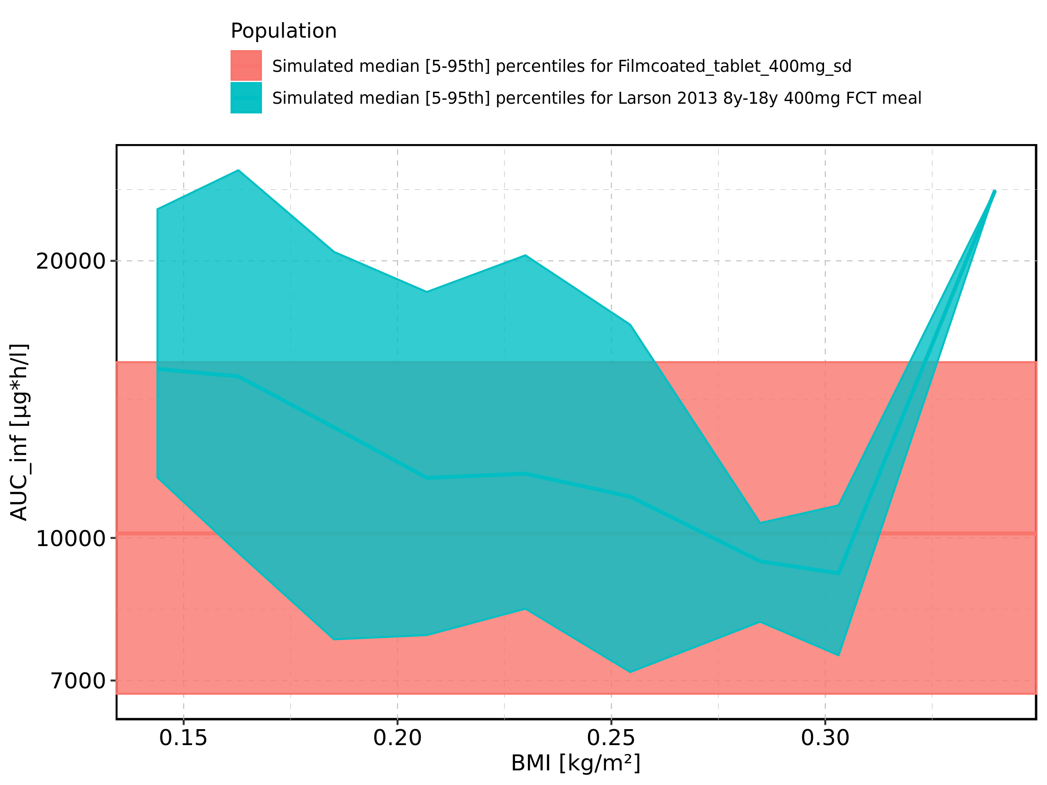

Figure 215: BMI-dependence of AUC_inf for Larson 2013 8y-18y 400mg FCT meal. Profiles are plotted in a linear scale.

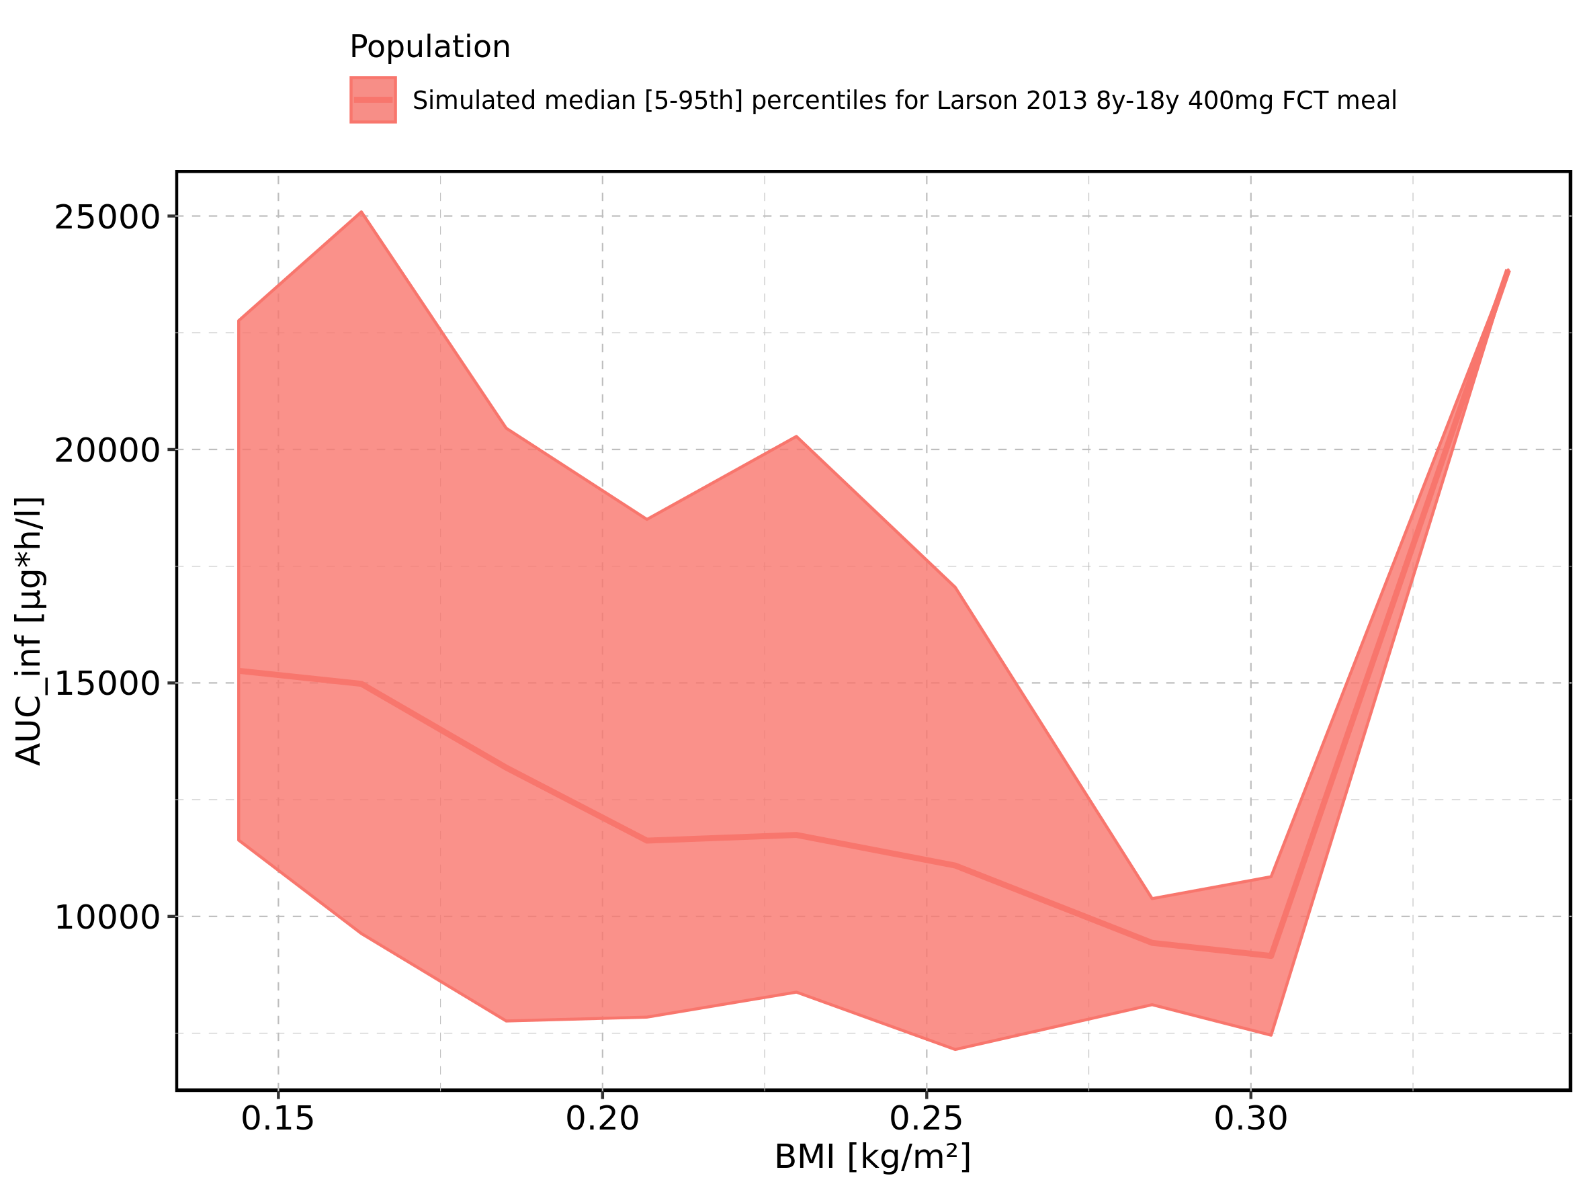

Figure 216: BMI-dependence of AUC_inf for Larson 2013 8y-18y 400mg FCT meal. Profiles are plotted in a logarithmic scale.

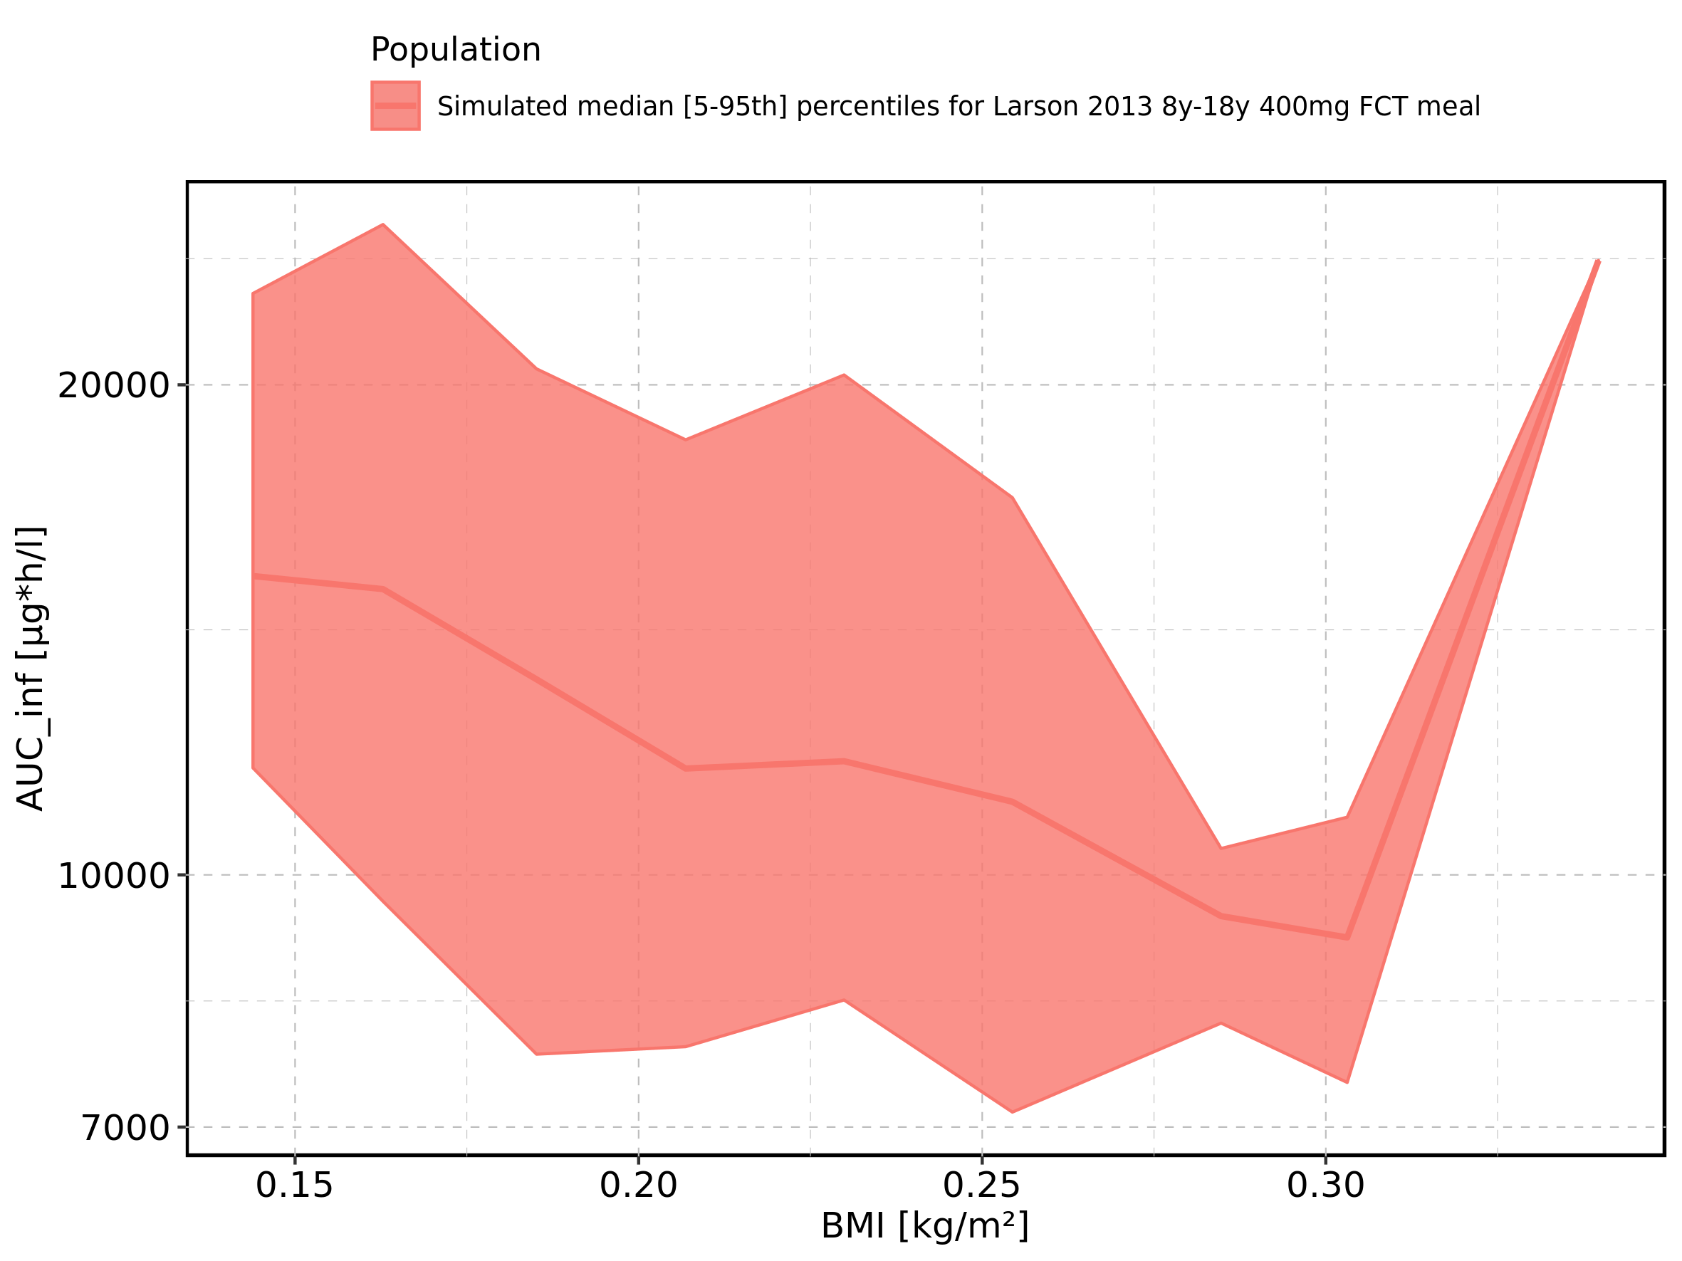

Figure 217: BMI-dependence of AUC_inf for Filmcoated_tablet_400mg_sd. Profiles are plotted in a linear scale.

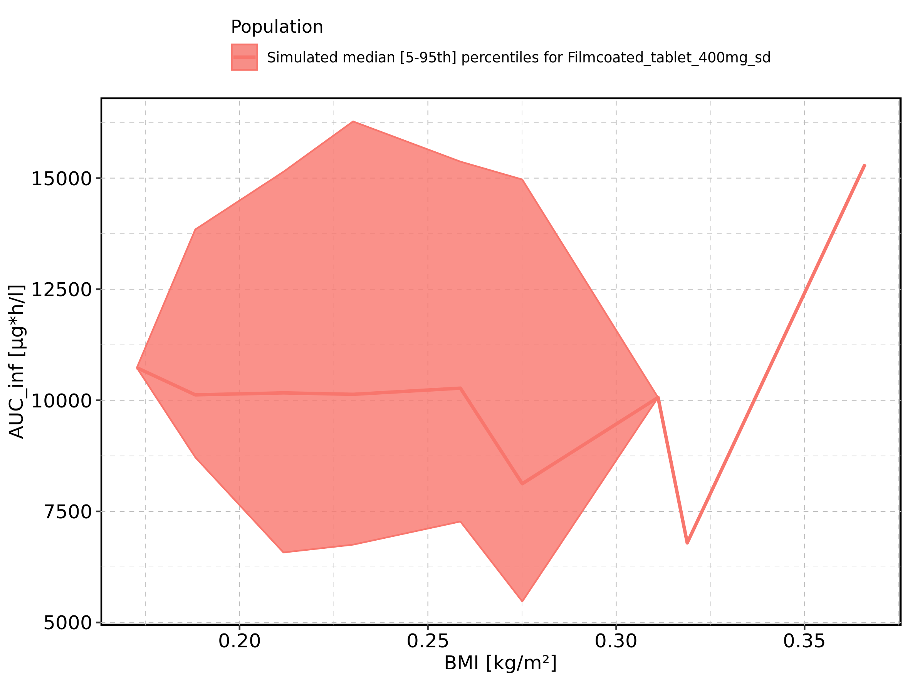

Figure 218: BMI-dependence of AUC_inf for Filmcoated_tablet_400mg_sd. Profiles are plotted in a logarithmic scale.

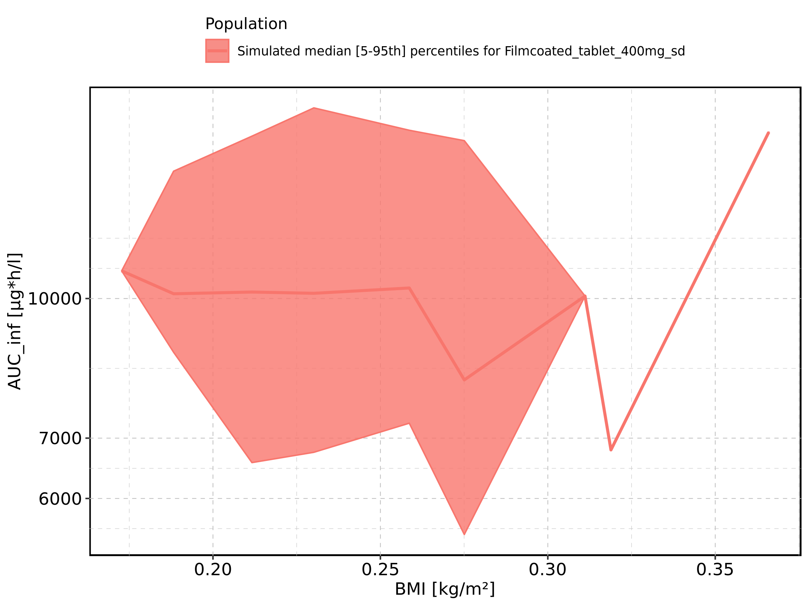

Figure 219: Gender-dependence of AUC_inf for Larson 2013 8y-18y 400mg FCT meal in comparison to Filmcoated_tablet_400mg_sd. Profiles are plotted in a linear scale.

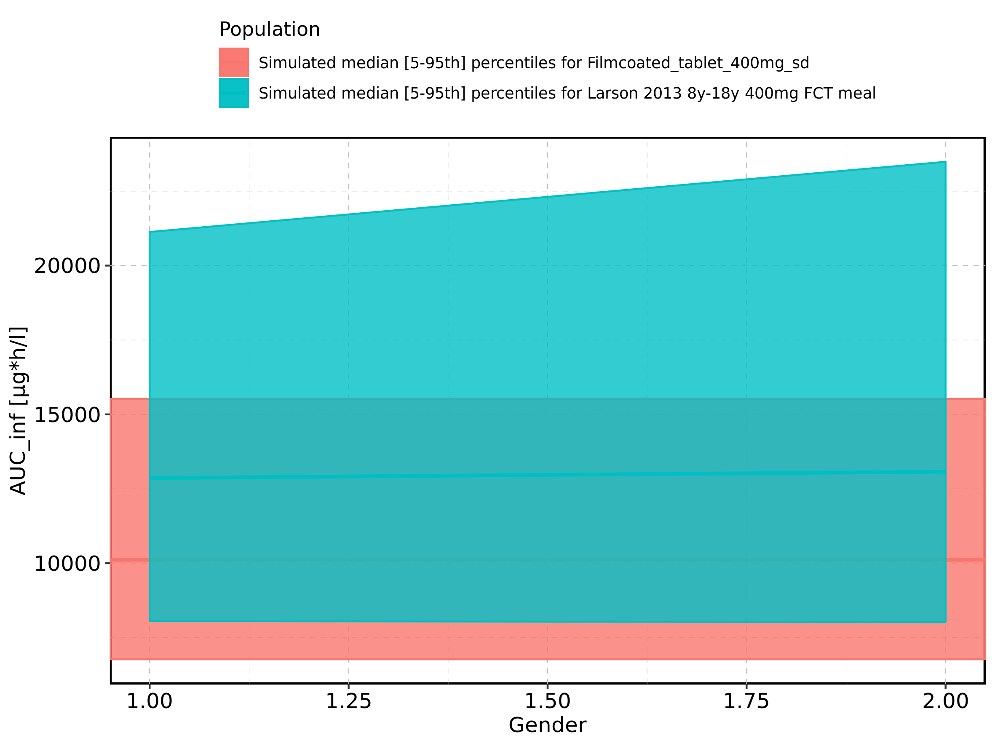

Figure 220: Gender-dependence of AUC_inf for Larson 2013 8y-18y 400mg FCT meal in comparison to Filmcoated_tablet_400mg_sd. Profiles are plotted in a logarithmic scale.

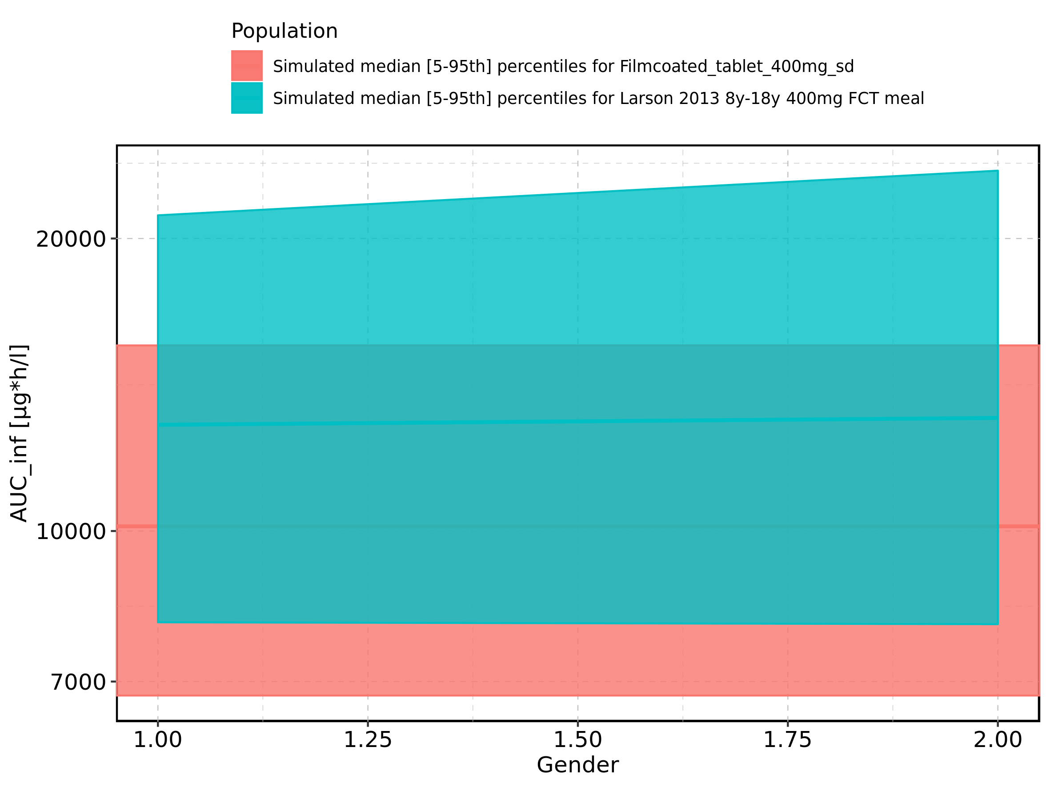

Figure 221: Gender-dependence of AUC_inf for Larson 2013 8y-18y 400mg FCT meal. Profiles are plotted in a linear scale.

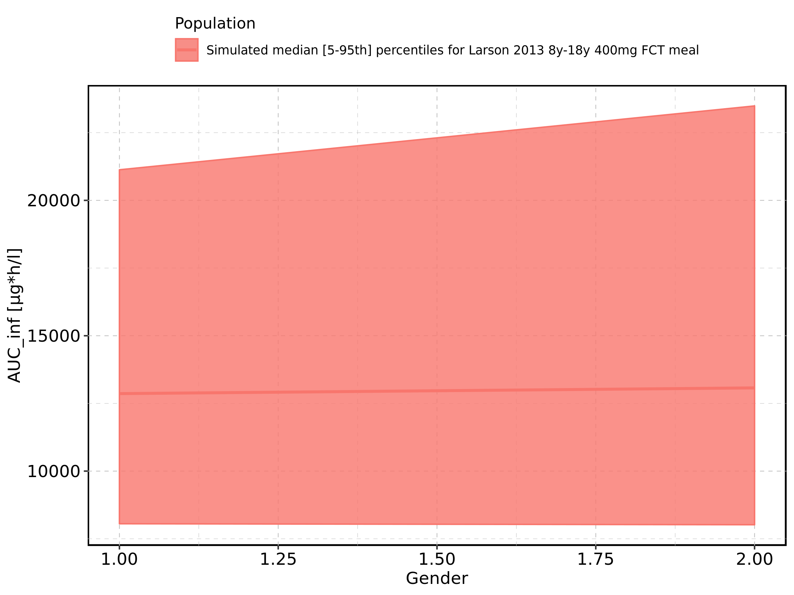

Figure 222: Gender-dependence of AUC_inf for Larson 2013 8y-18y 400mg FCT meal. Profiles are plotted in a logarithmic scale.

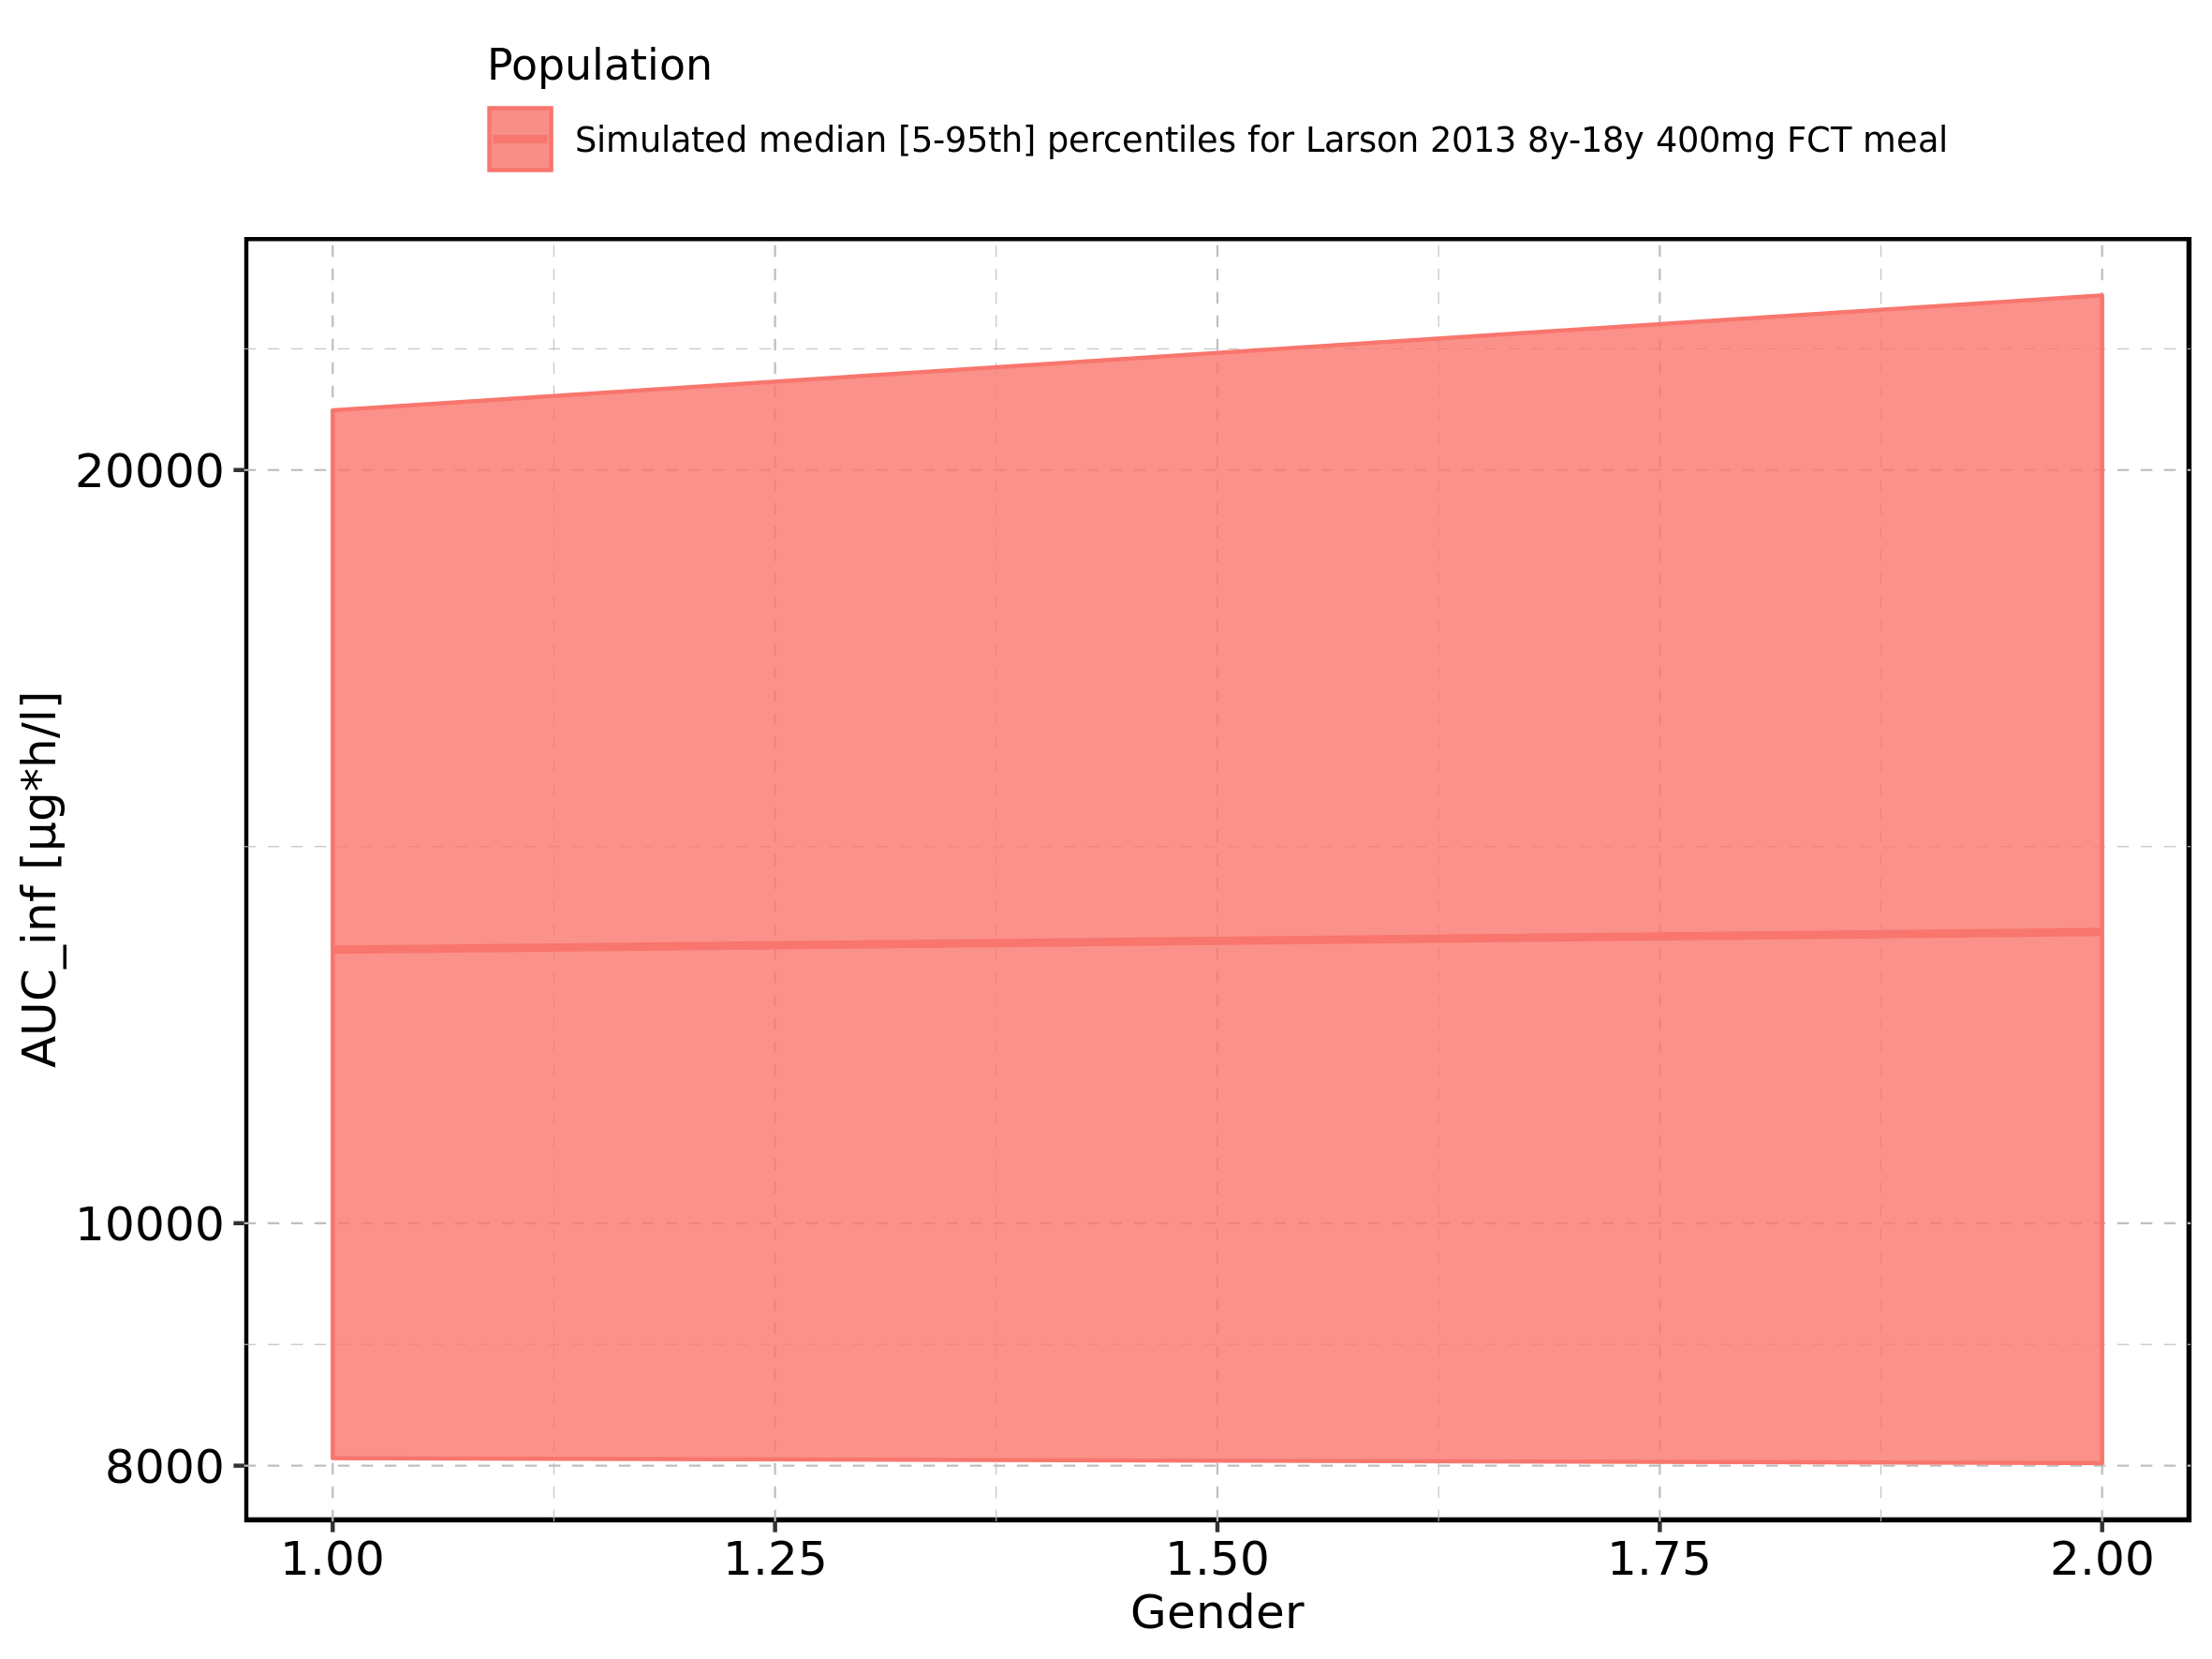

Figure 223: Gender-dependence of AUC_inf for Filmcoated_tablet_400mg_sd. Profiles are plotted in a linear scale.

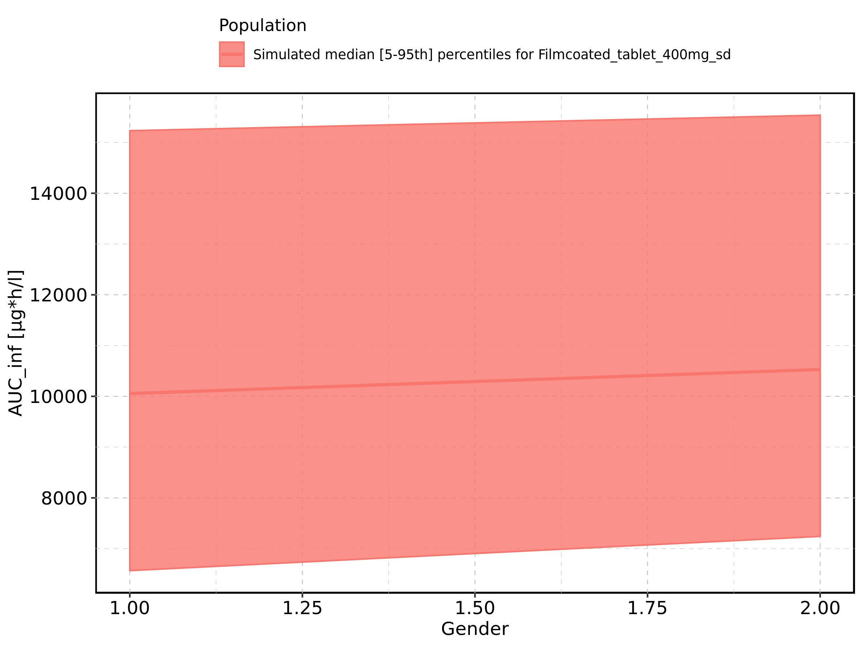

Figure 224: Gender-dependence of AUC_inf for Filmcoated_tablet_400mg_sd. Profiles are plotted in a logarithmic scale.

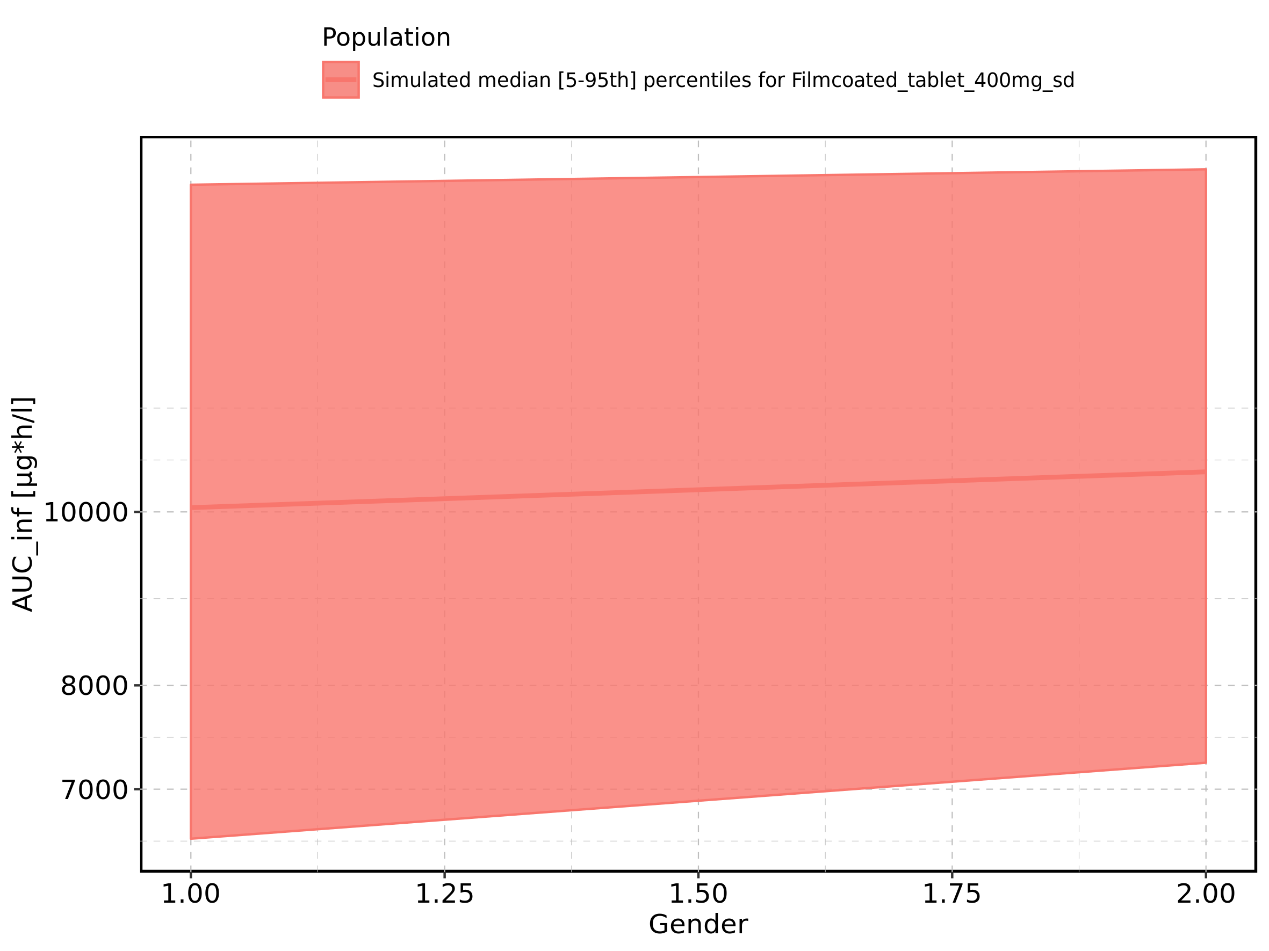

Figure 225: AUC_inf_norm of Raltegravir shown as box-whisker plot, which indicates the 5th, 25th, 50th, 75th, and 95th percentiles in linear scale.

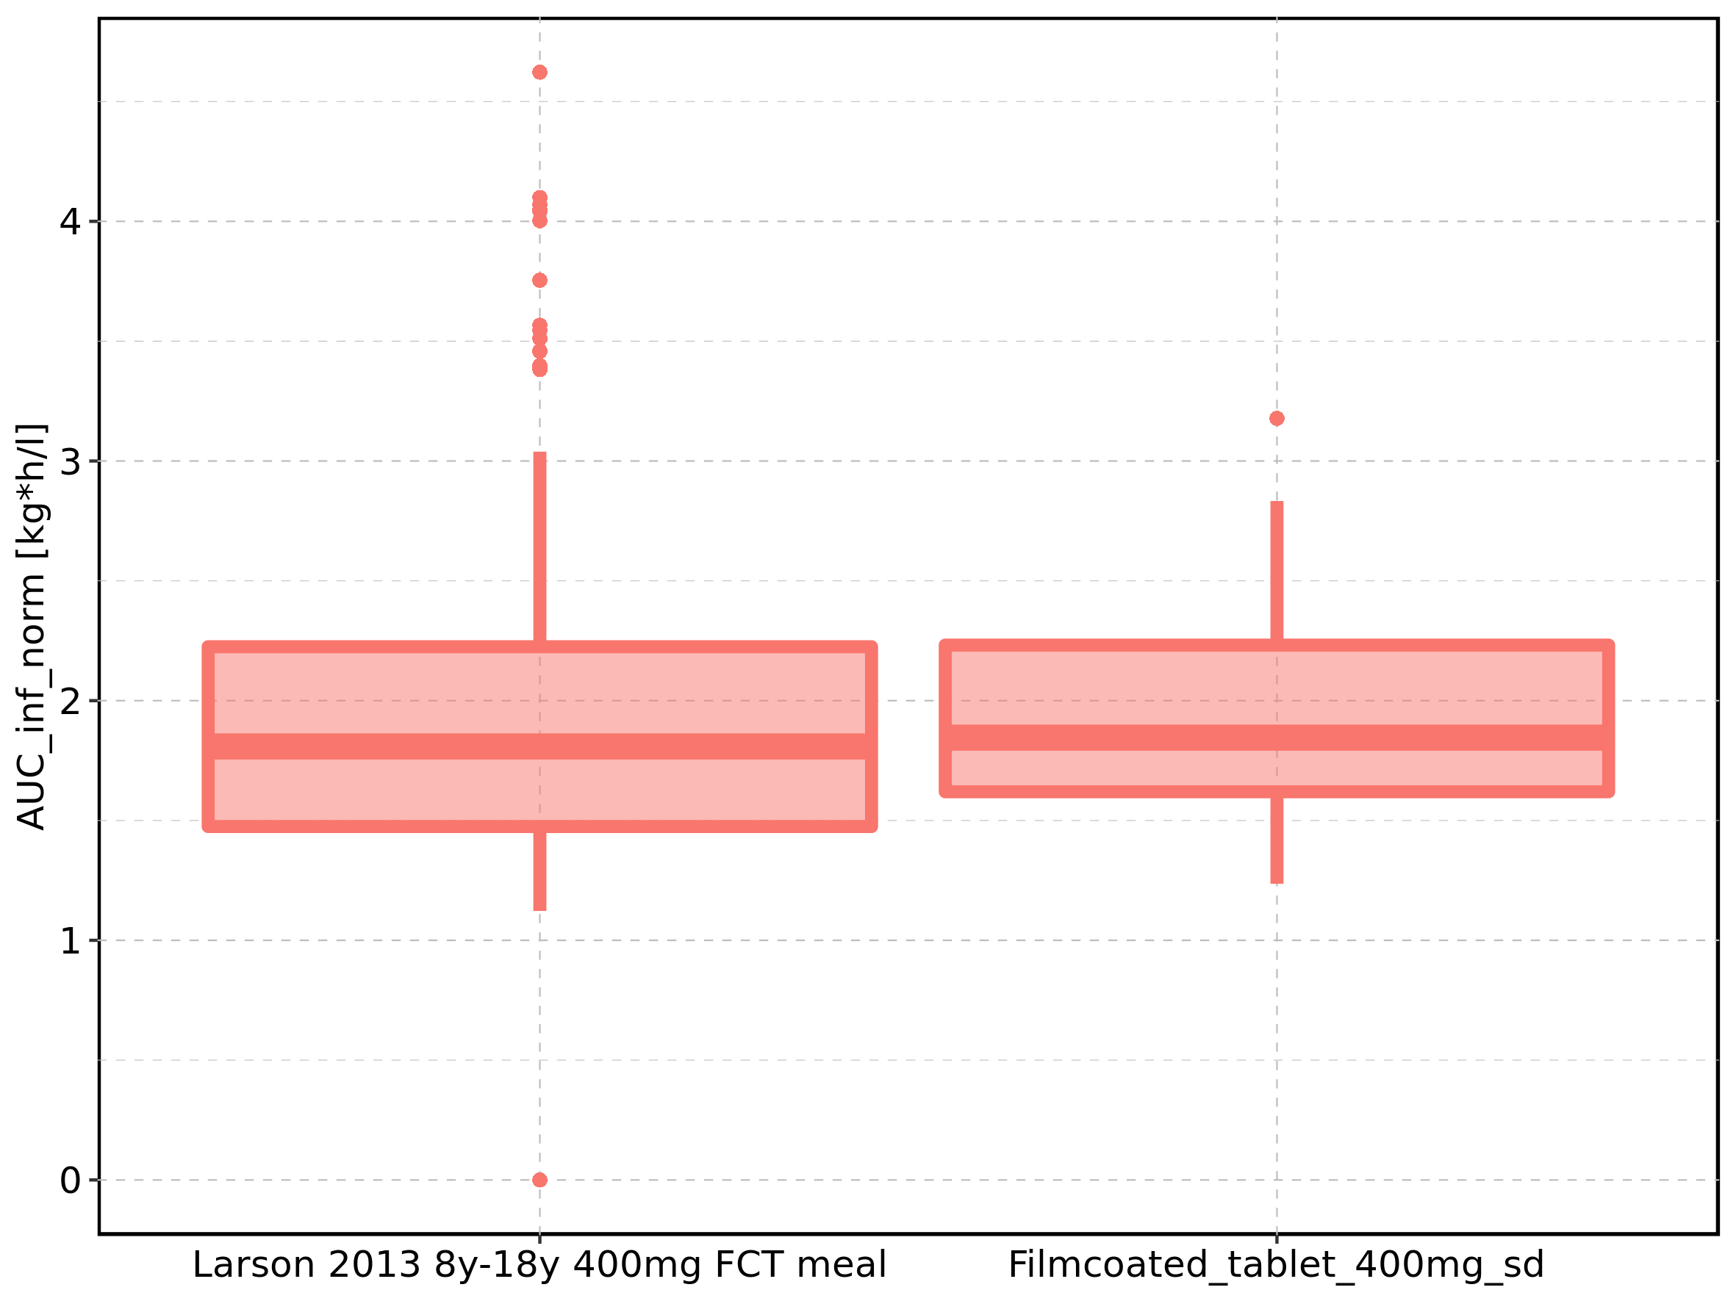

|  |  |  |  |  |  |  |  |  |  |  |
| --- | --- | --- | --- | --- | --- | --- | --- | --- | --- | --- |
| Population | N | 5th percentile | 25th percentile | 50th percentile | 75th percentile | 95th percentile | mean | standard deviation | geo mean | geo standard deviation |
| Larson 2013 8y-18y 400mg FCT meal | 500 | 1.122459 | 1.474697 | 1.808947 | 2.224967 | 3.039113 | 1.911305 | 0.6244296 | 0.000000 | NA |
| Filmcoated_tablet_400mg_sd | 100 | 1.235885 | 1.619815 | 1.845499 | 2.231818 | 2.832975 | 1.939375 | 0.5032643 | 1.875269 | 1.300506 |

Figure 226: AUC_inf_norm of Raltegravir shown as box-whisker plot, which indicates the 5th, 25th, 50th, 75th, and 95th percentiles in logarithmic scale.

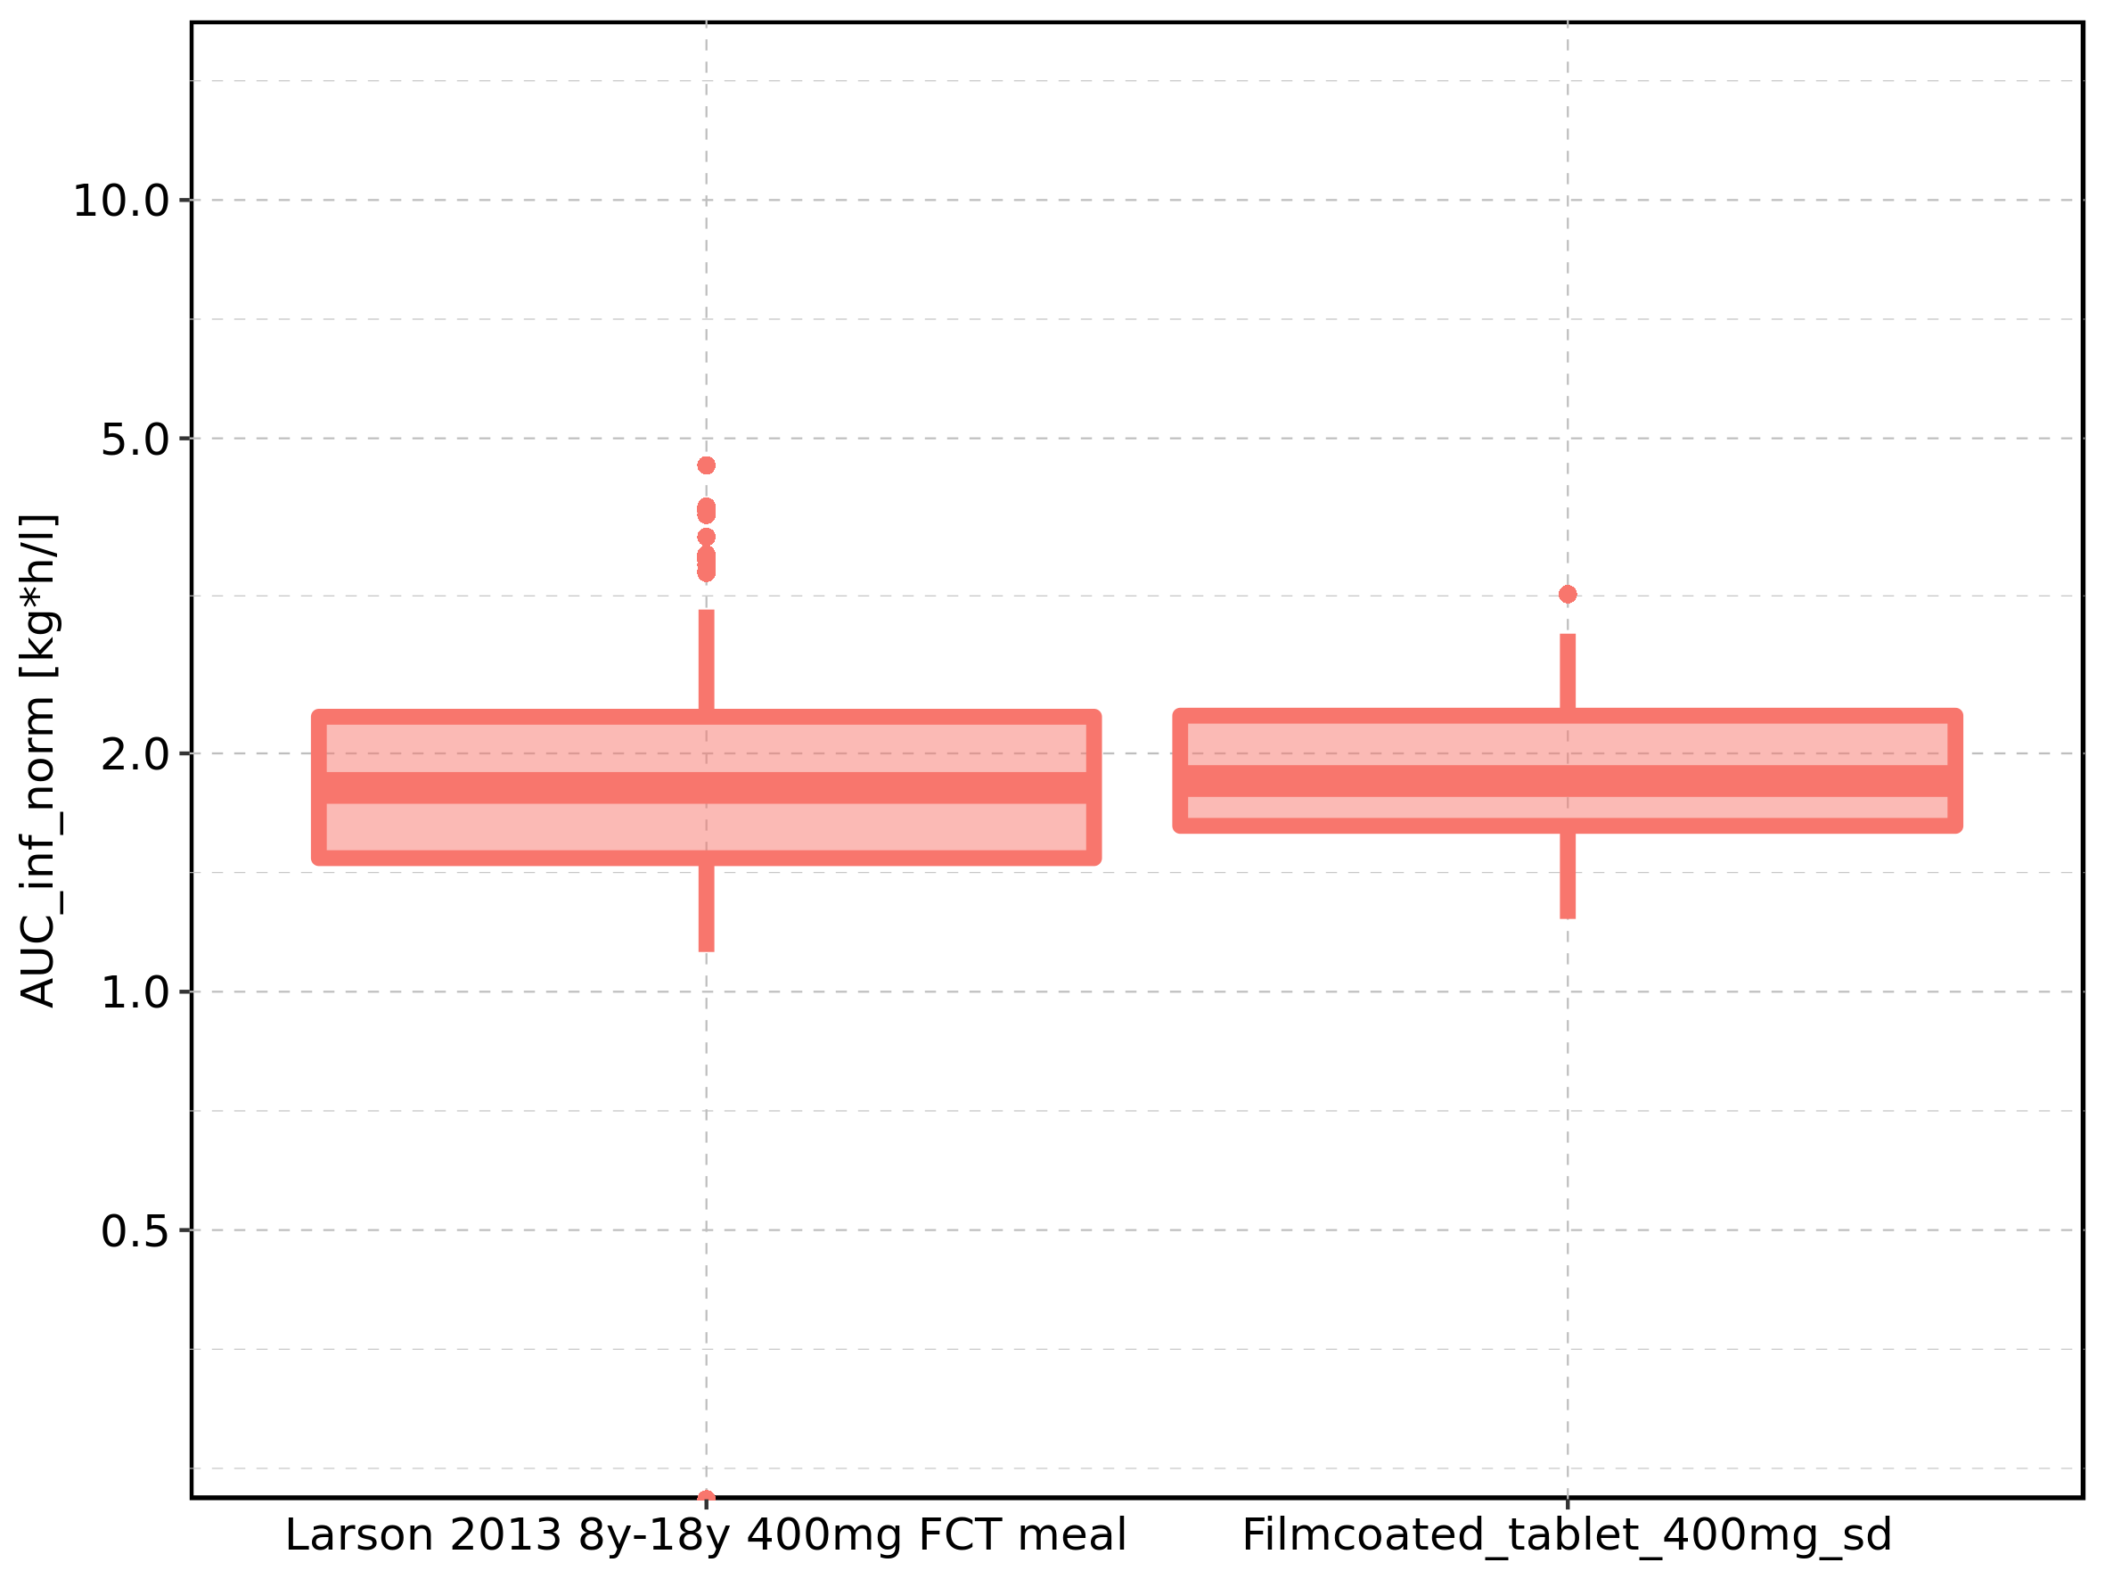

Figure 227: Age-dependence of AUC_inf_norm for Larson 2013 8y-18y 400mg FCT meal in comparison to Filmcoated_tablet_400mg_sd. Profiles are plotted in a linear scale.

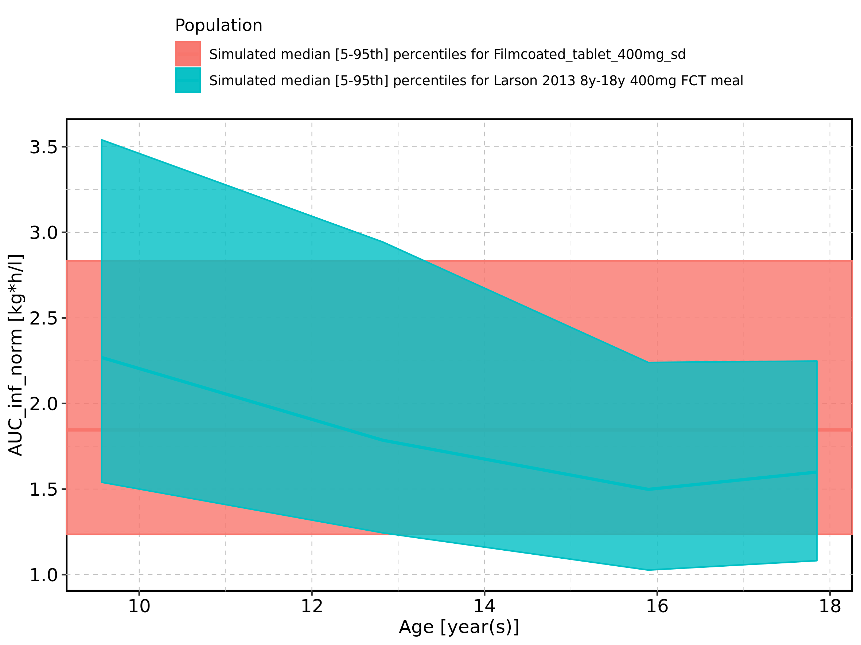

Figure 228: Age-dependence of AUC_inf_norm for Larson 2013 8y-18y 400mg FCT meal in comparison to Filmcoated_tablet_400mg_sd. Profiles are plotted in a logarithmic scale.

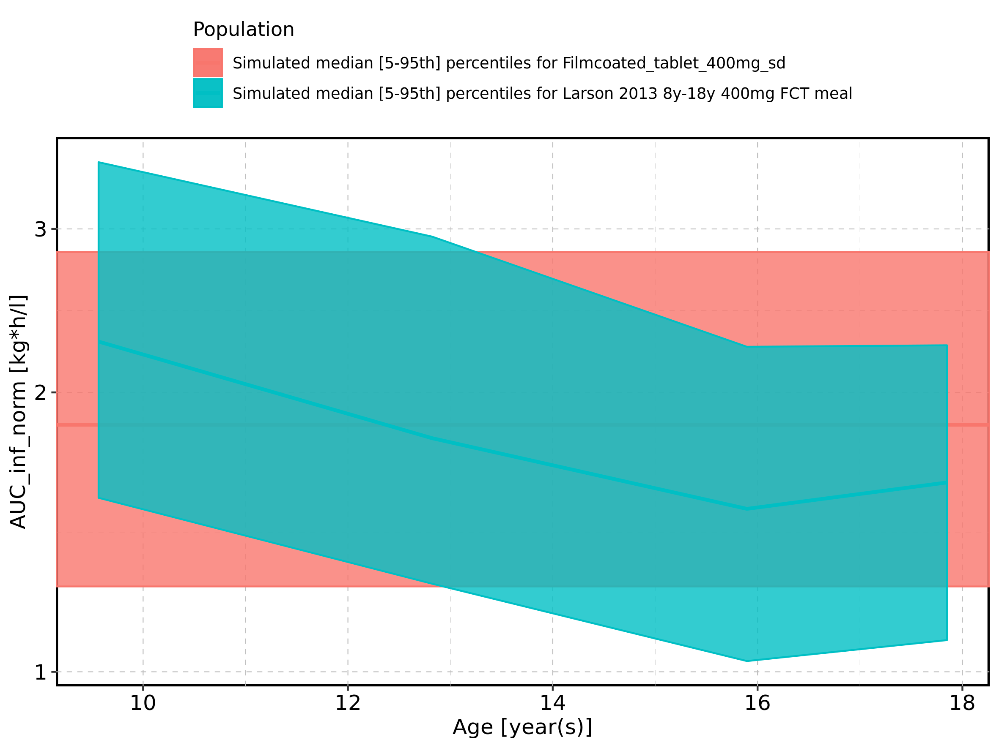

Figure 229: Age-dependence of AUC_inf_norm for Larson 2013 8y-18y 400mg FCT meal. Profiles are plotted in a linear scale.

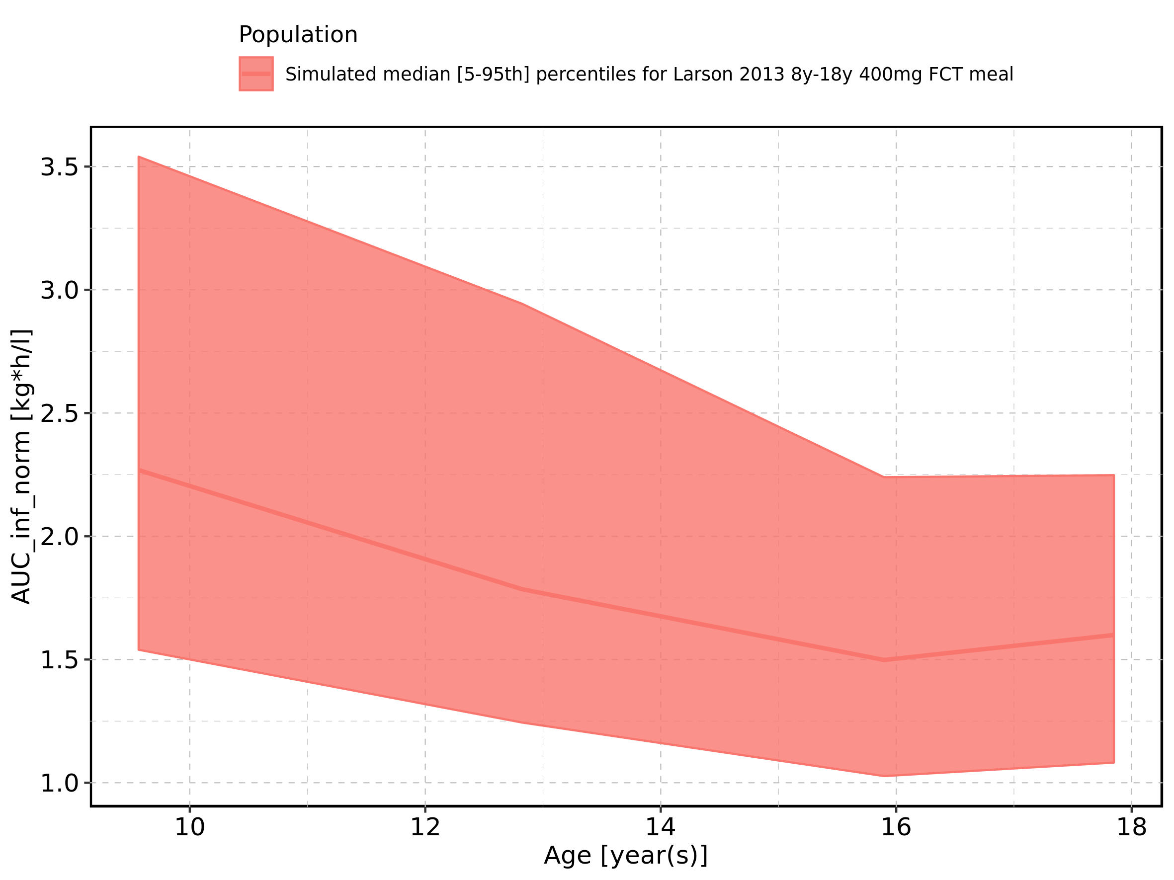

Figure 230: Age-dependence of AUC_inf_norm for Larson 2013 8y-18y 400mg FCT meal. Profiles are plotted in a logarithmic scale.

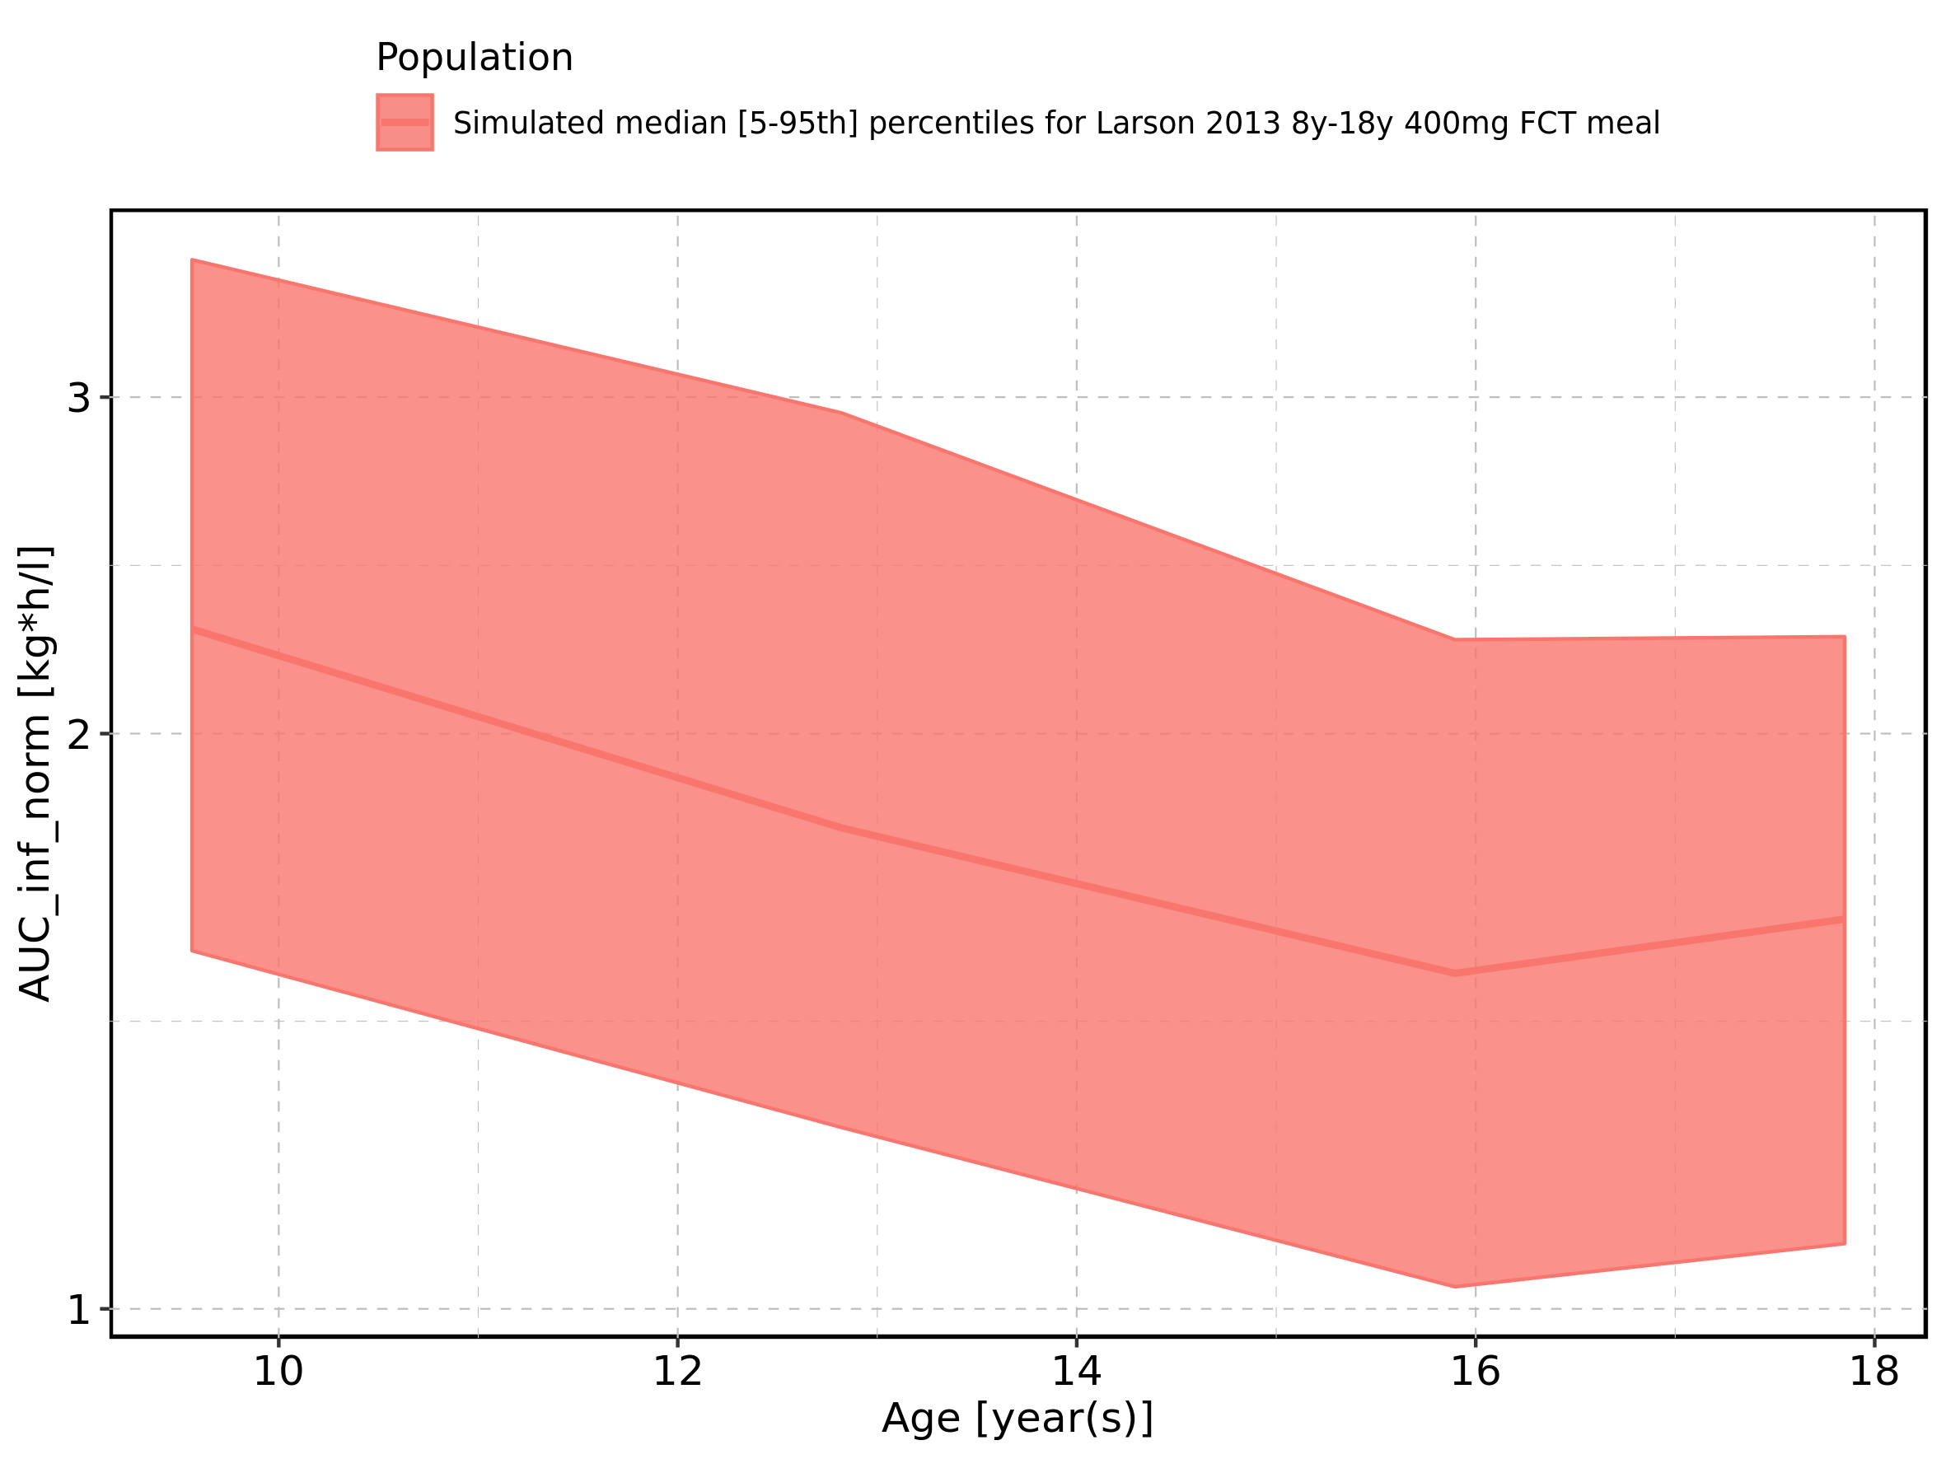

Figure 231: Age-dependence of AUC_inf_norm for Filmcoated_tablet_400mg_sd. Profiles are plotted in a linear scale.

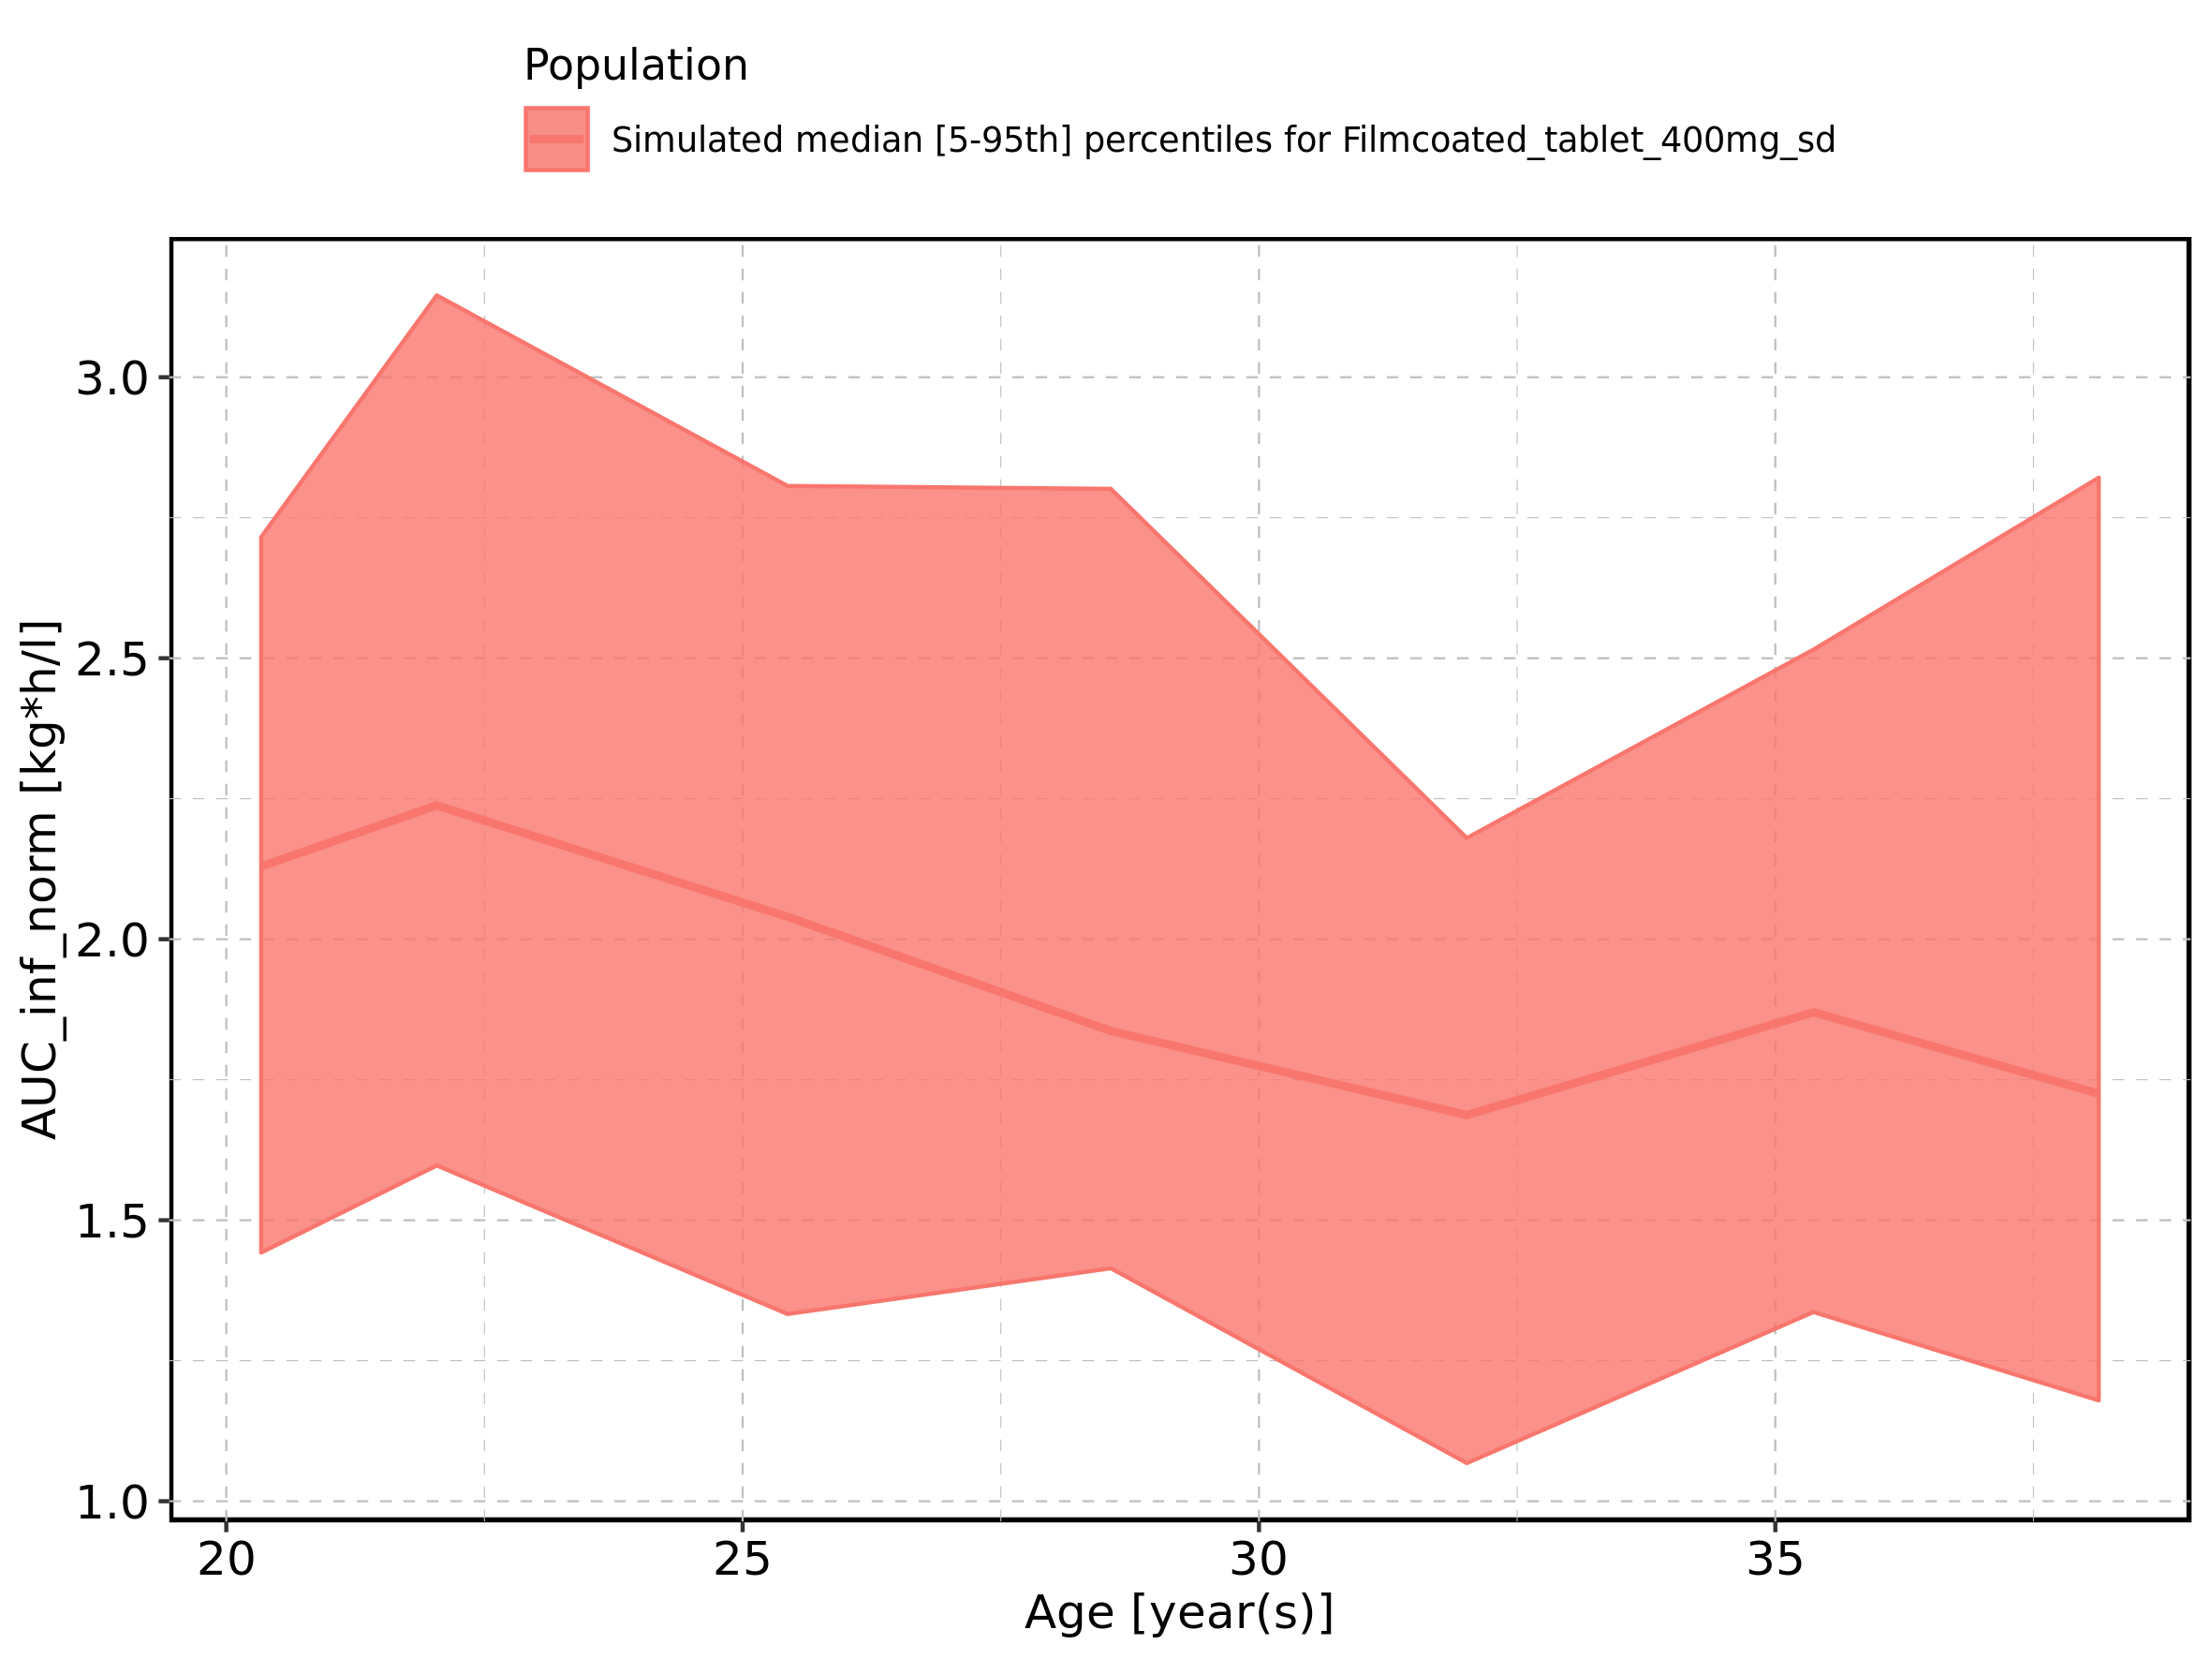

Figure 232: Age-dependence of AUC_inf_norm for Filmcoated_tablet_400mg_sd. Profiles are plotted in a logarithmic scale.

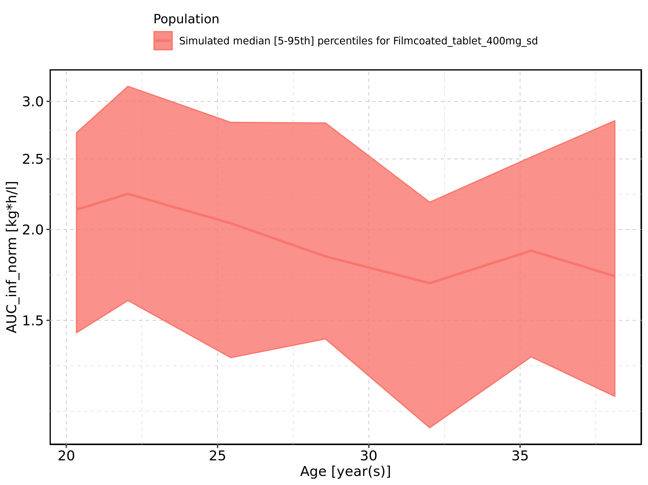

Figure 233: Height-dependence of AUC_inf_norm for Larson 2013 8y-18y 400mg FCT meal in comparison to Filmcoated_tablet_400mg_sd. Profiles are plotted in a linear scale.

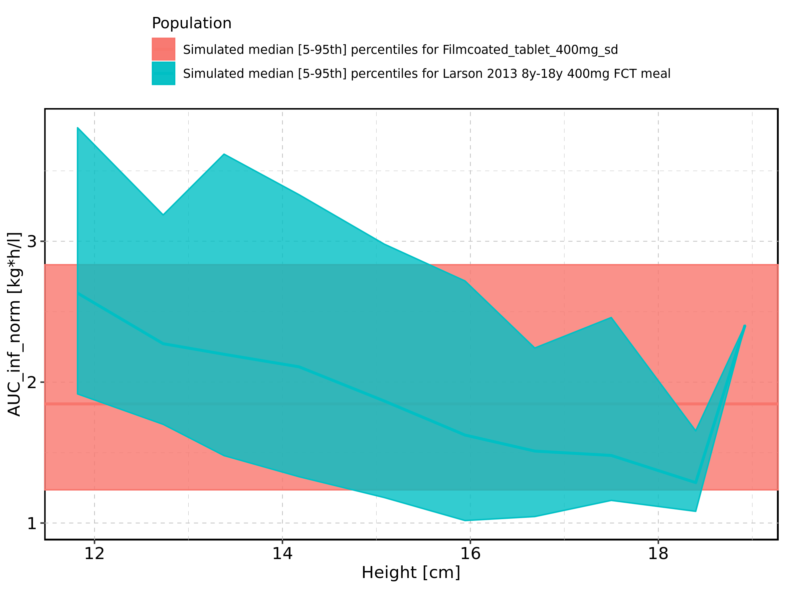

Figure 234: Height-dependence of AUC_inf_norm for Larson 2013 8y-18y 400mg FCT meal in comparison to Filmcoated_tablet_400mg_sd. Profiles are plotted in a logarithmic scale.

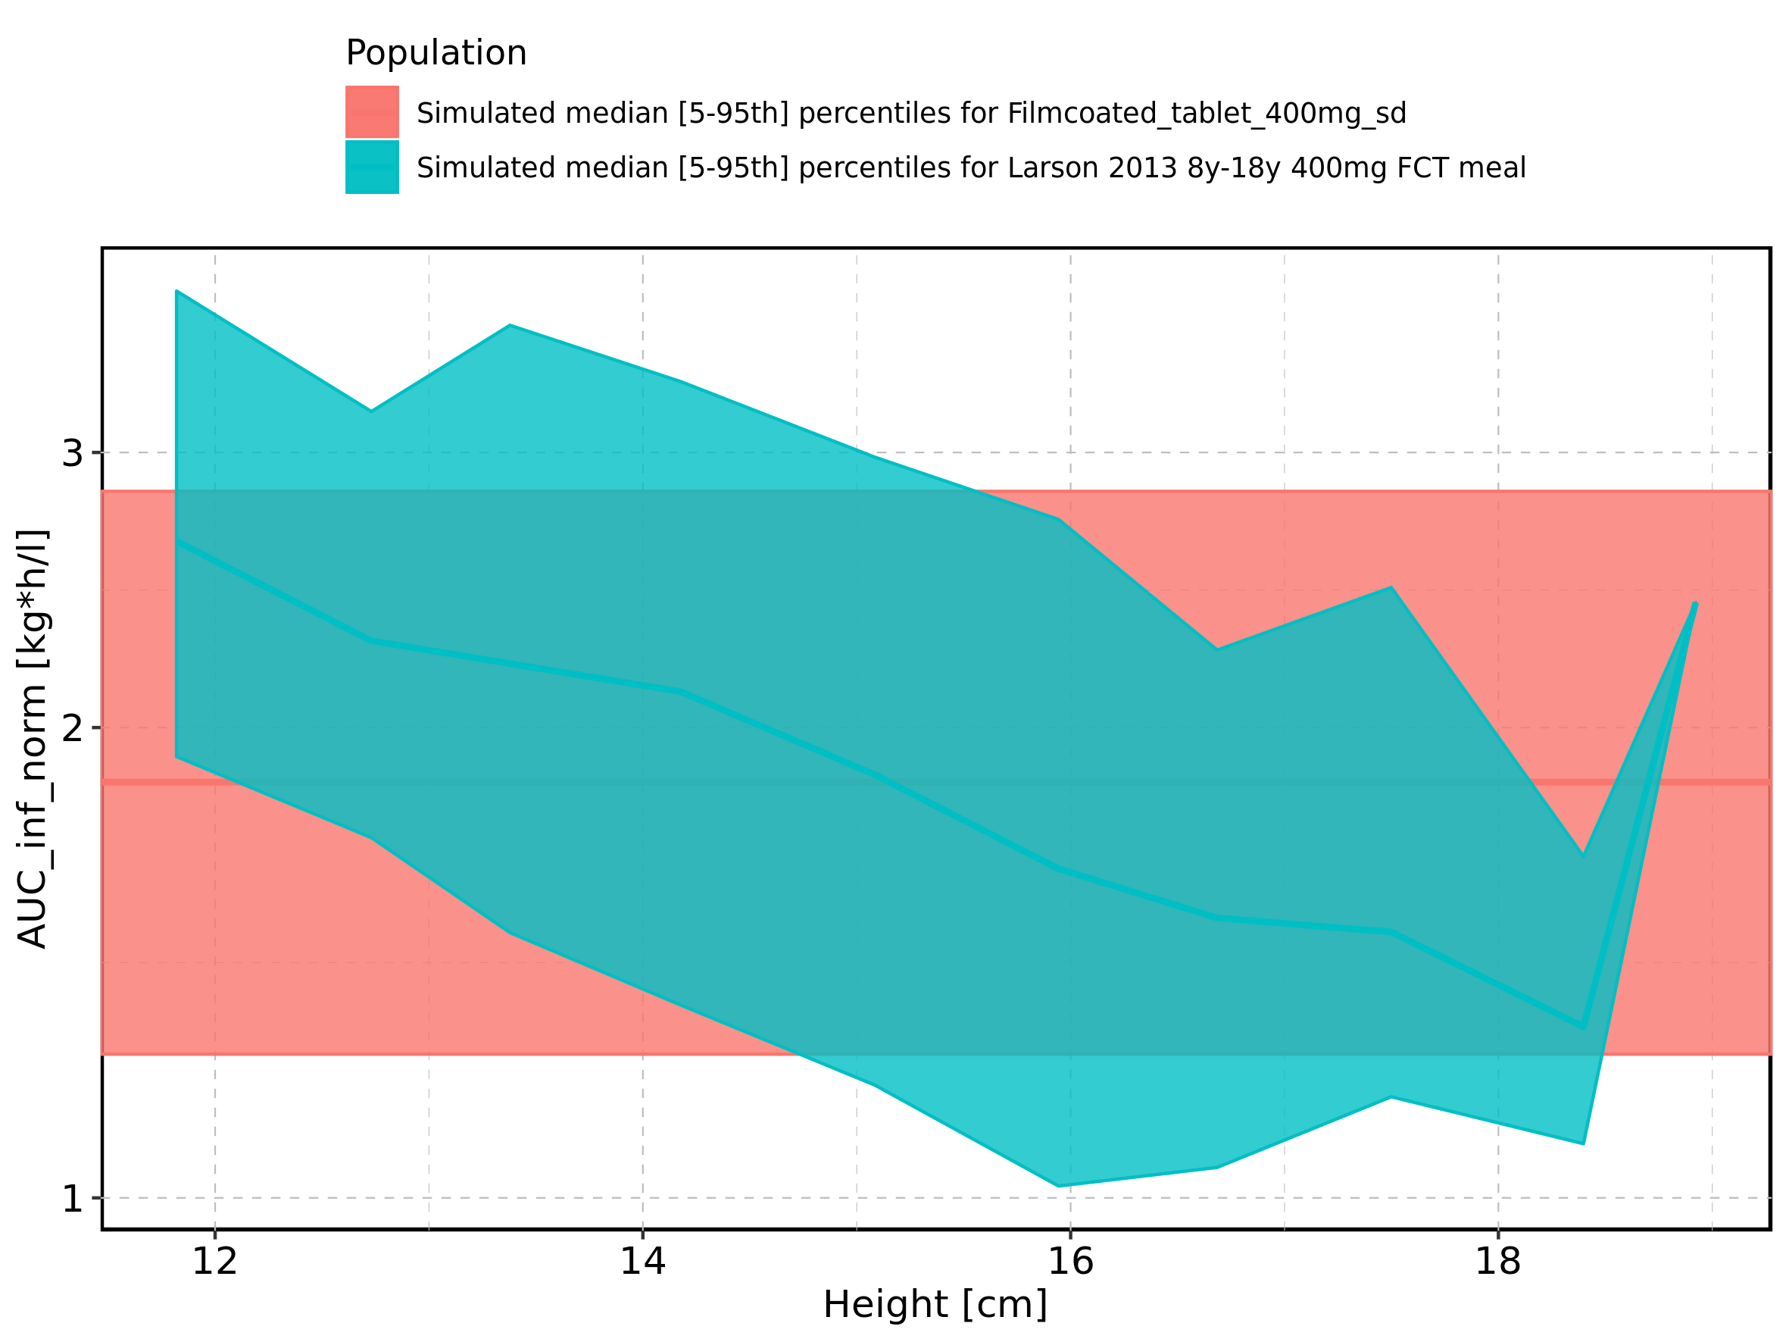

Figure 235: Height-dependence of AUC_inf_norm for Larson 2013 8y-18y 400mg FCT meal. Profiles are plotted in a linear scale.

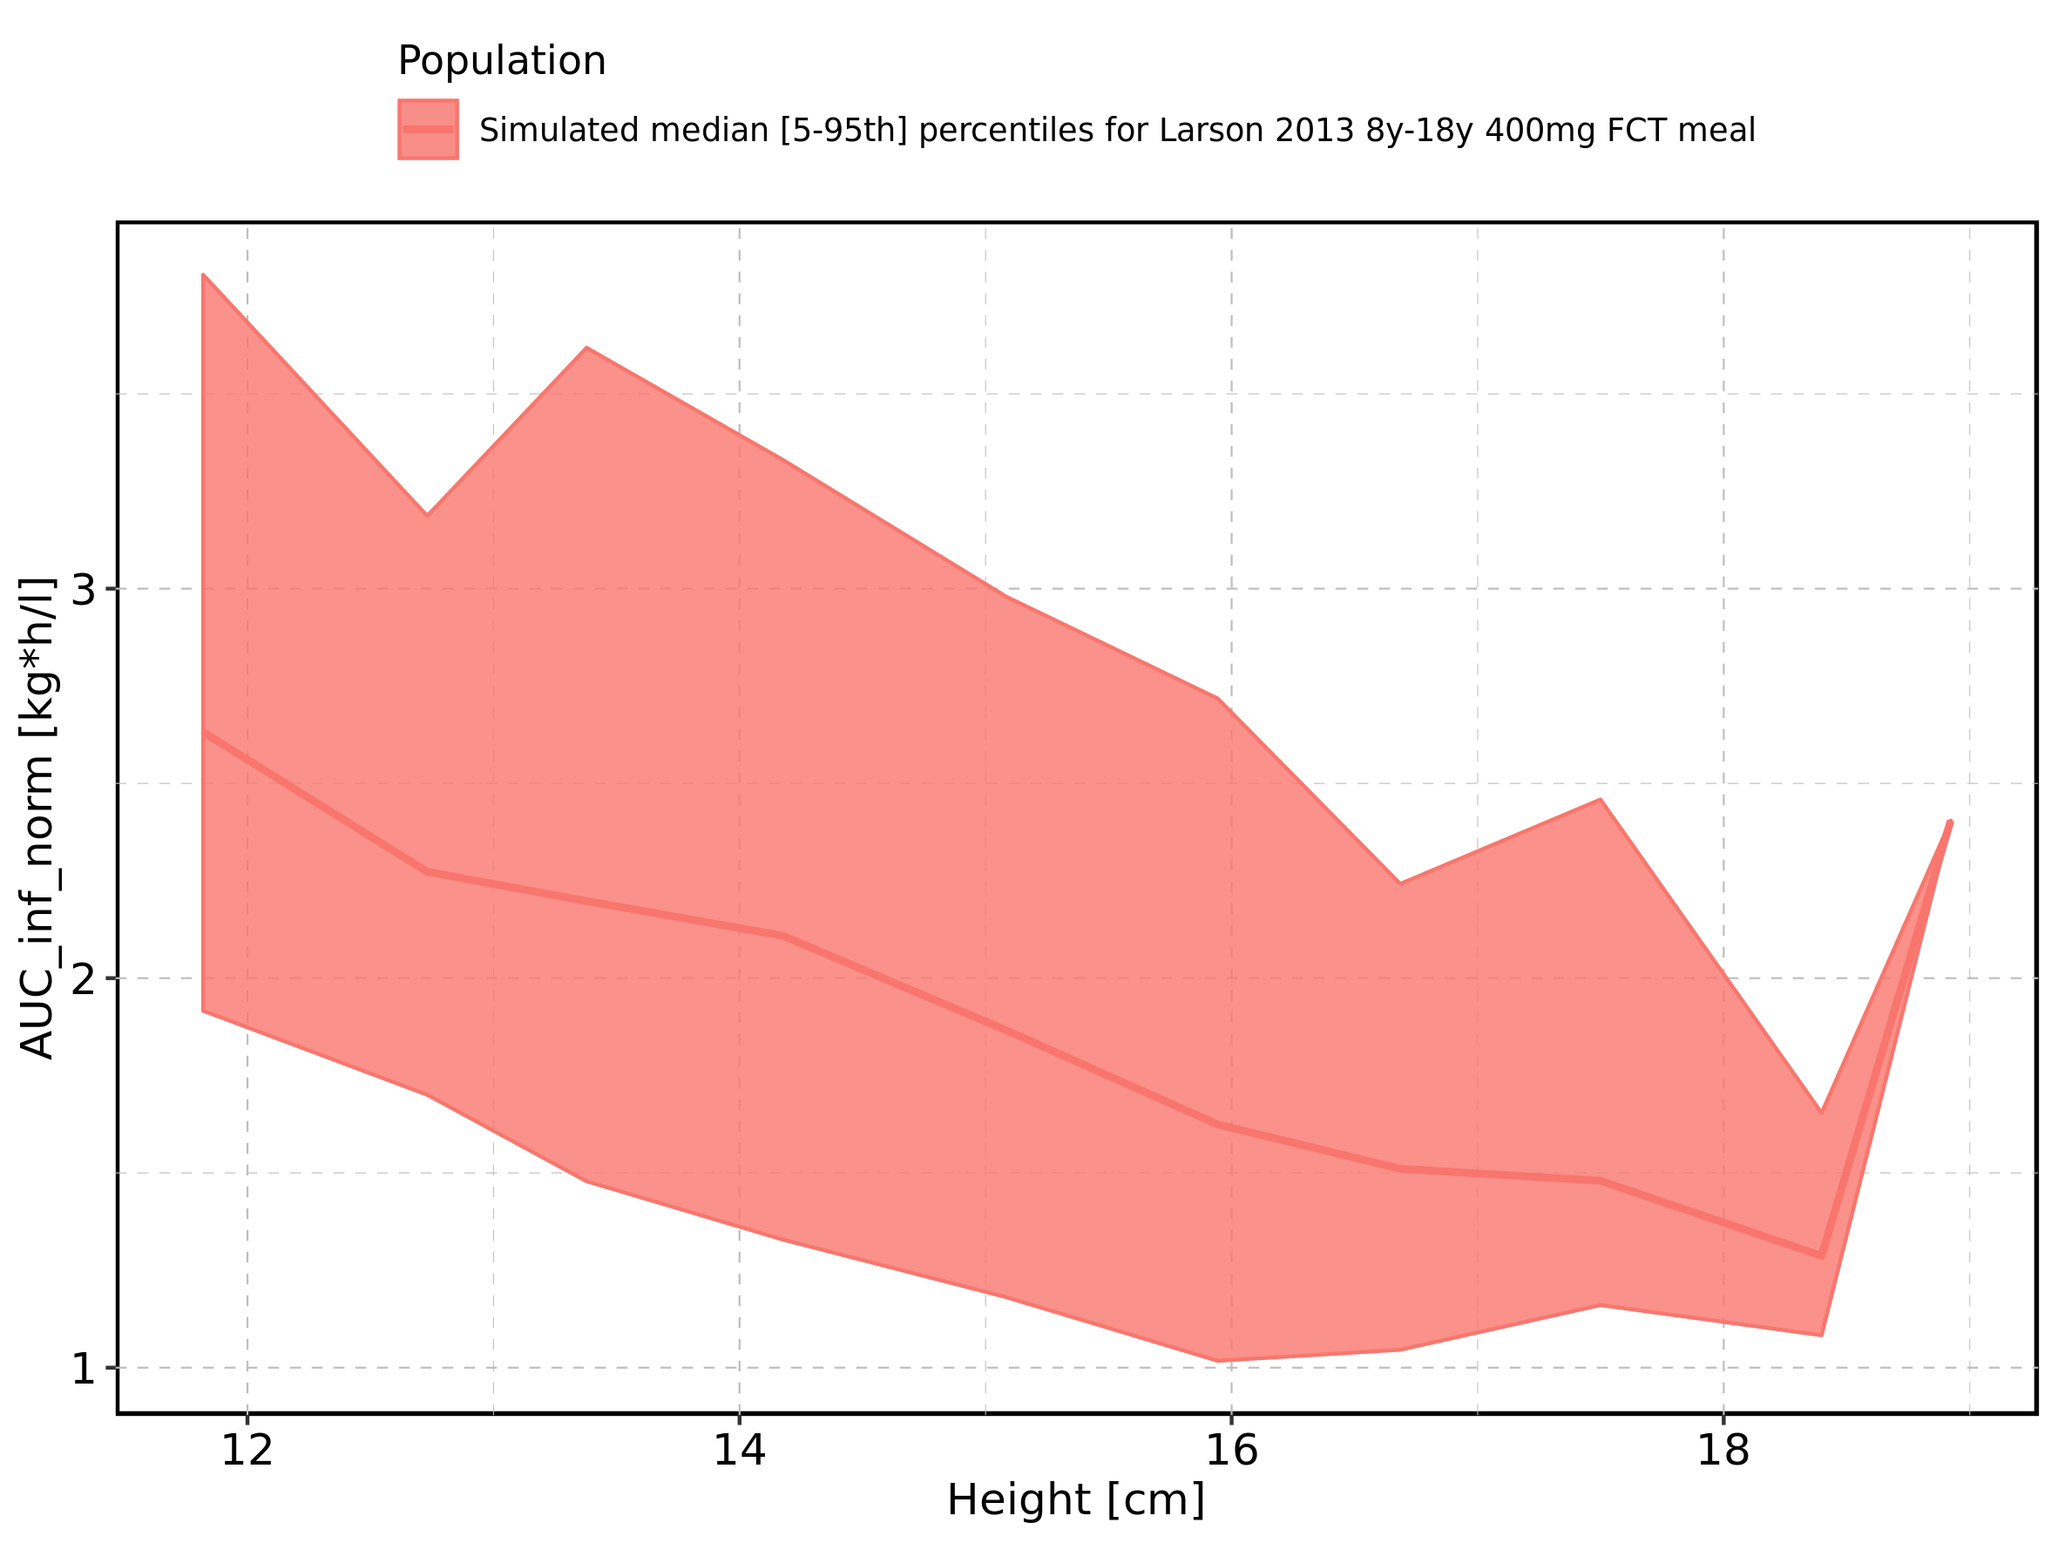

Figure 236: Height-dependence of AUC_inf_norm for Larson 2013 8y-18y 400mg FCT meal. Profiles are plotted in a logarithmic scale.

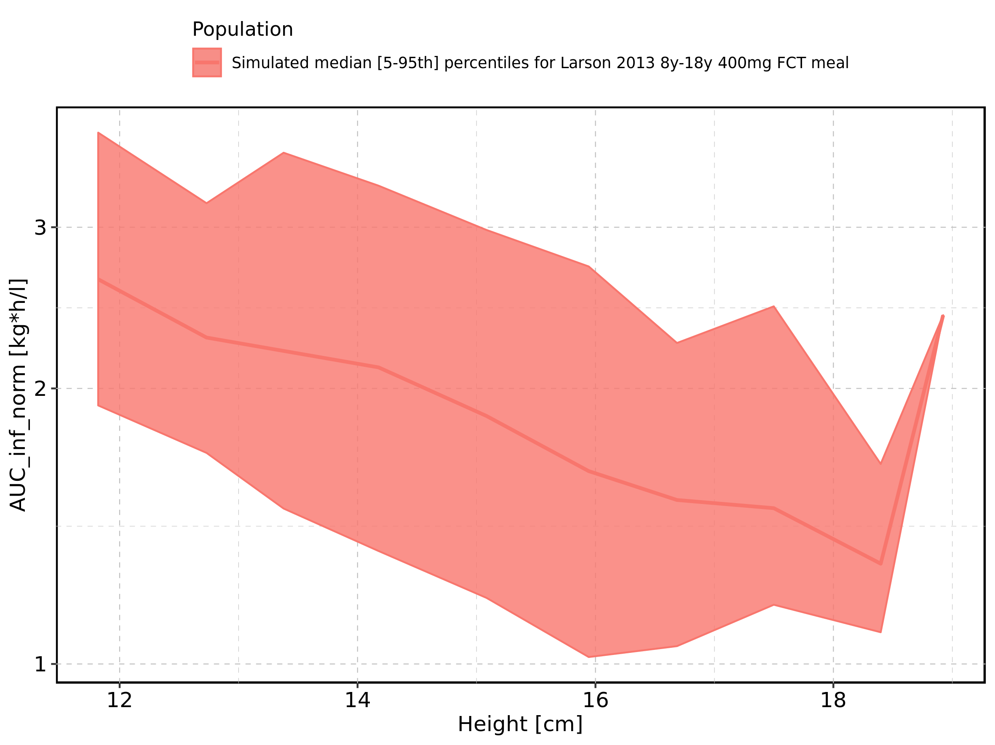

Figure 237: Height-dependence of AUC_inf_norm for Filmcoated_tablet_400mg_sd. Profiles are plotted in a linear scale.

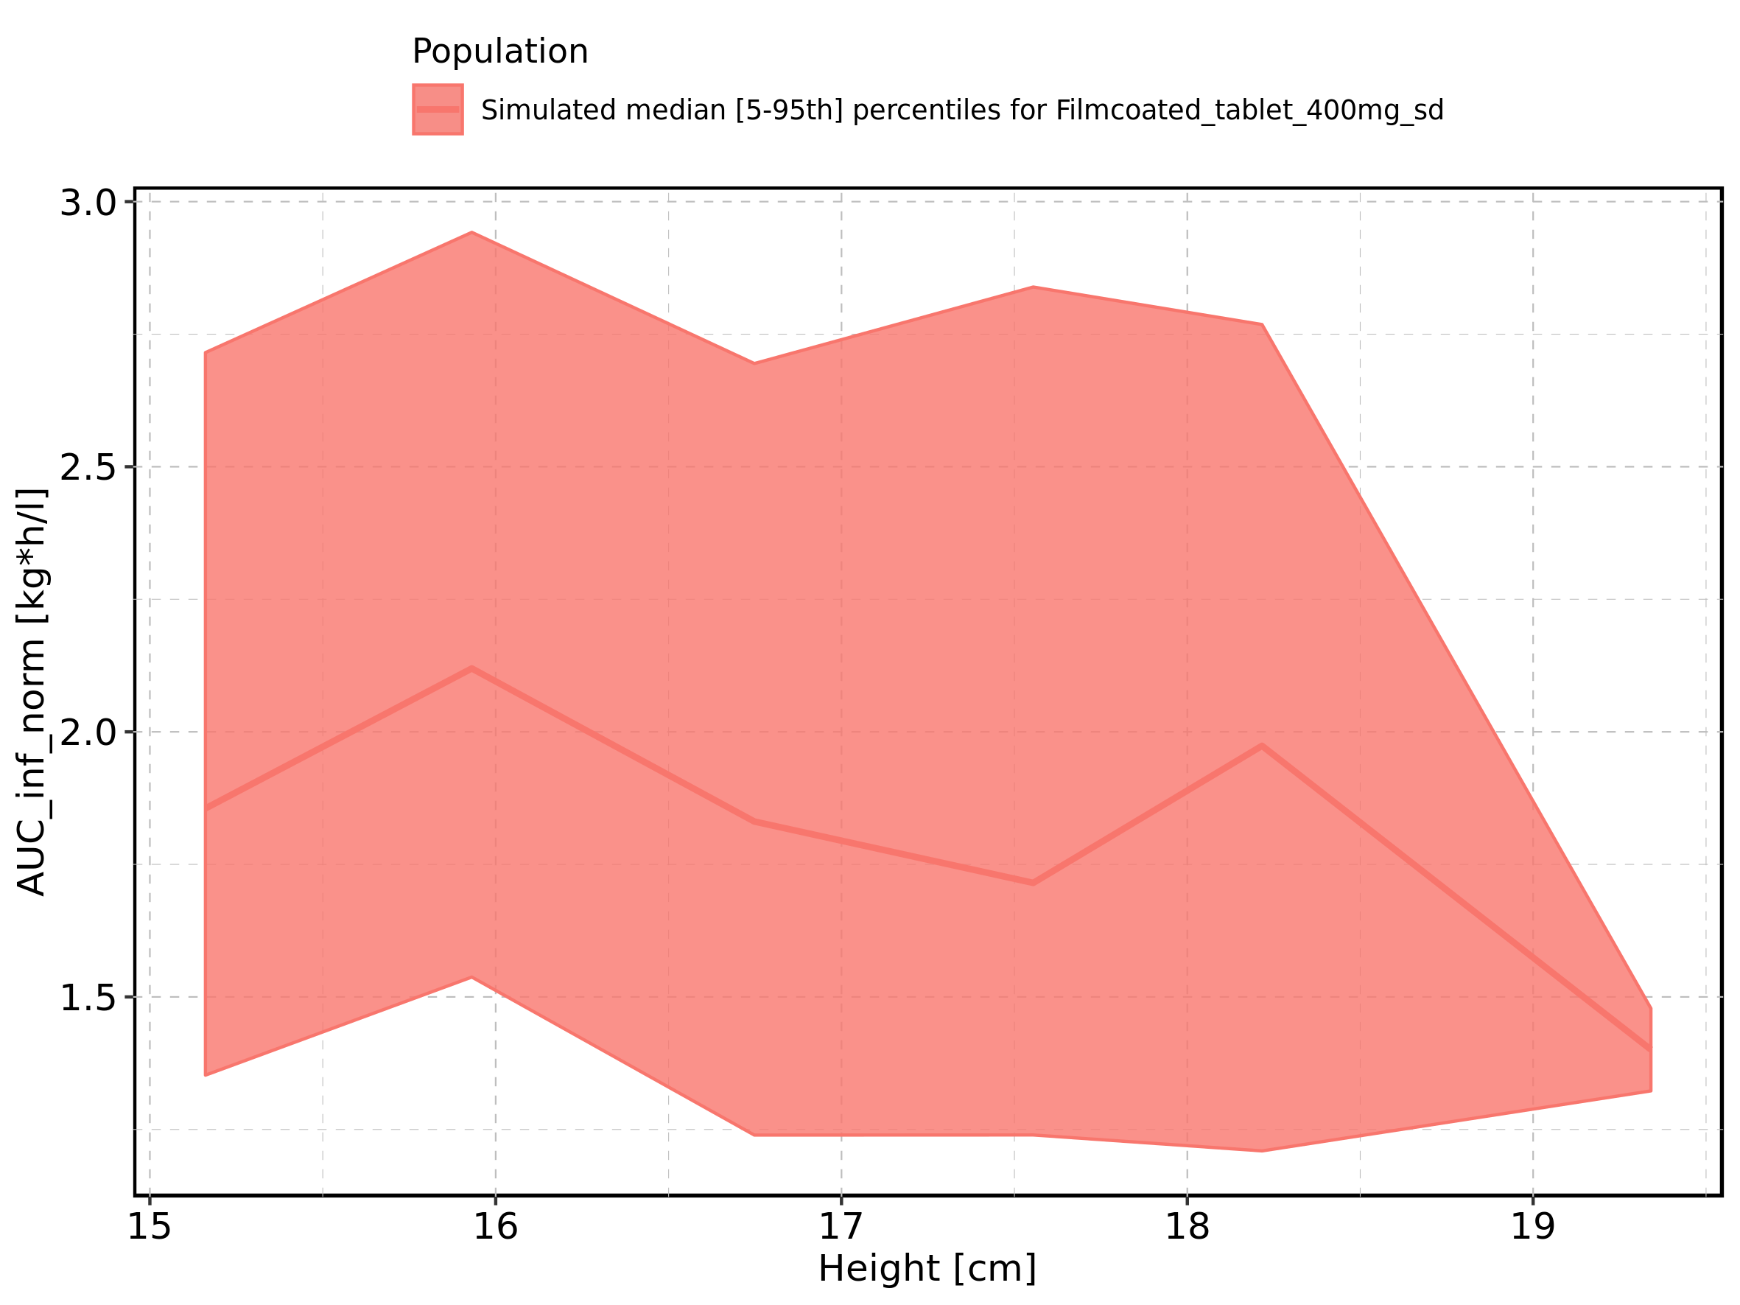

Figure 238: Height-dependence of AUC_inf_norm for Filmcoated_tablet_400mg_sd. Profiles are plotted in a logarithmic scale.

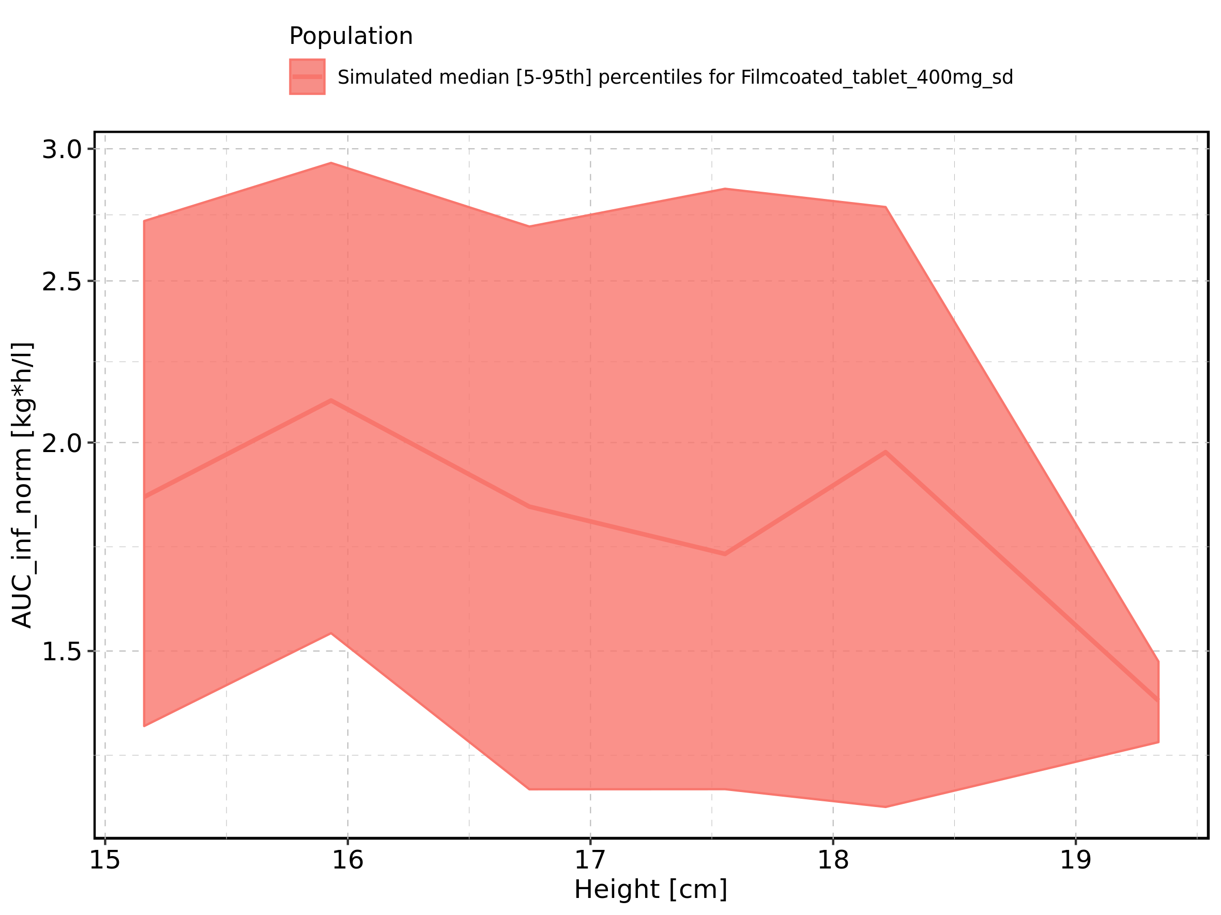

Figure 239: Weight-dependence of AUC_inf_norm for Larson 2013 8y-18y 400mg FCT meal in comparison to Filmcoated_tablet_400mg_sd. Profiles are plotted in a linear scale.

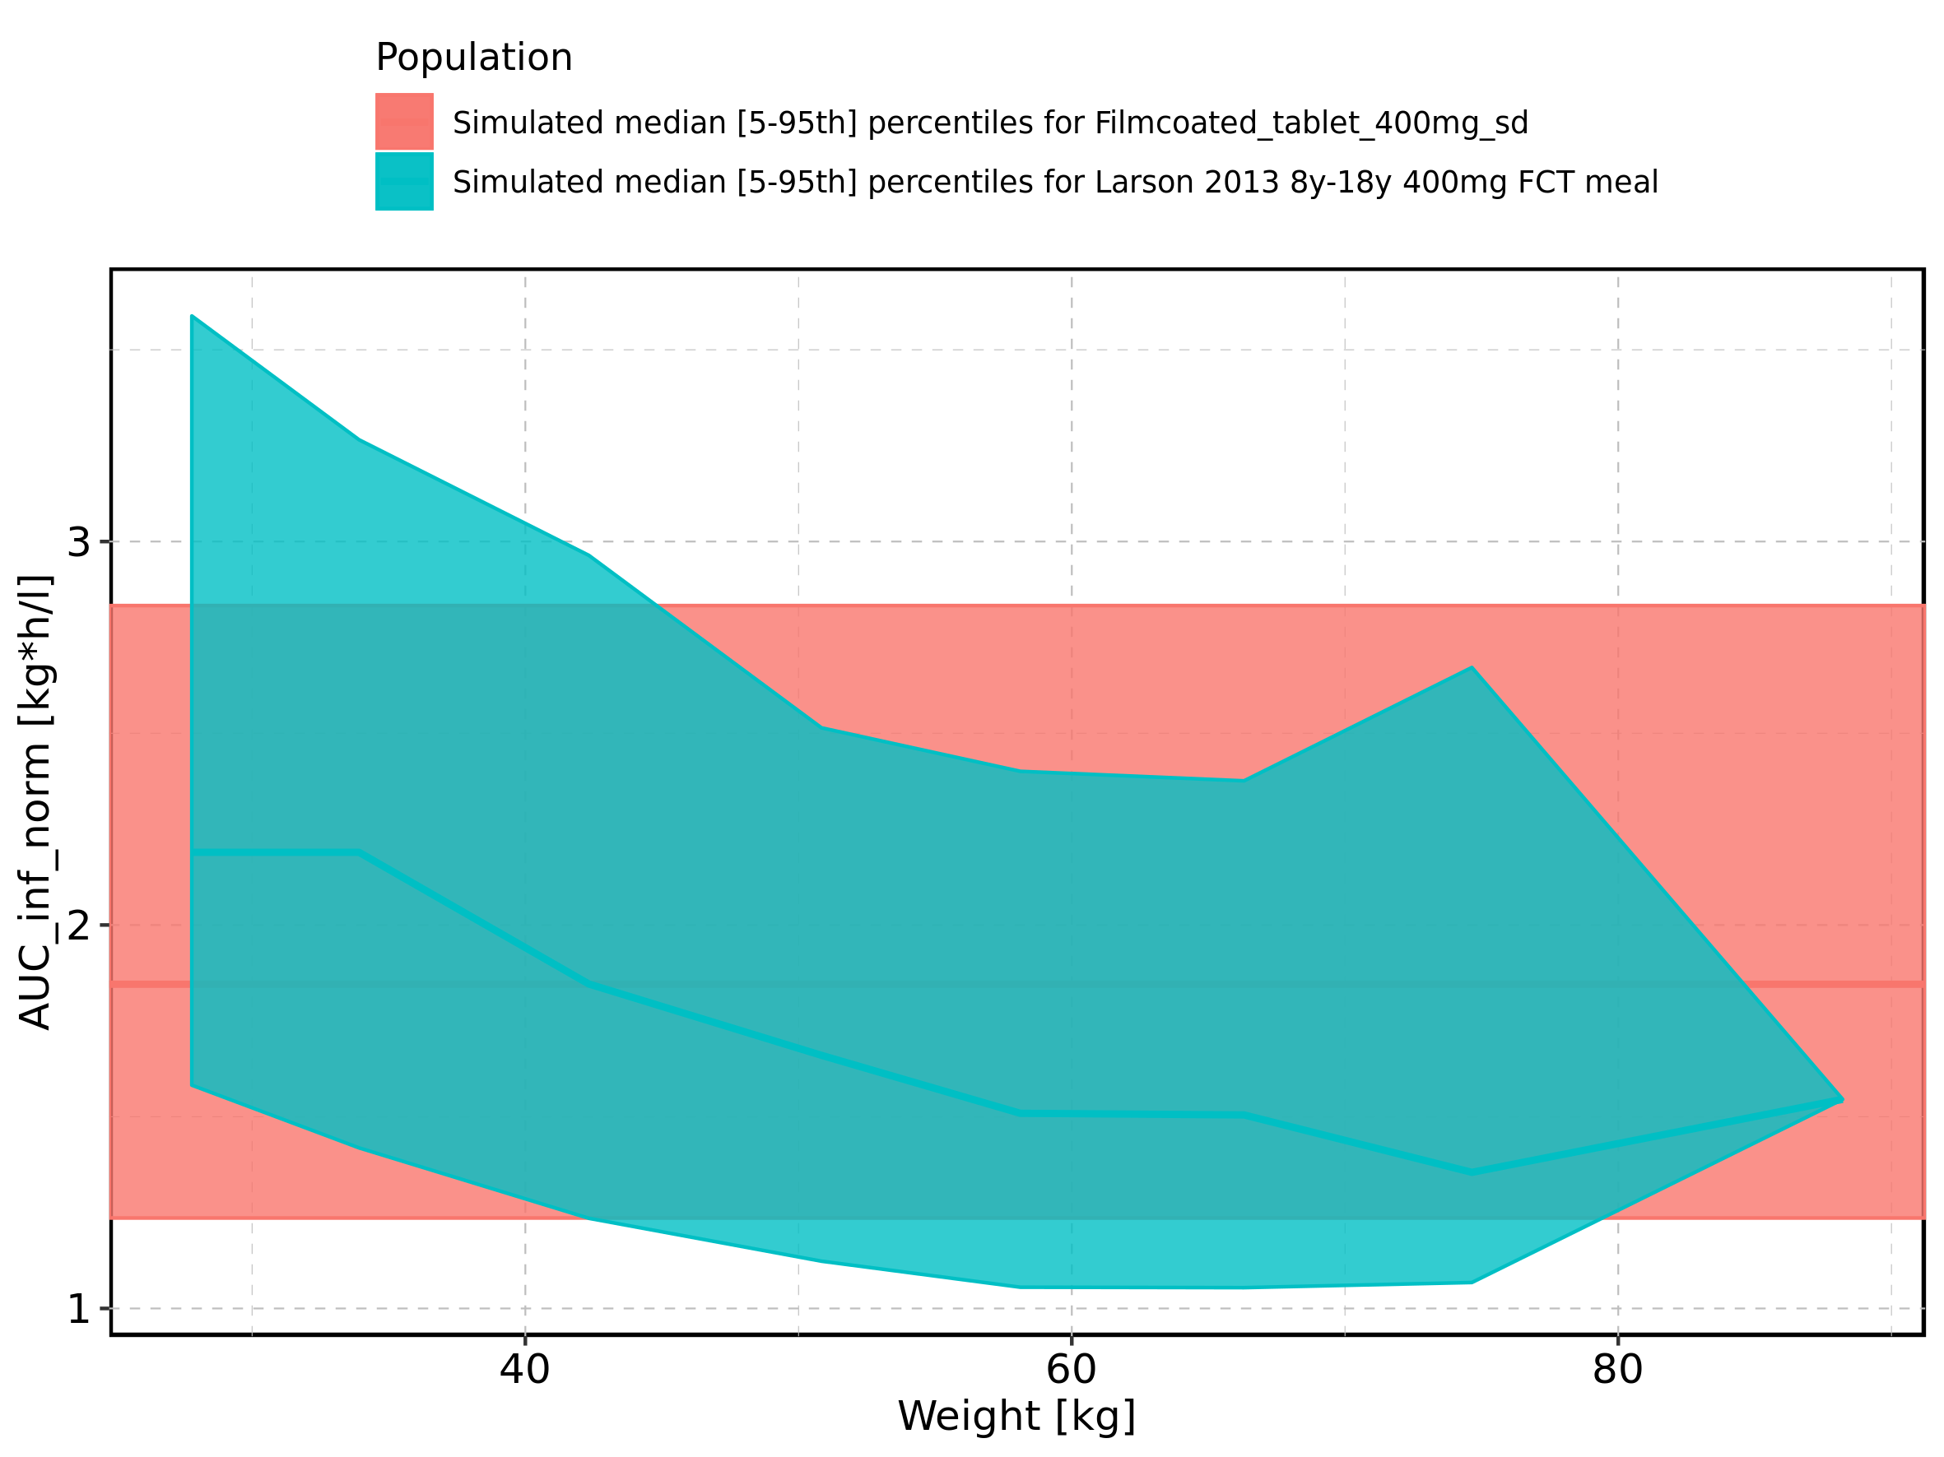

Figure 240: Weight-dependence of AUC_inf_norm for Larson 2013 8y-18y 400mg FCT meal in comparison to Filmcoated_tablet_400mg_sd. Profiles are plotted in a logarithmic scale.

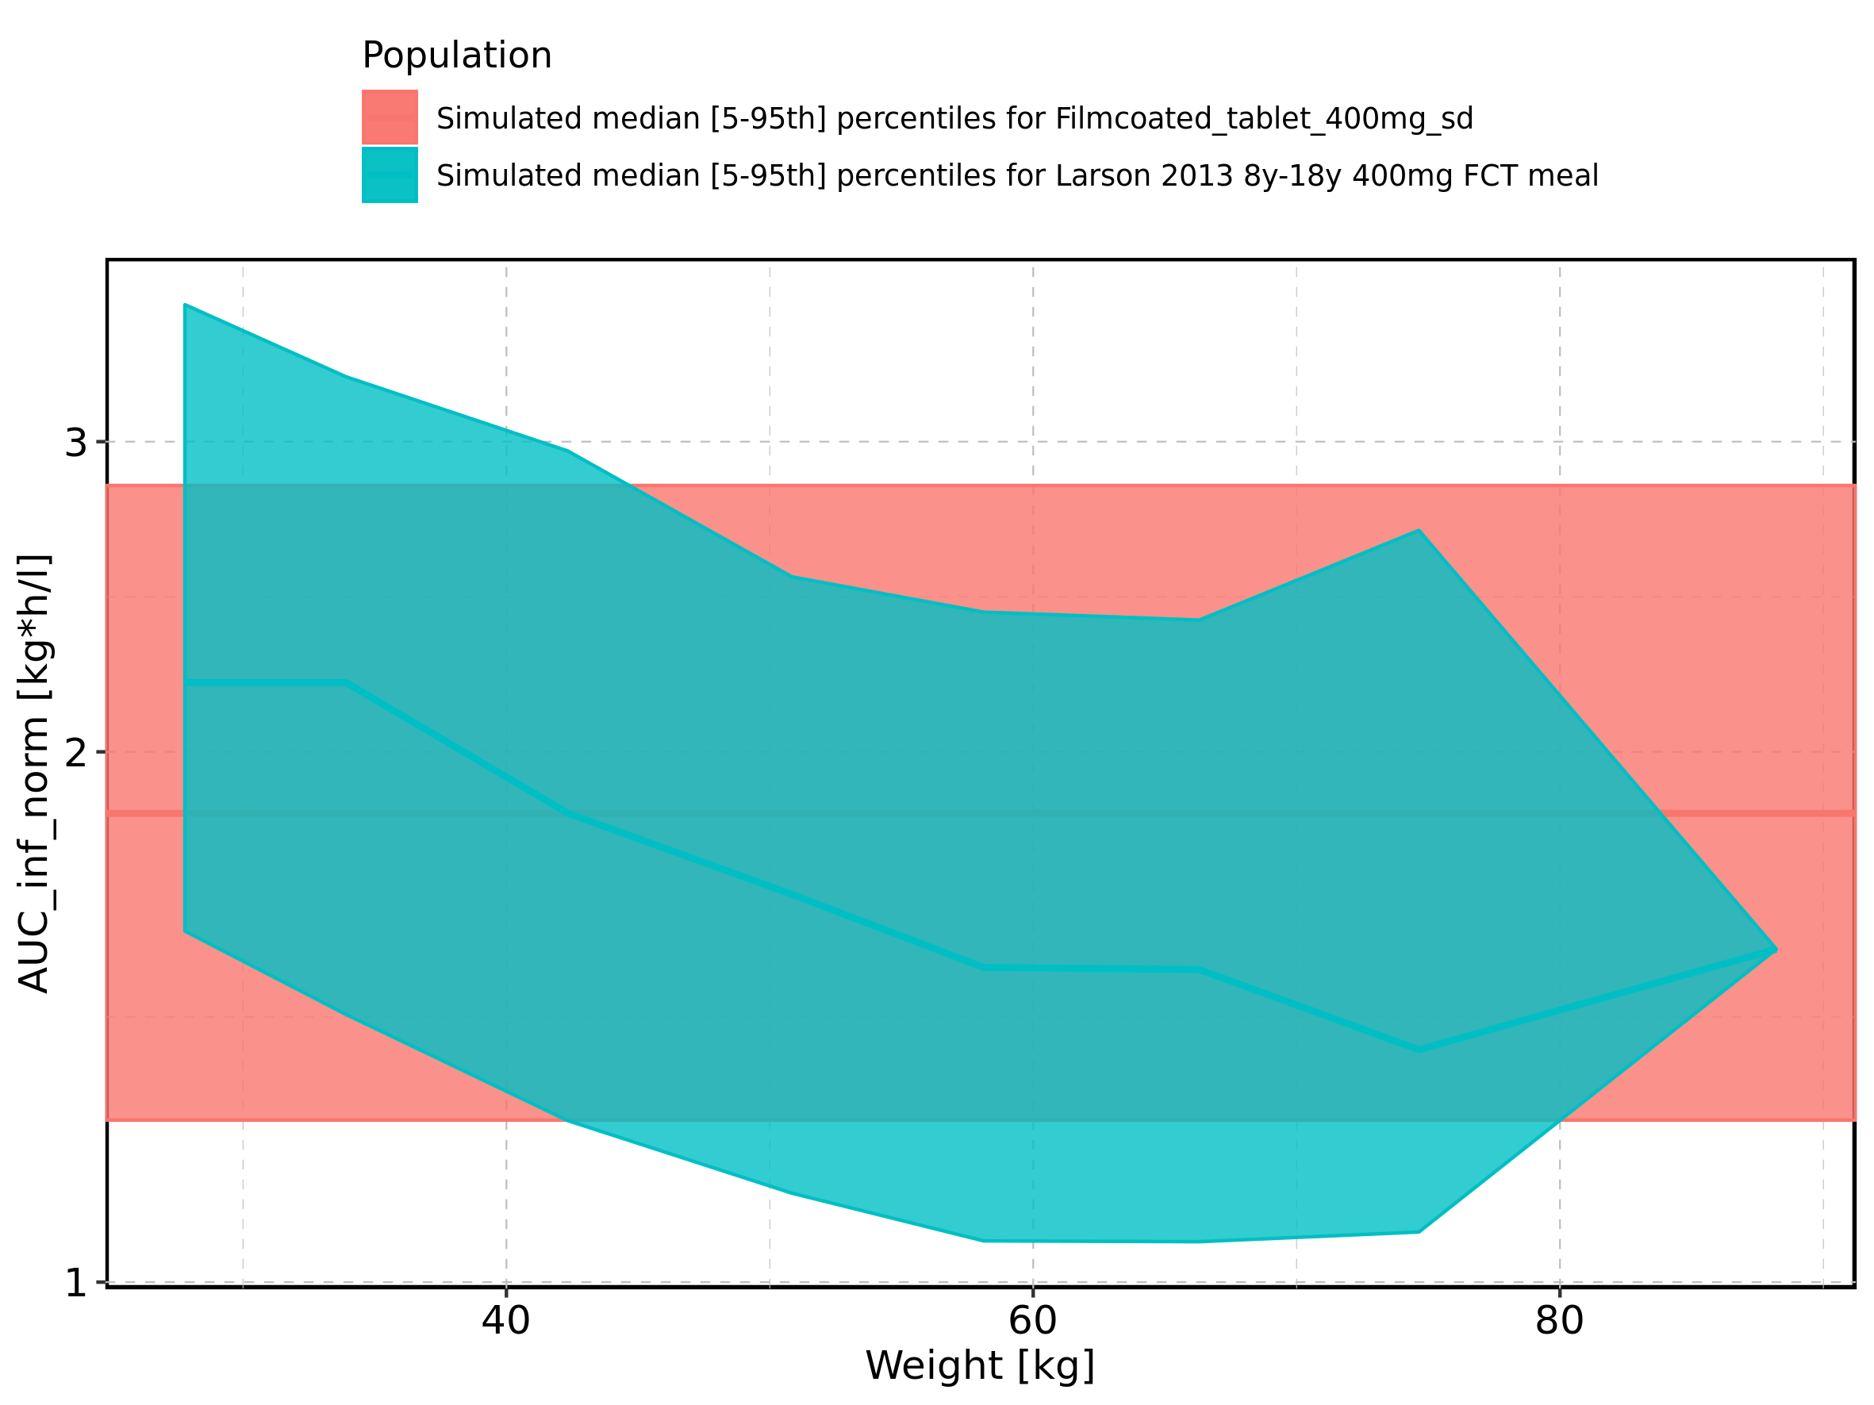

Figure 241: Weight-dependence of AUC_inf_norm for Larson 2013 8y-18y 400mg FCT meal. Profiles are plotted in a linear scale.

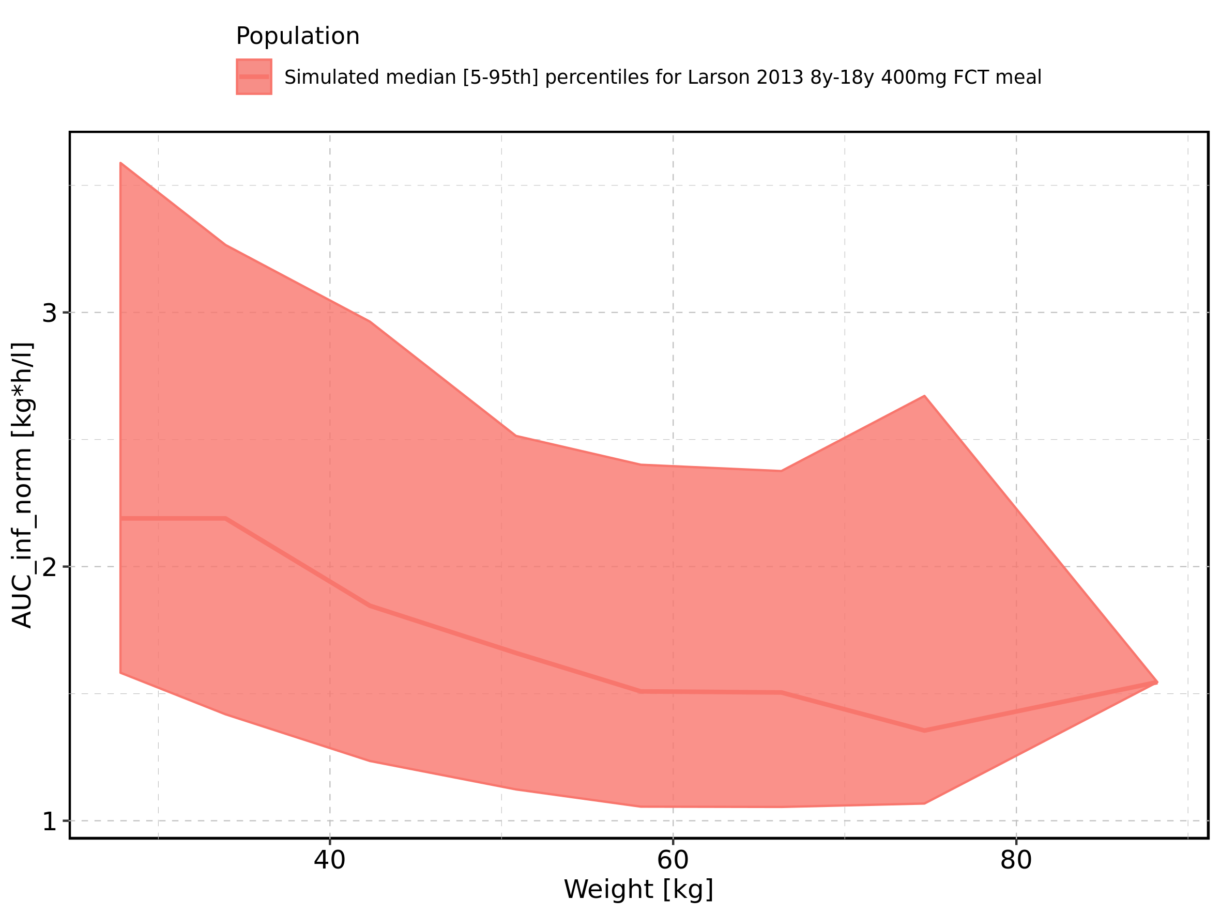

Figure 242: Weight-dependence of AUC_inf_norm for Larson 2013 8y-18y 400mg FCT meal. Profiles are plotted in a logarithmic scale.

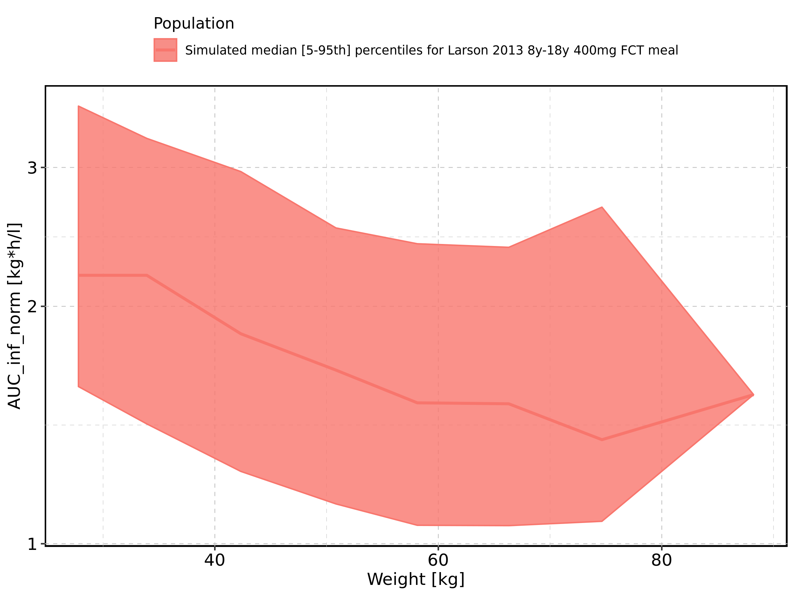

Figure 243: Weight-dependence of AUC_inf_norm for Filmcoated_tablet_400mg_sd. Profiles are plotted in a linear scale.

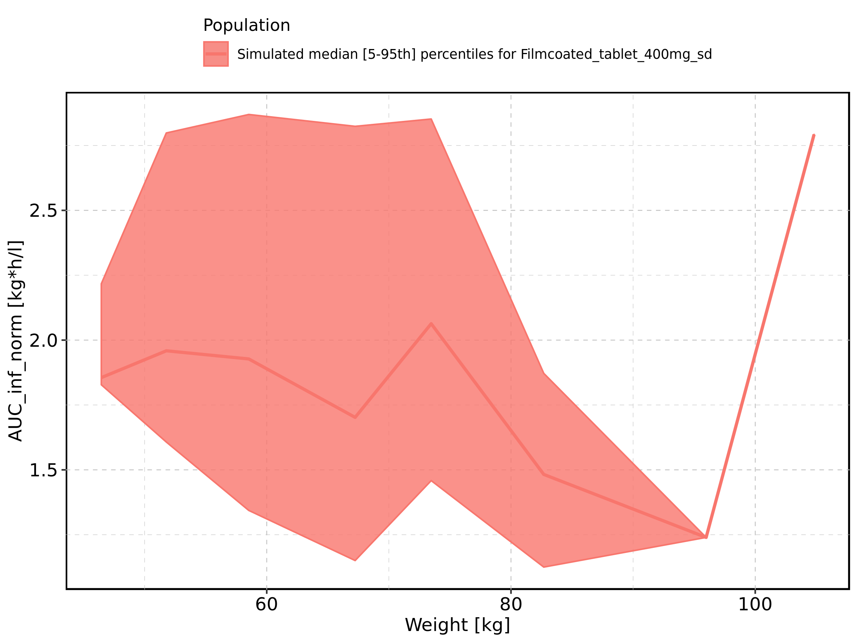

Figure 244: Weight-dependence of AUC_inf_norm for Filmcoated_tablet_400mg_sd. Profiles are plotted in a logarithmic scale.

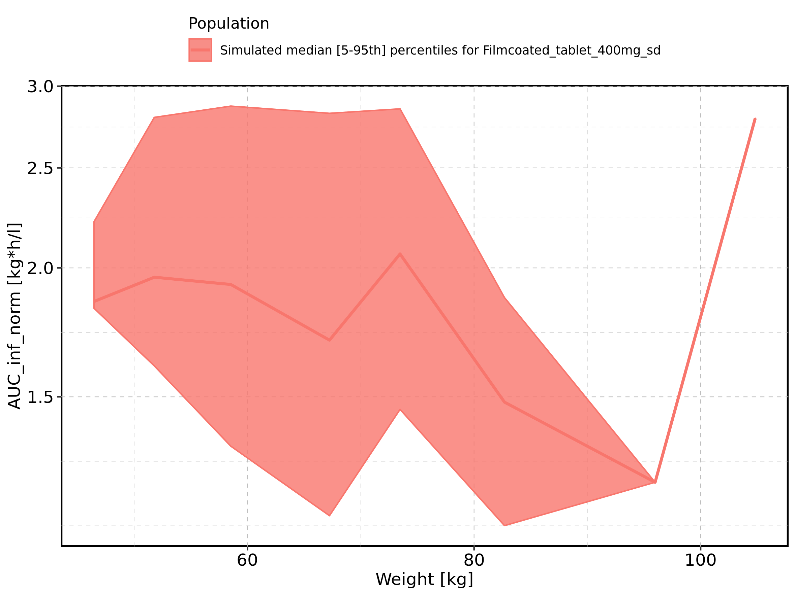

Figure 245: BMI-dependence of AUC_inf_norm for Larson 2013 8y-18y 400mg FCT meal in comparison to Filmcoated_tablet_400mg_sd. Profiles are plotted in a linear scale.

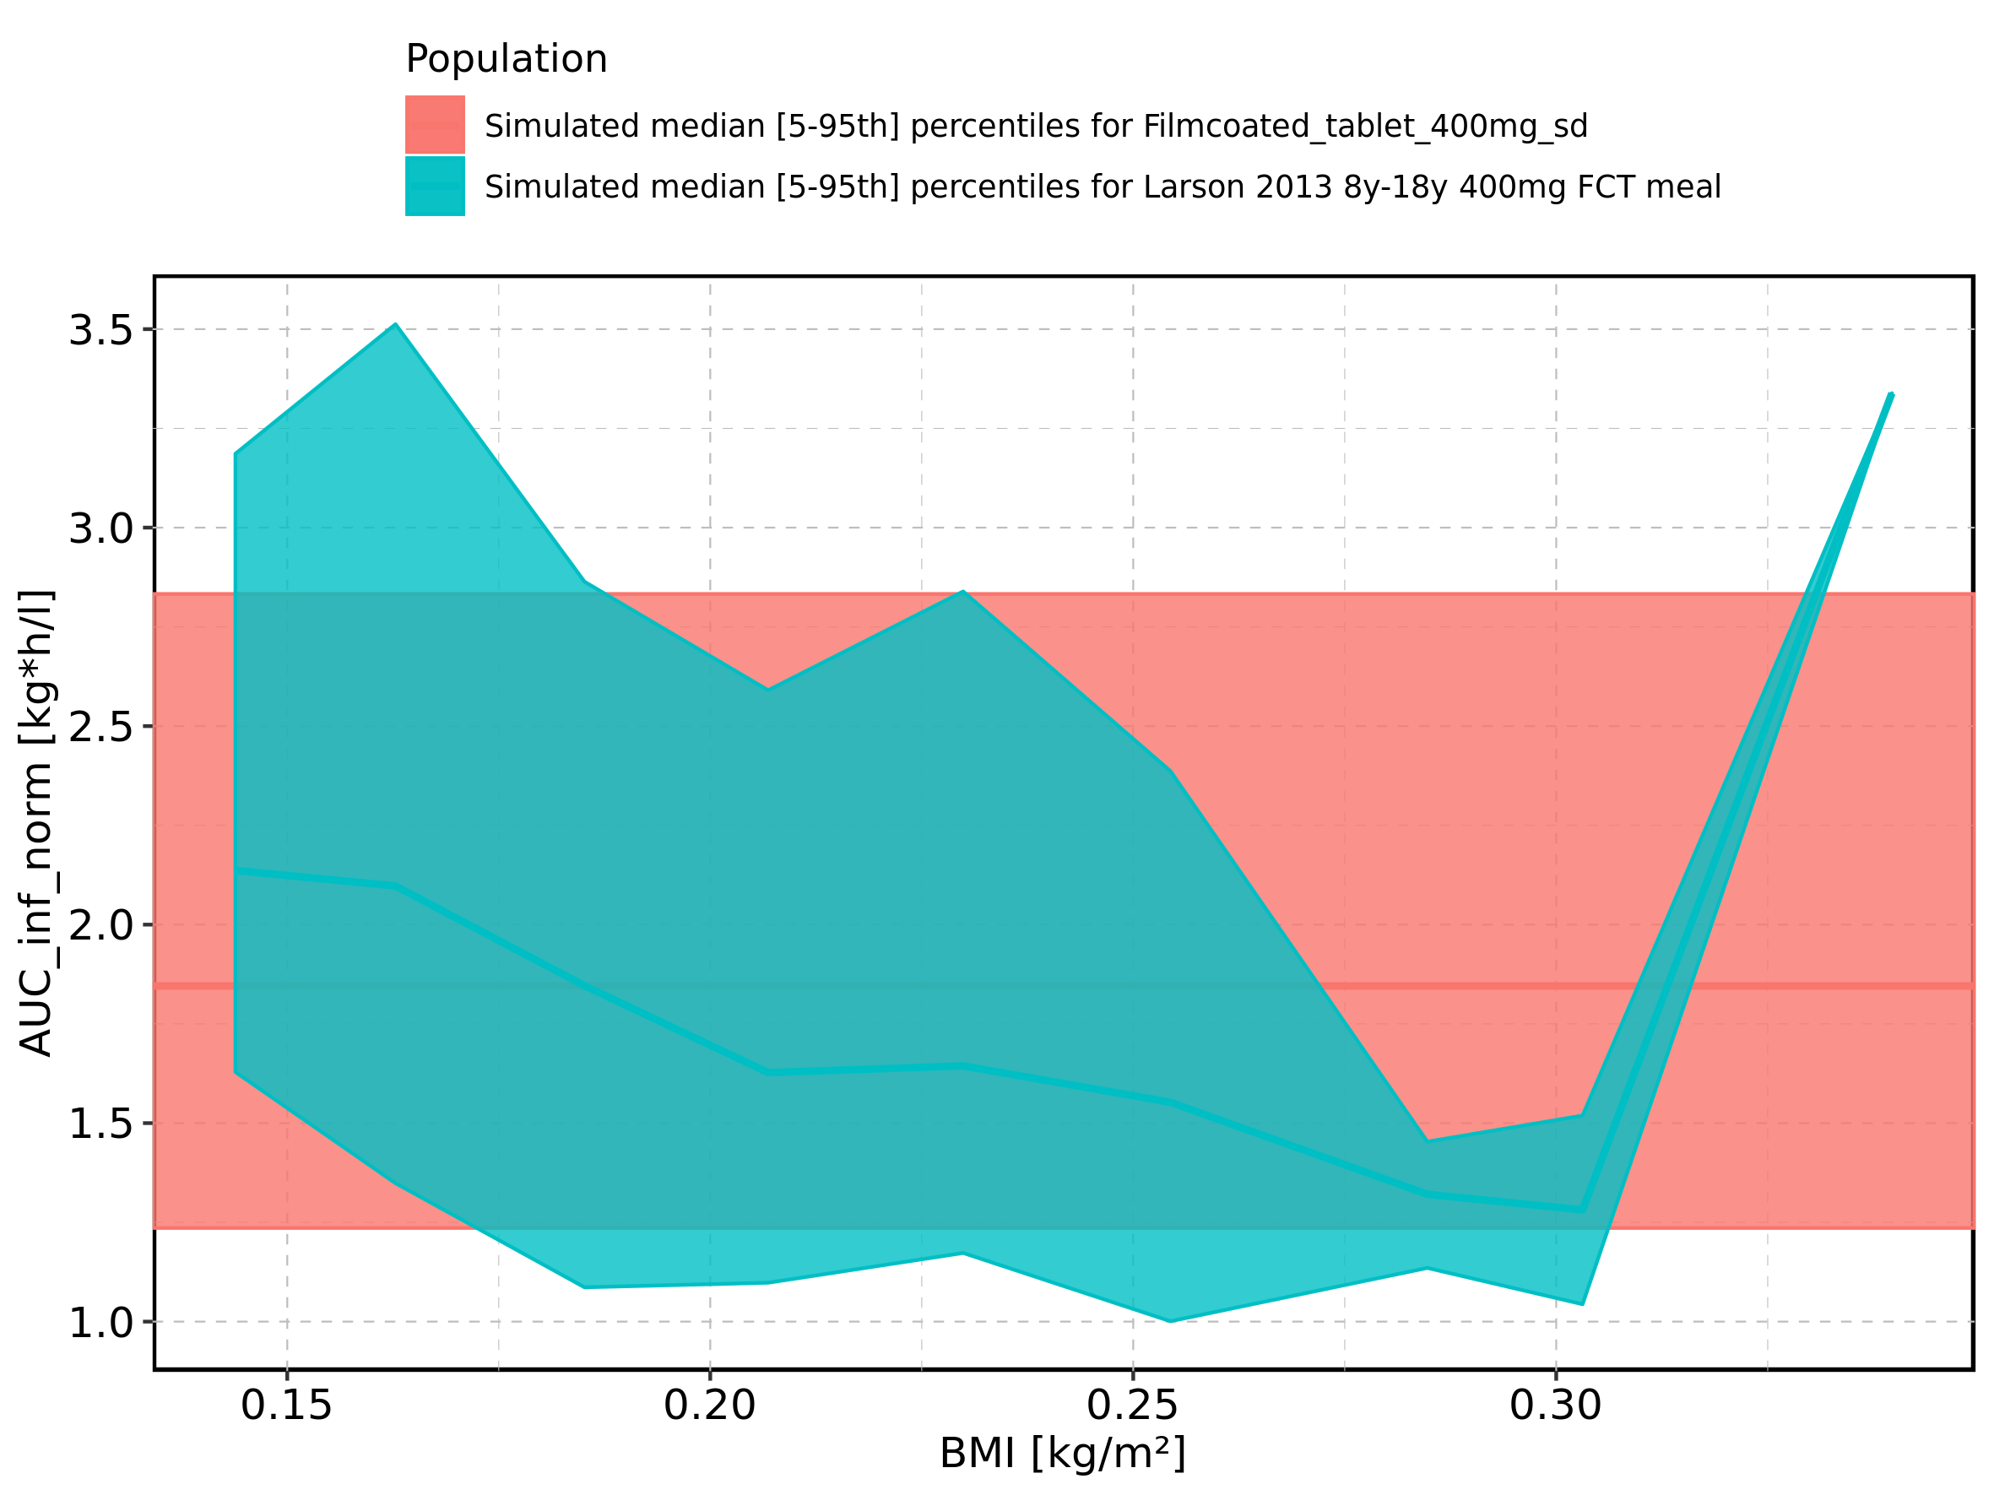

Figure 246: BMI-dependence of AUC_inf_norm for Larson 2013 8y-18y 400mg FCT meal in comparison to Filmcoated_tablet_400mg_sd. Profiles are plotted in a logarithmic scale.

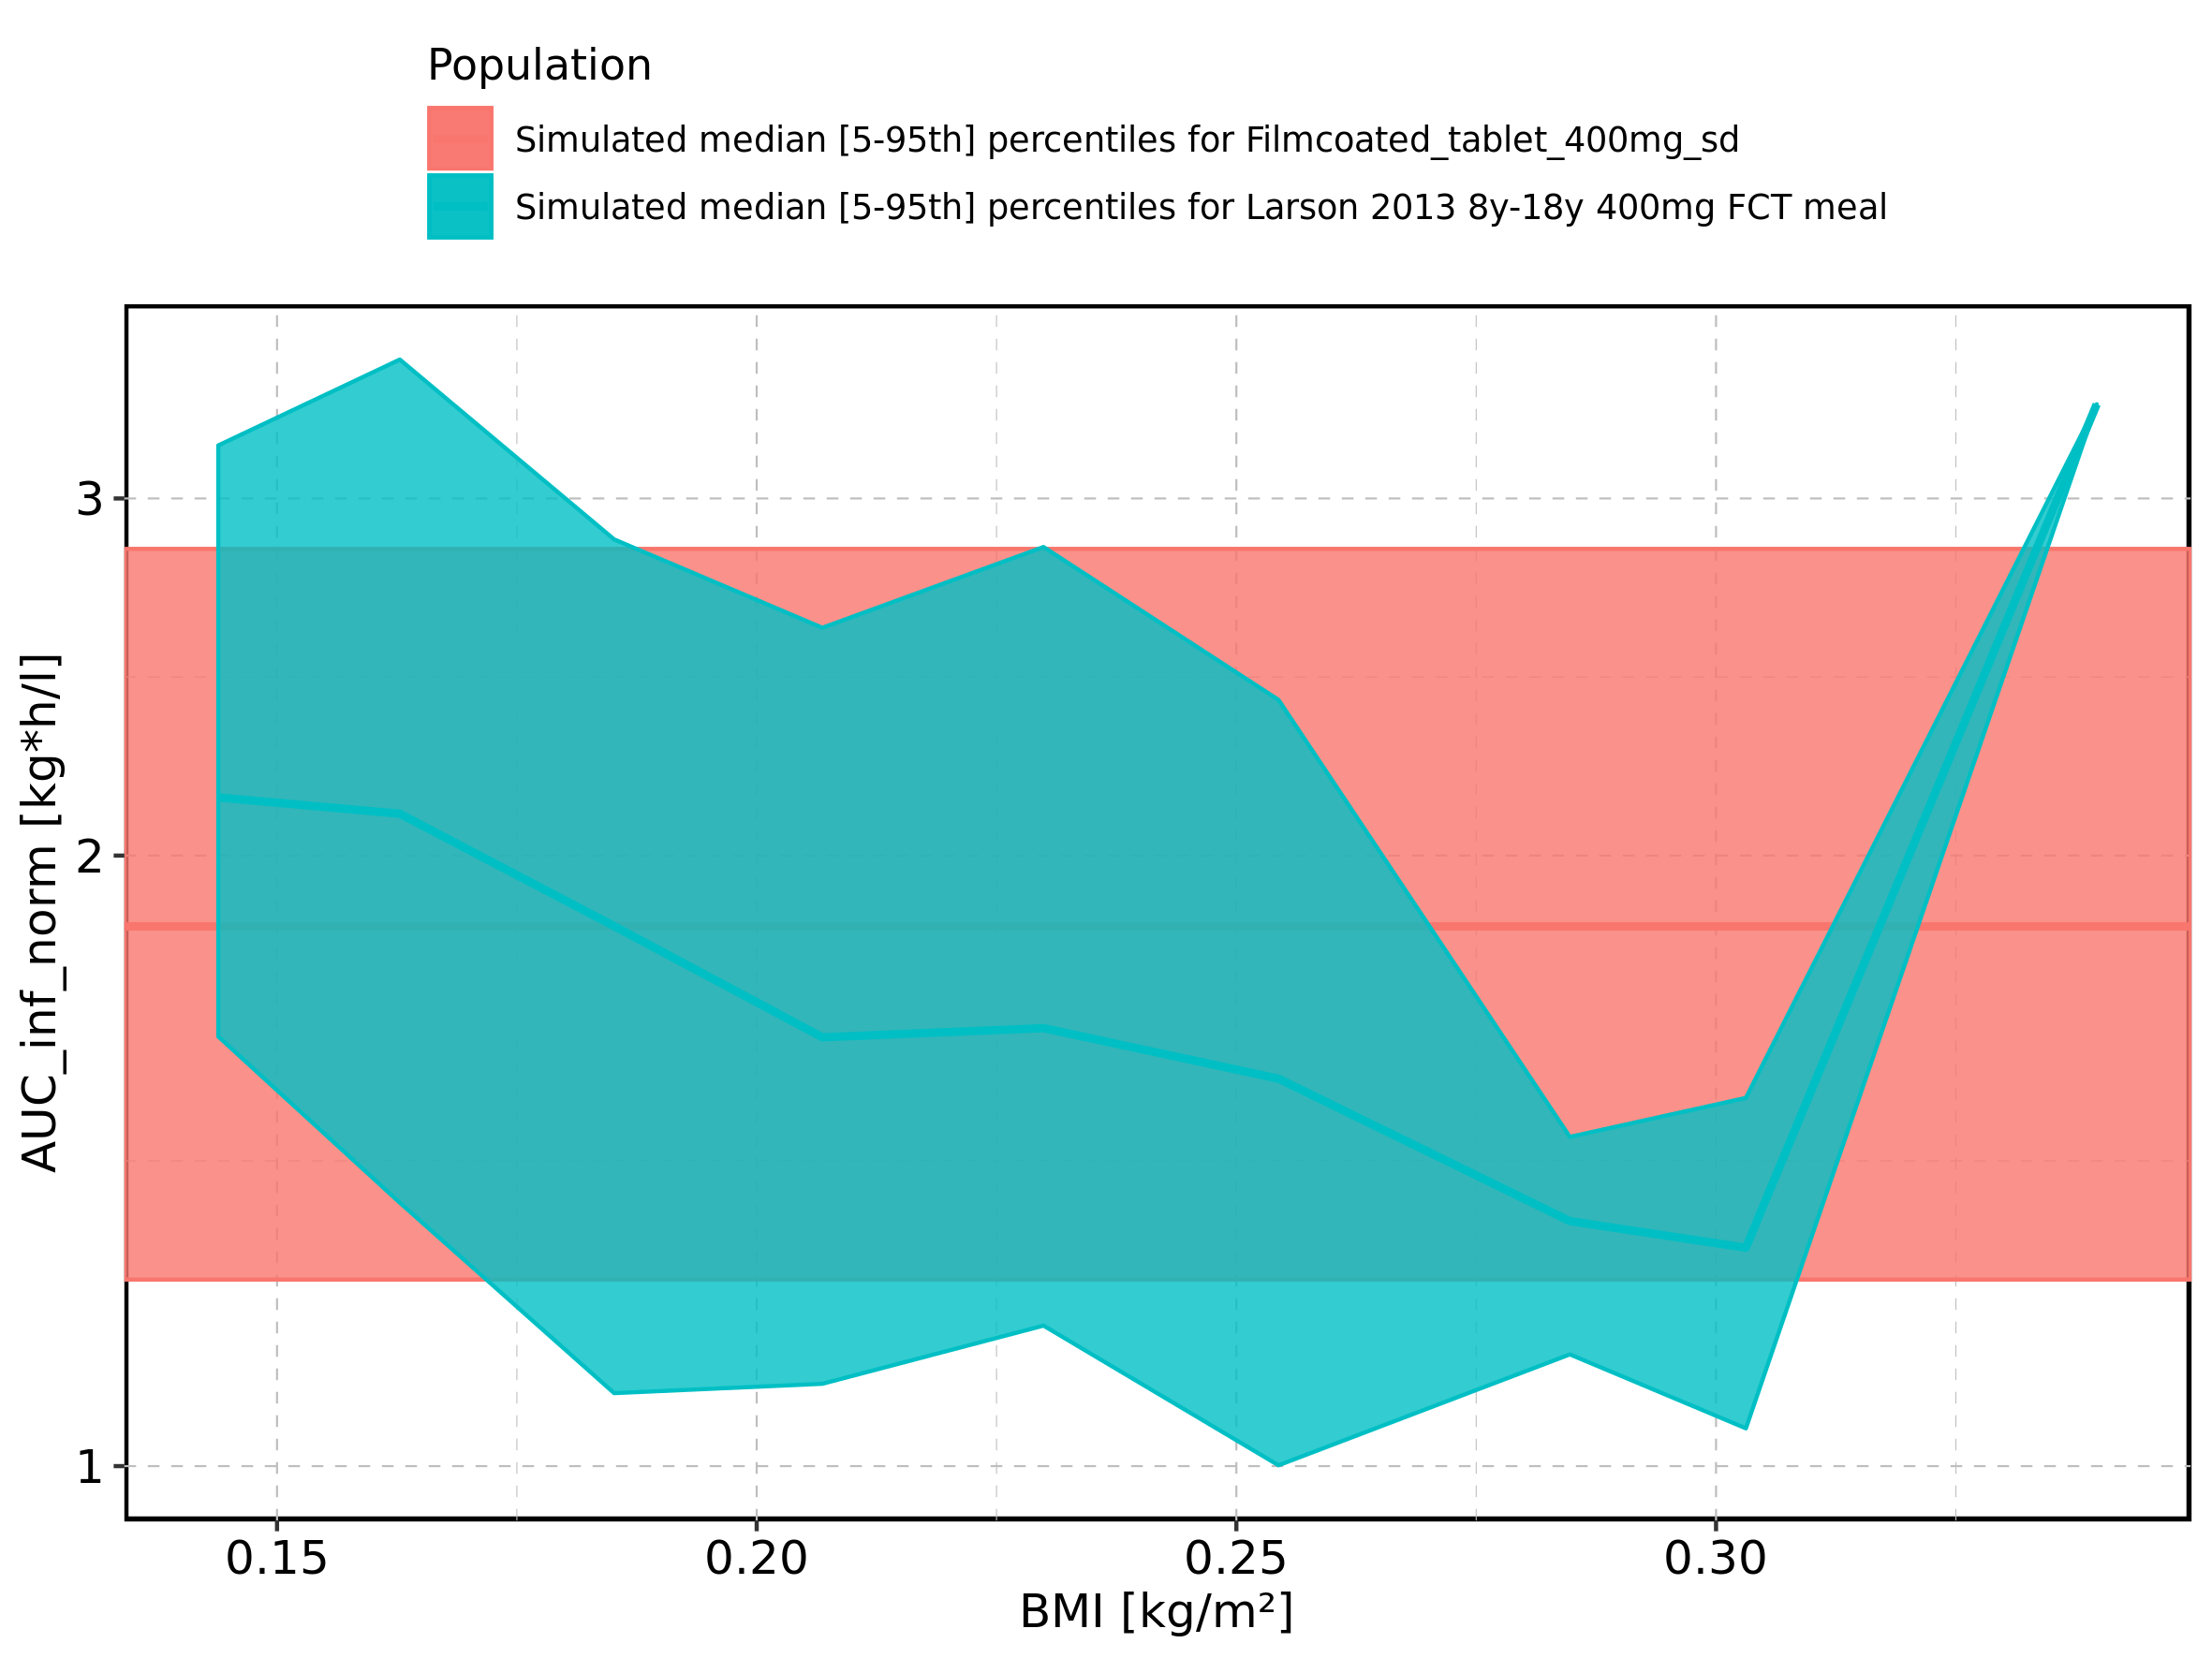

Figure 247: BMI-dependence of AUC_inf_norm for Larson 2013 8y-18y 400mg FCT meal. Profiles are plotted in a linear scale.

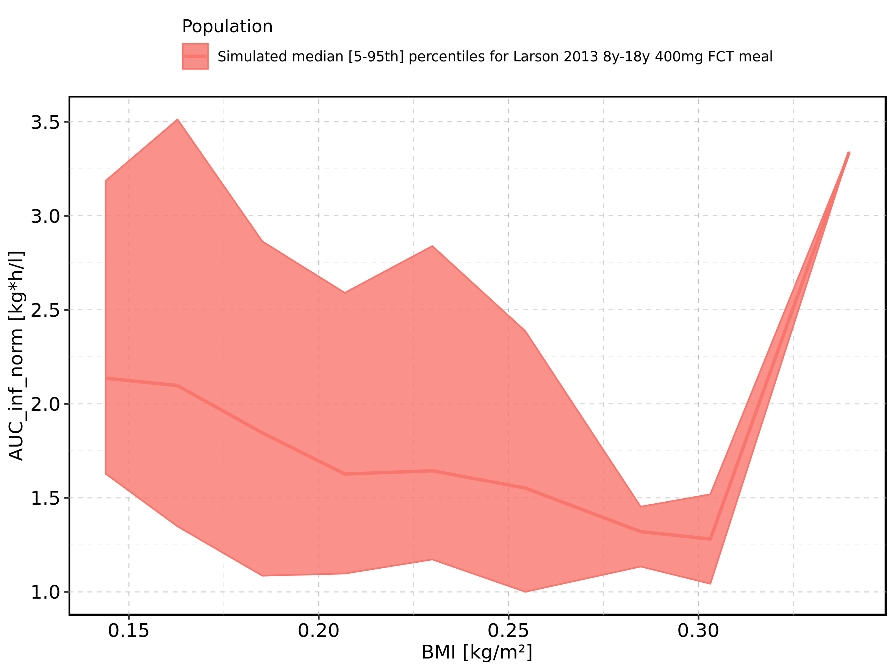

Figure 248: BMI-dependence of AUC_inf_norm for Larson 2013 8y-18y 400mg FCT meal. Profiles are plotted in a logarithmic scale.

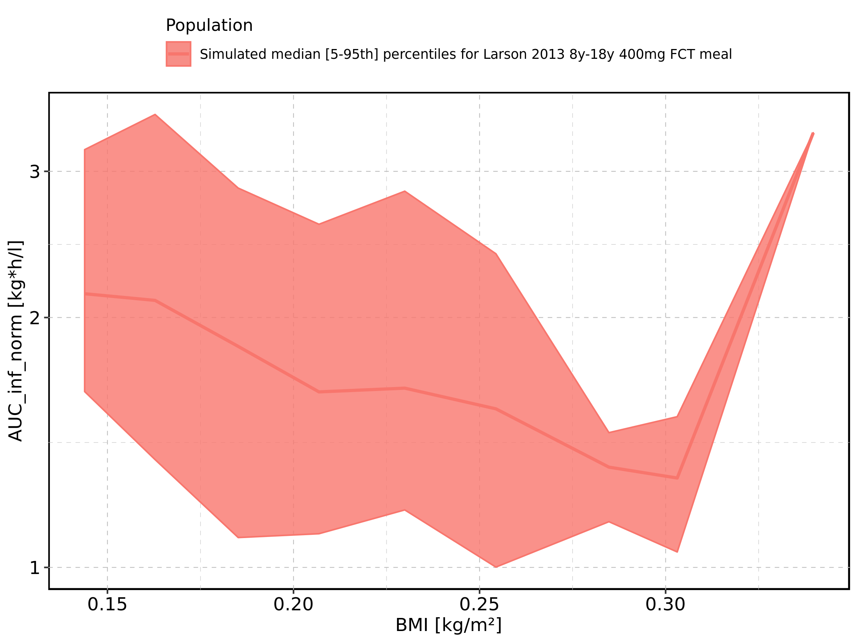

Figure 249: BMI-dependence of AUC_inf_norm for Filmcoated_tablet_400mg_sd. Profiles are plotted in a linear scale.

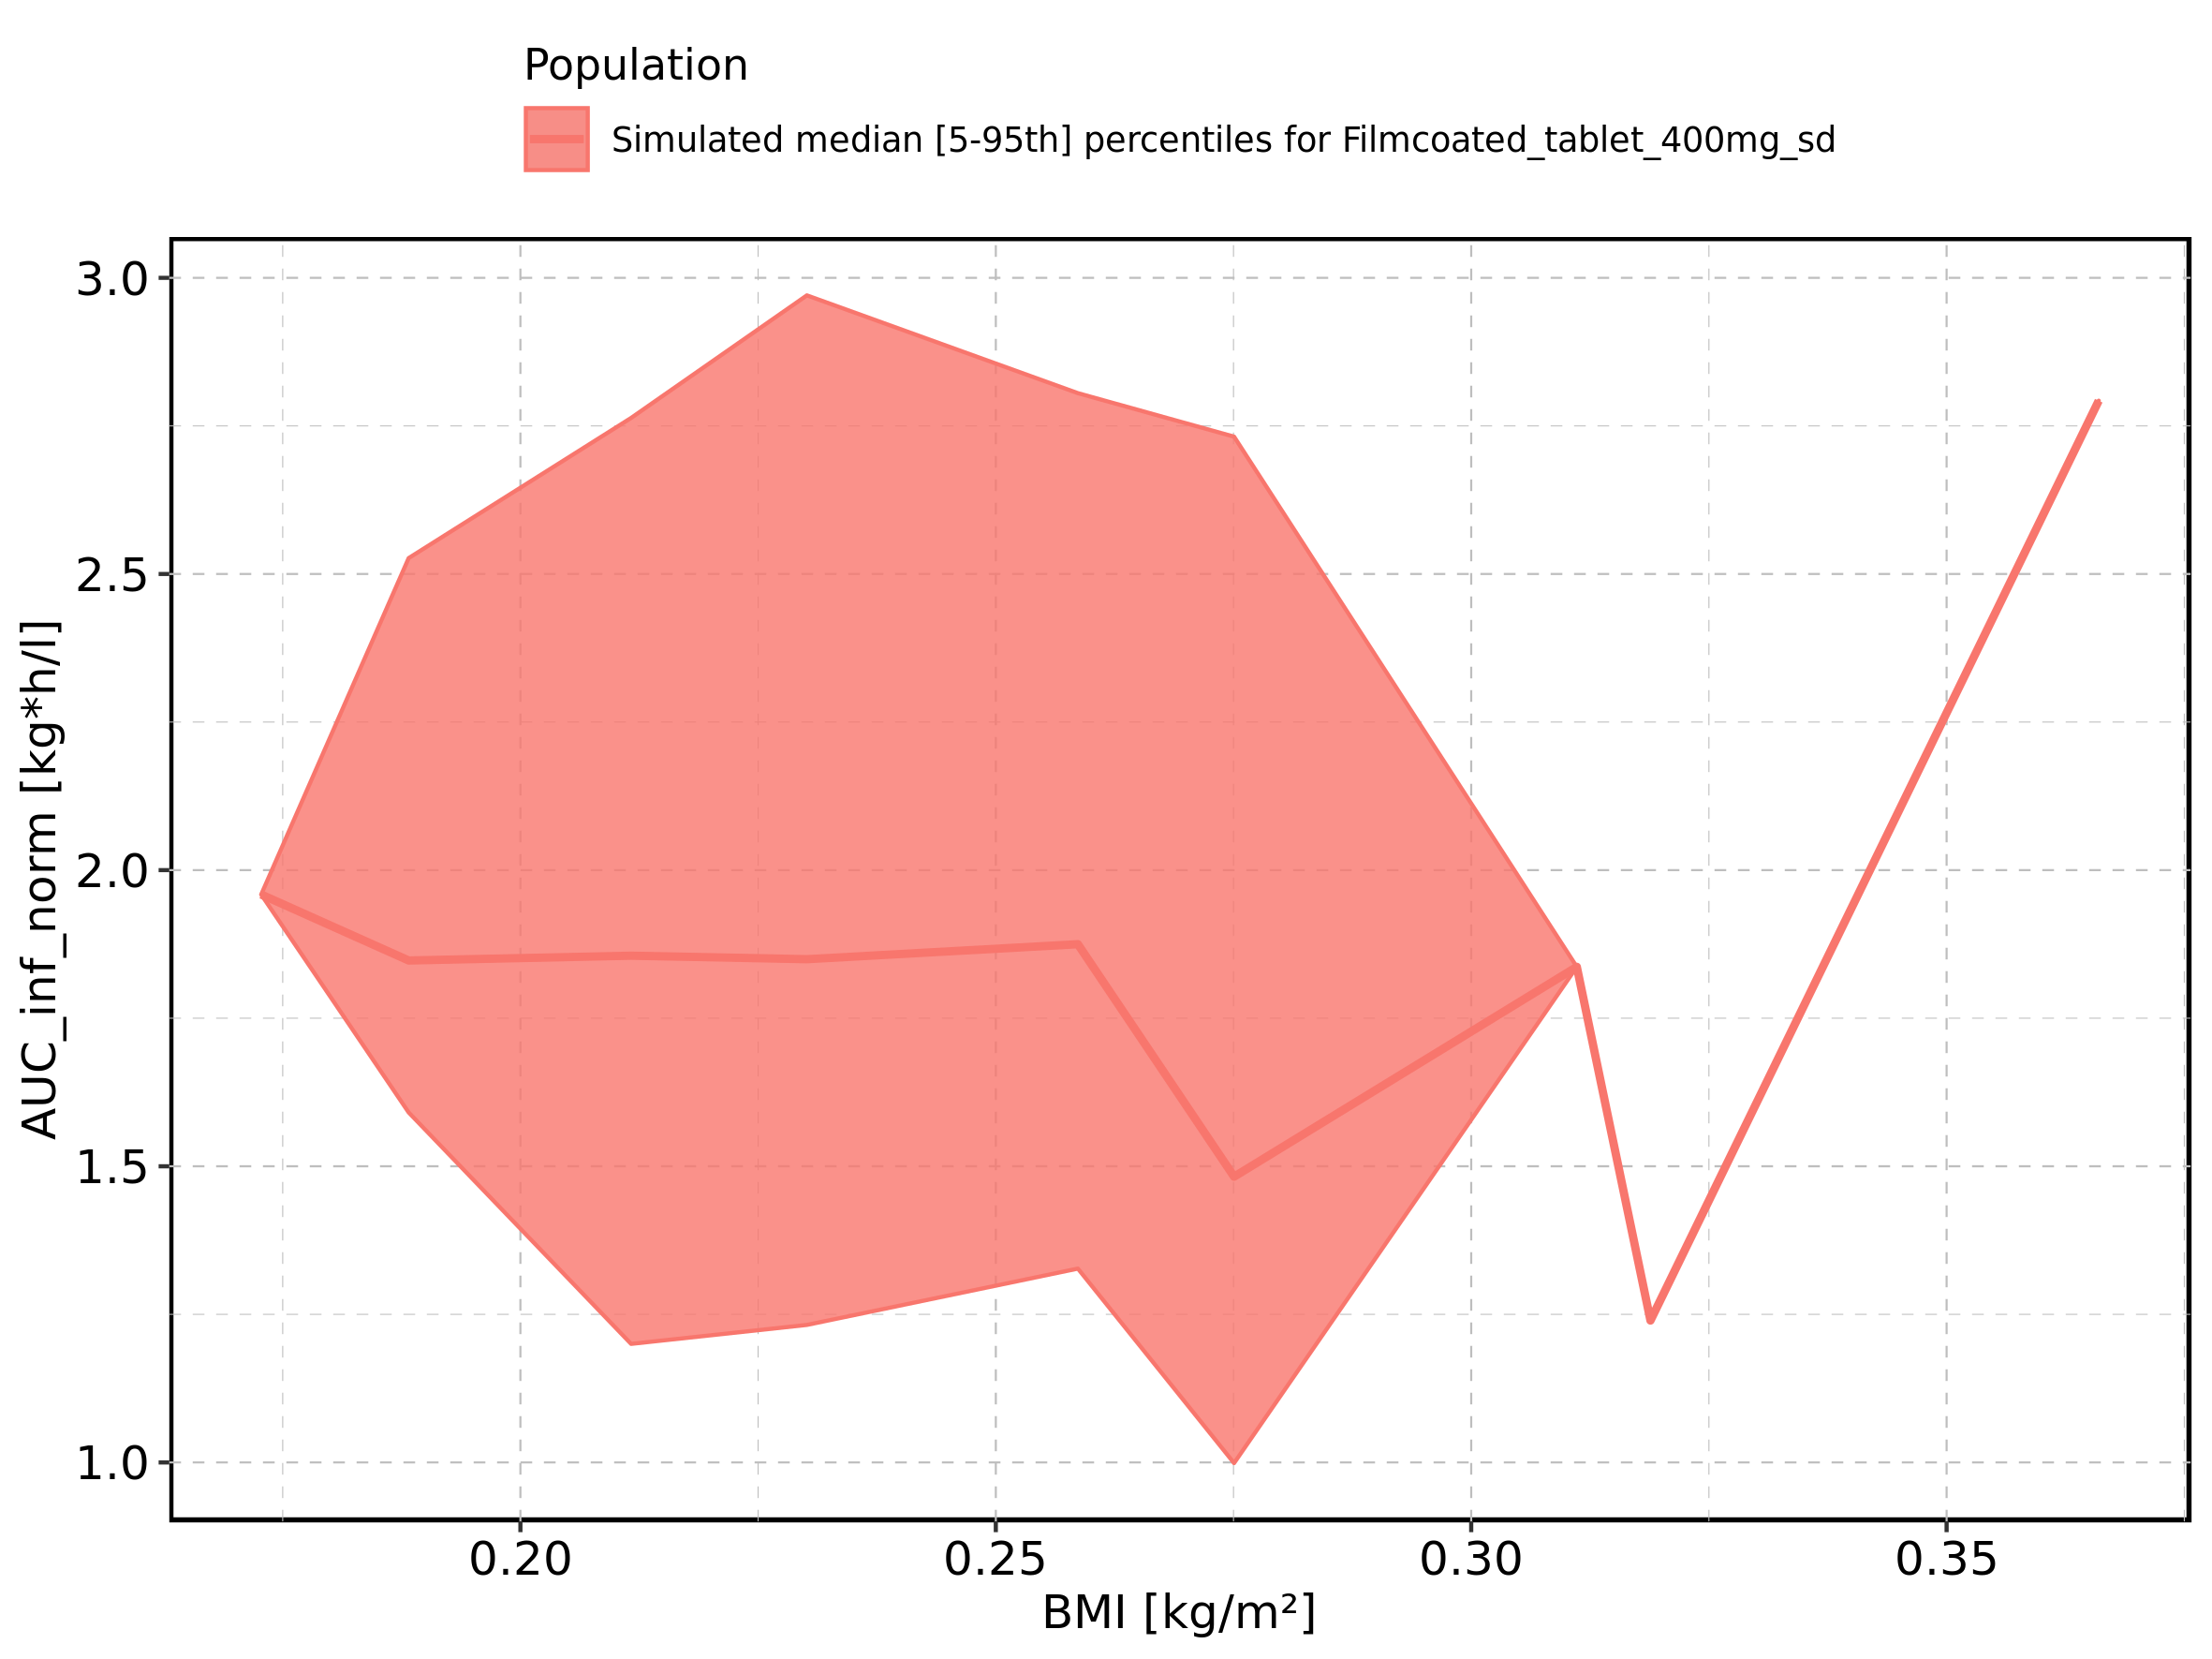

Figure 250: BMI-dependence of AUC_inf_norm for Filmcoated_tablet_400mg_sd. Profiles are plotted in a logarithmic scale.

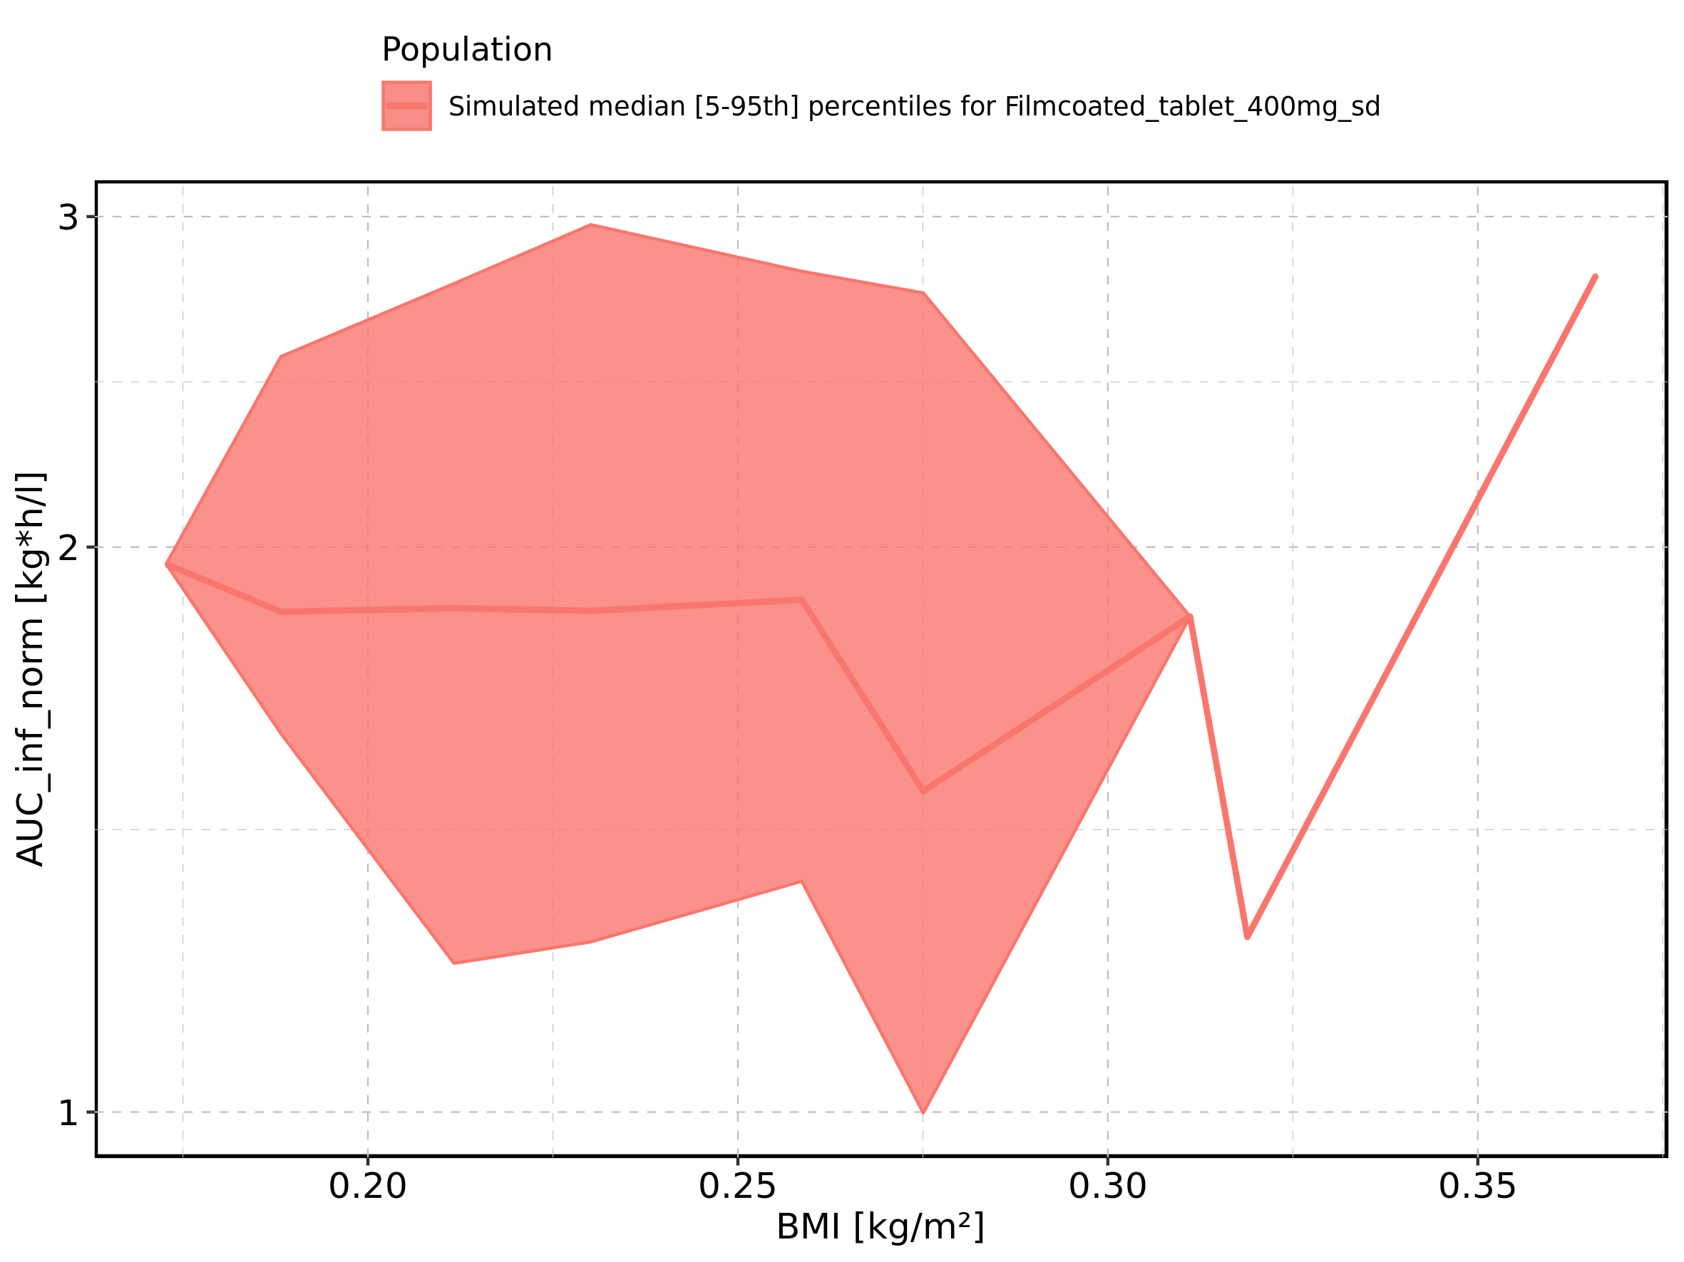

Figure 251: Gender-dependence of AUC_inf_norm for Larson 2013 8y-18y 400mg FCT meal in comparison to Filmcoated_tablet_400mg_sd. Profiles are plotted in a linear scale.

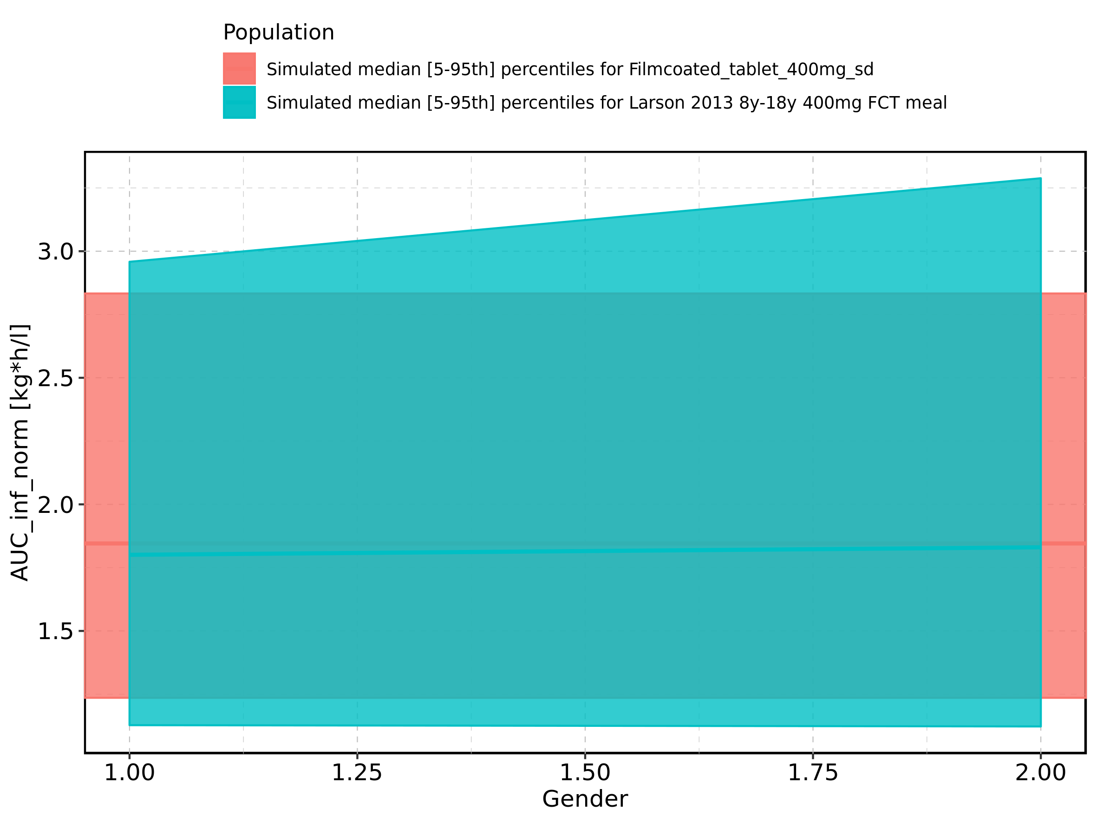

Figure 252: Gender-dependence of AUC_inf_norm for Larson 2013 8y-18y 400mg FCT meal in comparison to Filmcoated_tablet_400mg_sd. Profiles are plotted in a logarithmic scale.

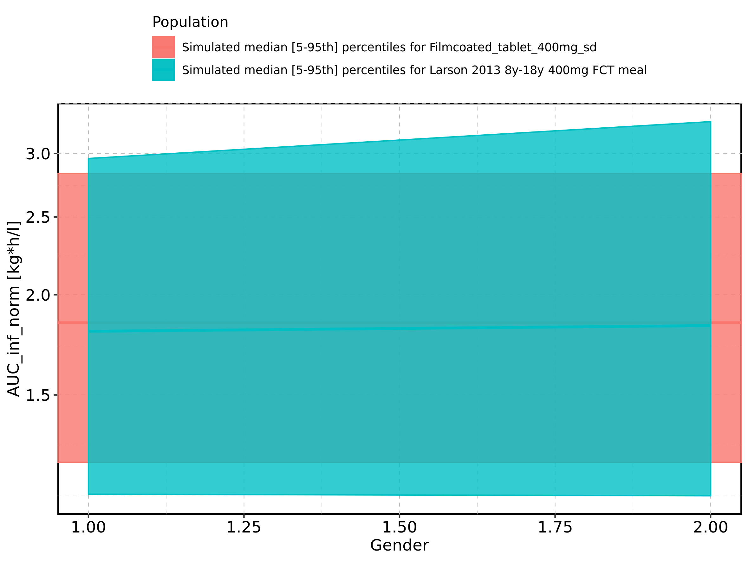

Figure 253: Gender-dependence of AUC_inf_norm for Larson 2013 8y-18y 400mg FCT meal. Profiles are plotted in a linear scale.

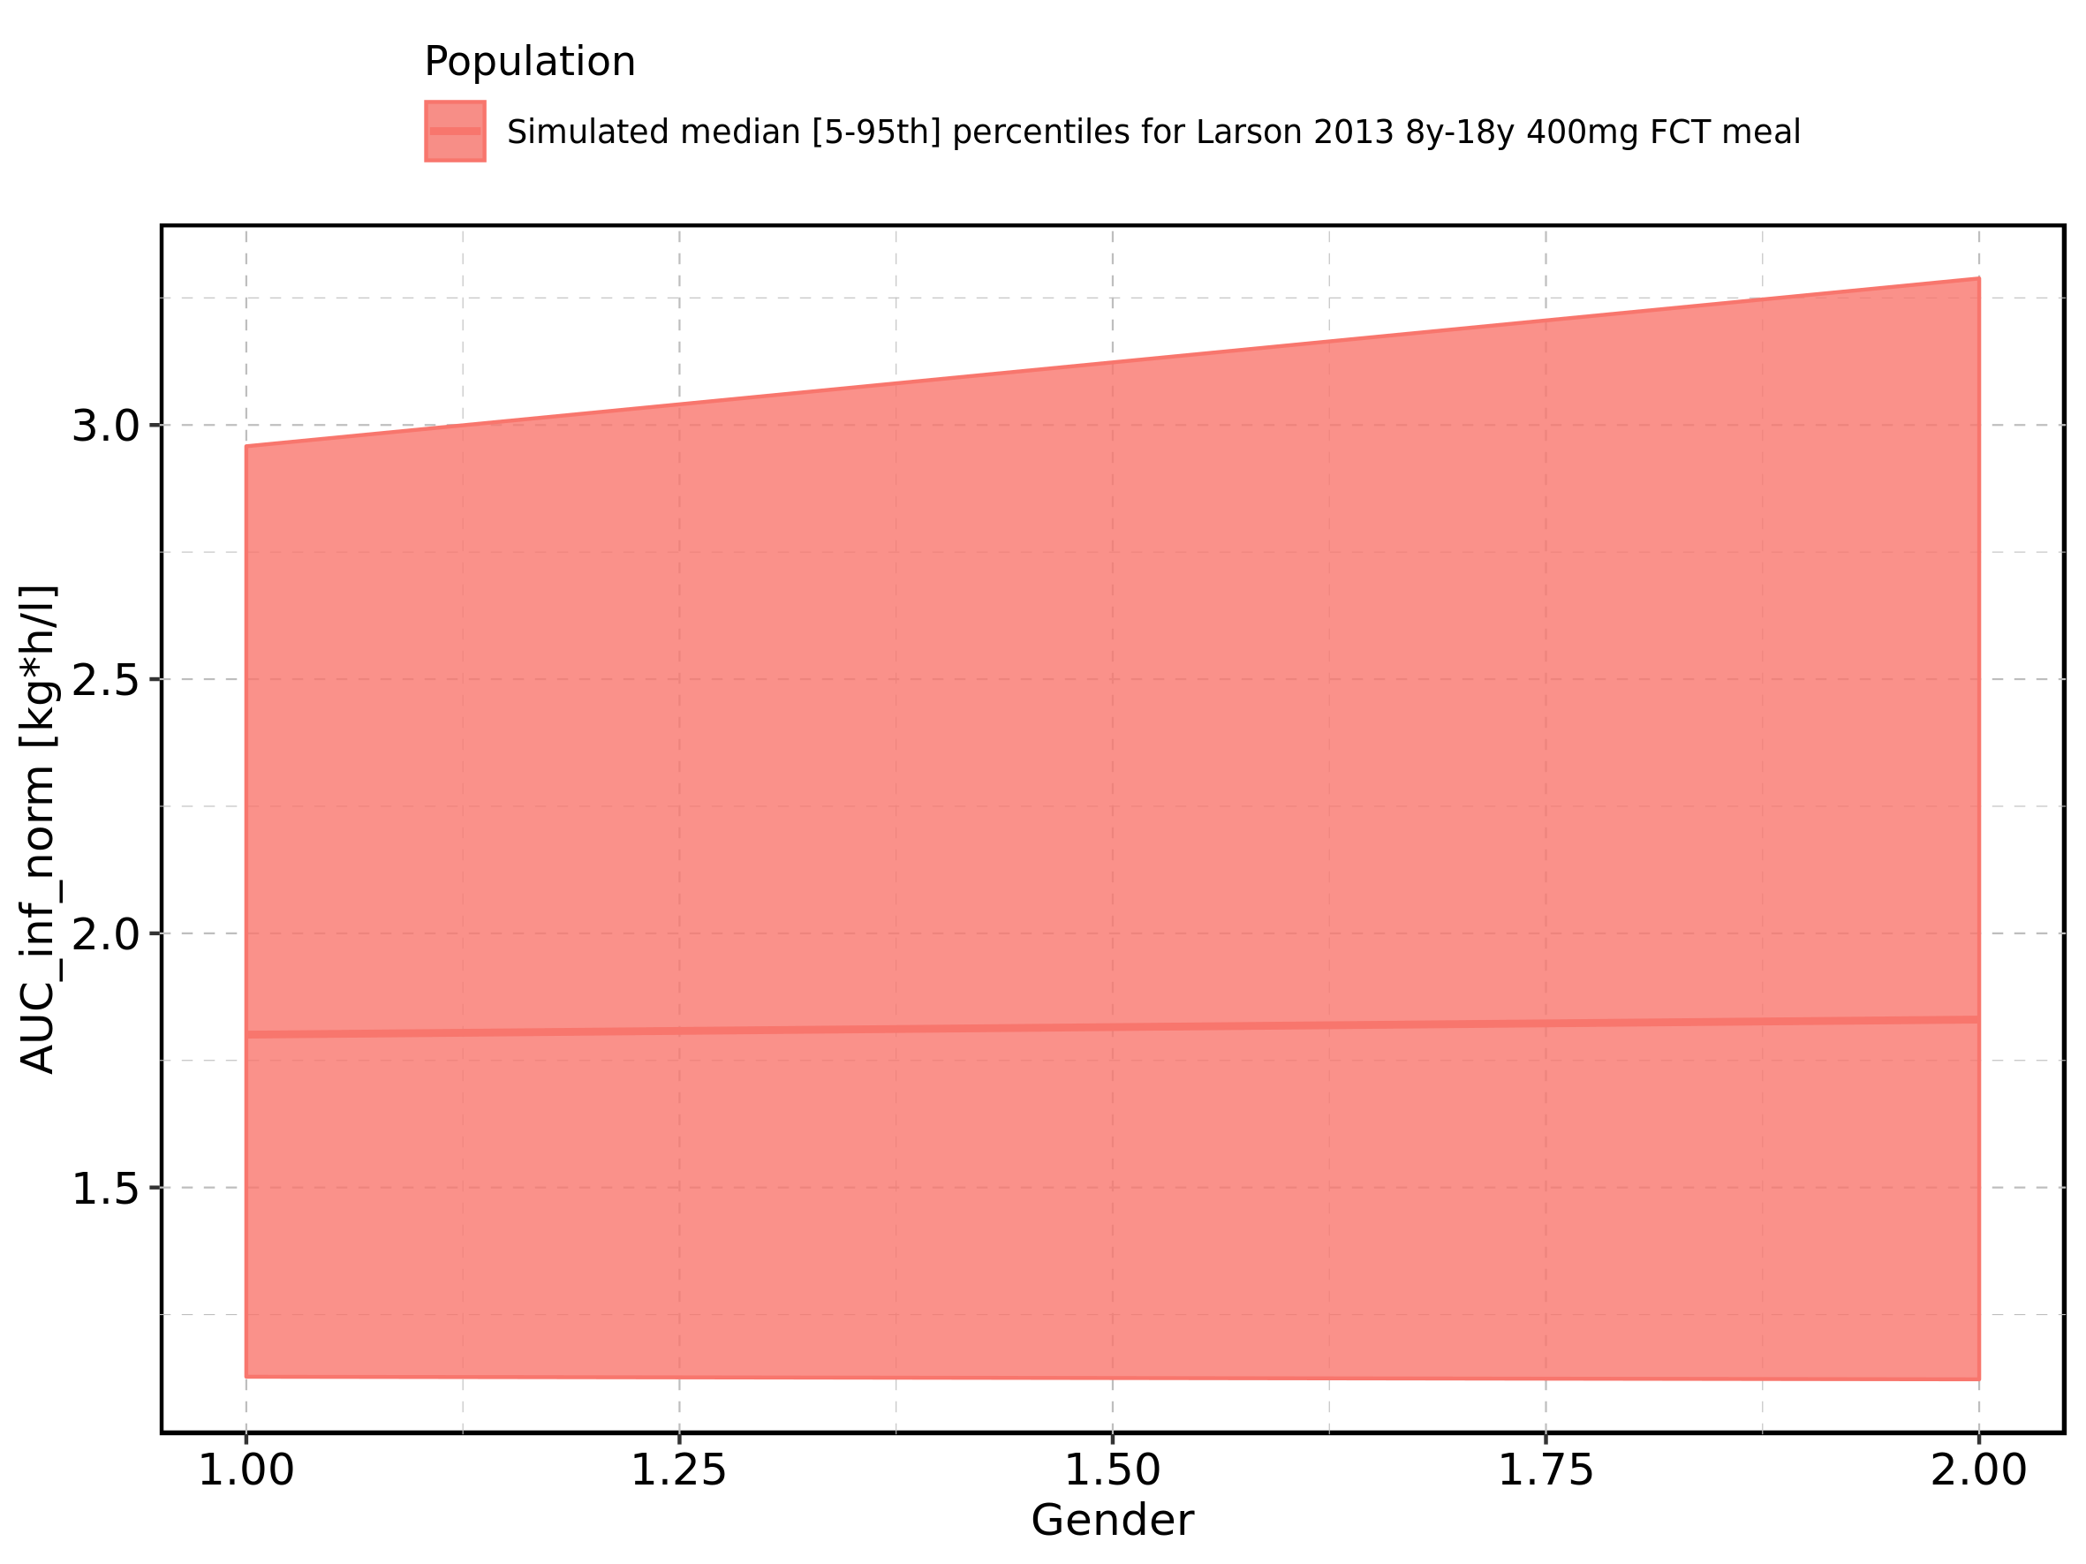

Figure 254: Gender-dependence of AUC_inf_norm for Larson 2013 8y-18y 400mg FCT meal. Profiles are plotted in a logarithmic scale.

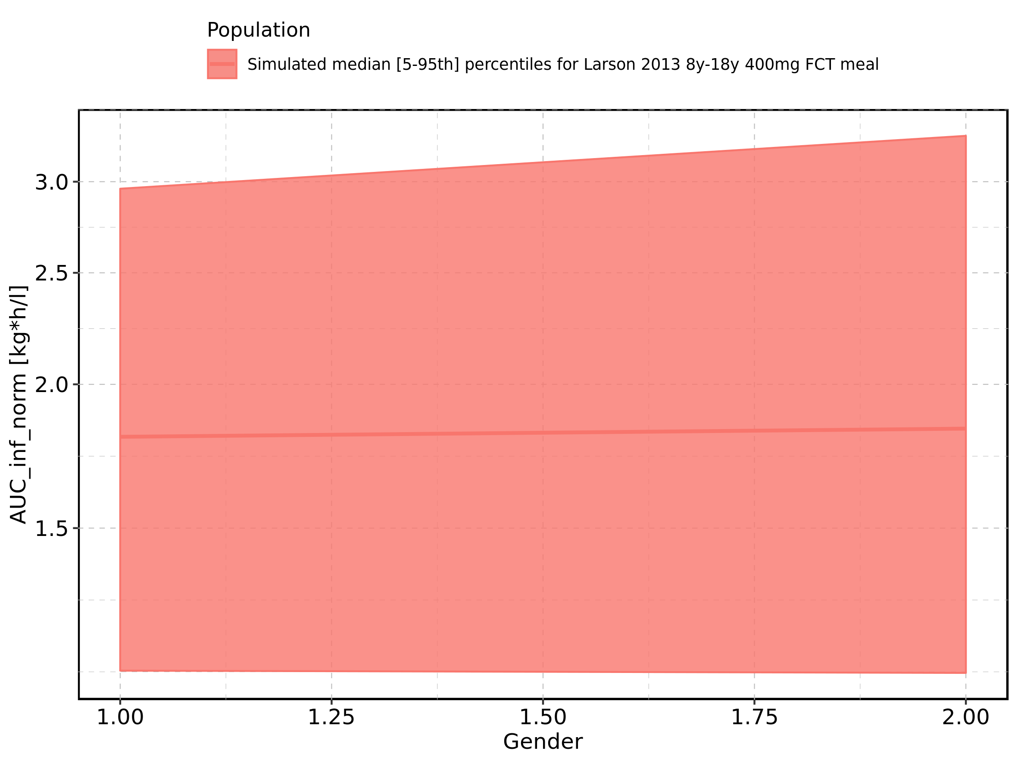

Figure 255: Gender-dependence of AUC_inf_norm for Filmcoated_tablet_400mg_sd. Profiles are plotted in a linear scale.

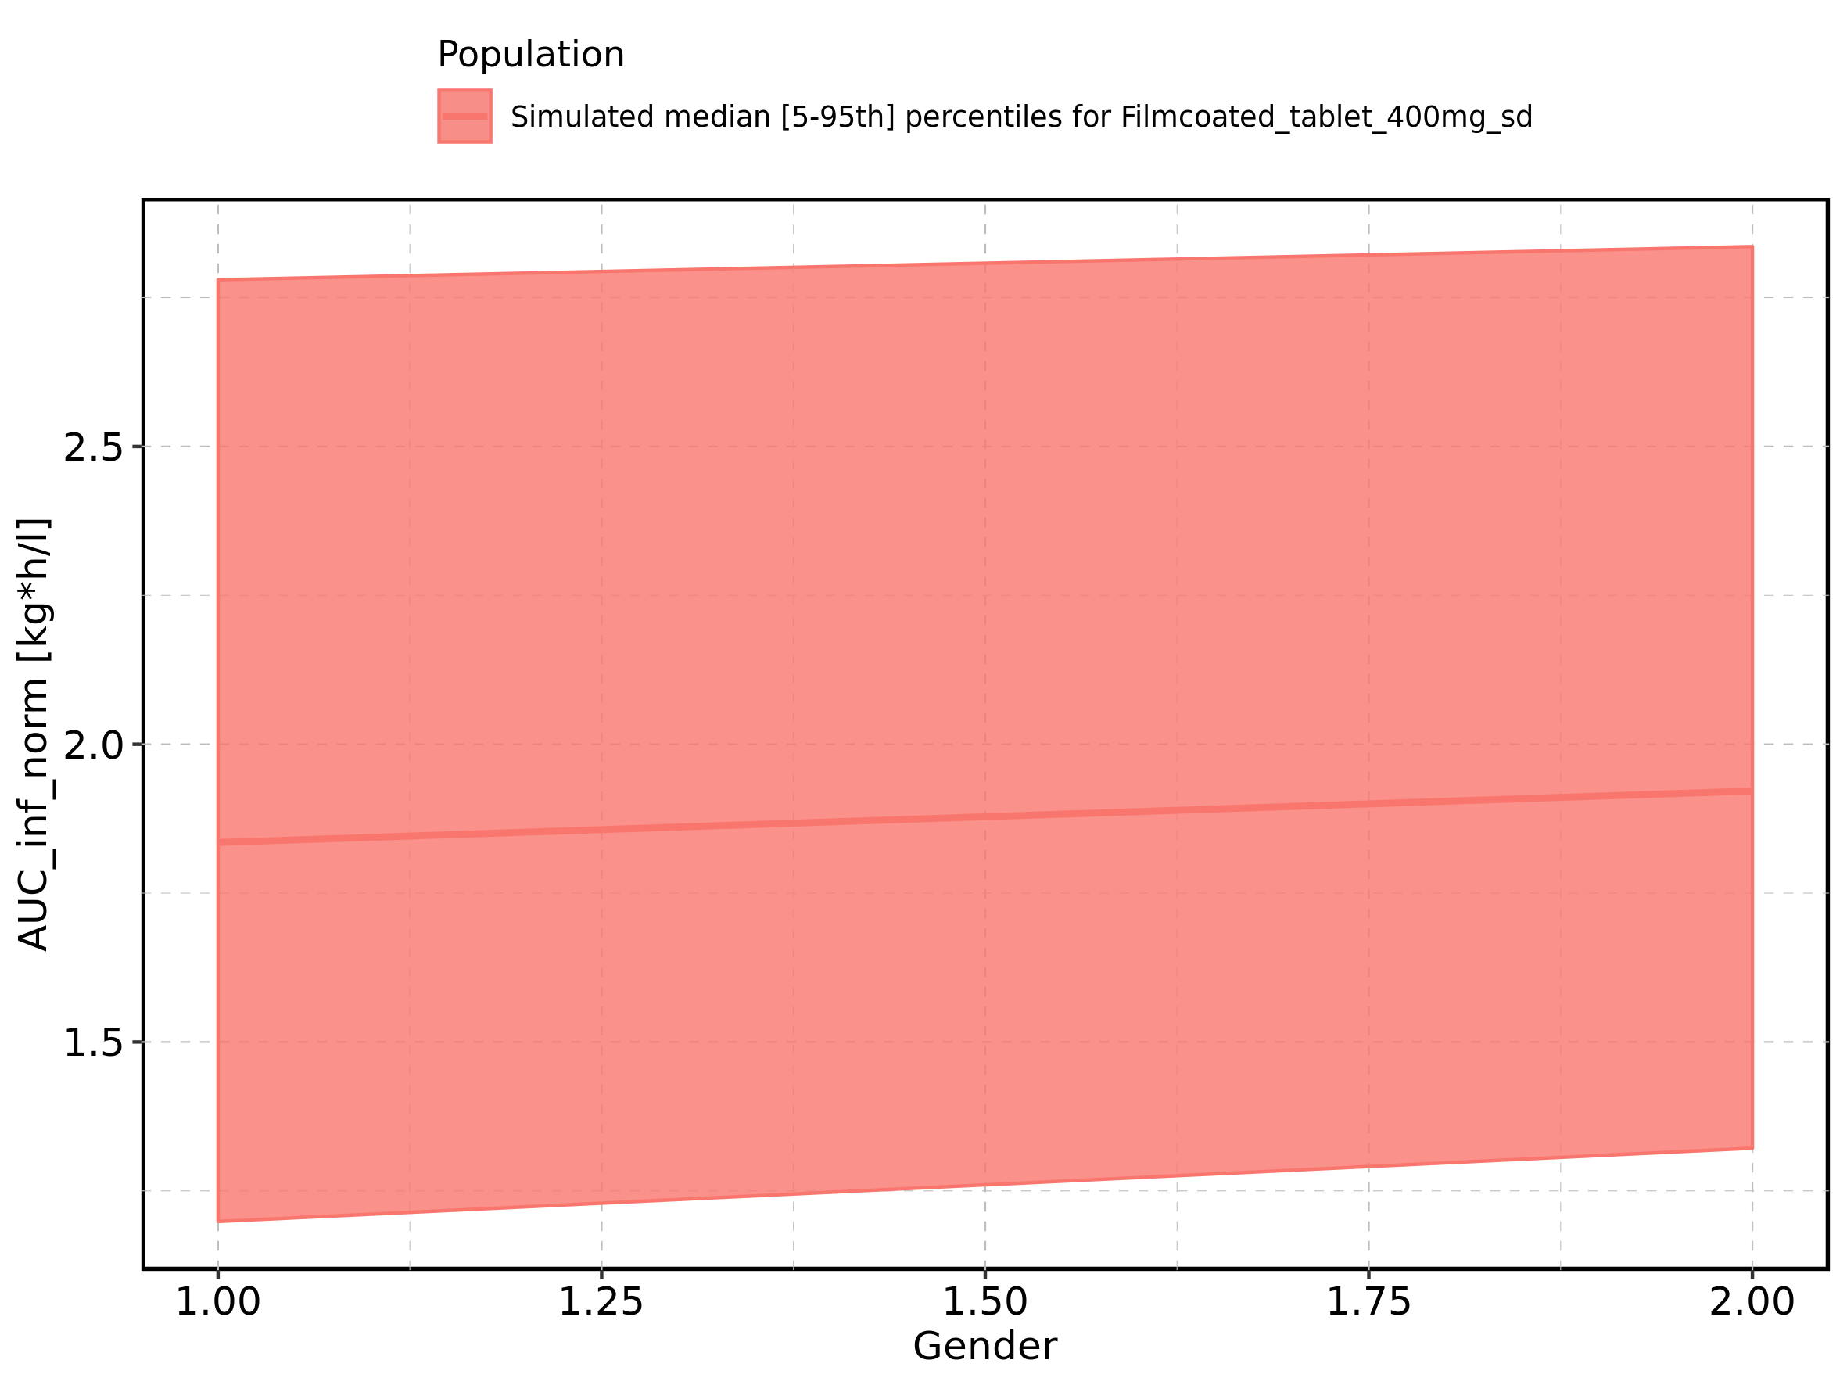

Figure 256: Gender-dependence of AUC_inf_norm for Filmcoated_tablet_400mg_sd. Profiles are plotted in a logarithmic scale.

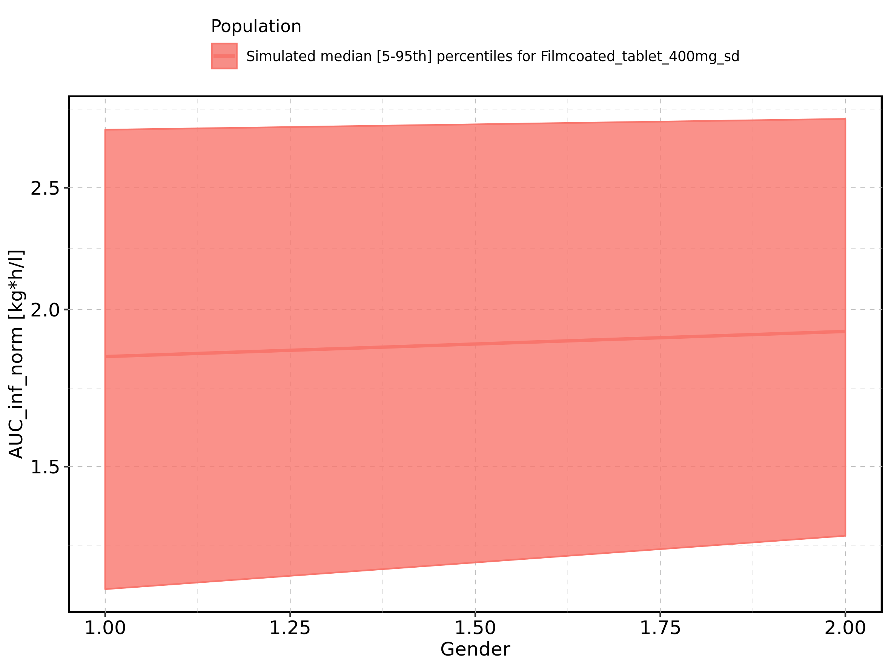

Figure 257: MRT of Raltegravir shown as box-whisker plot, which indicates the 5th, 25th, 50th, 75th, and 95th percentiles in linear scale.

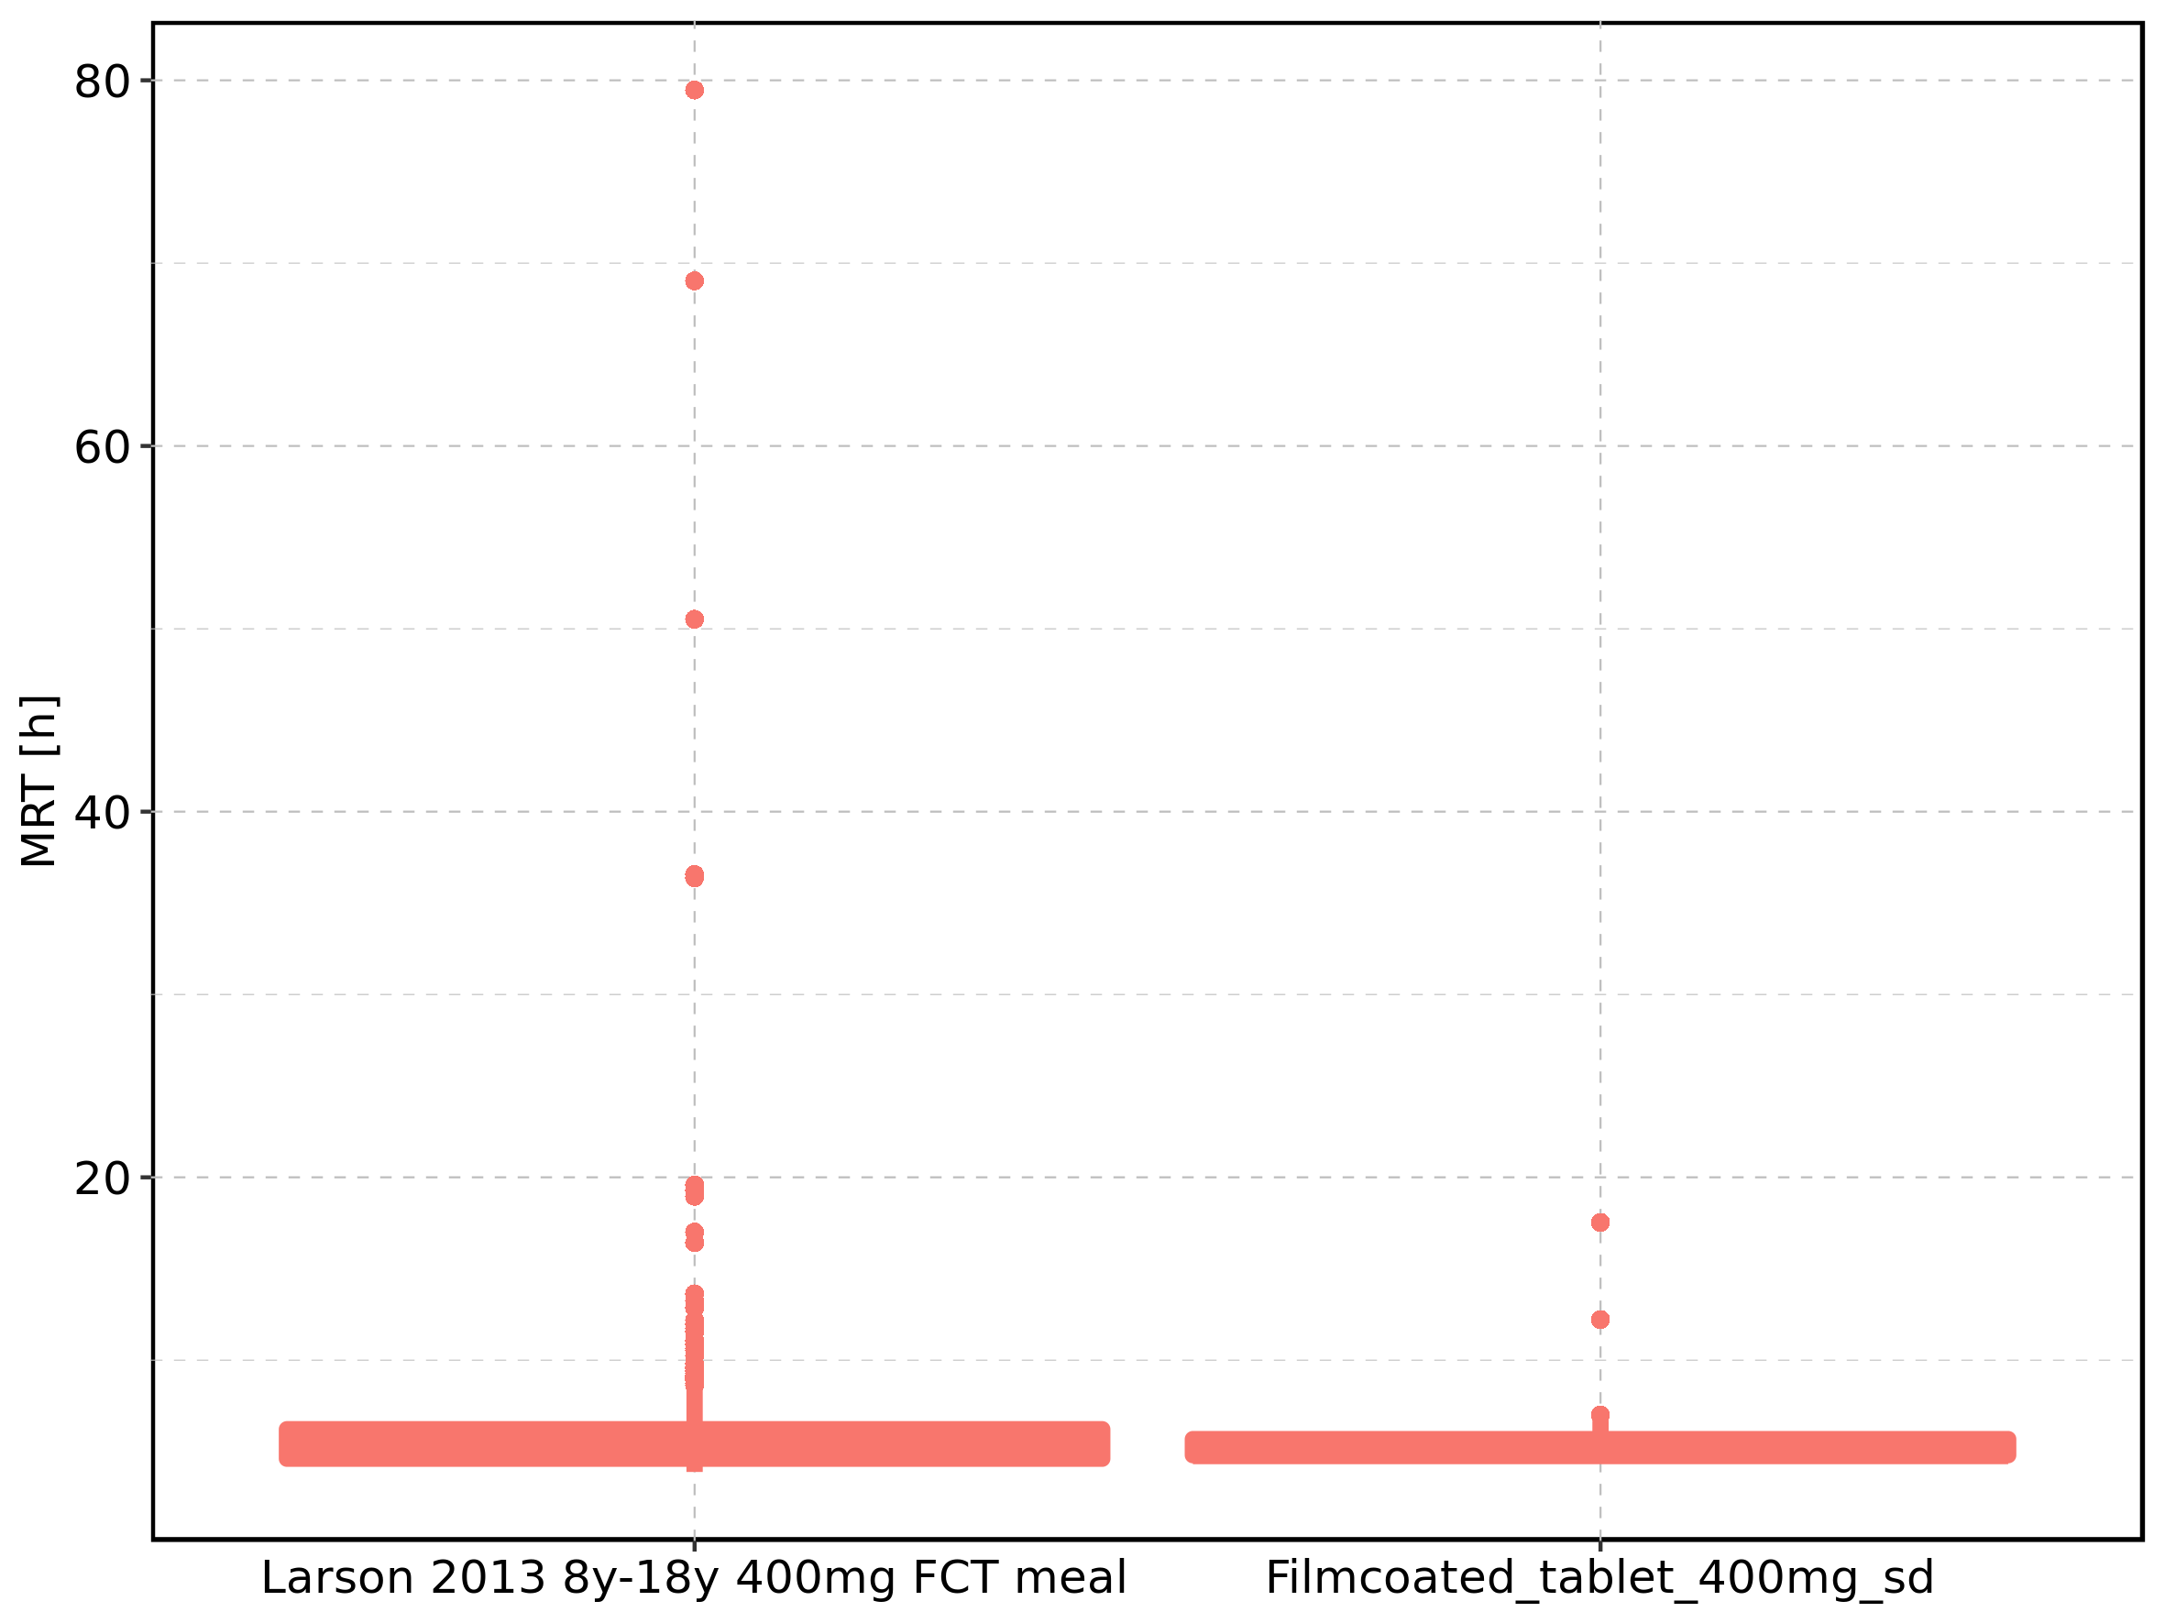

|  |  |  |  |  |  |  |  |  |  |  |
| --- | --- | --- | --- | --- | --- | --- | --- | --- | --- | --- |
| Population | N | 5th percentile | 25th percentile | 50th percentile | 75th percentile | 95th percentile | mean | standard deviation | geo mean | geo standard deviation |
| Larson 2013 8y-18y 400mg FCT meal | 497 | 3.883445 | 4.609144 | 5.323850 | 6.221885 | 10.309078 | 6.26299 | 5.564334 | 5.638130 | 1.436885 |
| Filmcoated_tablet_400mg_sd | 100 | 4.431077 | 4.803066 | 5.199119 | 5.682457 | 6.697588 | 5.43842 | 1.539075 | 5.318614 | 1.206249 |

Figure 258: MRT of Raltegravir shown as box-whisker plot, which indicates the 5th, 25th, 50th, 75th, and 95th percentiles in logarithmic scale.

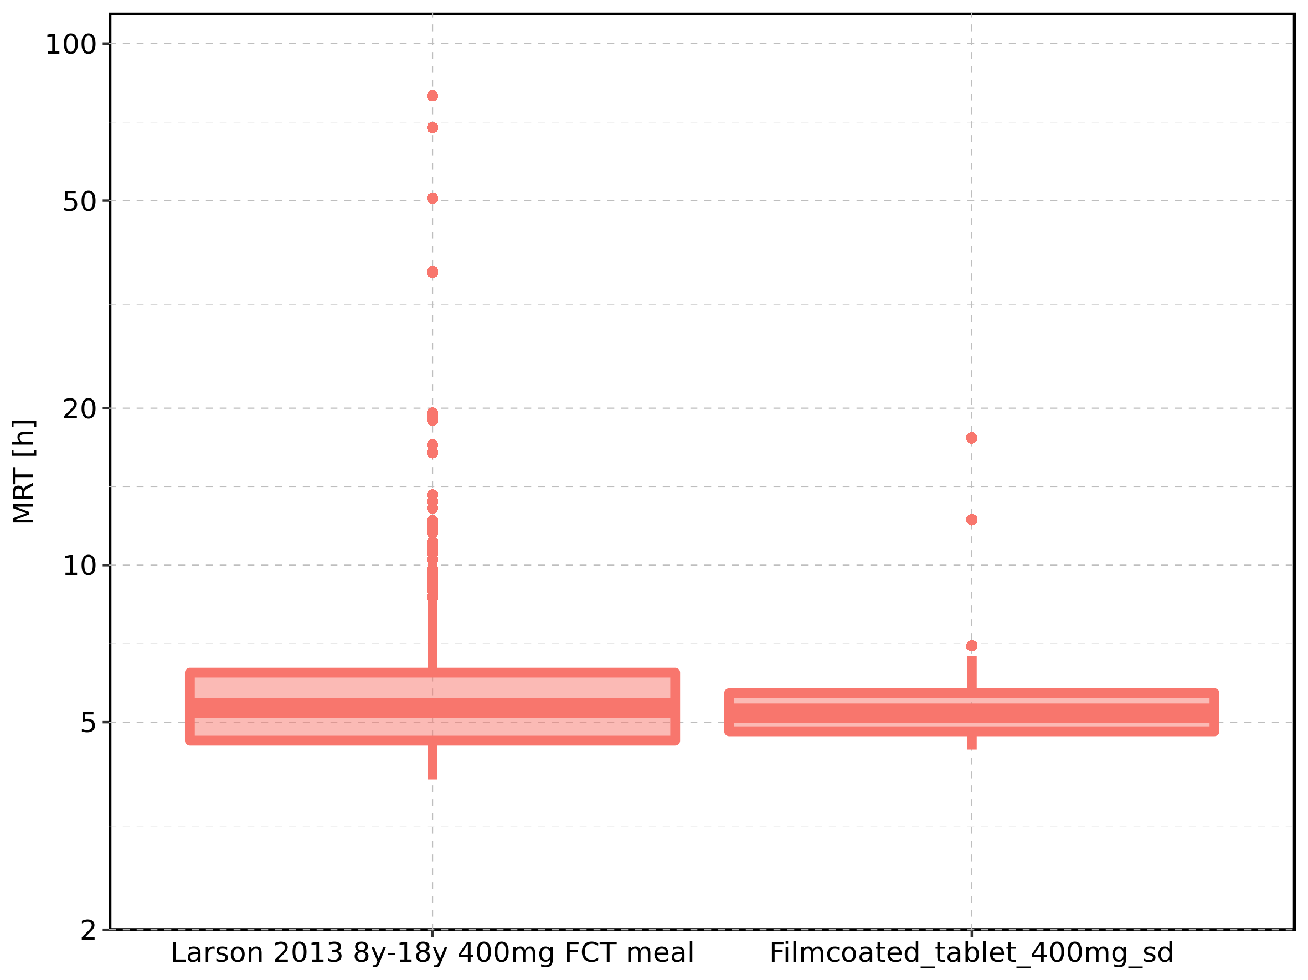

Figure 259: Age-dependence of MRT for Larson 2013 8y-18y 400mg FCT meal in comparison to Filmcoated_tablet_400mg_sd. Profiles are plotted in a linear scale.

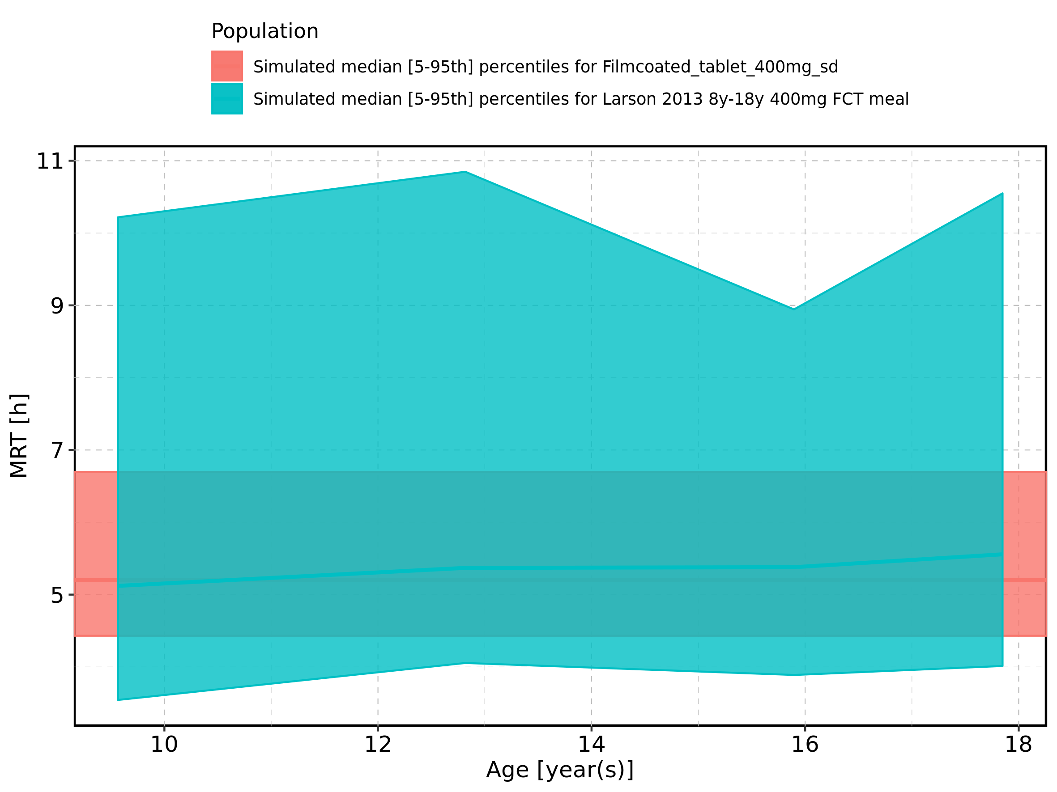

Figure 260: Age-dependence of MRT for Larson 2013 8y-18y 400mg FCT meal in comparison to Filmcoated_tablet_400mg_sd. Profiles are plotted in a logarithmic scale.

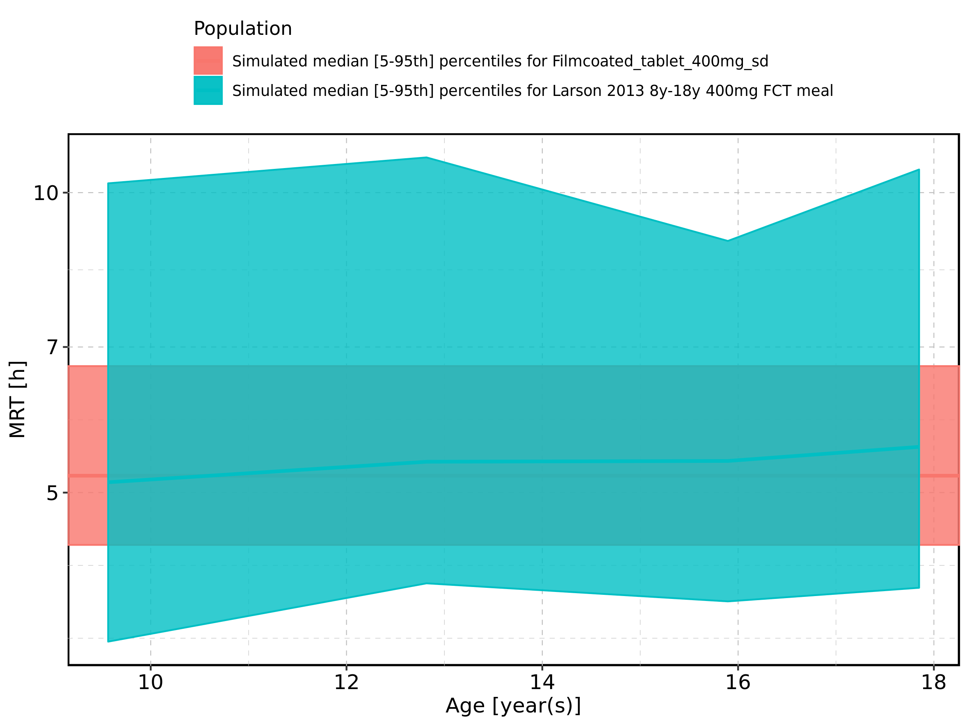

Figure 261: Age-dependence of MRT for Larson 2013 8y-18y 400mg FCT meal. Profiles are plotted in a linear scale.

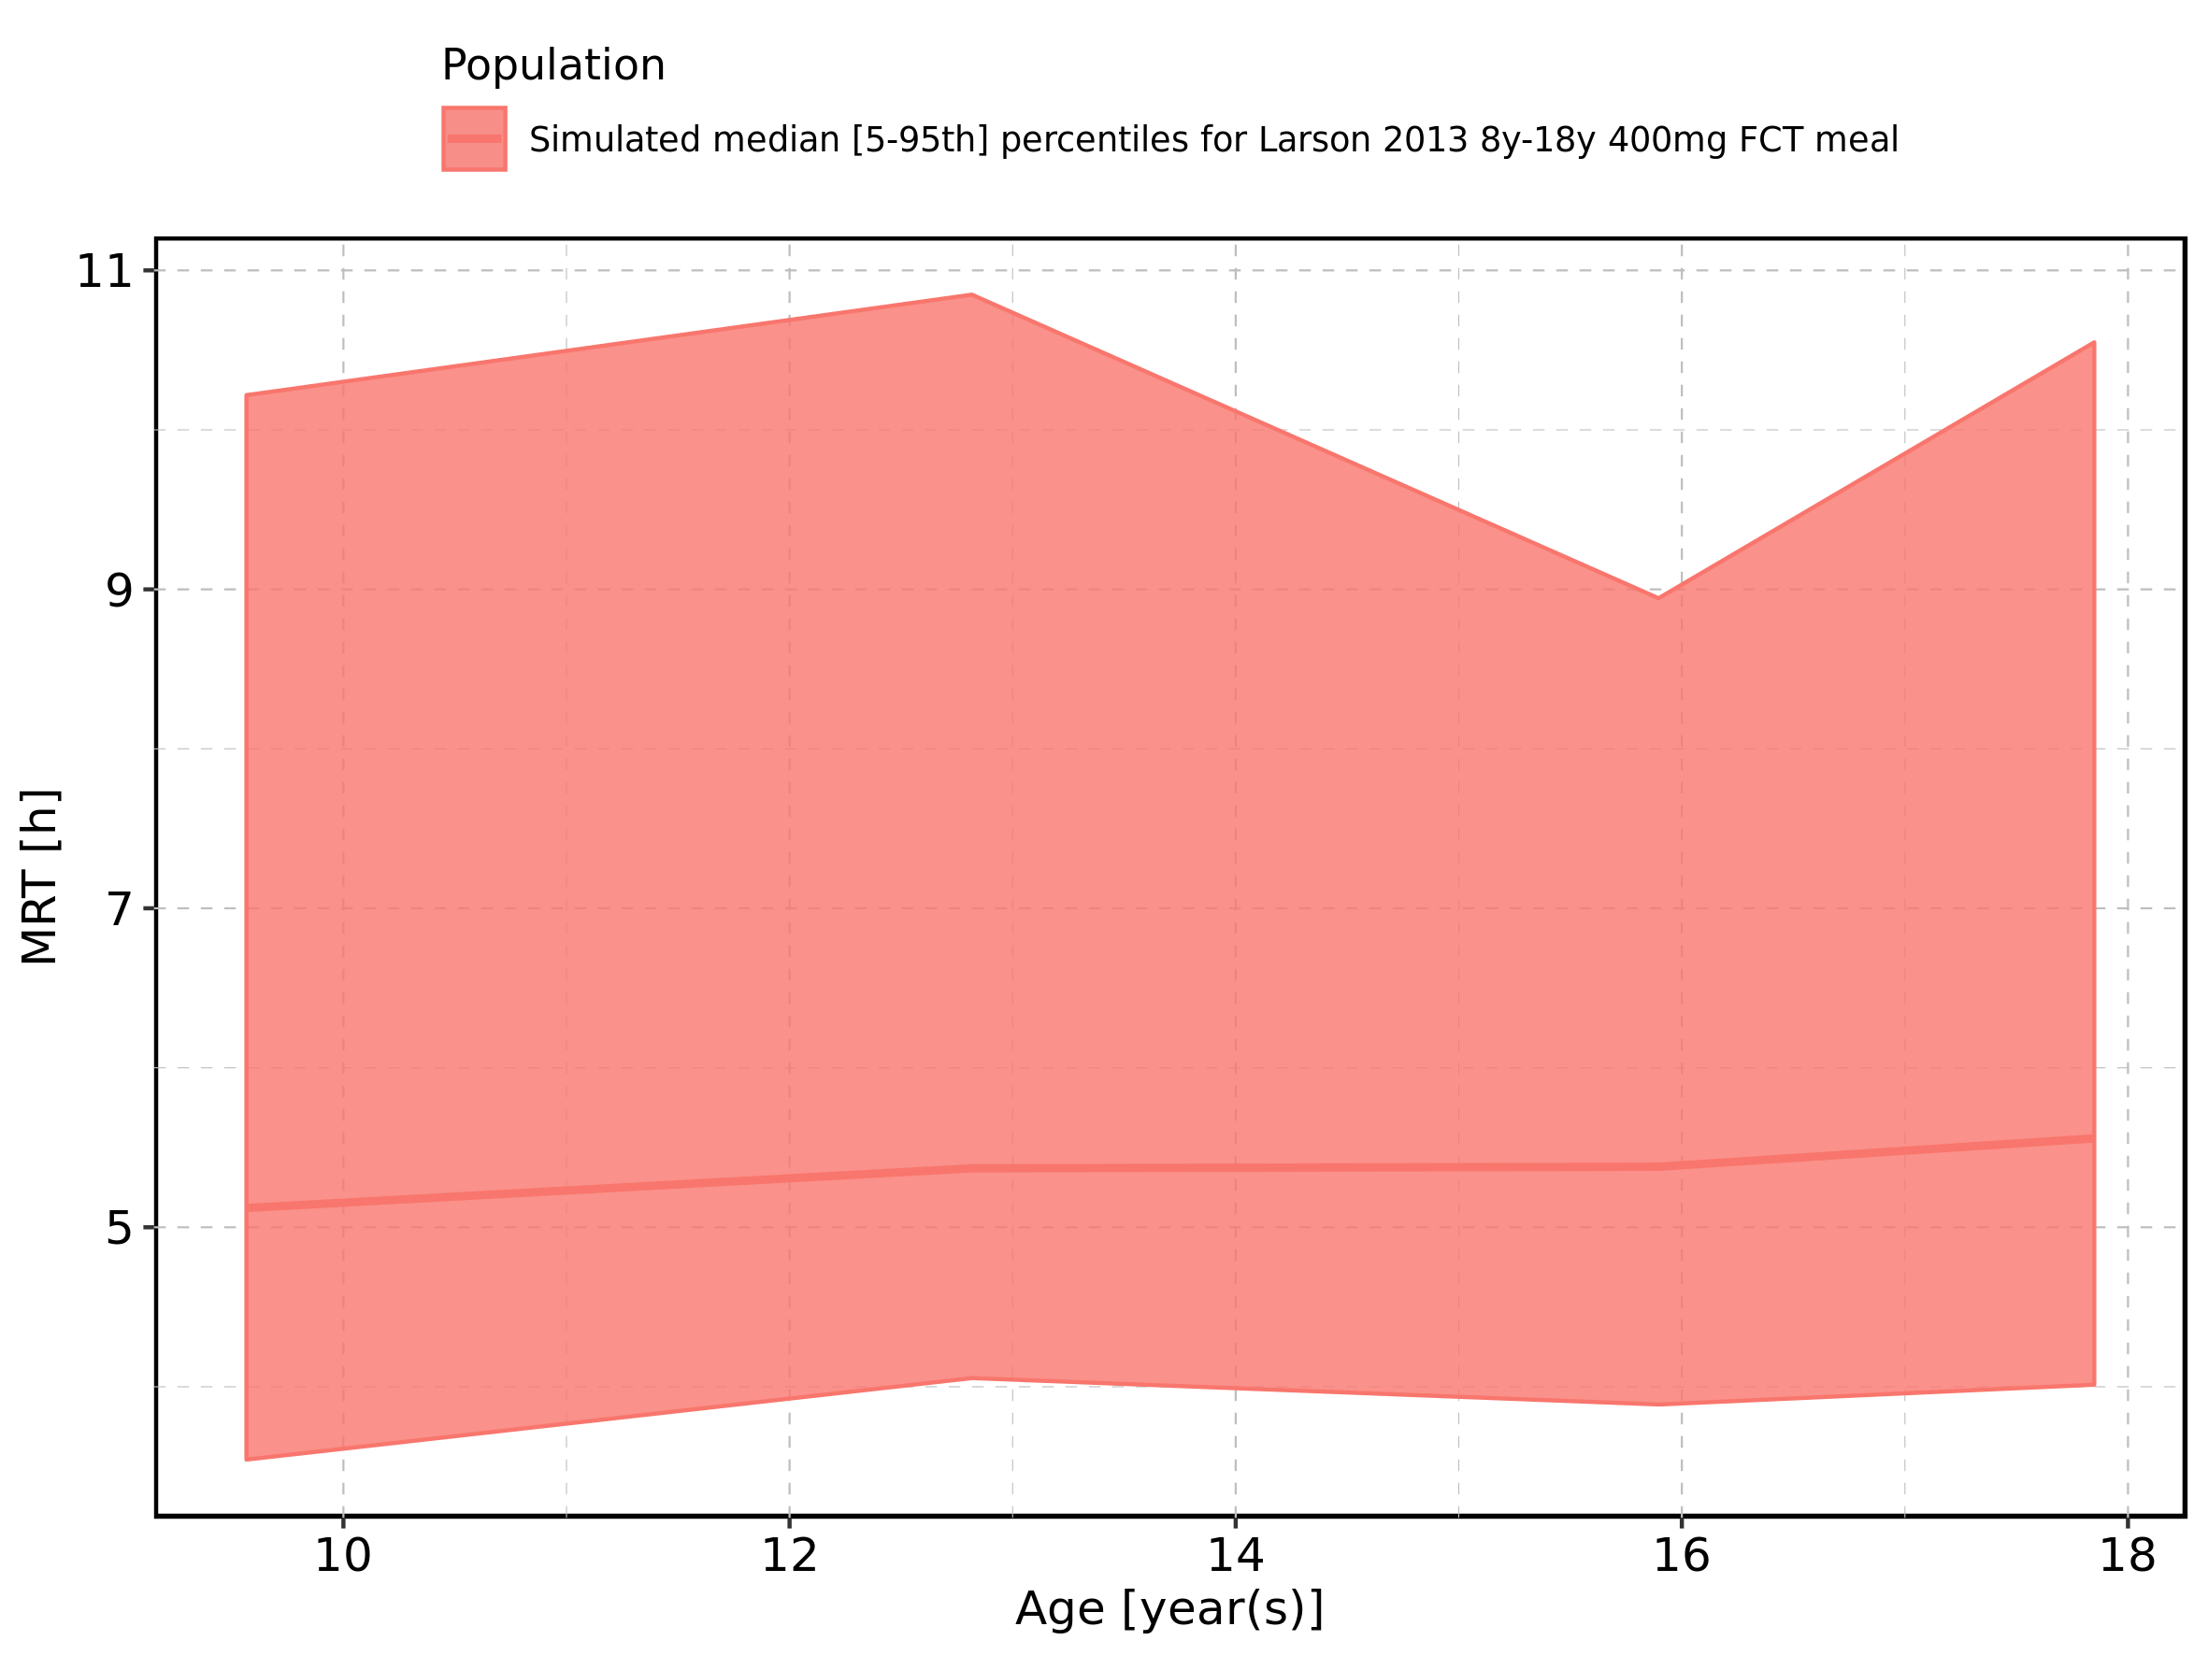

Figure 262: Age-dependence of MRT for Larson 2013 8y-18y 400mg FCT meal. Profiles are plotted in a logarithmic scale.

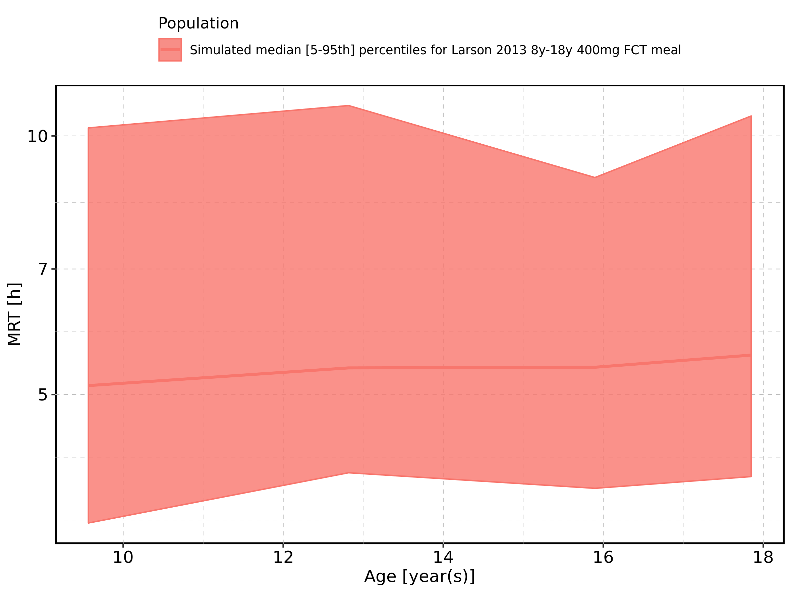

Figure 263: Age-dependence of MRT for Filmcoated_tablet_400mg_sd. Profiles are plotted in a linear scale.

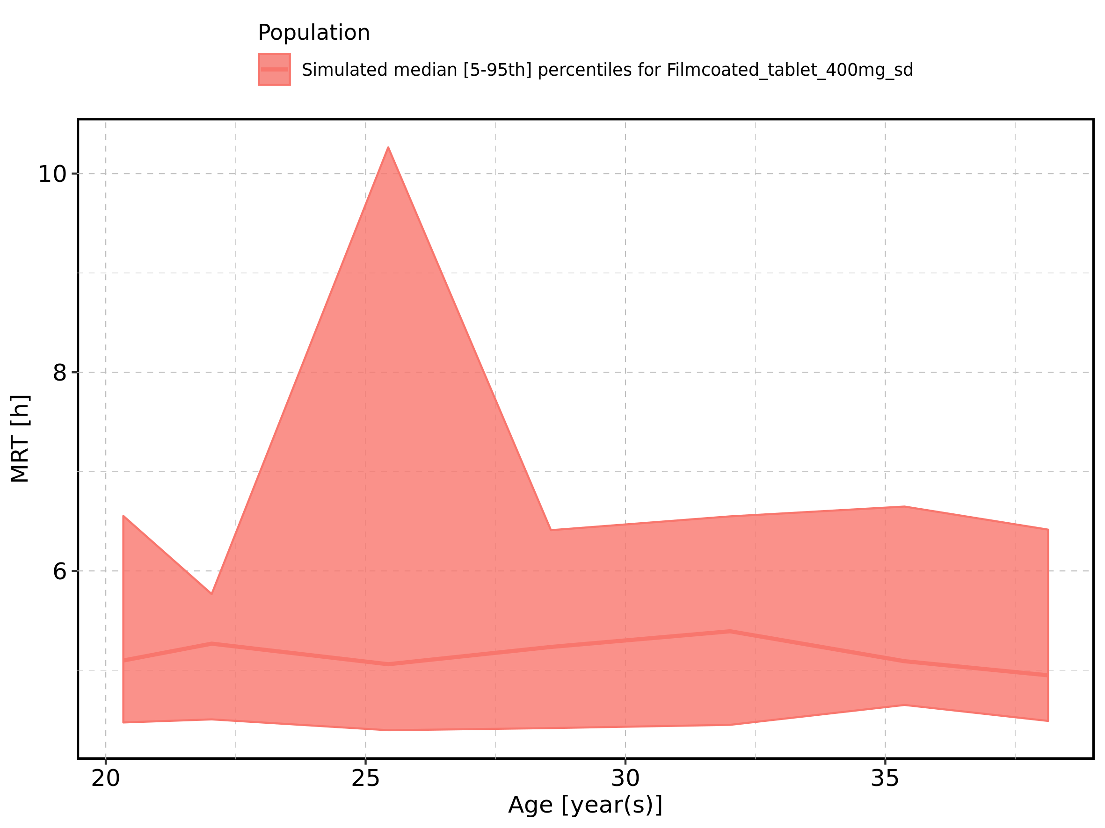

Figure 264: Age-dependence of MRT for Filmcoated_tablet_400mg_sd. Profiles are plotted in a logarithmic scale.

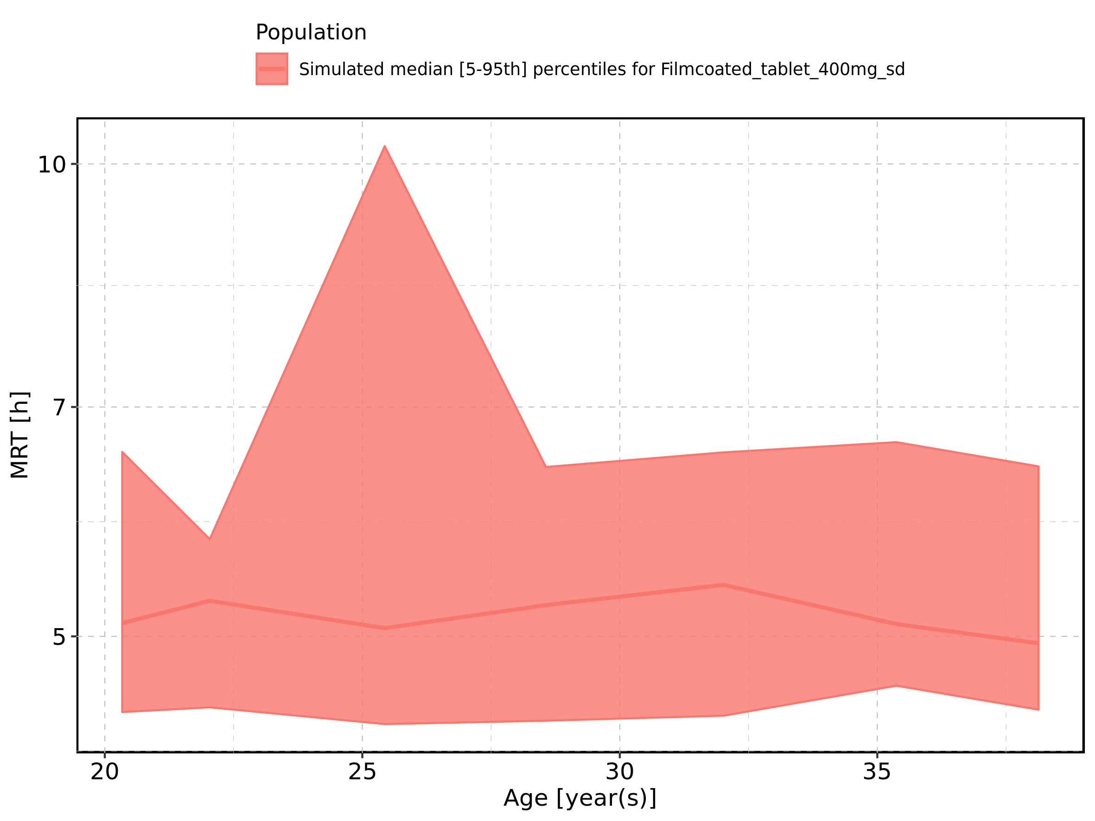

Figure 265: Height-dependence of MRT for Larson 2013 8y-18y 400mg FCT meal in comparison to Filmcoated_tablet_400mg_sd. Profiles are plotted in a linear scale.

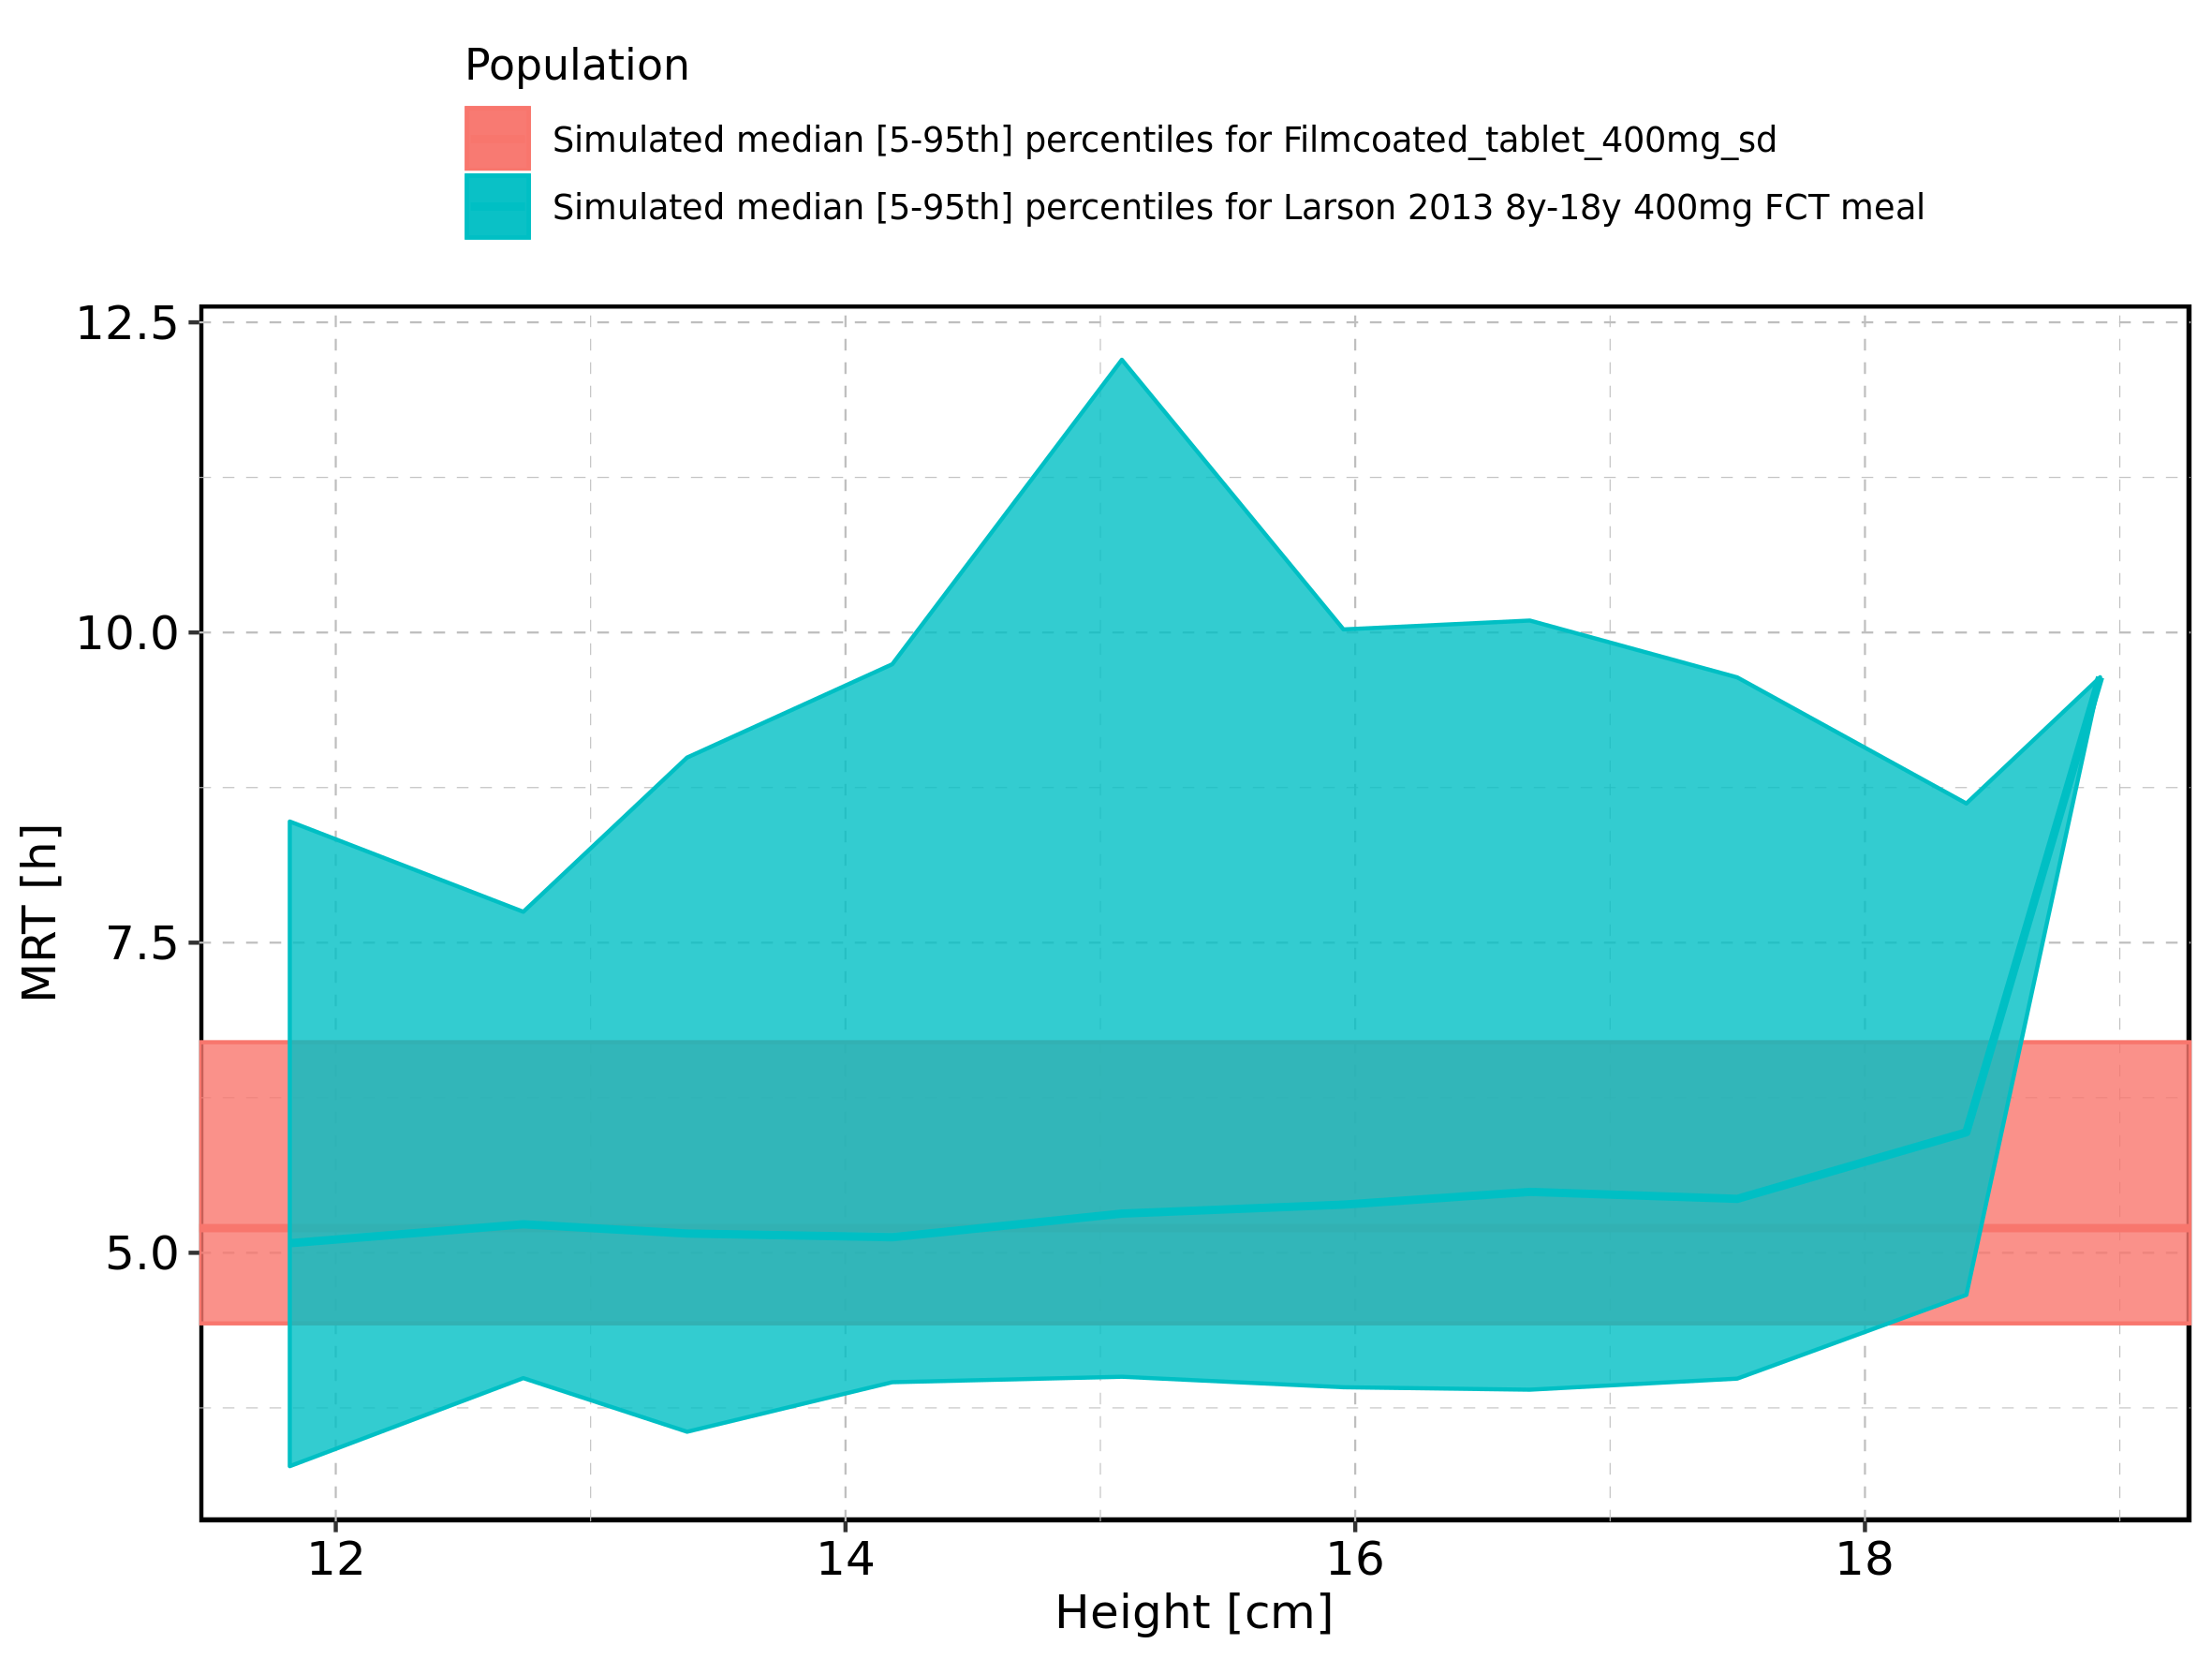

Figure 266: Height-dependence of MRT for Larson 2013 8y-18y 400mg FCT meal in comparison to Filmcoated_tablet_400mg_sd. Profiles are plotted in a logarithmic scale.

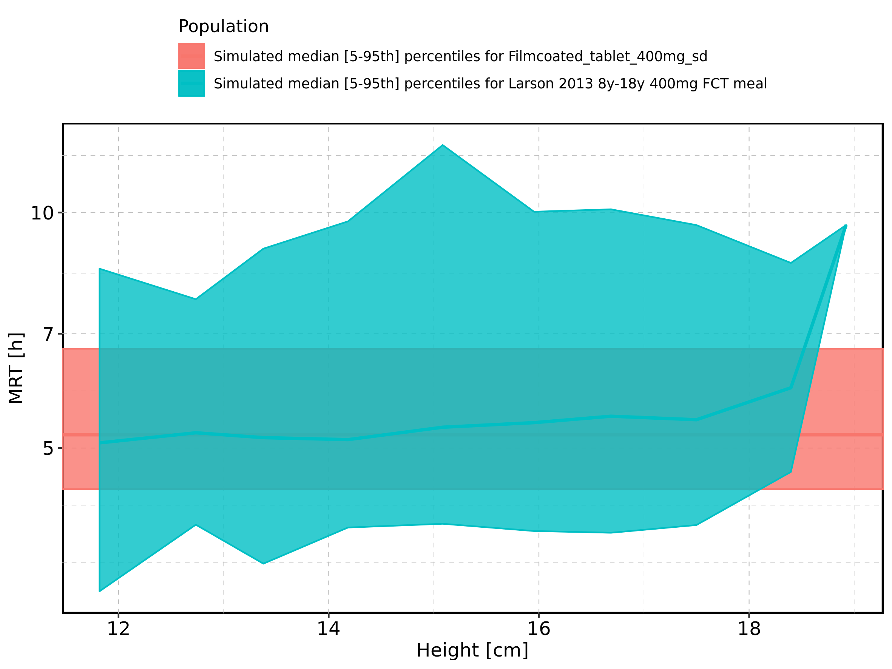

Figure 267: Height-dependence of MRT for Larson 2013 8y-18y 400mg FCT meal. Profiles are plotted in a linear scale.

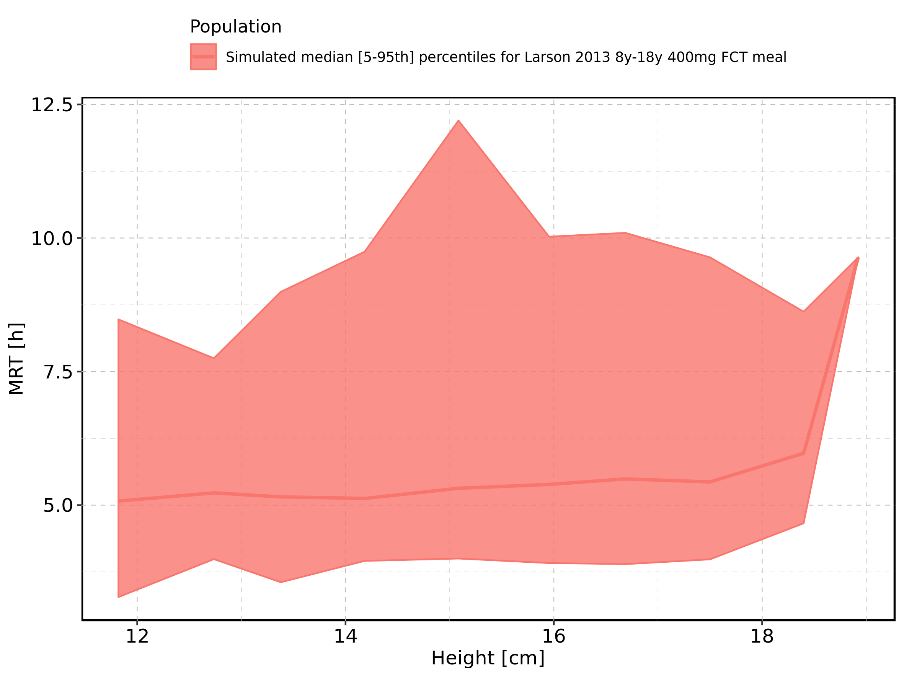

Figure 268: Height-dependence of MRT for Larson 2013 8y-18y 400mg FCT meal. Profiles are plotted in a logarithmic scale.

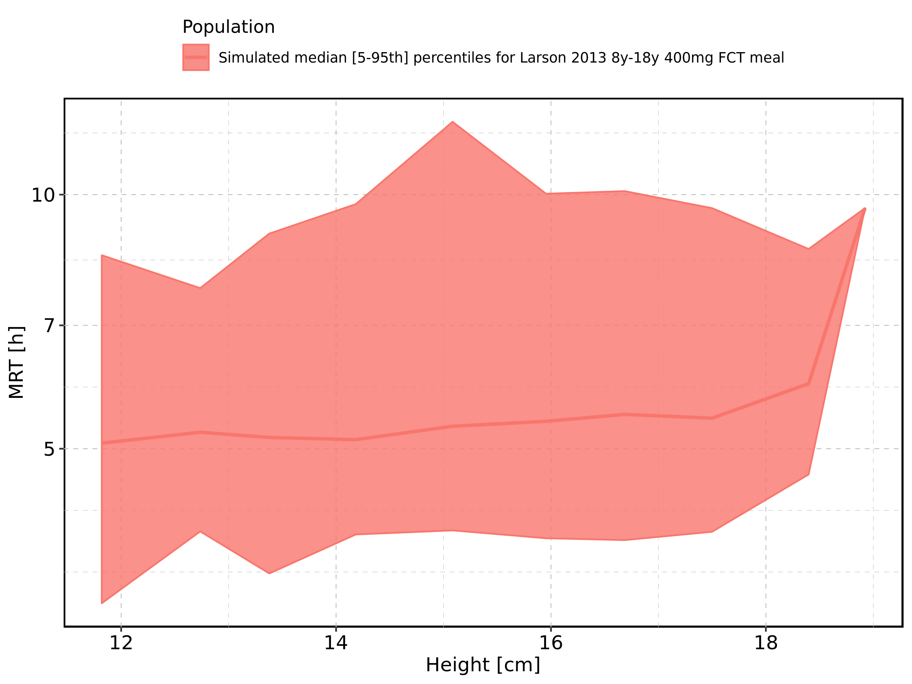

Figure 269: Height-dependence of MRT for Filmcoated_tablet_400mg_sd. Profiles are plotted in a linear scale.

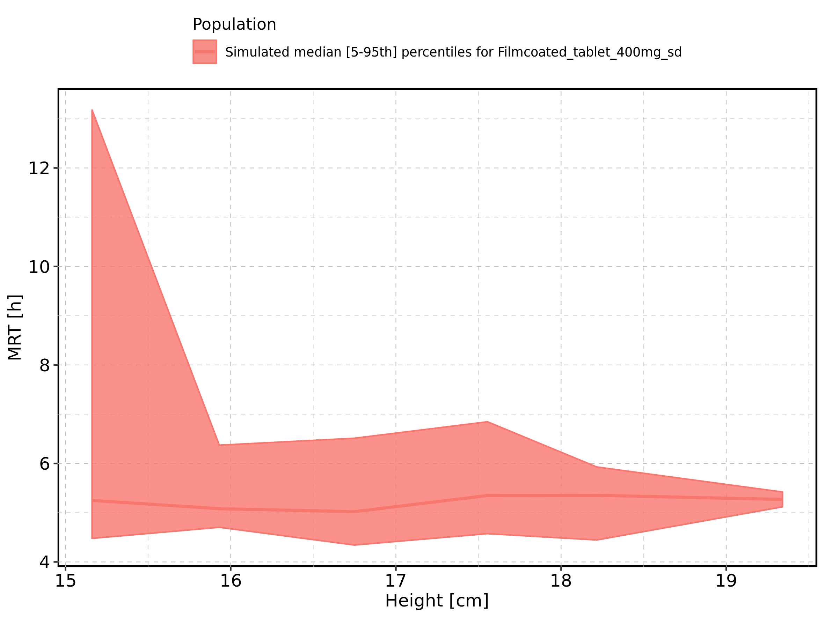

Figure 270: Height-dependence of MRT for Filmcoated_tablet_400mg_sd. Profiles are plotted in a logarithmic scale.

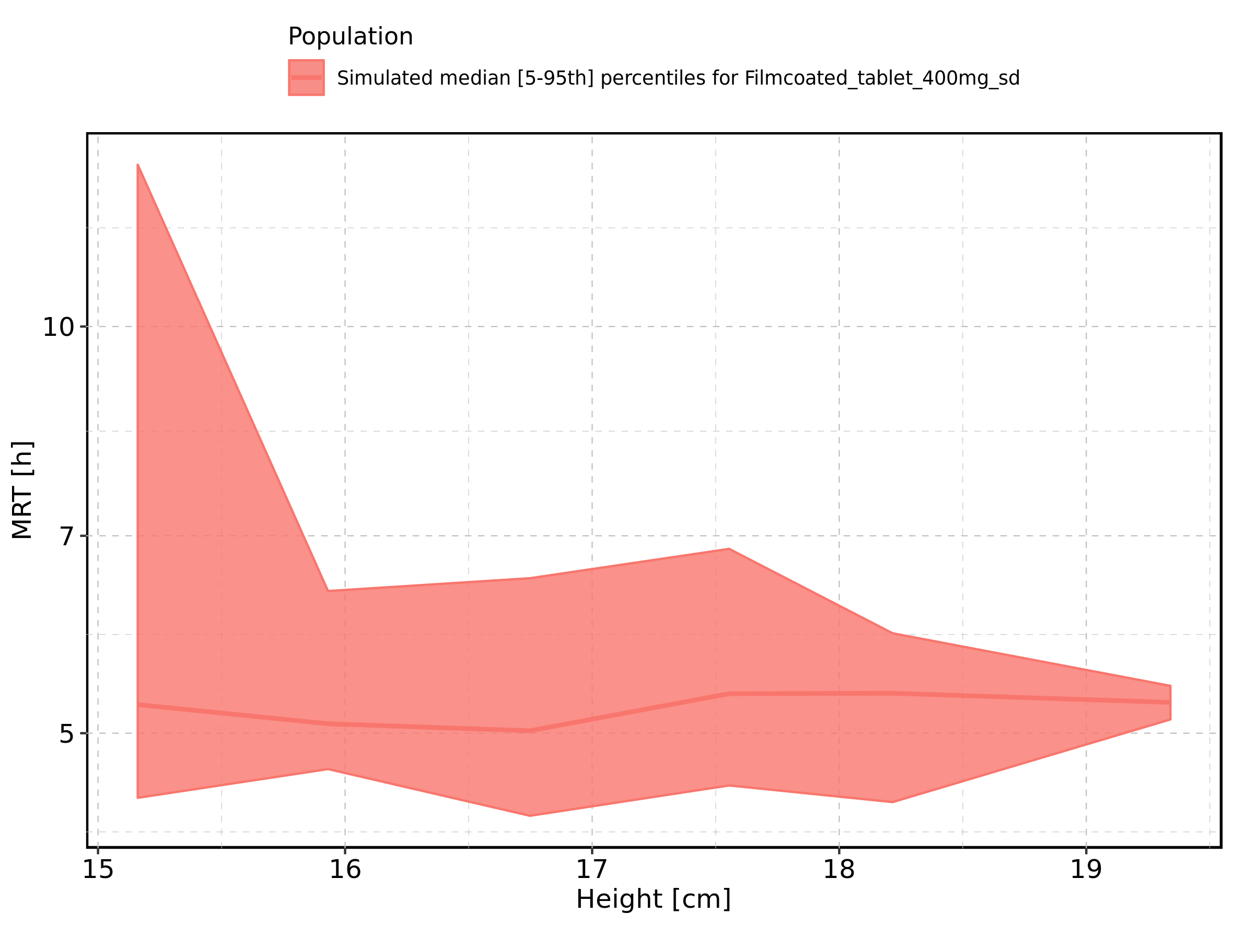

Figure 271: Weight-dependence of MRT for Larson 2013 8y-18y 400mg FCT meal in comparison to Filmcoated_tablet_400mg_sd. Profiles are plotted in a linear scale.

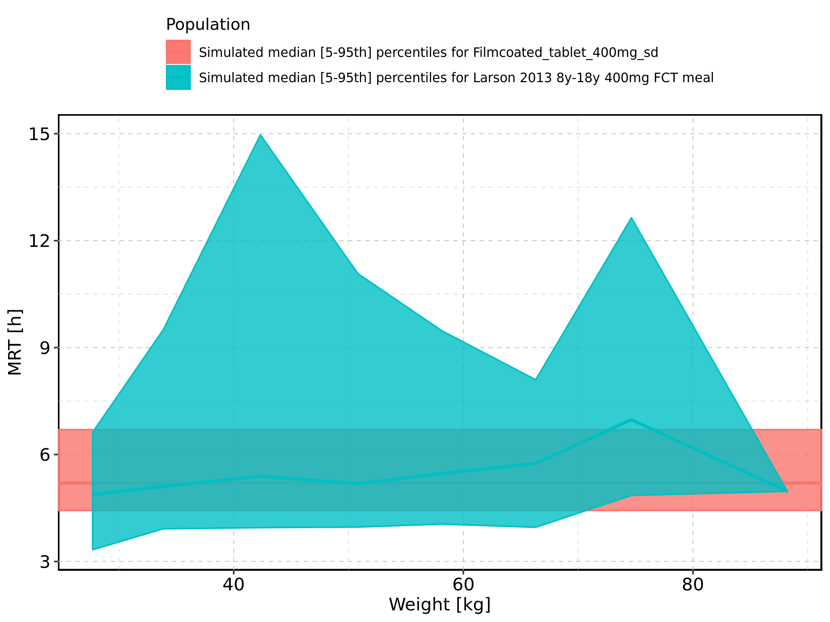

Figure 272: Weight-dependence of MRT for Larson 2013 8y-18y 400mg FCT meal in comparison to Filmcoated_tablet_400mg_sd. Profiles are plotted in a logarithmic scale.

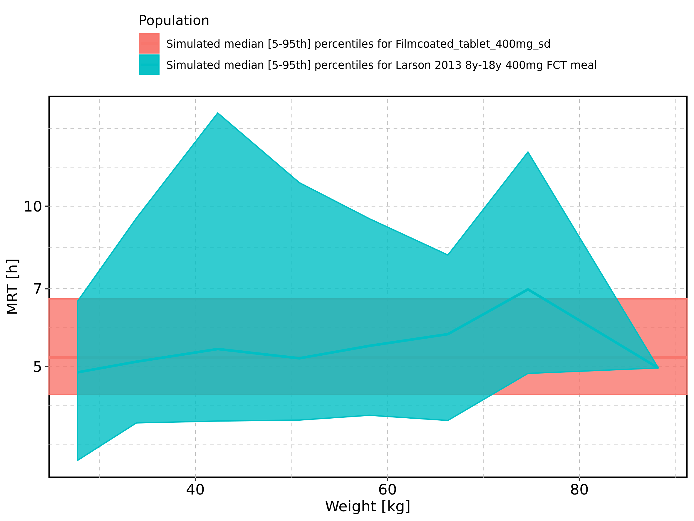

Figure 273: Weight-dependence of MRT for Larson 2013 8y-18y 400mg FCT meal. Profiles are plotted in a linear scale.

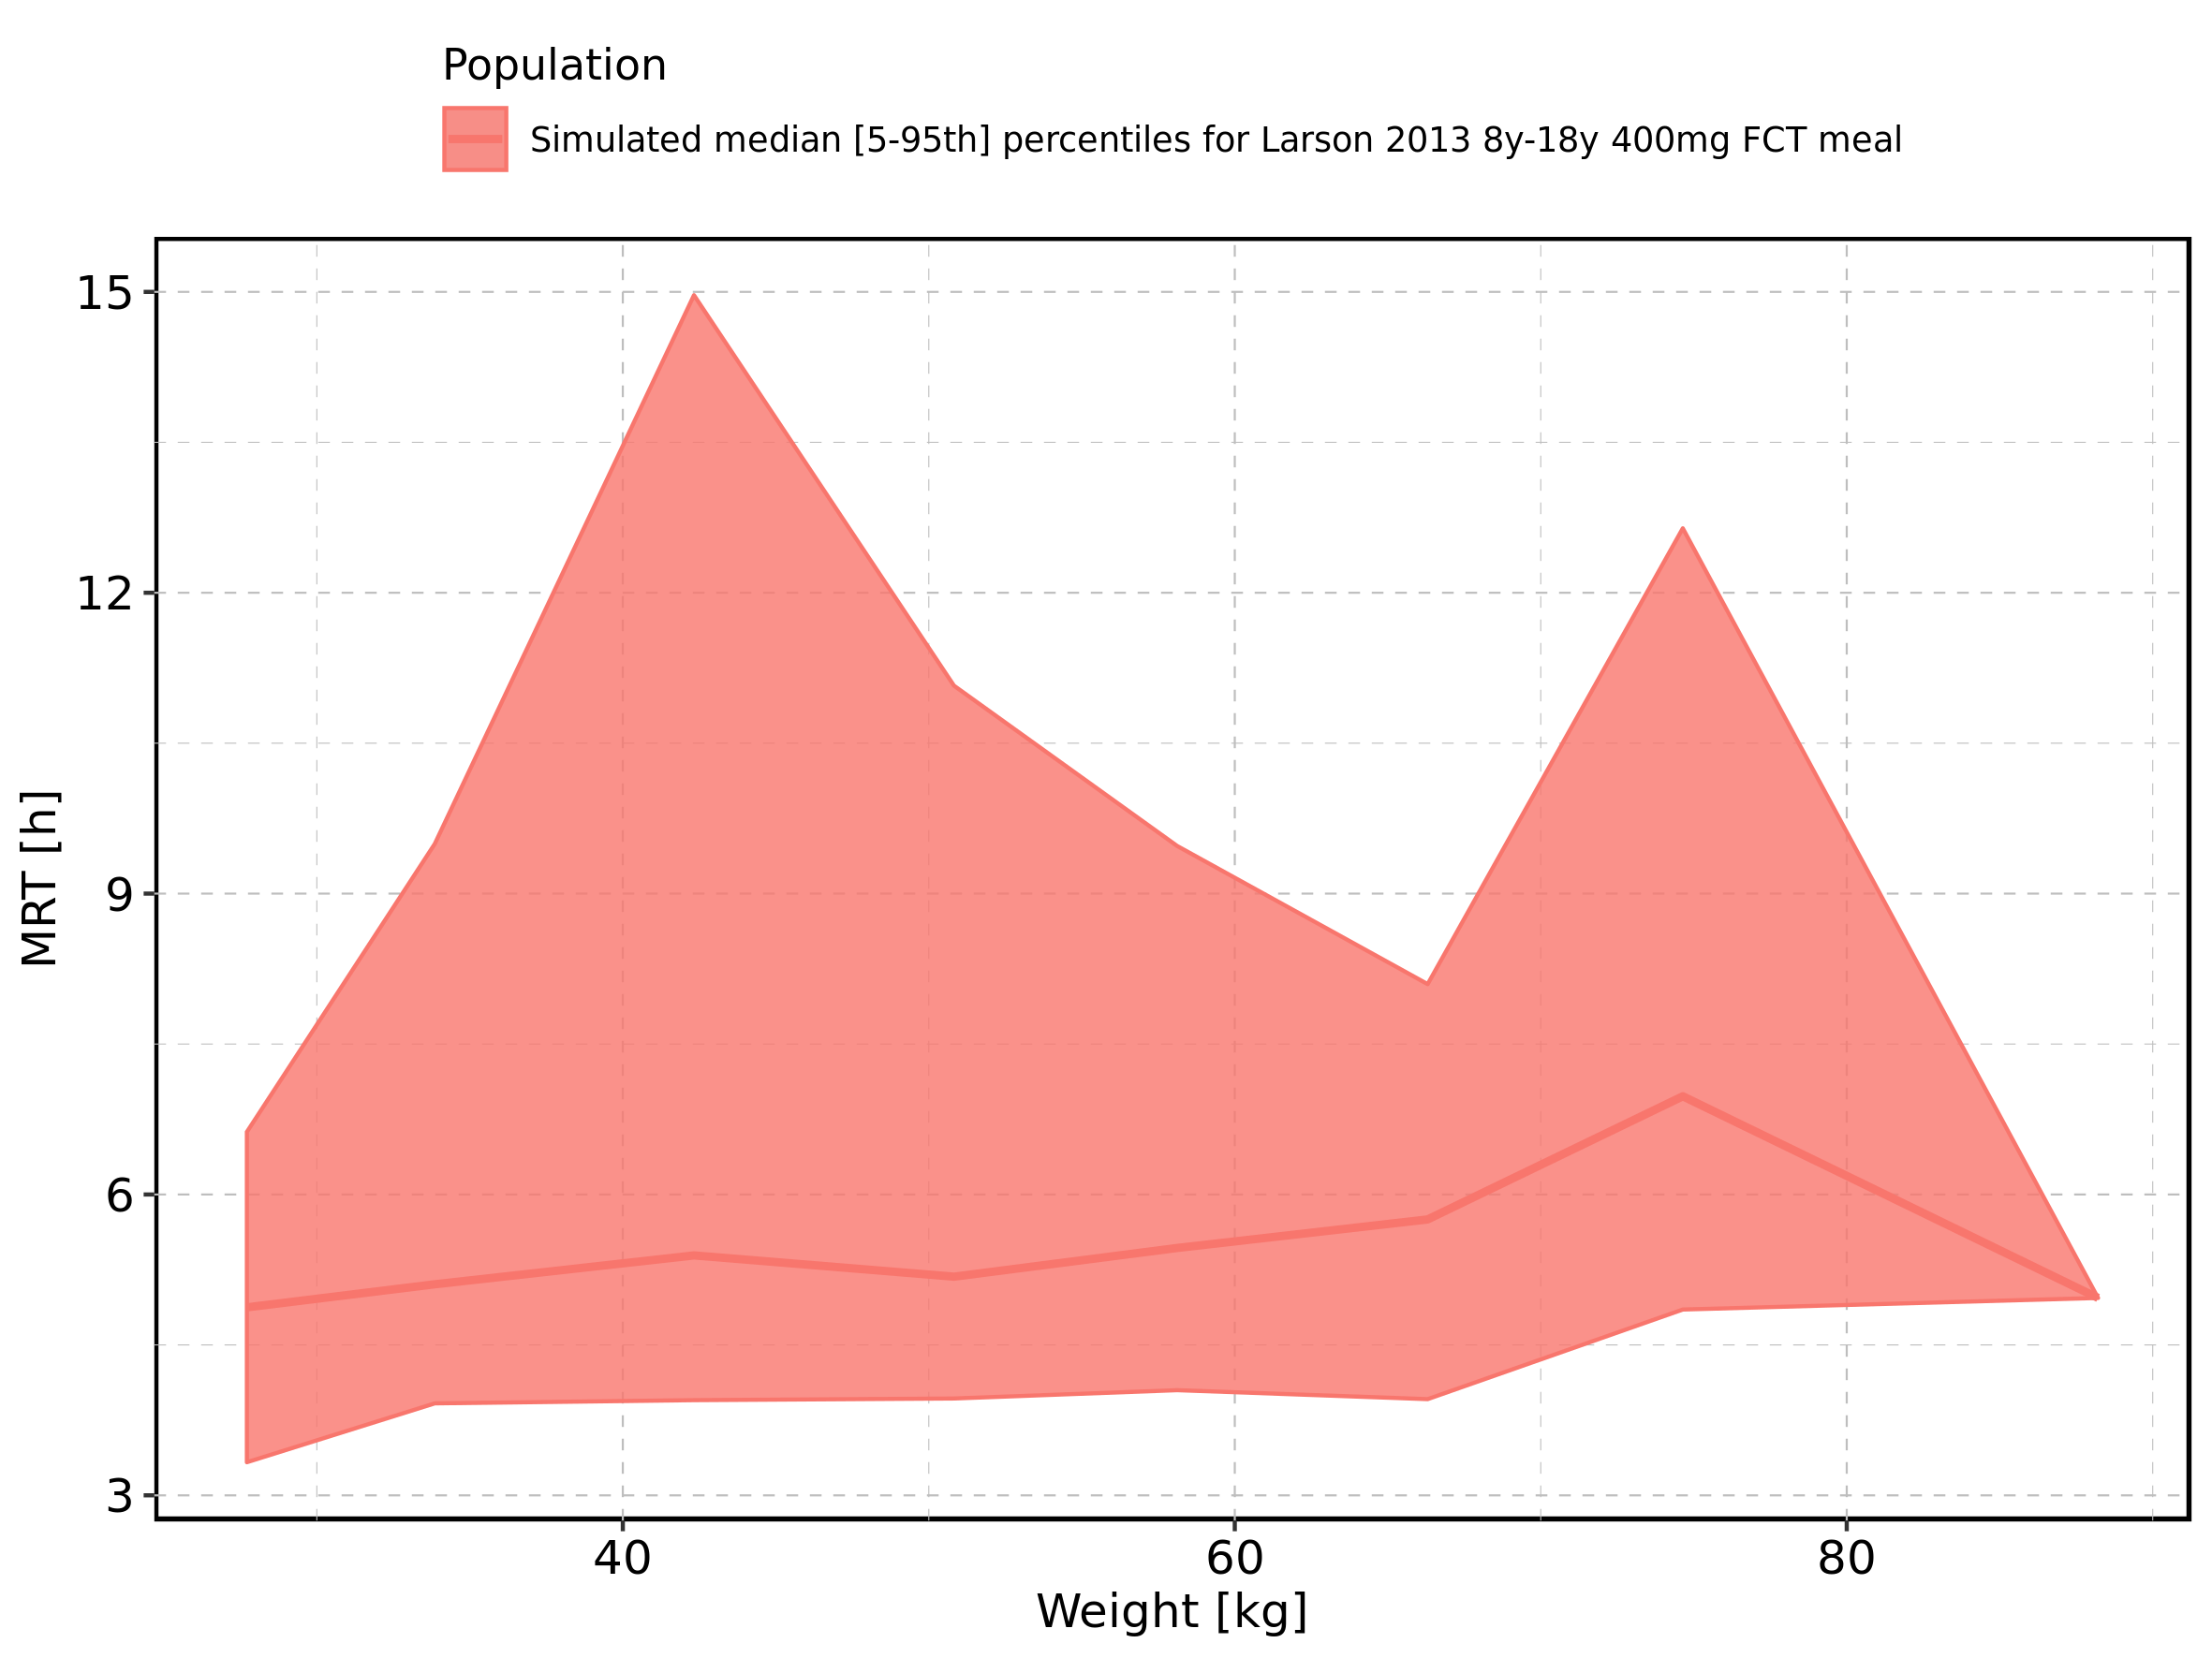

Figure 274: Weight-dependence of MRT for Larson 2013 8y-18y 400mg FCT meal. Profiles are plotted in a logarithmic scale.

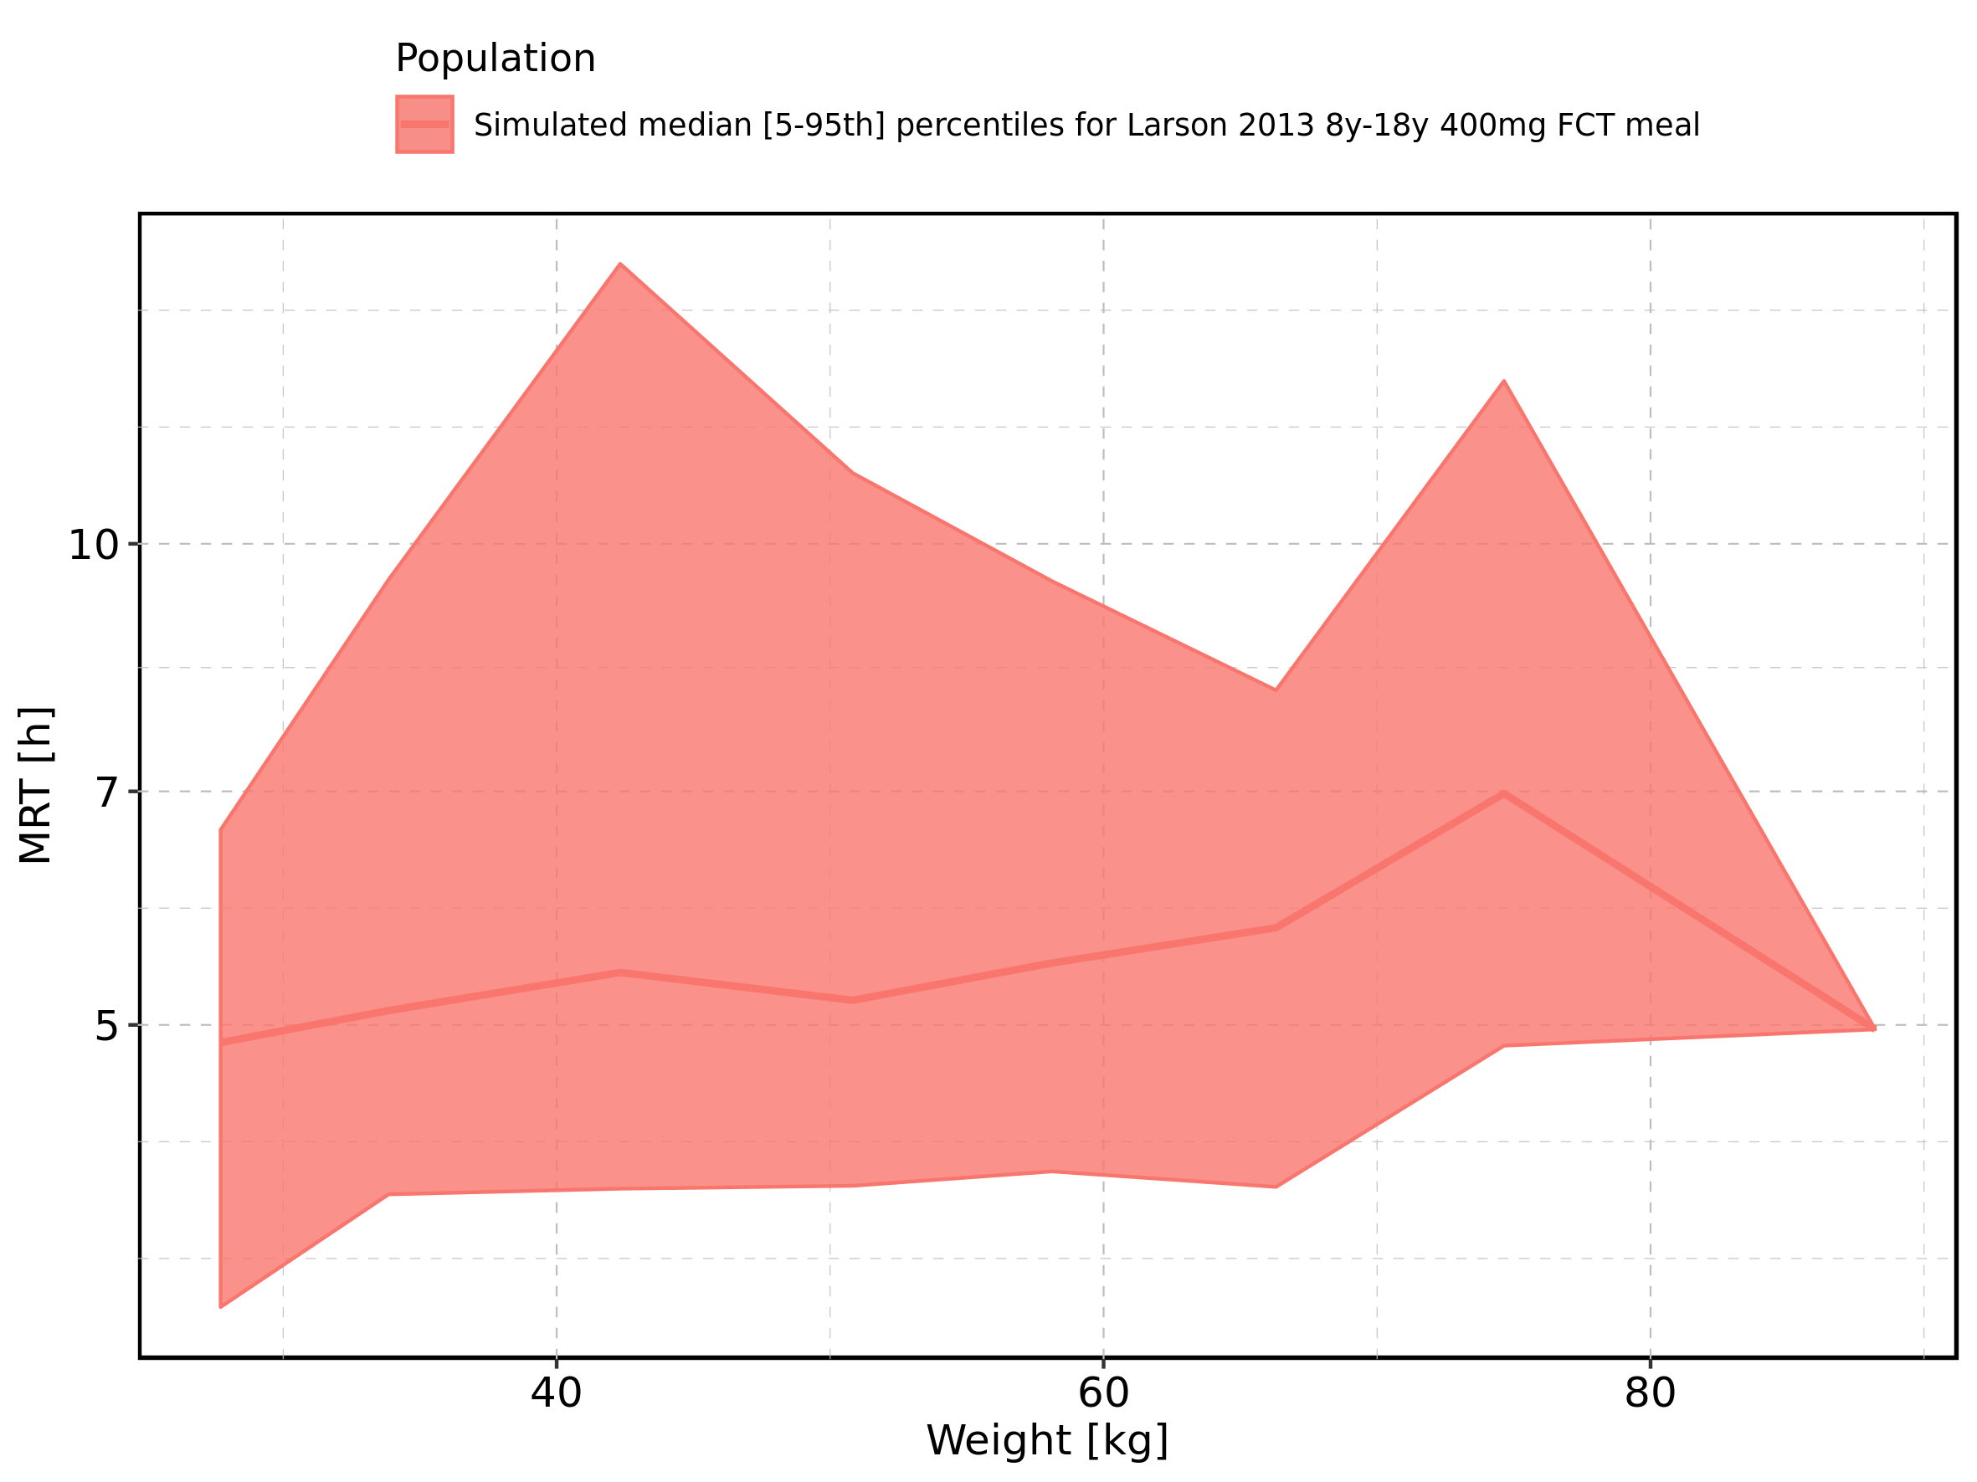

Figure 275: Weight-dependence of MRT for Filmcoated_tablet_400mg_sd. Profiles are plotted in a linear scale.

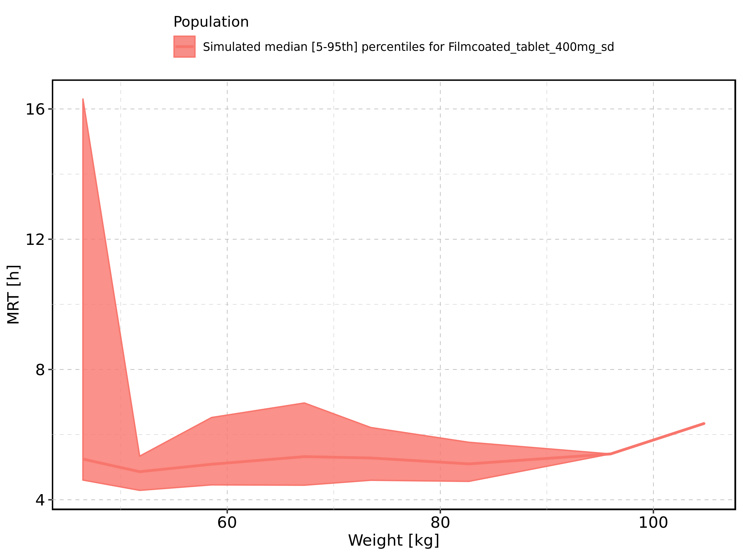

Figure 276: Weight-dependence of MRT for Filmcoated_tablet_400mg_sd. Profiles are plotted in a logarithmic scale.

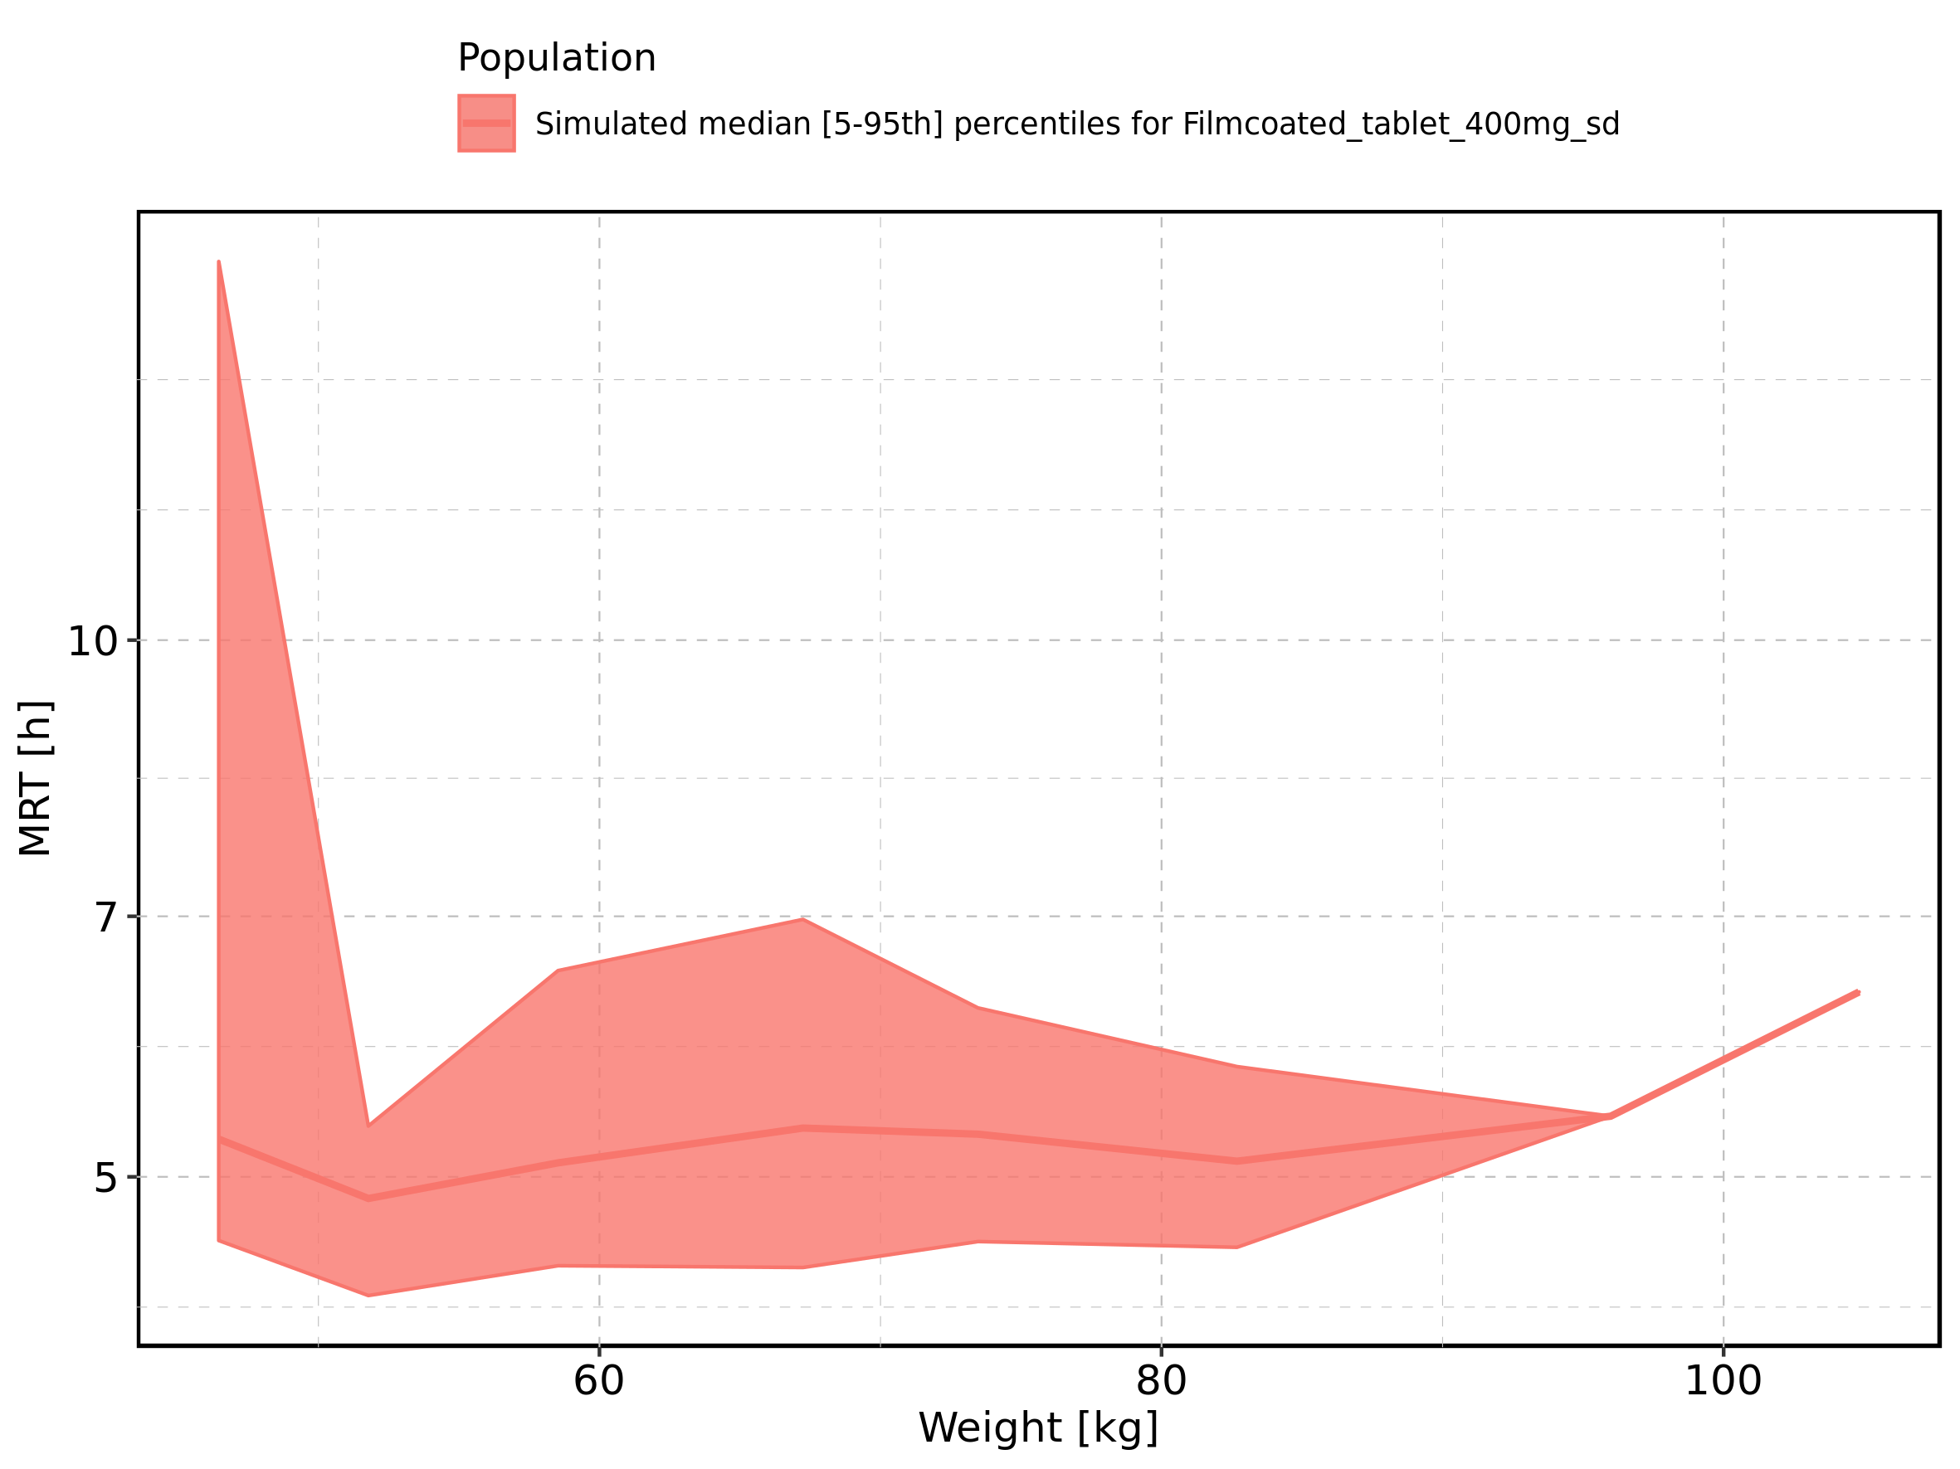

Figure 277: BMI-dependence of MRT for Larson 2013 8y-18y 400mg FCT meal in comparison to Filmcoated_tablet_400mg_sd. Profiles are plotted in a linear scale.

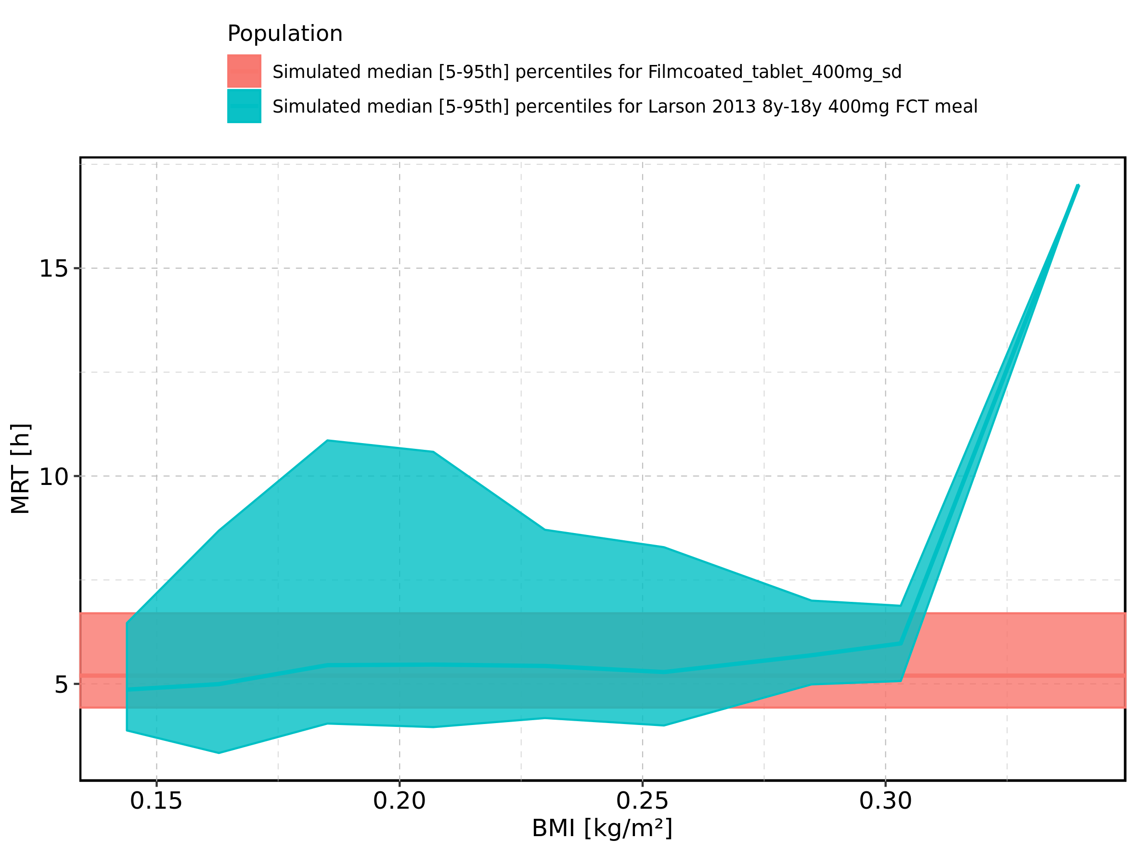

Figure 278: BMI-dependence of MRT for Larson 2013 8y-18y 400mg FCT meal in comparison to Filmcoated_tablet_400mg_sd. Profiles are plotted in a logarithmic scale.

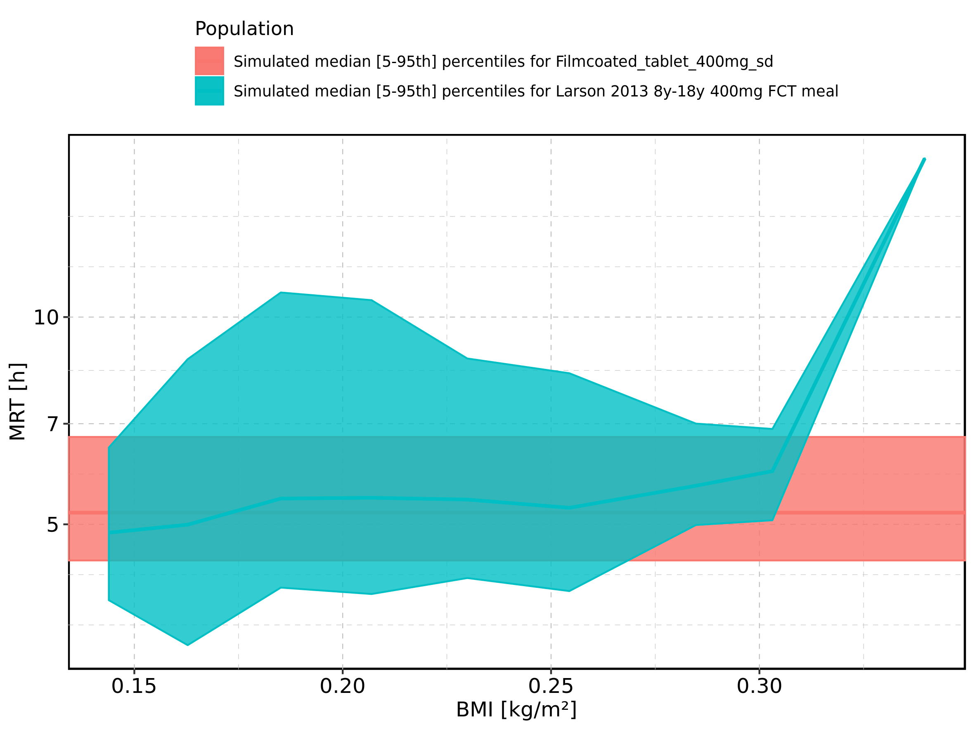

Figure 279: BMI-dependence of MRT for Larson 2013 8y-18y 400mg FCT meal. Profiles are plotted in a linear scale.

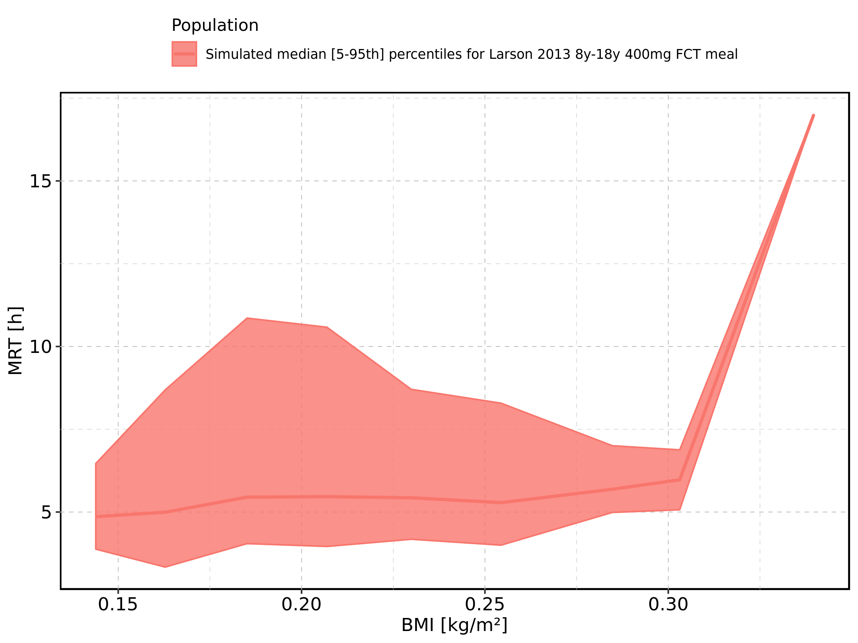

Figure 280: BMI-dependence of MRT for Larson 2013 8y-18y 400mg FCT meal. Profiles are plotted in a logarithmic scale.

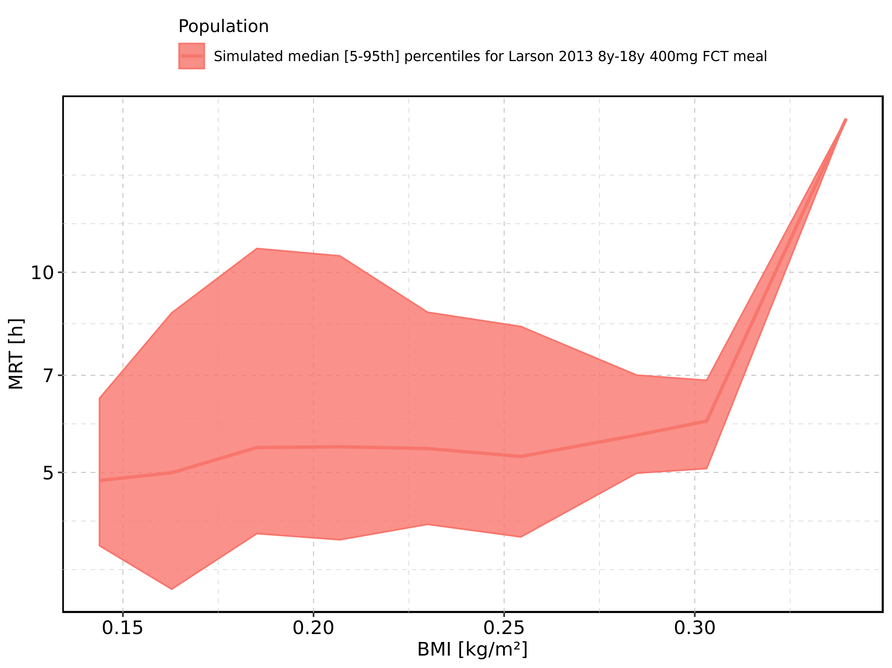

Figure 281: BMI-dependence of MRT for Filmcoated_tablet_400mg_sd. Profiles are plotted in a linear scale.

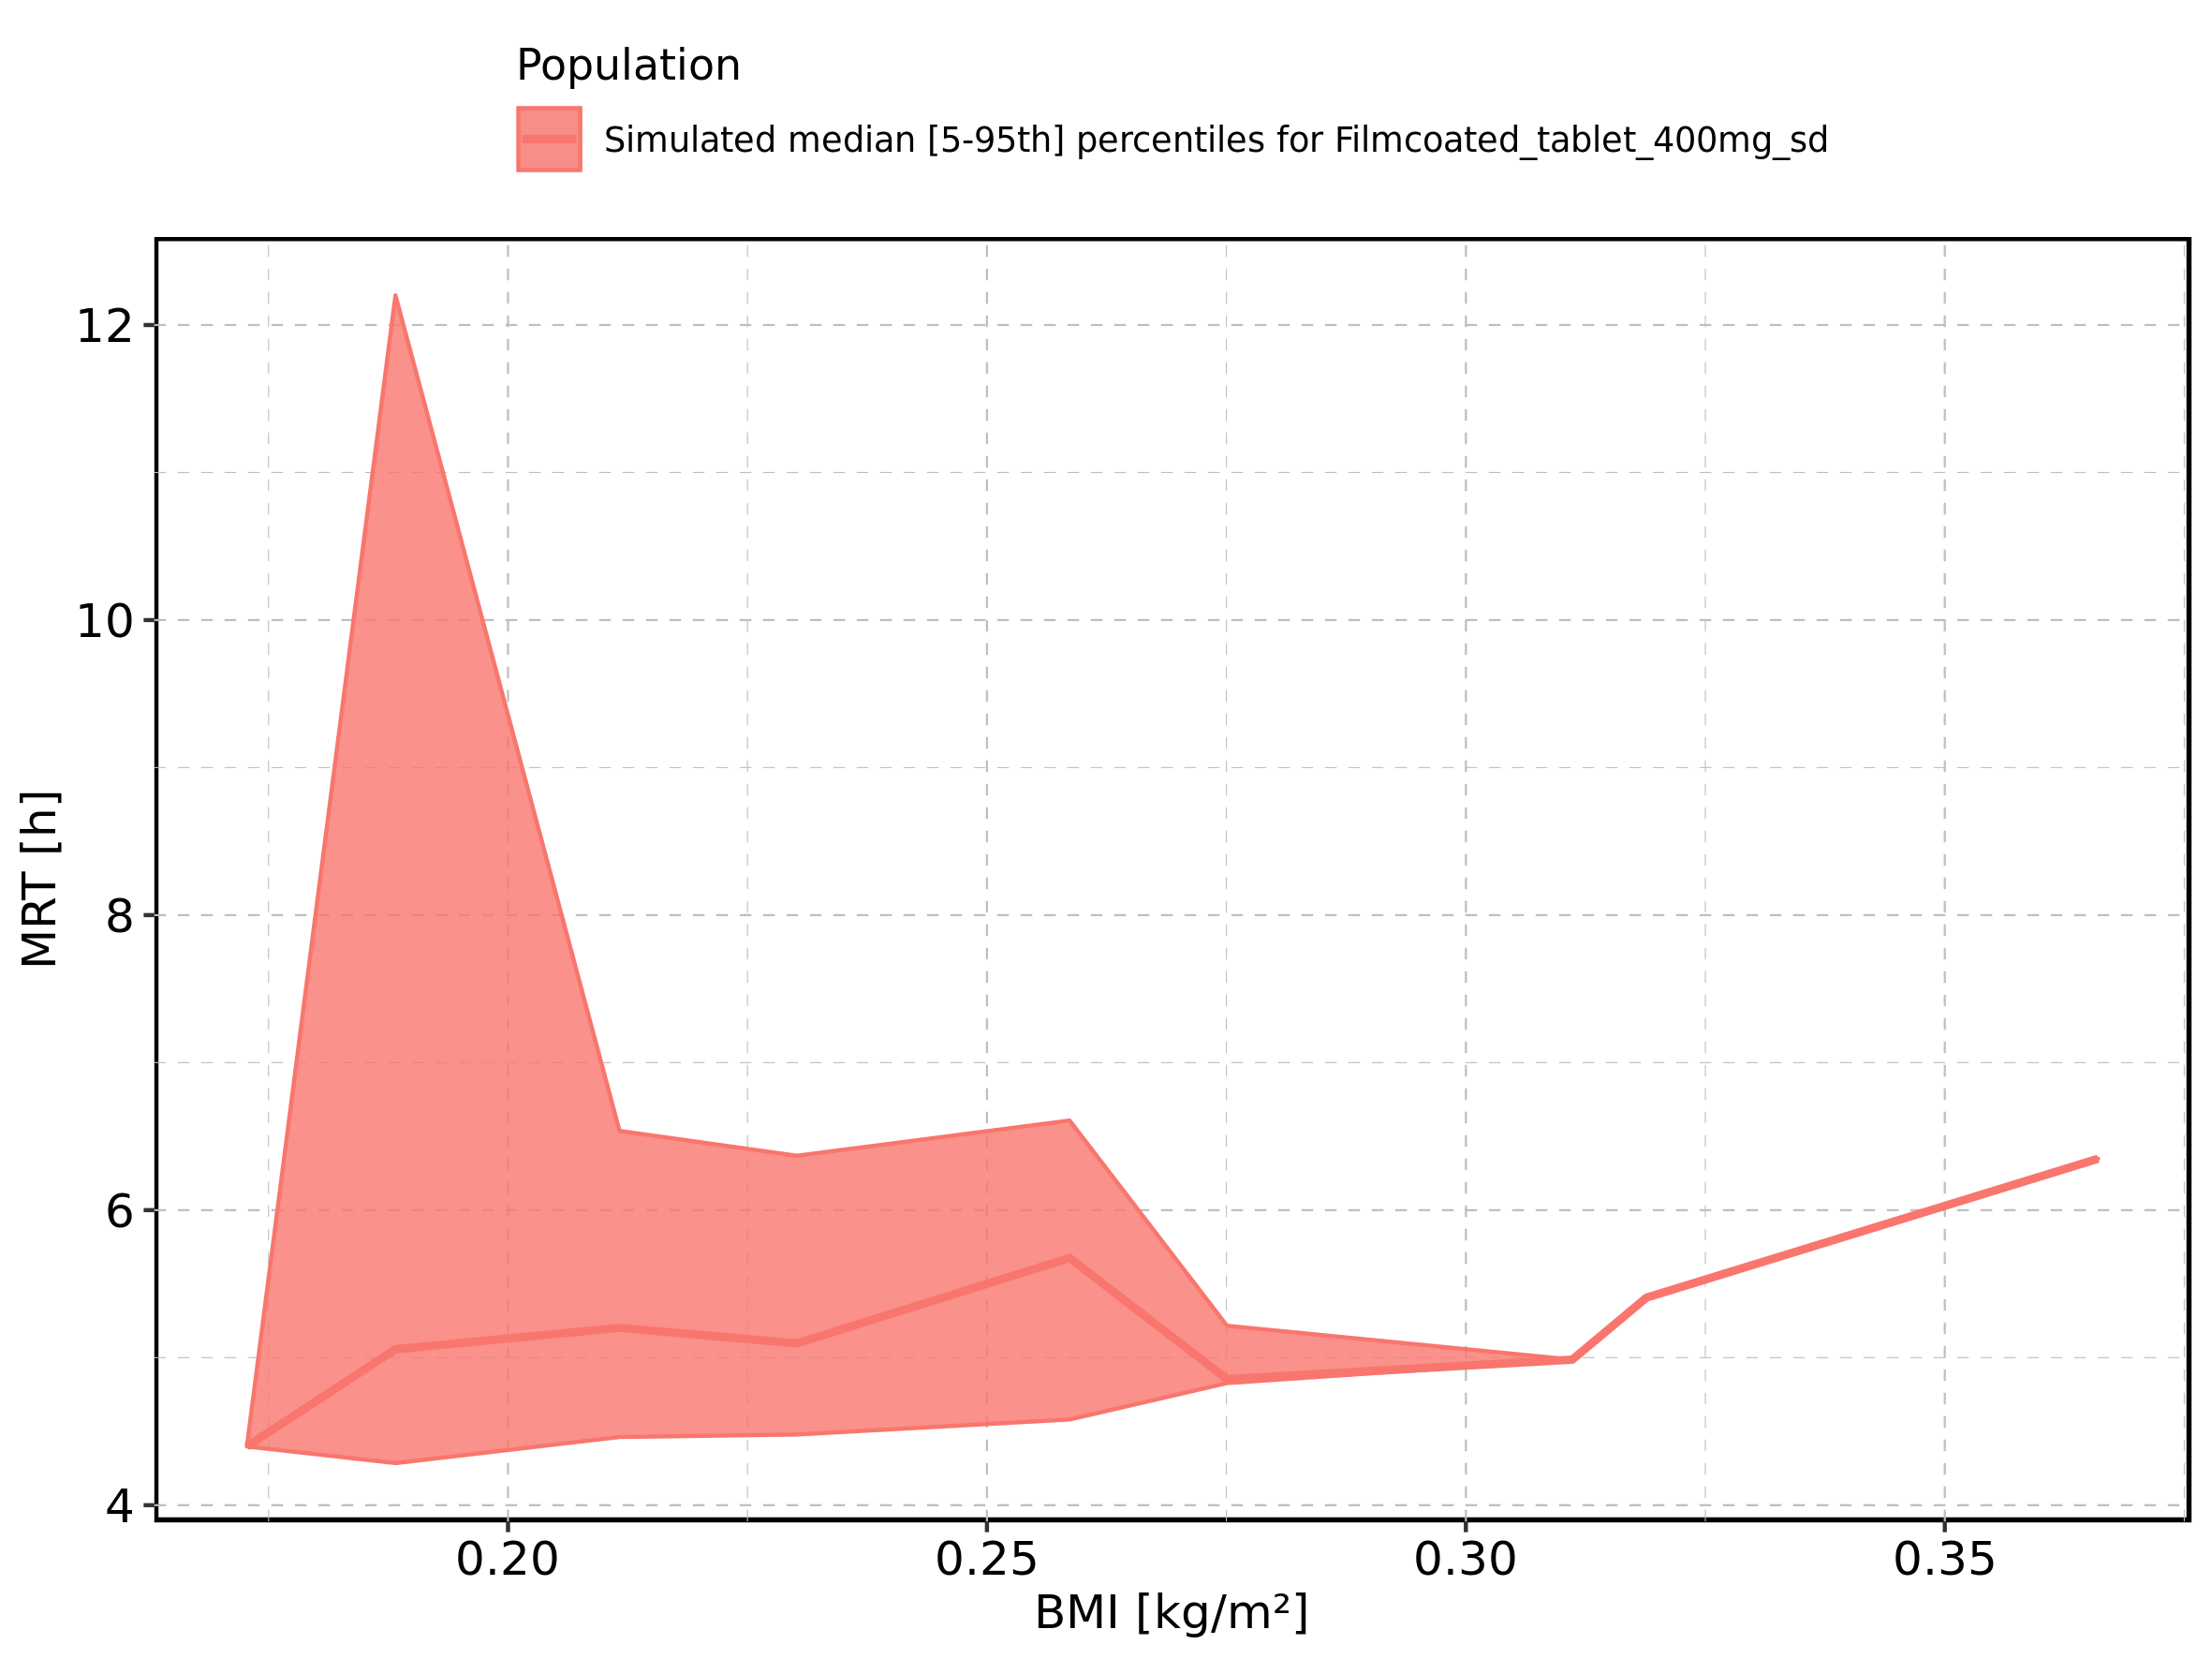

Figure 282: BMI-dependence of MRT for Filmcoated_tablet_400mg_sd. Profiles are plotted in a logarithmic scale.

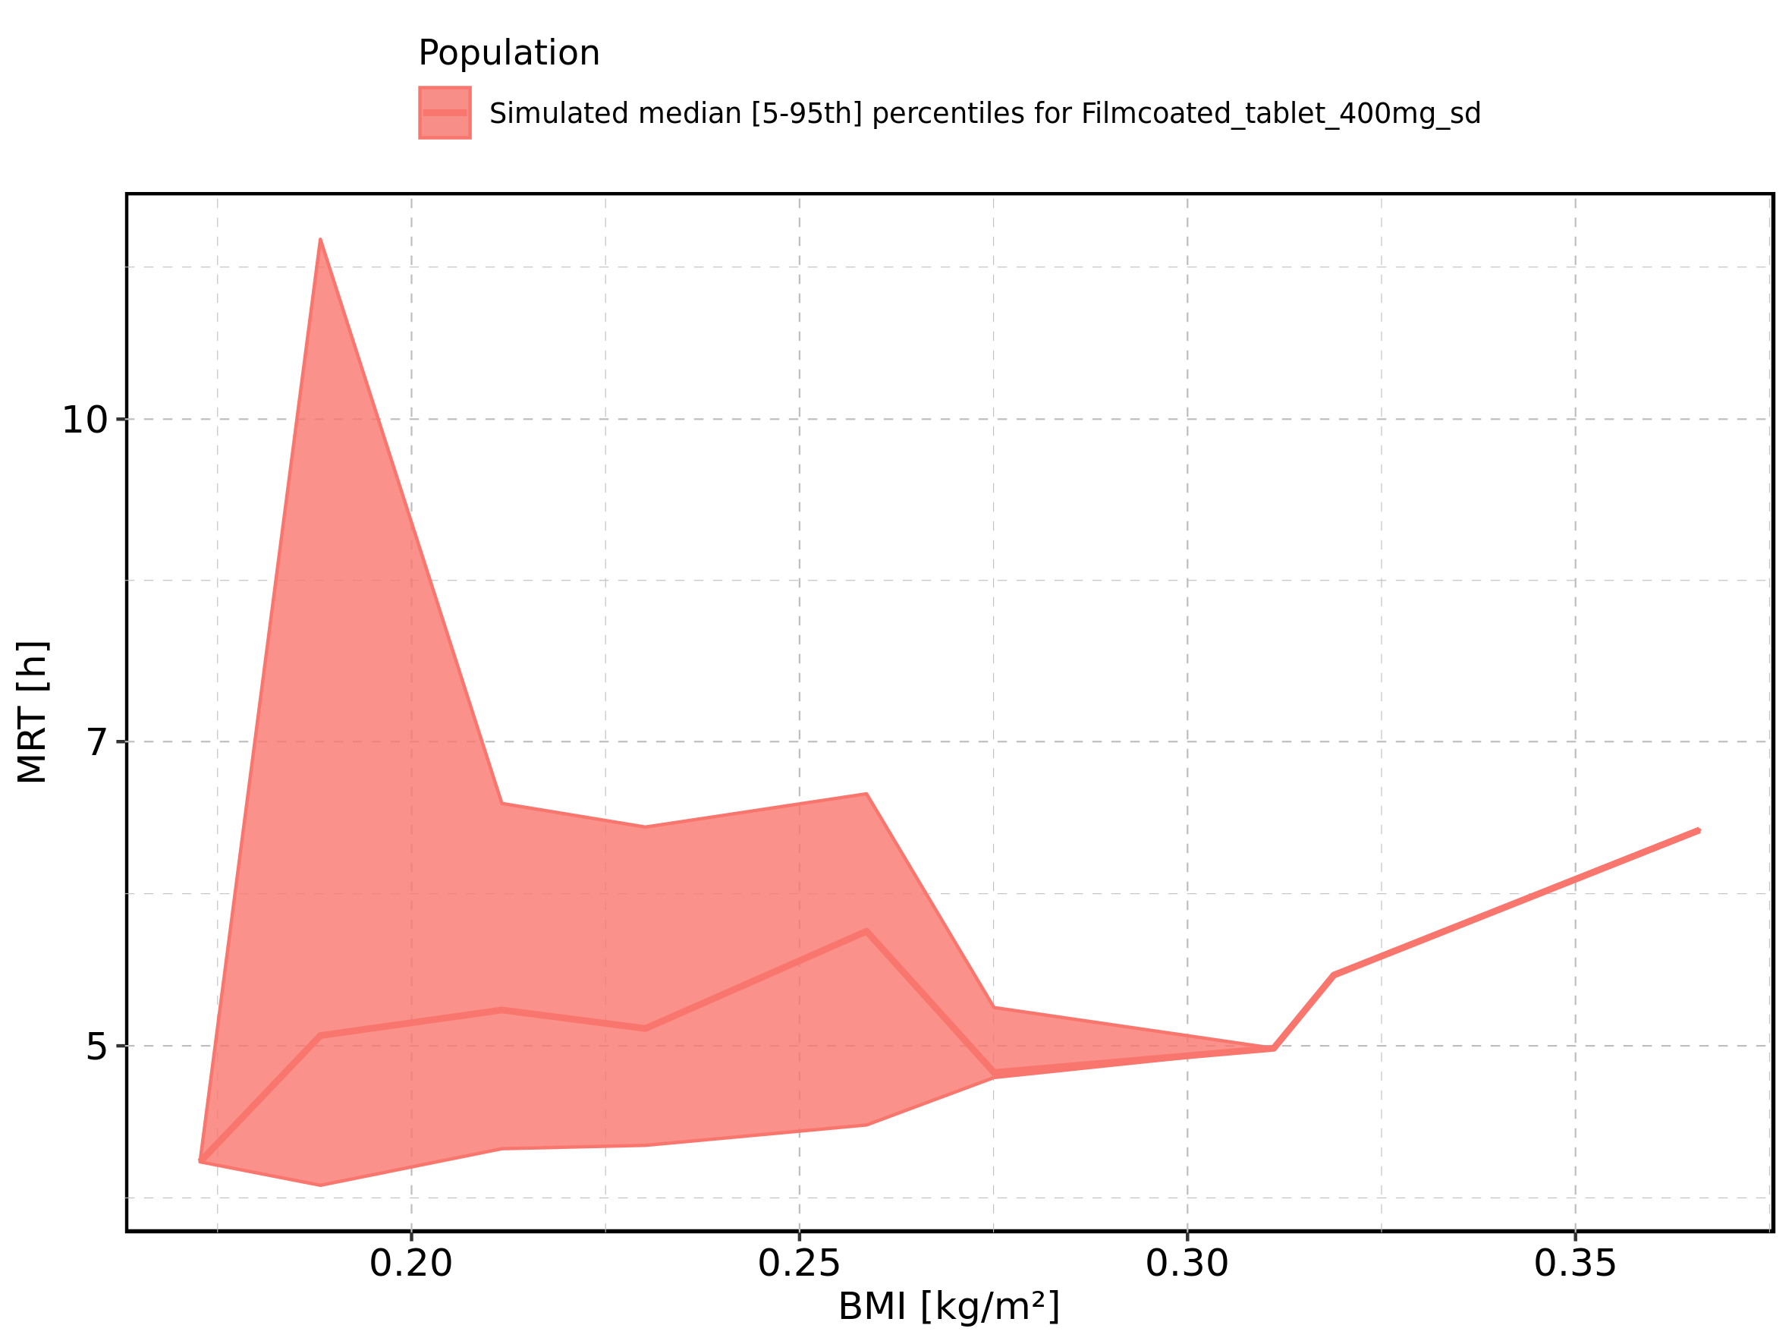

Figure 283: Gender-dependence of MRT for Larson 2013 8y-18y 400mg FCT meal in comparison to Filmcoated_tablet_400mg_sd. Profiles are plotted in a linear scale.

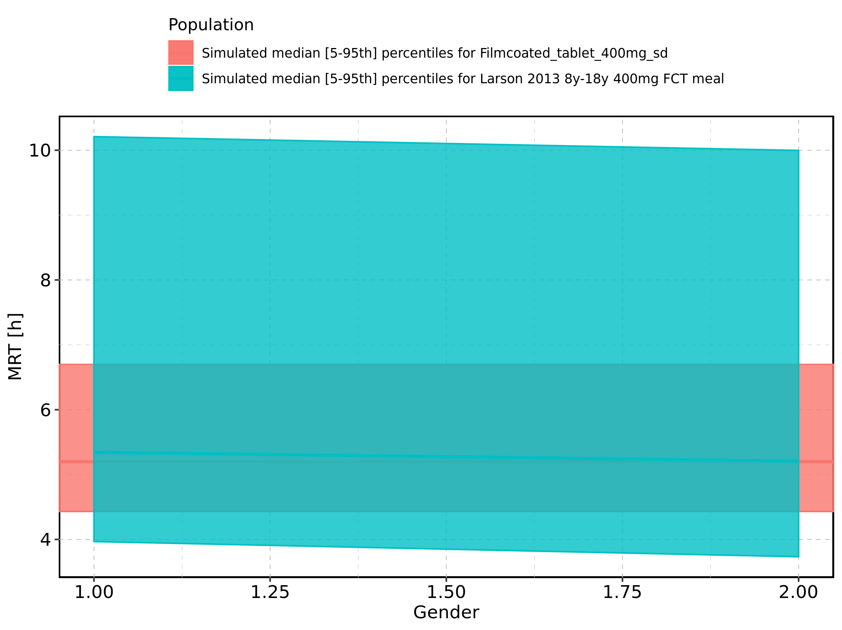

Figure 284: Gender-dependence of MRT for Larson 2013 8y-18y 400mg FCT meal in comparison to Filmcoated_tablet_400mg_sd. Profiles are plotted in a logarithmic scale.

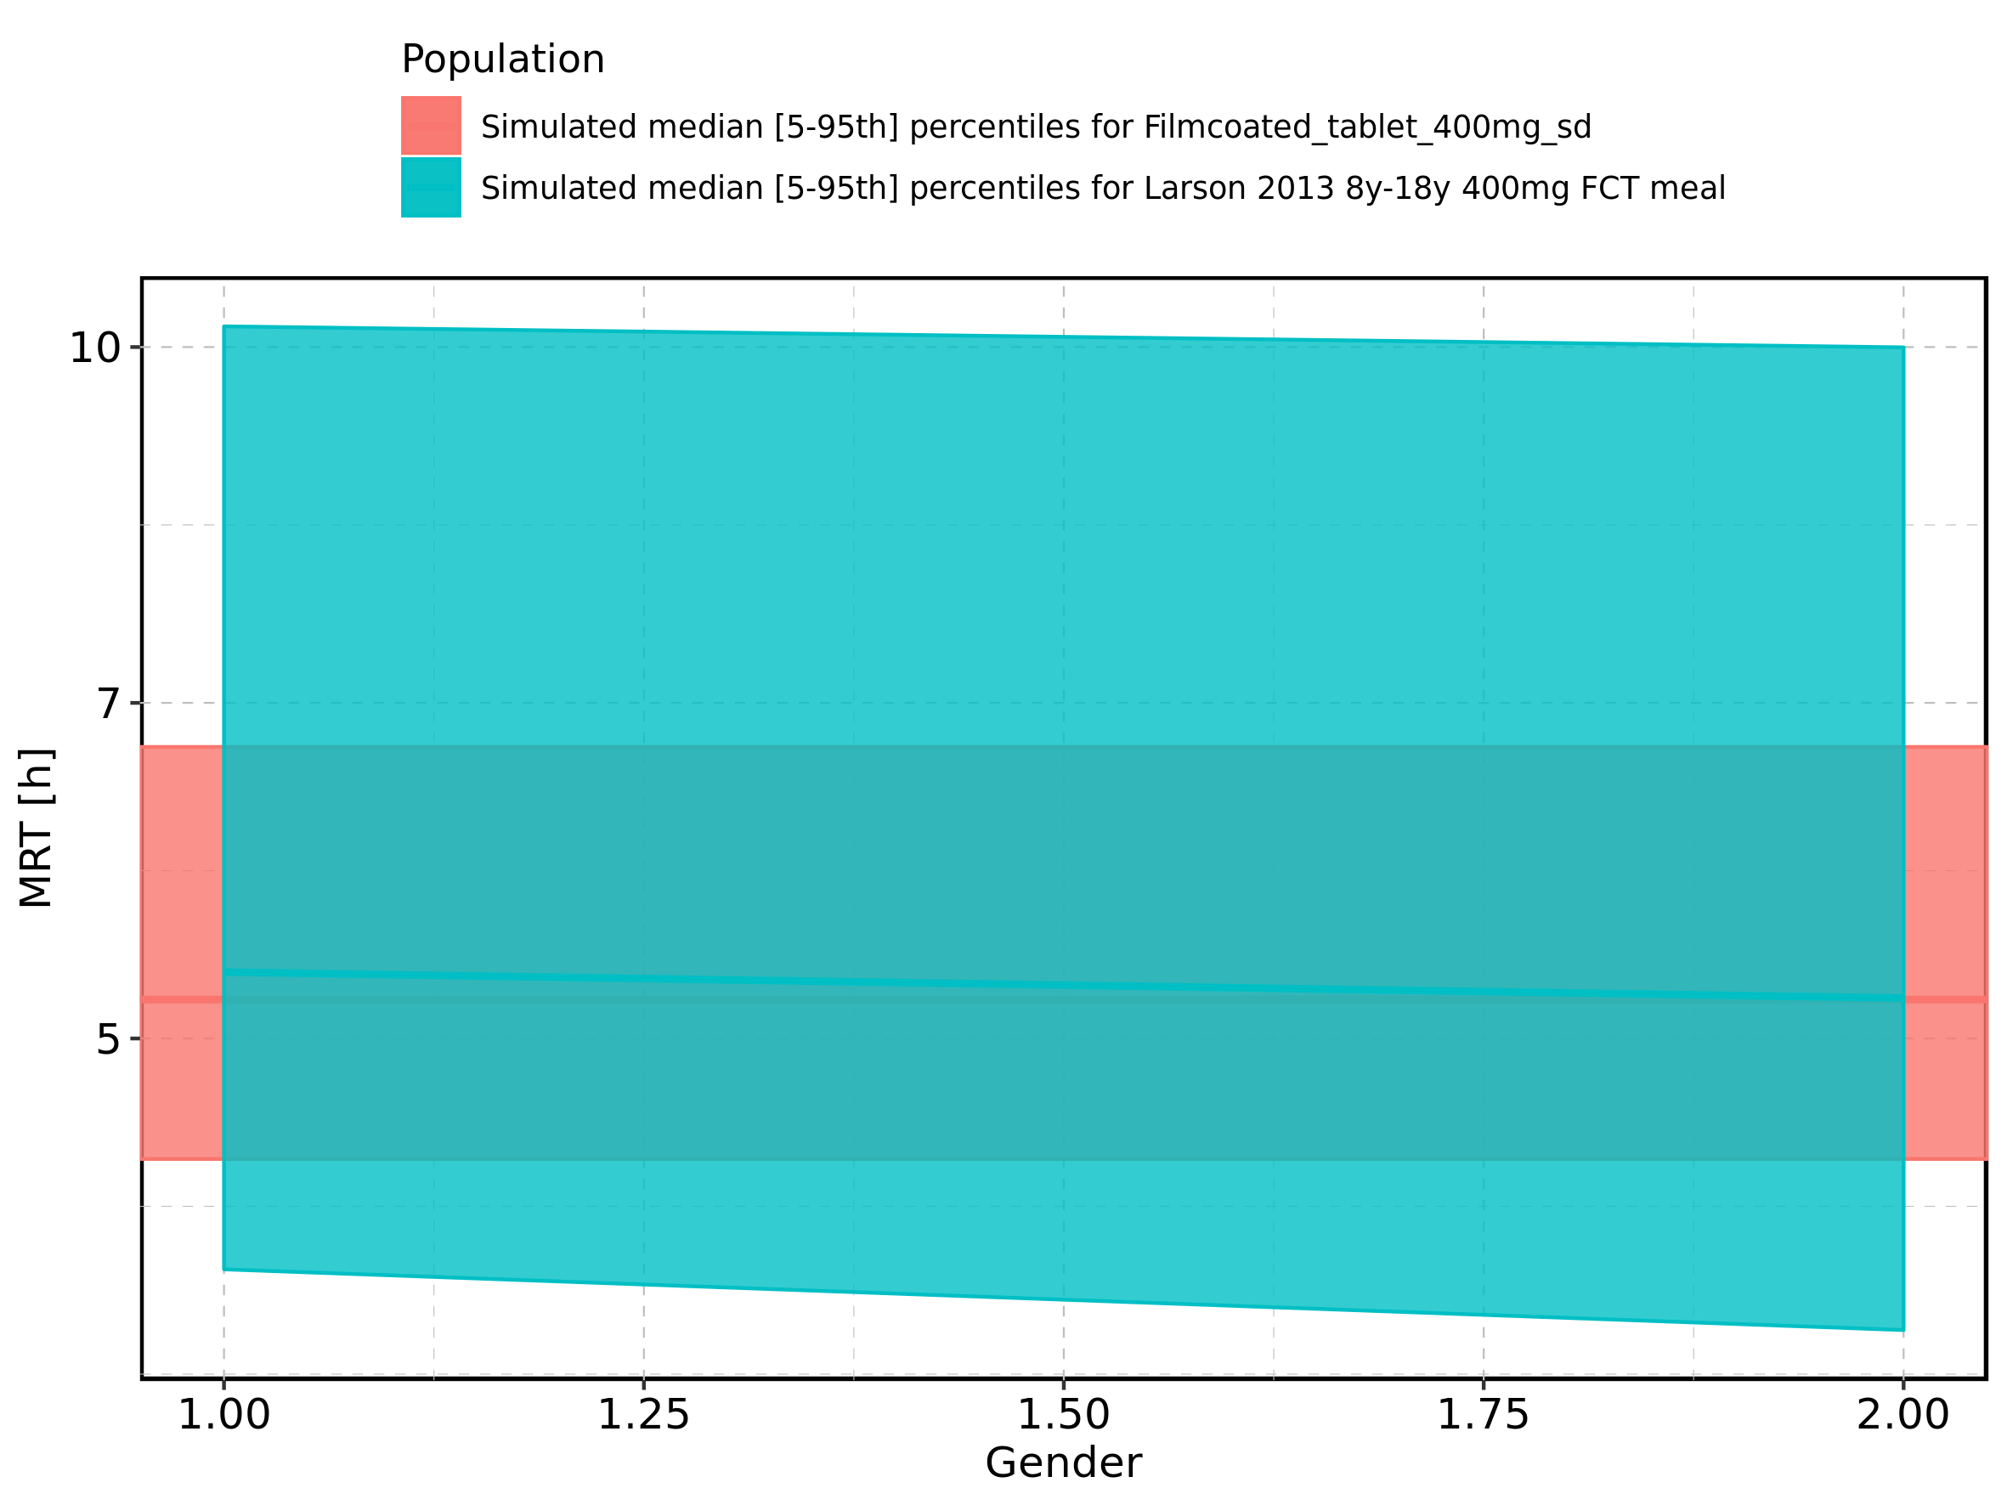

Figure 285: Gender-dependence of MRT for Larson 2013 8y-18y 400mg FCT meal. Profiles are plotted in a linear scale.

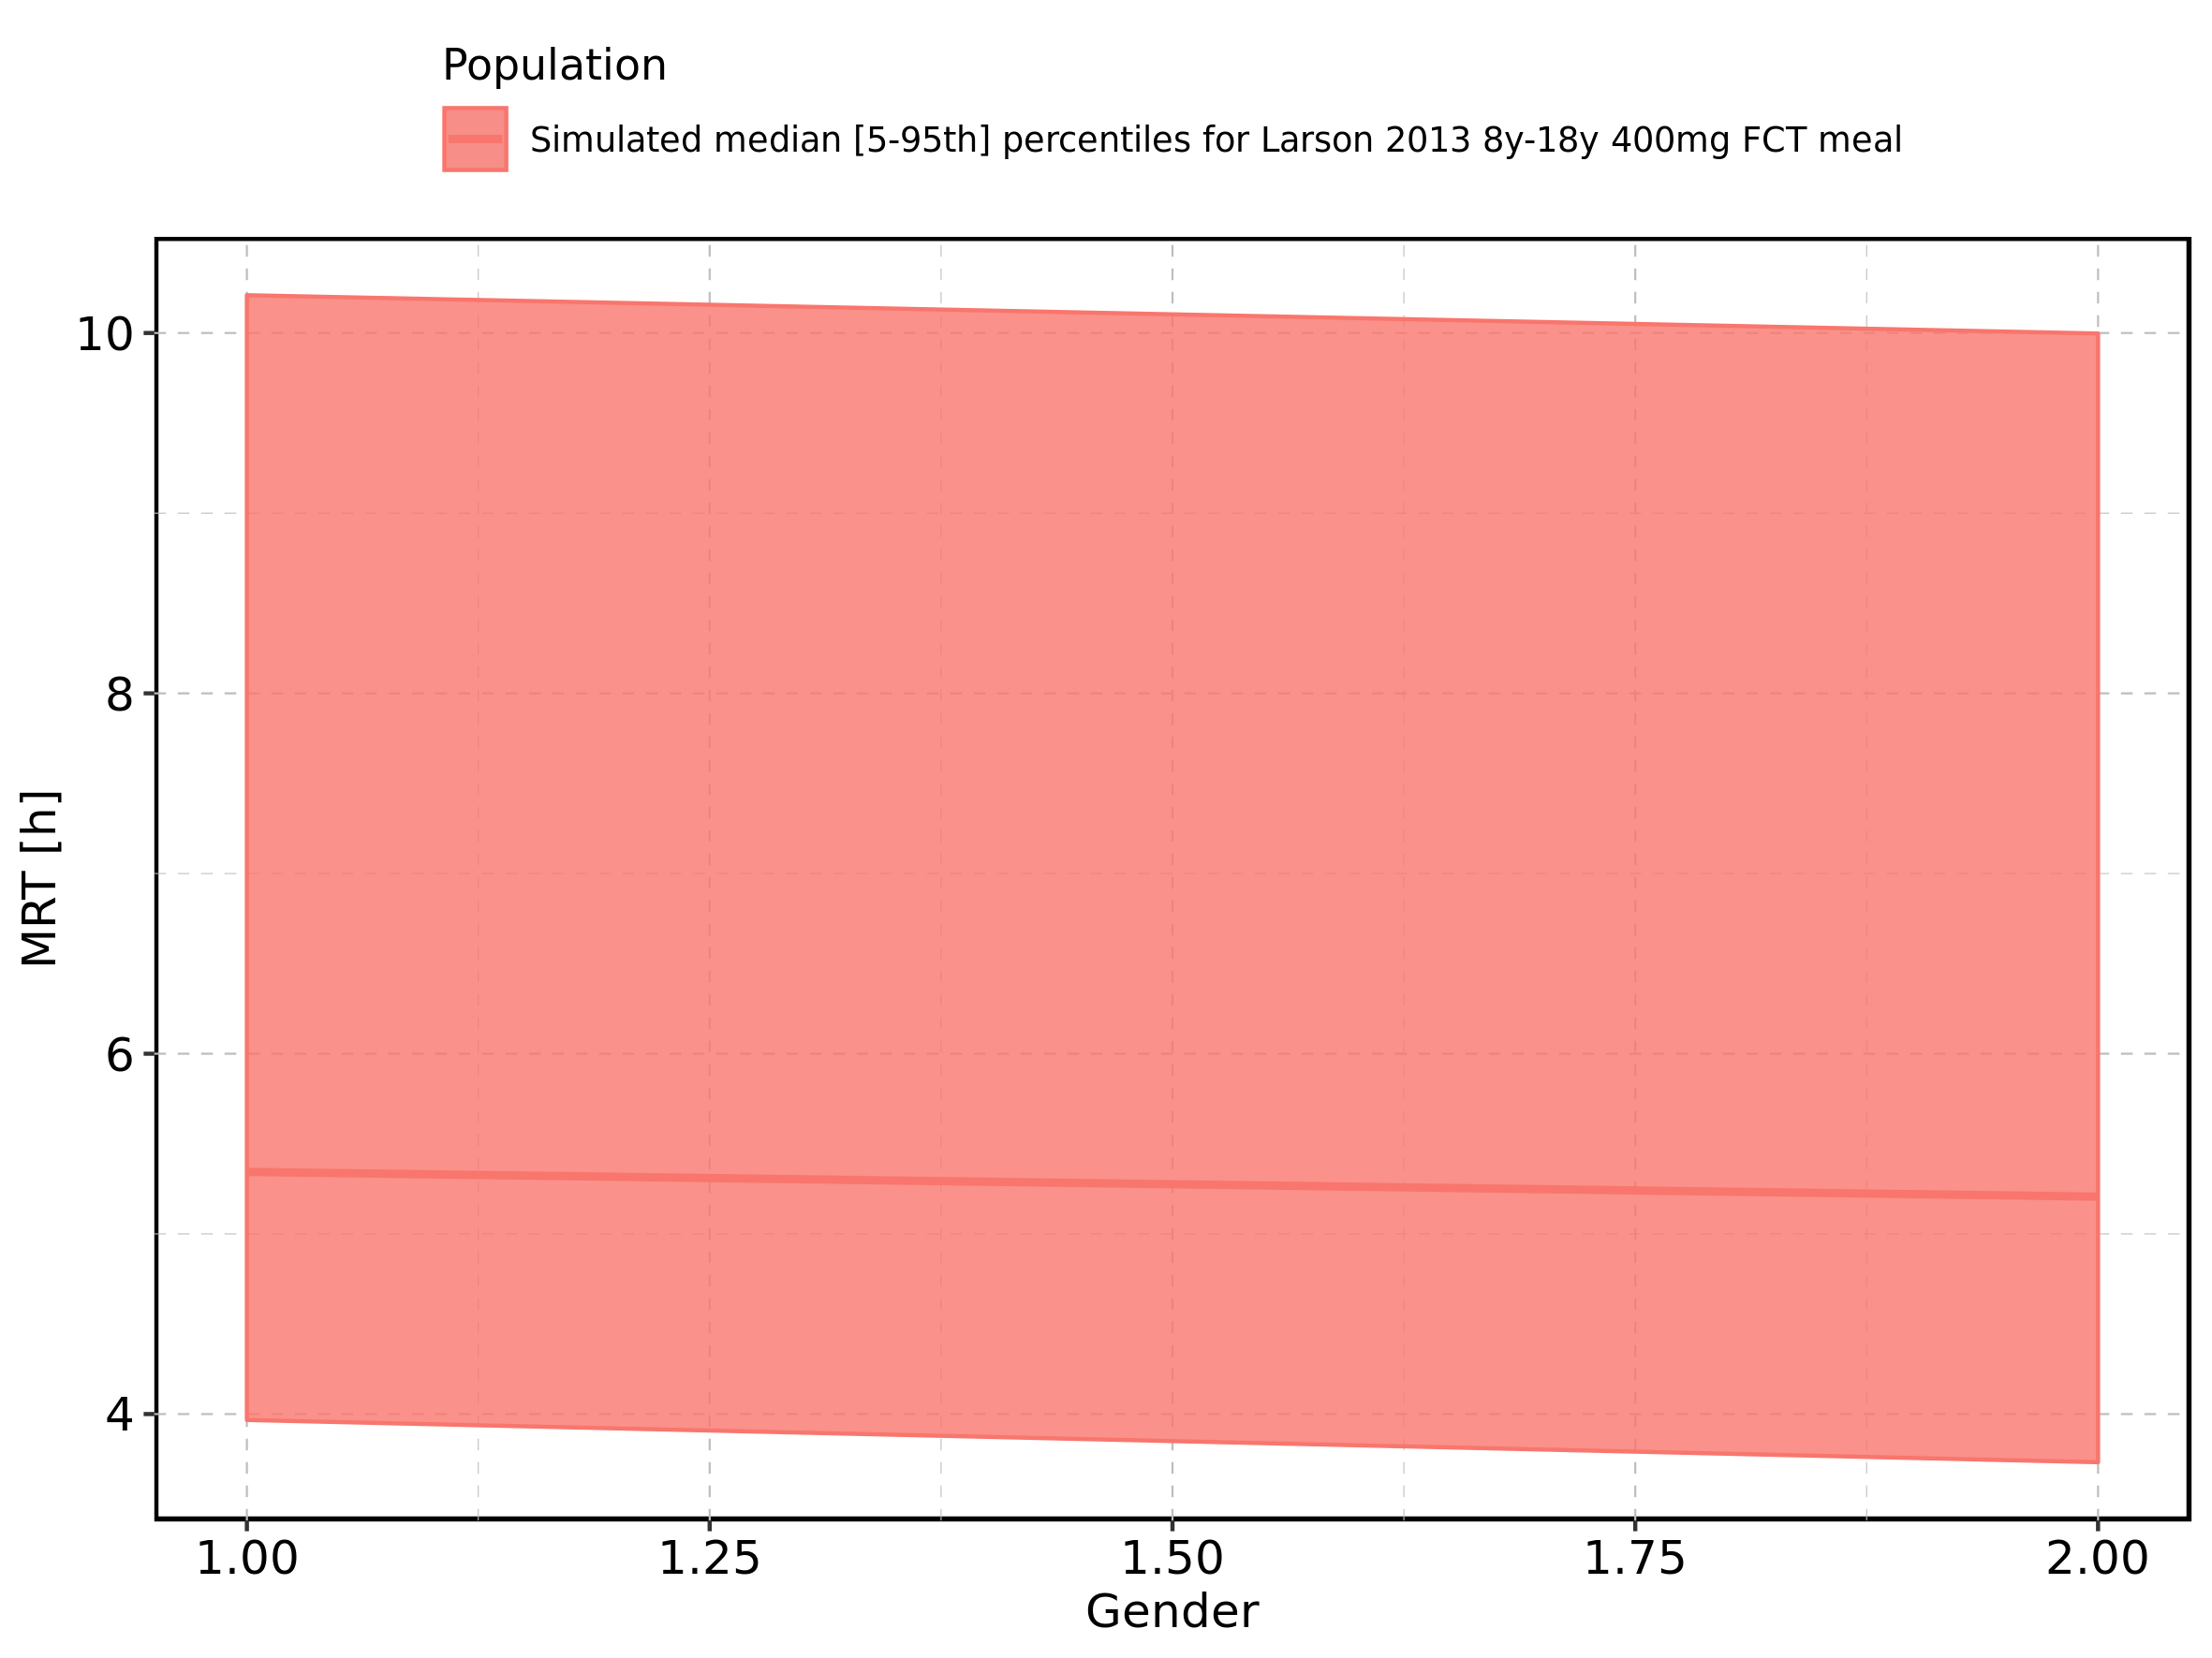

Figure 286: Gender-dependence of MRT for Larson 2013 8y-18y 400mg FCT meal. Profiles are plotted in a logarithmic scale.

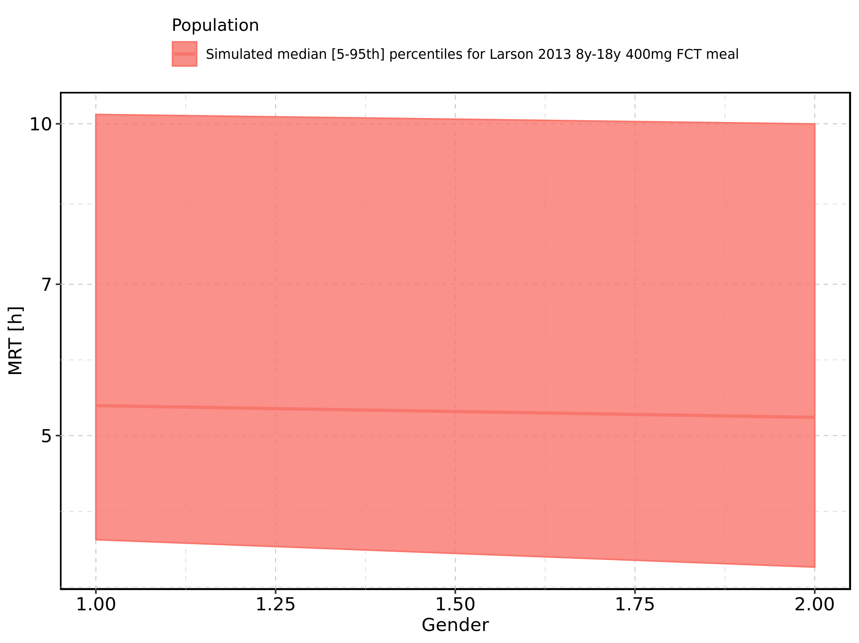

Figure 287: Gender-dependence of MRT for Filmcoated_tablet_400mg_sd. Profiles are plotted in a linear scale.

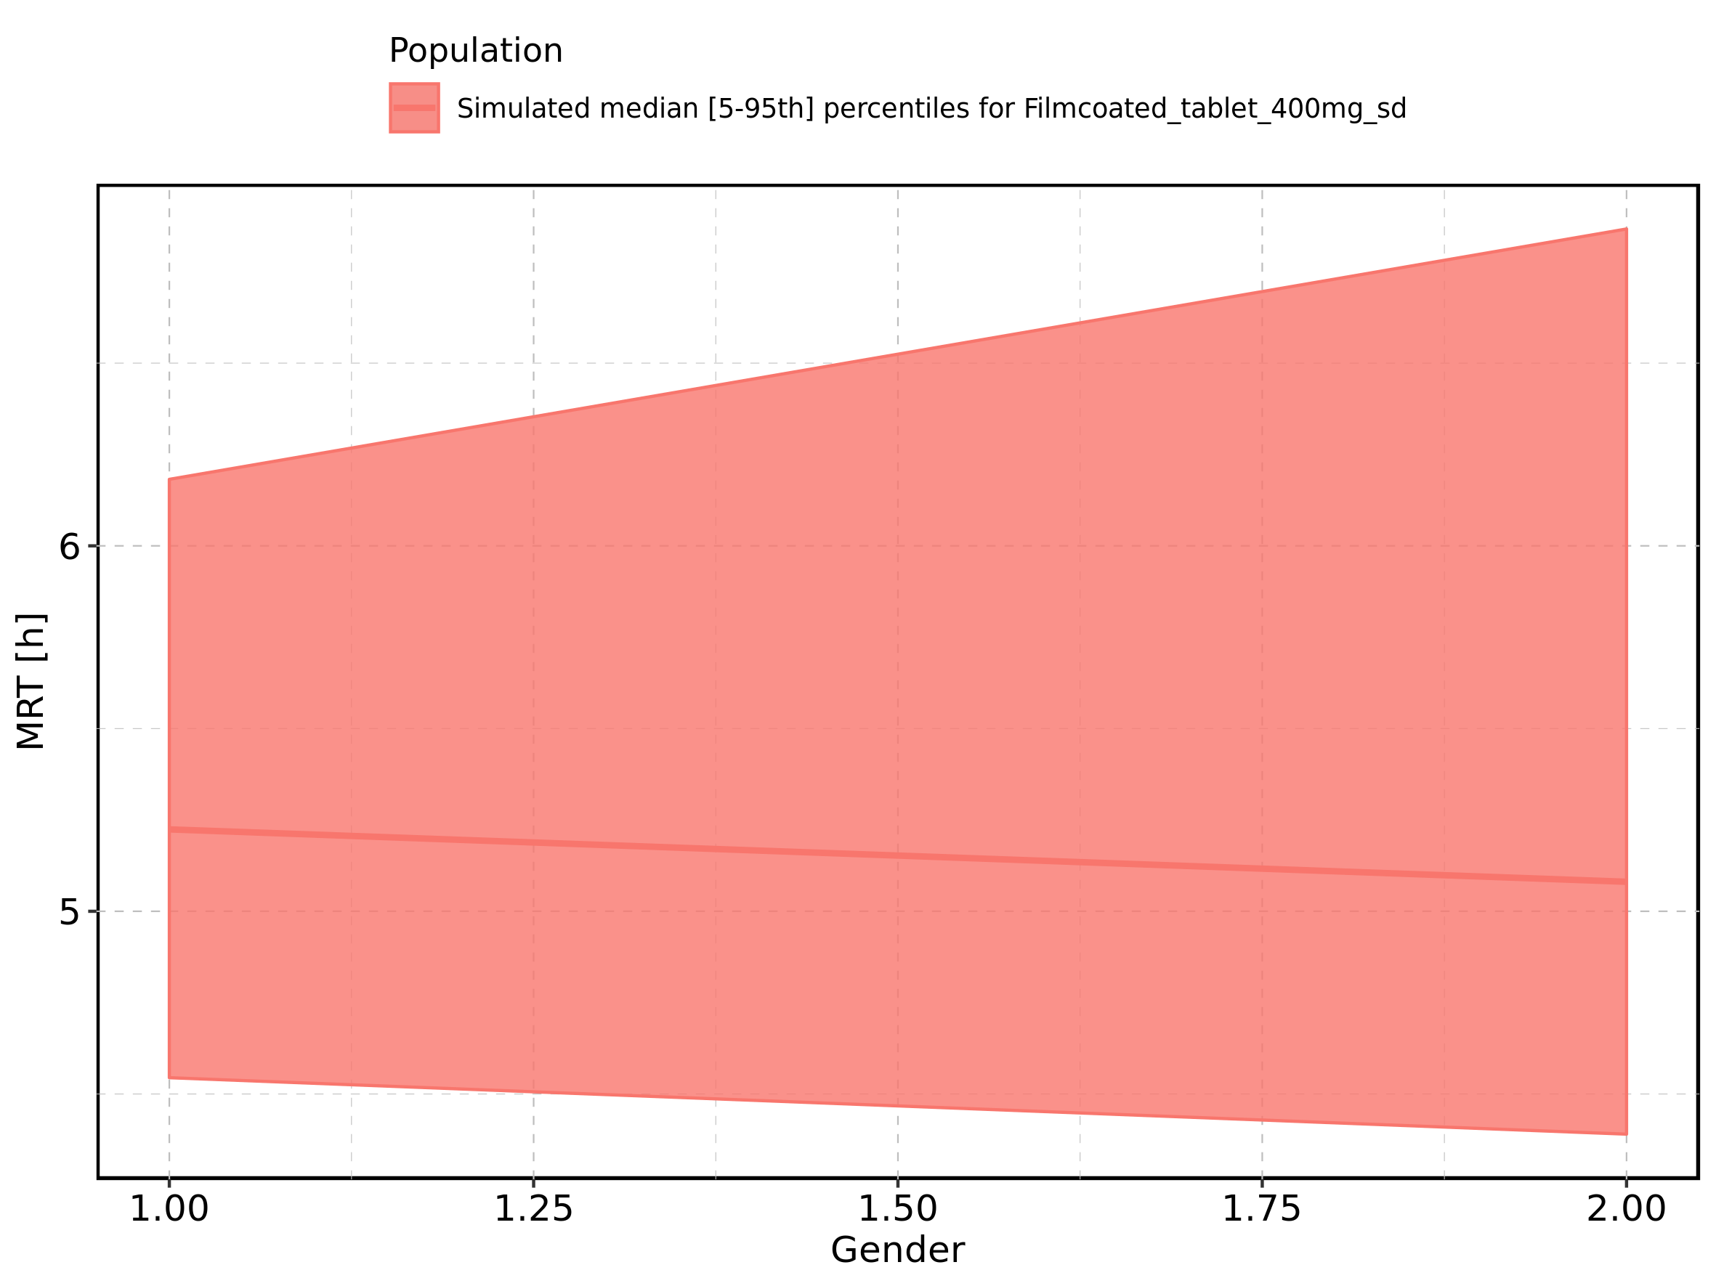

Figure 288: Gender-dependence of MRT for Filmcoated_tablet_400mg_sd. Profiles are plotted in a logarithmic scale.

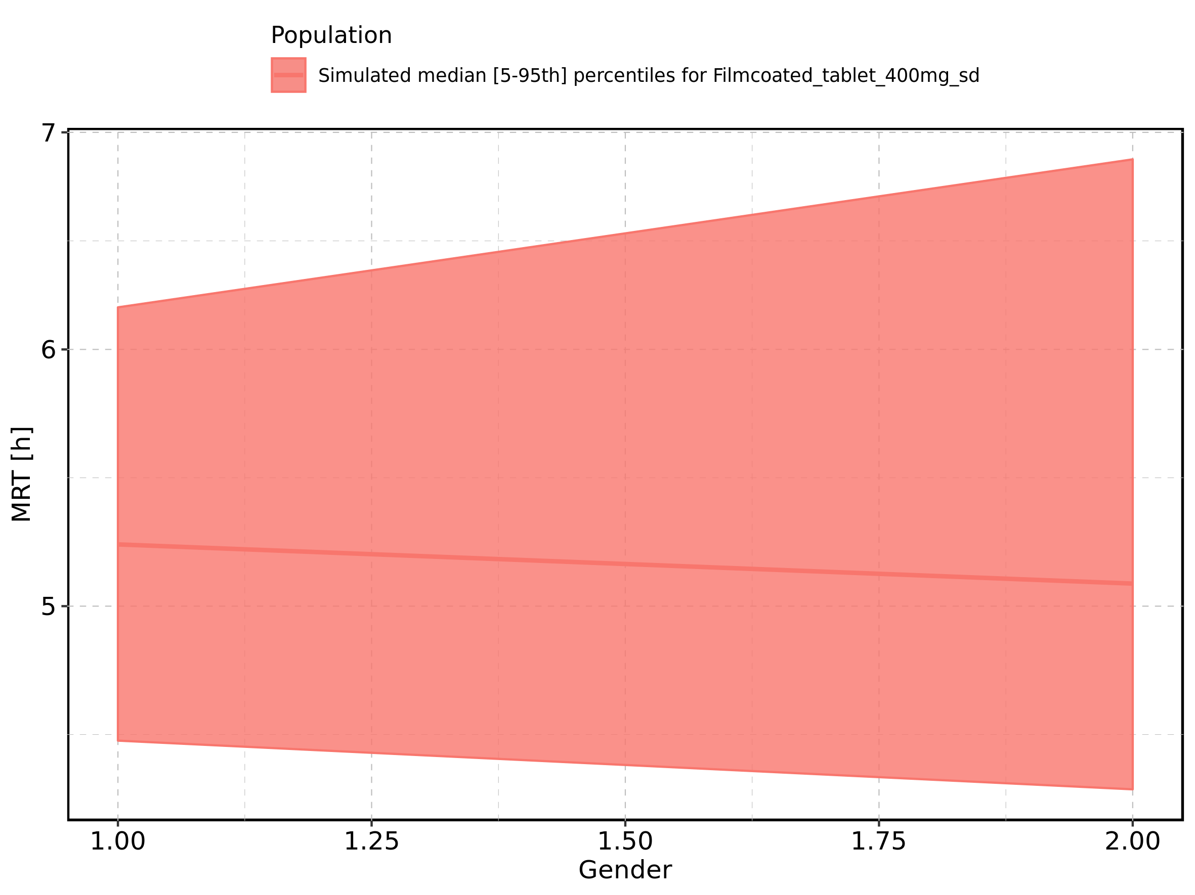

Figure 289: Thalf of Raltegravir shown as box-whisker plot, which indicates the 5th, 25th, 50th, 75th, and 95th percentiles in linear scale.

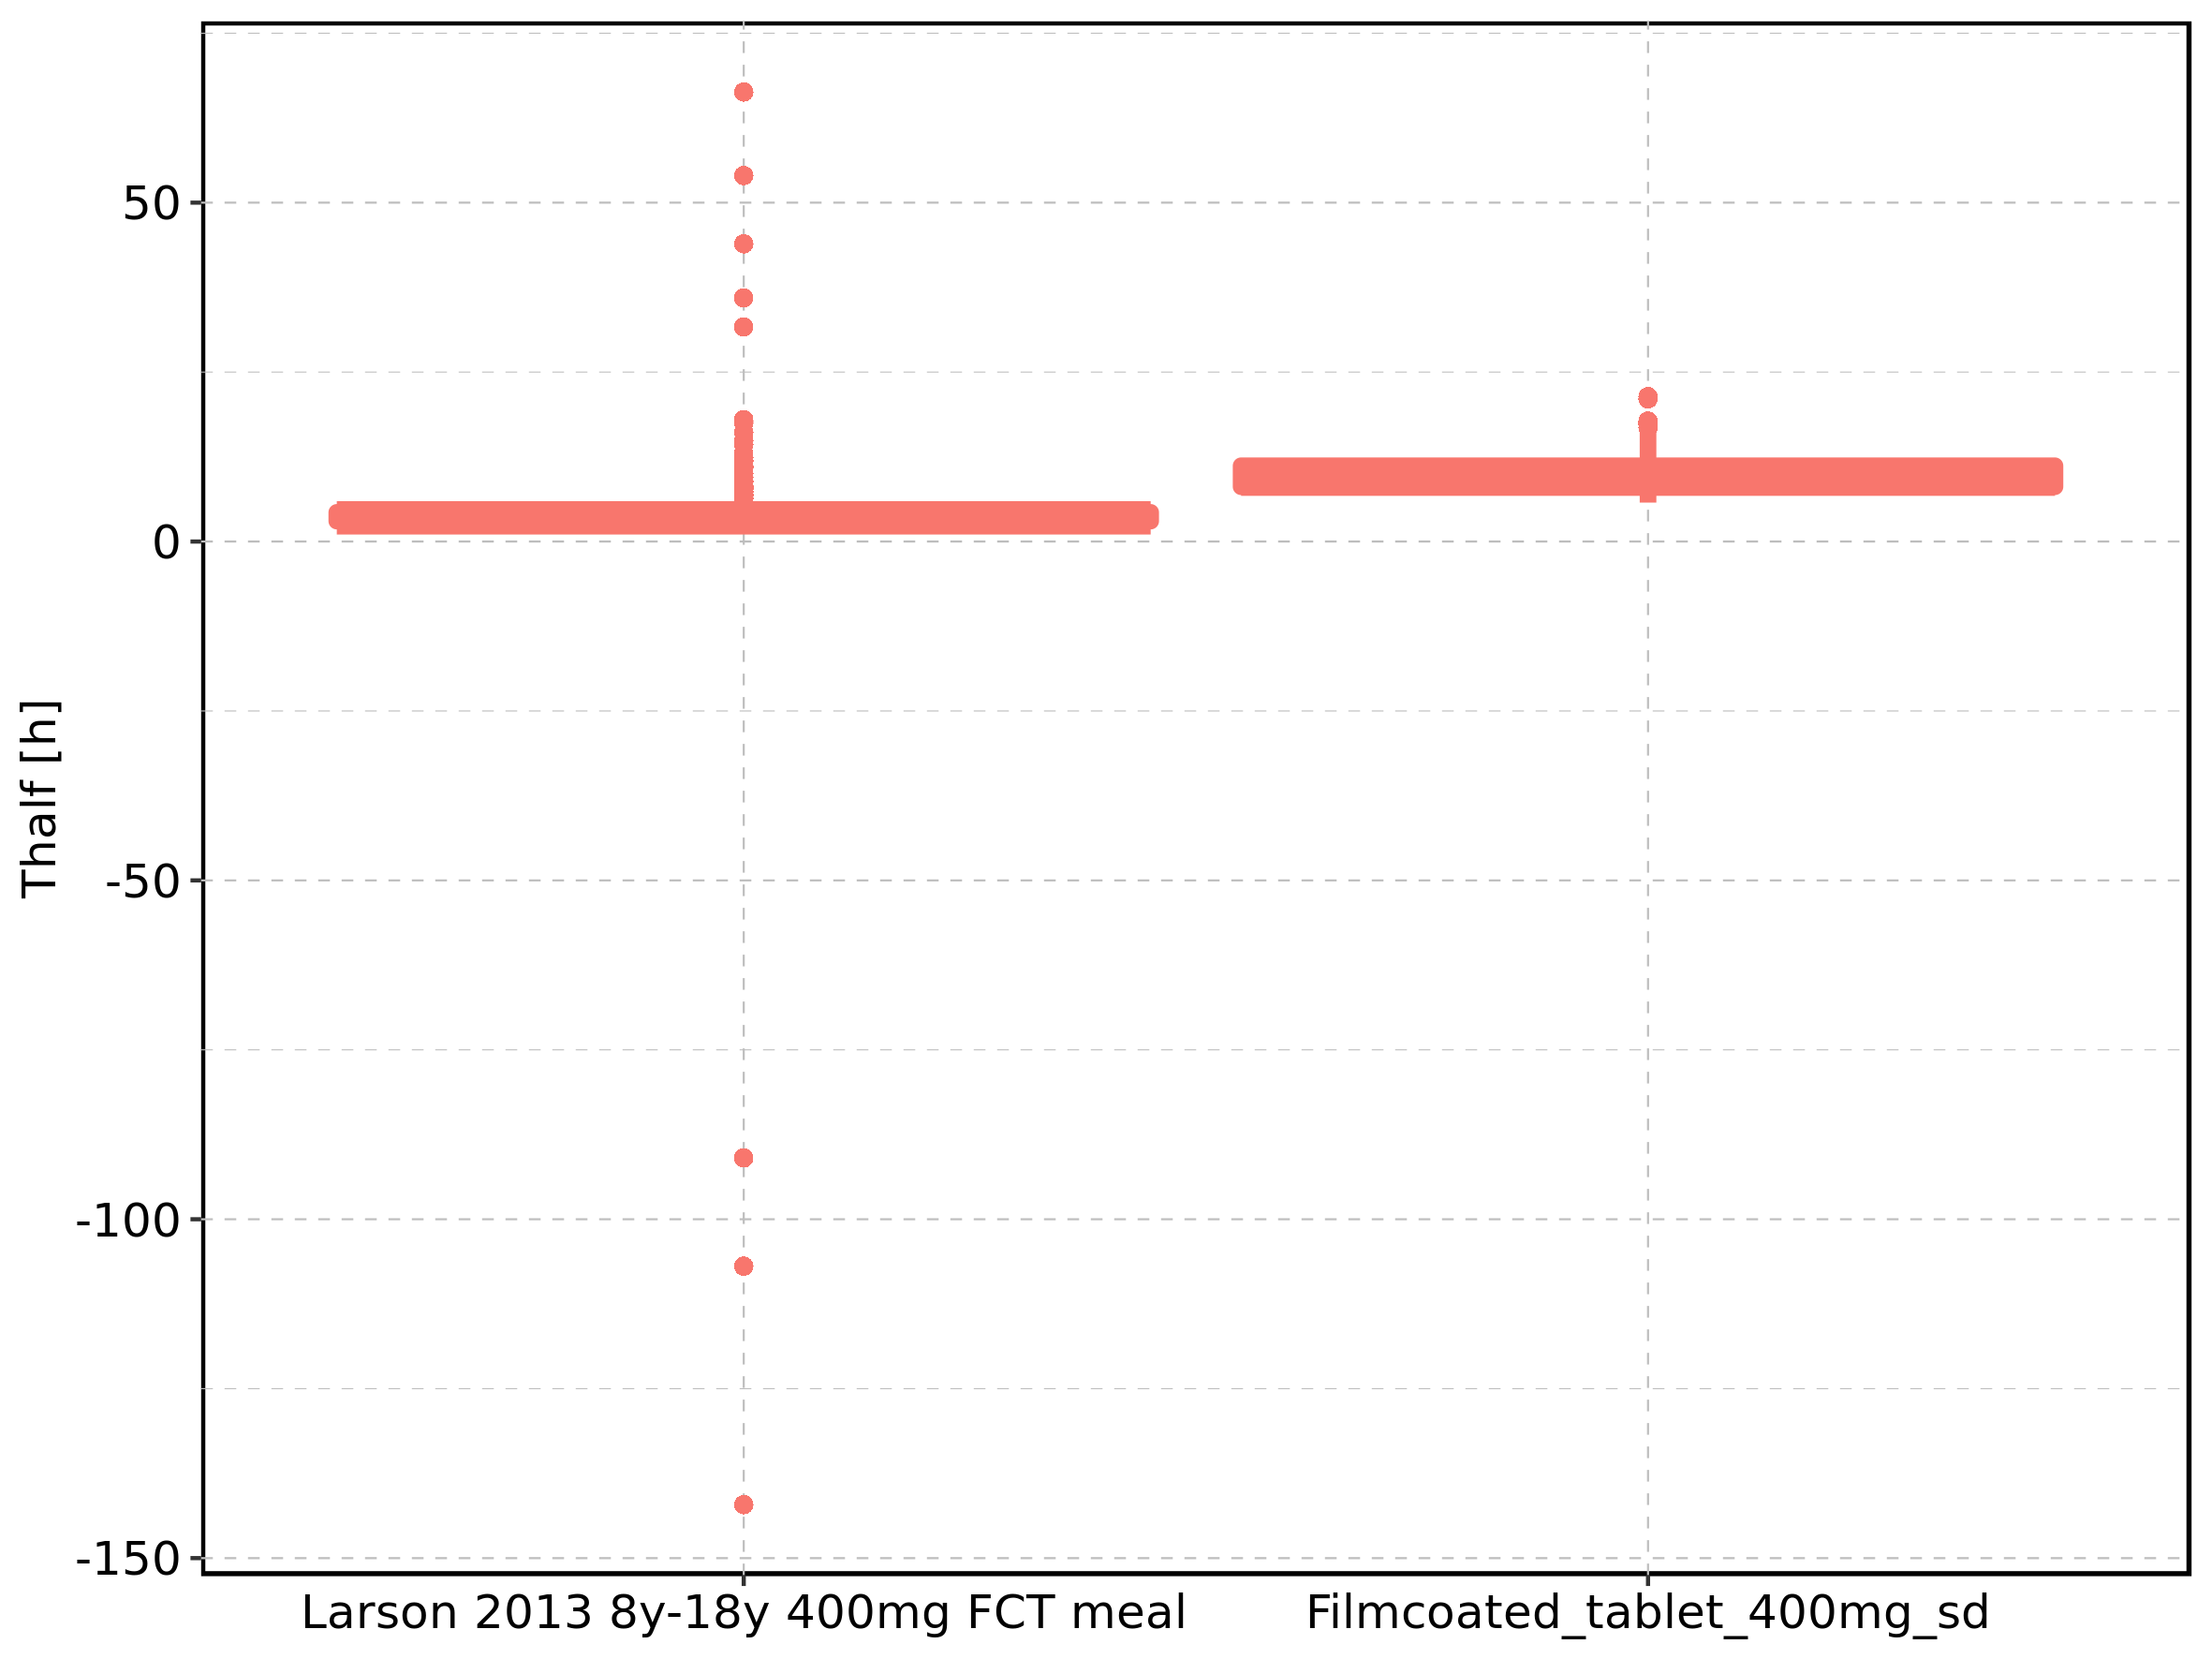

|  |  |  |  |  |  |  |  |  |  |  |
| --- | --- | --- | --- | --- | --- | --- | --- | --- | --- | --- |
| Population | N | 5th percentile | 25th percentile | 50th percentile | 75th percentile | 95th percentile | mean | standard deviation | geo mean | geo standard deviation |
| Larson 2013 8y-18y 400mg FCT meal | 500 | 2.549721 | 3.014642 | 3.492027 | 4.299532 | 9.428484 | 3.895567 | 10.493434 | NA | NA |
| Filmcoated_tablet_400mg_sd | 100 | 5.739979 | 8.084065 | 9.195944 | 11.176013 | 16.813811 | 9.987298 | 3.182538 | 9.545373 | 1.348088 |

Figure 290: Thalf of Raltegravir shown as box-whisker plot, which indicates the 5th, 25th, 50th, 75th, and 95th percentiles in logarithmic scale.

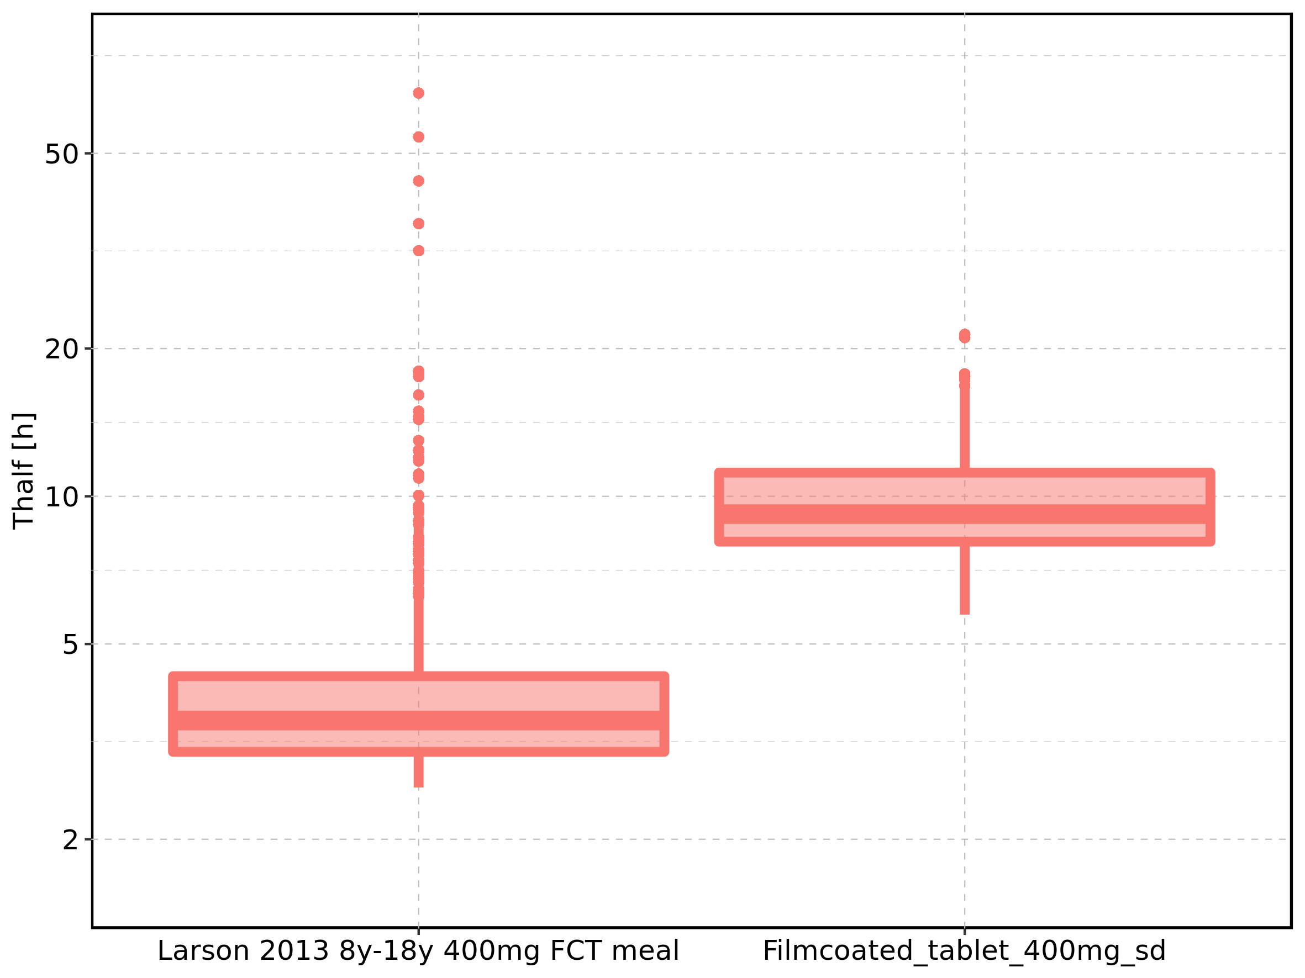

Figure 291: Age-dependence of Thalf for Larson 2013 8y-18y 400mg FCT meal in comparison to Filmcoated_tablet_400mg_sd. Profiles are plotted in a linear scale.

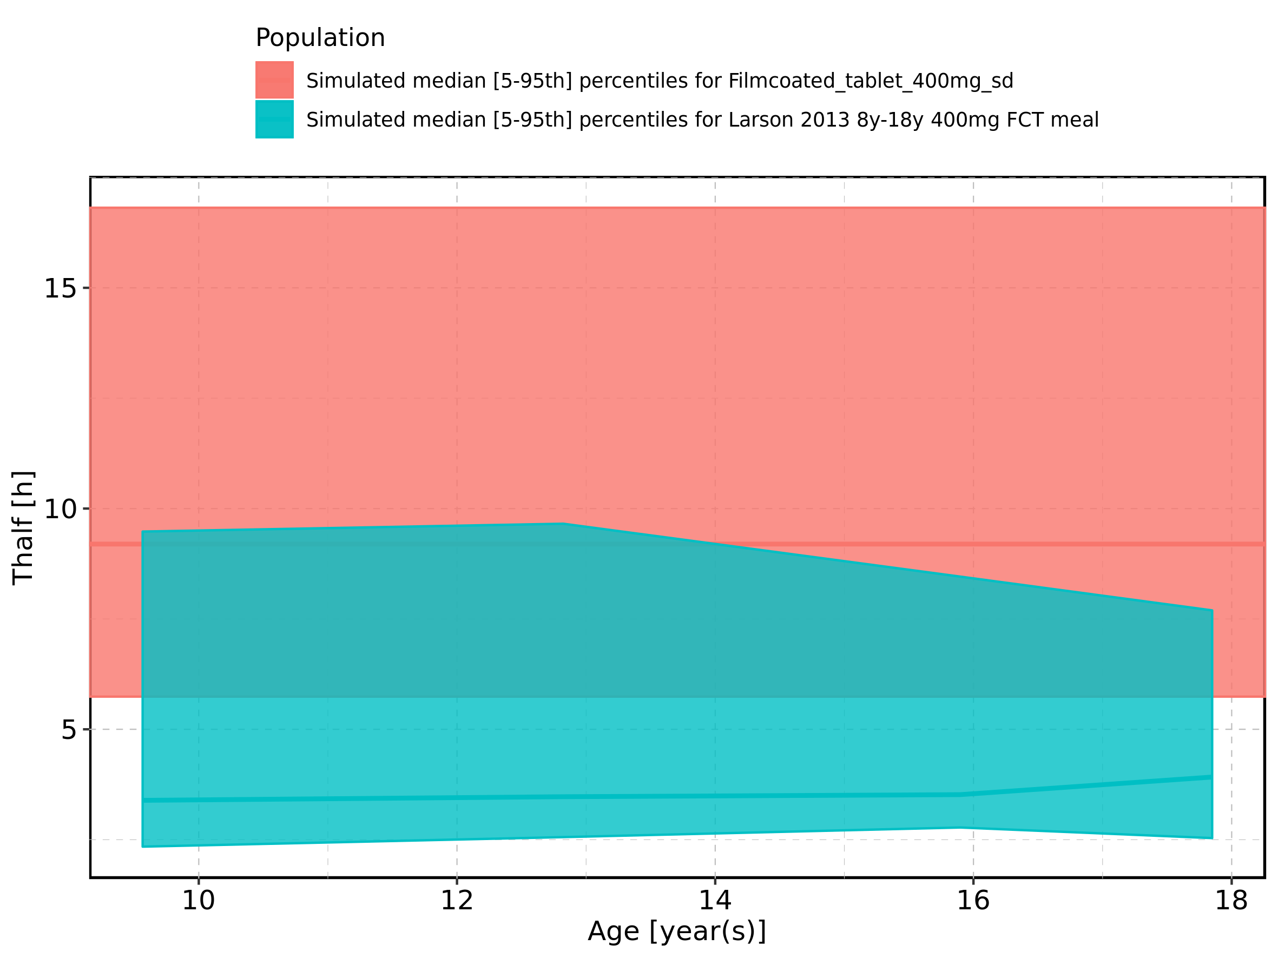

Figure 292: Age-dependence of Thalf for Larson 2013 8y-18y 400mg FCT meal in comparison to Filmcoated_tablet_400mg_sd. Profiles are plotted in a logarithmic scale.

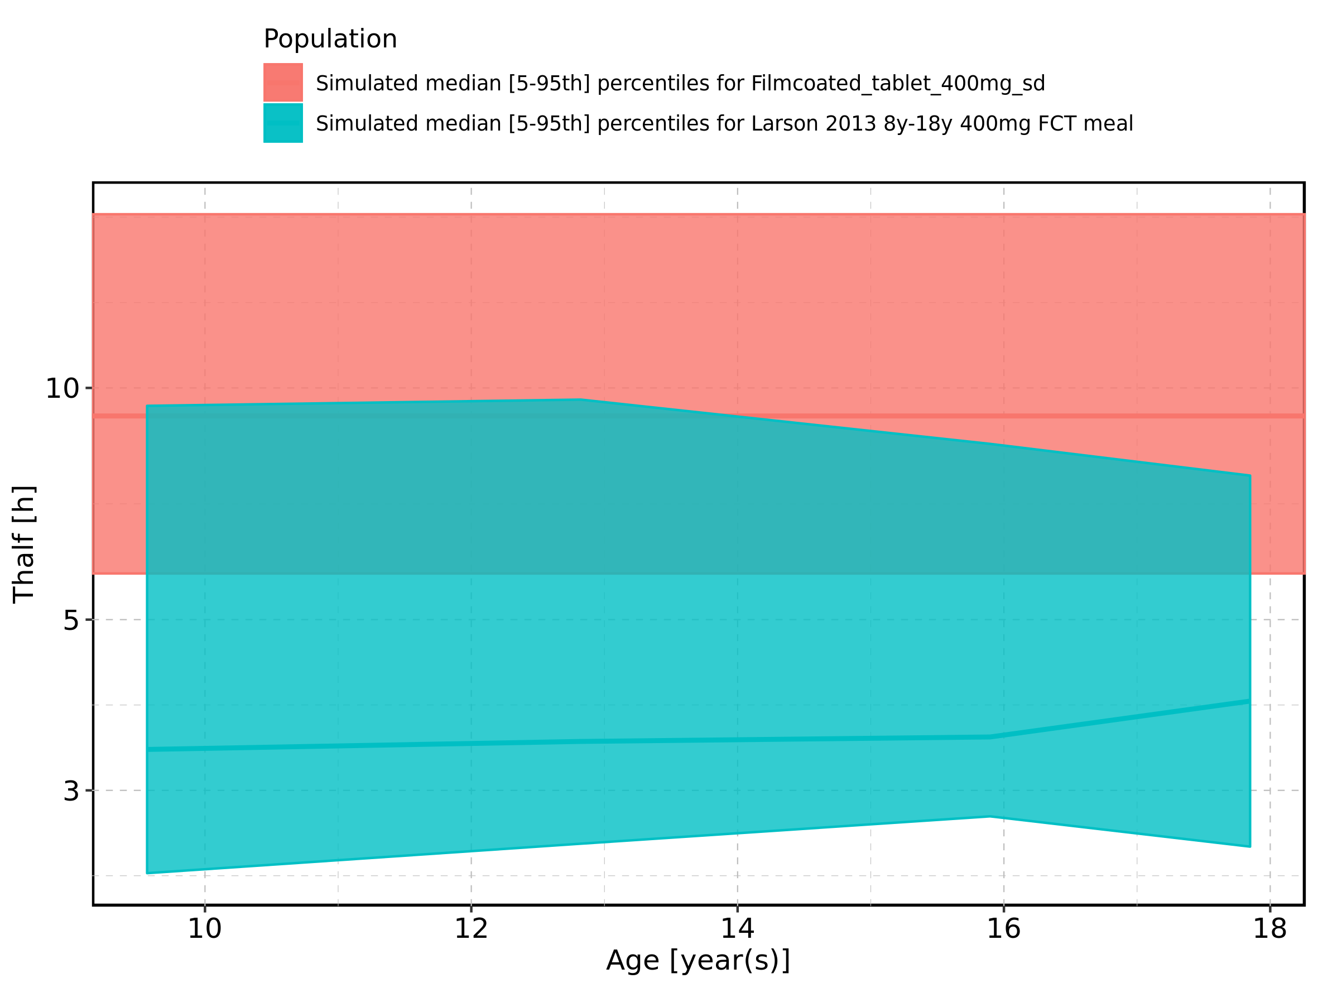

Figure 293: Age-dependence of Thalf for Larson 2013 8y-18y 400mg FCT meal. Profiles are plotted in a linear scale.

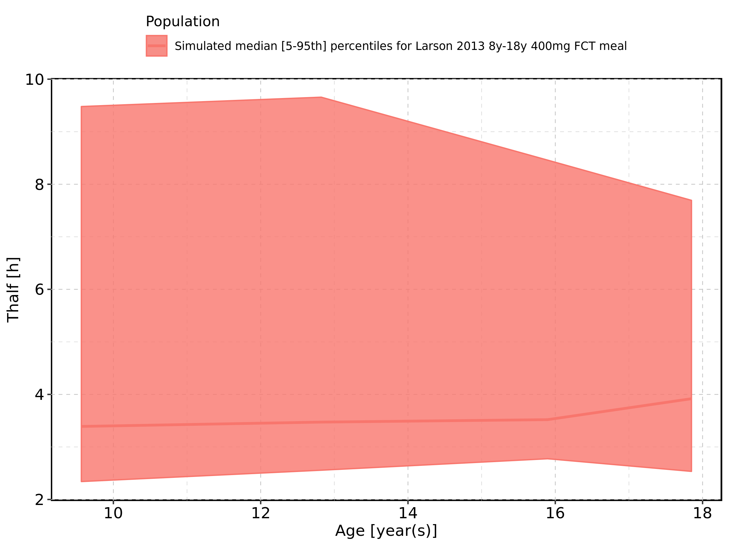

Figure 294: Age-dependence of Thalf for Larson 2013 8y-18y 400mg FCT meal. Profiles are plotted in a logarithmic scale.

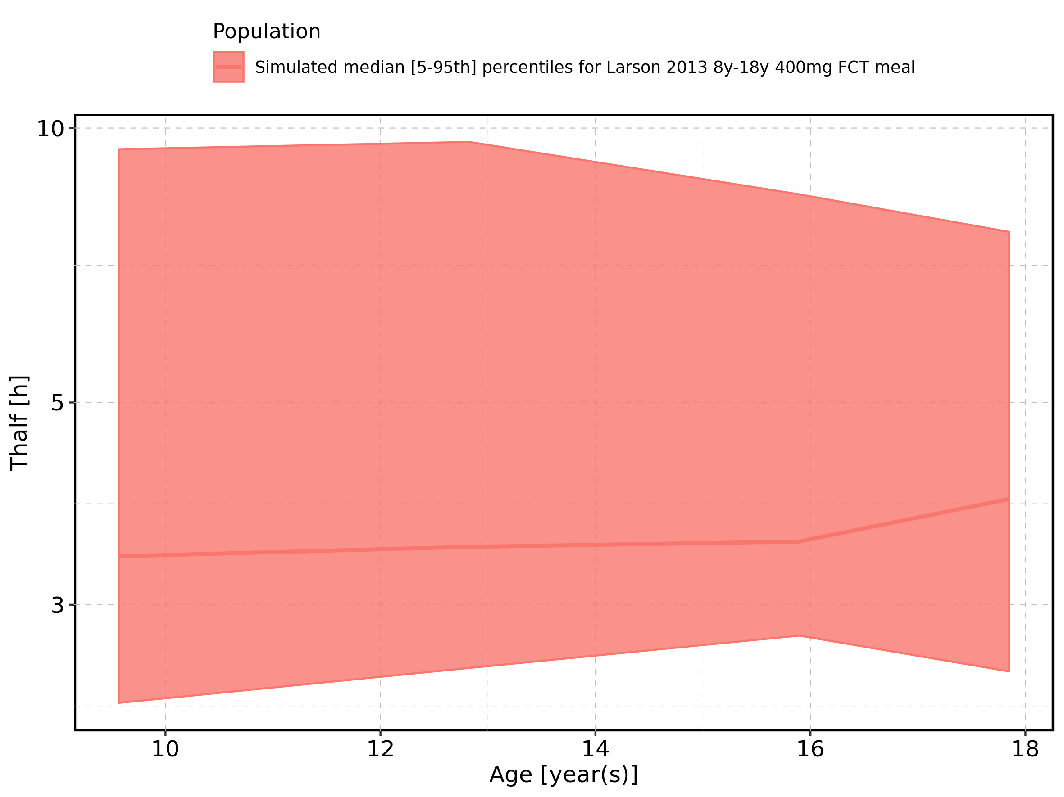

Figure 295: Age-dependence of Thalf for Filmcoated_tablet_400mg_sd. Profiles are plotted in a linear scale.

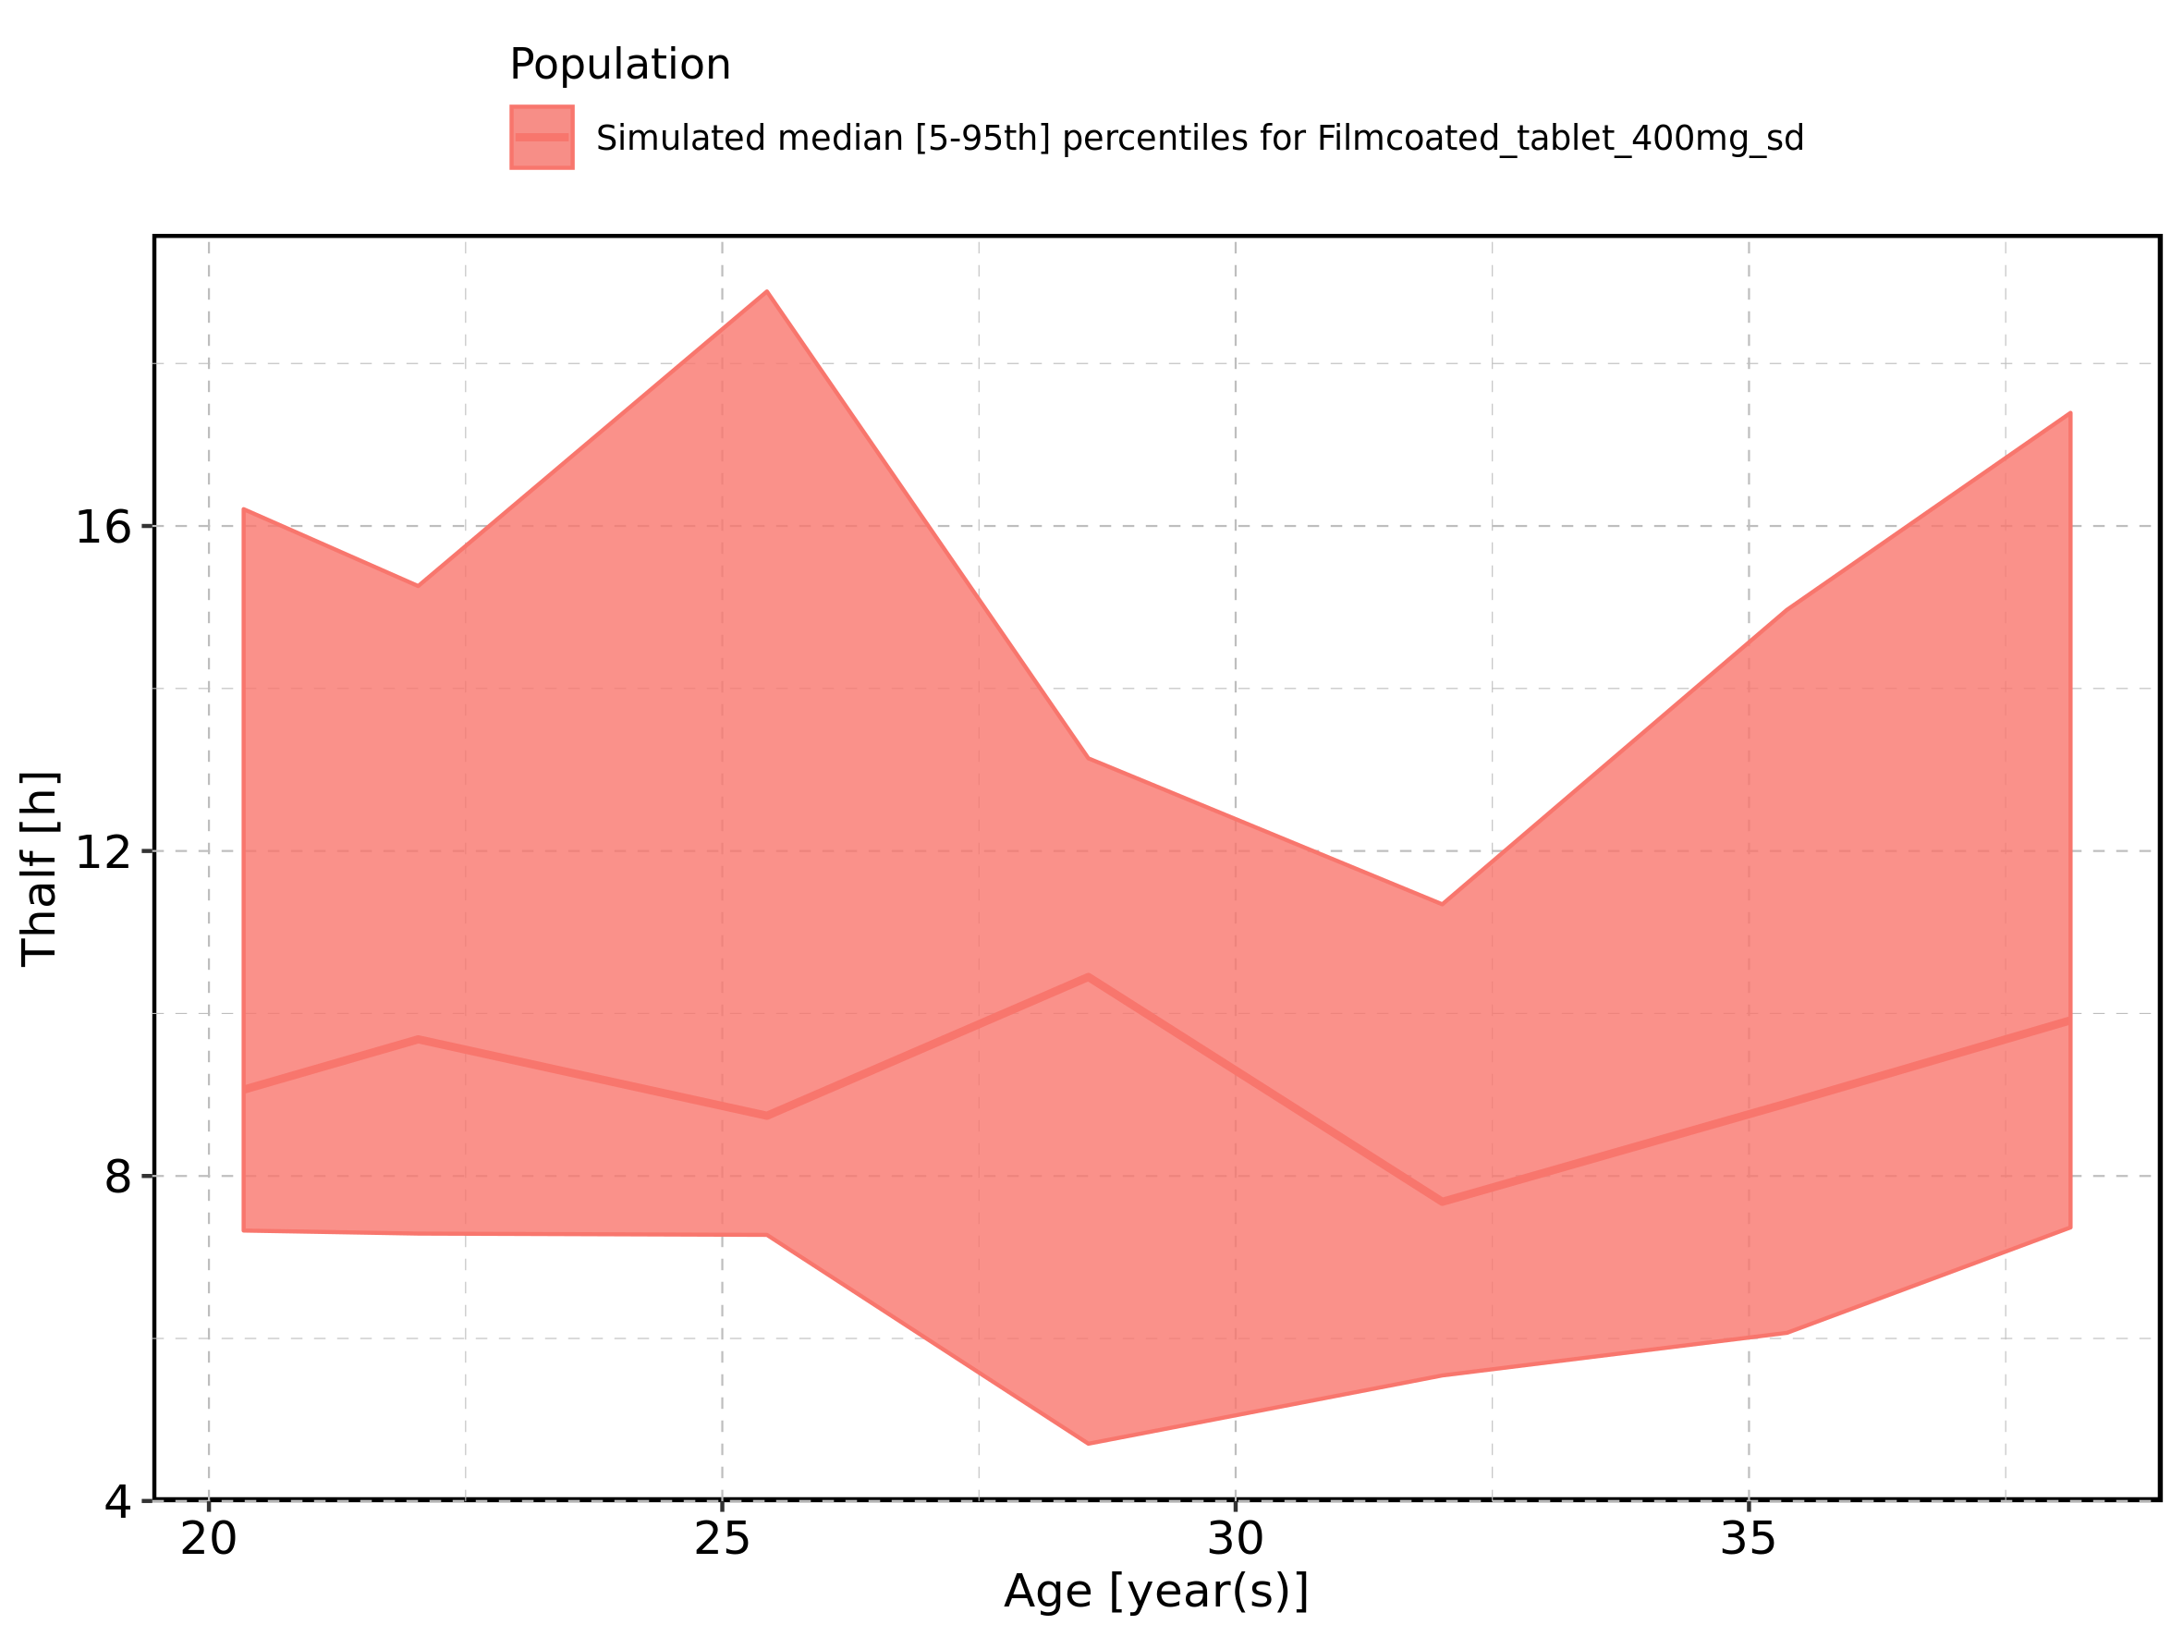

Figure 296: Age-dependence of Thalf for Filmcoated_tablet_400mg_sd. Profiles are plotted in a logarithmic scale.

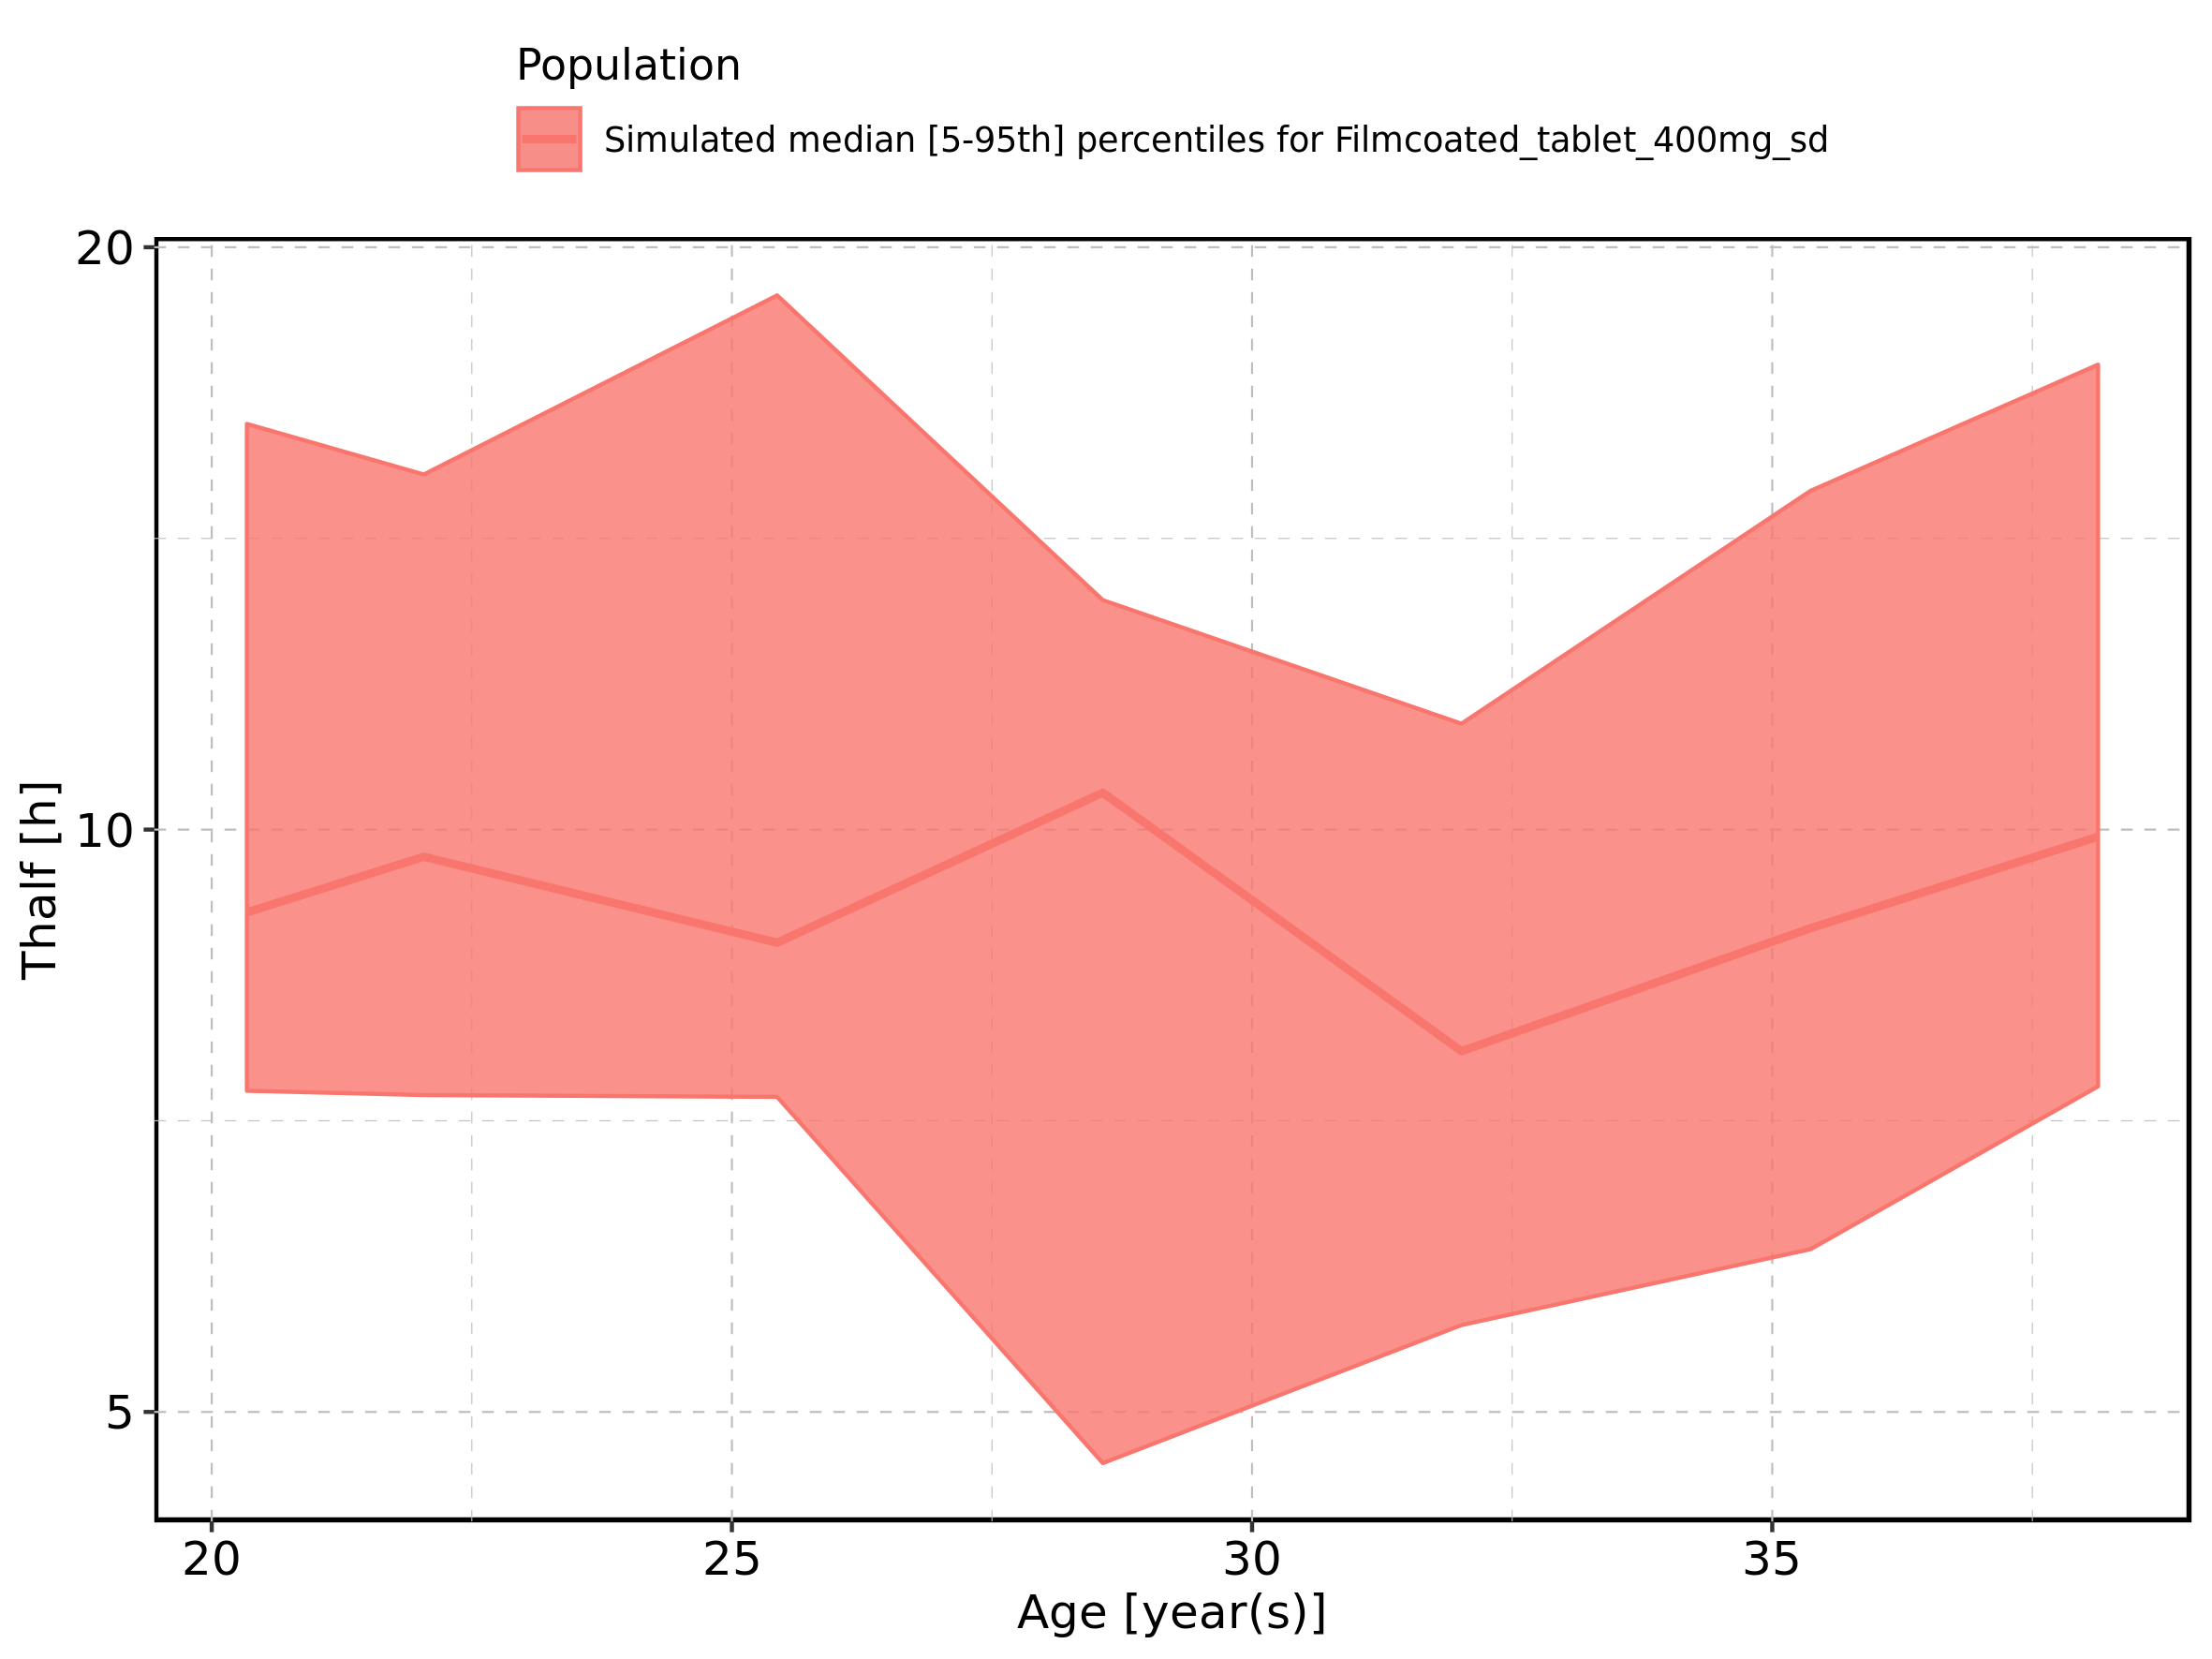

Figure 297: Height-dependence of Thalf for Larson 2013 8y-18y 400mg FCT meal in comparison to Filmcoated_tablet_400mg_sd. Profiles are plotted in a linear scale.

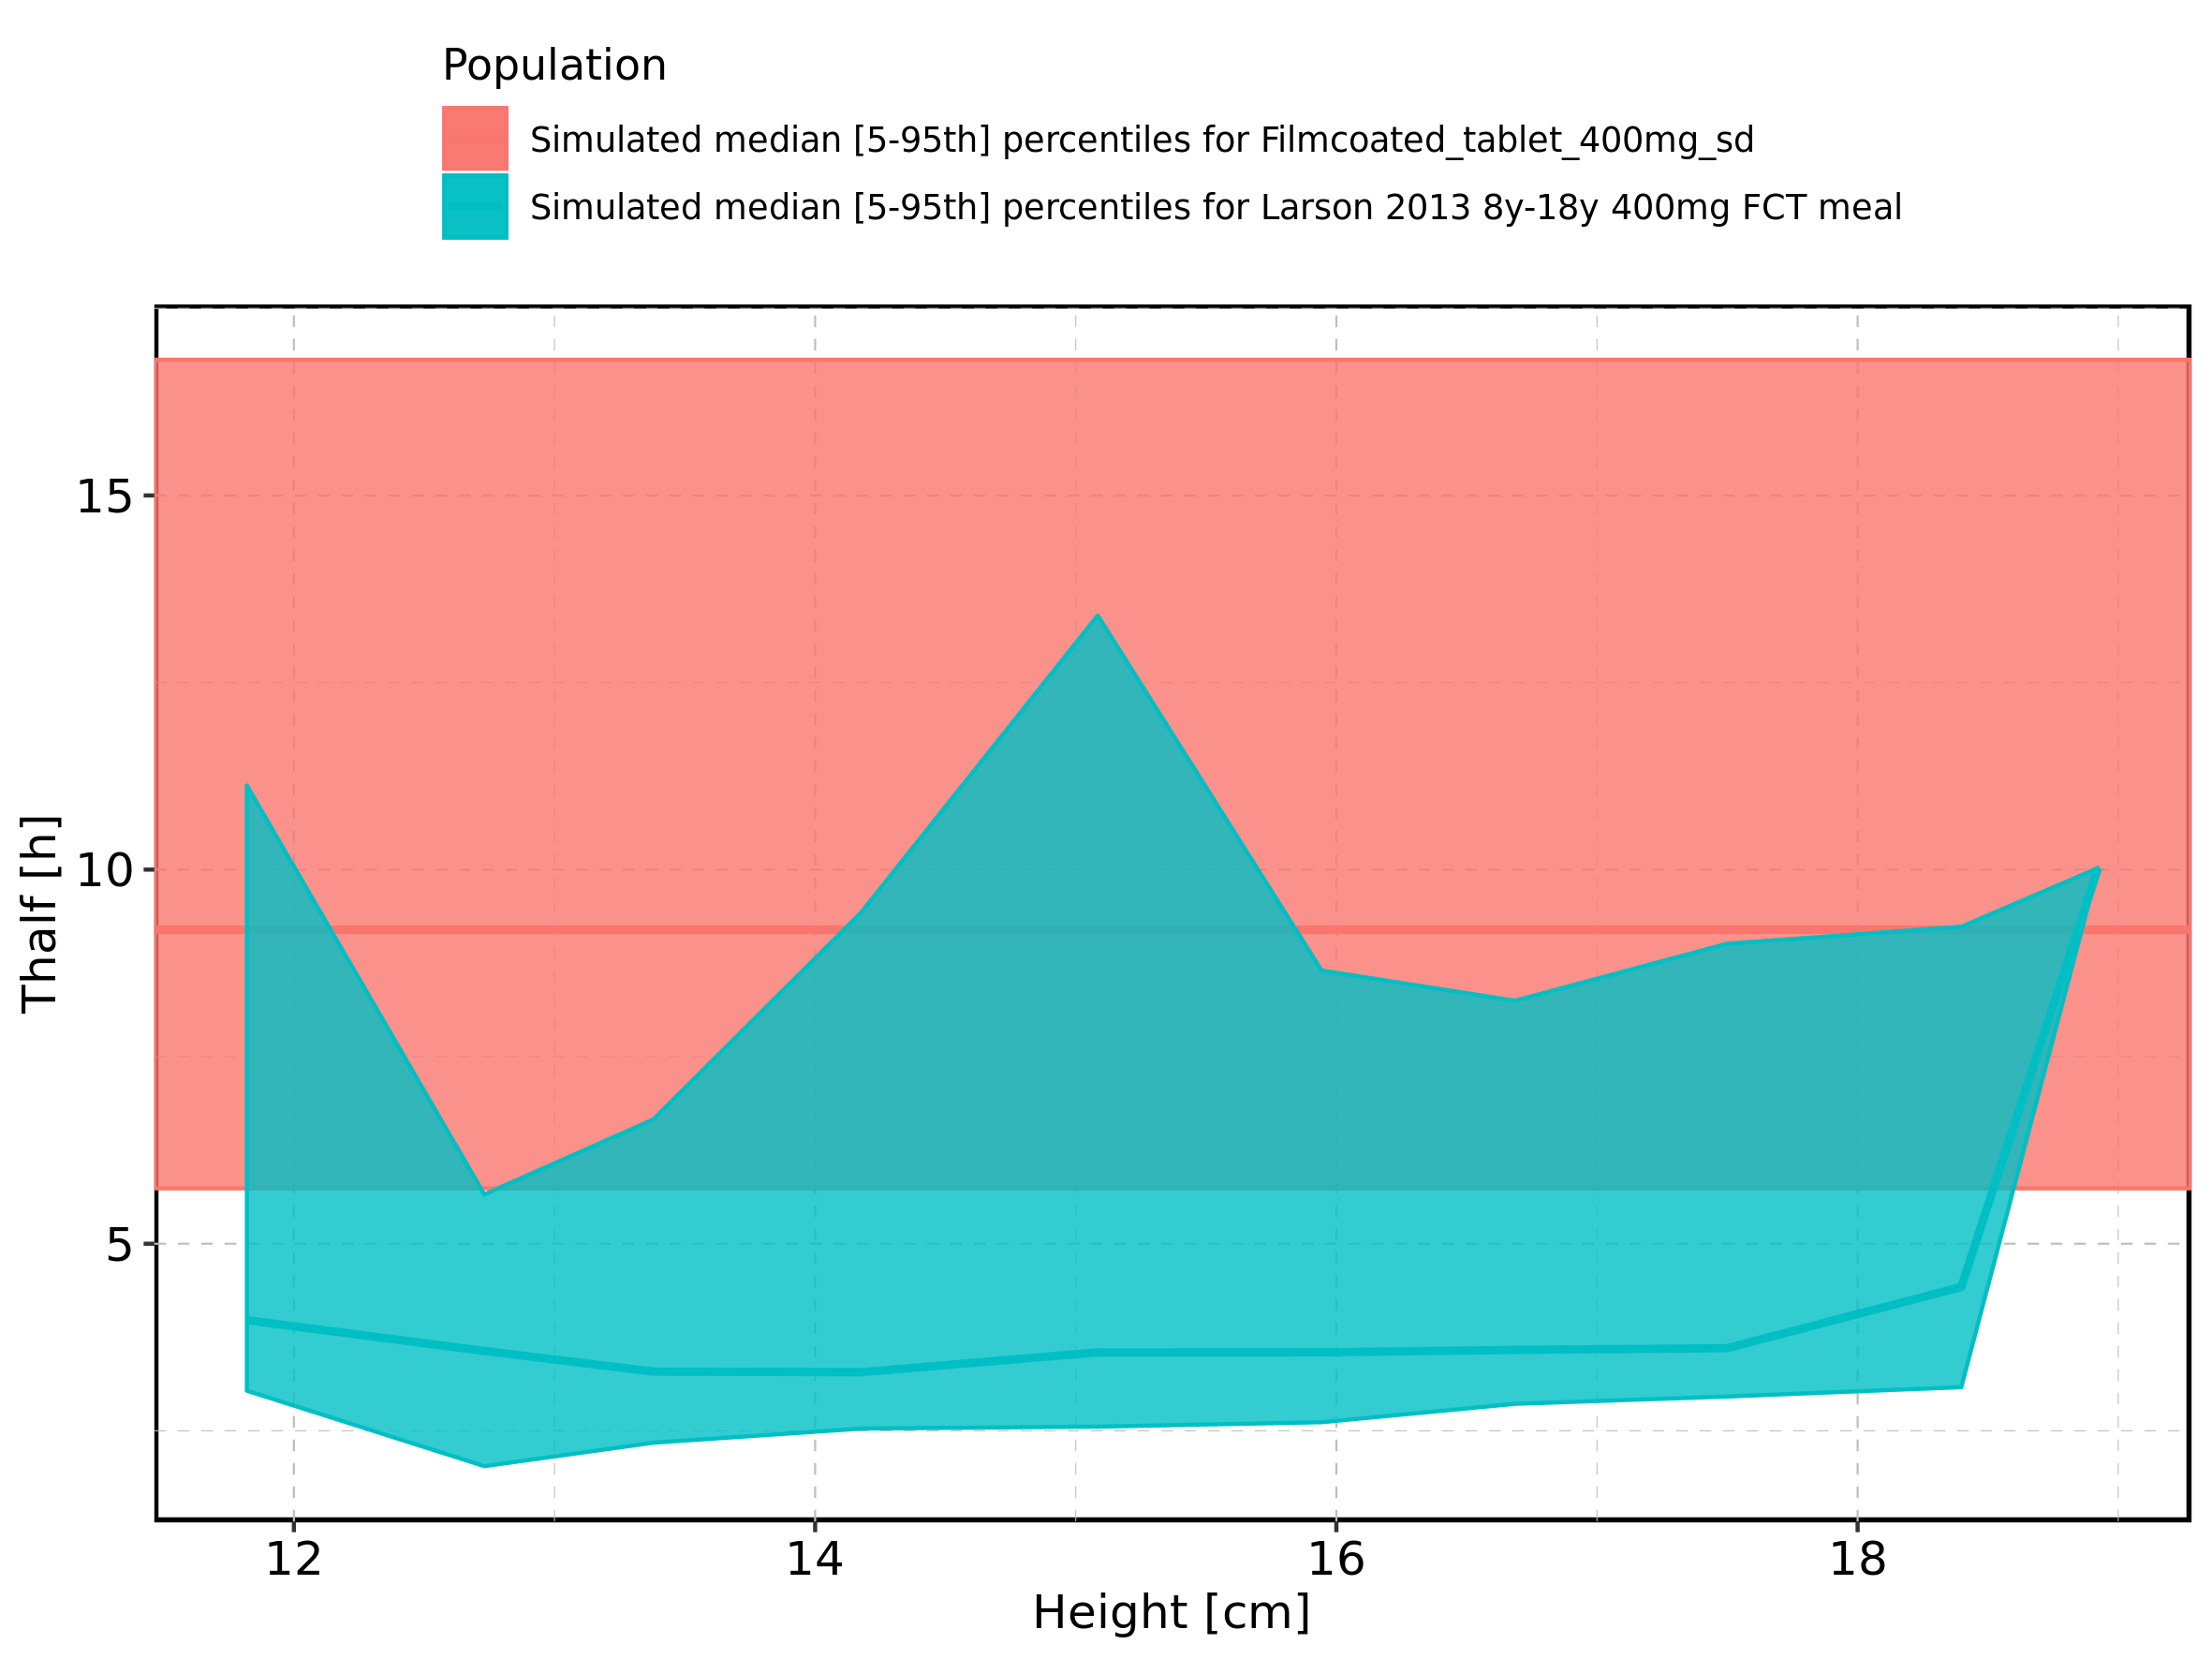

Figure 298: Height-dependence of Thalf for Larson 2013 8y-18y 400mg FCT meal in comparison to Filmcoated_tablet_400mg_sd. Profiles are plotted in a logarithmic scale.

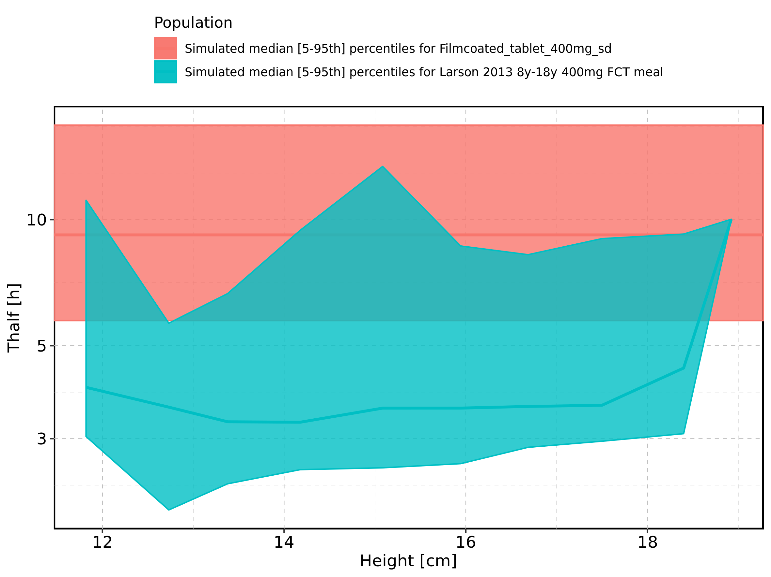

Figure 299: Height-dependence of Thalf for Larson 2013 8y-18y 400mg FCT meal. Profiles are plotted in a linear scale.

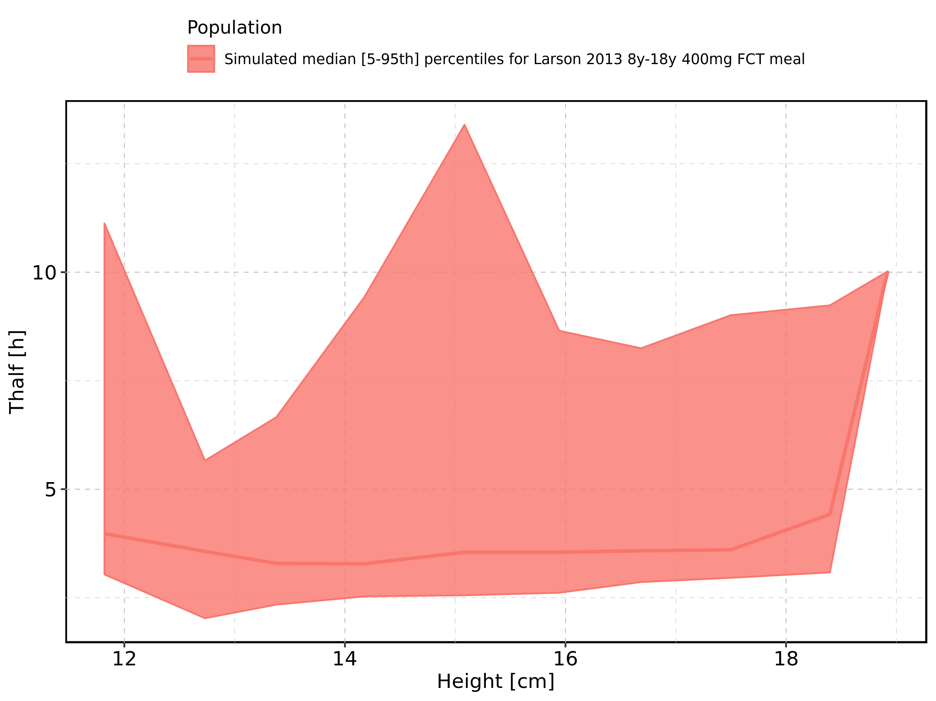

Figure 300: Height-dependence of Thalf for Larson 2013 8y-18y 400mg FCT meal. Profiles are plotted in a logarithmic scale.

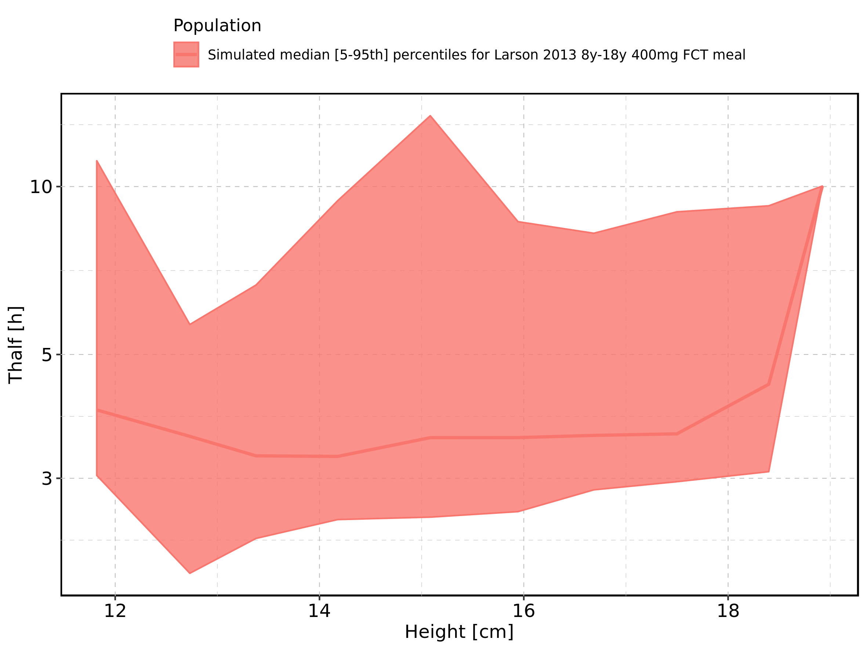

Figure 301: Height-dependence of Thalf for Filmcoated_tablet_400mg_sd. Profiles are plotted in a linear scale.

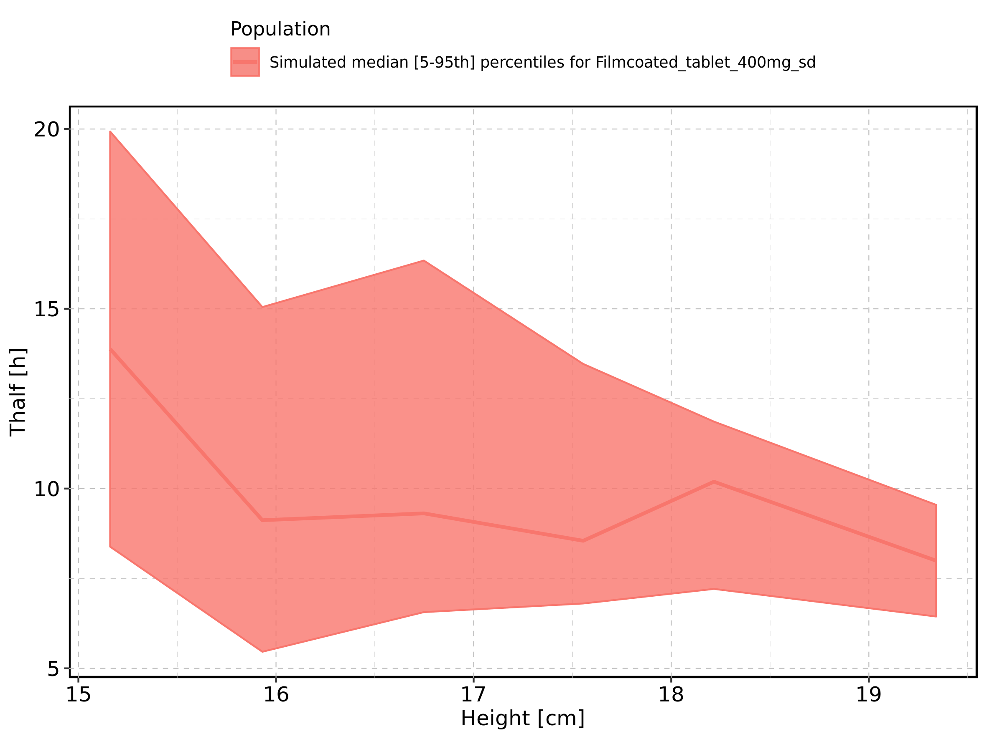

Figure 302: Height-dependence of Thalf for Filmcoated_tablet_400mg_sd. Profiles are plotted in a logarithmic scale.

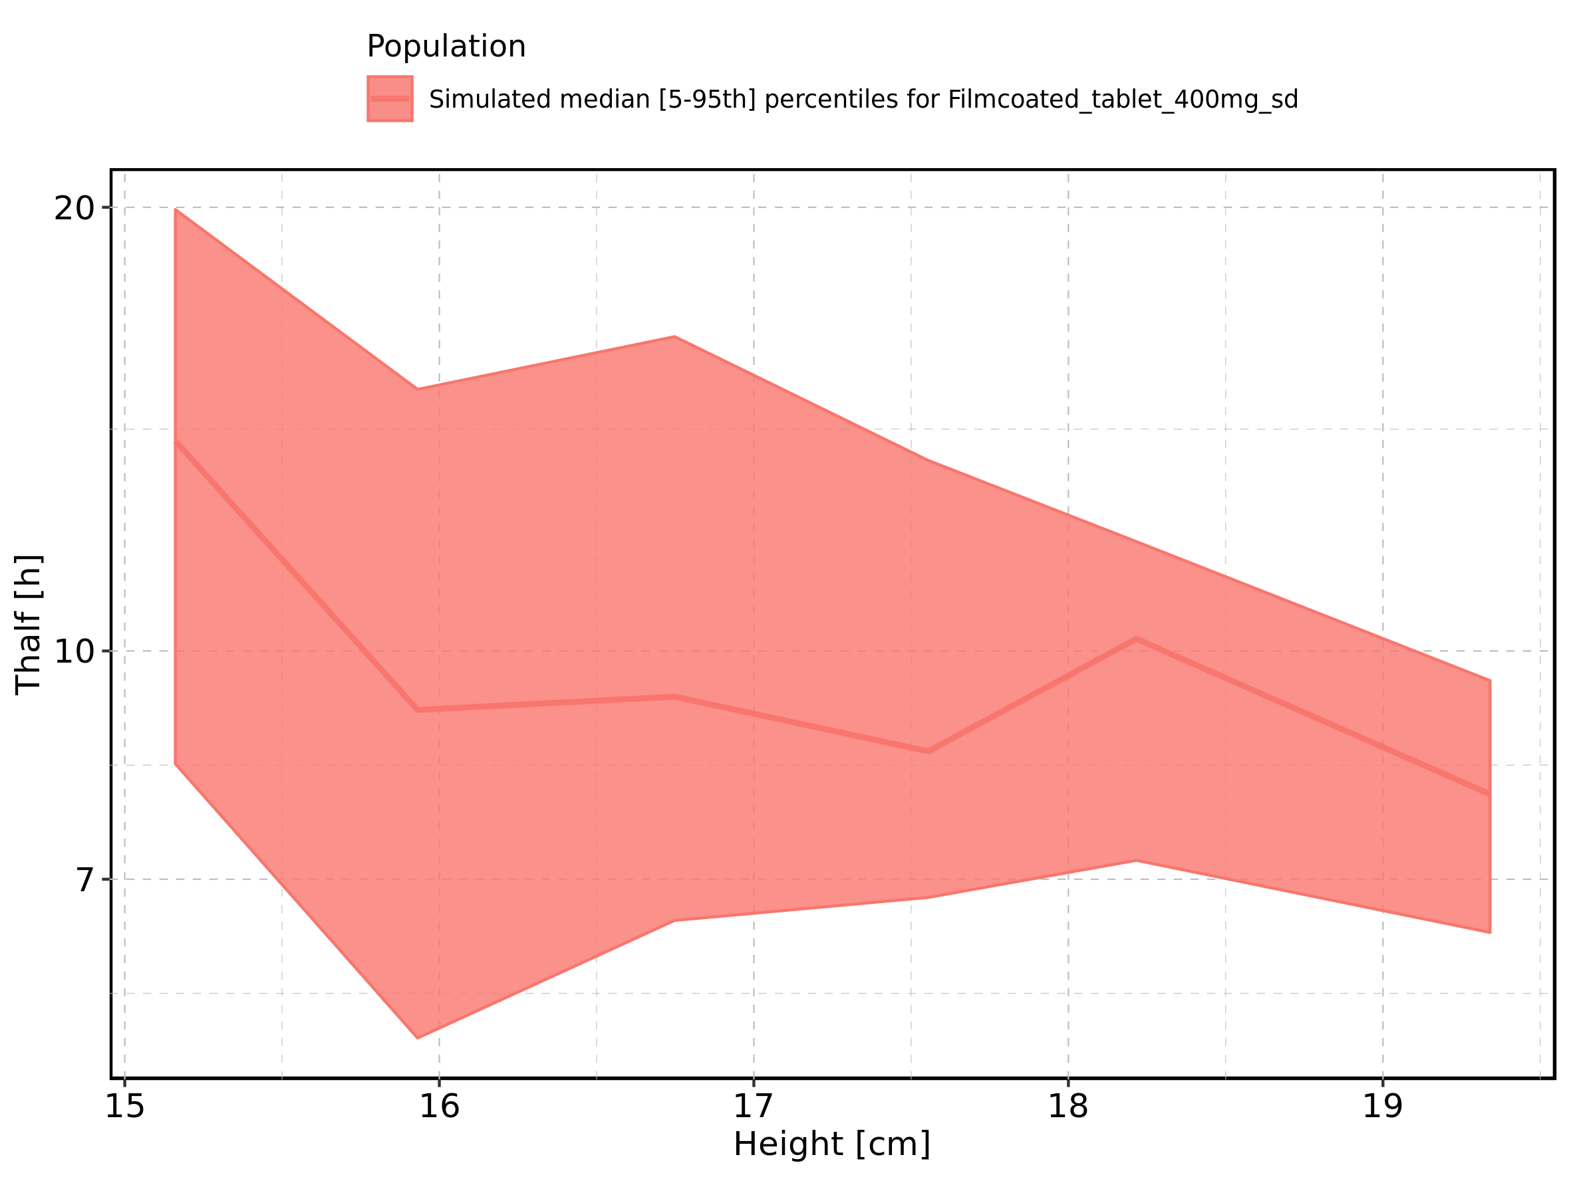

Figure 303: Weight-dependence of Thalf for Larson 2013 8y-18y 400mg FCT meal in comparison to Filmcoated_tablet_400mg_sd. Profiles are plotted in a linear scale.

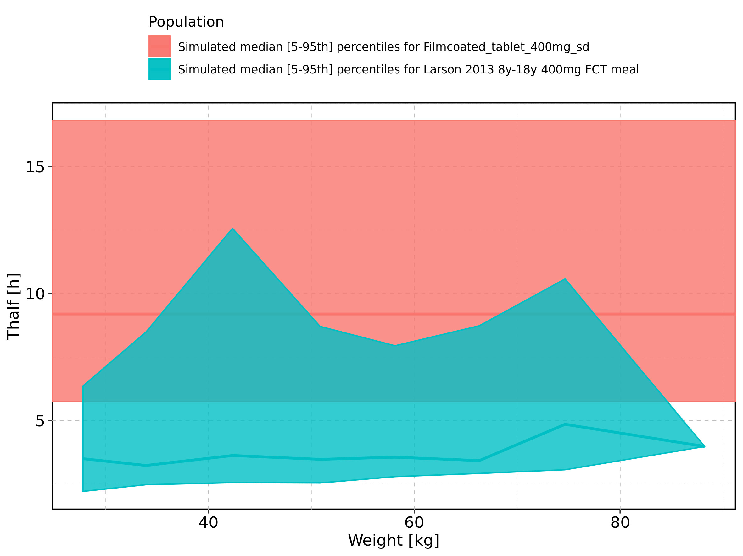

Figure 304: Weight-dependence of Thalf for Larson 2013 8y-18y 400mg FCT meal in comparison to Filmcoated_tablet_400mg_sd. Profiles are plotted in a logarithmic scale.

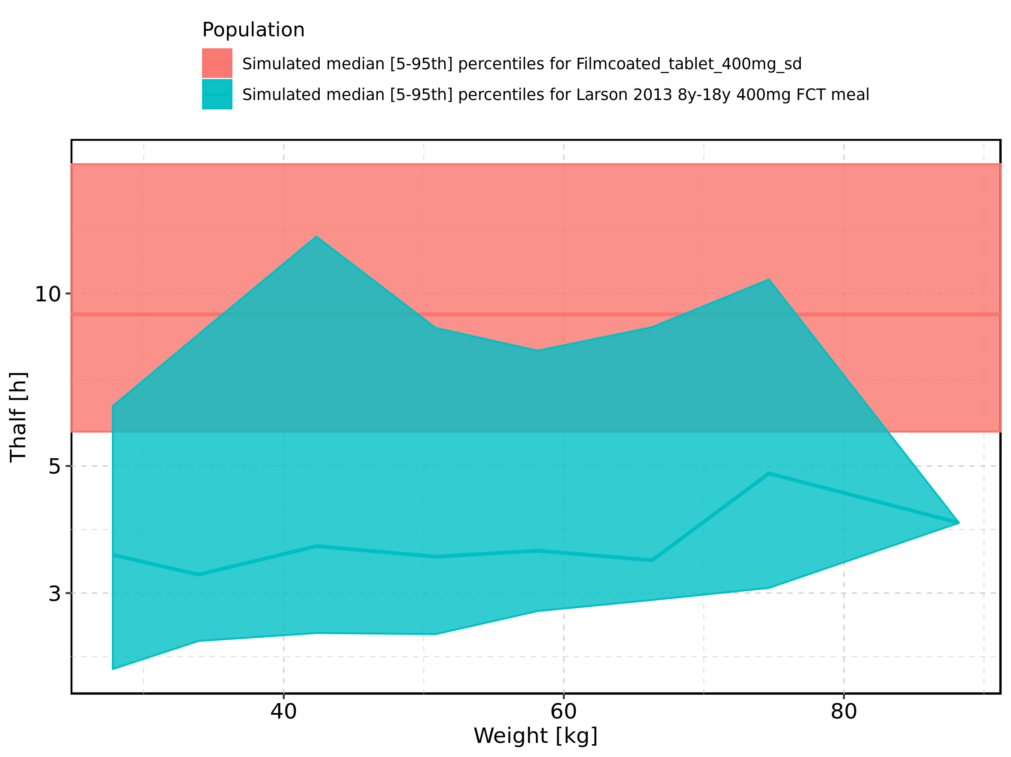

Figure 305: Weight-dependence of Thalf for Larson 2013 8y-18y 400mg FCT meal. Profiles are plotted in a linear scale.

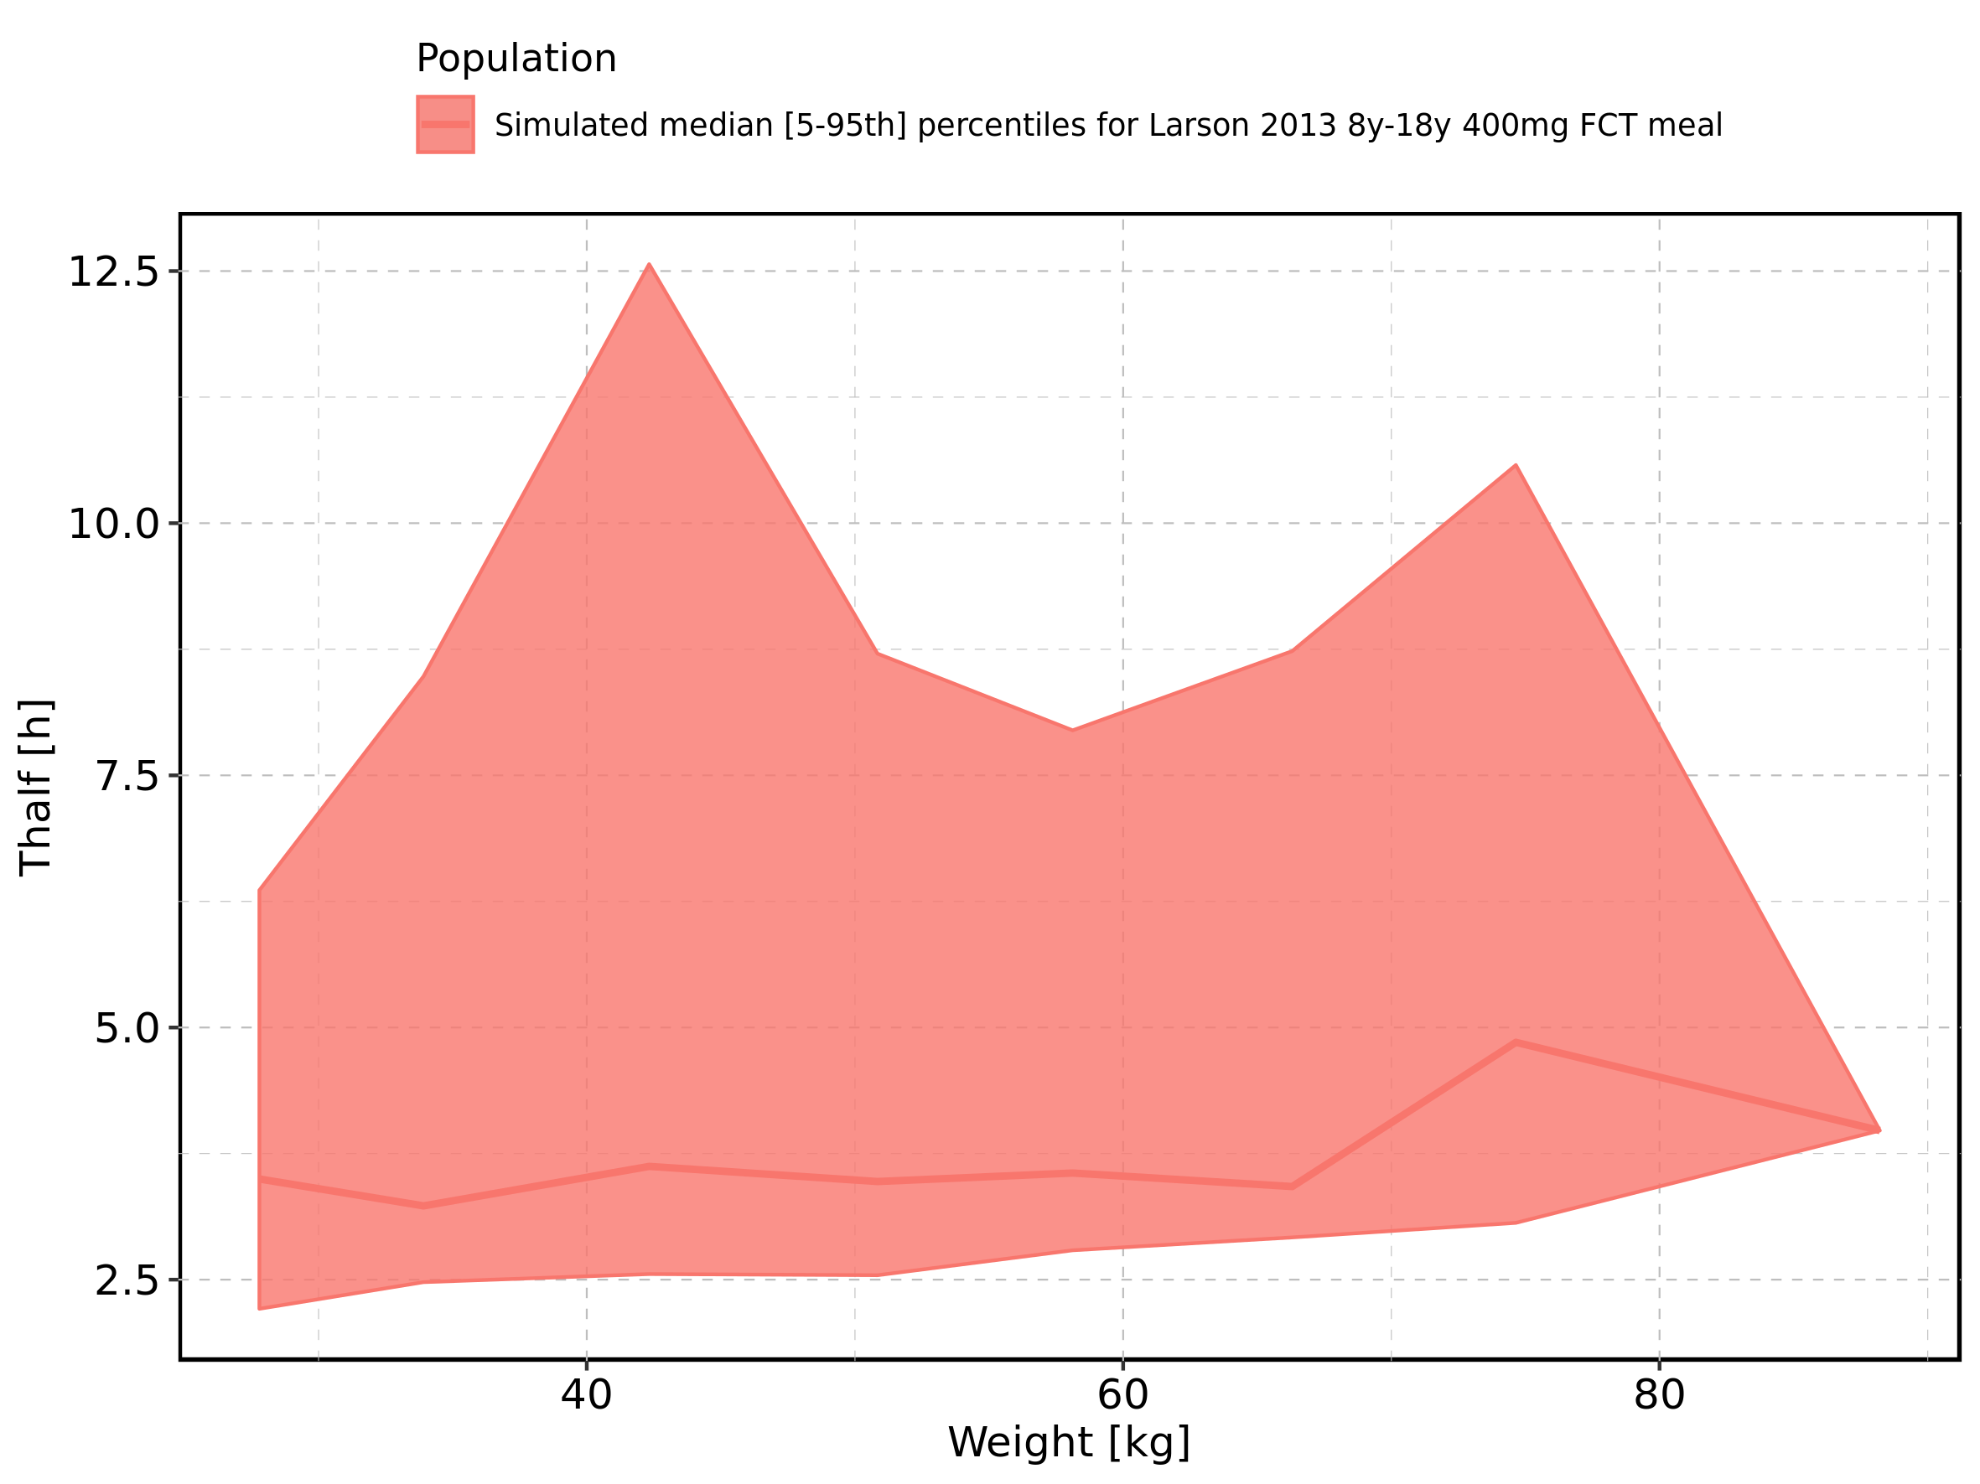

Figure 306: Weight-dependence of Thalf for Larson 2013 8y-18y 400mg FCT meal. Profiles are plotted in a logarithmic scale.

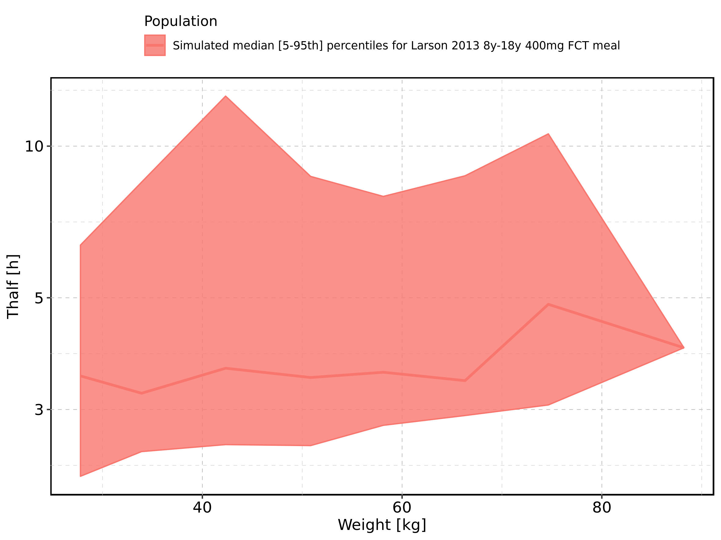

Figure 307: Weight-dependence of Thalf for Filmcoated_tablet_400mg_sd. Profiles are plotted in a linear scale.

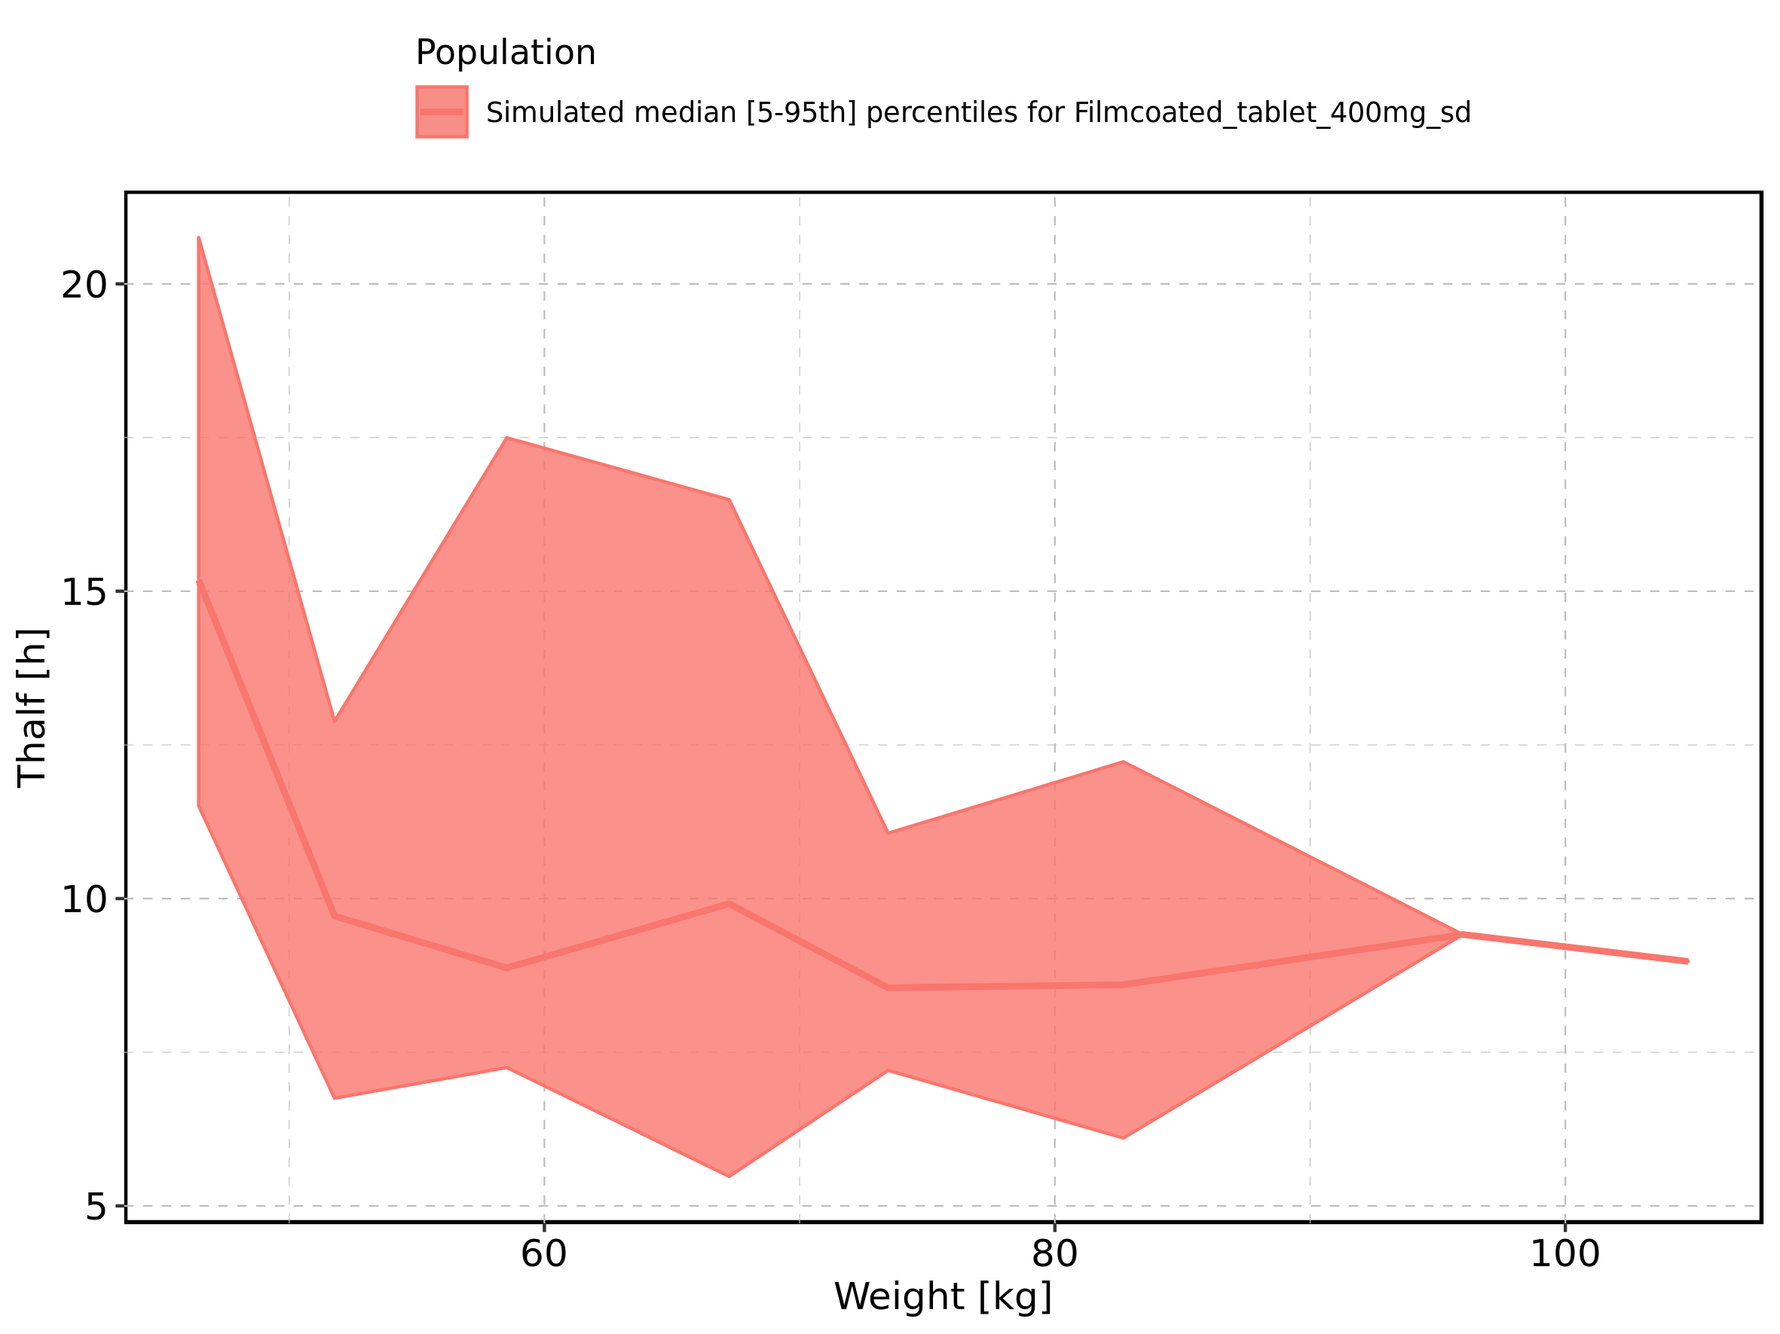

Figure 308: Weight-dependence of Thalf for Filmcoated_tablet_400mg_sd. Profiles are plotted in a logarithmic scale.

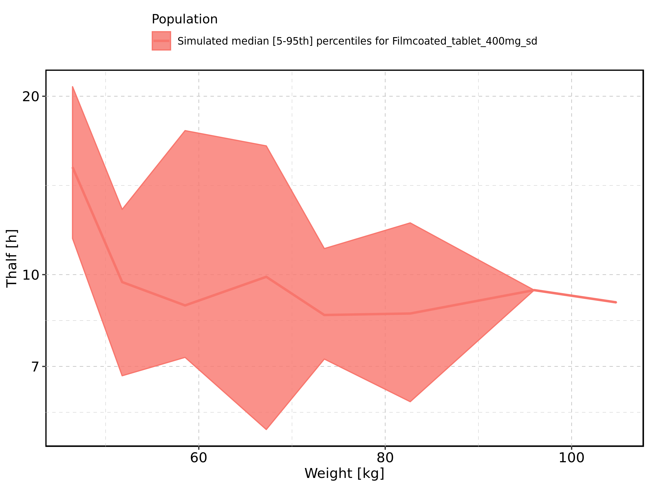

Figure 309: BMI-dependence of Thalf for Larson 2013 8y-18y 400mg FCT meal in comparison to Filmcoated_tablet_400mg_sd. Profiles are plotted in a linear scale.

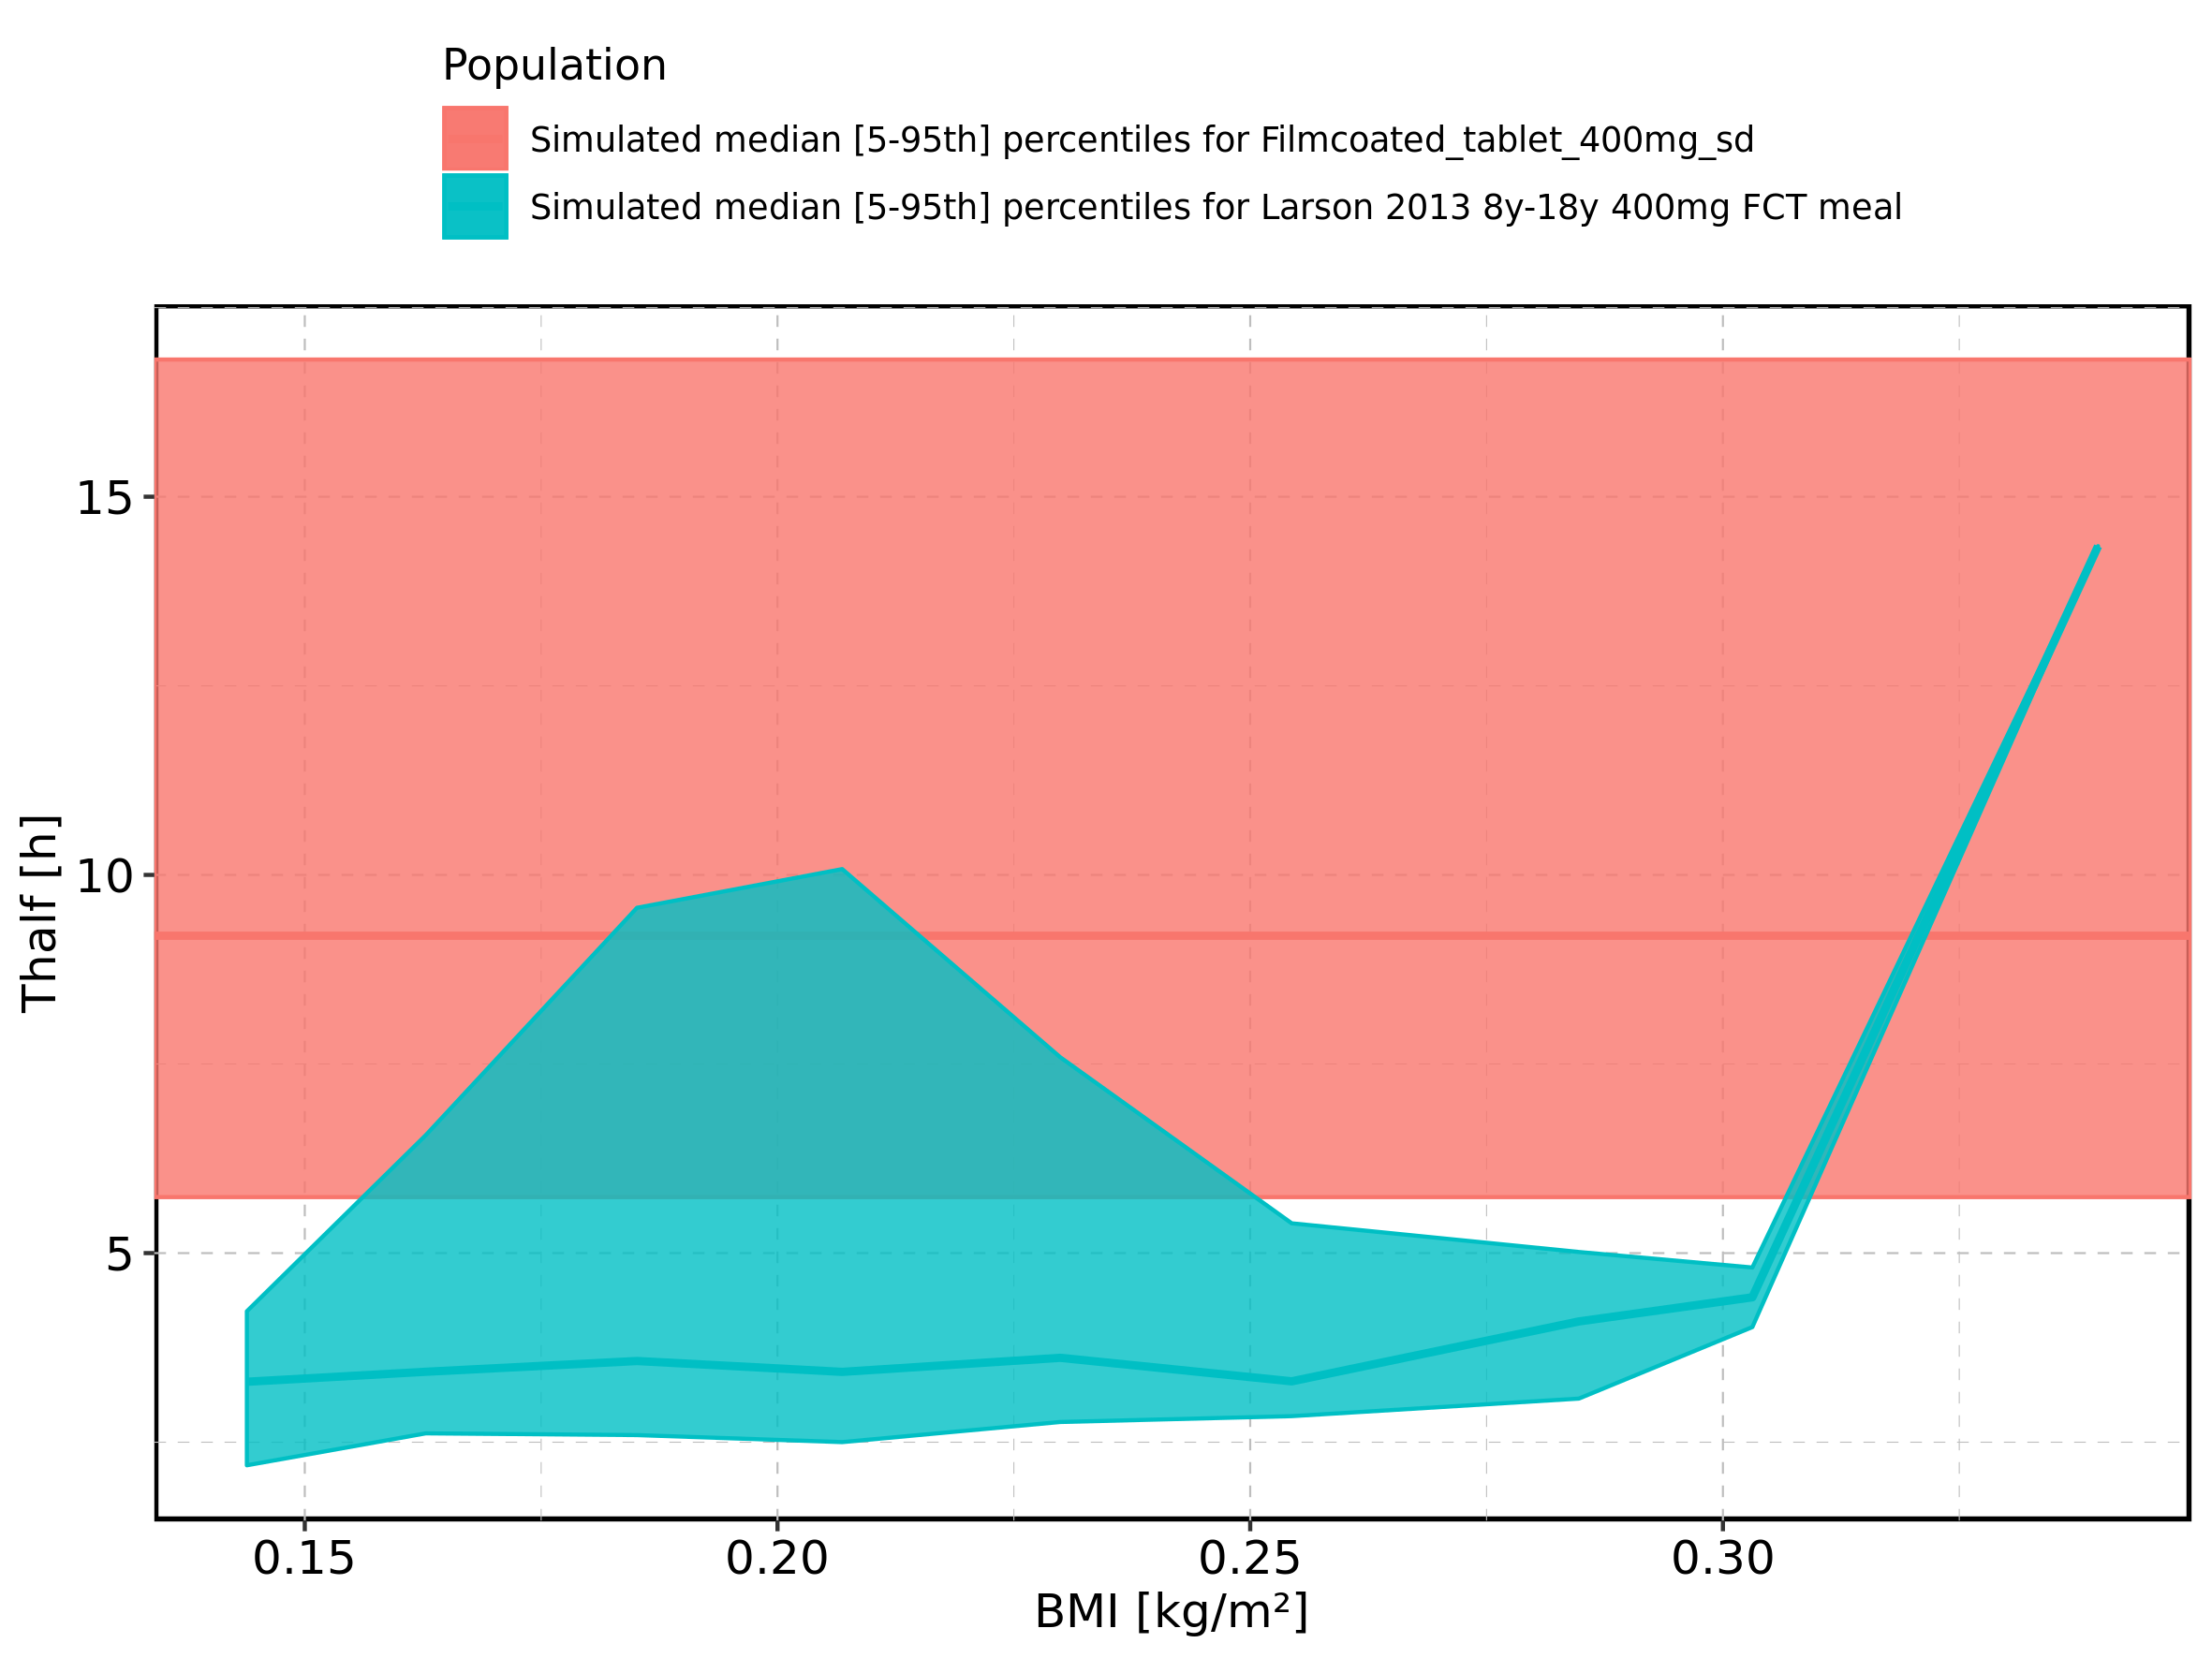

Figure 310: BMI-dependence of Thalf for Larson 2013 8y-18y 400mg FCT meal in comparison to Filmcoated_tablet_400mg_sd. Profiles are plotted in a logarithmic scale.

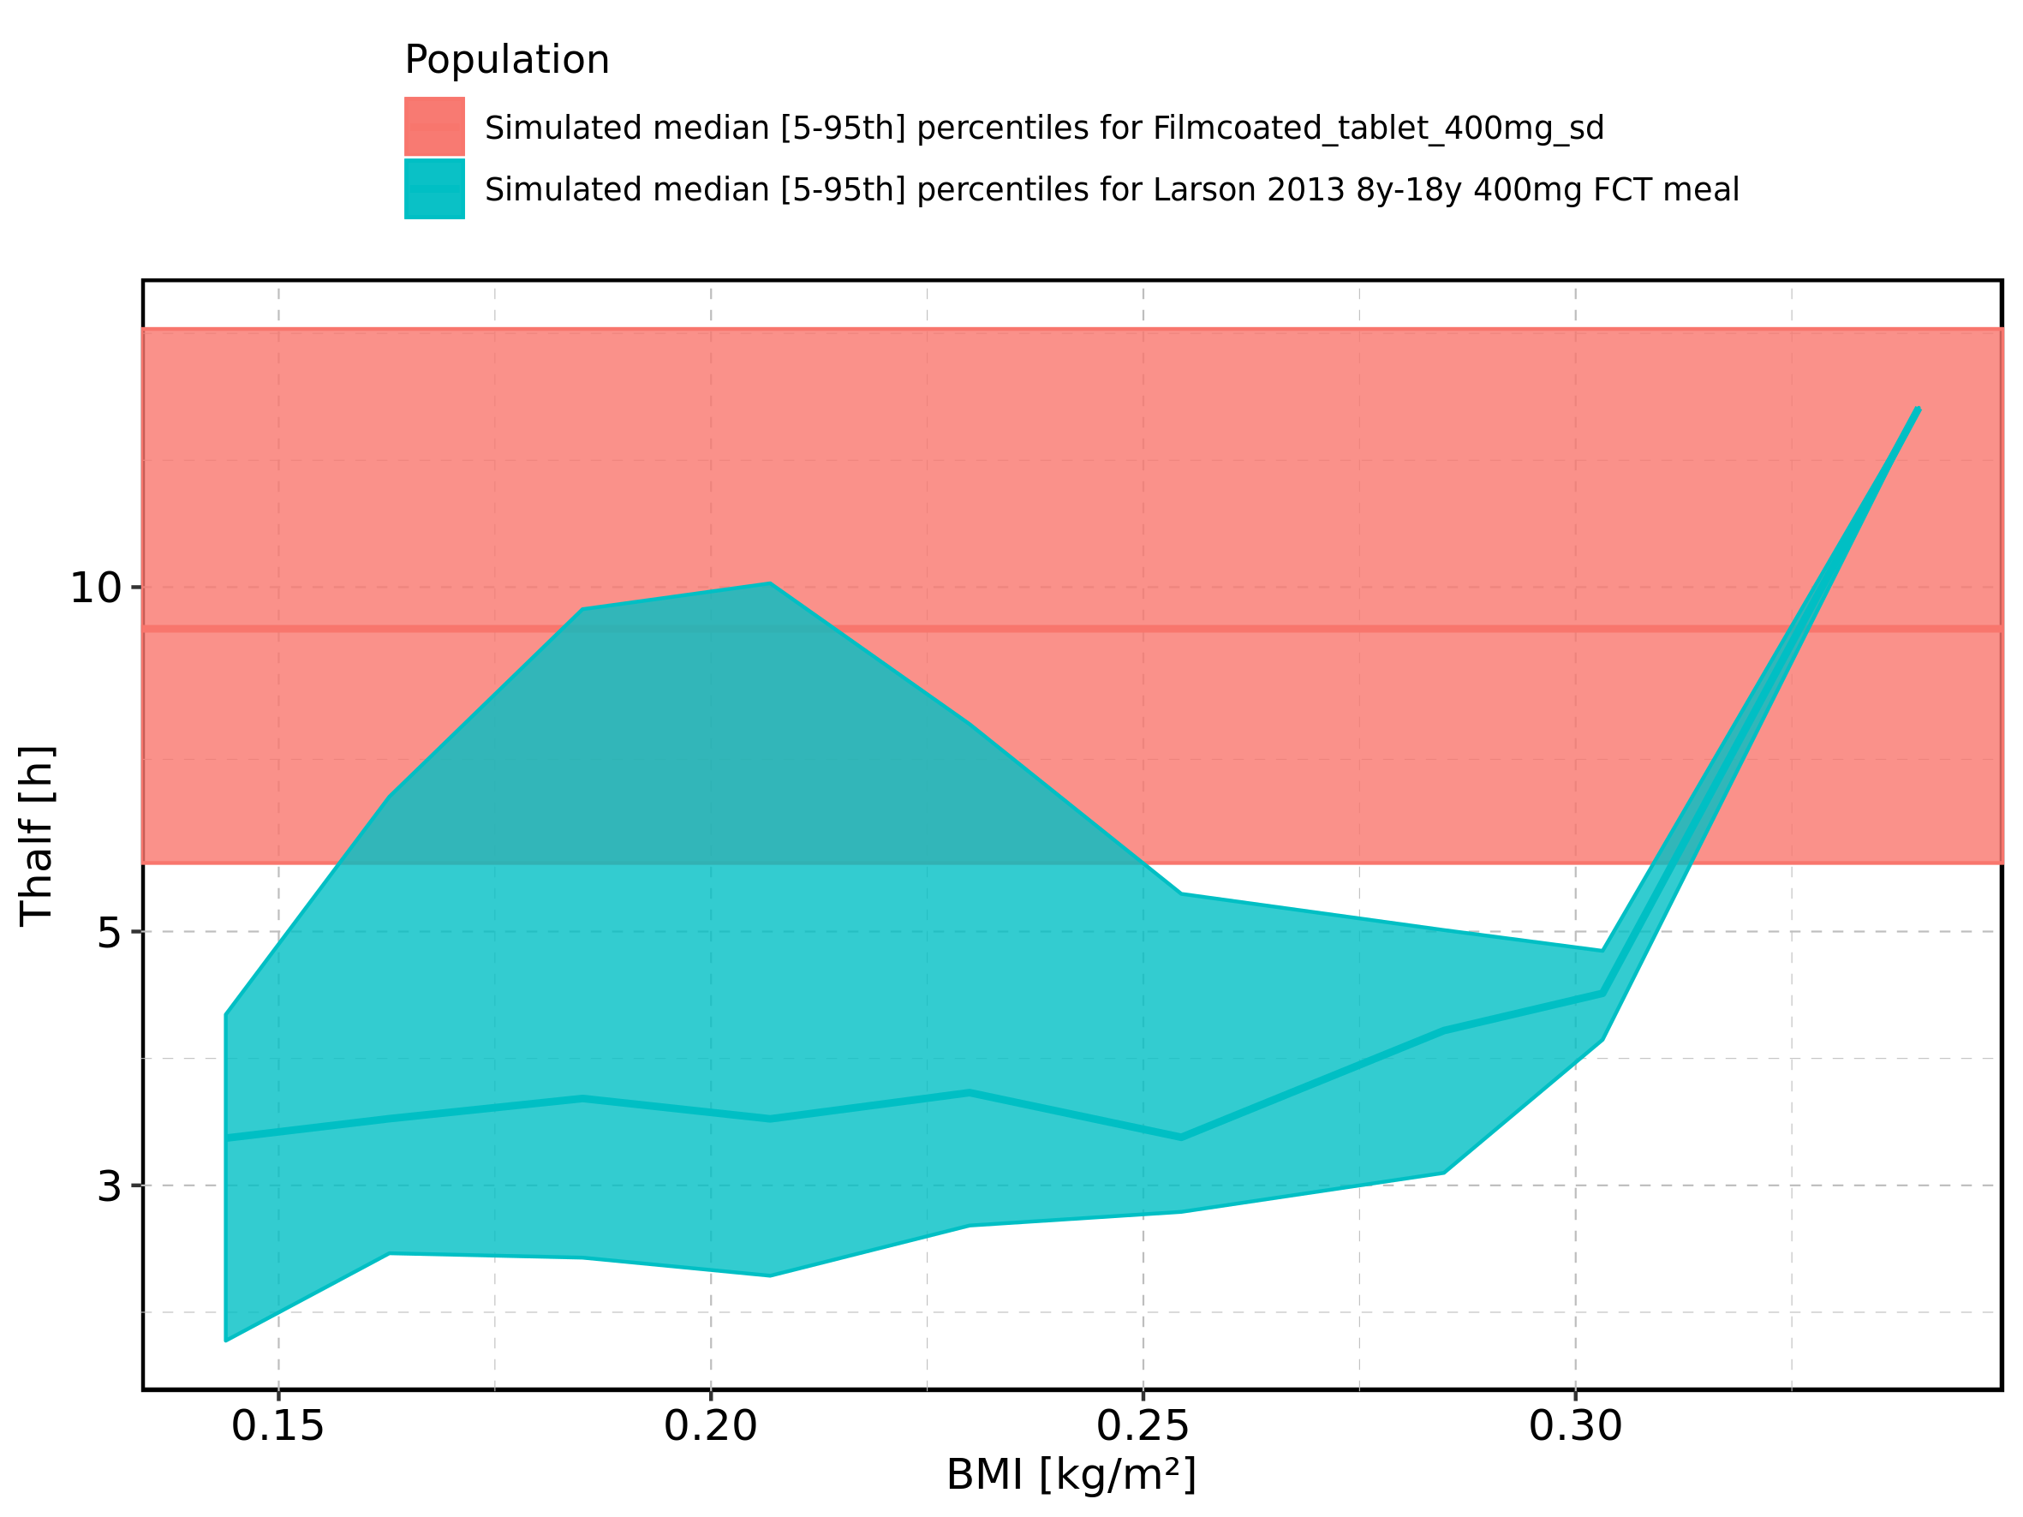

Figure 311: BMI-dependence of Thalf for Larson 2013 8y-18y 400mg FCT meal. Profiles are plotted in a linear scale.

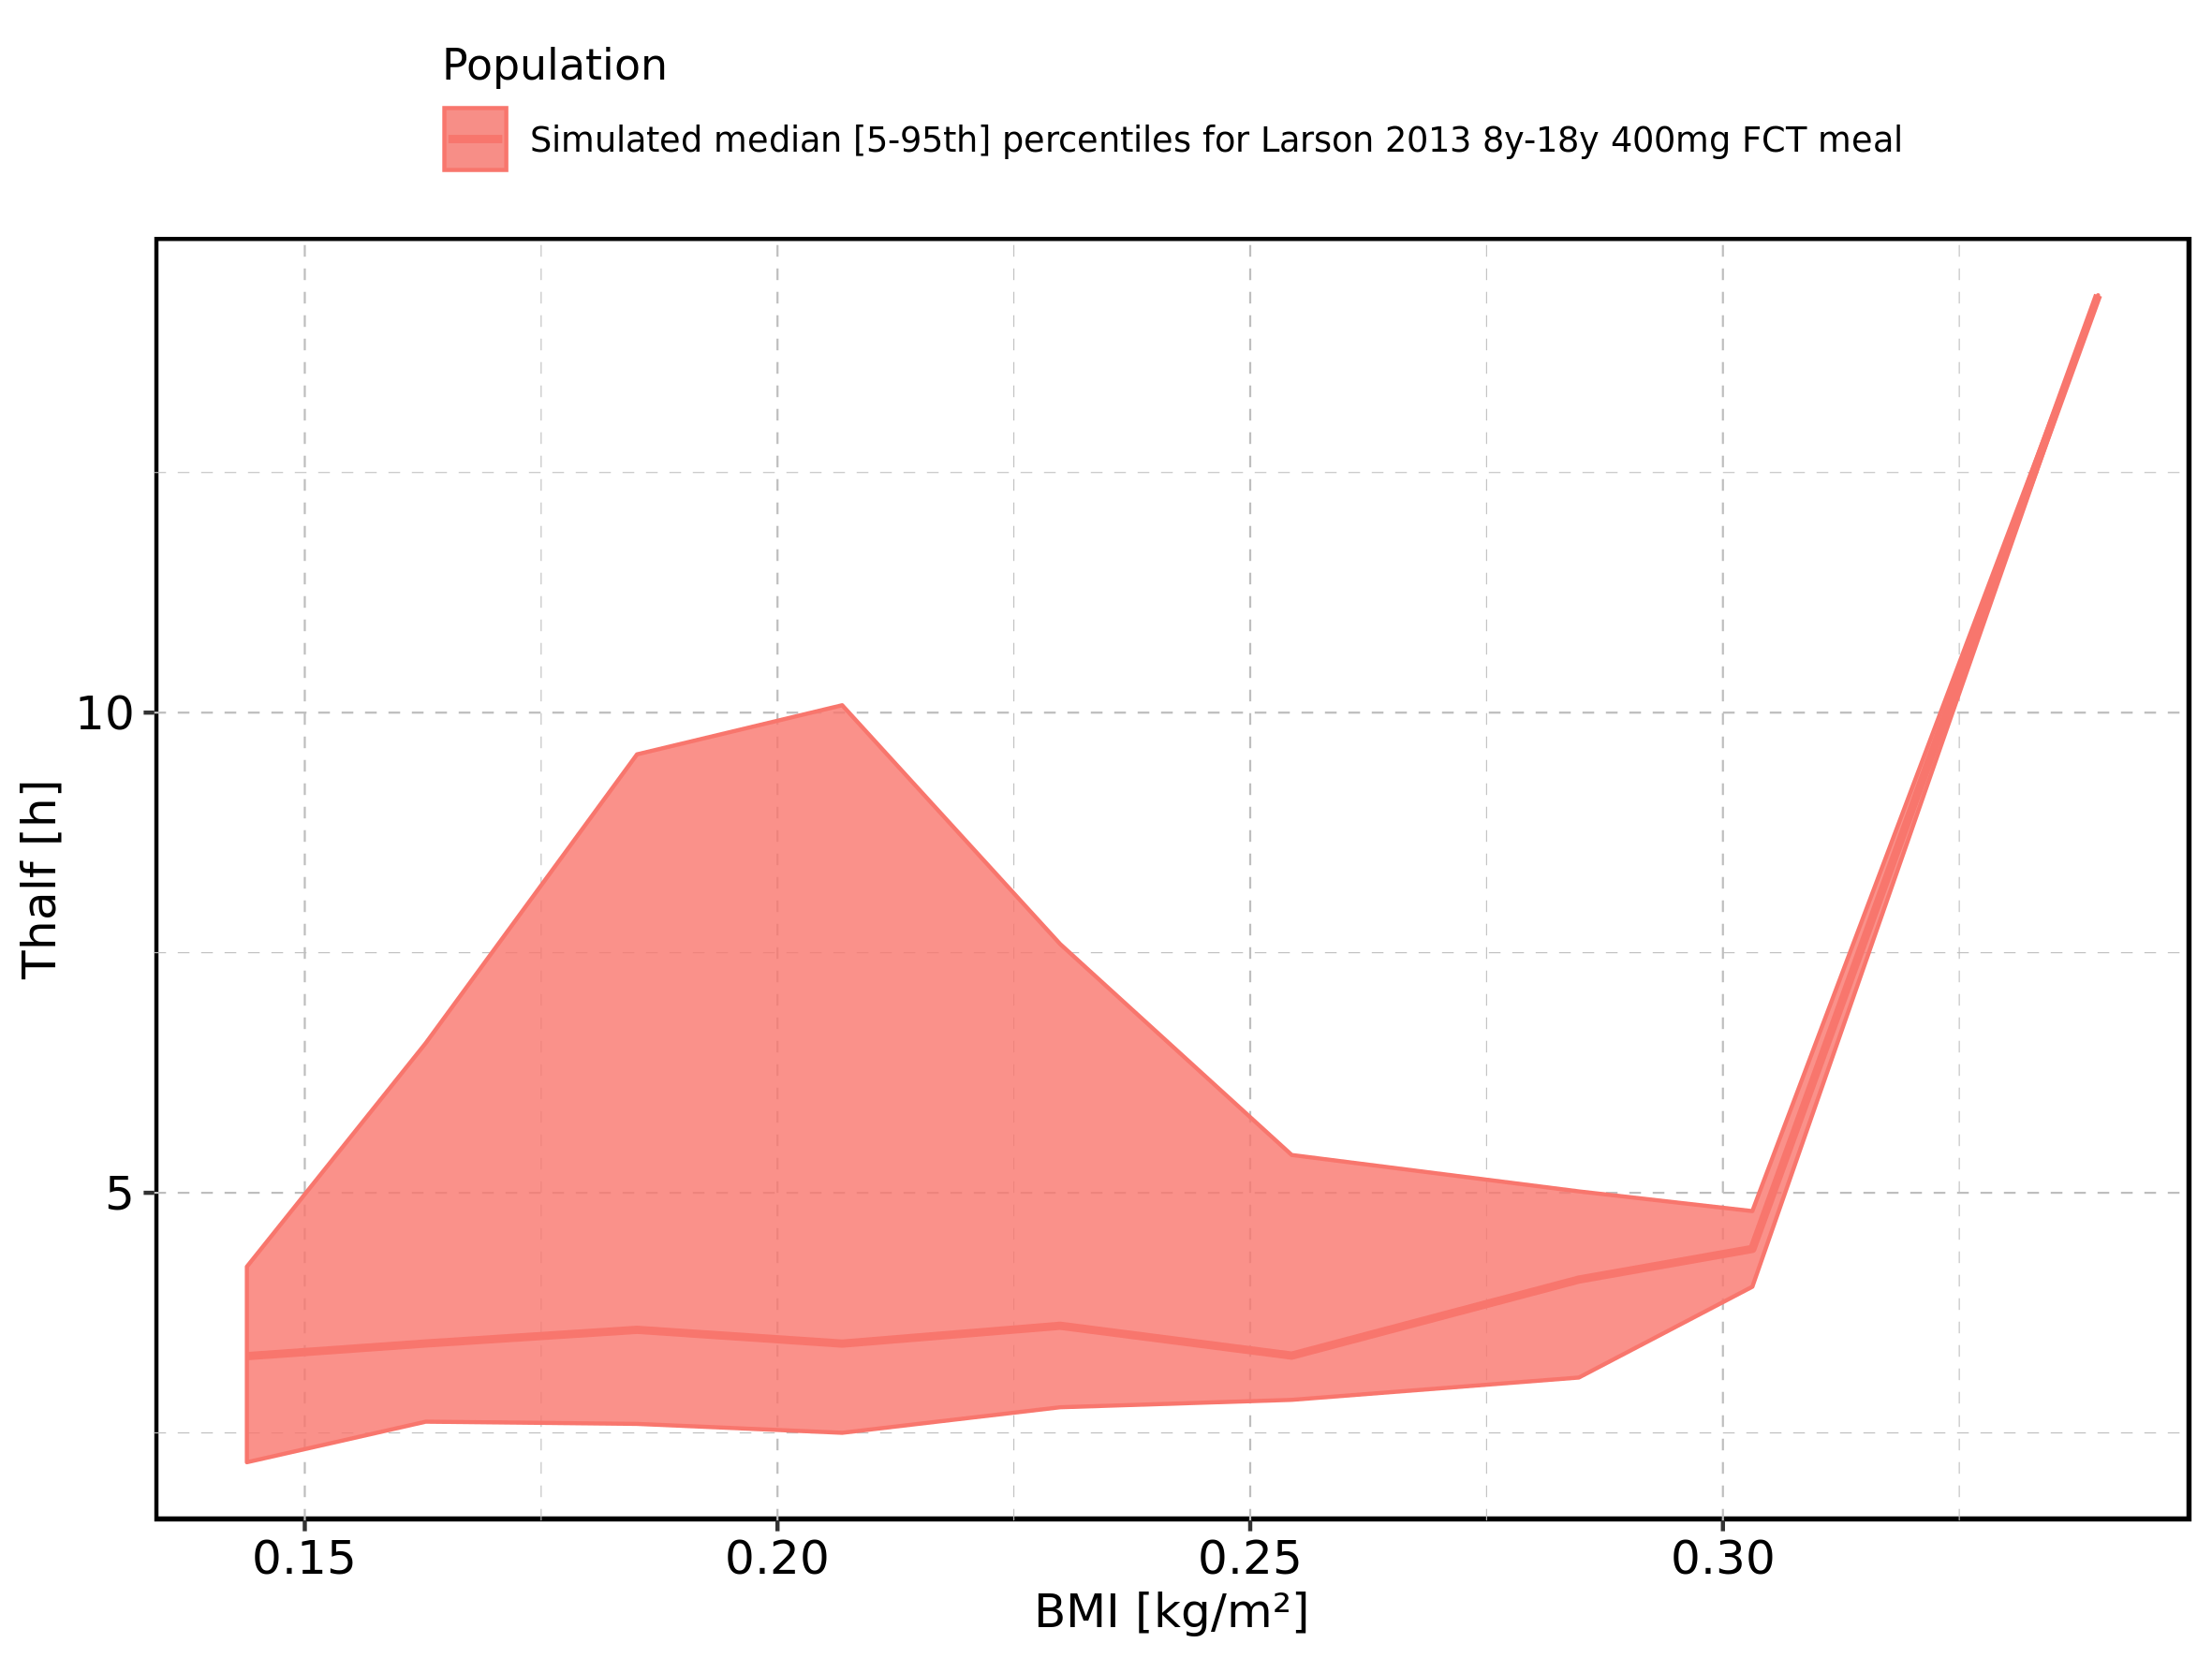

Figure 312: BMI-dependence of Thalf for Larson 2013 8y-18y 400mg FCT meal. Profiles are plotted in a logarithmic scale.

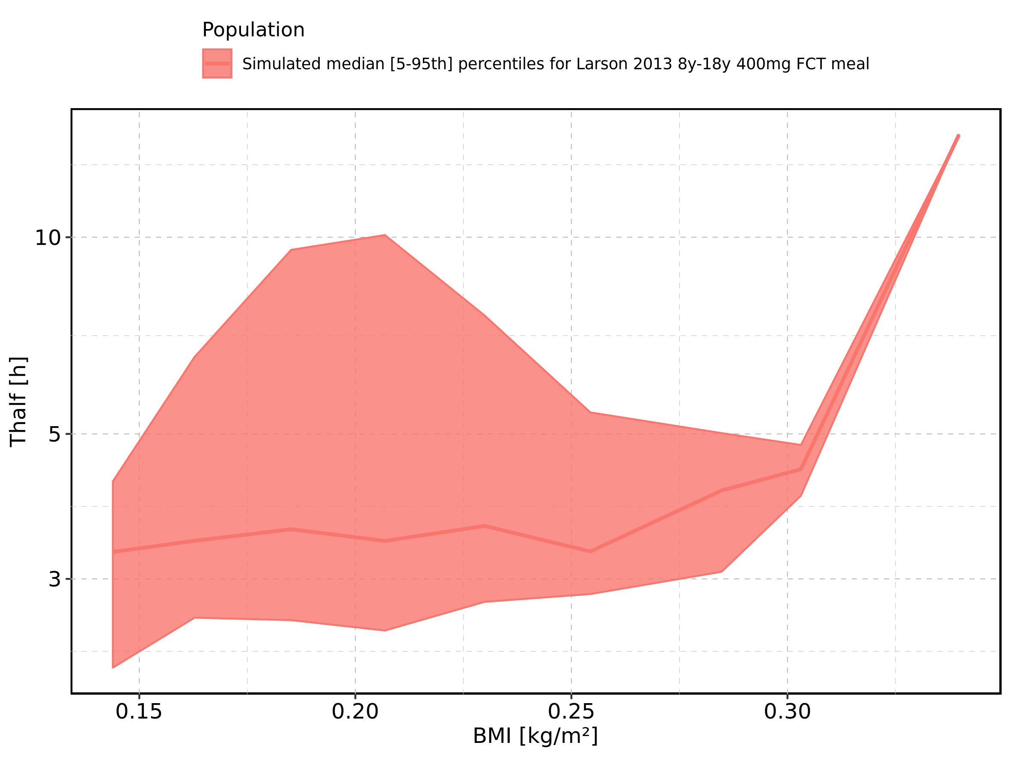

Figure 313: BMI-dependence of Thalf for Filmcoated_tablet_400mg_sd. Profiles are plotted in a linear scale.

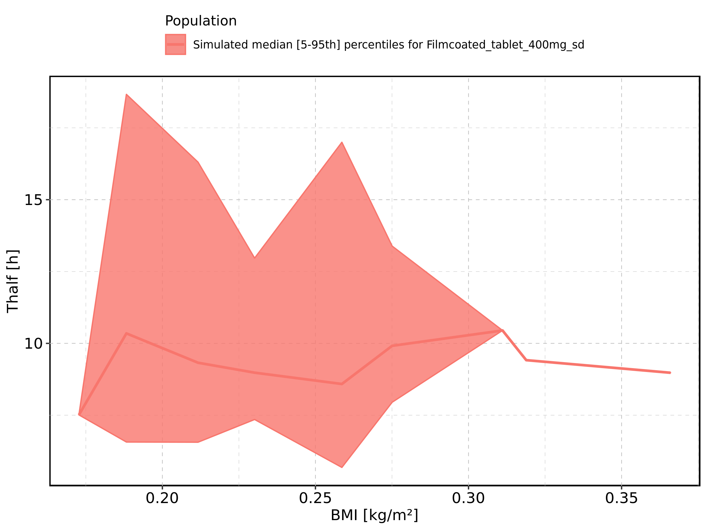

Figure 314: BMI-dependence of Thalf for Filmcoated_tablet_400mg_sd. Profiles are plotted in a logarithmic scale.

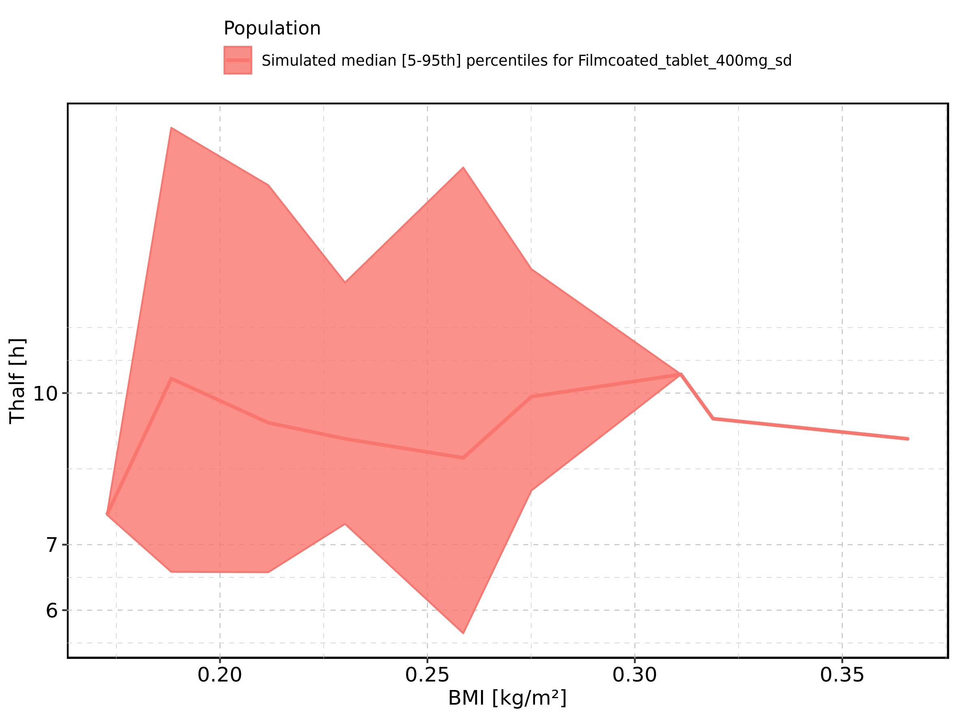

Figure 315: Gender-dependence of Thalf for Larson 2013 8y-18y 400mg FCT meal in comparison to Filmcoated_tablet_400mg_sd. Profiles are plotted in a linear scale.

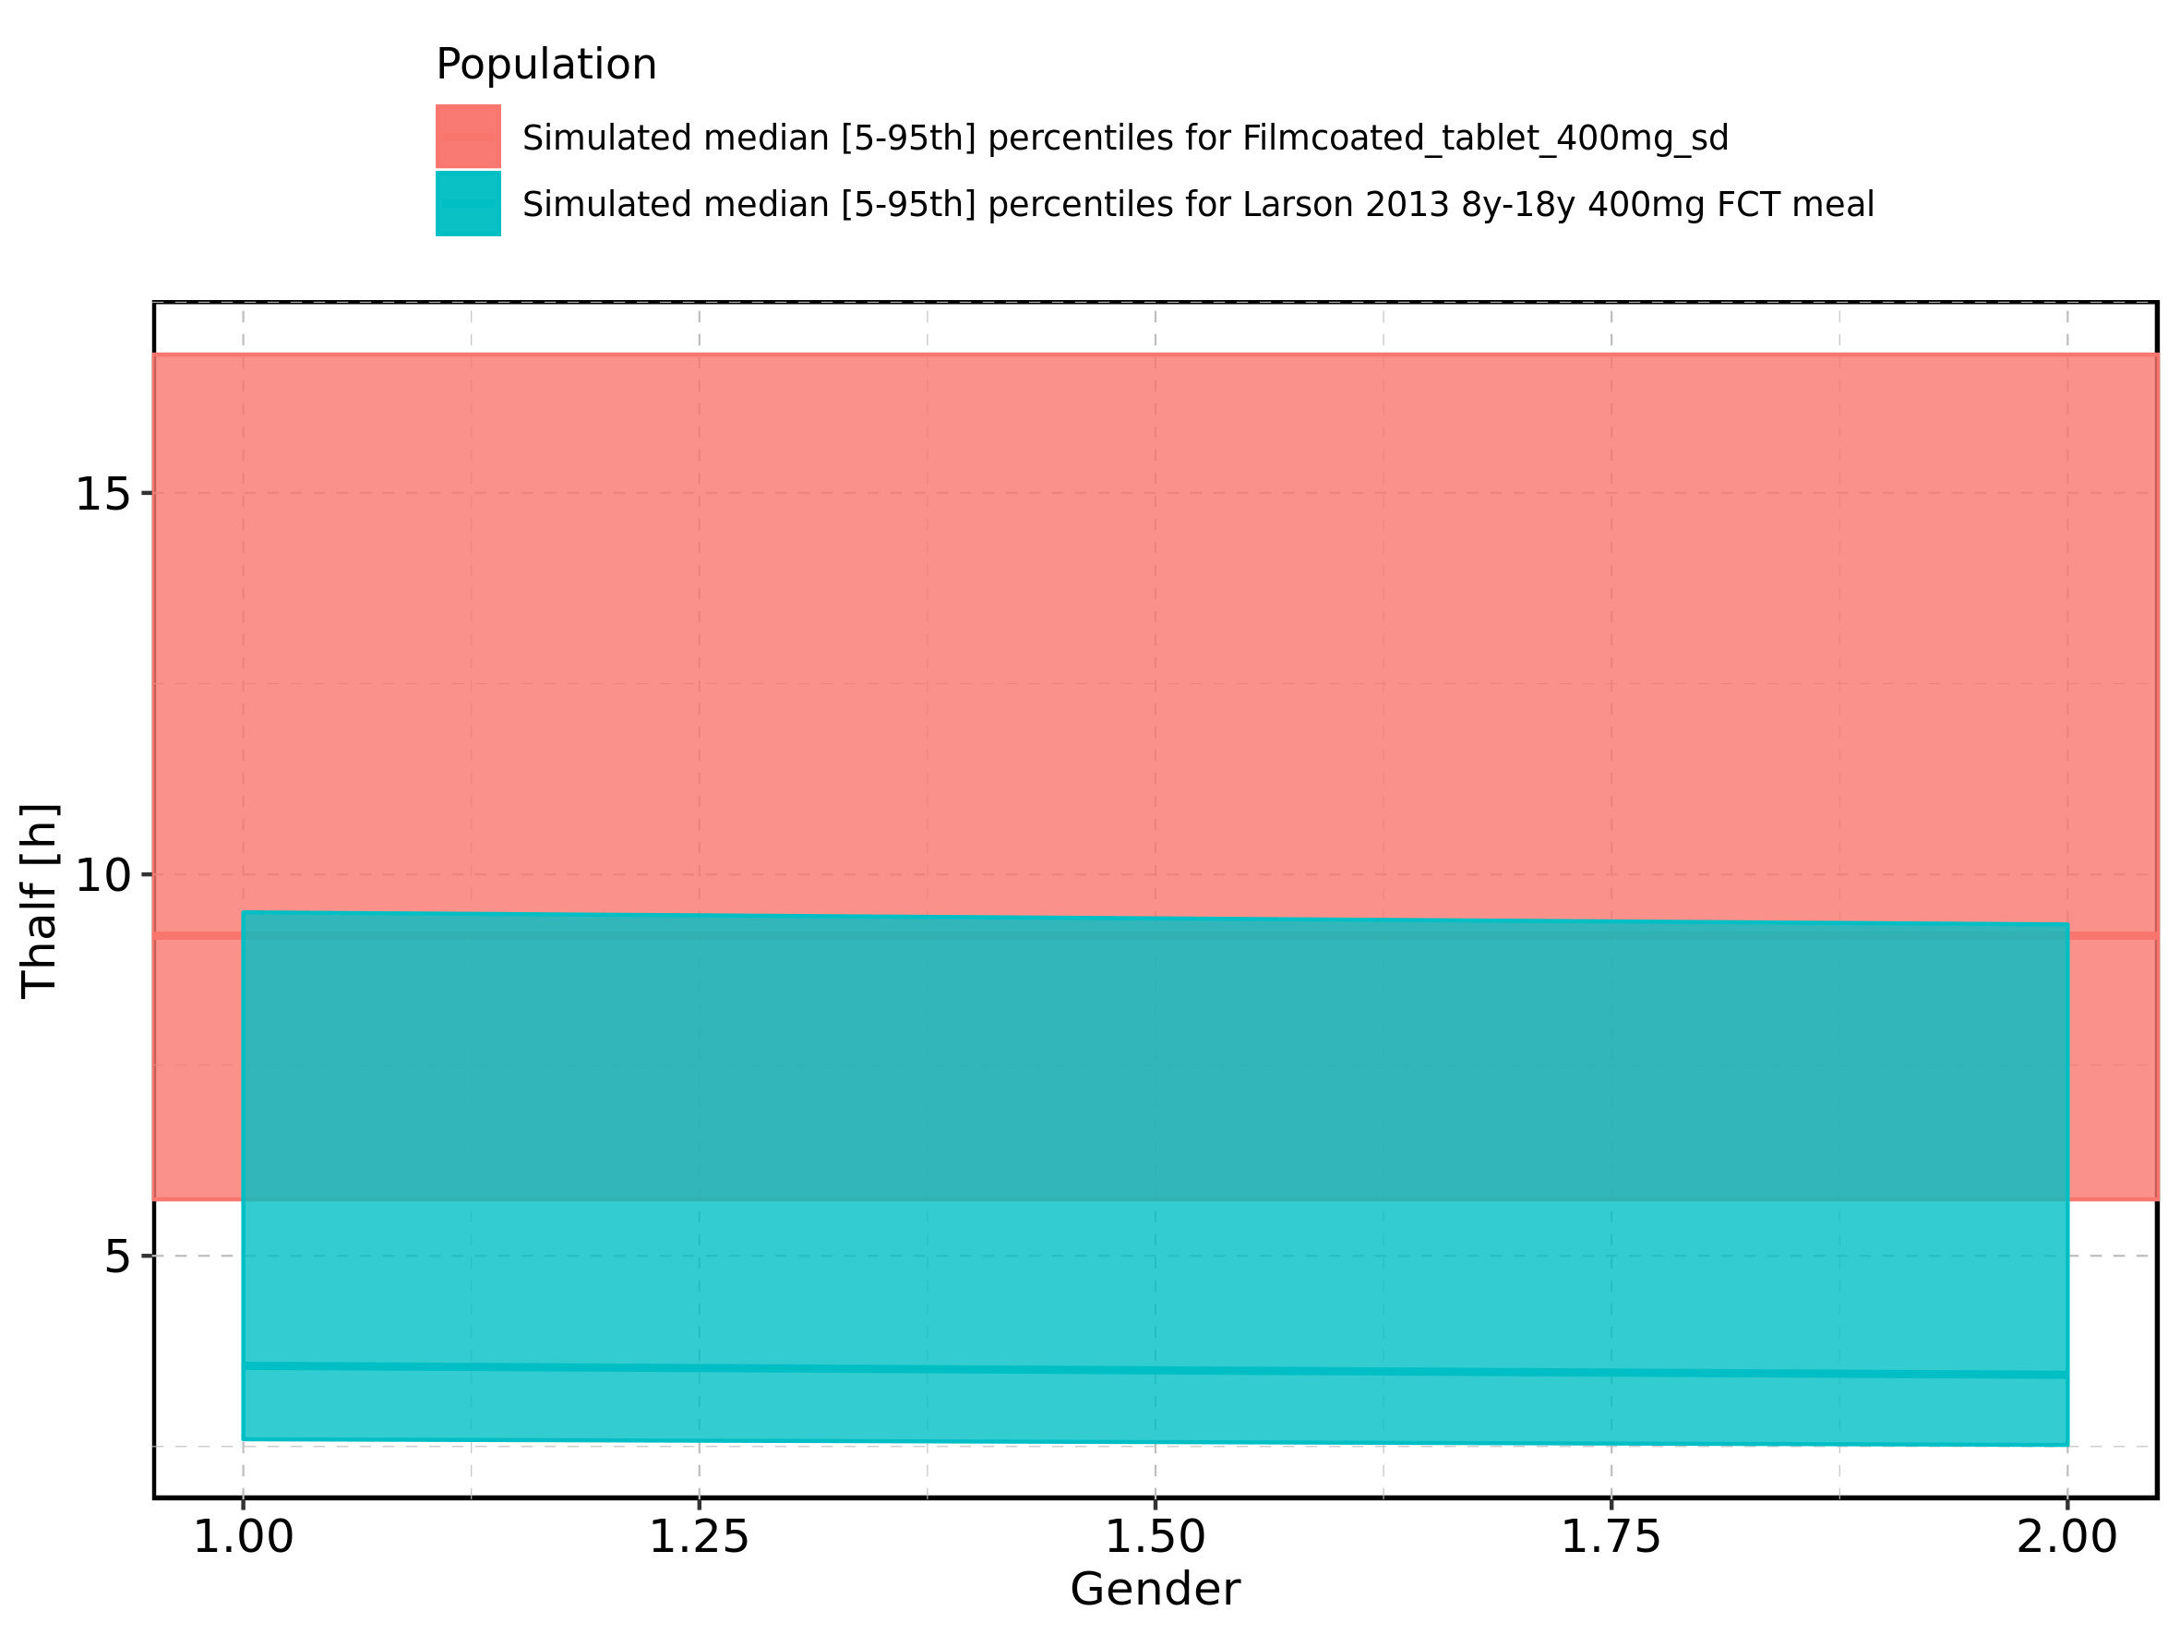

Figure 316: Gender-dependence of Thalf for Larson 2013 8y-18y 400mg FCT meal in comparison to Filmcoated_tablet_400mg_sd. Profiles are plotted in a logarithmic scale.

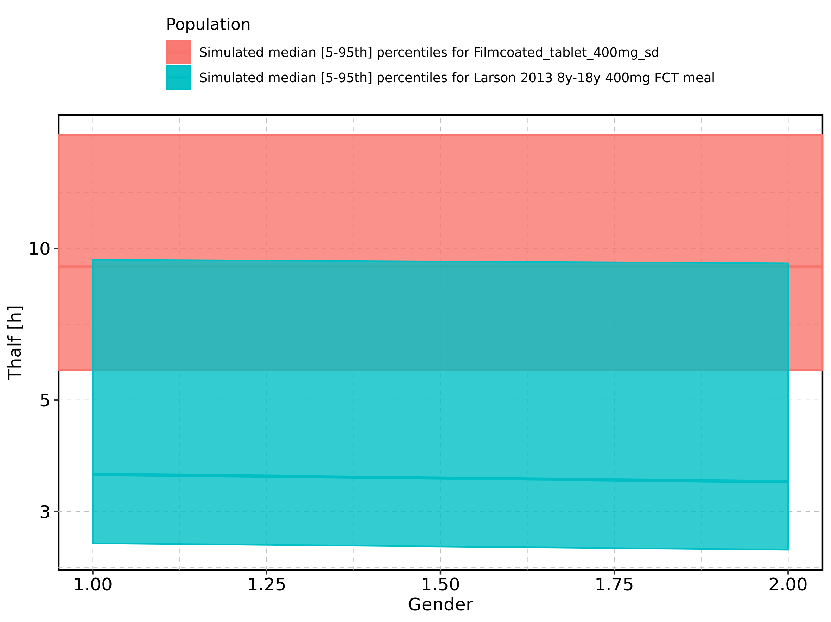

Figure 317: Gender-dependence of Thalf for Larson 2013 8y-18y 400mg FCT meal. Profiles are plotted in a linear scale.

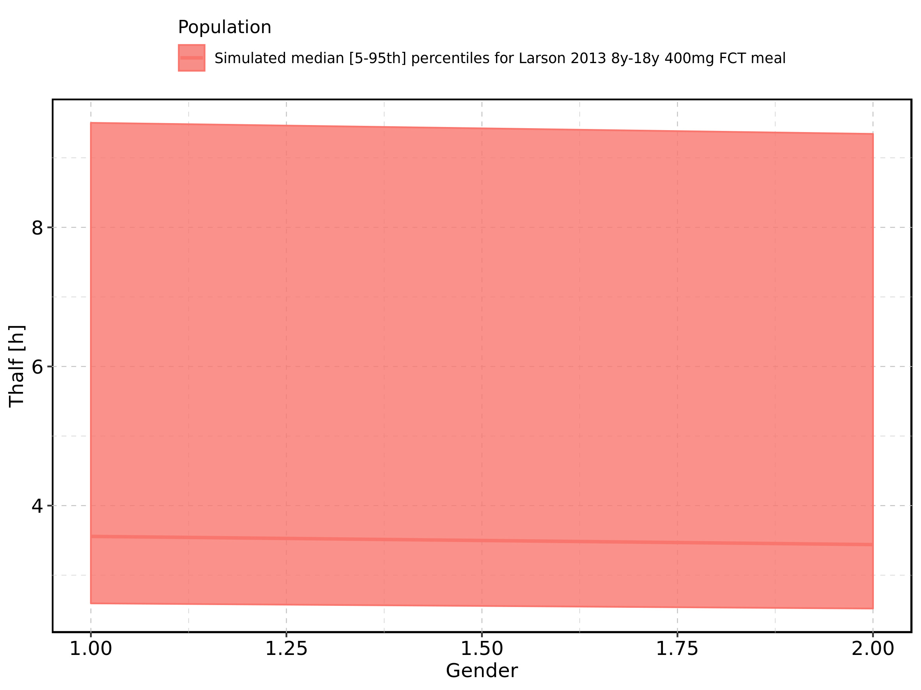

Figure 318: Gender-dependence of Thalf for Larson 2013 8y-18y 400mg FCT meal. Profiles are plotted in a logarithmic scale.

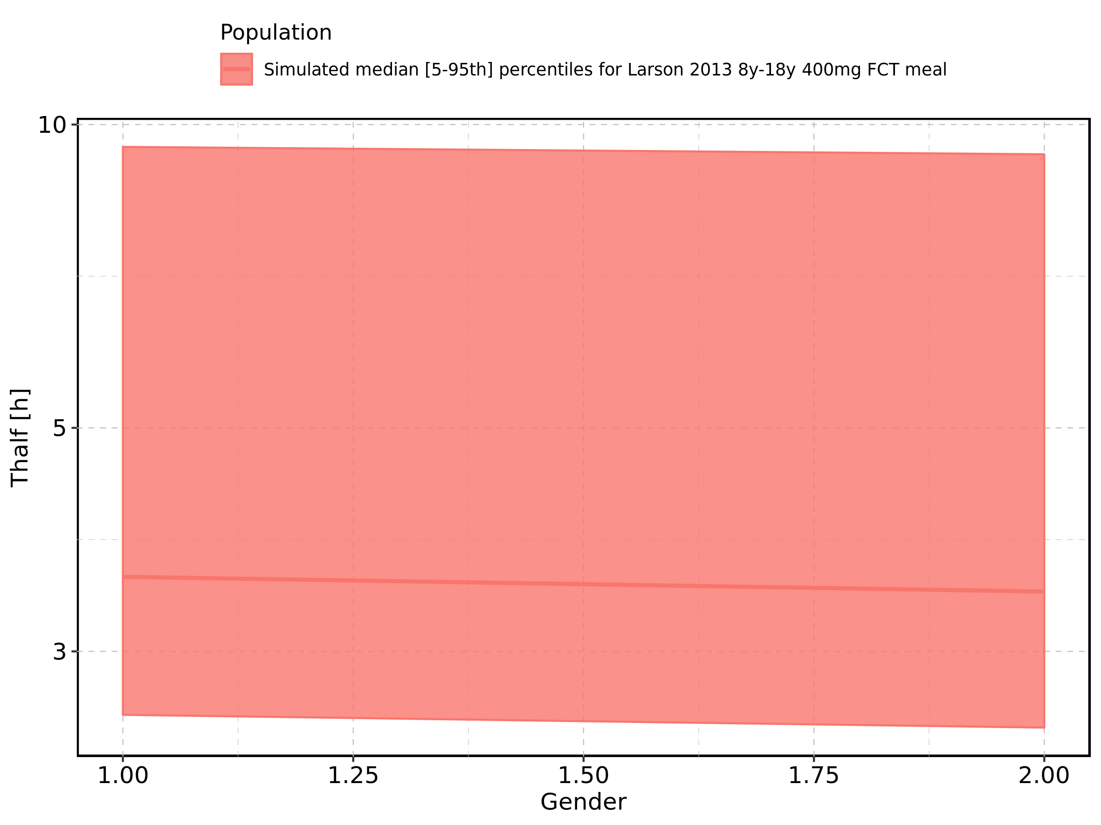

Figure 319: Gender-dependence of Thalf for Filmcoated_tablet_400mg_sd. Profiles are plotted in a linear scale.

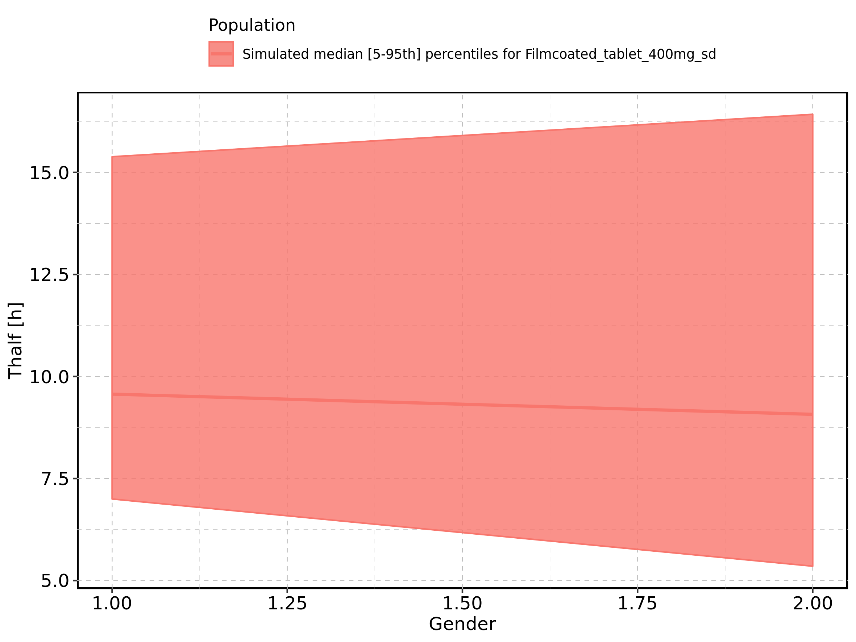

Figure 320: Gender-dependence of Thalf for Filmcoated_tablet_400mg_sd. Profiles are plotted in a logarithmic scale.

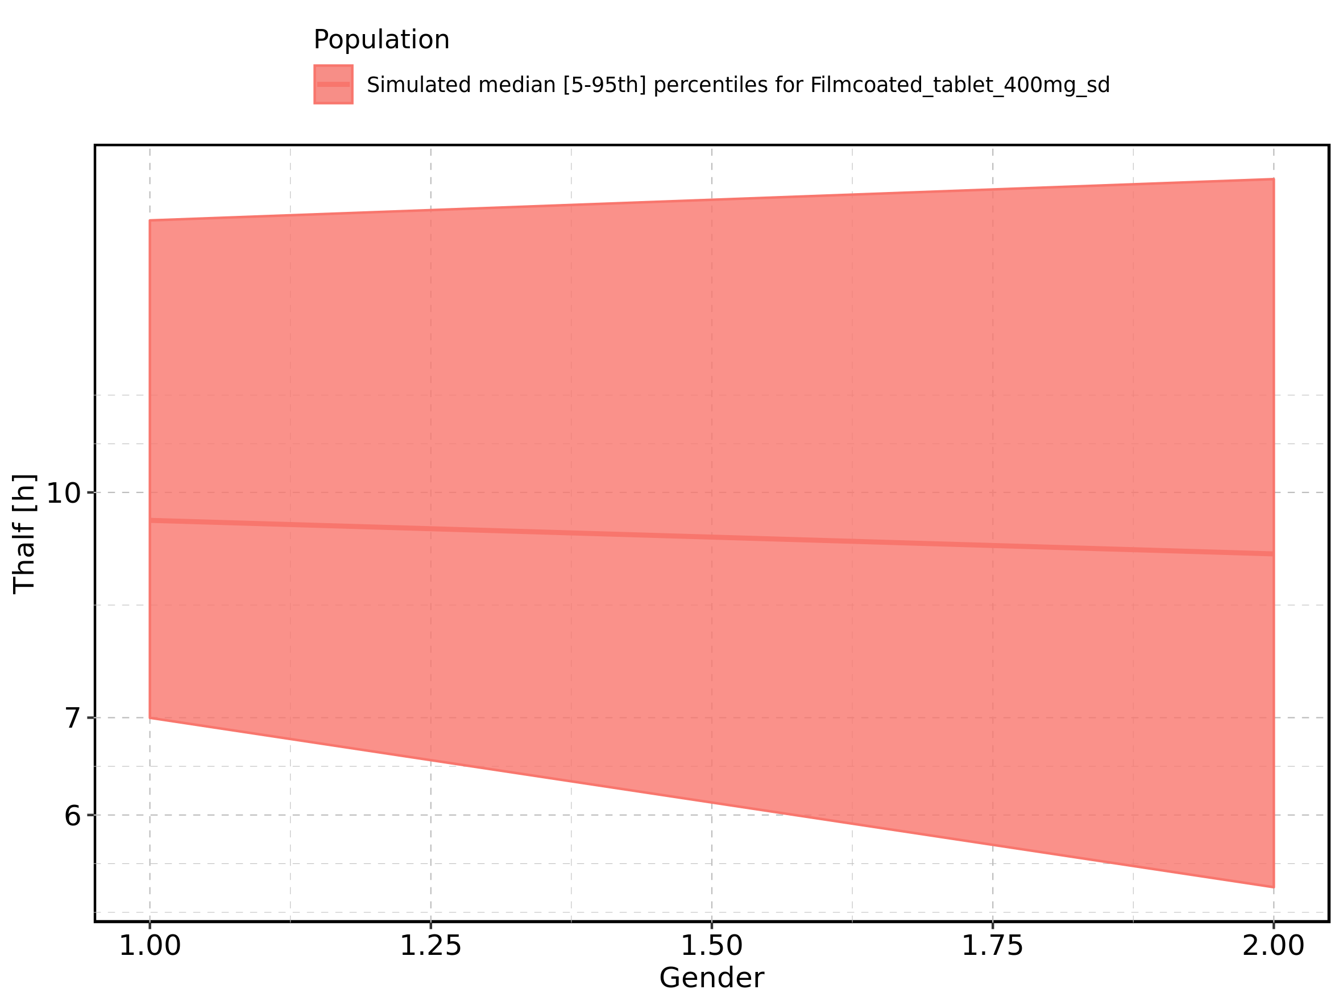

Figure 321: CL of Raltegravir shown as box-whisker plot, which indicates the 5th, 25th, 50th, 75th, and 95th percentiles in linear scale.

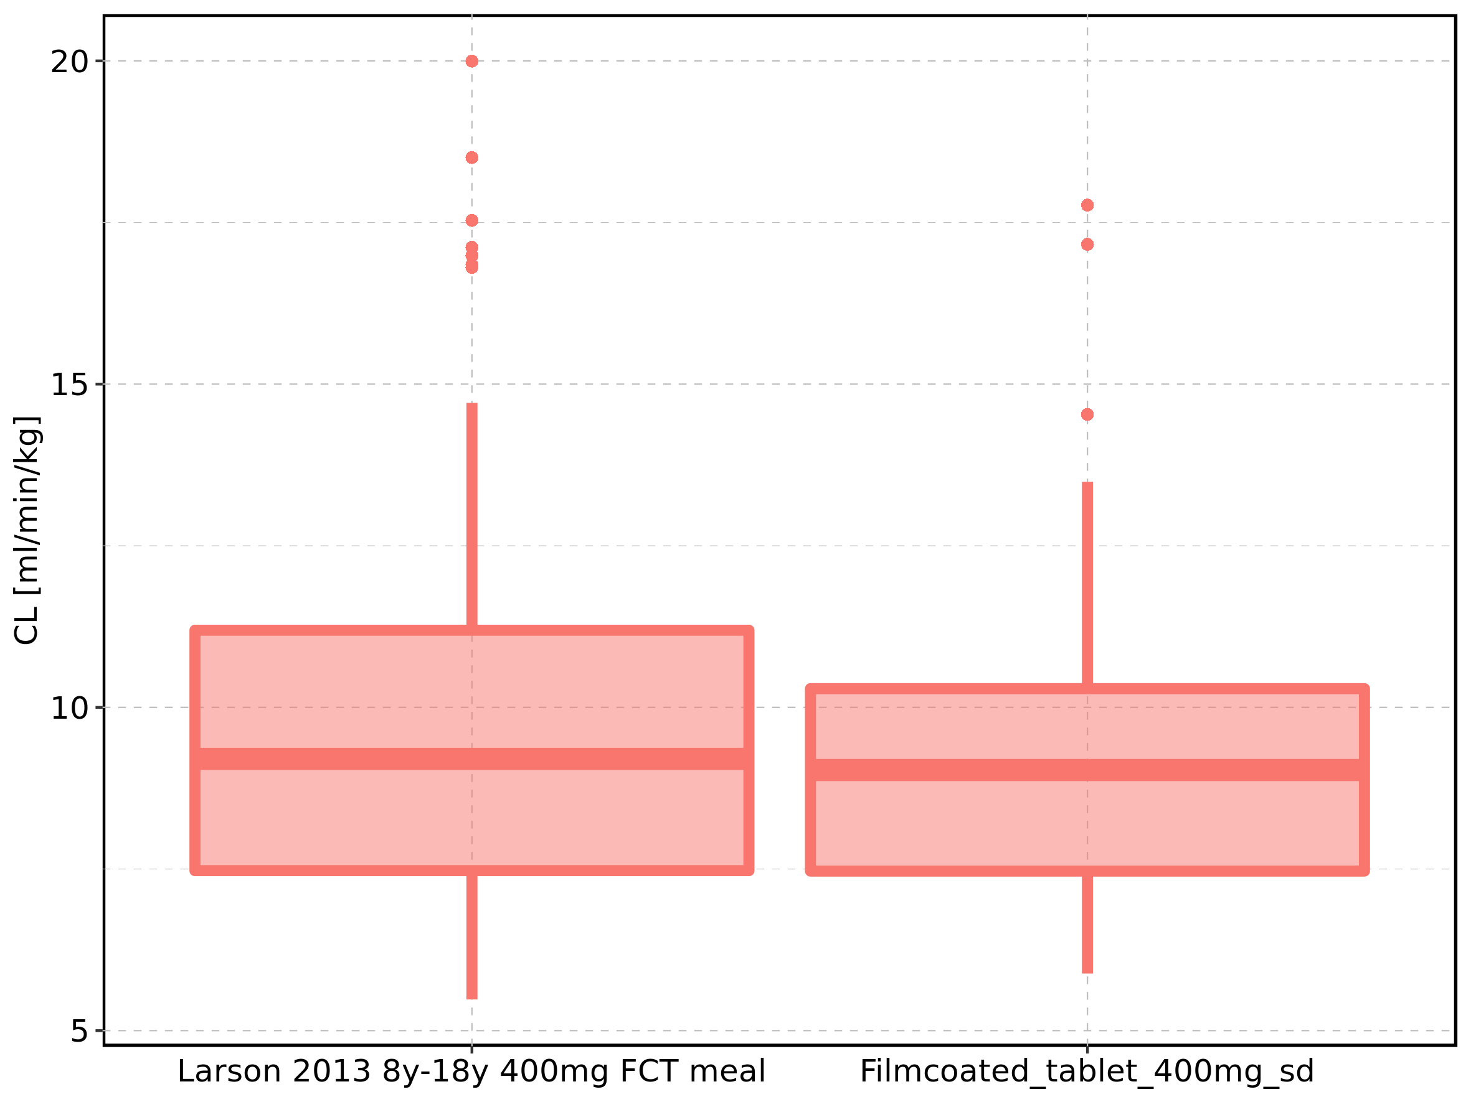

|  |  |  |  |  |  |  |  |  |  |  |
| --- | --- | --- | --- | --- | --- | --- | --- | --- | --- | --- |
| Population | N | 5th percentile | 25th percentile | 50th percentile | 75th percentile | 95th percentile | mean | standard deviation | geo mean | geo standard deviation |
| Larson 2013 8y-18y 400mg FCT meal | 497 | 5.482107 | 7.474598 | 9.202990 | 11.19313 | 14.70885 | 9.494908 | 2.837539 | 9.079494 | 1.353166 |
| Filmcoated_tablet_400mg_sd | 100 | 5.883098 | 7.467935 | 9.030982 | 10.28982 | 13.48808 | 9.200767 | 2.501942 | 8.887615 | 1.300506 |

Figure 322: CL of Raltegravir shown as box-whisker plot, which indicates the 5th, 25th, 50th, 75th, and 95th percentiles in logarithmic scale.

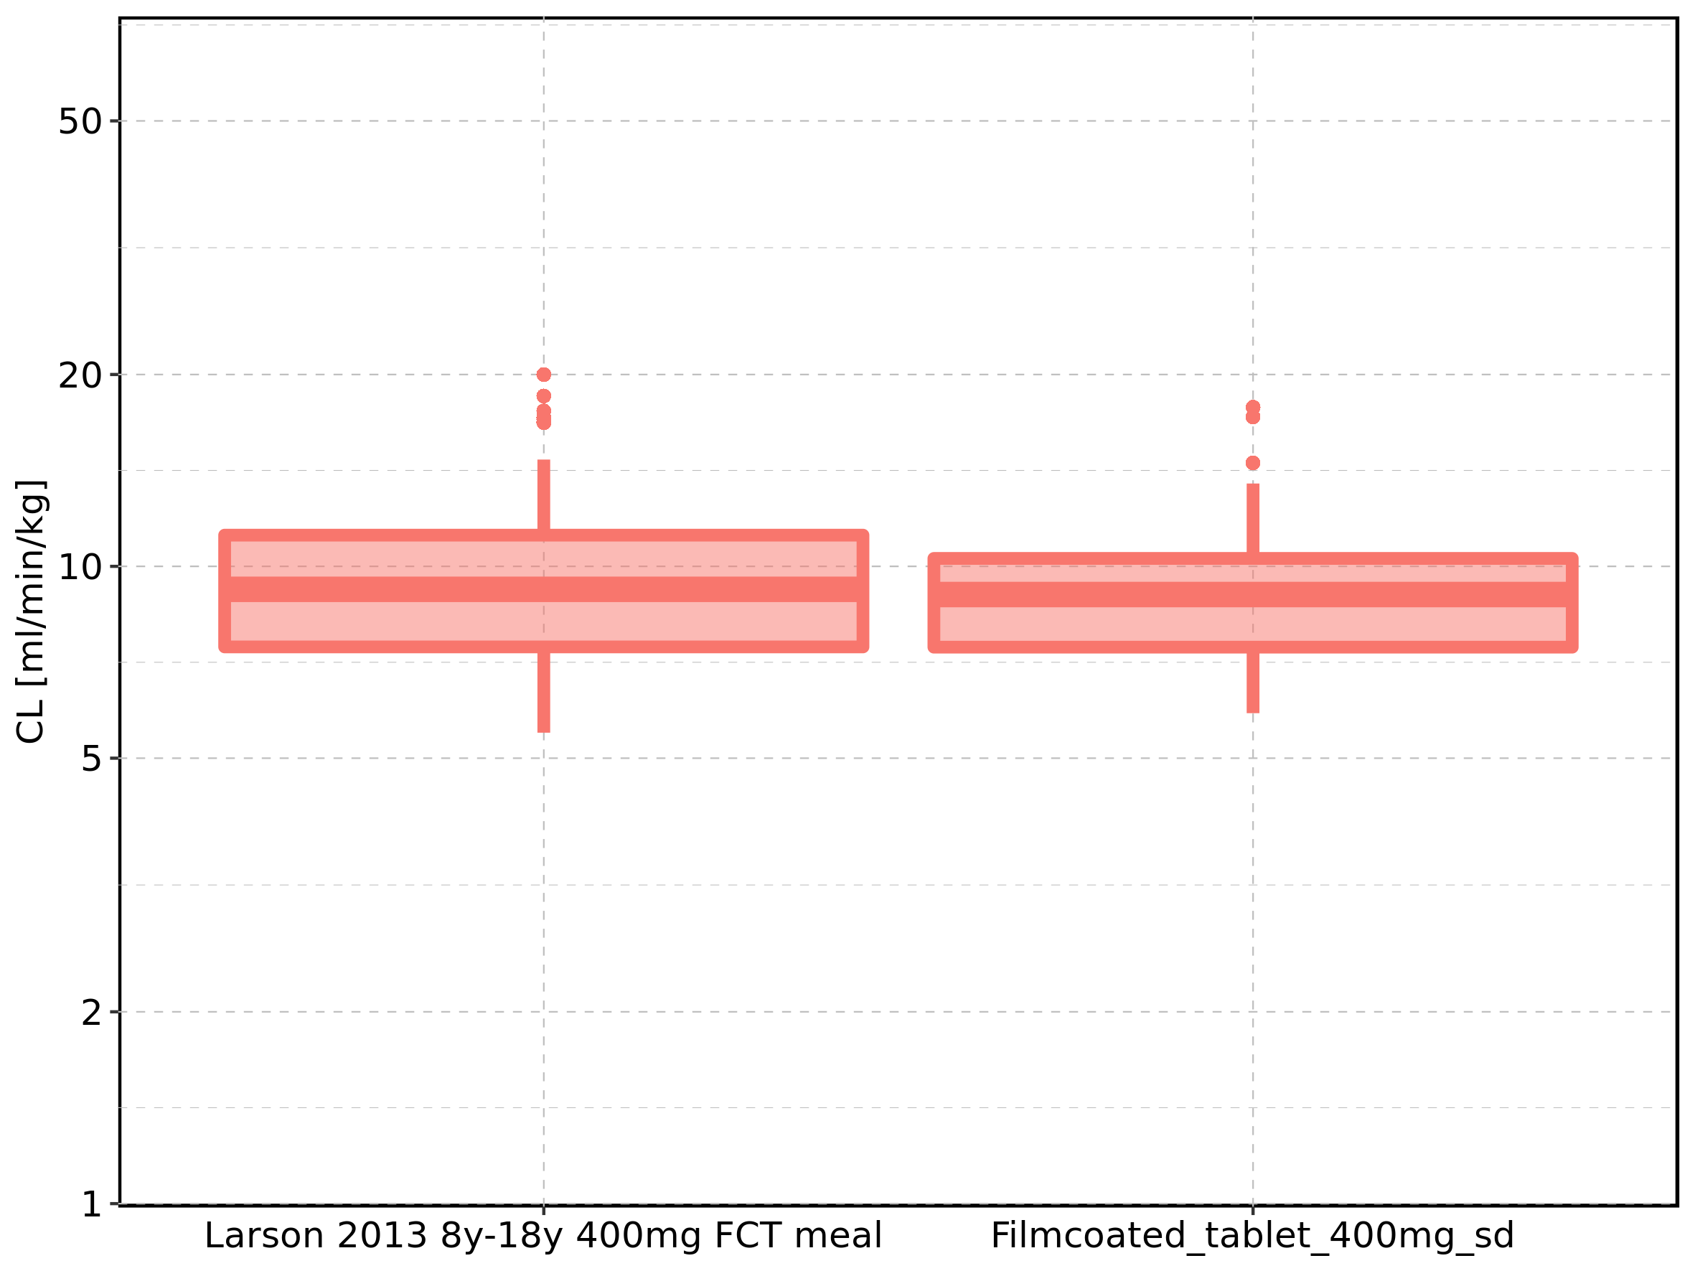

Figure 323: Age-dependence of CL for Larson 2013 8y-18y 400mg FCT meal in comparison to Filmcoated_tablet_400mg_sd. Profiles are plotted in a linear scale.

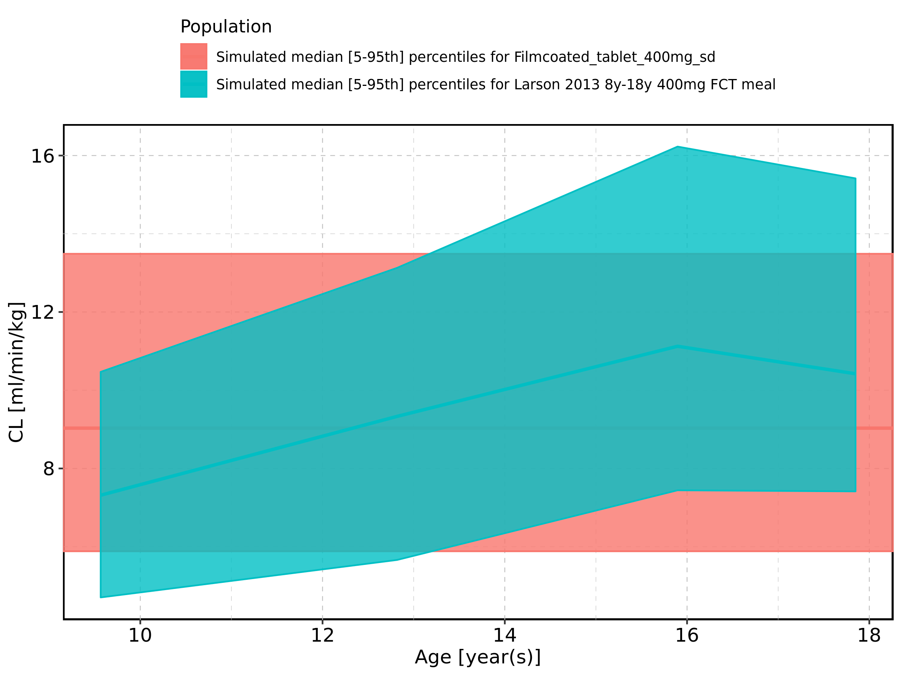

Figure 324: Age-dependence of CL for Larson 2013 8y-18y 400mg FCT meal in comparison to Filmcoated_tablet_400mg_sd. Profiles are plotted in a logarithmic scale.

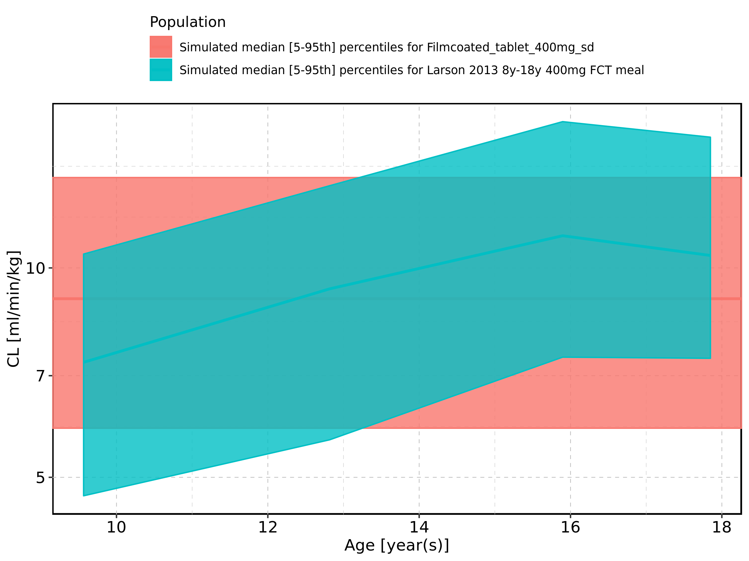

Figure 325: Age-dependence of CL for Larson 2013 8y-18y 400mg FCT meal. Profiles are plotted in a linear scale.

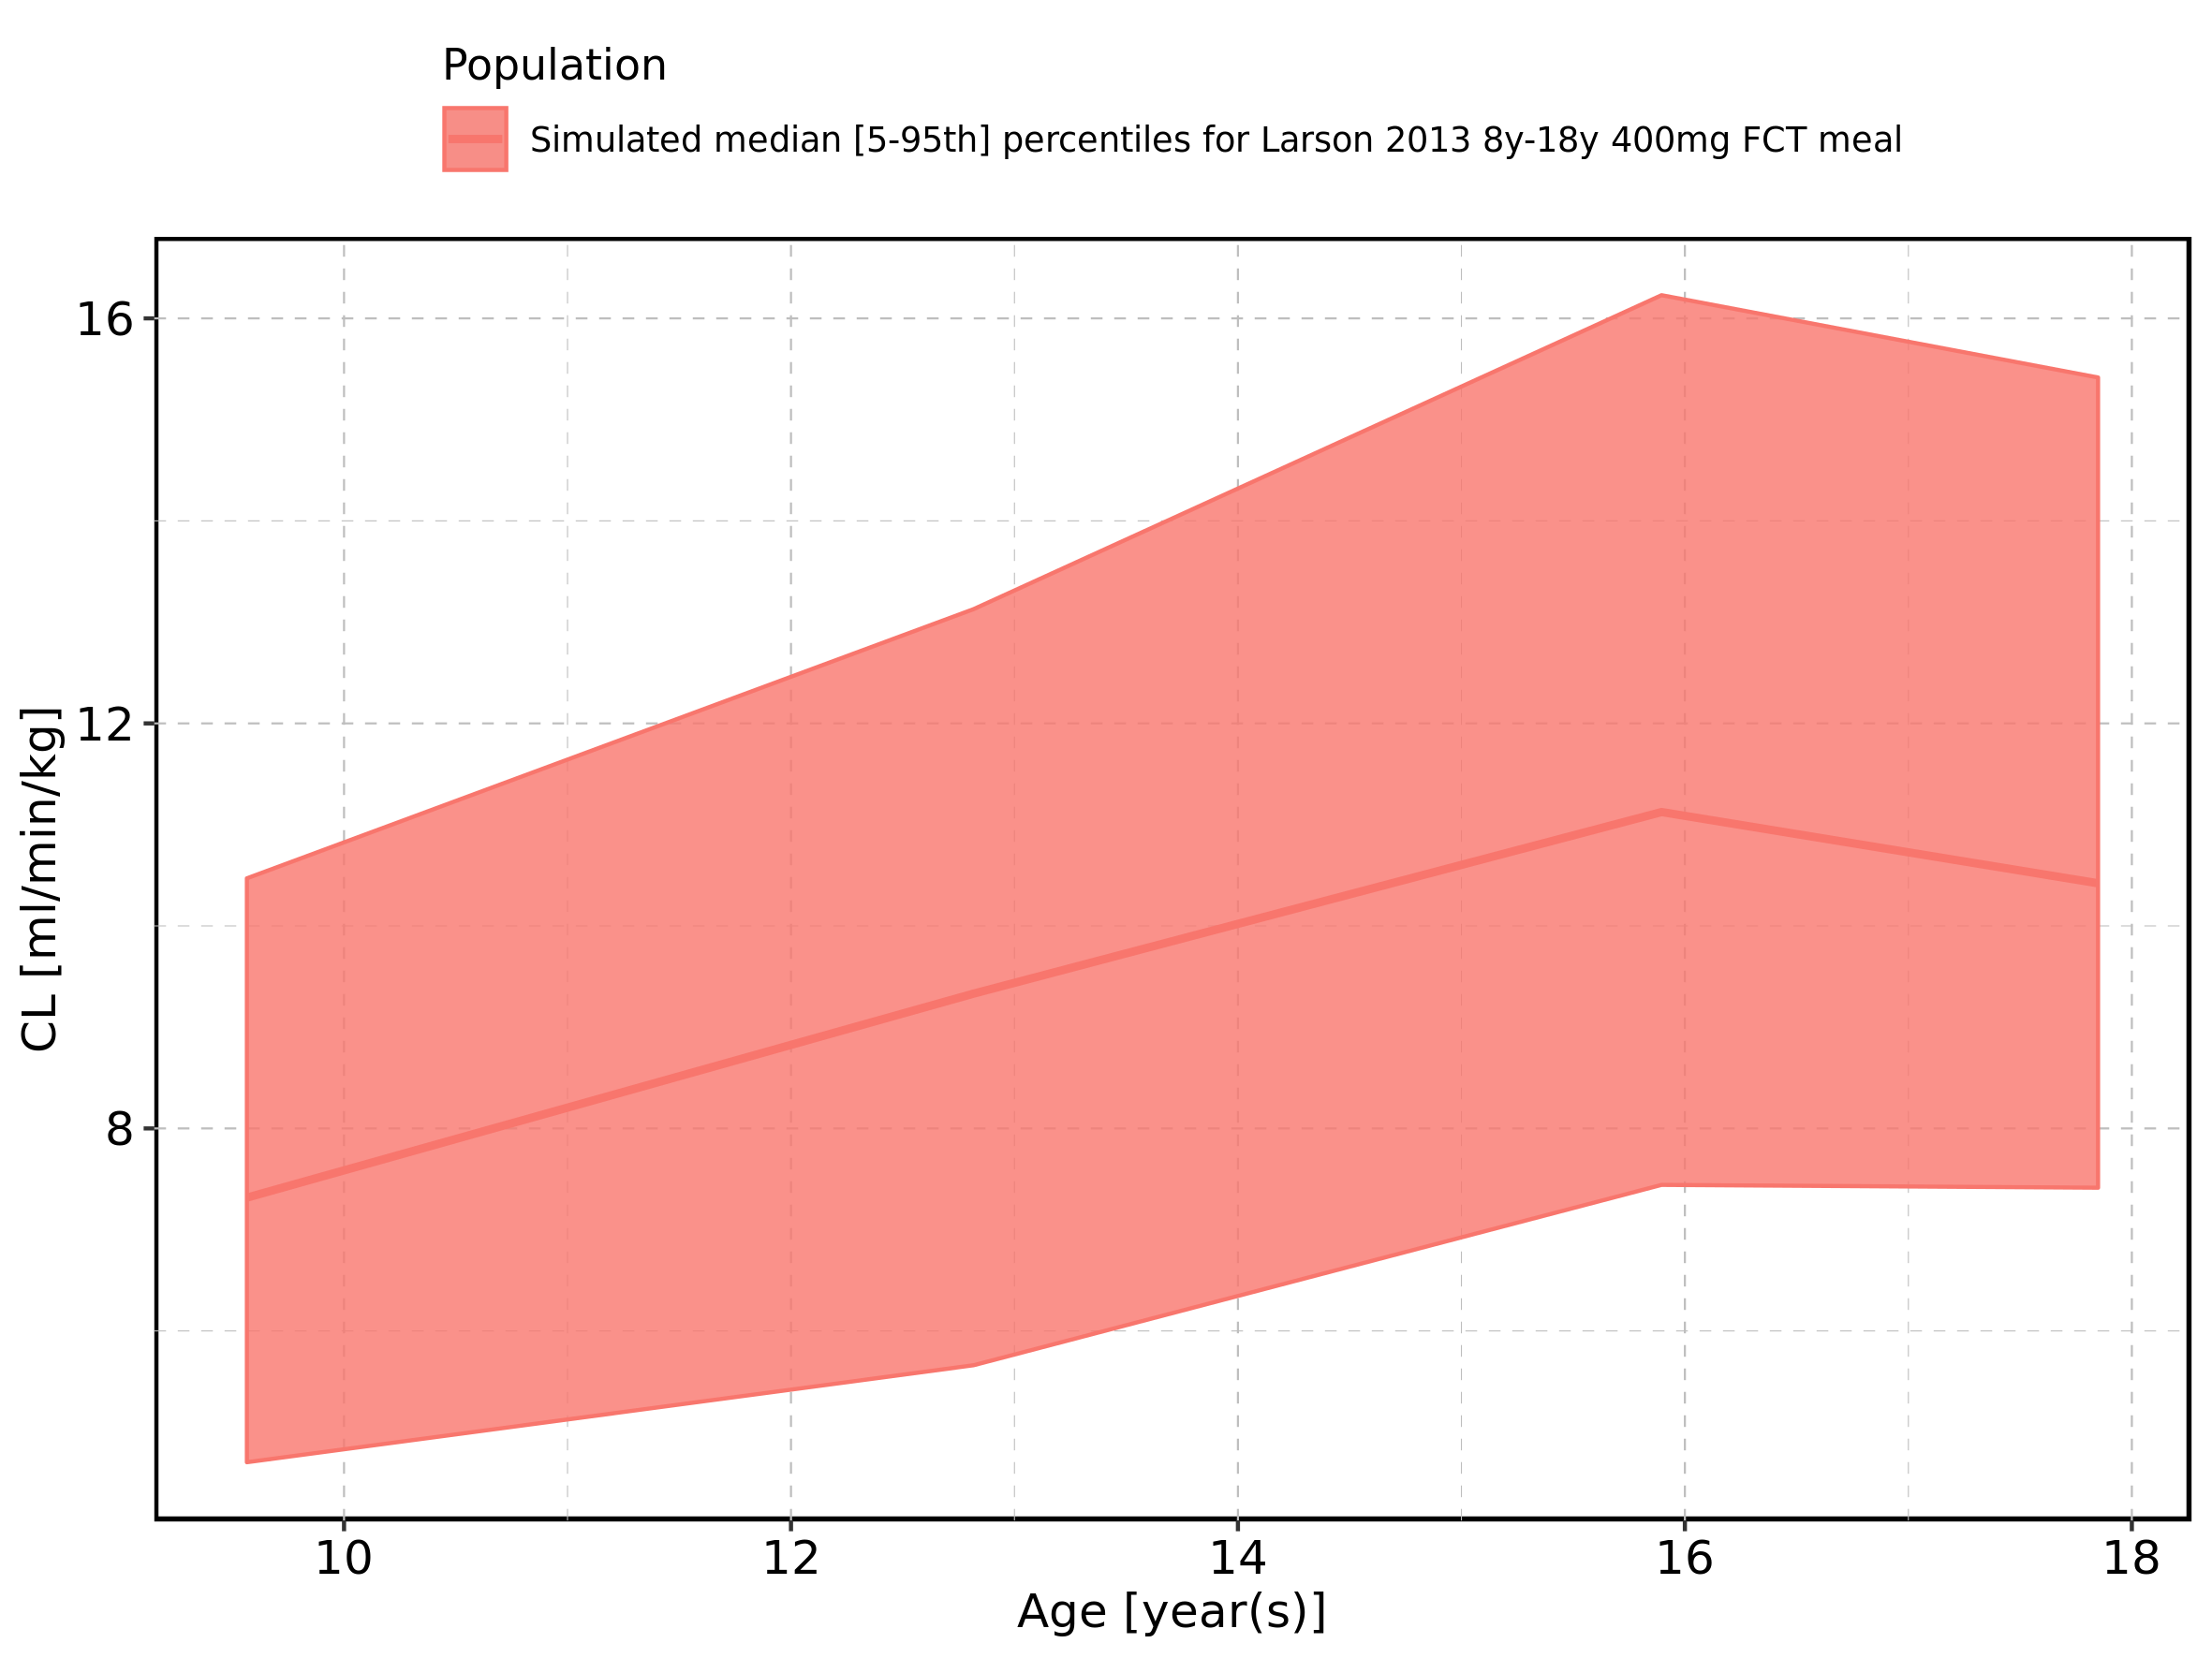

Figure 326: Age-dependence of CL for Larson 2013 8y-18y 400mg FCT meal. Profiles are plotted in a logarithmic scale.

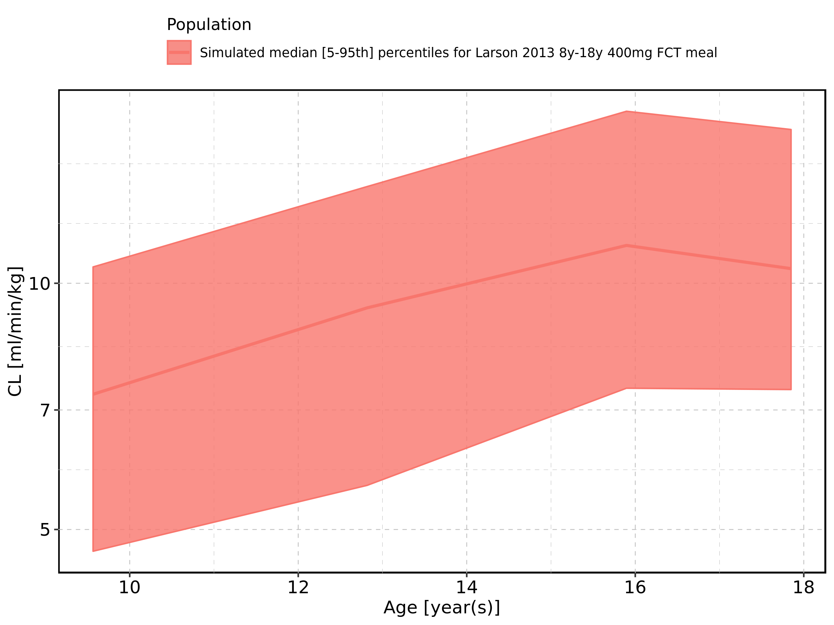

Figure 327: Age-dependence of CL for Filmcoated_tablet_400mg_sd. Profiles are plotted in a linear scale.

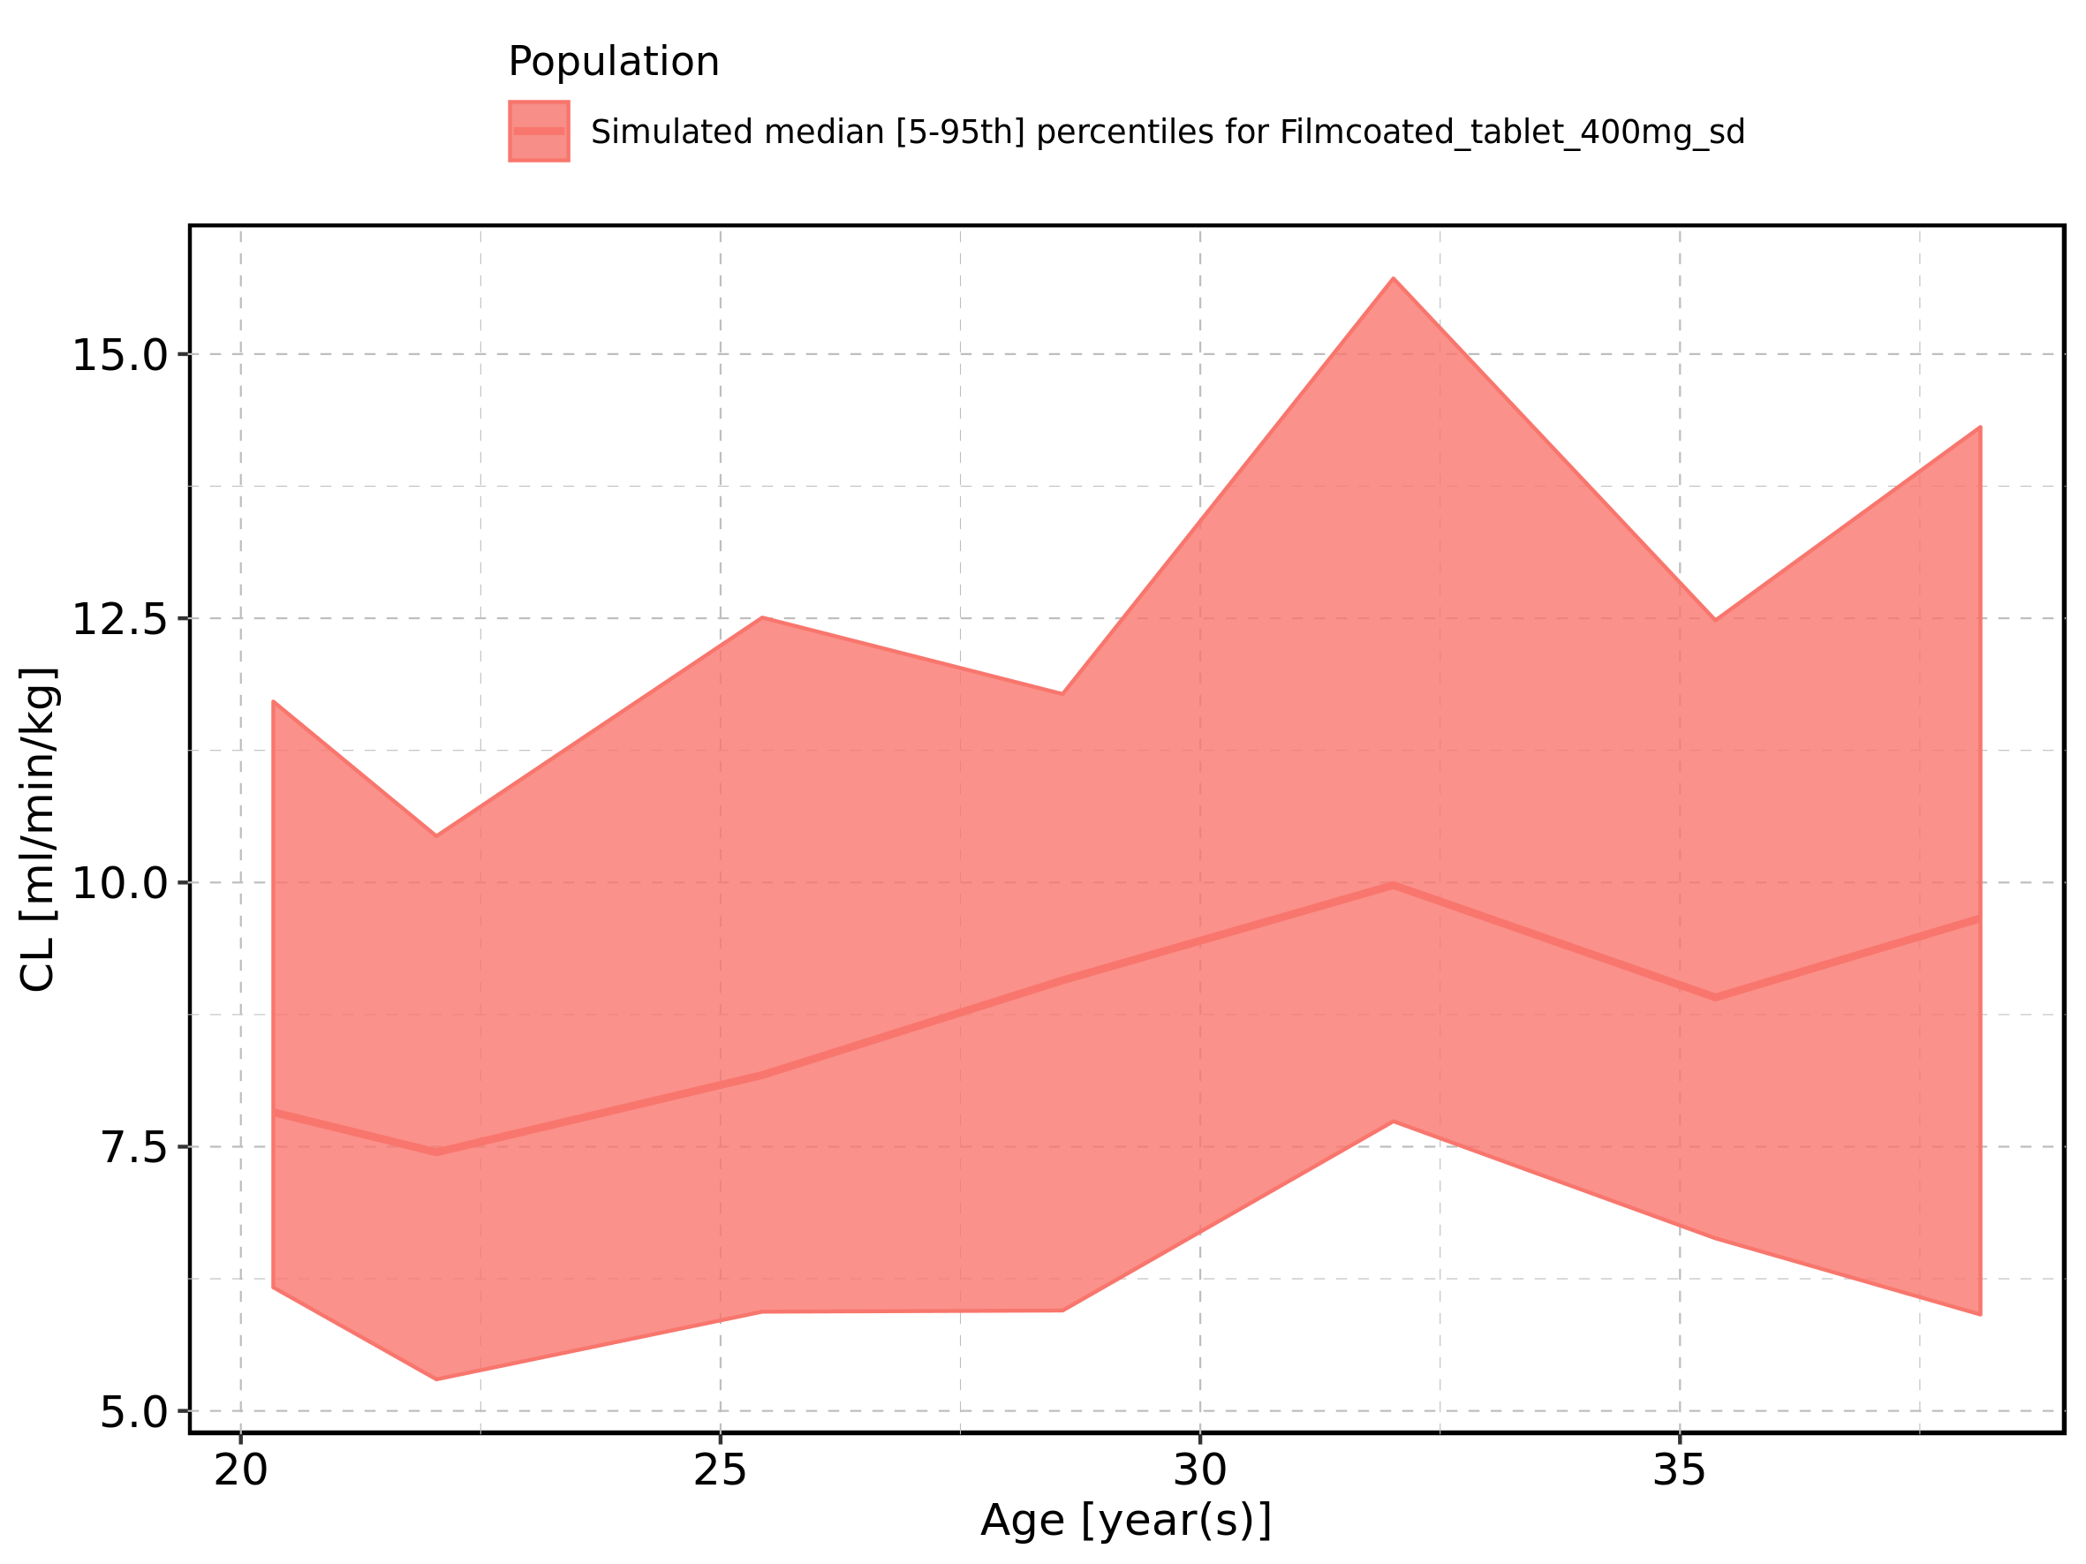

Figure 328: Age-dependence of CL for Filmcoated_tablet_400mg_sd. Profiles are plotted in a logarithmic scale.

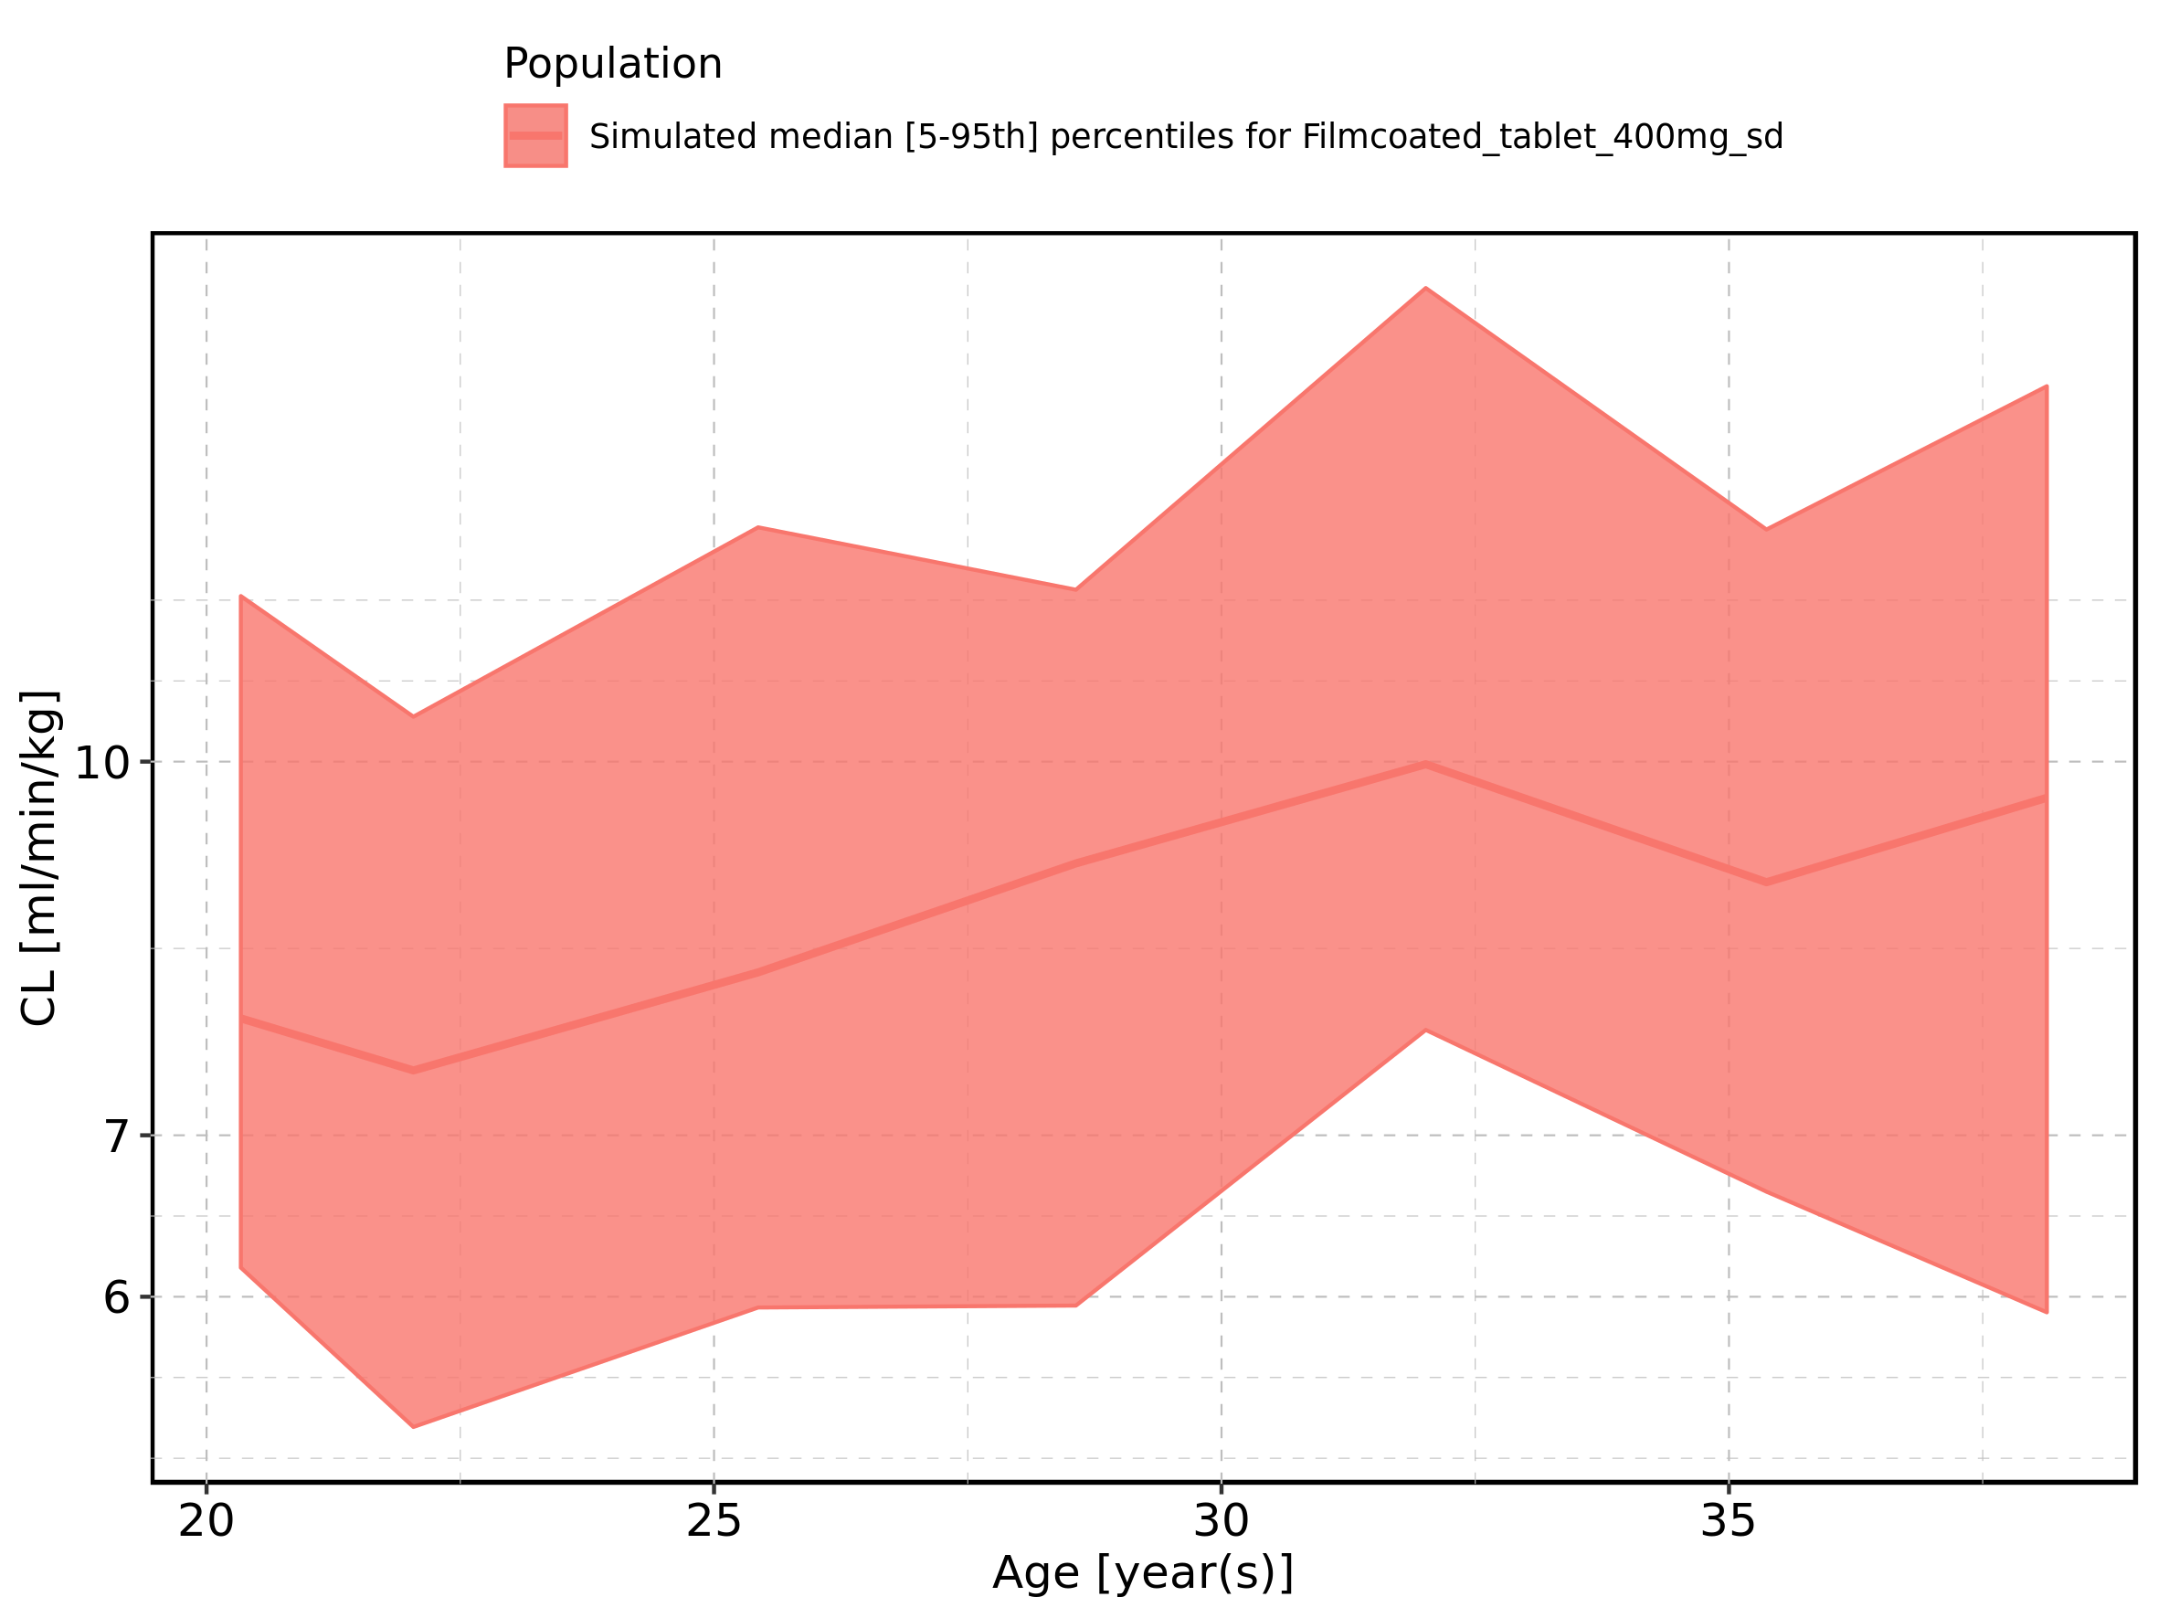

Figure 329: Height-dependence of CL for Larson 2013 8y-18y 400mg FCT meal in comparison to Filmcoated_tablet_400mg_sd. Profiles are plotted in a linear scale.

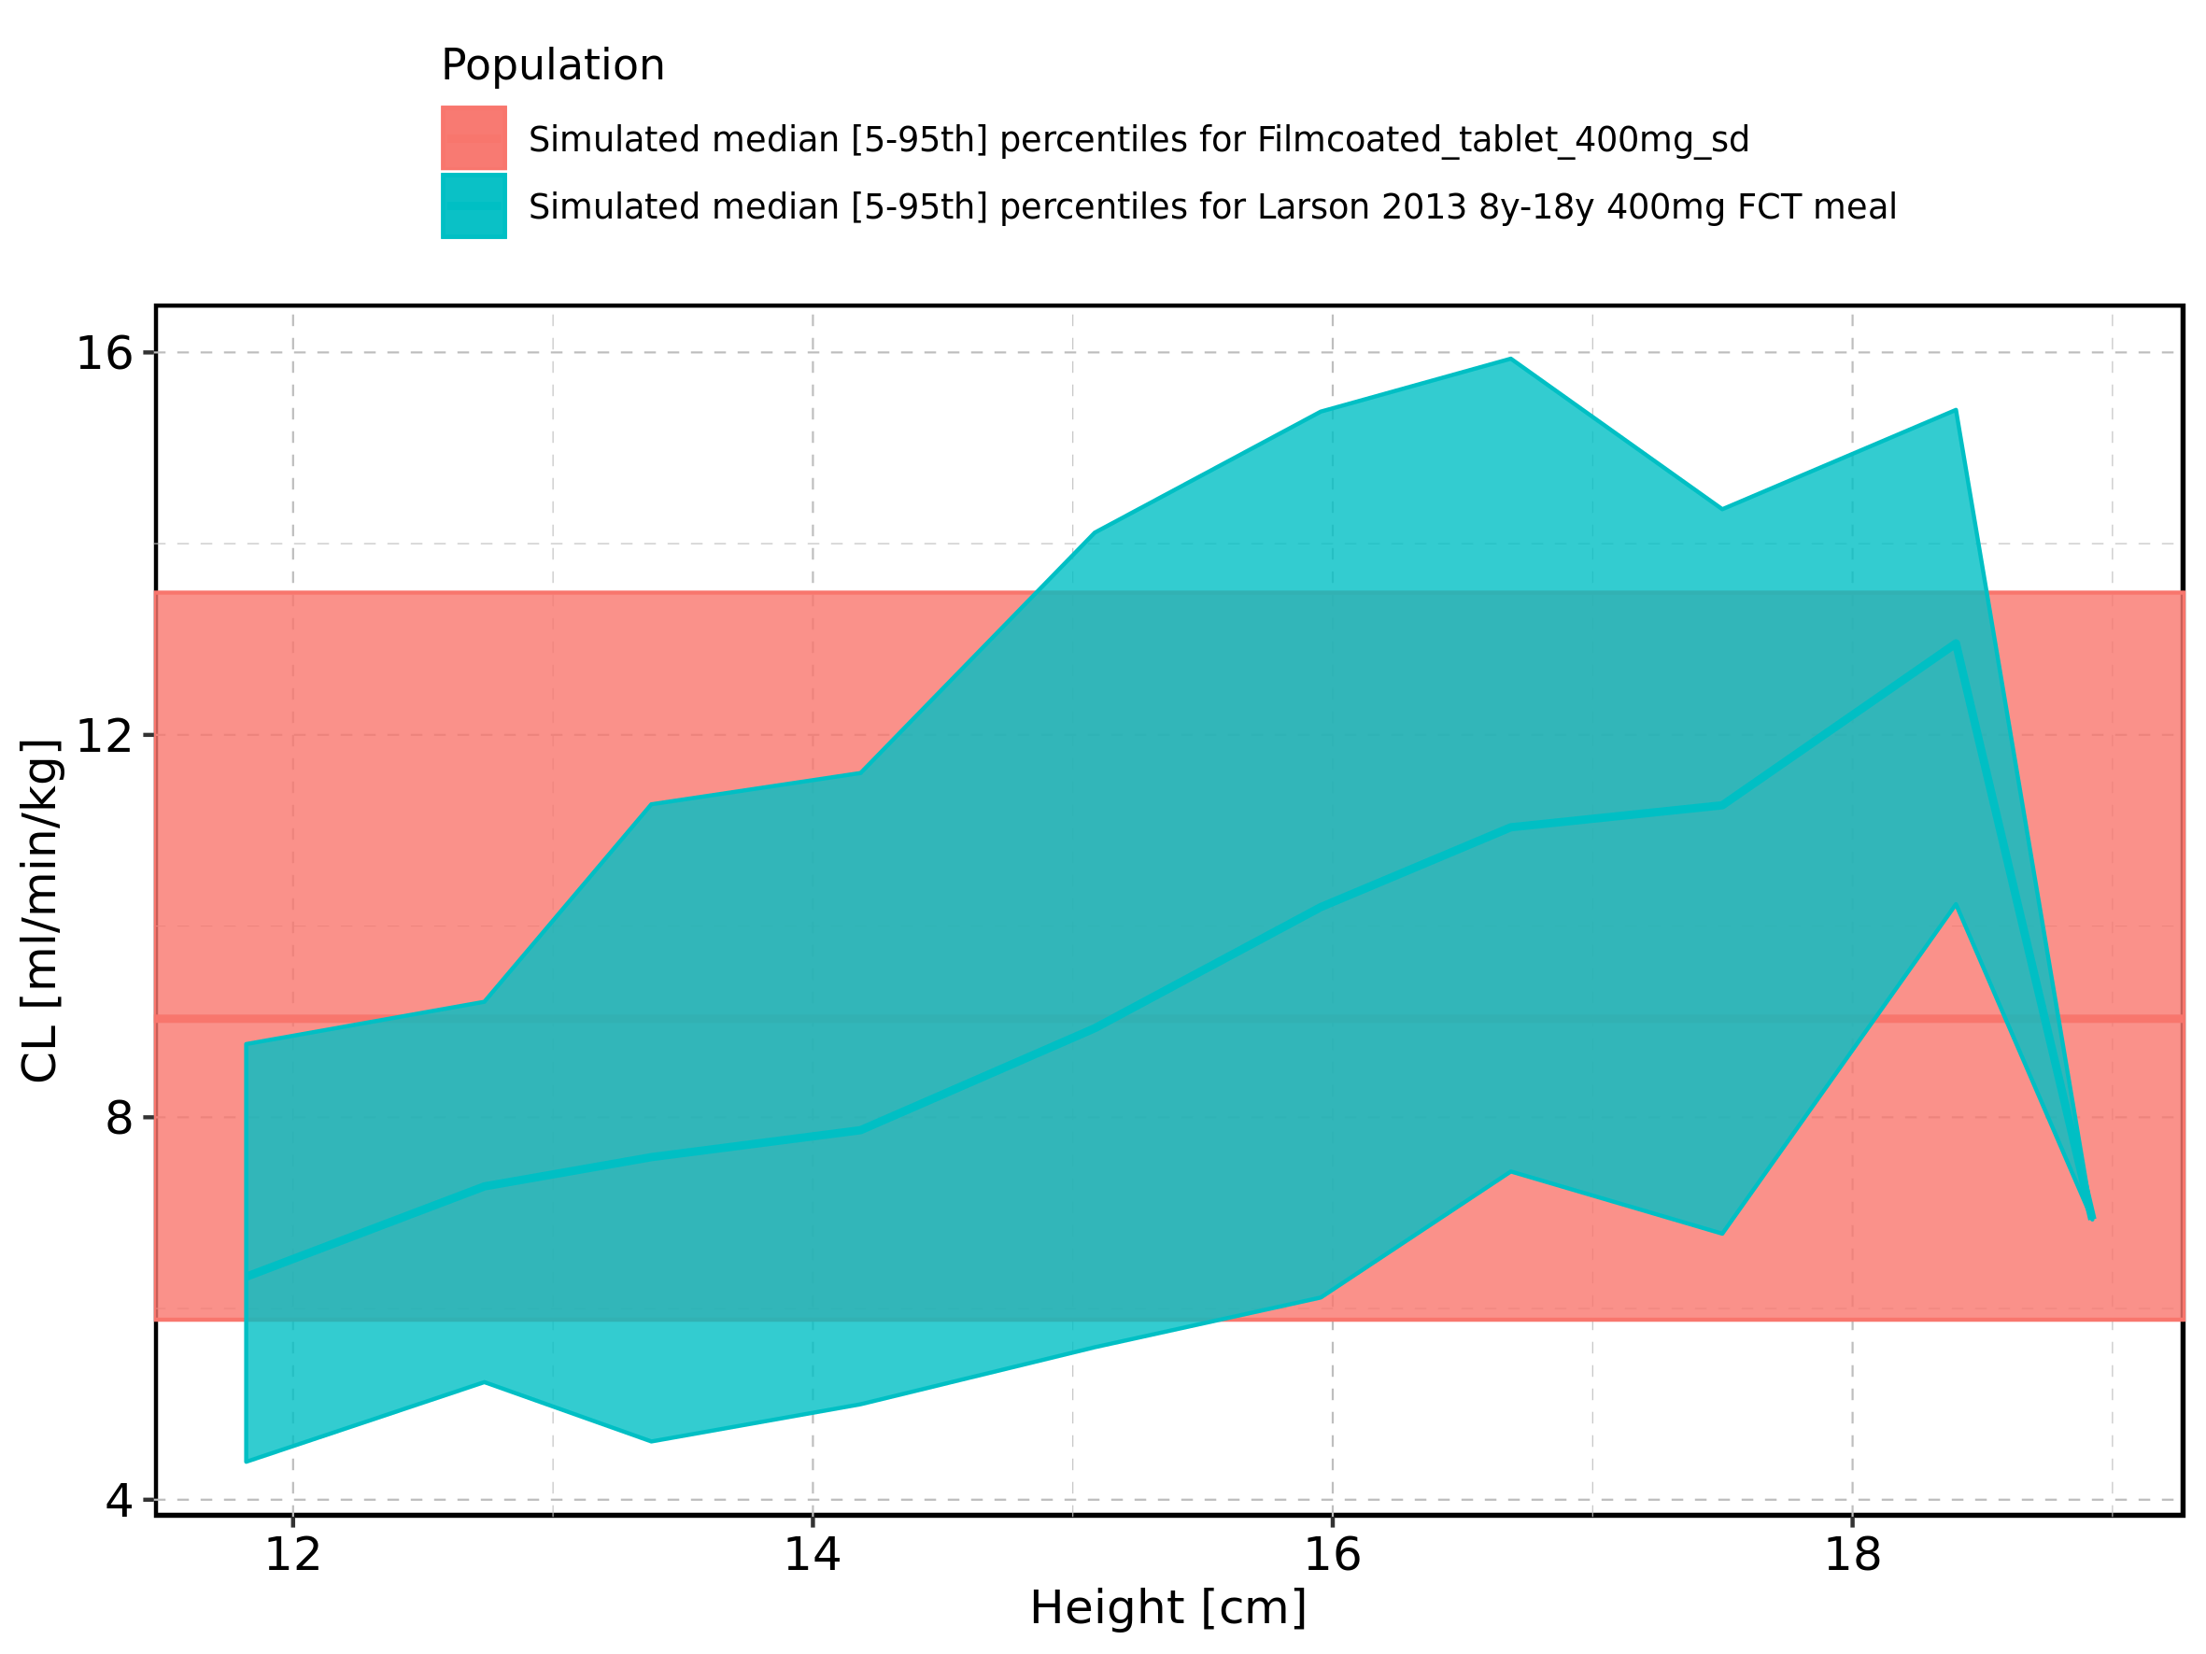

Figure 330: Height-dependence of CL for Larson 2013 8y-18y 400mg FCT meal in comparison to Filmcoated_tablet_400mg_sd. Profiles are plotted in a logarithmic scale.

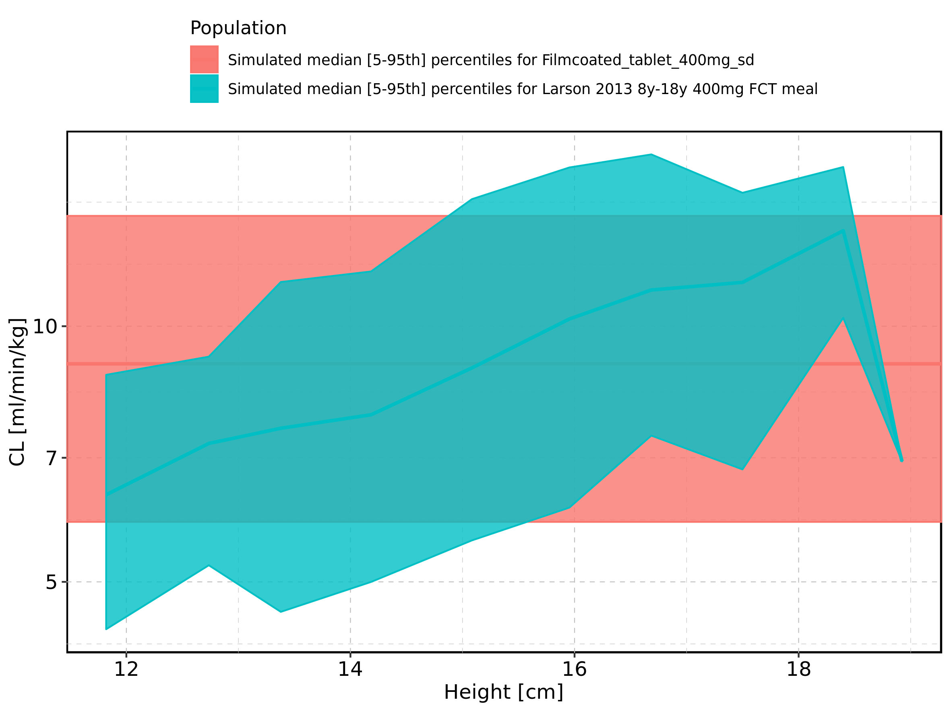

Figure 331: Height-dependence of CL for Larson 2013 8y-18y 400mg FCT meal. Profiles are plotted in a linear scale.

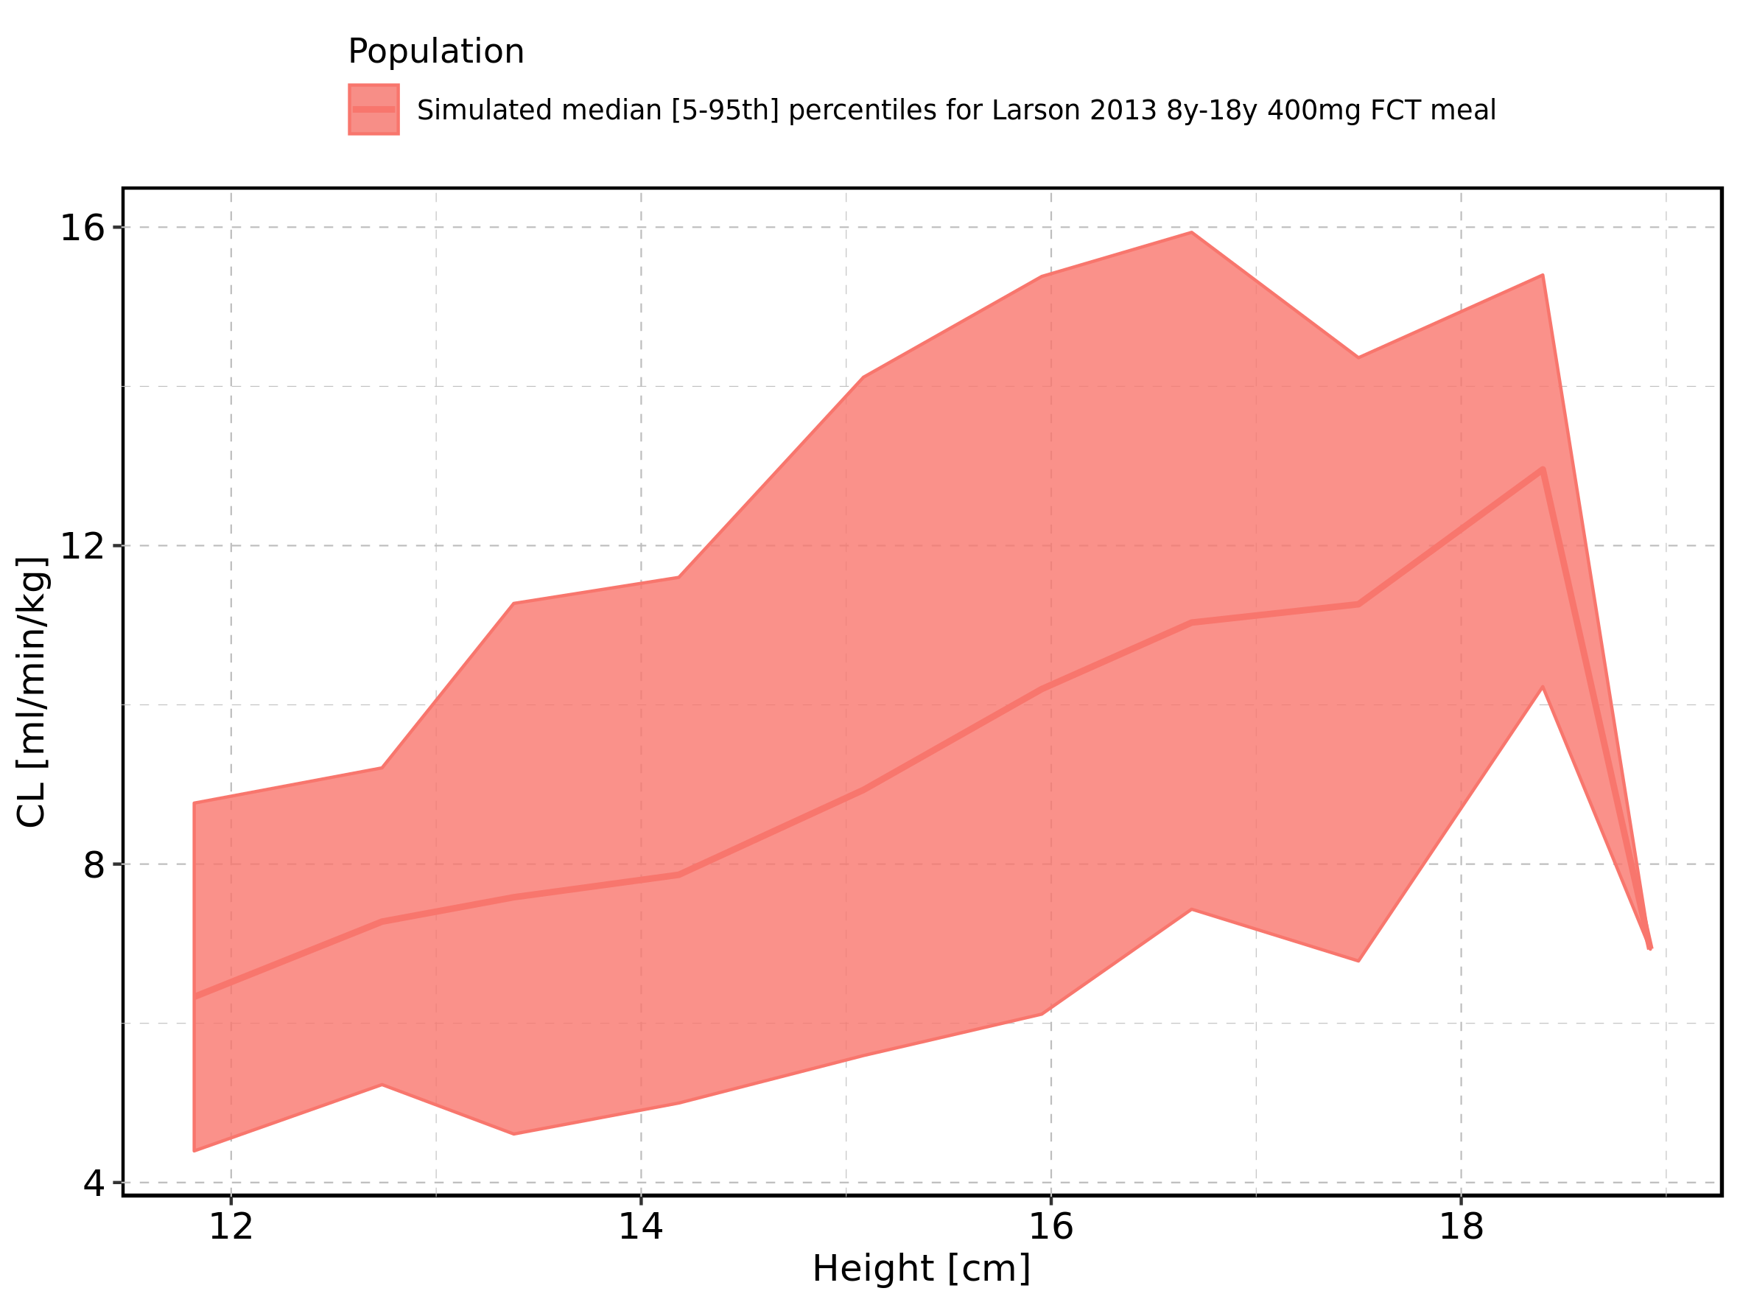

Figure 332: Height-dependence of CL for Larson 2013 8y-18y 400mg FCT meal. Profiles are plotted in a logarithmic scale.

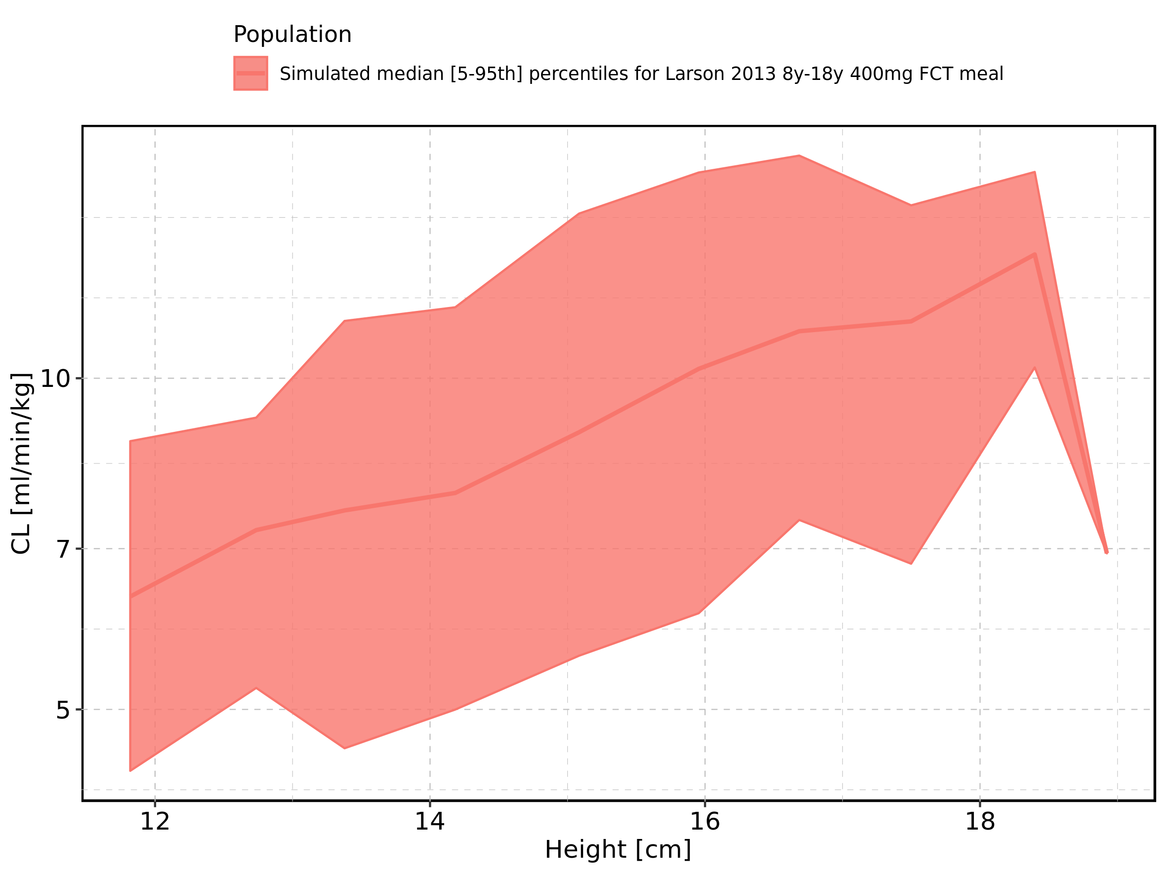

Figure 333: Height-dependence of CL for Filmcoated_tablet_400mg_sd. Profiles are plotted in a linear scale.

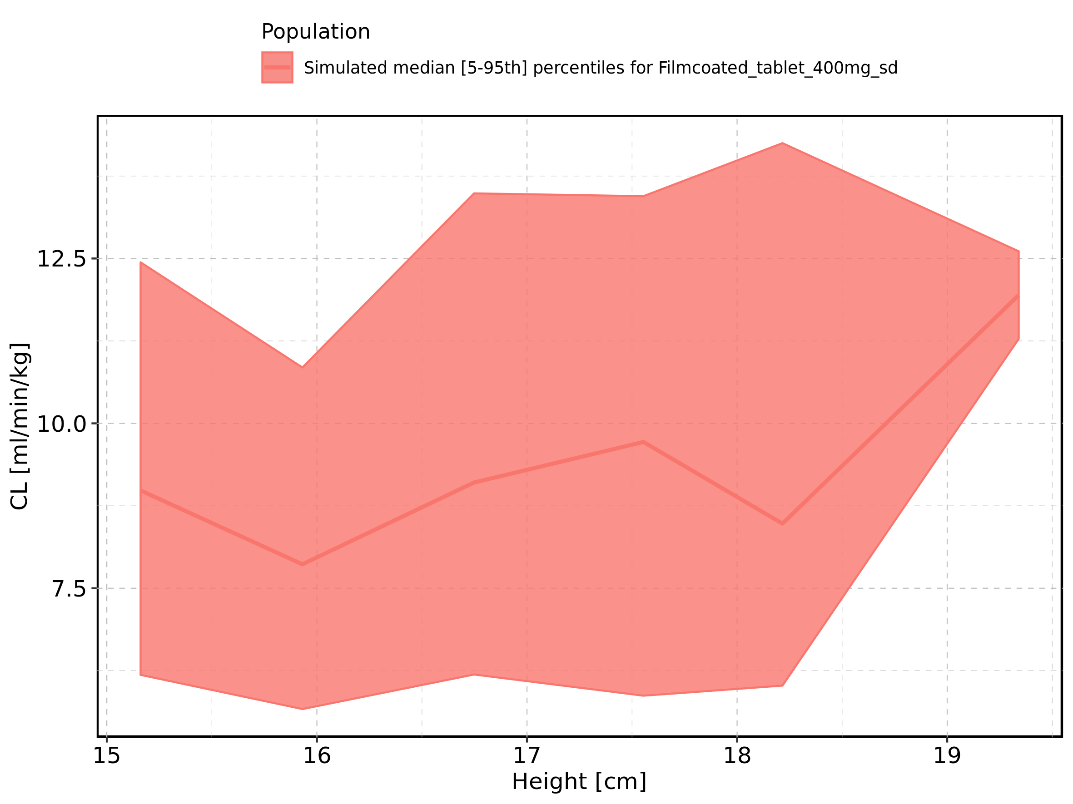

Figure 334: Height-dependence of CL for Filmcoated_tablet_400mg_sd. Profiles are plotted in a logarithmic scale.

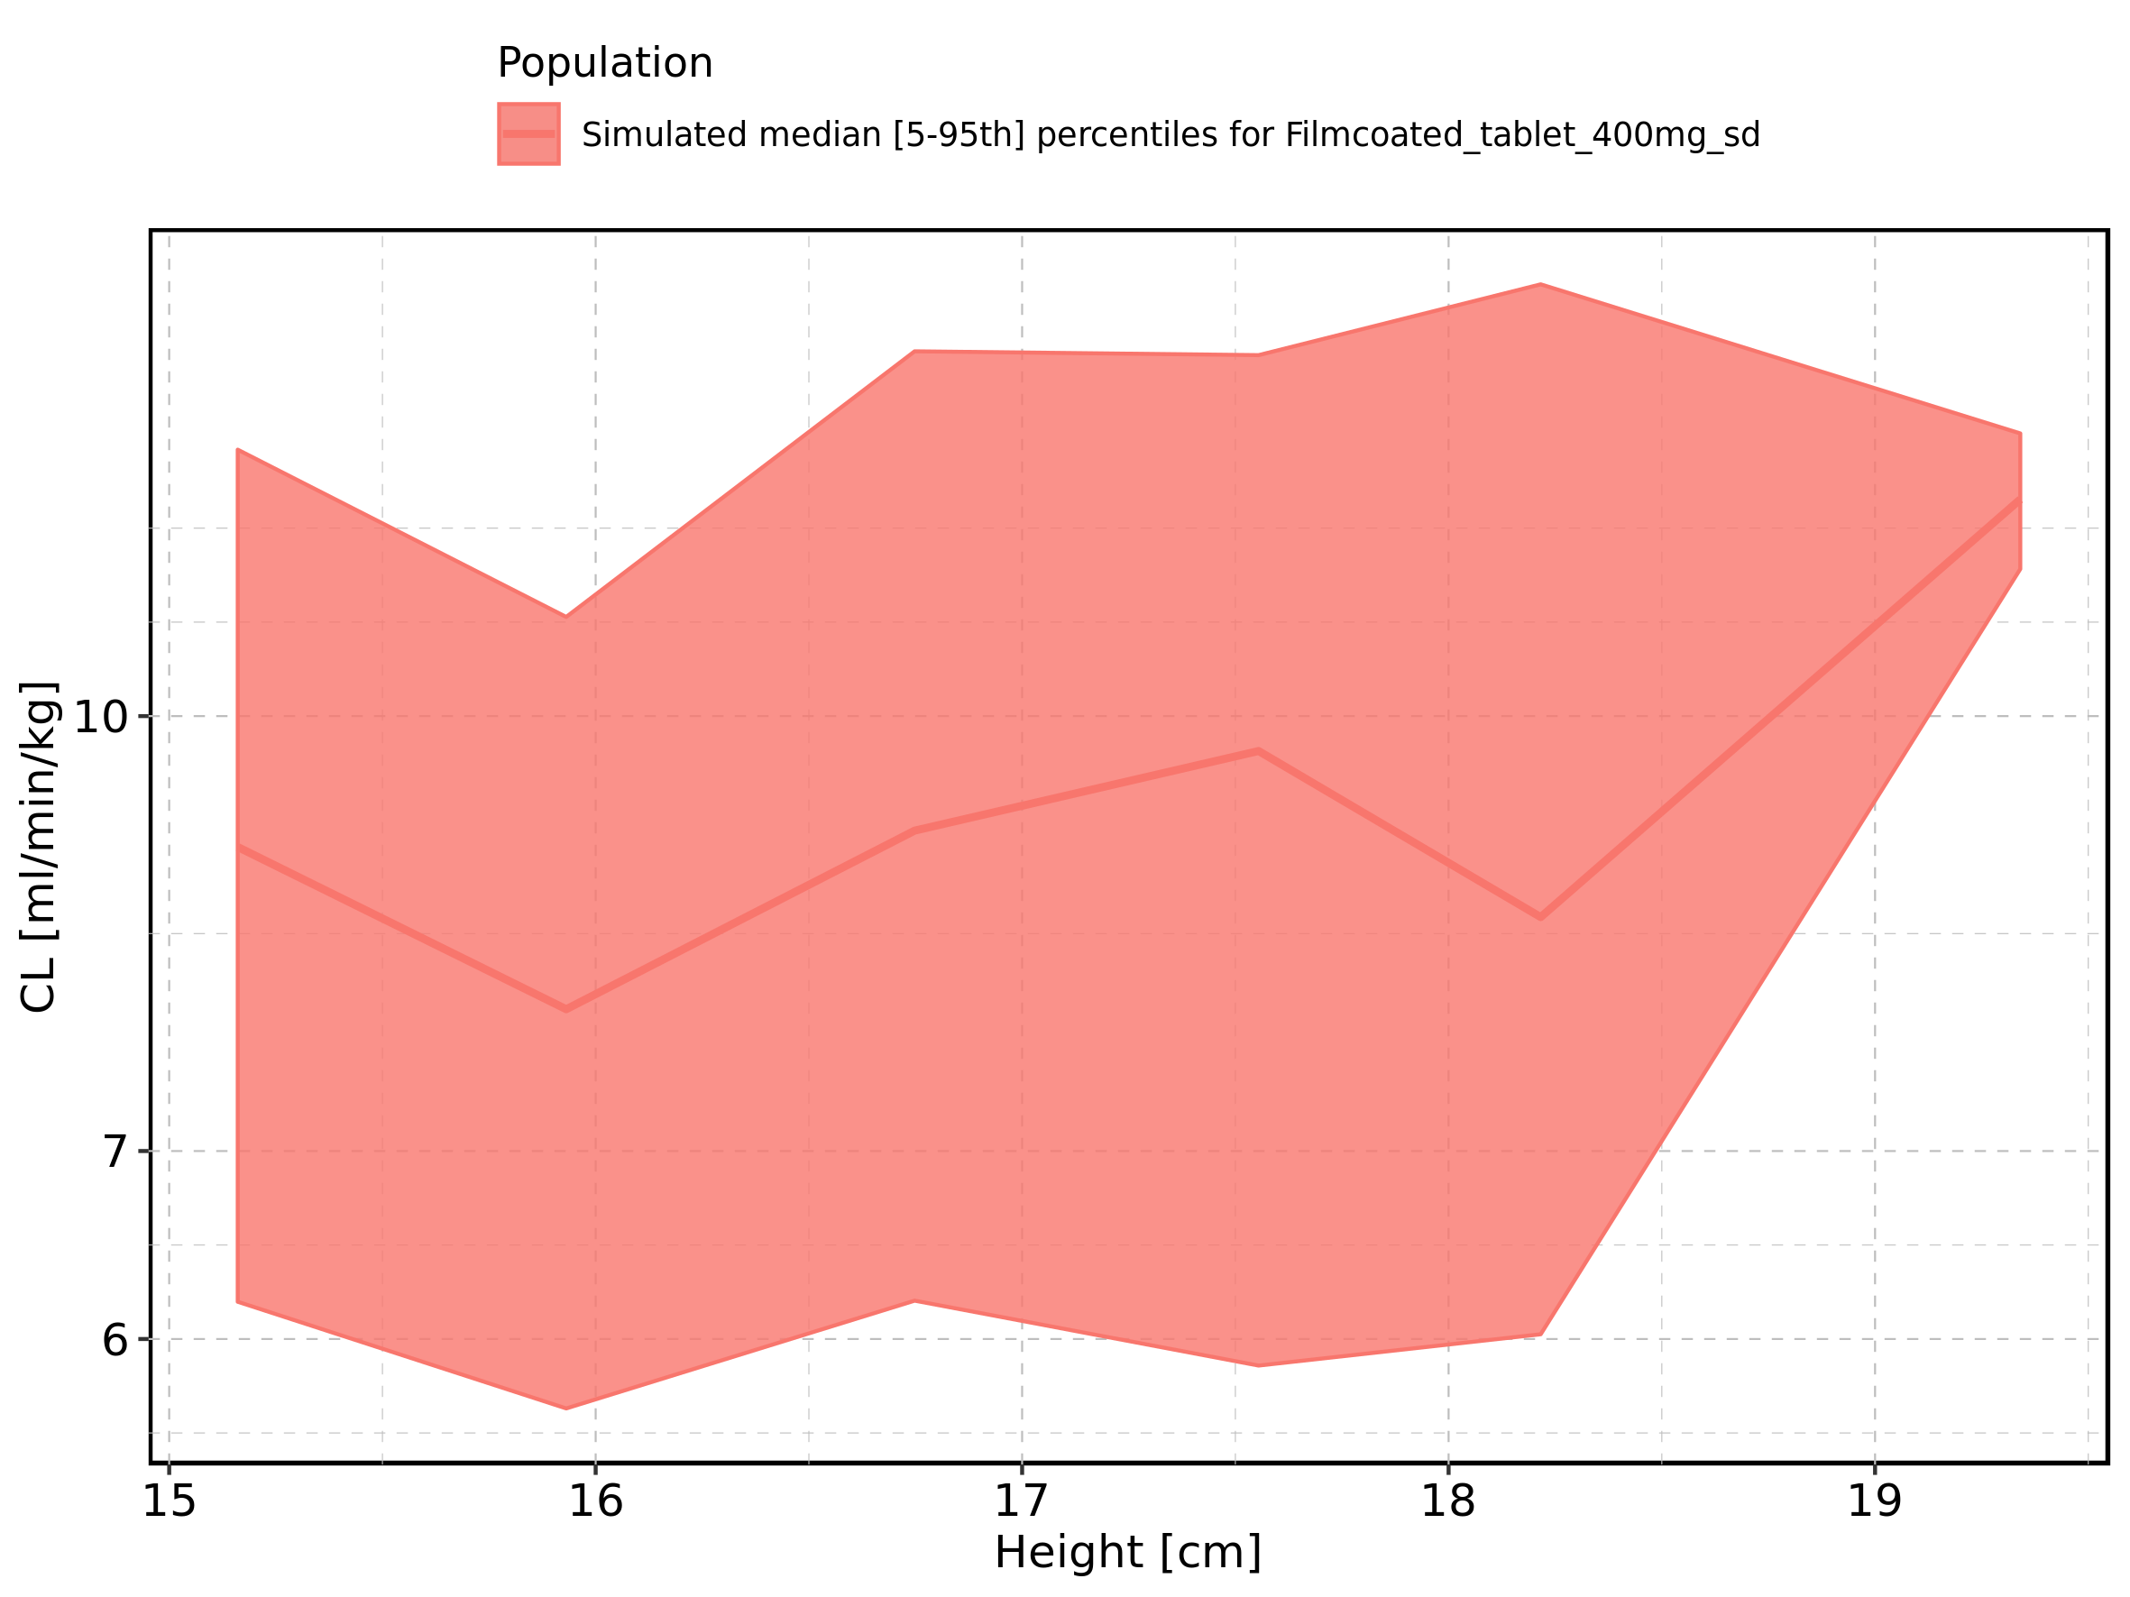

Figure 335: Weight-dependence of CL for Larson 2013 8y-18y 400mg FCT meal in comparison to Filmcoated_tablet_400mg_sd. Profiles are plotted in a linear scale.

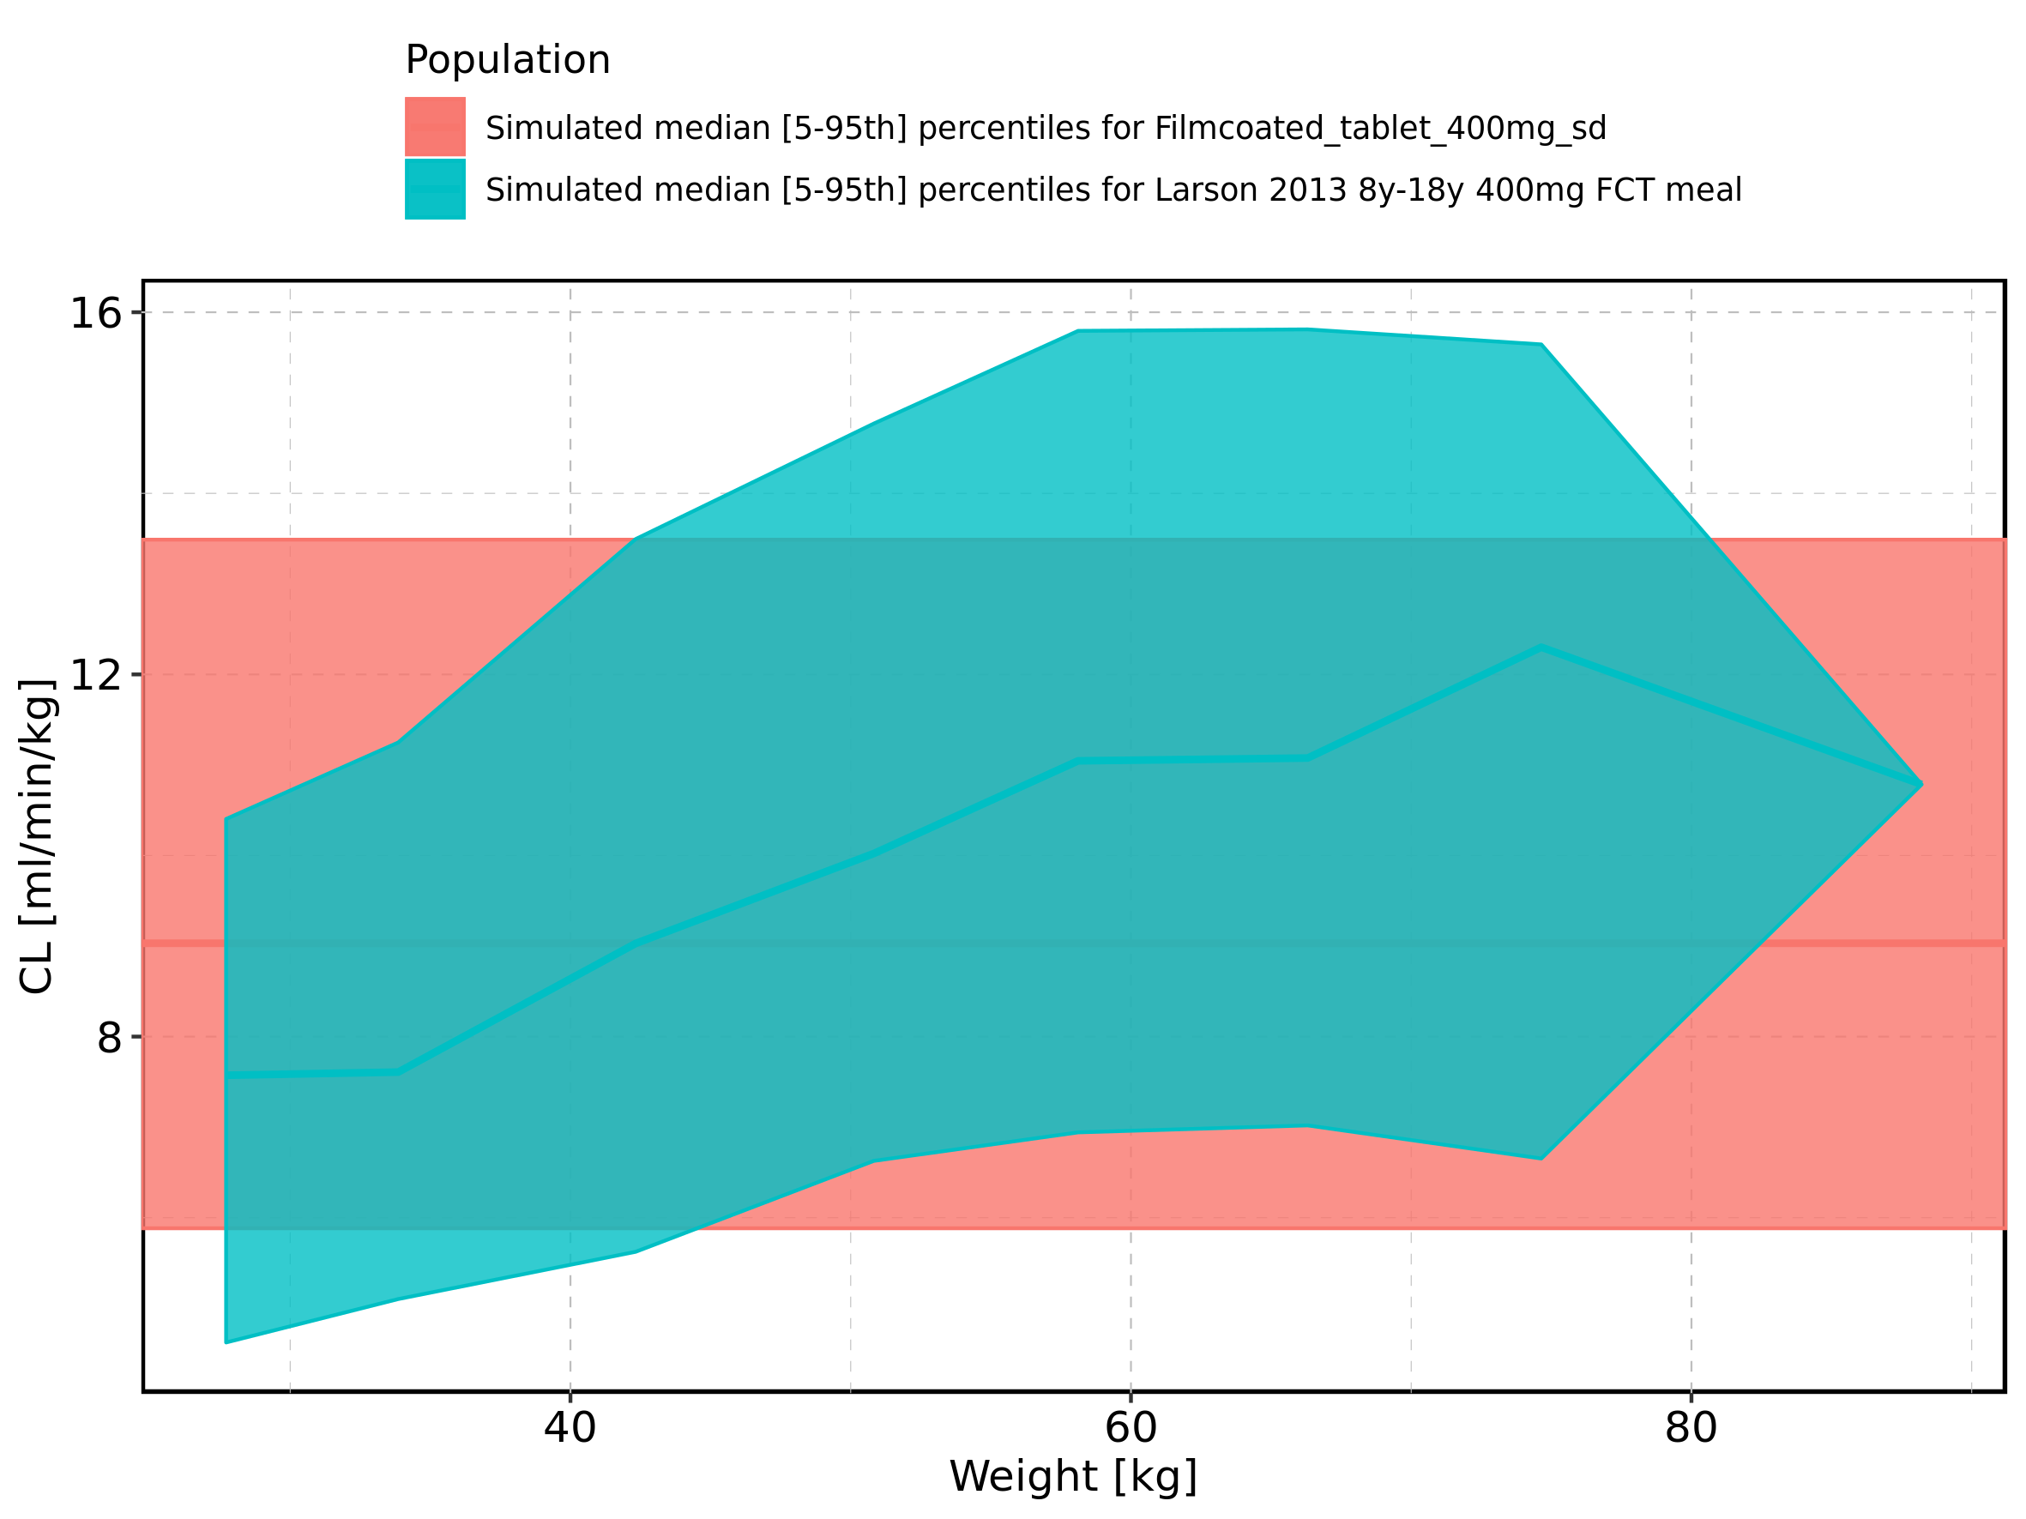

Figure 336: Weight-dependence of CL for Larson 2013 8y-18y 400mg FCT meal in comparison to Filmcoated_tablet_400mg_sd. Profiles are plotted in a logarithmic scale.

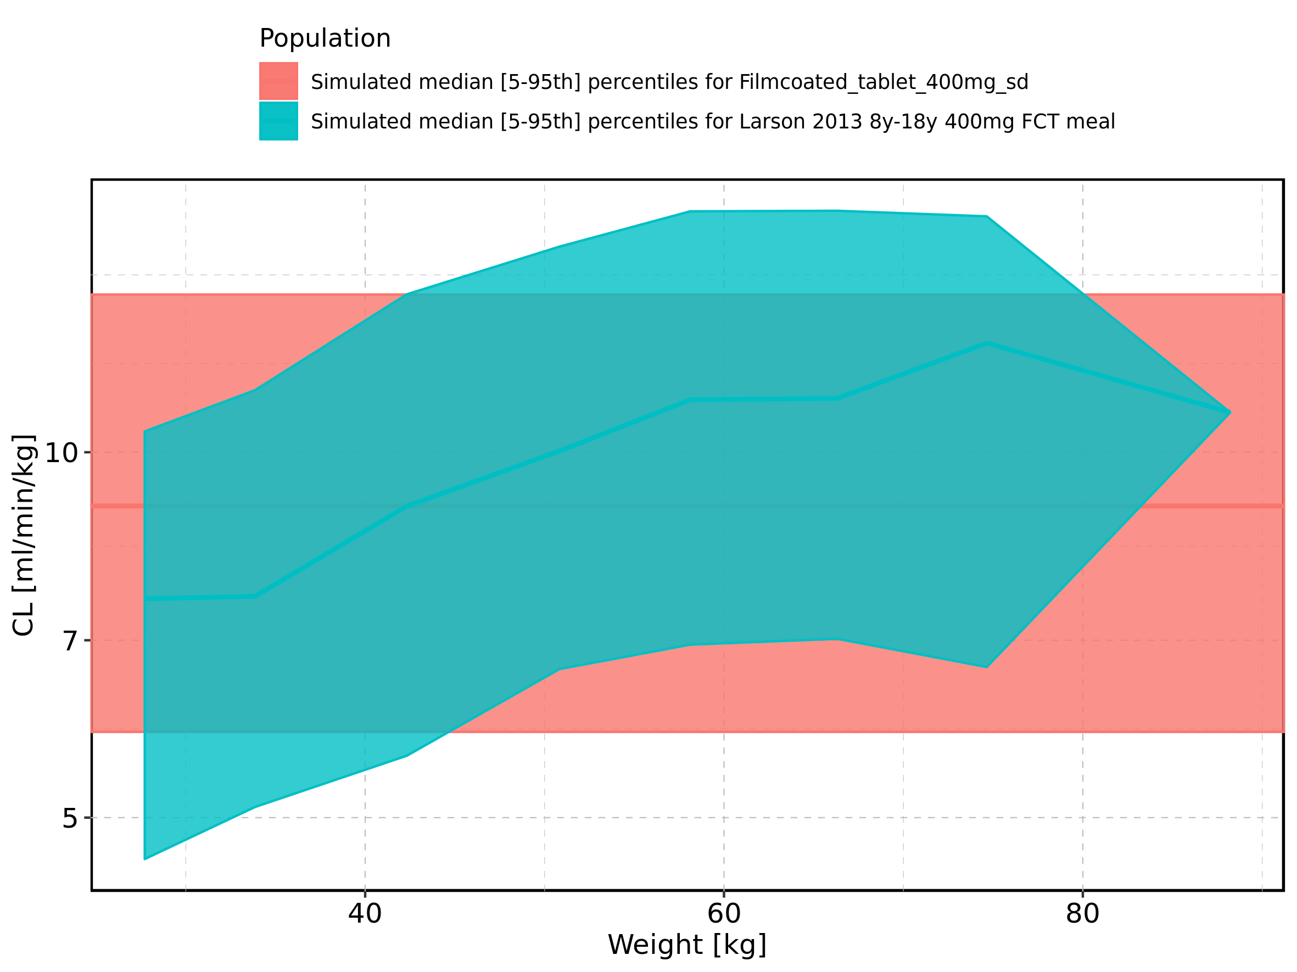

Figure 337: Weight-dependence of CL for Larson 2013 8y-18y 400mg FCT meal. Profiles are plotted in a linear scale.

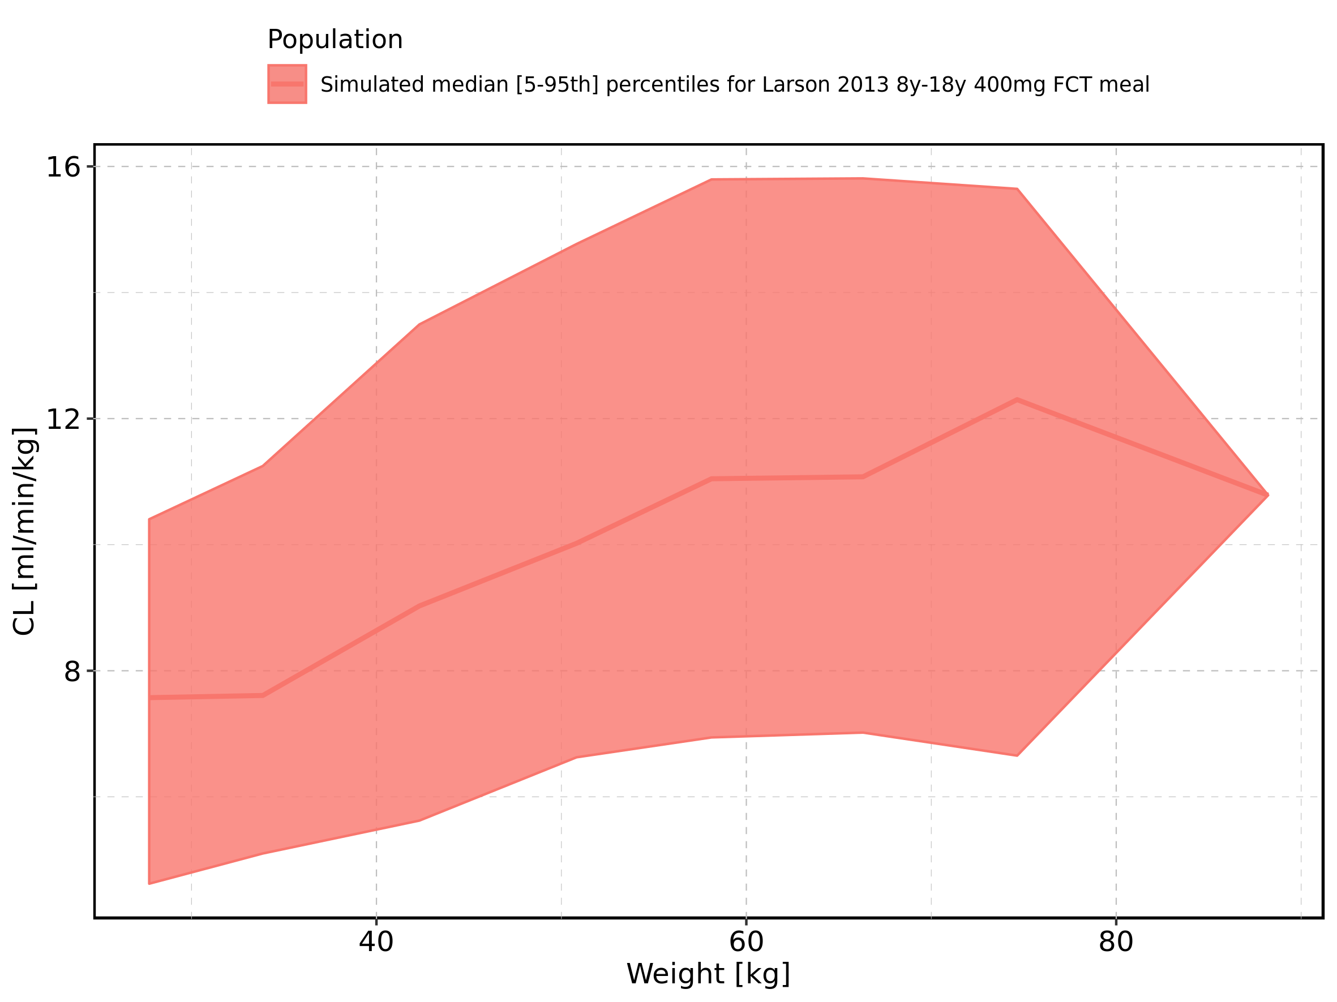

Figure 338: Weight-dependence of CL for Larson 2013 8y-18y 400mg FCT meal. Profiles are plotted in a logarithmic scale.

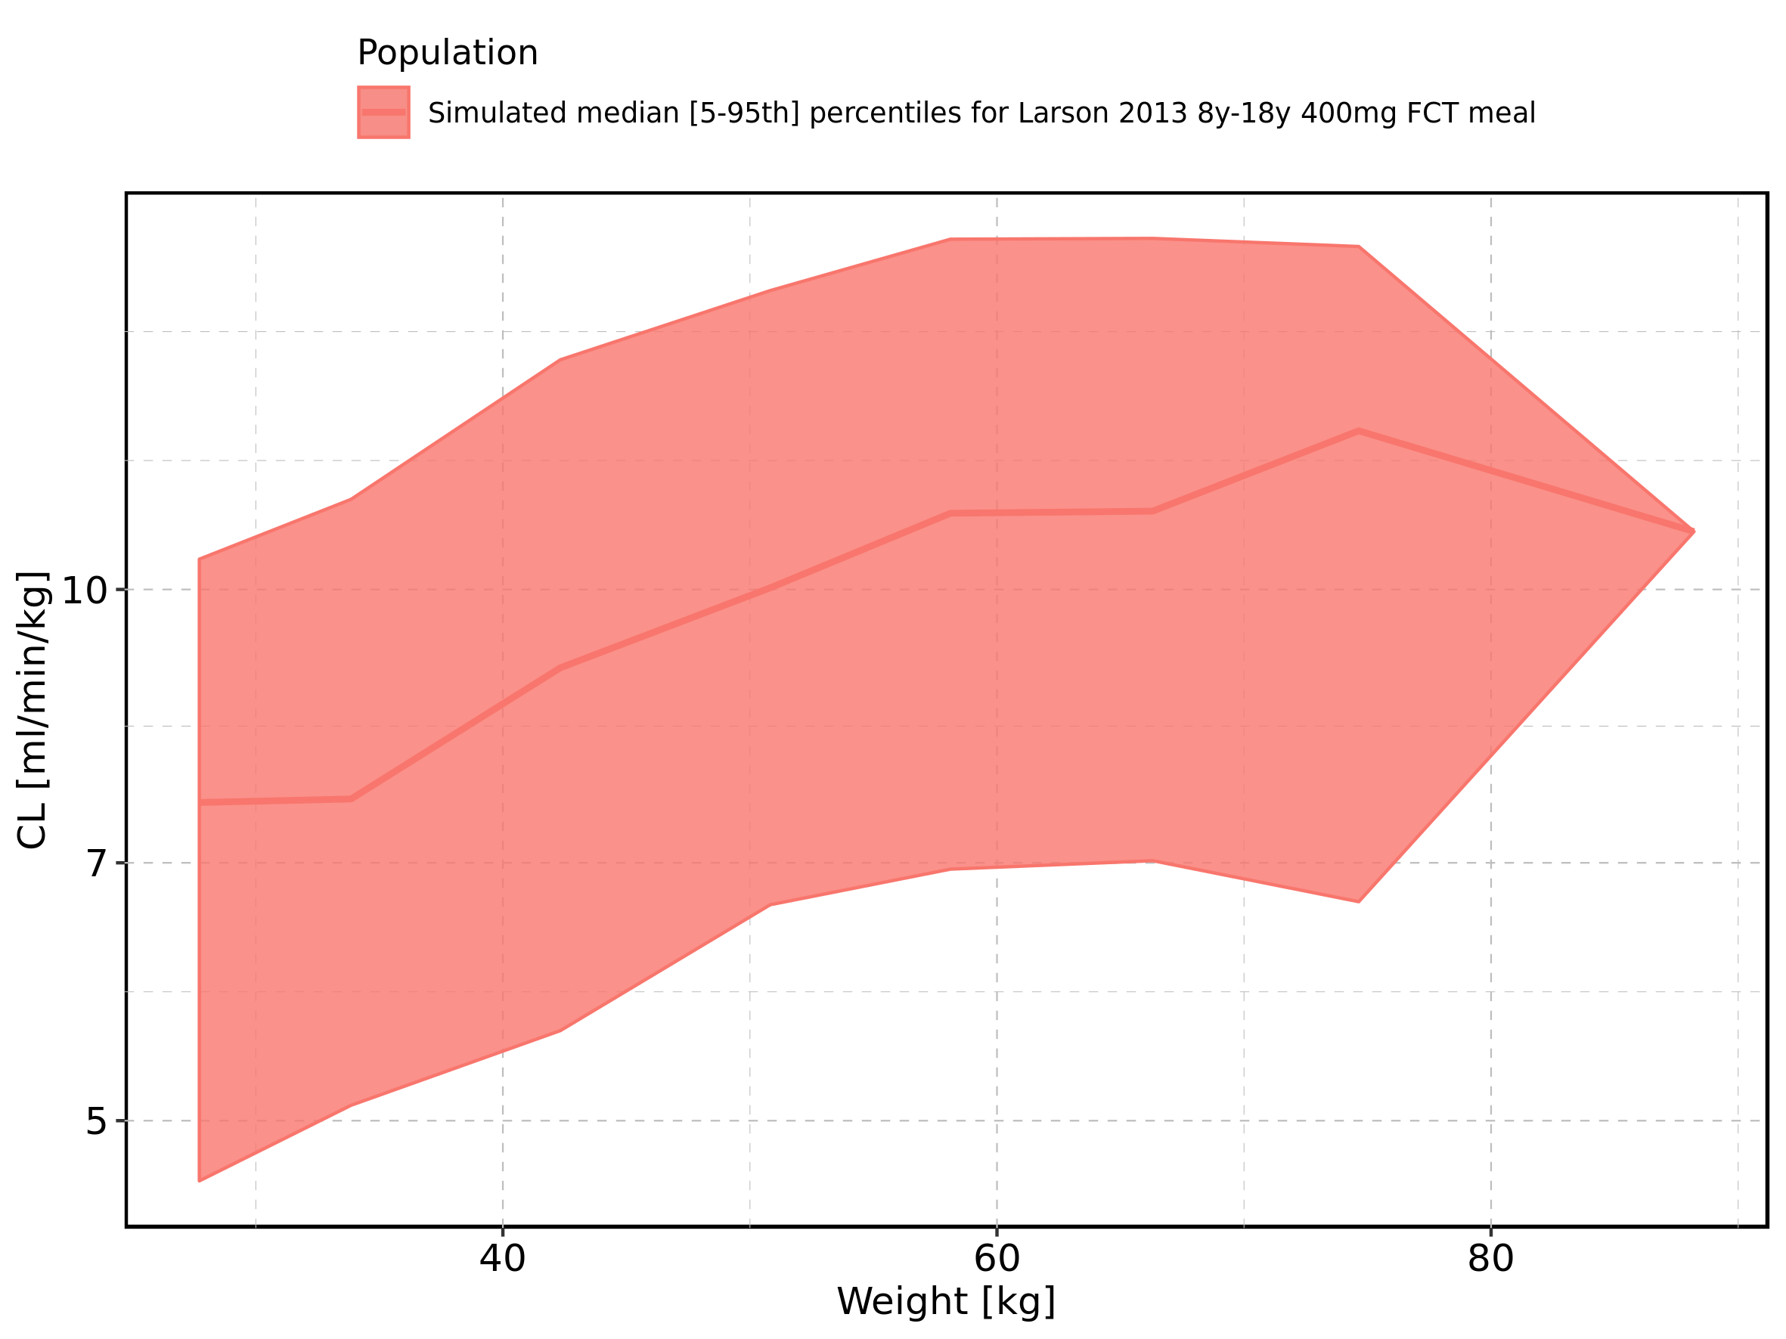

Figure 339: Weight-dependence of CL for Filmcoated_tablet_400mg_sd. Profiles are plotted in a linear scale.

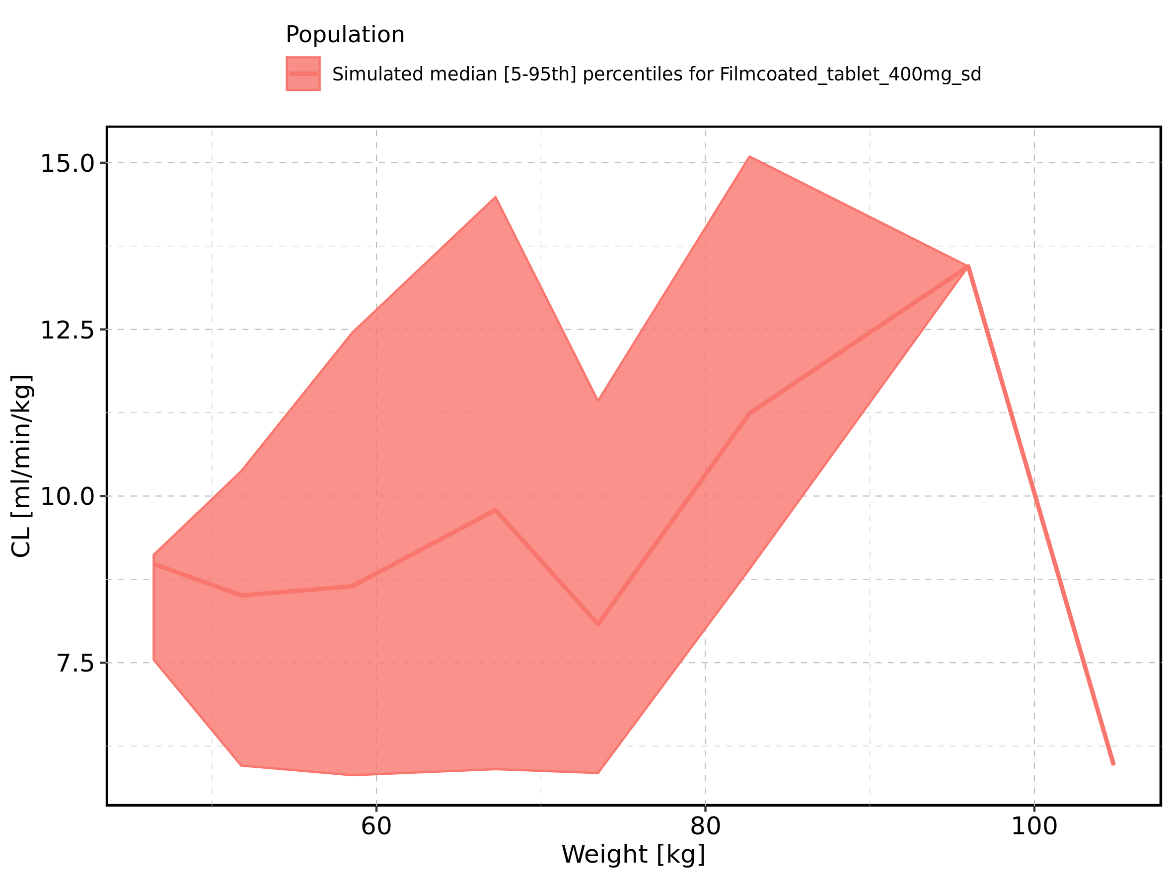

Figure 340: Weight-dependence of CL for Filmcoated_tablet_400mg_sd. Profiles are plotted in a logarithmic scale.

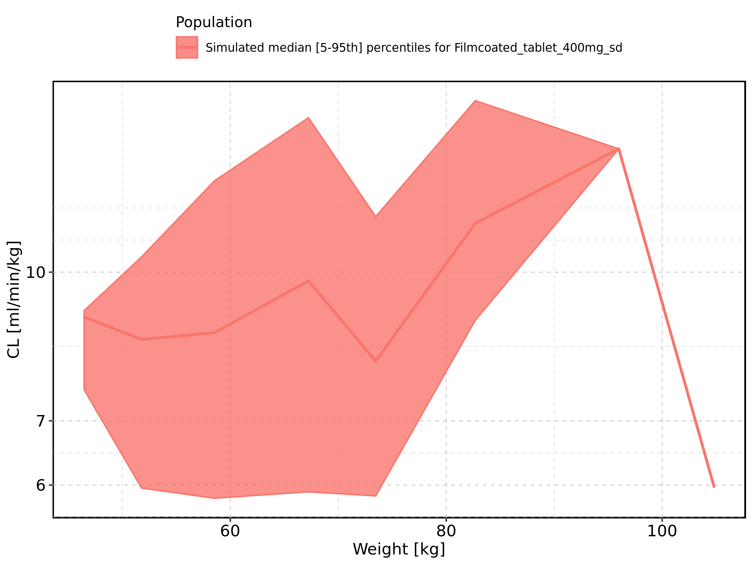

Figure 341: BMI-dependence of CL for Larson 2013 8y-18y 400mg FCT meal in comparison to Filmcoated_tablet_400mg_sd. Profiles are plotted in a linear scale.

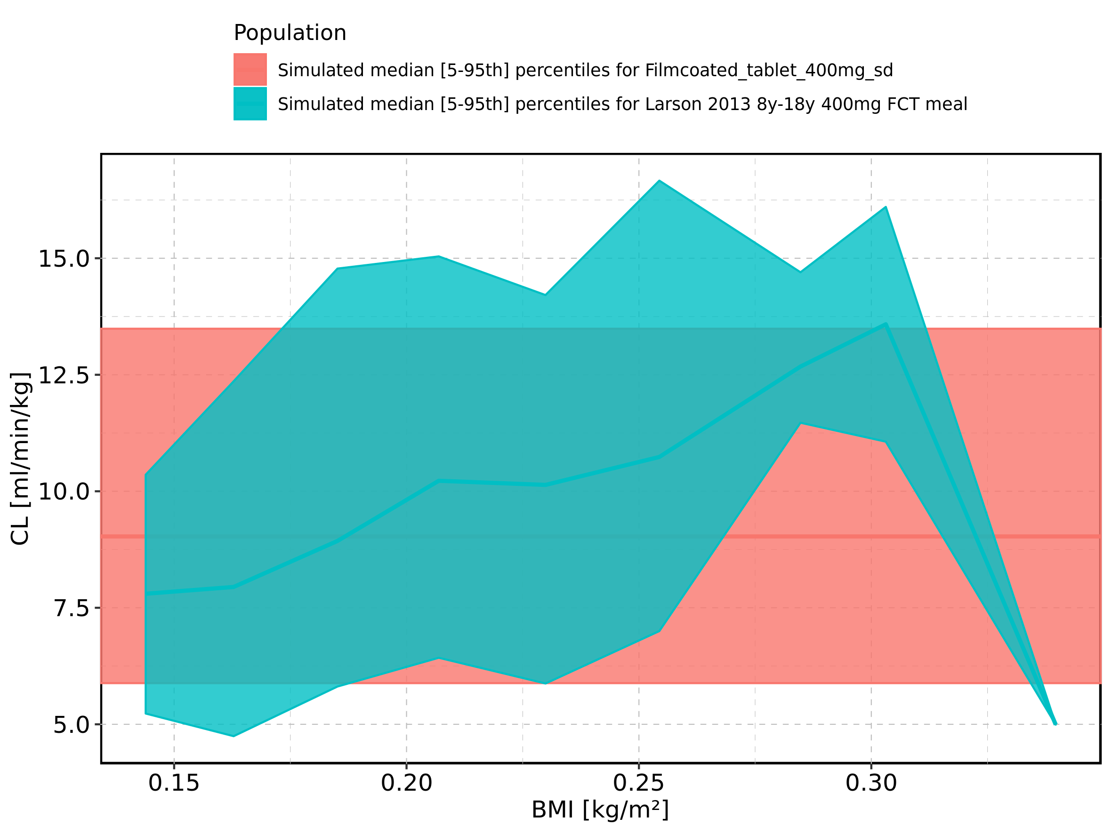

Figure 342: BMI-dependence of CL for Larson 2013 8y-18y 400mg FCT meal in comparison to Filmcoated_tablet_400mg_sd. Profiles are plotted in a logarithmic scale.

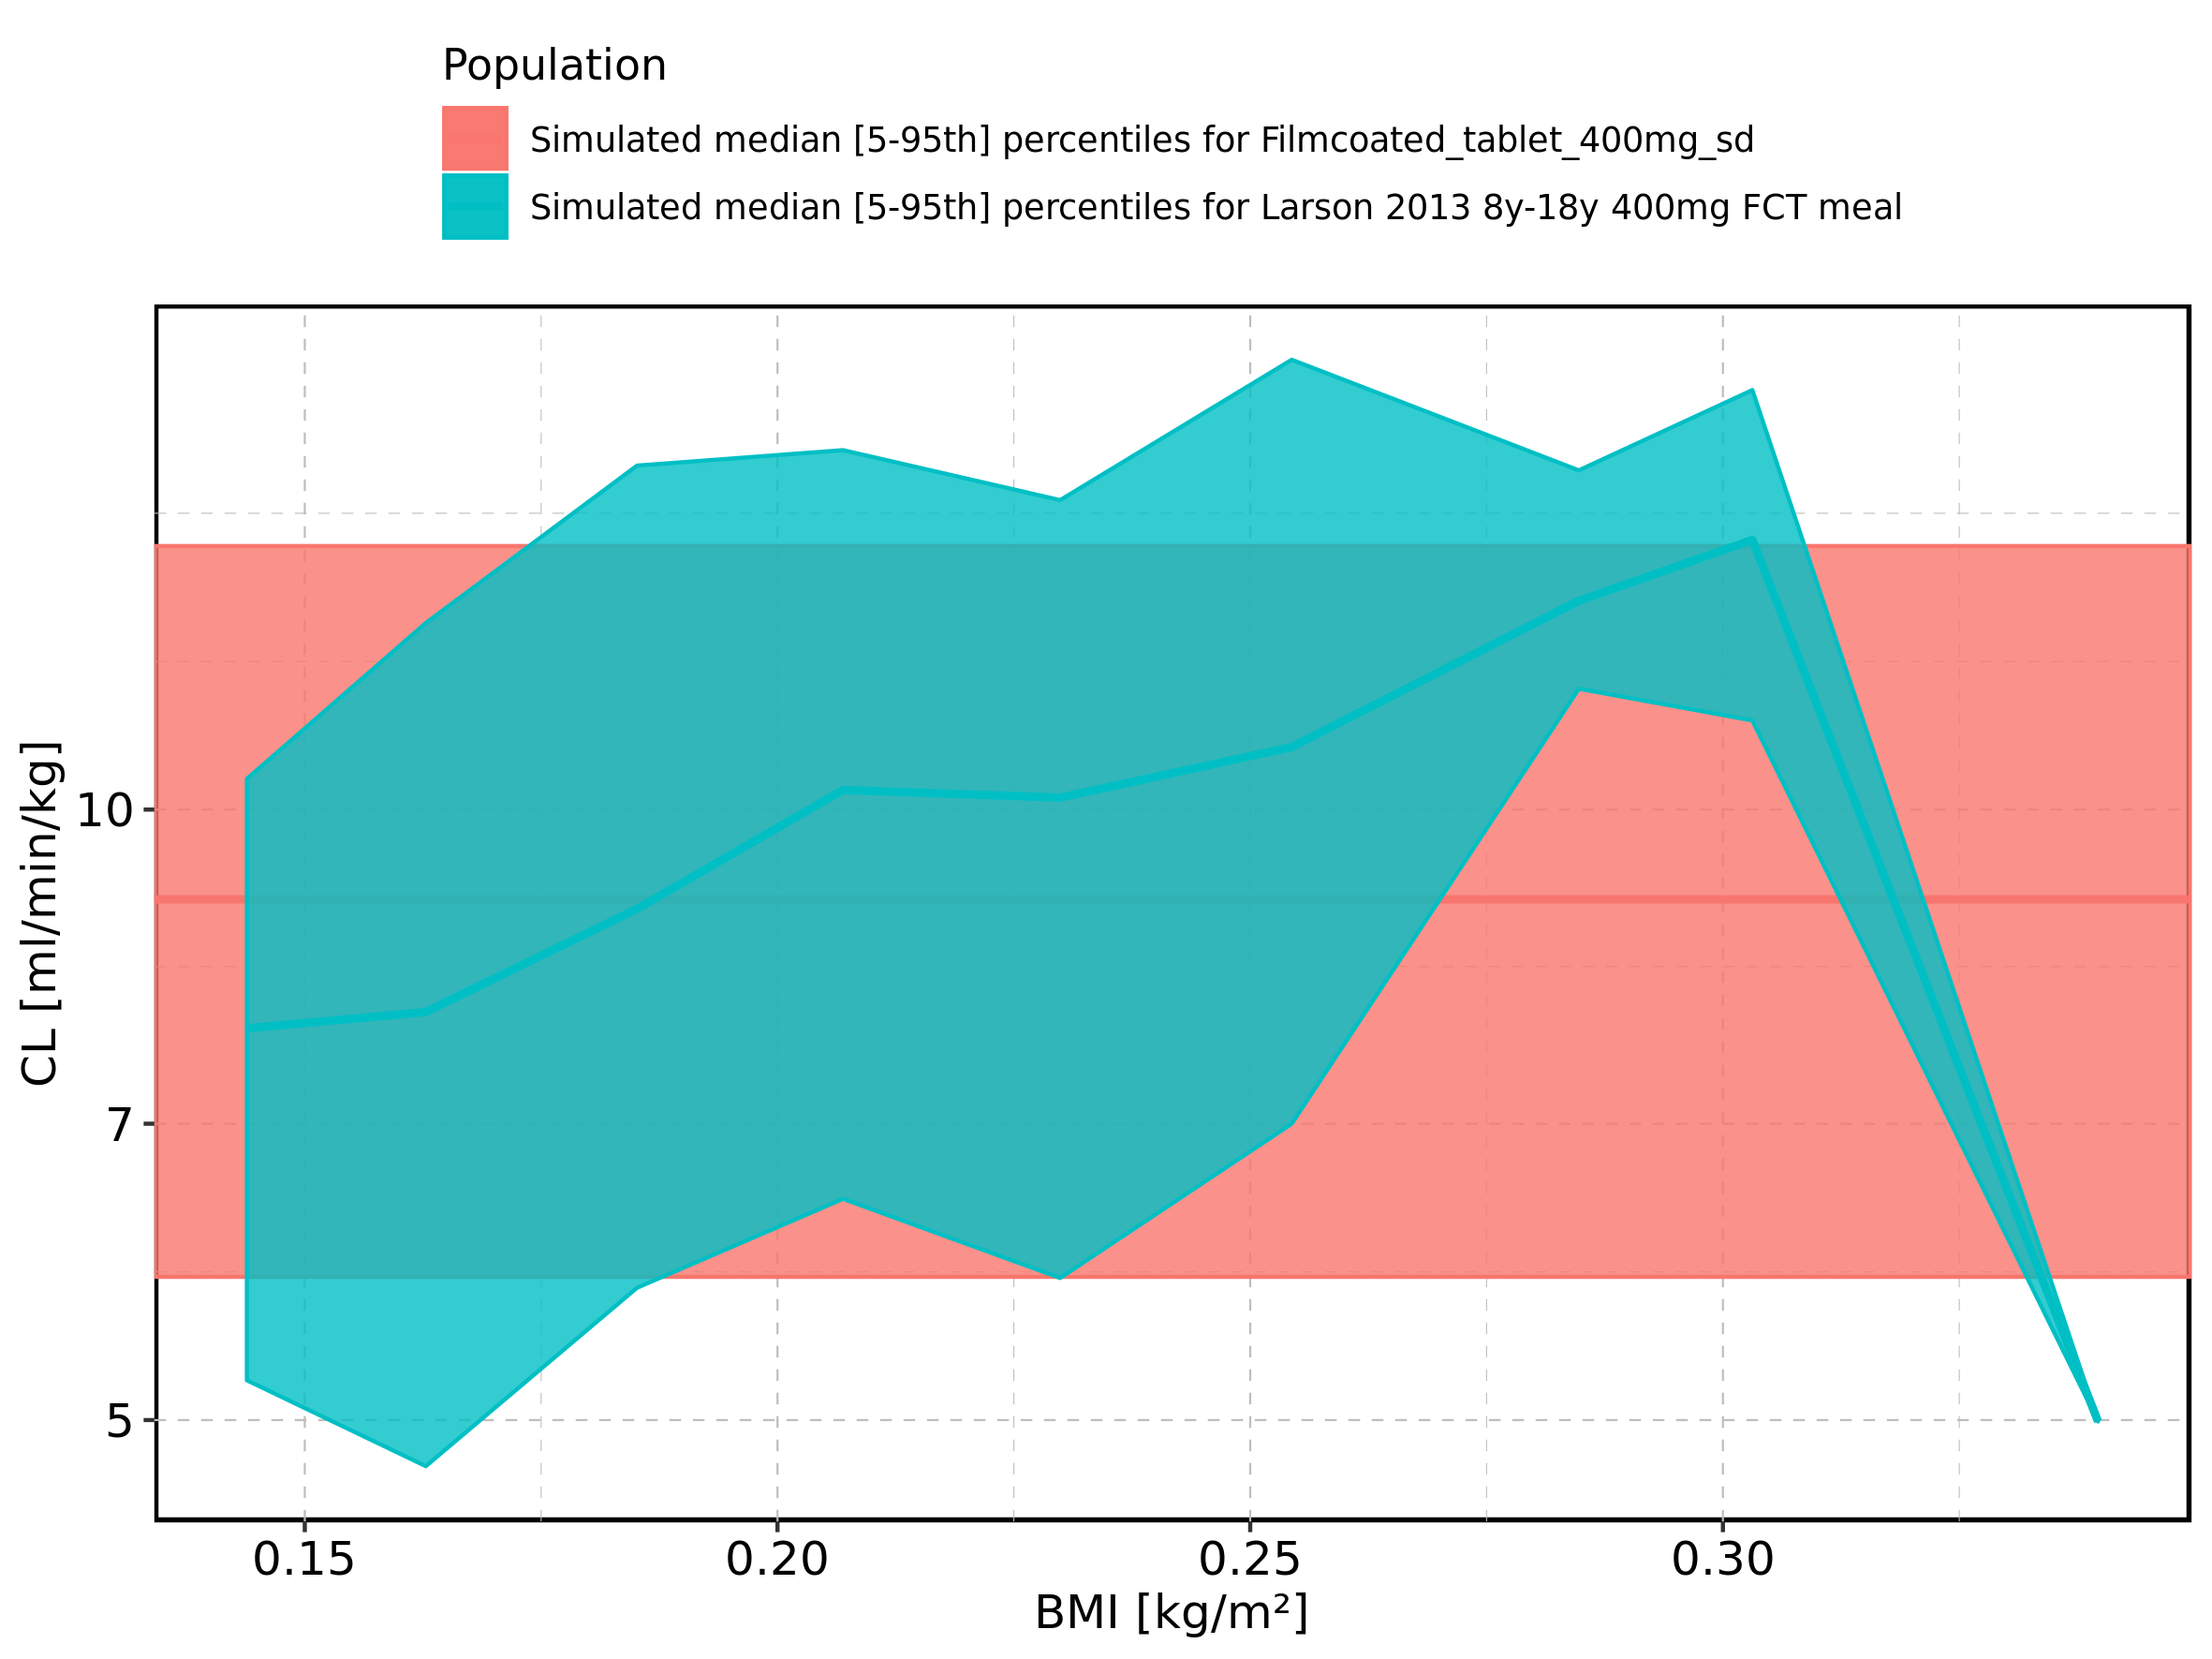

Figure 343: BMI-dependence of CL for Larson 2013 8y-18y 400mg FCT meal. Profiles are plotted in a linear scale.

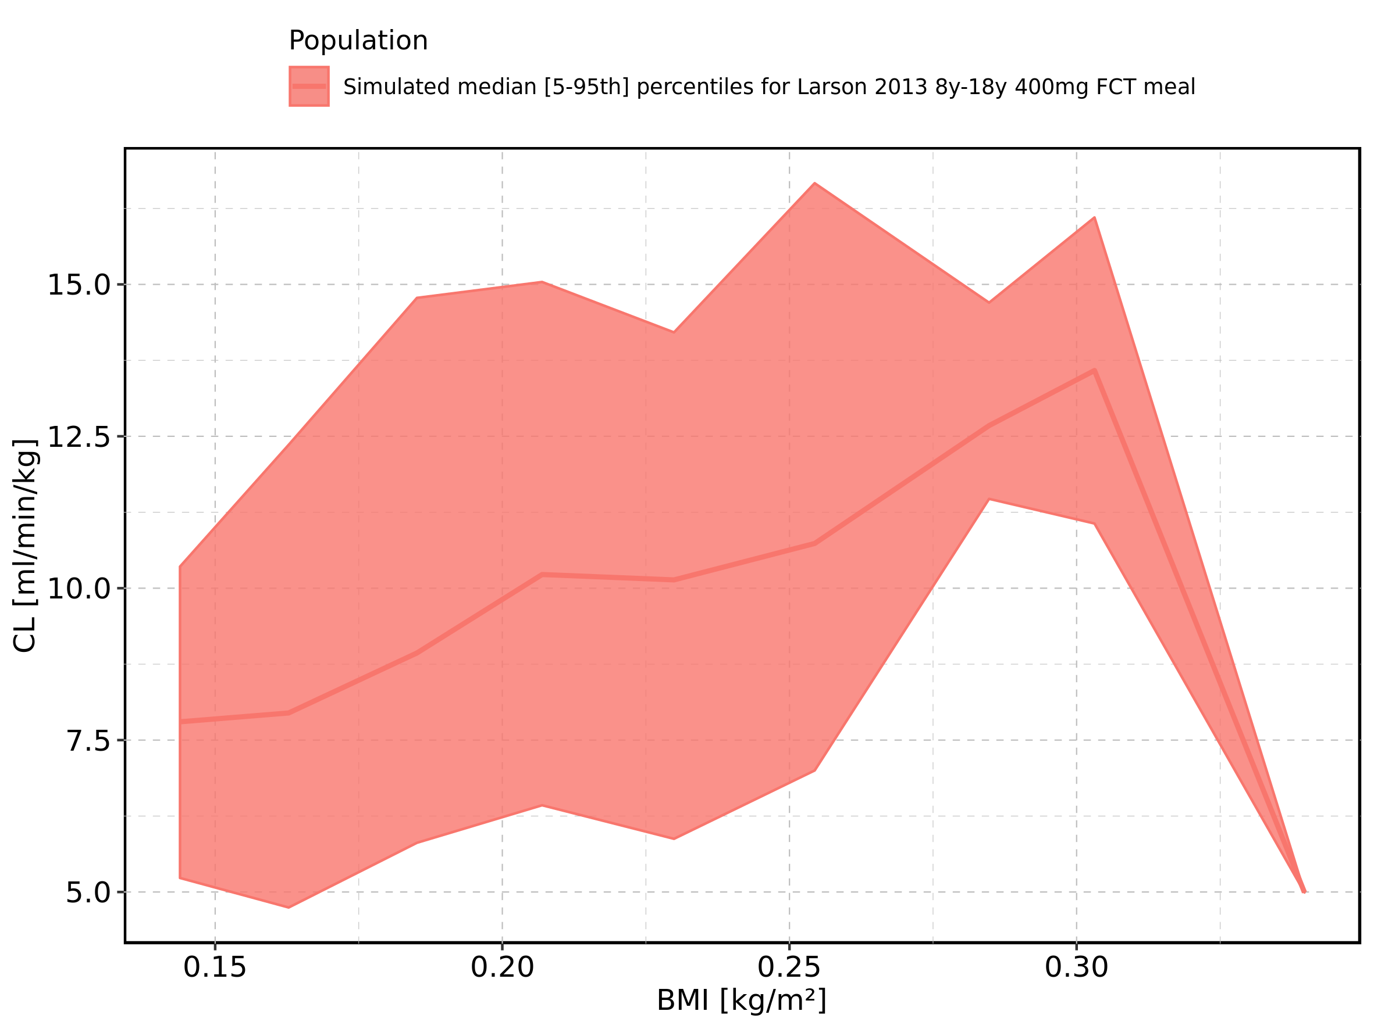

Figure 344: BMI-dependence of CL for Larson 2013 8y-18y 400mg FCT meal. Profiles are plotted in a logarithmic scale.

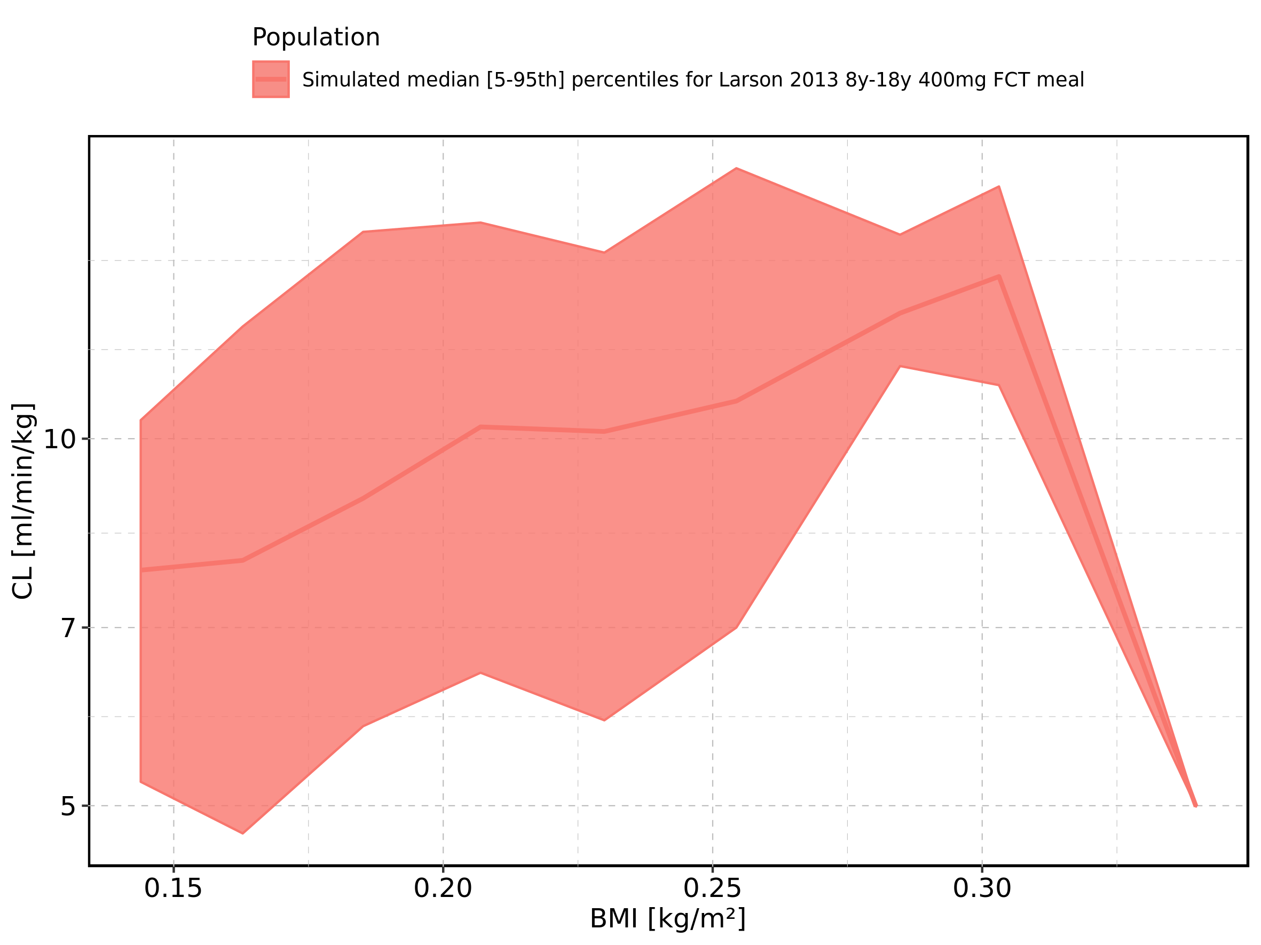

Figure 345: BMI-dependence of CL for Filmcoated_tablet_400mg_sd. Profiles are plotted in a linear scale.

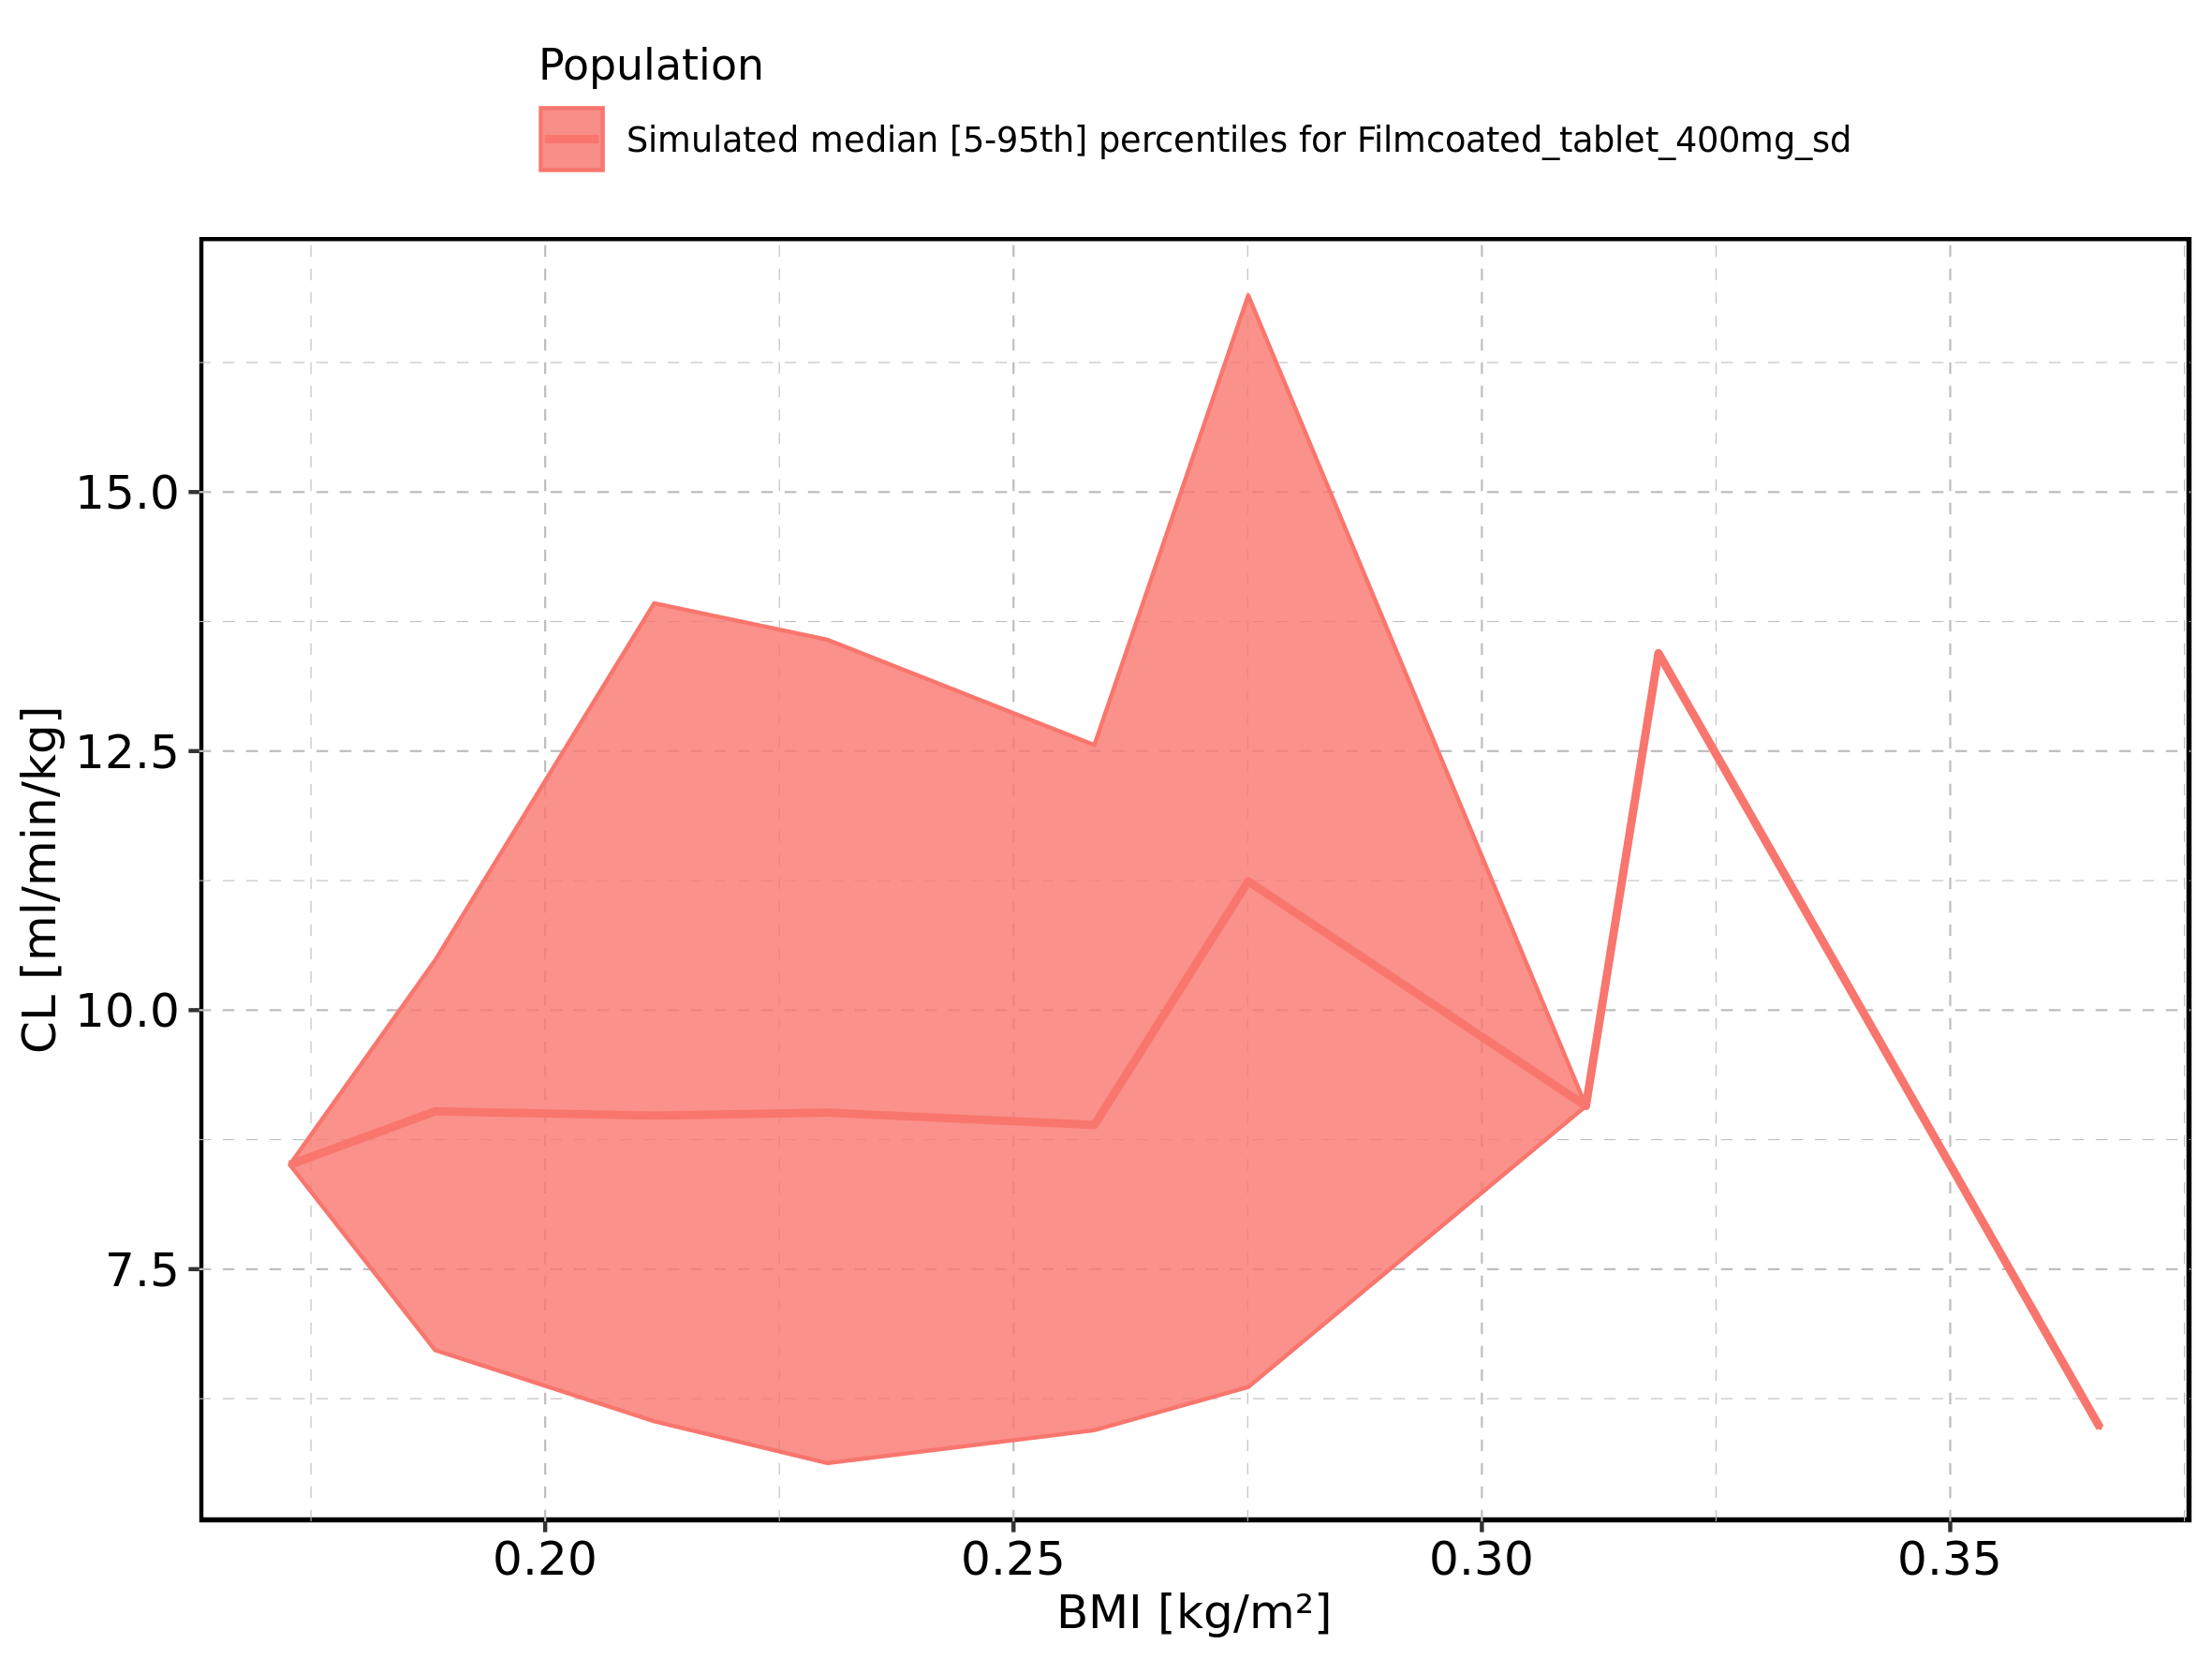

Figure 346: BMI-dependence of CL for Filmcoated_tablet_400mg_sd. Profiles are plotted in a logarithmic scale.

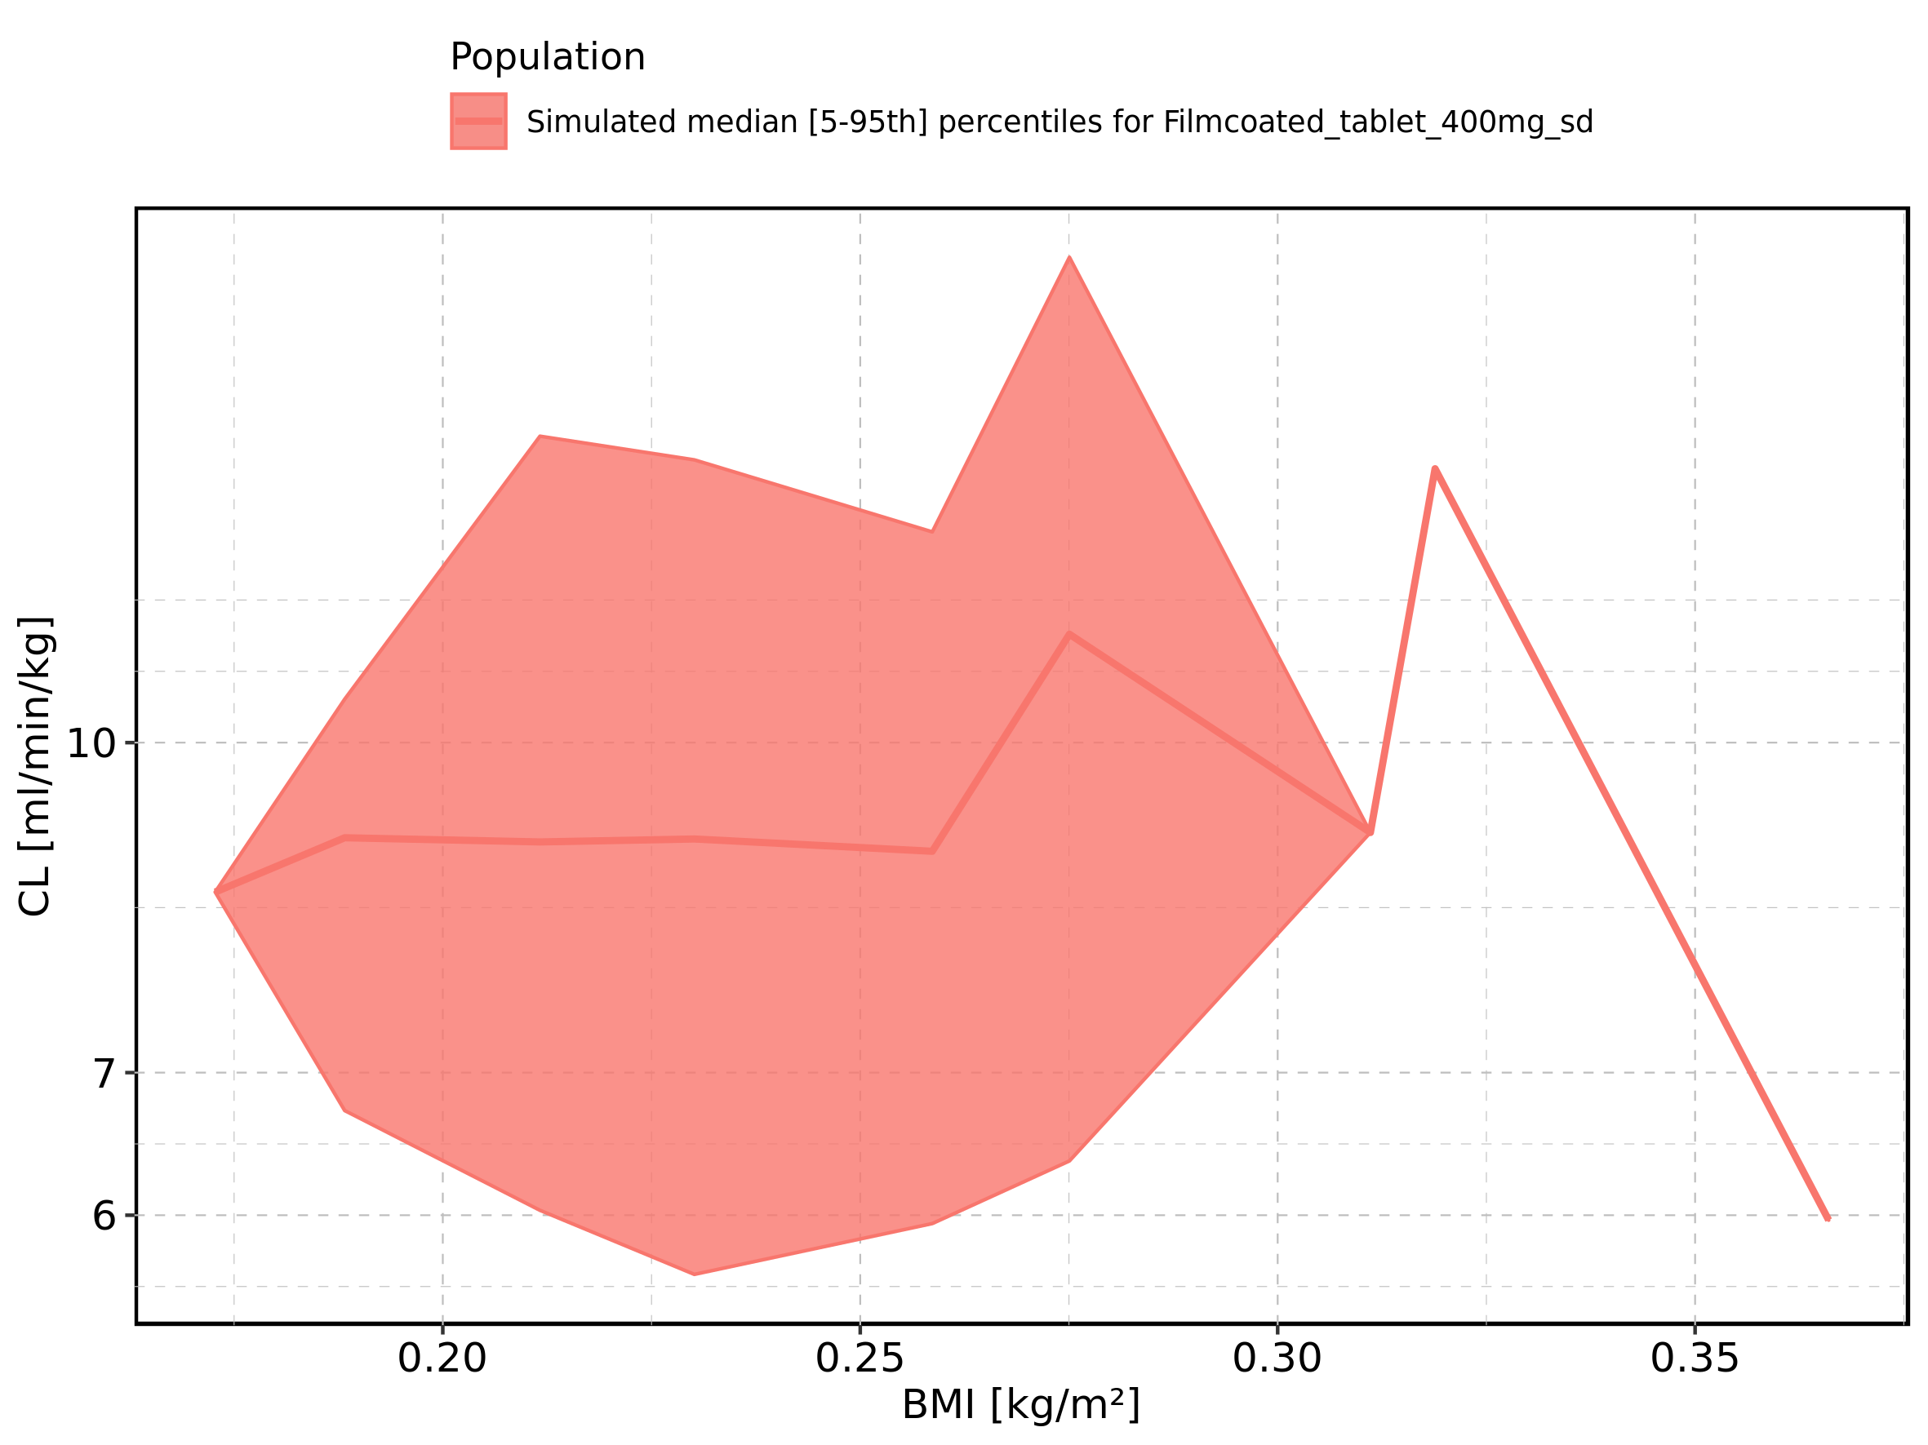

Figure 347: Gender-dependence of CL for Larson 2013 8y-18y 400mg FCT meal in comparison to Filmcoated_tablet_400mg_sd. Profiles are plotted in a linear scale.

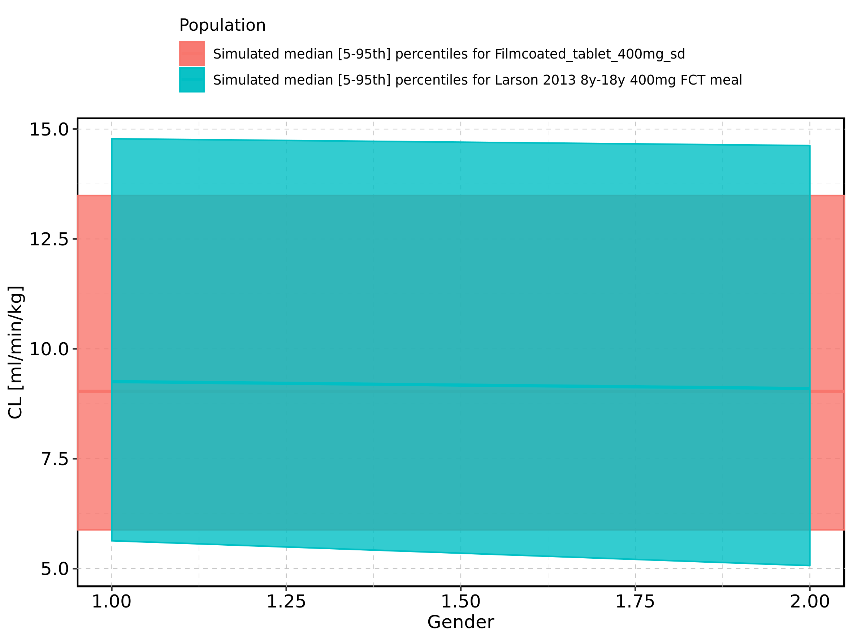

Figure 348: Gender-dependence of CL for Larson 2013 8y-18y 400mg FCT meal in comparison to Filmcoated_tablet_400mg_sd. Profiles are plotted in a logarithmic scale.

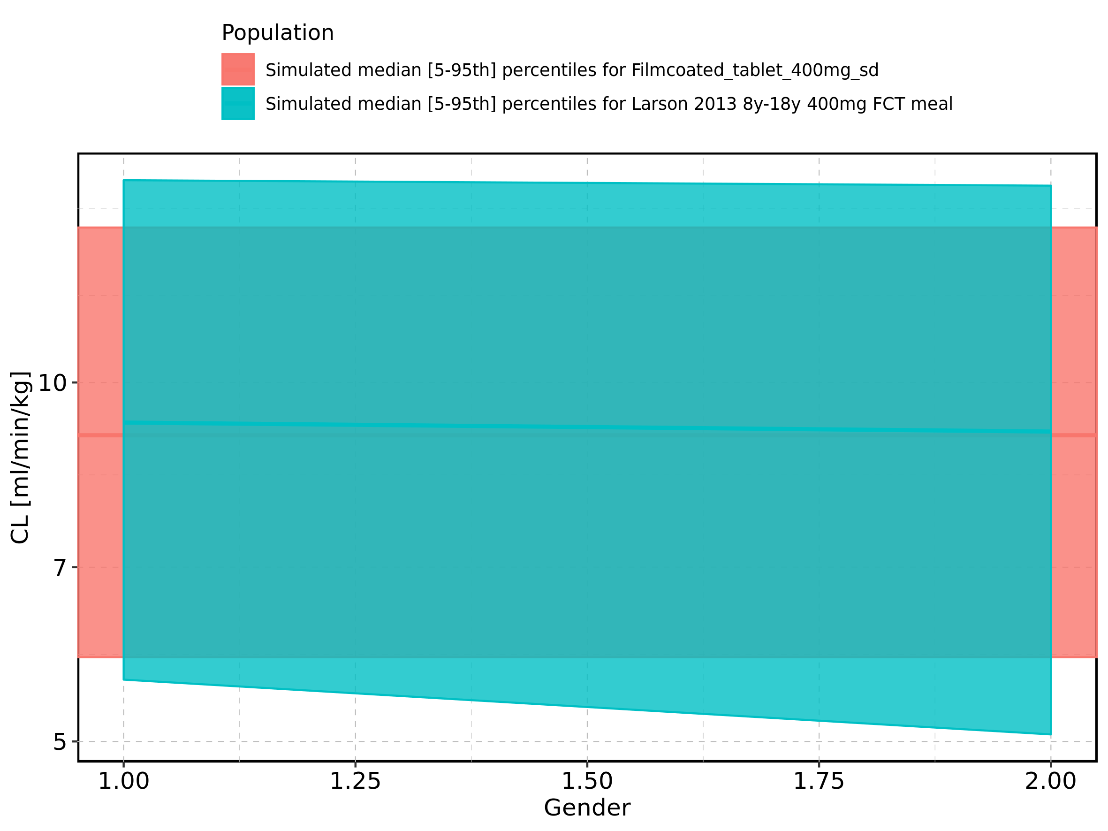

Figure 349: Gender-dependence of CL for Larson 2013 8y-18y 400mg FCT meal. Profiles are plotted in a linear scale.

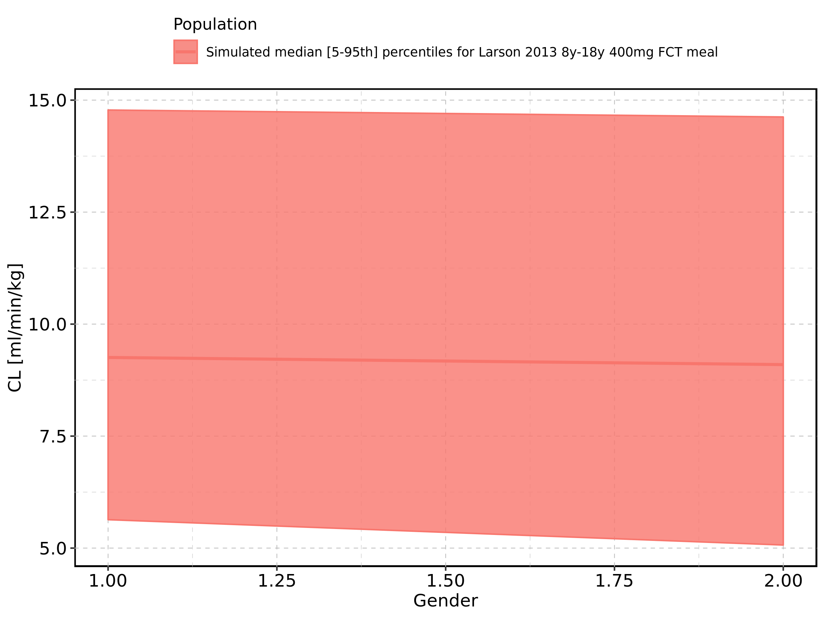

Figure 350: Gender-dependence of CL for Larson 2013 8y-18y 400mg FCT meal. Profiles are plotted in a logarithmic scale.

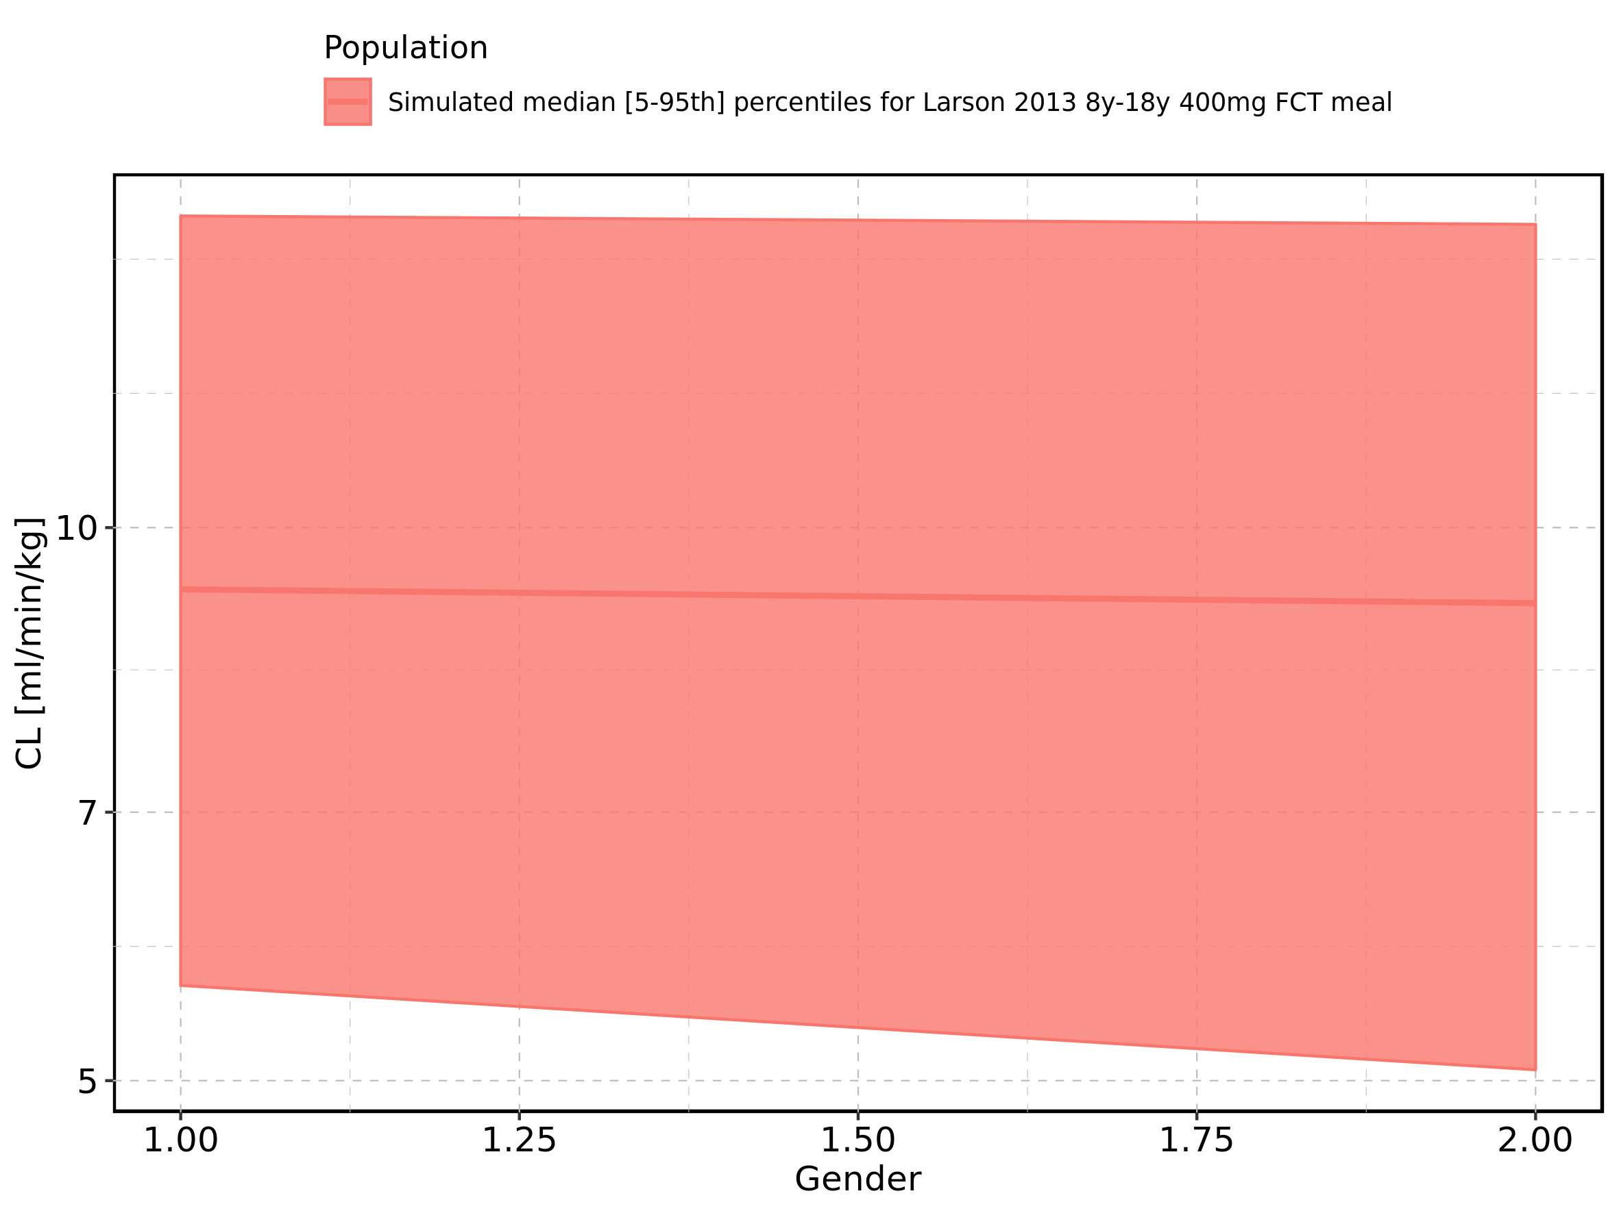

Figure 351: Gender-dependence of CL for Filmcoated_tablet_400mg_sd. Profiles are plotted in a linear scale.

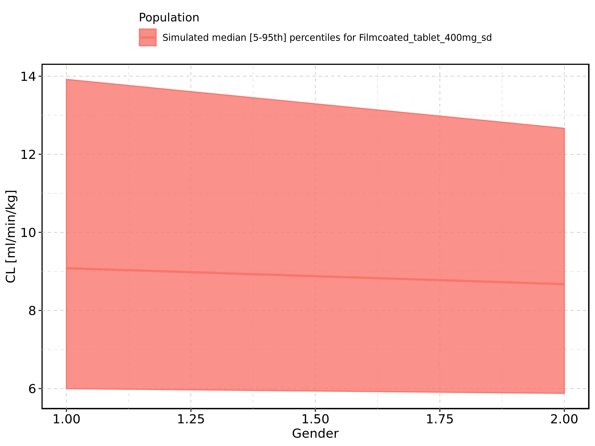

Figure 352: Gender-dependence of CL for Filmcoated_tablet_400mg_sd. Profiles are plotted in a logarithmic scale.

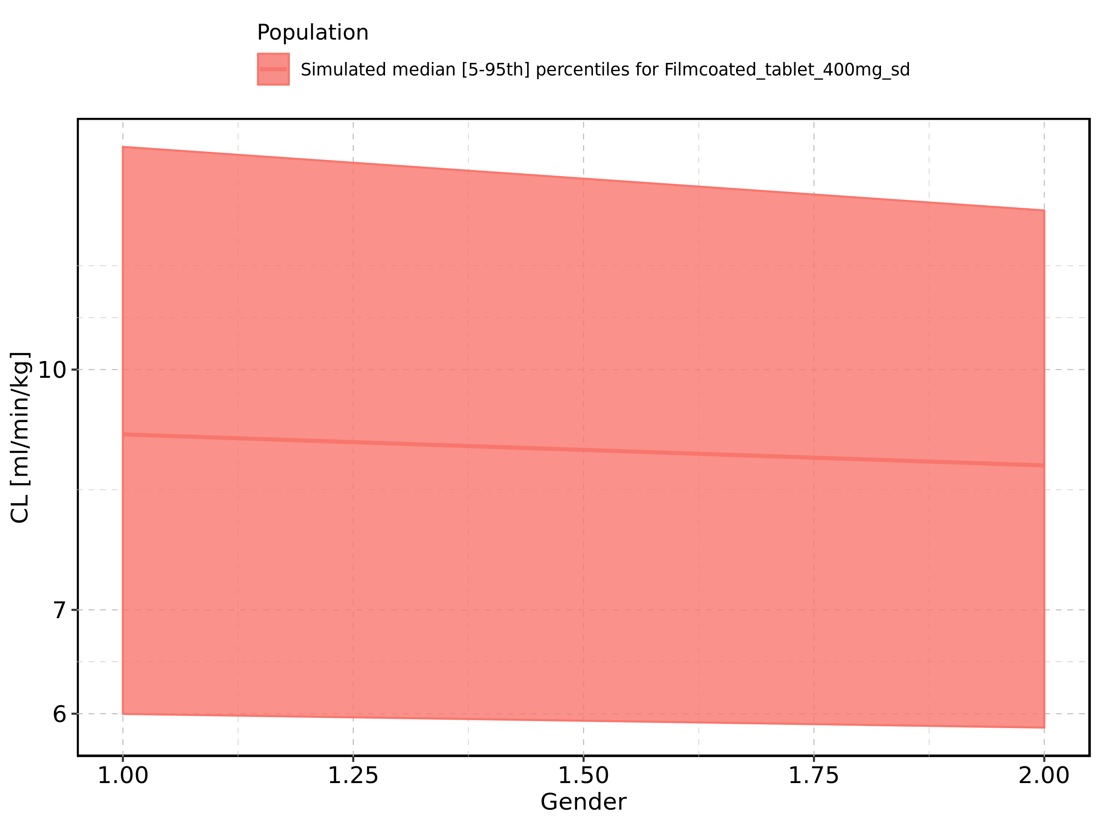

Figure 353: Vss of Raltegravir shown as box-whisker plot, which indicates the 5th, 25th, 50th, 75th, and 95th percentiles in linear scale.

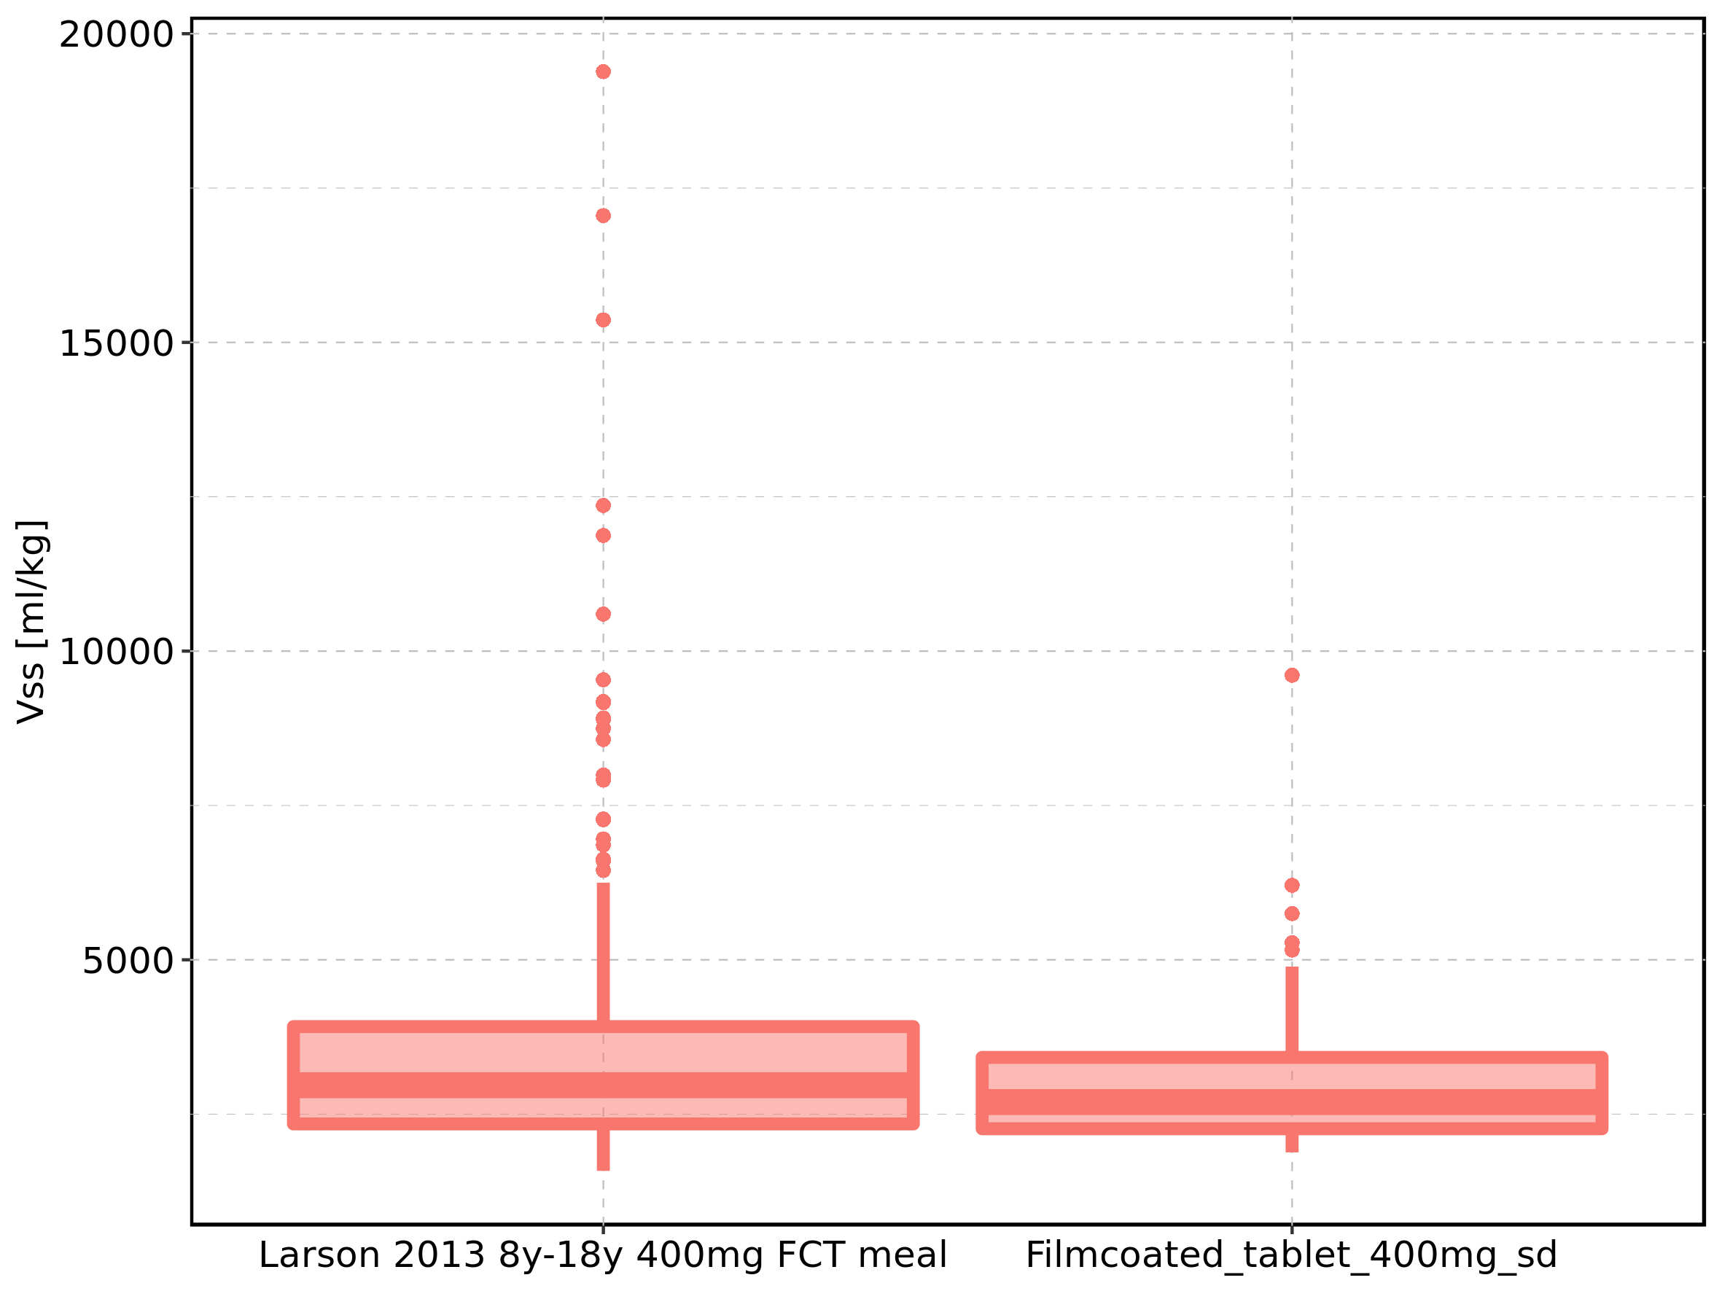

|  |  |  |  |  |  |  |  |  |  |  |
| --- | --- | --- | --- | --- | --- | --- | --- | --- | --- | --- |
| Population | N | 5th percentile | 25th percentile | 50th percentile | 75th percentile | 95th percentile | mean | standard deviation | geo mean | geo standard deviation |
| Larson 2013 8y-18y 400mg FCT meal | 497 | 1581.086 | 2341.617 | 2968.180 | 3917.840 | 6249.022 | 3396.626 | 1880.053 | 3071.482 | 1.528279 |
| Filmcoated_tablet_400mg_sd | 100 | 1880.267 | 2263.552 | 2695.832 | 3418.902 | 4890.574 | 2993.695 | 1138.953 | 2836.187 | 1.369004 |

Figure 354: Vss of Raltegravir shown as box-whisker plot, which indicates the 5th, 25th, 50th, 75th, and 95th percentiles in logarithmic scale.

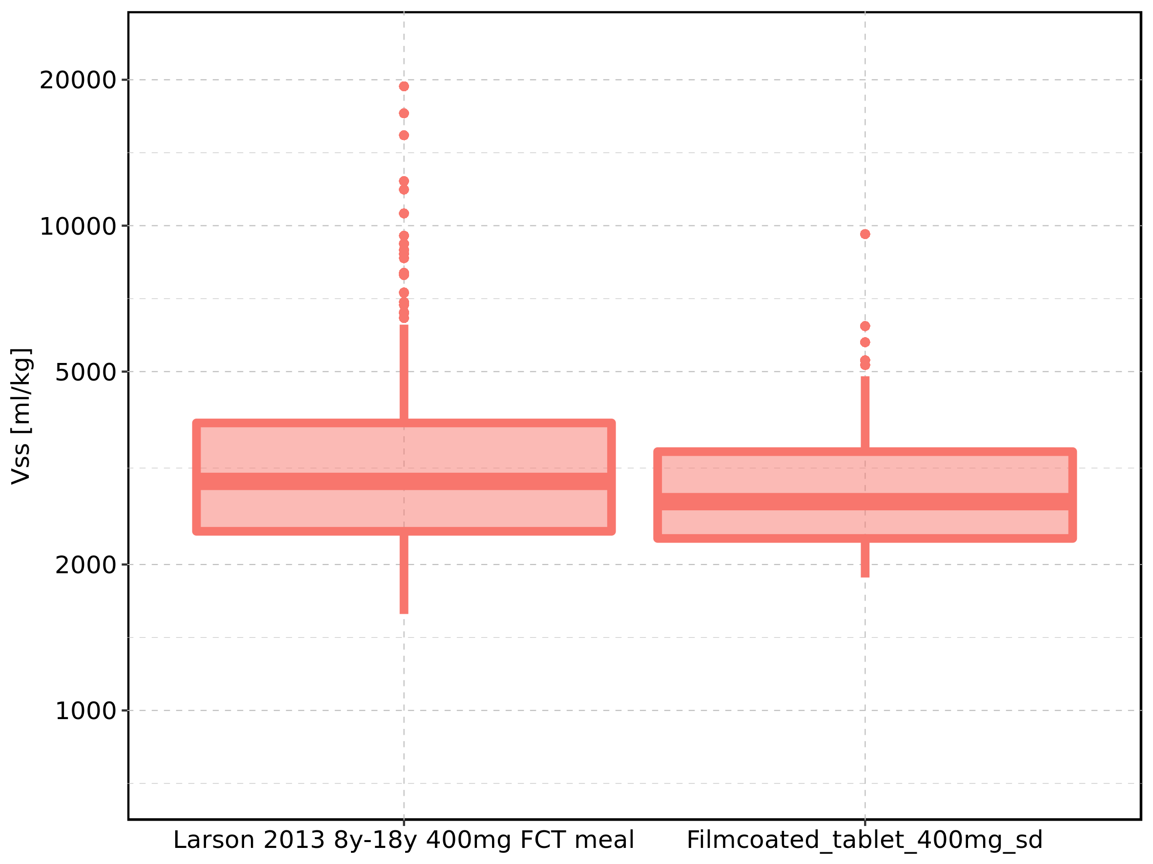

Figure 355: Age-dependence of Vss for Larson 2013 8y-18y 400mg FCT meal in comparison to Filmcoated_tablet_400mg_sd. Profiles are plotted in a linear scale.

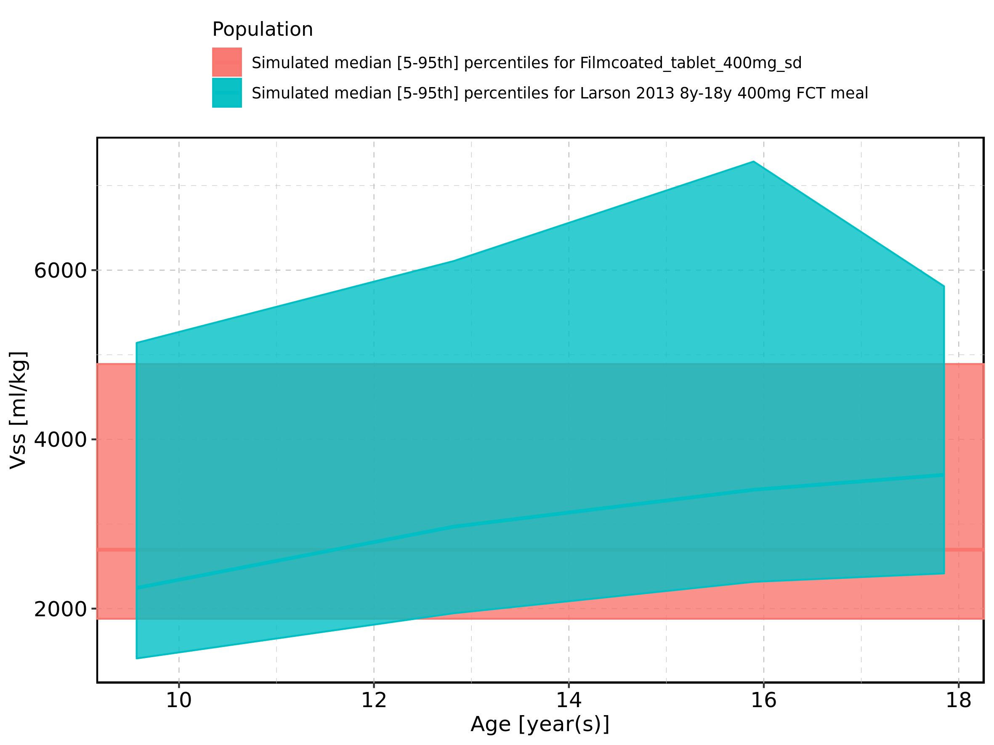

Figure 356: Age-dependence of Vss for Larson 2013 8y-18y 400mg FCT meal in comparison to Filmcoated_tablet_400mg_sd. Profiles are plotted in a logarithmic scale.

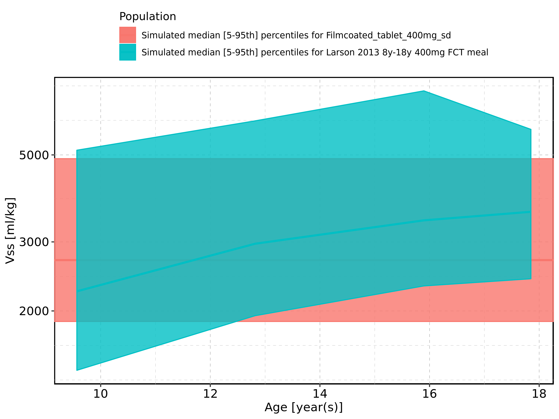

Figure 357: Age-dependence of Vss for Larson 2013 8y-18y 400mg FCT meal. Profiles are plotted in a linear scale.

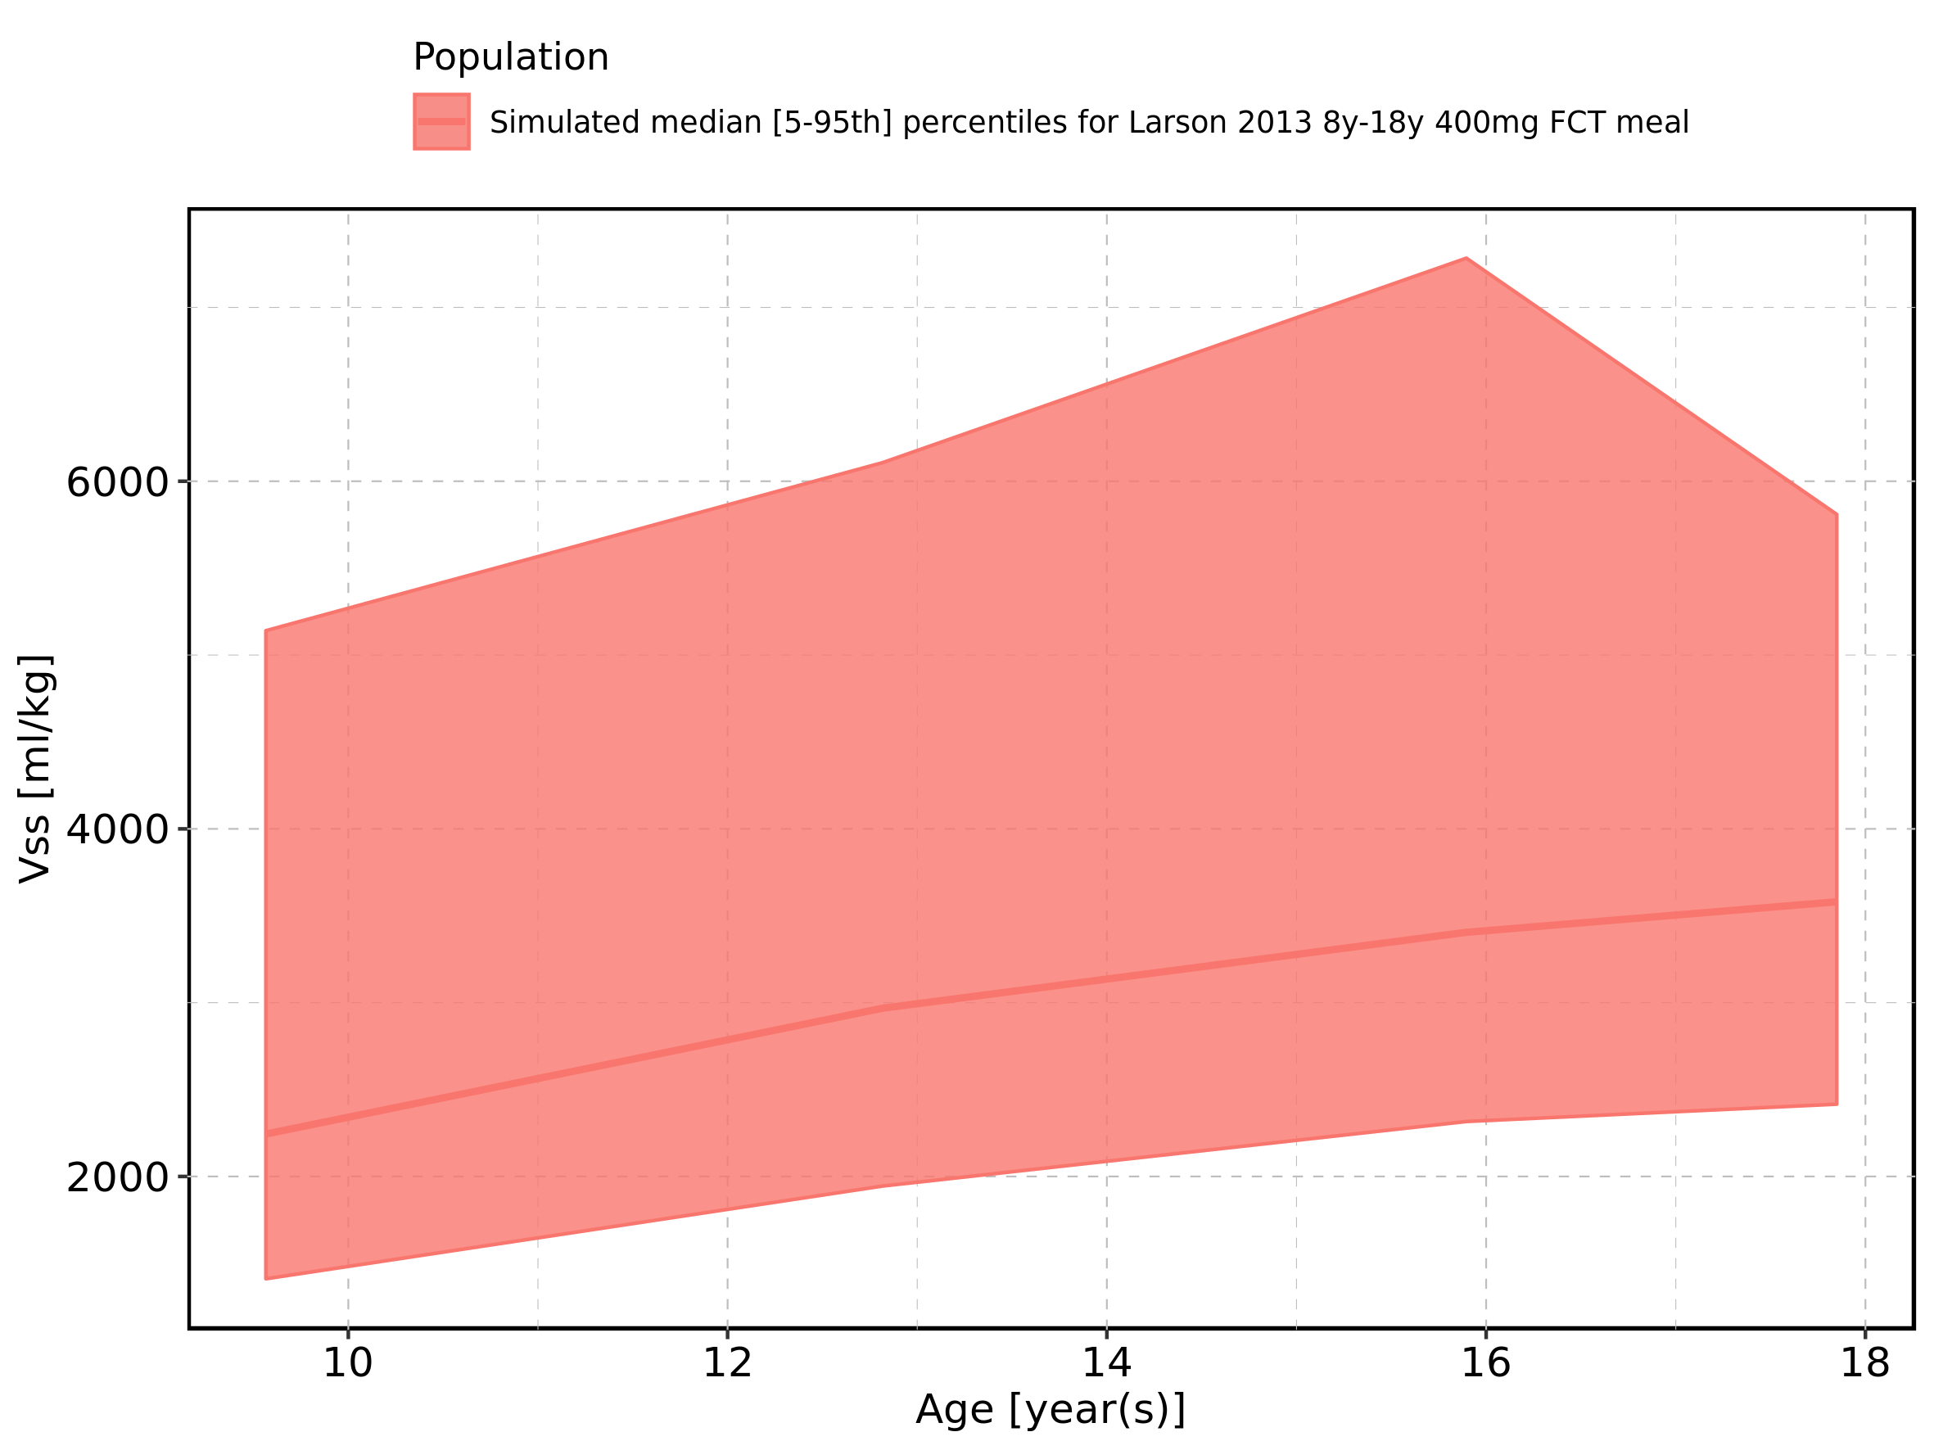

Figure 358: Age-dependence of Vss for Larson 2013 8y-18y 400mg FCT meal. Profiles are plotted in a logarithmic scale.

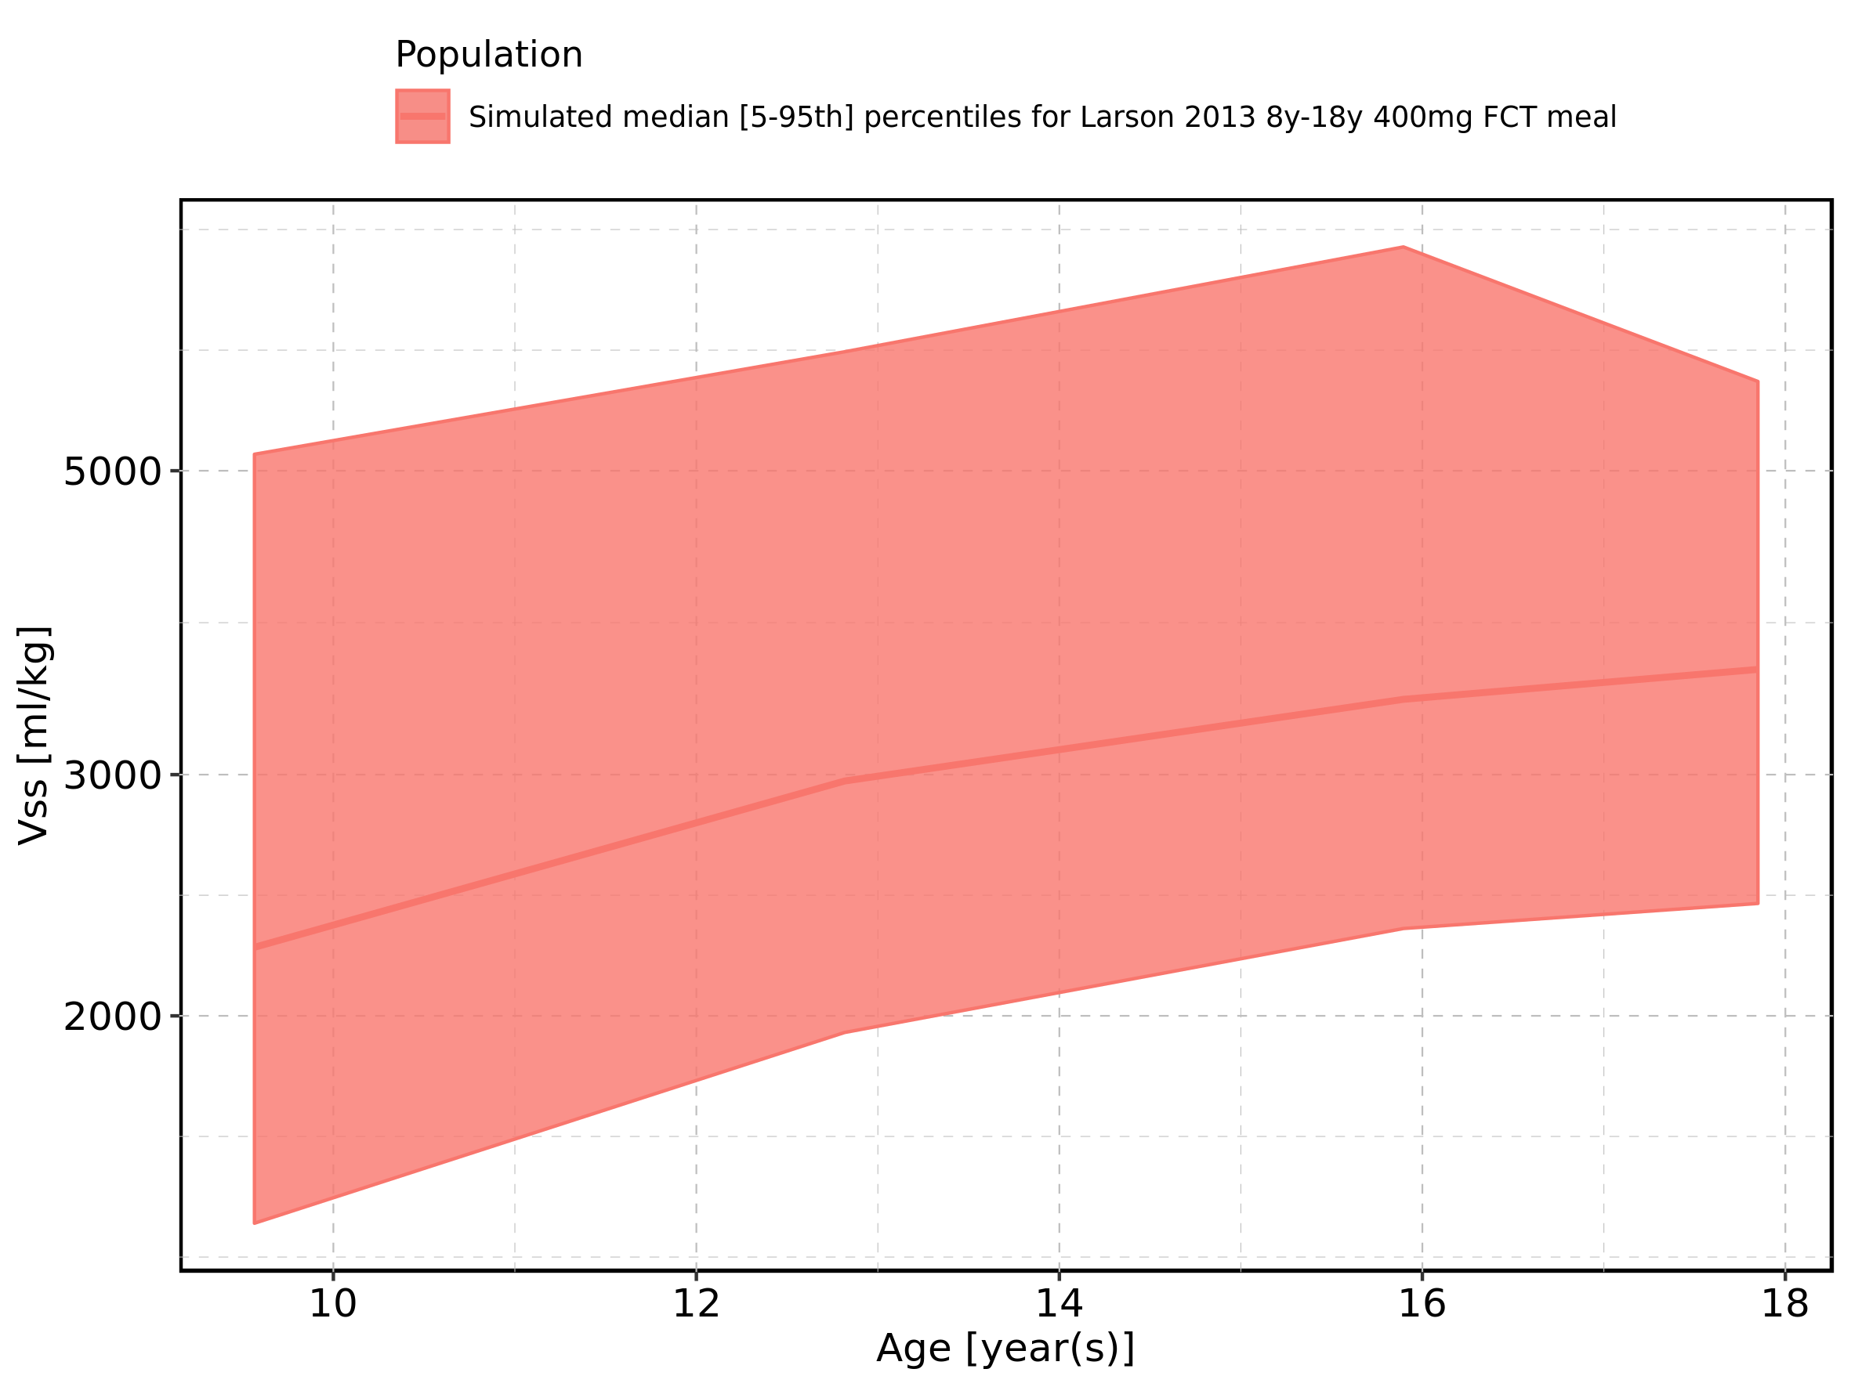

Figure 359: Age-dependence of Vss for Filmcoated_tablet_400mg_sd. Profiles are plotted in a linear scale.

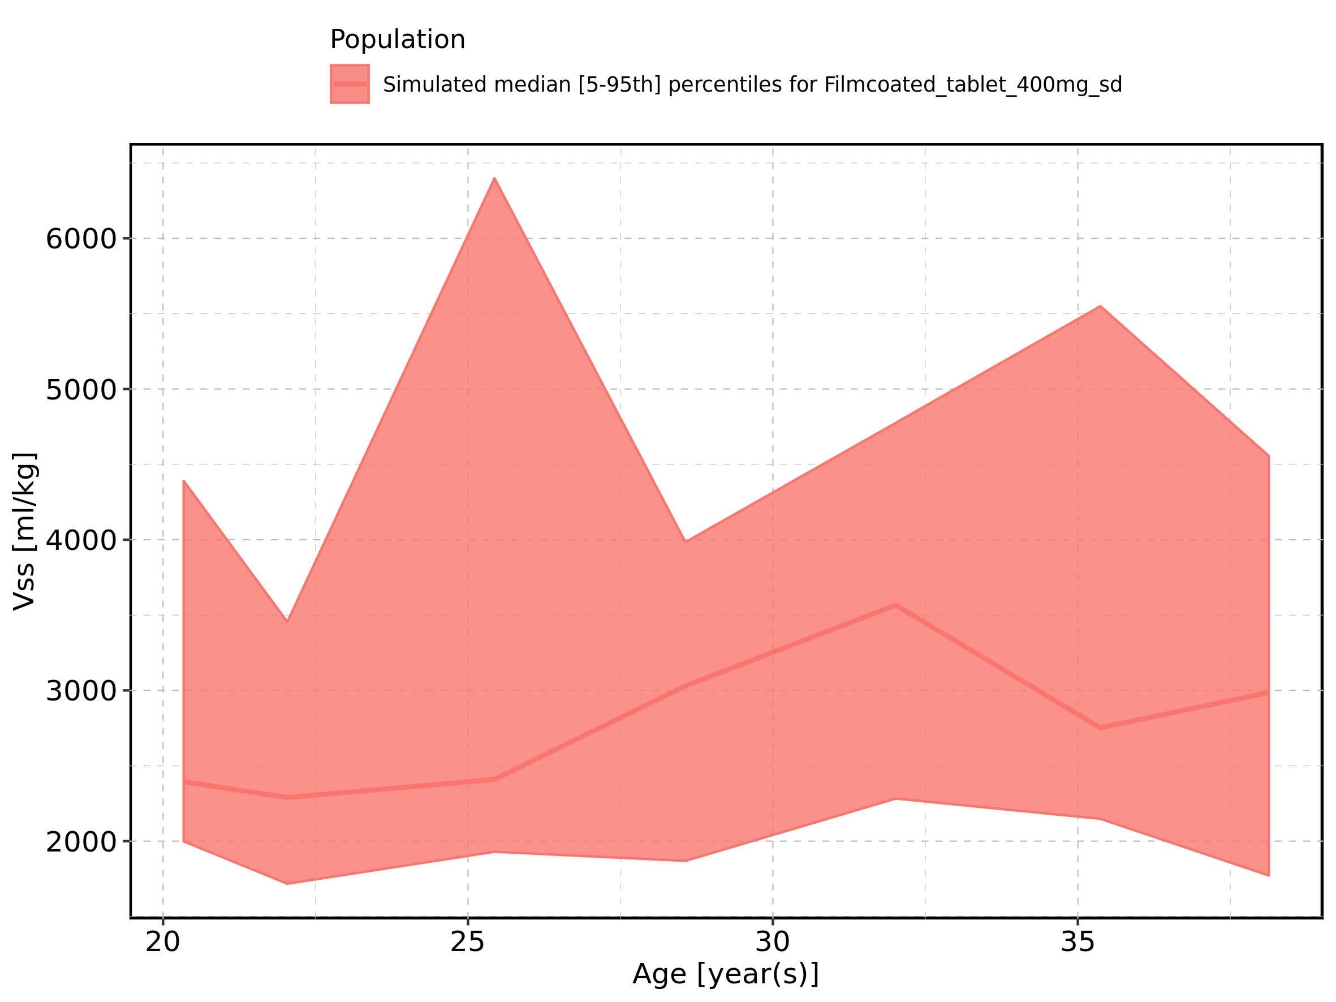

Figure 360: Age-dependence of Vss for Filmcoated_tablet_400mg_sd. Profiles are plotted in a logarithmic scale.

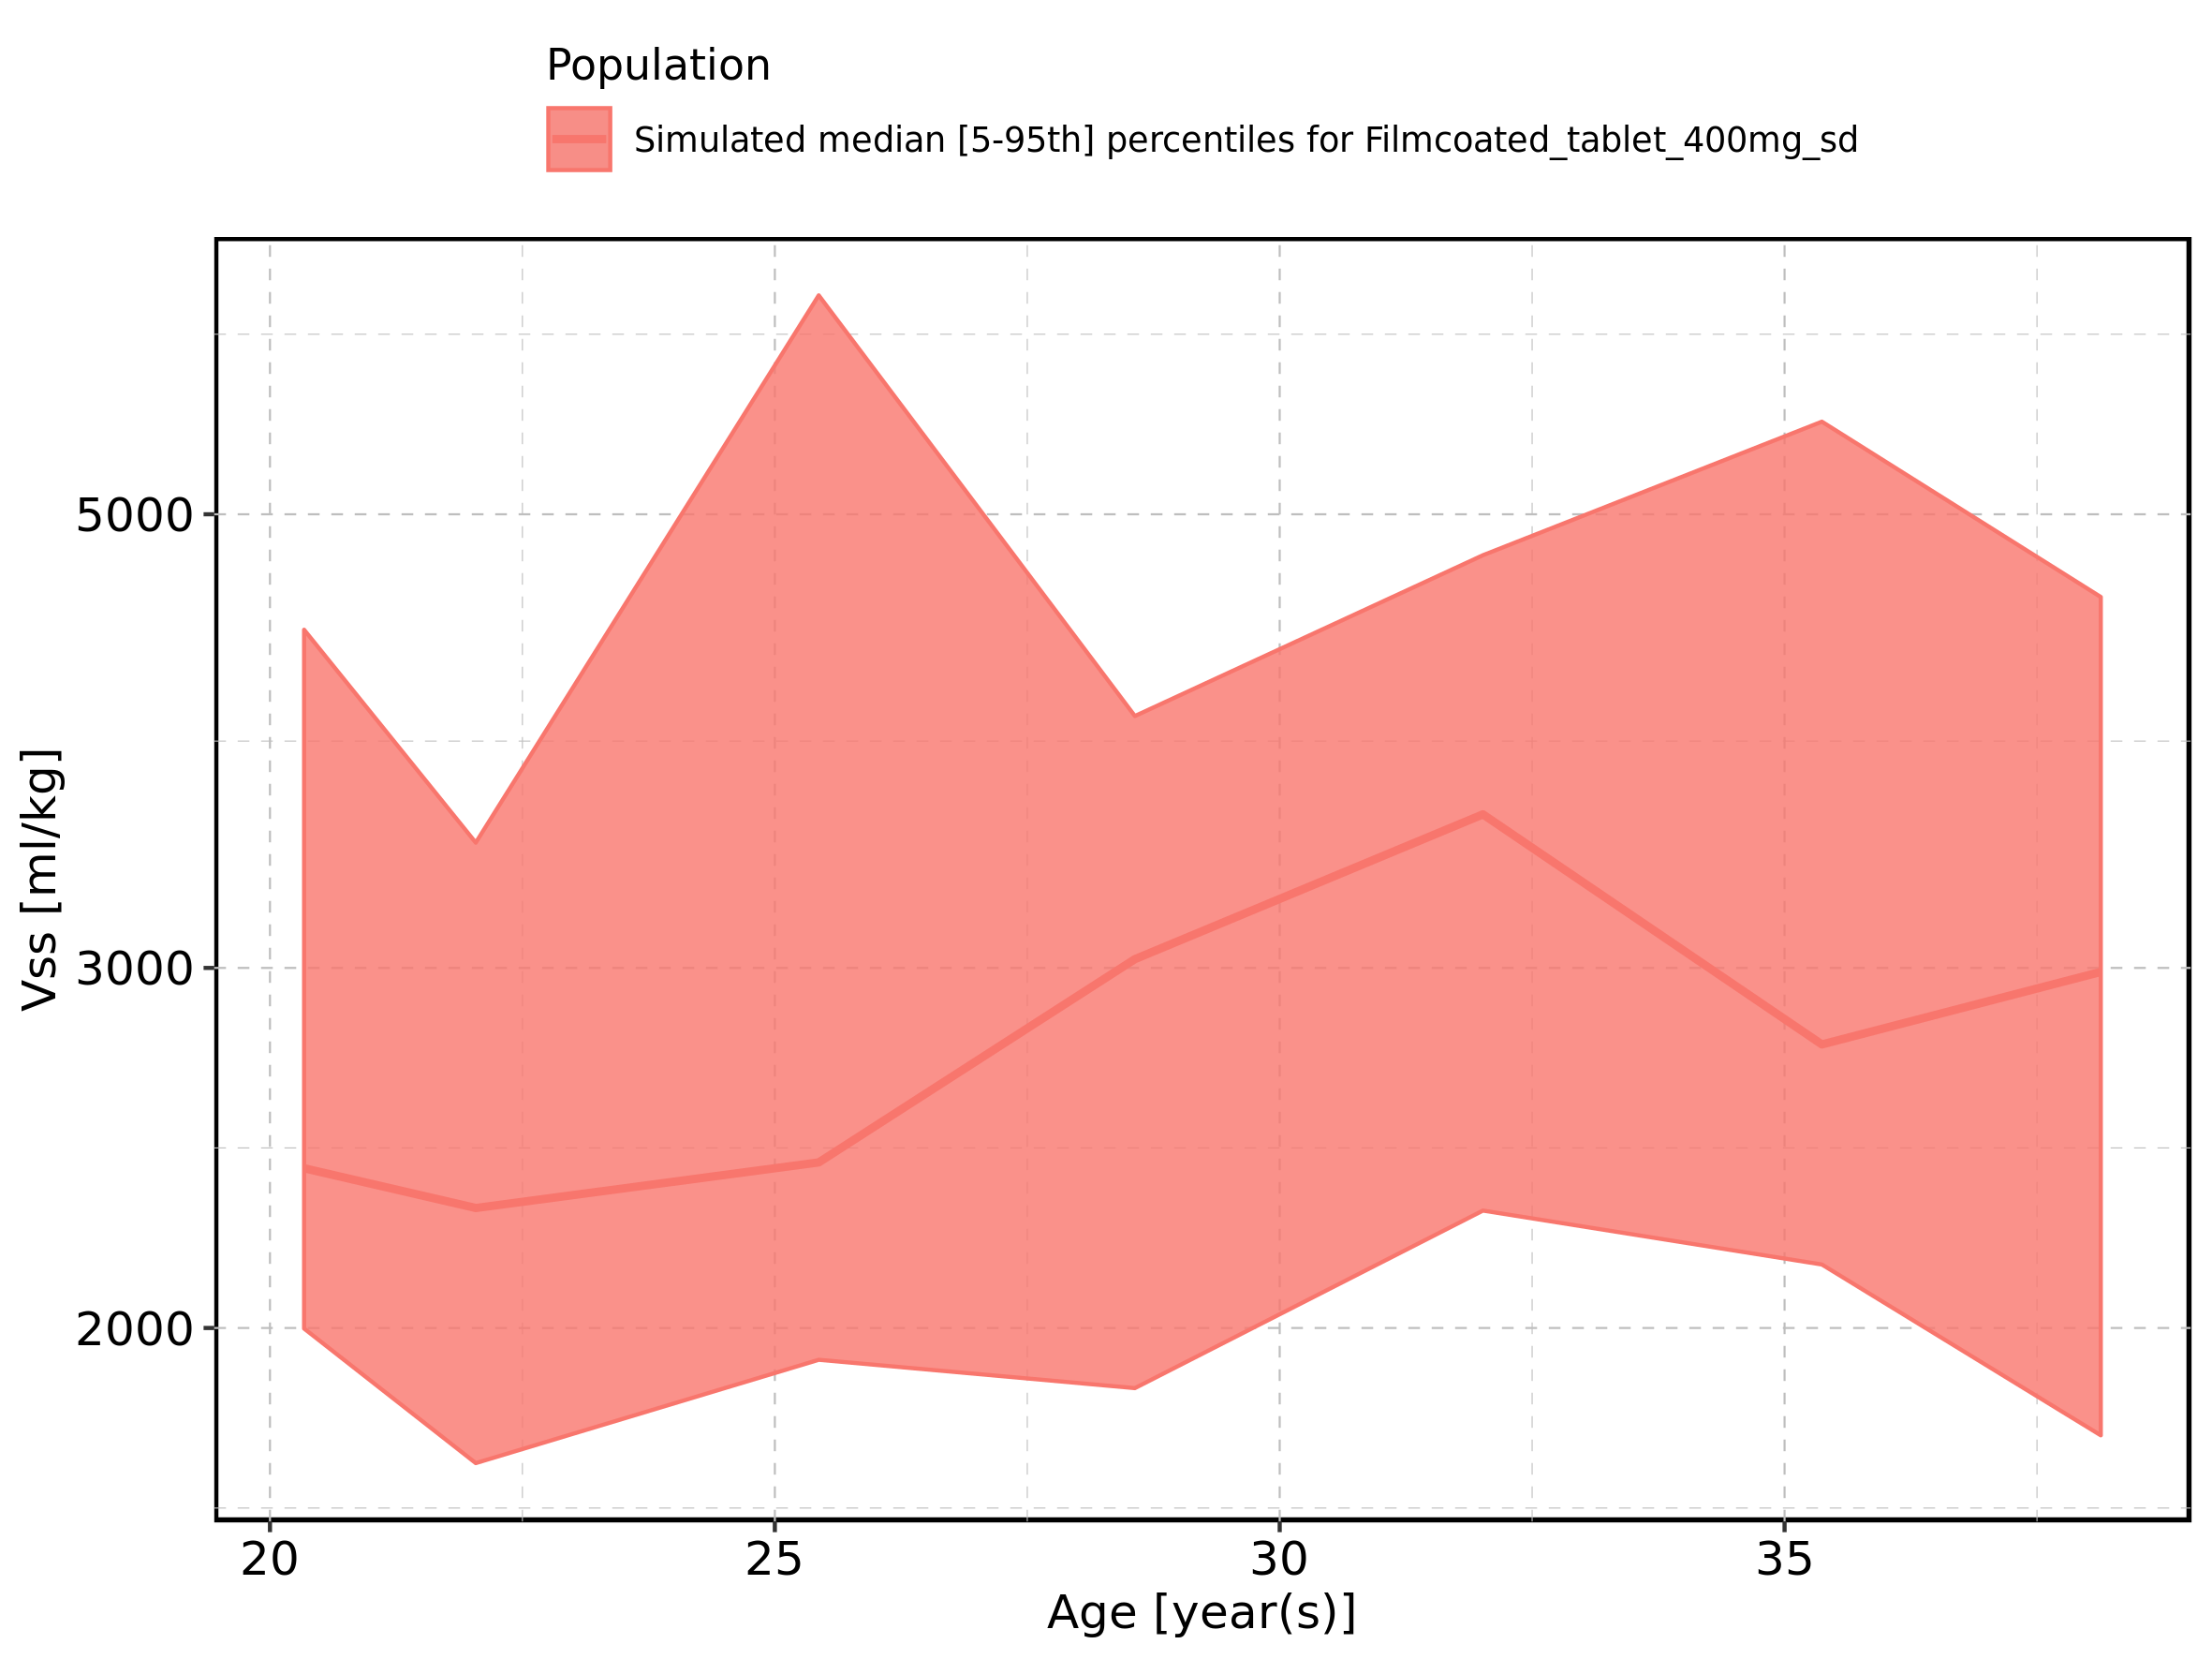

Figure 361: Height-dependence of Vss for Larson 2013 8y-18y 400mg FCT meal in comparison to Filmcoated_tablet_400mg_sd. Profiles are plotted in a linear scale.

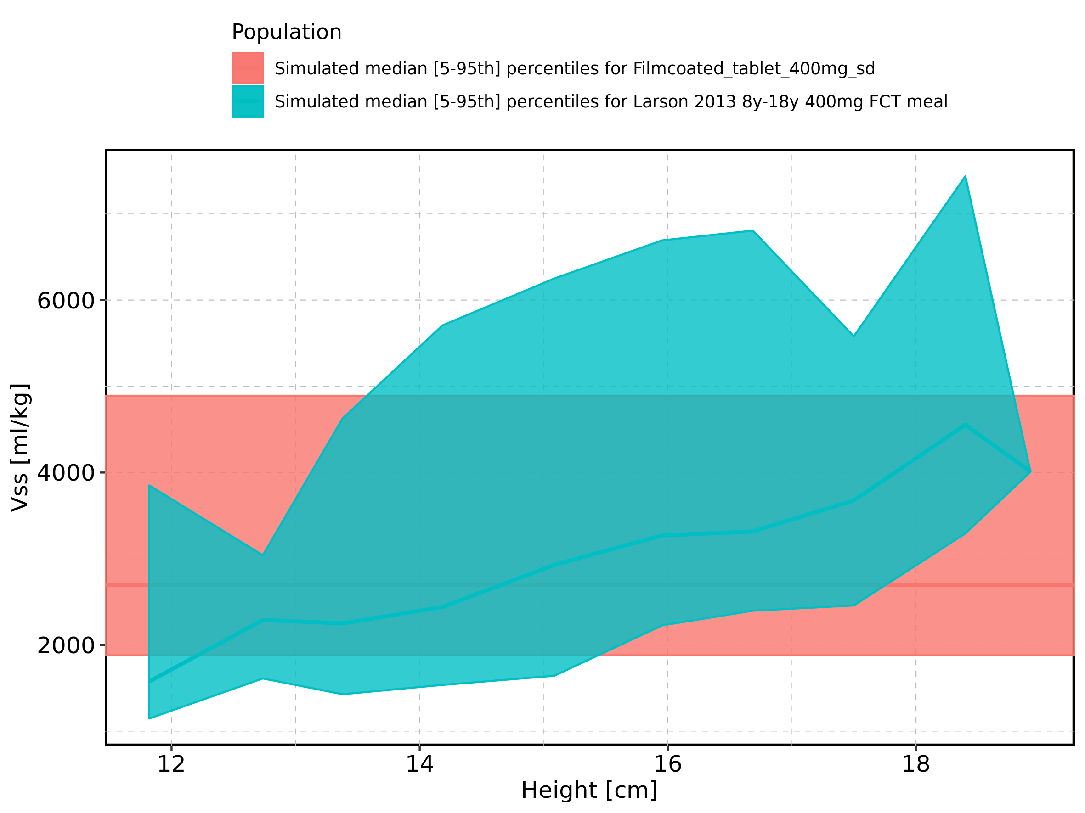

Figure 362: Height-dependence of Vss for Larson 2013 8y-18y 400mg FCT meal in comparison to Filmcoated_tablet_400mg_sd. Profiles are plotted in a logarithmic scale.

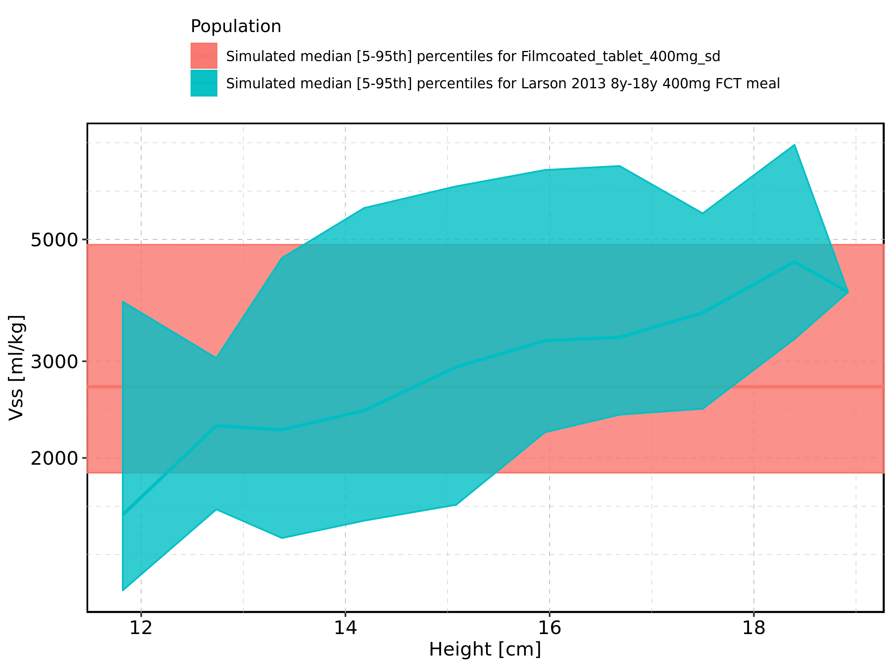

Figure 363: Height-dependence of Vss for Larson 2013 8y-18y 400mg FCT meal. Profiles are plotted in a linear scale.

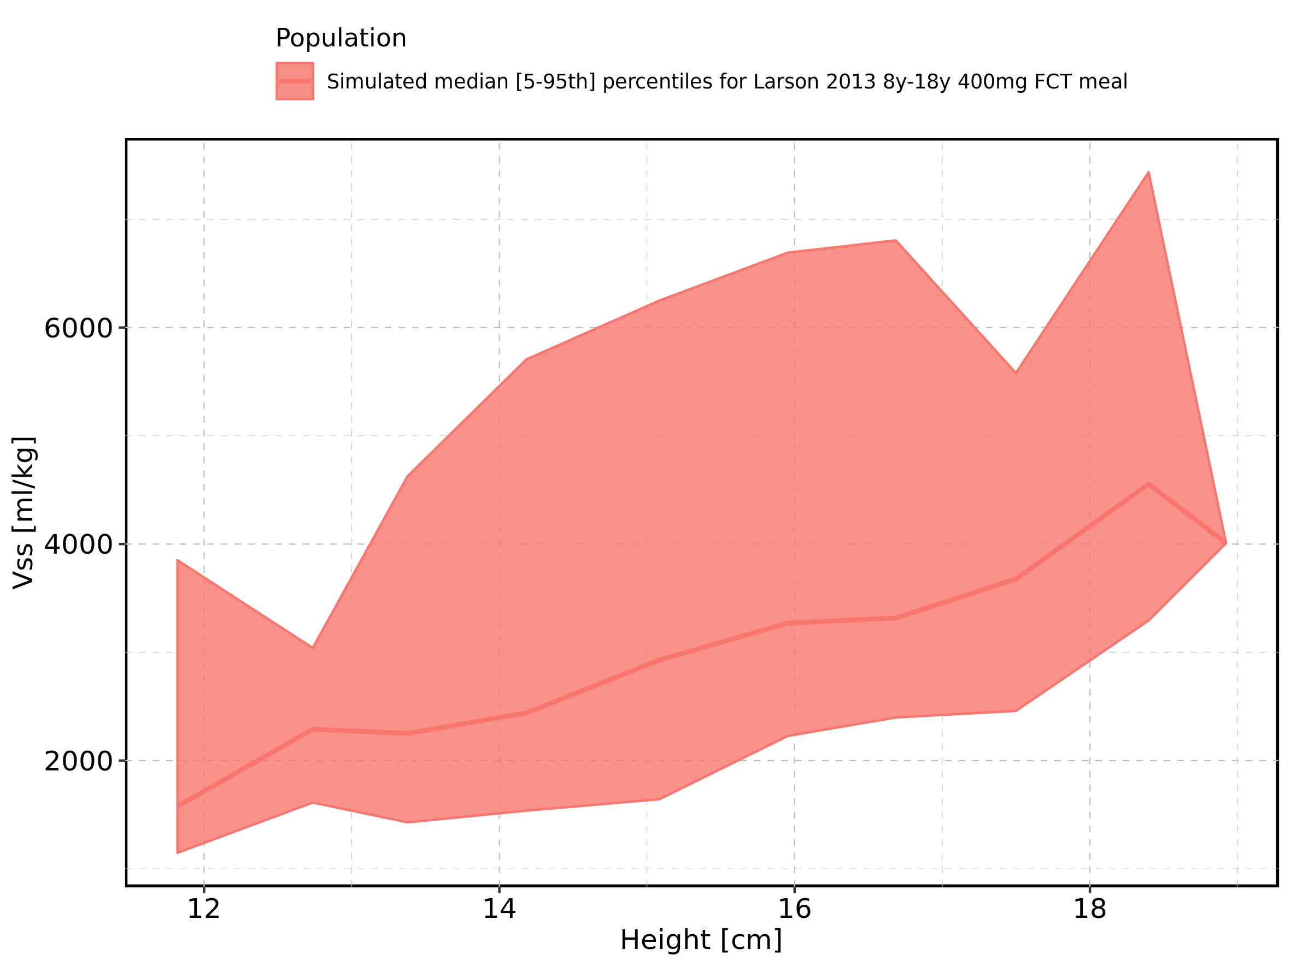

Figure 364: Height-dependence of Vss for Larson 2013 8y-18y 400mg FCT meal. Profiles are plotted in a logarithmic scale.

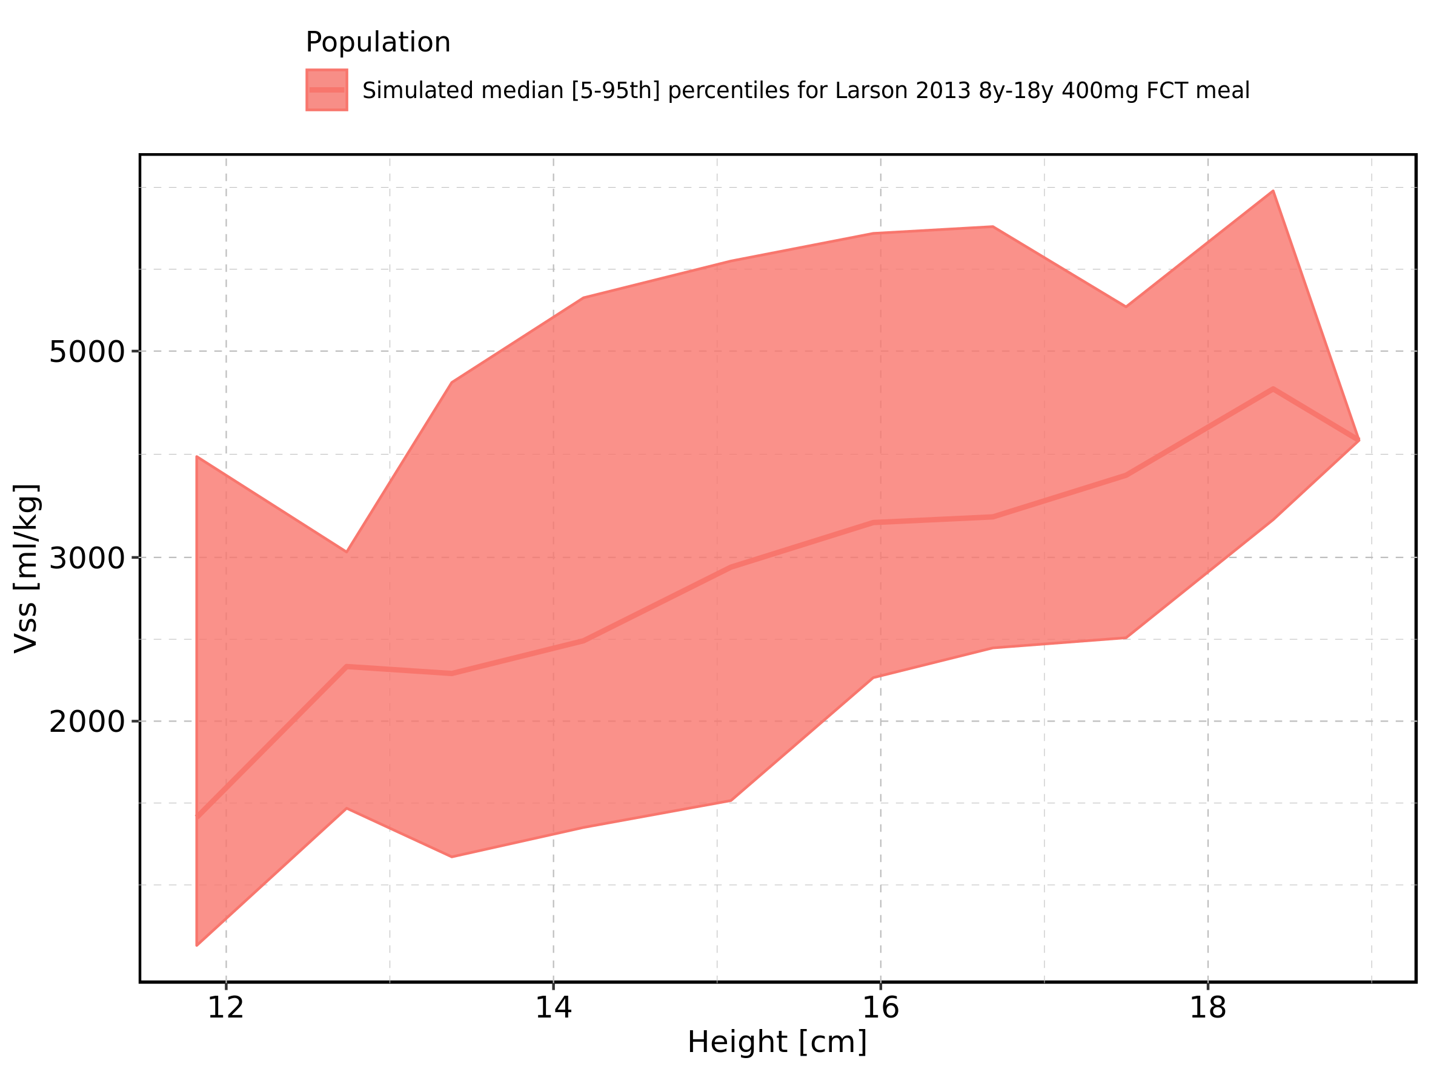

Figure 365: Height-dependence of Vss for Filmcoated_tablet_400mg_sd. Profiles are plotted in a linear scale.

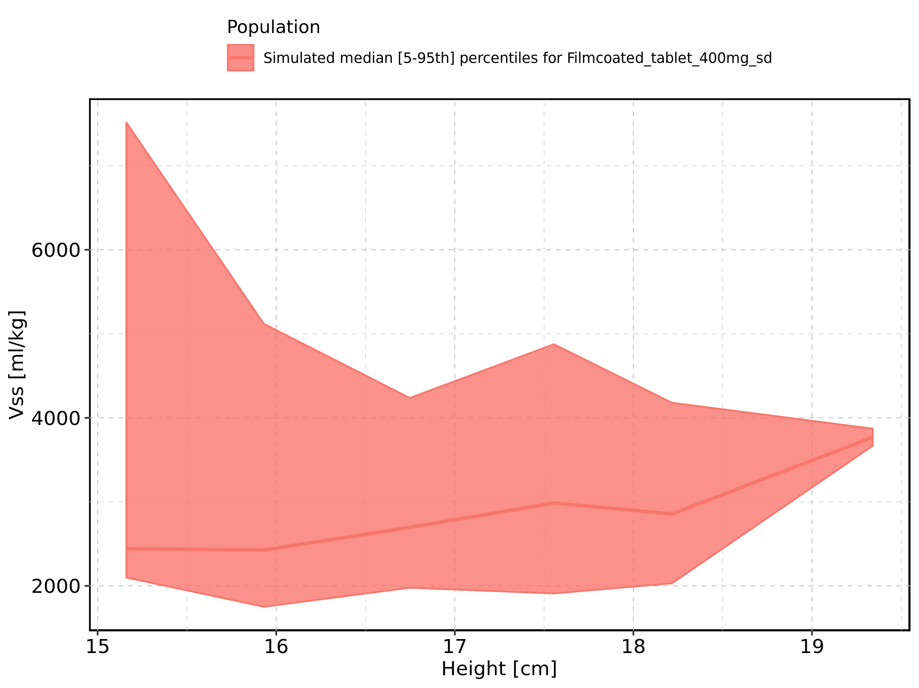

Figure 366: Height-dependence of Vss for Filmcoated_tablet_400mg_sd. Profiles are plotted in a logarithmic scale.

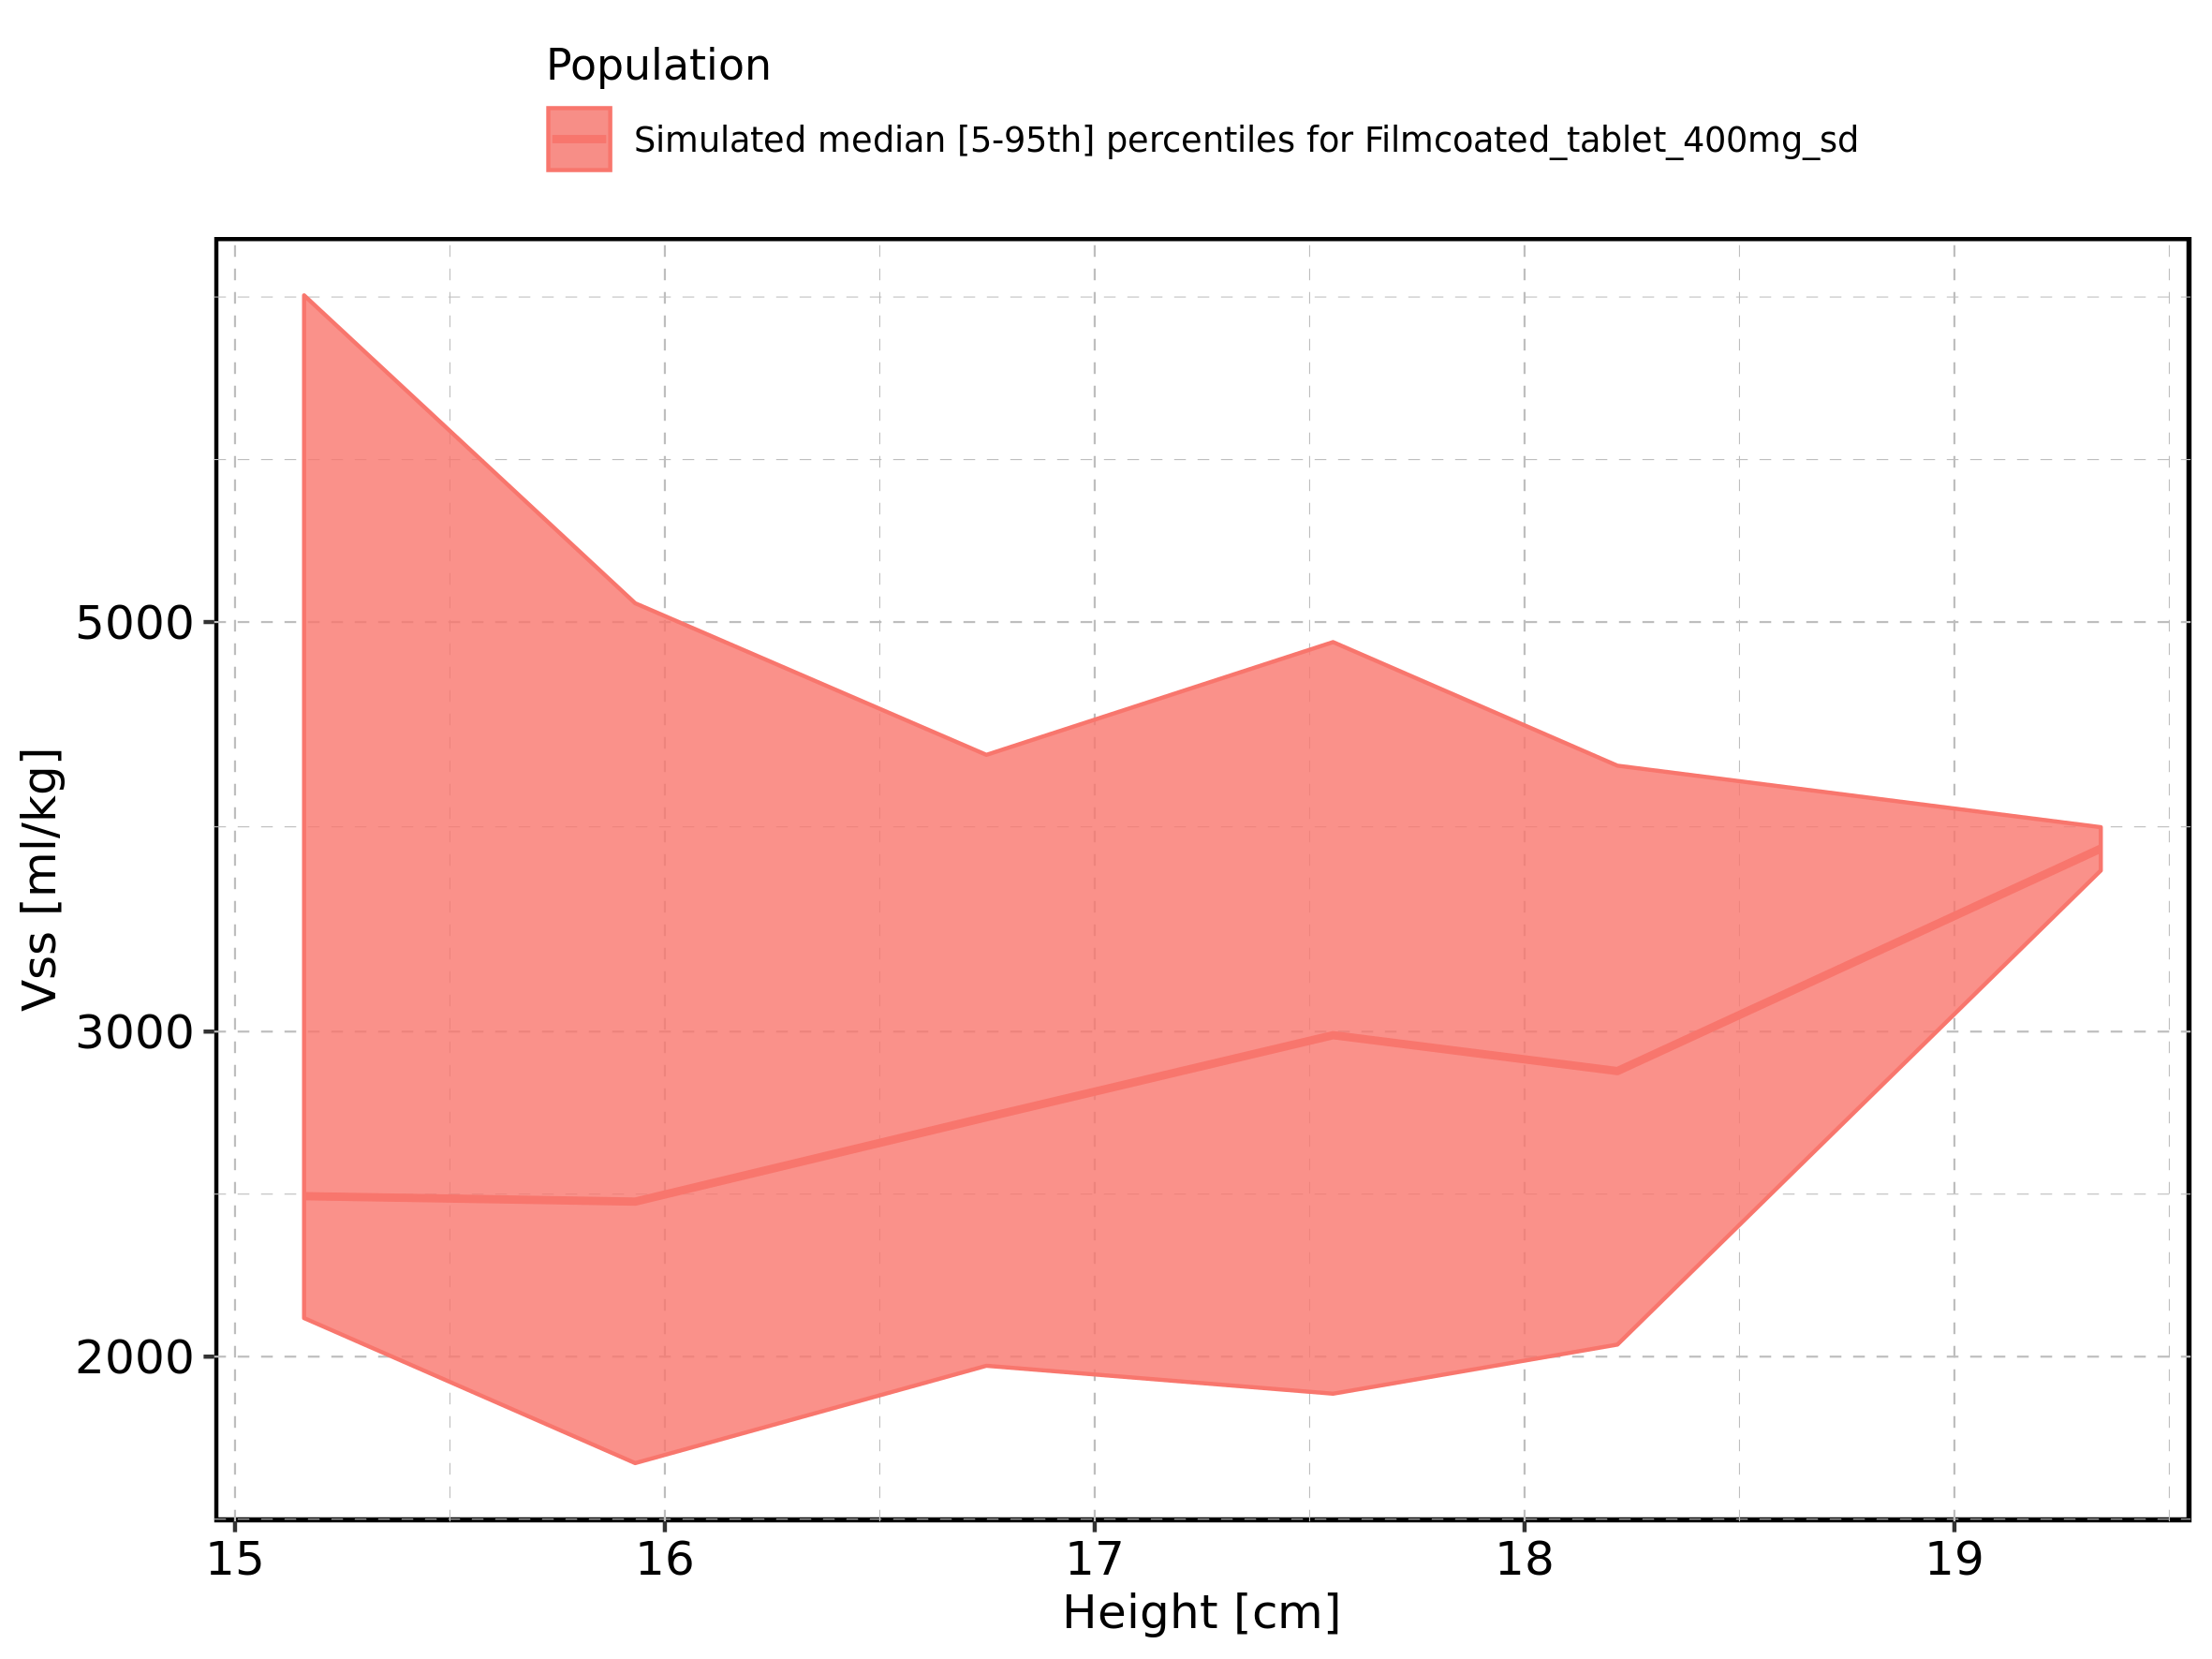

Figure 367: Weight-dependence of Vss for Larson 2013 8y-18y 400mg FCT meal in comparison to Filmcoated_tablet_400mg_sd. Profiles are plotted in a linear scale.

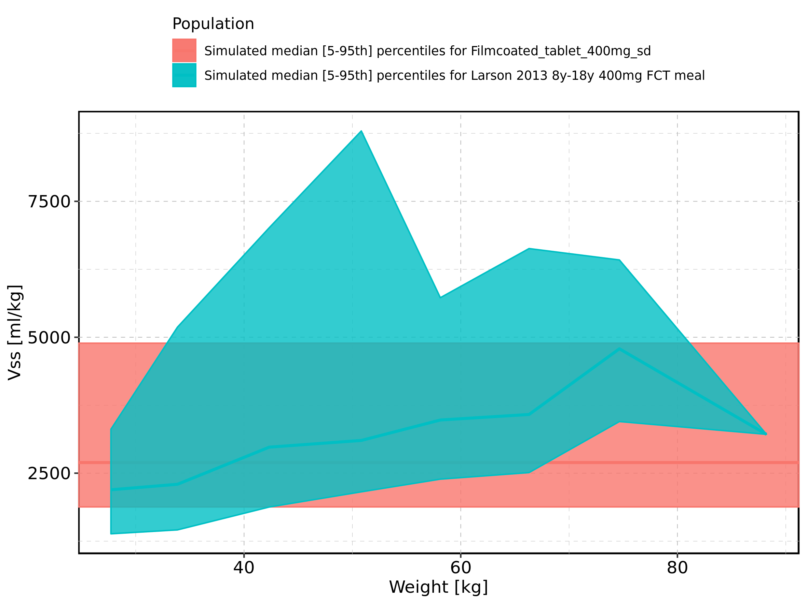

Figure 368: Weight-dependence of Vss for Larson 2013 8y-18y 400mg FCT meal in comparison to Filmcoated_tablet_400mg_sd. Profiles are plotted in a logarithmic scale.

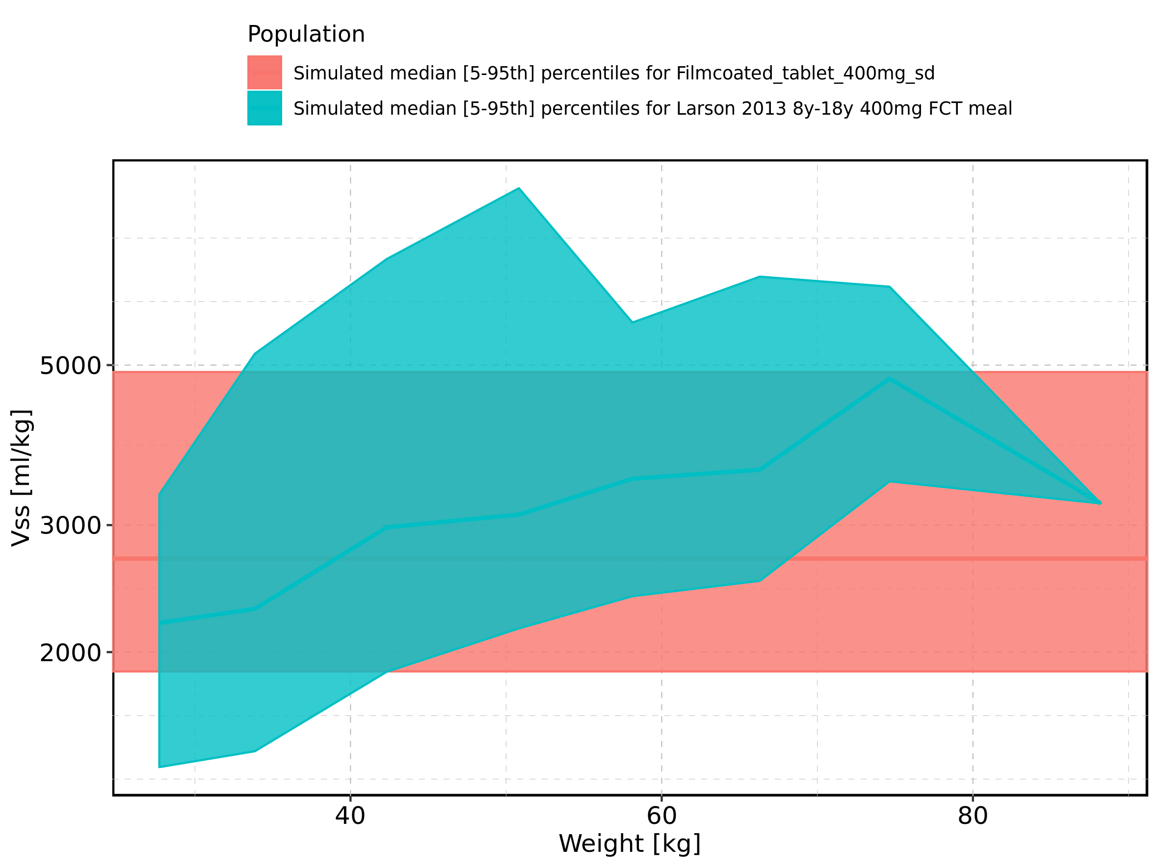

Figure 369: Weight-dependence of Vss for Larson 2013 8y-18y 400mg FCT meal. Profiles are plotted in a linear scale.

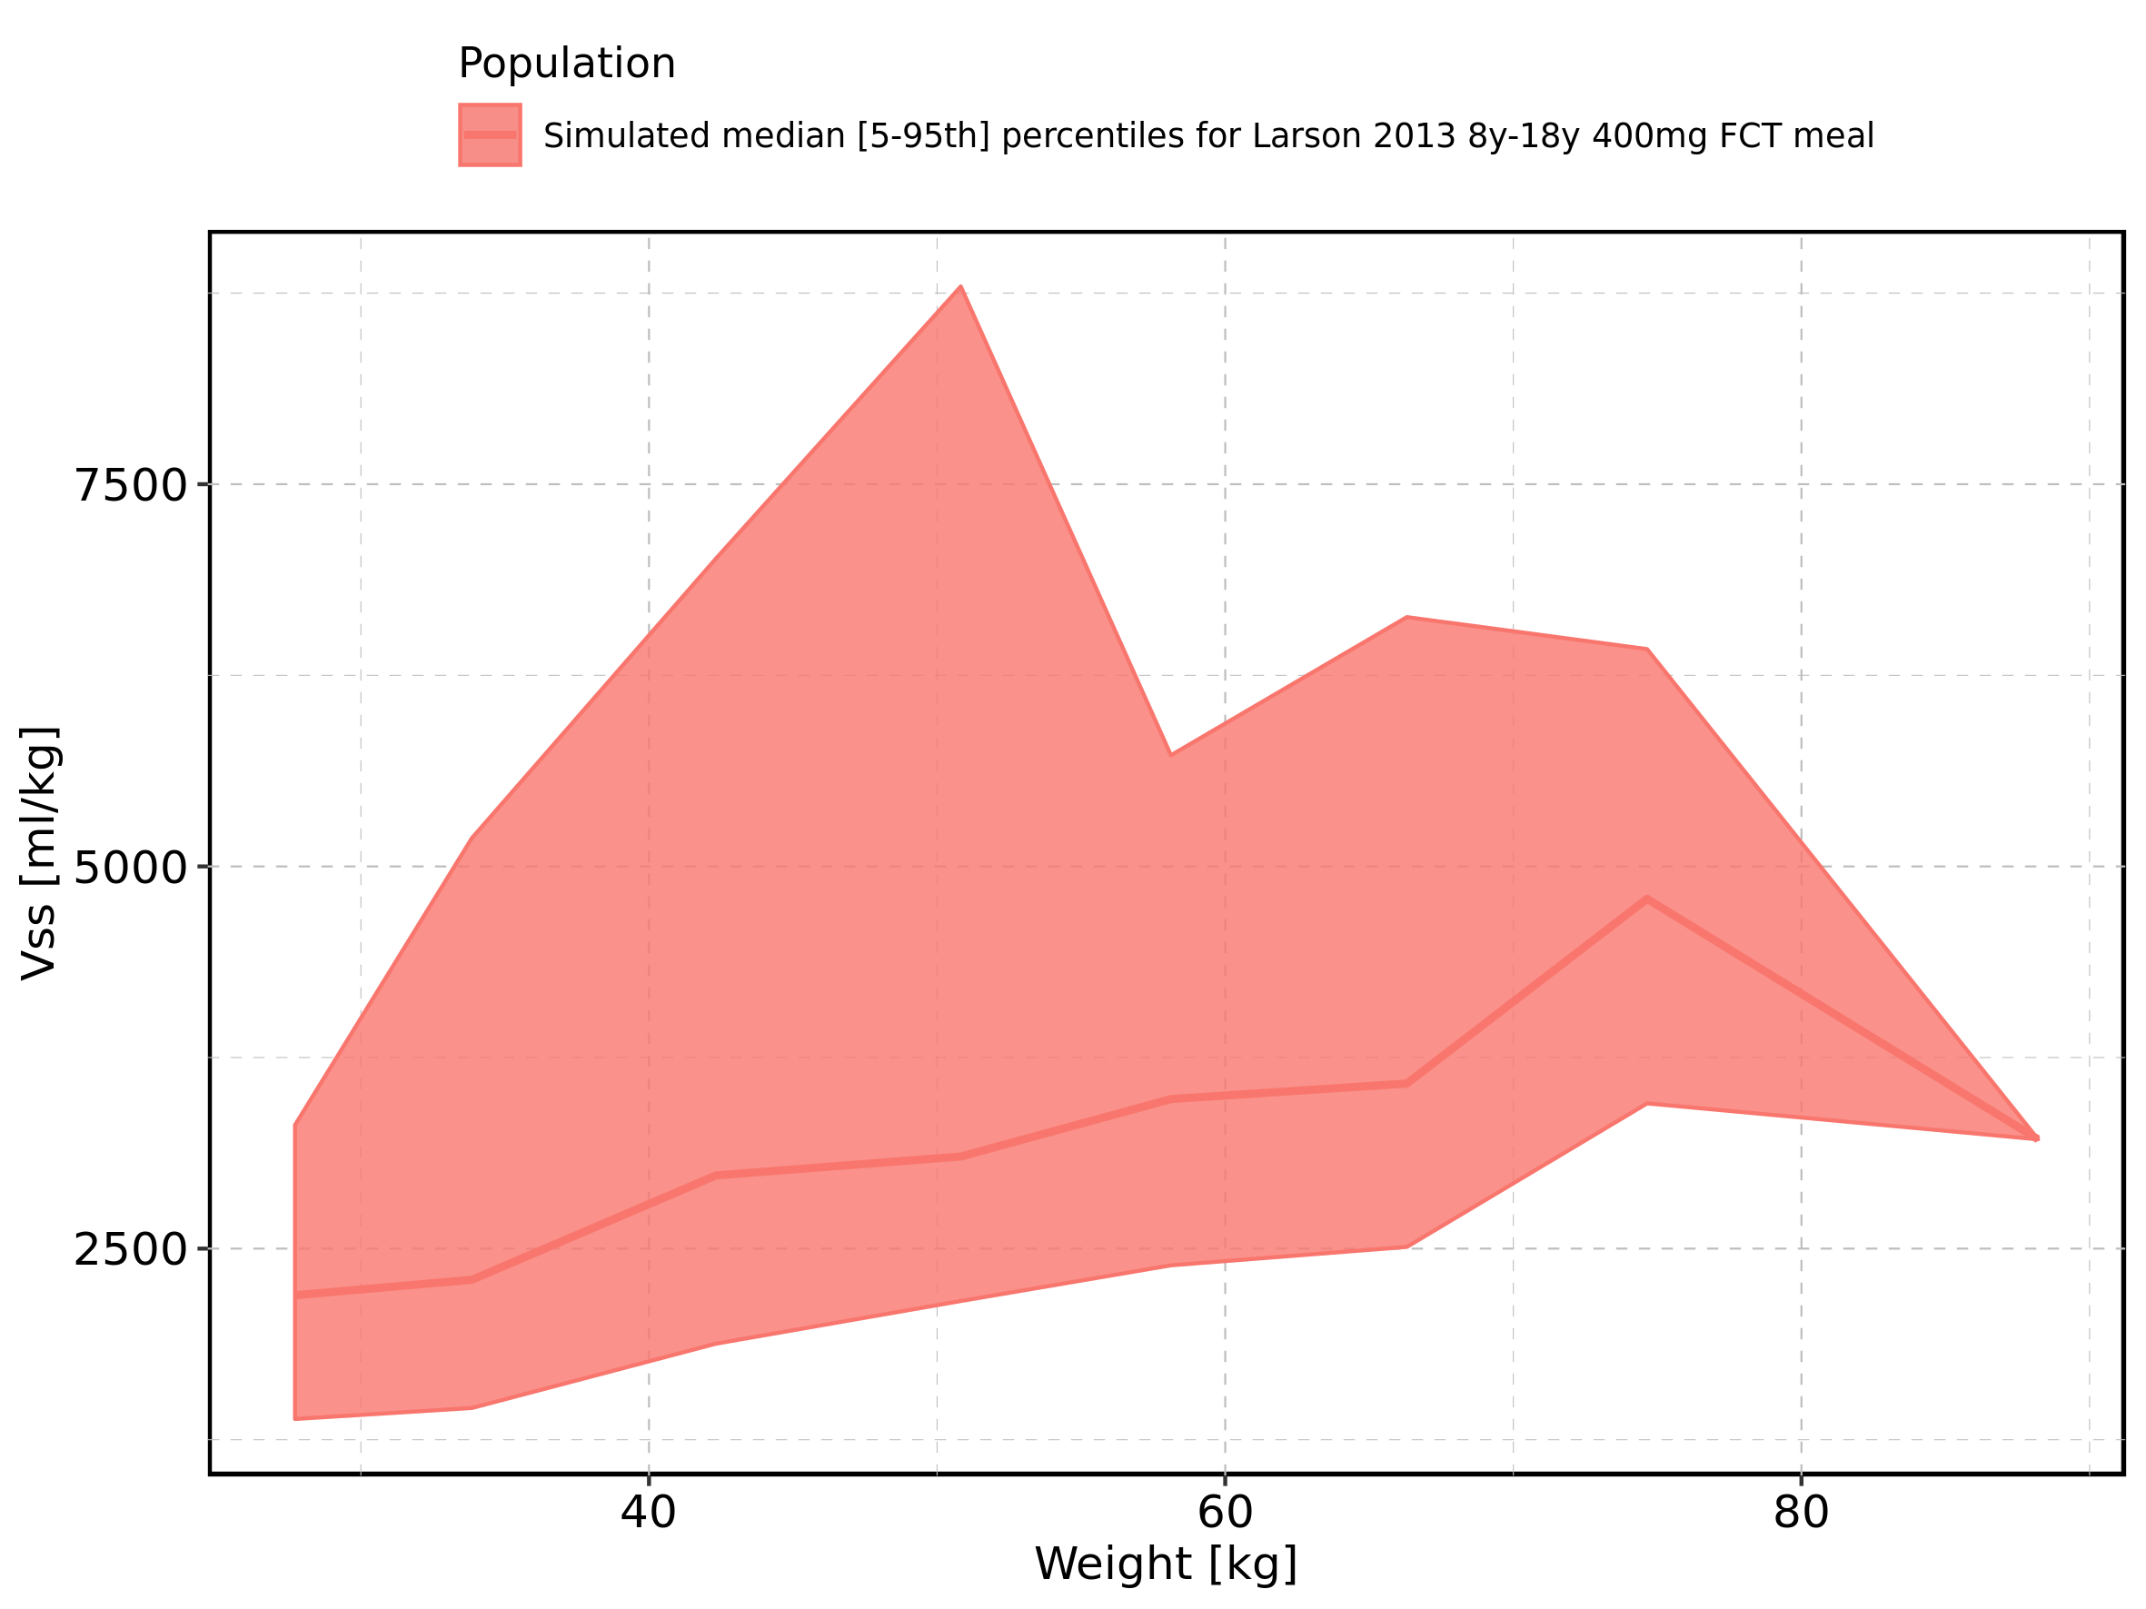

Figure 370: Weight-dependence of Vss for Larson 2013 8y-18y 400mg FCT meal. Profiles are plotted in a logarithmic scale.

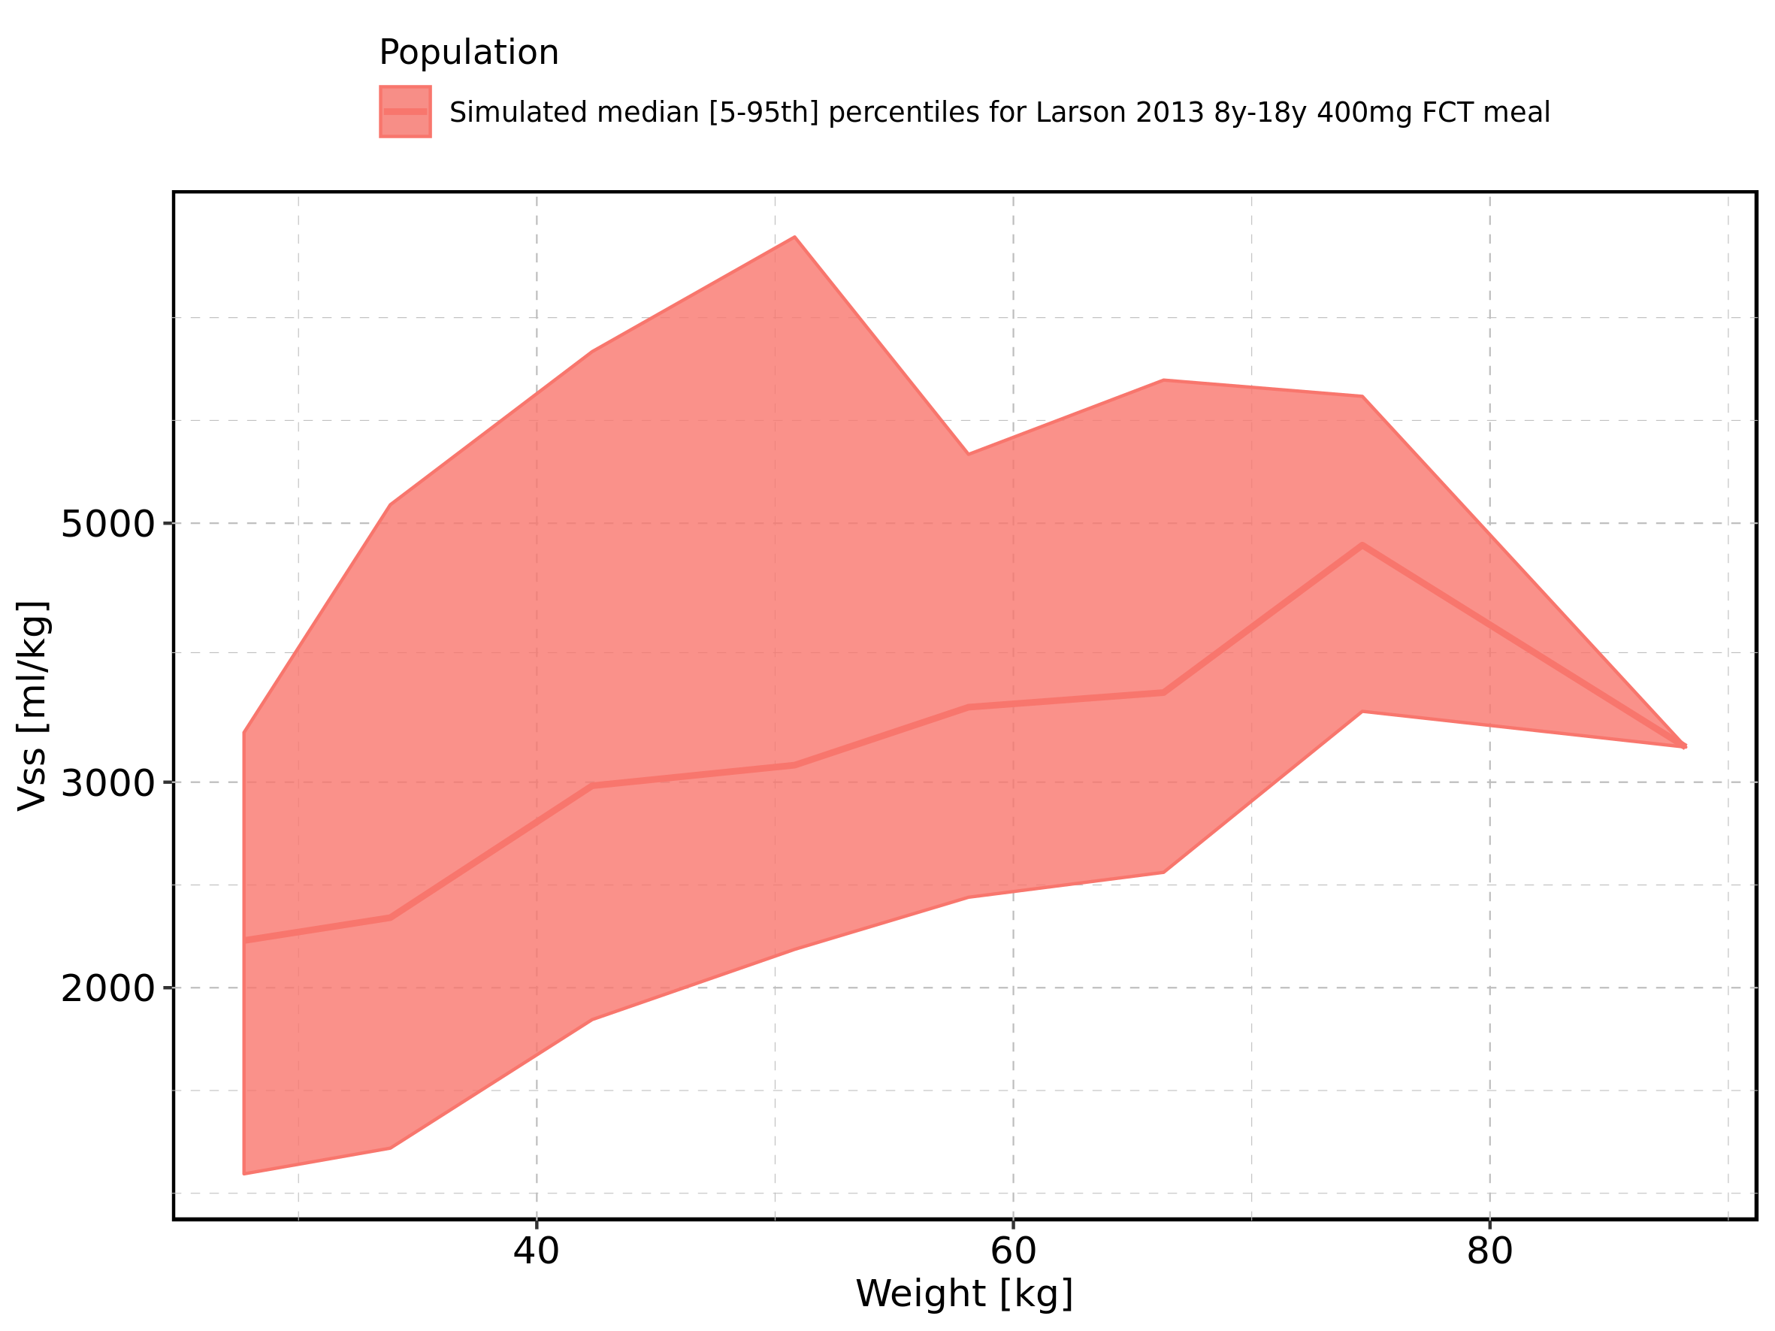

Figure 371: Weight-dependence of Vss for Filmcoated_tablet_400mg_sd. Profiles are plotted in a linear scale.

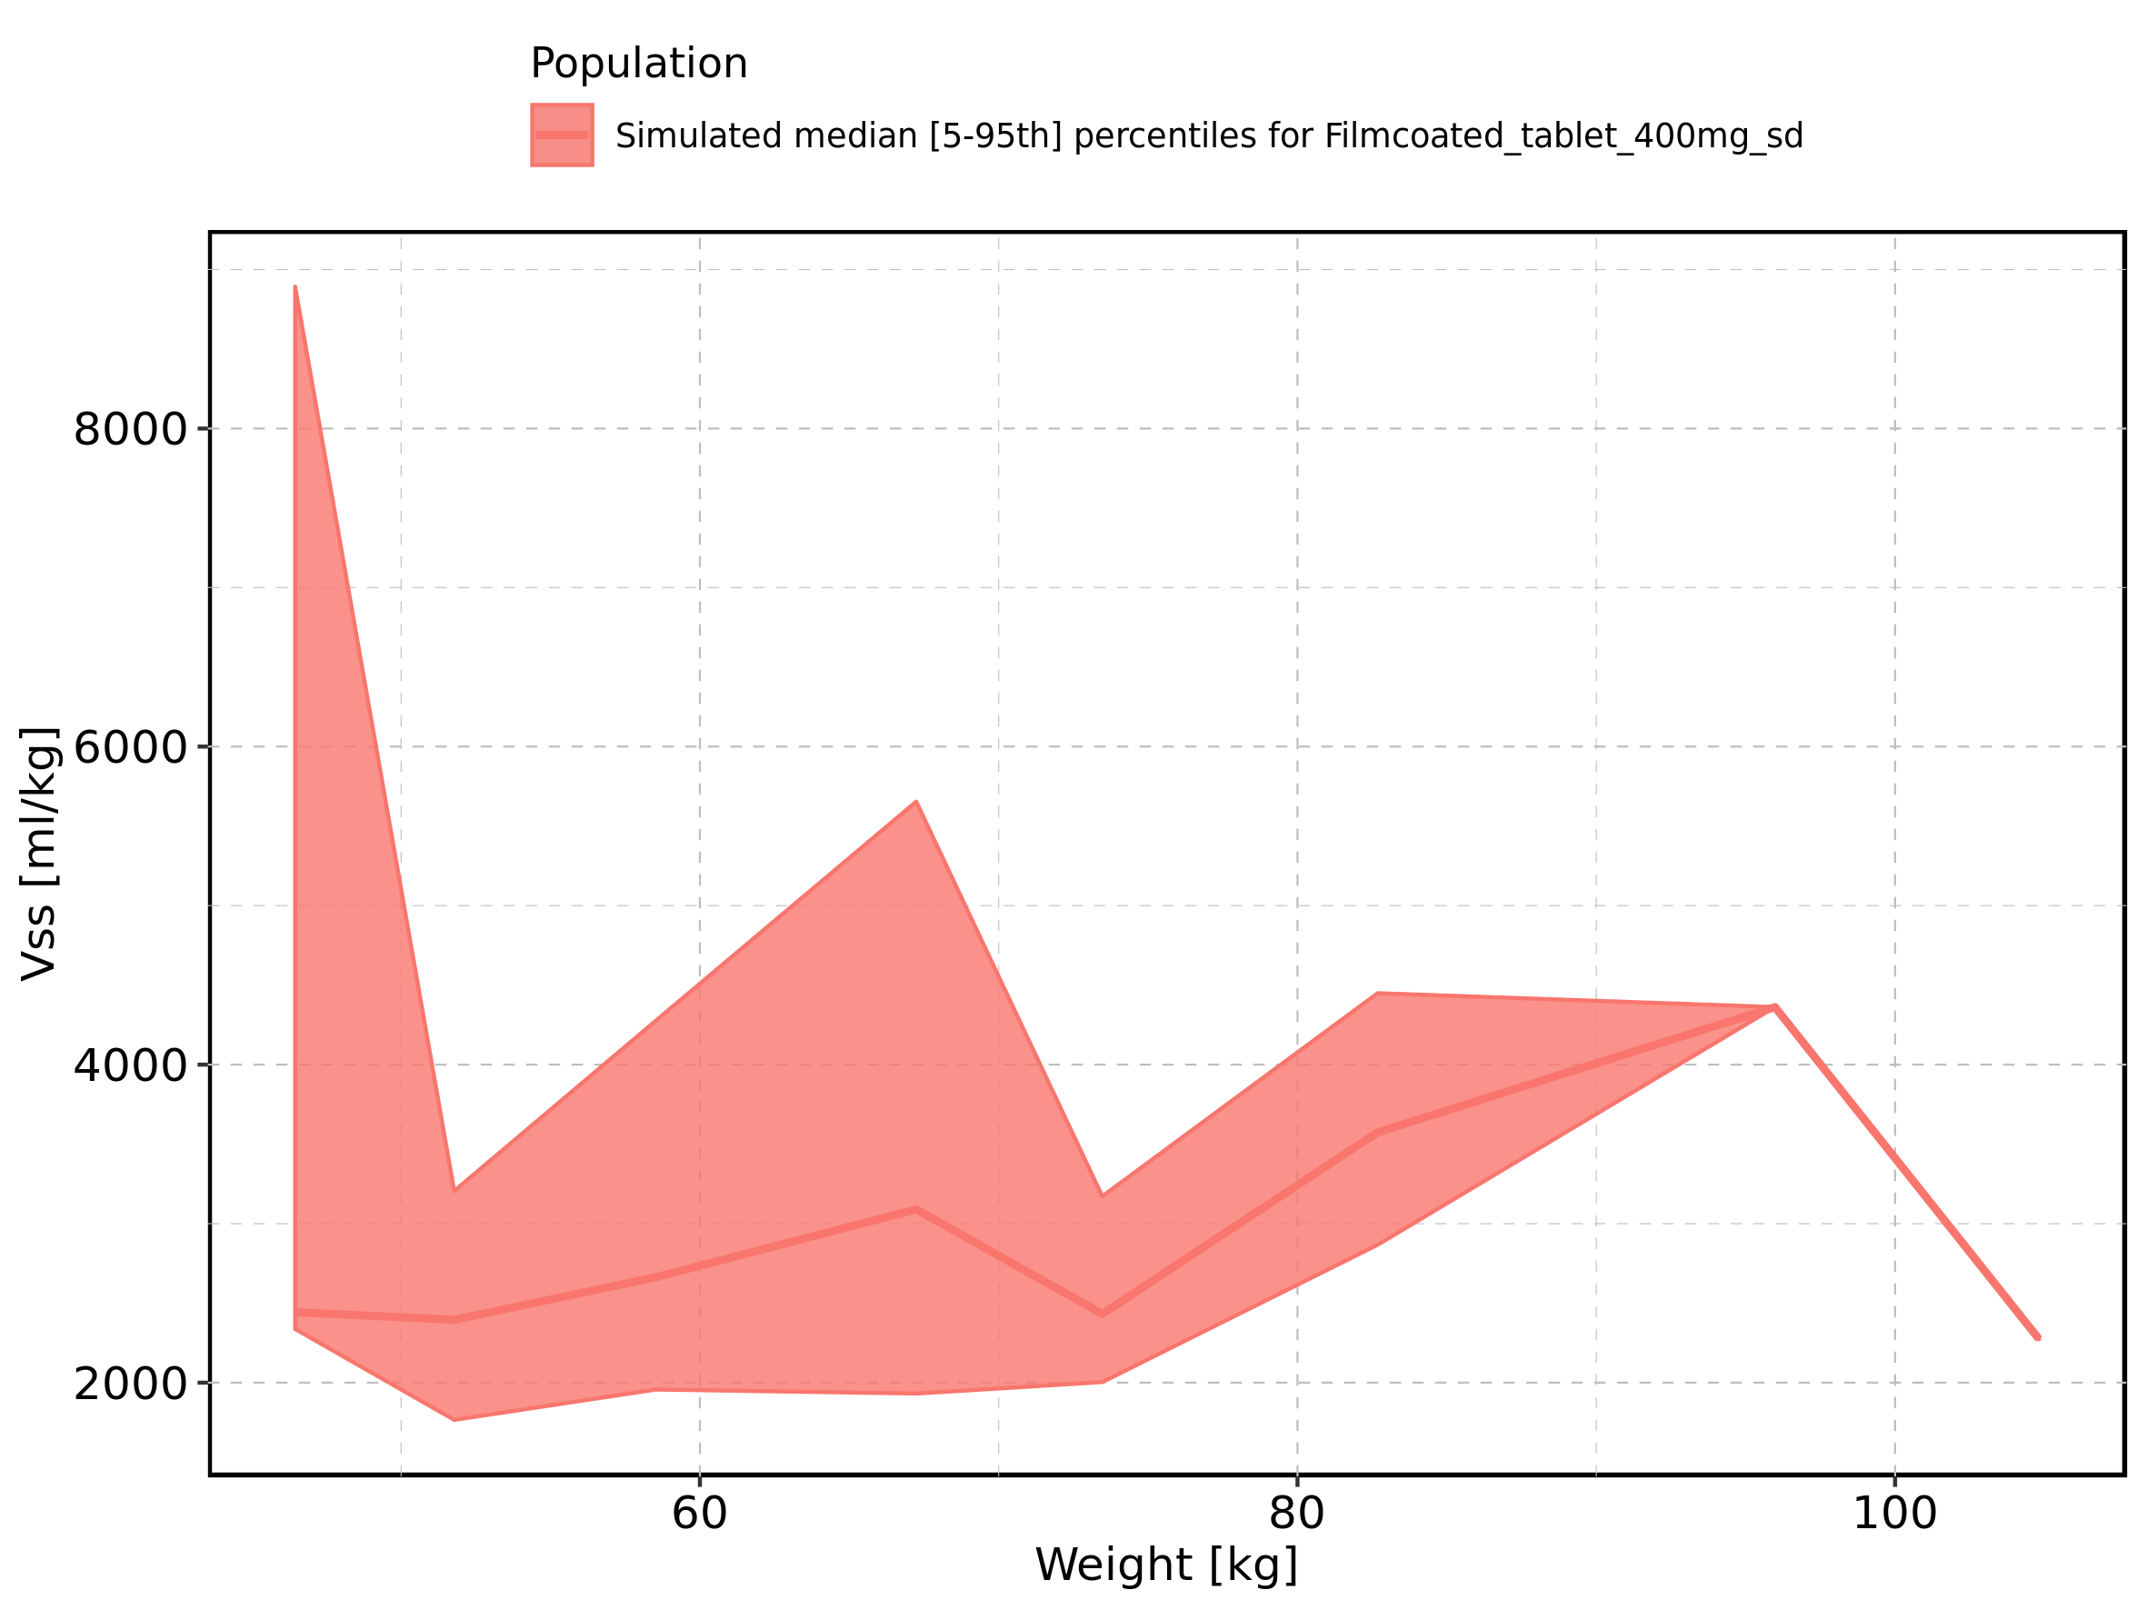

Figure 372: Weight-dependence of Vss for Filmcoated_tablet_400mg_sd. Profiles are plotted in a logarithmic scale.

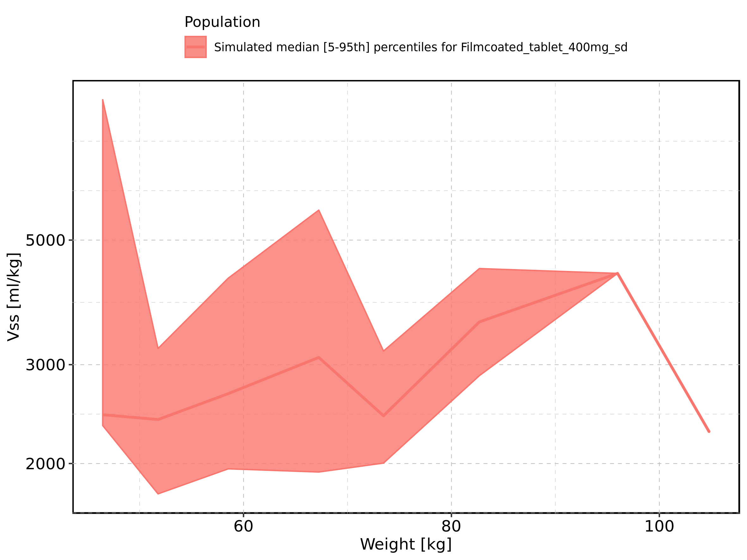

Figure 373: BMI-dependence of Vss for Larson 2013 8y-18y 400mg FCT meal in comparison to Filmcoated_tablet_400mg_sd. Profiles are plotted in a linear scale.

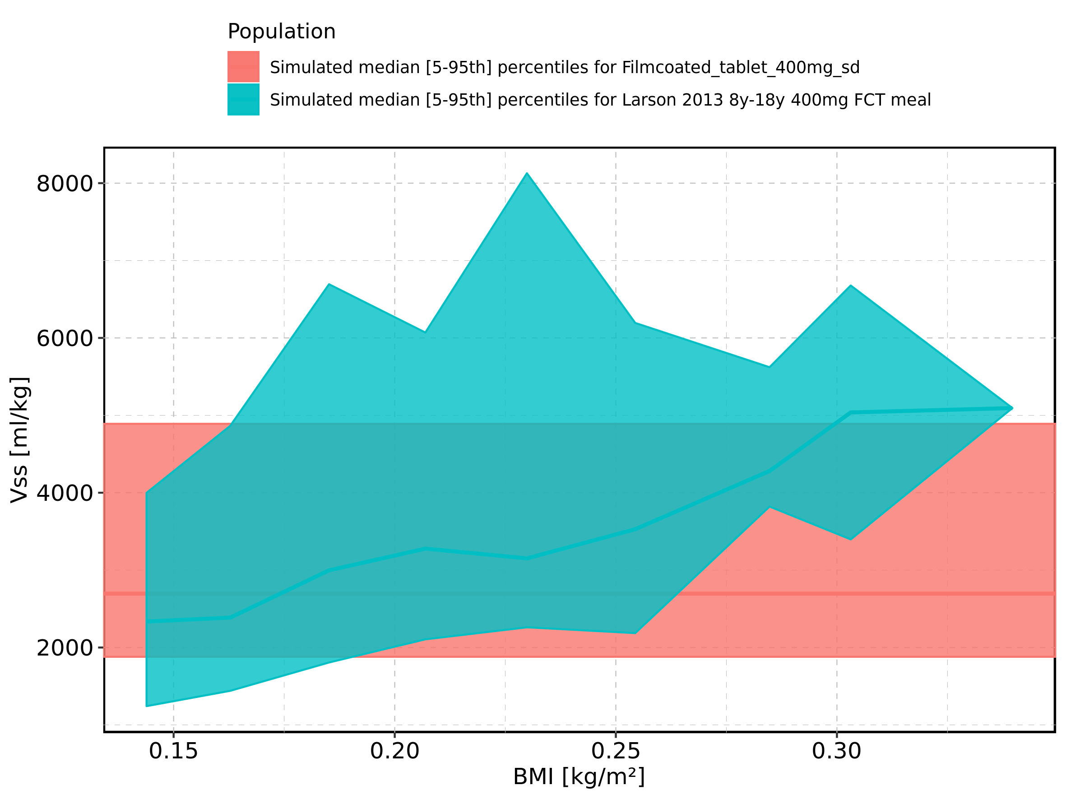

Figure 374: BMI-dependence of Vss for Larson 2013 8y-18y 400mg FCT meal in comparison to Filmcoated_tablet_400mg_sd. Profiles are plotted in a logarithmic scale.

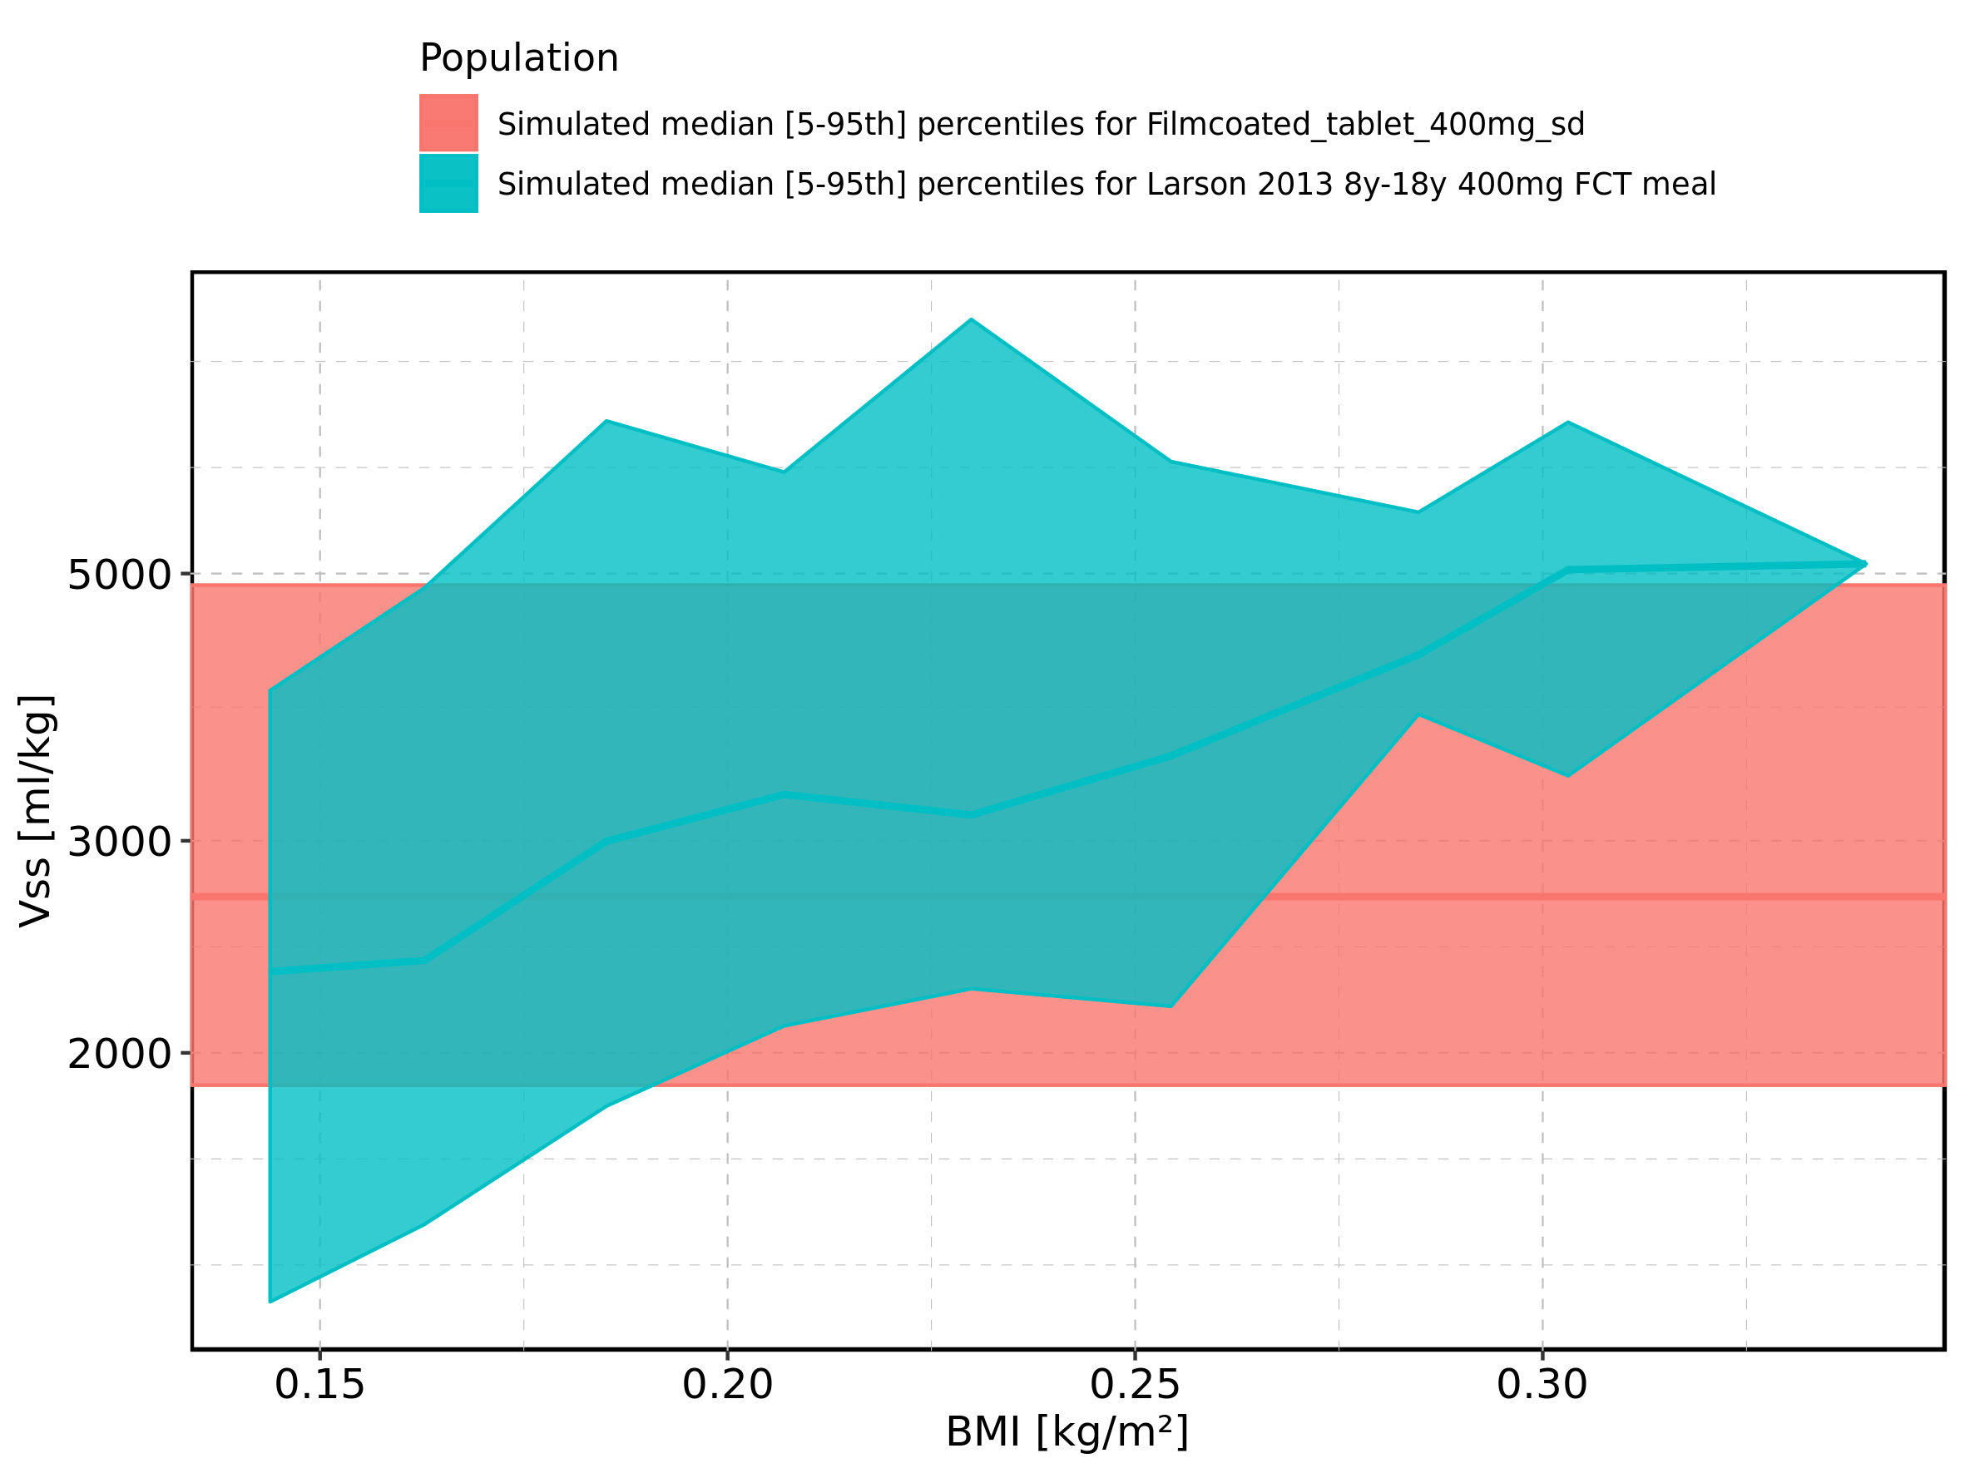

Figure 375: BMI-dependence of Vss for Larson 2013 8y-18y 400mg FCT meal. Profiles are plotted in a linear scale.

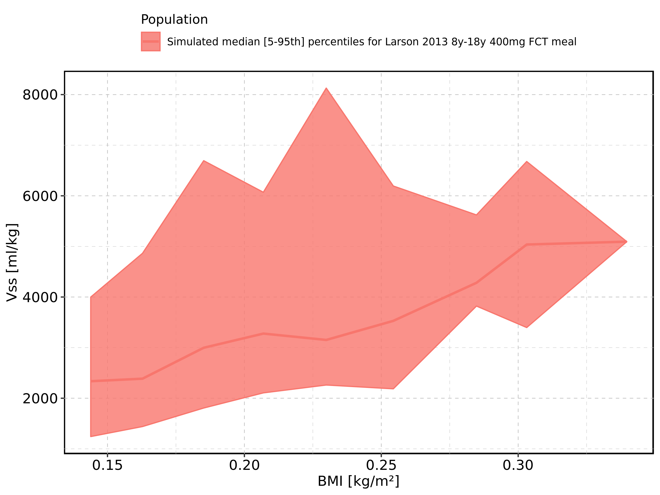

Figure 376: BMI-dependence of Vss for Larson 2013 8y-18y 400mg FCT meal. Profiles are plotted in a logarithmic scale.

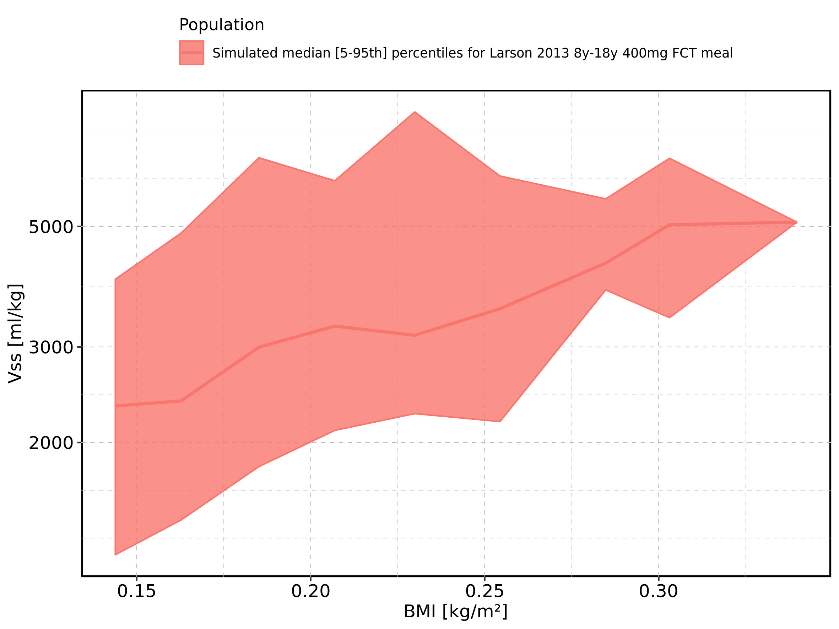

Figure 377: BMI-dependence of Vss for Filmcoated_tablet_400mg_sd. Profiles are plotted in a linear scale.

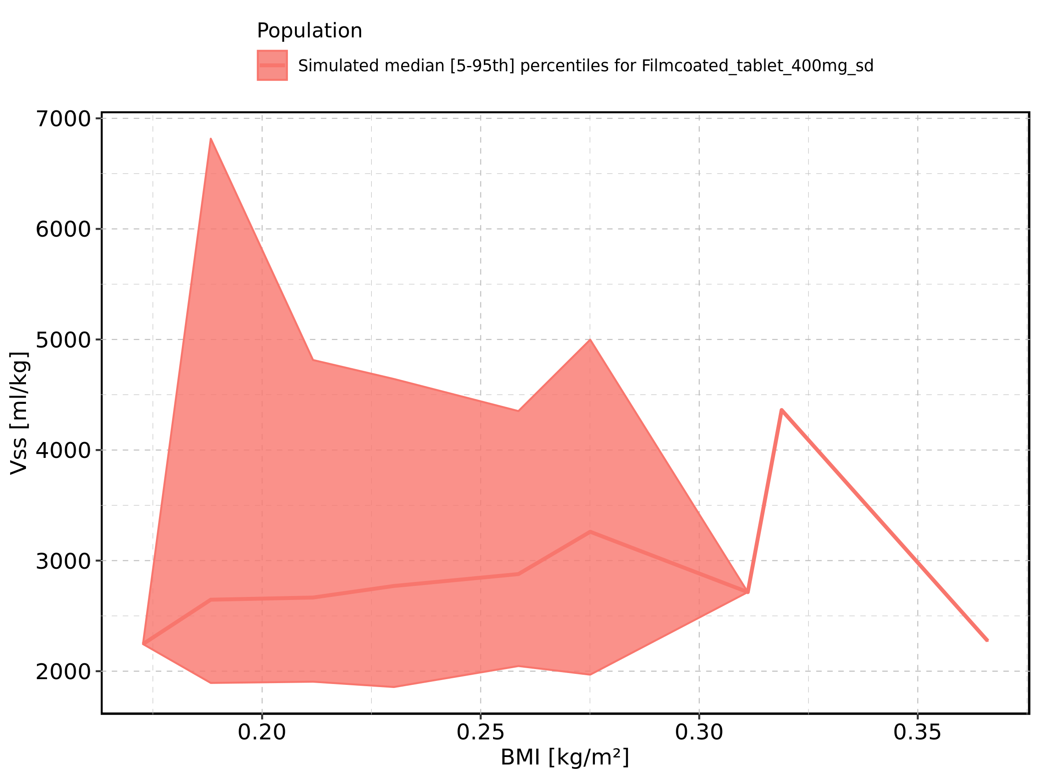

Figure 378: BMI-dependence of Vss for Filmcoated_tablet_400mg_sd. Profiles are plotted in a logarithmic scale.

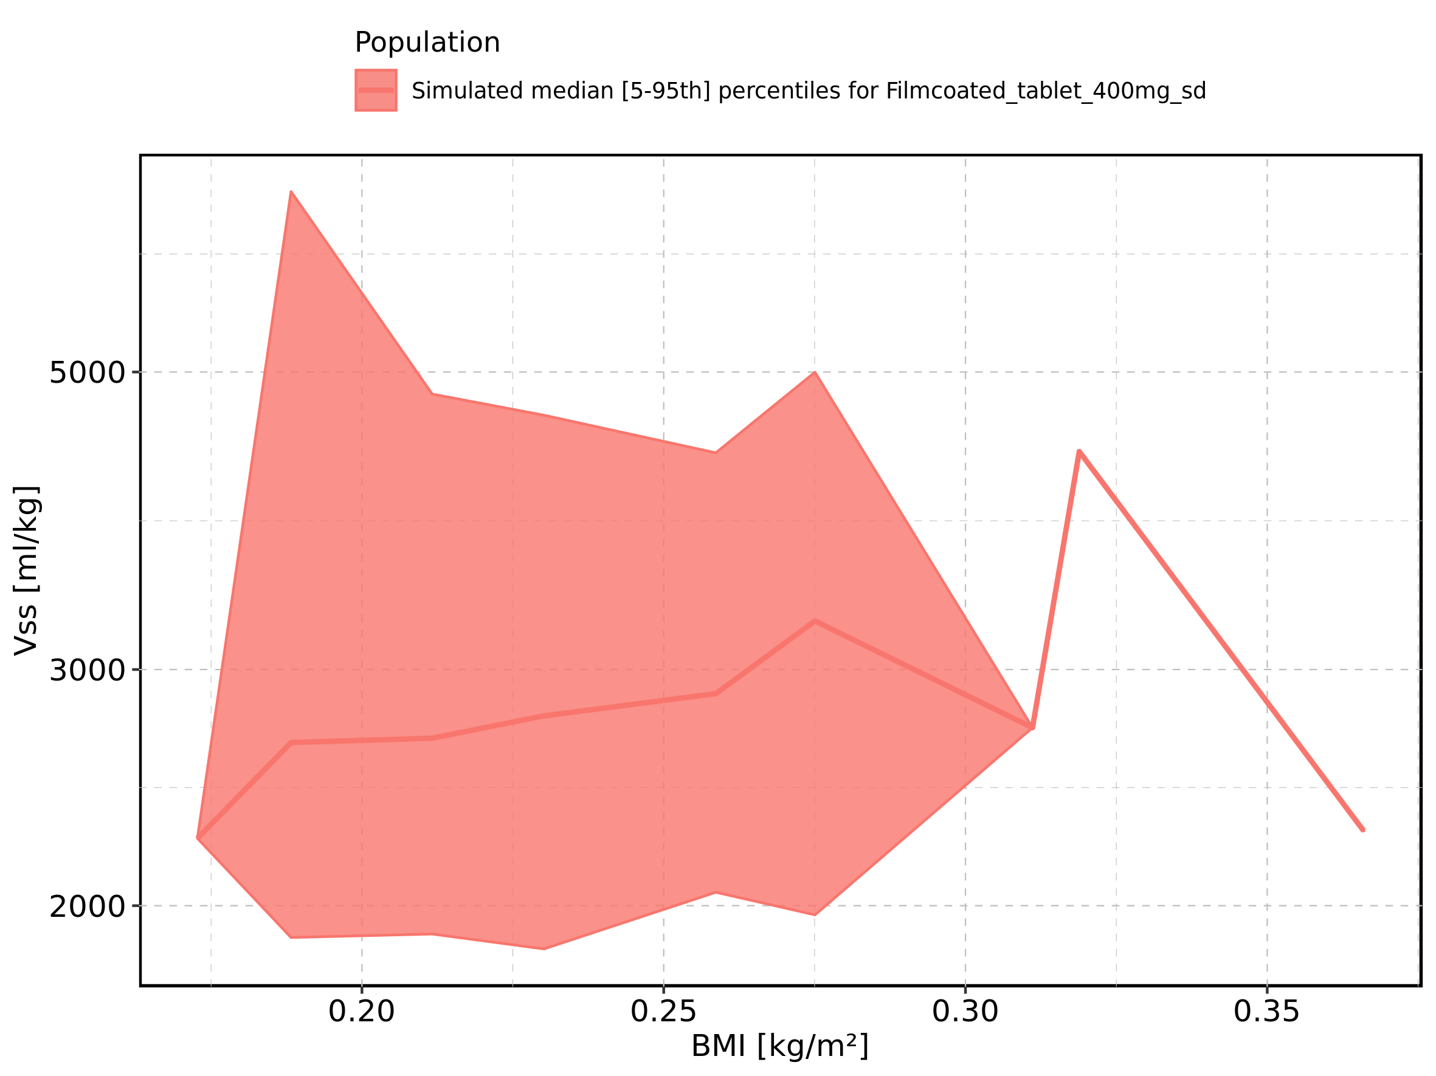

Figure 379: Gender-dependence of Vss for Larson 2013 8y-18y 400mg FCT meal in comparison to Filmcoated_tablet_400mg_sd. Profiles are plotted in a linear scale.

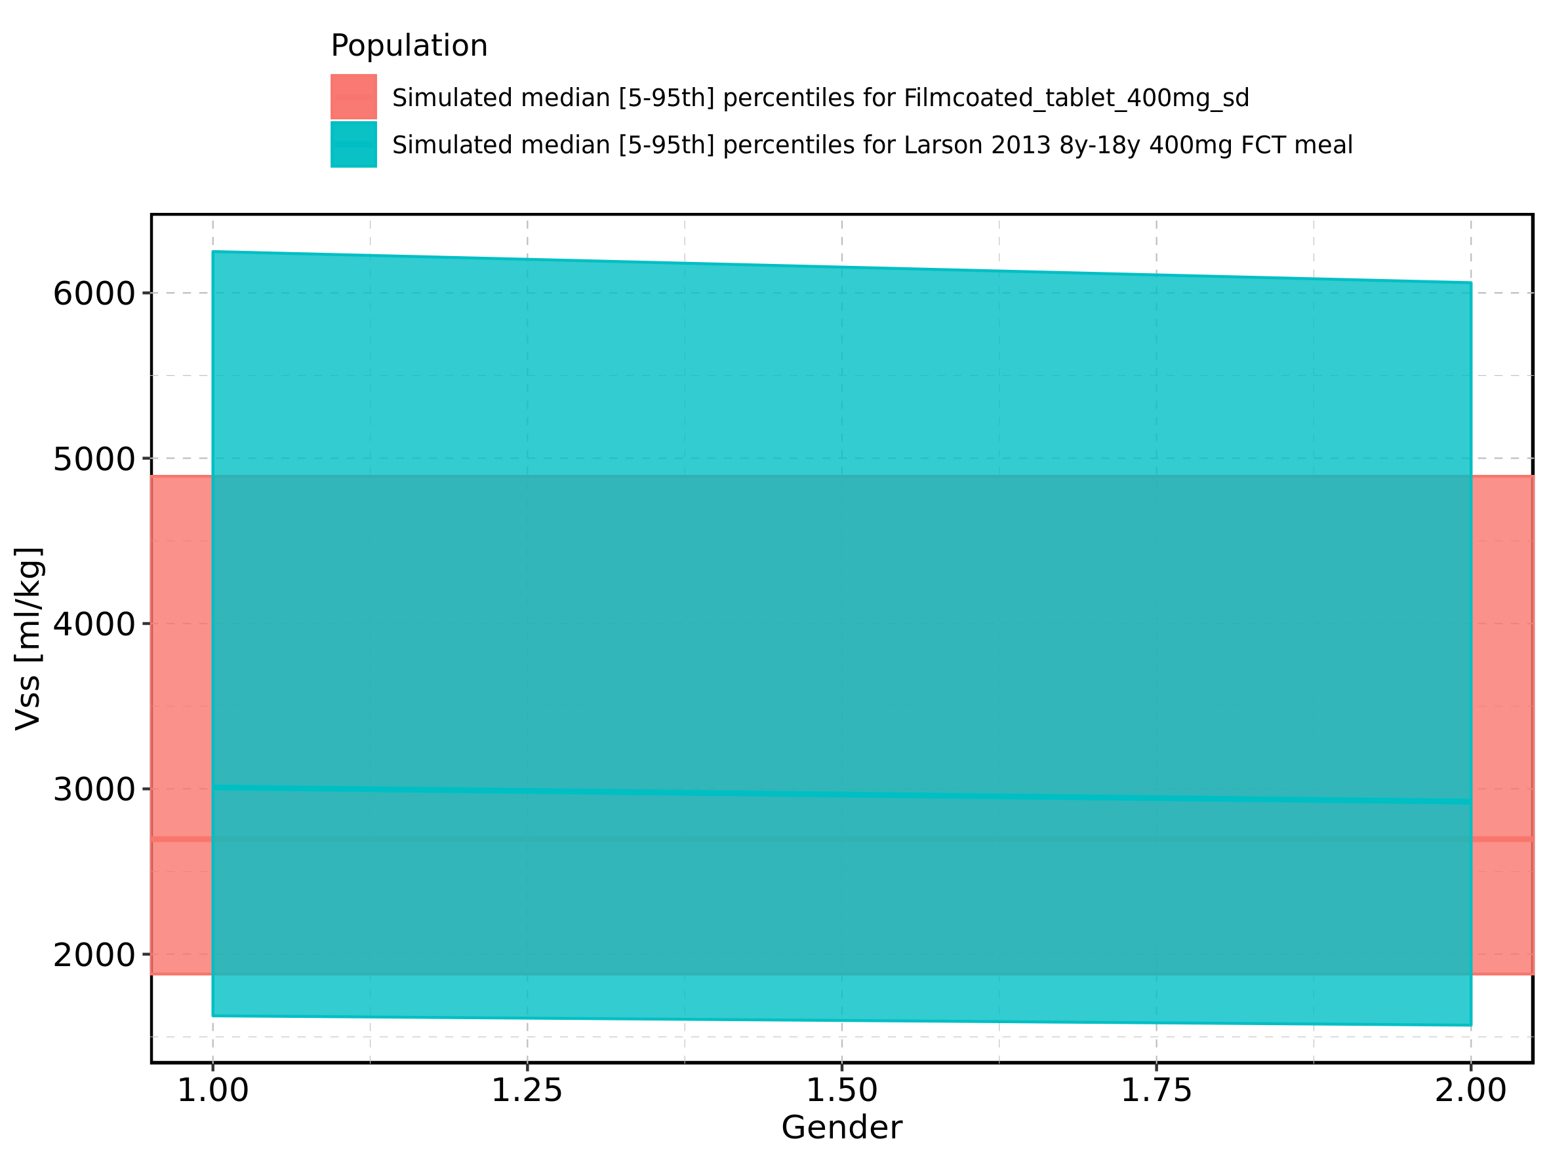

Figure 380: Gender-dependence of Vss for Larson 2013 8y-18y 400mg FCT meal in comparison to Filmcoated_tablet_400mg_sd. Profiles are plotted in a logarithmic scale.

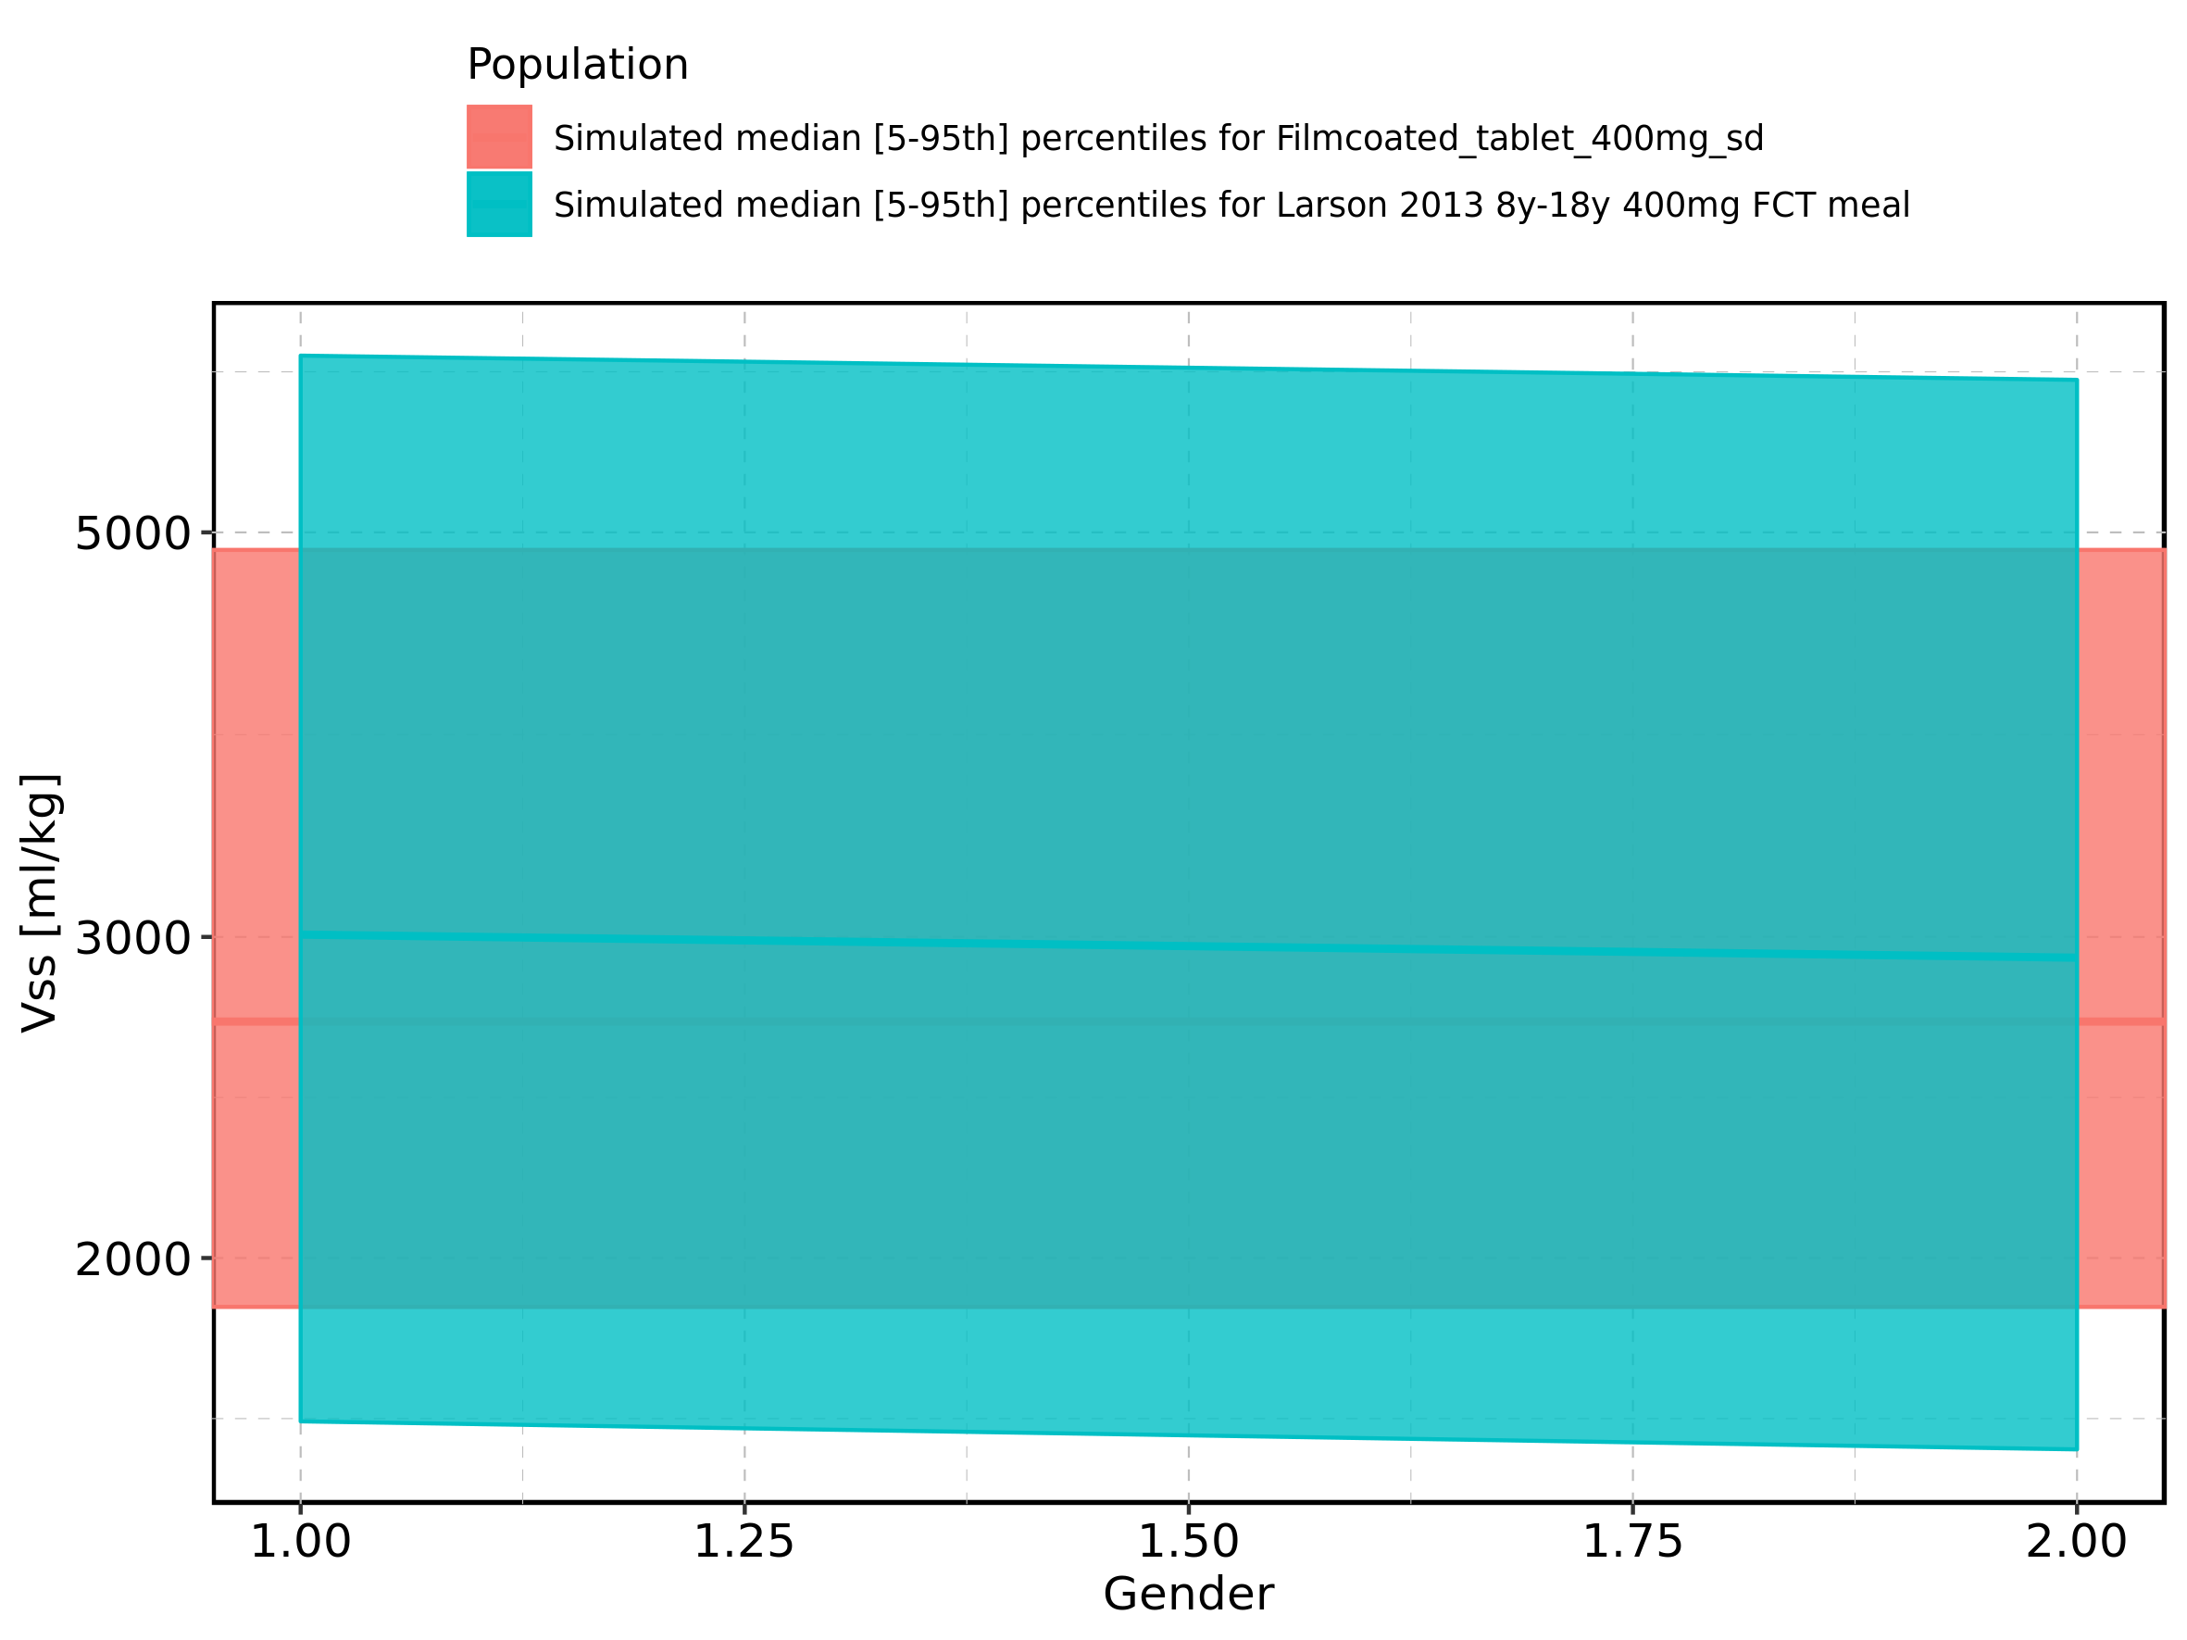

Figure 381: Gender-dependence of Vss for Larson 2013 8y-18y 400mg FCT meal. Profiles are plotted in a linear scale.

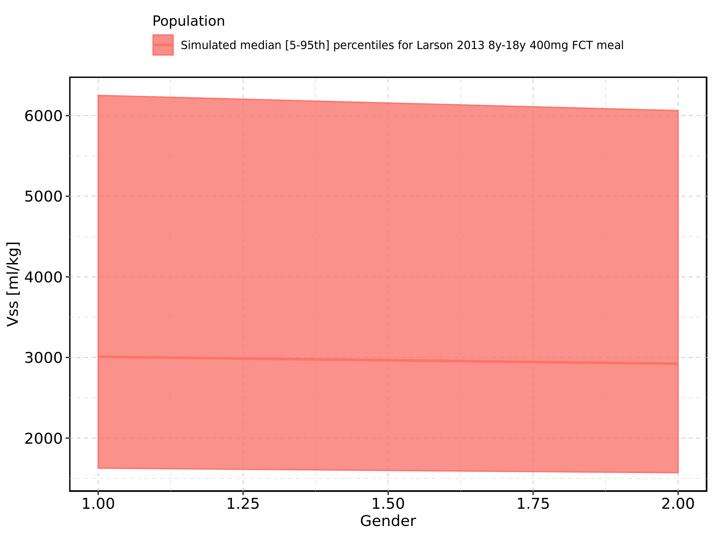

Figure 382: Gender-dependence of Vss for Larson 2013 8y-18y 400mg FCT meal. Profiles are plotted in a logarithmic scale.

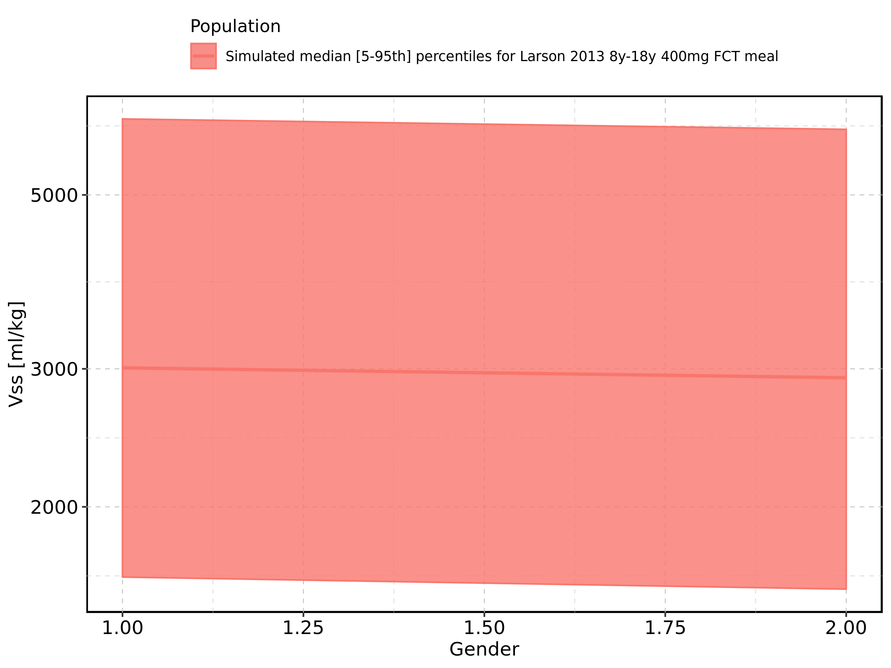

Figure 383: Gender-dependence of Vss for Filmcoated_tablet_400mg_sd. Profiles are plotted in a linear scale.

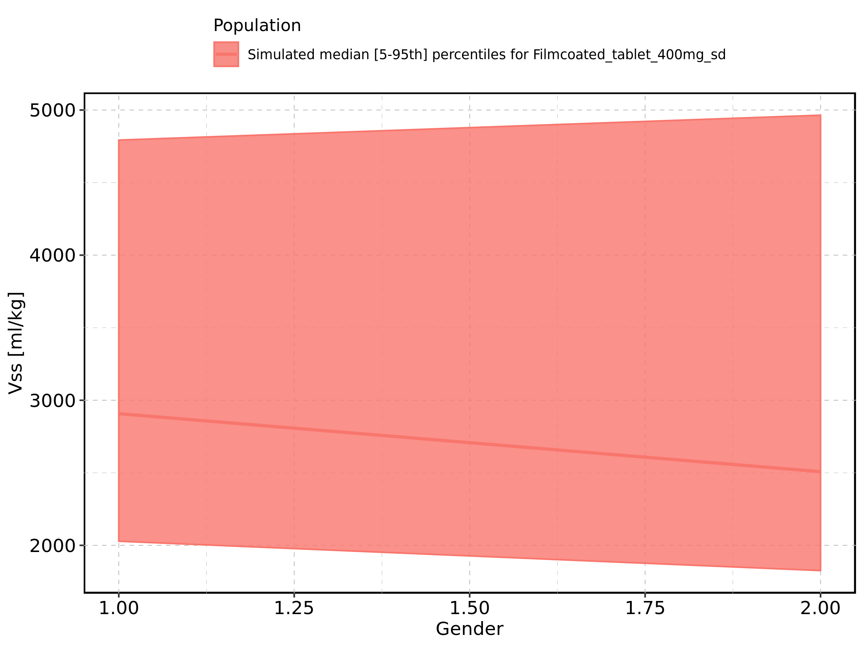

Figure 384: Gender-dependence of Vss for Filmcoated_tablet_400mg_sd. Profiles are plotted in a logarithmic scale.

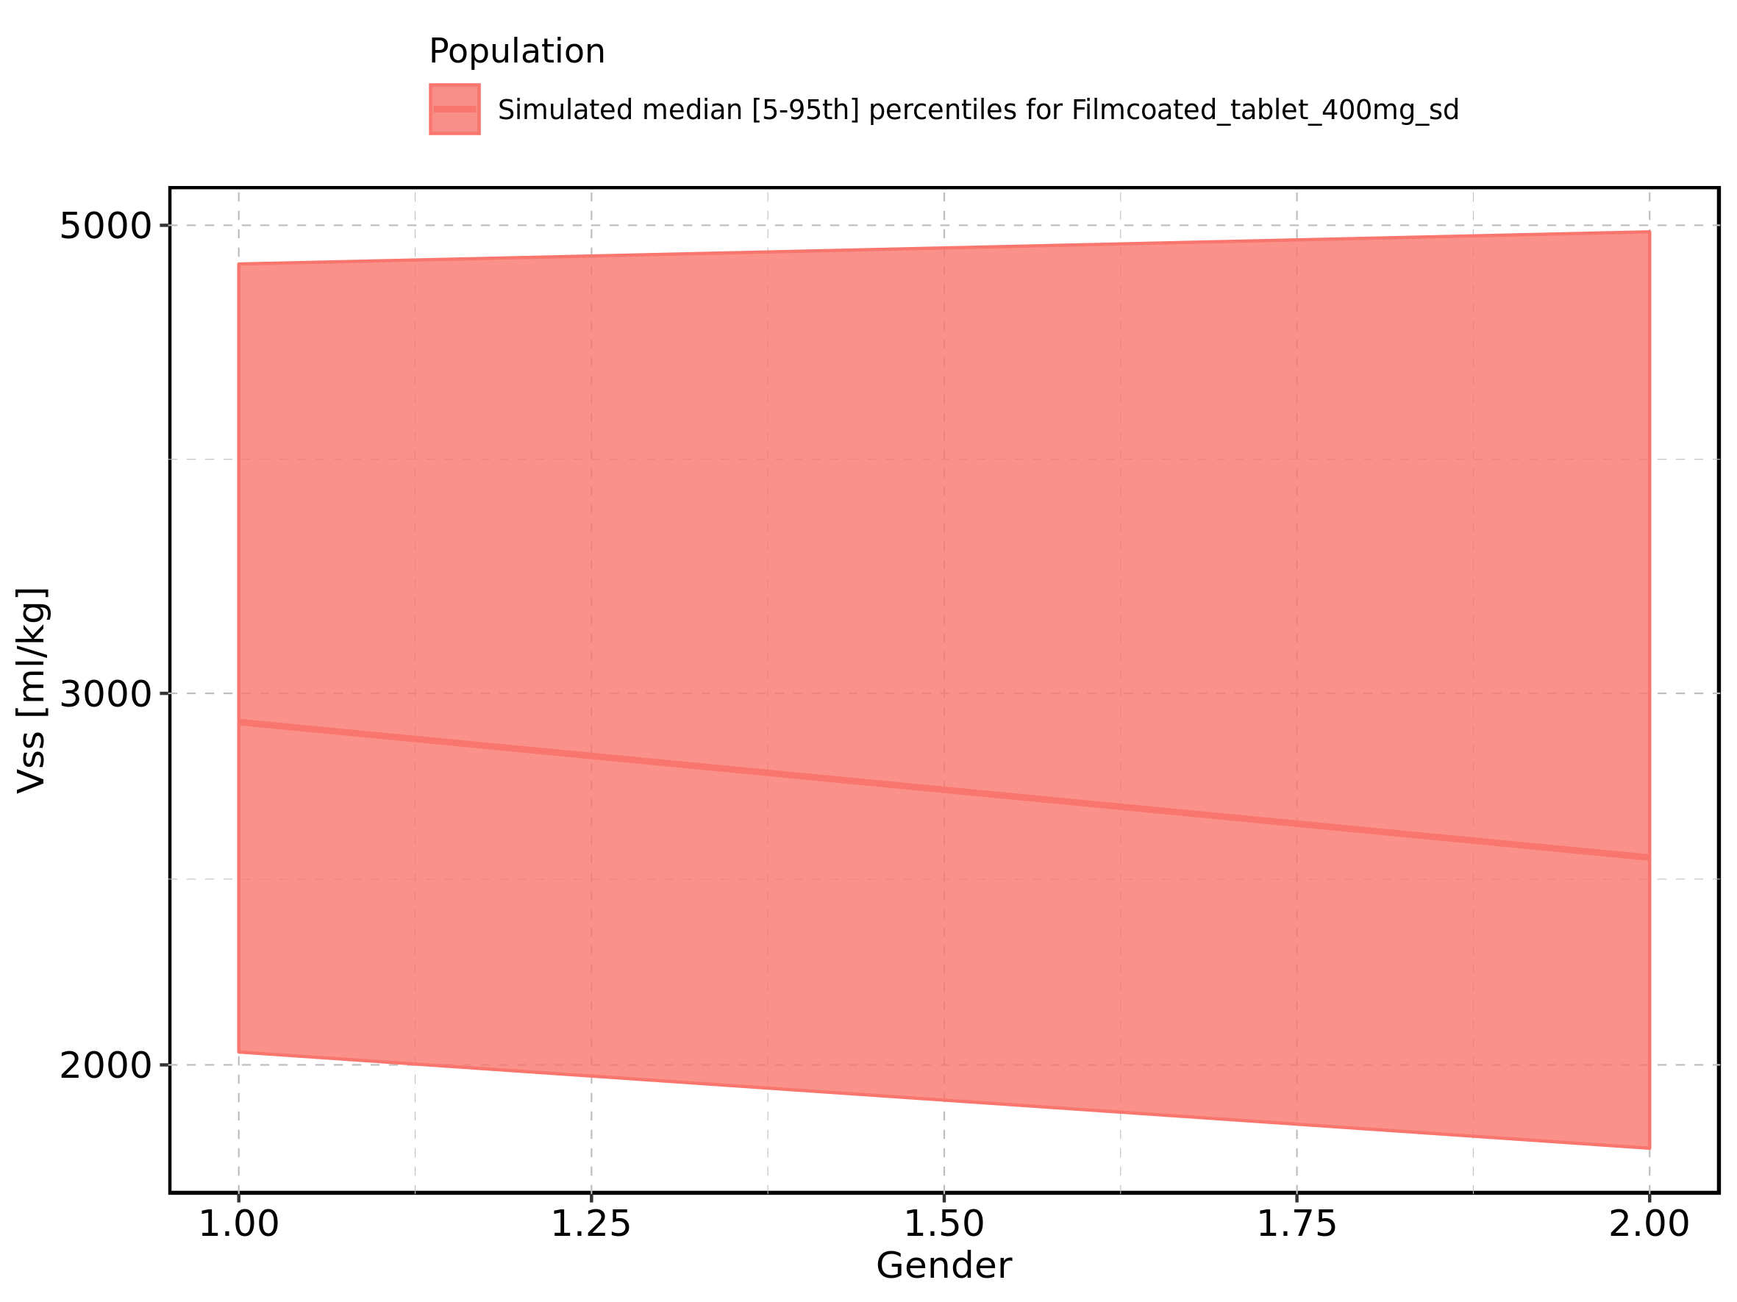

Figure 385: Vd of Raltegravir shown as box-whisker plot, which indicates the 5th, 25th, 50th, 75th, and 95th percentiles in linear scale.

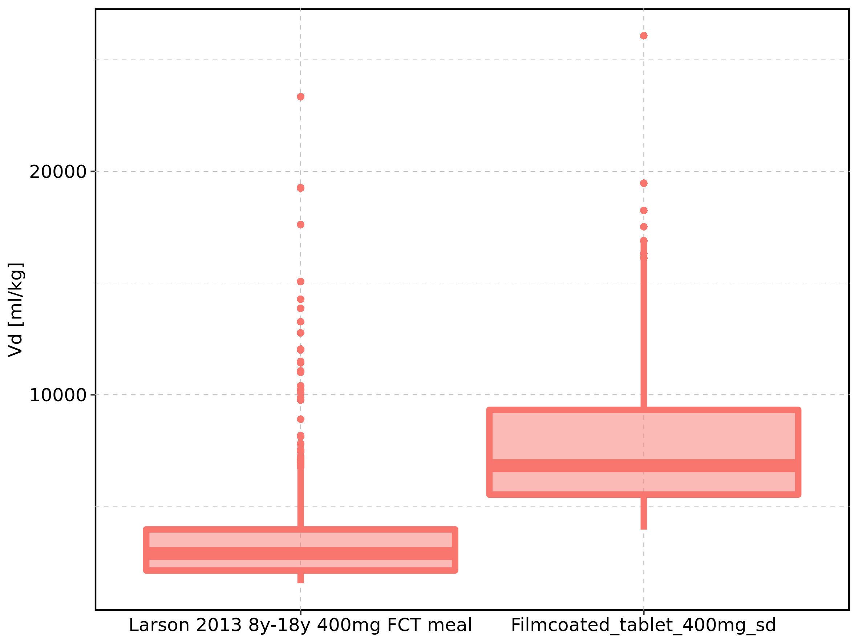

|  |  |  |  |  |  |  |  |  |  |  |
| --- | --- | --- | --- | --- | --- | --- | --- | --- | --- | --- |
| Population | N | 5th percentile | 25th percentile | 50th percentile | 75th percentile | 95th percentile | mean | standard deviation | geo mean | geo standard deviation |
| Larson 2013 8y-18y 400mg FCT meal | 497 | 1564.173 | 2133.960 | 2893.517 | 3971.826 | 7809.583 | 3610.032 | 2601.888 | 3089.065 | 1.670647 |
| Filmcoated_tablet_400mg_sd | 100 | 3961.869 | 5531.187 | 6823.958 | 9325.517 | 16886.073 | 8090.423 | 4000.154 | 7343.514 | 1.531150 |

Figure 386: Vd of Raltegravir shown as box-whisker plot, which indicates the 5th, 25th, 50th, 75th, and 95th percentiles in logarithmic scale.

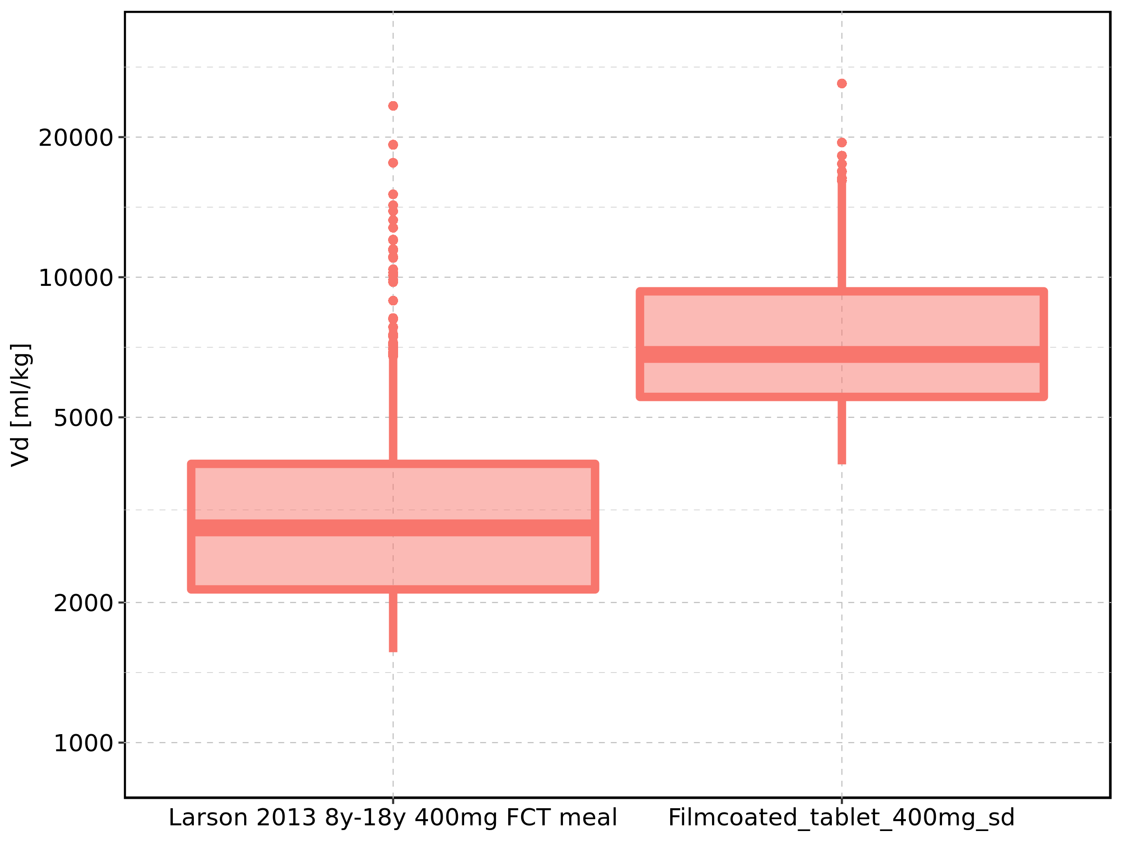

Figure 387: Age-dependence of Vd for Larson 2013 8y-18y 400mg FCT meal in comparison to Filmcoated_tablet_400mg_sd. Profiles are plotted in a linear scale.

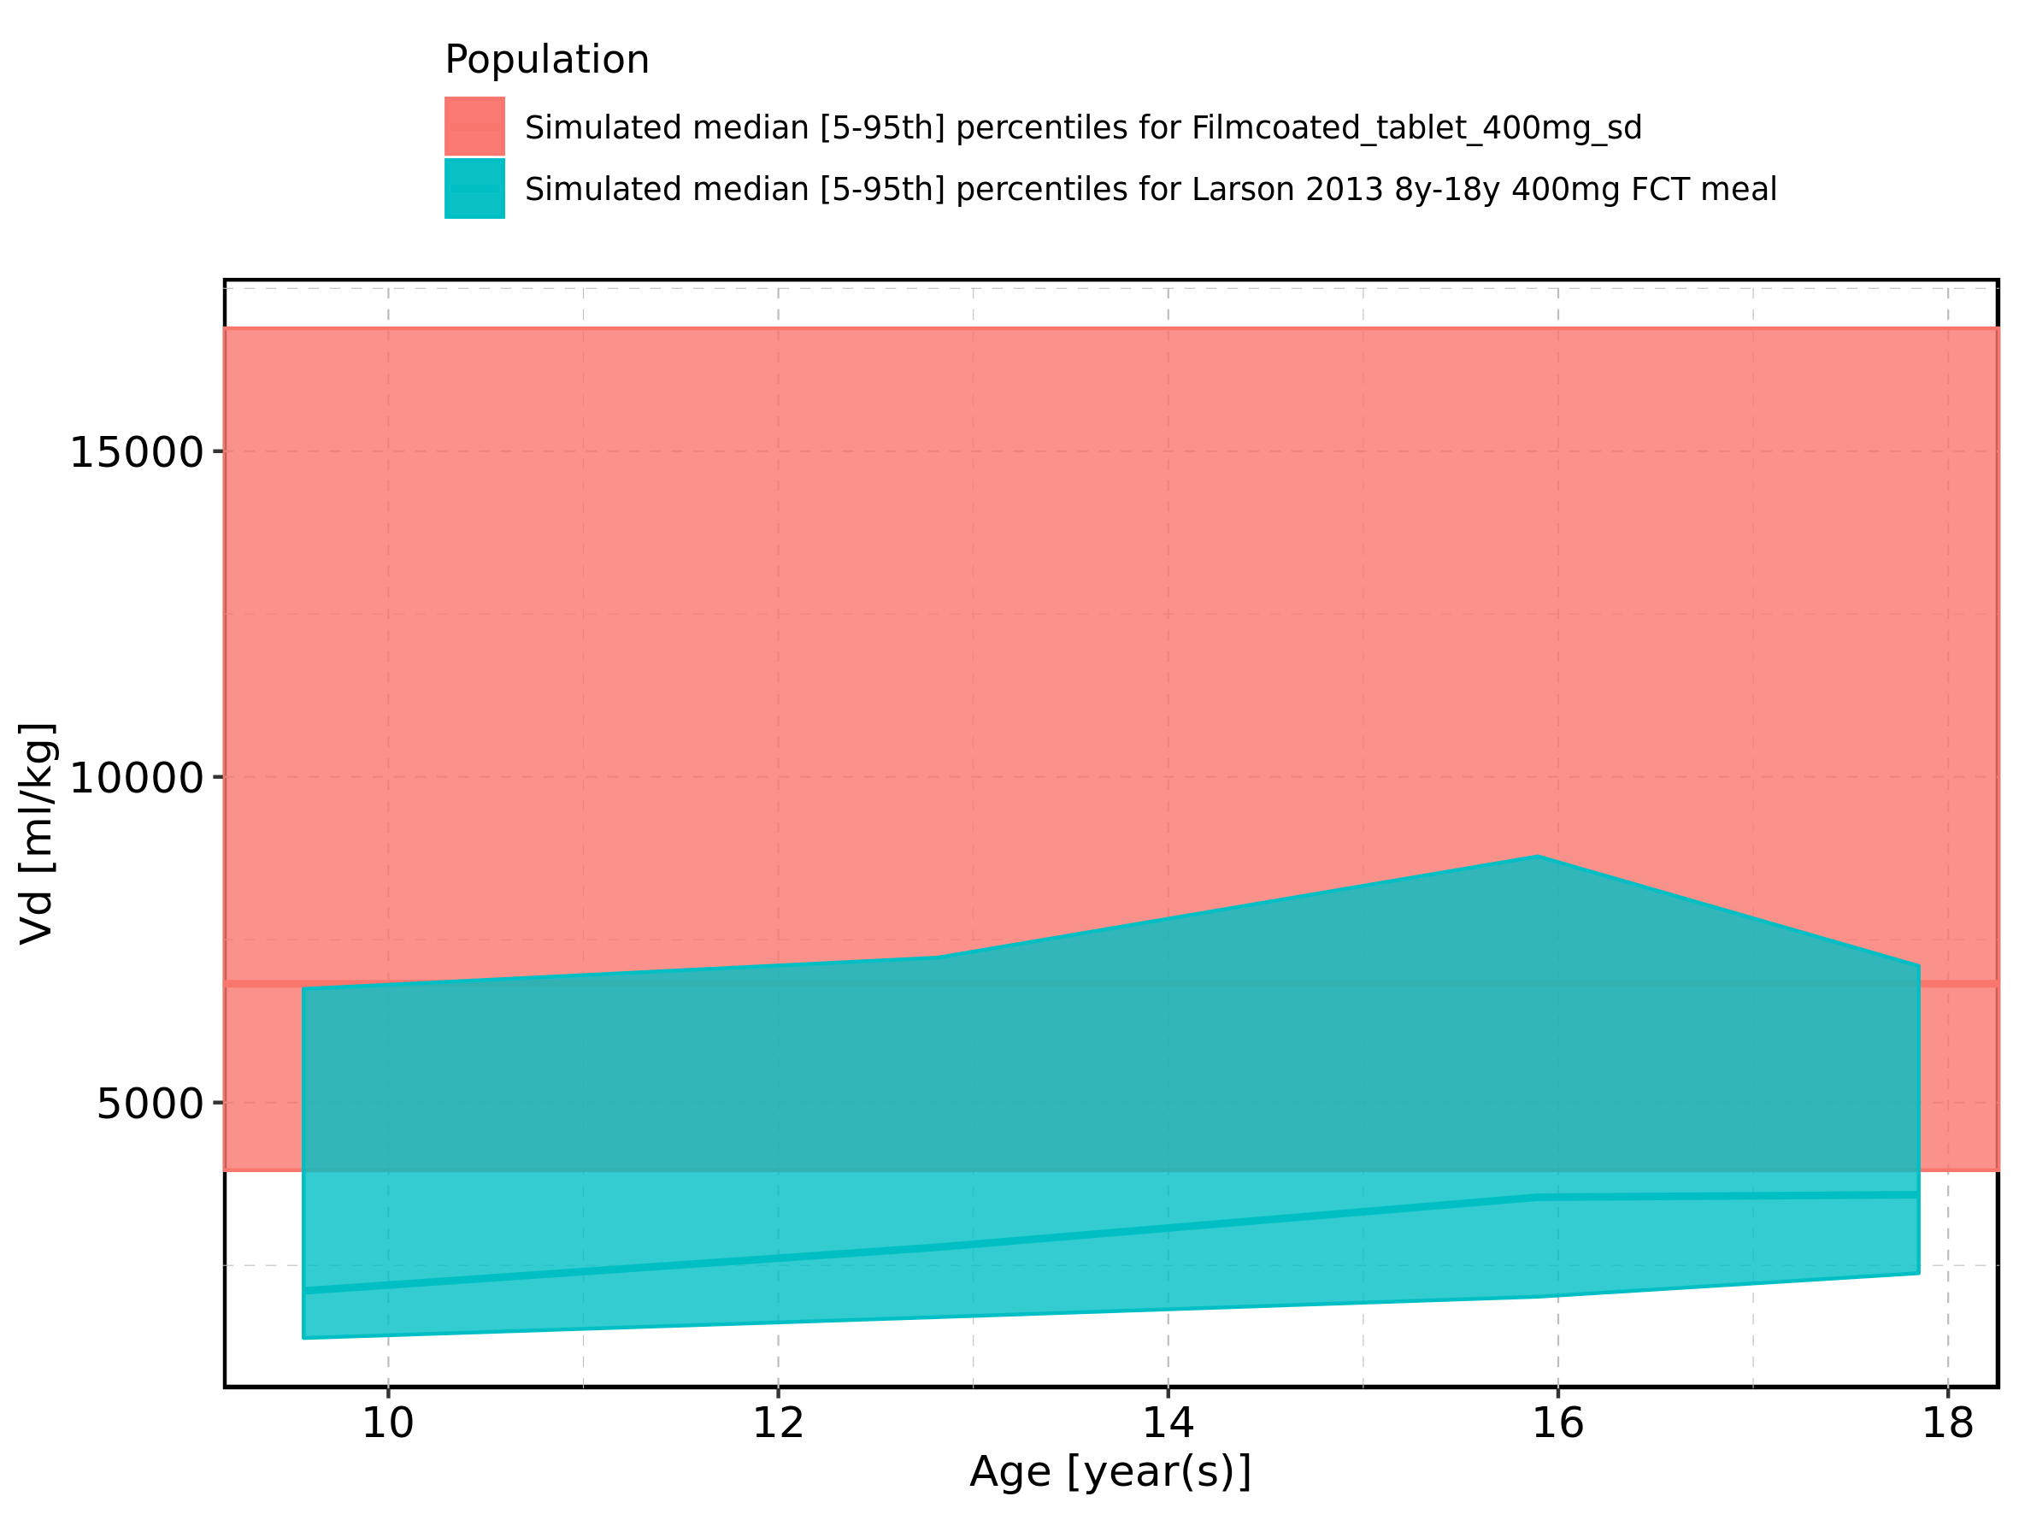

Figure 388: Age-dependence of Vd for Larson 2013 8y-18y 400mg FCT meal in comparison to Filmcoated_tablet_400mg_sd. Profiles are plotted in a logarithmic scale.

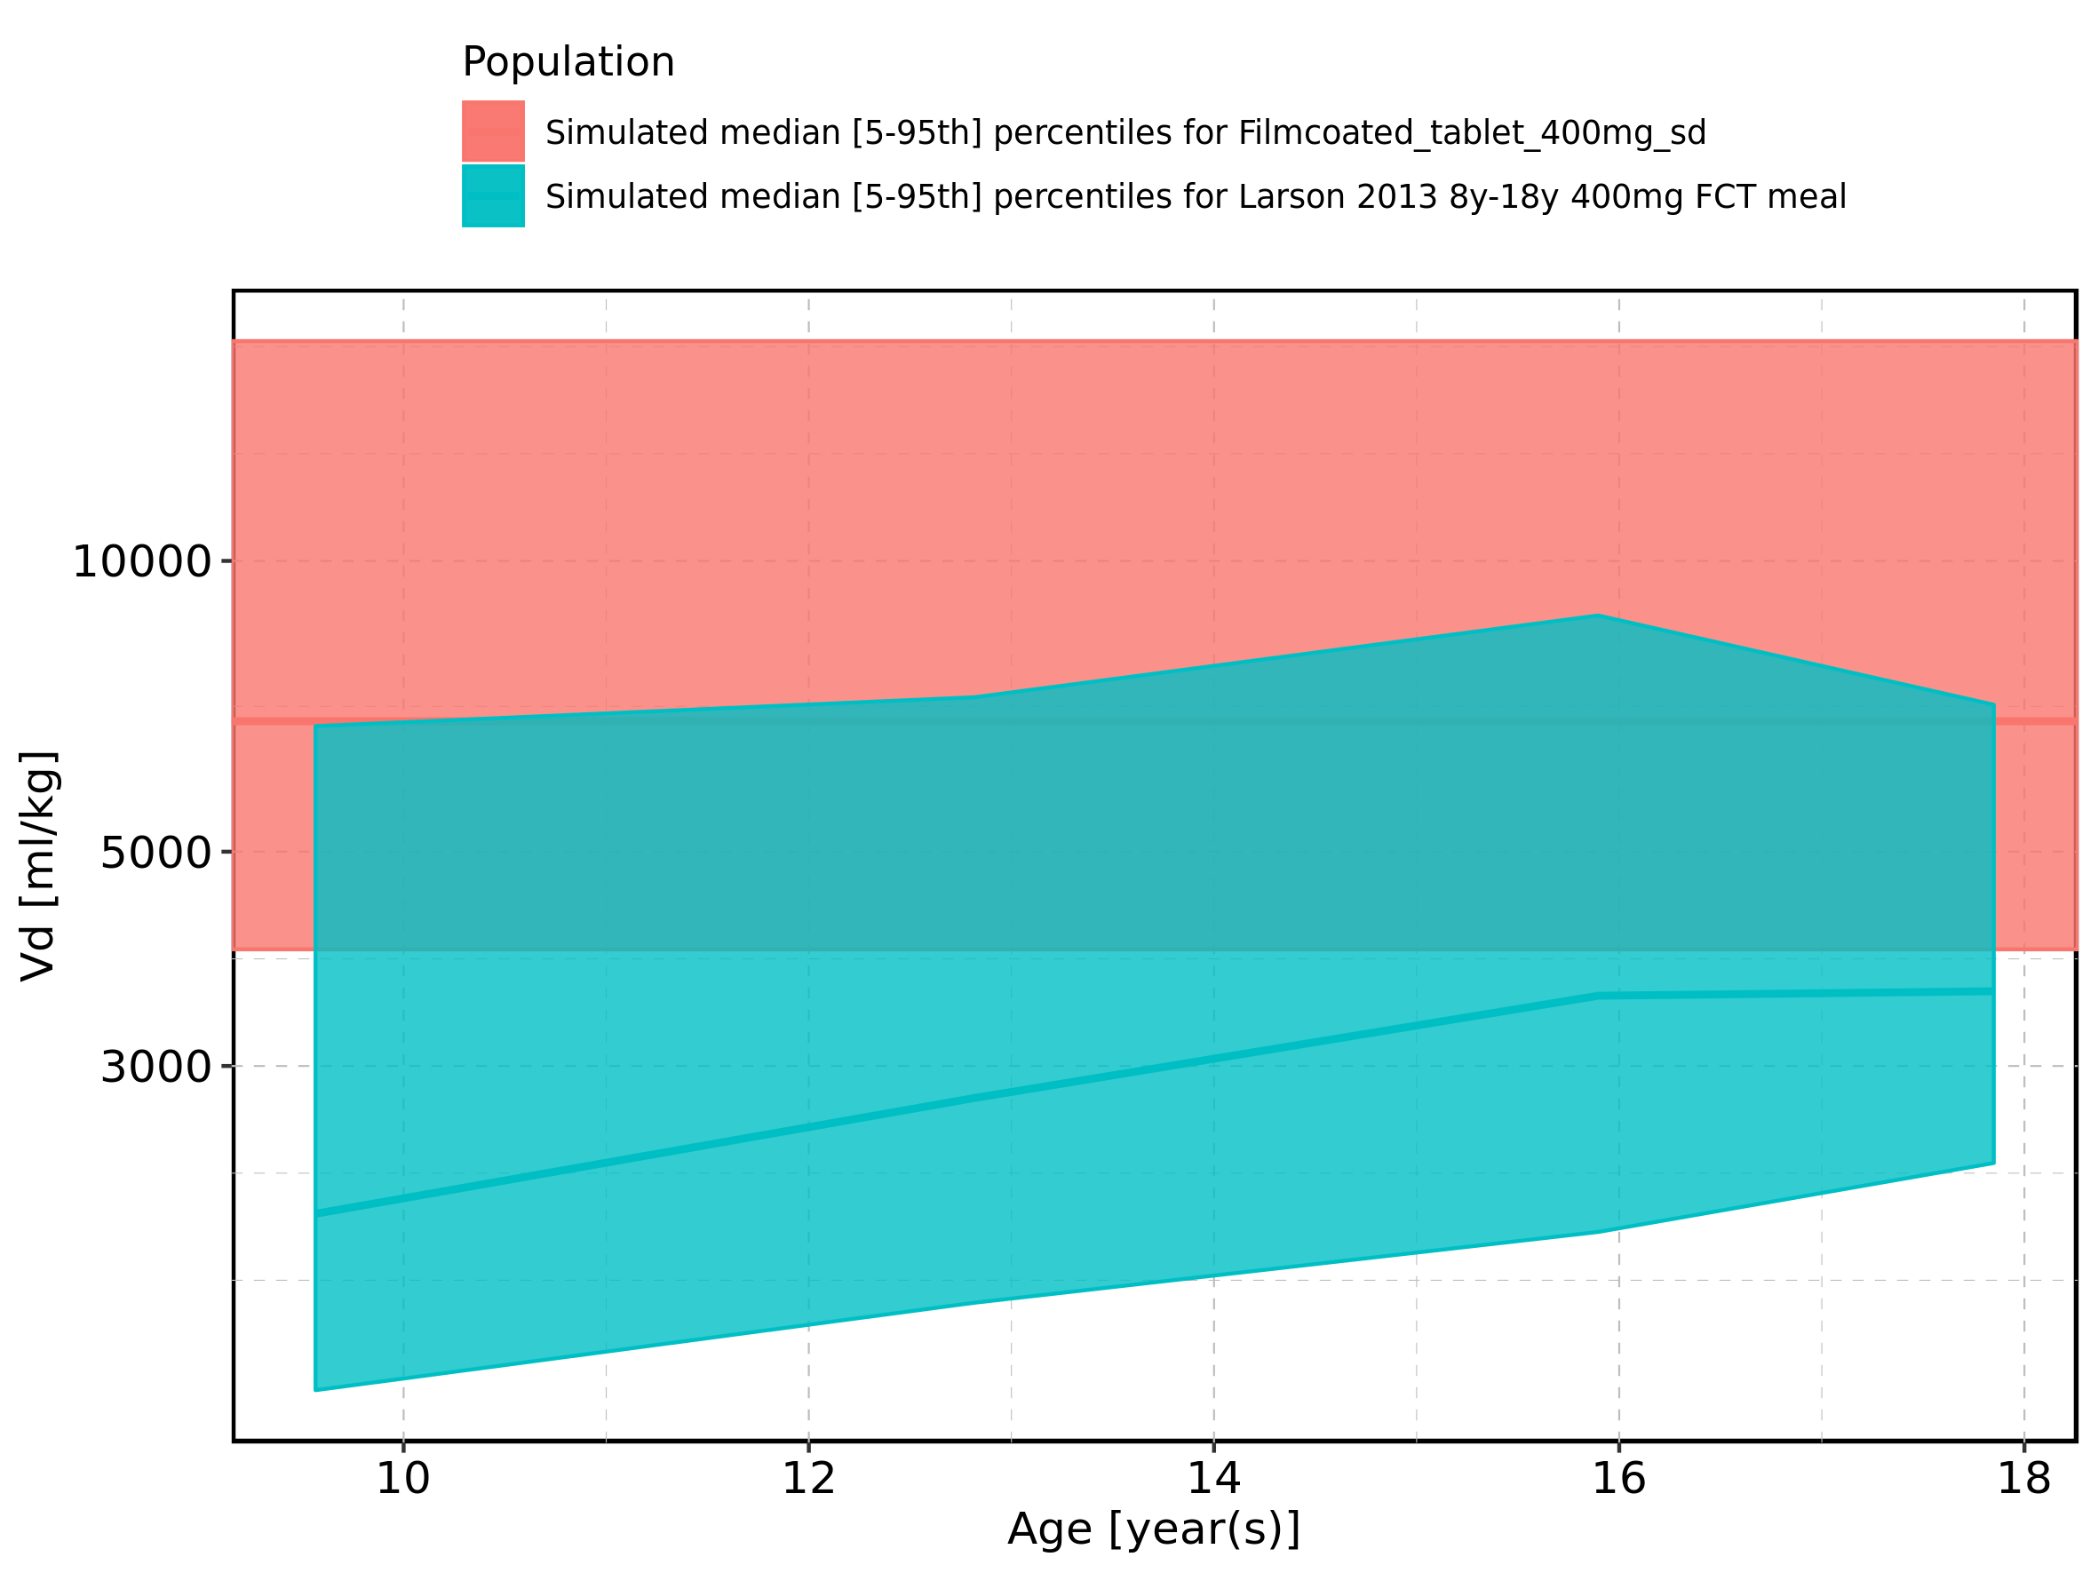

Figure 389: Age-dependence of Vd for Larson 2013 8y-18y 400mg FCT meal. Profiles are plotted in a linear scale.

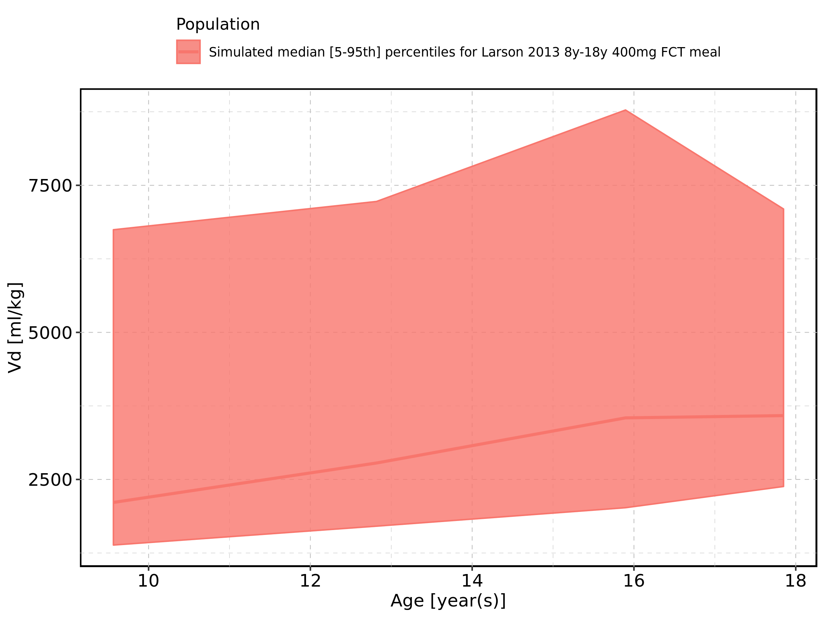

Figure 390: Age-dependence of Vd for Larson 2013 8y-18y 400mg FCT meal. Profiles are plotted in a logarithmic scale.

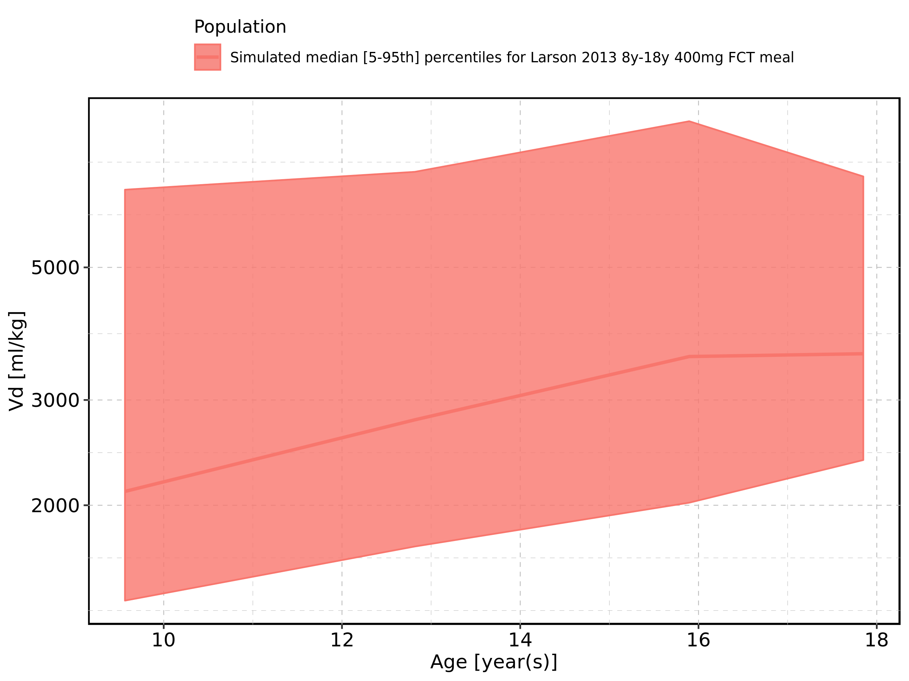

Figure 391: Age-dependence of Vd for Filmcoated_tablet_400mg_sd. Profiles are plotted in a linear scale.

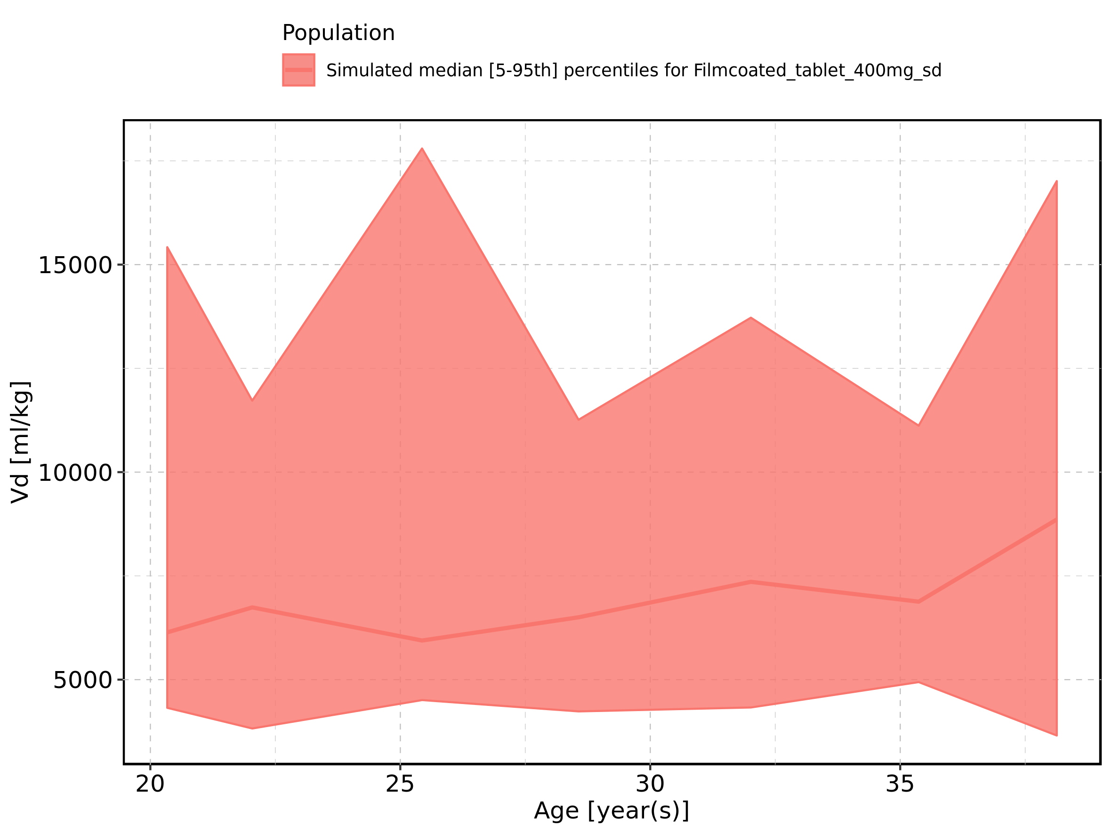

Figure 392: Age-dependence of Vd for Filmcoated_tablet_400mg_sd. Profiles are plotted in a logarithmic scale.

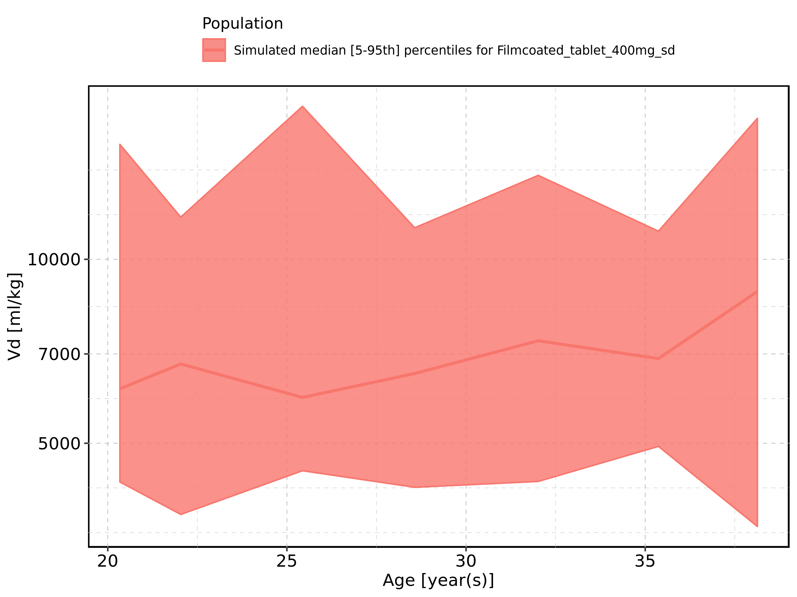

Figure 393: Height-dependence of Vd for Larson 2013 8y-18y 400mg FCT meal in comparison to Filmcoated_tablet_400mg_sd. Profiles are plotted in a linear scale.

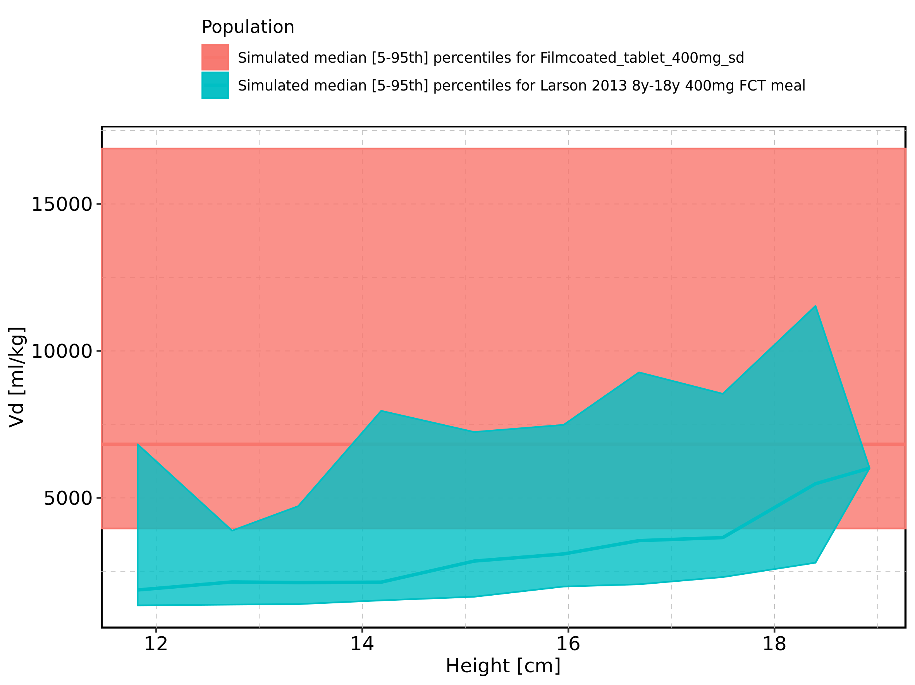

Figure 394: Height-dependence of Vd for Larson 2013 8y-18y 400mg FCT meal in comparison to Filmcoated_tablet_400mg_sd. Profiles are plotted in a logarithmic scale.

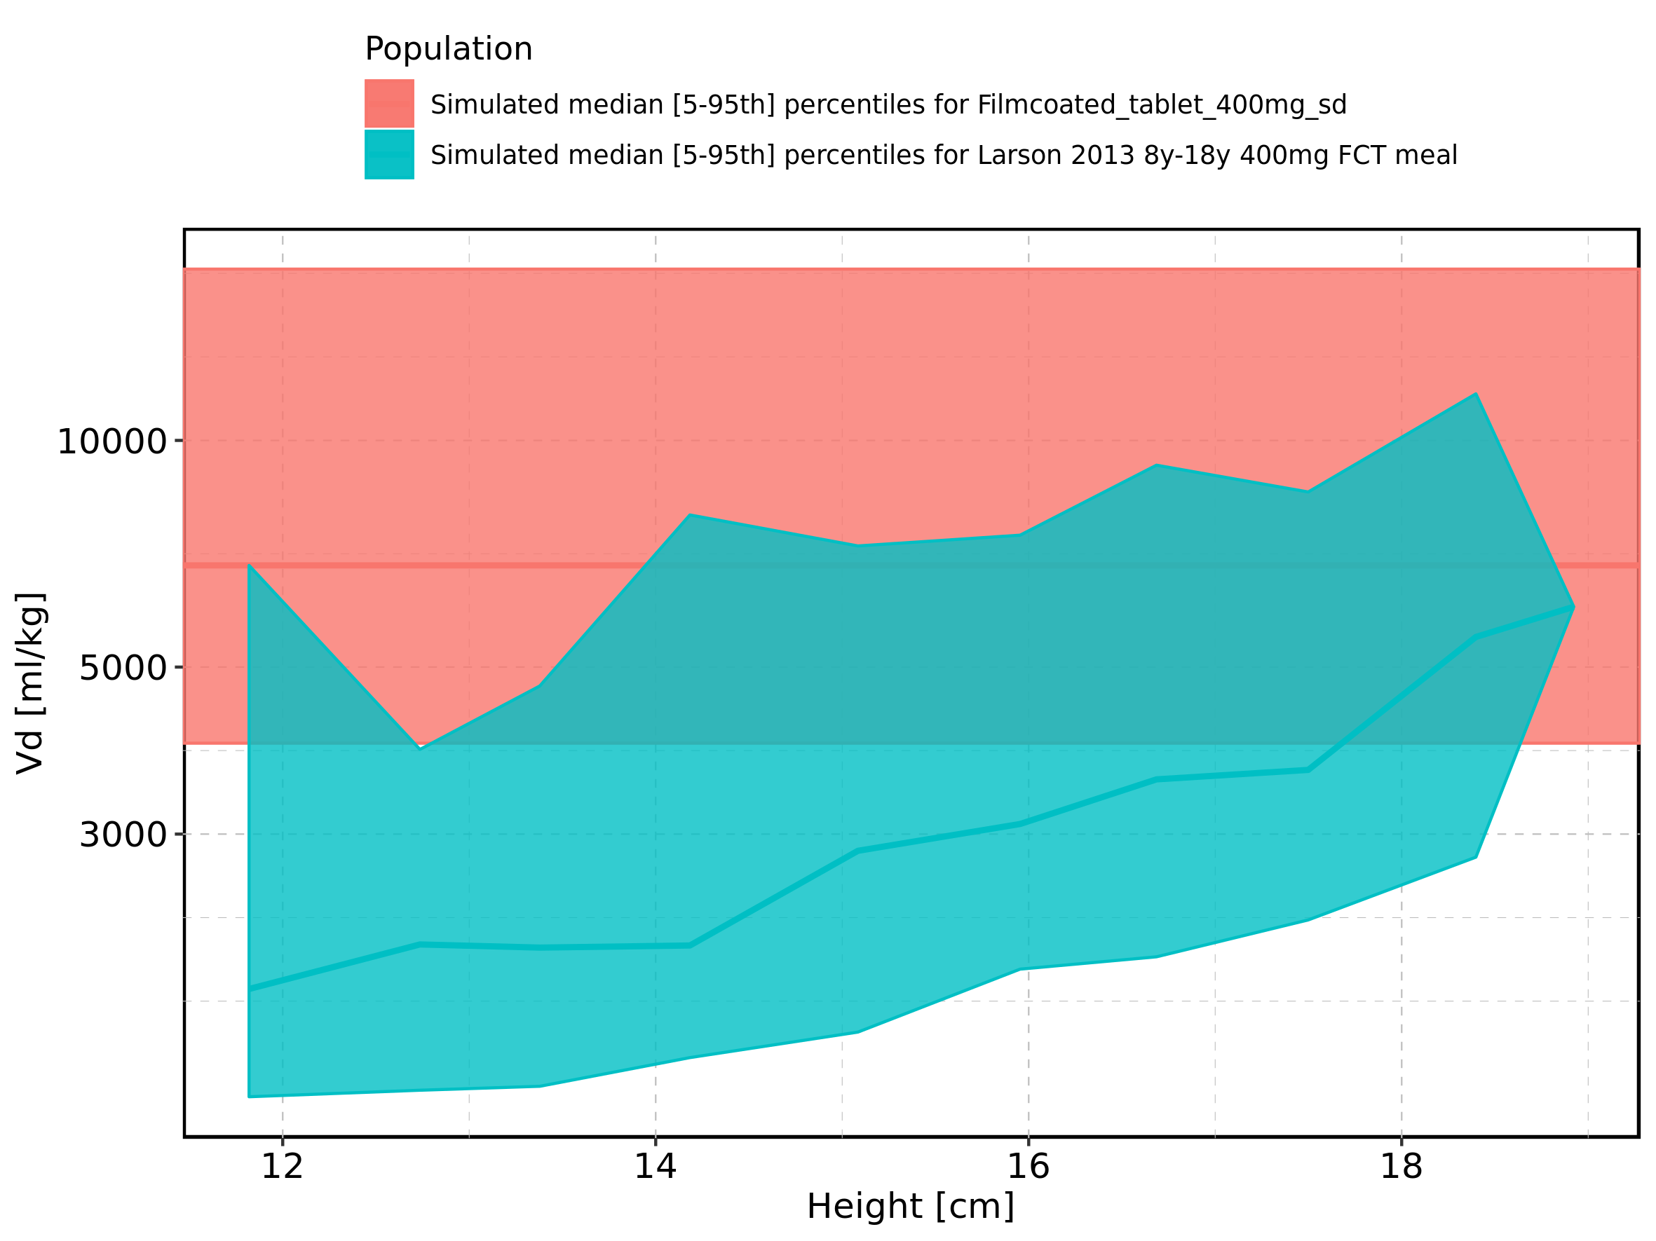

Figure 395: Height-dependence of Vd for Larson 2013 8y-18y 400mg FCT meal. Profiles are plotted in a linear scale.

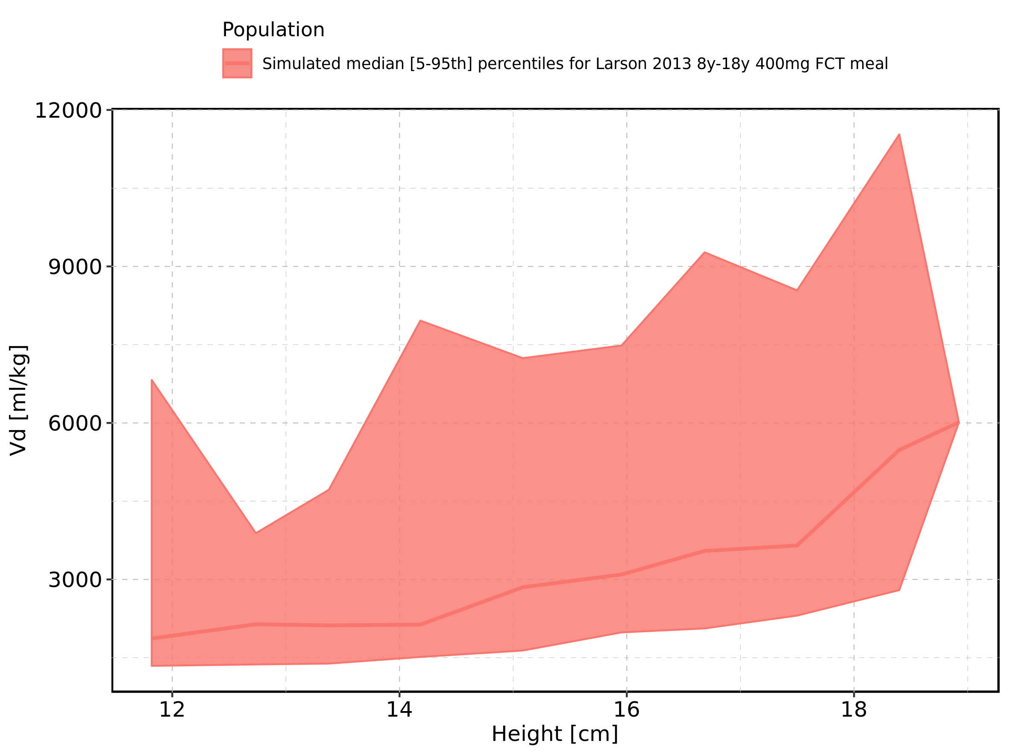

Figure 396: Height-dependence of Vd for Larson 2013 8y-18y 400mg FCT meal. Profiles are plotted in a logarithmic scale.

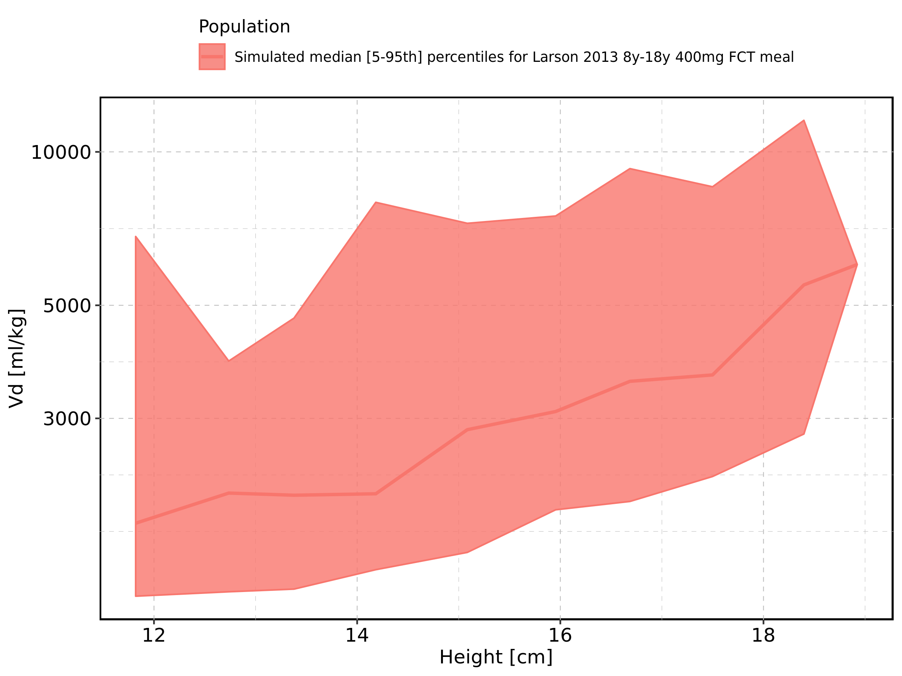

Figure 397: Height-dependence of Vd for Filmcoated_tablet_400mg_sd. Profiles are plotted in a linear scale.

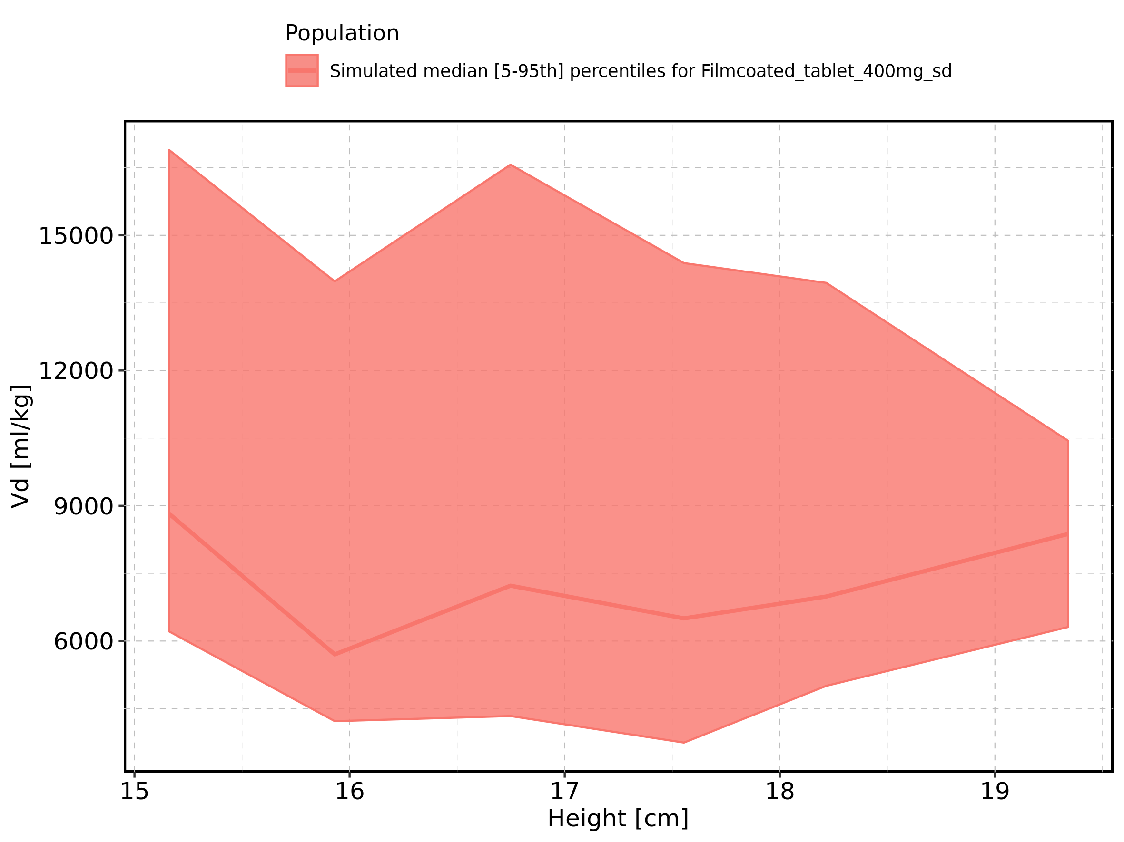

Figure 398: Height-dependence of Vd for Filmcoated_tablet_400mg_sd. Profiles are plotted in a logarithmic scale.

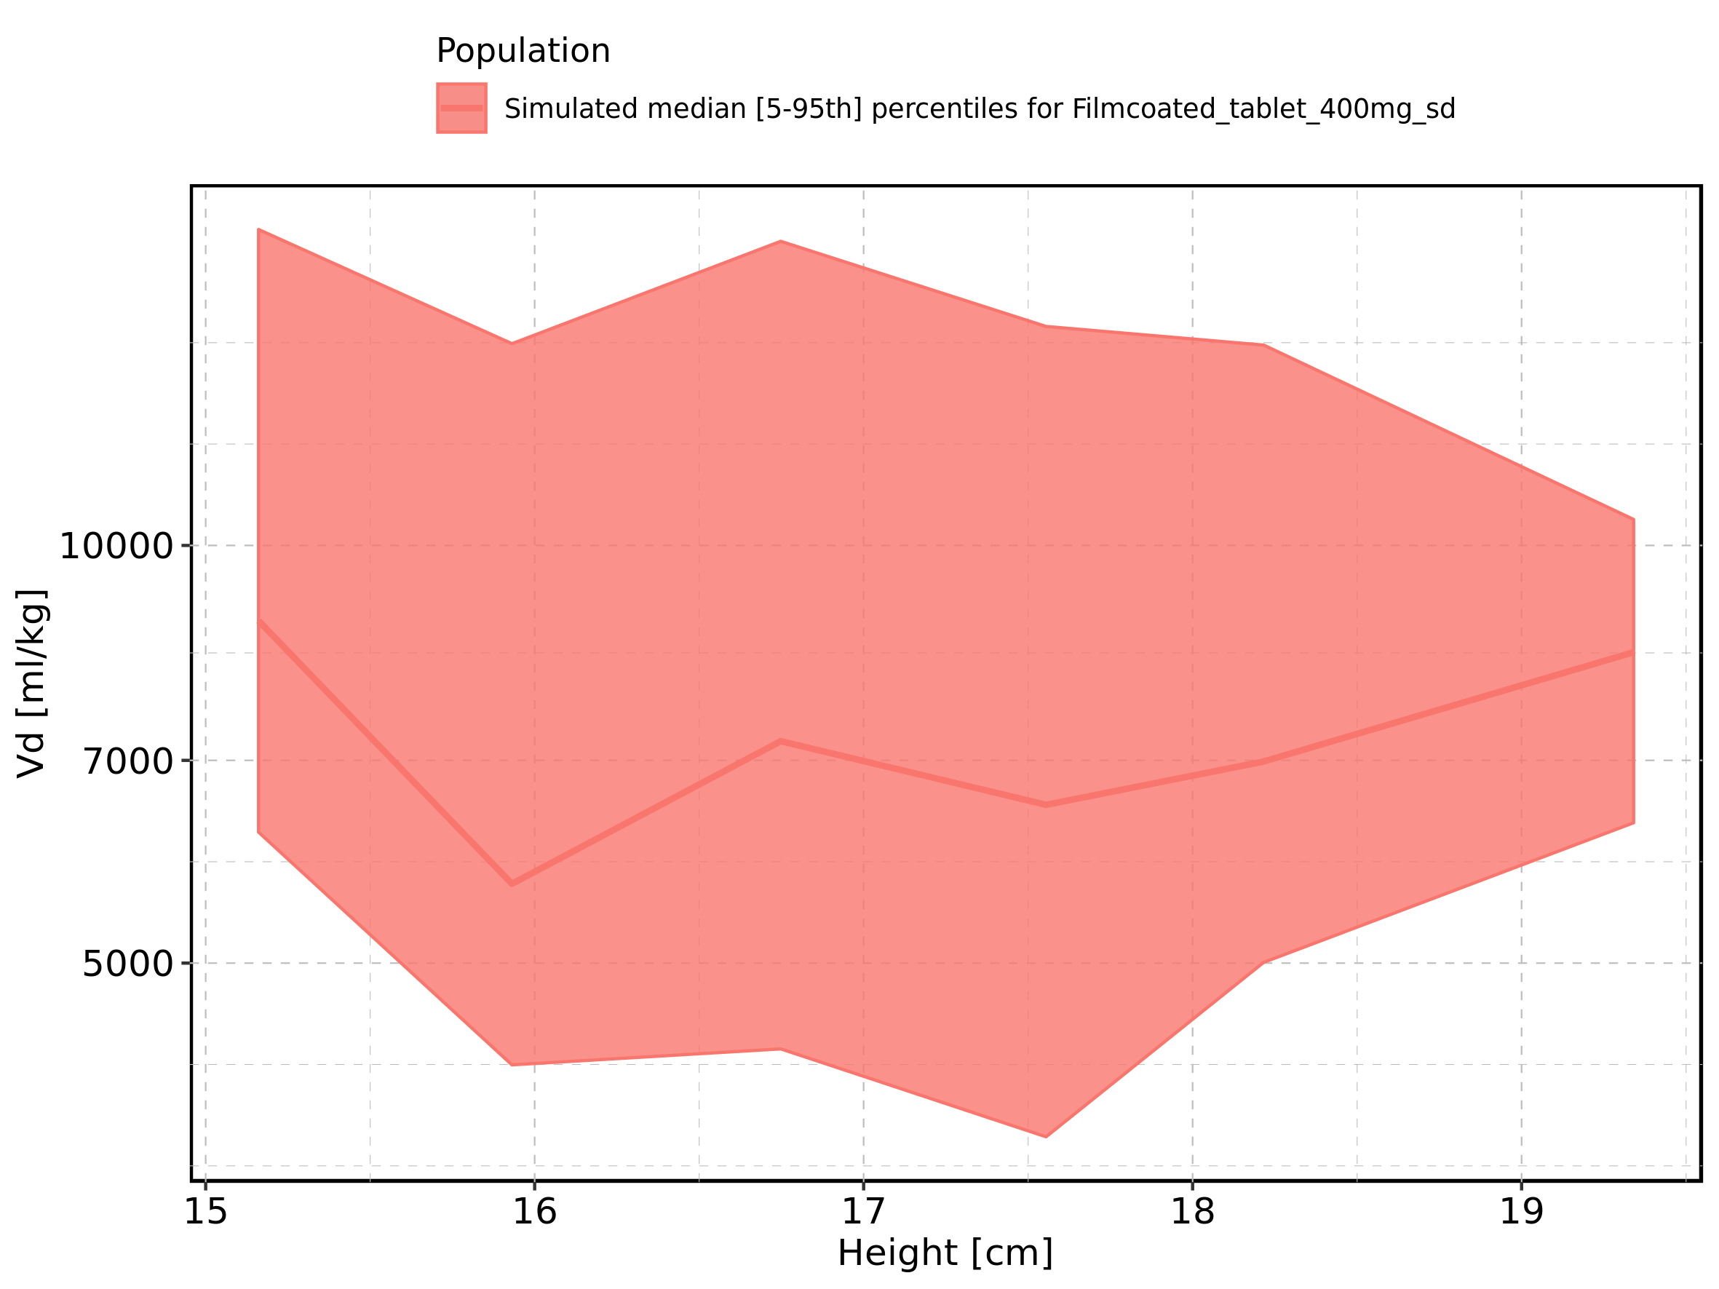

Figure 399: Weight-dependence of Vd for Larson 2013 8y-18y 400mg FCT meal in comparison to Filmcoated_tablet_400mg_sd. Profiles are plotted in a linear scale.

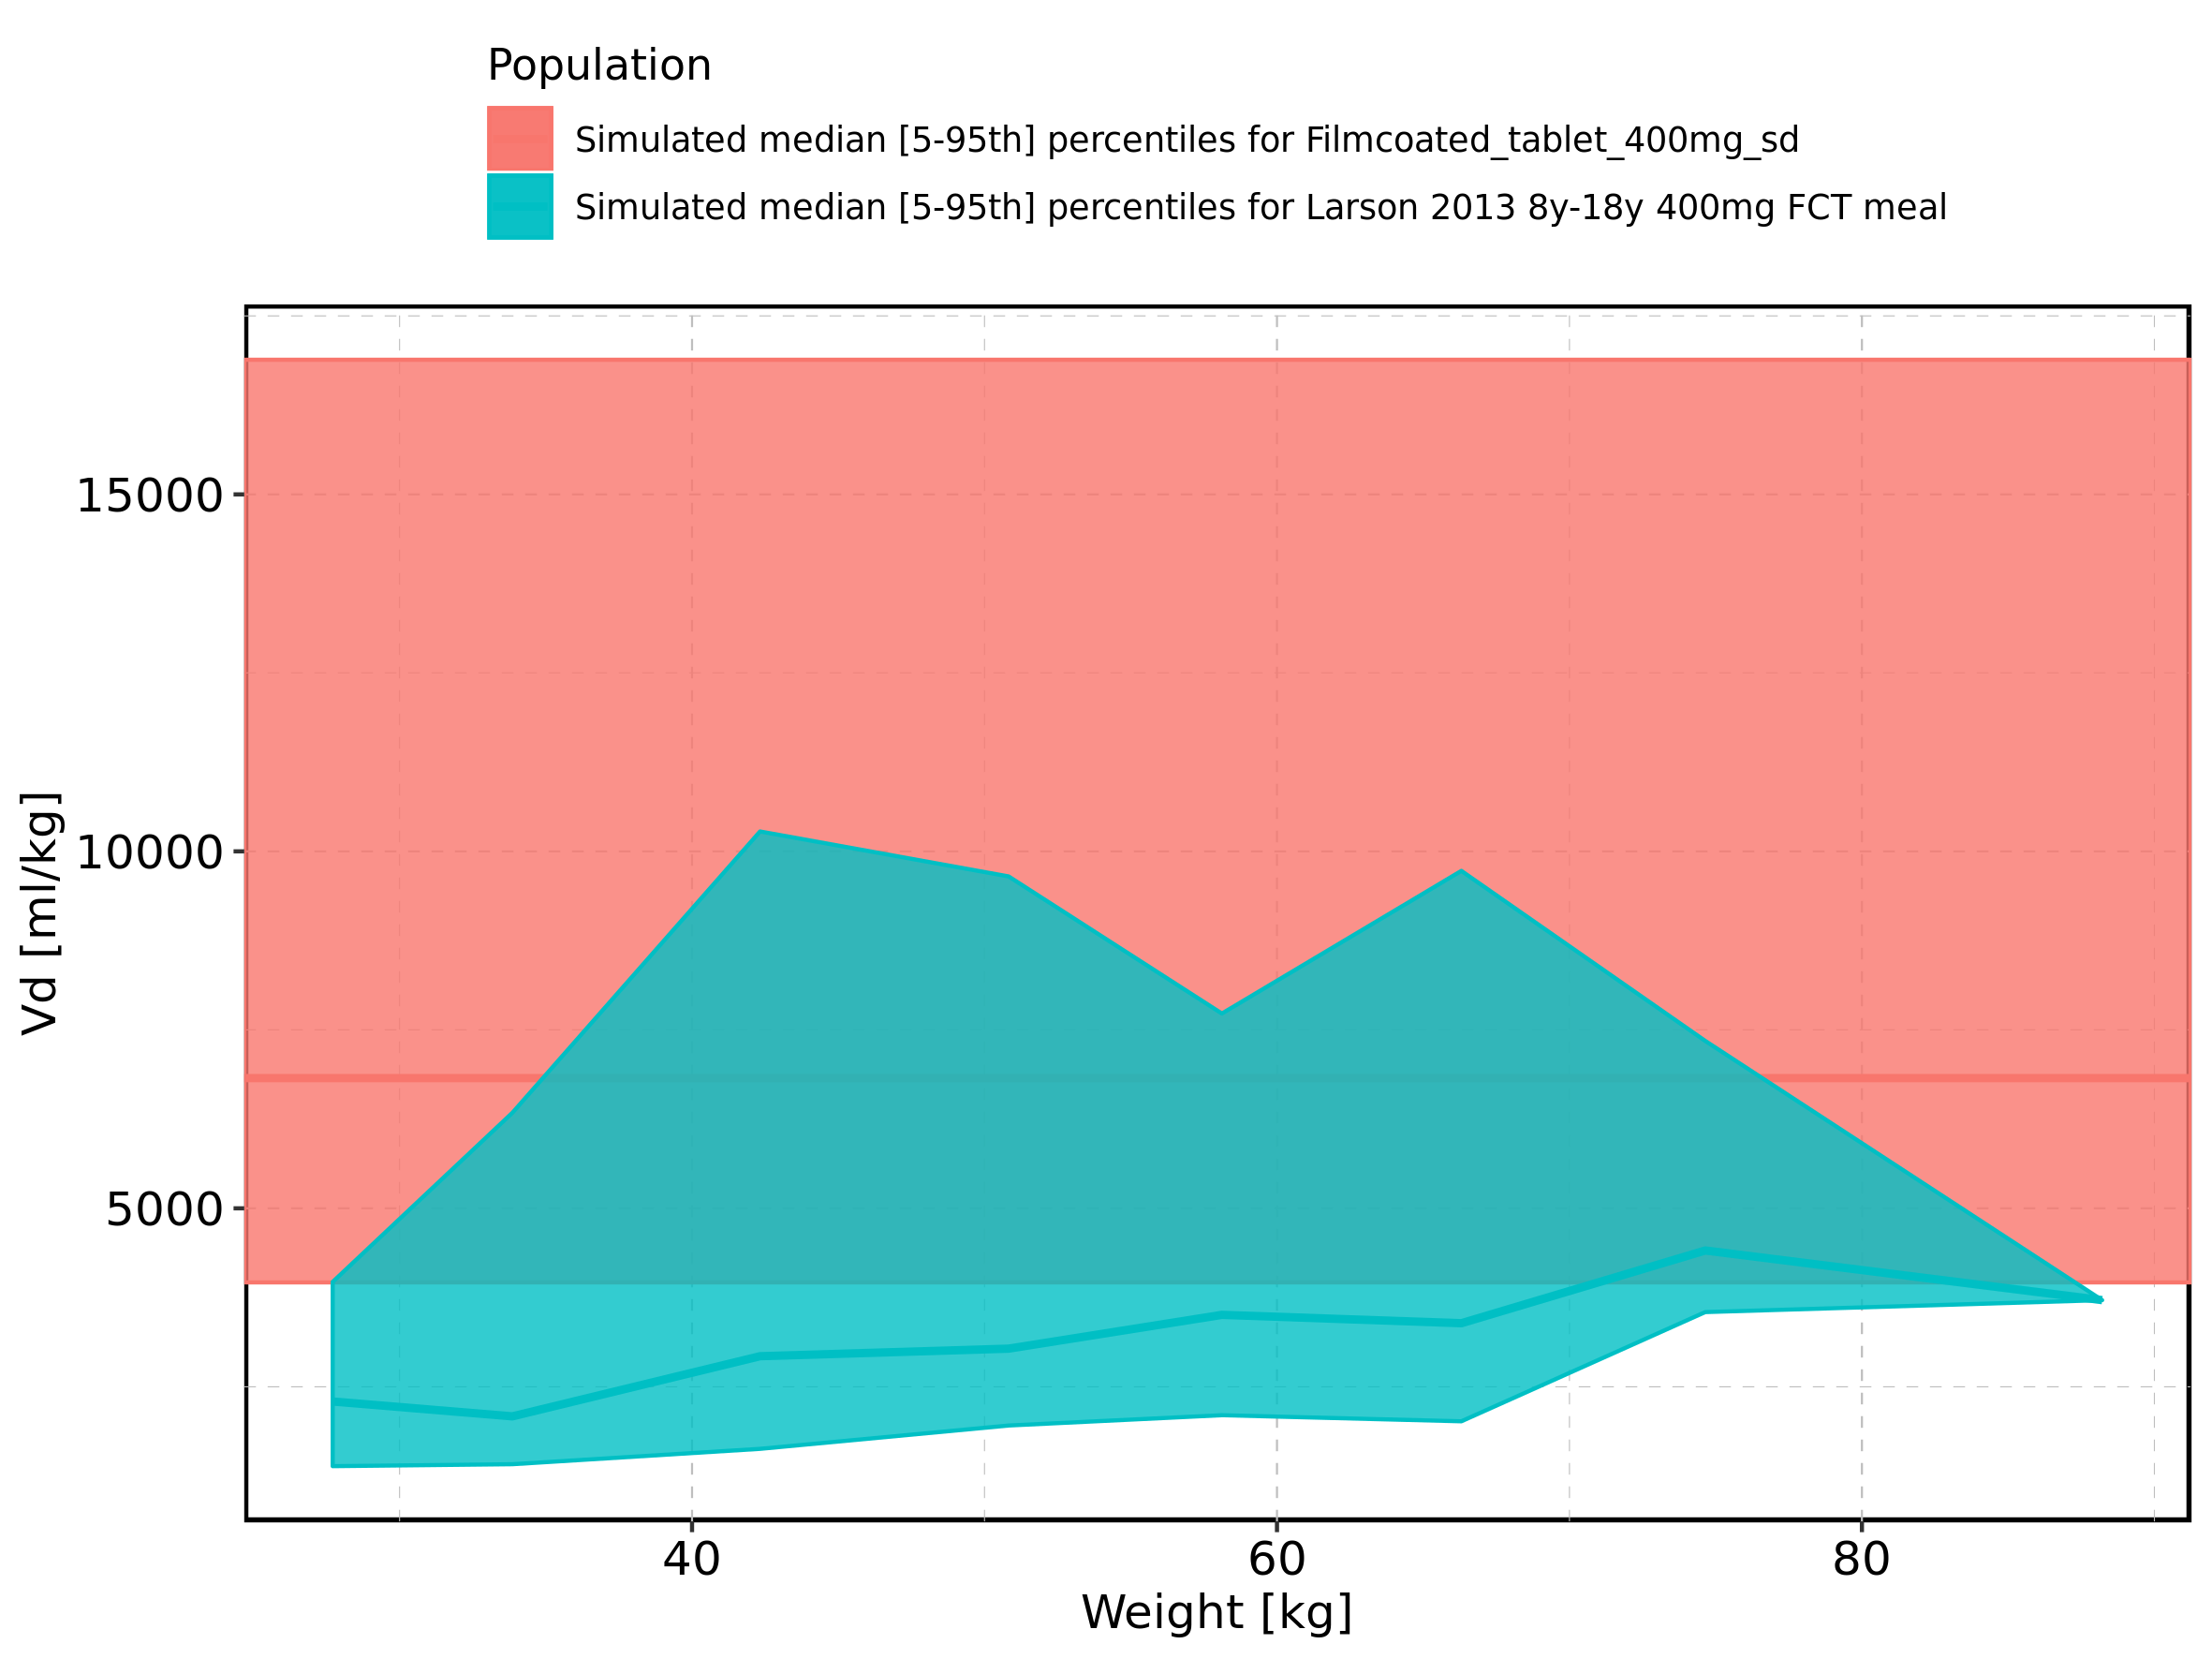

Figure 400: Weight-dependence of Vd for Larson 2013 8y-18y 400mg FCT meal in comparison to Filmcoated_tablet_400mg_sd. Profiles are plotted in a logarithmic scale.

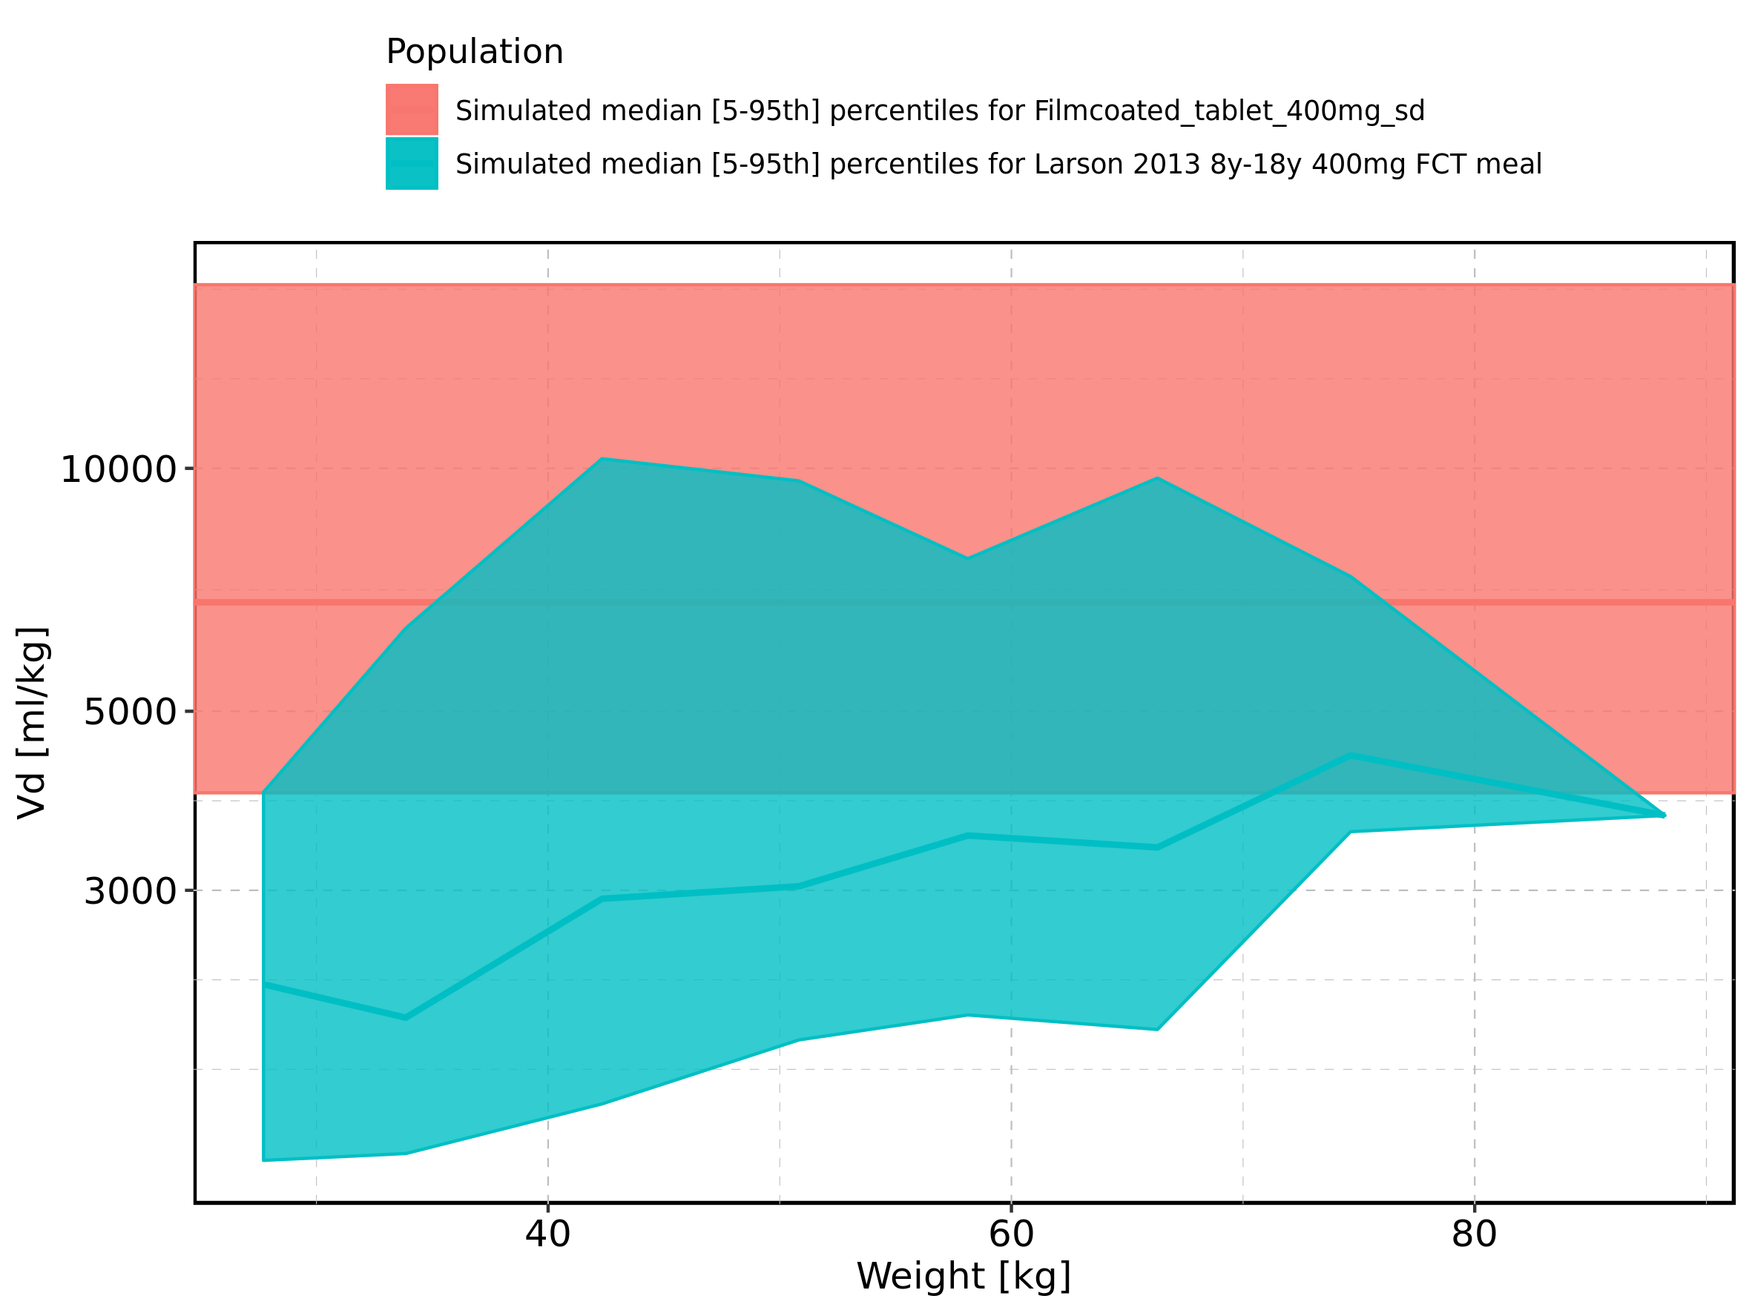

Figure 401: Weight-dependence of Vd for Larson 2013 8y-18y 400mg FCT meal. Profiles are plotted in a linear scale.

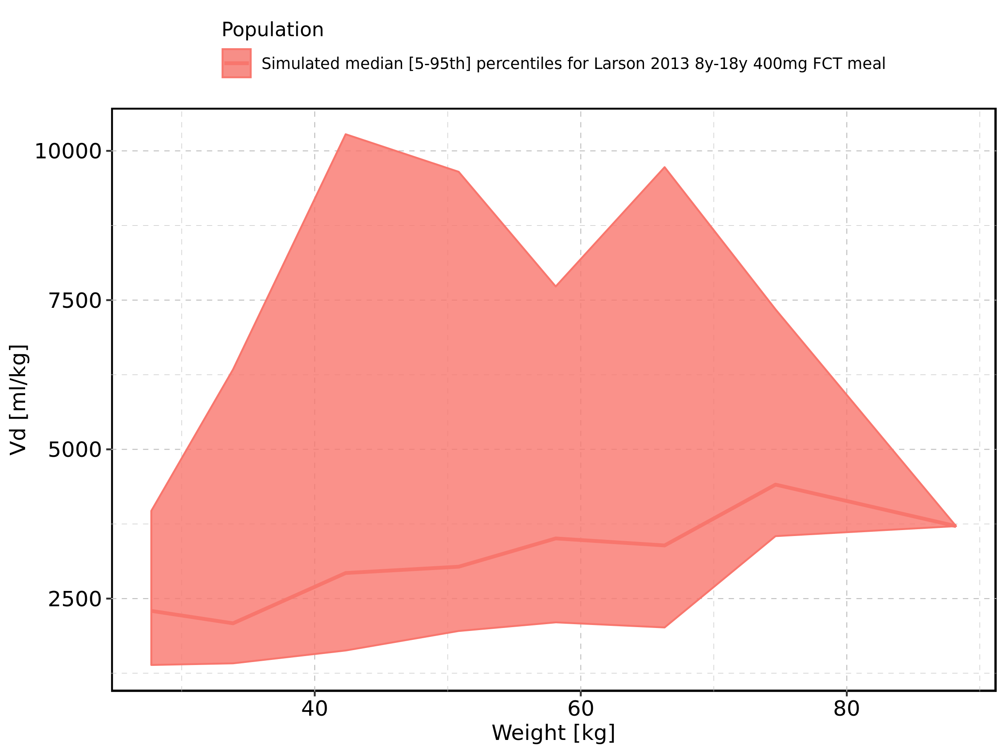

Figure 402: Weight-dependence of Vd for Larson 2013 8y-18y 400mg FCT meal. Profiles are plotted in a logarithmic scale.

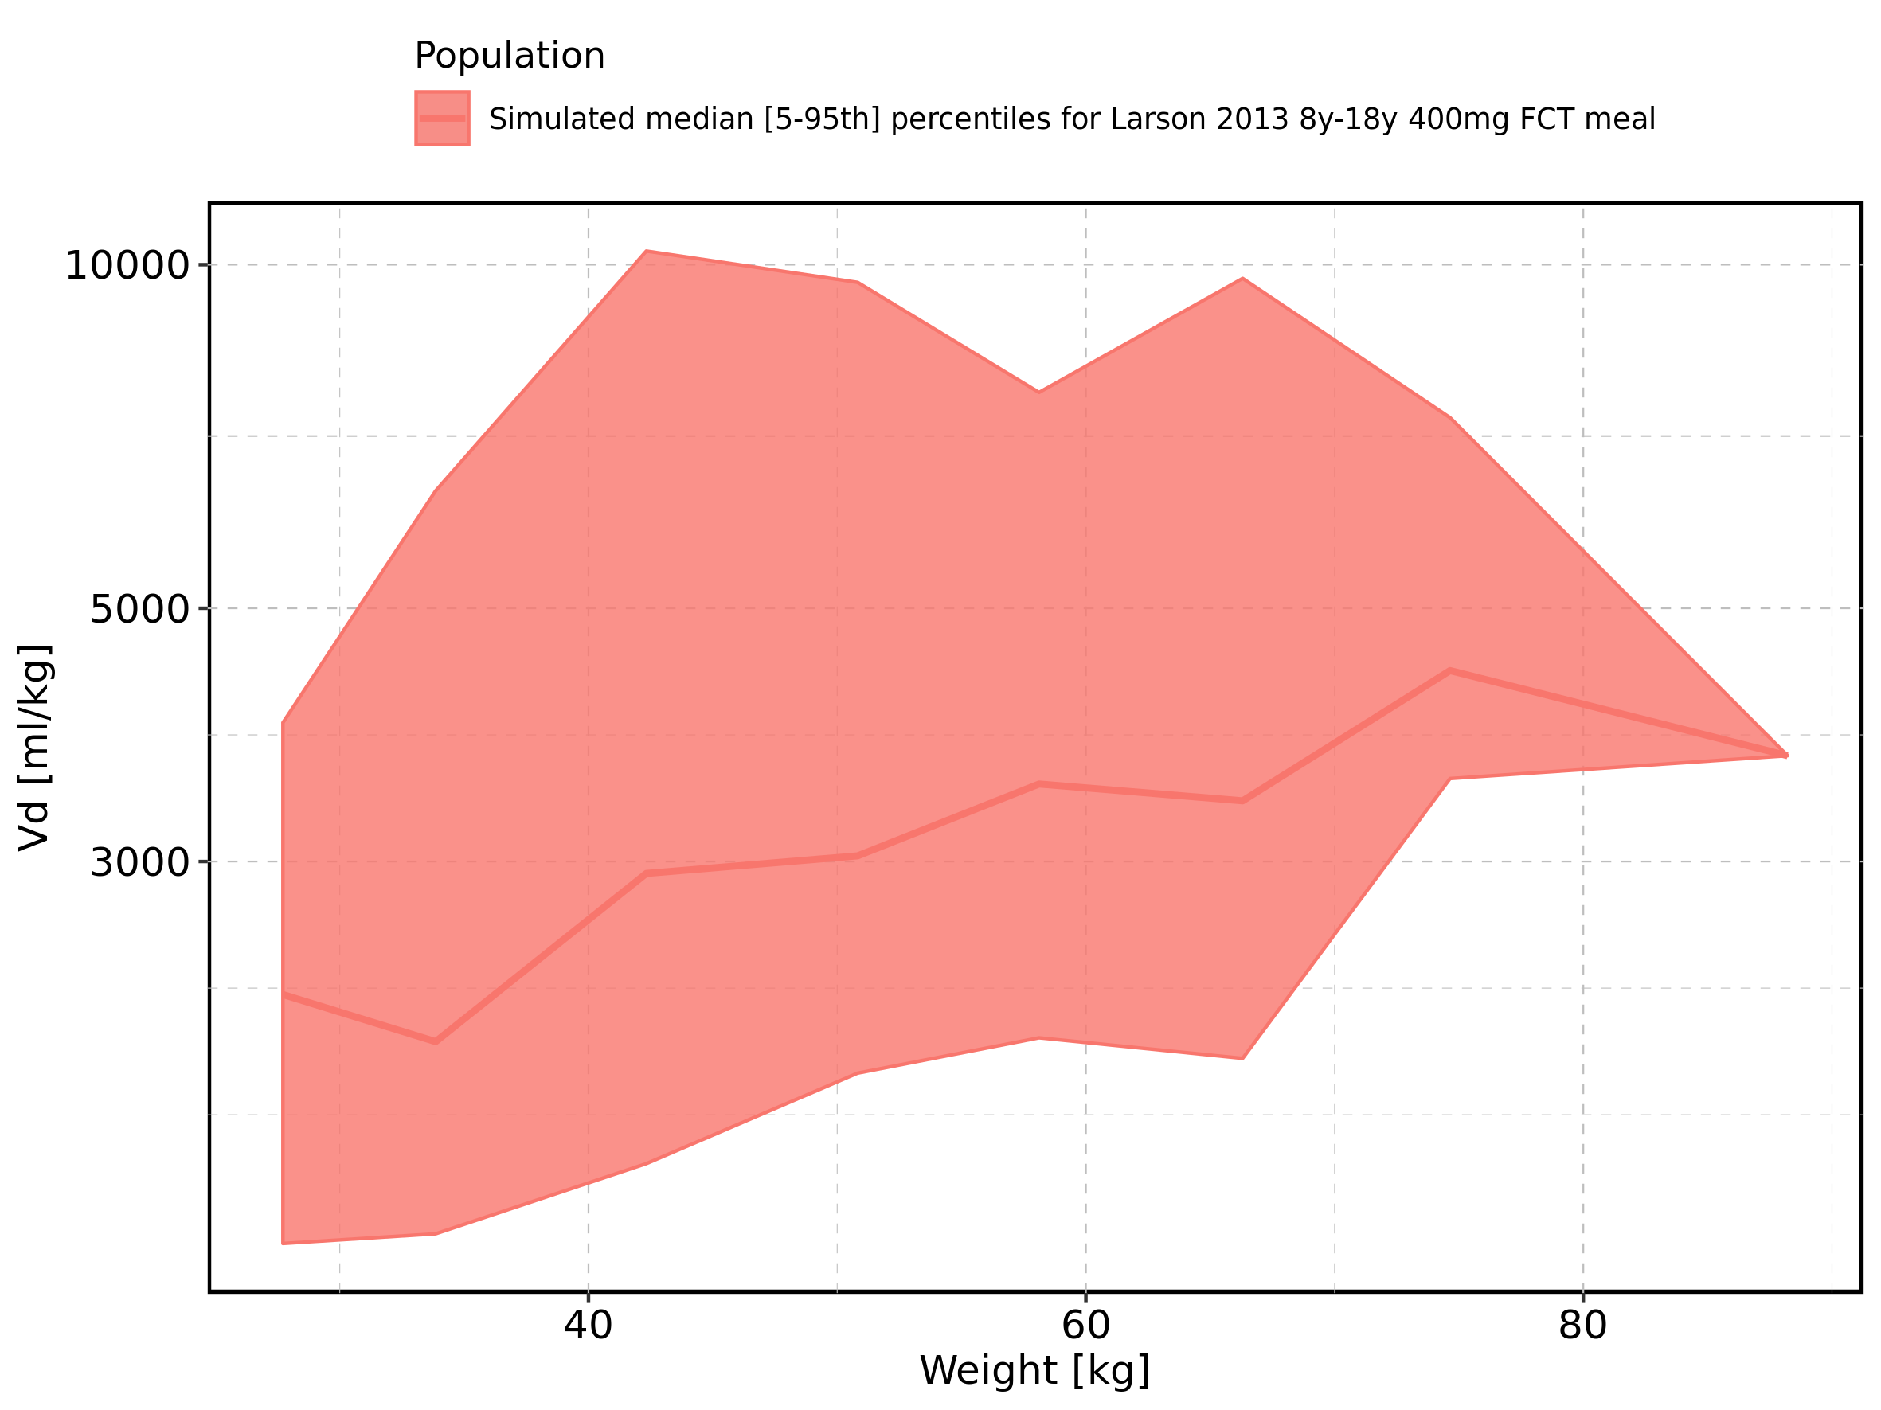

Figure 403: Weight-dependence of Vd for Filmcoated_tablet_400mg_sd. Profiles are plotted in a linear scale.

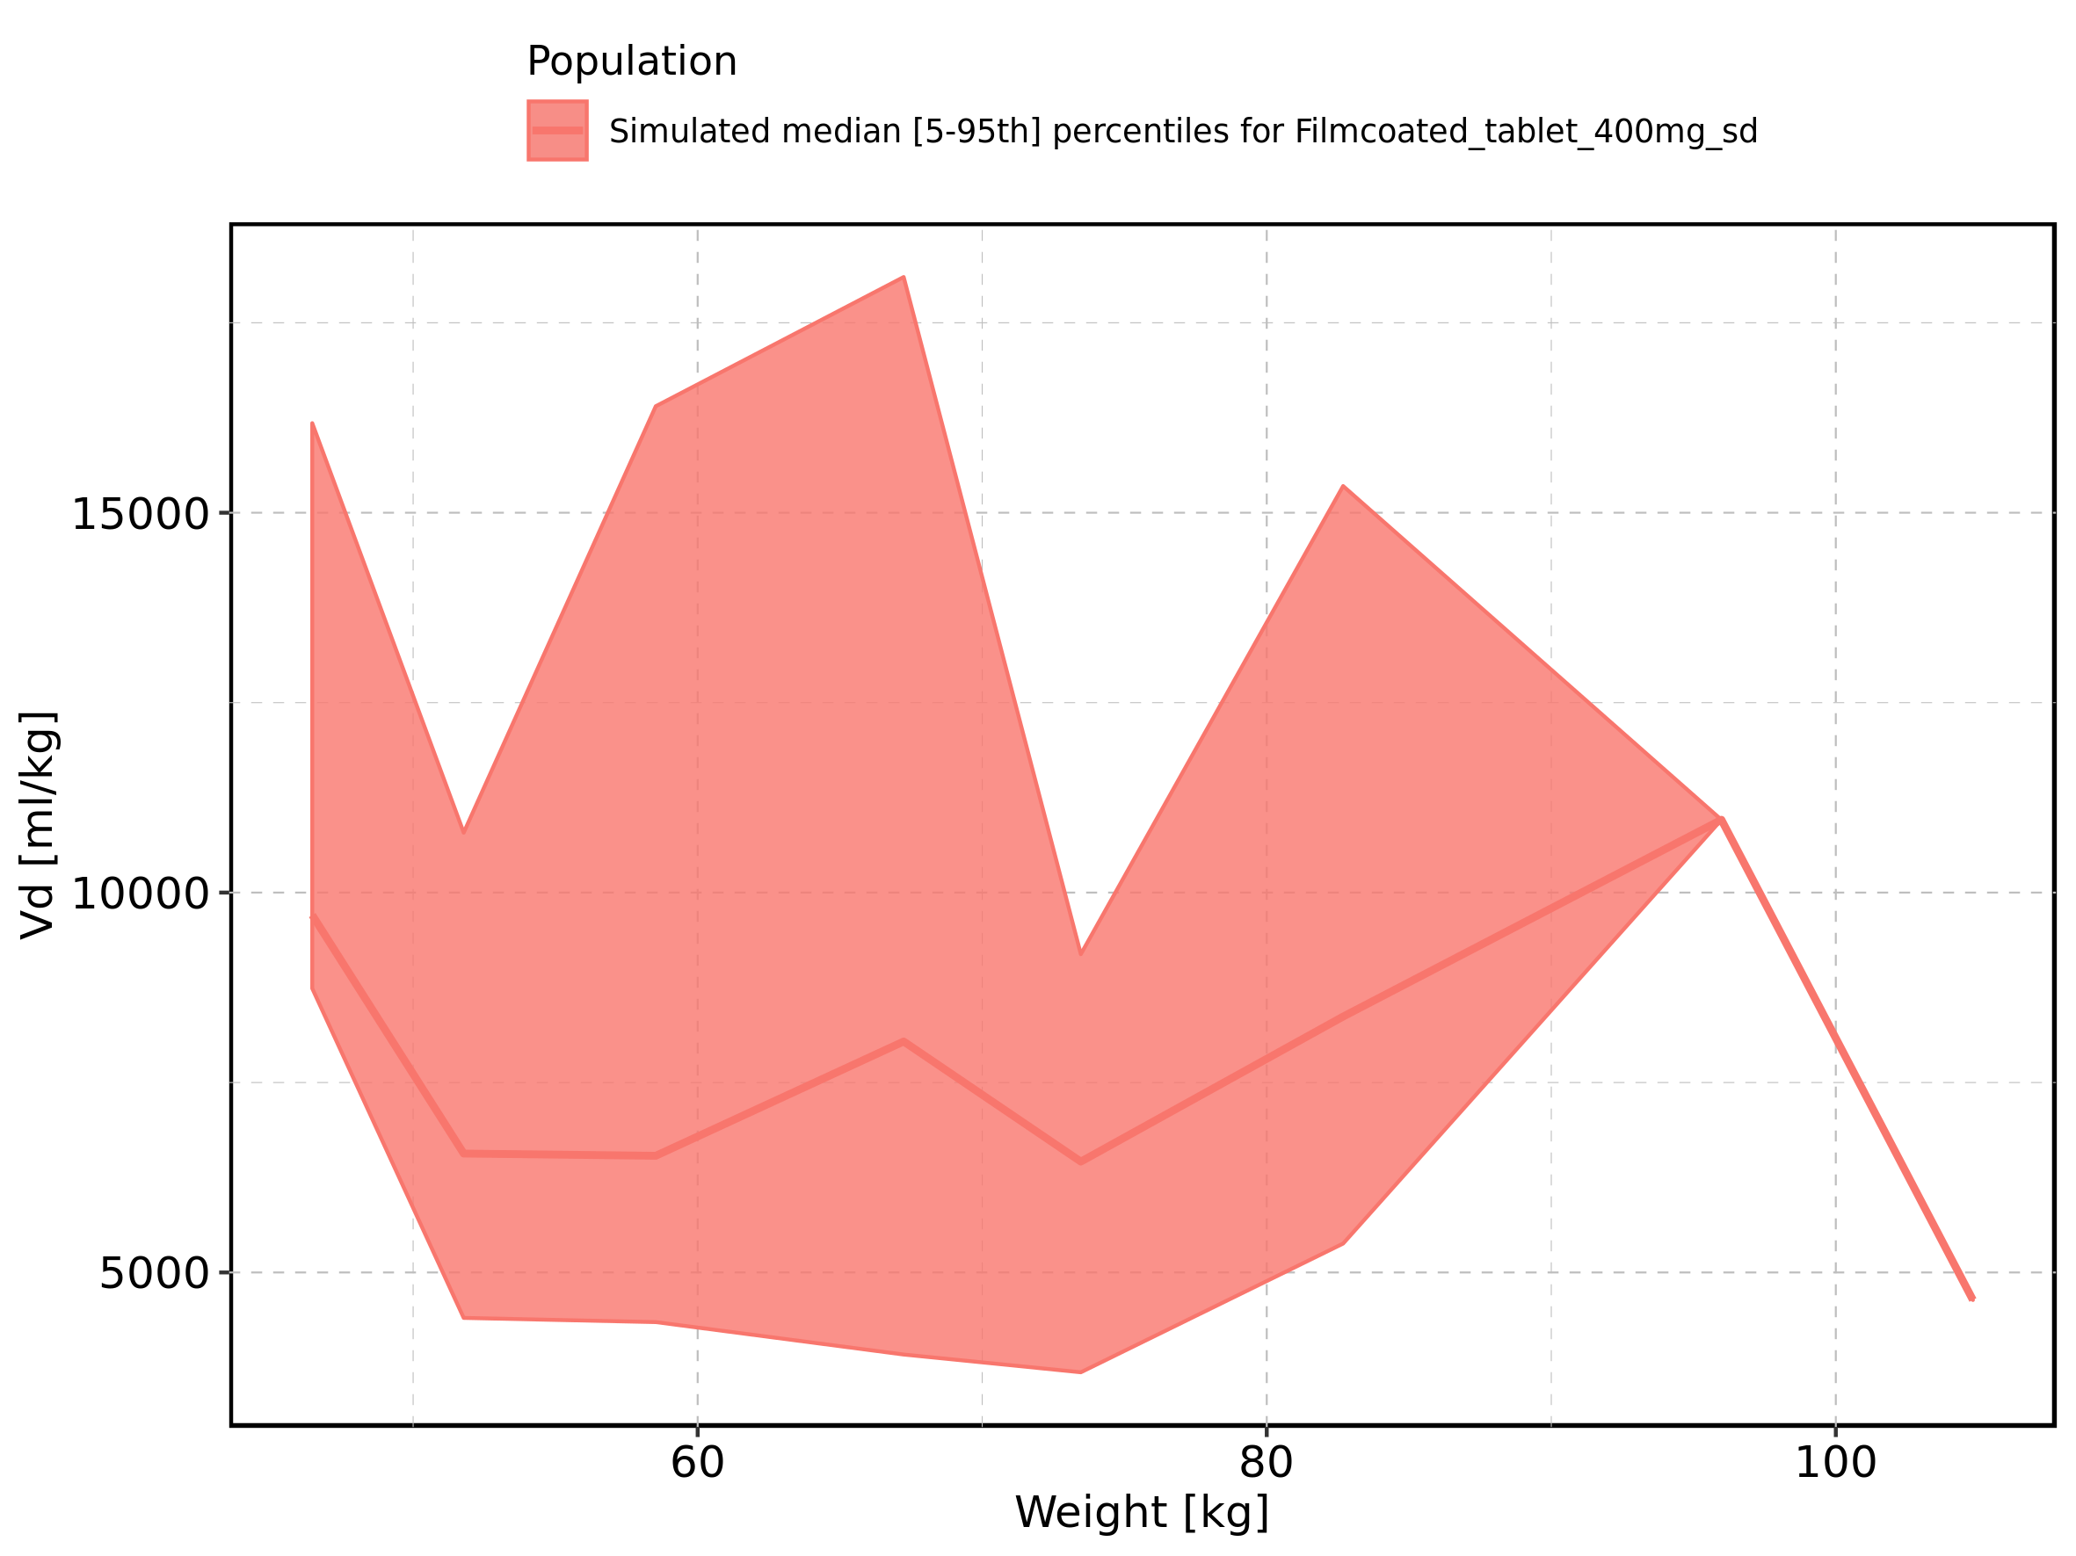

Figure 404: Weight-dependence of Vd for Filmcoated_tablet_400mg_sd. Profiles are plotted in a logarithmic scale.

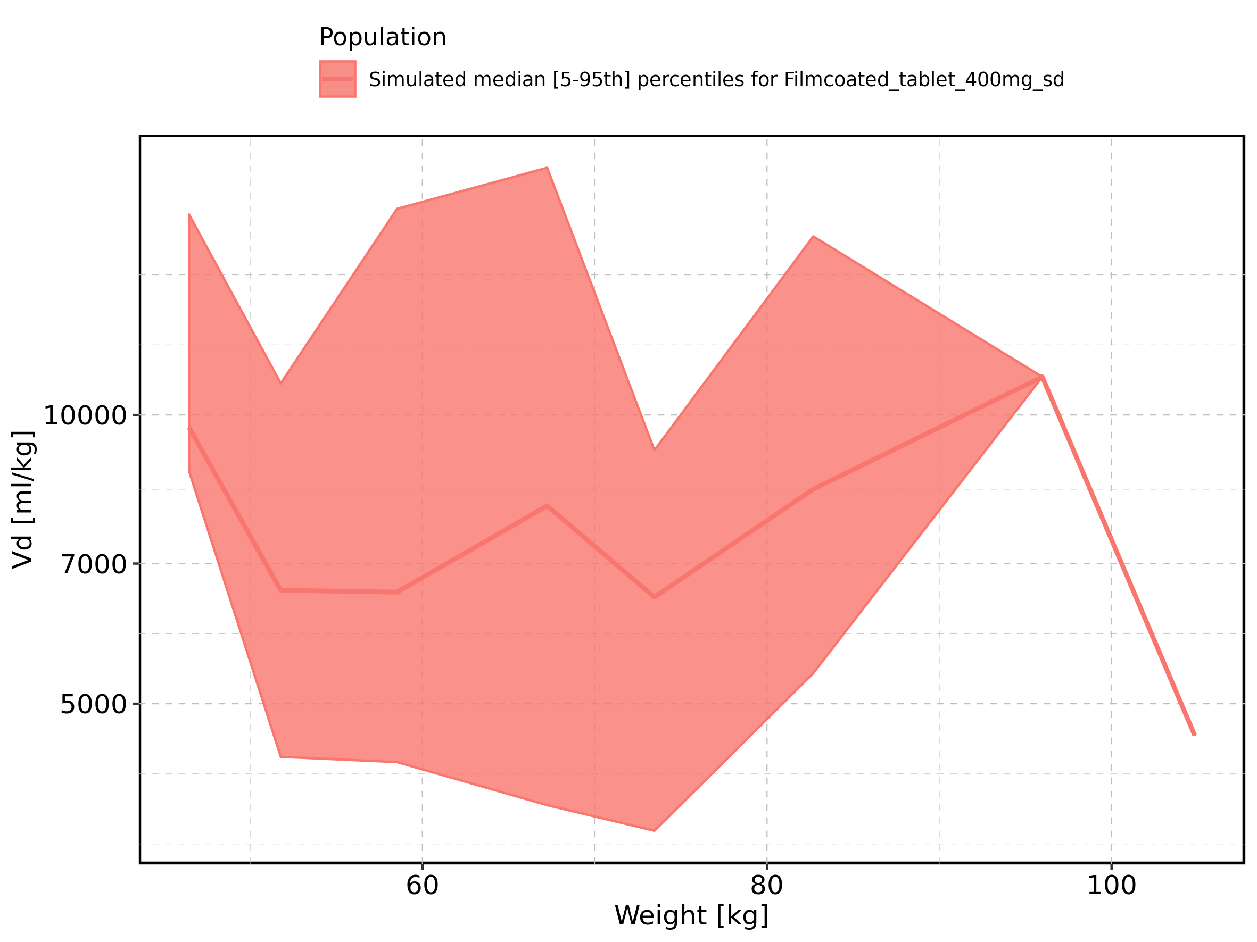

Figure 405: BMI-dependence of Vd for Larson 2013 8y-18y 400mg FCT meal in comparison to Filmcoated_tablet_400mg_sd. Profiles are plotted in a linear scale.

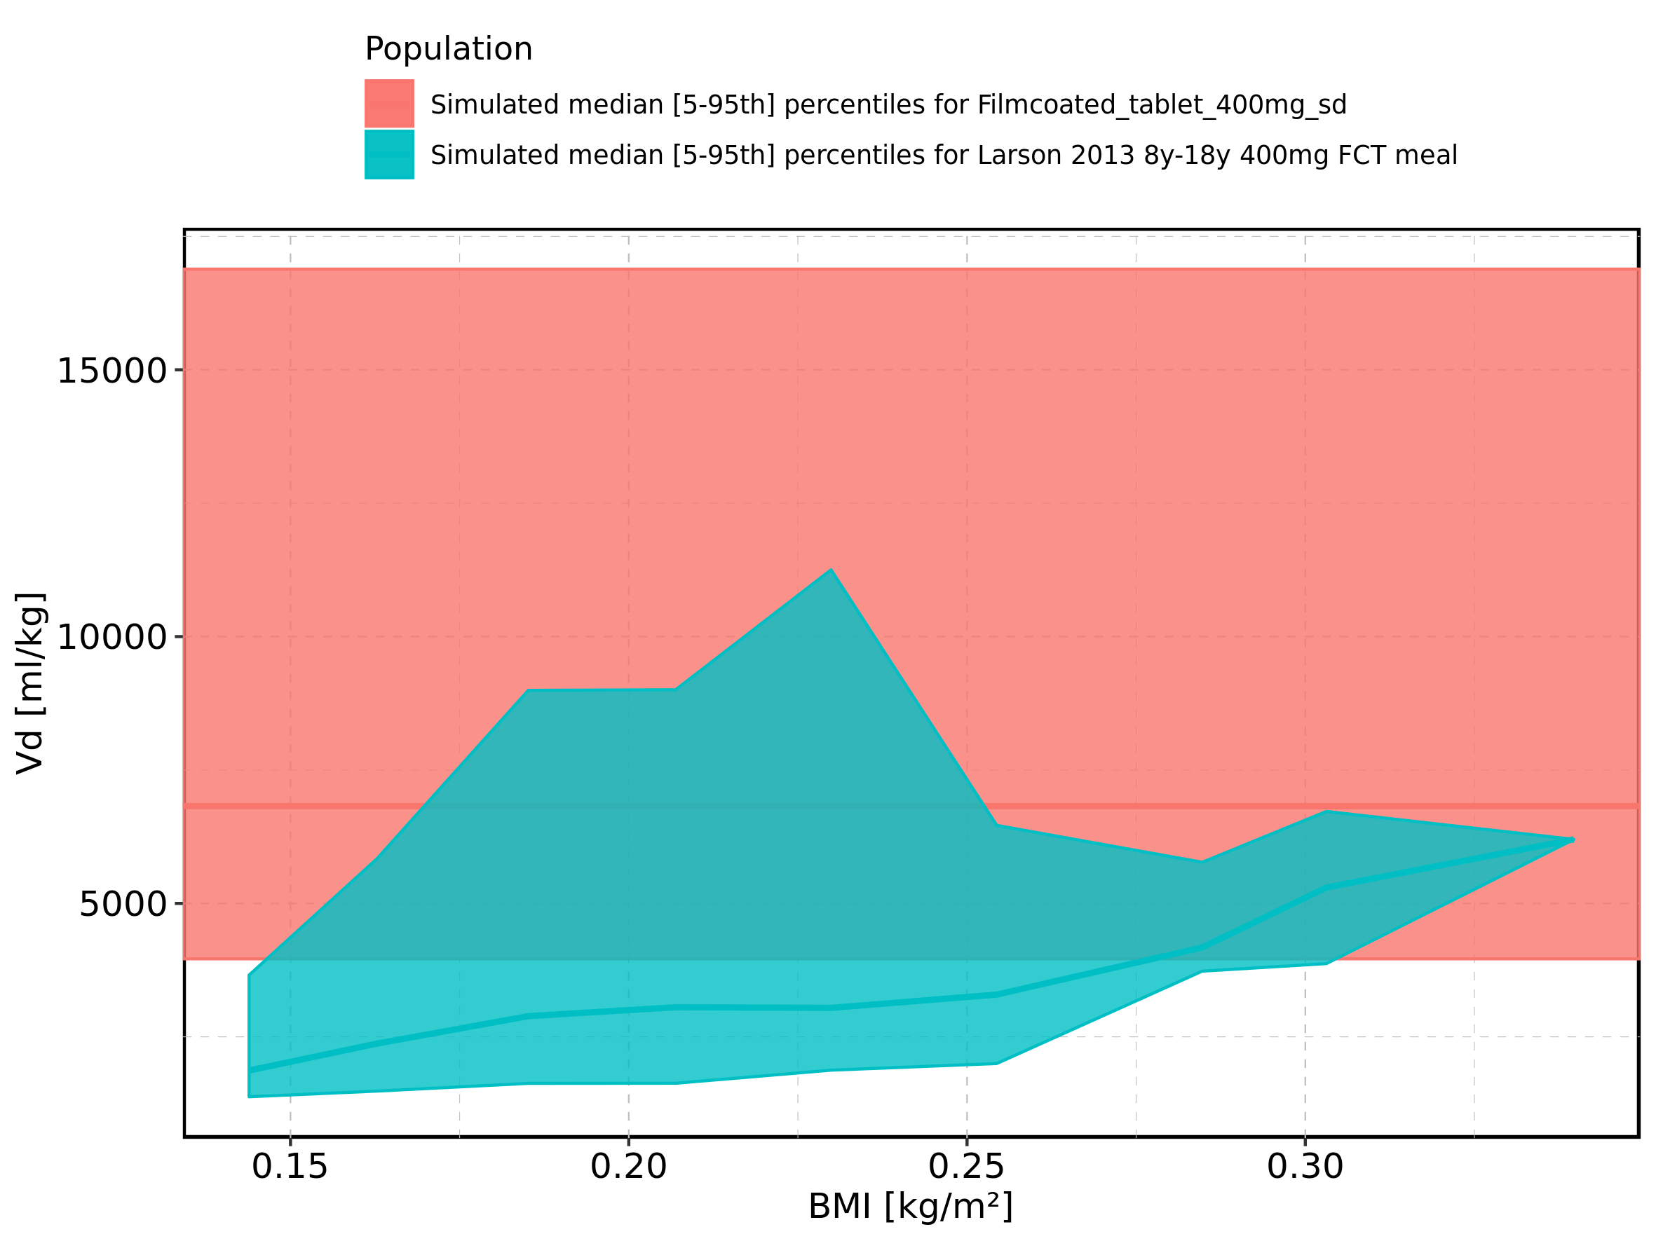

Figure 406: BMI-dependence of Vd for Larson 2013 8y-18y 400mg FCT meal in comparison to Filmcoated_tablet_400mg_sd. Profiles are plotted in a logarithmic scale.

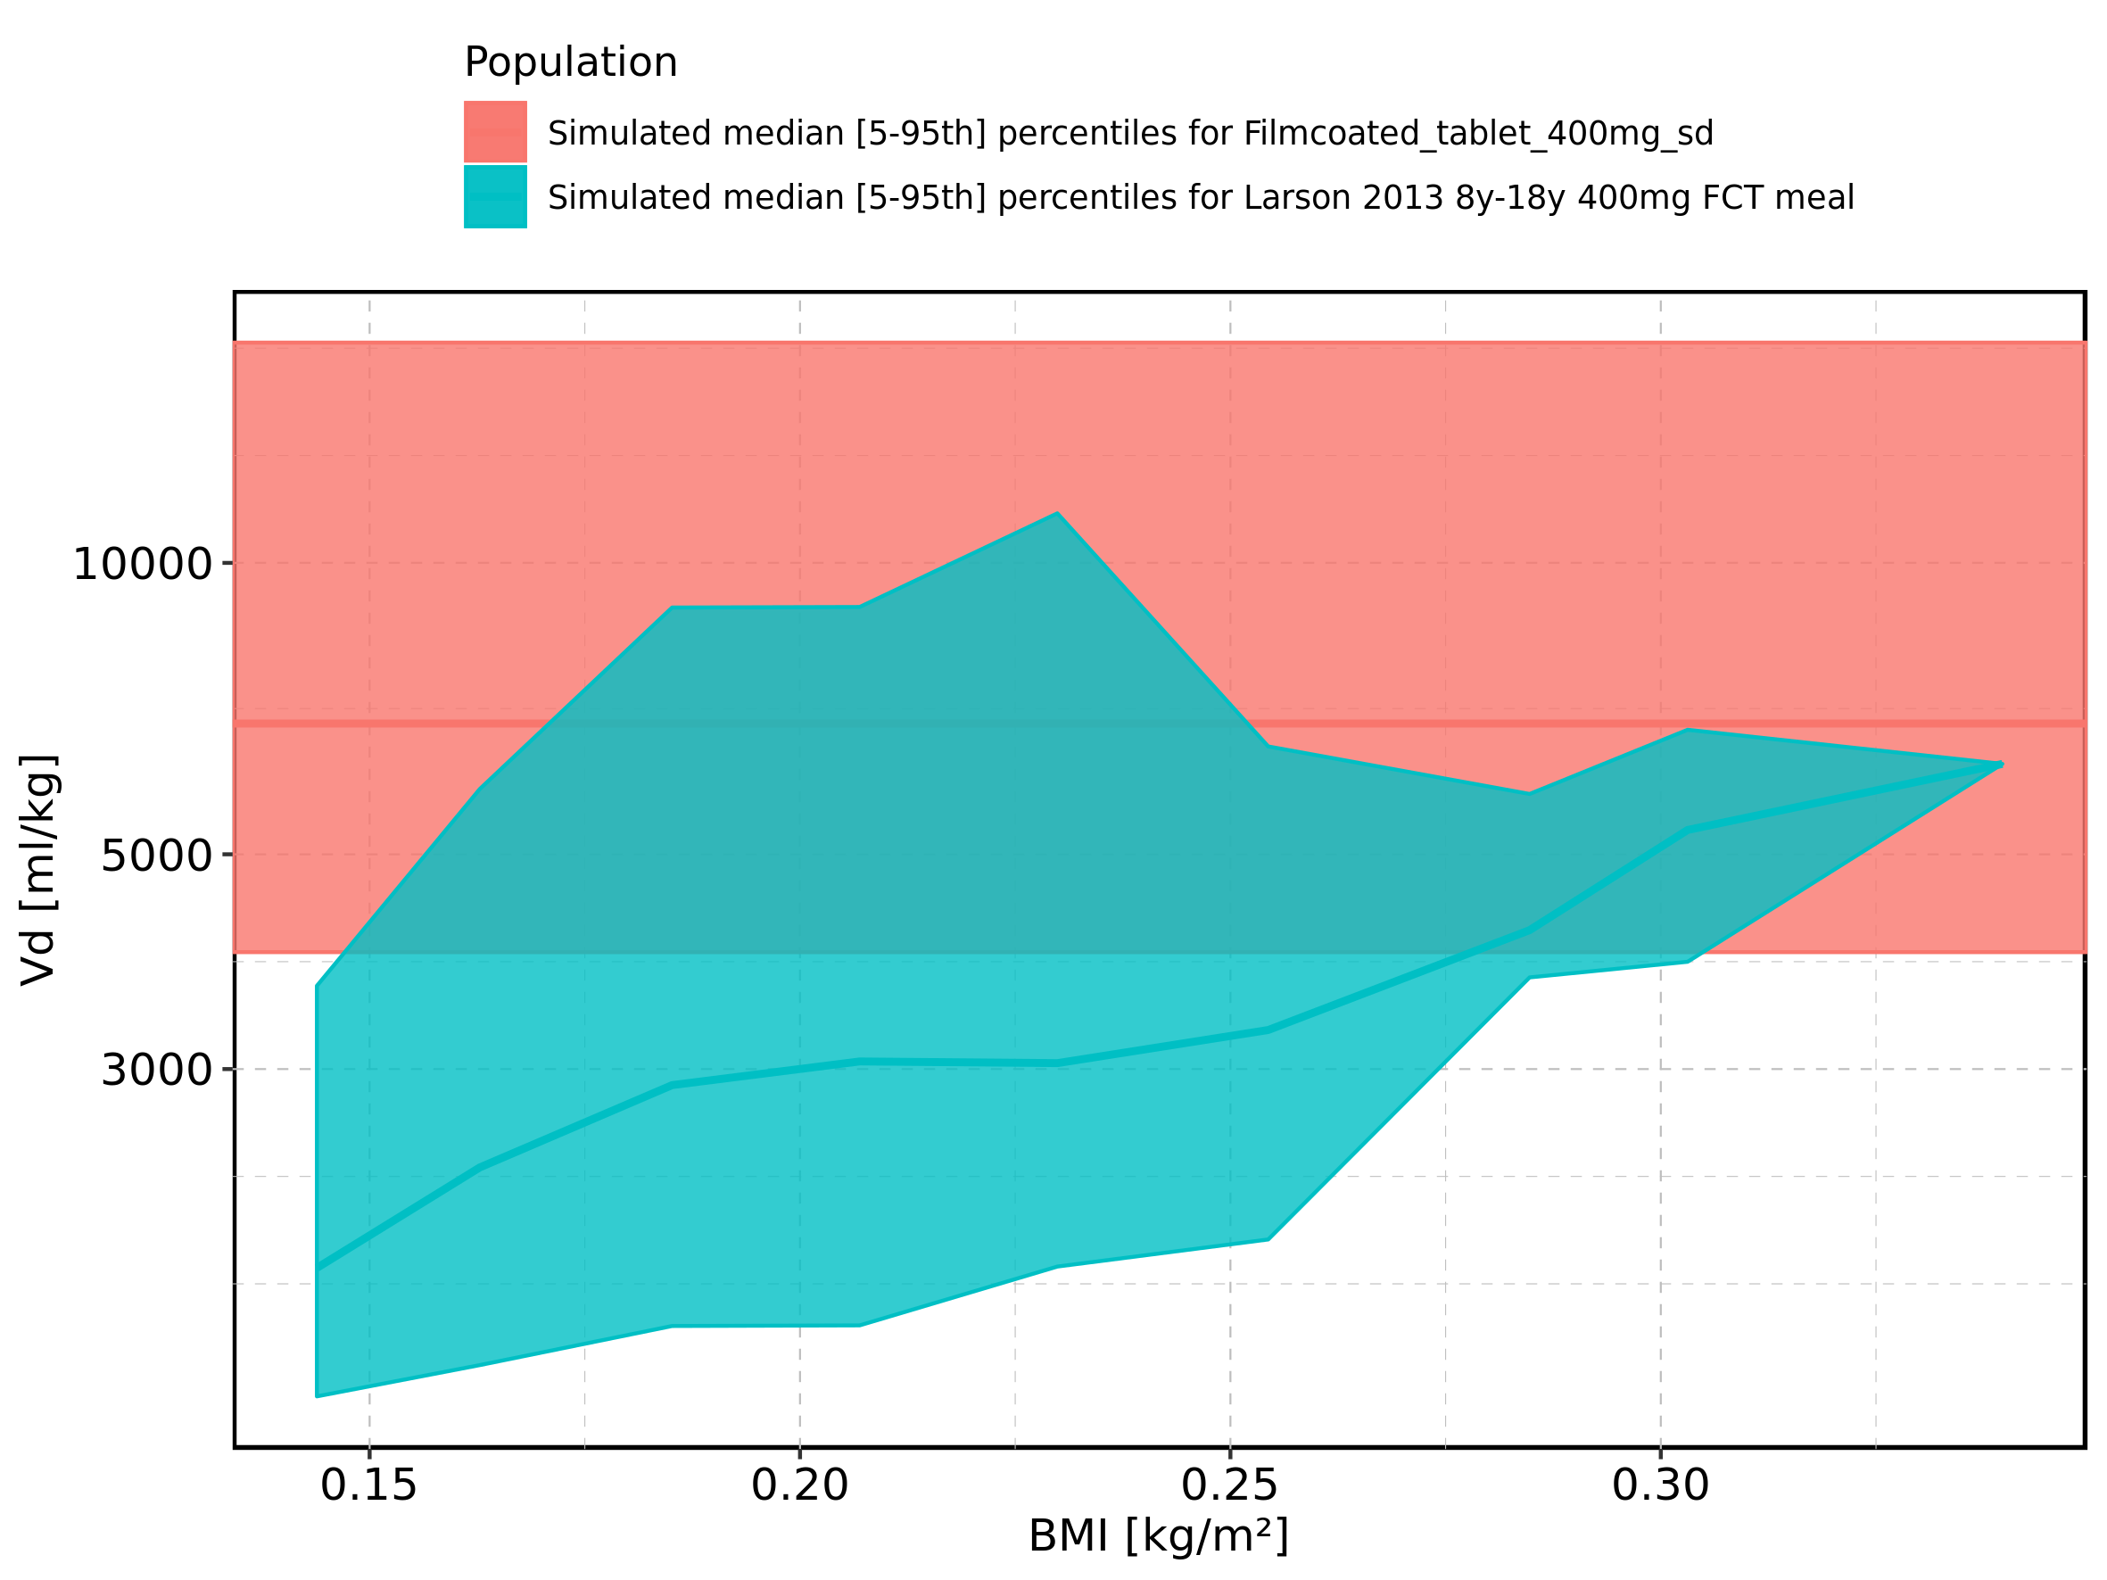

Figure 407: BMI-dependence of Vd for Larson 2013 8y-18y 400mg FCT meal. Profiles are plotted in a linear scale.

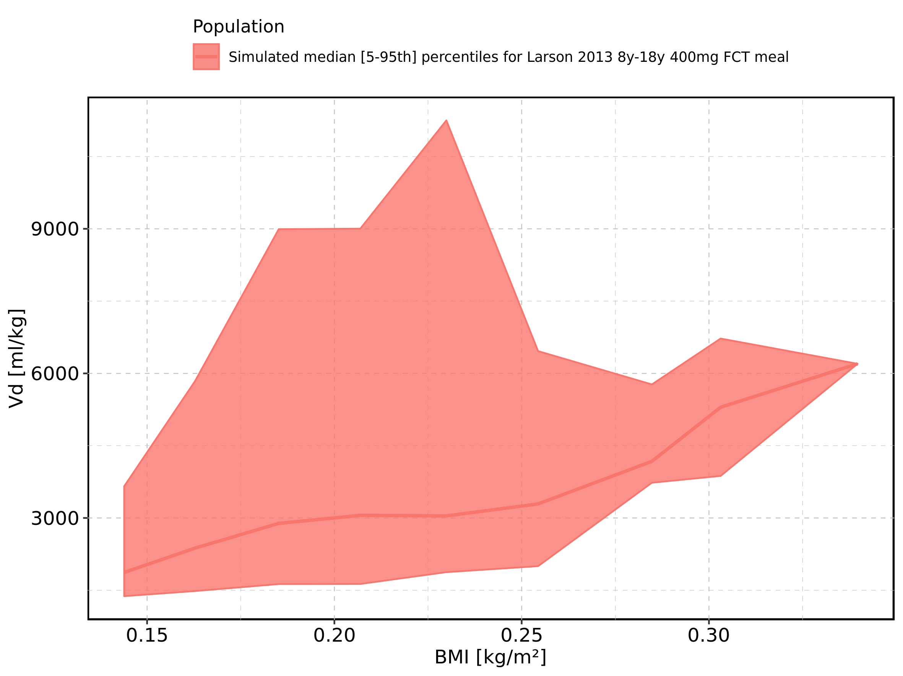

Figure 408: BMI-dependence of Vd for Larson 2013 8y-18y 400mg FCT meal. Profiles are plotted in a logarithmic scale.

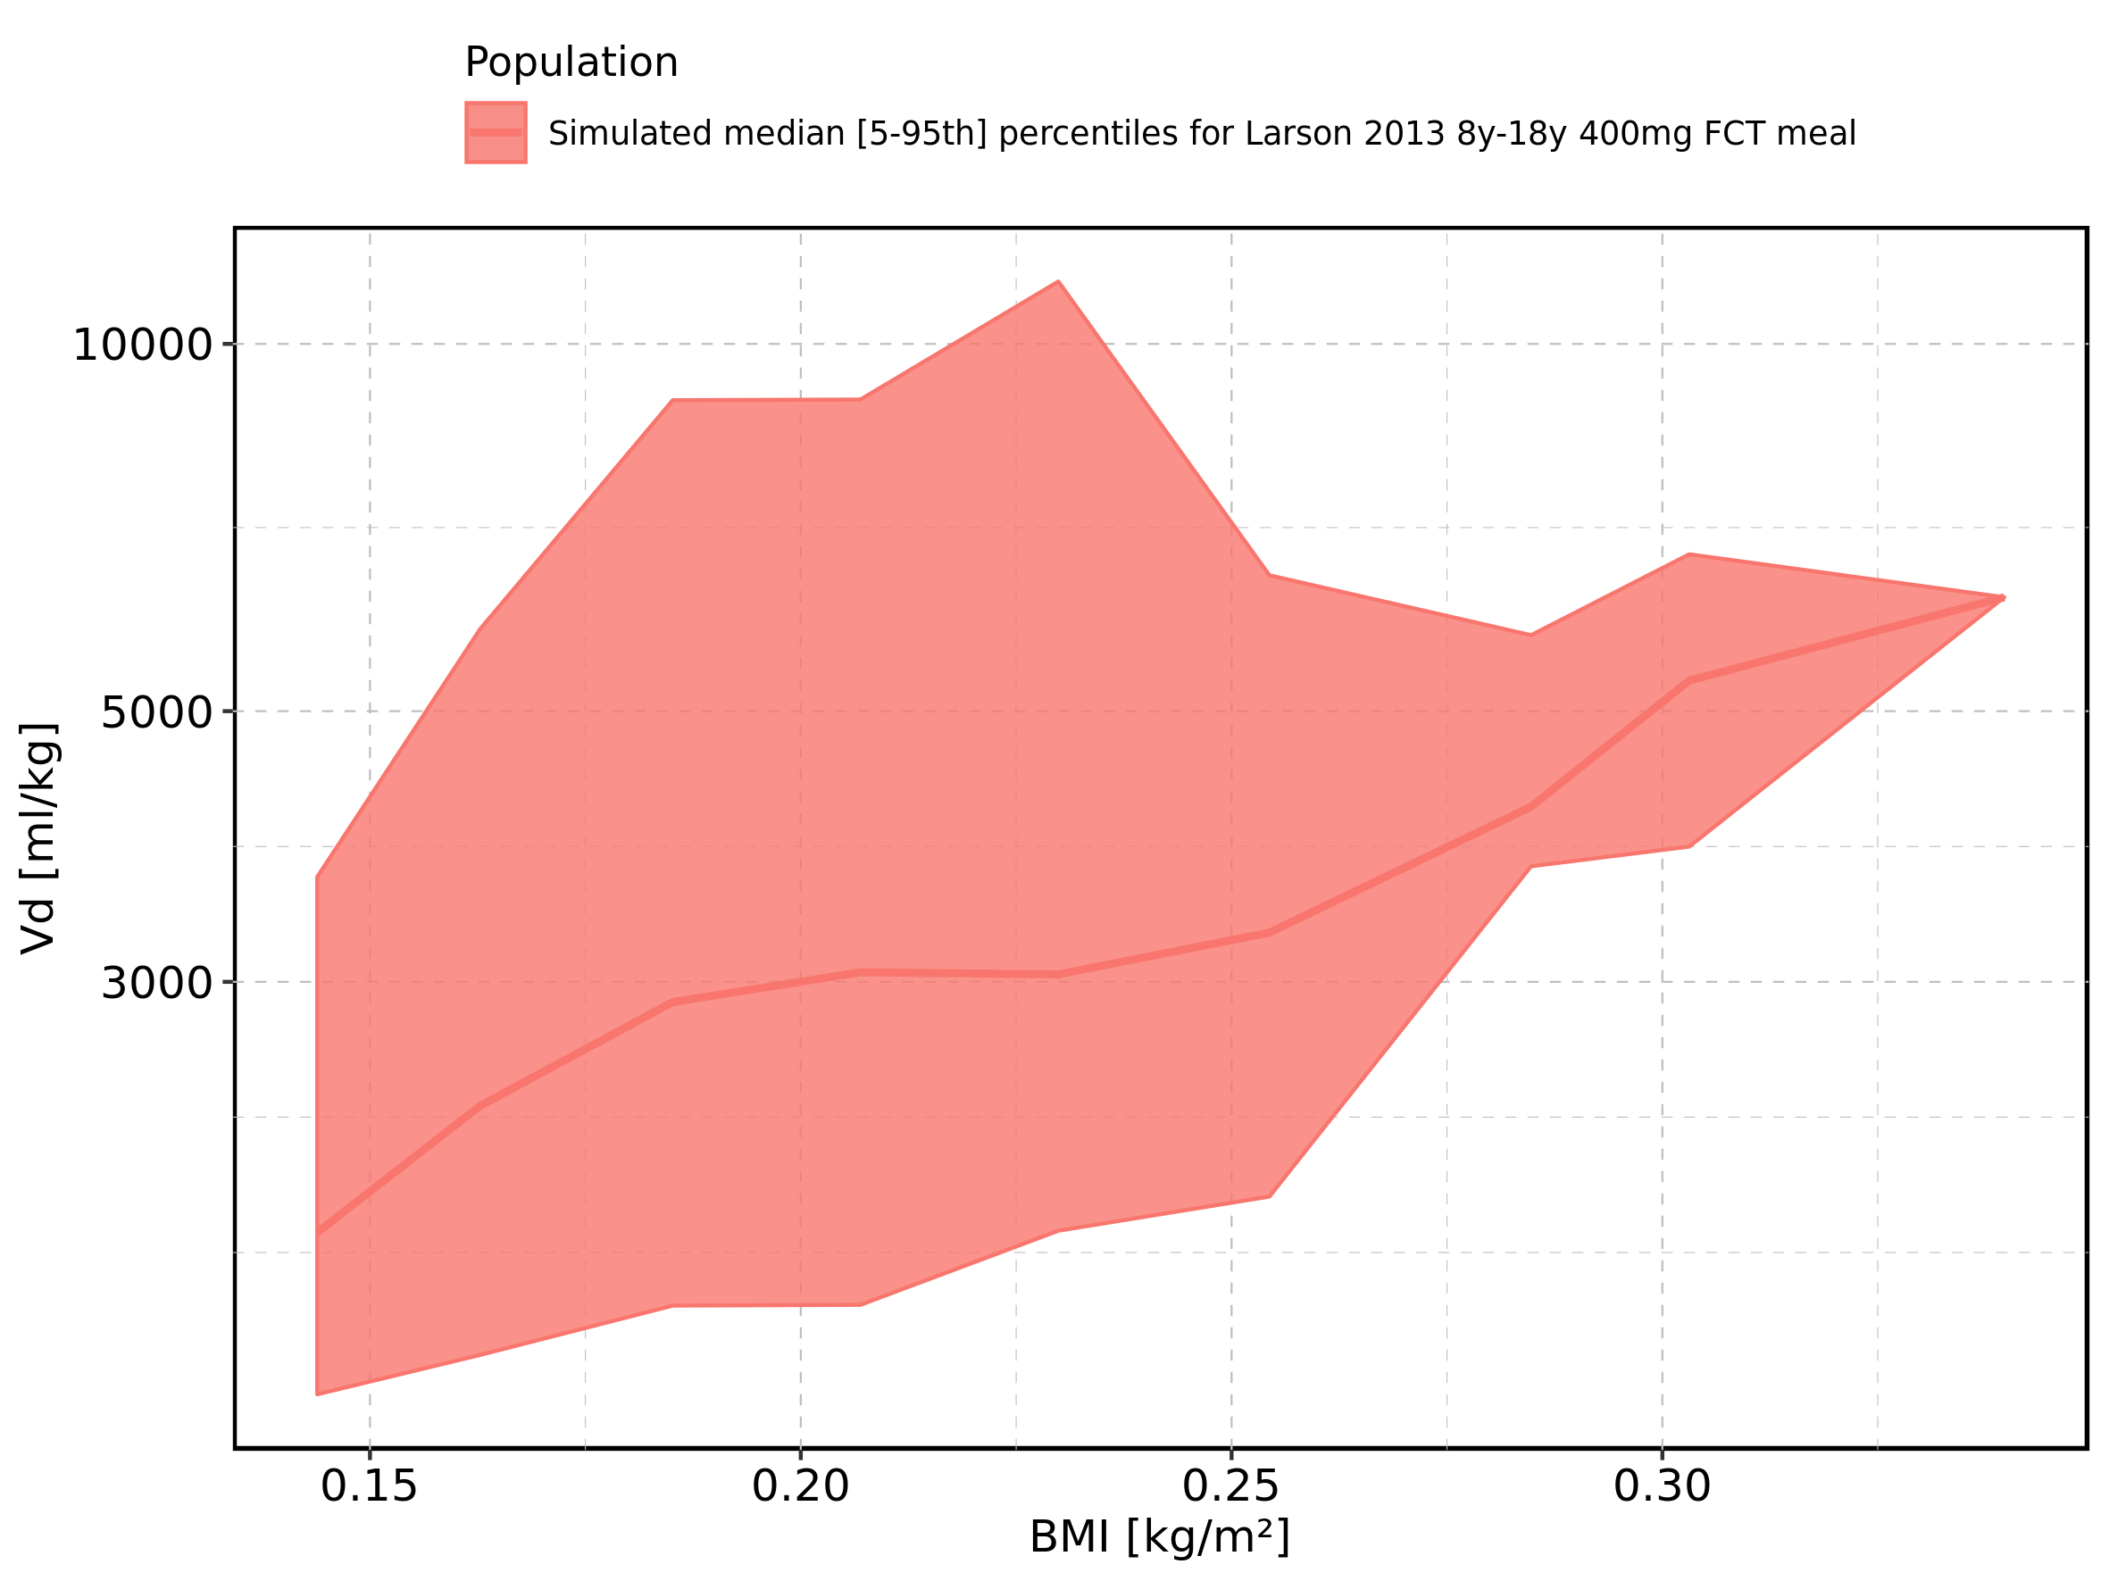

Figure 409: BMI-dependence of Vd for Filmcoated_tablet_400mg_sd. Profiles are plotted in a linear scale.

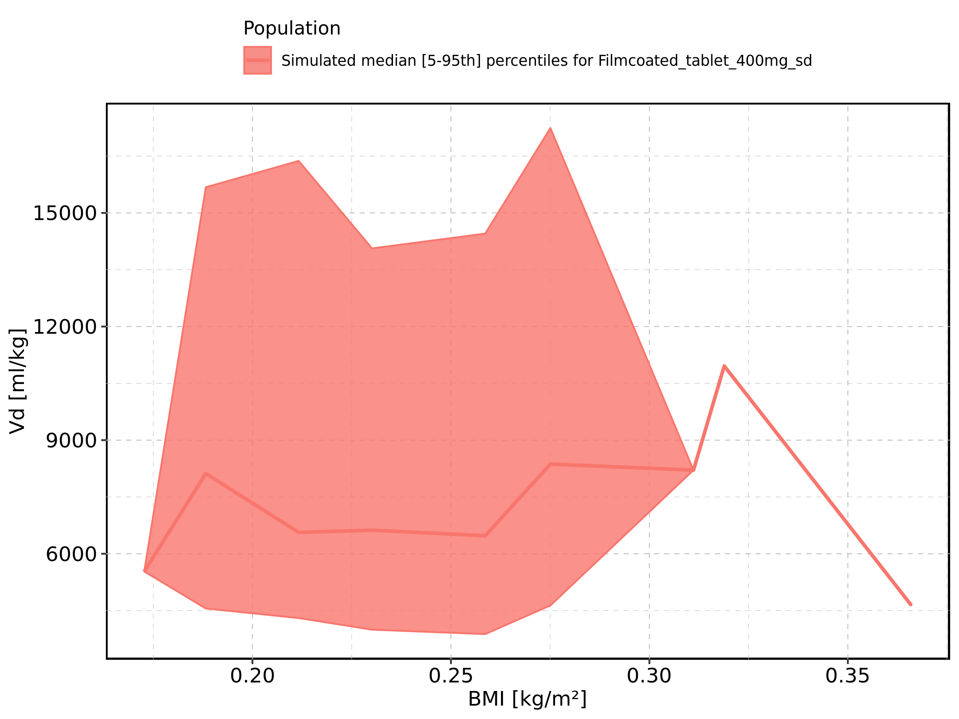

Figure 410: BMI-dependence of Vd for Filmcoated_tablet_400mg_sd. Profiles are plotted in a logarithmic scale.

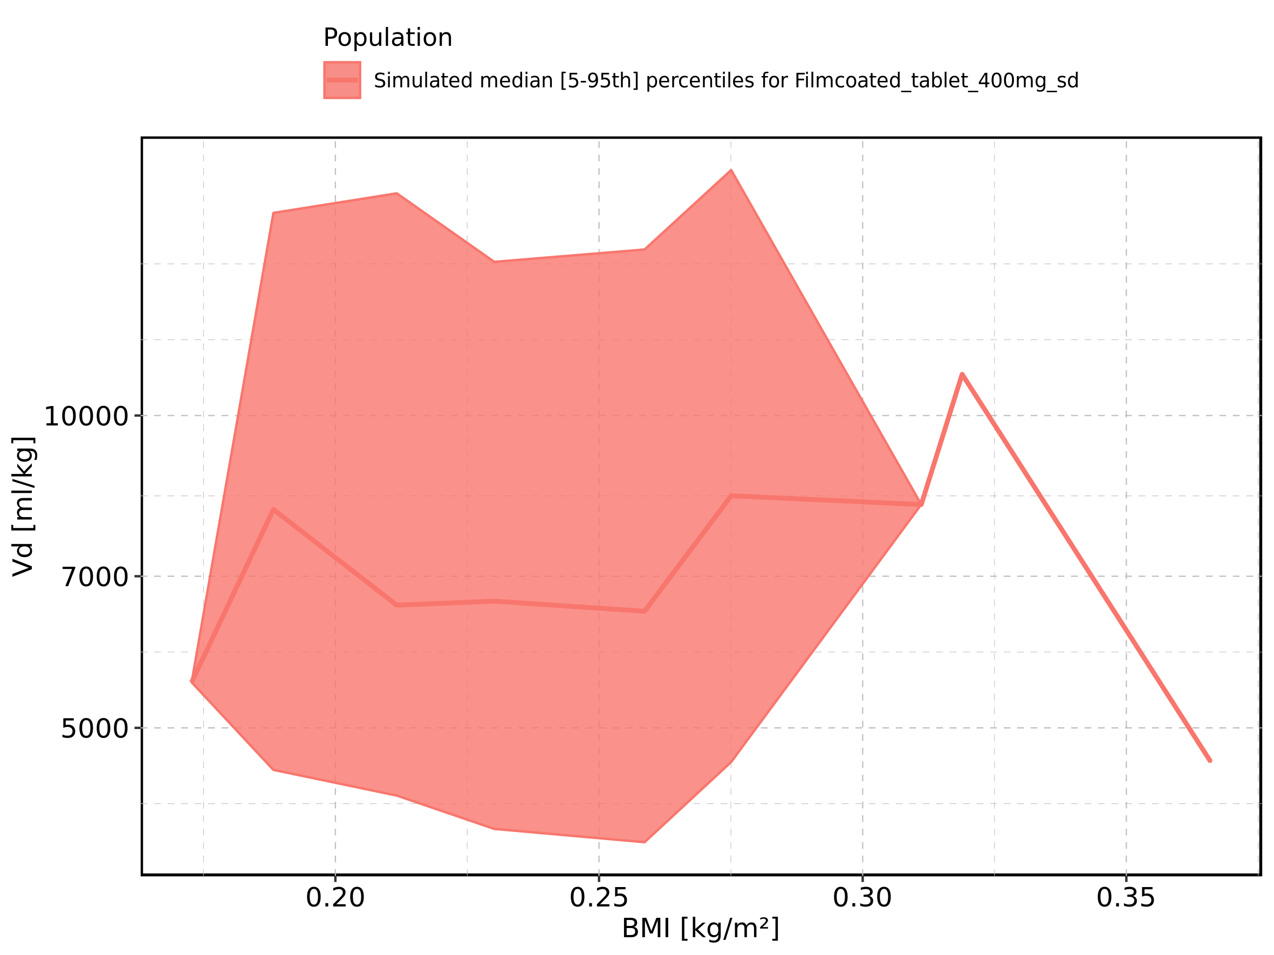

Figure 411: Gender-dependence of Vd for Larson 2013 8y-18y 400mg FCT meal in comparison to Filmcoated_tablet_400mg_sd. Profiles are plotted in a linear scale.

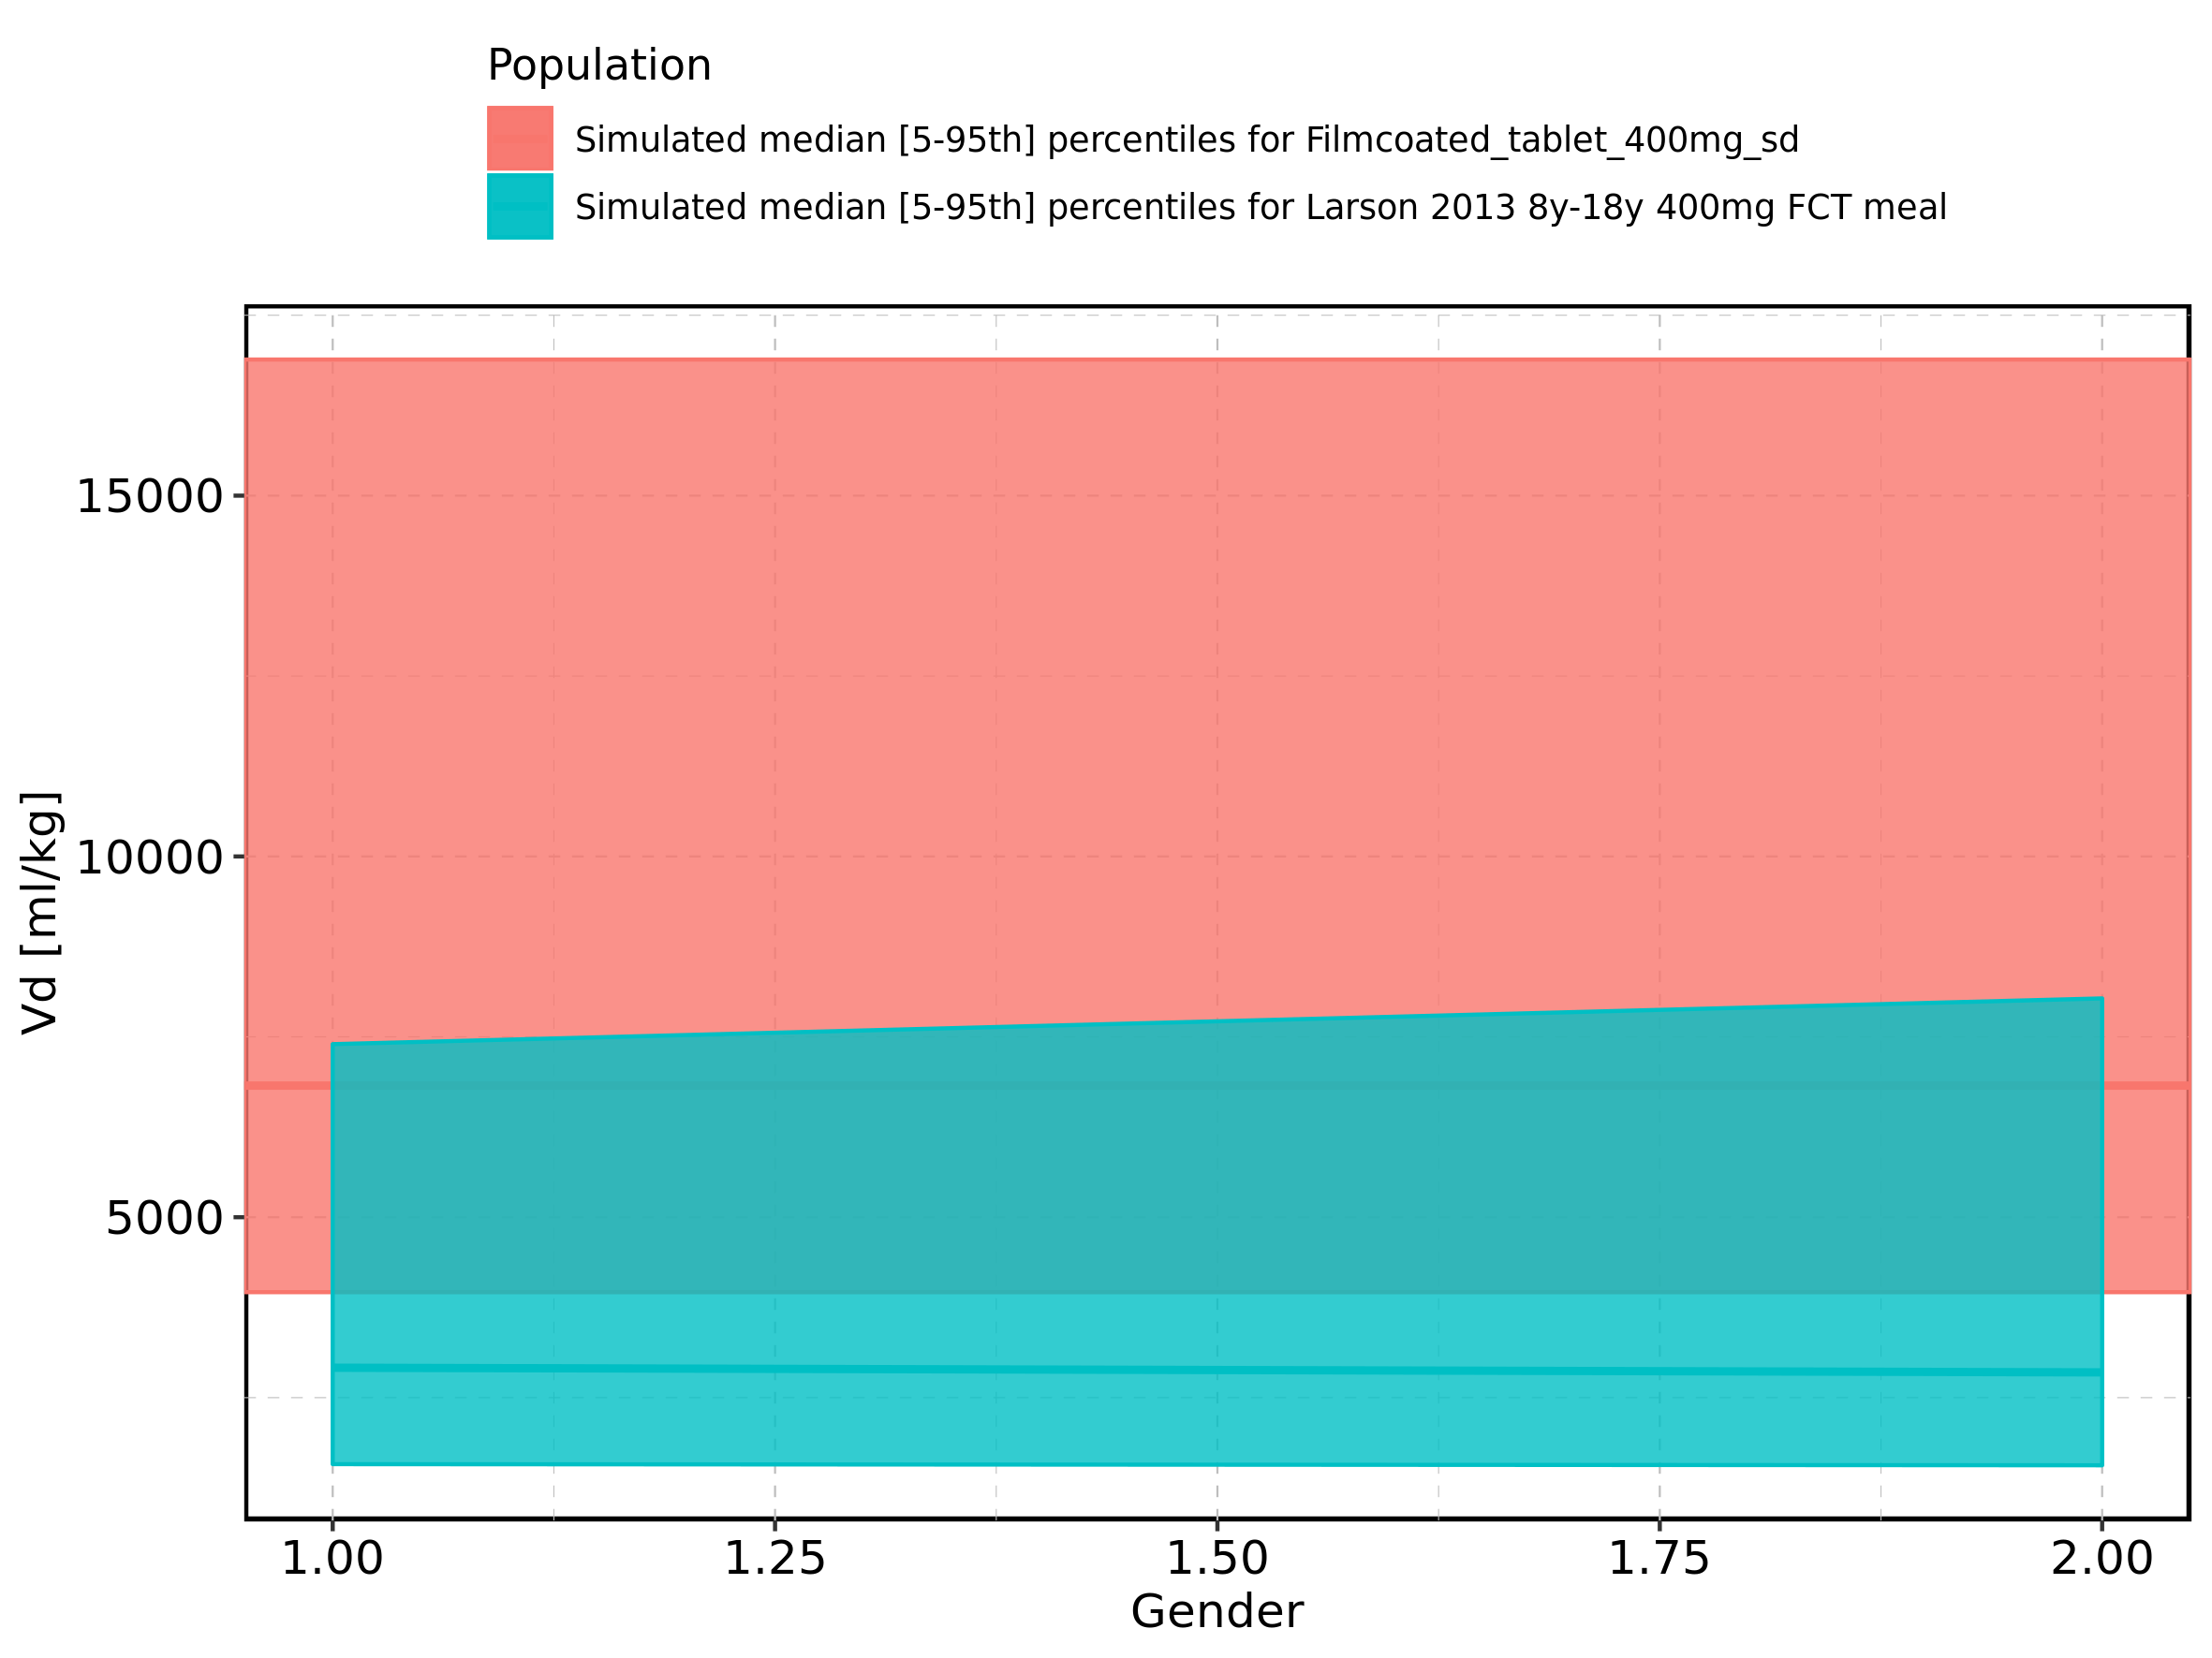

Figure 412: Gender-dependence of Vd for Larson 2013 8y-18y 400mg FCT meal in comparison to Filmcoated_tablet_400mg_sd. Profiles are plotted in a logarithmic scale.

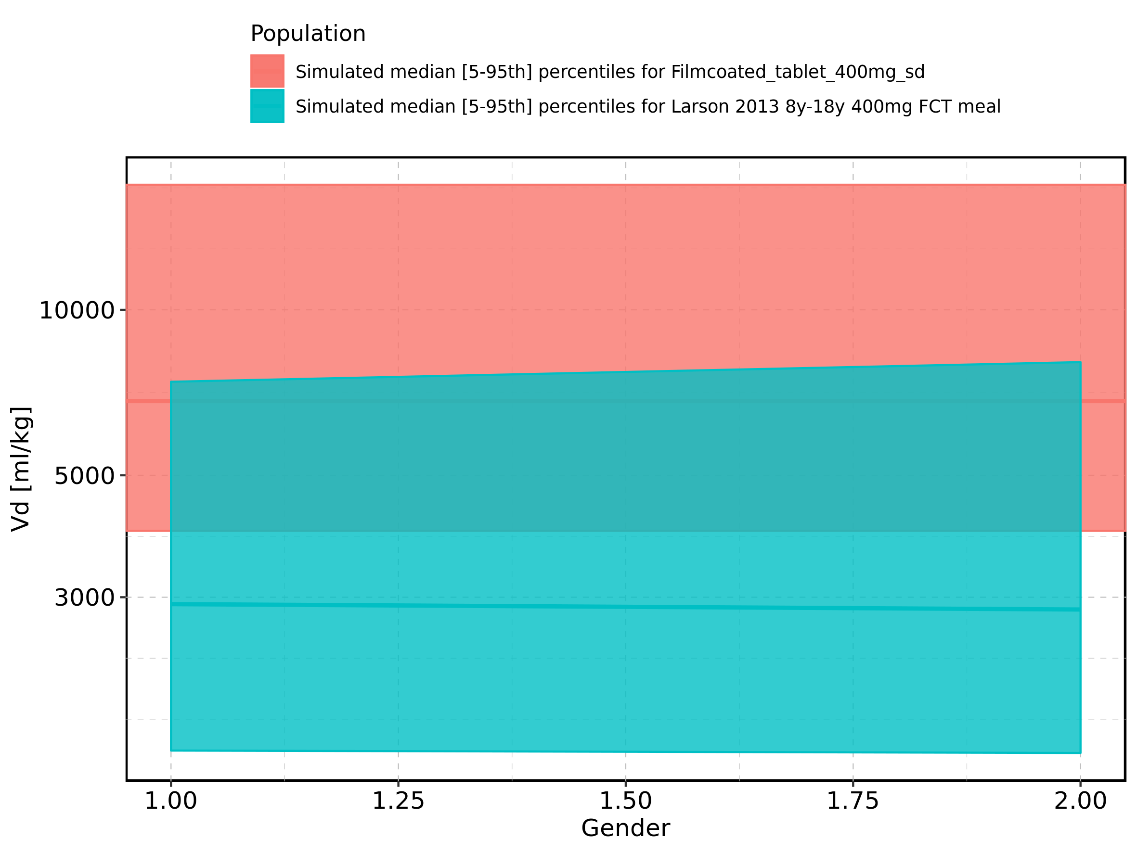

Figure 413: Gender-dependence of Vd for Larson 2013 8y-18y 400mg FCT meal. Profiles are plotted in a linear scale.

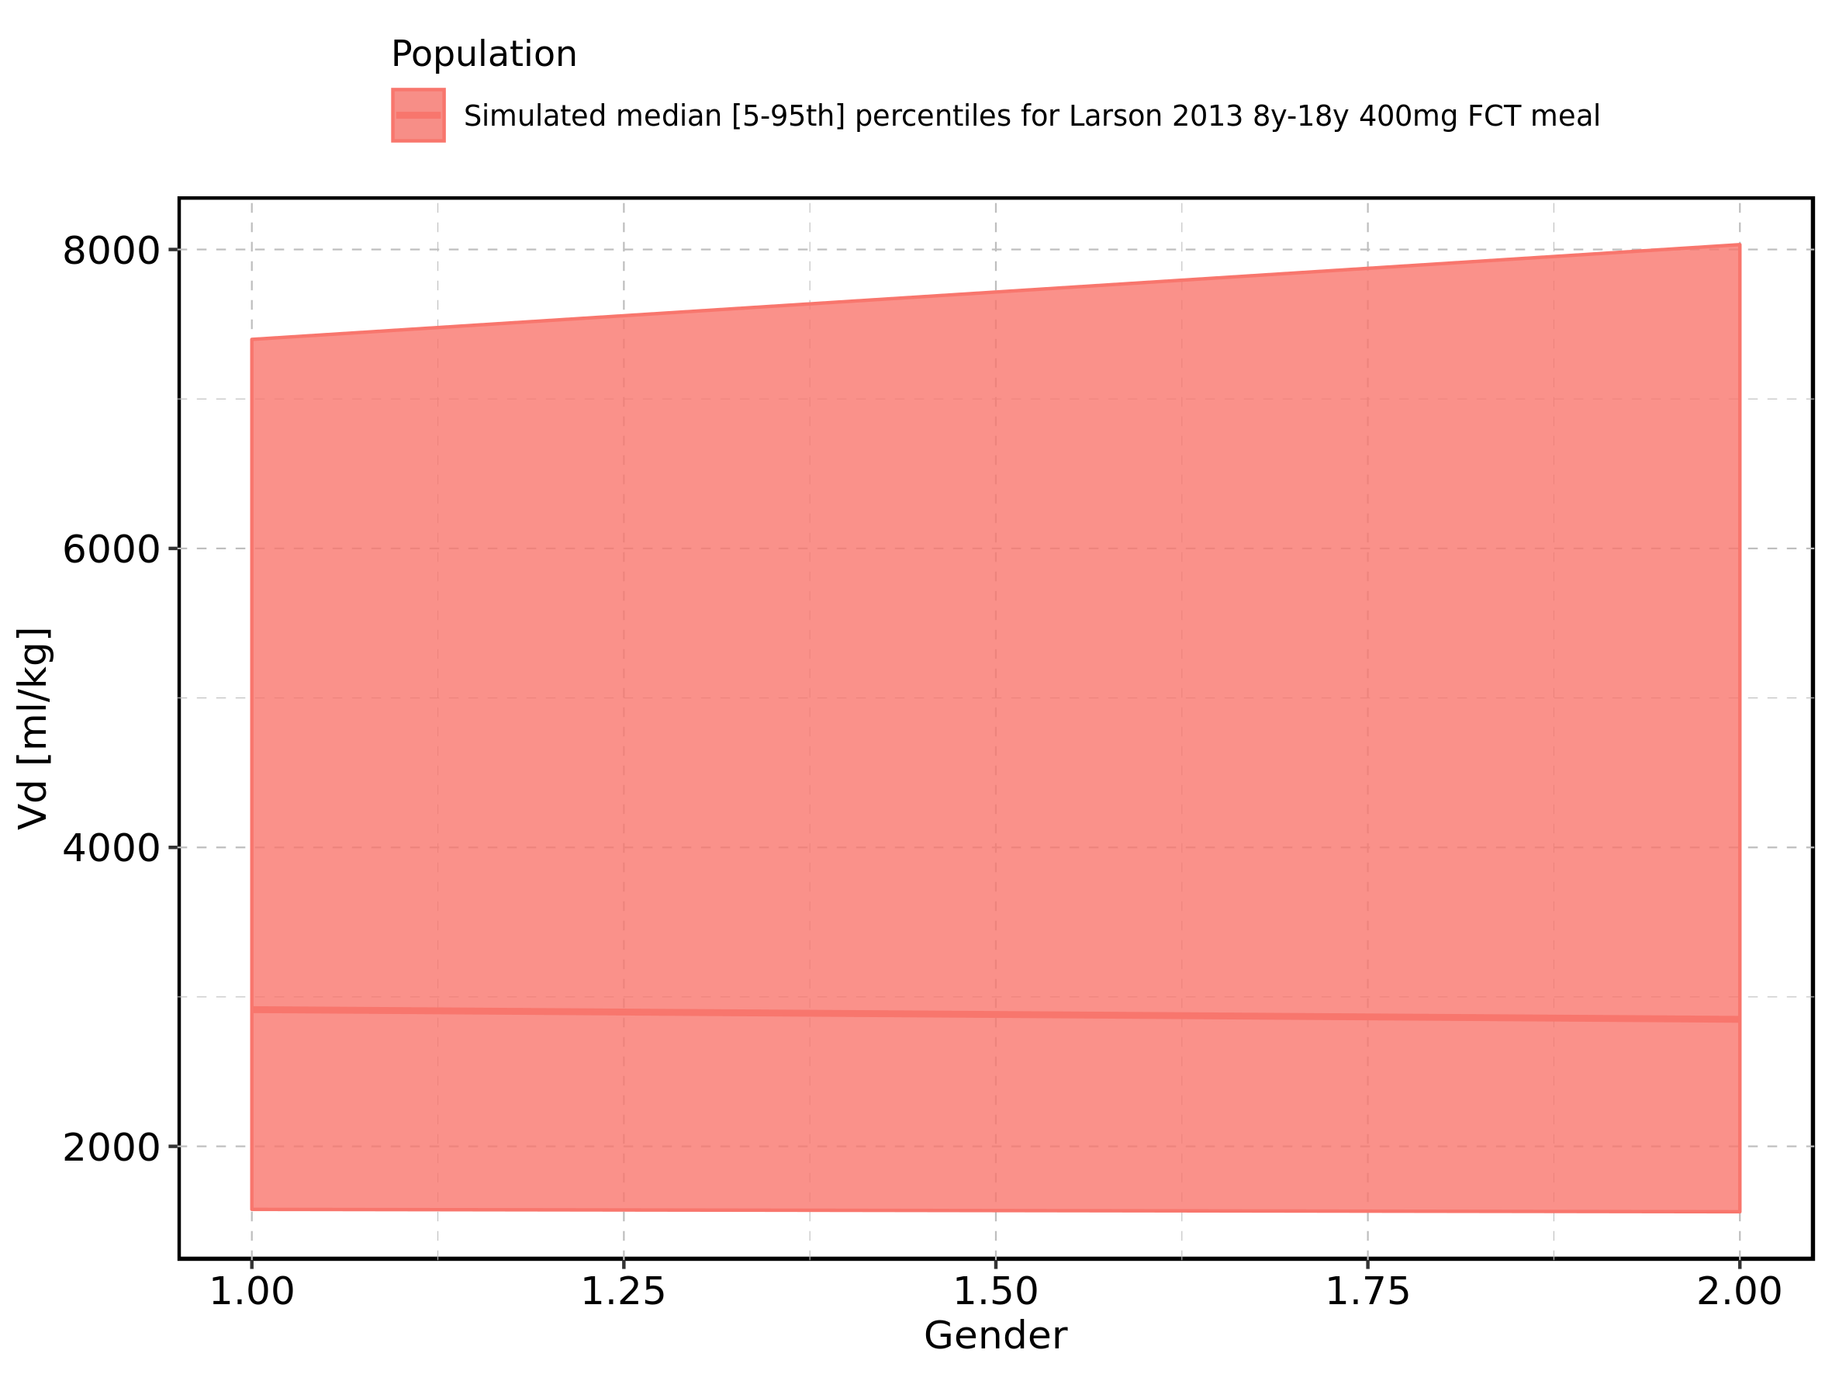

Figure 414: Gender-dependence of Vd for Larson 2013 8y-18y 400mg FCT meal. Profiles are plotted in a logarithmic scale.

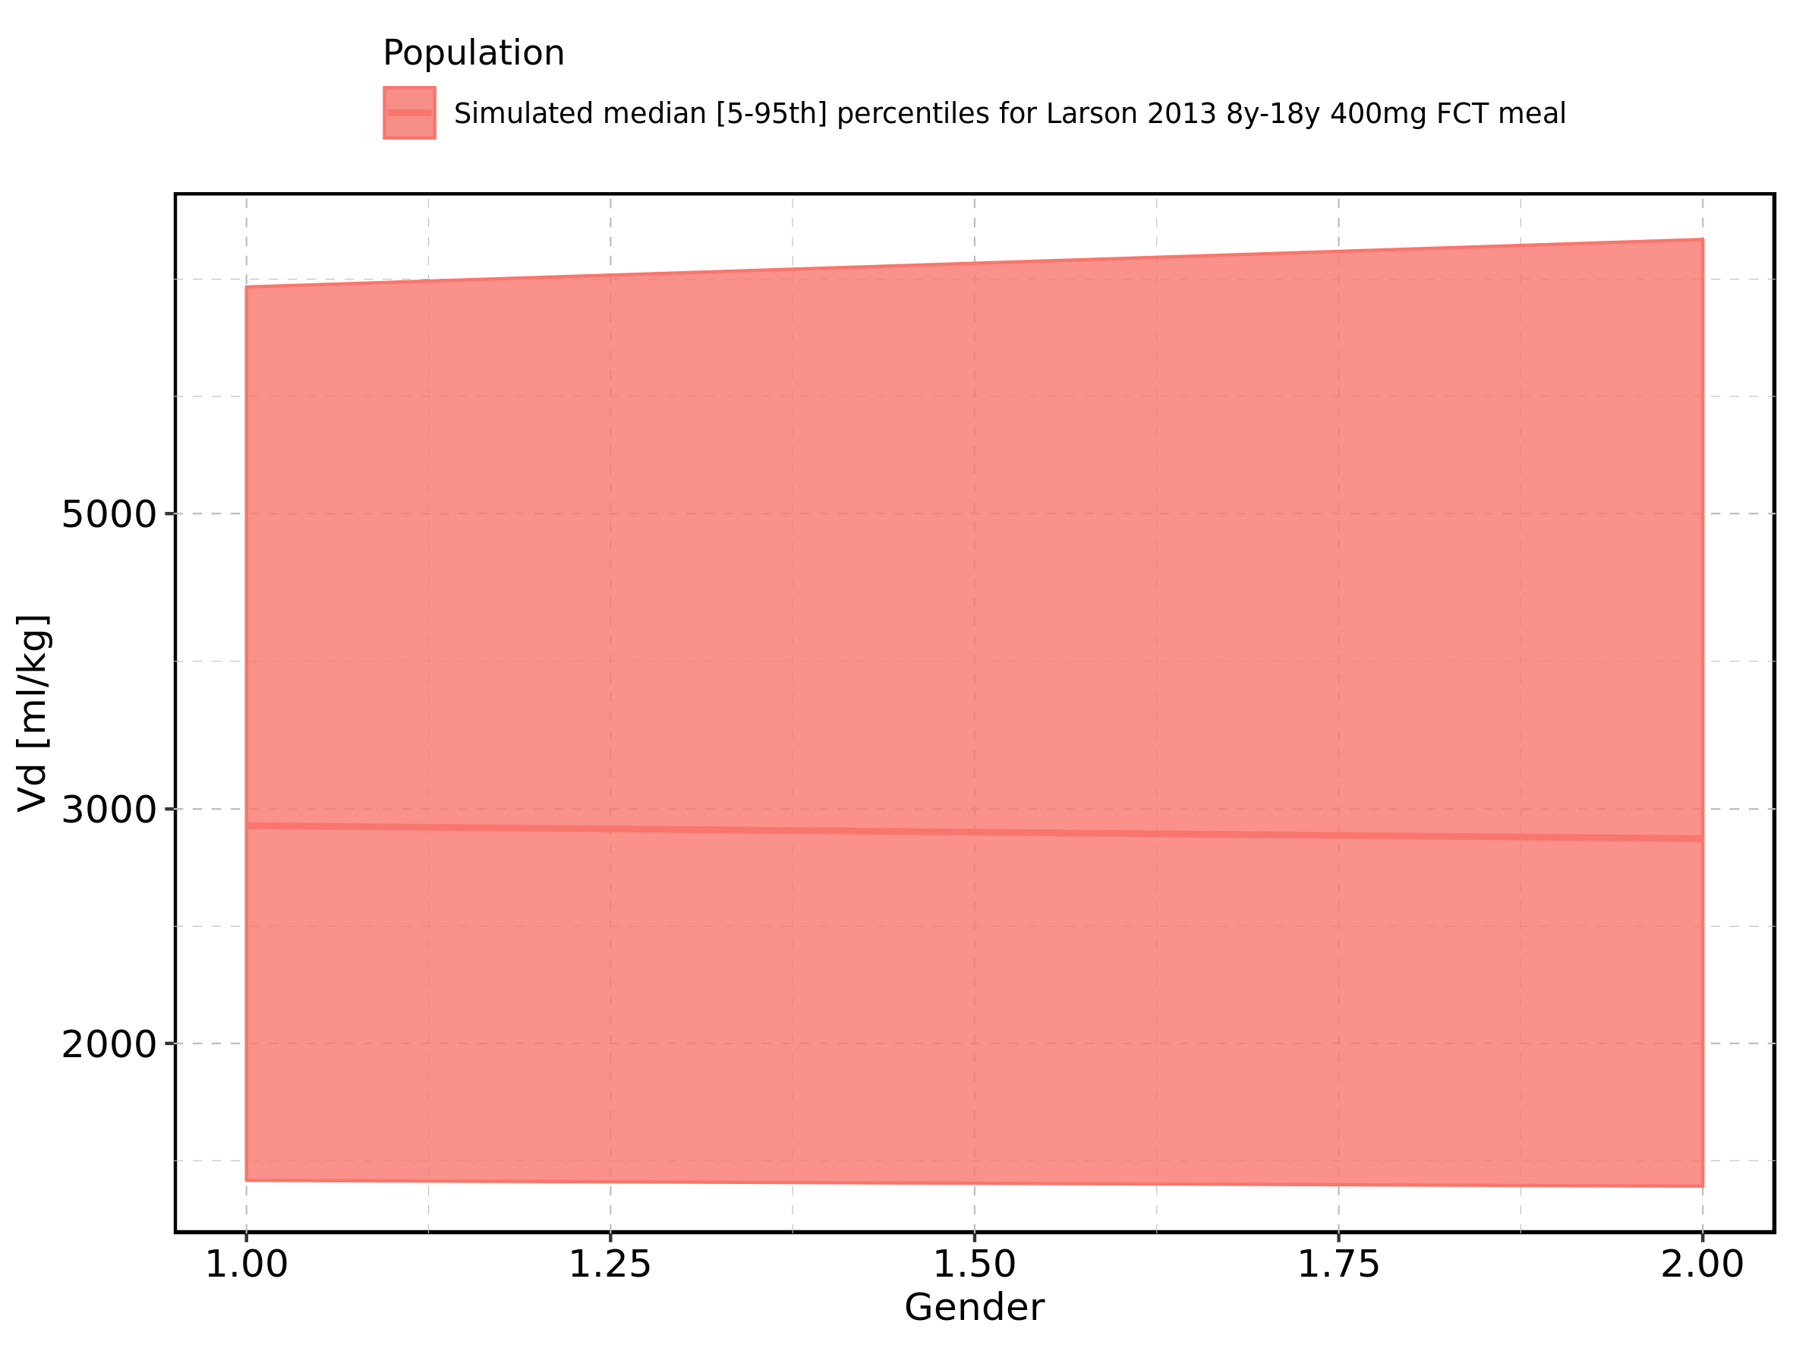

Figure 415: Gender-dependence of Vd for Filmcoated_tablet_400mg_sd. Profiles are plotted in a linear scale.

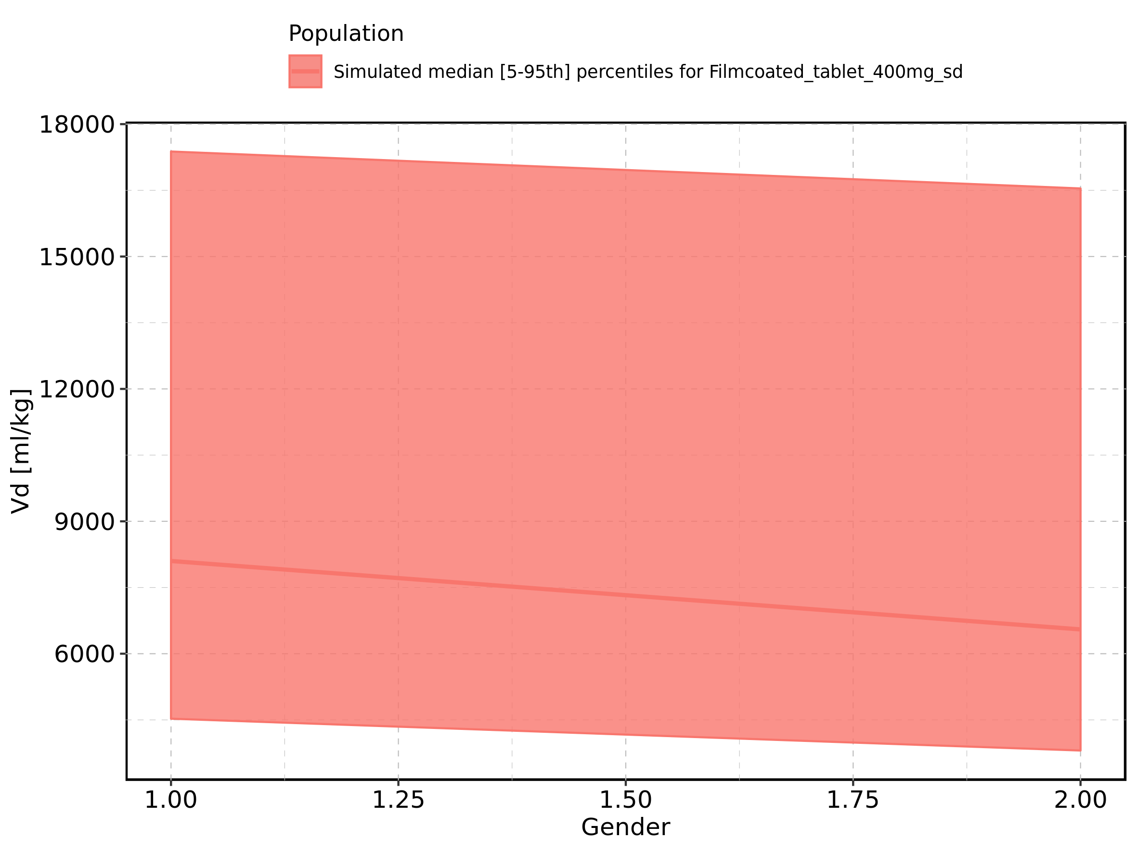

Figure 416: Gender-dependence of Vd for Filmcoated_tablet_400mg_sd. Profiles are plotted in a logarithmic scale.

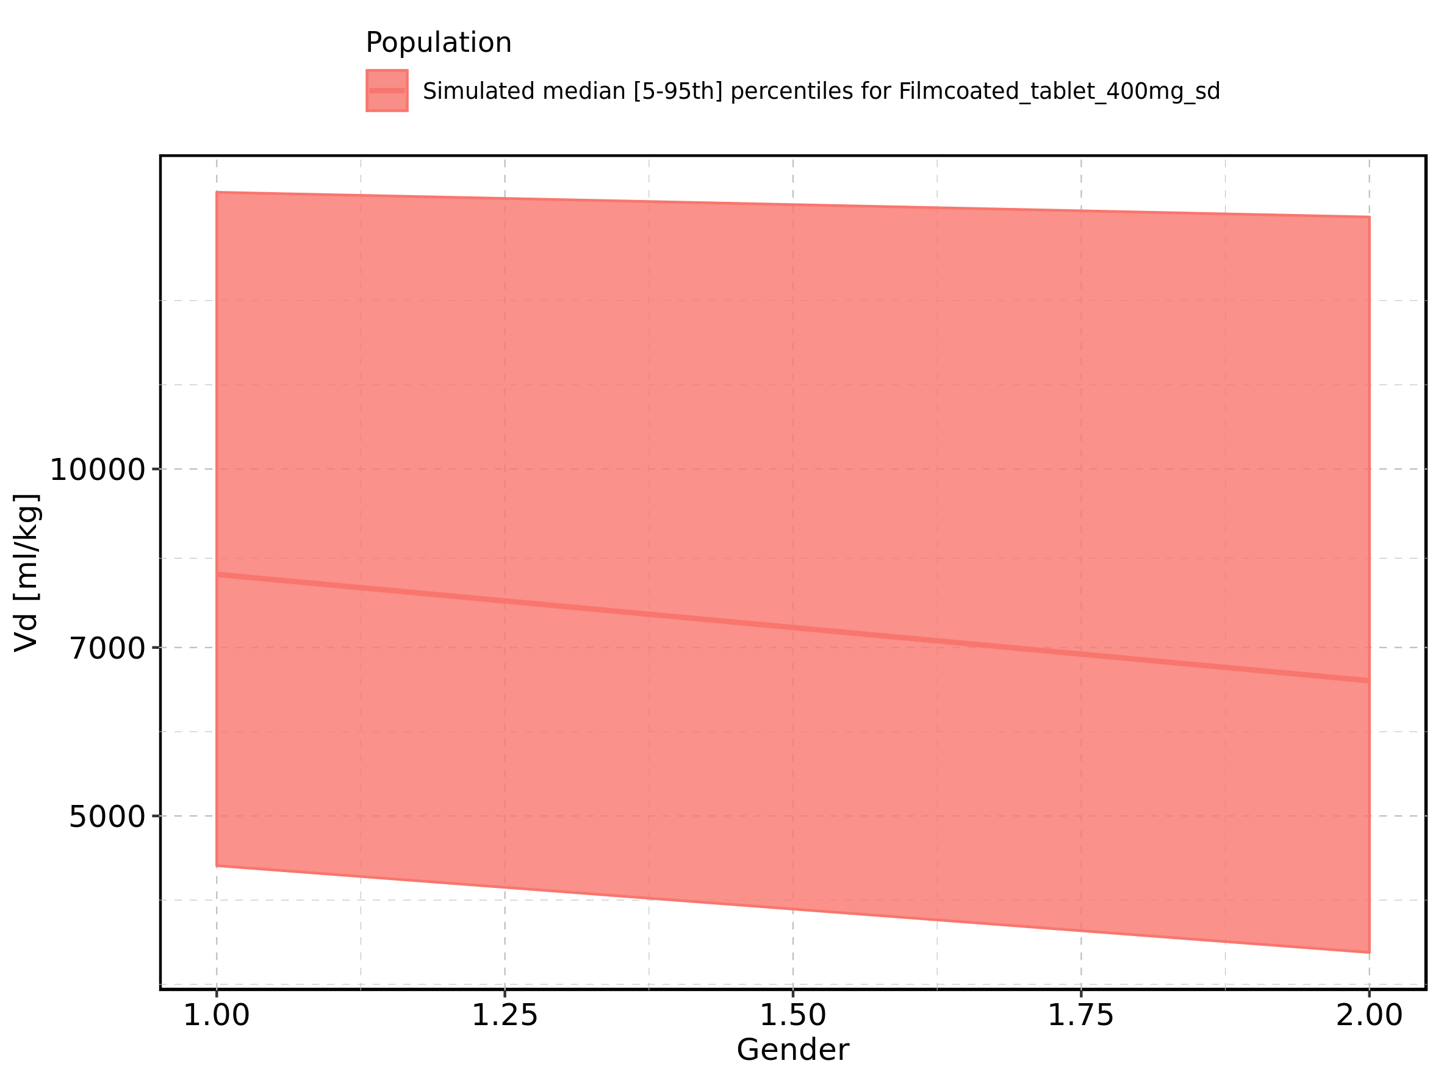

# 2. Time profiles and residual plots

## 2.1. Time profiles and residual plots for Larson 2013 8y-18y 400mg FCT meal

Figure 417: Predicted vs observed of Larson 2013 8y-18y 400mg FCT meal for Larson 2013 8-18y meal. Data source: Data/Raltegravir_PK.txt. Predictions and observations are plotted in a linear scale.

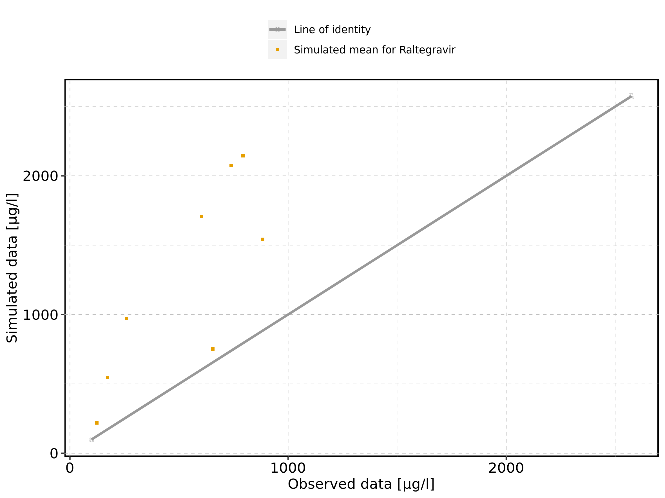

Figure 418: Predicted vs observed of Larson 2013 8y-18y 400mg FCT meal for Larson 2013 8-18y meal. Data source: Data/Raltegravir_PK.txt. Predictions and observations are plotted in a logarithmic scale.

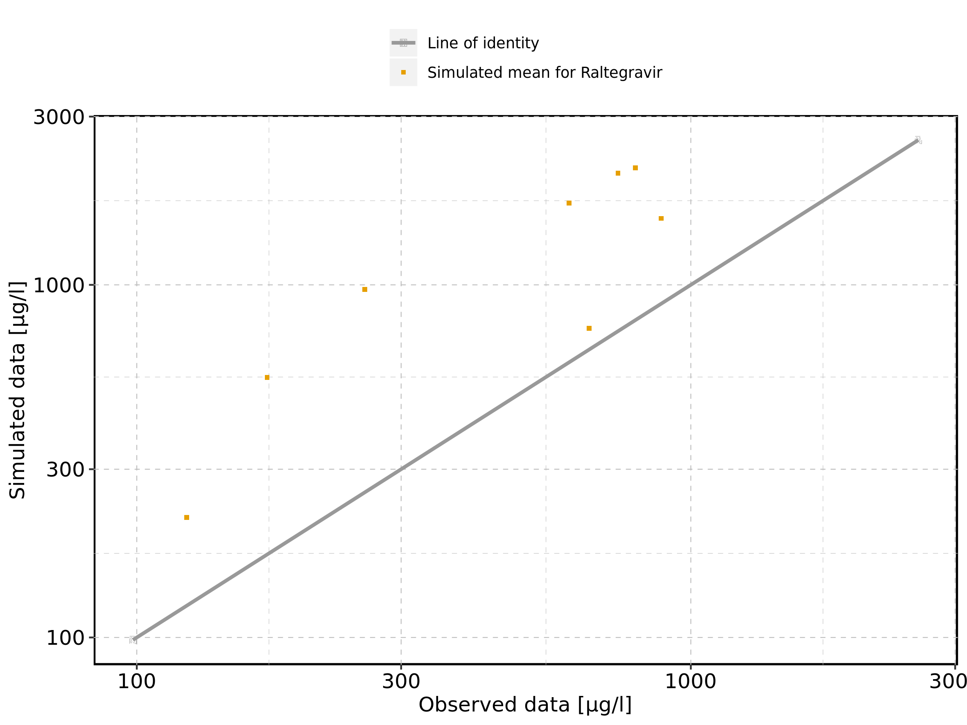

Figure 419: Logarithmic residuals vs predicted values of Larson 2013 8y-18y 400mg FCT meal for Larson 2013 8-18y meal. Data source: Data/Raltegravir_PK.txt.

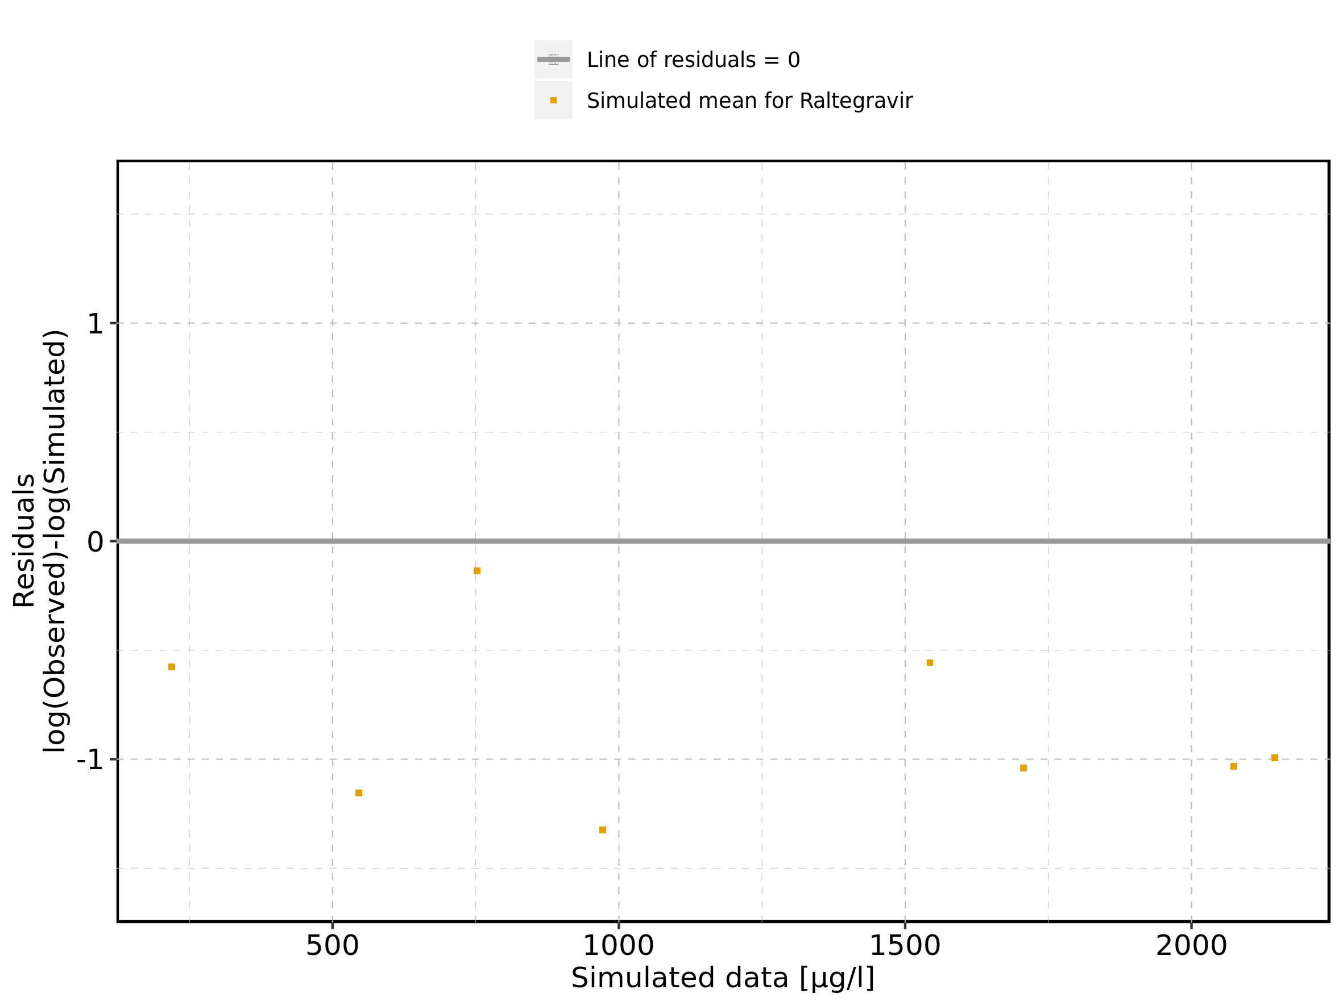

Figure 420: Logarithmic residuals vs time of Larson 2013 8y-18y 400mg FCT meal for Larson 2013 8-18y meal. Data source: Data/Raltegravir_PK.txt.

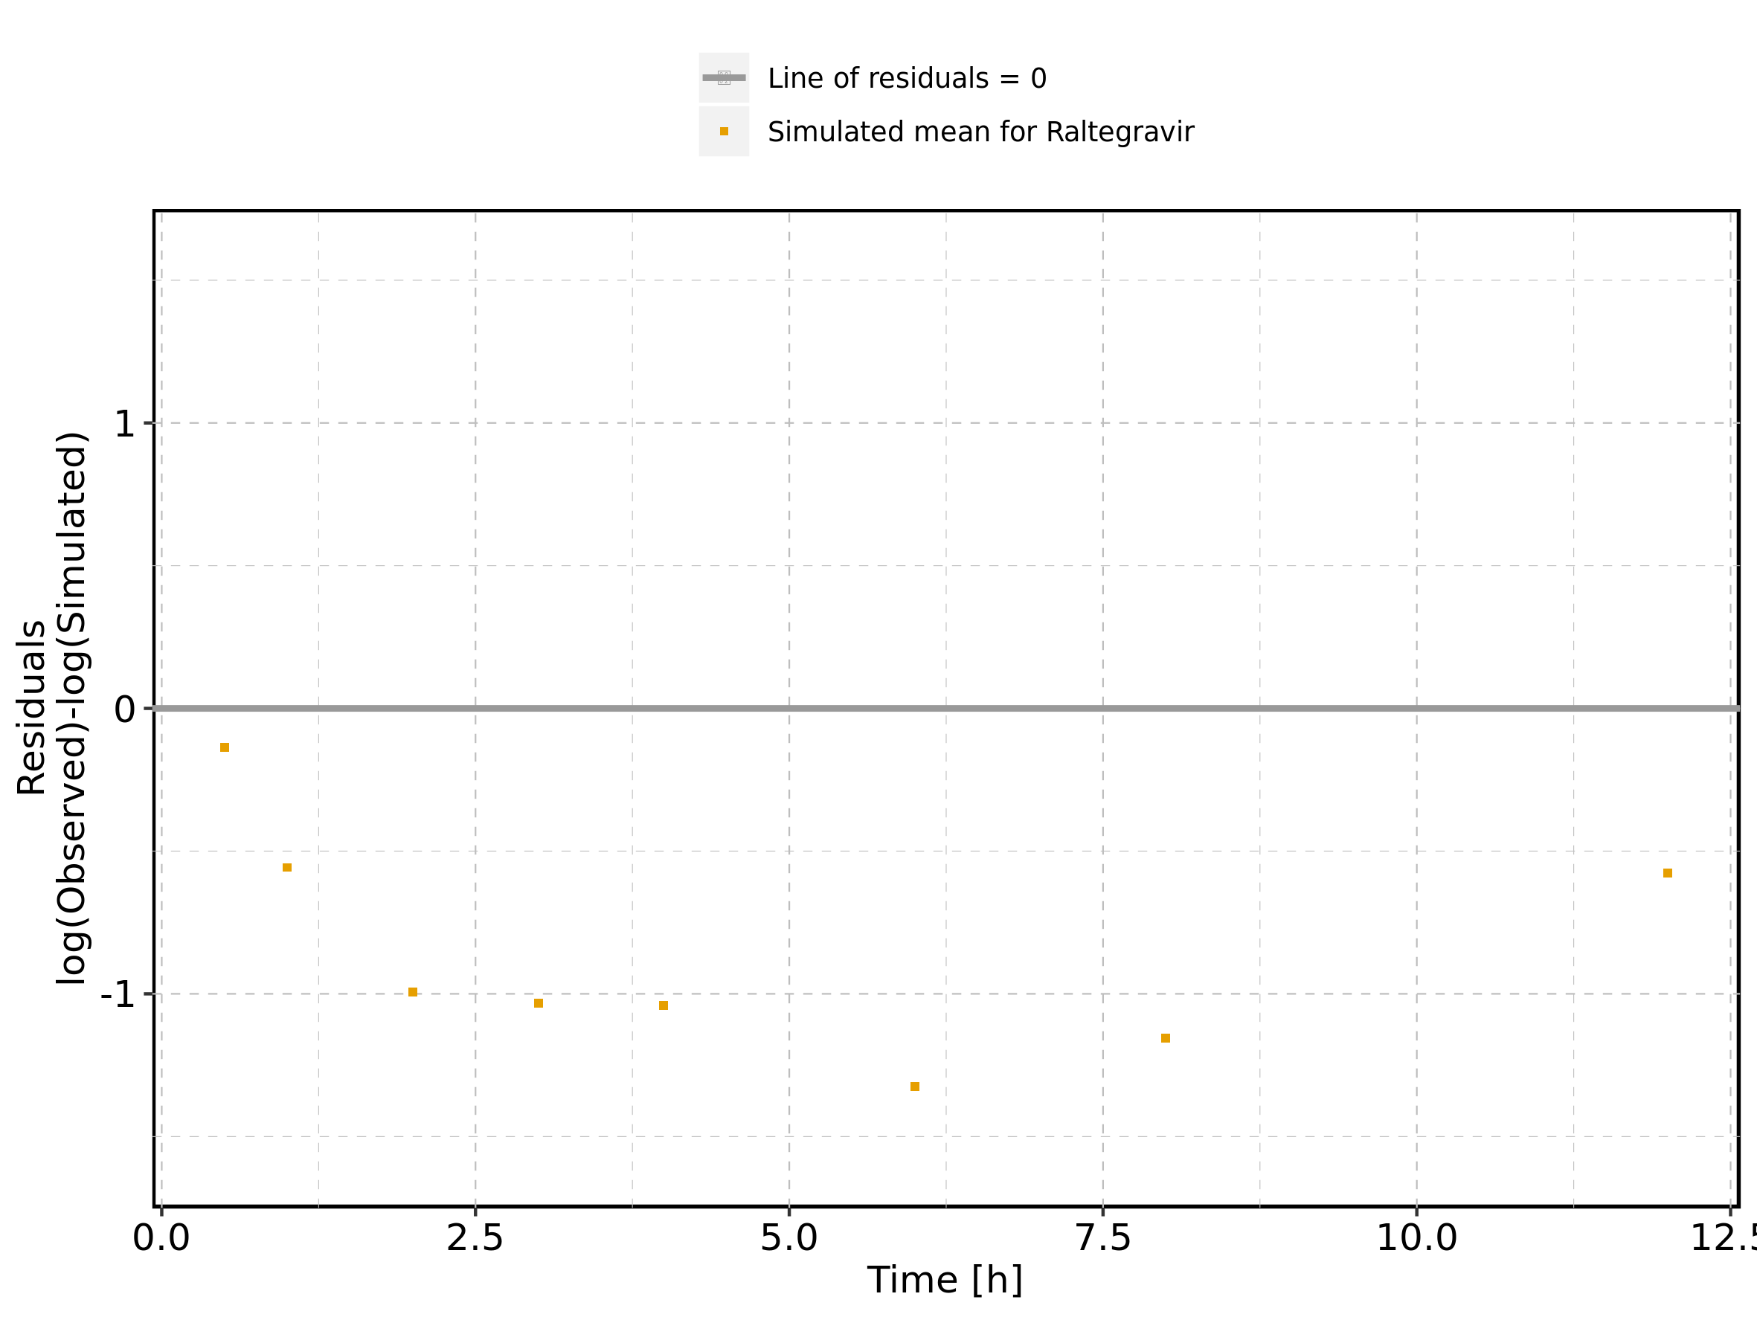

Figure 421: Logarithmic residuals distribution of Larson 2013 8y-18y 400mg FCT meal for Larson 2013 8-18y meal. Data source: Data/Raltegravir_PK.txt.

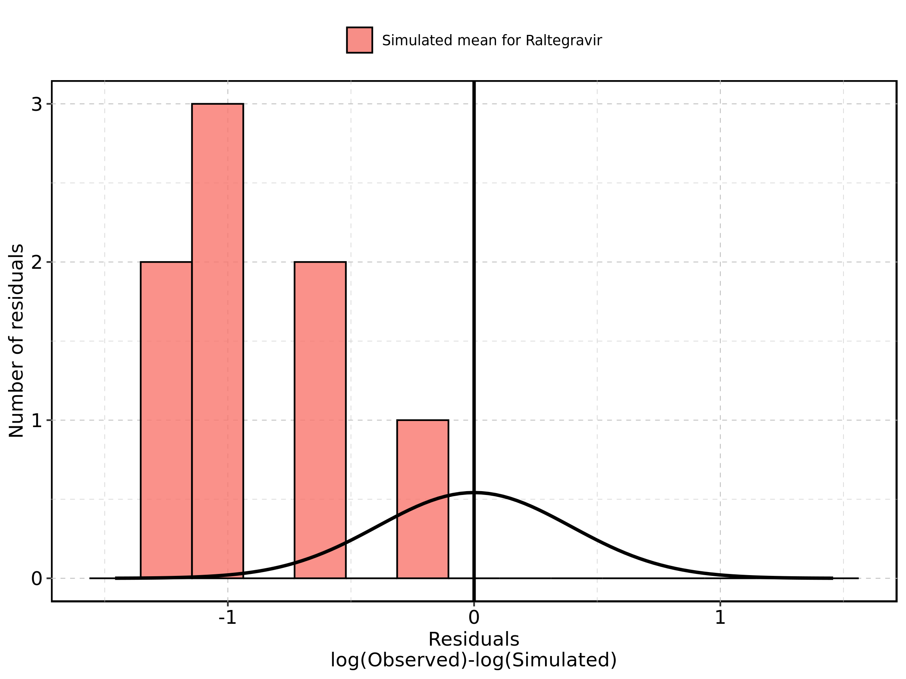

Figure 422: Logarithmic residuals of Larson 2013 8y-18y 400mg FCT meal for Larson 2013 8-18y meal as quantile-quantile plot. Data source: Data/Raltegravir_PK.txt.

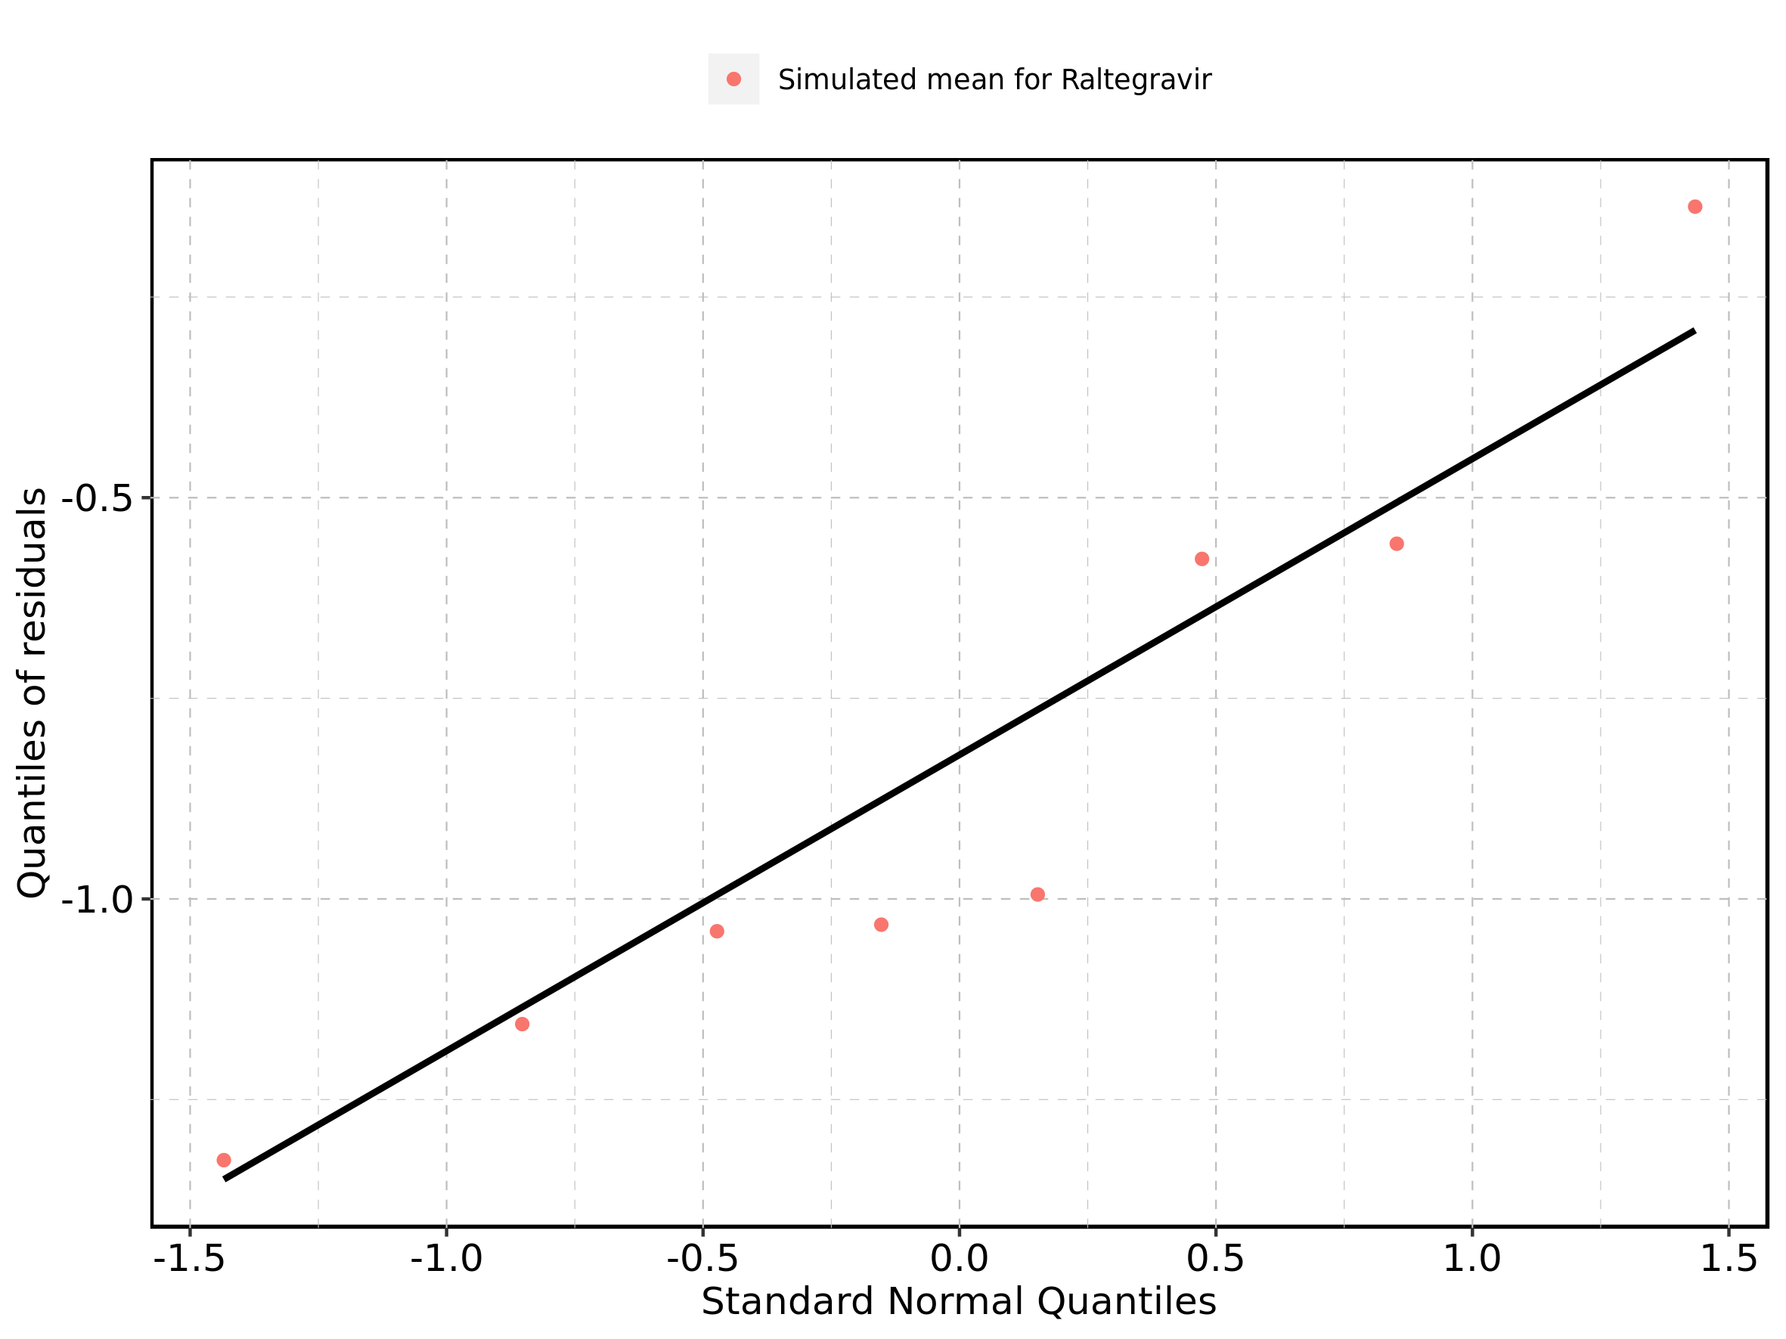

## 2.2. Time profiles and residual plots for Filmcoated_tablet_400mg_sd

Figure 423: Predicted vs observed of Filmcoated_tablet_400mg_sd for Raltegravir 400mg filmcoated tablet. Data source: Data/Raltegravir_PK.txt. Predictions and observations are plotted in a linear scale.

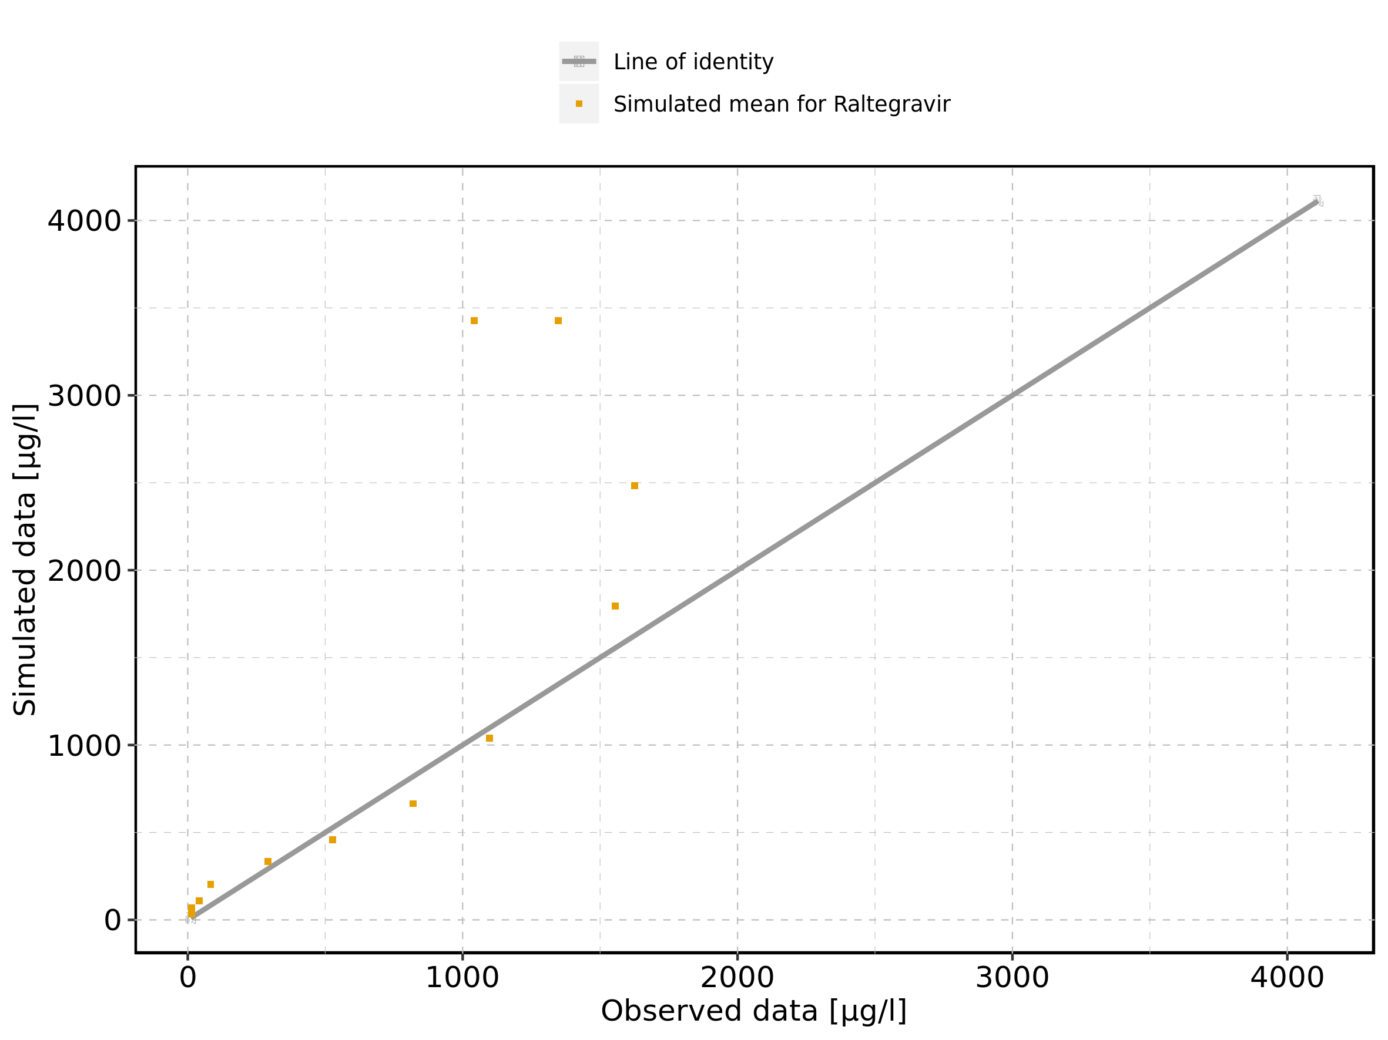

Figure 424: Predicted vs observed of Filmcoated_tablet_400mg_sd for Raltegravir 400mg filmcoated tablet. Data source: Data/Raltegravir_PK.txt. Predictions and observations are plotted in a logarithmic scale.

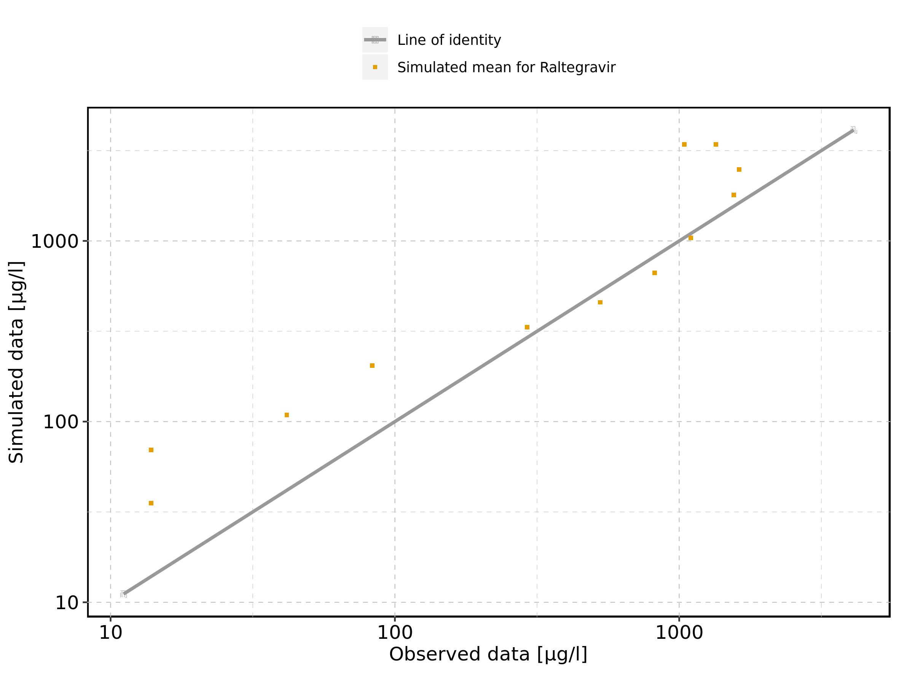

Figure 425: Logarithmic residuals vs predicted values of Filmcoated_tablet_400mg_sd for Raltegravir 400mg filmcoated tablet. Data source: Data/Raltegravir_PK.txt.

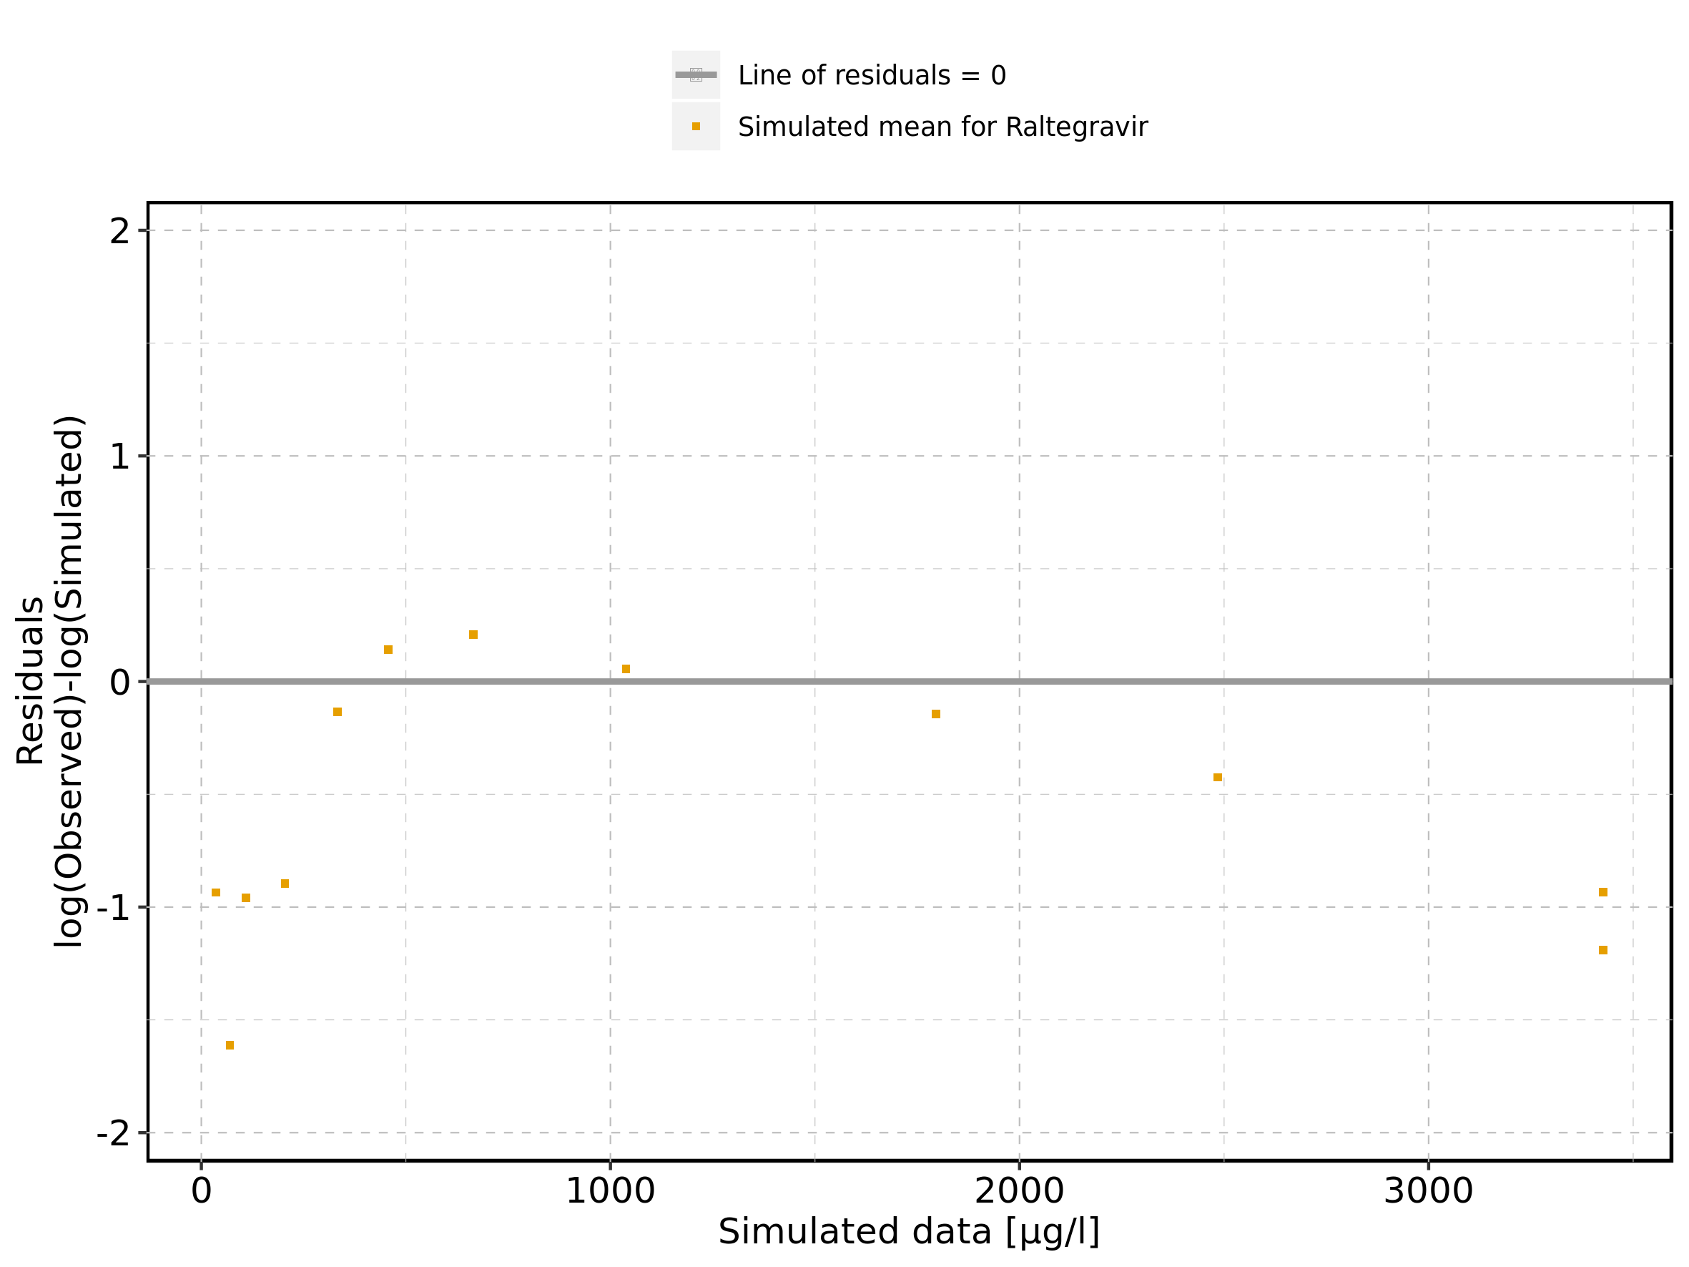

Figure 426: Logarithmic residuals vs time of Filmcoated_tablet_400mg_sd for Raltegravir 400mg filmcoated tablet. Data source: Data/Raltegravir_PK.txt.

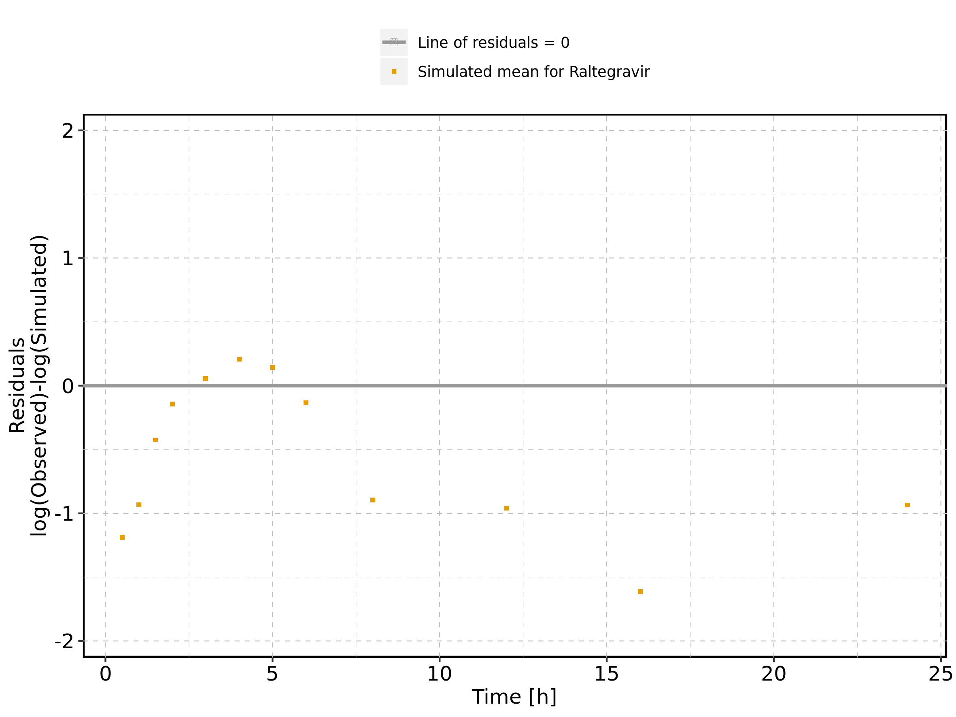

Figure 427: Logarithmic residuals distribution of Filmcoated_tablet_400mg_sd for Raltegravir 400mg filmcoated tablet. Data source: Data/Raltegravir_PK.txt.

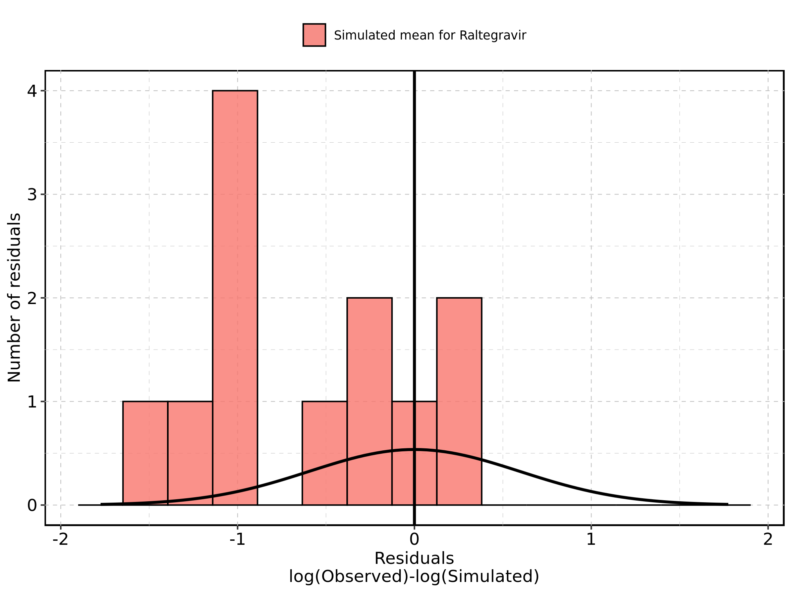

Figure 428: Logarithmic residuals of Filmcoated_tablet_400mg_sd for Raltegravir 400mg filmcoated tablet as quantile-quantile plot. Data source: Data/Raltegravir_PK.txt.

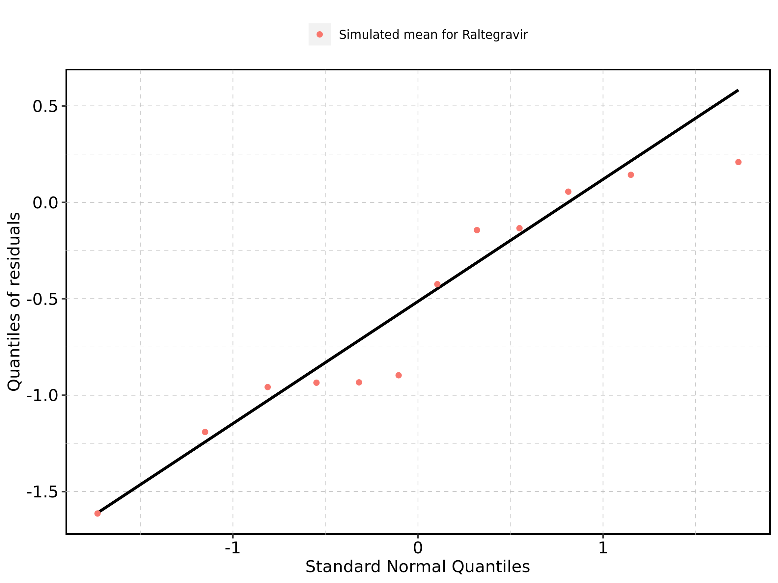

## 2.3. Residuals across all simulations

Figure 429: Distribution of residuals for Larson 2013 8y-18y 400mg FCT meal, Filmcoated_tablet_400mg_sd

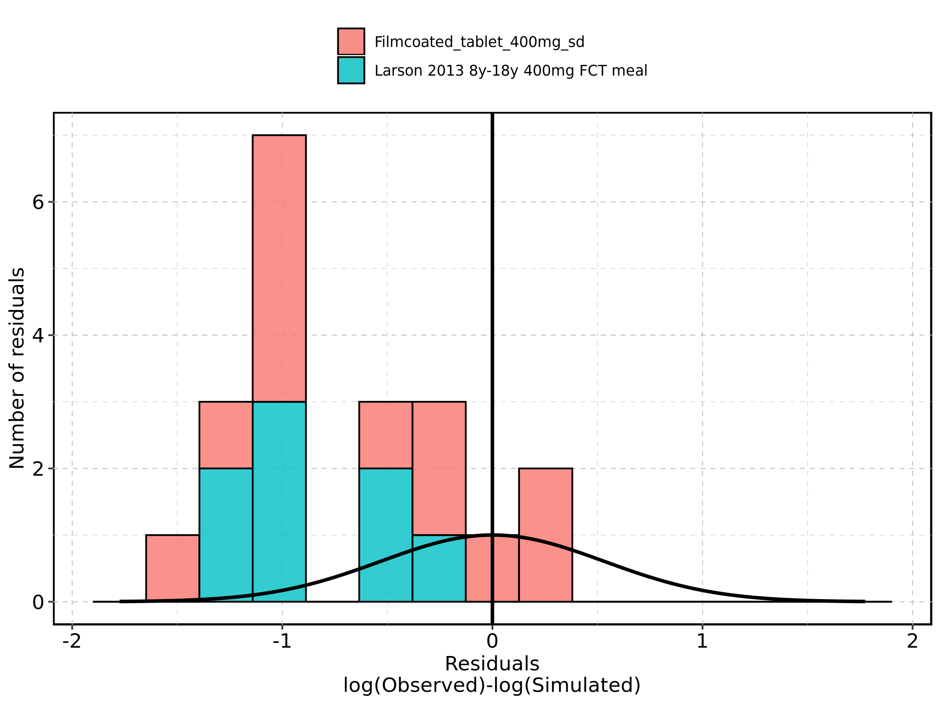

Figure 430: Residuals for Larson 2013 8y-18y 400mg FCT meal, Filmcoated_tablet_400mg_sd as quantile-quantile plot.

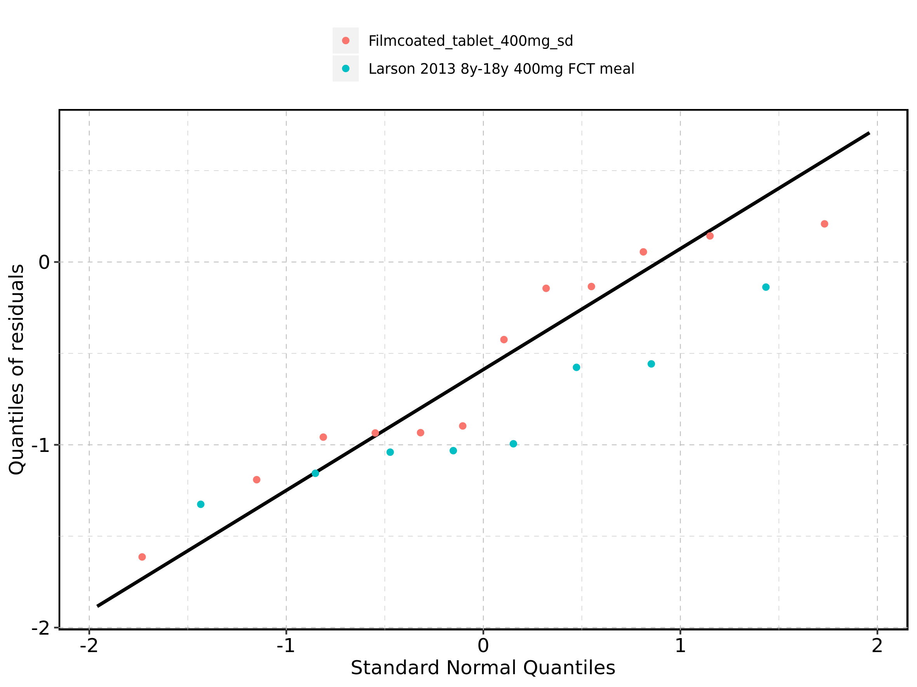

# 3. Demography

Figure 431: Age-dependence of Height for Larson 2013 8y-18y 400mg FCT meal in comparison to Filmcoated_tablet_400mg_sd. Profiles are plotted in a linear scale.

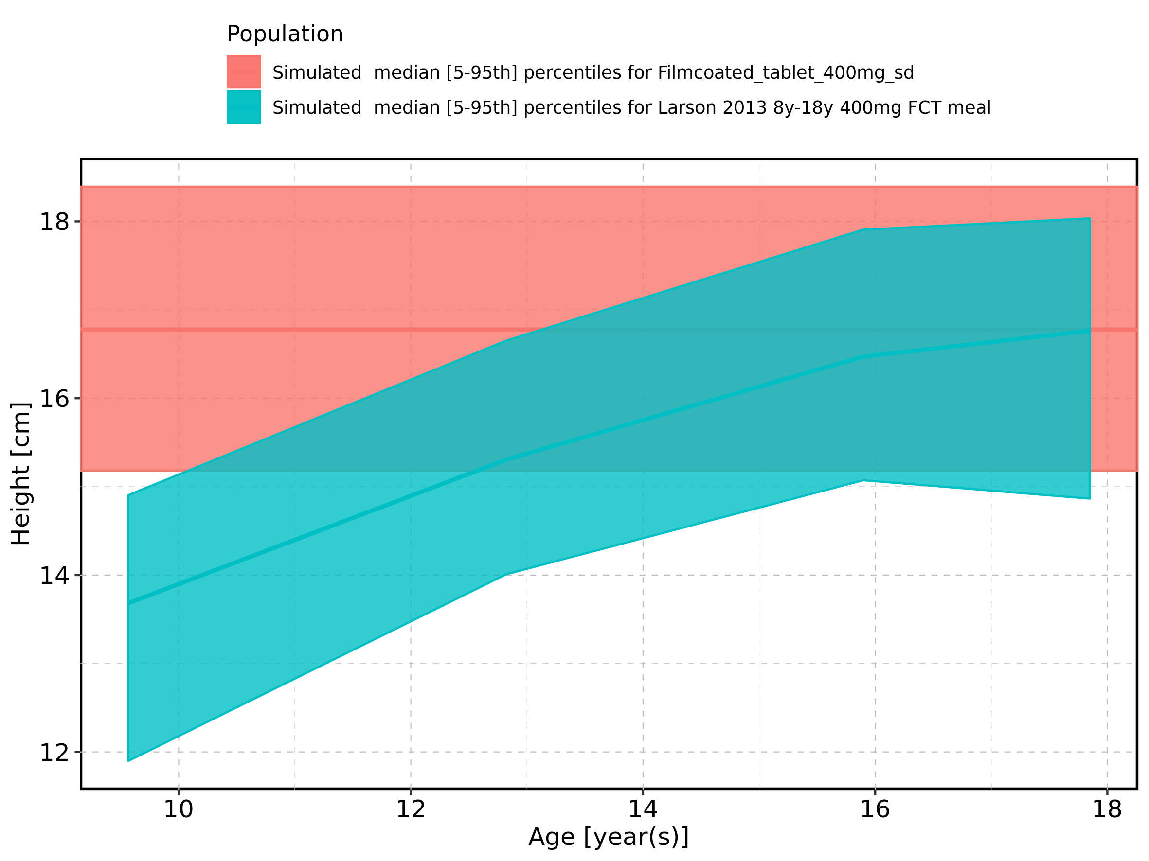

Figure 432: Age-dependence of Height for Larson 2013 8y-18y 400mg FCT meal in comparison to Filmcoated_tablet_400mg_sd. Profiles are plotted in a logarithmic scale.

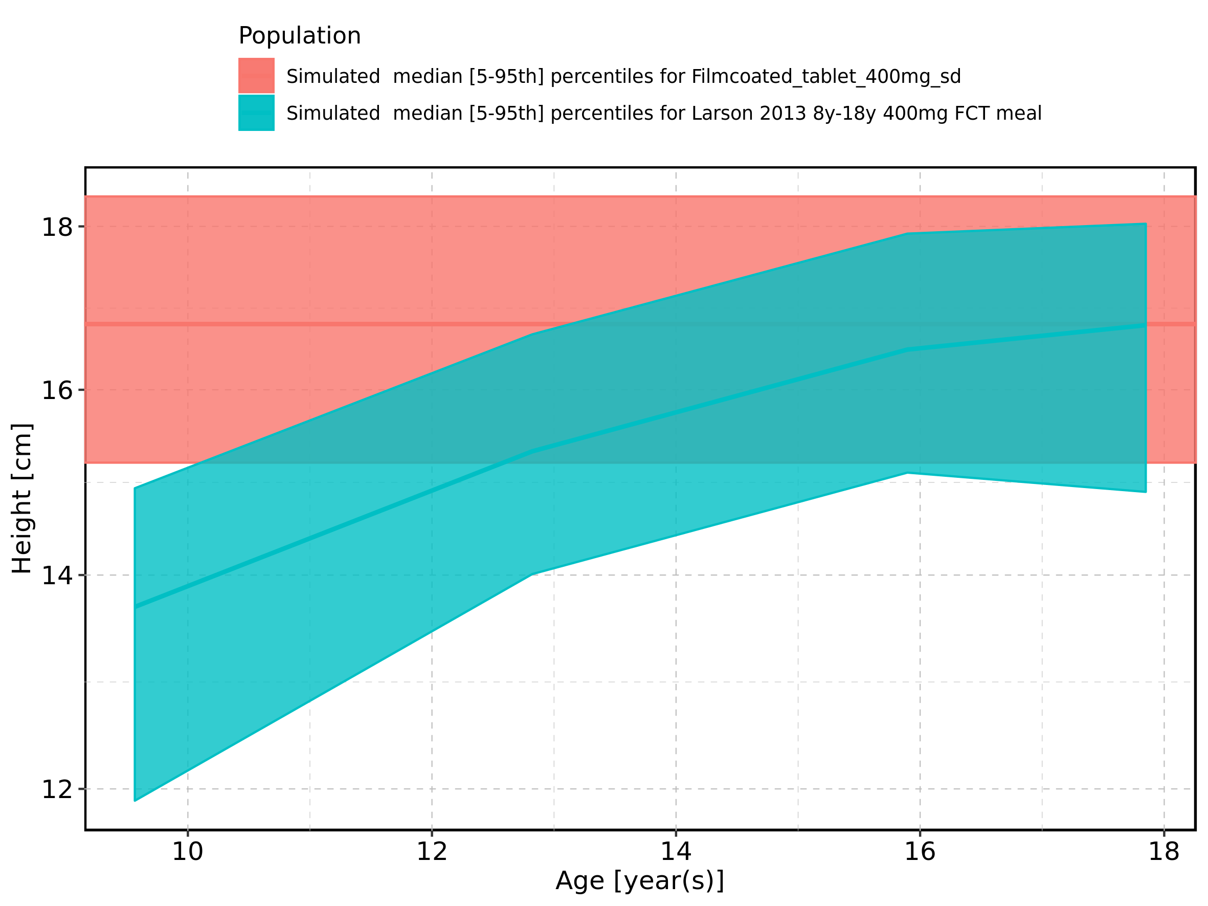

Figure 433: Age-dependence of Height for Larson 2013 8y-18y 400mg FCT meal. Profiles are plotted in a linear scale.

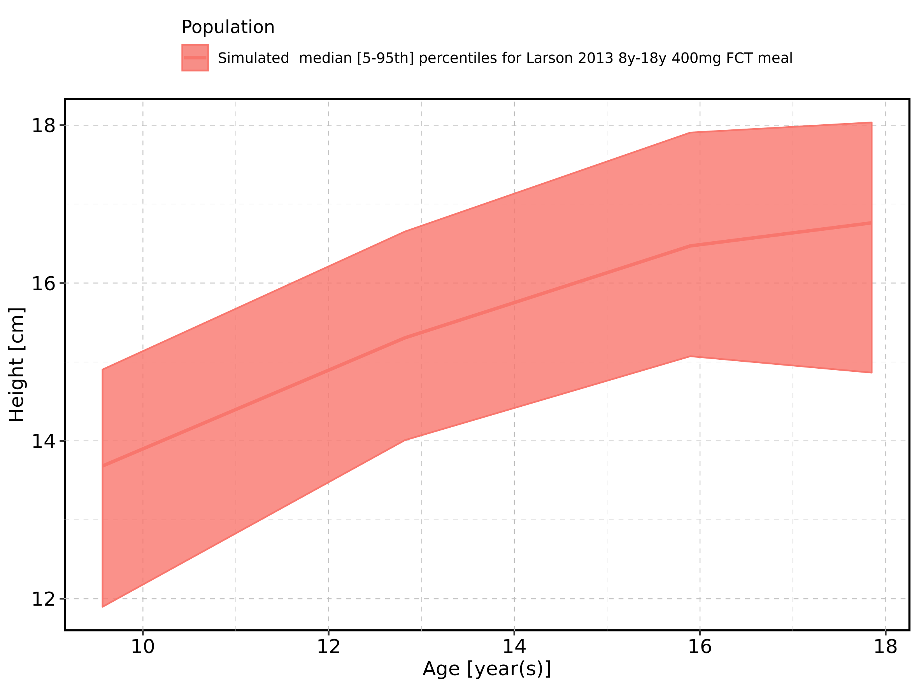

Figure 434: Age-dependence of Height for Larson 2013 8y-18y 400mg FCT meal. Profiles are plotted in a logarithmic scale.

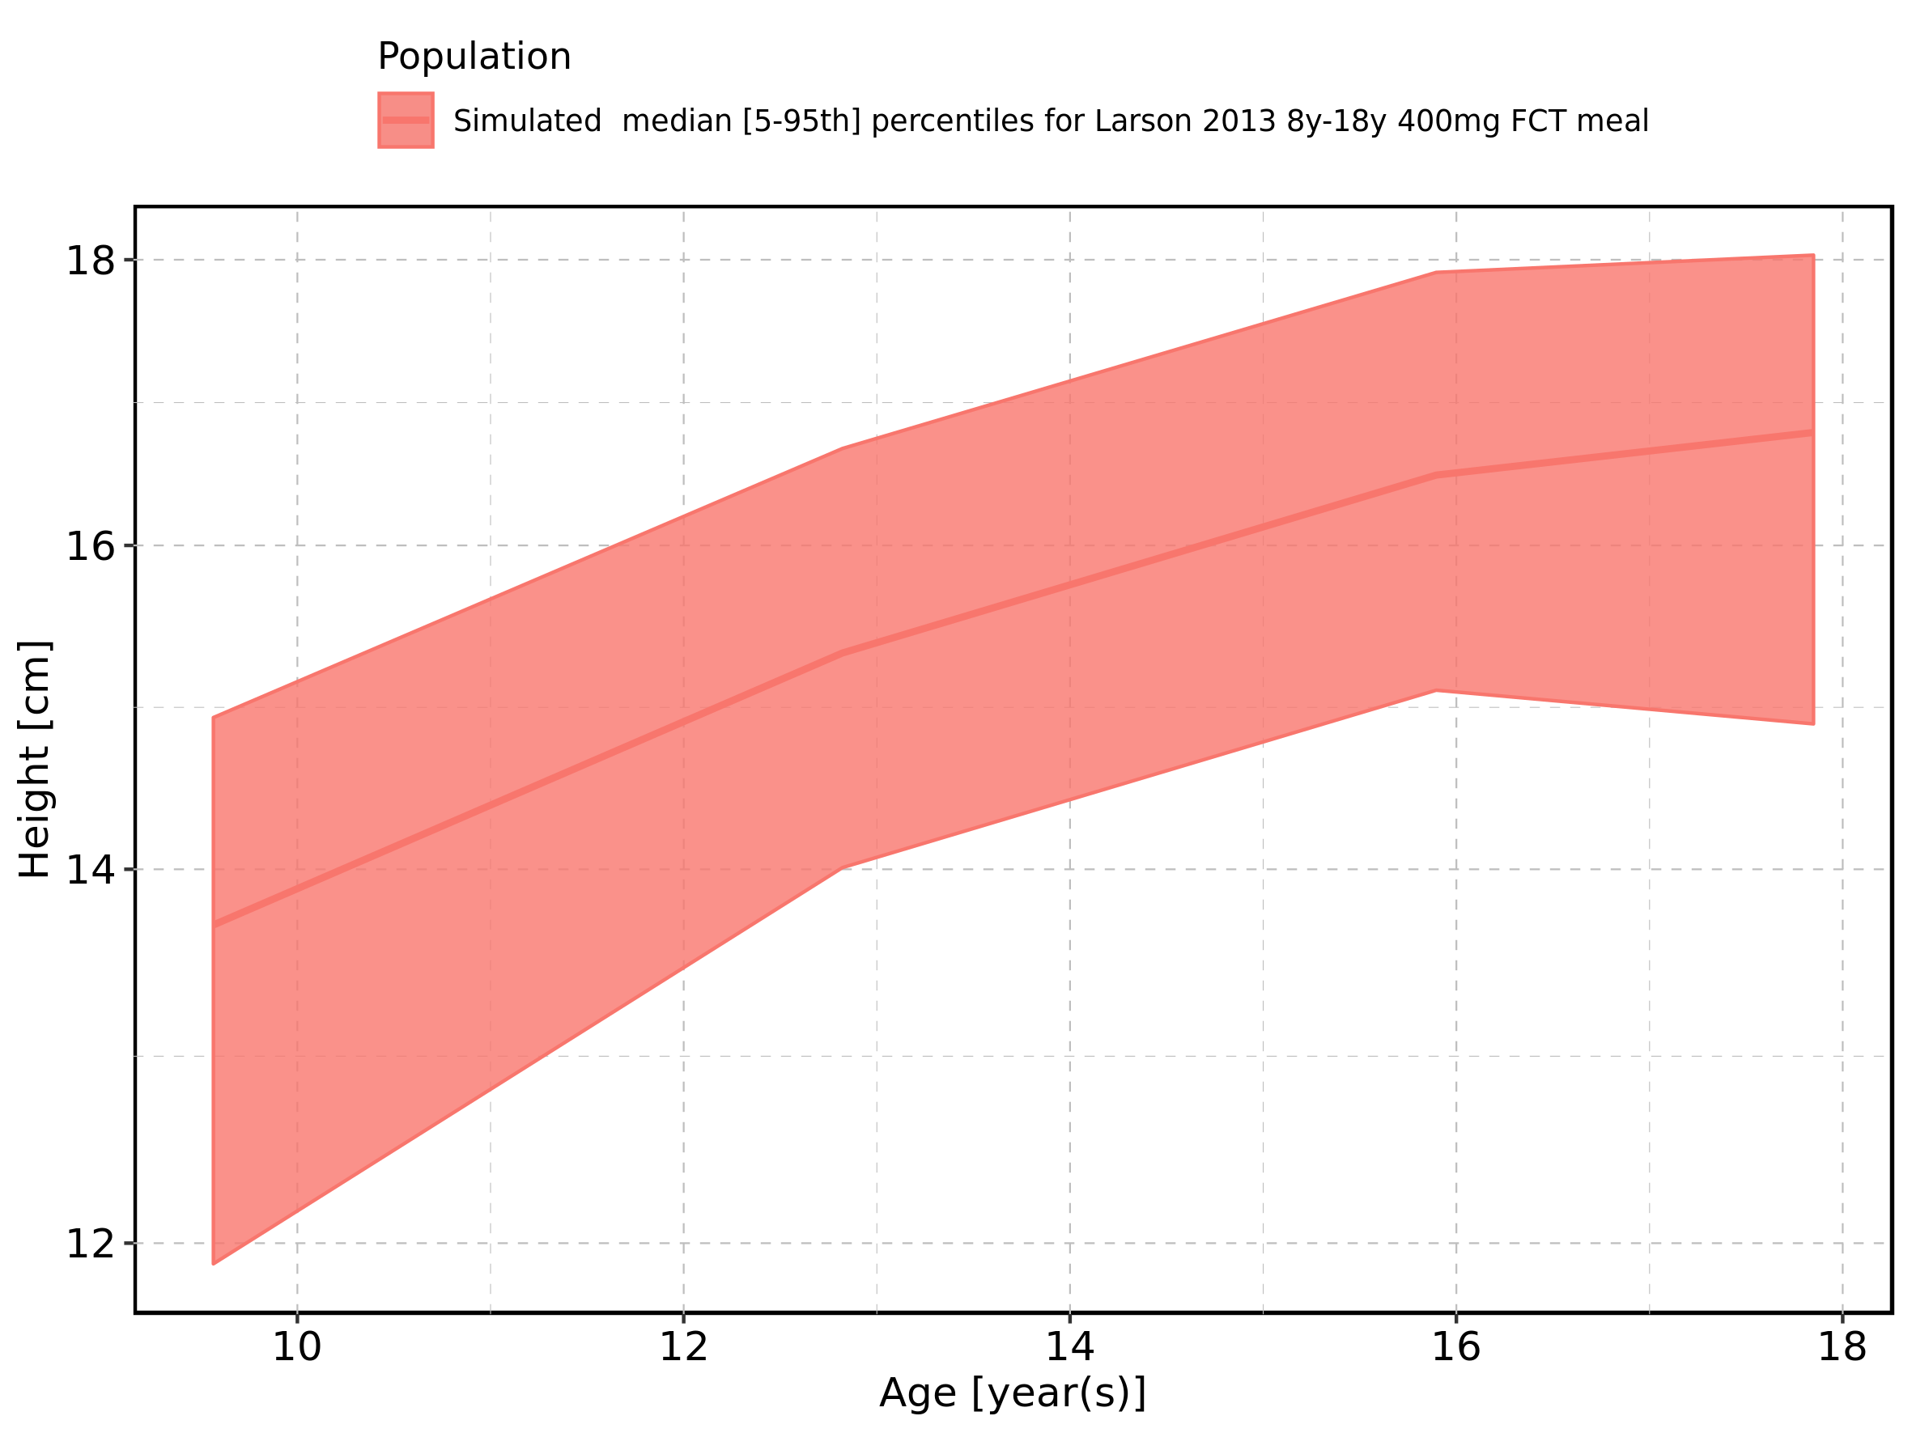

Figure 435: Age-dependence of Height for Filmcoated_tablet_400mg_sd. Profiles are plotted in a linear scale.

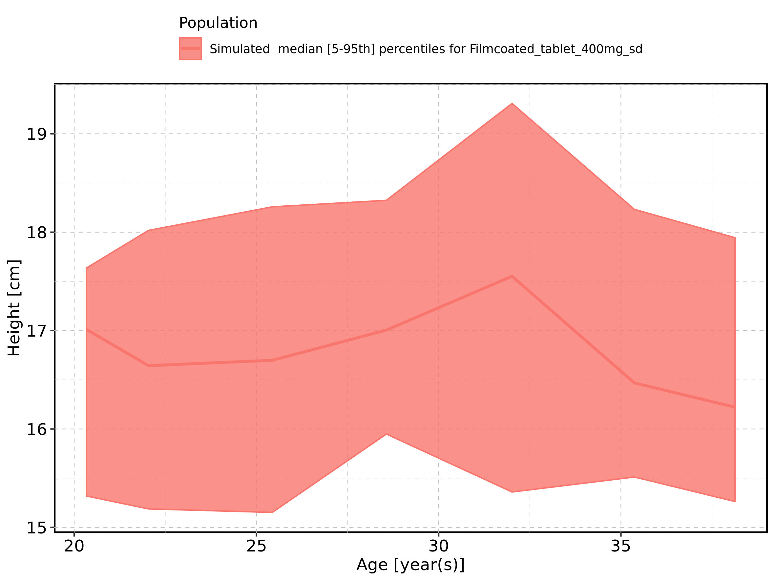

Figure 436: Age-dependence of Height for Filmcoated_tablet_400mg_sd. Profiles are plotted in a logarithmic scale.

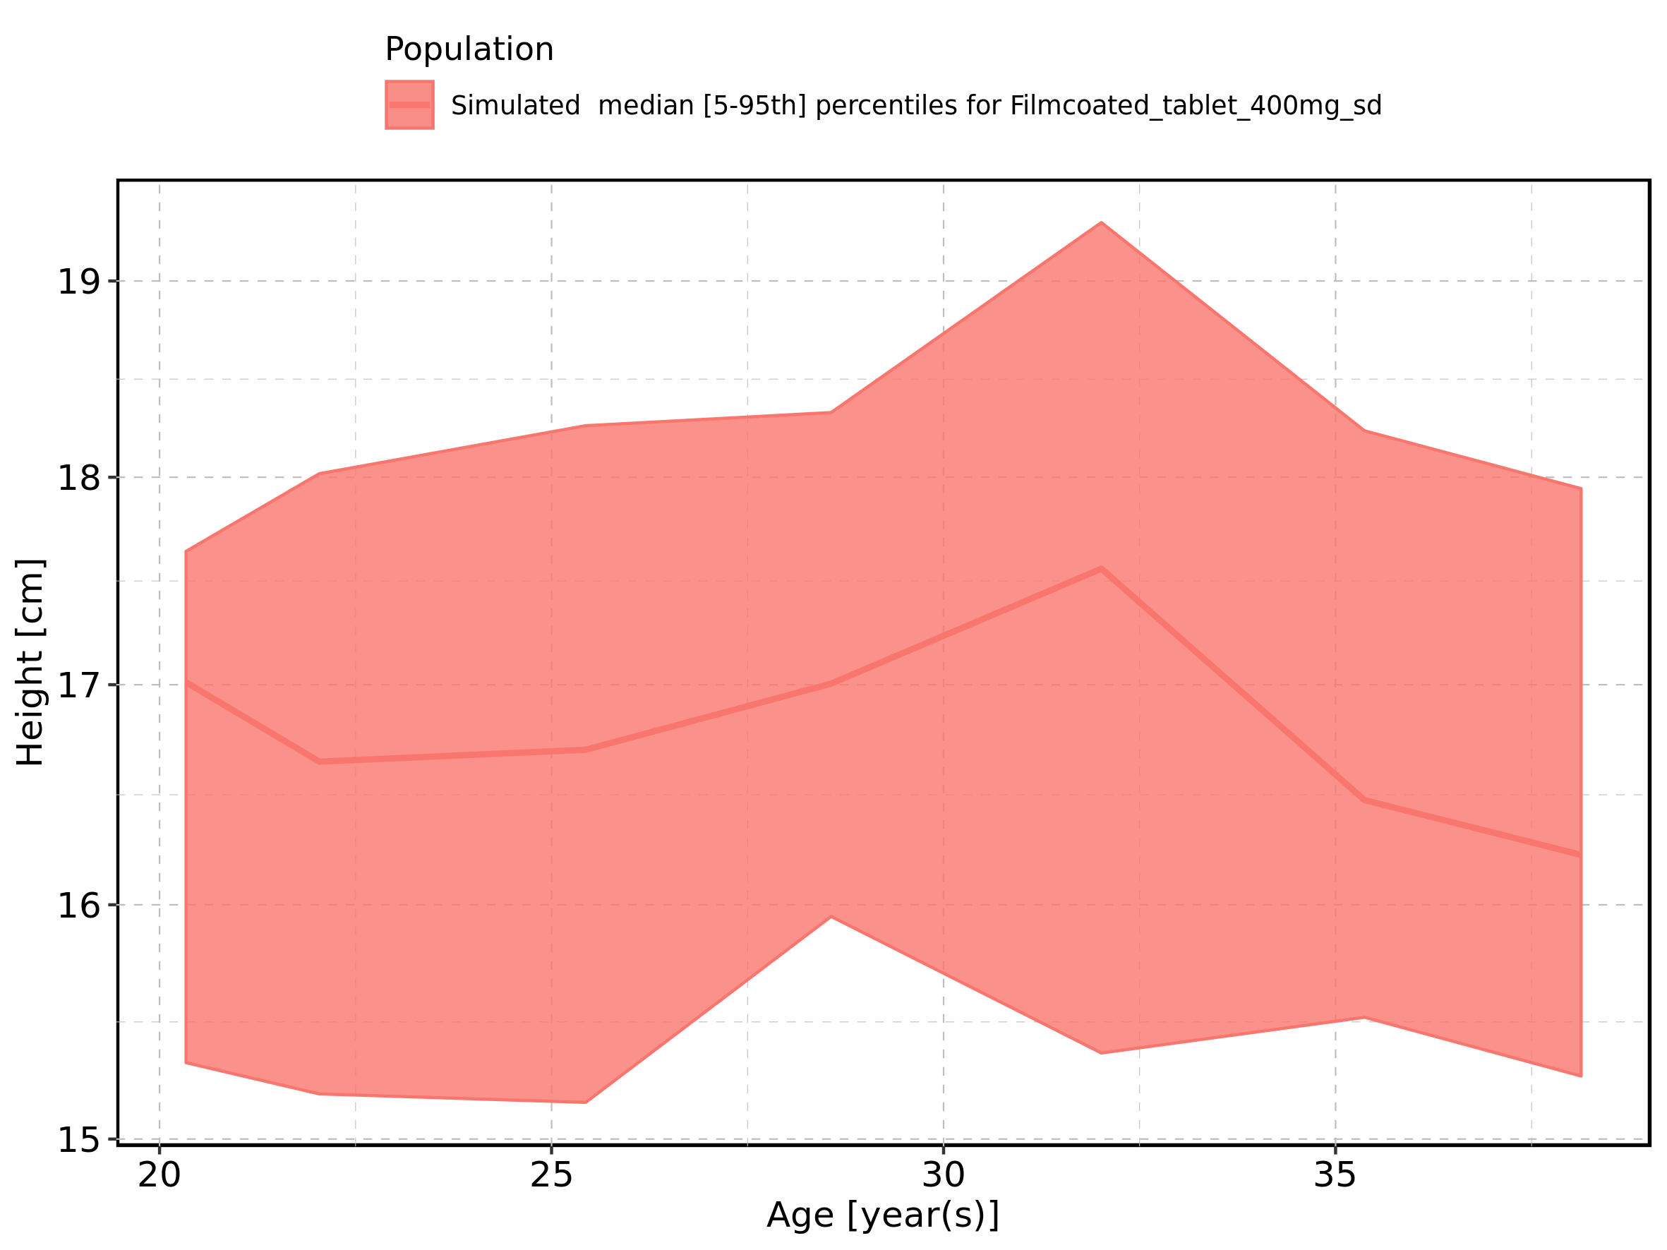

Figure 437: Age-dependence of Weight for Larson 2013 8y-18y 400mg FCT meal in comparison to Filmcoated_tablet_400mg_sd. Profiles are plotted in a linear scale.

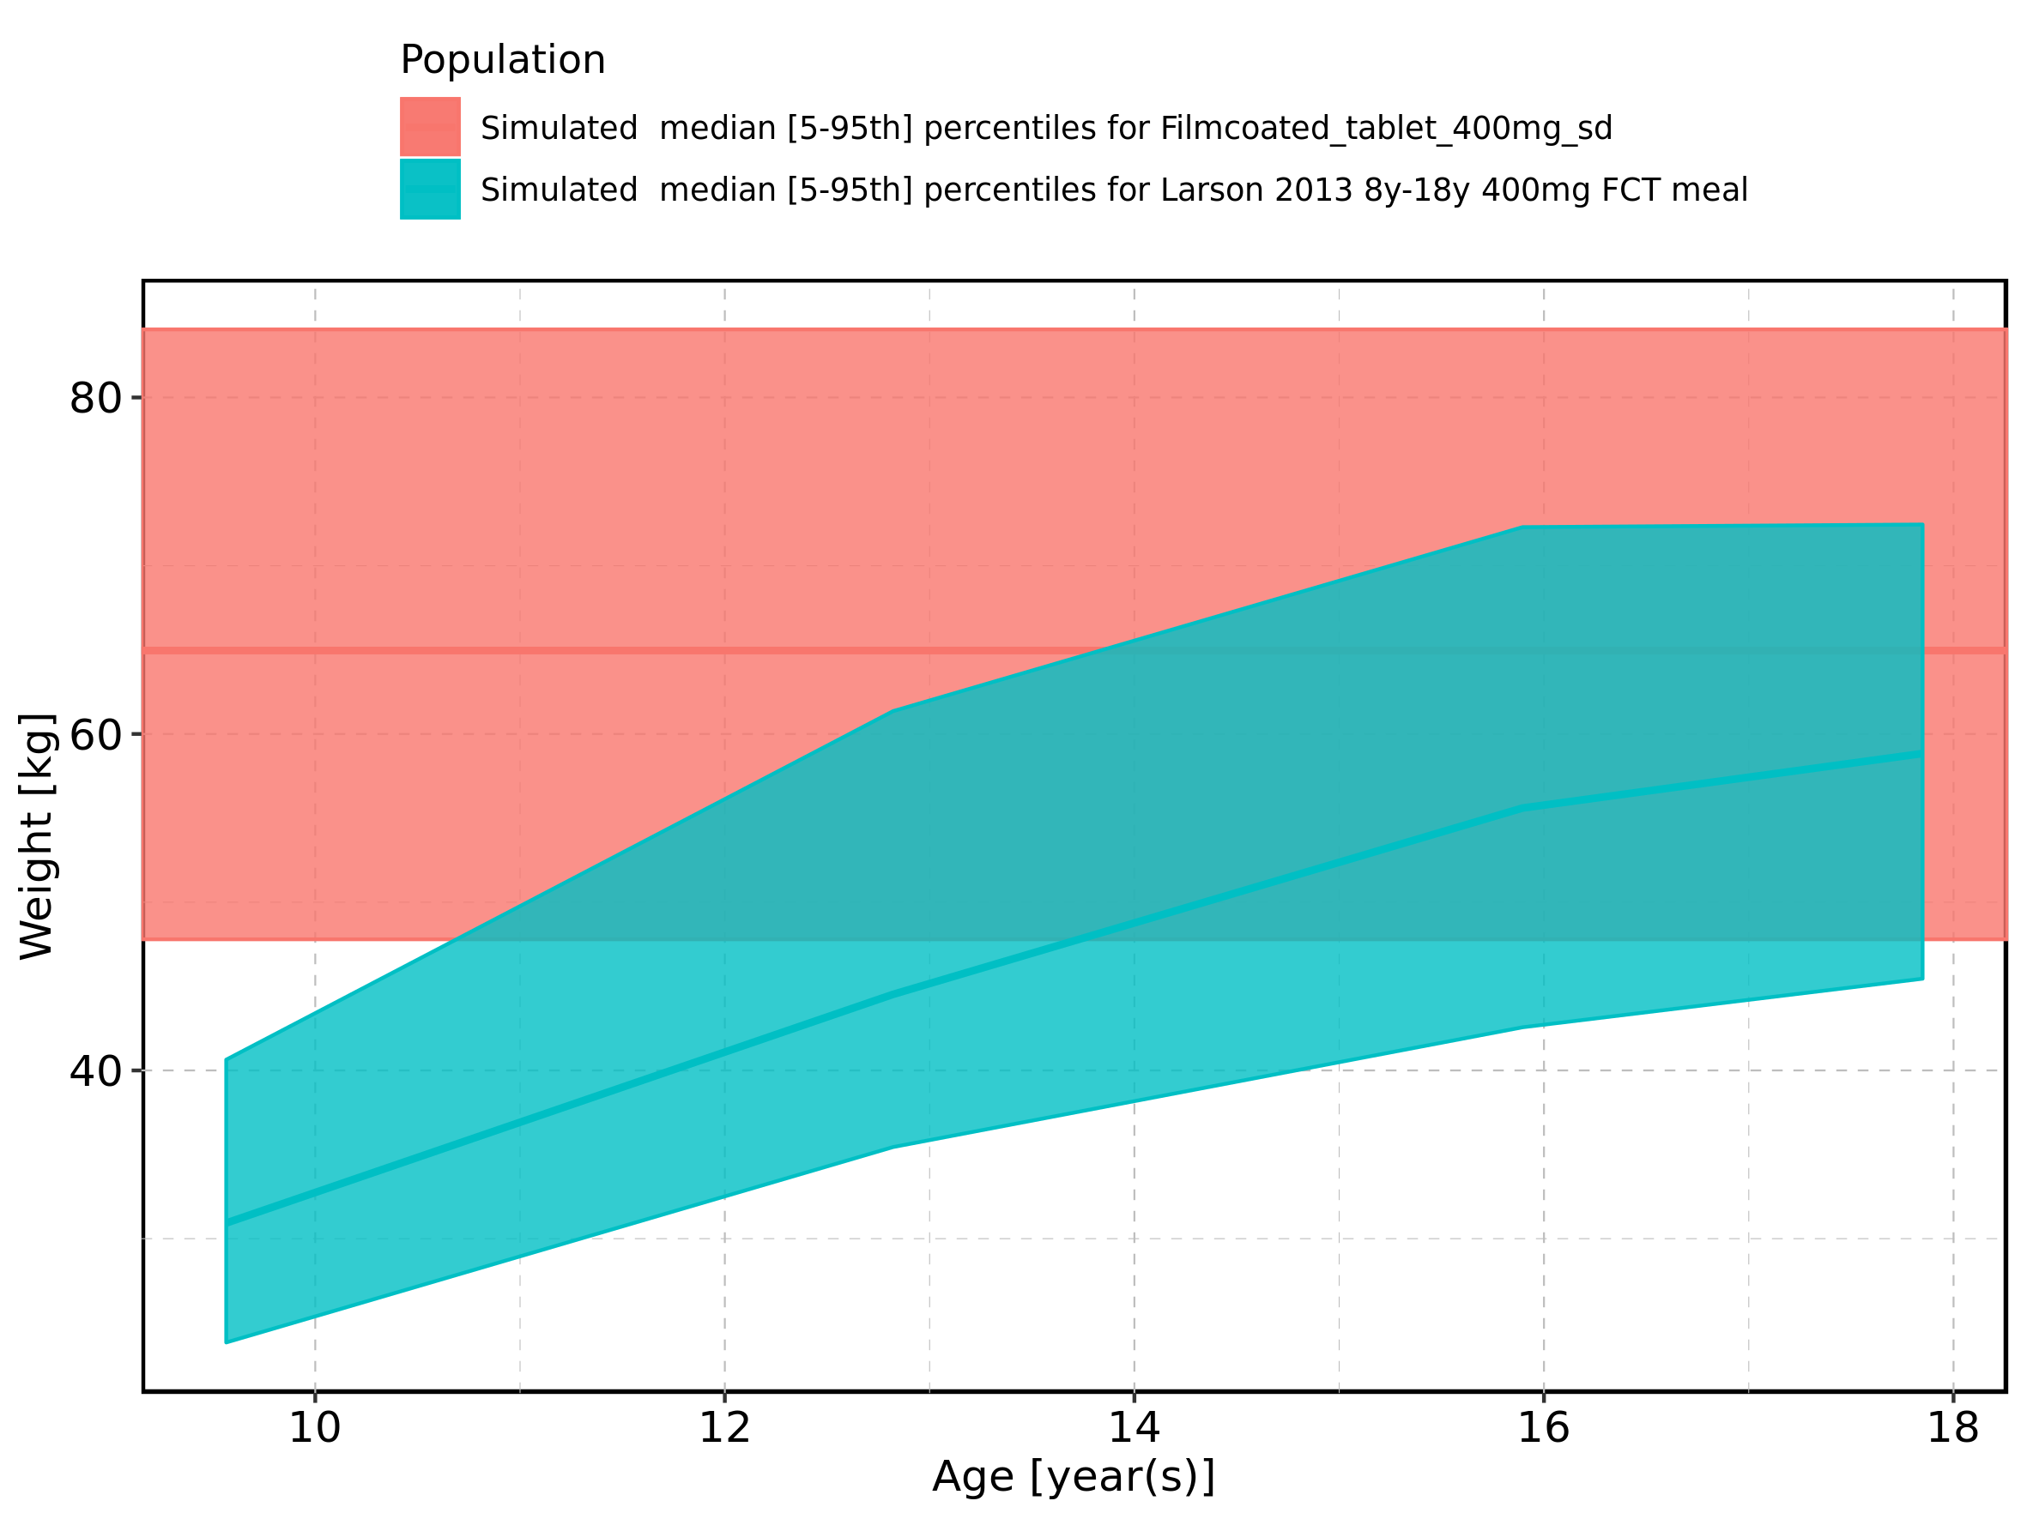

Figure 438: Age-dependence of Weight for Larson 2013 8y-18y 400mg FCT meal in comparison to Filmcoated_tablet_400mg_sd. Profiles are plotted in a logarithmic scale.

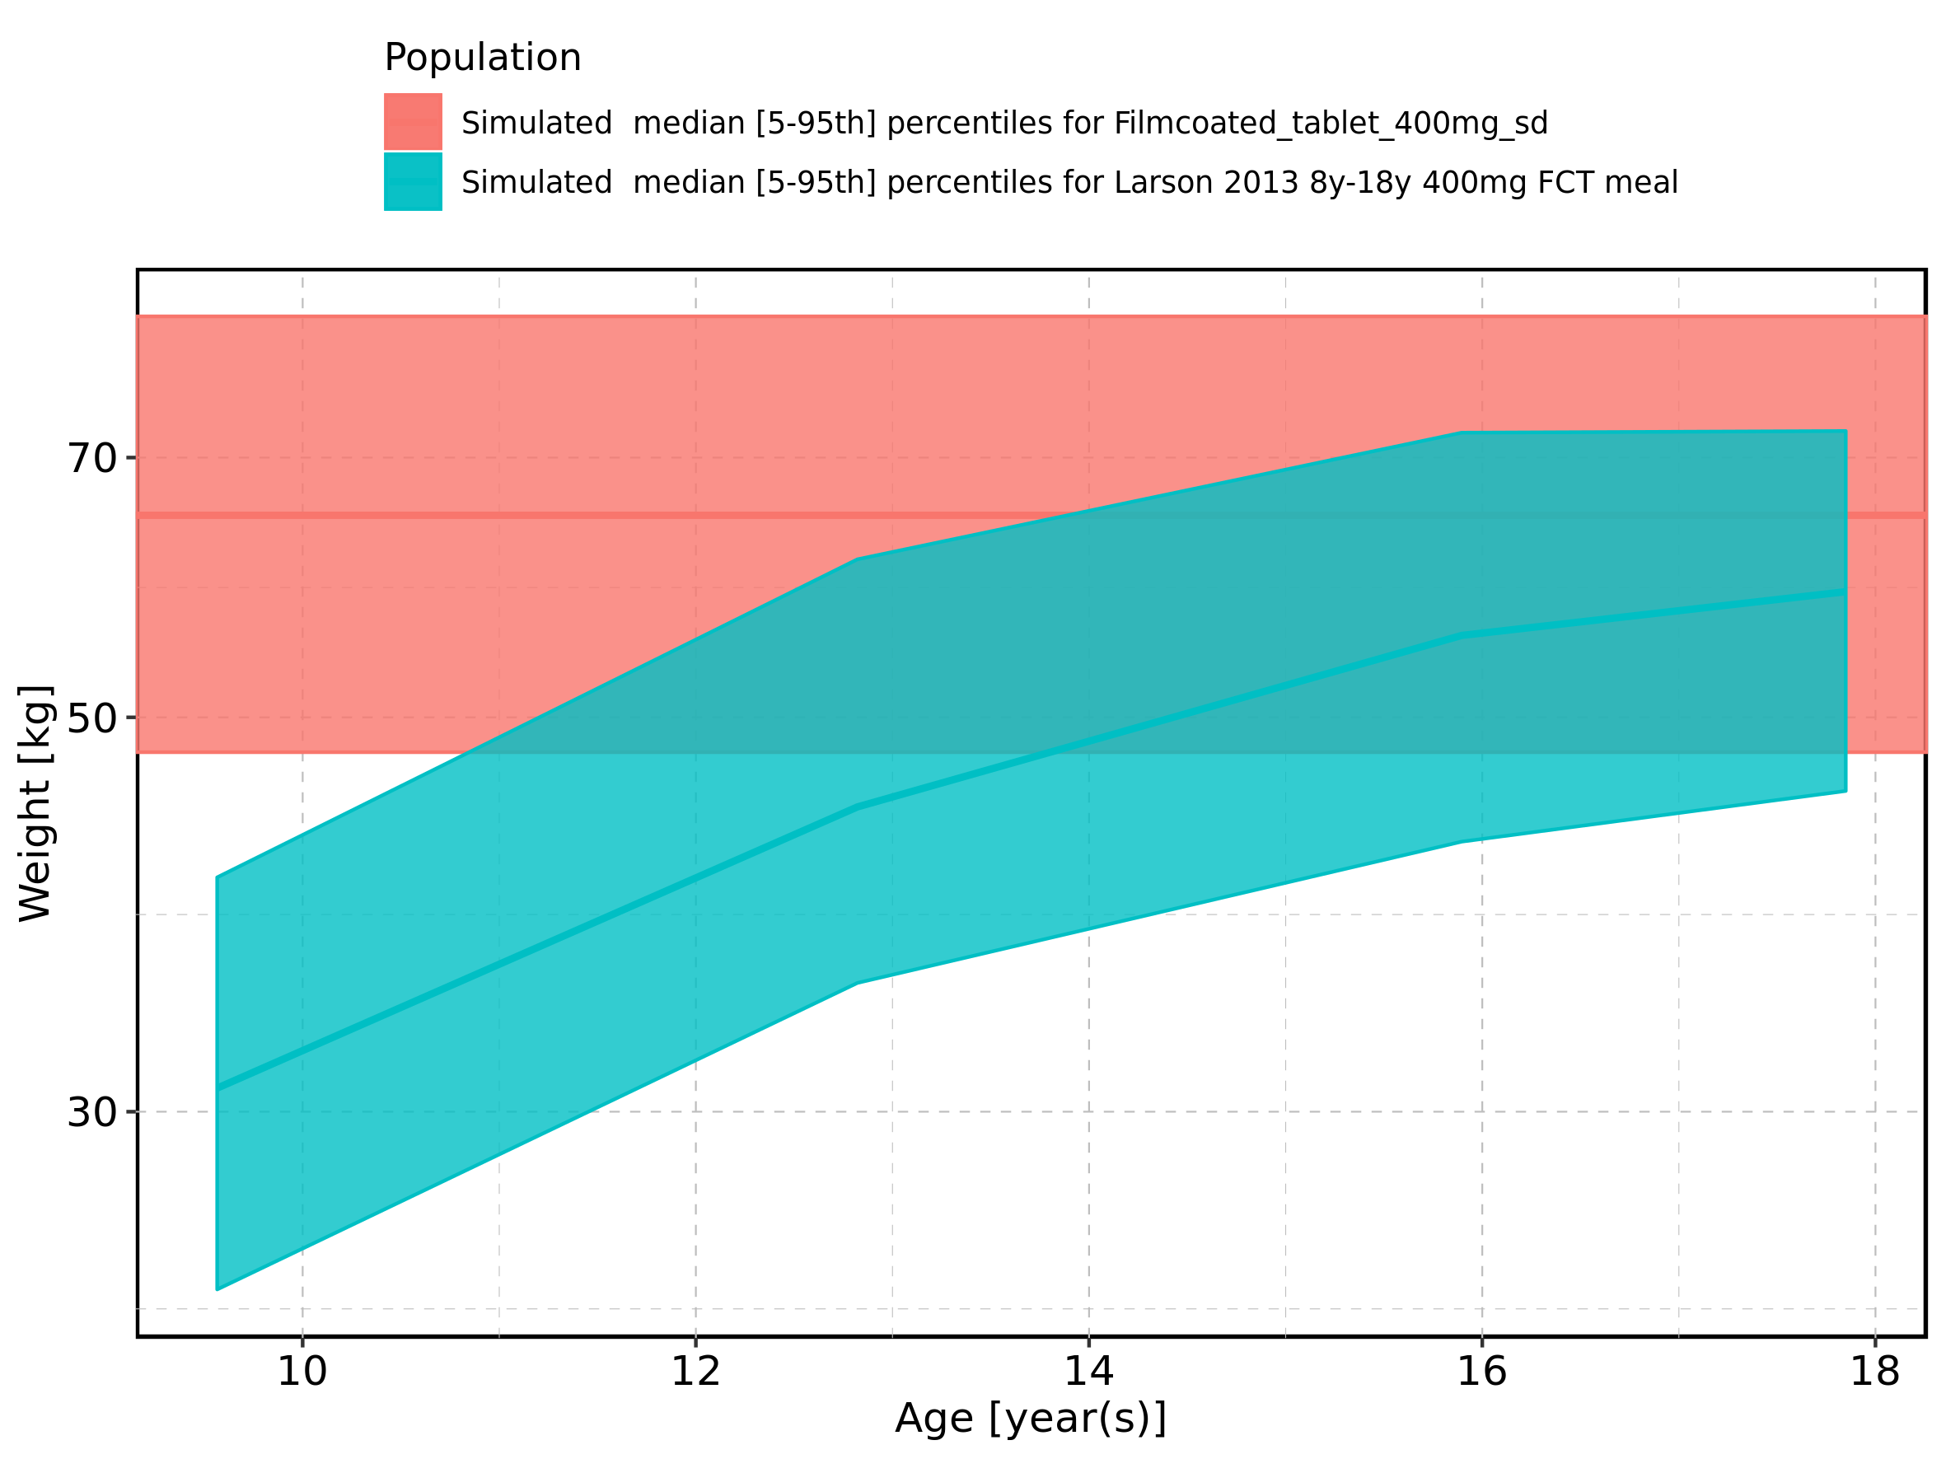

Figure 439: Age-dependence of Weight for Larson 2013 8y-18y 400mg FCT meal. Profiles are plotted in a linear scale.

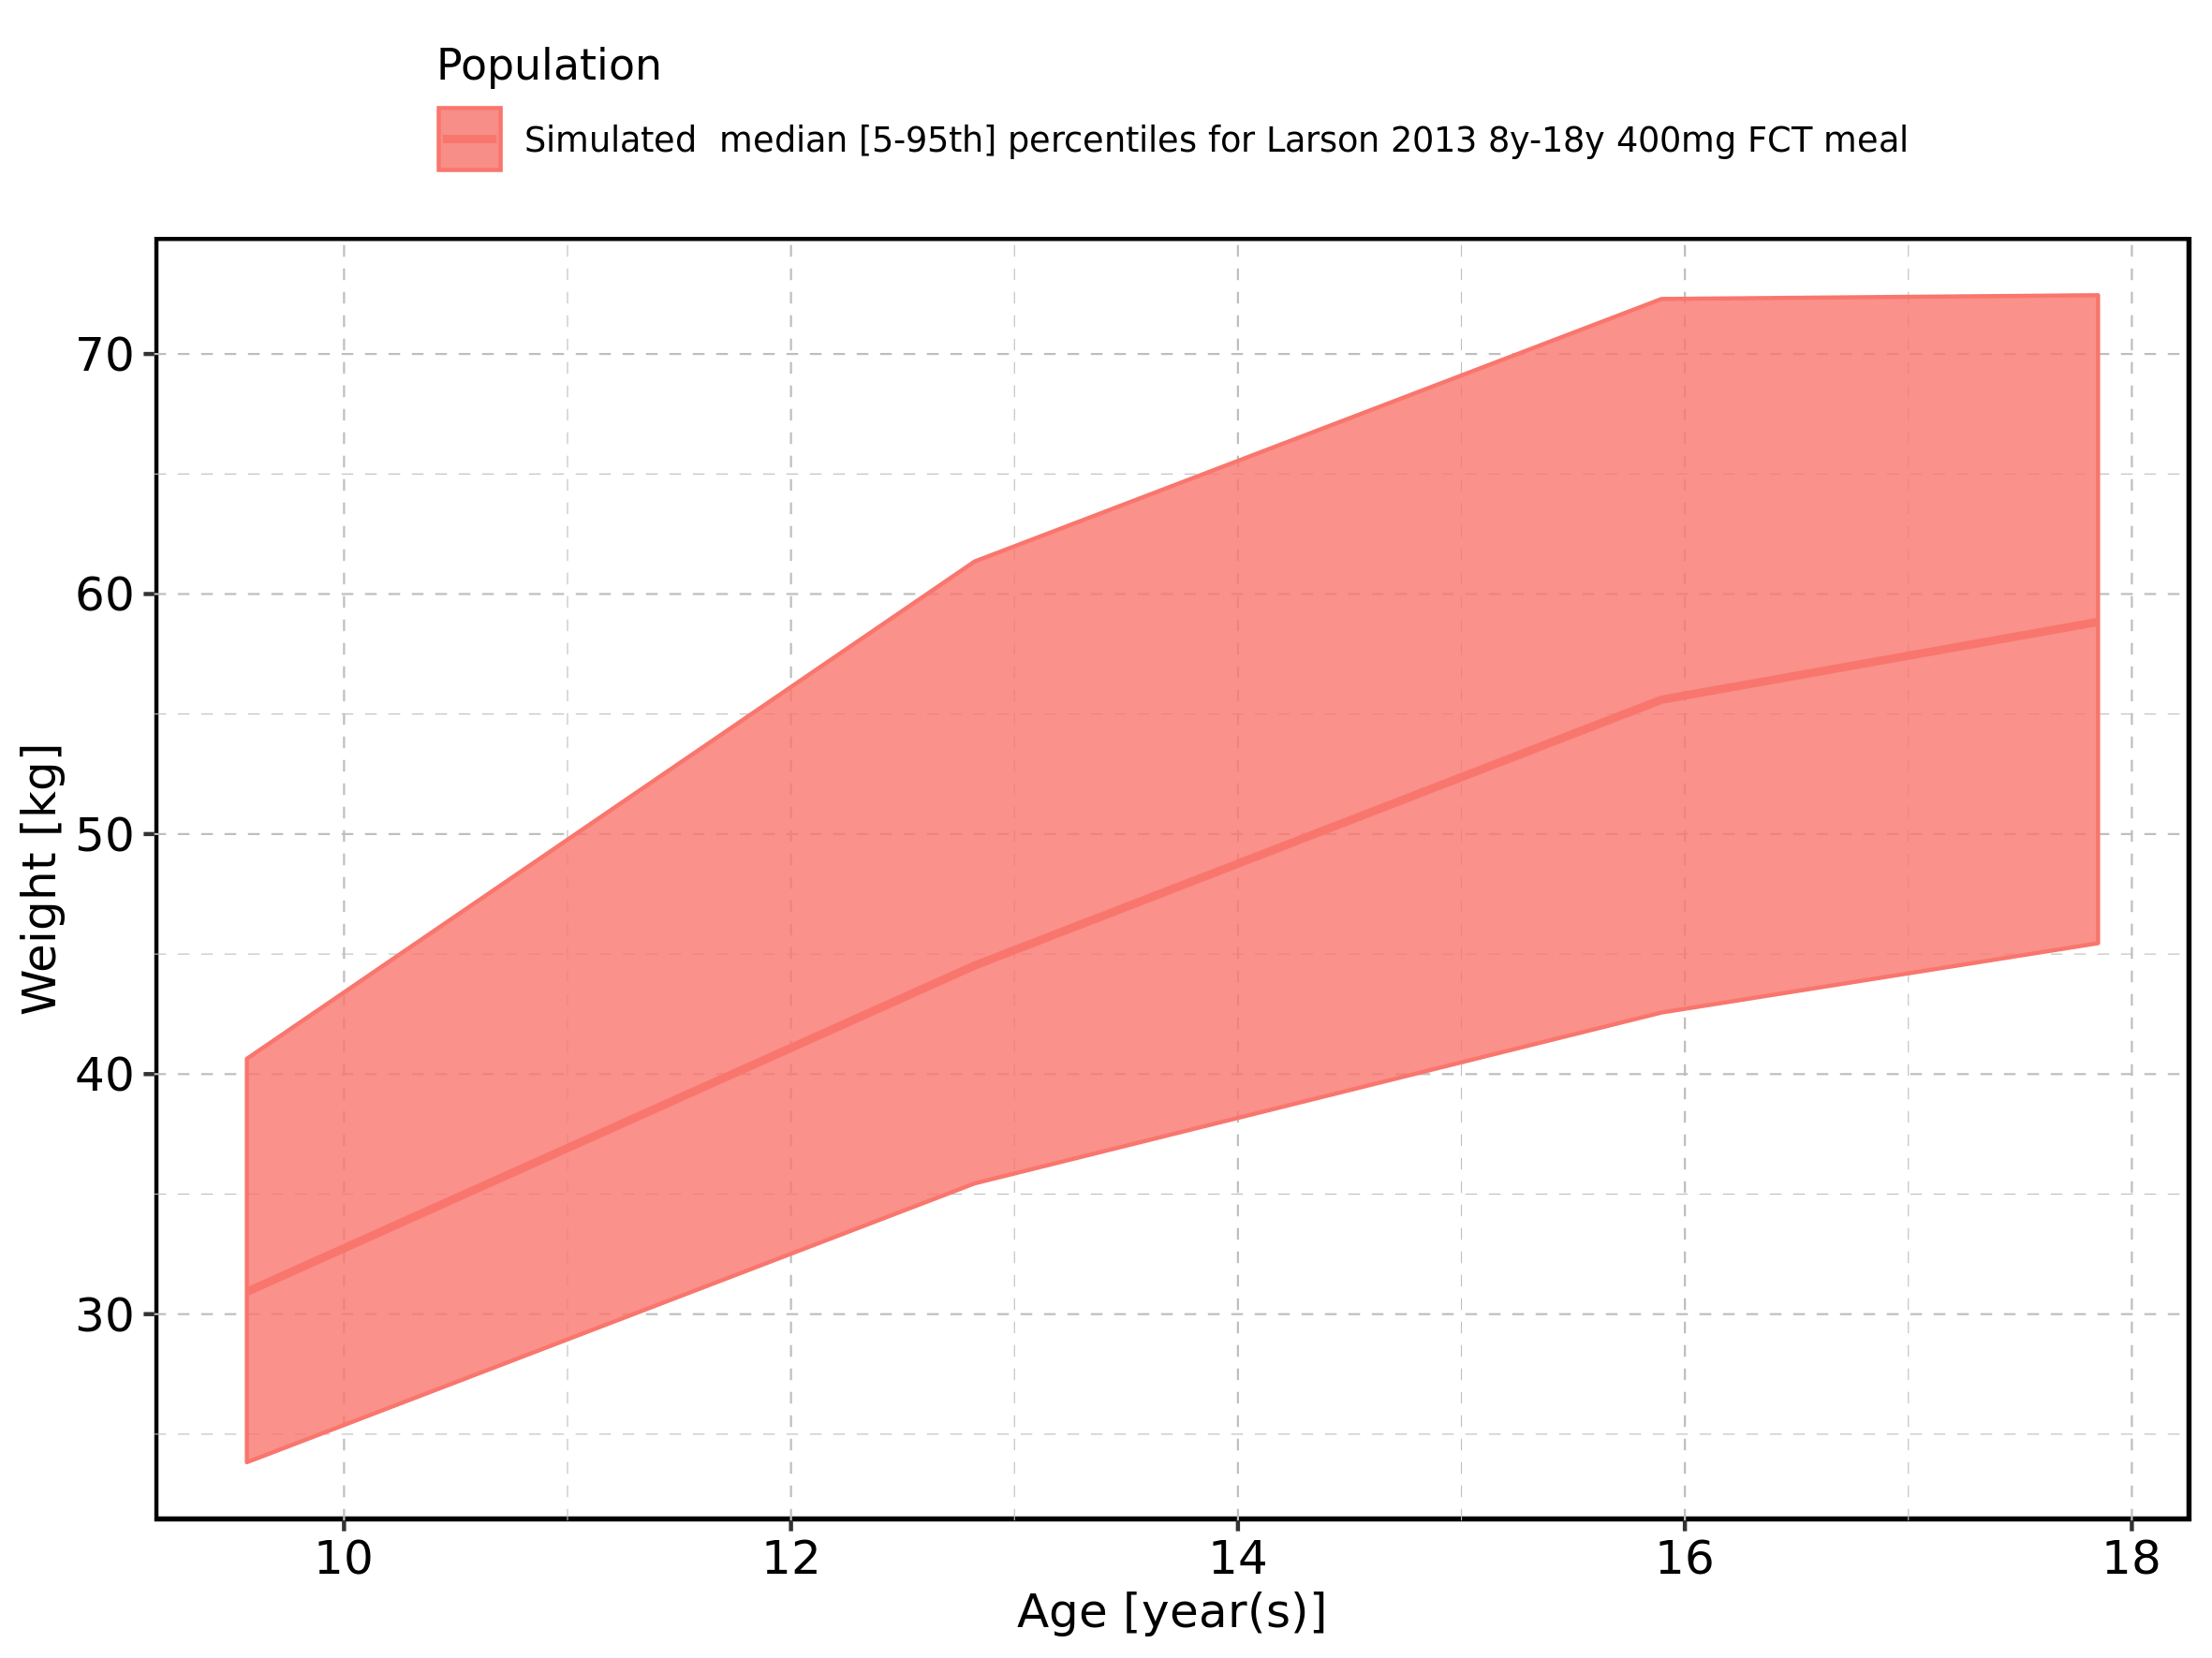

Figure 440: Age-dependence of Weight for Larson 2013 8y-18y 400mg FCT meal. Profiles are plotted in a logarithmic scale.

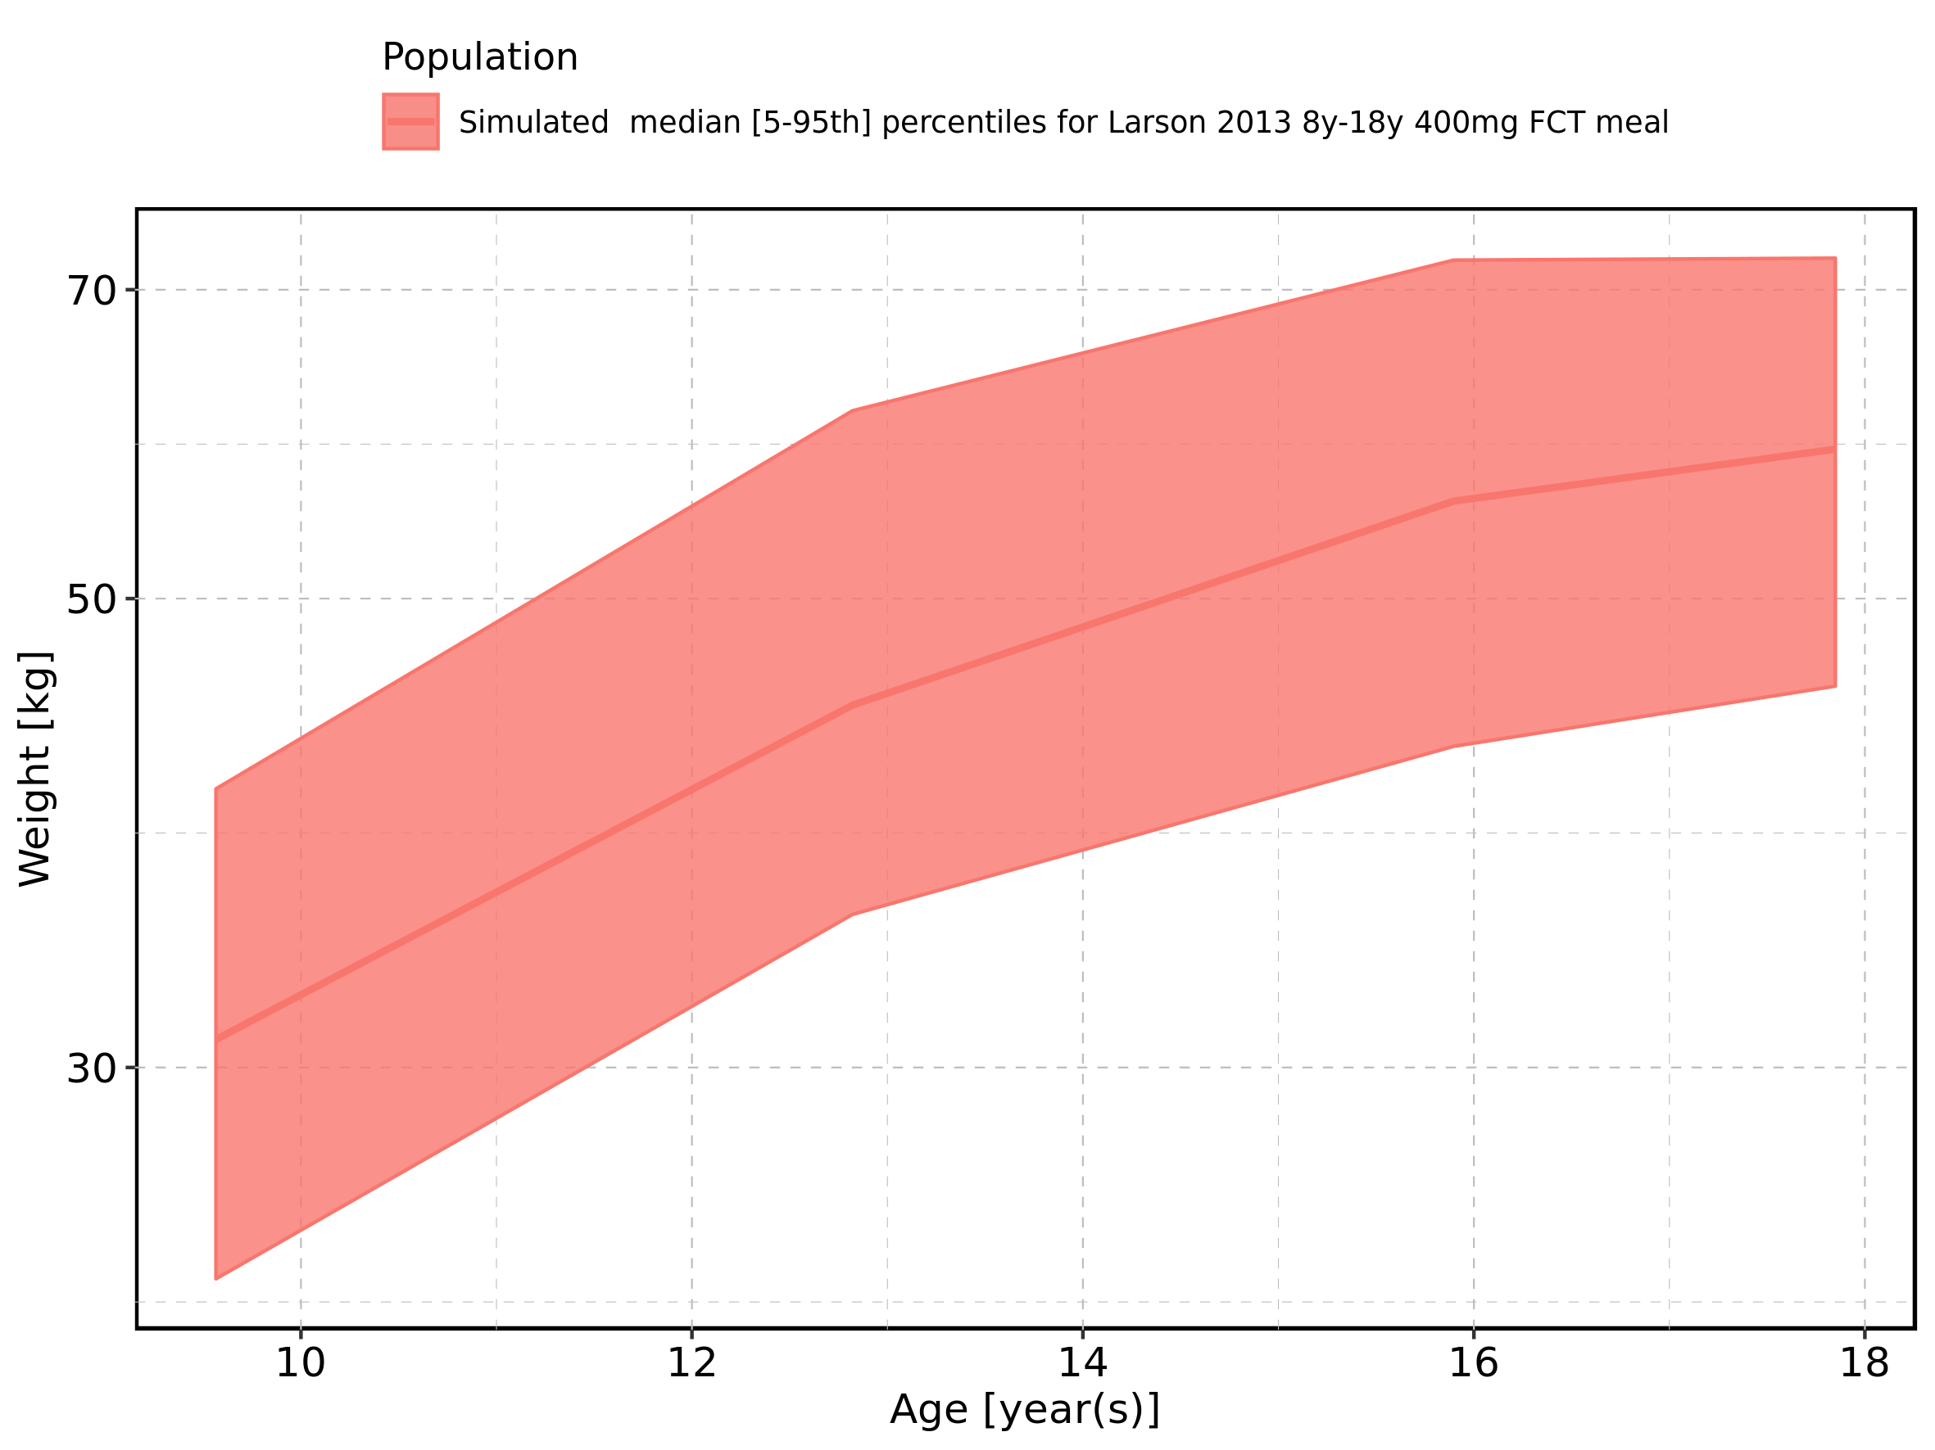

Figure 441: Age-dependence of Weight for Filmcoated_tablet_400mg_sd. Profiles are plotted in a linear scale.

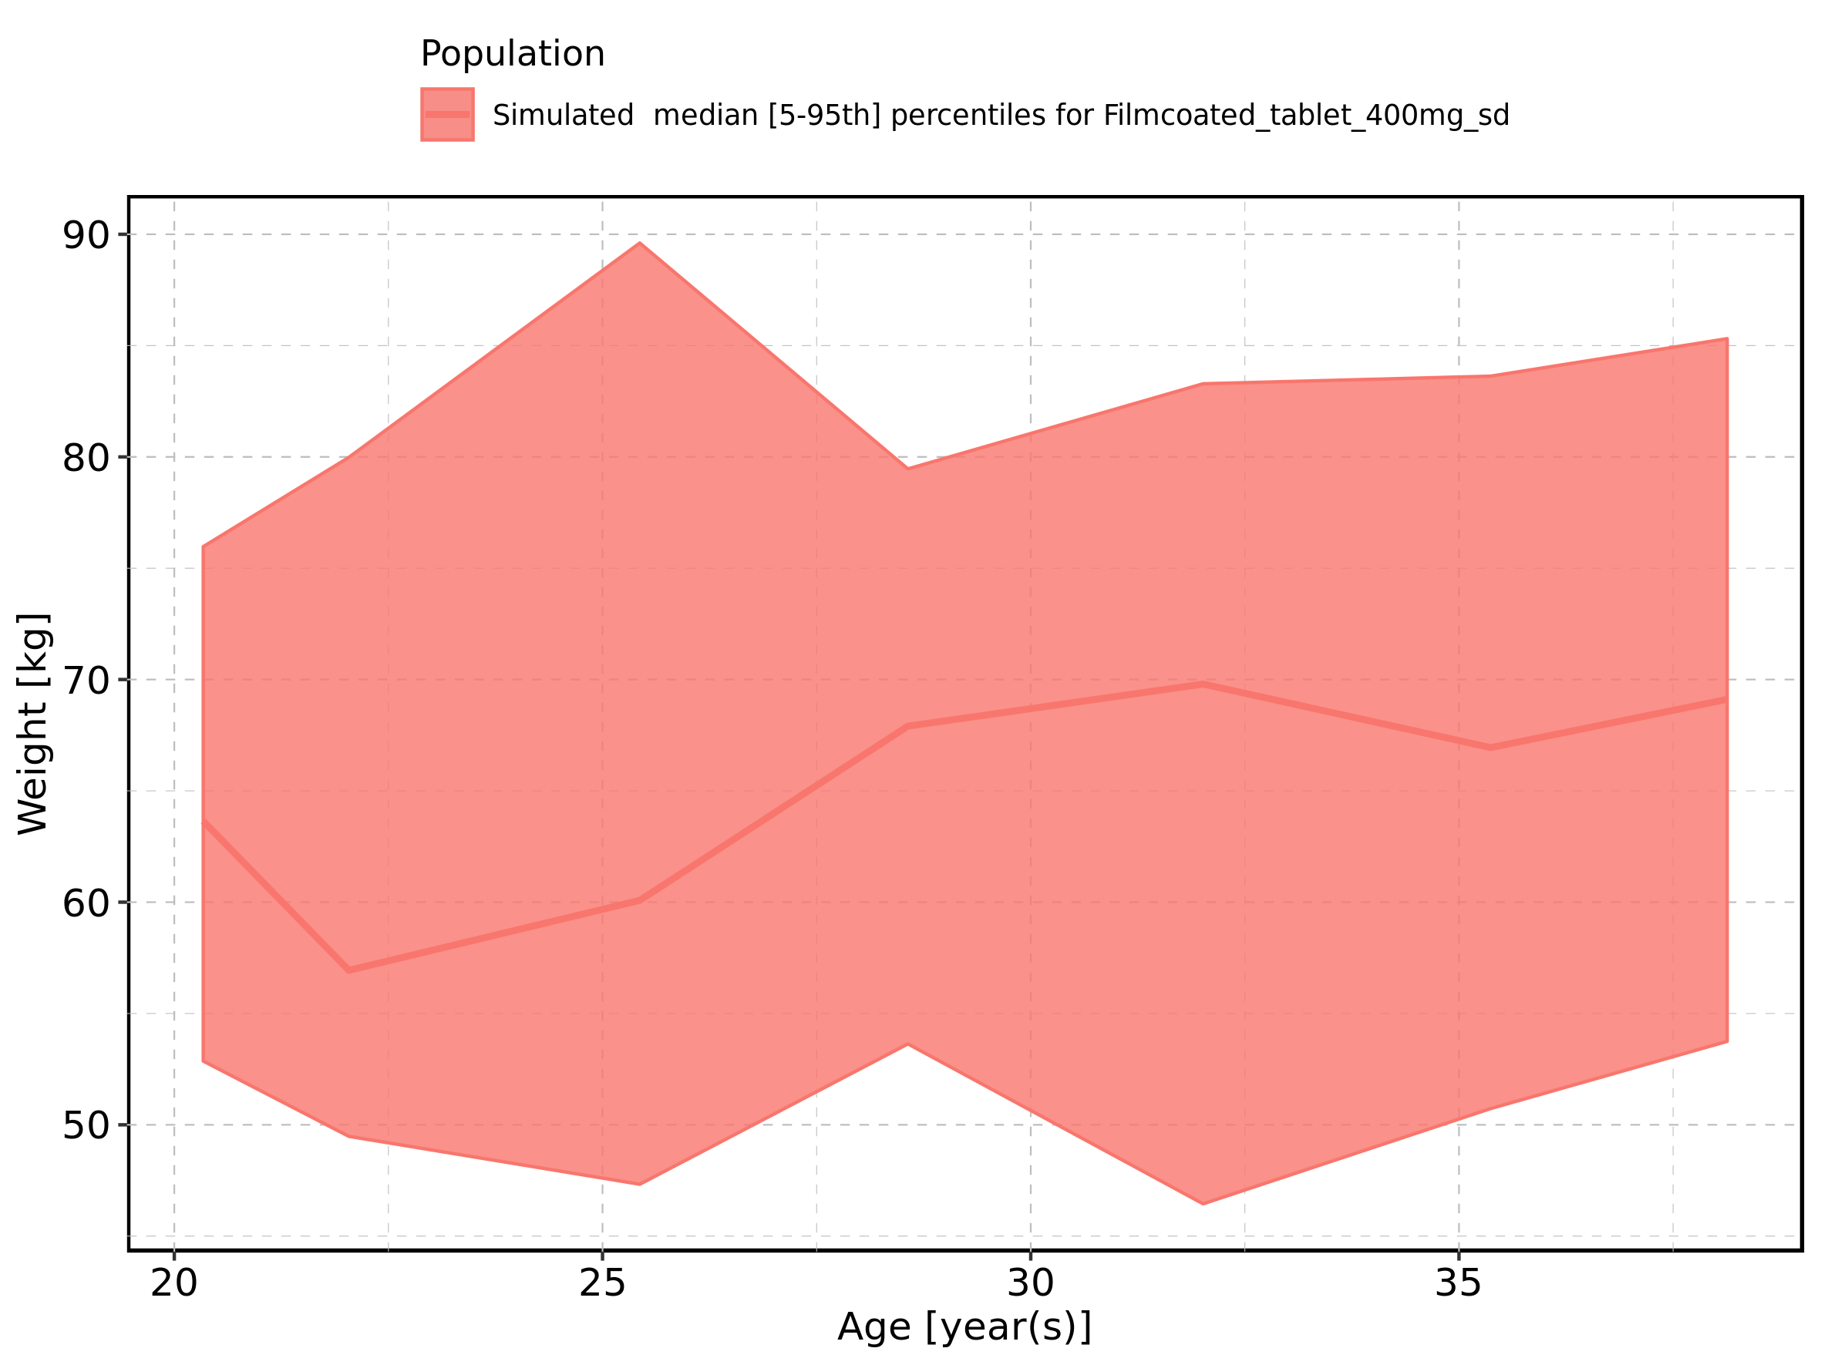

Figure 442: Age-dependence of Weight for Filmcoated_tablet_400mg_sd. Profiles are plotted in a logarithmic scale.

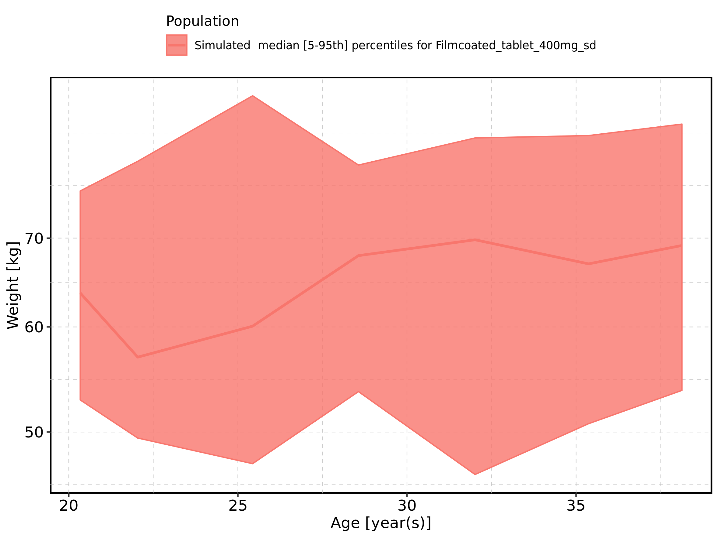

Figure 443: Age-dependence of BMI for Larson 2013 8y-18y 400mg FCT meal in comparison to Filmcoated_tablet_400mg_sd. Profiles are plotted in a linear scale.

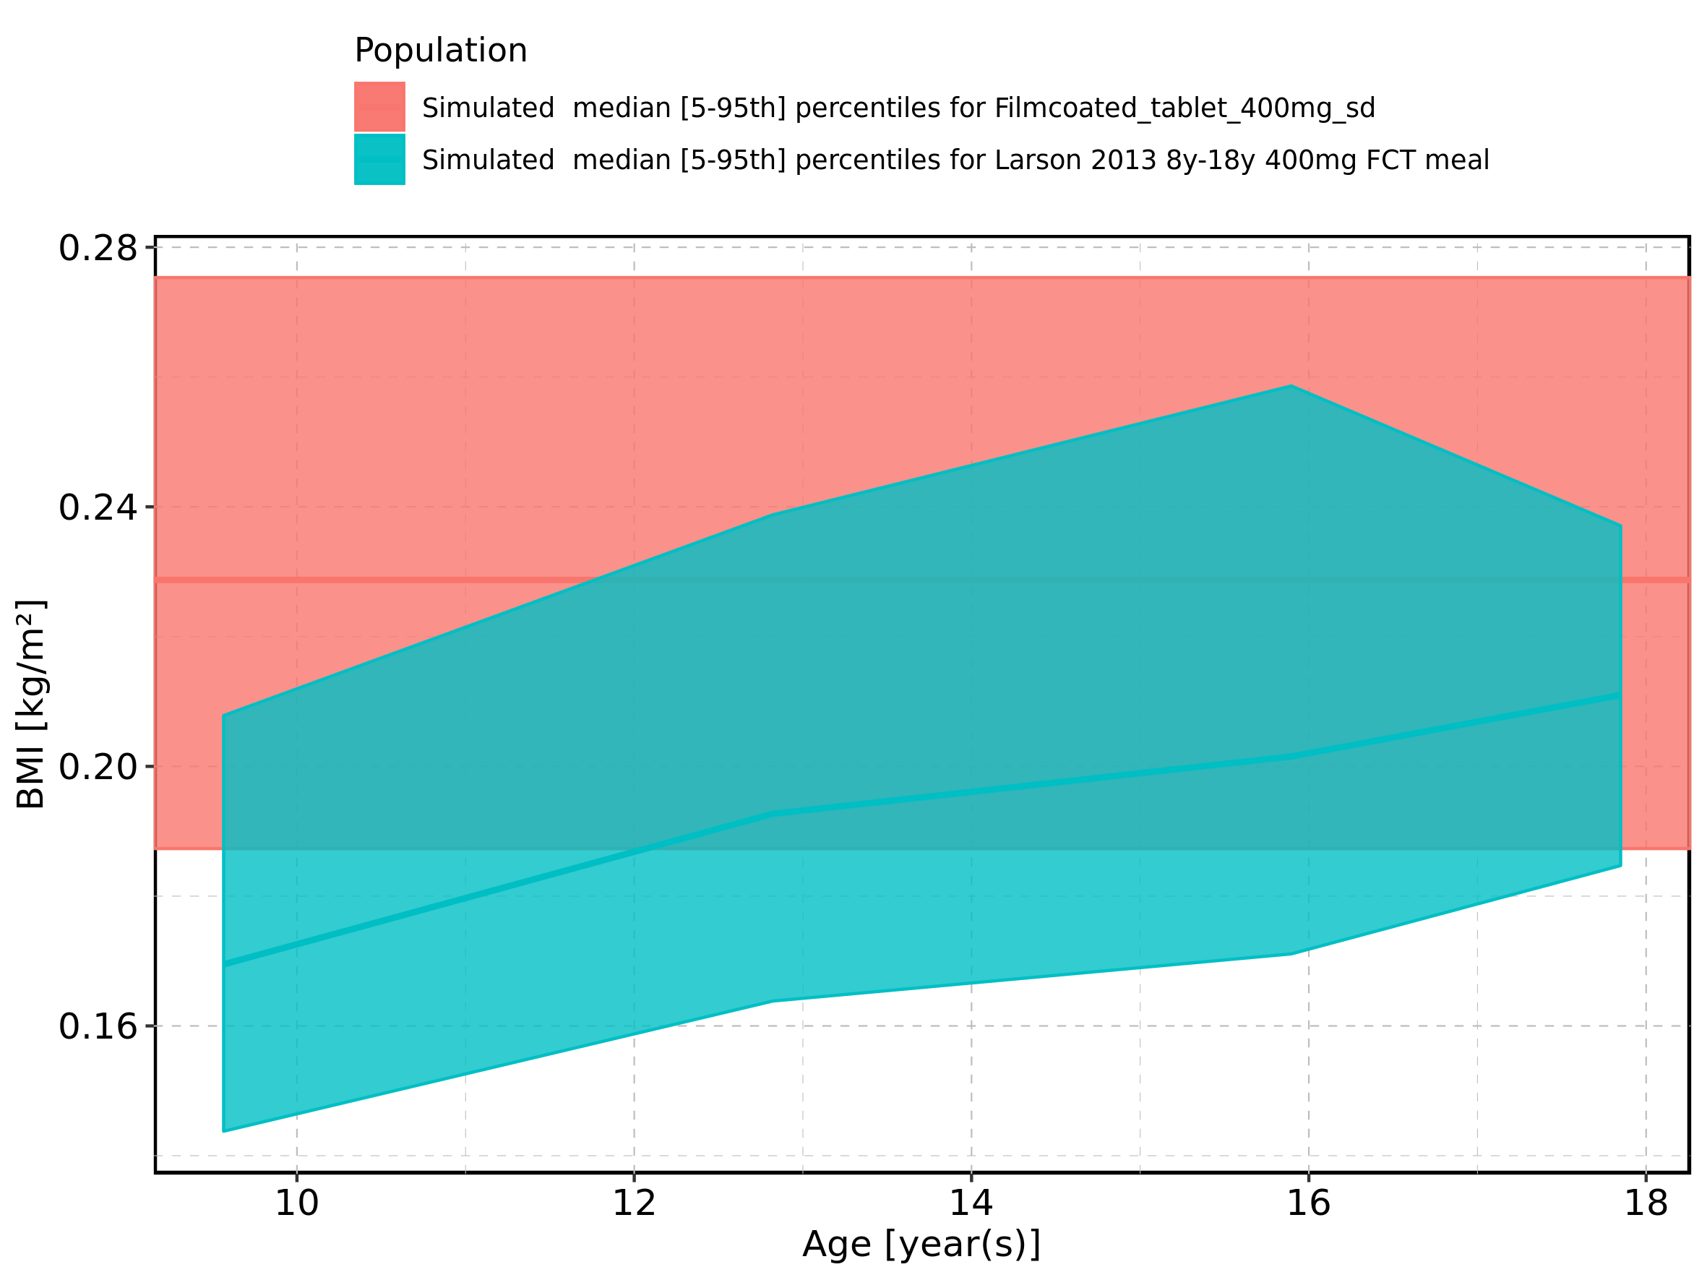

Figure 444: Age-dependence of BMI for Larson 2013 8y-18y 400mg FCT meal in comparison to Filmcoated_tablet_400mg_sd. Profiles are plotted in a logarithmic scale.

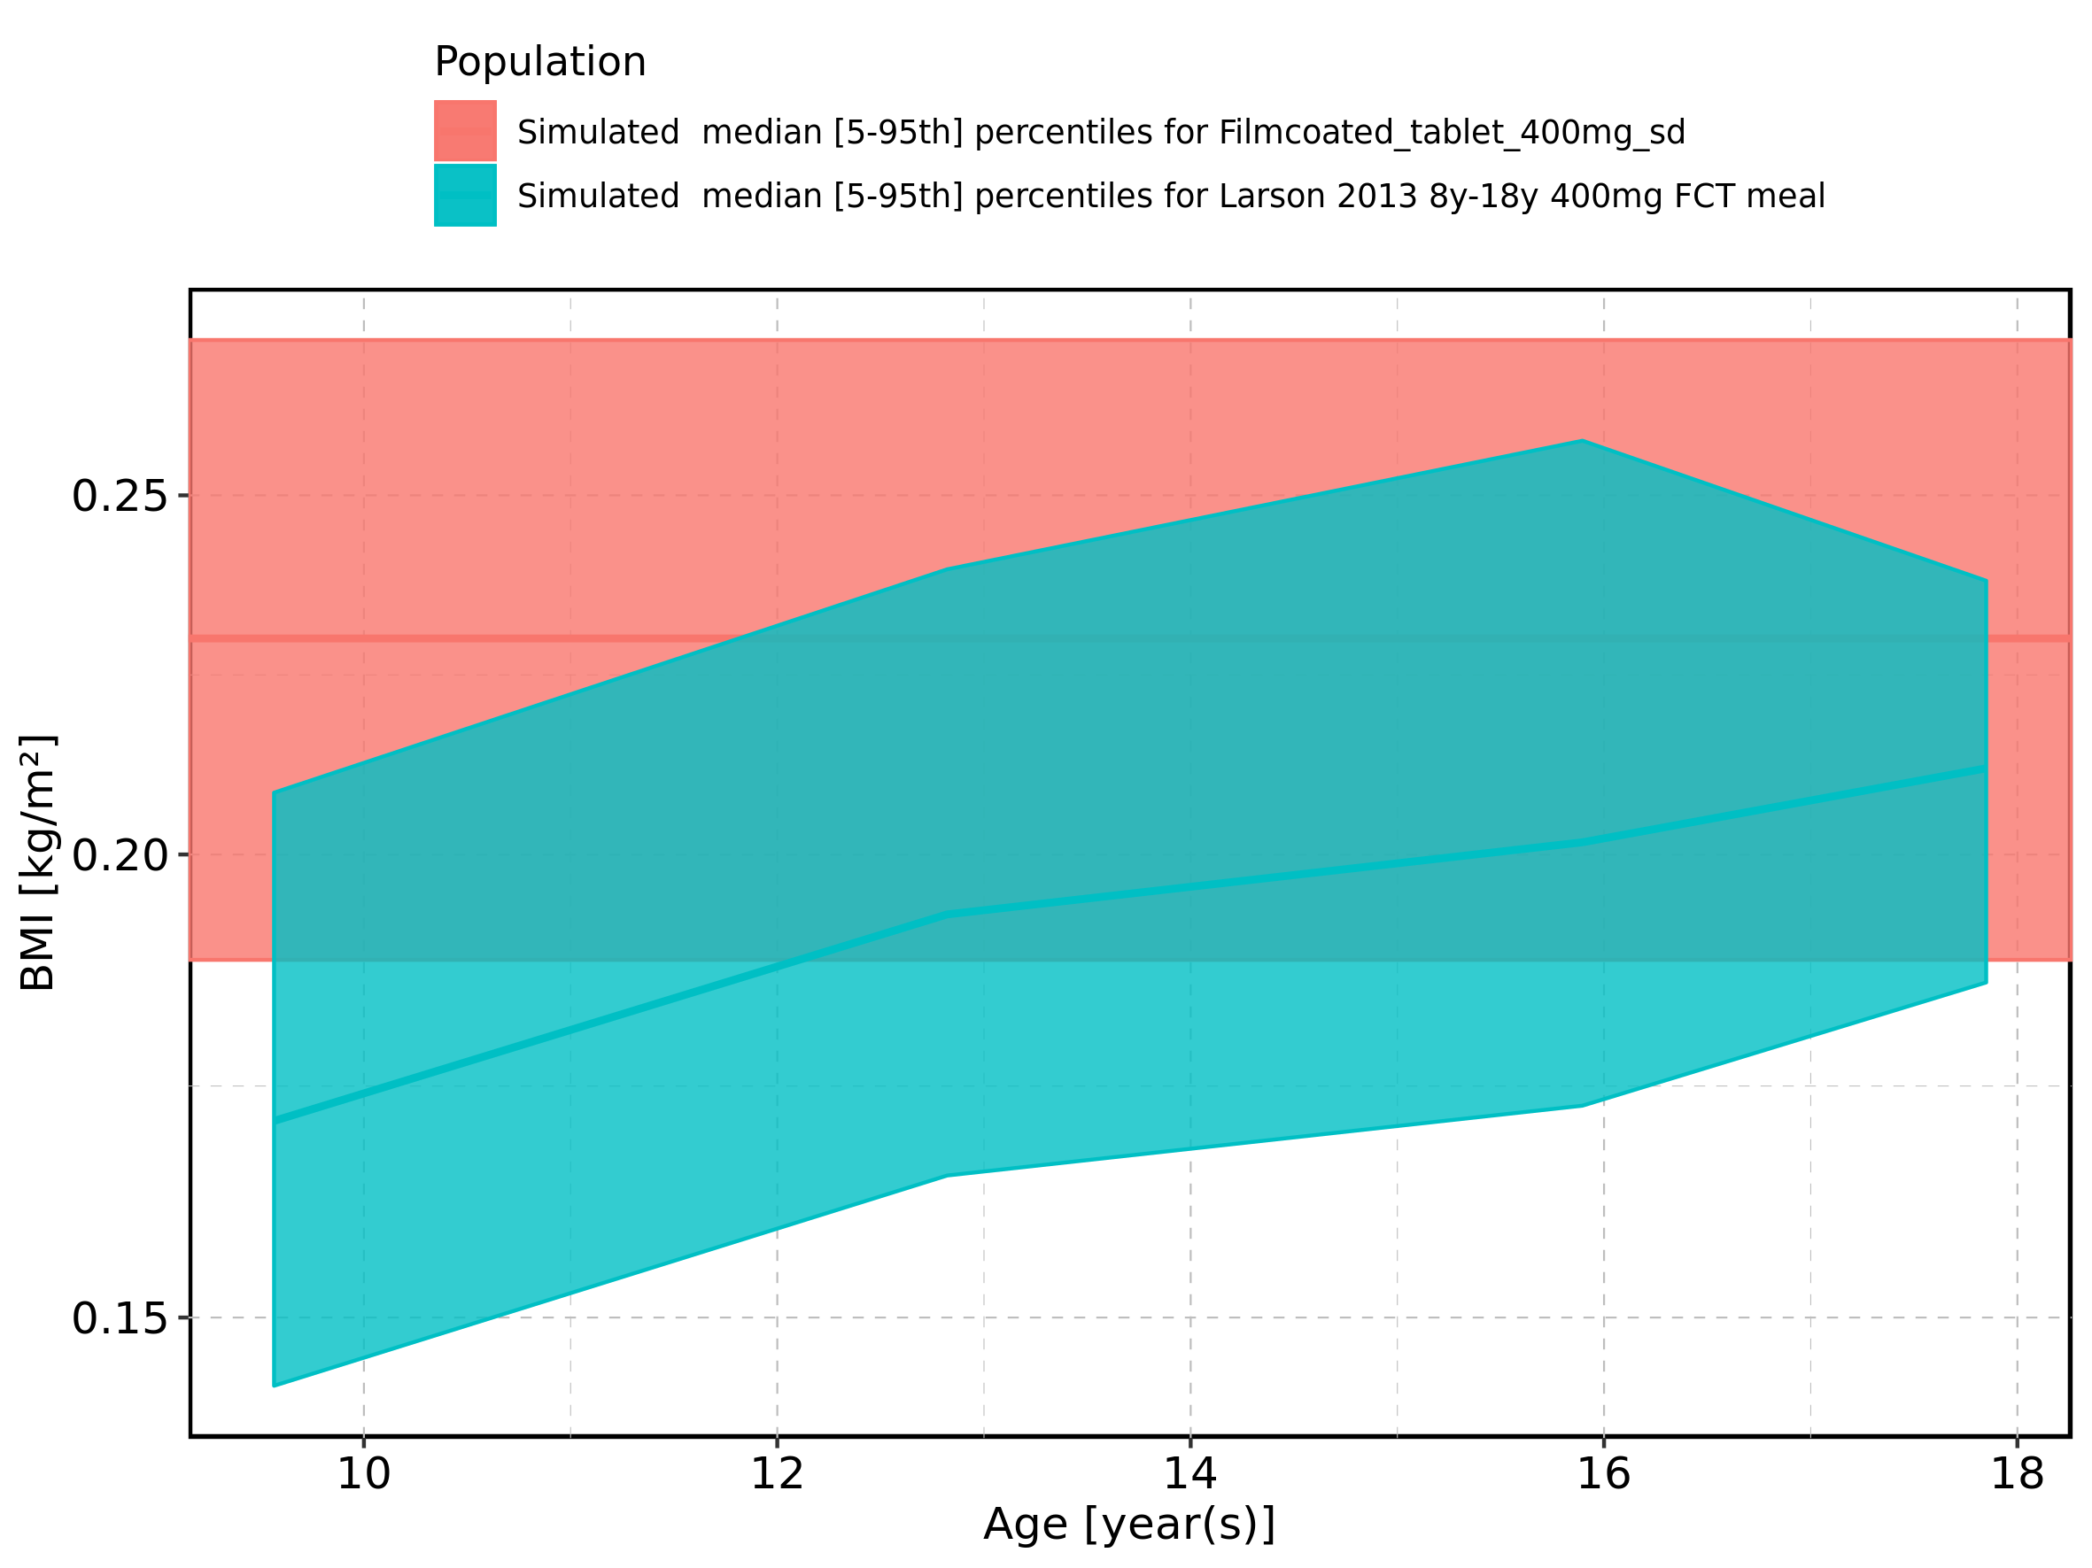

Figure 445: Age-dependence of BMI for Larson 2013 8y-18y 400mg FCT meal. Profiles are plotted in a linear scale.

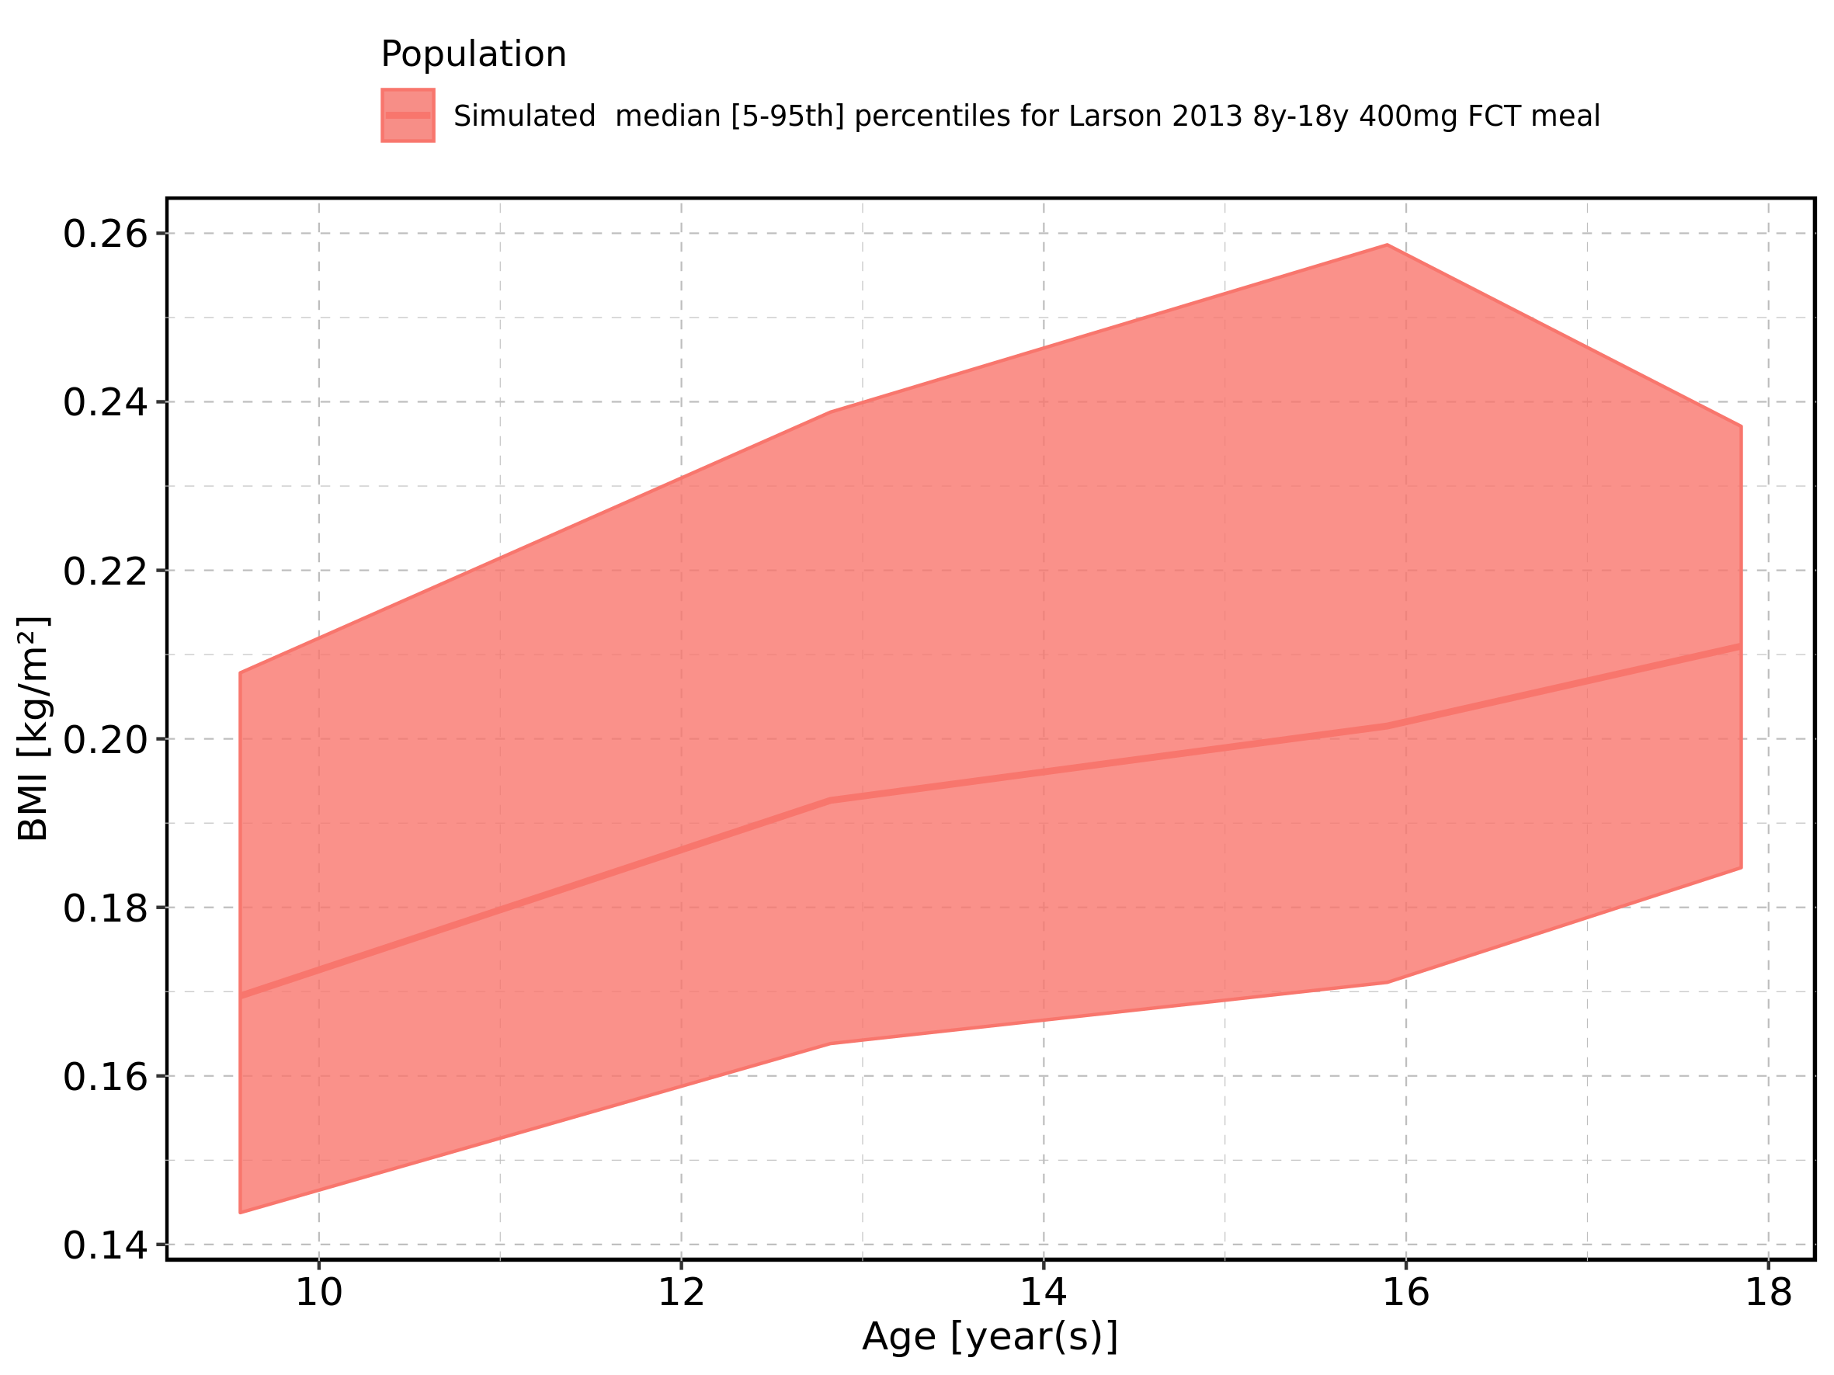

Figure 446: Age-dependence of BMI for Larson 2013 8y-18y 400mg FCT meal. Profiles are plotted in a logarithmic scale.

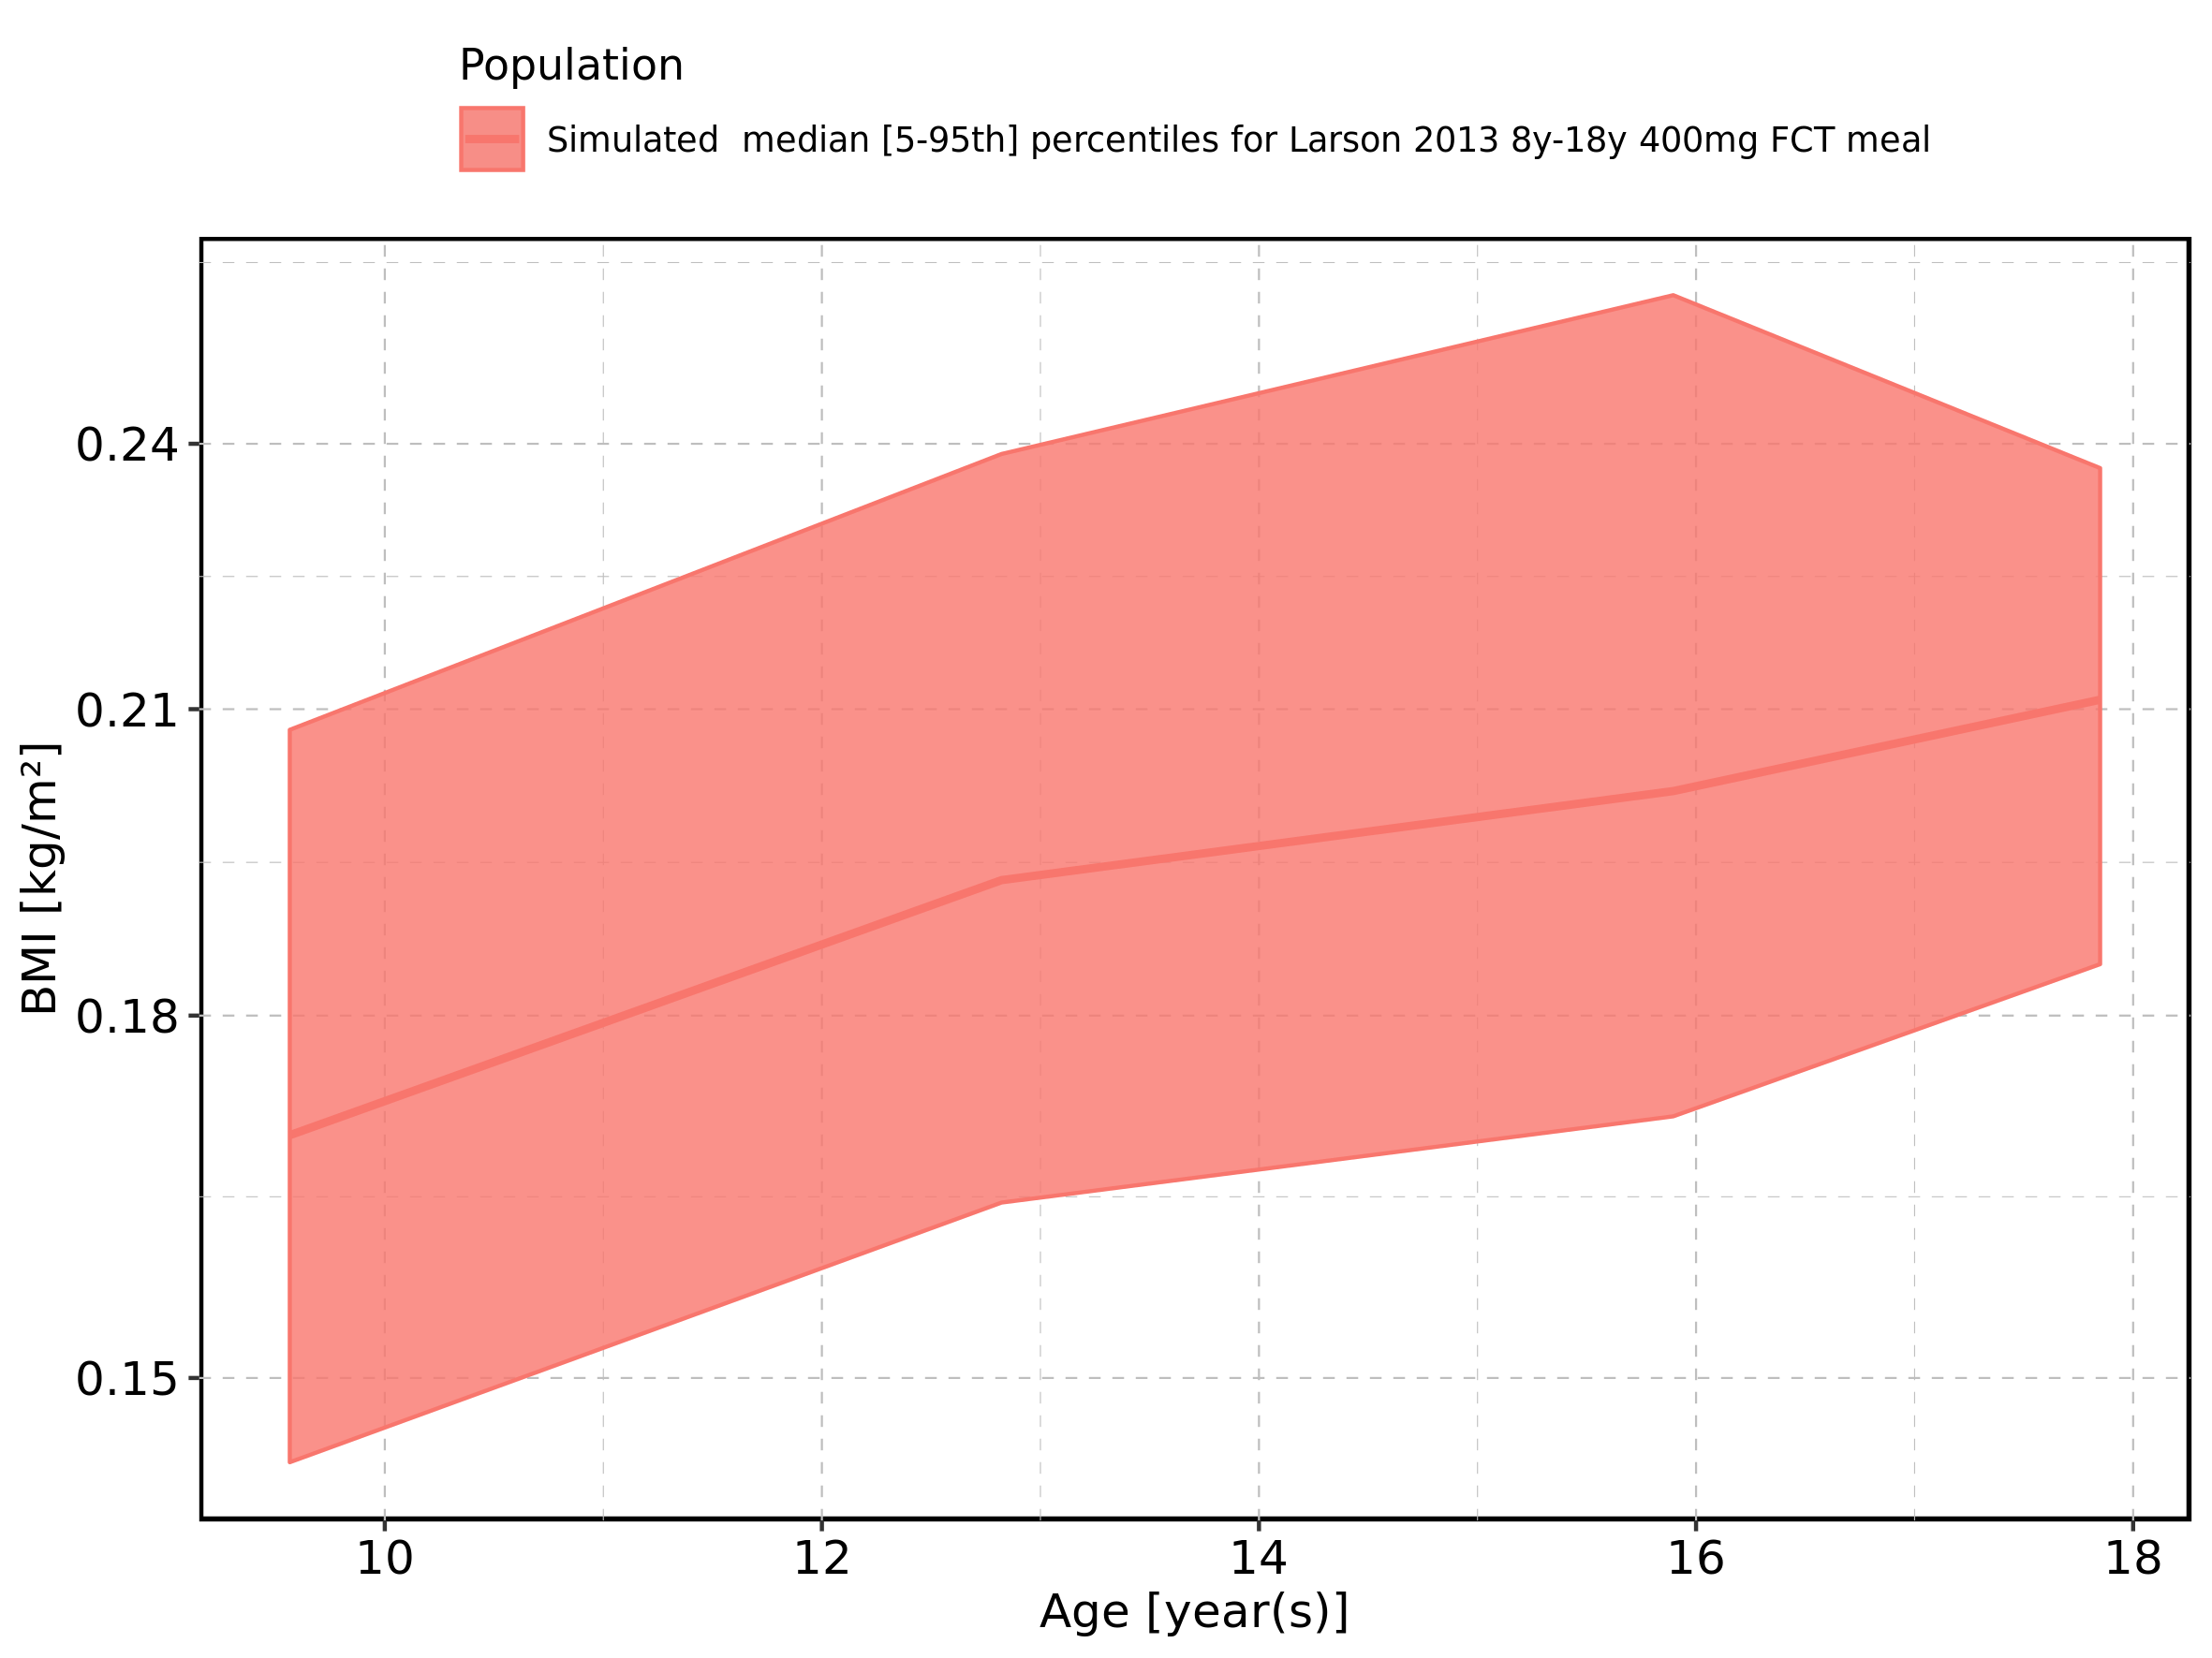

Figure 447: Age-dependence of BMI for Filmcoated_tablet_400mg_sd. Profiles are plotted in a linear scale.

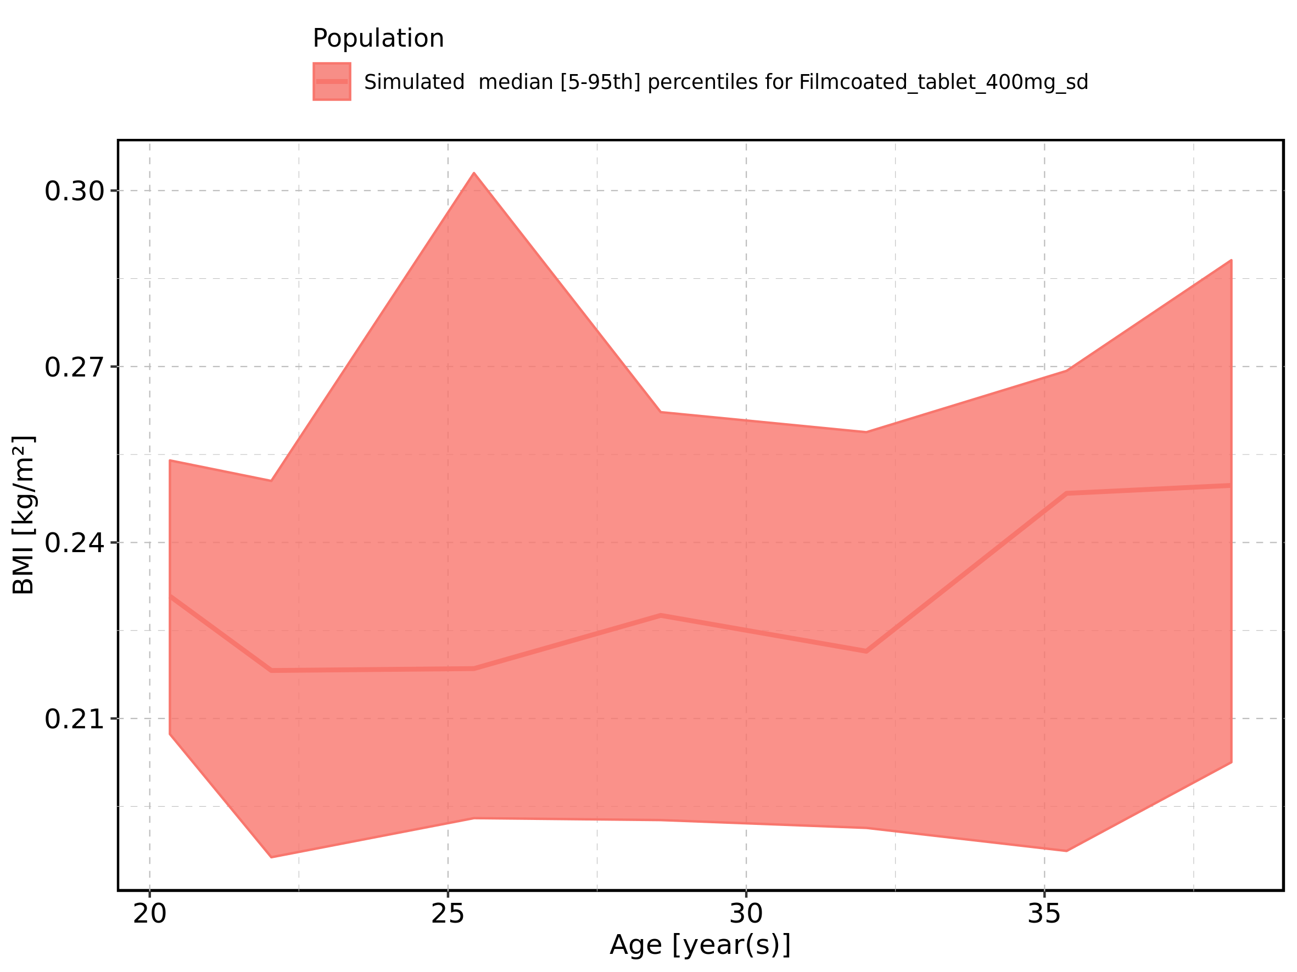

Figure 448: Age-dependence of BMI for Filmcoated_tablet_400mg_sd. Profiles are plotted in a logarithmic scale.

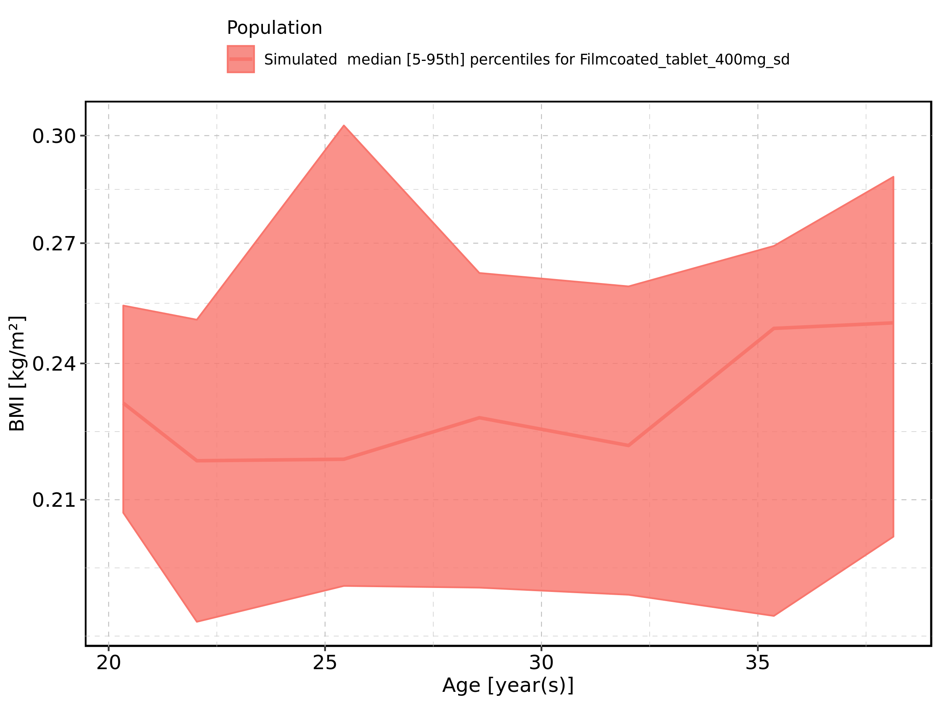

Figure 449: Age-dependence of Gender for Larson 2013 8y-18y 400mg FCT meal in comparison to Filmcoated_tablet_400mg_sd. Profiles are plotted in a linear scale.

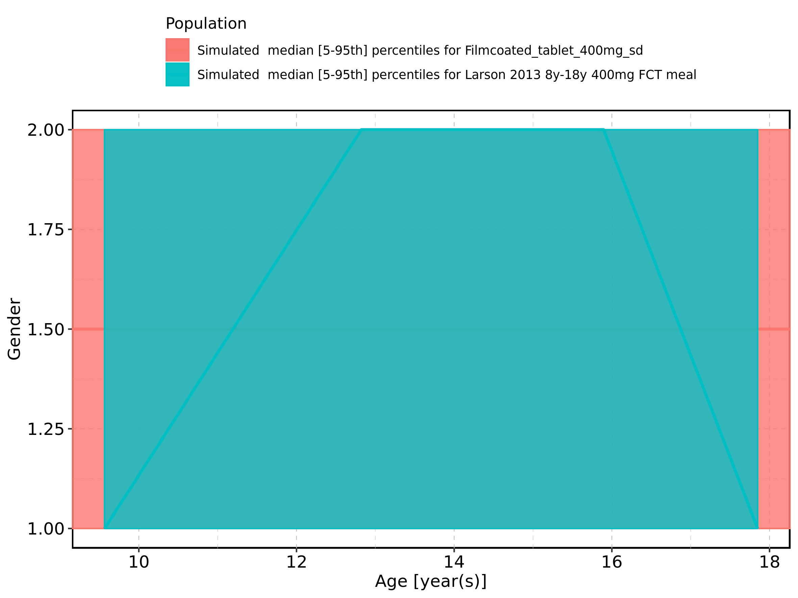

Figure 450: Age-dependence of Gender for Larson 2013 8y-18y 400mg FCT meal in comparison to Filmcoated_tablet_400mg_sd. Profiles are plotted in a logarithmic scale.

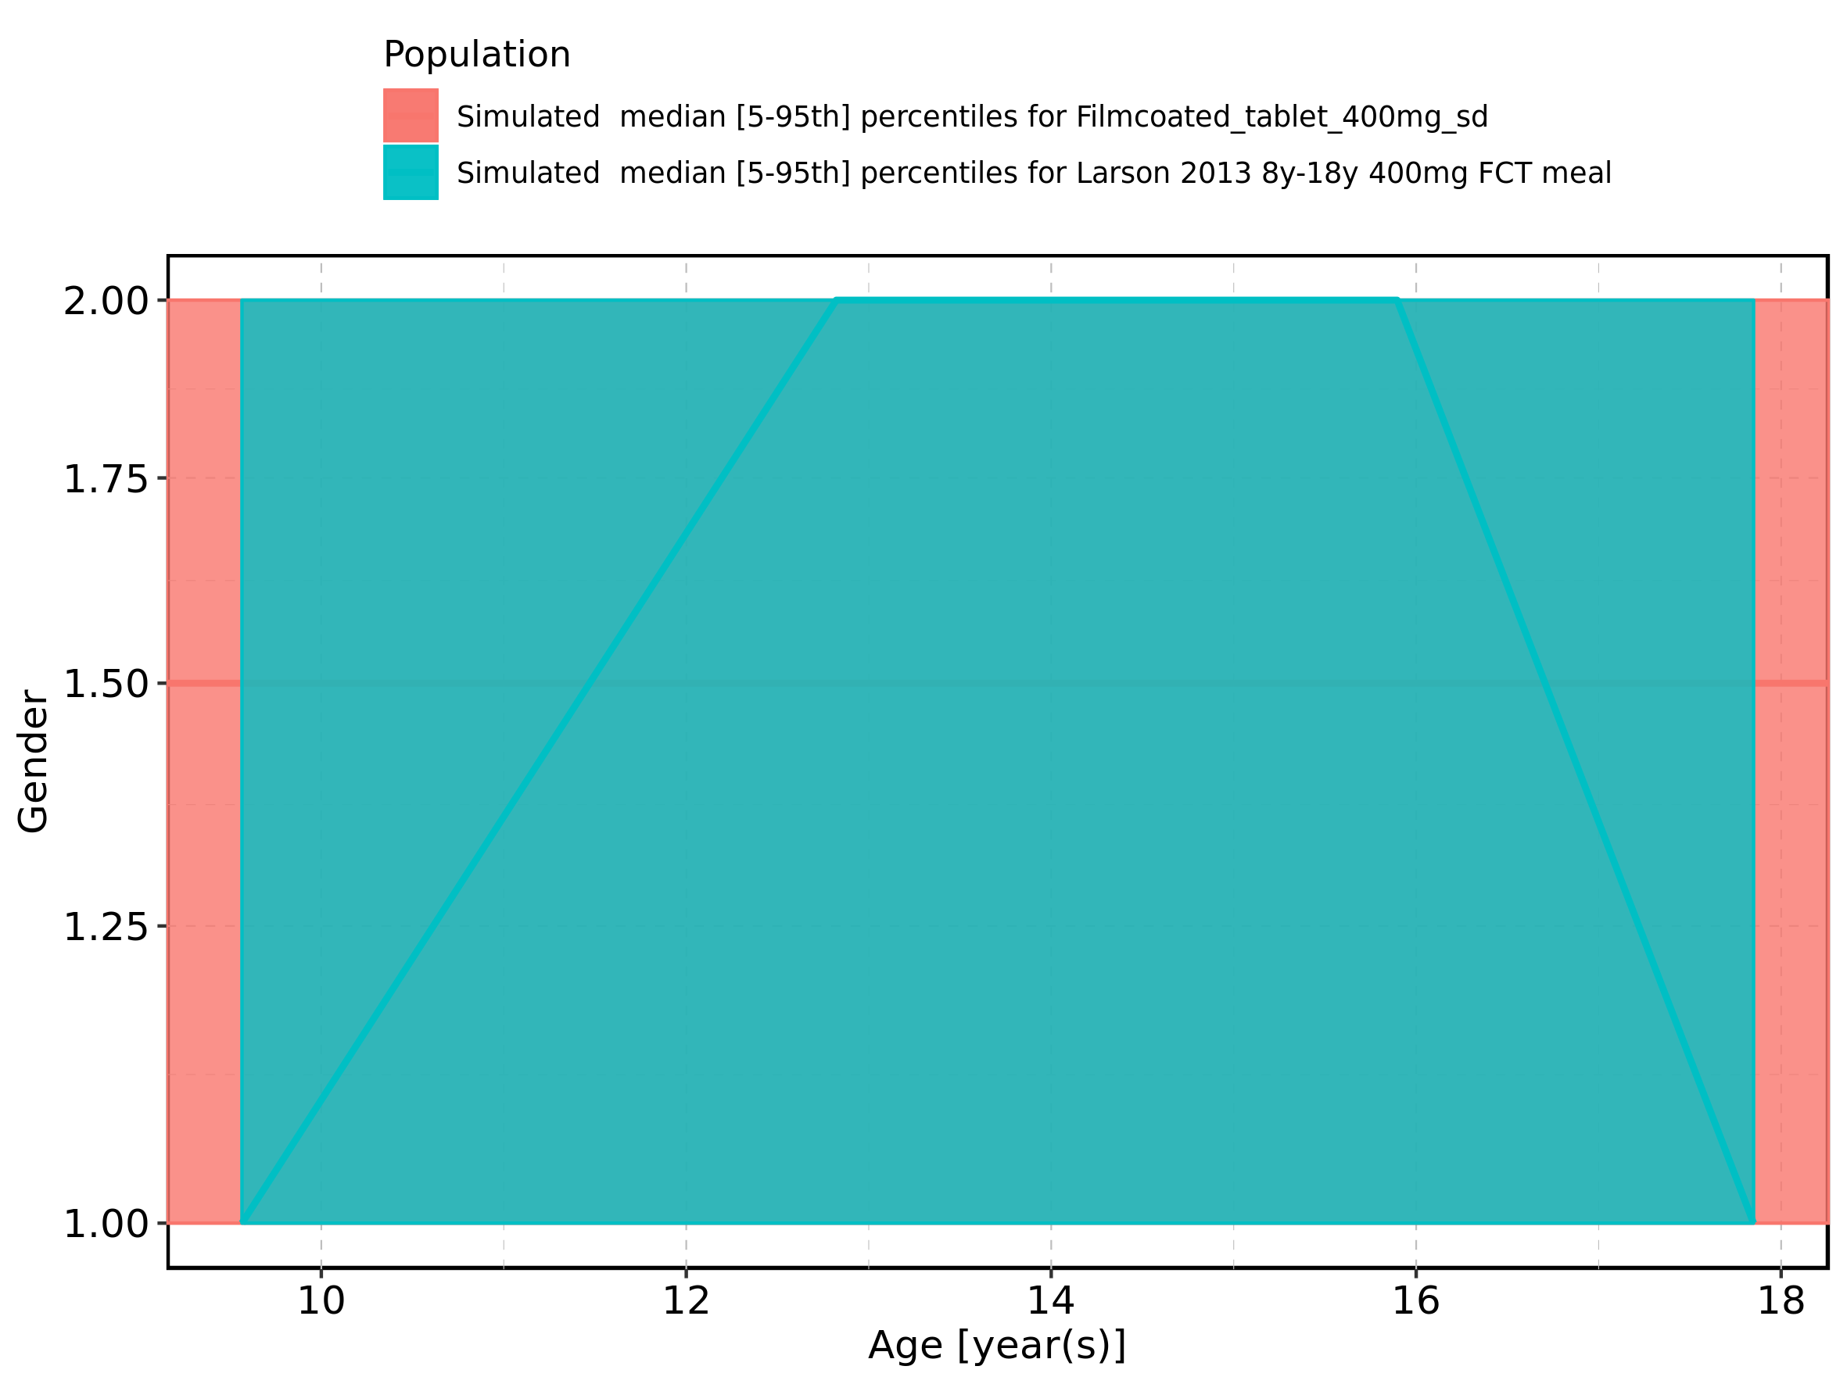

Figure 451: Age-dependence of Gender for Larson 2013 8y-18y 400mg FCT meal. Profiles are plotted in a linear scale.

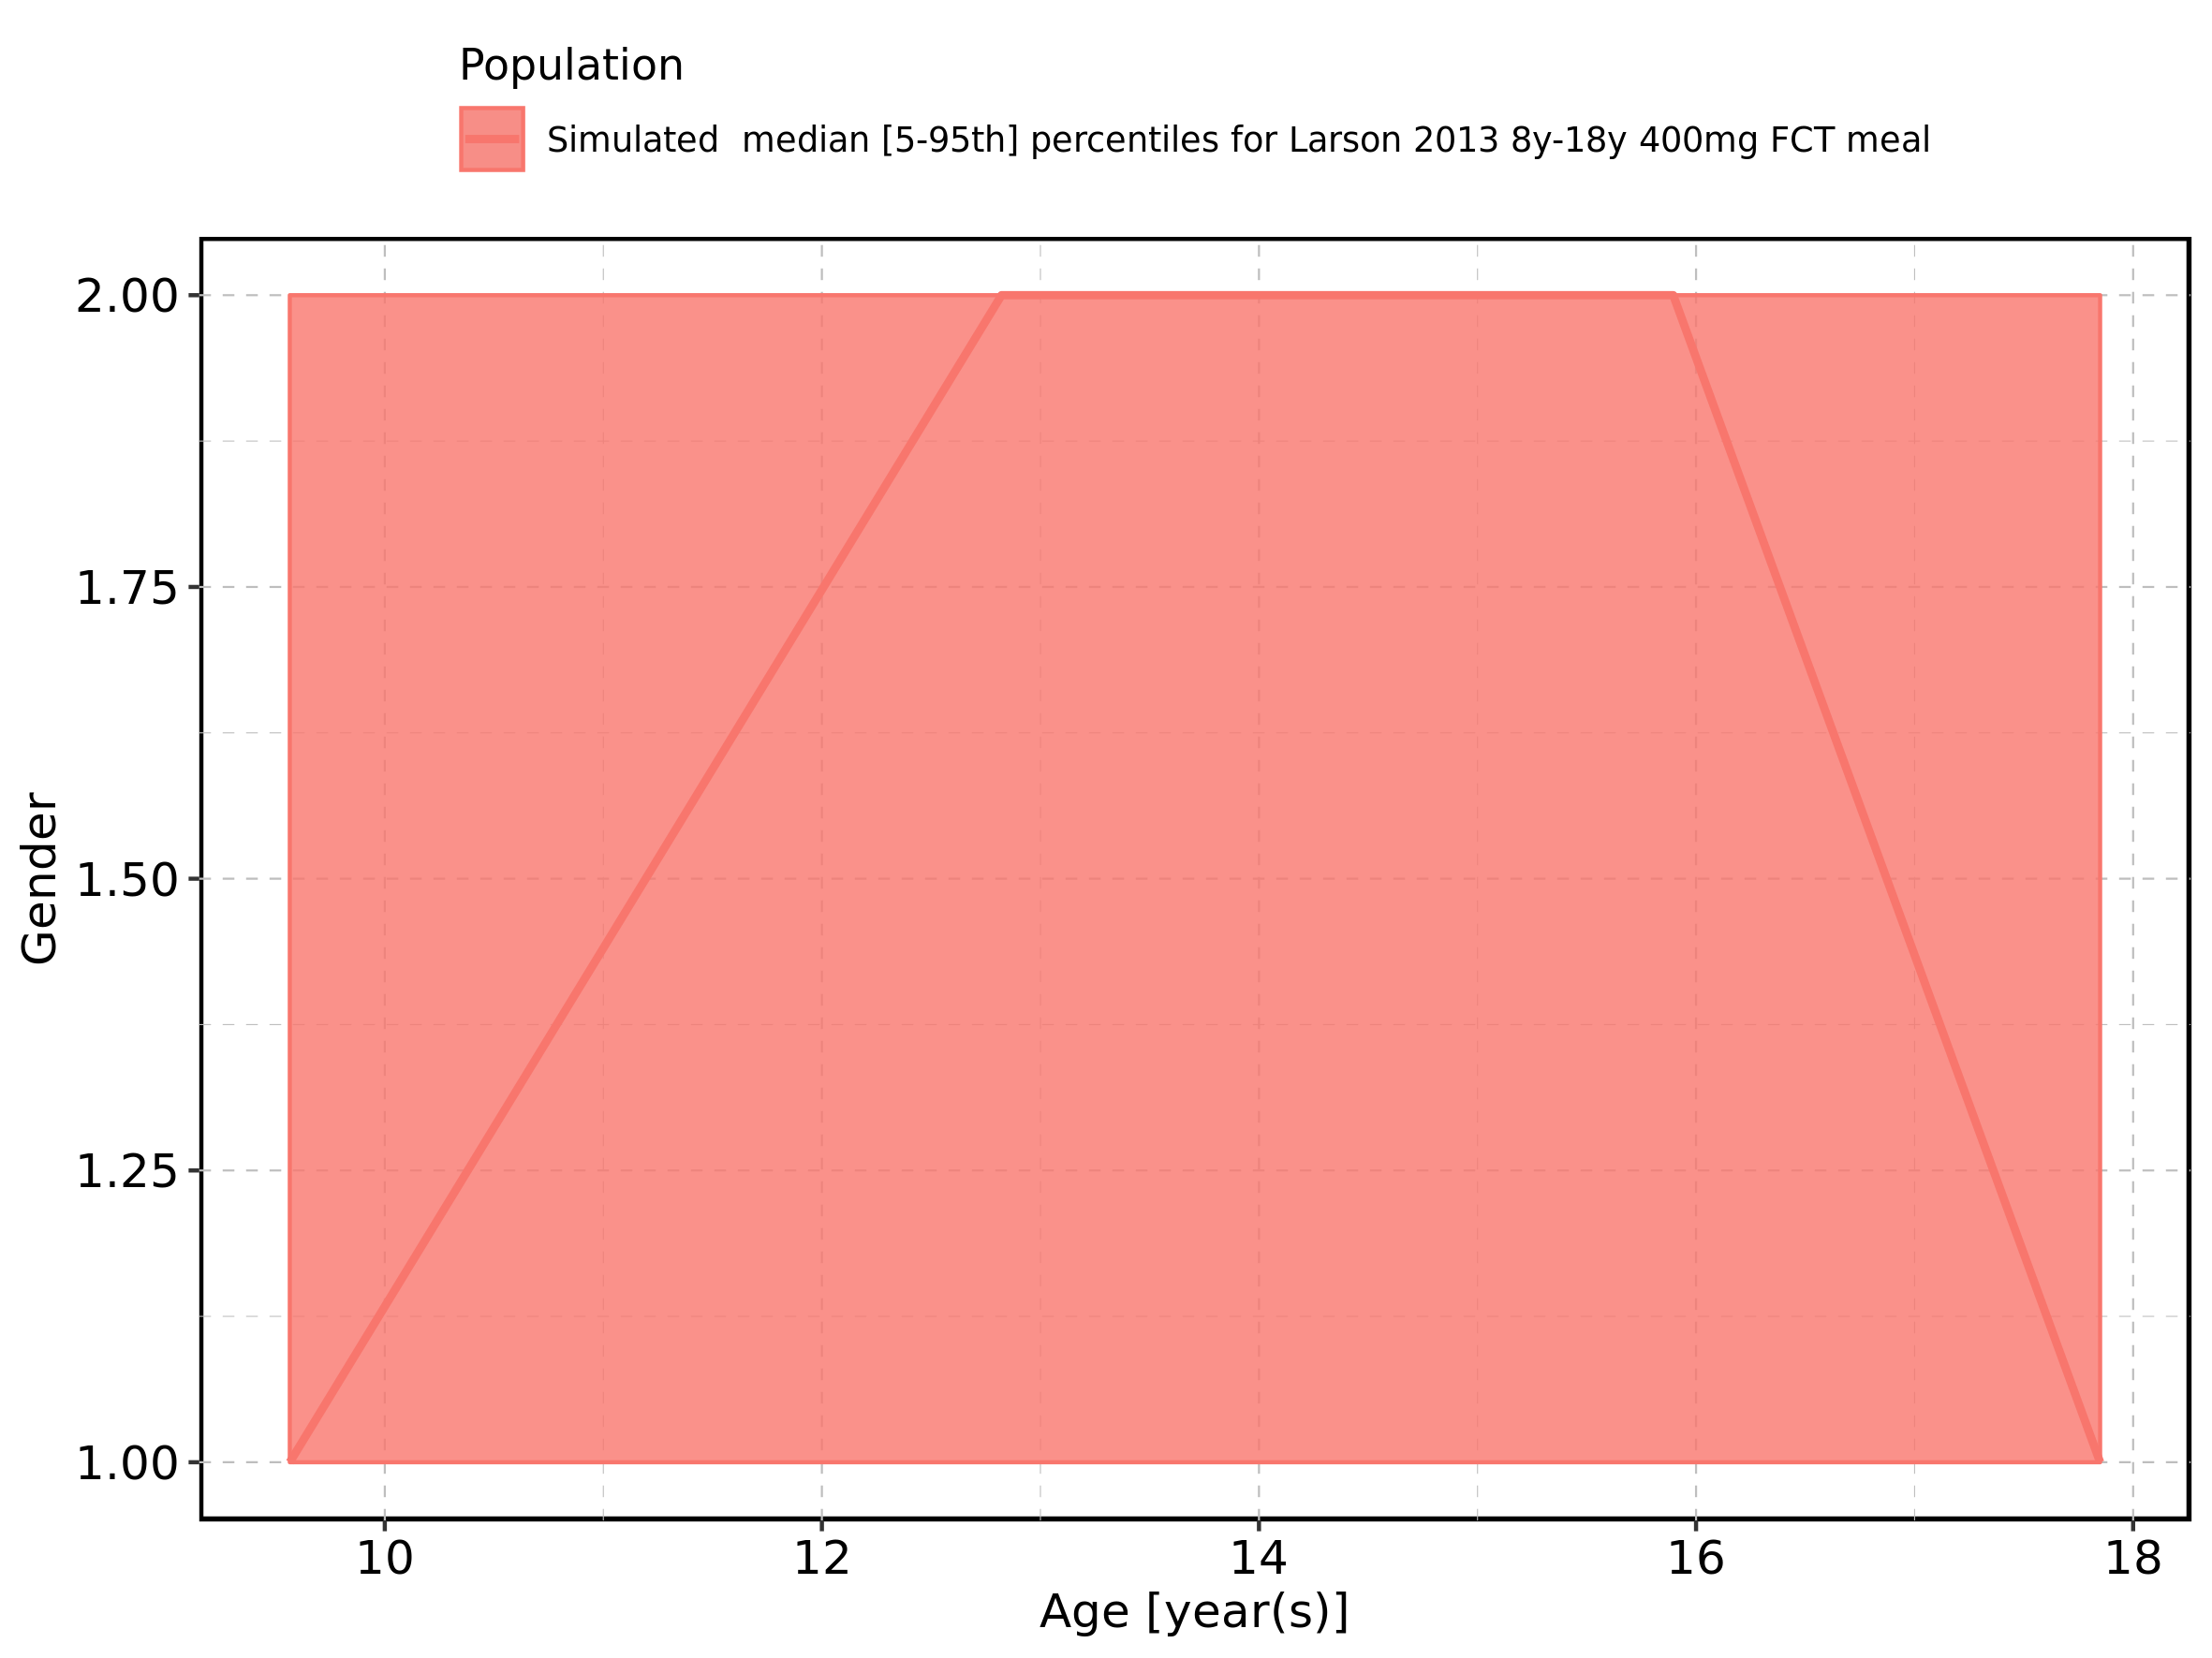

Figure 452: Age-dependence of Gender for Larson 2013 8y-18y 400mg FCT meal. Profiles are plotted in a logarithmic scale.

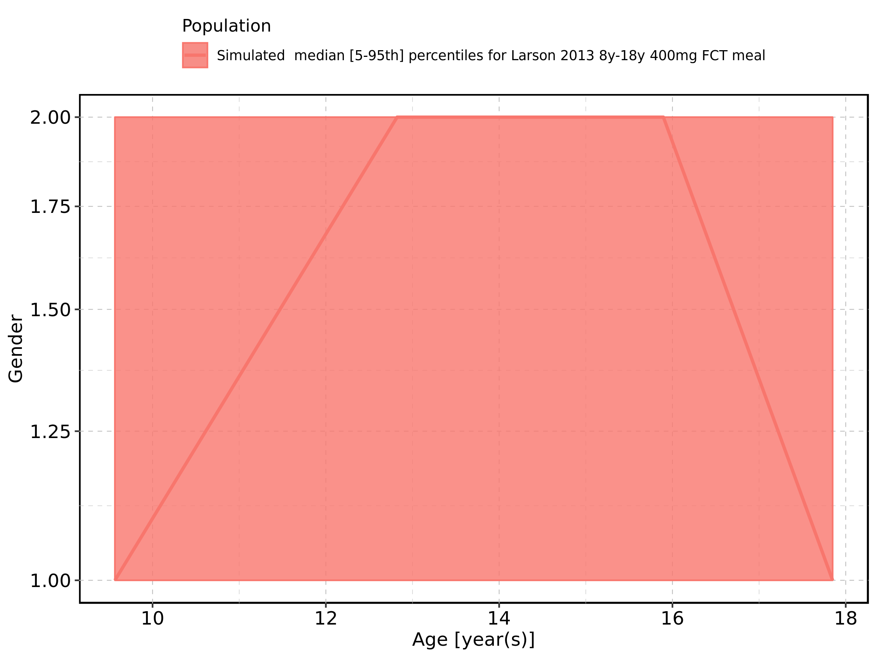

Figure 453: Age-dependence of Gender for Filmcoated_tablet_400mg_sd. Profiles are plotted in a linear scale.

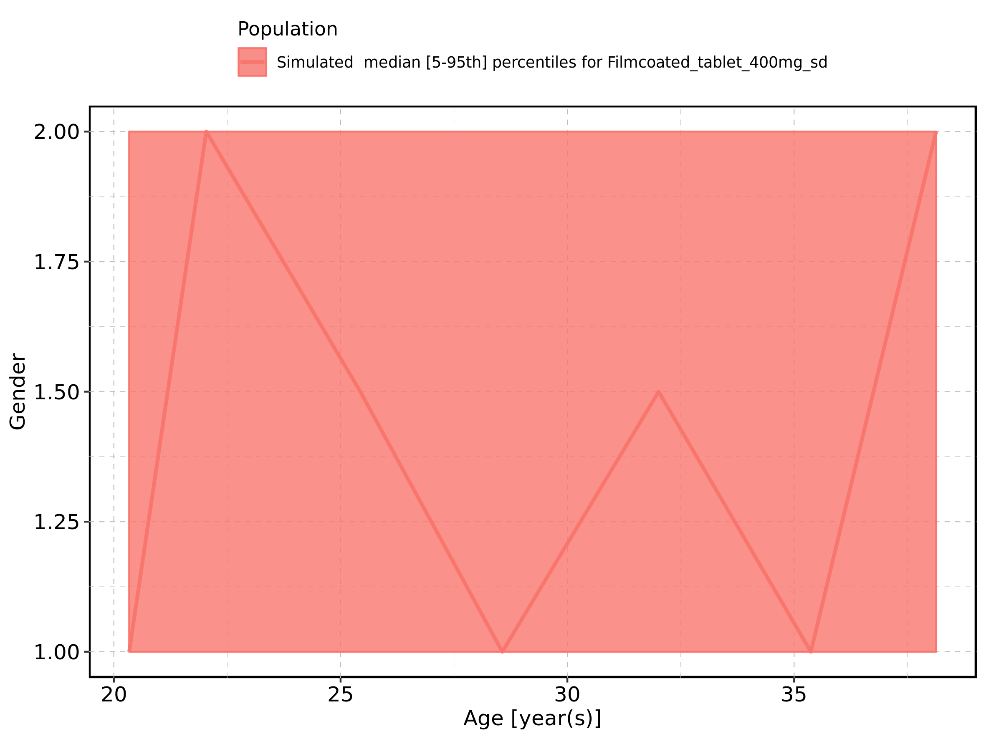

Figure 454: Age-dependence of Gender for Filmcoated_tablet_400mg_sd. Profiles are plotted in a logarithmic scale.

